Supplementary Appendix

Figure S1: EAT-On algorithm to determine food allergic status at the end of the study. This diagram details how food allergic status was determined based on oral food challenges, consumption and allergy test results in a hierarchical way. This was used for all 6 food allergens studied originally as a part of the EAT study including sesame seed.
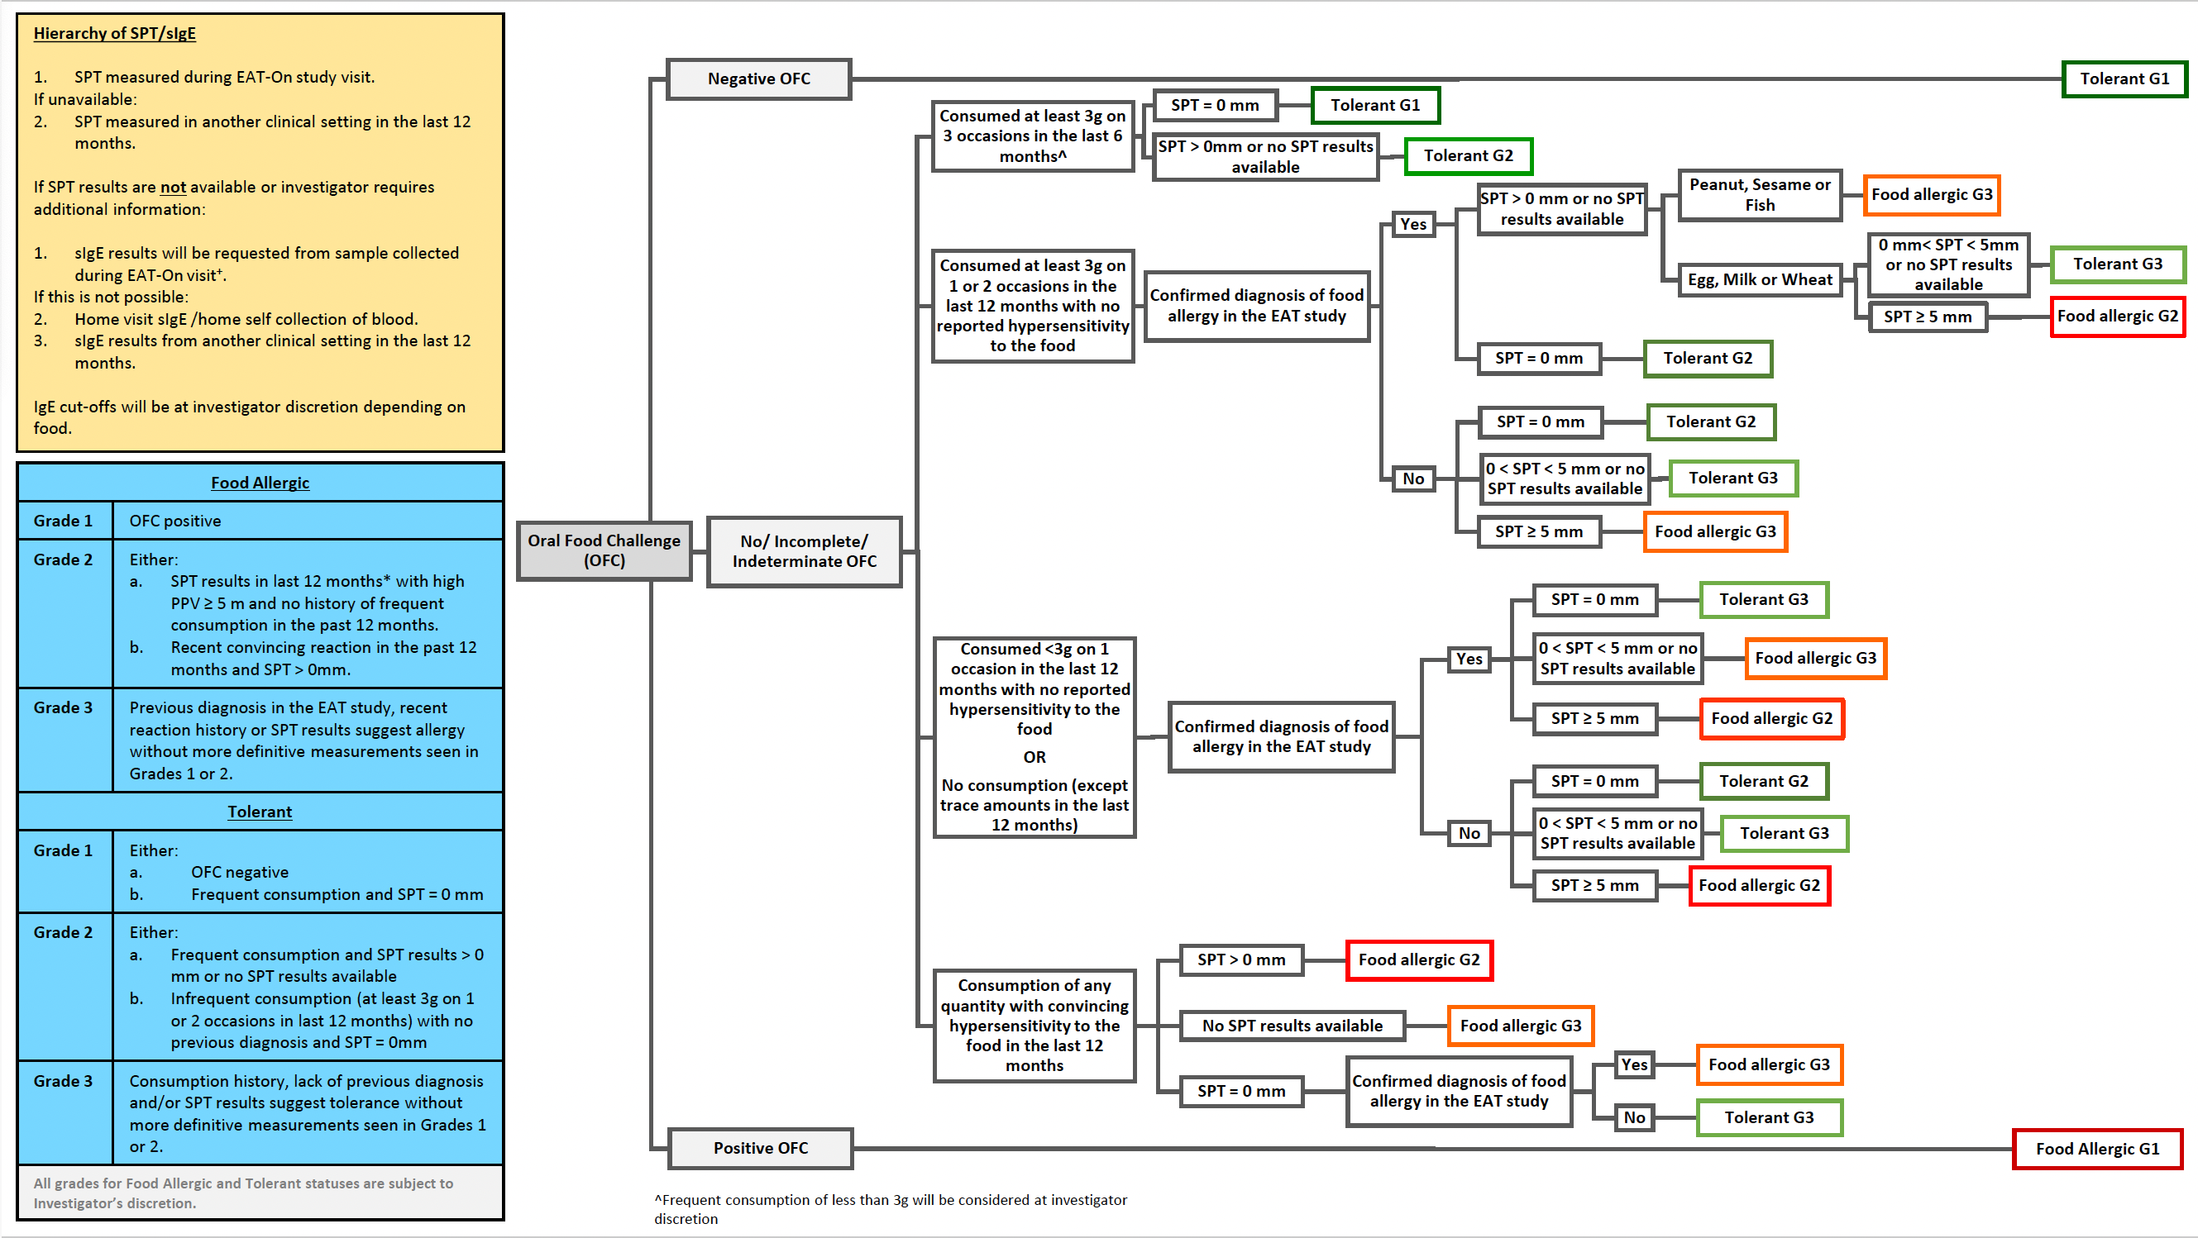

Figure S2: Determining sesame seed allergy status for the entire EAT-On Cohort. This flow diagram details how sesame seed allergic status was determined based on patient encounters during the EAT-On Study. Patients had a clinical and/or telephone visit and were found to be sesame seed allergic or tolerant based on OFC and/or consumption (regular consumption was defined as eating 3 grams of sesame seed protein at least 3 times in the last 6 months). If neither OFC nor consumption data were available, SPT<5mm was used to determine tolerance. The red box indicates sesame allergic children who were included in the biomarker analysis. [1] Represents where the patients who were sesame seed sensitized and not allergic were selected from for the biomarker analysis.

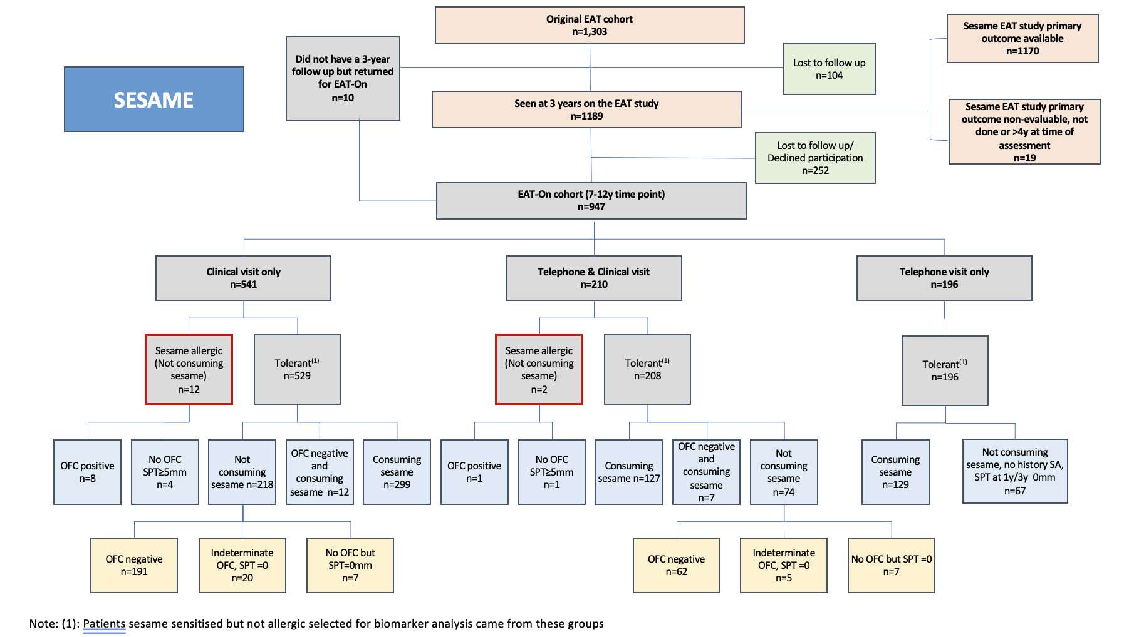

Figure S3: Scatter plot showing the sesame sIgE values at 12 and 36 months in relation to the sesame allergy outcome at 7-12years for (A) sesame sIgE and (B) ses i 1-sIgE

A

B
Table S1: Biomarkers of the sesame allergic children at 7-12years who did not have an OFC

Participant | Sesame allergic (SA) status | OFC (Y/N) | SPT (mm) at 7-12years | Sesame IgE (kUA/L) at 7-12years | Ses i 1-IgE (kUA/L) at 7-12years | Consuming sesame at 7-12y (Y/N)
1 | Still allergic | N | 9.5 | 21.5 | 3.1 | N
2 | Still allergic | N | 12.5 | 5.1 | 6.2 | N
3 | New allergic | N | 7 | 18.4 | 14.9 | N
4 | New allergic | N | 16.5 | 22.4 | 22.1 | N
5 | New allergic | N | 18.5 | 5.9 | 3.5 | N
6 | New allergic | Y | 0 | 30.8 | 7.9 | N
7 | Still allergic | Y | 7 | 19.4 | 2.3 | N
8 | New allergic | Y | 6.5 | 0.8 | 0.4 | N
9 | New allergic | Y | 17.5 | 4.6 | 4.6 | N
10 | New allergic | Y | 3.5 | 6.8 | 0.4 | N
11 | New allergic | Y | 3 | 1.6 | 0.6 | N
12 | New allergic | Y | 3 | 0.8 | 0.01 | N
13 | Still allergic | Y | 0 | 0.7 | 0.3 | N
14 | New allergic | Y | 20 | 9.9 | 9.6 | N

Table S2: Baseline clinical characteristics between sesame allergic, sesame sensitised not allergic and not food allergic or sensitised to sesame children
 | Sesame allergic  (n=14) | Sesame sensitised but not allergic (n=287) | Not food allergic or sensitised to sesame  (n=648) | P value* | P value⁺
Mean age years (SD) | 7.8 (0.6) | 8.4 (1.2) | 8.9 (1.3) | 0.03 | <0.001
Female sex n (%) | 5 (35.7) | 142 (49.5) | 334 (51.5) | 0.32 | 0.45
Ethnicity n (%)  White Caucasian  Non-Caucasian  - Mixed  - Asian/Asian British  - Black/Black British  - Chinese or other ethnic group | 9 (64.3)  5 (35.7)  4 (20)  1 (7.1)  0 (0)  0 (0) | 241 (84.0)  46 (16.0)  24 (8.4)  7 (2.4)  10 (3.5)  5 (1.7) | 580 (89.5)  68 (10.5)  49 (7.6)  6 (0.9)  10 (1.5)  3 (0.4) | 0.06¹  0.26² | p<0.01¹  <0.01²
History of eczema n (%) | 13 (90) | 163 (56.8) | 247 (38.1) | <0.01 | <0.001
Eczema at 7-12 years n (%) | 10 (71.4) | 85 (29.8) n=285 | 112 (17.5) | <0.01 | <0.001
Asthma at 7-12 years n (%) | 6 (42.9) | 34 (12.0) n=284 | 48 (7.6) | <0.01 | <0.001
Allergic rhinitis at 7-12 years n (%) | 8 (57.1) | 107 (37.7) n=284 | 111 (17.6) | 0.14 | <0.001
* This P value refers to the comparison made between sesame allergic versus sesame sensitised but not allergic children.
⁺ This P value refers to the comparison made between sesame allergic, sesame sensitised but not allergic and not sesame allergic or sesame sensitised children (Kruskal wallis or chi2 test)
¹ p-value comparison between White Caucasian and Non-Caucasian groups
² p-value comparison between White Caucasian, Mixed race, Asian/Asian British, Black/Black British, Chinese or other ethnic group (all subgroups)

The total n is denoted in () next to each individual value if it differs from the total n of the whole group due to missing data.

Table S3: Comparison of consumption at different time points between the children who developed new sesame allergy at 7-12years old and the sesame sensitised not allergic children
 | New sesame allergic  (n=10) | Sesame sensitised not allergic (n=286) | p-value²
4 months*
Total weekly sesame consumption frequency Weekly Mean Frequency (SD)¹ | 0.17 (0.35) | 0.21 (0.60) | 0.5772
Never n (%) | 7 (77.8) | 230 (85.8) | 0.5796
Once a Month n (%) | 0 (0.0) | 7 (2.6)
Twice a Month n (%) | 1 (11.1) | 3 (1.1)
Once a Week n (%) | 1 (11.1) | 6 (2.2)
Twice a Week n (%) | 0 (0.0) | 21 (7.8)
Three to Four times a week n (%) | 0 (0.0) | 1 (0.4)
Missing | 1 | 18
12 months*
Total weekly sesame consumption frequency  Weekly Mean Frequency (SD)¹ | 2.38 (2.27) | 2.18 (2.41) | 0.7013
Never n (%) | 2 (20.0) | 45 (16.2) | 0.7027
Once a month n (%) | 0 (0.0) | 19 (6.9)
Twice a month n (%) | 0 (0.0) | 22 (7.9)
Once a week n (%) | 1 (10.0) | 25 (9.0)
Twice a week n (%) | 2 (20.0) | 59 (21.3)
Three to four times a week n (%) | 3 (30.0) | 66 (23.8)
Daily n (%) | 2 (20.0) | 31 (11.2)
More than once a day n (%) | 0 (0.0) | 10 (3.6)
Missing | 0 | 9
36 months*
Total weekly sesame consumption frequency Weekly Mean Frequency (SD)¹ | 1.30 (2.08) | 2.35 (2.52) | 0.0355
None n (%) | 4 (40.0) | 28 (9.9) | 0.0356
Once a Month n (%) | 2 (20.0) | 27 (9.5)
Twice a month | 0 (0.0) | 21 (7.4)
Once a week n (%) | 0 (0.0) | 38 (13.4)
Twice a week n (%) | 2 (20.0) | 41 (14.5)
Three to four times a week n (%) | 1 (10.0) | 88 (31.1)
Daily n (%) | 1 (10.0) | 26 (9.2)
More than once a day n (%) | 0 (0.0) | 14 (4.9)
Missing | 0 | 3
7-12 years**
Less than 3g sesame protein, 3 times in 6 months n (%) | 10 (100.0) | 89 (31.1) | <.0001
At least 3g sesame protein, 3 times in 6 months n (%) | 0 (0.0) | 197 (68.9)
¹ Mean (SD) Weekly Sesame Consumption Frequency (where 1.0 = sesame protein consumption once a week)
² Wilcoxon Rank-Sum test, null hypothesis is that the distribution of weekly consumption among EAT-On sesame allergy and sesame sensitized but not allergic groups are equal, two-sided test
*Data was collected from food frequency questionnaires from parents at each of the EAT Study time points (4 months, 12 months, 36 months)

**Data was collected from asking parents about sesame consumption as per study criteria definition of tolerance. They were either consuming the equivalent of 3 grams of sesame protein in the 6 months prior to them being seen in the study.

Table S4: Univariate analysis looking at the covariates affecting sesame allergy at 7-12 years
Independent variable | Odds ratio | Std error | p> |z| | 95% CI | AUC
Sex (female) | 0.57 | 0.32 | 0.32 | 0.2, 1.7 | 0.4312
Ethnicity (Non-Caucasian) | 2.91 | 1.69 | 0.07 | 0.9, 9.1 | 0.5984
History of eczema | 9.89 | 10.33 | 0.03 | 1.3, 76.7 | 0.6803
Eczema at 7-12y | 5.88 | 3.56 | <0.01 | 1.8, 19.3 | 0.7080
Asthma at 7-12y | 5.51 | 3.14 | <0.01 | 1.8, 16.9 | 0.6544
Allergic rhinitis at 7-12y | 2.21 | 1.22 | 0.15 | 0.7, 6.5 | 0.5973
SPT at 1 year | 1.54 | 0.49 | 0.18 | 0.8, 2.9 | 0.5237
SPT at 3 years | 3.25 | 0.84 | <0.001 | 2.0, 5.4 | 0.6713
SPT at 7-12 years (tahini) | 2.69 | 0.54 | <0.001 | 1.8, 4.0 | 0.9213
Sesame sIgE 1 year (log10) | 8.42 | 3.80 | <0.001 | 3.5, 20.4 | 0.8730
Sesame sIgE 3 years (log10) | 12.72 | 6.12 | <0.001 | 4.9, 32.7 | 0.9054
Sesame sIgE 7-12 years (log10) | 14.76 | 7.50 | <0.001 | 5.5, 39.9 | 0.9442
Ses i 1-sIgE 1 year (log10) | 16.22 | 8.44 | <0.001 | 5.9, 45.0 | 0.8461
Ses i 1-sIgE 3 years (log10) | 29.63 | 22.3 | <0.001 | 6.7, 129.8 | 0.9355
Ses i 1-sIgE 7-12 years (log10) | 35.51 | 26.58 | <0.001 | 8.2, 154.0 | 0.9475
Sesame IgG4/IgE ratio 1 year | 1.00 | 0.01 | 0.05 | 0.995, 0.999 | 0.2573
Sesame IgG4/IgE ratio 3 years | 1.00 | 0.02 | <0.01 | 0.992, 0.998 | 0.096
Sesame IgG4/IgE ratio 7-12 years | 0.99 | 0.004 | 0.01 | 0.98, 0.997 | 0.154
MAT sesame 1 year | 1.62 | 0.32 | 0.02 | 1.1, 2.4 | 0.8569
MAT sesame 3 year | 1.40 | 0.20 | 0.02 | 1.1, 1.8 | 0.7735
MAT sesame 7-12 years | 5.28 | 2.40 | <0.001 | 2.2, 12.9 | 0.7620

Table S5: Multivariable logistic regression analyses looking at the covariates that correlate with sesame allergy determined at 7-12 years of age by time point over time
Independent variable | Odds ratio | Std error | p> |z| | 95% CI | VIF | AUC
Multivariable analysis using 1 year biomarker data
SPT at 1 year | 0.26 | 0.75 | 0.64 | 0.001, 72.9 | 1.35 | 0.8302
Sesame sIgE 1 year (log 10) | 1.21 | 1.09 | 0.84 | 0.2, 7.1 | 2.35 | 0.8302
Sesame Ses i 1-sIgE 1 year (log 10) | 17.4 | 13.3 | <0.001 | 3.9, 77.5 | 2.21 | 0.8302
Sesame IgG4/IgE 1 year (log 10) | 0.87 | 0.27 | 0.67 | 0.5, 1.6 | 1.42 | 0.8302
MAT sesame 1 year | 1.09 | 0.18 | 0.62 | 0.8, 1.5 | 1.35 | 0.8302
Multivariable analysis using 3 year biomarker data
SPT at 3 years | 1.4 | 0.74 | 0.53 | 0.5, 3.9 | 1.17 | 0.968
Sesame sIgE 3 years (log 10) | 1.1 | 1.47 | 0.94 | 0.08, 15.1 | 3.15 | 0.968
Sesame Ses i 1-sIgE 3 years (log 10) | 17.5 | 17.99 | <0.01 | 2.3, 131.5 | 2.52 | 0.968
Sesame IgG4/IgE ratio 3 years (log 10) | 0.72 | 0.3 | 0.41 | 0.3, 1.6 | 1.42 | 0.968
MAT sesame 3 years | 1.1 | 0.34 | 0.83 | 0.6, 2.0 | 1.3 | 0.968
Multivariable analysis using 7-12 years biomarker data
SPT at 7-12 years | 3.3 | 1.4 | <0.01 | 1.4, 7.6 | 1.30 | 0.996
Sesame sIgE 7-12 years (log 10) | 1.1 | 1.5 | 0.95 | 0.1, 16.8 | 2.61 | 0.996
Sesame Ses i 1-sIgE 7-12 years (log 10) | 11.3 | 13.0 | 0.04 | 1.2, 107.1 | 2.50 | 0.996
Sesame IgG4/IgE ratio 7-12 years (log 10) | 0.7 | 0.5 | 0.56 | 0.2, 2.7 | 1.54 | 0.996
MAT sesame 7-12 years | 4.0 | 4.2 | 0.18 | 0.5, 30.9 | 1.30 | 0.996

Table S6: Baseline and change from 1 to 3-years of age of Ses i 1-sIgE in predicting sesame allergy at 7-12-years of age.
Independent variable | Odds ratio | Std error | p> |z| | 95% CI | AUC
Ses i 1-sIgE (log10) at baseline (1-year) | 57.87 | 1.18 | <0.001 | 8.6, 1150.0 | 0.9092
Change in Ses i 1-sIgE (log10) from 1y to 3y | 17.6 | 0.81 | <0.001 | 4.6, 138.5 | 0.9092

Table S7: Baseline and change from 1 to 3-years of age of sesame-sIgE in predicting sesame allergy at 7-12-years of age.
Independent variable | Odds ratio | Std error | p> |z| | 95% CI | AUC
Sesame-sIgE (log10) at baseline (1-year) | 15.02 | 10.26 | <0.001 | 3.9, 57.3 | 0.8657
Change in sesame-sIgE (log10) from 1y to 3y | 9.47 | 6.62 | 0.001 | 2.4, 37.3 | 0.8657

