Supplementary Materials
S1: Re-evaluation of the original diagnosis
All cases of SCD were re-evaluated by an expert panel after excluding cases with decomposition. Data from the autopsy, including the original description of the gross examination of the heart and supplementary examinations, were re-evaluated. Each case was microscopically re-examined to ensure that it met the criteria for SADS. All available heart samples were used for microscopic re-evaluation, including samples from the conduction system, if available. Re-evaluation of the microscopic diagnosis was conducted by a trainee in forensic pathology and a forensic pathologist with a master’s degree in cardiovascular pathology. The cases were reviewed in collaboration with cardiac pathology experts from CRY St. George University, London. Complex cases, cases with changes of uncertain significance, and potentially reclassified cases were discussed for consensus regarding the diagnosis of SADS, which was established collectively. Cases with morphological changes meeting the criteria for cardiomyopathy and ischemic cases with coronary artery stenosis >75% were excluded. Cases of idiopathic fibrosis were also excluded. Idiopathic fibrosis was diagnosed in cases with normal heart weight and intramyocardial fibrosis in > 20% of the tissue in at least two samples. Idiopathic hypertrophy or idiopathic left ventricular hypertrophy (ILVH) were excluded, and the diagnosis was based on abnormal heart weight (>500 g for males and >400 g for females) and/or LV wall thickness >15 mm, with microscopic myocyte hypertrophy, with or without fibrosis. The remaining SADS cases were perceived as morphologically normal, did not fulfill any of the above-mentioned criteria, and were included in the cohort.

S2: Morphological features
Morphological feature | Explanation
Area | The size of the cell.
Area convex | The area of the convex hull that enclose the cell.  This helps in understanding the overall shape and compactness of the cell.
Eccentricity | Measures how much the shape of the cell differs from circular.
equivalentDiameterArea | The diameter of a circle with the same area as the cell. This helps comparing cells of different shapes by normalizing their size to a circle.
Extent | The ratio of cell area to area of its bounding box. This indicates how much of the bounding box is filled by the cell.
feret diameter Max | The longest distance between any two points along the boundary of the cell. This feature is the elongation of the cell.
Perimeter | The length of the cell boundary.
PerimeterCrofton | An estimation of the perimeter of a cell by averaging lengths of lines crossing the cell at different angles. This provides a more accurate measurement of the cell’s boundary for irregularly shaped cells.
Solidity | The ratio of the cell area to the area of its convex hull, indicating compactness.
Nearest Neighbor | The distance to the closest neighboring cell. This estimates the density of cells.
IntensityMin | The minimum intensity value within the cell. The darkest pixel.
IntensityMax | The maximum intensity value within the cell. The brightest pixel.
IntensitySD | The standard deviation of intensity values within the cell. This measures the variation in brightness, indicating how much the intensity values differentiate from the mean within the cell. Higher values suggest more variability.
IntensityMean | The average intensity value within the cell. This provides a measure of the overall brightness within the cell.
Features provided by the Quan10 algorithm for each cell type, meaning that all features are included for both cardiomyocyte nuclei and lymphocytes in the analyses.

S3: Details of the likely pathogenic variants
Phenotype | Gene | Location | Nucleotide change (REF/ALT) | Amino acid change | dbSNP ID | ACMG criteria | ACMG classification
SADS | PKP2 | chr12:32841102 | C/T | Trp538* | rs397517001 | PVS1, PS1, PM2 | Likely pathogenic
SADS | RBM20 | chr10:110812723 | C/T | Gln792* | NA | PVS1, PM2 | Likely pathogenic
SADS | TTN | chr2:178756292 | -/C | Gly3557fs | rs778172350 | PVS1, PM2 | Likely pathogenic
SADS | TTN | chr2:178566608 | C/T | Trp26508* | rs765149776 | PVS1, PM2 | Likely pathogenic
SADS | SCN5A | chr3: 8606790 | G/A | Arg340Gln | rs191009474 | PS3, PM2 | Likely pathogenic
SADS | DSP | chr6:7577001 | G/T | Glu9946* | NA | PVS1, PM2 | Likely pathogenic
Control | TTN | chr2:178589581 | C/T | Trp11842* | NA | PVS1, PM2 | Likely pathogenic
Control | TTN | chr2:178622768 | C/T | splice site | rs749705939 | PVS1, PM2, PP5 | Likely pathogenic
Control | TTN | chr2:178594647 | C/T | splice site | NA | PVS1, PM2 | Likely pathogenic
Details of likely pathogenic variants identified in either SADS or controls cases.

S4: Variables of importance from the random forest model
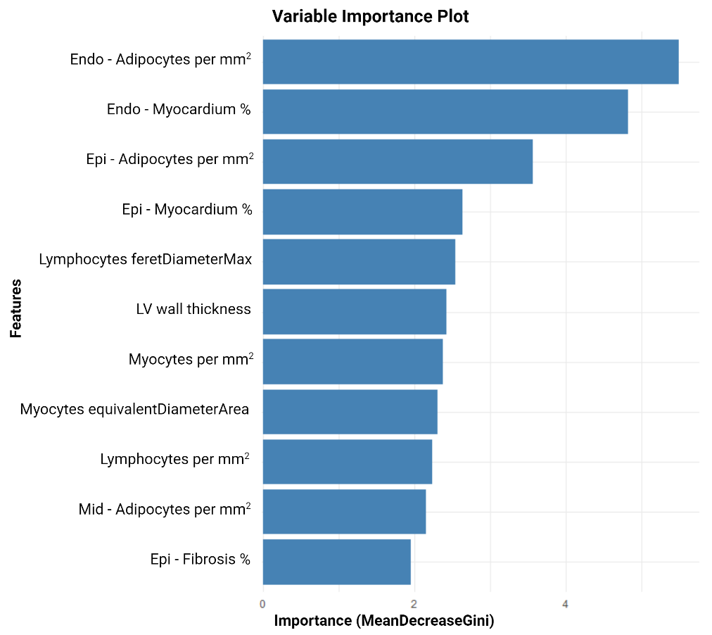
Variables of importance for the final RF model. LV, left ventricle; PCT, percentages; Myo, Myocardium; Epi, epicardial region; Endo, endocardial region.

S5:
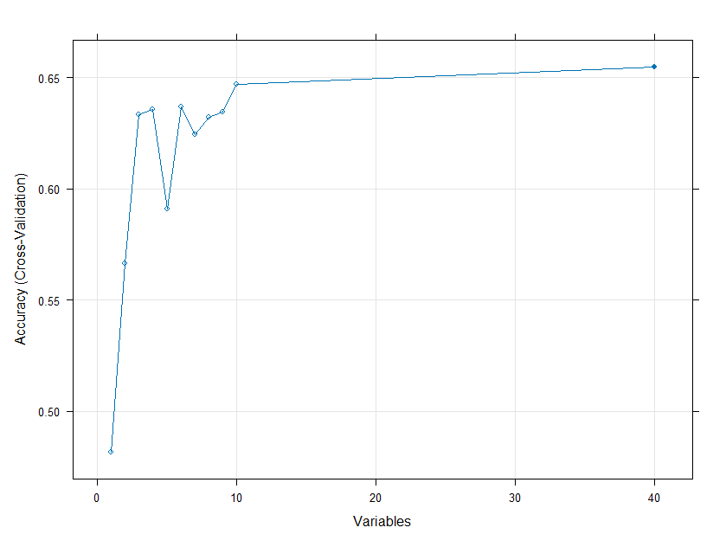
The number of variables plotted over accuracy for the recursive feature elimination, showing that around ten variables were the best number of variables included.

