Combination of heart failure and atrial fibrillation worsens
ethnicity-related disparity: an individual patient-level meta-analysis of randomized trials

Online Supplement

Supplementary Table S1: Breakdown of population by ethnicity and rhythm 2
Supplementary Table S2: Baseline characteristics for HF in sinus rhythm 3
Supplementary Table S3: Baseline characteristics for HF plus AF 4
Supplementary Table S4: Baseline characteristics after propensity score matching 5
Supplementary Table S5: Propensity score-matched analysis 6
Supplementary Table S6: Heart failure treatment efficacy 7
Supplementary Table S7: Beta blocker efficacy in HF with sinus rhythm 8

Supplementary Figure S1: Participant flow diagram 9
Supplementary Figure S2: Risk of Bias Assessment 10

Supplementary Table S1: Breakdown of population by ethnicity and rhythm

Ethnicity | HF in sinus rhythm | HF plus AF | Total
White/Caucasian | 11,865 (87%) | 2,949 (94%) | 14,814 (89%)
African/African-American | 1,226 (9%) | 141 (4%) | 1,367 (8%)
Asian* | 144 (1%) | 20 (1%) | 164 (1%)
Other** | 333 (2%) | 35 (1%) | 368 (2%)
Total | 13,568 | 3,145 | 16,713
AF=atrial fibrillation; HF=heart failure
*Asian ethnicity refers to patients from South Asia, Southeast Asia, and East Asia
**An ethnicity of ‘Other’ was used for patients whose ethnic background was not represented by the other 3 categories, including: Hispanic, Middle Eastern, Native American, Indigenous, and people of the Pacific Islands

Supplementary Table S2: Baseline characteristics for HF in sinus rhythm

Baseline characteristic | Non-white  (n=1,703) | White  (n=11,865) | p-value
Intervention arm, n (%) | 884 (51.9%) | 6,048 (51.0%) | 0.47
Women, n (%) | 582 (34.2%) | 3,348 (28.2%) | <0.001
Age, median years (IQR) | 57.1 (48.4-66.0) | 65.9 (57.0-73.0) | <0.001
BMI, median kg/m² (IQR) | 28.0 (24.2-32.9) | 27.0 (24.3-30.4) | <0.001
Systolic BP, median mmHg (IQR) | 120 (108-135) | 125 (112-139) | <0.001
Diastolic BP, median mmHg (IQR) | 75 (68-82) | 76.7 (70-81.7) | 0.011
Heart rate, mean (SD) | 82.5 (13.6) | 78.6 (12.4) | <0.001
LVEF, median (IQR) | 0.24 (0.18-0.33) | 0.30 (0.22-0.37) | <0.001
NYHA Class III/IV, n (%) | 1,216 (71.8%) | 6,167 (52.0%) | <0.001
Comorbidities
Previous myocardial infarction, n (%) | 608 (35.7%) | 6,858 (57.8%) | <0.001
Previous stroke, n (%) | 63 (6.9%) | 516 (6.1%) | 0.35
Previous CABG or PCI, n (%) | 313 (18.5%) | 2,721 (23.6%) | <0.001
Hypertension, n (%) | 1,167 (69.9%) | 6,017 (52.2%) | <0.001
Peripheral arterial disease, n (%) | 140 (8.6%) | 981 (8.7%) | 0.89
Diabetes mellitus, n (%) | 681 (40.8%) | 3,017 (26.0%) | <0.001
Medication
Digoxin, n (%) | 1,201 (72.0%) | 5,074 (44.1%) | <0.001
ACE inhibitor or ARB, n (%) | 1,413 (95.9%) | 9,688 (94.5%) | 0.020
Calcium channel blocker, n (%) | 167 (10.1%) | 1,278 (11.0%) | 0.24
Aldosterone antagonist, n (%) | 823 (7.1%) | 76 (4.6%) | <0.001
Oral anticoagulant, n (%) | 513 (30.7%) | 2,773 (24.1%) | <0.001
Diuretic, n (%) | 1,373 (93.2%) | 8,264 (80.6%) | <0.001
Statin, n (%) | 407 (25.0%) | 3043 (27.0%) | 0.09
ACE = angiotensin-converting enzyme; ARB = angiotensin receptor blocker. BMI = body mass index; BP = blood pressure; CABG = coronary artery bypass grafting; IQR = interquartile range; LVEF = left ventricular ejection fraction; NYHA = New York Heart Failure Association; PCI = percutaneous coronary intervention; SD = standard deviation;
Missing data report: BMI n=19 non-white, n=104 white; systolic BP n=8 non-white, n=59 white; diastolic BP n=11 non-white, n=61 white; heart rate n=1 non-white, n=12 white; LVEF n=12 non-white, n=49 white; NYHA n=9 non-white, n=63 white; MI n=0 non-white, n=1 white; stroke n=788 non-white, n=3402 white; CABG/PCI n=14 non-white, n=343 white; hypertension n=34 non-white, n=349 white; peripheral arterial disease n=76 non-white, n=606 white; diabetes mellitus n=34 non-white, n=259 white; digoxin n=34 non-white, n=349 white; ACE inhibitor or ARB n=230 non-white, n=1609 white; calcium channel blocker n=42 non-white, n=261 white; aldosterone antagonist n=34 non-white, n=349 white; oral anticoagulant n=34 non-white, n=350 white, diuretic n=58 non-white, n=644 white; statin n=4 non-white, n=60 white.

Supplementary Table S3: Baseline characteristics for HF plus AF

Baseline characteristic | Non-white  (n=196) | White  (n=2,949) | p-value
Intervention arm, n (%) | 102 (52.0%) | 1,462 (49.6%) | 0.50
Women, n (%) | 52 (26.5%) | 741 (25.1%) | 0.66
Age, median years (IQR) | 65.2 (57.0-74.0) | 71.0 (63.0-76.0) | <0.001
BMI, median kg/m² (IQR) | 27.8 (23.4-32.4) | 27.6 (24.7-31.2) | 0.86
Systolic BP, median mmHg (IQR) | 119 (107.5-131.5) | 127 (115-140) | <0.001
Diastolic BP, median mmHg (IQR) | 74.5 (65-80.8) | 78.3 (70-83) | 0.003
Heart rate, mean (SD) | 77.1 (14.8) | 80.9 (14.1) | <0.001
LVEF, median (IQR) | 0.30 (0.21-0.50) | 0.31(0.23-0.45) | 0.65
NYHA Class III/IV, n (%) | 146 (74.9%) | 1,872 (63.7%) | 0.002
Comorbidities
Previous myocardial infarction, n (%) | 54 (27.6%) | 1,047 (35.5%) | 0.023
Previous stroke, n (%) | 10 (8.7%) | 177 (8.8%) | 0.98
Previous CABG or PCI, n (%) | 29 (14.8%) | 481 (16.6%) | 0.51
Hypertension, n (%) | 147 (75.0%) | 1,680 (57.0%) | <0.001
Peripheral arterial disease, n (%) | 16 (8.3%) | 199 (6.9%) | 0.45
Diabetes mellitus, n (%) | 66 (34.4%) | 738 (25.5%) | 0.007
Medication
Digoxin, n (%) | 145 (74.0%) | 2,147 (72.8%) | 0.72
ACE inhibitor or ARB, n (%) | 130 (94.2%) | 2,186 (94.8%) | 0.74
Calcium channel blocker, n (%) | 35 (18.2%) | 352 (12.2%) | 0.014
Aldosterone antagonist, n (%) | 11 (5.6%) | 420 (14.2%) | 0.001
Oral anticoagulant, n (%) | 147 (75.0%) | 1,819 (61.7%) | <0.001
Diuretic, n (%) | 136 (98.6%) | 2,395 (92.1%) | 0.005
Statin, n (%) | 44 (22.9%) | 582 (20.1%) | 0.36
ACE = angiotensin-converting enzyme; ARB = angiotensin receptor blocker. BMI = body mass index; BP = blood pressure; CABG = coronary artery bypass grafting; IQR = interquartile range; LVEF = left ventricular ejection fraction; NYHA = New York Heart Failure Association; PCI = percutaneous coronary intervention; SD = standard deviation;
Missing data report: BMI n=4 non-white, n=18 white; systolic BP n=0 non-white, n=1 white; diastolic BP n=0 non-white, n=2 white; heart rate n=0 non-white, n=1 white; LVEF n=1 non-white, n=15 white; NYHA n=1 non-white, n=9 white; MI n=0 non-white, n=2 white; stroke n=81 non-white, n=928 white; CABG/PCI n=0 non-white, n=51 white; peripheral arterial disease n=4 non-white, n=60 white; diabetes mellitus n=4 non-white, n=60 white; ACE inhibitor or ARB n=58 non-white, n=644 white; calcium channel blocker n=4 non-white, n=60 white; diuretic n=58 non-white, n=644 white; statin n=4 non-white, n=60 white.

Supplementary Table S4: Baseline characteristics after propensity score matching

Variable | Non-white  (n=1354) | White  (n=1011) | p-value
Age, mean years (SD) | 55.6 (12.2) | 55.4 (12.2) | 0.74
Female gender, wt % | 30.7 | 30.6 | 0.97
LVEF, mean % (SD) | 23.0 (7.7) | 23.2 (7.8) | 0.47
NYHA class III/IV, wt % | 80.6 | 79.8 | 0.63
BMI, mean kg/m² (SD) | 28.3 (6.2) | 28.3 (5.5) | 0.95
Heart rate, mean beats per min (SD) | 84.5 (12.8) | 84.6 (12.4) | 0.77
Previous myocardial infarction, wt % | 37.6 | 36.6 | 0.58
Diabetes, wt % | 38.5 | 41.0 | 0.18
History of hypertension, wt % | 68.1 | 68.1 | 1.00
Previous CABG or PCI, wt % | 17.7 | 19.0 | 0.37
Digoxin, wt % | 84.3 | 83.5 | 0.60
ACE inhibitor or ARB, wt % | 96.5 | 96.8 | 0.67
Aldosterone antagonists, wt % | 5.2 | 5.4 | 0.86
Anticoagulants, wt % | 33.1 | 30.3 | 0.12
Diuretics, wt % | 94.2 | 94.2 | 1.00
ACE = angiotensin-converting enzyme; ARB = angiotensin receptor blocker; BMI = body mass index; CABG = coronary artery bypass grafting; LVEF = left ventricular ejection fraction; NYHA = New York Heart Failure Association; PCI = percutaneous coronary intervention; SD = standard deviation.
Wt % = weighted percentage

Supplementary Table S5: Propensity score-matched analysis

Outcome | Crude event numbers from unmatched cohort (%) | Propensity-score matched odds ratio for  non-white vs white (95% CI), p-value | P-value for comparison of sinus rhythm vs AF
All-cause mortality
HF in sinus rhythm | 330/1703 (19.4%) vs 1610/11865 (13.6%) | 1.17 (0.96-1.41), p=0.12 | 0.009
HF plus AF | 64/196 (32.7%) vs 532/2949 (18.0%) | 2.66 (1.47-4.81), p=0.001 | 0.009
Cardiovascular-related mortality
HF in sinus rhythm | 278/1703 (16.3%) vs 1317/11865 (11.1%) | 1.12 (0.92-1.37), p=0.26 | 0.07
HF plus AF | 45/196 (23.0%) vs 432/2949 (14.6%) | 2.03 (1.1-3.75), p=0.024 | 0.07
Heart failure-related mortality
HF in sinus rhythm | 75/1703 (4.4%) vs 376/11865 (3.2%) | 0.87 (0.63-1.21), p=0.40 | 0.26
HF plus AF | 15/196 (7.7%) vs 153/2949 (5.2%) | 1.49 (0.62-3.63), p=0.38 | 0.26
Cardiovascular-related hospitalization
HF in sinus rhythm | 557/1703 (32.7%) vs 2962/11865 (25.0%) | 1.21 (1.02-1.42), p=0.026 | 0.37
HF plus AF | 79/196 (40.3%) vs 879/2949 (29.8%) | 1.54 (0.93-2.56), p=0.10 | 0.37
Heart failure-related hospitalisation
HF in sinus rhythm | 470/1703 (27.6%) vs 1736/11865 (14.6%) | 1.28 (1.08-1.52), p=0.005 | 0.10
HF plus AF | 69/196 (35.2%) vs 606/2949 (20.5%) | 2.05 (1.2-3.49), p=0.008 | 0.10
AF = atrial fibrillation; CI = confidence Interval

Supplementary Table S6: Heart failure treatment efficacy

All-cause mortality | Adjusted hazard ratio (95% CI), p-value
All-cause mortality | Beta-blockers vs placebo | Spironolactone vs placebo
HF in sinus rhythm | 0.75 (0.67-0.82), p<0.001 | 0.90 (0.68-1.18), p=0.44
HF plus AF | 0.82 (0.71-1.04), p=0.13 | 0.80 (0.55-1.16), p=0.24
CI = confidence interval.

Supplementary Table S7: Beta blocker efficacy in HF with sinus rhythm

Beta-blocker vs placebo: | Crude event numbers (%) | Adjusted hazard ratio  (95% CI), p-value | Interaction p-value for ethnicity | Propensity-score matched odds ratio (95% CI), p-value | Interaction p-value for ethnicity (propensity matched)
All-cause mortality
Non-white | 170/884 (19.2%) vs 160/819 (19.5%) | 1.00 (0.79-1.27), p=0.99 | 0.008 | 1.13 (0.86-1.47), p=0.38 | 0.001
White | 706/6048 (11.7%) vs 904/5817 (15.5%) | 0.70 (0.63-0.78), p<0.001 | 0.008 | 0.69 (0.61-0.78), p<0.001 | 0.001
Cardiovascular-related mortality
Non-white | 146/884 (16.5%) vs 132/819 (16.1%) | 1.06 (0.83-1.37), p=0.83 | 0.001 | 1.27 (0.96-1.68), p=0.10 | <0.001
White | 556/6048 (9.2%) vs 761/5817 (13.1%) | 0.66 (0.58-0.74), p<0.001 | 0.001 | 0.63 (0.55-0.71), p<0.001 | <0.001
Heart failure-related mortality
Non-white | 42/884 (4.8%) vs 33/819 (4.0%) | 1.24 (0.78-1.99), p=0.37 | 0.010 | 1.75 (1.05-2.93), p=0.033 | <0.001
White | 153/6048 (2.5%) vs 223/5817 (3.8%) | 0.63 (0.51-0.78), p<0.001 | 0.010 | 0.60 (0.48-0.75), p<0.001 | <0.001
CI = confidence interval.

Supplementary Figure S1: Participant flow diagram

AF=Atrial Fibrillation; ANZ=Australia/New Zealand Heart Failure Study; BEST=Beta-Blocker Evaluation Survival Trial; CAPRICORN=Carvedilol Post-Infarct Survival Control in Left Ventricular Dysfunction Study; CHRISTMAS=Carvedilol Hibernating Reversible Ischaemia Trial: Marker of Success Study; CIBIS I=Cardiac Insufficiency Bisoprolol Study; CIBIS II=Cardiac Insufficiency Bisoprolol Study II; COPERNICUS=Carvedilol Prospective Randomised Cumulative Survival Study; ECG=Electrocardiogram; HF=Heart Failure; MDC=Metoprolol in Dilated Cardiomyopathy Trial;
MERIT-HF=Metoprolol CR/XL Randomised Intervention Trial in Congestive Heart Failure; RCT=Randomised Controlled Trial; SENIORS=Study of the Effects of Nebivolol Intervention in Outcomes and Rehospitalisation in Seniors with Heart Failure Study; TOPCAT=Treatment of Preserved Cardiac Function Heart Failure with an Aldosterone Antagonist

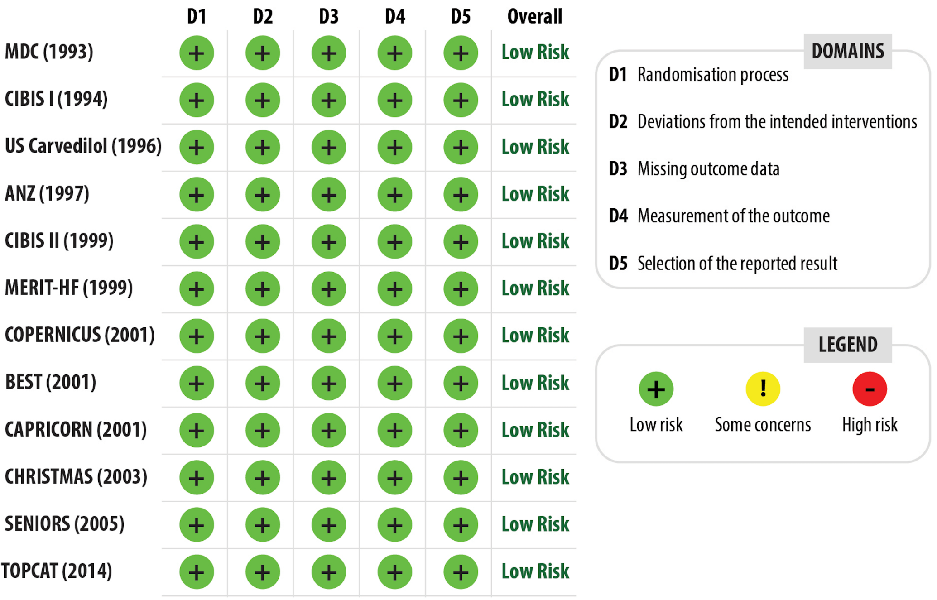
Supplementary Figure S2: Risk of Bias Assessment

ANZ=Australia/New Zealand Heart Failure Study; BEST=Beta-Blocker Evaluation Survival Trial; CAPRICORN=Carvedilol Post-Infarct Survival Control in Left Ventricular Dysfunction Study; CHRISTMAS=Carvedilol Hibernating Reversible Ischaemia Trial: Marker of Success Study; CIBIS I=Cardiac Insufficiency Bisoprolol Study; CIBIS II=Cardiac Insufficiency Bisoprolol Study II;
COPERNICUS=Carvedilol Prospective Randomised Cumulative Survival Study; MDC=Metoprolol in Dilated Cardiomyopathy Trial; MERIT-HF=Metoprolol CR/XL Randomised Intervention Trial in Congestive Heart Failure; SENIORS=Study of the Effects of Nebivolol Intervention in Outcomes and Rehospitalisation in Seniors with Heart Failure Study; TOPCAT=Treatment of Preserved Cardiac Function Heart Failure with an Aldosterone Antagonist;

