Supplemental Figure 1. ROC curve for LGE extent
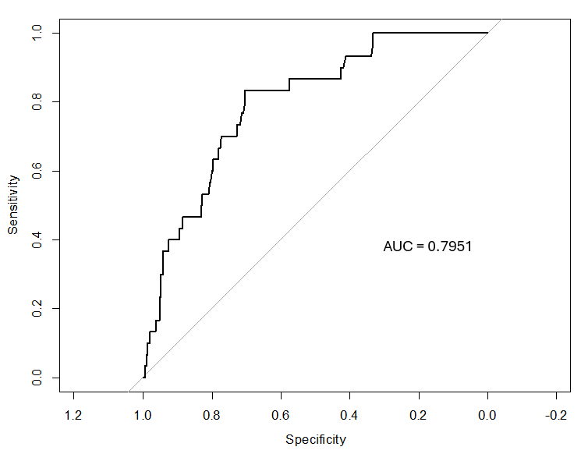
Receiver operating characteristics (ROC) curve analysis for the classification of arrhythmic events by LGE extent.

Supplemental Figure 2. Kaplan-Meier curves showing survival free from the arrhythmic endpoint in the subgroup of patients with no ventricular arrhythmias at presentation
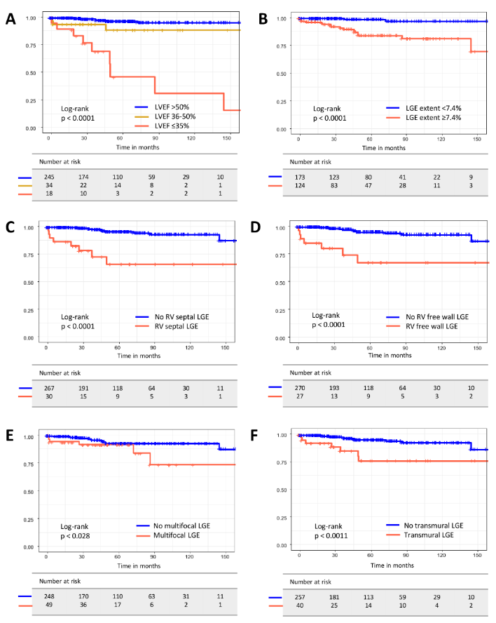
Kaplan-Meier curves showing survival free from the arrhythmic endpoint (sustained VT, VF, appropriate ICD therapy) for patients with no ventricular arrhythmic events at presentation. patients stratified by A) LVEF; B) LGE extent; C) presence of LGE on the right side of the interventricular septum; D) presence of LGE in the right ventricular free wall; D) presence of multifocal LGE in the left ventricle; E) presence of transmural LGE in the left ventricle. ICD, implantable cardioverter defibrillator; LGE, late gadolinium enhancement; LVEF, left ventricular ejection fraction; RV, right ventricular; VF, ventricular fibrillation; VT, ventricular tachycardia.
Supplemental Figure 3. Proposed algorithm for arrhythmic risk stratification in patients with biopsy-proven sarcoidosis and no ventricular arrhythmic event at presentation*
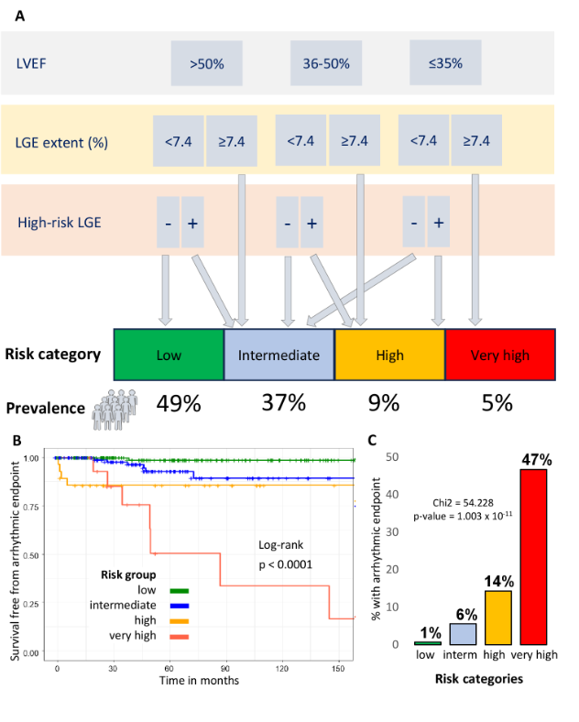
A) Proposed algorithm for arrhythmic risk stratification in patients with biopsy-proven sarcoidosis and no ventricular arrhythmias at presentation, based on LVEF, LGE extent (<7.4% or ≥7.4%), and high-risk LGE features (i.e., LGE on the right side of the septum, and/or LGE in the right ventricular free wall, and/or left ventricular multifocal LGE). B) Survival curves based on the proposed algorithm. C) Observed event rate based on the proposed risk group categories. LGE, late gadolinium enhancement; LVEF, left ventricular ejection fraction. *In the absence of significant coronary artery disease (i.e., previous percutaneous coronary intervention, coronary artery bypass graft, or known obstructive coronary artery disease), significant valvular artery disease (i.e., severe valvular stenosis or regurgitation or previous valve replacement or repair) or alternative diagnosis of cardiomyopathy.

