SUPPLEMENTARY DATA

Table S1. Distribution of all members among Heart Teams.
Figure S1. Distribution of core members and additional specialties among Heart teams. ACHD=adult congenital heart disease, HT=heart team, VAD=ventricular assist device.
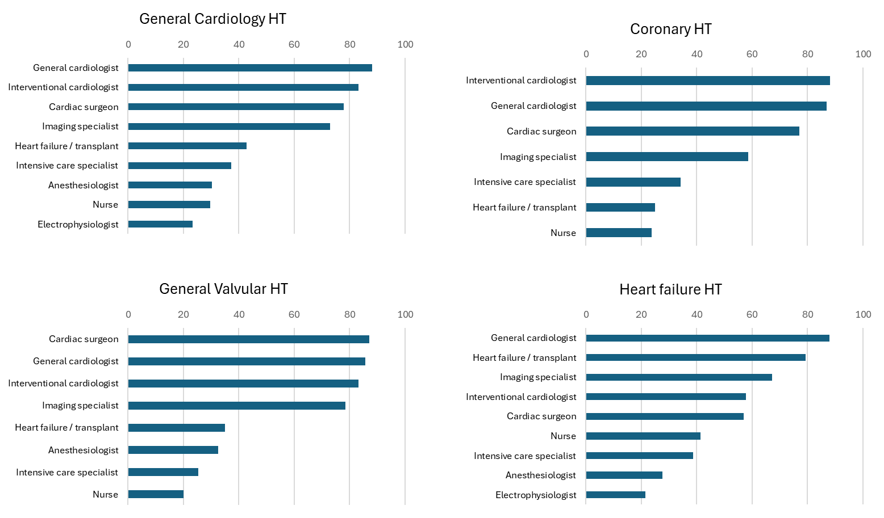
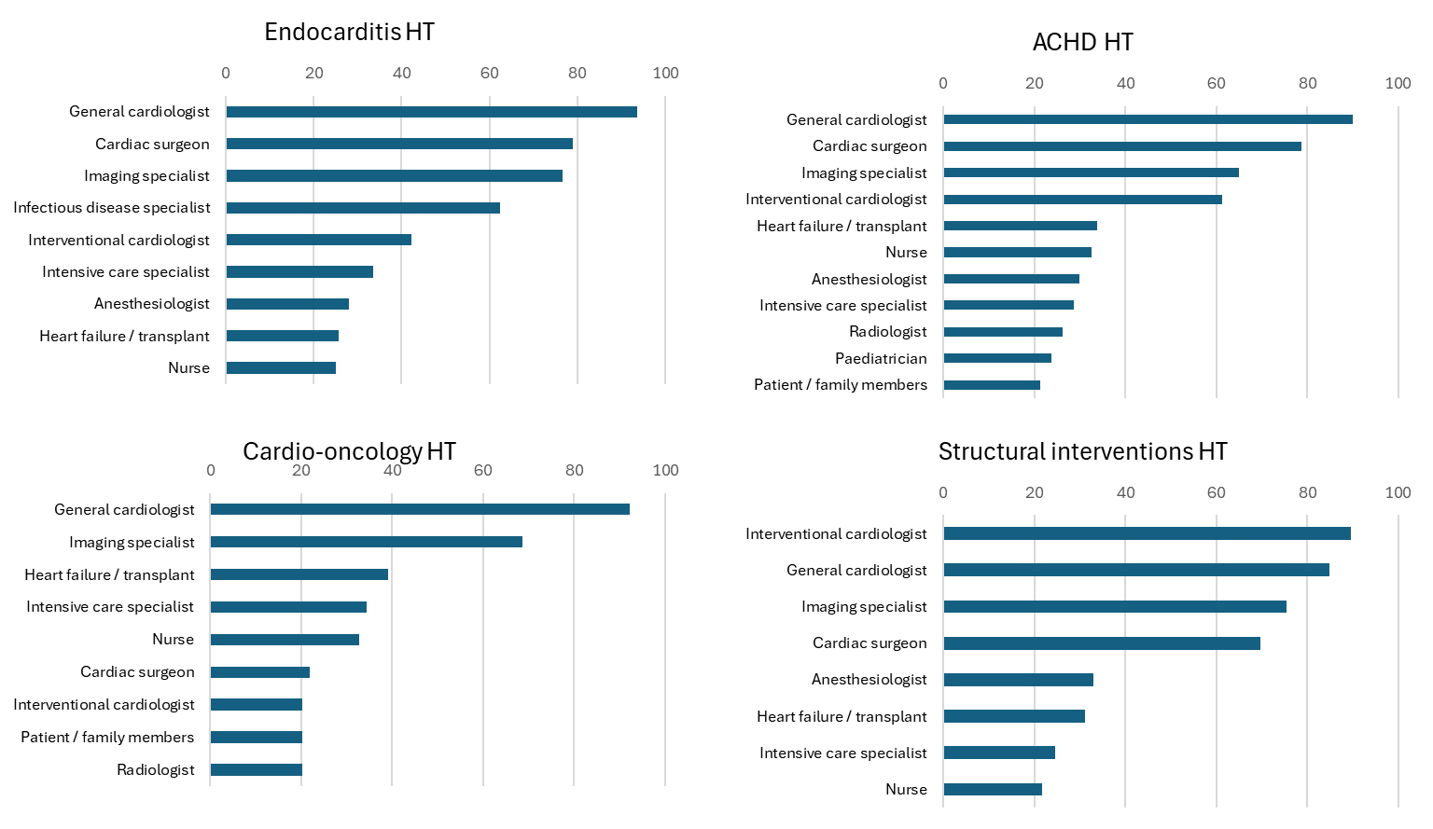

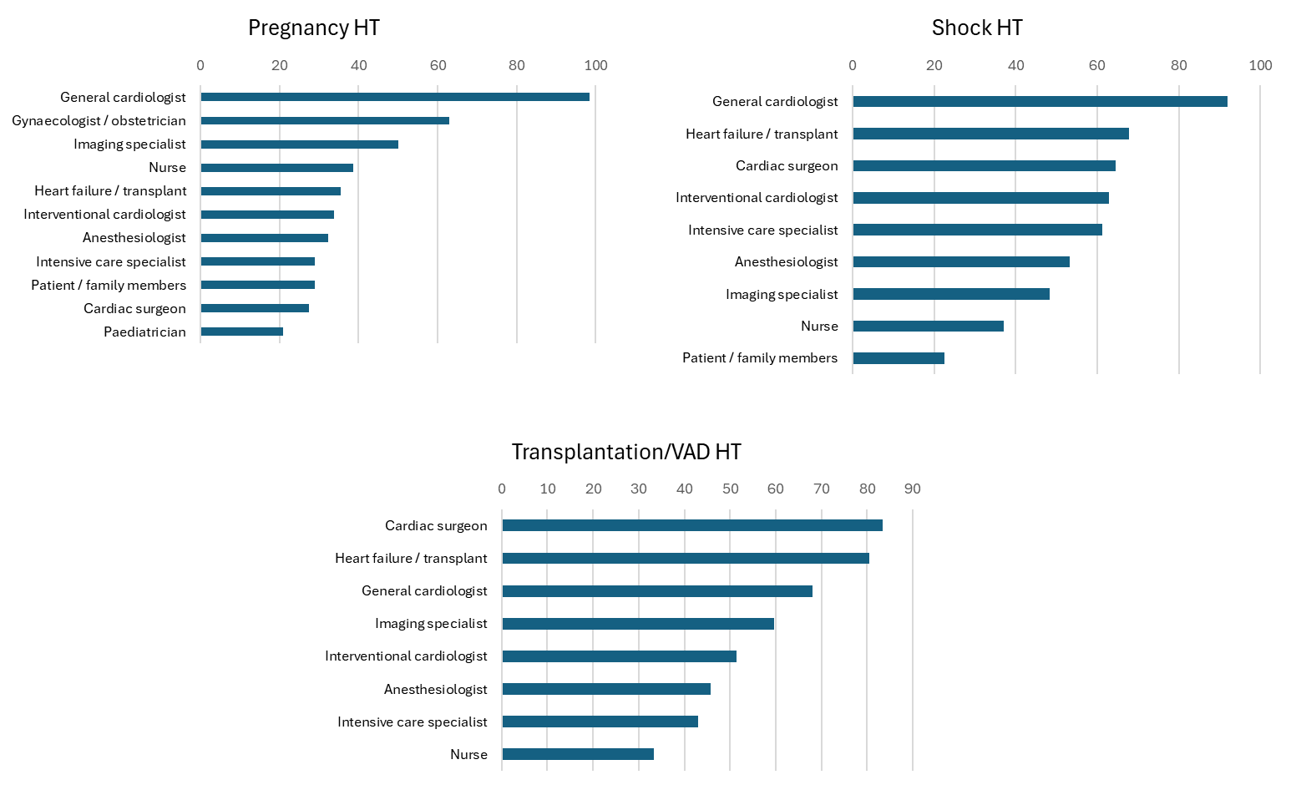

Table S2. The frequency of heart teams meetings.
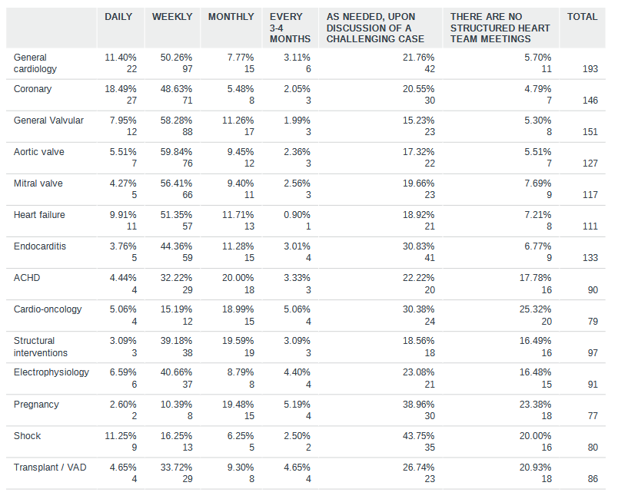

Figure S2. Topics discussed within Heart Teams, shown as a percentage of multiple-choice question. ACHD=adult congenital heart disease, VAD=ventricular assist device.

