Supplementary material

Year | Crude mortality rates of GPA/MPA (Deaths per 10,000,000(95% CI))
Year | GPA | MPA | Total
2011 | 9.78 (8.97, 10.6) | 0.81 (0.57, 1.06) | 10.48 (9.65, 11.32)
2012 | 9.03 (8.27, 9.82) | 1.06 (0.78, 1.35) | 9.99 (9.18, 10.81)
2013 | 9.04 (8.27, 9.83) | 0.96 (0.7, 1.23) | 9.89 (9.08, 10.72)
2014 | 8.44 (7.7, 9.19) | 1.44 (1.12, 1.78) | 9.74 (8.95, 10.54)
2015 | 8.49 (7.75, 9.24) | 1.17 (0.89, 1.47) | 9.55 (8.78, 10.33)
2016 | 8.61 (7.88, 9.36) | 1.41 (1.11, 1.74) | 9.87 (9.09, 10.67)
2017 | 7.52 (6.84, 8.22) | 1.62 (1.29, 1.98) | 8.96 (8.22, 9.73)
2018 | 7.84 (7.15, 8.55) | 1.51 (1.19, 1.84) | 9.16 (8.40, 9.94)
2019 | 7.89 (7.15, 8.65) | 1.86 (1.48, 2.26) | 9.49 (8.67, 10.32)
2020 | 7.23 (6.54, 7.95) | 2.48 (2.04, 2.94) | 9.41 (8.60, 10.24)
2021 | 7.74 (7.0, 8.49) | 2.37 (1.95, 2.81) | 9.81 (8.98, 10.66)

Supplementary Table S1: Crude mortality rates of GPA and MPA over time. The table shows deaths per 10,000,000 with 95% confidence intervals.

Year | Age at death from GPA and MPA
Year | Lower quartile | Median quartile | Upper quartile
2011 | 60-64 | 70-74 | 80-84
2012 | 60-64 | 70-74 | 80-84
2013 | 60-64 | 70-74 | 80-84
2014 | 60-64 | 70-74 | 80-84
2015 | 60-64 | 70-74 | 80-84
2016 | 65-69 | 75-79 | 80-84
2017 | 65-69 | 75-79 | 80-84
2018 | 65-69 | 75-79 | 80-84
2019 | 65-69 | 75-79 | 80-84
2020 | 65-69 | 75-79 | 80-84
2021 | 65-69 | 75-79 | 80-84

Supplementary Table S2: Distribution of age at death from GPA and MPA by year (2011–2021). The table shows the lower quartile, median, and upper quartile age ranges at death for each year.
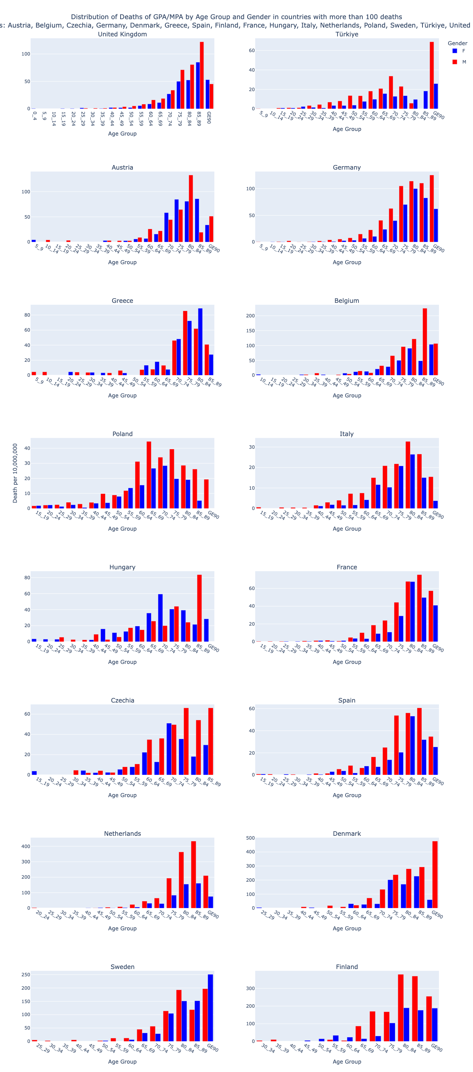

Supplementary Figure S1: Pooled mortality rates for GPA/MPA by age and gender in European countries with more than 100 deaths (2011 – 2021). Note that the axis scales vary between different countries.

