Supplement 1: Interval from maternal infection to birth (days)
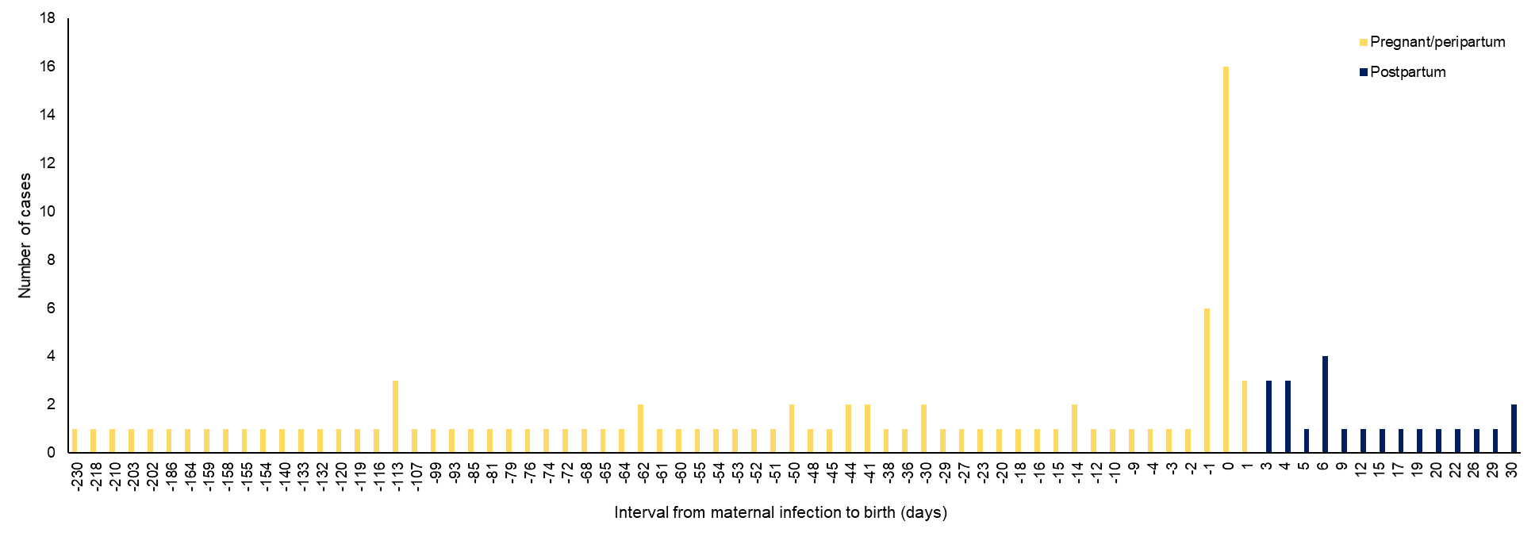

Supplement 2: Serotype distribution of IPD cases by pregnancy status
Serotype | Pregnant  n (%) | Postpartum  n (%) | Non-pregnant  n (%) | Total  n (%)
8 | 38 (30.9%) | 8 (23.5%) | 436 (30.7%) | 482 (30.5%)
12F | 31 (25.2%) | 7 (20.6%) | 275 (19.4%) | 313 (19.8%)
3 | 9 (7.3%) | 7 (20.6%) | 87 (6.1%) | 103 (6.5%)
9N | 4 (3.3%) | 1 (2.9%) | 80 (5.6%) | 85 (5.4%)
22F | 5 (4.1%) | 1 (2.9%) | 68 (4.8%) | 74 (4.7%)
19A | 8 (6.5%) | 1 (2.9%) | 63 (4.4%) | 72 (4.6%)
10A | 2 (1.6%) | 1 (2.9%) | 44 (3.1%) | 47 (3.0%)
7F | 4 (3.3%) | 0 (0.0%) | 37 (2.6%) | 41 (2.6%)
33F | 3 (2.4%) | 1 (2.9%) | 34 (2.4%) | 38 (2.4%)
15A | 2 (1.6%) | 1 (2.9%) | 33 (2.3%) | 36 (2.3%)
23A | 4 (3.3%) | 0 (0.0%) | 25 (1.8%) | 29 (1.8%)
11A | 3 (2.4%) | 0 (0.0%) | 25 (1.8%) | 28 (1.8%)
23B | 1 (0.8%) | 1 (2.9%) | 21 (1.5%) | 23 (1.5%)
24F | 1 (0.8%) | 1 (2.9%) | 17 (1.2%) | 19 (1.2%)
20 | 0 (0.0%) | 0 (0.0%) | 17 (1.2%) | 17 (1.1%)
1 | 0 (0.0%) | 0 (0.0%) | 15 (1.1%) | 15 (1.0%)
16F | 1 (0.8%) | 1 (2.9%) | 13 (0.9%) | 15 (1.0%)
35F | 2 (1.6%) | 0 (0.0%) | 11 (0.8%) | 13 (0.8%)
19F | 0 (0.0%) | 0 (0.0%) | 13 (0.9%) | 13 (0.8%)
15B/C | 1 (0.8%) | 1 (2.9%) | 11 (0.8%) | 13 (0.8%)
Other | 4 (3.3%) | 2 (5.9%) | 96 (6.8%) | 102 (6.5%)

