- Supplementary Information
This Supplementary Information provides technical and methodological detail supporting AI concepts referenced in the main text.

  - Cross Specialty AI Functions: Technical Overview

Accurate real-time delineation of tumour boundaries is a central technical objective of AI in FgS. CNNs which learn hierarchical spatial and intensity features from labelled fluorescence images, have emerged as the dominant approach for this task. Using supervised learning, CNNs are trained on annotated datasets in which each pixel is labelled as tumour or non-tumour, enabling near–real-time, pixel-wise segmentation of intraoperative fluorescence images and reducing reliance on qualitative visual interpretation (89). Among commonly used architectures, U-Net is well suited to biomedical image segmentation due to its encoder–decoder design, which captures contextual information through convolution and pooling and restores spatial resolution via up-convolutions (See Fig S1) (16). Mask R-CNN extends this framework by integrating a region proposal network with parallel mask prediction, enabling simultaneous object detection and high-fidelity instance-level segmentation through mechanisms such as RoIAlign, which is particularly advantageous in complex intraoperative imaging environments (104).

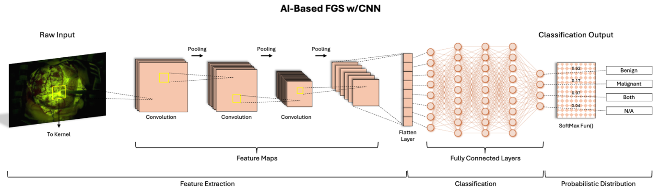
Figure S1. Schematic of a CNN-based Fg surgery framework, where raw fluorescence images undergo pixel-wise segmentation and hierarchical feature extraction to generate probabilistic tissue classifications (benign, malignant, both, or N/A).

  - Standardisation, Decision Support, and Multimodal Integration
AI enables quantitative interpretation of FI by correcting hyperspectral artefacts and improving tissue and margin classification, reducing subjectivity in intraoperative assessment (22,23). Although routine multimodal integration with iMRI, CT, or ultrasound is not yet established, AI-based registration methods demonstrate technical feasibility for aligning fluorescence with anatomical imaging, particularly in neurosurgical applications (105). Similar exploratory workflows combining near-infrared fluorescence with intraoperative CT or ultrasound are emerging in Thoracic and gynaecological surgery, supporting the potential for future multimodal Fg workflows (55,69,89). AI-driven intraoperative FI uses deep learning, particularly CNNs, to perform pixel-level tumour segmentation by learning spatial and intensity patterns from annotated datasets, enabling more objective margin delineation than visual interpretation alone (22,89). Outputs can be presented as intuitive probability overlays to support intraoperative decisions regarding additional resection, while uncertainty-aware approaches, such as Bayesian inference, can highlight regions of lower confidence that warrant closer surgeon review (16,106).
Table S1. Methodological quality assessment of outcome-critical clinical and translational studies.
Publication | Cancer type | Study design | Data size (patient number (nP) or study (nS)) | Key methodological strengths | Key limitations / risk of bias
Lacroix (2001)  (1) | Glioblastoma | Retrospective cohort | nP= 416 | Large cohort; multivariate analysis linking EOR to survival | Retrospective; historical cohort; selection bias
Brown (2016)  (2) | Glioblastoma | Systematic review & meta-analysis | nS = 37 | Large, pooled population; consistent survival signal for EOR | Substantial inter-study heterogeneity; predominance of retrospective cohorts; confounding by indication.
Chaichana (2014)  (3) | Glioblastoma | Retrospective cohort | nP = 259 | Quantitative EOR thresholds; survival and recurrence outcomes | Single-centre; retrospective; potential treatment and referral bias
Eljamel (2015)  (9) | Glioblastoma | Meta-analysis | nS= 20 | Synthesises effect of 5-ALA–guided surgery on GTR rates and time to progression | Substantial inter-study heterogeneity; predominantly non-randomised cohorts; variable outcome definitions
Esteves (2015)  (102) | High-grade glioma | Health-economic analysis | nS = 2 | Model-based cost-effectiveness analysis integrating clinical outcome inputs | Model-based assumptions; indirect survival estimates
Ewelt (2011)  (4) | Glioblastoma (elderly) | Retrospective cohort | nP= 103 | Focus on under-studied elderly population | Age-restricted cohort; retrospective; treatment-selection bias
Grabowski (2014)  (7) | Glioblastoma | Retrospective cohort | nP = 128 | Residual tumour volume quantified; radiological correlation | Retrospective; imaging-dependent volumetric measurements; no randomisation”
Hansen (2020)  (88) | High-grade glioma | Retrospective cohort | nP= 209 | Retrospective comparison of 5-ALA and fluorescein–guided resection | Single-centre; non-randomised
Li YM (2016)  (6) | Glioblastoma | Retrospective cohort | nP= 1229 | Very large cohort; multivariable survival analysis | Retrospective design; institutional practice effects
Picart (2024)  (14) | Glioblastoma | Randomised controlled trial | nP= 171 | Multicentre RCT; contemporary comparator | Single-blinded; surgeon unblinded; inter-centre variability
Pichlmeier (2008)  (5) | Glioblastoma | Secondary analysis of RCT | nP = 243 | Based on phase III trial data; secondary survival analysis | Post-hoc analysis
Sanai (2011)  (19) | Glioblastoma | Retrospective cohort | nP= 500 | Defines EOR thresholds and continuous survival association | Retrospective; imaging-based EOR
Schatlo (2015)  (13) | High-grade glioma | Retrospective cohort | nP= 200 | Evaluates combined iMRI + 5-ALA | Confounding from multimodal intervention
Schebesch (2022)  (15) | High-grade glioma | Retrospective cohort | nP= 347 | Large real-world fluorescein-guided cohort with volumetric MRI analysis | Retrospective; single-centre; non-randomised
Stummer (2006)  (12) | Glioblastoma | Randomised controlled trial | nP= 322 | Landmark phase III trial; MRI-defined objective EOR endpoint | Non-blinded surgeons; pre-temozolomide era
Baig-Mirza (2021)  (10) | Glioblastoma | Retrospective cohort | nP= 343 | Survival comparison between 5-ALA–guided and white-light resection | Retrospective; historical controls
Xiao (2024)  (16) | High-grade glioma | Retrospective cohort | nP= 67 | Focus on eloquent and deep-seated tumours | Small sample; retrospective; single-centre
Suero-Molina (2025)  (26) | Glioma | Retrospective ML cohort | nP= 163 | MRI deep-learning prediction of intraoperative fluorescence | Retrospective; indirect (non-clinical) endpoints
Shen (2021)  (21) | Glioblastoma | Prospective intraoperative ML feasibility study | nP= 23 | Real-time CNN applied to NIR-II fluorescence for intraoperative tissue classification | Specimen-level analysis; indirect surgical endpoints; no EOR or survival outcomes
Fan (2024)  (51) | Endometrial cancer | Systematic review & meta-analysis | nS= 62 | Pooled FNR and risk factors (injection site, tracer type, ultrastaging) | Heterogeneity; protocol variability; mostly observational
Uccella (2019)  (49) | Ovarian cancer | Prospective multicentre study | nP = 31 | Prospective design; multicentre feasibility data | Learning-curve effects; limited long-term outcomes
Quan et al. (2020)  (75) | Lung cancer | Diagnostic translational study (preclinical + pilot human) | nP= 6 | Negative-contrast intraoperative tumour margin visualisation using inhaled ICG (NIR) | Very small human cohort; largely preclinical; margin contrast not validated against oncologic outcomes
Mao (2017) (73) | Lung cancer | Prospective feasibility study | nP= 36 | Real-time NIR fluorescence detection of small / sub-centimetre pulmonary nodules using intravenous ICG | Small cohort; single-centre; localisation not oncologic margin validation
Li et al. (2021) (74) | Pulmonary nodules (≤2 cm) | Retrospective localisation cohort | nP = 471 | CT-guided percutaneous ICG injection enabling high-success intraoperative localisation for VATS | Retrospective; nodule-based analysis; preoperative localisation only (not margin assessment)
Predina (2018) (77) | Lung cancer | Phase I first-in-human trial | nP = 20 | Tumour-targeted intraoperative near-infrared fluorescence imaging using folate-receptor targeting | Safety and feasibility only; not powered for oncologic or margin outcomes
Neijenhuis (2022) (69) | Lung cancer | Systematic review | nS = 22 | Comprehensive synthesis of intraoperative near-infrared (NIR) tumour imaging techniques and tracers | Substantial imaging heterogeneity; wide variability in tracers, timing, and outcome measures

