Supplemental methods

Contents page
Supplementary methods 2
Literature search 2
Supplemental Figures 3
Supplemental Tables 6

Detailed methods

Literature search
Database searched | Platform | Years of coverage | Records | Records after duplicates removed
Medline ALL | Ovid | 1946 - Present | 119 | 118
Embase | Embase.com | 1971 - Present | 279 | 161
Web of Science Core Collection* | Web of Knowledge | 1975 - Present | 172 | 35
Cochrane Central Register of Controlled Trials | Wiley | 1992 - Present | 3 | 0
Total |  |  | 573 | 314
*Science Citation Index Expanded (1975-present) ; Social Sciences Citation Index (1975-present) ; Arts & Humanities Citation Index (1975-present) ; Conference Proceedings Citation Index- Science (1990-present) ; Conference Proceedings Citation Index- Social Science & Humanities (1990-present) ; Emerging Sources Citation Index (2005-present)

Medline Ovid
(exp Cardiomyopathies/ OR (cardiomyopath* OR noncompact* OR non-compact* OR LVNC OR Kearns-Sayre* OR barth-syndrom* OR heart-amyloidos* OR right-ventric*-dysplas* OR takotsubo OR tako-tsubo).ab,ti,kf.) AND (rbm20 gene/ OR ribonucleic acid binding motif protein 20, human.nm. OR (rbm20 OR ((RNA-binding-motif* OR rbm OR ribonucleic-acid-binding-motif*) ADJ3 (20))).ab,ti,kf.)
Embase.com
('cardiomyopathy'/exp OR (cardiomyopath* OR noncompact* OR non-compact* OR LVNC OR Kearns-Sayre* OR barth-syndrom* OR heart-amyloidos* OR right-ventric*-dysplas* OR takotsubo OR tako-tsubo):ab,ti,kw) AND ('rbm20 gene'/de OR 'rna binding motif protein 20'/de OR 'rbm20 protein'/de OR (rbm20 OR ((RNA-binding-motif* OR rbm) NEAR/3 (20))):ab,ti,kw)
Web of Science
TS=(((cardiomyopath* OR noncompact* OR non-compact* OR LVNC OR Kearns-Sayre* OR barth-syndrom* OR heart-amyloidos* OR right-ventric*-dysplas* OR takotsubo OR tako-tsubo)) AND ((rbm20 OR ((RNA-binding-motif* OR rbm) NEAR/2 (20)))))
Cochrane Central
((cardiomyopath* OR noncompact* OR non NEXT compact* OR LVNC OR Kearns NEXT Sayre* OR barth NEXT syndrom* OR heart NEXT amyloidos* OR right NEXT ventric* NEXT dysplas* OR takotsubo OR tako NEXT tsubo):ab,ti,kw) AND ((rbm20 OR ((RNA NEXT binding NEXT motif* OR rbm) NEAR/3 (20))):ab,ti,kw)

Supplemental Figures

Figure S1. Flowchart of literature review screening

Figure S2a, b,c,d. Post-HTx, explanted native heart tissues of two patients were available for histopathological analyses and were compared to the available imaging. Both patients had the 1900C>T variant. Tissue of one patient showed minor hypertrophic changes in the myocardium of the LV, with focal (especially anterior) vacuolization of cardiomyocytes, along with mild subendocardial replacement fibrosis and interstitial fibrosis. There was also minimal chronic inflammation observed in some areas. No convincing disarray was noted. CMR of this patient showed mid-myocardial LGE was present in the septum, along with hingepoint LGE. Additionally, there is visible pericardial effusion up to 1.5cm at the lateral wall. The other patient’s tissue showed comparable characteristics, but without inflammation and with more fibrosis.
a.
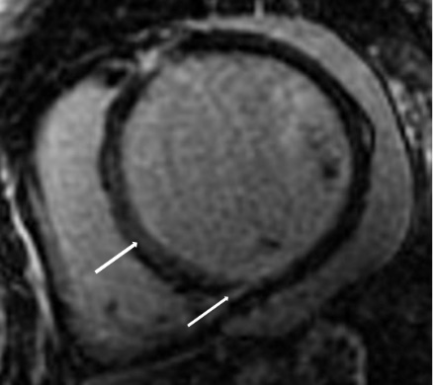

b.
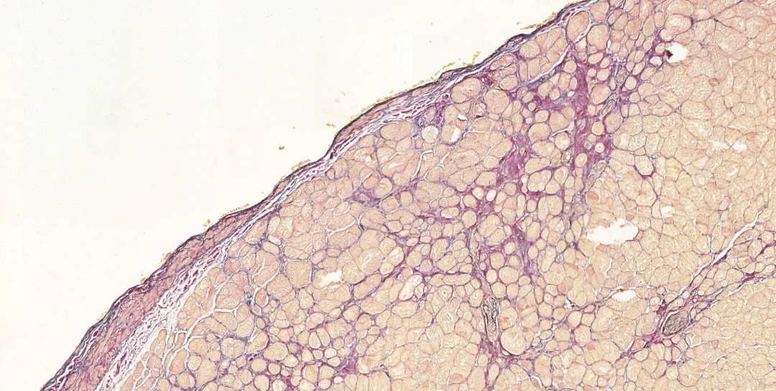

c.
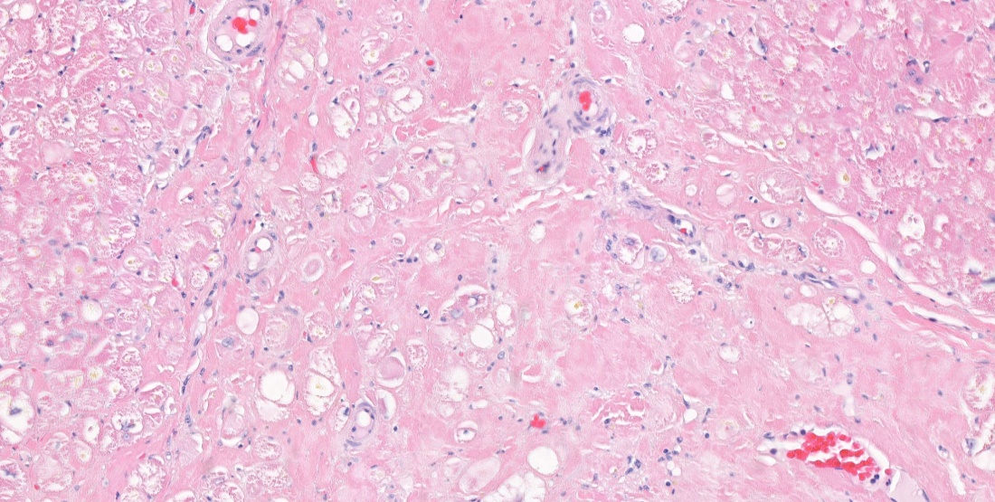

d.
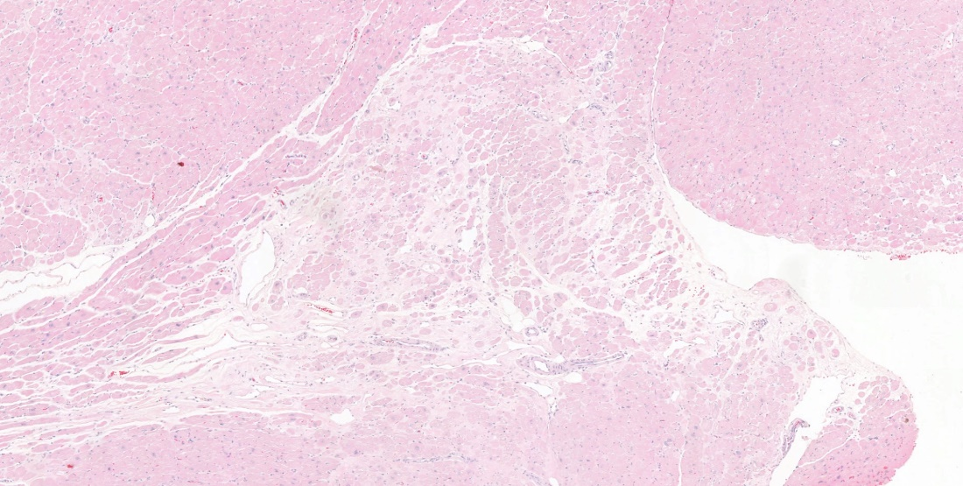

Figure S3a.Kaplan-Meyer curve for the for event-free survival for composite endpoint in RBM20 patients.
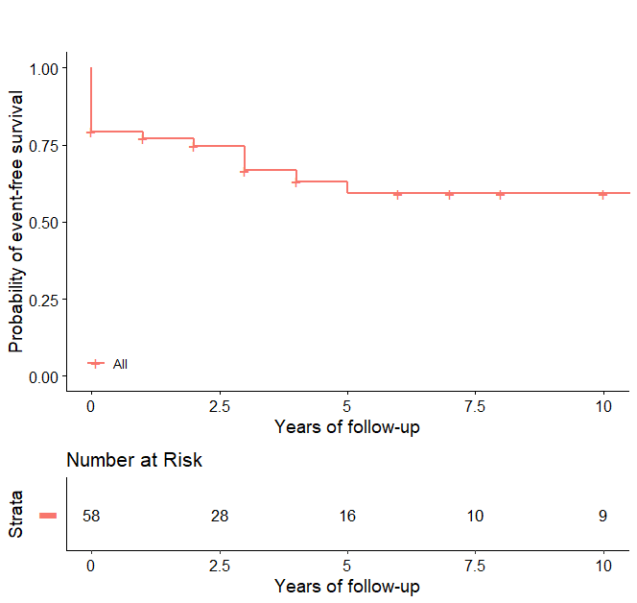

Figure S3b. Cumulative incidence for VA in RBM20 males and females.

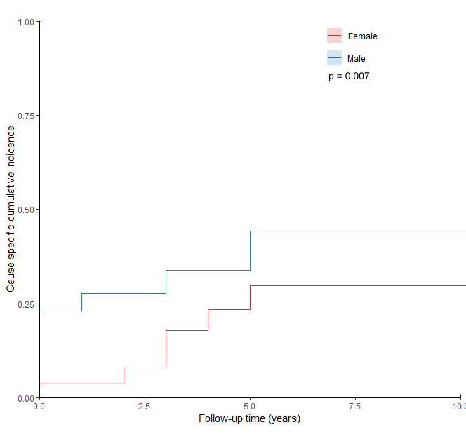

Figure S3c. Cumulative incidence for end-stage HF in RBM20 males and females.
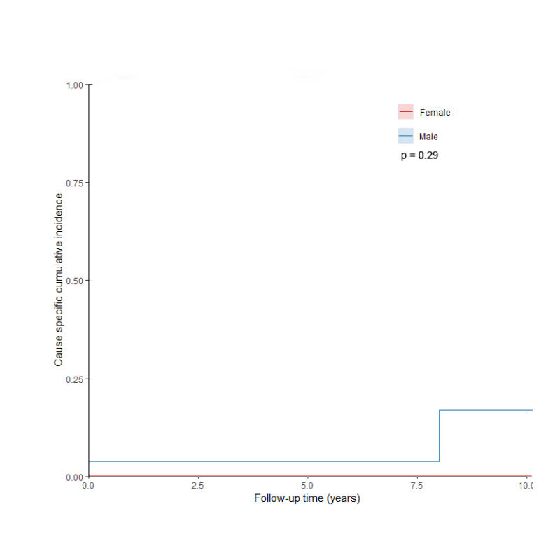
Figure S3d. Cumulative incidence for VA in RBM20 vs. DCM controls.
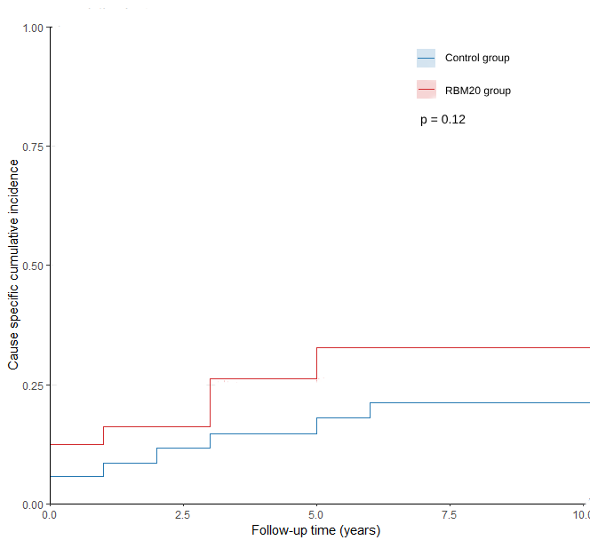

Figure S3e. Cumulative incidence for end-stage HF in RBM20 vs. DCM controls.
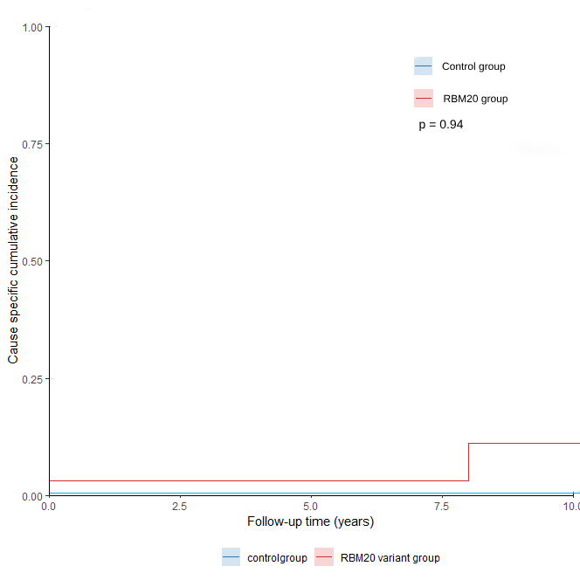

Supplemental Tables

Table S1a. Baseline characteristics of RBM20 patients with no truncated variant compared to RBM20 patients with a truncated variant.

Characteristics | Non-truncated (n=49) | Truncated (n=14)
Demographics
Age at presentation, years | 40 ± 15 | 48 ± 14
Male | 19/49 (39) | 10/14 (71)
Ethnicity,
Caucasian | 24/26 (92) | 8/10(80)
African | 0/26 (0) | 2/10 (20)
Asian | 0/26 (0) | 0/10 (0)
Other | 2/26 (8) | 0/10 (0)
Comorbidities,
Hypertension | 8/44 (18) | 5/14 (36)
Diabetes | 3/26 (12) | 1/12 (8)
Hypercholesterolemia | 2/26 (8) | 2/12 (17)
Cancer | 3/25 (12) | 0/12 (0)
Stroke | 2/26 (8) | 1/12 (8)
Coronary artery disease | 3/26 (12) | 0/12 (0)
Family history
CMP or HF | 42/48 (88) | 6/10 (60)
SCA and / or VA | 27/45 (60) | 1/12 (8)
Genetic testing | 17/28 (61) | 4/12 (33)
Primary presentation
Heart failure | 14/49 (29) | 5/14 (36)
VA/ syncope | 11/49 (22) | 4/14 (29)
Chest pain/palpitations | 6/49 (12) | 1/14 (7)
Asymptomatic/screening | 18/49 (37) | 4/14 (29)
Physical Examination
Height, m | 173 ± 12 | 177 ± 3
Weight, kg | 80 ± 19 | 86 ± 16
Heart rate, bpm | 67 (57- 79) | 63 (55-71)
Systolic BP, mmHg | 126 ± 17 | 128 ± 13
Diastolic BP, mmHg | 75 ± 11 | 79 ± 9
Electrocardiography
Sinus rhythm | 24/46 (52) | 8/11 (73)
AF/atrial flutter rhythm | 20/46 (43) | 3/11 (27)
Paced rhythm | 2/46 (4) | 0/11 (0)

Characteristics | Non-truncated (n=49) | Truncated (n=14)
PQ, ms (mean ±SD) | 146 ± 24 | 160 ± 36
QRS, ms (mean ±SD) | 107 ± 22 | 116 ± 23
QTc, ms (mean±SD) | 409 ± 38 | 416 ± 37
Bundle branch block | 6/24 (25) | 2/9 (22)
2nd AV block | 2/25 (8) | 1/8 (13)
Echocardiography
LA diameter, mm | 37 ± 8 | 41 ± 7
LVED diameter, mm | 58 ±10 | 62 ± 8
LVES diameter, mm | 46 ±17 | 46 ± 15
IVS diameter, mm | 8 (7- 9) | 8 (8-10)
PWT diameter, mm | 7 (6–8) | 8 (8-10)
LVEF, % | 39 ± 13 | 44 ± 15
TAPSE diameter, mm | 27 ± 31 | 25 ± 4
Severe valve disease | 3/23 (13) | 0/9 (0)
MRI
LVEF | 40 (25-52) | 45 (36-51)
RVEF | 54 (49-56) | 49 (36-51)
Delayed enhancement | 12/27 (44) | 4/10 (40)
Medication, n (%)
Anticoagulants | 12/25 (48) | 3/11 (27)
Antiplatelet | 4/26 (16) | 0/10 (0)
Beta-receptor antagonist | 34/45 (76) | 8/13 (62)
RAAS inhibitor | 27/45 (60) | 9/14 (64)
MRA | 13/45 (29) | 6/14 (43)
Diuretics | 14/45 (31) | 3/14 (21)
Digoxin | 2/45 (3) | 0/14 (0)
Amiodarone | 3/43 (7) | 1/13 (8)
Calcium channel blockers | 4/42 (10) | 0/14 (0)
Cardiomyopathy, n (%)
DCM | 48/49 (98) | 12//14 (93)
NCCM | 1/49 (2) | 1/14 (7)
Proband | 27/49 (55) | 12/14 (86)
* Continuous variables are summarised by mean ± SD or median (IQR), categorical variables are described as: n (%). AV block= atrioventricular; BP= blood pressure; CMP= cardiomyopathy; CMR=cardiovascular magnetic resonance; DCM; dilated cardiomyopathy; HF = heart failure; IVS: interventricular septal; LA= Left atrium; LVED= left ventricular end diastolic; LVEF= left ventricular ejection fraction; LVES= left ventricular end systolic; MRA; mineralocorticoid receptor antagonist; NCCM= noncompaction cardiomyopathy; PWT= posterior wall thickness; RAAS= renin-angiotensin-aldosterone system; RVEF= right ventricular ejection fraction; SCA = sudden cardiac arrest; TAPSE= tricuspid annular plane systolic excursion; VA= malignant ventricular arrhythmia; VT: ventricular tachycardia.

Table S1b. Clinical outcomes of RBM20 patients with no truncated variant compared to RBM20 patients with a truncated variant.
Characteristics | Non-truncated (n=49) | Truncated(n=14)
Follow-up, years | 6.0 [3.0-11.0] | 1.5 [1.0-4.0]
Devices, n (%)
CRT | 6/44 (14) | 0/10 (0)
ICD | 14/44 (32) | 4/10 (40)
Primary prevention | 13/14 (93) | 1/4 (25)
Secondary prevention | 1/14 (7) | 3/4 (75)
Outcome, n (%)
Invasive EP | 2/22 (9) | 1/9 (11)
Age first VA | 45 ± 14 | 44 ± 18
Age of onset heart failure | 45 ± 14 | 62 ± 9
ICD appropriate therapy | 6/14 (43) | 2/7 (29)
ICD inappropriate therapy | 3/14 (21) | 1/7 (14)
Heart transplant | 6/39 (15) | 1/13 (8)
Cardiovascular death | 1/39 (3) | 0/13 (0)
Composite arrhythmia* | 13/48 (27) | 6/13 (46)
End-stage heart failure* | 7/41 (17) | 1/14 (7)
Composite endpoint* | 15/47 (32) | 6/14 (43)
Continuous variables are summarised by mean ± SD or median (IQR); categorical variables are described as n (%). CRT = cardiac resynchronization therapy; EP = electrophysiology; ICD = implantable cardioverter-defibrillator; VA = malignant ventricular arrhythmia. *Lifetime outcome.

Table S2a. Baseline characteristics of RBM20 patients compared to age/sex/left ventricular dysfunction matched dilated cardiomyopathy patients without genetic variants.
Characteristics | RBM20 (n=35) | Control  (n=35) | P value
Demographics
Age at presentation, years | 45 ± 15 | 45 ± 15 | 0.94
Male | 18 (51) | 18 (51) | 1.00
Ethnicity, |  |  | 0.11
Caucasian | 17 (85) | 34 (97)
African | 2 (10) | 0 (0)
Asian | 0 (0) | 1 (3)
Other | 1 (5) | 0 (0)
Comorbidities,
Hypertension | 8 (86) | 4 (11) | 0.19
Diabetes | 3 (14) | 3 (9) | 0.67
Hypercholesterolemia | 2 (9) | 2 (6) | 0.64
Cancer | 1 (5) | 1 (3) | 1.00
Stroke | 2 (9) | 1 (3) | 0.55
Coronary artery disease | 0 (0) | 3 (9) | 0.28
Family history
CMP or HF | 24 (77) | 10 (36) | 0.001
SCA and / or VA | 13 (42) | 6 (21) | 0.01
Genetic testing | 9 (41) | 1 (3) | <0.001
Primary presentation |  |  | 0.04
Heart failure | 11 (31) | 15 (43)
VA/ syncope | 11 (31) | 5 (14)
Chest pain/palpitations | 1 (3) | 7 (20)
Asymptomatic/screening | 12 (34) | 8 (23)
Physical Examination
Height, m | 175 ± 8 | 176 ± 12 | 0.11
Weight, kg | 83 ± 17 | 83 ± 19 | 0.22
Heart rate, bpm | 65 (60 - 77) | 64 (60-75) | 0.74
Systolic BP, mmHg | 120 ± 15 | 115 ± 14 | 0.54
Diastolic BP, mmHg | 74 ± 10 | 72 ± 10 | 0.86
Electrocardiography
Sinus rhythm | 19 (54) | 15 (43) | 1.00
AF/atrial flutter rhythm | 14 (40) | 4 (11) | <0.001
Paced rhythm | 2 (6) | 15 (43) | 0.004
PQ, ms (mean ±SD) | 152± 25 | 175 ± 43 | 0.14
QRS, ms (mean ±SD) | 111 ± 24 | 134 ± 31 | 0.002
QTc, ms (mean±SD) | 415 ± 42 | 426 ± 63 | 0.41
Bundle branch block | 5 (26) | 9 (26) | 0.30
2nd degree AV block | 2 (12) | 3 (9) | 0.39
Characteristics | RBM20 (n=35) | Controls  (n=35) | P value
Echocardiography
LA diameter, mm | 39 ± 7 | 40 ± 8 | 0.80
LVED diameter, mm | 61 ± 9 | 60 ± 10 | 0.06
LVES diameter, mm | 50± 17 | 53 ± 15 | 0.99
IVS diameter, mm | 8 (7- 9) | 8 (7-10) | 0.77
PWT diameter, mm | 8 (6 - 8) | 8 (7-10) | 0.11
LVEF, % | 36 ± 13 | 35 ± 12 | 1.00
LV dysfunction | 21 (60) | 21 (60) | 1.00
TAPSE diameter, mm | 31 ± 36 | 27 ± 42 | 0.88
Valve stenosis/insufficiency | 2 (10) | 6 (19) | 1.00
CMR, n (%) | 22 (63) | 9 (26)
LVEF | 36 (25 - 50) | 28 (17-42) | 0.08
RVEF | 53 (48 - 57) | 52 (35-55) | 0.21
Delayed enhancement | 9 (43) | 2 (40) | 1.00
Medication, n (%)
Anticoagulants | 10 (55) | 11 (31) | 0.29
Antiplatelet | 3 (14) | 4 (12) | 1.00
Beta-receptor antagonist | 26 (74) | 31 (89) | 0.10
RAAS inhibitor | 25 (71) | 30 (86) | 0.13
MRA | 12 (34) | 19 (56) | 0.07
Diuretics | 10 (29) | 23 (66) | 0.002
Digoxin | 1 (3) | 15 (43) | <0.001
Amiodarone | 3 (9) | 6 (18) | 0.48
Calcium channel blockers | 2 (6) | 2 (6) | 1.00
Cardiomyopathy, n (%)
DCM | 35 (100) | 35 (100) | 1.00
NCCM | 0 (0) | 0 (0) | 1.00
Proband | 22 (63) | 0 (0) | NA
* Continuous variables are summarised by mean ± SD or median (IQR), categorical variables are described as: n (%). AV block= atrioventricular; BP= blood pressure; CMP= cardiomyopathy; DCM; dilated cardiomyopathy; HF = heart failure; IVS: interventricular septal; LA= Left atrium; LVED= left ventricular end diastolic; LVEF= left ventricular ejection fraction; LVES= left ventricular end systolic; MRA; mineralocorticoid receptor antagonist; NCCM= noncompaction cardiomyopathy; PWT= posterior wall thickness; RAAS= renin-angiotensin-aldosterone system; RVEF= right ventricular ejection fraction; SCA = sudden cardiac arrest; TAPSE= tricuspid annular plane systolic excursion; VA= malignant ventricular arrhythmia; VT: ventricular tachycardia.

Table S2b. Clinical outcomes of RBM20 patients compared to age/sex/left ventricular dysfunction matched dilated cardiomyopathy patients without genetic variants.
Characteristics | RBM20 (n=35) | Control (n=35) | P value
Follow-up, years | 3.0 [1.0-10.8] | 13.0 [7.0-17.0] | 0.001
Devices, n (%)
CRT | 3 (9) | 8 (23) | <0.001
ICD | 12 (34) | 12 (34) | 1.00
- Primary prevention | 9 (82) | 7(58) | 0.63
- Secondary prevention | 2 (18) | 5 (42) | 0.26
Outcome, n (%)
Age first VA | 47± 17 | 56 ± 11 | 0.57
Age of onset heart failure | 47 ± 16 | 45 ±15 | 0.98
ICD appropriate therapy | 6 (29) | 6 (25) | 0.79
ICD inappropriate therapy | 2 (10) | 1 (4) | 0.59
Composite arrhythmia* | 12 (34) | 9 (26) | 0.43
Composite endpoint* | 13 (37) | 12 (34) | 1.00
End-stage heart failure* | 5 (14) | 7 (20) | 0.60
LVAD | 0 (0) | 1 (3) | 1.00
Heart transplant | 4 (13) | 3 (9) | 0.70
Cardiovascular death | 1 (6) | 4 (11) | 0.45
Continuous variables are summarised by mean ± SD or median (IQR), categorical variables are described as: n (%). CRT= cardiac resynchronization therapy; EP= electrophysiology; ICD= implantable cardioverter-defibrillator; LVAD= left ventricular assistant device; VA= malignant ventricular arrhythmia. *lifetime outcome

Table S3. Univariable stratified Cox regression analyses in the age, sex and LV-function matched cohort.

 | Risk factor present |  |  |  |  | Risk factor absent
 | HR | lower | upper | P value |  | HR | lower | upper | P value
Hypertension** | - | - | - | - |  | 1.001 | 0.395 | 2.534 | 0.999
Diabetes mellitus | 0.712 | 0.063 | 8.022 | 0.783 |  | 2.381 | 0.923 | 6.144 | 0.073
LVEDD abnormal* | 0.875 | 0.296 | 2.586 | 0.809 |  | 10.25 | 1.146 | 91.649 | 0.037
QRS > 120 ms | 0.997 | 0.28 | 3.551 | 0.996 |  | 6.24 | 0.757 | 51.42 | 0.089
PR > 200 ms** | - | - | - | - |  | 1.972 | 0.626 | 6.215 | 0.246
HF hospitalization | 1.848 | 0.513 | 6.654 | 0.348 |  | 1.647 | 0.519 | 5.225 | 0.397
Primary presentation HF | 1.725 | 0.568 | 5.244 | 0.336 |  | 1.386 | 0.425 | 4.52 | 0.589
NSVT** | - | - | - | - |  | 1.003 | 0.33 | 3.046 | 0.996
LVEF < 40% | 1.688 | 0.601 | 4.74 | 0.321 |  | 1.087 | 0.25 | 4.715 | 0.912
HF= heart failure; LVEF= left ventricular ejection fraction; LVEDD= left ventricular end diastolic diameter; NSVT= non-sustained ventricular tachycardia; PQ= PQ duration electrocardiogram; QRS= QRS complex duration electrocardiogram
* Abnormal LVEDD was defined as ≥60 mm for male, and ≥54 mm for female patients
** There was (quasi-)complete separation present with a positive relationship between the presence of the RBM20 variant and the composite endpoint, making it impossible to estimate the effect.

