Supplementary Table S1: Search Strategy - PICO
Populations | OR adult* OR child* OR adolescent* OR infan* OR youth* OR pregnant women* OR maternal health* OR famil* OR elderly* OR older adult* OR senior* OR immunocompromised* OR migrant* OR refugee* OR vulnerable group* OR indigenous OR rural* OR urban* OR displaced person* OR minority group* OR low-income group* * OR migrant* OR immigr* OR emigr* OR refugee* OR asylum* OR foreign* OR undocument* OR non-citizen* OR citizenship* OR transient* OR displac* OR expat* OR nationalit* OR non-resident* OR newly-arrived OR newcomer* OR new-comer* OR foreign-born OR country OR origin* OR refugi* OR asile OR etrang* OR sans-papiers OR transitoire* OR citoyen*  OR Exp Transients and migrants/ OR Exp Emigrants and Immigrants/ OR Exp Refugees/
Catch-up Vaccination | #2 (Vaccin* OR dose* immunis* OR immuniz* OR couverture* OR immunit* OR innocul* OR Exp Vaccination/ OR Exp Immunization Programs/ OR Exp Immunization Schedule OR Exp Vaccination Coverage/ OR Exp Mass Vaccination/) AND #3 (catch-up OR OR delay*OR OR missed OR supplementary OR schedule adjustment* OR out-of-schedule*OR non-routine vaccin* OR life-course vaccin* OR missed dose*OR mop-up)
Intervention | #4 intervention* OR polic* OR strateg* OR program* OR initiative* OR approach* OR campaign* OR service delivery* OR implementation* OR outreac* OR health service* OR community-based* OR mobile clinic* OR immunization coverage* OR primary care* OR public health initiative* OR integrated service* OR system approach* OR initiative* OR pilot* OR service* OR project*  OR Exp Practice Guidelines/ OR Exp Program Evaluation/
LMICs | #5 Afghanistan* OR Albania* OR Algeria* OR Angola* OR Antigua and Barbuda* OR Argentina* OR Armenia* OR Azerbaijan* OR Bangladesh* OR Belarus* OR Belize* OR Benin* OR Bhutan* OR Bolivia* OR Bosnia and Herzegovina* OR Botswana* OR Brazil* OR Burkina Faso* OR Burundi* OR Cabo Verde* OR Cambodia* OR Cameroon* OR Central African Republic* OR Chad* OR Comoros* OR Congo (Democratic Republic)* OR Congo (Republic)* OR Côte d’Ivoire* OR Djibouti* OR Dominica* OR Dominican Republic* OR Ecuador* OR Egypt* OR El Salvador* OR Eswatini* OR Ethiopia* OR Fiji* OR Gabon* OR Gambia* OR Georgia* OR Ghana* OR Grenada* OR Guatemala* OR Guinea* OR Guinea-Bissau* OR Guyana* OR Haiti* OR Honduras* OR India* OR Indonesia* OR Iran* OR Iraq* OR Jamaica* OR Jordan* OR Kazakhstan* OR Kenya* OR Kiribati* OR Kosovo* OR Kyrgyz Republic* OR Lao PDR* OR Lebanon* OR Lesotho* OR Liberia* OR Libya* OR Madagascar* OR Malawi* OR Malaysia* OR Maldives* OR Mali* OR Marshall Islands* OR Mauritania* OR Mauritius* OR Micronesia* OR Moldova* OR Mongolia* OR Montenegro* OR Morocco* OR Mozambique* OR Myanmar* OR Namibia* OR Nepal* OR Nicaragua* OR Niger* OR Nigeria* OR North Macedonia* OR Pakistan* OR Papua New Guinea* OR Paraguay* OR Peru* OR Philippines* OR Rwanda* OR Samoa* OR São Tomé and Príncipe* OR Senegal* OR Serbia* OR Sierra Leone* OR Solomon Islands* OR Somalia* OR South Sudan* OR Sri Lanka* OR St. Lucia* OR St. Vincent and the Grenadines* OR Sudan* OR Suriname* OR Syria* OR Tajikistan* OR Tanzania* OR Thailand* OR Timor-Leste* OR Togo* OR Tonga* OR Tunisia* OR Turkmenistan* OR Tuvalu* OR Uganda* OR Ukraine* OR Uzbekistan* OR Vanuatu* OR Venezuela* OR Vietnam* OR West Bank and Gaza* OR Yemen* OR Zambia* OR Zimbabwe* OR Low and middle income OR Least developed countries OR Exp Developing Countries/
Year | Limit [no.] to yr= 2000 – 2024
Study Limit | Limit to humans.
Combine terms | #1 AND (#2 AND #3) AND #4 AND #5

Supplementary Table S2: LMICs included by region.

Asia | Africa | Europe & Central Asia | Latin America & Caribbean | Middle East | East Asia & Pacific
Afghanistan | Angola | Albania | Argentina | Armenia | Fiji
Bangladesh | Burundi | Belarus | Antigua and Barbuda | Georgia | Cambodia
Bhutan | Benin | North Macedonia | Belize | Iraq | Papua New Guinea
Indonesia | Burkina Faso | Montenegro | Brazil | Jordan | Solomon Islands
India | Botswana | Serbia | Dominica | Lebanon | Tonga
Kazakhstan | Central African Republic | Ukraine | Dominican Republic | Yemen | Vanuatu
Sri Lanka | Cameroon |  | Grenada |  | Samoa
Maldives | Comoros |  | Guatemala
Myanmar | Cabo Verde |  | Honduras
Mongolia | Djibouti |  | Haiti
Malaysia | Algeria |  | Jamaica
Nepal | Egypt |  | Nicaragua
Philippines | Ethiopia |  | Peru
Thailand | Gabon |  | Paraguay
Tajikistan | Ghana |  | El Salvador
Turkmenistan | Guinea-Bissau |  | Suriname
Uzbekistan | Kenya
 | Madagascar
 | Mali
 | Morocco
 | Mozambique
 | Mauritania
 | Malawi
 | Namibia
 | Niger
 | Nigeria
 | Rwanda
 | Senegal
 | Sierra Leone
 | Somalia
 | Eswatini
 | Chad
 | Tunisia
 | Uganda
 | Zimbabwe

Supplementary Figure SF1: Critical Appraisal of the 37 Included Studies
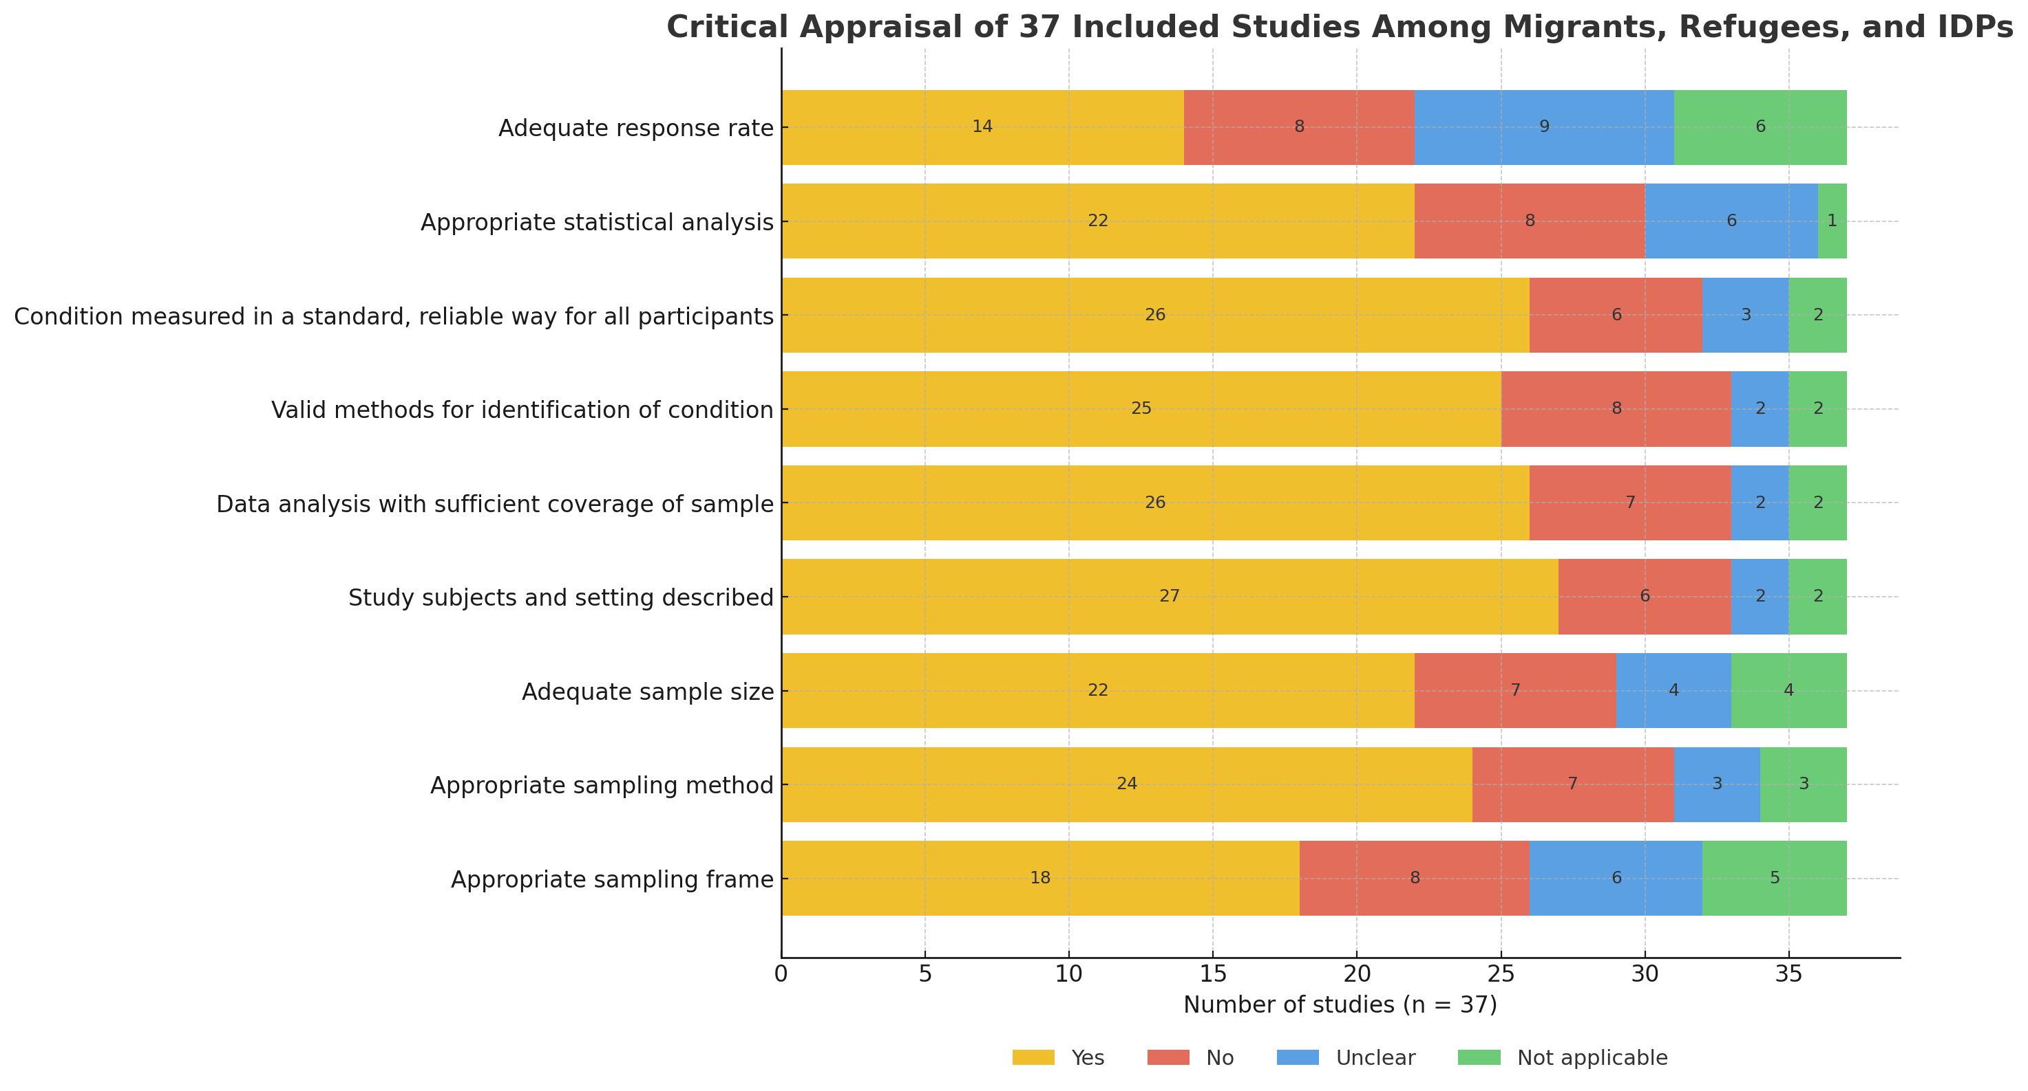

Supplementary Figure SF1: Critical appraisal summary across 37 records showing the number of records rated Yes, No, Unclear, or Not applicable for each appraisal item. Two reviewers independently appraised methodological quality using CASP (qualitative studies), ROBINS-I (non-randomised quantitative designs), AACODS (grey literature), and AGREE II (guidance). For cross-tool synthesis, domain judgements were mapped to a 3-point scale (Yes = 1, Unclear = 0.5, No = 0) and converted to study-level percentages; studies were classified high (≥70%), moderate (50–69%), or low (<50%) quality. “Not applicable” indicates items not relevant to a design (e.g., statistical analyses for qualitative work). Disagreements were resolved by consensus (third reviewer as arbiter if needed). Overall risk of bias across the 37 records was Low (n = 24), Moderate (n = 12), and High (n = 1); see Supplementary Figure SF2 for the distribution.

Supplementary Figure SF2: Overall Quality Ratings of 37 Included Studies
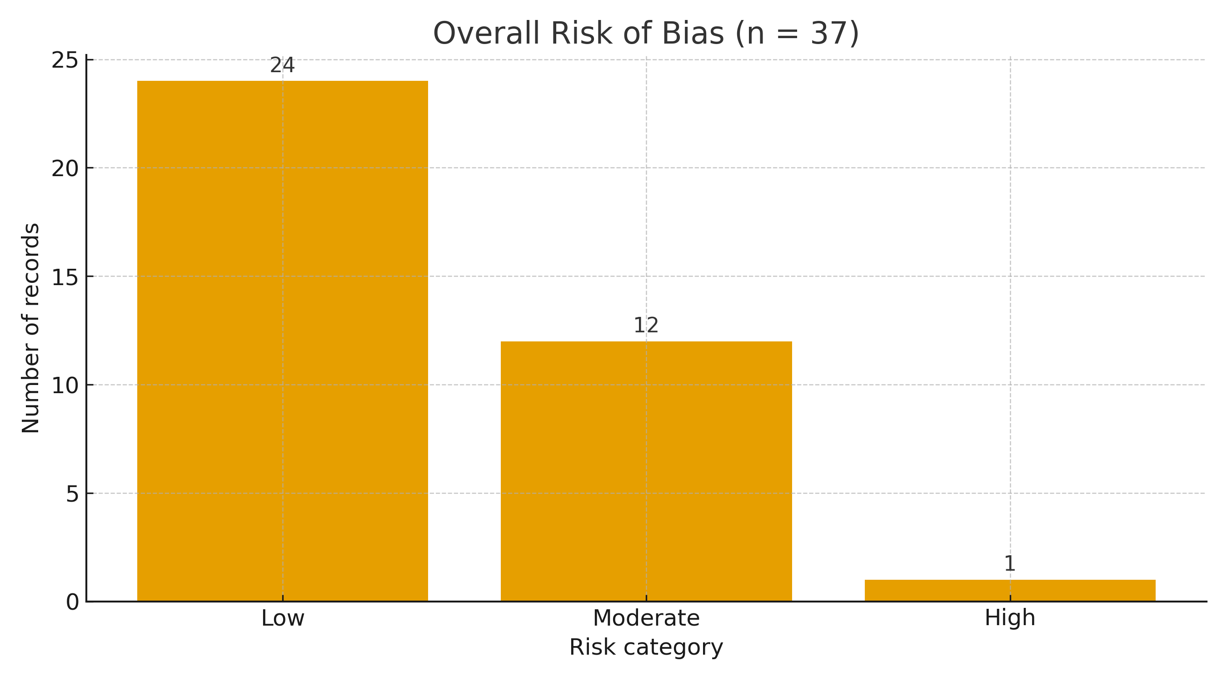
Supplementary Figure SF2: Overall risk of bias of included records (n = 37). Bars show the number of records rated Low (n=24; 64.9%), Moderate (n=12; 32.4%), and High (n=1; 2.7%) overall risk of bias. We appraised peer-reviewed observational and qualitative studies with ROBINS-I and CASP, respectively; grey literature with AACODS. Where a record had both study types/tools, we applied a conservative worst-grade-wins rule to assign the single overall rating shown here. AACODS domains (Authority, Accuracy, Coverage, Objectivity, Date, Significance) were synthesised to Low/Moderate/High concern; ROBINS-I “Serious/Critical” would map to High (none critical were included).

Supplementary Table S3: Characteristics and outcomes of included LMIC records (n=37)

# | Author, year, Ref | Country / WHO region | Population/ size- if reported (n=) * | Setting† | Age group | Vaccine(s) | Delivery strategies / interventions‡ | Uptake (if reported) | Barriers (reported) | Enablers (reported) | Study design / source | Quality tool | Item rating / ROB score
1 | UNICEF, 2022,  [46] | Brazil / AMR | Refugees, migrants (n=NR) | Shelters | Adolescent, Adult | Multi-vaccine incl. HPV, measles, Mening-C | Shelter fixed-post sessions with roving outreach; same-day co-administration of eligible vaccines; open-vial/walk-in policy; paper registers & vaccination cards with later data entry; referral/appointment booking to municipal primary health care (PHC) for dose completion | 87% (Mening C, shelter campaign) † | Mobility between shelters; limited ID | Shelter access; community liaison; co-delivery of multiple vaccines | Agency report (grey) | AACODS | Low
2 | UNHCR, 2021,  [40] | Jordan / EMR | Refugees/ (n=NR) | National (fixed + mobile) | Adolescent, Adult | COVID-19 | Camp health-post fixed stations with mobile vans rotating across camp blocks; integration with the national electronic booking/registry for appointment scheduling & eligibility checks; scheduled “catch-up days” for new arrivals and prior defaulters. | NR | Booking/ID issues early on | National eligibility; mixed fixed/mobile offer | Agency news (grey) | AACODS | Low
3 | Harvey et al., 2020, [35] | Kenya / AFR | Mobile migrants/  Refugees/ (n=NR) | Community | Adolescents | Polio (OPV/IPV); MR (integrated rounds) | Route-mapping of mobile clans; pop-up posts at markets; school-linked outreach; open-vial & walk-in | Programme rounds ~87–90% in integrated contexts | Mobility; documentation checks | Micro-planning; open-vial; local leaders | Peer-reviewed | ROBINS-I | Low
4 | Honein-AbouHaidar et al., 2024, [32] | Lebanon / EMR | Refugees (Syrian)/ (n=NR) | PHC, hospital, mobile | Adolescent, Adult | Pneumococcal; MR | Primary care (PHC)–based catch-up via routine visits; opportunistic offers in hospital outpatient/ED (and at discharge); CHW-led active recall/defaulter tracing; scheduled mobile outreach days in informal settlements/camps. | +25% pneumococcal uptake; MR delivered (no %) | Mistrust; follow-up loss | CHWs; settlement outreach; PHC integration | Peer-reviewed (mixed) | ROBINS-I / CASP | High/ Low
5 | Komakech et al., 2025, [22] | Uganda / AFR | Refugees/ (n=NR) | PHC integration (strategies/ policy) | Adults (mostly) | Various (strategies scope) | Policy-level integration of catch-up vaccine via a life-course approach into refugee PHC; data flows between OPM/PHC | NR | Financing gaps; role clarity | Policy inclusion; PHC platform | Peer-reviewed | ROBINS-I | Low
6 | WHO, 2021, [28] | Bangladesh / SEAR | Rohingya refugees/  (n= ~48,000 -COVID-19); LCV; Td/DTaP/HepB (n=NR) | Camps | Adults (55+) | COVID-19, LCV: Td/DTaP/  HepB | Camp micro-planning (sector mapping & session calendars); temporary age-expanded eligibility for adolescent/adult catch-up; roving mobile teams across camp sectors; priority queues/time-slots and assisted triage for older adults. | ~48,000 – COVID-19, 79% (LCV: Td/DTaP/  HepB)† | Initial exclusion; crowding | Mobile teams; community messaging | WHO feature (grey) | AACODS | Low
7 | Reda et al., 2024, [29] | Bangladesh / SEAR | Rohingya refugees/ (n=NR) | PHC + outreach | Adolescent, Adult | Various | PHC-based immunisation with outreach support; counselling provided by health workers; informal (ad-hoc) recall of those missing doses. | NR | Misinformation; language; documentation; workload | Community framing (“protect family”); trusted intermediaries | Peer-reviewed | CASP | Moderate
8 | World Bank, 2021, [33] | Lebanon / EMR | Refugees/  Migrants/ (n=NR) | NR | Adolescent, Adult | COVID-19 | Eligibility expanded at national level; delivery via fixed posts across PHC/hospitals; mobile outreach (vans) targeting high-density neighbourhoods. | NR | NR | Formal inclusion; multi-site access | WB feature (grey) | AACODS | Low
9 | Serrano-Córdova et al., 2023, [38] | Ecuador / AMR | Venezuelan migrants/ (n=NR) | National/  communities | Adolescent, Adult | COVID-19 (policy inclusion) | Fixed posts i.e regional hospital; later community outreach in migrant hotspots via mobile vans/ community clinics | NR | Admin/legal barriers | Policy shifts to inclusion; community offers | Peer-reviewed (scoping) | ROBINS-I | Low
10 | Mbabazi et al., 2009, [23] | Uganda / AFR | Mixed incl. camps/ (n=NR) | Campaigns/SIA | Adolescents | MR | Nationwide SIAs complemented by school-based mop-ups and social mobilisation activities. | >85% post-campaign coverage | Hard-to-reach pockets | Community mobilisation; school access | Peer-reviewed | ROBINS-I | Low
11 | WHO, 2024, [24] | Uganda / AFR | Refugees/  Migrants/ (n=NR) | PHC + outreach | Adolescent, Adult | Various | Integrated migrants/refugee-PHC services with periodic outreach via mobile vans/ clinics in settlements | NR | Staffing; supply balance | Joint MoH/UN planning; settlement days | WHO news (grey) | AACODS | Low
12 | Refugees International, 2024, [36] | Kenya / AFR | Refugees/  (n=NR) | Policy context | Adolescent, Adult | NR | Implementation guidance for operationalising new Refugee Act (ID, entitlement, PHC links) | NR | NR | NR | Policy brief (grey) | AACODS | Low
13 | Kenya Law, 2025, [37] | Kenya / AFR | Refugees/  Asylum/ (n=NR) | NR | Adolescent, Adult | NR | Statutory framework enabling access to healthcare and documentation (incl. catch-up vaccination) | NR | NR | NR | Law (grey) | AACODS | Low
14 | UNHCR, 2025,  [48] | Rwanda / AFR | Refugees/  (n=NR) | Camp PHC + outreach | Adolescent, Adult | Various | Camp PHC posts with scheduled outreach days and referral to hospitals | NR | NR | NR | Ops profile (grey) | AACODS | Low
15 | EC-ECHO, 2023,  [25] | Uganda / AFR | Refugees/  Hosts/ (n=NR) | PHC/  community | Adolescent, Adult | Various | Community days with PHC sessions and cross-programme linkages | NR | NR | NR | Feature (grey) | AACODS | low
16 | UNHCR, 2020,  [42] | Morocco / EMR | Migrants/  refugees | PHC + outreach | Adolescent, Adult | Various | Municipal PHC posts embedded with NGO outreach where needed via mobile team (vans) | 94% (multi-vaccination catch-up)† | Irregular status | NGO–PHC coordination | Ops plan (grey) | AACODS | Moderate
17 | UNHCR (UPR), 2020, [43] | Morocco / EMR | Migrants/  Refugees/ (n=NR) | NR | Adolescent, Adult | Various | Rights and legal framework with administrative facilitation for access to services | NR | NR | NR | Rights submission (grey) | AACODS | Moderate
18 | Miller, 2023,  [34] | Lebanon / EMR | Refugees/ (n=NR) | PHC/hospital | Adolescent, Adult | Various | Opportunistic offers in hospital/PHC with referral loops | NR | NR | NR | Commentary (grey) | AACODS | Moderate
19 | Uganda MoH, 2019, [26] | Uganda / AFR | Refugees/  hosts | PHC integration | Adolescent, Adult | Life-course | Life-course vaccine integration in HSIRRP with joint planning | NR | NR | NR | Govt plan (grey) | AACODS | Low
20 | Hasan et al., 2024, [30] | Bangladesh / SEAR | Refugees/  Migrants/ (n=NR) | PHC / system (service organisation; some outreach) | Adolescent, Adult | COVID-19 (vaccination mentioned contextually) | PHC service adaptations and coordination across public facilities and refugee-serving providers during COVID-19; vaccination mentioned contextually | NR | NR | NR | Peer-reviewed | ROBINS-I / CASP | Moderate/ Low
21 | WHO-EMRO, 2023, [41] | Jordan / EMR | Migrants/  refugees | PHC, hospitals, camps | Adolescent, Adult | Various | Multi-platform delivery via PHC posts, opportunistic hospital offers, and camp campaigns | NR | NR | NR | Country profile (grey) | AACODS | Low
22 | Deal et al., 2023,  [54] | Multi-country (incl. LMICs) | Migrants/  Refugees/  (n=NR) | NR | Adolescent, Adult | Various | BeSD drivers synthesis informing strategies and identifying barriers within migrants, refugees and IDPs groups. | NR | NR | NR | Peer-reviewed | ROBINS-I / CASP | Low/Low
23 | UNESCO, 2022,  [47] | Peru / AMR | Migrants/  Refugees/ (n=NR) | Fixed-site, campaigns | Adolescent, Adult | COVID-19 | Fixed posts followed by outreach and policy inclusion steps | NR | NR | NR | Case study (grey) | AACODS | Low
24 | ACSG, 2020,  [44] | Philippines / WPR | Refugees/  IDPs/  (n=NR) | Capacity/  registration | Adolescent, Adult | NR | Case management with registration enabling PHC access | NR | NR | NR | Grey | AACODS | Low
25 | UNHCR, 2021,  [31] | Bangladesh / SEAR | Refugees/ (n=NR) | NR | Adolescent, Adult | COVID-19 access | Legal and policy facilitation for access with advocacy for migrants’ inclusions | NR | NR | NR | Grey | AACODS | Moderate
26 | UNHCR, 2021,  [55] | Latin America / AMR | IDPs/ (n=NR) | NR | Adolescent, Adult | COVID-19 | Regional campaigns with fixed posts in shelters | NR | NR | NR | Grey | AACODS | Low
27 | Pinto-Alvarez et al., 2023, [39] | Ecuador / AMR | Migrants/ (n=NR) | NR | Adolescent, Adult | COVID-19 | Policy commitments enabling access pathways for migrants, refugees and IDPs | NR | NR | NR | Grey (journal blog) | AACODS | Moderate
28 | Thobani et al., 2022, [53] | Pakistan / EMR | Gen. pop incl. Migrants/ Refugees and IDPs/ (n=NR) | School- and community-based | Adolescent | TCV | School- and community-based campaign with mop-ups where needed | 98% coverage reported | Access gaps out of school | School outreach | Peer-reviewed | ROBINS-I | Low
29 | Health Policy Watch, 2024,  [56] | Multi-country (LMICs) | Migrants,  refugees/  hosts/ (n=NR) | NR | Adolescent, Adult | Various | Joint PHC–humanitarian planning and service delivery (“convergence”- coordinated operations) | NR | NR | NR | Feature (grey) | AACODS | Moderate
30 | Mohamed et al., 2020, [50] | Tanzania / AFR | Gen. pop incl. Migrants/ Refugees and IDPs (ops lessons)/ (n=NR) | Outreach/SIA | Adolescents | Injectable SIA (incl. MR) | SIA field operations with additional micro-plans for hard-to-reach areas | NR | Terrain/logistics | Micro-planning | Peer-reviewed | ROBINS-I | Moderate
31 | Alavian et al., 2010, [51] | Iran / EMR | Migrants/ Refugees and IDPs/ (n=NR) | Schools/PHC | Adolescent/ Young Adult | HepB (catch-up) | School-based offers with PHC follow-up and series tracking | ~75% first dose; drop-off | Series completion (drop-off across doses) | NR | Peer-reviewed | ROBINS-I | Moderate
32 | Gavi, 2024, [52] | Nigeria / AFR | Mixed incl. IDPs/ (n=NR) | PHC/outreach | Adolescent, Adult | Multi-vaccine (incl. HPV) | Collaborative learning with outreach days and PHC integration | NR | NR | NR | Feature (grey) | AACODS | Moderate
33 | IOM, 2023, [49] | N. Ethiopia / AFR | IDPs/ (n=NR) | Mobile/  temporary clinics | Adolescent, Adult | Measles, polio, others | Pop-up clinics in high-density IDP sites with rapid mop-ups | NR | NR | Flexible mobile posts (pop-ups; rapid mop-ups) | Grey | AACODS | Moderate
34 | Refugee Law Project, 2006,  [27] | Uganda / AFR | Refugees/ (n=NR) | NR | Adolescent, Adult | NR | Formal recognition with administrative facilitation for access to catch-up vaccination services | NR | NR | NR | Grey | AACODS | Low
35 | Philippines DOJ, 2025, [45] | Philippines / WPR | Refugees/  IDPs / (n=NR) | NR | Adolescent, Adult | NR | Refugee/IDP protection unit with service linkage to health care (incl. catch-up vaccination) | NR | NR | NR | Grey | AACODS | Low
36 | WHO – SEARO, 2018, [57] | SEAR (regional) | Migrants  /Refugees/ (n=NR) | NR | Adolescent, Adult | Various | Regional practices featuring PHC integration and outreach | NR | NR | NR | WHO report (grey) | AACODS | Low
37 | Kaur et al., 2023 (MMWR), [58] | Global (LMIC context) | Gen. pop incl. Migrants/ Refugees and IDPs/ (n=NR) | NR | Adolescent, Adult | Various | Routine PHC alongside SIAs for missed doses | NR | NR | NR | Surveillance (grey) | AACODS | Low
Population: migrants = foreign-born; refugees/asylum seekers; IDPs = internally displaced persons. * Population/size values reflect the vaccinated subgroup when reported (n), and eligible denominators when available (N). NR = not reported. ≈ denotes author-reported approximations. Population labels are non-exclusive (e.g., migrants/refugees/IDPs).
† Settings—taxonomy & roles (used for synthesis): PHC (primary health care/GP/clinic); Hospital/ED (hospital outpatient/inpatient or ED opportunistic offers); School (school/college/university); Camp/Shelter fixed-post (camp health posts, reception centres, shelters); Mobile/Outreach (roving teams, community days, includes community pop-ups in markets/workplaces/faith sites); SIA/Campaign (supplementary immunisation activity/catch-up rounds); Policy/System (policy/legal/registration/strategy).
Abbreviations (Setting/roles): CHW = community health worker; OPD = outpatient department; ED = emergency department; NGO = non-governmental organisation; MoH = Ministry of Health; OPM = Office of the Prime Minister (Uganda); UPR = Universal Periodic Review; HSIRRP = Health Sector Integrated Refugee Response Plan.
Setting summary (coded across 37 records): PHC/opportunistic 11/37 (29.7%); Mobile/Outreach 11/37 (29.7%); Camp/Shelter fixed-post 7/37 (18.9%); SIA/Campaign 6/37 (16.2%); School 5/37 (13.5%); Hospital/ED 4/37 (10.8%); Digital recall/e-registries 2/37 (5.4%); CHW defaulter tracing 2/37 (5.4%). Records may list multiple settings; counts are non-exclusive. Community pop-ups are counted under Mobile/Outreach. Policy/System records describe the enabling environment and are not counted as delivery settings.
‡ Delivery strategies / interventions (coding used): Fixed-post (PHC clinics or camp/shelter health posts); Mobile/Outreach (roving/mobile teams, community days; includes pop-ups at markets/workplaces/faith sites); School-linked; Hospital/ED opportunistic (offers in OPD/ED/inpatient with referral); SIA/Campaign (supplementary immunisation activity catch-up rounds). “Community-based” and “pop-up” activities are counted under Mobile/Outreach. Records may list multiple strategies; counts are non-exclusive.
Vaccines: MV = multi-vaccine; MR = measles–rubella; MMR = measles–mumps–rubella; OPV/IPV = oral/inactivated poliovirus vaccine; HepB = hepatitis B vaccine; HPV = human papillomavirus vaccine; MenC = meningococcal C; PCV = pneumococcal conjugate vaccine; PPSV = pneumococcal polysaccharide vaccine; TT/Td/Tdap = tetanus-containing vaccines; DTaP = diphtheria–tetanus–acellular pertussis; TCV = typhoid conjugate vaccine; OCV = oral cholera vaccine; LCV = life-course vaccination (e.g., Td/DTaP/HepB).
Other: NR = not reported; ID = identification documents; SMS = short message service; e-registry/e-booking = electronic registry/booking; RoB = risk of bias; BeSD = Behavioural and Social Drivers (of Vaccination); LMIC = low- and middle-income country; WHO regions — AFR = African Region; AMR = Region of the Americas; EMR = Eastern Mediterranean Region; SEAR = South-East Asia Region; WPR = Western Pacific Region; EUR = European Region.

Supplementary Table S3: Table includes 37 records. Populations and settings/strategies are non-exclusive (a record may list multiple groups or delivery modes). Uptake refers to vaccinated subgroup (n) or eligible denominator (N) when reported; NR = not reported; ≈ = author estimate. Appraisal: AACODS (grey literature), ROBINS-I (non-randomised quantitative), CASP (qualitative), both for mixed-methods, AGREE II (guideline), narrative appraisal for non-primary peer-reviewed items; overall risk-of-bias ratings: Low 24, Moderate 12, High 1. Symbols: Population/size column uses n for vaccinated subgroup, N for eligible denominator; † identifies the Setting taxonomy; ‡ identifies the Delivery strategies taxonomy. Key terms: IDPs = internally displaced persons; PHC = primary health care; SIA/Campaign = supplementary immunisation activity; CHW = community health worker. Vaccine abbreviations: MV = multi-vaccine; MR= measles-rubella; MMR = measles, mumps, rubella; OPV/IPV = oral/inactivated polio; HepB = hepatitis B; HPV = human papillomavirus; MenC= meningococcal C; PCV/PPSV = pneumococcal conjugate/polysaccharide; TCV = typhoid conjugate; OCV = oral cholera vaccine.

Supplemental Figure SF4. Country distribution of included LMIC studies/reports (n=32):

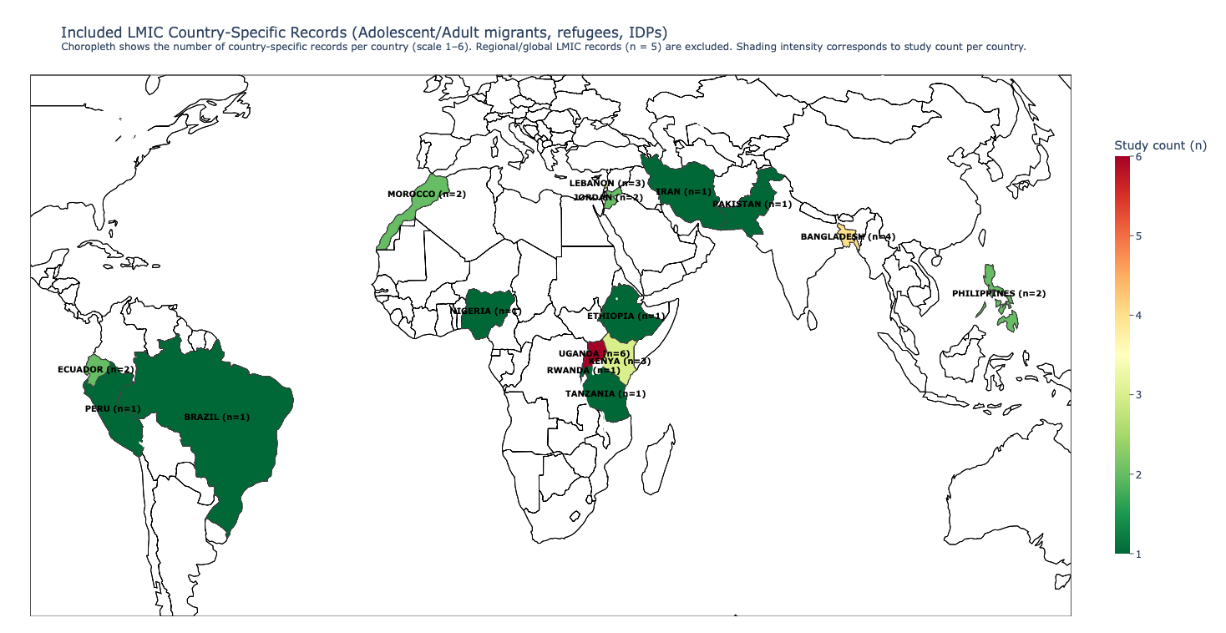

Supplementary Figure SF4: Country distribution of included LMIC records (n = 32 country-specific records across 16 countries). Choropleth shows the number of country-specific records per country (scale 1–6). Regional/global LMIC records (n = 5) are excluded. Countries and counts: Uganda (6), Bangladesh (4), Lebanon (3), Kenya (3), Ecuador (2), Jordan (2), Morocco (2), Philippines (2), Brazil (1), Peru (1), Rwanda (1), Ethiopia (1), Tanzania (1), Iran (1), Nigeria (1), Pakistan (1). Shading intensity corresponds to study count per country.

