SUPPLEMENT
Age, years (median [IQR]) | 57 [45, 66]
Male, no (%) | 741 (58%)
Ethnicity, no (%) | 1114 (87%) white
 | 130 (10%) Afro-Carribean
 | 9 (<1%) Asian
 | 2 (<1%) Hispanic
BMI, Kg/m^2, median [IQR] | 28.7 [24.9, 34.0]
No past medical history, no (%) | 204 (16%)
Diabetes, no (%) | 234 (18%)
Hyperlipidaemia, no (%) | 491 (38%)
Current or ex-smoker, no (%) | 562 (44%)
Atrial fibrillation, no (%) | 128 (10%)
Pre-existing diagnosis of heart failure, no (%) | 255 (20%)
Previous MI, no (%) | 208 (26%)
Known coronary artery disease, no % | 234 (18%)
ICD in situ, no (%) | 135 (10%)

Supplementary Table 1: clinical details of the prognosis dataset.

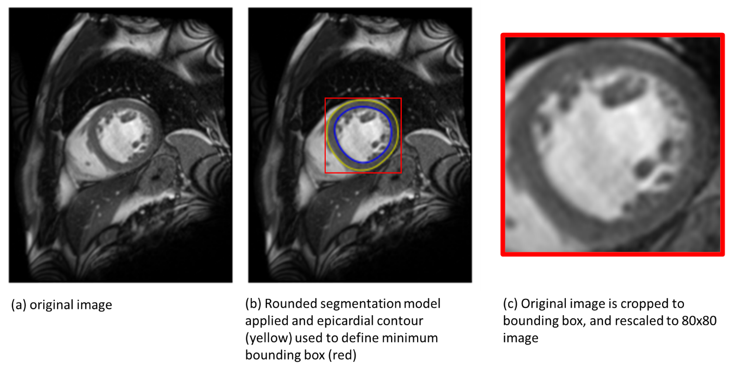

Supplementary Figure 1: illustration of pre-processing for training of Trabecular model. The rounded model is first applied to the image to identify the epicardial border (yellow contour), which defines a minimum bounding box (red box). The original image is cropped to the bounding box and rescaled to 80x80 pixels.

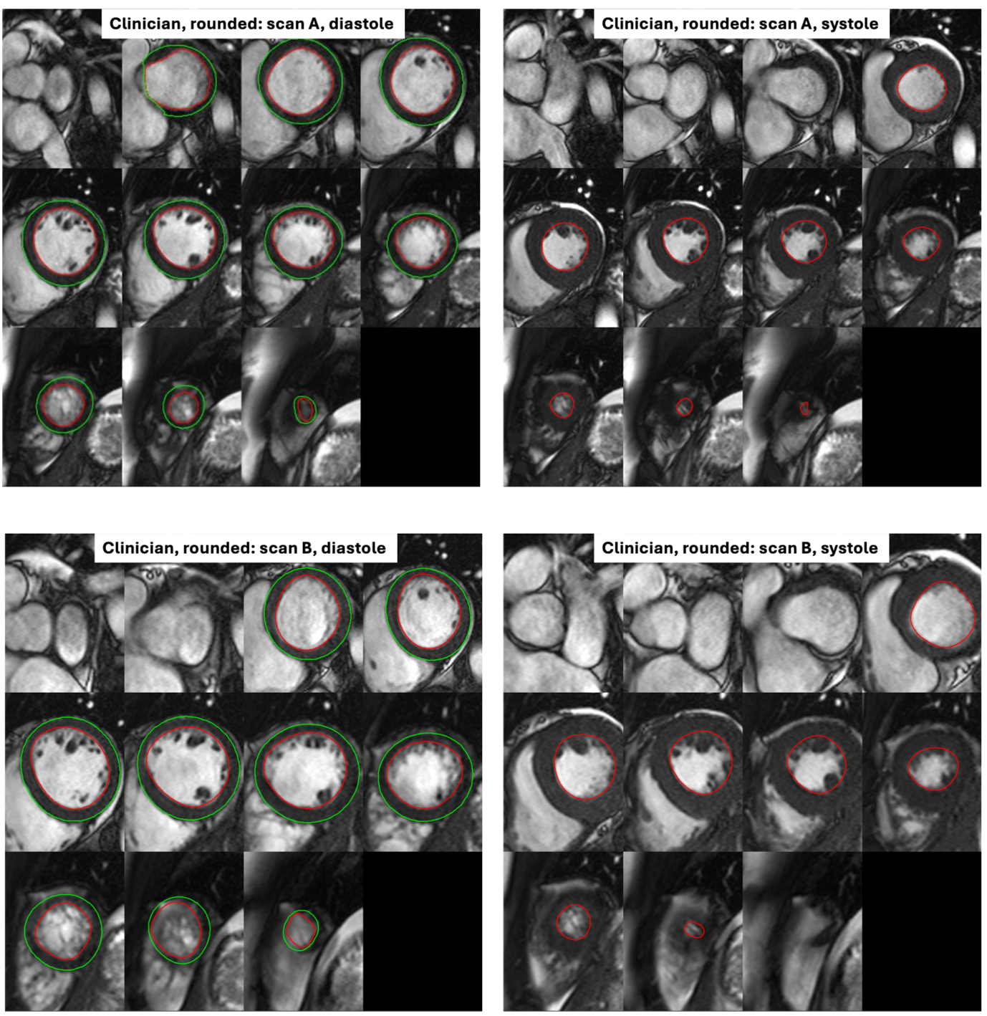

Supplementary Figure 2a Segmentations on a healthy volunteer test-retest pair in diastole and systole using clinician segmentation

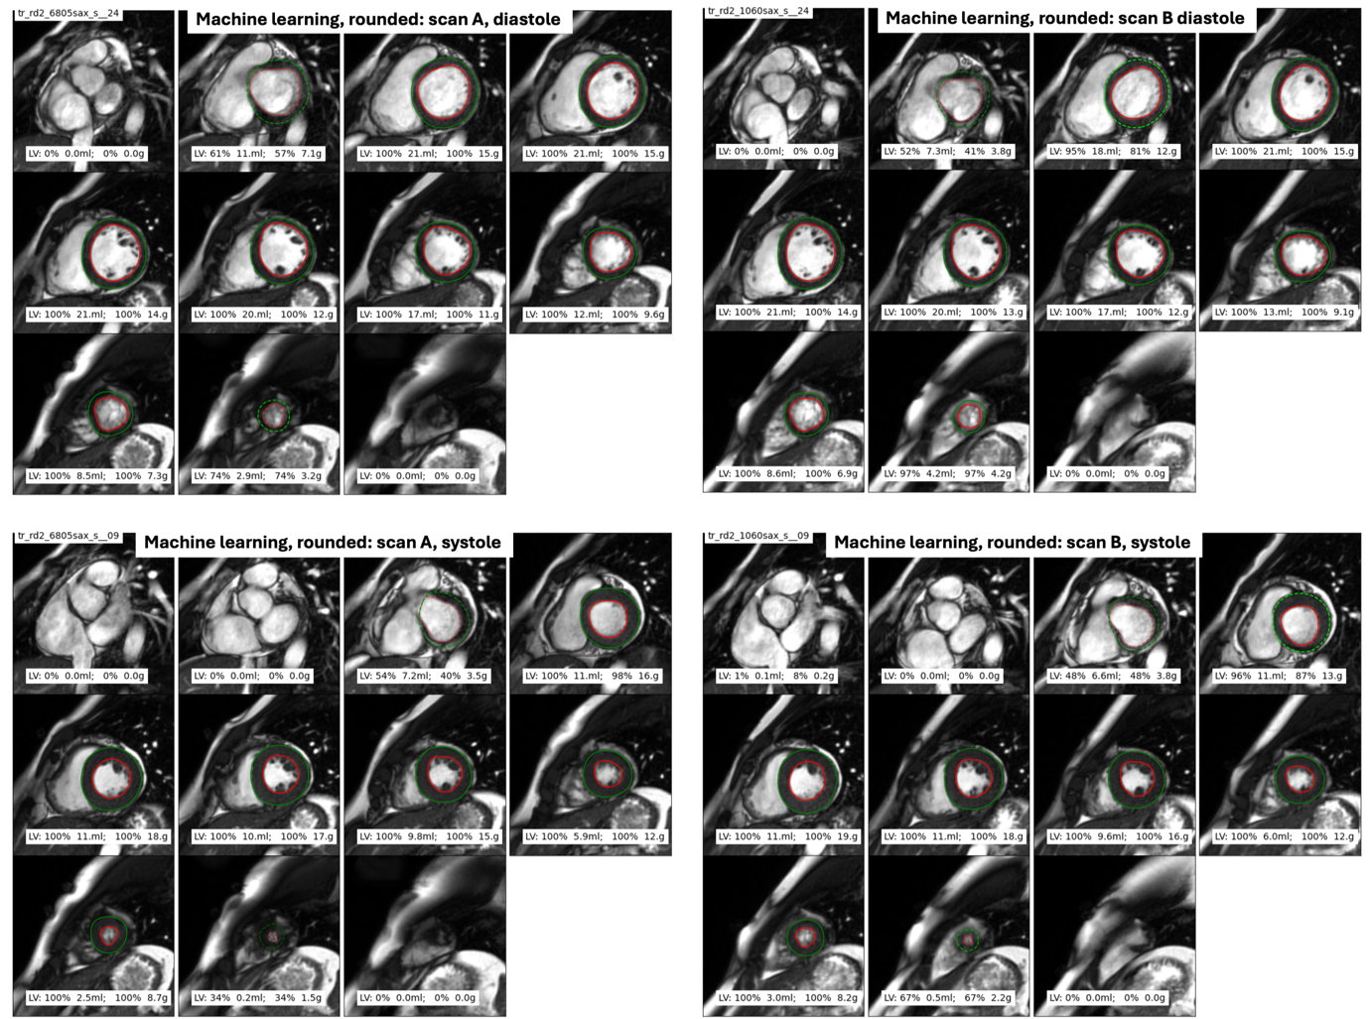

Supplementary Figure 2b Segmentations on a healthy volunteer test-retest pair in diastole and systole using ML rounded segmentation

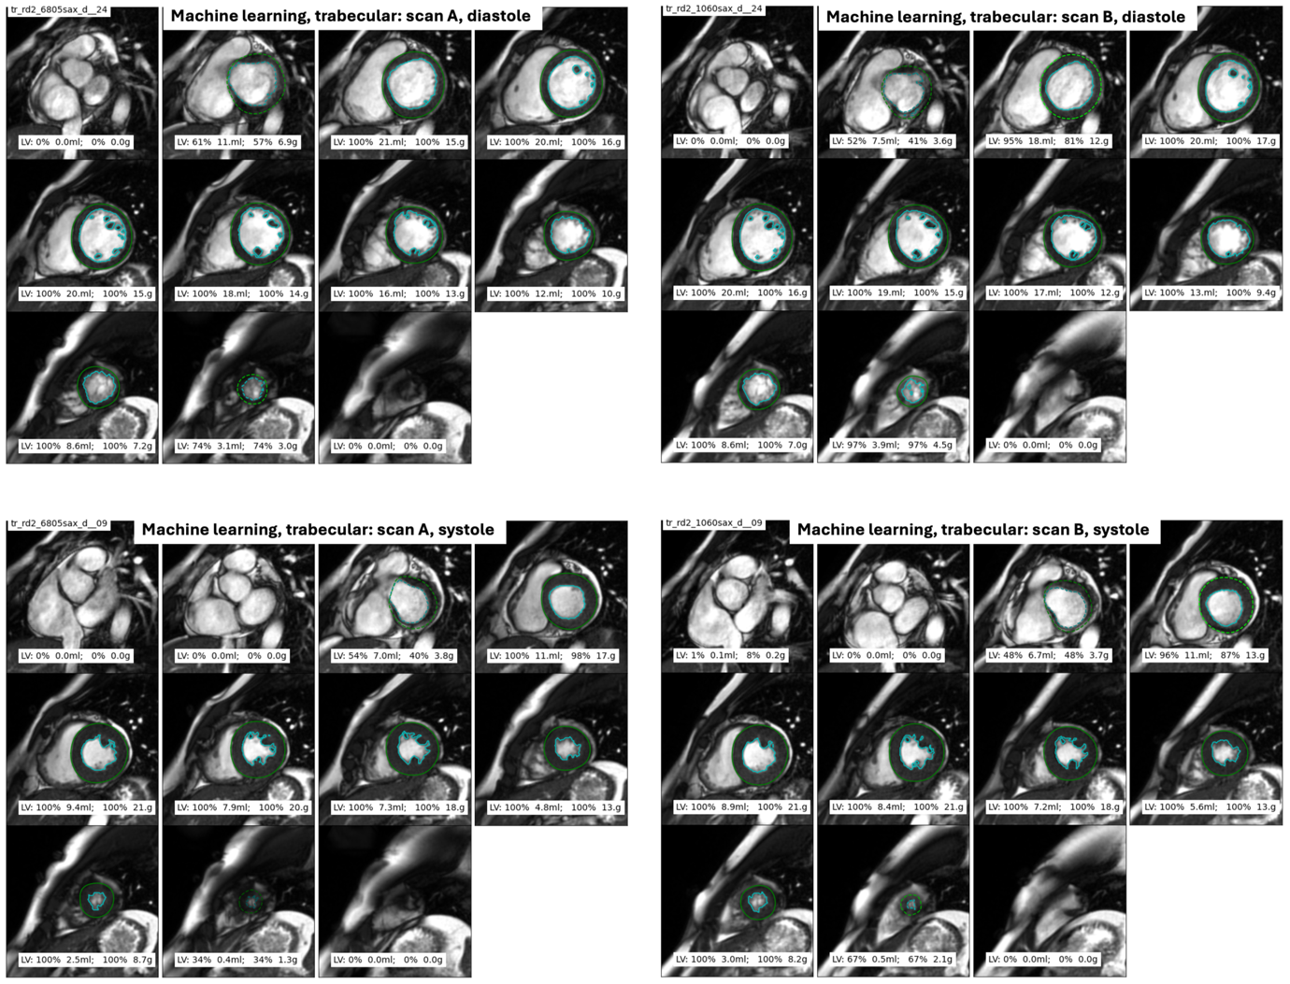

Supplementary Figure 2c Segmentations on a healthy volunteer test-retest pair in diastole and systole using ML trabecular segmentation

