Supplementary Appendix
 | Description
Supplementary Text 1 |  | World Health Organization recommended reference tests for diabetes and tuberculosis
Supplementary Text 2  Supplementary Text 3 |  | Search strategy referred to in paper  Meta regression quantitative outputs  M
Supplementary Figure 1 | Yield of diabetes mellitus screening stratified by age group
Supplementary Figure 2 | Prevalence of diabetes mellitus stratified by age group
Supplementary Figure 3 | Luis Furuya-Kanamori Index Plots for Assessment of Publication Bias

Supplementary Text 1. Recommended reference tests for diabetes and tuberculosis

World Health Organization (WHO) recommended diagnostic tests for diabetes mellitus (DM)

WHO Recommended Test for DM | Cut-Points to Diagnose DM
2-hour post-load (75g glucose) venous plasma glucose | ≥ 11.0 mmol/l
2-hour post-load (75 g glucose) capillary plasma glucose | ≥ 12.2 mmol/l
Fasting venous or capillary plasma glucose. | ≥ 7.0 mmol/l
Glycated haemoglobin (HbA1c) | ≥ 6.5% or 48 mmol/mol
Random (non-fasting) blood glucose and symptoms | ≥ 11.1 mmol/l
Note: World Health Organization recommend two tests (preferably the same test) in someone who is asymptomatic. Random blood glucose should only be used in the presence of diabetes symptoms. Plasma glucose is preferred in people with symptoms who are suspected of having type 1 diabetes.

Acceptable reference standard for tuberculosis (TB) diagnosis

Pulmonary TB disease | Extrapulmonary TB disease
Molecular World Health Organization (WHO)-recommended rapid diagnostic (mWRD) – see below | Molecular WHO-recommended rapid diagnostic test (see next page to see which tests WHO recommends)
Sputum smear microscopy or culture for Mycobacterium tuberculosis | As defined in studies (e.g. including biopsy)

Supplementary Text 2. Search strategy

Database | Search # | Search Strategy
PubMed | 1 | "tuberculosis"[MESH] OR tuberculosis[TIAB] OR TB[TIAB] OR "Koch Disease*"[TIAB] OR "Mycobacterium tuberculosis*"[TIAB]
PubMed | 2 | "Diabetes Mellitus"[MESH] OR diabetes*[TIAB] OR diabetic*[TIAB] OR "wolfram syndrome"[TIAB] OR "Donohue syndrome"[TIAB] OR "prediabet*"[TIAB] OR "impaired glucose tolerance"[TIAB] OR "impaired fasting glucose"[TIAB] OR "Hyperglycemia"[Mesh] OR hyperglycemi*[TIAB] OR HYPERGLYCAEMI*[TIAB] OR dysglycemi*[TIAB] OR dysglycaemi*[TIAB]
PubMed | 3 | "Early Diagnosis"[Mesh:Noexp] OR "mass screening"[MESH:Noexp] OR screen*[TIAB] OR "early detect*"[TIAB] OR detect*[TIAB] OR identif*[TIAB] OR test*[TIAB] OR diagnos*[TIAB]
PubMed | 4 | #1 AND #2 AND #3
PubMed | 5 | #4 AND (2000/1/1:3000/12/12[pdat]) AND excludepreprints[Filter]
PubMed | 6 | #5 NOT (letter[PT] OR letter[TI] OR comment[PT] OR comment*[TI] OR editorial[PT] OR editorial[TI] OR "pubmed books"[Filter])
CINAHL | S1 | MH "Tuberculosis+" OR TI ( tuberculosis OR "Koch disease*" OR "mycobacterium tuberculosis*") OR AB ( tuberculosis OR "Koch disease*" OR "mycobacterium tuberculosis*" )
CINAHL | S2 | MH ("Diabetes Mellitus+" OR "hyperglycemia") OR TI (diabetes* OR diabetic* OR "wolfram syndrome" OR "donohue syndrome" OR "impaired glucose tolerance" OR hyperglycemi* OR hyperglycaemi* OR dysglycemi* OR dysglycaemi*) OR AB (diabetes* OR diabetic* OR "wolfram syndrome" OR "donohue syndrome" OR "impaired glucose tolerance" OR hyperglycemi* OR hyperglycaemi* OR dysglycemi* OR dysglycaemi*)
CINAHL | S3 | MH ("Early Diagnosis") OR TI ("mass screening" OR screen* OR "early detect*" OR detect* OR identif* OR test* OR diagnos*) OR AB ("mass screening" OR screen* OR "early detect*" OR detect* OR identif* OR test* OR diagnos*)
CINAHL | S4 | S1 AND S2 AND S3
CINAHL | S5 | S4 AND PY 20000101-20230331 AND PT ("Journal Article" OR "Meta Analysis" OR "Review" OR "Systematic Review")
CINAHL | S6 | S5 NOT (PT ("editorial OR "letter" OR "commentary") OR TI (editorial OR letter* OR comment*)) [with Peer Review Limiter applied]
Cochrane Controlled Register of Trials | 1 | [mh "tuberculosis"] OR tuberculosis:ti,ab OR tb:ti,ab OR "koch disease*"ti,ab OR "mycobacterium tuberculosis*":ti,ab
Cochrane Controlled Register of Trials | 2 | [mh "diabetes mellitus"] OR diabetes*:ti,ab OR diabetic*:ti,ab OR "wolfrom syndrome":ti,ab OR "Donohue syndrome":ti,ab OR "prediabet*":ti,ab OR "impaired glucose tolerance":ti,ab OR "impaired fasting glucose":ti,ab OR [mh "Hyperglycemia"] OR hyperglycemi*:ti,ab OR HYPERGLYCAEMI*:ti,ab OR dysglycemi*:ti,ab OR dysglycaemi*:ti,ab
Cochrane Controlled Register of Trials | 3 | [mh ^"early diagnosis"] OR [mh ^"mass screening"] OR screen*:ti,ab OR "early detect*":ti,ab OR detect*:ti,ab OR identif*:ti,ab OR test*:ti,ab OR diagnos*:ti,ab
Cochrane Controlled Register of Trials | 4 | #1 AND #2 AND #3 [with Publication Year from 2000 to 2023, in Trials]
Embase (Elsevier) | 1 | 'tuberculosis'/exp OR tuberuculosis:ti,ab OR TB:ti,ab OR 'Koch disease*':ti,ab OR 'mycobaterium tuberculosis*':ti,ab
Embase (Elsevier) | 2 | 'diabetes mellitus'/exp OR diabetes*:ti,ab or diabetic*:ti,ab OR 'wolfram syndrome':ti,ab OR 'donohue syndrome':ti,ab OR 'impaired glucose tolerance':ti,ab OR 'hyperglycemia'/exp OR hyperglycemi*:ti,ab OR HYPERGLYCAEMI*:ti,ab OR dysglycemi*:ti,ab OR dysglycaemi*:ti,ab
Embase (Elsevier) | 3 | 'early diagnosis'/exp OR 'mass screening'/de OR screen*:ti,ab OR 'early detect*':ti,ab OR detect*:ti,ab OR identif*:ti,ab OR test*:ti,ab OR diagnos*:ti,ab
Embase (Elsevier) | 4 | #1 AND #2 AND #3
Embase (Elsevier) | 5 | #4 AND [2000-2023]/py AND ([article]/lim OR [article in press]/lim OR [review]/lim OR 'systematic review*':ti OR 'meta analys*':ti OR review:ti)
Embase (Elsevier) | 6 | #5 NOT ([letter]/lim OR [editorial]/lim OR letter*:ti OR editorial*:ti OR comment*:ti)
Global Health (CABI Direct) | 1 | Allfied:((Tuberculosis * OR "mycobacterium tuberculosis*" OR "koch disease") AND (diabetes* OR diabet* OR "wolfram syndrome" OR "donohue syndrome" OR "impaired glucose tolerance" OR hyperglycemi* OR hyperglycaemi* OR dysglycemi* OR dysglycaemi*) AND ("early diagnosis" OR "mass screening" Or screen* OR "early detect*" OR detect* OR identif* OR test* OR diagnos*) AND NOT title:(comment* OR editorial OR letter) AND yr:[2000 TO 2023]) AND ( ((item-type:(( "Conference paper" OR "Journal article") )) (sc:(( "HE" ) )) ))
LILACS (VHL Regional Portal) | 1 | (tuberculosis* OR tb OR "Koch Disease*" OR "Mycobacterium tuberculosis*") AND (diabetes* OR diabetic* OR "wolfram syndrome" OR "donohue syndrome" OR "impaired glucose tolerance" OR hyperglycemi* OR hyperglycaemi* OR dysglycemi* OR dysglycaemi*) AND ("Early Diagnosis" OR "mass screening" OR screen* OR "early detect*" OR detect* OR identif* OR test* OR diagnos*) AND (year_cluster:[2000 TO 2023])
Web of Science (Elsevier) | 1 | TS=(*tuberculosis* OR "koch Disease*")
Web of Science (Elsevier) | 2 | TS=("diabetes Mellitus" OR diabet* OR "wolfram syndrome" OR "donohue syndrome" OR "impaired glucose tolerance" OR hyperglycemi* OR hyperglycaemi* OR dysglycemi* OR dysglycaemi*)
Web of Science (Elsevier) | 3 | TS=("early diagnosis" OR "mass screening" Or screen* OR "early detect*" OR detect* OR identif* OR test* OR diagnos*)
Web of Science (Elsevier) | 4 | #1 AND #2 AND #3
Web of Science (Elsevier) | 5 | #4 AND PY=(2000-2023) AND (DT=("ARTICLE" OR "REVIEW") OR TI=(*review*))
Web of Science (Elsevier) | 6 | #5 NOT TI=(letter* OR comment* OR editorial*)
Note: Exact Search option used with all Web of Science searches.

Supplementary Text 3. Meta regression quantitative outputs

A. Yield of Diabetes Mellitus Screening

Model 1: WHO Region Only
Table S1. Meta-regression of DM screening yield by WHO region (Model 1)
WHO Region | Coefficient (B_1) | Variance (VAR_1) | Standard Error | Interpretation
Africa | 0 (ref) | 0.000000 | — | Reference
SE Asia | 0.2537 | 0.005861 | 0.0766 | Higher than Africa
Americas | 0.0435 | 0.009053 | 0.0951 | Similar to Africa
Eastern Mediterranean | 0.6790 | 0.009538 | 0.0977 | Higher than Africa
Western Pacific | -0.0670 | 0.002190 | 0.0468 | Lower than Africa
Europe | 0.1138 | 0.000911 | 0.0302 | Higher than Africa
Constant | 0.4088 | 0.000911 | 0.0302 | Baseline

Model 2: WHO Region, Age Group, and OGTT Use
Table S2. Meta-regression of DM screening yield (Model 2)
Variable | Category | Coefficient (B_2) | Variance (VAR_2) | Standard Error
WHO Region | Africa (reference) | 0 | 0 | —
WHO Region | SE Asia | 0.1984 | 0.007982 | 0.0893
WHO Region | Americas | 0.0254 | 0.011521 | 0.1073
WHO Region | Eastern Mediterranean | 0.5884 | 0.016334 | 0.1278
WHO Region | Western Pacific | -0.1239 | 0.004452 | 0.0667
WHO Region | Europe | 0.0232 | 0.007017 | 0.0838
WHO Region | Constant | 0.3991 | 0.001260 | 0.0355
Age Group | <40 years (reference) | 0 | 0 | —
Age Group | ≥40 years | 0.1003 | 0.005781 | 0.0760
Diagnostic Method | No OGTT (reference) | 0 | 0 | —
Diagnostic Method | OGTT used | -0.0082 | 0.021175 | 0.1455

B. Prevalence of Diabetes Mellitus

Model 1: WHO Region Only
Table S3. Meta-regression of DM prevalence by WHO region (Model 1)
WHO Region | Coefficient (B_1) | Variance (VAR_1) | Standard Error | Interpretation
Africa | 0 (ref) | 0.000000 | — | Reference
SE Asia | 0.4729 | 0.011951 | 0.1093 | Higher than Africa
Americas | 0.2123 | 0.008235 | 0.0907 | Higher than Africa
Eastern Mediterranean | 0.6204 | 0.029475 | 0.1717 | Higher than Africa
Western Pacific | 0.1961 | 0.012227 | 0.1106 | Higher than Africa
Europe | 0.2013 | 0.001541 | 0.0393 | Higher than Africa
Constant | 0.5399 | 0.001541 | 0.0393 | Baseline

Model 2: WHO Region, Age Group, and OGTT Use
Table S4. Meta-regression of DM prevalence (Model 2)
Variable | Category | Coefficient (B_2) | Variance (VAR_2) | Standard Error
WHO Region | Africa (reference) | 0 | 0 | —
WHO Region | SE Asia | 0.4480 | 0.015222 | 0.1234
WHO Region | Americas | 0.2018 | 0.009529 | 0.0976
WHO Region | Eastern Mediterranean | 0.5712 | 0.046729 | 0.2162
WHO Region | Western Pacific | 0.1628 | 0.023772 | 0.1542
WHO Region | Europe | 0.1521 | 0.016561 | 0.1287
WHO Region | Constant | 0.5449 | 0.001457 | 0.0382
Age Group | <40 years (reference) | 0 | 0 | —
Age Group | ≥40 years | 0.0441 | 0.013935 | 0.1180
Diagnostic Method | No OGTT (reference) | 0 | 0 | —
Diagnostic Method | OGTT used | -0.1157 | 0.019568 | 0.1399

Notes
• Coefficients (B) and variances (VAR) are from random-effects meta-regression using inverse-variance weighting
• Standard Error (SE) = √(Variance)
• All analyses used Freeman-Tukey double arcsine transformation for proportions
• DerSimonian-Laird (DL) method for between-study variance estimation
• Robust standard errors used to account for model misspecification
• Africa is the reference category for WHO regions
• Age <40 years and 'No OGTT' are reference categories for their respective variables
• Software: Stata version 18.0 (StataCorp LLC, College Station, TX, USA)
Abbreviations: DM, diabetes mellitus; OGTT, oral glucose tolerance test; SE, standard error; WHO, World Health Organization

Supplementary Figure 1. Yield of diabetes mellitus screening stratified by age-group, among people with tuberculosis
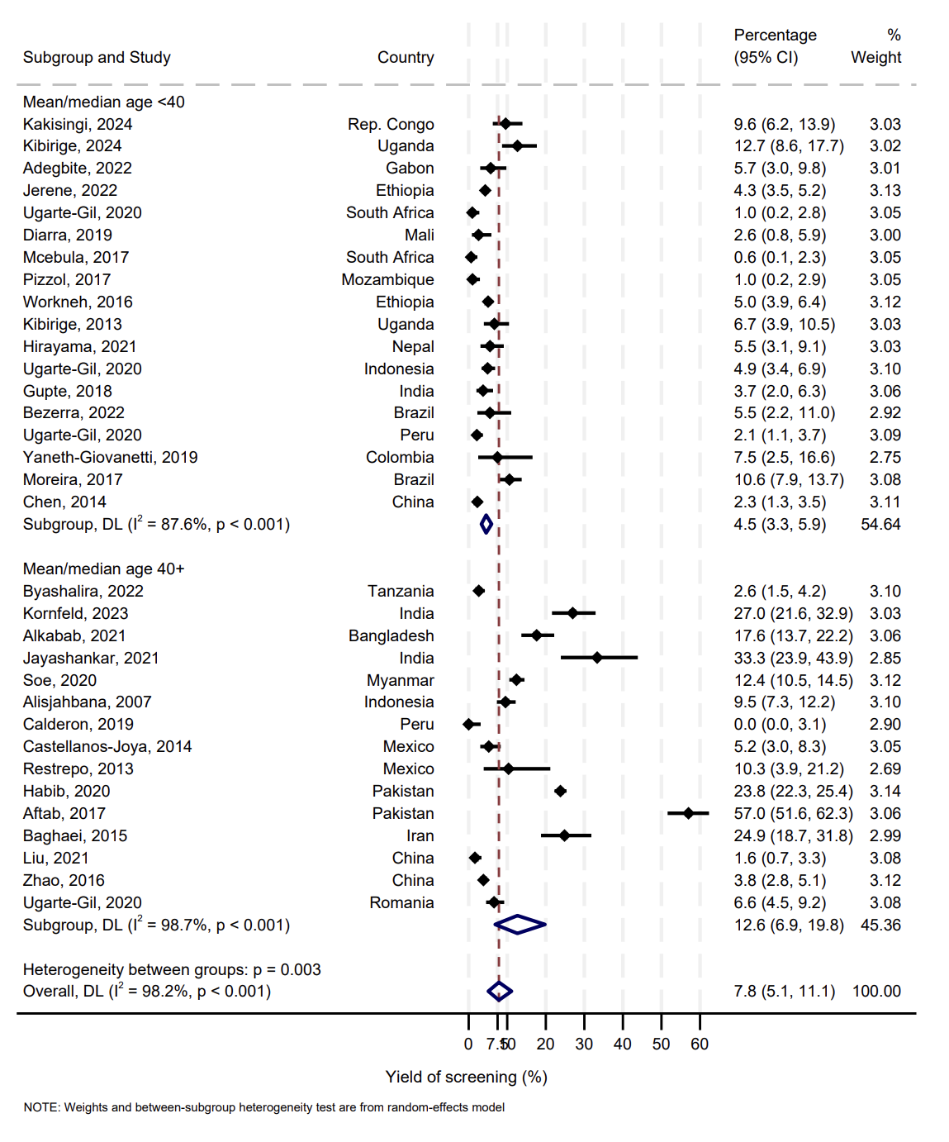

Supplementary Figure 2. Prevalence of diabetes mellitus (DM) stratified by age-group among people with tuberculosis.

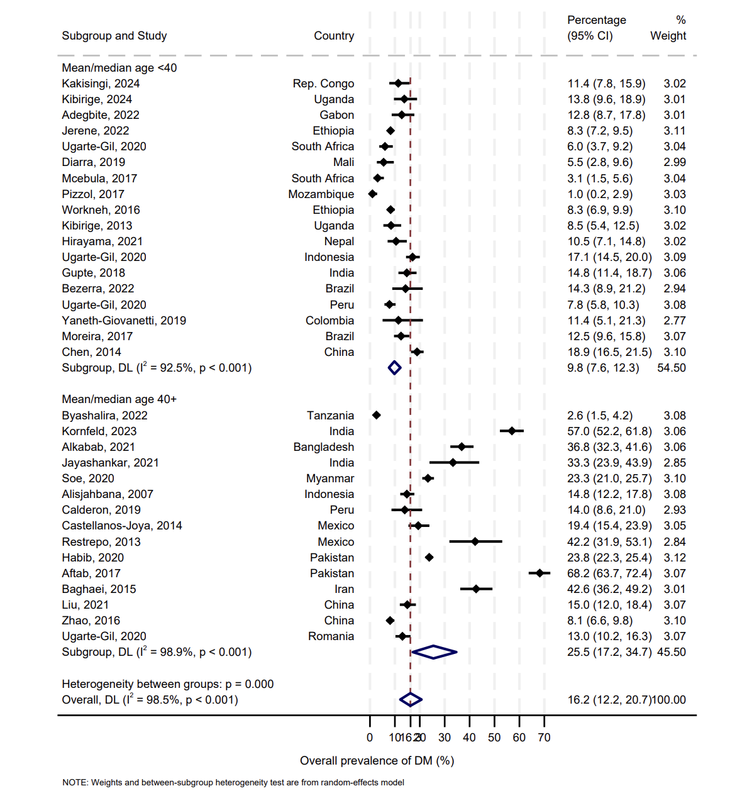

Supplemental Figure 3. Luis Furuya-Kanamori Index Plots for Assessment of Publication Bias

Luis Furuya-Kanamori Index Plot for Publication Bias in Assessing the Yield of Diabetes in Tuberculosis

Luis Furuya-Kanamori Index Plot for Publication Bias in Assessing the Prevalence of Diabetes in Tuberculosis

