Studies investigating complement proteins
Parameter | de Nooijer et al. | Nakae et al. | Gardinali et al. | Stöve et al | Chen et al. | Hack et al. | McCabe et al. | Li et al | Zhao et al. | Zogheib et al | Dionigi et al | Ahmad et al | Groeneveld et al | Andaluz-Ojeda et al. | Dominioni et al. | Cheng et al | Hedetoft et al
Sample size | 209 | 14 | 26 | 22 | 516 | 37 | 68 | 132 | 324 | 27 | 38 | 36 | 158 | 50 | 135 | 188 | 242
Mortality | 60% (126) | 42% (6) | 46% (12) | 54% (12) | 38%(198) | 57% (20) | 27% (19) | 33% (43) | 44% (144) | 37% (10) | 47% (18) | 66% (24) | 6% (10) | 42% (21) | 56%(76) | 20% (39) | 17% (41)
Proteins measured | C3 C3a C3c C5 C5a TCC | CH50 C3 C3a C4 C4a C5 C5a | C3 C4 C3a | C3a | C3 | C3a  C4a | C3 | C1q | C3  MAC  MBL | MBL | FB | C5  MAC  sCD59 | C3a | C3  C4 | FB  C3 | C3a | C4c  C4d  C3bc  C3dg  MAC
Recruitment period | December 2017 and December 2019 | Not mentioned | Not mentioned | Not mentioned | June 2017 October 2022 | Not mentioned | Not mentioned | July 2020 to March 2021 | Not mentioned | Not mentioned | 1982-1983 | June 2020 and January 2021 | Not mentioned | January 2010 to January 2011 | October 1982 and October 1985 | Not mentioned | February 2013 and March 2017
Setting | Multicentric | Single center | Single center | Single center | Single center | Single center | Single center | Single center | Single center | Single center | Single center | Single center | Single center | Single center | Multicenter | Multicenter | Multicenter
Location | Greece | Japan | Italy | Germany | China | Netherlands | USA | China | China | France | Italy | Jordan | Netherlands | Spain | Italy | USA | Denmark
Sepsis type | Community acquired and HAI | Sepsis (various causes) | Severe sepsis (bacterial) | Sepsis, severe sepsis | Sepsis | Sepsis | Sepsis | Sepsis, severe sepsis | Severe sepsis, septic shock | H1N1 sepsis | Septic surgical patients | Sepsis | Sepsis | Severe sepsis, septic shock | Septic surgical patients, | Sepsis | Necrotsing Soft Tissue infection
Primary aim to look at complement | Yes | Yes | Yes | Yes | Yes | Yes | Yes | Yes | Yes | Yes | Yes | Yes | Yes | Yes | Yes | Yes | Yes
Complement measurement method | ELISA | Double Antibody RIA | Radial Immunodiffusion | ABICAP | Immunoturbidimetry | RIA | Radial Immunodiffusion | Immunoturbidimetric method | ELISA | ELISA | Nephelometry | ELISA | RIA | DadeBehringBNII | Nephelometry | Western Blot | ELISA
Measurement time point | within 24 h after sepsis diagnosis | At diagnosis | At ICU admission | At ICU admission | Admission in the hospital | Admission to ICU | At admission | At admission | ED arrival | within 24 h of ICU admission | On the day of diagnosis | Within 48h of admission | ICU admission | Day 1 after ICU | At hospital admission | At hospital admission | At hospital admission
Mortality reported | 28 days | hospital | hospital | hospital | 28 days | In ICU | In hospital | 28 days | Yes | 30-days | In ICU | ICU stay | 28 days | In ICU | In hospital | 28 days | 30-days
Used consensus definition of sepsis | Yes | Yes | Yes | Yes | Yes | Yes | No | Yes | Yes | Yes | Yes | Yes | Yes | Yes | Yes | Yes | Yes
Source of data for scoring | Full text and author contact | Full text | Full text | Full text | Full text | Full text | Full text | Full text | Full text | Full text | Full text | Full text | Full text | Full text and author contact | Full text | Full text | Full text and author contact
Age mean(SD) | 76 [65–84] | 52.9 ± 16.5 | 52 | 45 | - | - | - | 56.88 ± 14.2 | 67.9 ± 13.6 | 56 ± 29 |  | 63.1 ± 15.7 | 64 (17—97) | 68.5 (19.2) |  |  | 62 (51–70)
Sex male n(%) | 119 (57) | 8 (57) | 20 (77) | - 14(64) | 275 (53) | - | - | 78(60) | 114 ( 63.7%) | - |  | 16 (44%) | 81 (51) | 32 (64%) |  |  | 144 (60)
Culture positive  GP  GN  Other  Culture Negative | - |  | 6  19  1 | 10  5  7 |  | 11  23 | 68 | 13  47  72  58 |  |  | GP 67%  GN 26% |  |  | 36(72%)  14(28%)  19(38%)  3(6%)  14(28%) |  |  | 222(92%)  50(21%)
Infection type | Nosocomial and community | Community | Community | Community | Community | Community | Community | Community | Community | Community | Nosocomial and community | Community | Community | Community | Community | Community | Community
Infection site  Lung  Blood  UT  Abdomen  Other  Site unknown | 161  34  13 | 3  3  8 | 3  14 (0)  9 (20)  1  1 | 10  3  3  6 | 60 (Lung)  336  Abdo 132  120 (Other) | - | 68 | 40  36  39  40  17 | 110  15  54 | 27 | 100% Abdomen |  | 71  4  29  23 | 23(46%)  NA  9(18%)  5(10%)  NA |  |  | Necrotising soft tissue infection
ICU LOS | - | - |  |  |  |  |  |  |  | 22 [IQR 23] | - | 11.8 ± 10.7 |  | NA | NA | NA | NA
Hospital LOS | - | - |  |  |  |  |  |  |  |  | - | 15.9 ± 10.5 |  | NA | NA | NA | NA
SOFA | 11 (9-14) |  |  |  | 8 +-1 |  |  | 5(3,8) |  | 12 [IQR 5] |  | 8.3 ± 4.8 | - | 8.0 (4.0) | NA | NA | 8 (6–10)

Supplemental Table 1. Characteristics of Studies Investigating Complement Proteins Included in the Meta-Analysis
This table summarizes the characteristics of studies evaluating complement proteins in septic patients, including sample size, mortality, measured proteins, methods of measurement, timing of sampling, and patient populations.
Abbreviations:
C3, C4, C5 = Complement components;
C1q = Complement component 1q;
MAC = Membrane attack complex;
MBL = Mannose-binding lectin;
FB = Factor B;
sCD59 = soluble CD59;
CH50 = Total hemolytic complement activity;
TCC = Terminal complement complex;
ELISA = Enzyme-linked immunosorbent assay;
RIA = Radioimmunoassay;
LOS = Length of stay;
ICU = Intensive Care Unit;
ED = Emergency Department;
GP = Gram-positive;
GN = Gram-negative;
UT = Urinary tract.

Studies investigating Immunoglobulins
 | Andaluz-Ojeda 2011 | Bermejo-Martin 2014 | Pathare 2021 | Tamayo 2012 | Akatsuka 2021 | Welte 2018 | Venet 2011 | Zhang 2022 | Alagna 2021 | Giamarellos 2013 | De la Torre 2016 | Geier 2015 | Rademaker 2024
Sample size | 50 | 172 | 47 | 42 | 238 | 79 | 44 | 106 | 956 | 290 | 189 | 83 | 255
Mortality | 42% (21) | 24% (42) | 34% (16) | 42% (18) | 22% (53) | 27% (22) | 20% (9) | 35% (38) | 13% (127) | 38% (112) | 23% (45) | 42% (35) | 19% (47)
Proteins measured | IgG, IgM, IgA | IgG1,G2,G3,G4, IgA,IgM, IgE | IgM | IgG IgG1 IgG2 IgG3 IgG4 IgM IgA | IgG | IgG, IgM, IgA | IgG IgA IgM | IgA1-2,IgG1-4,IgM | IgA,IgM,IgG | IgM | IgG1-4, IgA, IgM | IgG,IgM,IgA | IgG, IgM
Recruitment period | January 2010 to January 2011 | January 2012 to December 2012 | January 2011 to March 2014 | January to December 2011. | January 2013 to August 2018 | October 2011 to February 2015 |  | February 2017 to February 2019 | July 2008 to October 2013 | January 2010 to December 2010 | 01/2001-03/2012 | May 2012 until April 2013, | 01/2011-06/2024
Setting | Single centre | Multicentric | Single centre | Single centre | Single centre | Multicentric | Single centre | Single centre | Multicentric | Multicentric | single centre | single centre | Multicentric
Location | Spain | Spain | Wales | Spain | Japan | Germany, Spain, UK | France | China | Italy | Greece | Spain | Germany | Netherlands
Sepsis type | Sepsis, severe sepsis, septic shock | Severe sepsis, septic shock | Sepsis | Septic shock | Sepsis | sCAP | Septic shock | Sepsis | Severe sepsis, septic shock | Sepsis, septic shock | CAP | Sepsis | CAP Sepsis-3 defined septic shock
Primary aim to look at Ig level | Yes | Yes | Yes | Yes | Yes | No | Yes | Yes | No | Yes | yes | Yes | Yes
Ig measurement method | Nephelometry | Luminex assay | ELISA | Multiplex Immunoglobulin Isotyping kit | Not reported | Not reported | nephelometry | Fluorescence assay | Turbidimetry | enzyme-linked immunosorbent assay | nephelometry | Turbidimetry | Turbidimetry
Measurement time point | Day 1, Day 3, Day 10 of admission | On diagnosis of sepsis | Within 12hrs of ICU admission | in the 24 first hours following diagnosis | On ICU admission | sCAP on IMV in ICU baseline day 1 n=79, and day 5, 7, 21 , in n=5-9 | days 1–2 | On enrollment | Day 1, 2, 7 after enrollment | Within 24hours of time of diagnosis | first contact and time of cap diagnosis | On arrival to ICU | Upon ICU admission
Mortality reported | Within 28 days | ICU | ICU mortality | Within 28 days | Within 28 days | Within 28 days | Within 28 days | Within 28 days | Within 90 days | Within 28 days | 30 day | ICU mortality | ICU mortality
Used consensus definition of sepsis | Yes | Yes | Yes | Yes | Yes | Yes | Yes | Yes | Yes | Yes | no | Yes | Yes
Source of data for scoring | Full text | Full text | Full text | Full text | Full text | Full text | Full text and author contact | Full text | Full text | Full text and author contact | Full text | Full text and author contact | Full text and author contact
Age mean(SD) | 68.5 (19.2) | 68.5 (19.0) | 63 (54-71) | 68.3 (14.4) | 65.4 | 65.5 (14.8) | 72 [62–80] | 78.31 (10.86) | 66.6 (14.7) | 70(16.9) | 60.1(17.4) | 62 ± 14 | 62 [48–70]
Sex male n(%) | 32 (64%) | 115 (66.9) | 23 (49) | 30 (71%) | 66.4% | 57 (72.2) | 39 (63) | 62 (58.5) | 561 (58.7) | 144(49.5) | 146(71.2) | 54 (65.1 %) | 159 (62)
Culture positive  GP  GN  Other  Culture Negative | Not reported  14  19  not reported | Not reported  39  58  11 | 28  15  13  0  16 |  |  | 34  12  6 (other)  33 (viral) | Bacilli Gram− 30 (48) Cocci Gram+ 28 (45) |  |  | unclear | not reported |  | S. pneumoniae 58(23%) or H. influenzae  29(11%)
Infection type community vs. nosocomial | Not mentioned | Not mentioned | Not reported | Community | Not reported | Community | community and nosocomial | Not reported | Not reported | Community and nosocomial | Community |  | Community
Infection site  Lung  Blood  UT  Abdomen  Other  Site unknown | 23  ?  9  5 | 57  9  26  60  20 | 15  ?  5  17  10 |  | 91  7  13  76  51 | 79 (Lung 100%) | Pulmonary 24 (39) Abdominal 27 (44) Others 11 (18) |  | 326  ?  89  329  212 | 115(40%)  46(16%)  81(28%)  49(17%)  0(0%) | lung 100% |  | lung 100%
ICU LOS |  | 8 (12.0) | 8 (4-17) | Survivors 35.0 (119.1) NS 18.4 (18.7) |  | 14.4 (5.82) | 18 [18–31] |  | Not reported for secondary analysis | NA | not reported |  | 10 [6–16]
Hospital LOS |  | 25 (25.0) | 27 (15-66) |  |  | 14.4 (5.82) |  | 6.66 (6.35) | Not reported for secondary analysis | NA | not reported |  | not reported
SOFA/APACHE II | SOFA - 8.0 (4.0) | APACHE II - 21 (10.0) | SOFA day 1- 15(13-17)  APACHE II 17 (14-21) | APACHE S 13.0 (5.6) NS 18.4 (3.5) | SOFA 8 (5-10)  APACHE 22 (18-26) | SOFA: 10.5 (3.8)  APACHE: 26.2 (8.3) | SAPS II at diagnosis of shock* 52 [42–64] SOFA Score* 10 [9–13] | 5.0 (2.56) | 8.9 (2.4) | 18.4±6.5  (apache) | not reported | 28.1 ± 8.3 (APACHE) | SOFA 7 [6–9]

Supplemental Table 2. Characteristics of Studies Investigating Immunoglobulins Included in the Meta-Analysis
This table presents the clinical and methodological characteristics of studies assessing immunoglobulin levels in patients with sepsis, including study design, proteins evaluated, timing, and outcomes.
Abbreviations:
IgG, IgA, IgM = Immunoglobulin G, A, M;
IgG1–4 = IgG subclasses;
IgA1–2 = IgA subclasses;
CAP = Community-acquired pneumonia;
SAPS II = Simplified Acute Physiology Score II;
SOFA = Sequential Organ Failure Assessment;
APACHE II = Acute Physiology and Chronic Health Evaluation II;
LOS = Length of stay;
ICU = Intensive Care Unit;
GP = Gram-positive;
GN = Gram-negative;
UT = Urinary tract.

Studies investigating antimicrobial peptides and proteins
Parameter | Ingrid 2010 | Xue 2023 | Tang 2023 | Bergquist 2020 | Dou 2022 | Katsaros 2022 | Tverring 2017
Sample size | 31 | 146 | 51 | 248 | 206 | 139 | 511
Mortality | 39% (12) | 44% (64) | 71% (38) | 7% (18) | 66% (137) | 19% (27) | 28% (145)
Proteins measured | BPI, HBP, alpha defensins, lactoferrin, ll-37, | HBP | HBP | HBP | HBP | HBP | HBP
Recruitment period | 23/03/2004-07/12/2007 | 07/2020-06/2022 | 01/2019-09/2022 | 01/02/2012-31/01/2013 | 08/2019-01/2020 | 26/09/2017-01/09/2018 | 01/09/2011-01/02/2012
Setting | Single centre | Single centre | Single centre | Single centre | Single centre | Multicentre | Multicentre
Location | Sweden | China | China | Sweden | China | Greece | Finland
Sepsis type | Sepsis (severe sepsis, septic shock) | Septic shock | Sepsis | Sepsis | Sepsis | Sepsis | Severe sepsis, septic shock
Primary aim to look at AMP | Yes | Yes | Yes | Yes | yes | yes | yes
AMP measurement method | (sandwich) ELISA | immunofluorescence assay | Jet-iStar3000 automatic immune analyzer | Briefly, plates were coated with a mouse monoclonal antibody directed against HBP | elisa | fluorescence dry quantitative immunoassay | elisa
Measurement time point | Day of inclusion, day 4 | at admission and 72hrs later | 1st, 3rd, 5th day after admission | At admission, day 2 & day 3 | at admission, 24 hrs, 48hrs | within 1st hr of ed admission | at admission up to 2 hrs after admission
Mortality reported | 90 day | 28 days | 28 day | 30 day | 30 day | 72 hr, 28 day | 28 day
Used consensus definition of sepsis | Yes | Yes | Yes | Yes | Yes | Yes | No
Source of data for scoring | Full text | Full text | Full text | Full text | Full text | Full text | Full text
Age mean(SD) | Not reported (median) | 65,38 | 54.24 (16.24) | 73 (62-76) | Not reported (median) | 75.2(14.5) | not reported (median)
Sex male n(%) | 12(38.7) | 79(54.11) | 27(52.9) | 172 (61.87)  Sepsis group 54 (61) | 136(66.1) | 88(53) | 319 (62.43)
Culture positive  GP  GN  Other  Culture Negative | 51.6%, GP 10, GN 8, other 0 | not reported | Not reported | Not reported | not reported | Blood culture GN 7.8%  Urine culture 17% | cuture pos-22.30, gn- 9.98
Infection type community vs. nosocomial | Not reported | not reported | not reported | Not reported | not reported | Community | community/nosocomial
Infection site  Lung  Blood  UT  Abdomen  Other  Site unknown | Not reported | lungs 65.7, blood 43.8 | 35.29 (Lung)  15.69 (UT)  21.57 (Other) | Lung 34%  Bacteraemia (unknown) 20%  UT 11%  Abdomen 18% | 87.38, 5.33, 5.33, 16.02, 3.88 | 93(56%)  4(2%)  38(23%)  21(13%) | 50.49  not reported  7.05  24.66  not reported
ICU LOS (mean) | not reported | 11,94 | Not reported | 3 (1-6) | not reported (median) | not reported | not reported
Hospital LOS | not reported | not reported | 8.32 (+/-2.63) days | Not reported | not reported (median) | not reported | not reported
SOFA | 3 (0-4) | 10,33 | 8.86 (+/-2.76) | 8 (6-11) | not reported (median) | 3.29(+/-1.92) | not reported (medianfor 601 patients)

Supplemental Table 3. Characteristics of Studies Investigating Antimicrobial Peptides (AMPs) Included in the Meta-Analysis
Overview of studies evaluating antimicrobial peptides and proteins in sepsis, including recruitment details, measurement methods, timing, and clinical characteristics.
Abbreviations:
AMP = Antimicrobial peptide;
HBP = Heparin-binding protein;
BPI = Bactericidal/permeability-increasing protein;
LL-37 = Human cathelicidin;
ELISA = Enzyme-linked immunosorbent assay;
ICU = Intensive Care Unit;
ED = Emergency Department;
LOS = Length of stay;
GP = Gram-positive;
GN = Gram-negative;
UT = Urinary tract.

MIMIC database– Supplemental Data

 | C3,  N = 616¹ | C4,  N = 630¹ | Immunoglobulin A,  N = 1,576¹ | Immunoglobulin G,  N = 1,869¹ | Immunoglobulin M,  N = 1,443¹
Time
0-1 days | 323 (52%) | 336 (53%) | 835 (53%) | 1,023 (55%) | 767 (53%)
2-5 days | 293 (48%) | 294 (47%) | 741 (47%) | 846 (45%) | 676 (47%)
Gender
F | 331 (54%) | 337 (53%) | 716 (45%) | 818 (44%) | 654 (45%)
M | 285 (46%) | 293 (47%) | 860 (55%) | 1,051 (56%) | 789 (55%)
Survival
Alive | 551 (89%) | 566 (90%) | 1,434 (91%) | 1,691 (90%) | 1,309 (91%)
Dead | 65 (11%) | 64 (10%) | 142 (9.0%) | 178 (9.5%) | 134 (9.3%)
Age | 53 (42, 65) | 53 (42, 65) | 61 (51, 71) | 61 (51, 70) | 61 (51, 71)
¹ n (%); Median (IQR)

Supplemental Table 4. Characteristics of Patients from the MIMIC-IV Cohort Included in the Meta-Analysis
This table details the patient characteristics from the MIMIC-IV ICU database cohort included in the meta-analysis, stratified by complement and immunoglobulin protein measurements.
Abbreviations:
MIMIC-IV = Medical Information Mart for Intensive Care, version IV;
ICU = Intensive Care Unit;
IgA, IgG, IgM = Immunoglobulin A, G, M;
C3, C4 = Complement components;
IQR = Interquartile range.

OMICS Studies – Supplemental Data
 | Mi [68] | Langley [70] | De Coux [69]
Timepoints (days) | D1, D3, D5 | D1, D2 | D1
Patient numbers | 1189 | 121 | 20
Mortality (%) | 17% | 26% | 50%
Number of proteins analysed | 63 (+) | 163 | 500
Cohort | ICU | ED | ICU

Supplemental Table 5. Characteristics of OMICS-Based Studies Included in the Meta-Analysis

Details of included proteomic studies analyzing multiple humoral immunity proteins in sepsis, with cohort characteristics, sample timing, and mortality rates.
Abbreviations:
ED = Emergency Department;
ICU = Intensive Care Unit;
D1, D2, D3, D5 = Day 1, 2, 3, and 5.

Newcastle–Ottawa Scale (NOS)
Study | Selection (0–4) | Comparability (0–2) | Outcome (0–3) | Total NOS (0–9) | Study Quality
Serum levels of immunoglobulins and severity of community-acquired pneumonia | 3 | 2 | 2 | 7 | High quality
Dynamic changes in heparin-binding protein as a prognostic biomarker for 30-day mortality in sepsis patients in the intensive care | 3 | 2 | 2 | 7 | High quality
TNFR1, TNFR2, neutrophil gelatinase-associated lipocalin and heparin binding protein in identifying sepsis and predicting outcome | 3 | 2 | 2 | 7 | High quality
Kinetics of circulating immunoglobulin M in sepsis relationship with final outcome | 3 | 2 | 2 | 7 | High quality
Longitudinal assessment of immunoglobulin response and disease progression in critically ill patients with community acquired …. | 3 | 2 | 2 | 7 | High quality
Influence of the serum levels of immunoglobulins on clinical outcomes in medical intensive-care patients | 3 | 2 | 2 | 7 | High quality
Heparin Binding Protein for the Early Diagnosis and Prognosis of Sepsis in the Emergency Department The Prompt Multicenter Study | 3 | 2 | 2 | 7 | High quality
The Predictive Value of Heparin-Binding Protein and D-Dimer in Patients with Sepsis | 3 | 2 | 2 | 7 | High quality
Immunoglobulins IgG1, IgM and IgA a synergistic team influencing survival in sepsis | 3 | 2 | 2 | 7 | High quality
Higher levels of IgA and IgG at sepsis onset are associated with higher mortality results from the Albumin Italian Outcome Sepsis | 3 | 2 | 2 | 7 | High quality
Low immunoglobulin G level is associated with poor outcomes in patients with sepsis and septic shock | 3 | 2 | 2 | 7 | High quality
Changes in Heparin-Binding Protein, Procalcitonin, and C-Reactive Protein Within the First 72 Hours Predict 28-Day Mortality in Pa | 3 | 2 | 2 | 7 | High quality
Heparin-binding protein (HBP) improves prediction of sepsis-related acute kidney injury | 3 | 2 | 2 | 7 | High quality
Plasma IgM Levels Differentiate between Survivors and Non-Survivors of Culture-Positive and Culture-Negative Sepsis and SIRS …. | 3 | 2 | 2 | 7 | High quality
Elevated plasma levels of heparin-binding protein in intensive care unit patients with severe sepsis and septic shock | 3 | 2 | 2 | 7 | High quality
Prediction of short-term mortality in elderly patients with sepsis using immunoglobulin G2 An observational study | 3 | 2 | 2 | 7 | High quality
Serum Complement Levels in Bacteremia Due to Gram-Negative Organisms | 2 | 1 | 2 | 5 | Moderate quality
The Prognostic Performance of the Complement System in Septic Patients in Emergency Department A Cohort Study | 3 | 2 | 2 | 7 | High quality
The role of the innate immune response in hospital- versus community-acquired infection in febrile medical patients | 4 | 2 | 2 | 8 | High quality
Use of cardiac troponin I, lactic acid, procalcitonin, and serum complement C3 as prognostic indicators in patients with sepsis… | 4 | 2 | 2 | 8 | High quality
Sepsis Score and Complement Factor B for Monitoring Severely Septic Surgical Patients and for Predicting Their Survival | 4 | 2 | 2 | 8 | High quality
Sepsis Score and Acute-Phase Protein Response as Predictors of Outcome in Septic Surgical Patients | 3 | 2 | 2 | 7 | High quality
Serum C1q Levels Have Prognostic Value for Sepsis and are Related to the Severity of Sepsis and Organ Damage | 3 | 2 | 2 | 7 | High quality
Efficacy and safety of trimodulin, a novel polyclonal antibody preparation, in patients with severe community-acquired pneumonia … | 4 | 2 | 2 | 8 | High quality
Assessment of plasmatic immunoglobulin G, A and M levels in septic shock patients | 3 | 2 | 2 | 7 | High quality
Beneficial role of endogenous immunoglobulin subclasses and isotypes in septic shock | 3 | 2 | 2 | 7 | High quality
Prospective Observational Study on the Association Between Serum Mannose-Binding Lectin Levels and Severe Outcome in Critically… | 3 | 2 | 2 | 7 | High quality
Circulating Complement C3-Alpha Chain Levels Predict Survival of Septic Shock Patients | 4 | 2 | 2 | 8 | High quality
Circulating complement proteins in patients with sepsis or systemic inflammatory response syndrome. | 4 | 2 | 2 | 8 | High quality
Chronological changes in the complement system in sepsis | 2 | 1 | 2 | 5 | Moderate quality
Elevated plasma levels of the anaphylatoxins C3a and C4a are associated with a fatal outcome in sepsis | 2 | 1 | 2 | 5 | Moderate quality
Complement Activation and Polymorphonuclear Neutrophil Leukocyte Elastase in Sepsis Correlation With Severity of Disease | 3 | 1 | 2 | 6 | Moderate quality
Complement Terminal Pathway Activation is Associated with Organ Failure in Sepsis Patients | 3 | 2 | 2 | 7 | High quality
Early natural killer cell counts in blood predict mortality in severe sepsis | 3 | 2 | 2 | 7 | High quality
Complement activation in severely ill patients with sepsis no relationship with inflammation and disease severity | 4 | 1 | 2 | 7 | High quality
Increase in the Complement Activation Product C4d and the Terminal Complement Complex sC5b-9 Is Associated with Disease Severity … | 4 | 2 | 2 | 8 | High quality

Supplemental Table 6. Newcastle–Ottawa Scale (NOS) assessment of included studies.
Scores are shown for each domain (Selection, Comparability, Outcome) with total score (0–9) and overall study quality (High, Moderate, Low).

Supplemental figures

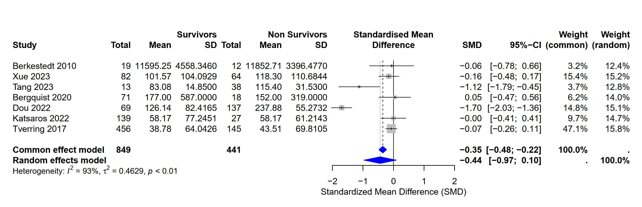

Supplemental Figure 1: Meta-analysis of Heparin Binding Protein (HBP) in patients with sepsis.
Forest plots comparing the levels of different HBPt proteins between survivors and non-survivors in the ICU. Each individual study is represented by a square, with its size proportional to the study's weight in the meta-analysis. Horizontal bars indicate 95% confidence intervals. The blue diamond represents the pooled effect estimate from the random-effects model. Heterogeneity values (I²) are provided for each analysis.

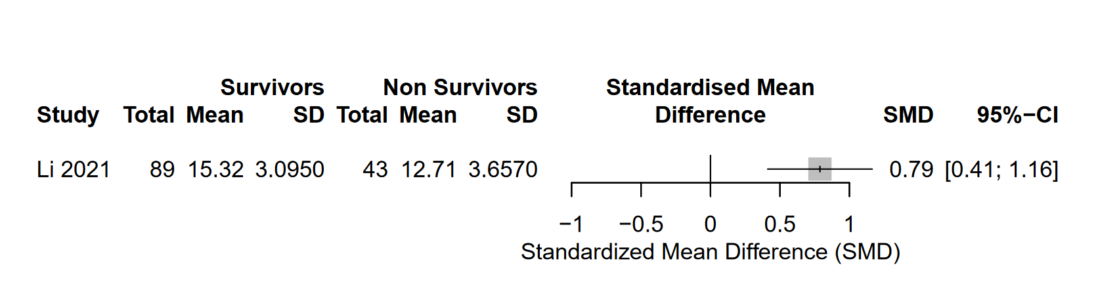
C1q

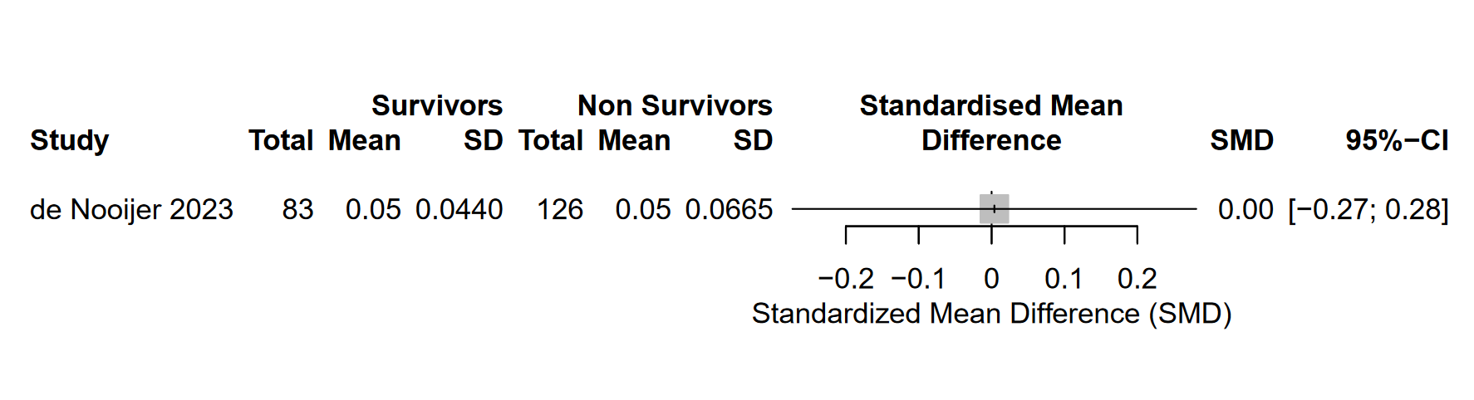C3c

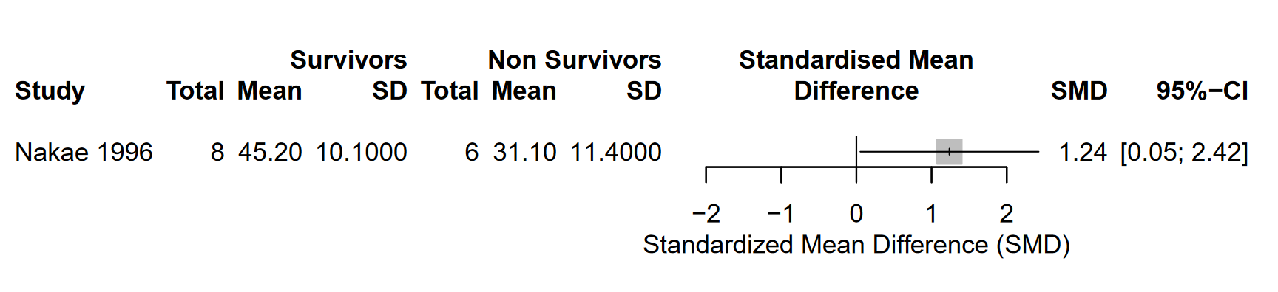
CH50
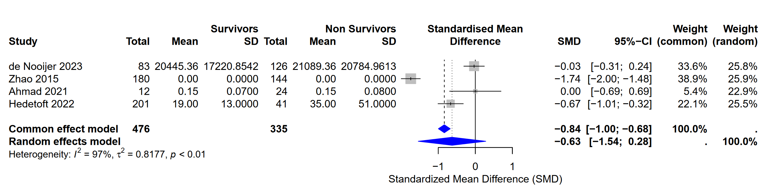MAC

For simplification TCC reported in de Noojer et al and Hedetoft et al articles as well as sC5b-9 reported in Ahmad’s article were considered as same as MAC.

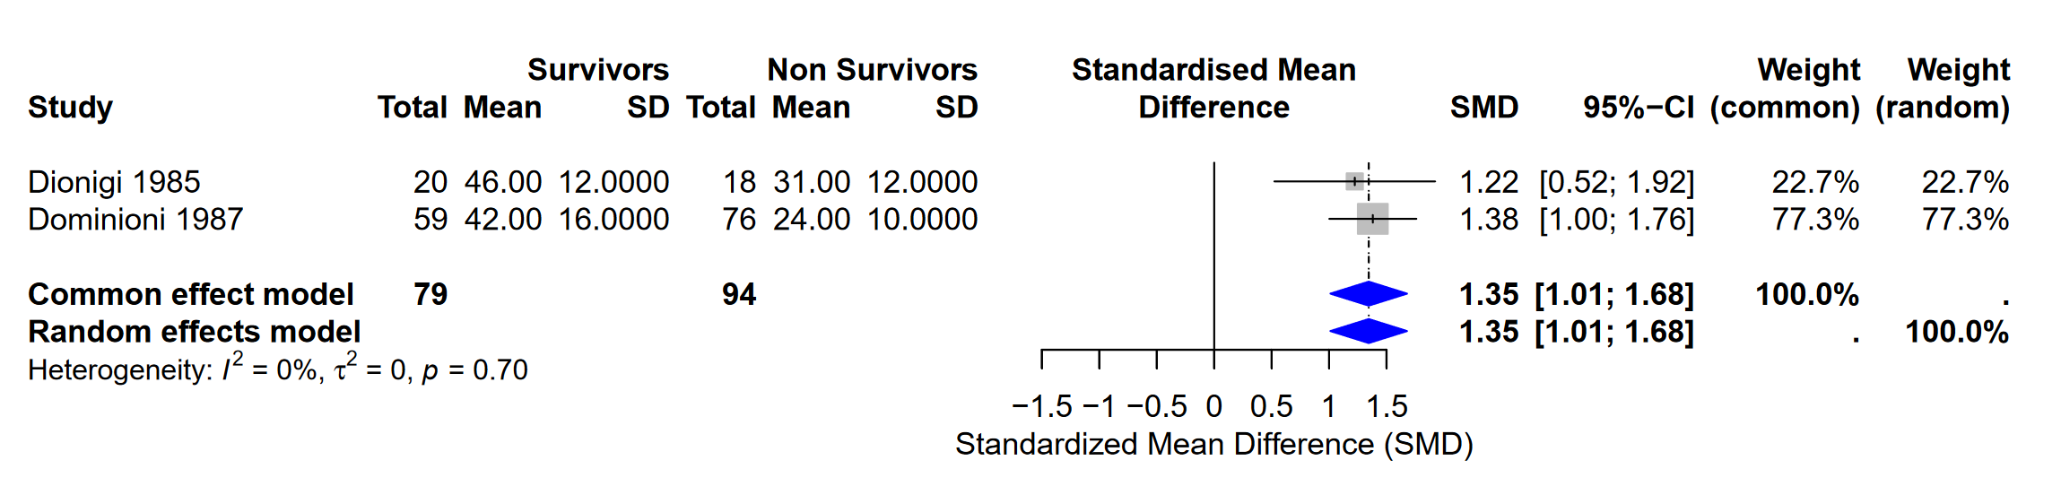
FB

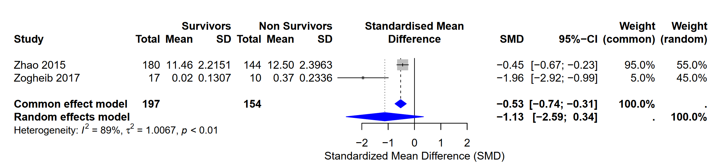
MBL

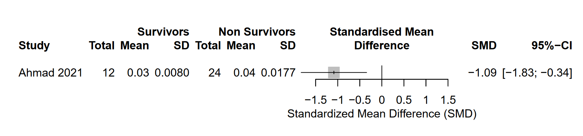
sCD59

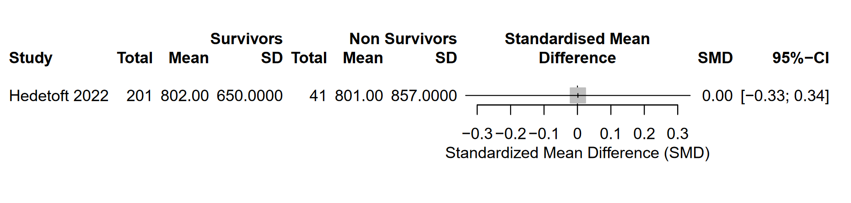
C3dg
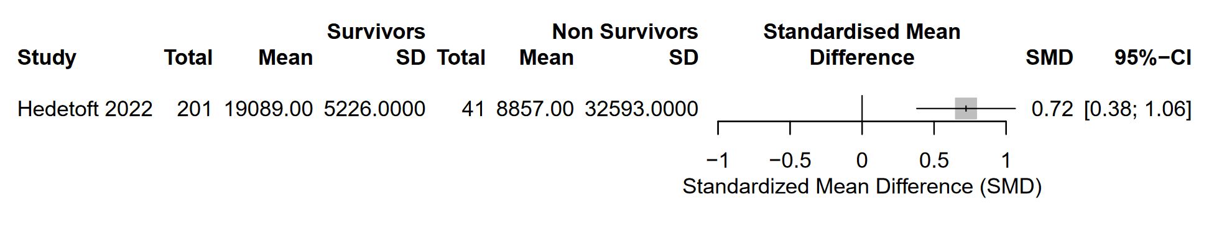
C3bc
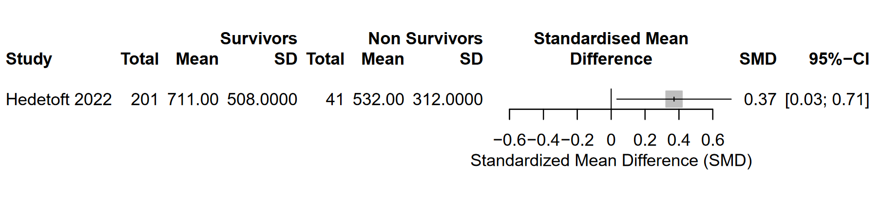
C4c
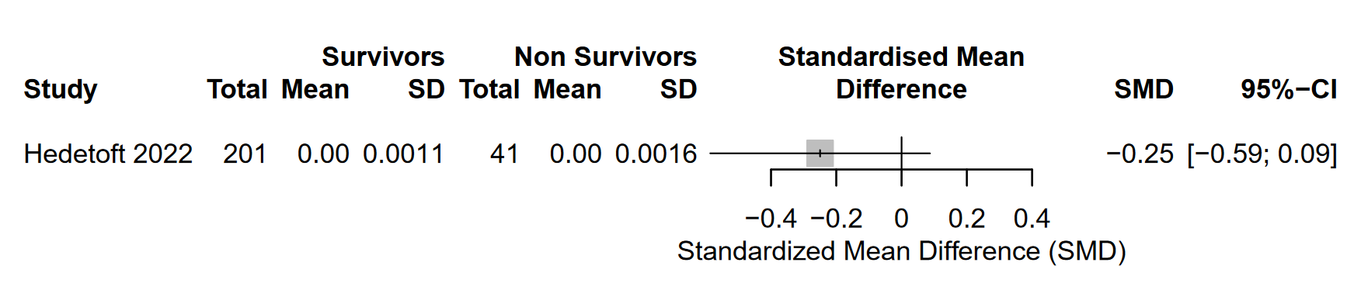
C4d

Supplemental Figure 2: Meta-analysis of complement proteins in patients with sepsis.
Forest plots comparing the levels of different complement proteins between survivors and non-survivors in the ICU. Each individual study is represented by a square, with its size proportional to the study's weight in the meta-analysis. Horizontal bars indicate 95% confidence intervals. The blue diamond represents the pooled effect estimate from the random-effects model. Heterogeneity values (I²) are provided for each analysis.

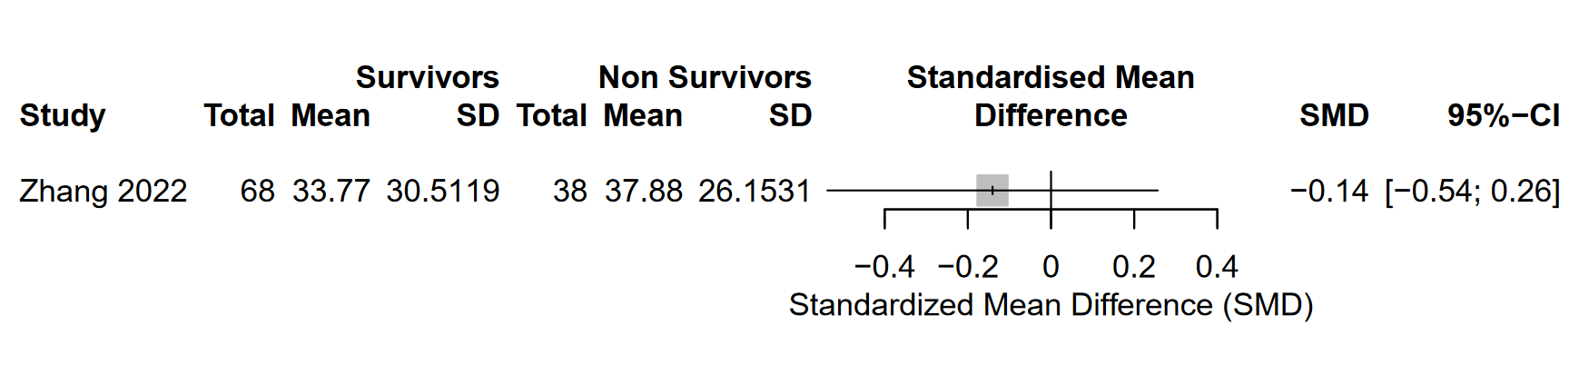
IgA1

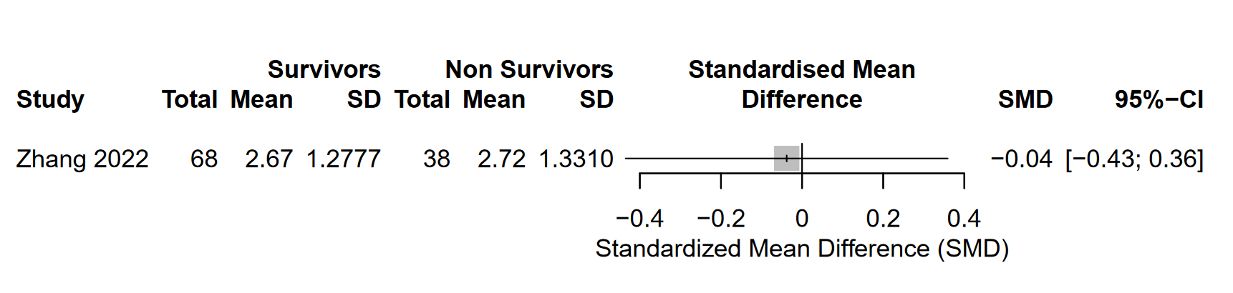
IgA2

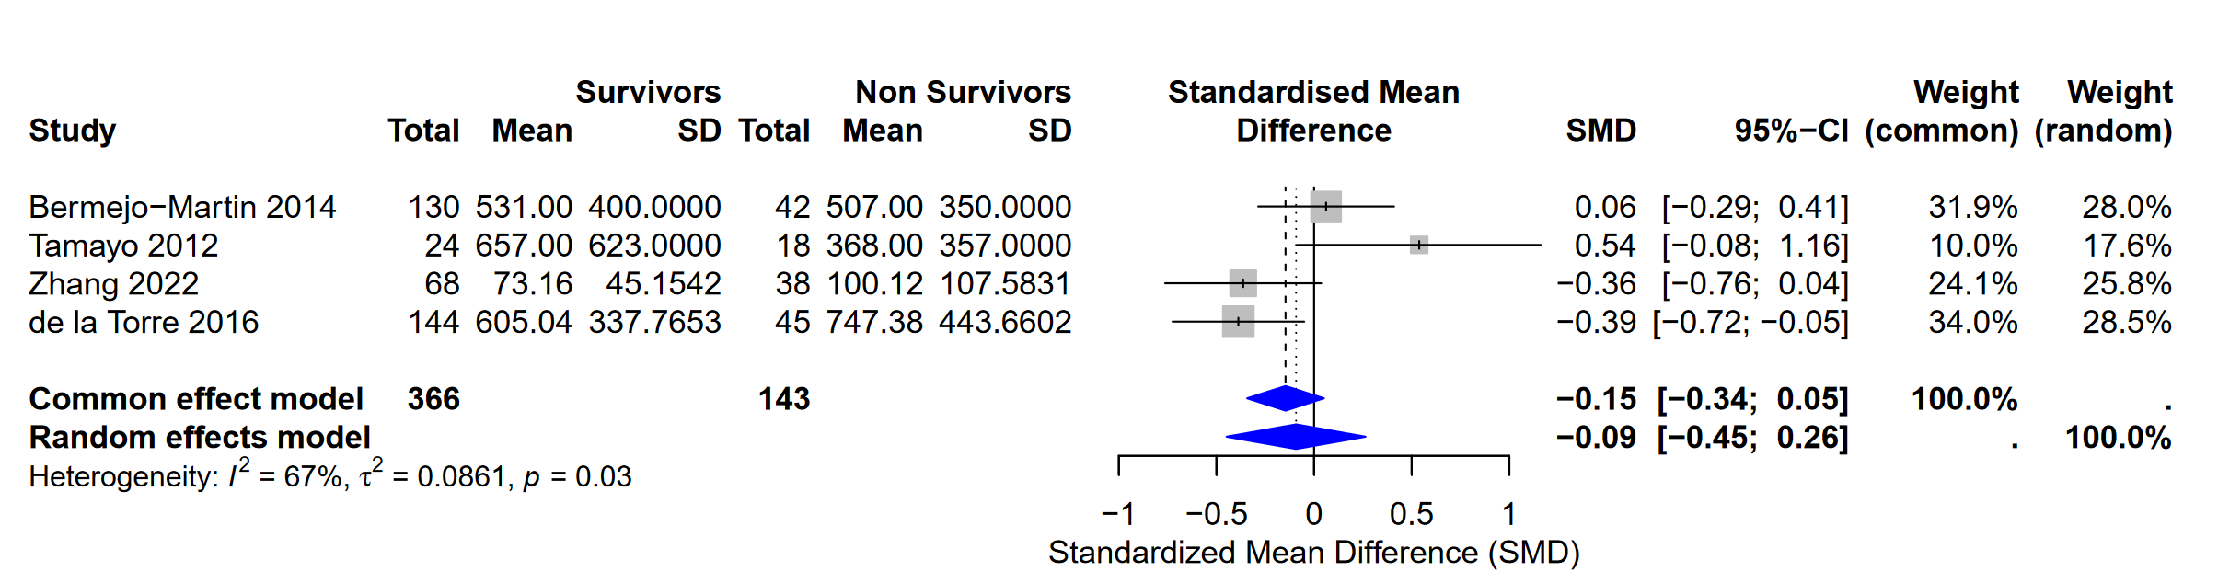
IgG1

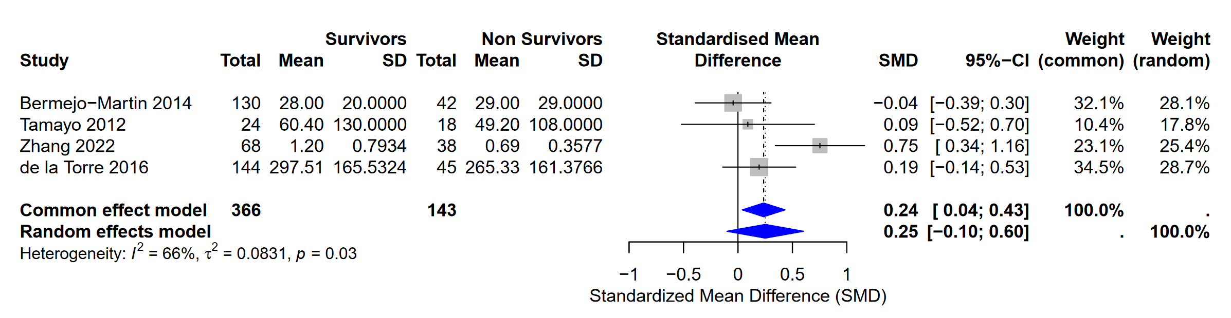
IgG2

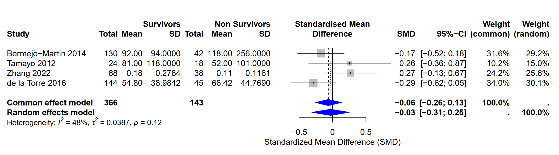
IgG3

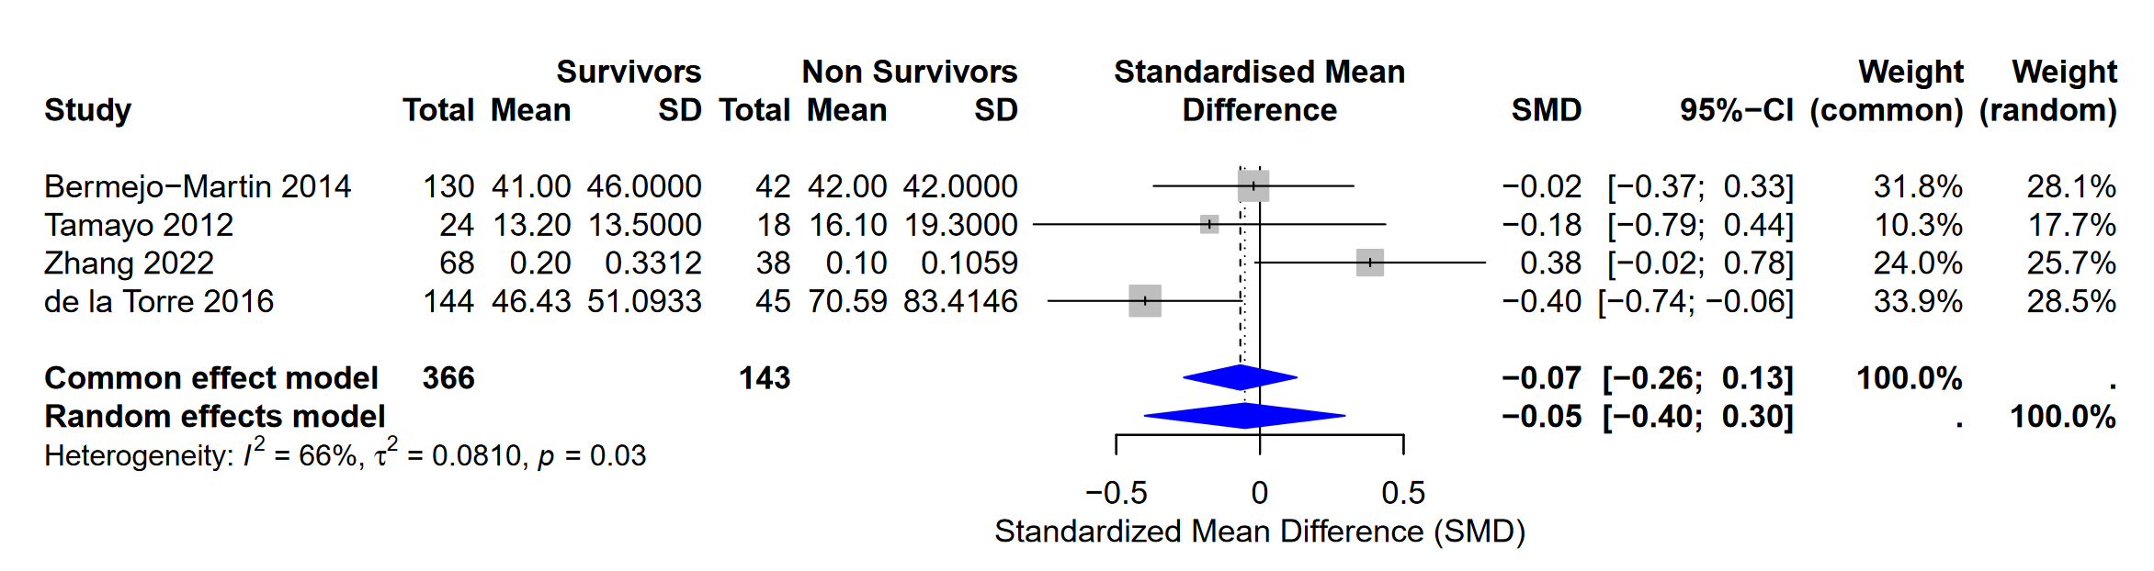
IgG4

Supplemental Figure 3: Meta-analysis of immunoglobulin in patients with sepsis.
Forest plots comparing the levels of different complement proteins between survivors and non-survivors in the ICU. Each individual study is represented by a square, with its size proportional to the study's weight in the meta-analysis. Horizontal bars indicate 95% confidence intervals. The blue diamond represents the pooled effect estimate from the random-effects model. Heterogeneity values (I²) are provided for each analysis.

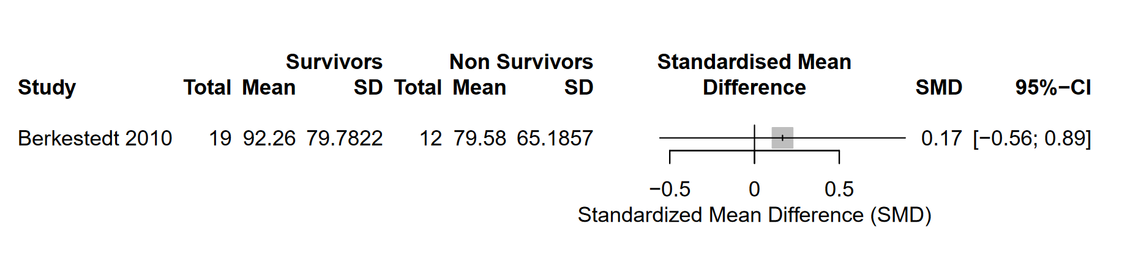
Defensin

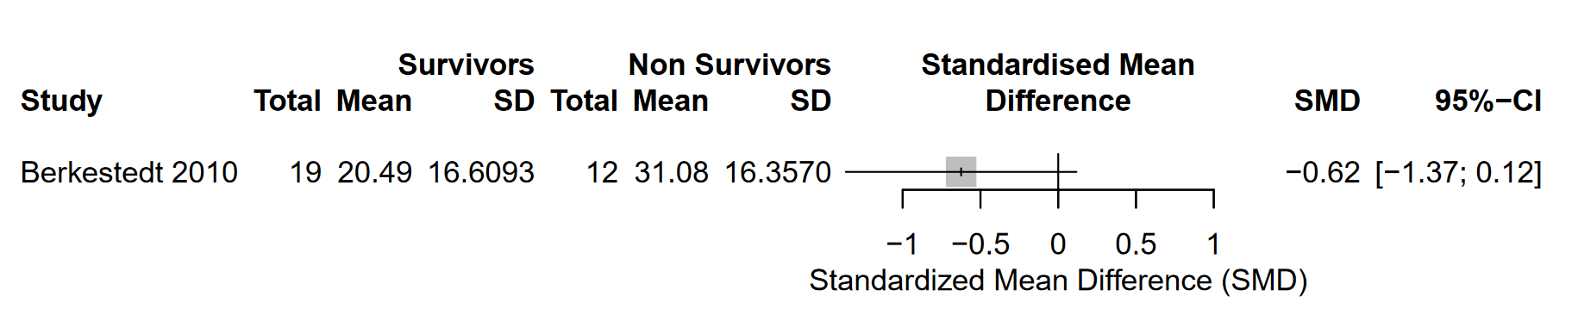
BPI

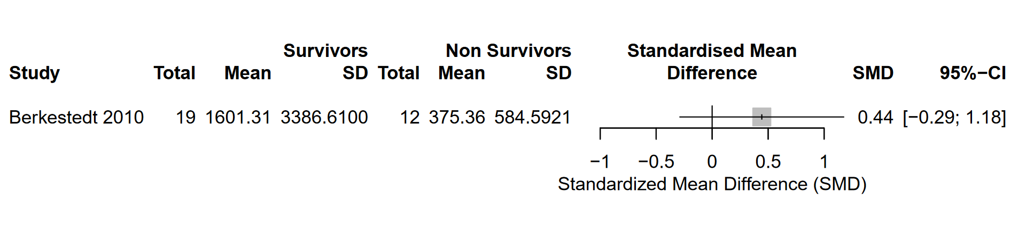
Lactoferrin

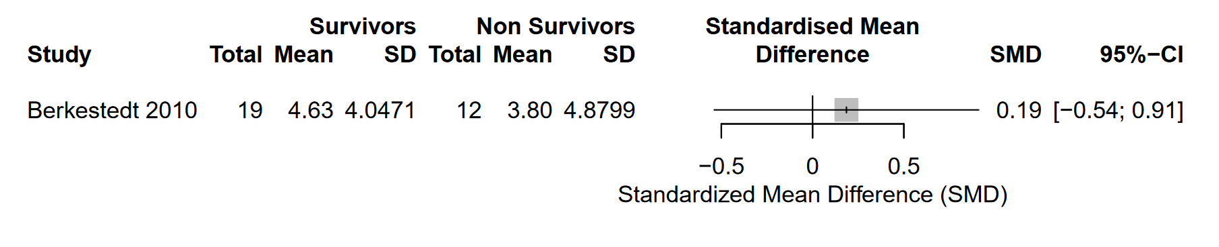
LL-37

Supplemental Figure 4: Meta-analysis of Anti-Microbial Peptides in patients with sepsis.
Forest plots comparing the levels of different complement proteins between survivors and non-survivors in the ICU. Each individual study is represented by a square, with its size proportional to the study's weight in the meta-analysis. Horizontal bars indicate 95% confidence intervals. The blue diamond represents the pooled effect estimate from the random-effects model. Heterogeneity values (I²) are provided for each analysis.

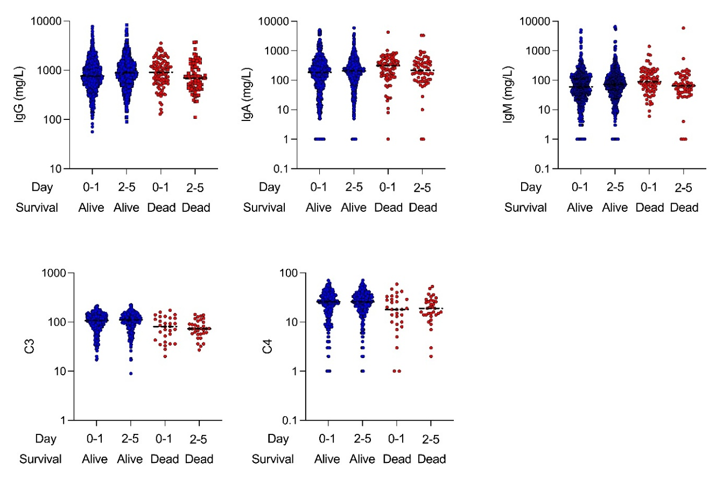

Supplemental Figure 5: MIMIC’s data: Boxplots illustrating the levels of immunoglobulins (A-C) and complement proteins (D-E) in critically ill patients stratified by survival status (blue = survivors, red = non-survivors) and time period (0-1 days vs. 2-5 days post-admission).

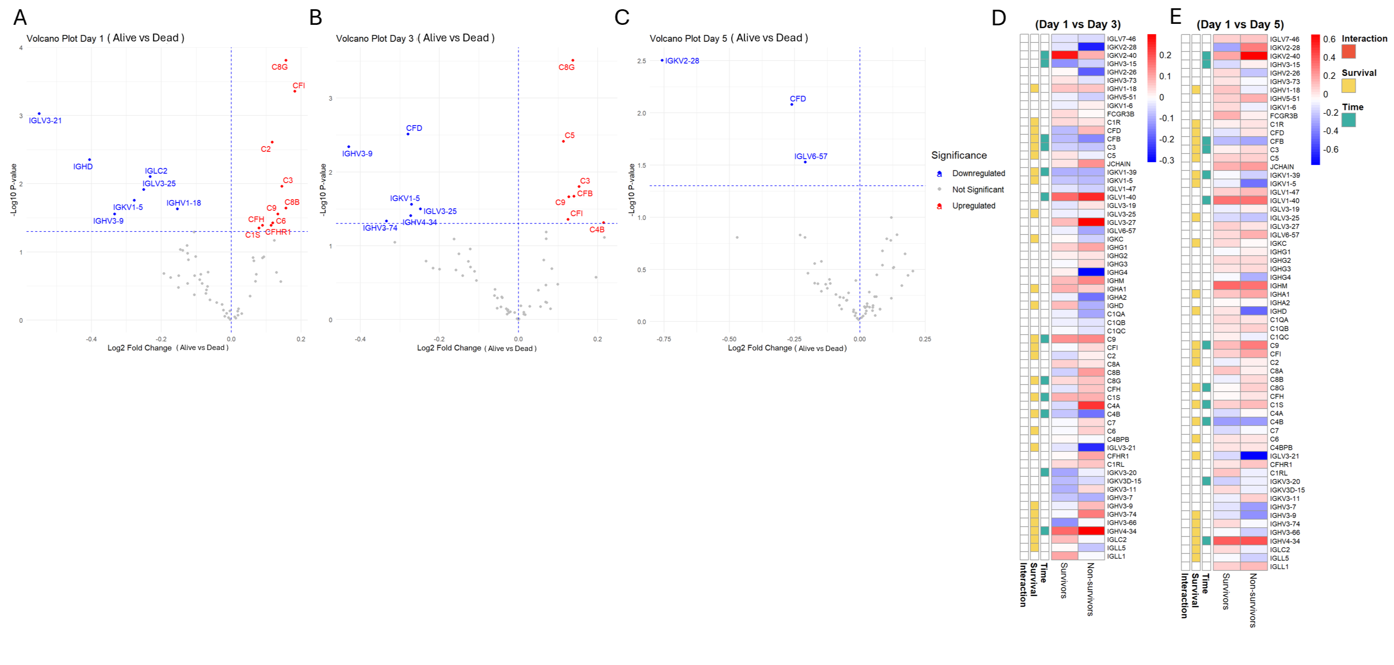
Supplementary Figure 6: Proteomic and mass spectrometry data from patients presenting in the ICU with sepsis (adapted from Mi et al. [68])
(a–c) Volcano plots comparing protein abundance between survivors and non-survivors on Day 1 (a), Day 3 (b), and Day 5 (c) after ICU admission. The x-axis represents the log₂ fold change (Alive vs. Dead), where positive values indicate higher abundance in survivors and negative values indicate higher abundance in non-survivors. The y-axis shows the –log₁₀(p-value). Proteins significantly overexpressed in survivors are shown in red, while those overexpressed in non-survivors are shown in blue. Grey points represent proteins with non-significant differences.
(d–e) Heatmaps showing temporal log₂ fold changes in protein abundance from Day 1 to Day 3 (d) and Day 1 to Day 5 (e), displayed separately for survivors and non-survivors. Rows represent individual proteins; columns represent timepoint comparisons. The color gradient reflects the direction and magnitude of change (red = increase; blue = decrease). Colored bars on the left indicate significant effects based on two-way ANOVA: green for time effect, yellow for survival effect, and orange for time × survival interaction.

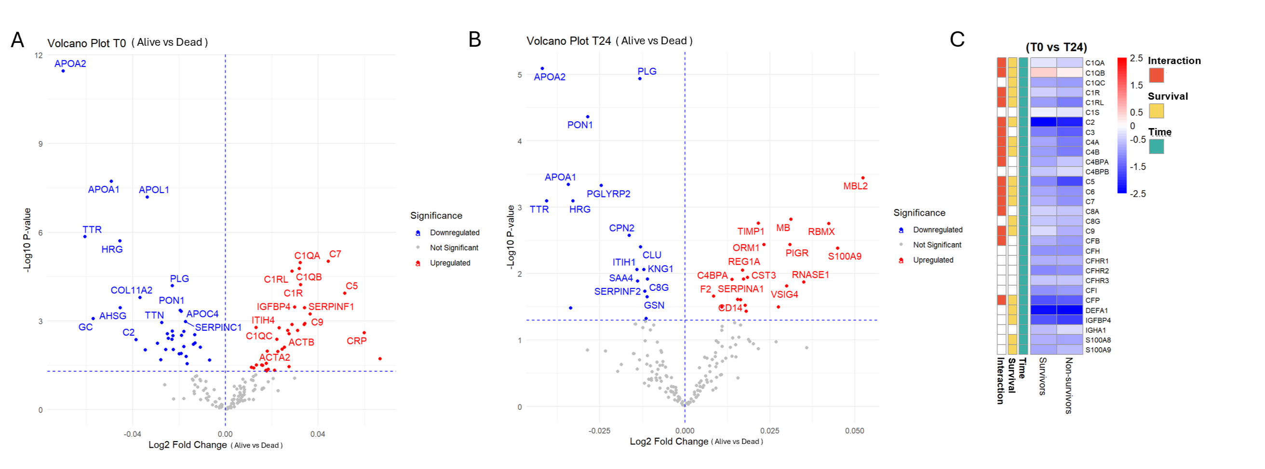

Supplementary Figure 7: Proteomic Data from Sepsis Patients Presenting to the Emergency Department (adapted from Langley et al. [70])
(a) Volcano plot comparing plasma protein abundance between survivors and non-survivors at baseline (T0), corresponding to the time of Emergency Department admission, prior to antibiotic or fluid administration. The x-axis represents the log₂ fold change (Alive vs Dead), where positive values indicate higher abundance in survivors, and negative values indicate higher abundance in non-survivors. The y-axis displays –log₁₀(p-value). Proteins significantly overexpressed in survivors are shown in red, and those overexpressed in non-survivors in blue. Grey points represent proteins with non-significant differences.
(b) Volcano plot at 24 hours post-presentation (T24), showing differential protein abundance between survivors and non-survivors after initial interventions. Axis conventions are the same as in panel (a).
(c) Heatmap showing longitudinal changes in plasma protein abundance from T0 to T24 in survivors and non-survivors. Each row corresponds to a protein from the complement system, immunoglobulins, or antimicrobial peptides. The color gradient represents the log₂ fold change (red = increased abundance; blue = decreased abundance). Left-side annotations indicate statistical significance from two-way ANOVA: green = time effect, yellow = survival effect, orange = time × survival interaction.

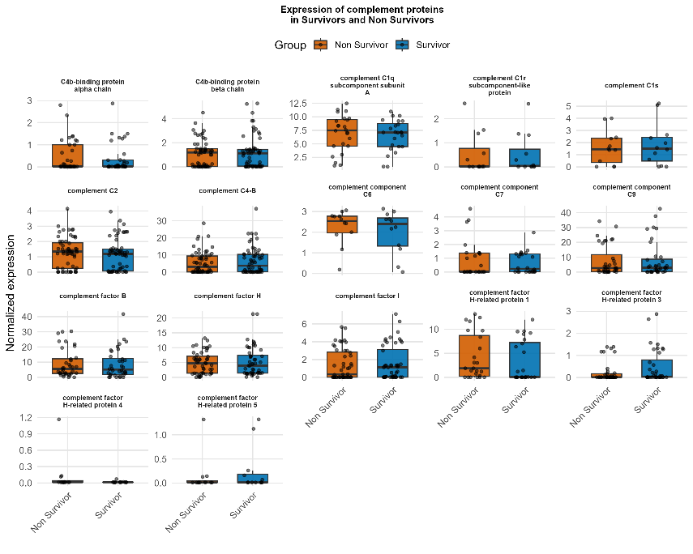

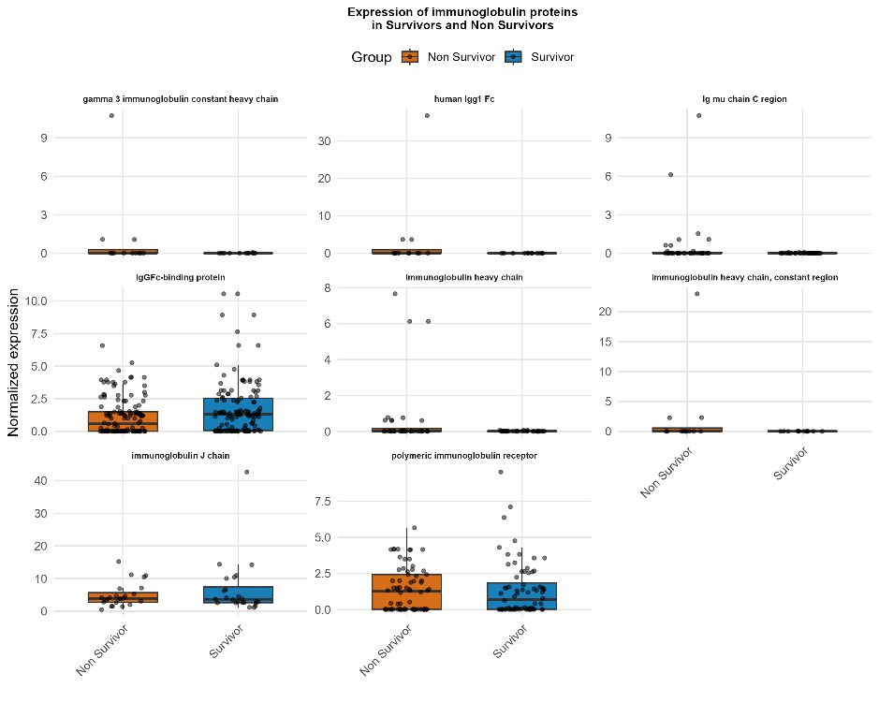

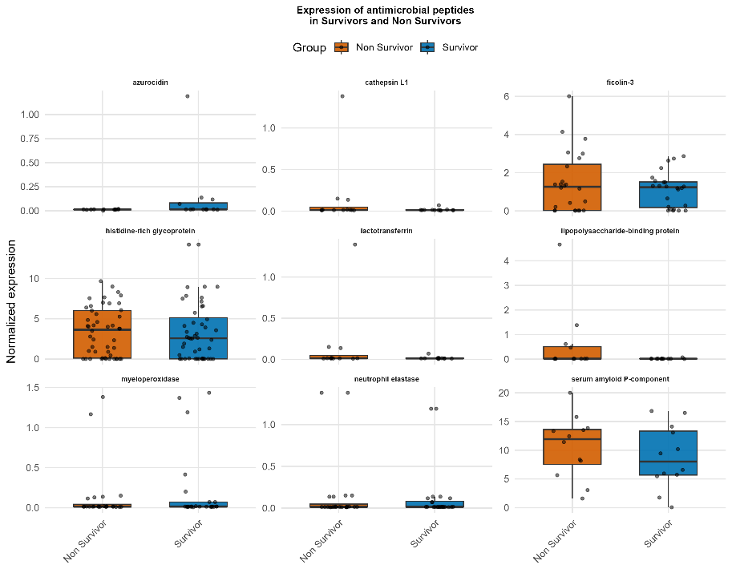

Supplemental Figure 8: Plasma Proteomic Analysis on ICU Admission (adapted from DeCoux et al. [69])
(a) Complement protein expression in sepsis survivors and non-survivors.
Box plots display the distribution of normalized expression levels for complement-related proteins in plasma samples collected at ICU admission. While some effector components of the terminal complement cascade (e.g., C9, C7, C2) appear visually elevated in non-survivors, only complement C5 was significantly different between groups according to an unpaired two-sample t-test (p = 0.042).
(b) Immunoglobulin protein expression in survivors and non-survivors.
Box plots showing plasma levels of immunoglobulin-related proteins, including IgG, IgA, and IgM components. Survivors exhibited higher expression of regulatory and transport proteins such as the immunoglobulin J chain, polymeric immunoglobulin receptor, and IgGFc-binding protein, the latter of which reached statistical significance (p = 0.006). Immunoglobulin heavy chain also showed a significant difference (p = 0.040).
(c) Antimicrobial peptide and related protein expression.
Box plots presenting expression levels of selected antimicrobial peptides and innate immune mediators, including azurocidin, cathepsin L1, ficolin-3, and myeloperoxidase.
Among the proteins tested, the following reached statistical significance between survivors and non-survivors:
- Tenascin C (p = 0.017)
- Coagulation factor X (p = 0.020)
- Adenosine deaminase CECR1 (p = 0.036)
- Pregnancy zone protein (p = 0.036)
- Neuropilin-1 (p = 0.042)
Statistical comparisons were performed using unpaired t-tests on normalized protein expression values.

C3
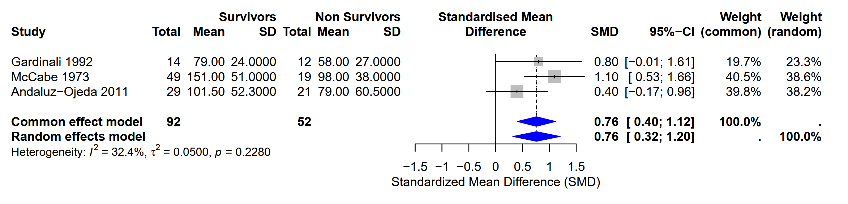
C3a
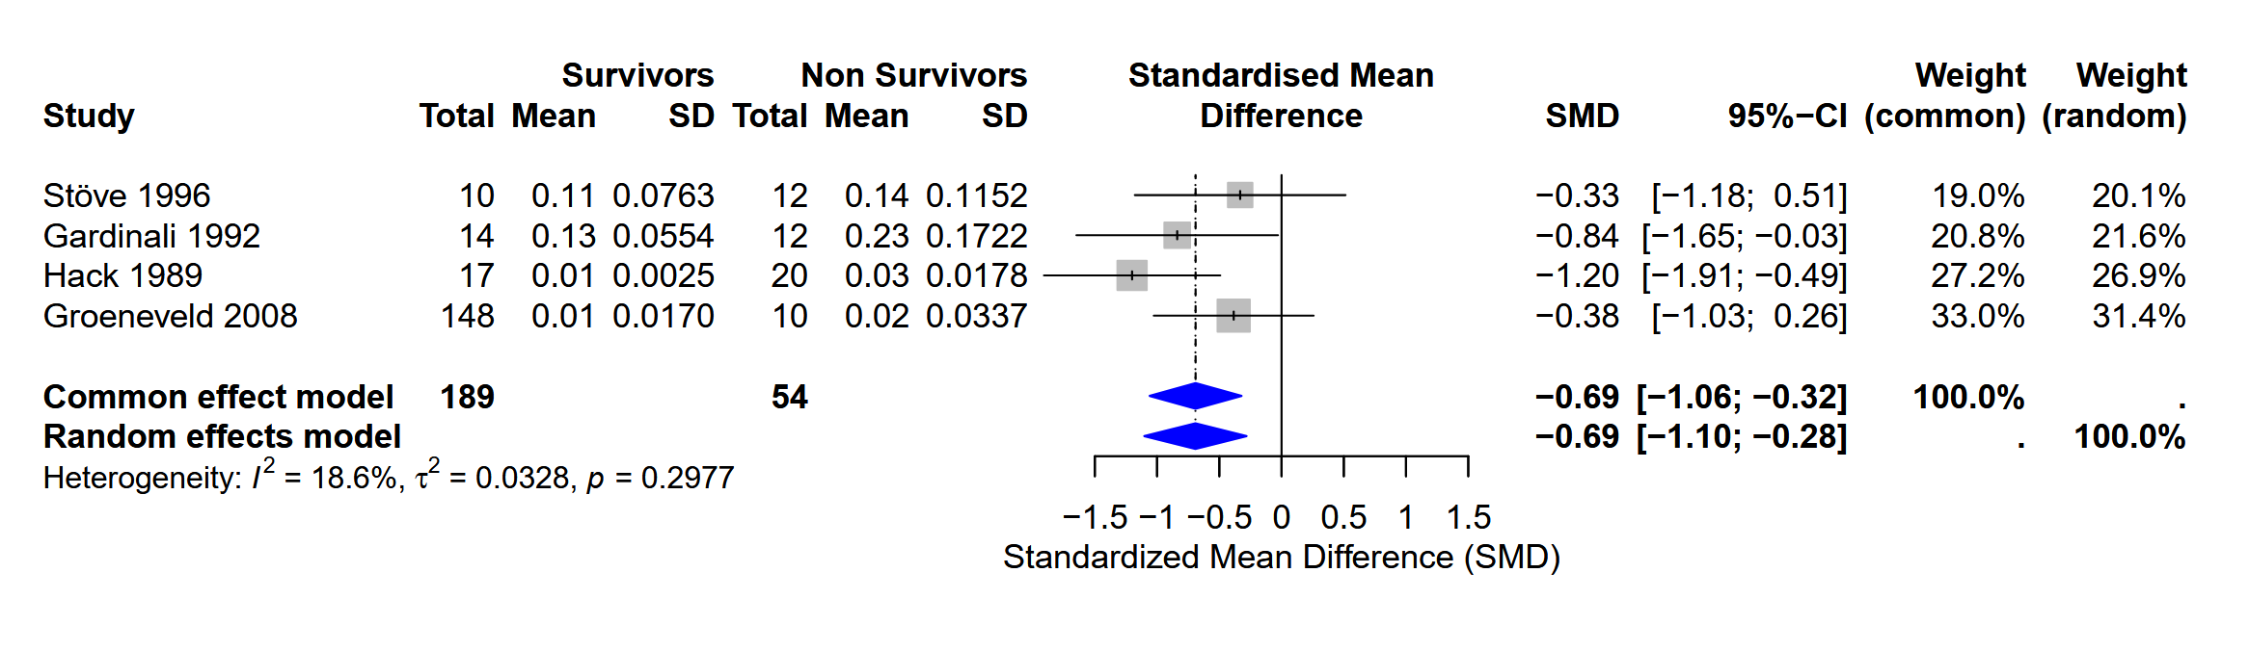
C4
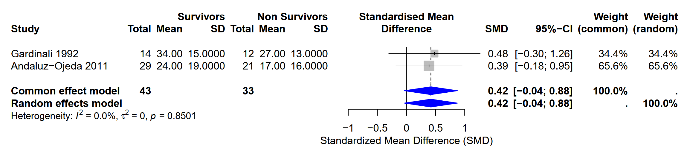
IgA
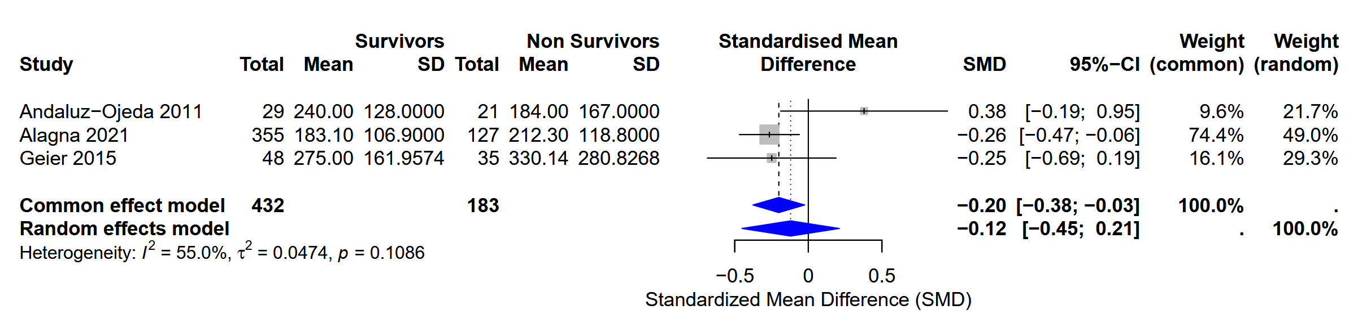
IgG
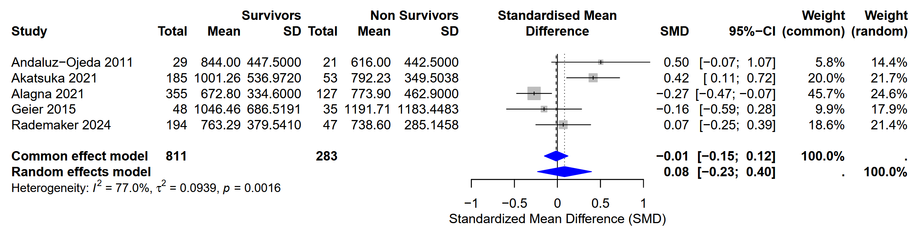

IgM
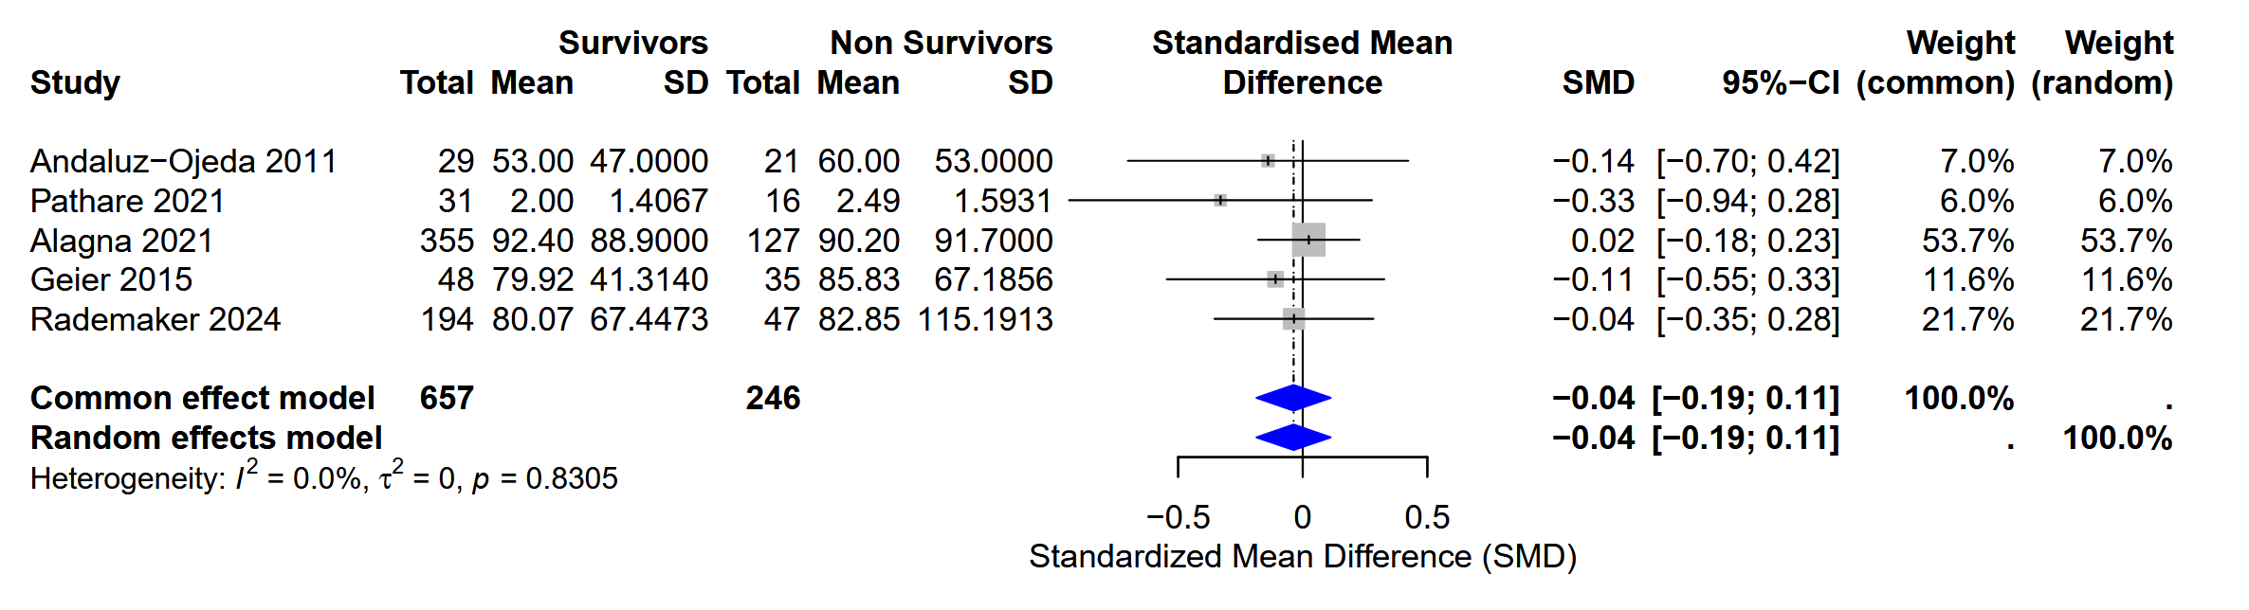

Supplemental Figure 9. Sensitivity analysis restricted to studies with protein measurements performed within 24 hours of ICU admission.

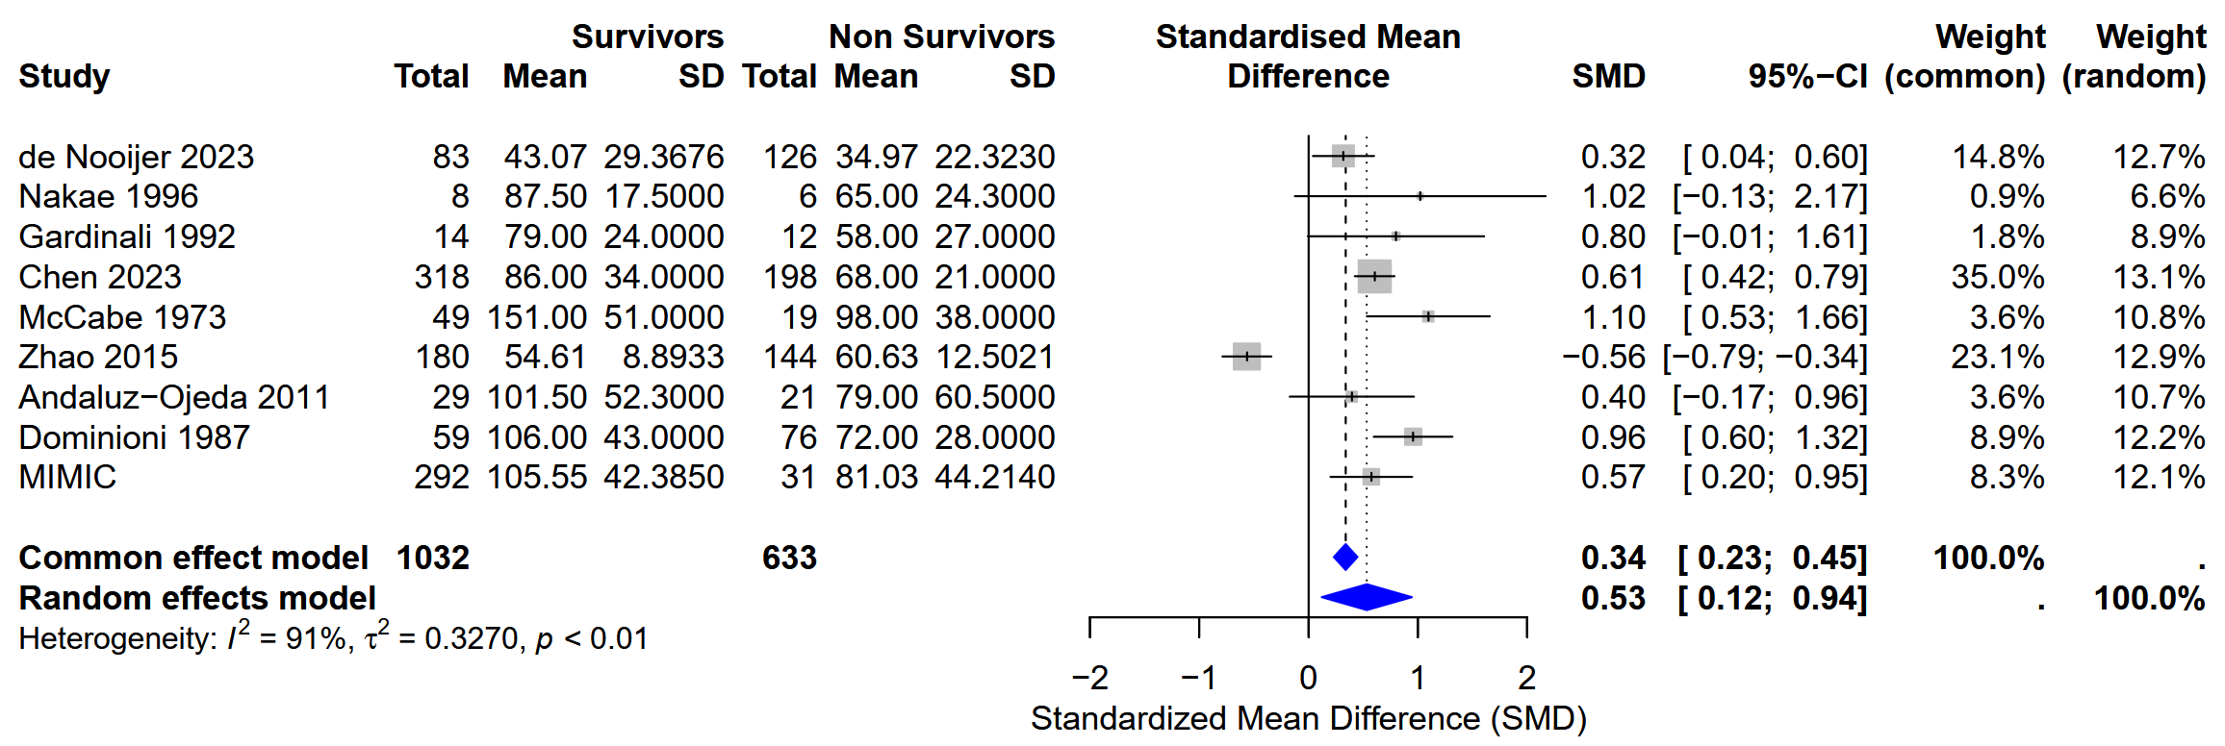
C3

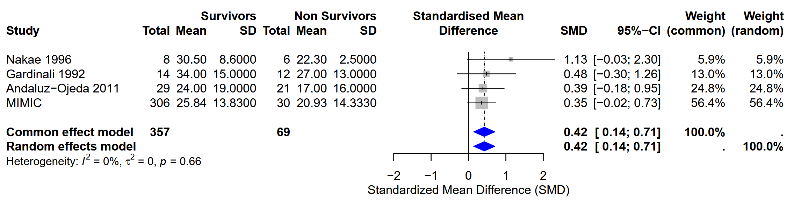
C4

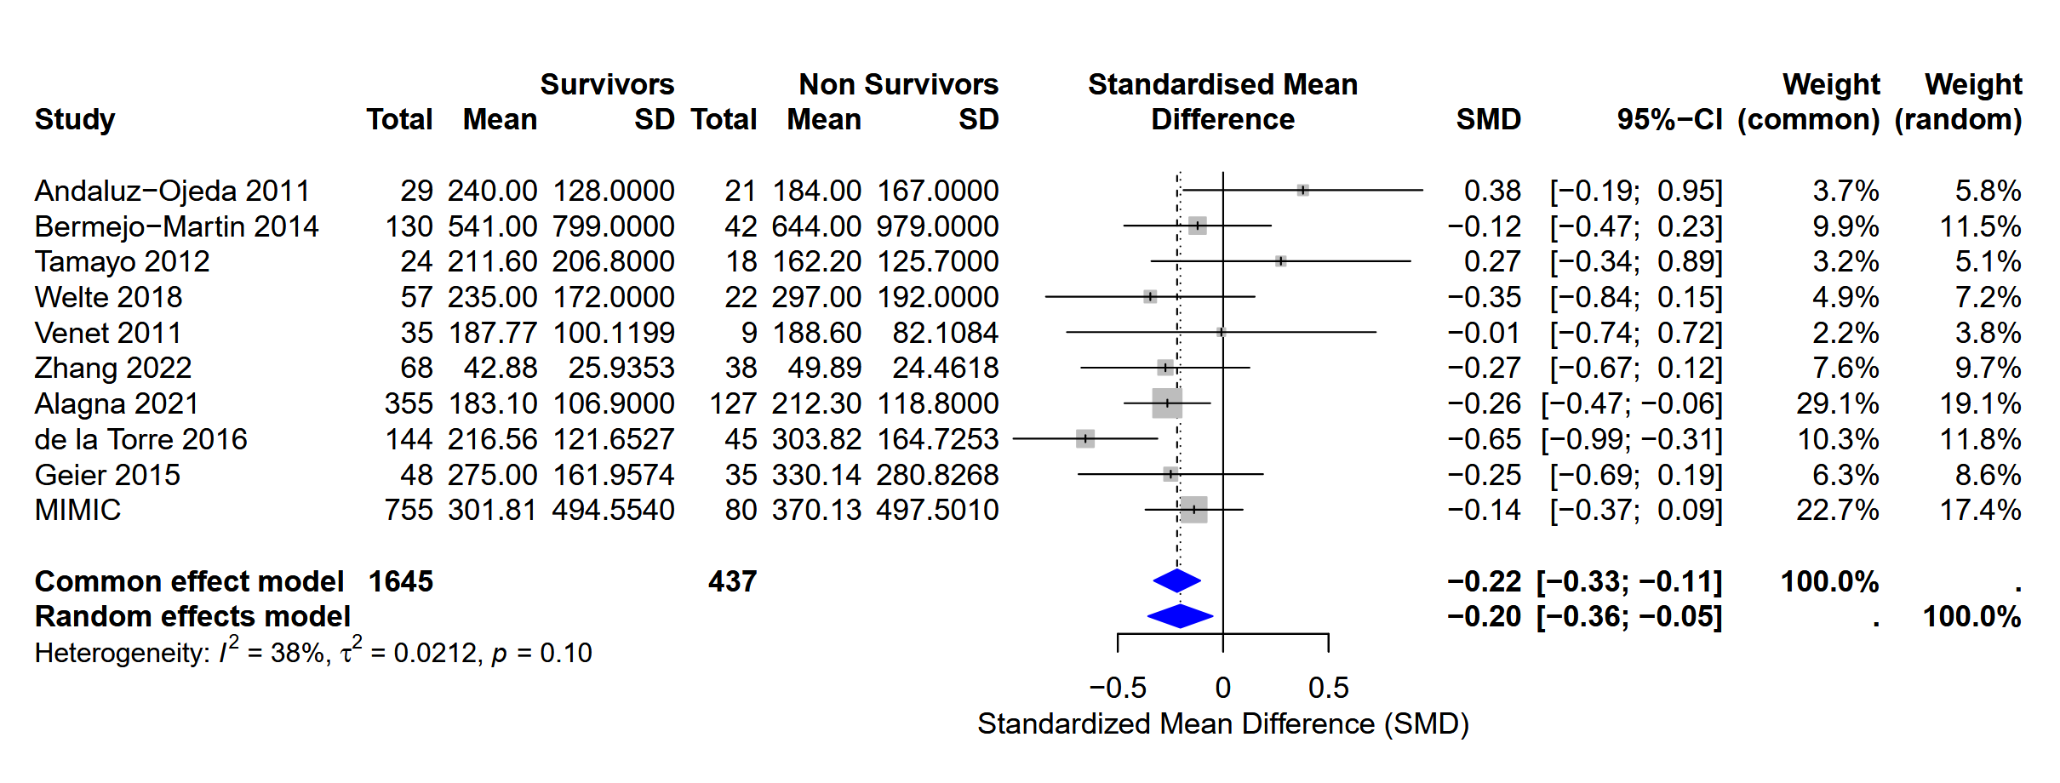
IgA

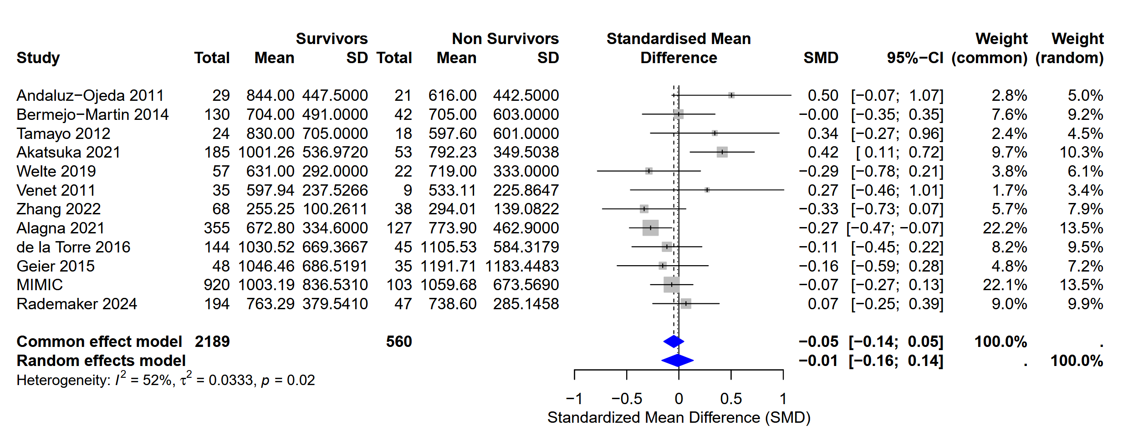
IgG

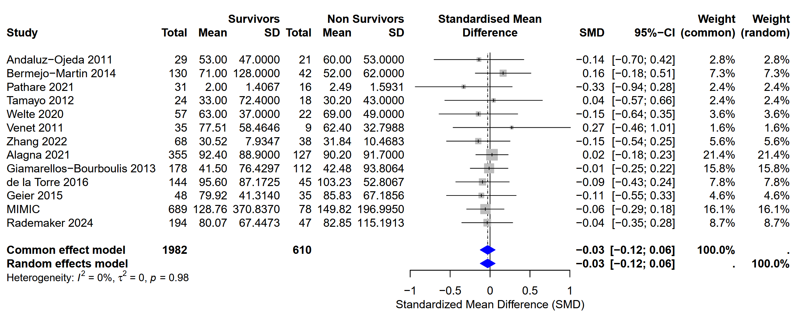
IgM

Supplemental Figure 10: Meta analysis of serum complement proteins and immunoglobulins with inclusion of the MIMIC data

