Supplementary table 1 -- International Classification of Diseases (ICD-9) Codes for study cohort identification
Disease Type | Condition | ICD-9-CM code/combination | Description
IPD | pneumococcal bacteremia | 038.2 | Pneumococcal septicemia
IPD | pneumococcal bacteremia | 038.0+041.2 | Streptococcal septicemia + PNI
IPD | pneumococcal bacteremia | 038.9+041.2 | Unspecified septicemia + PNI
IPD | pneumococcal bacteremia | 790.7+041.2 | Pneumococcal bacteremia + PNI
IPD | pneumococcal meningitis | 320.1 | Pneumococcal meningitis
IPD | pneumococcal meningitis | 320.2+041.2 | Streptococcal Pneumococcal meningitis + PNI
IPD | pneumococcal meningitis | 320.8x/320.9 +041.2 | Bacterial Pneumococcal meningitis, unspecified + PNI
IPD | pneumococcal meningitis | 322.9+041.2 | Pneumococcal meningitis, unspecified + PNI
IPD | bacteremic pneumonia | 510.x+041.2 | Empyema + PNI
IPD | bacteremic pneumonia | 511.1/511.9 +041.2 | Pleural effusion + PNI
IPD | bacteremic pneumonia | 038.2+ Pneumococcal  Pneumonia; | One code from the list of pneumococcal specific septicemia and one code from the list of pneumonia
IPD | bacteremic pneumonia | 038.0+041.2+ Pneumococcal  Pneumonia;
IPD | bacteremic pneumonia | 038.9+041.2+ Pneumococcal  Pneumonia;
IPD | bacteremic pneumonia | 790.7+041.2+ Pneumococcal  Pneumonia;
IPD | bacteremic pneumonia | 038.0+481;
IPD | bacteremic pneumonia | 038.9+481;
IPD | bacteremic pneumonia | 790.7+481
IPD | Others | 41.2 | Pneumococcal arthritis
IPD | Others | 567.1 | Pneumococcal peritonitis
IPD | Others | 420.9x+041.2 | Infective pericarditis + PNI
IPD | Others | 421.0+041.2 | Bacterial endocarditis + PNI
IPD | Others | 421.1/421.9 +041.2 | Endocarditis, unspecified + PNI
IPD | Others | 567.23+041.2 | Spontaneous bacterial peritonitis + PNI
IPD | Others | 730.0x, 730.2x +041.2 | Osteomyelitis + PNI
IPD | Others | 711.0x/711.9x +041.2 | Pyogenic/unspecified arthritis + PNI
non-IPD | Pneumococcal  Pneumonia | 481 | Pneumococcal pneumonia
non-IPD | Pneumococcal  Pneumonia | 482.9+041.2 | Bacterial pneumonia, unspecified+ PNI
non-IPD | Pneumococcal  Pneumonia | 485+041.2 | Bronchopneumonia + PNI
non-IPD | Pneumococcal  Pneumonia | 486+041.2 | Pneumonia, organism unspecified + PNI
non-IPD | AOM | 382.x+041.2 | Acute suppurative OM, suppurative and unspecified OM + PNI
non-IPD | OME | 381.x+041.2 | non-suppurative OM and eustachian tube disorders + PNI
non-IPD | OME | 384.0x+041.2 | Acute myringitis, unspecified + PNI
non-IPD | AOM  complication | 384.2+041.2 | Perforation of tympanic membrane + PNI
non-IPD | AOM  complication | 388.6+041.2 | Otorrhea + PNI
non-IPD | AOM  complication | 383.0x+041.2 | Acute mastoiditis + PNI
non-IPD | AOM procedure | 20.0x (myringotomy) +041.2 | Drainage of middle ear/tympanic Membrane + PNI
IPD, Invasive Pneumococcal Diseases; PNI, Pneumococcal Infections; AOM, acute Otitis Media; OME, Otitis Media with effusion.

Supplementary table 2 -- International Classification of Diseases (ICD-9) Codes for Prior Comorbidities

Disease Type | Condition | ICD-9-CM code/combination
Neurological | Cerebrospinal fluid leakage | Cerebrospinal fluid rhinorrhea: 349.81
Neurological | Cerebrospinal fluid leakage | Cerebrospinal fluid otorrhea: 388.61
Neurological | Cochlear implant | Implantation or replacement of cochlear prosthetic device, not otherwise specified: 20.96
Neurological | Cochlear implant | Implantation or replacement of cochlear prosthetic device, single channel: 20.97
Neurological | Cochlear implant | Implantation or replacement of cochlear prosthetic device, multiple channel: 20.98
Neurological | Chronic neurological conditions that can compromise respiratory functions, the handling of respiratory secretions, increase the risk for aspiration. | Cerebral cortex: 851.0
Neurological |  | Stroke (aspiration):
Neurological |  | 433-434 and 436
Neurological |  | 430-432
Neurological |  | Neoplasm: 140–239
Neurological |  | Seizures (aspiration): 333.2, 345, 649.4, 779.0, 780.39
Neurological |  | Brain stem: 851.40
Neurological |  | Multiple sclerosis: 340
Neurological |  | Parkinson’s disease: 332
Neurological |  | Tetanus: 037
Neurological |  | Unspecified disease of spinal cord: 336.9
Neurological |  | Spinal muscular atrophy: 335.1
Neurological |  | Late effect acute polio: 138
Neurological |  | Amyotrophic lateral sclerosis: 335.20
Neurological |  | Guillain-Barré syndrome: 357.0
Neurological |  | Disorders of porphyrin metabolism: 277.1
Neurological |  | Critical illness polyneuropathy: 357.82
Neurological |  | Myasthenia gravis: 358.00
Neurological |  | Acid maltase deficiency: 271.0
Neurological |  | Congenital muscular dystrophy: 359.0
Neurological |  | Hereditary progressive muscular dystrophy: 359.1
Neurological |  | Myotonic dystrophies: 359.21
Neurological |  | Polymyositis: 710.4
Neurological |  | Critical illness myopathy: 359.81
Neurological |  | Hypokalemia: 276.8
Neurological |  | Rhabdomyolysis: 728.88
Cardiovascular | Chronic cardiovascular disease (except hypertension without complication) | Chronic rheumatic heart disease: 393.xx-398.xx
Cardiovascular |  | Hypertensive heart disease: 402.xx
Cardiovascular |  | Hypertensive heart and chronic kidney disease: 404.xx
Cardiovascular |  | Ischemic heart disease: 410.xx-414.xx
Cardiovascular |  | Chronic pulmonary heart disease: 416.xx
Cardiovascular |  | Other diseases of endocardium: 424.xx
Cardiovascular |  | Cardiomyopathy: 425.xx
Cardiovascular |  | Heart failure: 428.xx
Cardiovascular |  | Ill-defined descriptions and complications of heart disease: 429.xx
Cardiovascular |  | Bulbus cordis anomalies and anomalies of cardiac septal closure: 745.xx
Cardiovascular |  | Other congenital anomalies of heart: 746.xx
Cardiovascular |  | Coarctation of aorta: 747.1
Lung | Chronic lung diseases | Cystic fibrosis: 277.0x
Lung | Chronic lung diseases | Other chronic pulmonary heart diseases: 416.8x
Lung | Chronic lung diseases | Chronic pulmonary heart disease, unspecified: 416.9x
Lung | Chronic lung diseases | Bronchitis, not specified as acute or chronic: 490.xx
Lung | Chronic lung diseases | Chronic bronchitis: 491.xx
Lung | Chronic lung diseases | Emphysema: 492.xx
Lung | Chronic lung diseases | Asthma: 493.xx
Lung | Chronic lung diseases | Bronchiectasis: 494.xx
Lung | Chronic lung diseases | Extrinsic allergic alveolitis: 495.xx
Lung | Chronic lung diseases | Chronic airway obstruction, not elsewhere classified: 496.xx
Lung | Chronic lung diseases | Coal workers' pneumoconiosis: 500.xx
Lung | Chronic lung diseases | Asbestosis: 501.xx
Lung | Chronic lung diseases | Pneumoconiosis due to other silica or silicates: 502.xx
Lung | Chronic lung diseases | Pneumoconiosis due to other inorganic dust: 503.xx
Lung | Chronic lung diseases | Pneumonopathy due to inhalation of other dust: 504.xx
Lung | Chronic lung diseases | Pneumoconiosis, unspecified: 505.xx
Lung | Chronic lung diseases | Chronic respiratory conditions due to fumes and vapors: 506.4x
Lung | Chronic lung diseases | Postinflammatory pulmonary fibrosis: 515.xx
Lung | Chronic lung diseases | Other alveolar and parietoalveolar pneumonopathy: 516.xx
Lung | Chronic lung diseases | Chronic respiratory failure: 518.83
Lung | Chronic lung diseases | Acute and chronic respiratory failure: 518.84
Lung | Chronic lung diseases | Other diseases of lung, not elsewhere classified: 518.89
Lung | Chronic lung diseases | Chronic respiratory disease arising in the perinatal period: 770.7x
Liver | Chronic liver diseases | Chronic liver disease and cirrhosis: 571.xx
Liver | Chronic liver diseases | Liver abscess and sequelae of chronic liver disease: 572.xx
Liver | Chronic liver diseases | Other disorders of liver: 573.xx
Liver | Chronic liver diseases | Esophageal varices with bleeding: 456.0
Liver | Chronic liver diseases | Esophageal varices without mention of bleeding: 456.1
Liver | Chronic liver diseases | Esophageal varices in diseases classified elsewhere: 456.2x
Liver | Chronic liver diseases | Viral hepatitis b with hepatic coma: 070.2x
Liver | Chronic liver diseases | Viral hepatitis b without mention of hepatic coma: 070.3x
Liver | Chronic liver diseases | Chronic hepatitis C with hepatic coma: 070.44
Liver | Chronic liver diseases | Chronic hepatitis C without mention of hepatic coma: 070.54
Liver | Chronic liver diseases | Unspecified viral hepatitis c: 070.7x
Kidney | Chronic kidney diseases | Hypertensive chronic kidney disease: 403.xx
Kidney | Chronic kidney diseases | Hypertensive heart and chronic kidney disease: 404.xx
Kidney | Chronic kidney diseases | Nephrotic syndrome: 581.xx
Kidney | Chronic kidney diseases | Chronic glomerulonephritis: 582.xx
Kidney | Chronic kidney diseases | Chronic kidney disease: 585.xx
Kidney | Chronic kidney diseases | Renal failure, unspecified: 586
Kidney | Chronic kidney diseases | Congenital anomalies of urinary system: 753.xx
Kidney | Chronic kidney diseases | Kidney replaced by transplant: V42.0
Kidney | Chronic kidney diseases | Postsurgical renal dialysis status: V45.1
Kidney | Chronic kidney diseases | Encounter for dialysis and dialysis catheter care: V56.xx
Metabolic | Metabolic diseases including diabetes mellitus or obesity; | Polyneuropathy in diabetes: 357.2x
Metabolic | Metabolic diseases including diabetes mellitus or obesity; | Diabetic retinopathy: 362.0x
Metabolic | Metabolic diseases including diabetes mellitus or obesity; | Diabetic cataract: 366.41
Metabolic | Metabolic diseases including diabetes mellitus or obesity; | Diabetes mellitus complicating pregnancy childbirth or the puerperium: 648.0x
Metabolic | Metabolic diseases including diabetes mellitus or obesity; | Insulins and antidiabetic agents causing adverse effects in therapeutic use: E932.3x
Metabolic | Metabolic diseases including diabetes mellitus or obesity; | Secondary diabetes mellitus: 249.xx
Metabolic | Metabolic diseases including diabetes mellitus or obesity; | Diabetes mellitus: 250.xx
Immunological | Immunocompromised states related to weakened immune system due to conditions such as asplenia, or HIV/AIDS | Disorders involving the immune mechanism: 279.xx
Immunological |  | Other disorders of purine and pyrimidine metabolism: 277.2
Immunological |  | Other deficiencies of circulating enzymes: 277.6
Immunological |  | Other B-complex deficiencies: 266.2
Immunological |  | Polyclonal hypergammaglobulinemia: 273.0
Immunological |  | Monoclonal paraproteinemia: 273.1
Immunological |  | Other paraproteinemias: 273.2
Immunological |  | Neutropenia: 288.0x
Immunological |  | Functional disorders of polymorphonuclear neutrophils: 288.1
Immunological |  | Genetic anomalies of leukocytes: 288.2
Immunological |  | Other specified diseases of blood and blood-forming organs: 289.89
Immunological |  | Other spinocerebellar diseases: 334.8
Immunological |  | Human immunodeficiency virus [HIV] disease: 042
Immunological |  | Asymptomatic human immunodeficiency virus [HIV] infection status: V08
Immunological |  | Human immunodeficiency virus, type 2 [HIV-2]: 079.53

Supplementary table 3 – Antimicrobial susceptibility tests (AST) results, grouped by class of antibiotics
Antibiotics Class | Sensitive | Intermediate susceptibility | Resistance | Total episodes tested | % Non-susceptible
WHO AWaRe classification -- Access
Tetracyclines | 5 | 27 | 2 | 34 | 85% (29/34)
Lincosamides | 40 | 163 | 0 | 203 | 80% (163/203)
Sulfonamide-trimethoprim-combinations | 776 | 1167 | 44 | 1987 | 61% (1211/1987)
Penicillins | 1676 | 400 | 104 | 2180 | 23% (504/2180)
Amphenicols | 39 | 7 | 0 | 46 | 15% (7/46)
Beta-lactam/beta-lactamase-inhibitor | 20 | 0 | 1 | 21 | 5% (1/21)
WHO AWaRe classification -- Watch
Macrolides | 449 | 1627 | 13 | 2089 | 79% (1640/2089)
Carbapenems | 7 | 1 | 2 | 10 | 30% (3/10)
Third-generation-cephalosporins | 281 | 25 | 41 | 347 | 19% (66/347)
Fluoroquinolones | 743 | 13 | 2 | 758 | 2% (15/758)
Glycopeptides | 280 | 0 | 0 | 280 | 0% (0/280)
Rifamycins | 61 | 0 | 0 | 61 | 0% (0/61)
WHO AWaRe classification – Reserve
Oxazolidinones | 90 | 0 | 0 | 90 | 0% (0/90)

Supplementary table 4 – The distribution of serotypes isolated
Invasive Pneumococcal Disease (IPD)
Included in Vaccine | Serotype** | Overall, N = 200 | Isolates non-susceptible to ≥1 antibiotics, N = 149 | Isolates susceptible to antibiotics, N = 51
PCV7 | 14 | 16 (8.0%) | 16 (11%) | 0 (0%)
 | 19F | 6 (3.0%) | 6 (4.0%) | 0 (0%)
 | 23F, 4, 6B, 9V | 17 (8.5%) | 14 (9.4%) | 3 (5.9%)
PCV13, in addition to PCV7 | 3 | 89 (44%) | 65 (44%) | 24 (47%)
 | 19A | 8 (4.0%) | 8 (5.4%) | 0 (0%)
 | Others | 1 (0.5%) | 1 (0.7%) | 0 (0%)
23vPPV, in addition to PCV13 | 11A, 12F, 15B, 17F, 20, 22F, 8 | 29 (14%) | 15 (10%) | 14 (27%)
Not included in vaccine | 23A | 7 (3.5%) | 7 (4.7%) | 0 (0%)
 | 11D, 15C, 15F, 29, 35B, 6D, 10B, 15A, 16F, 23B, 34, 6C, 7C | 27 (14%) | 17 (11%) | 10 (20%)
non-Invasive Pneumococcal Disease (non-IPD)
Included in Vaccine | Serotype | Overall, N = 152 | Isolates non-susceptible to ≥1 antibiotics, N = 131 | Isolates susceptible to antibiotics, N = 21
PCV7 | 14 | 10 (6.6%) | 10 (7.6%) | 0 (0%)
 | 19F | 16 (11%) | 16 (12%) | 0 (0%)
 | 4, 9V, 23F, 6B | 9 (5.9%) | 6 (4.6%) | 3 (14%)
PCV13, in addition to PCV7 | 3 | 72 (47%) | 58 (44%) | 14 (67%)
 | 19A | 15 (9.9%) | 15 (11%) | 0 (0%)
 | 6A, 7F | 3 (2.0%) | 3 (2.3%) | 0 (0%)
23vPPV, in addition to PCV13 | 11A, 20, 8 | 5 (3.3%) | 1 (0.8%) | 4 (19%)
Not included in vaccine | 23A | 7 (4.6%) | 7 (5.3%) | 0 (0%)
 | 15A, 15F, 16F, 35A, 35C, 6C, 7C | 15 (9.9%) | 15 (11%) | 0 (0%)

** Individual serotyping results with <5 observations were masked or regrouped to prevent re-identification of patients.
Serotypes not observed:
Listed in PCV7: 18C
Listed in PCV13, in addition to PCV7: 1

Supplementary table 5A -- Healthcare resources utilization (HCRU) of the included patients
 | IPD |  |  |  |  |  | non-IPD
AMR status | Overall, N = 555 | Isolates non-susceptible to ≥1 antibiotics, N = 314 | Isolates susceptible to antibiotics, N = 144 | not tested, N = 97 | p-value for episodes with or without AST tests | p-value for episodes with AST result only | Overall, N = 3,227 | Isolates non-susceptible to ≥1 antibiotics, N = 1,477 | Isolates susceptible to antibiotics, N = 316 | not tested, N = 1,434 | p-value for episodes with or without AST tests | p-value for episodes with AST result only
Female  [N (%)] | 197 (35%) | 106 (34%) | 42 (29%) | 49 (51%) | 0.002 | 0.3 | 1,171 (36%) | 463 (31%) | 93 (29%) | 615 (43%) | <0.001 | 0.5
Average age at start of episode  [Mean (SD)] | 55.05 (27.79) | 56.18 (26.43) | 58.35 (26.61) | 46.50 (32.07) | 0.015 | 0.3 | 53.61 (32.20) | 54.94 (30.75) | 60.63 (25.71) | 50.69 (34.54) | 0.006 | 0.06
Average total length of stay of episode in hospital  [Mean (SD)] | 24.89 (38.25) | 23.81 (34.99) | 29.06 (48.38) | 22.19 (30.42) | 0.6 | 0.4 | 19.64 (71.06) | 15.09 (33.46) | 17.83 (42.69) | 24.72 (98.83) | <0.001 | 0.4
Number of patients admitted to ICU  [N (%)] | 197 (35%) | 114 (36%) | 48 (33%) | 35 (36%) | 0.8 | 0.5 | 633 (20%) | 208 (14%) | 61 (19%) | 364 (25%) | <0.001 | 0.018
Average length of stay of ICU episode  [Mean (SD)] | 13.50 (20.28) | 13.70 (21.90) | 16.48 (21.70) | 8.74 (9.51) | 0.3 | 0.3 | 10.83 (11.34) | 12.23 (12.15) | 9.93 (10.63) | 10.18 (10.92) | 0.12 | 0.13
Number of Patients Readmitted within 30 days  [N (%)] | 8 (1%) | 6 (2%) | 2 (1%) | 0 (0%) | 0.5 | 0.7 | 119 (4%) | 48 (3%) | 16 (5%) | 55 (4%) | 0.2 | 0.13
Number of Patients Readmitted within 60 days  [N (%)] | 10 (2%) | 6 (2%) | 4 (3%) | 0 (0%) | 0.13 | 0.14 | 157 (5%) | 66 (4%) | 20 (6%) | 71 (5%) | 0.5 | 0.2
Number of Patients Readmitted within 90 days  [N (%)] | 11 (2%) | 7 (2%) | 4 (3%) | 0 (0%) | 0.13 | 0.14 | 172 (5%) | 71 (5%) | 21 (7%) | 80 (6%) | 0.4 | 0.2
Average number of medication prescriptions  [Mean (SD)] | 114.47 (150.36) | 117.82 (151.37) | 119.76 (175.28) | 95.79 (97.88) | 0.6 | 0.7 | 89.26 (140.18) | 76.98 (101.78) | 85.12 (210.41) | 102.81 (153.28) | <0.001 | 0.4
Average all-cause Inpatient admissions of the episode  [Mean (SD)] | 2.20 (2.95) | 2.17 (2.66) | 2.40 (3.64) | 2.02 (2.72) | >0.9 | 0.8 | 1.84 (1.70) | 1.76 (1.48) | 1.65 (1.06) | 1.95 (1.99) | 0.007 | 0.7
Average all-cause Outpatient visits of the episode  [Mean (SD)] | 4.50 (7.26) | 4.40 (5.70) | 4.92 (6.60) | 4.16 (11.53) | 0.038 | 0.4 | 3.62 (5.45) | 3.79 (5.84) | 3.84 (5.72) | 3.39 (4.95) | 0.12 | 0.5
Average all-cause Accident and Emergency visits of the episode  [Mean (SD)] | 1.20 (0.83) | 1.22 (0.84) | 1.24 (0.75) | 1.06 (0.90) | 0.061 | 0.5 | 1.27 (1.13) | 1.33 (1.09) | 1.19 (0.88) | 1.23 (1.21) | <0.001 | 0.11
Average days of antibiotic treatment  [Mean (SD)] | 71.87 (82.89) | 74.87 (93.52) | 69.48 (74.70) | 65.70 (52.35) | 0.7 | 0.4 | 53.73 (75.38) | 45.77 (56.66) | 53.54 (115.48) | 61.97 (80.12) | <0.001 | 0.5
Average number of antibiotic classes prescribed  [Mean (SD)] | 3.54 (1.78) | 3.60 (1.75) | 3.49 (1.86) | 3.40 (1.78) | 0.6 | 0.4 | 2.83 (1.59) | 2.62 (1.49) | 2.63 (1.60) | 3.08 (1.65) | <0.001 | 0.9

Supplementary table 5B -- Post-hoc analysis of case fatality rate by PD type and number of resistant antibiotic classes
Number of non-susceptible antibiotic classes | PD Type [N Death (Case fatality %))
Number of non-susceptible antibiotic classes | Overall, N = 3,782 | IPD*, N = 555 | Non-IPD#, N = 3,227
0 (i.e. susceptible) | 55 (12%) | 22 (15%) | 33 (10%)
Single antibiotic | 56 (12%) | 21 (21%) | 35 (9.4%)
Two antibiotic classes | 75 (8.4%) | 26 (18%) | 49 (6.6%)
MDR (3+ classes) | 51 (12%) | 9 (13%) | 42 (12%)
AMR not tested | 237 (15%) | 17 (18%) | 220 (15%)
Any resistance (ie resistance to 1 antibiotic or more) (overall) | 182 (10%) | 56 (18%) | 126 (8.5%)
(PD, Pneumococcal Diseases; AMR, Antimicrobial Resistant; IPD, Invasive Pneumococcal Diseases
* Including PD type of pneumococcal bacteremic pneumonia, pneumococcal bacteraemia, pneumococcal meningitis, and other IPD
# Including PD type of pneumococcal pneumonia, any pneumococcal otitis media

Supplementary table 6 – Multivariable logistic regression result of included episodes aged ≥ 18 on admission
 |  | IPD |  |  | Non-IPD
 |  | Univariable Odds ratio (95% CI) | Multivariable Odds ratio (95% CI) |  | Univariable Odds ratio (95% CI) | Multivariable Odds ratio (95% CI)
Covariate | Subgroup |  | Model 1: sex, age | Model 2: sex, age, prior co-morbidities |  | Model 3: sex, age | Model 4: sex, age, prior co-morbidities
Sex
 | Female | 1.00 (ref) | 1.00 (ref) | 1.00 (ref) | 1.00 (ref) | 1.00 (ref) | 1.00 (ref)
 | Male | 0.77 (0.48, 1.23) | 0.8 (0.49, 1.28) | 0.74 (0.45, 1.21) | 1.12 (0.83, 1.51) | 1.1 (0.81, 1.47) | 1.05 (0.78, 1.42)
Age group
 | 18-64 | 1.00 (ref) | 1.00 (ref) | 1.00 (ref) | 1.00 (ref) | 1.00 (ref) | 1.00 (ref)
 | 65-75 | 0.66 (0.39, 1.12) | 0.67 (0.40, 1.15) | 0.78 (0.45, 1.35) | 1.31 (0.92, 1.89) | 1.29 (0.90, 1.86) | 1.22 (0.85, 1.77)
 | > 75 | 0.67 (0.40, 1.13) | 0.68 (0.40, 1.15) | 0.83 (0.47, 1.45) | 1.23 (0.91, 1.66) | 1.23 (0.91, 1.66) | 1.12 (0.82, 1.54)
Prior co-morbidities
cardiovascular disease | No | 1.00 (ref) |  | 1.00 (ref) | 1.00 (ref)
 | Yes | 1.08 (0.54, 2.29) |  | 1.54 (0.73, 3.46) | 1.47 (1.01, 2.21) |  | 1.38 (0.92, 2.12)
Lung disease | No | 1.00 (ref) |  | 1.00 (ref) | 1.00 (ref)
 | Yes | 0.58 (0.33, 1.04) |  | 0.54 (0.29, 1.04) | 1.32 (0.97, 1.83) |  | 1.24 (0.89, 1.74)
Liver disease | No | 1.00 (ref) |  | 1.00 (ref) | 1.00 (ref)
 | Yes | 2.22 (0.89, 6.75) |  | 2.35 (0.89, 7.45) | 1.1 (0.64, 2.03) |  | 1.07 (0.61, 1.98)
Kidney disease | No | 1.00 (ref) |  | 1.00 (ref) | 1.00 (ref)
 | Yes | 0.64 (0.24, 1.81) |  | 0.65 (0.22, 2.04) | 0.84 (0.48, 1.57) |  | 0.69 (0.38, 1.31)
Metabolic disease | No | 1.00 (ref) |  | 1.00 (ref) | 1.00 (ref)
 | Yes | 0.61 (0.33, 1.17) |  | 0.65 (0.33, 1.30) | 1.2 (0.82, 1.80) |  | 1.14 (0.76, 1.74)
Immune disease | No | 1.00 (ref) |  | 1.00 (ref) | 1.00 (ref)
 | Yes | 2.6 (0.68, 17.0) |  | 2.6 (0.62, 17.8) | 1.95 (0.68, 8.25) |  | 1.75 (0.59, 7.46)
Neurological disease | No | 1.00 (ref) |  | 1.00 (ref) | 1.00 (ref)
 | Yes | 0.99 (0.40, 2.64) |  | 1.07 (0.41, 3.07) | 0.89 (0.54, 1.55) |  | 0.82 (0.49, 1.44)

Supplementary figure 1 – Flow chart for included cases and controls for the study
International classification of diseases, ICD; otitis media, OM; invasive pneumococcal disease, IPD; acute otitis media, AOM
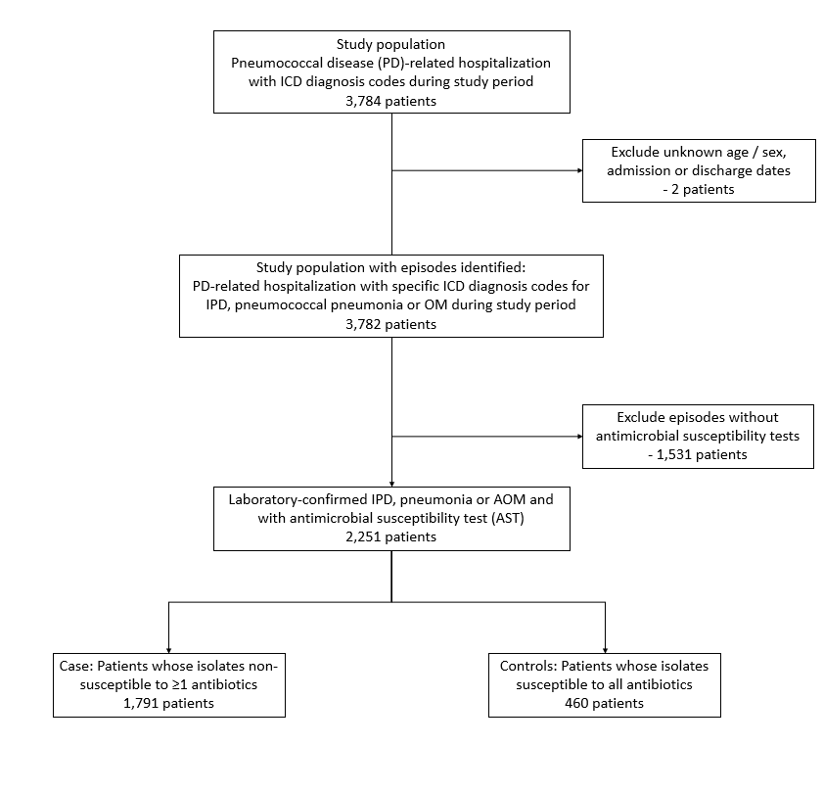

Supplementary figure 2 -- Incidence of Different Pneumococcal Disease Types in Hong Kong Population from 2012 to 2021
invasive pneumococcal disease, IPD
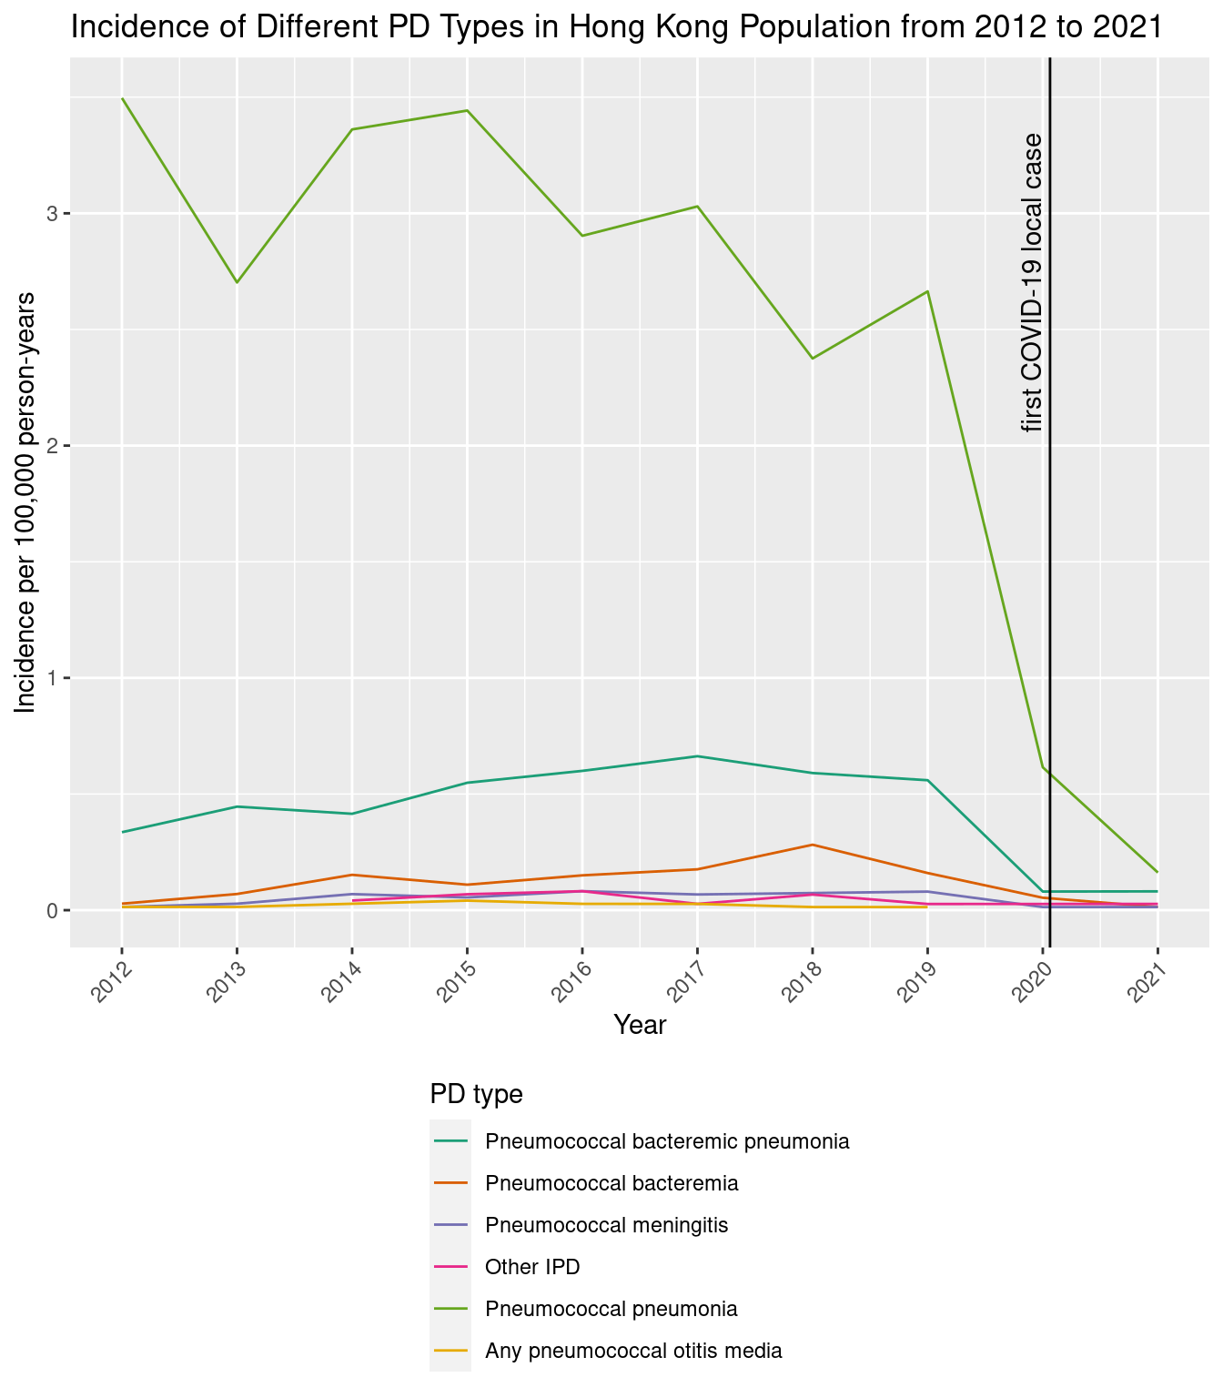

Supplementary figure 3A -- Incidence of PD episodes by AMR status in Hong Kong Population from 2012 to 2021
Upper pane: invasive pneumococcal disease, IPD; Lower pane: non-invasive pneumococcal disease, non-IPD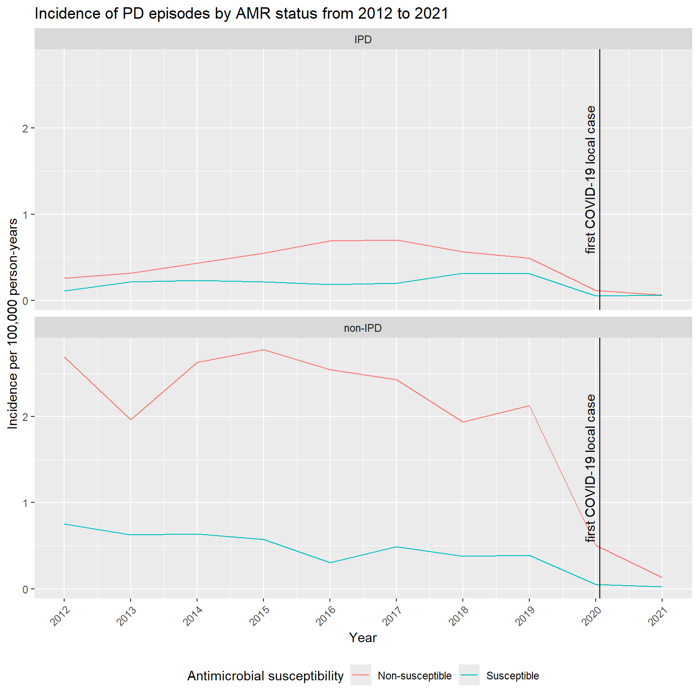

Supplementary figure 3B -- Incidence of Antimicrobial Resistance in Hong Kong Population from 2012 to 2021
Upper pane: invasive pneumococcal disease, IPD; Lower pane: non-invasive pneumococcal disease, non-IPD
