Supplementary Information

Characterizing air and noise pollution and their determinants in elementary schools in Accra, Ghana

Carissa L Lange¹, Sierra N Clark², Abosede S Alli¹, James Nimo^{3,4}, Kate A Kyeremateng^{1,5}, Samuel Agyei-Mensah⁶, Youssef Oulhote⁷, Allison F Hughes³, Majid Ezzati⁸⁻¹¹, Raphael E Arku^{1,}*

¹Department of Environmental Health Sciences, University of Massachusetts, Amherst, MA, USA
²School of Health and Medical Sciences, City St George's, University of London, London, UK
³Department of Physics, University of Ghana, Legon, Accra, Ghana
⁴Department of Environmental & Sustainable Engineering, State University of New York, Albany, USA
⁵Department of Biostatistics and Epidemiology, University of Massachusetts, Amherst, MA, USA
⁶Department of Geography and Resource Development, University of Ghana, Accra, Ghana
⁷Department of Environmental Medicine and Climate Sciences, Icahn School of Medicine at Mount Sinai, NY, USA
⁸Department of Epidemiology and Biostatistics, School of Public Health, Imperial College London, London, UK
⁹Regional Institute for Population Studies, University of Ghana, Accra, Ghana
¹⁰Abdul Latif Jameel Institute for Disease and Emergency Analytics, Imperial College London, London, UK
¹¹MRC Centre for Environment and Health, School of Public Health, Imperial College London, London, UK

*Correspondence to:
Raphael E. Arku
School of Public Health and Health Sciences
University of Massachusetts Amherst, MA, USA
E-mail: rarku@umass.edu

Overview
In Sub-Saharan African cities, elementary school environments may substantially contribute to children’s exposure to air and noise pollution, with potential impacts on health and learning. However, data on pollution levels, inequalities, and determinants in schools are limited. As part of the Accra School Health and Environment Study (ASHES), we measured fine particulate matter (PM_{2.5}), black carbon (BC), and noise levels in yards of 90 (74% public) primary schools across the Greater Accra Metropolitan Area (GAMA). Schoolyard characteristics (surface type, greenness, road proximity) were assessed to examine their associations with the measured pollutants. Further, noise annoyance was also evaluated through surveys among 1,037 schoolchildren recruited from the participating schools.

Figure S1 show the relationship between school’s proximity to major road (meters) and PM_{2.5}, BC, and environmental noise (Lday) across all schools. Scatterplots depict distance to nearest major road on a continuous scale, while boxplots categorize schools as residing within or beyond 500 meters from the nearest major road.
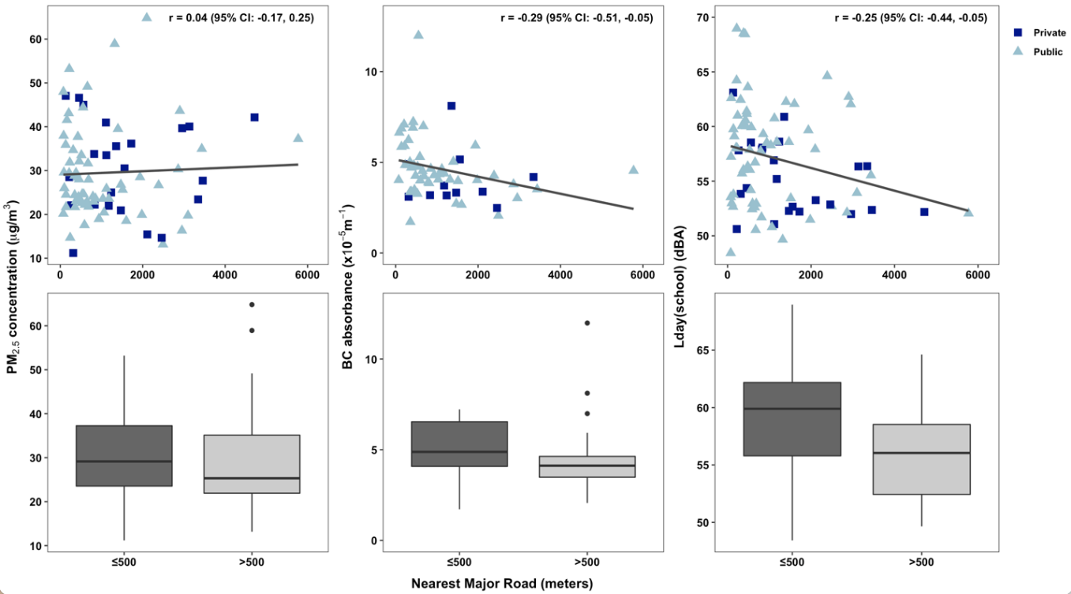

Figure S1. Association between proximity to major road (meters) and PM_{2.5}, BC, and environmental noise across all schools.

Figure S2 represents the relationship between greenness (as measured by NDVI) and PM_{2.5}, BC, and environmental noise (Lday) across all schools. Scatterplots depict NDVI on a continuous scale, while boxplots categorize school vegetation as either bare or sparse, according to the NDVI values.
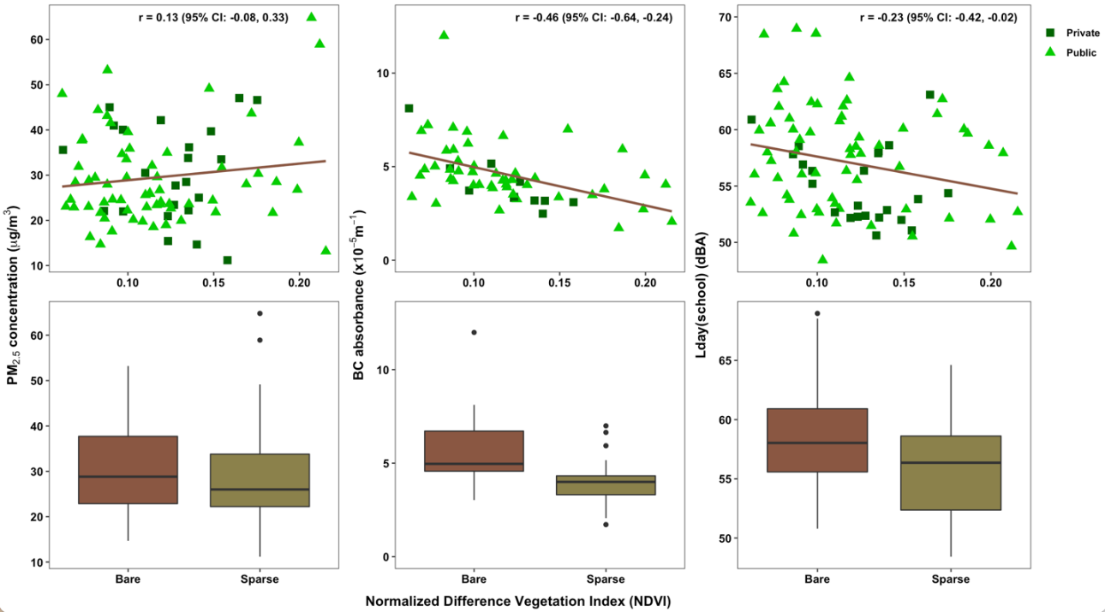
Figure S2. Association between NDVI and PM_{2.5}, BC, and environmental noise across all schools.

Concordance between environmental pollutants

In Figure S3, we examined the spatial correlation between air pollutants and environmental noise and show that correlations were weak, as high PM_{2.5} and BC levels did not consistently align with high noise, suggesting both shared and distinct sources of urban environmental pollution in the GAMA.

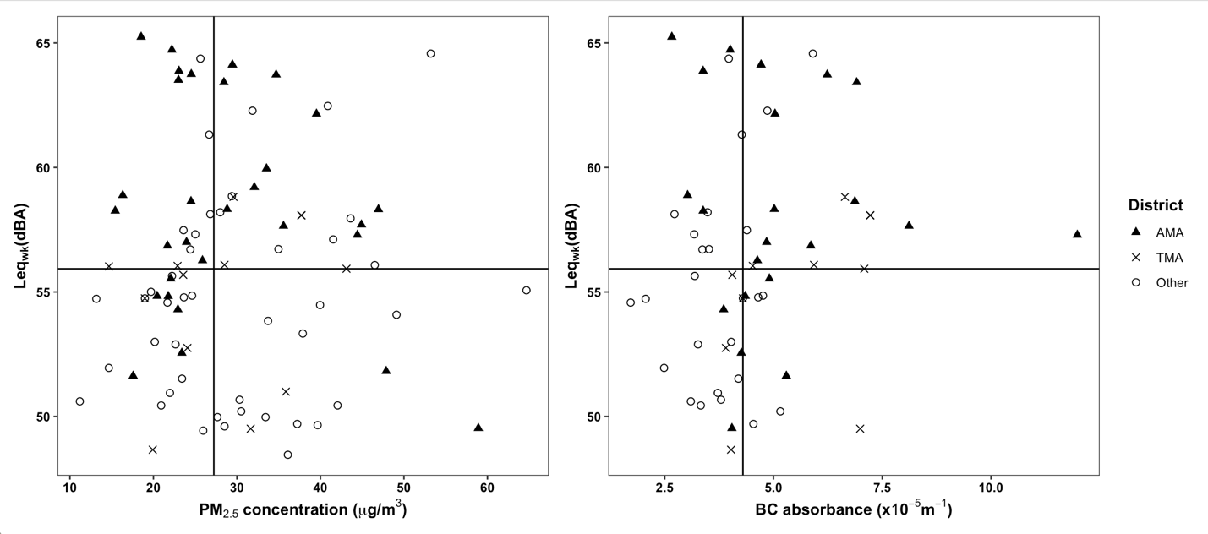
Figure S3. Concordance of PM_{2.5} and BC concentrations with environmental noise (Leq_{wk}) levels. The solid lines represent the median values of each pollutant

Noise Annoyance (Tables S1 and S2)
We assessed children’s self-reported noise annoyance at school using verbal and numeric surveys adapted from ISO/TS 15666:2003, and quantified the percentage of students “highly annoyed” (HA) by noise from five key sources: neighbors, traffic, aircraft, industry, and businesses. HA ranged from 60% for neighbor noise to 14% for road traffic and <10% for other sources. Schools with higher measured noise levels (Lday) were associated with greater HA to road-traffic noise.

Table S1. Total number (%) of students highly annoyed by noise from a variety of sources within the school environment. HA_{N,} HA_{v}, and HA_{vw} refer to the metrics from the 11-point numeric questions, 5-point verbal questions, and weighted 5-point verbal questions, respectively.

Noise Type | HA_{N} | HA_{v} | HA_{vw}
Neighbors | 616 (59.5) | 677 (65.4) | 561(54.2)
Road-traffic | 149 (14.4) | 173 (16.7) | 118 (11.4)
Aircraft/plane | 50 (4.8) | 78 (7.5) | 49 (4.7)
Industry | 24 (2.4) | 36 (3.5) | 23 (2.2)
Business/store/church | 65 (6.3) | 90 (8.7) | 62 (6.0)

Table S2. Total number (%) of students by district highly annoyed by noise from a variety of sources within the school environment. HA_{N,} HA_{v}, and HA_{vw} refer to the metrics from the 11-point numeric questions, 5-point verbal questions, and weighted 5-point verbal questions, respectively.
 |  | Noise Type
 |  | Neighbors | Road-traffic | Aircraft/  plane | Industry | Business/ store/  church
AMA  (n = 389) | HA_{N} | 260 (66.8) | 58 (14.9) | 15 (3.9) | 9 (2.3) | 24 (6.2)
AMA  (n = 389) | HA_{V} | 277 (71.2) | 67 (17.2) | 30 (7.7) | 15 (3.9) | 32 (8.2)
AMA  (n = 389) | HA_{VW} | 228 (58.6) | 45 (11.6) | 18 (4.6) | 11 (2.8) | 22 (5.7)
TMA  (n = 144) | HA_{N} | 100 (69.4) | 15 (17.4) | 6 (4.2) | 6 (4.2) | 13 (9.0)
TMA  (n = 144) | HA_{V} | 105 (72.9) | 27 (18.8) | 6 (4.2) | 6 (4.2) | 16 (11.1)
TMA  (n = 144) | HA_{VW} | 97 (67.4) | 21 (14.6) | 5 (3.4) | 4 (2.8) | 11 (7.6)
Other  (n = 503) | HA_{N} | 256 (50.9) | 66 (13.1) | 29 (5.8) | 9 (1.8) | 28 (5.6)
Other  (n = 503) | HA_{V} | 295 (58.6) | 79 (15.7) | 42 (8.3) | 15 (3.0) | 42 (8.3)
Other  (n = 503) | HA_{VW} | 236 (47.0) | 53 (10.5) | 25 (5.0) | 8 (1.6) | 29 (5.8)

Survey questions
Tables S3 shows the Annoyance questionnaire the schoolchildren responded to.

Table S3. Noise Annoyance Questionnaire
Verbal rating scale
Q1a. Thinking about the last (12 months of so) when you were at school, how much does noise from neighbors bother, disturb, or annoy you?
Q1b. Thinking about the last (12 months of so) when you were at school, how much does noise from road-traffic bother, disturb, or annoy you?
Q1c. Thinking about the last (12 months of so) when you were at school, how much does noise from aircraft/planes bother, disturb, or annoy you?
Q1d. Thinking about the last (12 months of so) when you were at school, how much does noise from nearby factories/industries bother, disturb, or annoy you?
Q1e. Thinking about the last (12 months of so) when you were at school, how much does noise from nearby business/stores/churches bother, disturb, or annoy you?
Numerical rating scale
Introduction: This uses a 0-to-10 opinion scale for how much noise bothers, disturbs, or annoys you when you were at school. If you are not at all annoyed choose 0; if you are extremely annoyed choose 10; if you are somewhere in between, choose a number between 0 and 10.
Q2a. Thinking about the last (12 months or so), when you are at school, what number from 0 to 10 best shows how much you were bothered, disturbe3d or annoyed by noise from neighbors?
Q2b. Thinking about the last (12 months or so), when you are at school, what number from 0 to 10 best shows how much you were bothered, disturbe3d or annoyed by road-traffic noise?
Q2c. Thinking about the last (12 months or so), when you are at school, what number from 0 to 10 best shows how much you were bothered, disturbe3d or annoyed by aircraft/planes noise?
Q2d. Thinking about the last (12 months or so), when you are at school, what number from 0 to 10 best shows how much you were bothered, disturbe3d or annoyed by noise from nearby factories/industries?
Q2e. Thinking about the last (12 months or so), when you are at school, what number from 0 to 10 best shows how much you were bothered, disturbe3d or annoyed by noise from nearby business/stores/churches?
School environmental assessment
Trained field assistants surveyed each school’s built environment, including yard and playground surfaces, ventilation, neighborhood type, vegetation, and nearby commercial activity.

Table S4. School Environment Survey
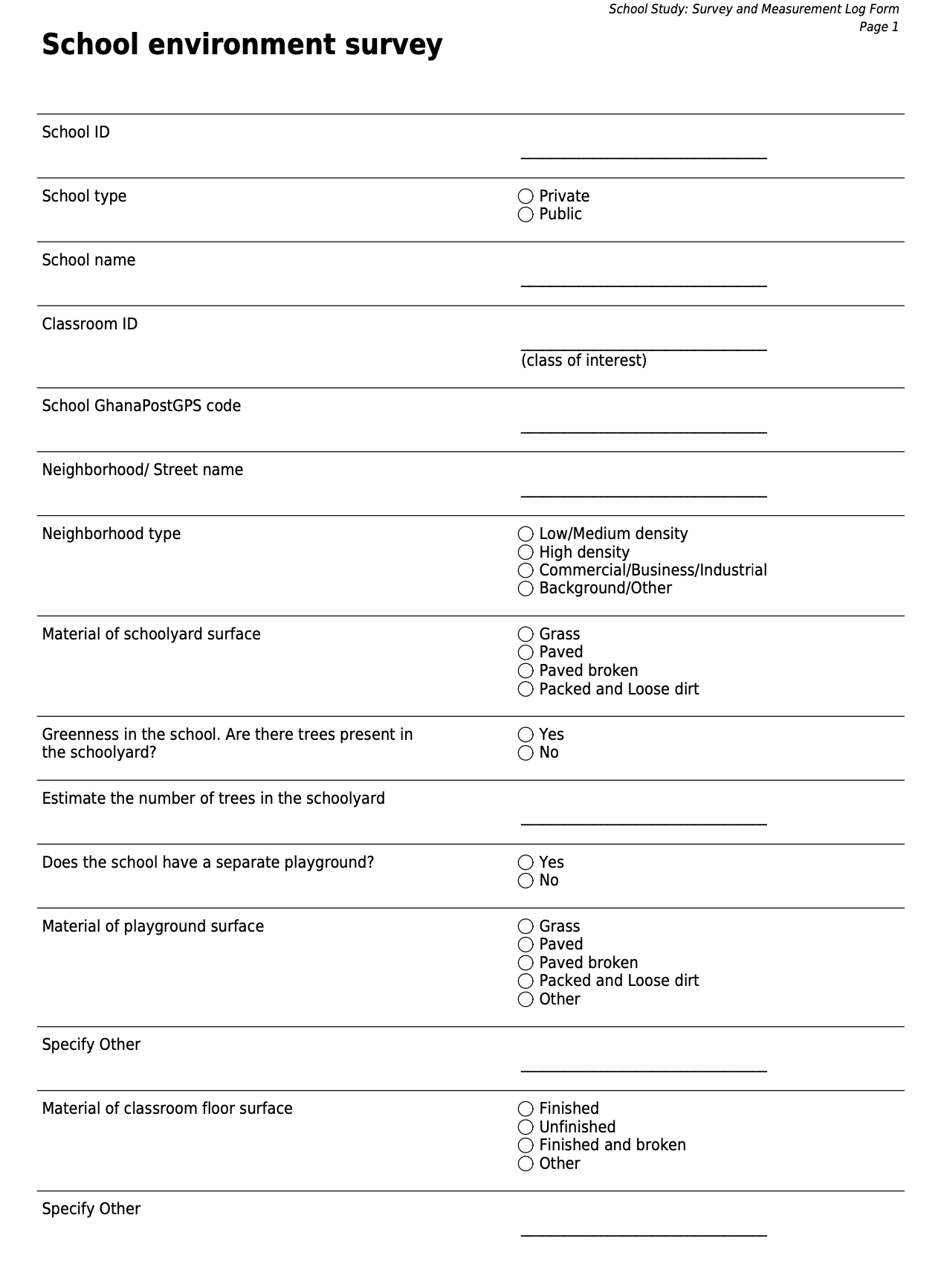
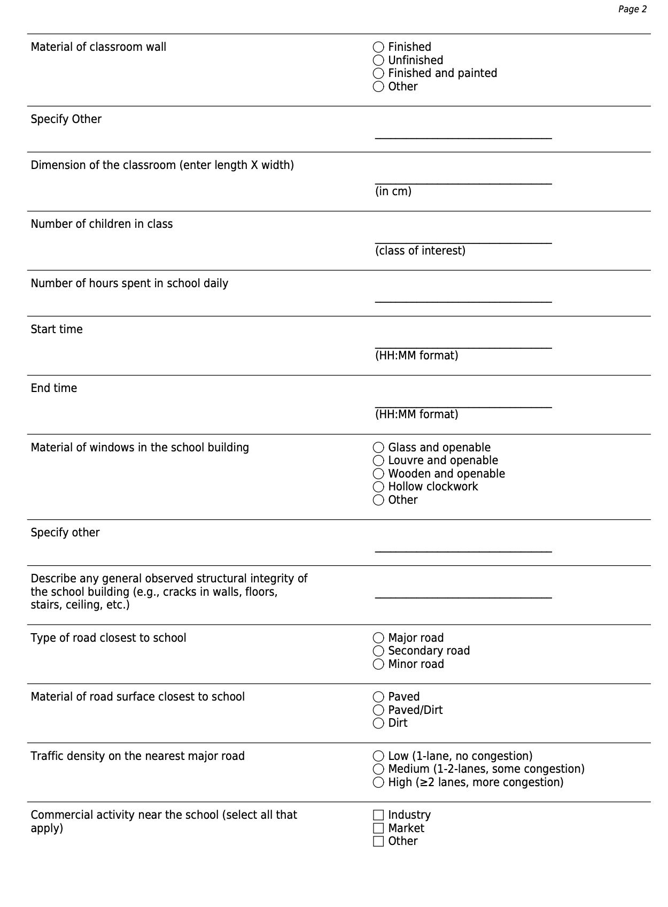
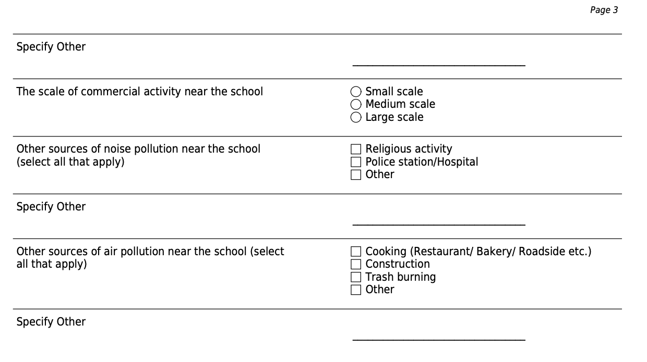

Table S5 presents pollutant concentrations across all schools. PM_{2.5} and black carbon (BC) concentrations have been seasonally adjusted and are presented as annual equivalent values. Lday(school) represents average environmental noise levels on school days (Monday - Friday) during typical school hours (7am - 3pm).

School ID | PM_{2.5} (µg/m³) | BC (x10⁻⁵m⁻¹) | L_{day(school)} (dBA)
S01 | 22.0 | 3.7 | 55.2
S02 | 42.1 | NA | 52.2
S03 | 44.9 | NA | 58.5
S04 | 46.9 | NA | 63.1
S05 | 35.6 | 8.1 | 60.9
S06 | 46.5 | NA | 54.4
S07 | 40.9 | NA | 56.9
S08 | 36.1 | NA | 52.2
S09 | 22.1 | 4.9 | 57.8
S10 | 11.2 | 3.1 | 53.8
S11 | 22.2 | 3.2 | 58.1
S12 | 33.4 | NA | 51.1
S13 | 28.5 | NA | 50.6
S14 | 33.7 | NA | 57.9
S15 | 23.4 | 4.2 | 56.4
S16 | 27.7 | NA | 52.4
S17 | 64.7 | NA | 57.9
S18 | 40.0 | NA | 56.3
S19 | 20.9 | 3.3 | 52.3
S20 | 39.7 | NA | 52.0
S21 | 25.0 | 3.2 | 58.6
S22 | 37.9 | NA | 57.2
S23 | 49.1 | NA | 56.7
S24 | 23.4 | 4.3 | 56.4
S25 | 29.5 | 4.7 | 68.5
S26 | 29.5 | 4.7 | 68.5
S27 | 29.4 | NA | 64.2
S28 | 24.6 | 4.8 | 56.0
S29 | 28.0 | 3.5 | 61.4
S30 | 24.4 | 3.4 | 60.1
S31 | 22.6 | 3.3 | 57.9
S32 | 25.9 | 4.6 | 60.8
S33 | 25.6 | 4.0 | 53.4
S34 | 26.0 | NA | 53.0
S35 | 31.9 | 4.9 | 58.0
S36 | 47.9 | NA | 53.5
S37 | 20.2 | 4.0 | 48.4
S38 | 30.5 | 5.2 | 52.7
S39 | 23.6 | 4.6 | 59.3
S40 | 23.6 | 4.4 | 58.6
S41 | 26.7 | 4.3 | 64.6
S42 | 19.9 | 4.0 | 51.5
S43 | 23.6 | 4.1 | 58.3
S44 | 19.0 | 4.3 | 58.5
S45 | 19.0 | 4.3 | 58.5
S46 | 43.1 | 7.1 | 58.1
S47 | 37.7 | 7.2 | 60.6
S48 | 24.1 | 3.9 | 57.8
S49 | 37.7 | 7.2 | 60.6
S50 | 37.2 | 4.5 | 52.0
S51 | 43.6 | NA | 62.7
S52 | 41.5 | NA | 59.1
S53 | 19.7 | NA | 53.9
S54 | 30.3 | 3.8 | 52.1
S55 | 53.2 | 5.9 | 69.0
S56 | 35.9 | NA | 52.7
S57 | 28.5 | 5.9 | 59.7
S58 | 31.7 | 7.0 | 50.5
S59 | 14.7 | NA | 61.0
S60 | 22.9 | 4.5 | 52.6
S61 | 29.6 | 6.6 | 62.6
S62 | 22.2 | 4.0 | 53.0
S63 | 28.8 | 5.0 | 55.7
S64 | 21.8 | NA | 52.9
S65 | 28.4 | 6.9 | 68.4
S66 | 34.7 | 6.2 | 62.4
S67 | 23.0 | NA | 63.6
S68 | 58.9 | 4.0 | 49.6
S69 | 22.9 | 3.9 | 51.7
S70 | 23.1 | 3.4 | 56.0
S71 | 39.5 | 5.0 | 62.3
S72 | 24.0 | 4.8 | 60.0
S73 | 33.5 | NA | 56.1
S74 | 15.4 | 3.4 | 53.3
S75 | 32.1 | NA | 61.2
S76 | 17.6 | 5.3 | 52.4
S77 | 17.6 | 5.3 | 52.4
S78 | 13.2 | 2.1 | 52.7
S79 | 14.7 | 2.5 | 52.9
S80 | 21.7 | 5.9 | 53.8
S81 | 27.9 | 4.2 | NA
S82 | 20.4 | 4.4 | 50.8
S83 | 44.4 | 12.0 | 54.2
S84 | 18.5 | 2.7 | 62.1
S85 | 35.0 | 3.5 | 55.5
S86 | 24.5 | NA | 59.9
S87 | 16.3 | 3.0 | 62.0
S88 | 21.7 | 1.7 | 60.0
S89 | 26.8 | 2.7 | 58.6
S90 | 24.5 | 6.9 | 59.8

Intermittency Ratio
We calculated the Intermittency Ratio (IR), which quantifies the proportion of sound energy arising from distinct, intermittent events that exceed 3 dBA above the site- and day-specific average sound level, following previous studies in Accra.

IR Formula¹:
$$IR ≡ \frac{{10}^{0.1L_{eq,T,Events}}}{{10}^{0.1L_{eq,T,tot}}}× 100 = {10}^{0.1{(L}_{eq,T,Events}{ - L}_{eq,T,tot}) }× 100(\%)$$
$L_{eq.T.Events}$ corresponds to all sound energy contributions that exceed a given threshold
$L_{eq.T.tot}$ corresponds to the equivalent continuous sound pressure level of all sound sources involved and is given as:
$$L_{eq,T,tot} ≡10 × \log{10}\left(\frac{1}{T}\int_{0}^{T}{{10}^{0.1L\left(t\right)}}dt\right) [dB]$$
Where L(t) is the continuous sound pressure level at the receiver position. A single pass-by only contributes to $L_{eq,T,Events}$ if its level exceeds a given threshold K.

$$K ≡ L_{eq,T,tot}+C[dB]$$
K is defined relative to the long-term average of the overall sound pressure level $L_{eq,T,tot}$ and an offset C. Thus, $L_{eq,T,Events}$ is defined as:

$$L_{eq,T,Events} ≡10 × \log{10}\left(\frac{1}{T}\int_{0}^{T}{{H(L\left(t\right)-K)10}^{0.1L\left(t\right)}}dt\right) [dB]$$
References
1. Wunderli JM, Pieren R, Habermacher M, et al. Intermittency ratio: A metric reflecting short-term temporal variations of transportation noise exposure. Journal of Exposure Science & Environmental Epidemiology 2016 26:6. 2015;26(6):575-585. doi:10.1038/jes.2015.56

