Appendices

Manuscript Title: Rising Tide of Stress: Global Trends and Structural Predictors over 18 Years

Supplementary Text
Figures A1–A3
Tables A1–A11

Supplementary Text

Here are the mathematical equations and descriptions for multilevel logistic regression models in the study.

Base model estimating the log-odds of stress over time.  $$\text{logit}(p_{ij})=γ_{00}+γ_{10}⋅X_{ij}+u_{0j}+u_{1j}⋅X_{ij}$$  The model includes fixed effects γ₀₀ (fixed intercept) and γ₁₀ (average yearly trend across all countries), and random effects that allow both intercepts (u_{0j}) and slopes (u_{1j}) to vary by country. The variable X_{ij} represents the normalized year. | (1)
Model estimating the log-odds of stress over time, as moderated by age group.  $$\text{logit}(p_{ij})=γ_{00}+γ_{10}⋅X_{ij}+γ_{01}⋅Z_{ij}+γ_{11}⋅X_{ij}⋅Z_{ij}+u_{0j}+u_{1j}⋅X_{ij}$$  The fixed effects include $γ_{00}$ (fixed intercept), $γ_{10}$ (main effect of normalized year), $γ_{01}$ (main effect of age group), and $γ_{11}$ (interaction between normalized normalized year and age). Here, $X_{ij}$ represents the normalized year and $Z_{ij}$ represents the categorical age variable. The random effects allow intercepts (u_{0j}) and slopes (u_{1j}) to vary by country. | (2)
Model estimating the log-odds of stress over time, as moderated by gender.  $$\text{logit}(p_{ij})=γ_{00}+γ_{10}⋅X_{ij}+γ_{01}⋅W_{ij}+γ_{11}⋅X_{ij}⋅W_{ij}+u_{0j}+u_{1j}⋅X_{ij}$$  The fixed effects include $γ_{00}$ (intercept), $γ_{10}$ (main effect of normalized year), $γ_{01}$ (main effect of gender), and $γ_{11}$ (interaction between normalized year and gender). Here, $X_{ij}$ represents the normalized year and $W_{ij}$ represents the female indicator variable. The random intercepts (u_{0j}) and slopes (u_{1j}) allow country-specific estimates. | (3)
Model estimating the log-odds of stress over time, as moderated by income quintile.  $$\text{logit}(p_{ij})=γ_{00}+γ_{10}⋅X_{ij}+γ_{01}⋅V_{ij}+γ_{11}⋅X_{ij}⋅V_{ij}+u_{0j}+u_{1j}⋅X_{ij}$$  The fixed effects are $γ_{00}$ (intercept), $γ_{10}$ (main effect of normalized year), $γ_{01}$ (main effect of income quintile), and $γ_{11}$ (interaction between normalized year and income quintile). Here, $X_{ij}$ represents the normalized year (year_norm_2 in this case) and $V_{ij}$ represents the income variable. The model included a random effects structure allowing country-specific intercepts and year slopes. | (4)
Model estimating the log-odds of stress over time, as moderated by world region.  $$\text{logit}\left(p_{ij}\right)=γ_{00}+γ_{10}⋅X_{ij}+γ_{01}⋅R_{ij}+γ_{11}⋅X_{ij}⋅R_{ij}+u_{0j}+u_{1j}⋅X_{ij}$$  The fixed effects include $γ_{00}$ (intercept), $γ_{10}$ (main effect of normalized year), $γ_{01}$ (main effect of world region), and $γ_{11}$ (interaction between normalized year and world region). Here, $X_{ij}$ represents the normalized year and $R_{ij}$ represents the world region categorical variable. The random effects allow country-specific intercepts and year slopes to vary. | (5)
Model estimating the log-odds of stress over time, as moderated by Fragile State Index (FSI) and adjusted for age group, gender, income quintile, world region, and country gross domestic product.  $$\text{logit}\left(p_{ij}\right)=γ_{00}+γ_{10}⋅X_{ij}+γ_{01}⋅F_{ij}^{B}+γ_{02}⋅F_{ij}^{W}+γ_{03}⋅G_{ij}+γ_{04}⋅I_{ij}+γ_{05}⋅A_{ij}+γ_{06}⋅W_{ij}+γ_{11}⋅F_{ij}^{B}⋅X_{ij}+γ_{12}⋅F_{ij}^{W}⋅X_{ij}+u0j+u1j⋅X_{ij}$$  The fixed effects are: $γ_{00}$ (intercept), $γ_{10}$ (main effect of normalized year), $γ_{01}$ (main effect of between-country FSI), $γ_{02}$ (main effect of within-country FSI), $γ_{03}$ (GDP effect), $γ_{04}$ (income quintile effect), $γ_{05}$ (age effect), $γ_{06}$ (gender effect), $γ_{11}$ (interaction between year and between-country FSI), and $γ_{12}$ (interaction between year and within-country FSI). Here, $X_{ij}$ represents normalized year, $F_{ij}^{B}$ represents between-country scaled FSI, $F_{ij}^{W}$ represents within-country scaled FSI, $G_{ij}$ represents log-transformed GDP per capita, $I_{ij}$ represents income quintile, $A_{ij}$ represents age group, and $W_{ij}$ represents gender. | (6)

Figure A1. Global trend of Fragile States Index (FSI) score, 2009–2023.
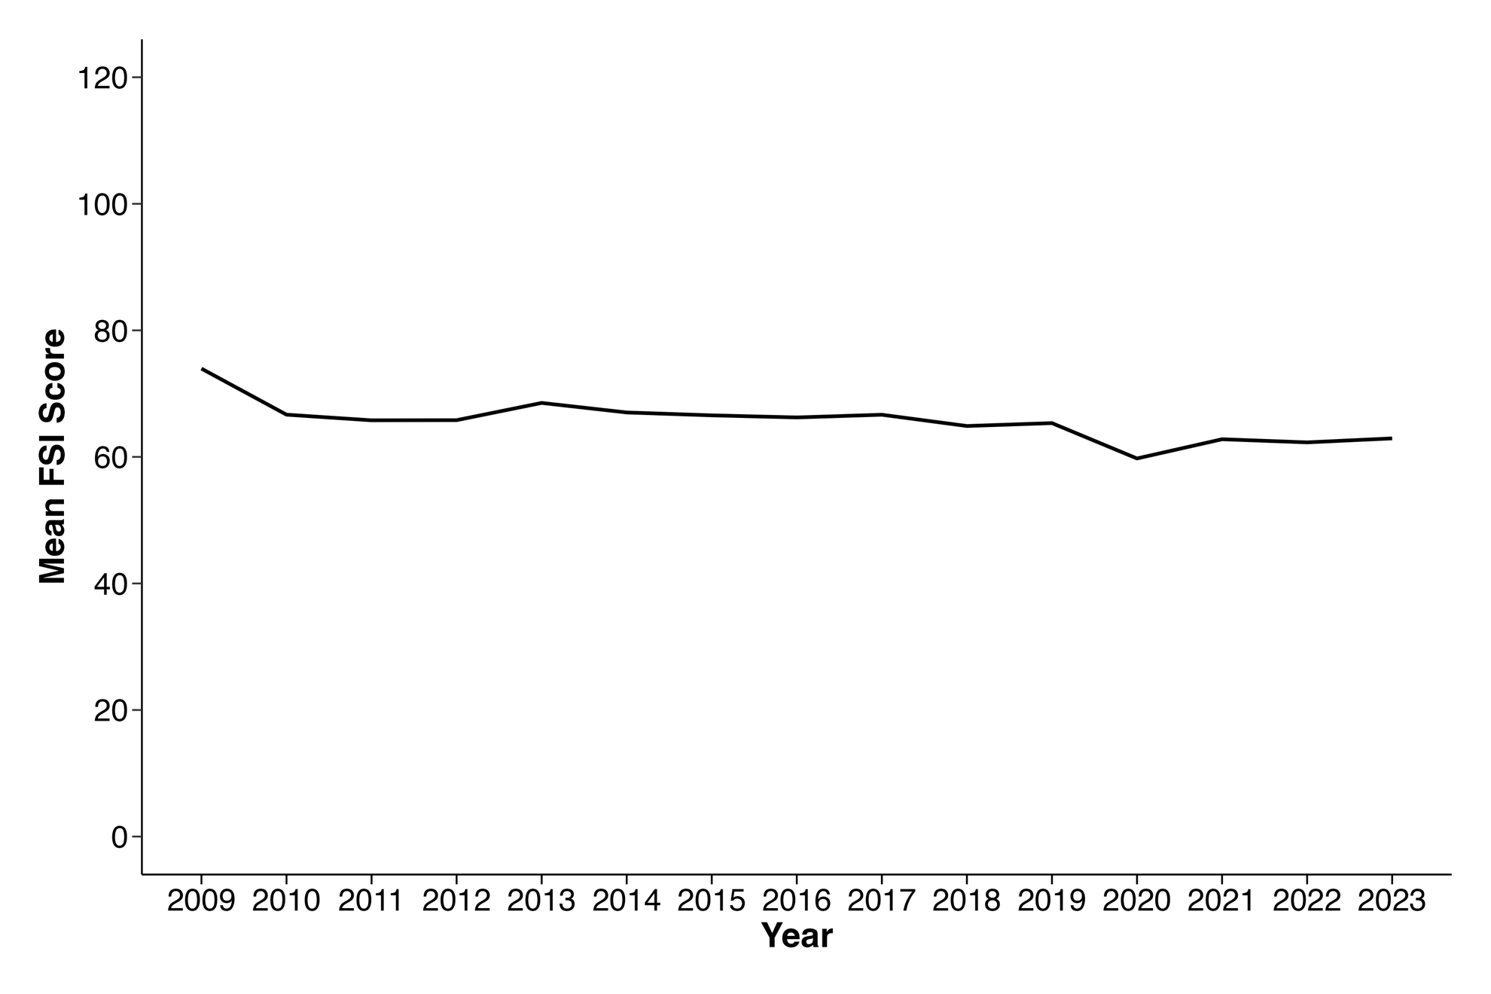

Fig. A2. Proportion of countries in each Fragile State Index category over time.
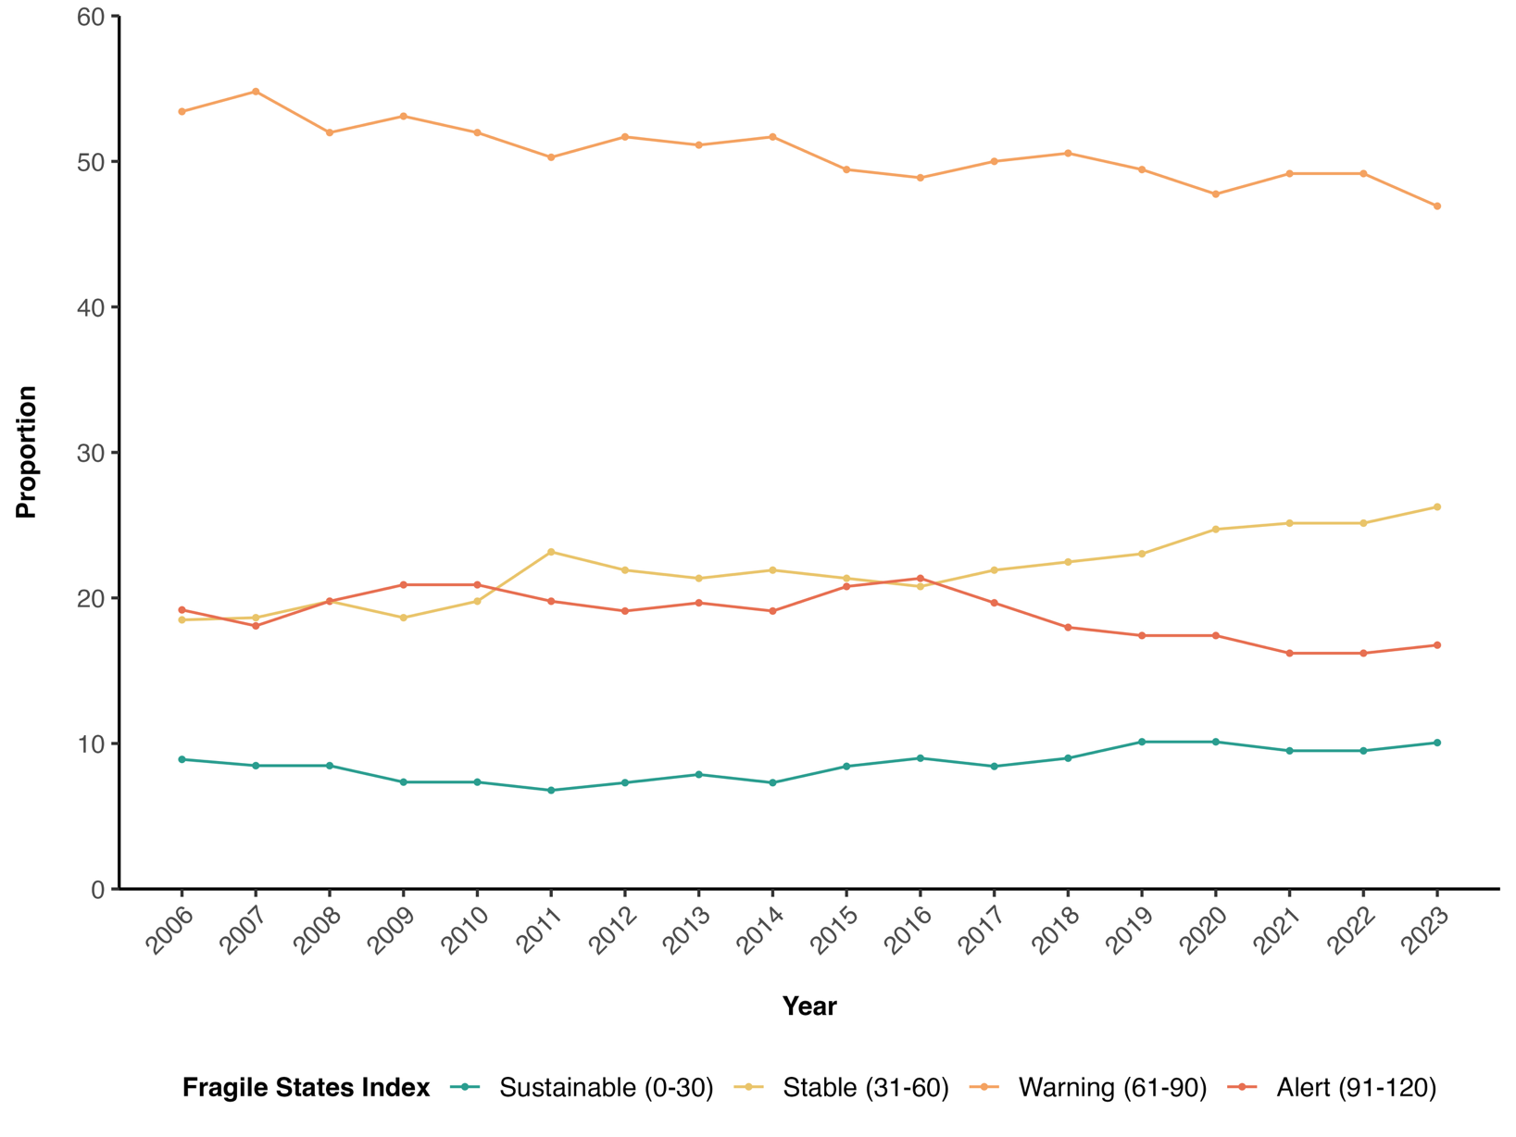

Fig. A3. Association between Fragile States Index (FSI) categories and stress report over Time.
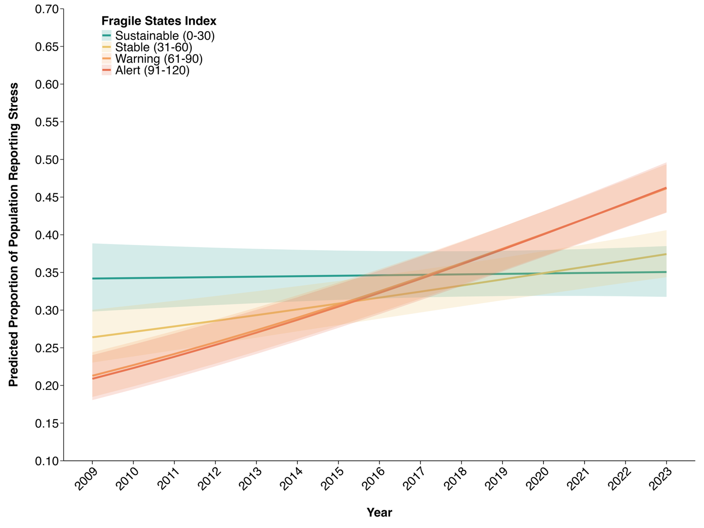

Note: The fitted values displayed here are the predicted values from the regression model, with the 95% Confidence Interval.

Table A1. Preregistration deviations.

# | Details |  | Original wording | Deviation description | Extent of deviation | Judgement of impact
Pre-registration titled Global Trends of Perceived Stress (DOI: 10.17605/osf.io/m6j5g)
1 | Type | Methods | Sample size:  “Gallup typically surveys 1,0000 individuals in each country or area, with some variation. Sample sizes in large countries may include at least 2,000 participants, whereas sample sizes in other countries may range from 500 to 1,000. The sample size is determined based on the availability of the data from the Gallup World Poll.” | There is a typo in the number of individuals that Gallup typically samples in a country; it should be 1,000 instead of 10,000. | Minor | The typo did not affect any analytic decision. All descriptive and regression analyses were conducted based on the actual number of observations in the datasets.
1 | Reason | Typo/Error
1 | Timing | After submission of pre-registration
2 | Type | Analyses | Data collection period:  “Based on sampling between 2005/2006 and 2021, the Gallup World Poll should comprise over 1.8 million adults. However, given that the stress measure has not been administered in every country, the sample size may range (a precise number will be known once the data set is accessed).” | The team decided to use the most updated set of data available at the Gallup World Poll, which included the pre-registered period (2005/2006-2021) and the subsequent years of 2022 and 2023. | Minor | The expanded study period enhanced the analyses as it provides more timely insight to the trend of stress reports over time.
2 | Reason | Other: More updated dataset was available.
2 | Timing | Before data access
3 | Type | Methods | Outliers and Exclusions:  “Participants who were missing outcome data (on the perceived stress item/measure) will be excluded.” | At the individual level, entries with missing any of the missing variables was omitted in the dataset: e.g., perceived stress, age, sex, income quintile, world regions.  At the country level, countries where at least 7 waves of data were collected to minimize model convergence issues. | Major | The original registration did not consider any exclusion criteria at the country level, even though most of the analyses were conducted at that level. The team decided to choose 7 years as it would cover at least half of the analytic timeframe for the analyses spanning the shortest period (income quintile, 2009-2023). This stringent exclusion criterion, although excluding countries with fewer data, allowed us to estimate the trajectory of stress by time in a more robust manner.
3 | Reason | Other: The change aimed to minimize model convergence. issues
3 | Timing | After data access
Pre-registration titled Stress and Conflict (DOI: 10.17605/osf.io/9av4f)
4 | Type | Research questions / hypotheses | Hypotheses:  “The questions being tested are: 1. Are cross-national differences in fragility associated with stress trends? Are people in countries that are more peaceful also less stressed? 2. Are within-country differences in fragility associated with stress? Are people less stressed when their country is less fragile? 3. Does state fragility have a lagged association with stress? 4. How do chronic stressors and demographic variables moderate the link between fragility and stress? ” | The third and fourth hypotheses were not tested in the current study. The related planned analyses were also removed as a result. | Minor | Combining the two studies related to perceived stress into one, the team decided to focus on examining the key hypotheses related to state fragility and stress. This decision should not impact the results.
4 | Reason | New knowledge
4 | Timing | Before data access
5 | Type | Analyses | Sample Size:  “The sample size is determined based on the availability of the data from the Gallup World Poll. Based on sampling between 2006 and 2021, the Gallup World Poll should comprise just under 3 million adults. However, given that the stress measure has not been administered in every country, the sample size may range (a precise number will be known once the data set is accessed). The Fragile States Index is a composite index of 12 indicators that are combined into one score for 179 countries. From 2006 to 2021, the number of countries ranked each year ranged from 146 to 179. This suggests that the data should comprise approximately 2990 country-years.” | The team decided to use the most updated set of data available at the Gallup World Poll, which included the pre-registered period (2005/2006-2021) and the subsequent years of 2022 and 2023.  Similarly, the team included the latest Fragile States Index up to 2023.  As the FSI analyses included Gross Domestic Products (GDP), age, sex, and income quintile in the models, the analytic dataset was restricted to 2009 – 2023, during which all the variables were collected. | Minor | The expanded study period enhanced the analyses as it provides more timely insight to the association between state fragility and perceived stress.
5 | Reason | Other: More updated datasets were available.
5 | Timing | After data access
6 | Type | Methods | Conditions:  “The current study is a secondary data analysis and participants will not be divided into conditions. We will use this section to describe the independent variable(s) and moderators included in our mixed-effect analyses. The present research will analyze national Fragile States Index scores in up to 179 countries, which capture each county’s level of fragility.” | Upon further data processing, we clarified the number of countries with available data from 2009 to 2023, which turned out to be 141 countries. | Minor | None—as it was simply an over-estimation of the number of countries in the final analytic dataset.
6 | Reason | Typo/Error
6 | Timing | After data access

Table A2. Descriptive statistics of key variables across waves (Overall and 2006-2013).
 | Overall | 2006 | 2007 | 2008 | 2009 | 2010 | 2011 | 2012 | 2013
Weighted Sample Size | 2460265.5 | 115781.1 | 33034.7 | 116524.2 | 114613.8 | 125364.3 | 176778.1 | 218450.3 | 133782.8
Female (%) | 1255844.0 (51.0) | 59497.6 (51.4) | 16858.2 (51.0) | 59816.5 (51.3) | 58843.1 (51.3) | 64579.7 (51.5) | 90753.0 (51.3) | 111879.2 (51.2) | 68242.4 (51.0)
Age Group (%)
15 – 29 years old | 854843.2 (34.9) | 40901.5 (36.1) | 12434.0 (38.9) | 43987.6 (37.9) | 42742.7 (37.4) | 44442.4 (35.6) | 63498.1 (36.1) | 75513.0 (34.7) | 48165.5 (36.1)
30 – 44 years old | 698933.5 (28.5) | 33141.4 (29.2) | 9921.8 (31.0) | 32751.7 (28.2) | 32513.8 (28.5) | 35301.4 (28.2) | 49671.2 (28.2) | 61234.4 (28.1) | 37785.1 (28.3)
45 – 59 years old | 500284.2 (20.4) | 22346.3 (19.7) | 6059.4 (19.0) | 22835.9 (19.7) | 22677.4 (19.9) | 25947.4 (20.8) | 35920.3 (20.4) | 45312.7 (20.8) | 27287.3 (20.4)
60+ years old | 395769.4 (16.2) | 16933.0 (14.9) | 3558.1 (11.1) | 16567.0 (14.3) | 16228.6 (14.2) | 19306.5 (15.4) | 26954.4 (15.3) | 35591.9 (16.4) | 20253.8 (15.2)
Self-reported Stress (%) | 820138.3 (33.3) | 32388.5 (28.0) | 8759.1 (26.5) | 31131.5 (26.7) | 30516.5 (26.6) | 34806.7 (27.8) | 54407.7 (30.8) | 69983.3 (32.0) | 43676.8 (32.6)
World Regions (%)
South Asia | 171230.7 (7.0) | 6046.3 (5.2) | 5133.9 (15.5) | 8236.0 (7.1) | 10904.7 (9.5) | 10950.9 (8.7) | 8449.0 (4.8) | 21766.1 (10.0) | 8030.2 (6.0)
Central and Eastern  Europe | 258599.7 (10.5) | 8955.9 (7.7) | - | 3565.0 (3.1) | 12959.8 (11.3) | 14908.3 (11.9) | 16908.2 (9.6) | 16902.3 (7.7) | 16835.5 (12.6)
Commonwealth of  Independent States | 210976.3 (8.6) | 11964.2 (10.3) | - | 11927.2 (10.2) | 12851.3 (11.2) | 13670.2 (10.9) | 12709.2 (7.2) | 13606.6 (6.2) | 12687.3 (9.5)
East Asia | 150949.9 (6.1) | 7598.8 (6.6) | 5092.0 (15.4) | 10295.2 (8.8) | 6853.2 (6.0) | 8770.3 (7.0) | 9119.5 (5.2) | 16332.5 (7.5) | 8192.9 (6.1)
Latin America and  Caribbean | 332822.3 (13.5) | 18969.2 (16.4) | 17846.8 (54.0) | 18454.5 (15.8) | 17942.4 (15.7) | 18318.9 (14.6) | 18795.2 (10.6) | 20282.0 (9.3) | 18789.9 (14.0)
Middle East and  North Africa | 302032.4 (12.3) | 11098.9 (9.6) | 996.5  ( 3.0) | 10329.7 (8.9) | 13172.2 (11.5) | 12906.1 (10.3) | 34008.9 (19.2) | 35725.5 (16.4) | 16553.9 (12.4)
North America,  Australia, and New  Zealand | 65508.6 (2.7) | 4377.1 (3.8) | - | 3755.5 (3.2) | 2010.7 (1.8) | 3757.2 (3.0) | 3731.9 (2.1) | 4025.4 (1.8) | 3517.7 (2.6)
Southeast Asia | 152934.0 (6.2) | 7538.4 (6.5) | 3965.4 (12.0) | 8507.6 (7.3) | 7076.8 (6.2) | 6976.1 (5.6) | 7895.7 (4.5) | 13848.0 (6.3) | 7029.0 (5.3)
Sub-Saharan  Africa | 465855.9 (18.9) | 22246.0 (19.2) | - | 24954.6 (21.4) | 18871.2 (16.5) | 18172.9 (14.5) | 31895.9 (18.0) | 28870.8 (13.2) | 27907.3 (20.9)
Western Europe | 349355.6 (14.2) | 16986.2 (14.7) | - | 16498.8 (14.2) | 11971.4 (10.4) | 16933.5 (13.5) | 33264.7 (18.8) | 47091.1 (21.6) | 14239.1 (10.6)
Mean FSI score (SD) | 65.59 (23.56) | - | - | - | 72.42 (22.62) | 67.77 (23.22) | 65.78 (23.39) | 65.81 (23.69) | 68.64 (22.77)

Table A3. Descriptive statistics of key variables across waves, Continued (2014-2023).
 | 2014 | 2015 | 2016 | 2017 | 2018 | 2019 | 2020 | 2021 | 2022 | 2023
Weighted Sample Size | 144904.6 | 143582.2 | 143019.9 | 147151.4 | 147364.6 | 170523.9 | 125963.1 | 126266.7 | 138299.2 | 138860.6
Female (%) | 73869.7 (51.0) | 72973.9 (50.8) | 72688.8 (50.8) | 74869.5 (50.9) | 74998.0 (50.9) | 87023.3 (51.0) | 63157.4 (50.1) | 64542.1 (51.1) | 70578.2 (51.0) | 70673.4 (50.9)
Age Group (%)
15 – 29 years old | 50960.2 (35.2) | 50070.2 (34.9) | 49399.0 (34.6) | 50622.3 (34.5) | 50715.3 (34.6) | 58153.9 (34.2) | 41847.6 (33.4) | 40799.4 (32.4) | 45348.5 (32.8) | 45241.9 (32.6)
30 – 44 years old | 40950.6 (28.3) | 40842.4 (28.5) | 40740.9 (28.6) | 42103.5 (28.7) | 41737.7 (28.4) | 48426.1 (28.5) | 36968.9 (29.5) | 36244.8 (28.8) | 39316.7 (28.5) | 39281.0 (28.3)
45 – 59 years old | 29483.2 (20.4) | 29141.1 (20.3) | 29025.5 (20.4) | 29966.4 (20.4) | 30105.2 (20.5) | 34996.2 (20.6) | 26494.6 (21.1) | 26338.2 (20.9) | 28029.2 (20.3) | 28317.8 (20.4)
60+ years old | 23240.4 (16.1) | 23306.7 (16.3) | 23420.8 (16.4) | 24085.3 (16.4) | 24150.4 (16.5) | 28509.1 (16.8) | 20005.2 (16.0) | 22493.3 (17.9) | 25385.5 (18.4) | 25779.4 (18.6)
Self-reported Stress  (%) | 47393.6 (32.7) | 48863.4 (34.0) | 50475.7 (35.3) | 53315.3 (36.2) | 53123.1 (36.0) | 61574.4 (36.1) | 48031.1 (38.1) | 47858.1 (37.9) | 51643.7 (37.3) | 52189.7 (37.6)
World Regions
(%)
South Asia | 8067.2 (5.6) | 7946.6 (5.5) | 6780.0 (4.7) | 8633.8 (5.9) | 8034.2 (5.5) | 14950.1 (8.8) | 13389.3 (10.6) | 7971.1 (6.3) | 7967.5 (5.8) | 7973.9 (5.7)
Central and  Eastern Europe | 16813.5 (11.6) | 16756.1 (11.7) | 16809.5 (11.8) | 16802.9 (11.4) | 16798.4 (11.4) | 16898.1 (9.9) | 16909.0 (13.4) | 16016.6 (12.7) | 16881.3 (12.2) | 16879.4 (12.2)
Commonwealth  of Independent  States | 12742.2 (8.8) | 12678.8 (8.8) | 12791.4 (8.9) | 12843.2 (8.7) | 14910.7 (10.1) | 14770.8 (8.7) | 8993.5 (7.1) | 9927.8 (7.9) | 10951.5 (7.9) | 10950.4 (7.9)
East Asia | 9545.7 (6.6) | 8206.0 (5.7) | 9342.6 (6.5) | 9116.6 (6.2) | 7640.9 (5.2) | 8808.6 (5.2) | 8511.0 (6.8) | 8499.1 (6.7) | 5016.5 (3.6) | 4008.7 (2.9)
Latin America  and Caribbean | 18933.5 (13.1) | 18457.8 (12.9) | 18344.1 (12.8) | 18932.8 (12.9) | 18412.8 (12.5) | 21161.5 (12.4) | 15436.6 (12.3) | 17433.5 (13.8) | 18387.5 (13.3) | 17923.2 (12.9)
Middle East and  North Africa | 17024.5 (11.7) | 18735.8 (13.0) | 18830.6 (13.2) | 17858.9 (12.1) | 16780.1 (11.4) | 20305.5 (11.9) | 12124.0 (9.6) | 11962.1 (9.5) | 16895.7 (12.2) | 16723.4 (12.0)
North America,  Australia, and  New Zealand | 4045.8 (2.8) | 4032.9 (2.8) | 4045.5 (2.8) | 4005.3 (2.7) | 4008.2 (2.7) | 4141.5 (2.4) | 4014.5 (3.2) | 4012.7 (3.2) | 4016.7 (2.9) | 4009.9 (2.9)
Southeast Asia | 8002.2 (5.5) | 7994.1 (5.6) | 7029.9 (4.9) | 8127.2 (5.5) | 10417.0 (7.1) | 13489.9 (7.9) | 8034.6 (6.4) | 9050.5 (7.2) | 8983.1 (6.5) | 8968.4 (6.5)
Sub-Saharan  Africa | 30736.4 (21.2) | 29597.2 (20.6) | 29510.7 (20.6) | 31349.4 (21.3) | 31336.9 (21.3) | 35964.3 (21.1) | 20045.2 (15.9) | 22835.7 (18.1) | 29717.3 (21.5) | 31844.1 (22.9)
Western Europe | 18993.6 (13.1) | 19176.9 (13.4) | 19535.6 (13.7) | 19481.3 (13.2) | 19025.3 (12.9) | 20033.7 (11.7) | 18505.5 (14.7) | 18557.6 (14.7) | 19482.3 (14.1) | 19579.1 (14.1)
Mean FSI score  (SD) | 66.83 (23.20) | 66.55 (23.99) | 66.43 (24.23) | 66.68 (23.91) | 65.01 (23.38) | 65.61 (22.67) | 60.73 (22.88) | 61.28 (22.63) | 62.40 (23.80) | 62.66 (24.20)

Table A4. Countries and settings in world regions categorized as by the World Happiness Reports.
World Regions | Countries and Settings
South Asia | Afghanistan, Bangladesh, India, Nepal, Pakistan, Sri Lanka
Central and Eastern Europe | Albania, Bosnia Herzegovina, Bulgaria, Croatia, Czech Republic, Estonia, Hungary, Kosovo, Latvia, Lithuania, Montenegro, North Macedonia, Poland, Romania, Serbia, Slovakia, Slovenia
Commonwealth of Independent States | Armenia, Azerbaijan, Belarus, Georgia, Kazakhstan, Kyrgyzstan, Moldova, Russia, Tajikistan, Turkmenistan, Ukraine, Uzbekistan
East Asia | China, Hong Kong, Japan, Mongolia, South Korea, Taiwan
Latin America and Caribbean | Argentina, Bolivia, Brazil, Chile, Colombia, Costa Rica, Dominican Republic, Ecuador, El Salvador, Guatemala, Haiti, Honduras, Jamaica, Mexico, Nicaragua, Panama, Paraguay, Peru, Uruguay, Venezuela
Middle East and North Africa | Algeria, Bahrain, Egypt, Iran, Iraq, Israel, Jordan, Kuwait, Lebanon, Libya, Morocco, Northern Cyprus, Palestine, Saudi Arabia, Tunisia, Turkey, United Arab Emirates, Yemen
North America and ANZ | Australia, Canada, New Zealand, United States
Southeast Asia | Cambodia, Indonesia, Laos, Malaysia, Myanmar, Philippines, Singapore, Thailand, Vietnam
Sub-Saharan Africa | Benin, Botswana, Burkina Faso, Cameroon, Chad, Comoros, Republic of the Congo, Democratic Republic of the Congo, Ethiopia, Gabon, Ghana, Guinea, Ivory Coast, Kenya, Liberia, Madagascar, Malawi, Mali, Mauritania, Mauritius, Mozambique, Namibia, Niger, Nigeria, Rwanda, Senegal, Sierra Leone, South Africa, Tanzania, Togo, Uganda, Zambia, Zimbabwe
Western Europe | Austria, Belgium, Cyprus, Denmark, Finland, France, Germany, Greece, Iceland, Ireland, Italy, Luxembourg, Malta, Netherlands, Norway, Portugal, Spain, Sweden, Switzerland, United Kingdom

Table A5. Percentage changes in stress reports in 146 countries from 2006 to 2023.
Country | First Year of Stress Report |  | Last Year of Stress Report |  | Percentage Change
Country | Year | Weighted Proportion | Year | Weighted Proportion | Percentage Change
Comoros | 2009 | 8.15 | 2023 | 48.04 | 489.48
Niger | 2006 | 10.06 | 2023 | 48.46 | 381.81
Tanzania | 2006 | 13.98 | 2023 | 57.67 | 312.61
Burkina Faso | 2006 | 9.44 | 2023 | 38.87 | 311.94
Mauritania | 2008 | 10.27 | 2023 | 36.52 | 255.69
Chad | 2006 | 16.22 | 2023 | 52.39 | 222.90
Guinea | 2011 | 16.43 | 2023 | 52.12 | 217.23
Nepal | 2006 | 13.21 | 2023 | 37.97 | 187.50
Turkmenistan | 2009 | 5.21 | 2019 | 13.83 | 165.46
Paraguay | 2006 | 13.26 | 2023 | 35.08 | 164.59
Liberia | 2008 | 19.58 | 2023 | 51.70 | 163.99
Ivory Coast | 2009 | 10.36 | 2023 | 27.22 | 162.79
Republic of the Congo | 2008 | 14.22 | 2023 | 36.39 | 155.89
Senegal | 2006 | 18.74 | 2023 | 46.32 | 147.15
Democratic Republic of the Congo | 2009 | 16.90 | 2023 | 41.66 | 146.43
Zambia | 2006 | 15.37 | 2022 | 37.40 | 143.27
Honduras | 2006 | 17.76 | 2023 | 41.43 | 133.21
Mali | 2006 | 11.32 | 2023 | 26.17 | 131.11
Nigeria | 2006 | 25.86 | 2023 | 58.81 | 127.48
Togo | 2006 | 15.06 | 2023 | 34.11 | 126.55
Laos | 2006 | 12.16 | 2023 | 27.47 | 125.98
Benin | 2006 | 18.34 | 2023 | 39.57 | 115.83
Morocco | 2011 | 23.40 | 2023 | 49.40 | 111.17
Uganda | 2006 | 26.84 | 2022 | 55.68 | 107.45
Jordan | 2005 | 25.90 | 2023 | 52.63 | 103.18
Ethiopia | 2012 | 16.12 | 2023 | 32.35 | 100.69
Ukraine | 2006 | 16.13 | 2023 | 31.62 | 95.97
Afghanistan | 2008 | 27.46 | 2023 | 53.76 | 95.76
El Salvador | 2006 | 25.59 | 2023 | 50.02 | 95.43
Gabon | 2011 | 18.68 | 2023 | 36.29 | 94.29
Mozambique | 2006 | 15.52 | 2023 | 29.81 | 92.11
Cameroon | 2006 | 23.95 | 2023 | 44.40 | 85.37
Azerbaijan | 2006 | 15.06 | 2023 | 27.25 | 81.00
Ghana | 2006 | 28.19 | 2023 | 50.92 | 80.60
Lithuania | 2006 | 12.31 | 2023 | 22.18 | 80.22
Egypt | 2005 | 32.28 | 2023 | 58.13 | 80.09
Myanmar | 2012 | 24.78 | 2023 | 44.58 | 79.93
Nicaragua | 2006 | 26.09 | 2023 | 46.03 | 76.41
Slovenia | 2006 | 20.91 | 2023 | 36.17 | 72.97
Venezuela | 2006 | 25.95 | 2023 | 44.65 | 72.06
Israel | 2006 | 37.47 | 2023 | 63.28 | 68.87
Sweden | 2005 | 18.74 | 2023 | 31.49 | 68.05
Sierra Leone | 2006 | 33.25 | 2023 | 54.53 | 63.99
Spain | 2005 | 23.44 | 2023 | 38.43 | 63.96
Bolivia | 2006 | 33.33 | 2023 | 54.26 | 62.83
Netherlands | 2005 | 17.31 | 2023 | 27.92 | 61.30
Rwanda | 2006 | 40.66 | 2019 | 65.34 | 60.70
China | 2006 | 34.93 | 2022 | 55.36 | 58.47
Bulgaria | 2010 | 18.60 | 2023 | 29.31 | 57.53
Belarus | 2006 | 14.23 | 2019 | 21.43 | 50.63
Pakistan | 2005 | 22.05 | 2023 | 33.04 | 49.83
Russia | 2006 | 13.38 | 2023 | 19.82 | 48.13
Guatemala | 2006 | 28.90 | 2023 | 42.80 | 48.12
Ecuador | 2006 | 35.83 | 2023 | 52.73 | 47.18
Malta | 2009 | 37.09 | 2023 | 54.50 | 46.93
Canada | 2005 | 36.76 | 2023 | 53.47 | 45.48
Argentina | 2006 | 29.30 | 2023 | 42.58 | 45.33
Iceland | 2008 | 26.72 | 2023 | 38.62 | 44.52
Jamaica | 2006 | 21.99 | 2022 | 31.74 | 44.34
Ireland | 2006 | 28.15 | 2023 | 40.48 | 43.82
Uzbekistan | 2006 | 8.97 | 2023 | 12.69 | 41.58
Kenya | 2006 | 23.48 | 2023 | 32.93 | 40.26
Mongolia | 2007 | 10.04 | 2023 | 13.82 | 37.61
Kuwait | 2006 | 25.54 | 2023 | 35.10 | 37.46
Panama | 2006 | 27.38 | 2022 | 37.56 | 37.20
Czech Republic | 2005 | 24.35 | 2023 | 33.18 | 36.25
Peru | 2006 | 37.19 | 2023 | 50.52 | 35.85
Uruguay | 2006 | 31.88 | 2023 | 43.24 | 35.62
Brazil | 2005 | 31.59 | 2023 | 42.76 | 35.35
Iraq | 2008 | 36.69 | 2023 | 49.58 | 35.15
Norway | 2006 | 27.69 | 2023 | 37.33 | 34.85
Moldova | 2006 | 17.13 | 2023 | 23.09 | 34.82
Lebanon | 2006 | 43.37 | 2023 | 58.16 | 34.09
Albania | 2009 | 37.17 | 2023 | 49.37 | 32.80
Botswana | 2006 | 20.90 | 2023 | 27.52 | 31.66
Costa Rica | 2006 | 34.66 | 2023 | 45.37 | 30.88
United Arab Emirates | 2006 | 28.31 | 2023 | 36.18 | 27.81
Finland | 2006 | 25.52 | 2023 | 32.56 | 27.57
Sri Lanka | 2006 | 43.21 | 2023 | 54.68 | 26.55
Taiwan | 2006 | 26.21 | 2023 | 33.06 | 26.16
Latvia | 2006 | 26.91 | 2023 | 33.90 | 25.95
Bahrain | 2009 | 34.27 | 2023 | 43.05 | 25.64
Haiti | 2006 | 33.50 | 2018 | 41.73 | 24.58
Austria | 2006 | 29.07 | 2023 | 36.15 | 24.32
Japan | 2005 | 30.43 | 2023 | 37.68 | 23.83
France | 2005 | 27.58 | 2023 | 33.38 | 21.00
India | 2006 | 21.48 | 2023 | 25.84 | 20.26
Estonia | 2006 | 20.49 | 2023 | 24.64 | 20.25
Belgium | 2005 | 30.52 | 2023 | 36.59 | 19.91
Saudi Arabia | 2005 | 25.31 | 2023 | 30.32 | 19.80
Malawi | 2006 | 25.43 | 2023 | 30.44 | 19.70
Dominican Republic | 2006 | 37.18 | 2023 | 44.43 | 19.51
Mexico | 2005 | 32.84 | 2023 | 39.24 | 19.46
Turkey | 2005 | 49.34 | 2023 | 58.72 | 19.01
Kazakhstan | 2006 | 11.67 | 2023 | 13.84 | 18.58
Syria | 2008 | 49.44 | 2015 | 58.53 | 18.38
Chile | 2006 | 29.80 | 2023 | 35.18 | 18.07
Australia | 2005 | 36.76 | 2023 | 43.36 | 17.94
Greece | 2005 | 48.88 | 2023 | 57.62 | 17.88
Armenia | 2006 | 23.45 | 2023 | 27.46 | 17.10
Colombia | 2006 | 36.39 | 2023 | 42.39 | 16.49
Indonesia | 2006 | 12.96 | 2023 | 14.96 | 15.43
Cambodia | 2006 | 34.80 | 2023 | 39.63 | 13.87
Cyprus | 2006 | 47.88 | 2023 | 54.41 | 13.64
Georgia | 2006 | 18.66 | 2023 | 21.14 | 13.30
Yemen | 2007 | 28.78 | 2023 | 32.25 | 12.06
United States | 2006 | 45.80 | 2023 | 50.87 | 11.06
United Kingdom | 2005 | 33.91 | 2023 | 37.58 | 10.83
Madagascar | 2006 | 45.25 | 2023 | 50.08 | 10.68
Portugal | 2006 | 37.41 | 2023 | 41.32 | 10.46
Hungary | 2005 | 29.12 | 2023 | 31.92 | 9.62
Northern Cyprus | 2012 | 60.42 | 2023 | 66.02 | 9.27
South Africa | 2006 | 30.35 | 2023 | 32.90 | 8.41
Bangladesh | 2006 | 35.42 | 2023 | 37.97 | 7.20
Tunisia | 2011 | 44.01 | 2023 | 47.10 | 7.02
Libya | 2012 | 39.05 | 2023 | 41.72 | 6.84
Bosnia Herzegovina | 2009 | 26.18 | 2023 | 27.69 | 5.77
Thailand | 2006 | 26.33 | 2023 | 27.25 | 3.51
Italy | 2005 | 38.56 | 2023 | 39.86 | 3.37
Palestine | 2006 | 44.54 | 2023 | 45.52 | 2.22
Iran | 2005 | 47.66 | 2023 | 47.84 | 0.39
Luxembourg | 2009 | 41.57 | 2023 | 41.70 | 0.32
North Macedonia | 2009 | 28.74 | 2023 | 28.65 | -0.32
Hong Kong | 2006 | 42.85 | 2022 | 42.42 | -1.01
Slovakia | 2006 | 33.10 | 2023 | 32.49 | -1.84
New Zealand | 2006 | 41.78 | 2023 | 40.75 | -2.46
Singapore | 2006 | 42.36 | 2022 | 40.08 | -5.40
Zimbabwe | 2006 | 29.60 | 2023 | 27.88 | -5.82
Croatia | 2009 | 29.80 | 2023 | 27.99 | -6.09
Namibia | 2014 | 27.98 | 2023 | 26.25 | -6.19
Kosovo | 2009 | 31.04 | 2023 | 28.15 | -9.33
Poland | 2005 | 24.42 | 2023 | 22.14 | -9.34
Switzerland | 2006 | 30.61 | 2023 | 27.68 | -9.56
Montenegro | 2009 | 27.74 | 2023 | 23.99 | -13.53
South Korea | 2006 | 45.79 | 2023 | 39.12 | -14.56
Denmark | 2005 | 21.78 | 2023 | 18.12 | -16.76
Romania | 2005 | 44.22 | 2023 | 36.49 | -17.49
Serbia | 2009 | 31.34 | 2023 | 25.26 | -19.40
Germany | 2005 | 39.70 | 2023 | 31.72 | -20.10
Tajikistan | 2006 | 36.77 | 2023 | 28.78 | -21.75
Algeria | 2011 | 33.33 | 2022 | 25.66 | -23.01
Kyrgyzstan | 2006 | 10.59 | 2023 | 7.82 | -26.14
Mauritius | 2011 | 36.24 | 2023 | 25.29 | -30.21
Philippines | 2008 | 74.84 | 2023 | 50.60 | -32.39
Vietnam | 2006 | 24.63 | 2023 | 13.96 | -43.33
Malaysia | 2006 | 33.67 | 2023 | 17.66 | -47.55

Table A6. Multilevel logistic regression model of the association between self-reported stress, gender, and normalized year.
 | Self-reported Stress
Predictors | Odds Ratios | 95% CI
(Intercept) | 0.32 *** | 0.29 – 0.36
Normalized Year | 1.88 *** | 1.69 – 2.09
Gender (Male) | (Ref) | (Ref)
Gender (Female) | 1.08 *** | 1.06 – 1.09
Normalized Year * Female | 1.10 *** | 1.08 – 1.12
Random Effects
σ² | 3.29
τ₀₀ _{Country} | 0.42
τ₁₁ _{Country, Normalized Year} | 0.44
ρ₀₁ _{Country} | -0.62
ICC | 0.08
N _{Country} | 146
Observations | 2461206
Marginal R² / Conditional R² | 0.012 / 0.093
* p<0.05 ** p<0.01 *** p<0.001

Table A7. Multilevel logistic regression model of the association between self-reported stress, age group, and normalized year.
 | Self-reported Stress
Predictors | Odds Ratios | 95% CI
(Intercept) | 0.309 *** | 0.280 – 0.342
Normalized Year | 1.866 *** | 1.686 – 2.065
Age (30-44) | 1.298 *** | 1.278 – 1.318
Age (45-59) | 1.195 *** | 1.174 – 1.215
Age (60+) | 0.784 *** | 0.768 – 0.800
Normalized Year * Age (30-44) | 1.083 *** | 1.056 – 1.110
Normalized Year * Age (45-59) | 1.134 *** | 1.102 – 1.166
Normalized Year * Age (60+) | 1.115 *** | 1.079 – 1.152
Random Effects
σ² | 3.29
τ₀₀ _{Country} | 0.43
τ₁₁ _{Country, Normalized Year} | 0.45
ρ₀₁ _{Country} | -0.62
ICC | 0.08
N _{Country} | 146
Observations | 2450103
Marginal R² / Conditional R² | 0.020 / 0.102
* p<0.05 ** p<0.01 *** p<0.001

Table A8. Multilevel logistic regression model of the association between self-reported stress, income quintile, and normalized year.

 | Self-reported Stress
Predictors | Odds Ratios | 95% CI
(Intercept) | 0.455 *** | 0.409 – 0.506
Normalized Year | 1.767 *** | 1.593 – 1.959
Second 20% of Income Quintiles | 0.870 *** | 0.853 – 0.886
Middle 20% of Income Quintiles | 0.806 *** | 0.791 – 0.822
Fourth 20% of Income Quintiles | 0.754 *** | 0.739 – 0.768
Richest 20% of Income Quintiles | 0.713 *** | 0.699 – 0.727
Normalized Year * Second 20% | 0.983 | 0.952 – 1.014
Normalized Year * Middle 20% | 0.964 * | 0.934 – 0.995
Normalized Year * Fourth 20% | 0.936 *** | 0.906 – 0.967
Normalized Year * Richest 20% | 0.945 *** | 0.914 – 0.977
Random Effects
σ² | 3.29
τ₀₀ _{Country} | 0.39
τ₁₁ _{Country, Normalized Year} | 0.37
ρ₀₁ _{Country} | -0.62
ICC | 0.08
N _{Country} | 139
Observations | 2065806
Marginal R² / Conditional R² | 0.012 / 0.090

* p<0.05 ** p<0.01 *** p<0.001

Table A9. Multilevel logistic regression model of the association between self-reported stress, geographical regions, and normalized year.

 |  | Self-reported Stress
Predictors |  | Odds Ratios | 95% CI
(Intercept) |  | 0.300 *** | 0.240 – 0.375
Normalized Year |  | 2.494 *** | 1.964 – 3.166
South Asia |  | (Ref) | (Ref)
Central and Eastern Europe |  | 1.342 | 1.000 – 1.801
Commonwealth of Independent States |  | 0.456 *** | 0.323 – 0.643
East Asia |  | 1.257 | 0.840 – 1.880
Latin America & Caribbean |  | 1.339 | 0.989 – 1.812
Middle East & North Africa |  | 2.216 *** | 1.698 – 2.893
North America, Australia, & New Zealand |  | 2.165 *** | 1.436 – 3.263
Southeast Asia |  | 1.062 | 0.660 – 1.707
Sub-Saharan Africa |  | 0.831 | 0.637 – 1.084
Western Europe |  | 1.746 *** | 1.314 – 2.321
Normalized Year * Central and Eastern Europe |  | 0.473 *** | 0.345 – 0.649
Normalized Year * Commonwealth of Independent States |  | 0.779 | 0.550 – 1.103
Normalized Year * East Asia |  | 0.581 * | 0.370 – 0.915
Normalized Year * Latin America & Caribbean |  | 0.915 | 0.653 – 1.282
Normalized Year * Middle East & North Africa |  | 0.554 *** | 0.409 – 0.750
Normalized Year * North America, Australia, & New Zealand |  | 0.562 * | 0.347 – 0.912
Normalized Year * Southeast Asia |  | 0.595 | 0.350 – 1.011
Normalized Year * Sub-Saharan Africa |  | 1.371 * | 1.040 – 1.808
Normalized Year * Western Europe |  | 0.493 *** | 0.370 – 0.656
Random Effects
σ² |  | 3.29
τ₀₀ _{Country} |  | 0.2
τ₁₁ _{Country, Normalized Year} |  | 0.24
ρ₀₁ _{Country} |  | -0.58
ICC |  | 0.05
N _{Country} |  | 146
Observations |  | 2312793
Marginal R² / Conditional R² |  | 0.047 / 0.092
* p<0.05 ** p<0.01 *** p<0.001

Table A10. Multilevel logistic regression model of the association between Fragile States Index (FSI) score, normalized year, the interaction between FSI score and normalized year, gender, age, income quintile, and log2 gross domestic product.
 | Self-reported Stress
Predictors | Odds Ratios | 95% CI
(Intercept) | 0.311 *** | 0.268 – 0.361
Between-country FSI Score | 0.564 *** | 0.481 – 0.660
Normalized Year | 2.470 *** | 2.153 – 2.833
Within-country FSI Score | 0.936 *** | 0.928 – 0.945
Log2 GDP per capita | 0.598 *** | 0.563 – 0.634
Second 20% | 0.863 *** | 0.855 – 0.871
Middle 20% | 0.796 *** | 0.788 – 0.804
Fourth 20% | 0.734 *** | 0.727 – 0.742
Richest 20% | 0.699 *** | 0.692 – 0.706
Age (30-44) | 1.356 *** | 1.345 – 1.367
Age (45-59) | 1.293 *** | 1.281 – 1.304
Age (60+) | 0.831 *** | 0.822 – 0.839
Female | 1.121 *** | 1.114 – 1.128
Between-country FSI Score * Normalized Year | 1.235 ** | 1.077 – 1.415
Within-country FSI Score * Normalized Year | 1.138 *** | 1.123 – 1.154
Random Effects
σ² | 3.29
τ₀₀ _{Country} | 0.91
τ₁₁ _{Country, Normalized Year} | 0.75
ρ₀₁ _{Country} | -0.82
ICC | 0.13
N _{Country} | 137
Observations | 2019983
Marginal R² / Conditional R² | 0.044 / 0.167
* p<0.05 ** p<0.01 *** p<0.001
Table A11. Multilevel logistic regression model of the association between Fragile States Index (FSI) categories, normalized year, the interaction between FSI score and normalized year, gender, age, income quintile, and log2 gross domestic product.

 | Self-reported Stress
Predictors | Odds Ratios | 95% CI
(Intercept) | 0.520 *** | 0.416 – 0.649
FSI Category: Stable (31-60) | 0.690 *** | 0.617 – 0.772
FSI Category: Warning (61-90) | 0.521 *** | 0.456 – 0.594
FSI Category: Alert (91-120) | 0.508 *** | 0.441 – 0.586
Normalized Year | 1.039 | 0.806 – 1.339
Log2 GDP per capita | 0.621 *** | 0.584 – 0.661
Second 20% Income | 0.863 *** | 0.855 – 0.871
Middle 20% Income | 0.796 *** | 0.788 – 0.804
Fourth 20% Income | 0.734 *** | 0.727 – 0.742
Richest 20% Income | 0.699 *** | 0.692 – 0.706
Age (30-44) | 1.356 *** | 1.345 – 1.367
Age (45-59) | 1.293 *** | 1.281 – 1.304
Age (60+) | 0.831 *** | 0.822 – 0.840
Female | 1.121 *** | 1.114 – 1.128
FSI Category: Stable (31-60) * Normalized Year | 1.606 *** | 1.357 – 1.902
FSI Category: Warning (61-90) * Normalized Year | 3.052 *** | 2.486 – 3.746
FSI Category: Alert (91-120) * Normalized Year | 3.139 *** | 2.512 – 3.921
Random Effects
σ² | 3.29
τ₀₀ _{Country} | 1.08
τ₁₁ _{Country, Normalized Year} | 0.89
ρ₀₁ _{Country} | -0.72
ICC | 0.17
N _{Country} | 137
Observations | 2019983
Marginal R² / Conditional R² | 0.079 / 0.237
* p<0.05 ** p<0.01 *** p<0.001

