- Supporting information

STEP | TEMP | TIME
Initial Denaturation | 98°C | 30 seconds
30 Cycles (outer round 1)  20 cycles (inner round 2) | 98°C  59.7°C  72°C | 10 seconds  30 seconds  50 seconds
Final Extension | 72°C | 2 minutes
Hold | 4–10°C | ∞
- S1 Table 1: Nested PCR conditions for the MLST protocol

3

Gene | Outer F primer | Outer R primer | Inner F primer | Inner R primer
Tryptophenase (tryp) | GAGATGTTCAAG TATGCCGATG | CAAGCTGGACTG TGAAGTGG | CGTCAACATCG GTGGCTTCA | GCGACAGCG ACGACATTCA  T
Glutaminase  (glut) | AAACGCTGGTGC  CATTACAAC | AAGGTTCTTGCC  ACGGATTG | TCGTTAATAGTG  GGTAAGGACG | CCAAGTATAG  CTCCGCTGAC
Family T2  asparagine-like threonine peptidase (P6)  (ft2a) | AAGGCTGTTGAG CGTGGTGC | GGTGTTCCGCCT GTAGAAGTGC | GAACAGGAGC ACCAGCAGAA | TCTCTAGCAA CGCAGCCAA C
Alanyl tRNA  synthase (alts) | AAGGAGGCAGAA  GACAAGTGG | TGGAGCATACTTA  GGAATGTTAGC | TCTGTCCAGGA  TGGTGTCTT | ACGCCTTCCT  CCTTCATCTT

DNA mismatch  repair protein (dmrp) | GGACTATCCTAC GATGCTATTGAG | GTGACCAAATTTC GCACCAAG | TCAAGGATATG GAAATCATCG | GTCTTCCGTG CGGACAATTC
Serine  hydroxymethyltra nsferase (shmt) | CAGGTGATACATT TATGGGATTG | GGCTATCTGTTC CTCCACTGAC | GCTGAGTGAAC GGTGGAACATT | GAAGATGAGG TCCTCCTTGA
Mannose 6-  phosphate  isomerase (m6pi). | TTACGGTTTTCGT CCATTTG | GACAACAACACC TCTTCCTGC | AGCCAGTTGGC TTCTGAGTT | AACAATTCCG CAAGCTGGG  AG
4 S2 Table 2: Primer sequences for inner and outer primers.

5

TRYP | GLUT | FT2A | ALTS | DMRP | SHMT | M6PI | Sequence  Type (ST) | New ST
1 | 3 | 6 | 9 | 5 | 1 | 2 | 118 | Y
5 | 3 | 1 | 4 | 5 | 1 | 2 | 131 | Y
5 | 3 | 1 | 4 | 5 | 1 | 2 | 131 | Y
5 | 1 | 6 | 11 | 5 | 1 | 1 | 129 | Y
5 | 3 | 4 | 4 | 5 | 1 | 2 | 135 | Y
5 | 1 | 1 | 12 | 1 | 1 | 2 | 127 | Y
5 | 3 | 1 | 11 | 1 | 1 | 2 | 134 | Y
5 | 3 | 1 | 4 | 2 | 1 | 2 | 132 | Y

1 | 1 | 1 | 12 | 2 | 1 | 2 | 112 | Y
2 | 1 | 1 | 12 | 1 | 1 | 2 | 121 | Y
1 | 1 | 1 | 2 | 8 | 1 | 1 | 14 | N
1 | 3 | 6 | 12 | 1 | 1 | 2 | 119 | Y
5 | 1 | 1 | 9 | 5 | 1 | 2 | 126 | Y
1 | 3 | 1 | 6 | 1 | 1 | 2 | 114 | Y
5 | 1 | 1 | 12 | 5 | 1 | 2 | 128 | Y
5 | 1 | 1 | 4 | 1 | 1 | 2 | 62/123 | Y
1 | 3 | 1 | 2 | 6 | 1 | 2 | 113 | Y
1 | 3 | 6 | 2 | 5 | 1 | 2 | 116 | Y
1 | 1 | 1 | 2 | 9 | 1 | 2 | 108 | Y
1 | 3 | 1 | 9 | 1 | 1 | 2 | 115 | Y
2 | 1 | 1 | 3 | 8 | 1 | 2 | 120 | Y
5 | 1 | 1 | 4 | 6 | 1 | 2 | 125 | Y
5 | 1 | 1 | 4 | 2 | 1 | 2 | 124 | Y
1 | 3 | 1 | 2 | 4 | 1 | 2 | 136 | Y
1 | 3 | 6 | 6 | 5 | 1 | 2 | 117 | Y
1 | 1 | 1 | 9 | 1 | 1 | 2 | 111 | Y
5 | 3 | 1 | 6 | 5 | 1 | 2 | 133 | Y

2 | 3 | 1 | 4 | 5 | 1 | 2 | 122 | Y
5 | 3 | 1 | 2 | 5 | 1 | 2 | 130 | Y
1 | 3 | 6 | 4 | 5 | 1 | 2 | 32 | N
1 | 1 | 1 | 2 | 1 | 1 | 3 | 109 | Y
1 | 1 | 1 | 4 | 8 | 1 | 3 | 110 | Y
5 | 3 | 1 | 6 | 5 | 1 | 2 | 133 | Y
2 | 1 | 1 | 3 | 1 | 1 | 2 | 44 | N
- S3 Table 3: MLST sequence types and allele numbers as generated by stringMLST, for each sample
- with sequencing results

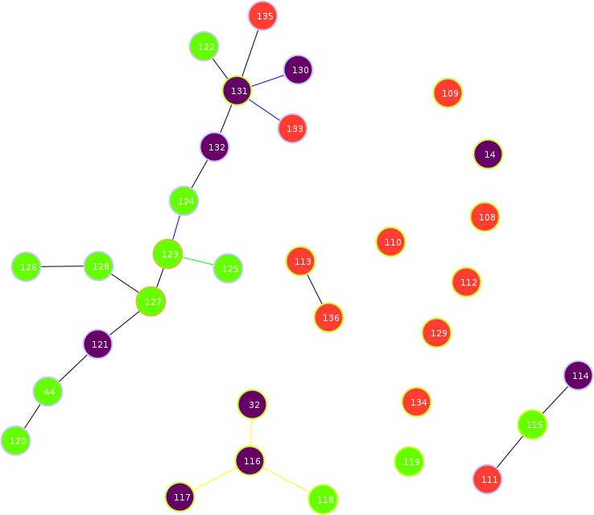

- S1 Figure 1: Population types mapped onto goeBURST clustering of T. vaginalis STs. Colours

- represent assignment to either type I (red), or type II (green). Any STs with mixed ancestry are

- represented in purple.

11

12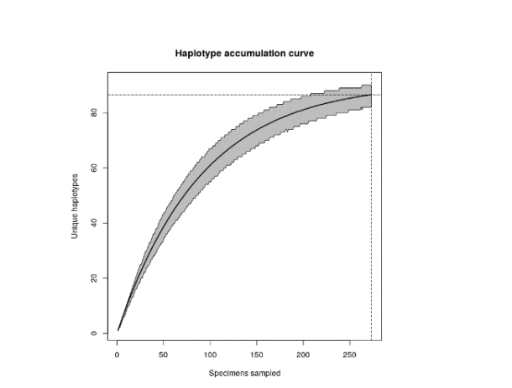

S1 Figure 2: Haplotype accumulation curve generated by HACSim in R, to estimate the number of additional samples required to better understand the distribution of genotypes in T. vaginalis samples.

