Co-designing narrative resources for implementation in lower limb amputation rehabilitation

Abstract
Background: Narratives help people to make sense of illness and trauma experiences. Exposure to a breadth of narratives is proposed to offer validation, reassurance and support well-being. Previous research constructed five narratives from people with major lower limb amputation (MLLA). However, efforts to bridge the research-practice gap, and meet clinical priorities by translating the narratives into resources, remained. This study aimed to illustrate an immersive co-design process and develop narrative resources for healthcare professionals working within, and people undergoing MLLA rehabilitation.
Methods: Commissioned by a National Health Service (NHS) MLLA rehabilitation centre, a 27-month rigorous co-design process was undertaken. An immersive, iterative three-stage process involving multiple end-user groups (e.g., patients, therapists, managers) and co-design activities (e.g., immersion, workshops) was used.
Results: Two co-design workstreams were undertaken, one to develop resources for people with MLLA and one for new allied healthcare professionals (AHPs). Outcomes included perceptions of the narratives (e.g., authentic, awareness raising), content and format priorities (e.g., visual, novel), and factors likely to influence implementation and engagement (e.g., readiness, existing knowledge).
Conclusions: Two narrative resource packages were co-designed for use in MLLA rehabilitation. The importance of context, and the dilemmas of sharing regressive narratives in clinical practice are discussed.
Key words
Stories, Amputation, Participatory Research, Implementation Science, Digital Health, Immersion.

INTRODUCTION
Major lower limb amputation (MLLA), defined as the removal of one or more limbs above the ankle ¹, has been evidenced to have wide-ranging physical and psychosocial impacts on individuals and their support networks. Often described as a ‘bereavement’, an amputation can lead to mixed and multiple emotions that can be challenging to make sense of (e.g., shock, sadness, anger and uncertainty) ²⁻⁶. Individuals can struggle to see a viable future or form expectations of their new normal ^{2, 7-10}, which can leave them feeling trapped and isolated ^{3,6,9}. Tensions and challenging interactions with family and friends can also be experienced ^{2,3,5}.
To understand peoples’ experiences and how best to support them, the dominant approach has been to focus on the individual’s “inner world” and how people think about and interpret their ‘new’ world. For example, researchers have explored identity ⁶, depression and anxiety ⁴, and quality of life ¹¹. Although social context is acknowledged, primacy has been given to individuals’ thinking and interpretation of their situation (e.g., rehabilitation, home). The limitation with this approach is that it can locate the problems experienced by patients squarely with the individual (e.g., they are not thinking/ feeling correctly) and it leaves the broader social context unchallenged. One method that can illuminate ‘thick socio-cultural’ discourses is narrative inquiry. While stories are ‘actual tales people tell’ in relation to personal experiences (e.g., injury), narratives comprise general overarching plot lines that are shaped by relationships, cultures, and society ¹². Narratives can circulate across different contexts and environments and act as templates that guide individuals in constructing their own personal story ¹³. The different narrative plots available in a particular context is termed a narrative environment ¹⁴. Within narrative environments, certain narratives are dominant while others are marginalised. For example, within hospitals, master narratives (e.g., treatment adherence, recovery) ¹⁵ are often promoted, while ‘counterstories’ (e.g., suffering) are supressed, perhaps due the paternalistic nature of healthcare ^{16,17}. Within MLLA rehabilitation, the narrative environment is narrow. Research has highlighted the limited circulation of everyday stories and information, and the dominance of unrealistic success stories, prompting people to lack an understanding of what is ‘typical’ and create inflated expectations of recovery ^{7,9,10,18,19}. Smith and Sparkes state, “… with multiplicity come more possible openings for restorying our lives and expanding our sense of who we are and could be” (p.280) ¹². Put simply, the more stories’ people can access, the more opportunity they have to live differently.
Aligned with research recommendations to explore social-cultural contexts and local clinical priorities, a National Health Service (NHS) England prosthetic rehabilitation centre approached the research team to forge an academic partnership. Categorised as a tertiary centre (e.g., rehabilitation gym, medical clinic, prosthetic workshop, and a comprehensive multidisciplinary team [MDT] including static and rotational staff from allied health and medical professions), individuals with MLLA usually attend this centre on a full-time basis, either as an in-patient or an out-patient, for five to 10 weeks, and receive MDT input. At this centre, allied health professionals (AHPs) expressed a need for resources that could inform practice and help “… meet or manage our patients’ needs and expectations to enhance the recovery process and enable them to lead an active, engaged and meaningful life” (p.4) ²⁰. Research began by Sanders and colleagues exploring the narrative environment and subsequently identifying five narrative trajectories of individuals with MLLA in this centre: accelerated decline, adaptation, illusory cure, muddling along and projection ²¹. Accelerated decline outlined a rapid decrease in wellbeing following MLLA. Adaptation depicted a managed improvement in wellbeing over time following an initial decline and sense of loss. The illusory cure plot depicted a period of low wellbeing prior to MLLA (e.g., chronic pain), followed by a marked increase during rehabilitation. Yet, after a trigger (e.g., unsurpassable challenge), a decline in wellbeing followed, breaking the fallacy that the amputation was the cure. Muddling along, represented moderate highs and managed lows where MLLA did not fundamentally change wellbeing. Finally, projection outlined contradictions and discrepancies between the story told by individuals and heard by others.
To continue the work of the partnership, the present study was commissioned to translate the five narratives into resources for clinical practice, to broaden the narrative environment of MLLA rehabilitation. To create appropriate and practical outputs, co-design, a participatory method, was used. Co-design utilises creative processes where patients and healthcare professionals work together to develop person-centred services, improvements, products, or innovations ²². Van Twillert and colleagues recommended such an approach in MLLA rehabilitation: “scientific knowledge from researchers, clinical knowledge from clinicians and practical knowledge from patients are important and should inform and strengthen each other” (p.209) ²³. Co-design provides patient and public contributors the opportunity to engage in impactful research which meets the needs of their communities ^{24,25}. Although there are previously published examples of co-design ²⁶⁻²⁸, this study is original and the first to depict how narrative trajectories can be crafted into narrative resources. The aim of this paper is to describe and evidence the immersive, iterative co-design processes, informed by implementation science, to guide future academic, clinical, and patient collaborations.
METHODS
Research philosophy
Underpinned by interpretivism ²⁹, our approach to co-design was framed and informed by ontological relativism which considers social reality to be fluid and multifaceted, and epistemological constructionism which considers knowledge as subjective, humanly constructed, and shaped by societal, social, and cultural experiences ^{30,31}. This approach is congruent with co-design practises which value multiple perspectives, context and curiosity ³².
Underpinning theories
The research was informed by the Knowledge-to-Action framework ³³. The framework describes and guides the process of translating research into practice, with wide application in healthcare settings ³⁴. The framework comprises two dynamic and interchangeable components, a knowledge creation funnel and an action cycle. As Sanders and colleagues constructed the knowledge (narrative trajectories) ²¹, this paper focuses on the development of resources using multiple stages of the action cycle (e.g., review knowledge, select knowledge, assess barriers/facilitators, and select and tailor interventions). The lead author also familiarised herself with two implementation theories (Consolidated Framework for Implementation Research ³⁵, Theoretical Domains Framework v2 ³⁶) to increase awareness of barriers and facilitators likely to impact resource implementation and which should be considered during co-design (e.g., context, innovation factors [appropriateness, benefit], individual factors [motivation, attitude]).
Narrative theory further underpinned the study. Congruent with the study aim and having been used in other public health related co-design research ³⁷, narrative theory conceptualises narratives as personal and social-cultural constructions, and essential means by which people make sense of their lives ¹³. Narratives are not merely passive – they do things. The assumptions on which narrative inquiry is based provide a strong rationale for use with co-design. For example, it is suggested that meaning is created, organised and expressed through narrative, and that society and culture ‘speak themselves’ through an individual’s story ³⁸. Thus, co-design may assist in considering the personal and social messages presented in each narrative trajectory. Furthermore, narrative theory suggests that the body is a storyteller and the stories we tell can give meaning to and understand bodies ³⁸. Consequently, it was important to develop narrative resources with those who had also experienced MLLA.
Together, the Knowledge-to-Action framework and narrative theory were utilised to centre peoples lived experiences in the resources, and to maximise the implementation and uptake of the resources in practice. The following principles of co-design guided the process: collaboration with different stakeholder groups; development through an evolving, adapting process; sharing power through a collective ownership; and finishing with the creation of practical outcomes ³⁹.
Immersion in the environment
The clinical lead of the MLLA rehabilitation service invited three researchers (omitted) to form a core working group with them (i.e., ‘outside-in’ pathway ⁴⁰) based upon pre-existing research relationships. All three researchers accepted the invitation and agreed to support the research priorities of the clinical lead.
Following ethical approval, the researchers continued to nurture trust and rapport with the clinical team. Quality relationships and regular communication in participatory knowledge translation research have been considered integral to success ^{41,42,43}. Gaining contextual knowledge (e.g., local terminology, everyday routines) and face-to-face communication have been recommended to build trust, respect and enhance relationships using shared language. As an outsider to the context and the setting, the first author sought to enhance the rigor of the research by immersing themselves in the rehabilitation setting both immediately prior to, and during the co-design process ⁴⁴. Immersion, and building the appropriate conditions for co-design (e.g., develop relationships and contextual knowledge) has been recommended ³², and aligned with the Knowledge-To-Action framework (e.g., understanding context) and narrative theory (understanding experiences).
To immerse themselves, the first author attended the rehabilitation centre at least once a week for 18 months, for approximately 5-7 hours per visit. This amounted to approximately 456 hours observing processes and engaging in informal discussion with AHPs and people with MLLA. Permission for immersion was granted by the clinical lead. Following immersion, observations relevant to the project aims and scope were recorded using field notes; no identifiable information was recorded, and the first author had no access to patient confidential information.
Recruitment
Established prosthetic users (EPUs) and allied health professionals (AHPs) were recruited. EPUs were deemed individuals who had been discharged from the rehabilitation centre for at least 18 months, but no longer than 3 years previously. This period was chosen with clinical support in consideration of relational ethics, to ensure that EPUs were beyond their first year living with their MLLA (the time frame covered by the narrative trajectories) ²¹. To gain a variety of perspectives, EPUs were sampled using a purposive, maximum-variation, criterion-based approach. The three criteria were age, gender, and level of MLLA (i.e., transtibial/transfemoral, unilateral/bilateral). Other inclusion criteria included being aged 18 or over, clear of cognitive impairments, and a previous patient of the service. EPUs were invited to join the research by invitation email from the clinical lead. All AHPs in the amputation therapy team were invited to participate and could be from any discipline (e.g., physiotherapy, psychology, occupational therapy,) with any level of expertise (e.g., students, managers).
Procedure
Prior to participation, all EPUs and AHPs were given the study information sheet and provided written informed consent. Participants were informed that they could participate in as much or as little of the co-design process as they choose. AHP participation was undertaken during continued professional development time or before/after routine daily activities as not to impact functioning of the unit or care provided. This was agreed upon with the clinical lead who co-conceived the project and who granted the letter of access to the first author.
Due to a clinical need for resources for two populations, two co-design workstreams were constructed: workstream 1, resources for AHPs new to MLLA rehabilitation and workstream 2, resources for people in MLLA rehabilitation. AHPs were invited to workstreams 1 and 2. EPUs were invited to workstream 2. Rationale for this was threefold: 1) to prevent EPU time and transport burden; 2) to give AHPs the space to discuss the narratives in reference to past patients who EPUs may have known; and 3) as lifelong users of the centre, and given the small sample size, EPU would be sharing experiences of current AHPs would could impair their disclosure, or could impact future care. In addition, separate meetings were held in workstream 2 with EPUs and AHPs to mitigate any pre-existing power dynamics ⁴⁵. Consistent with previous literature ¹⁸, the clinical lead felt EPUs may want to please their clinicians.
Workshops were the main co-design method for both workstreams. Workshops were jointly planned by the clinical lead and first author to ensure topics and materials were suitable (e.g., narrative trajectory images), a location was available, and timing was appropriate. The first author acted as the facilitator, and at the outset and re-iterated in subsequent workshops, expectations and guiding principles were explained (e.g., study expectations, respecting opinions, no right or wrong answers). Workshops were primarily held face-to-face at the centre, but due to the Covid-19 pandemic, email correspondence was also used for some periods. EPUs and AHPs were encouraged to share their experiences, debate the sharing of the narratives, prioritise content and select appropriate resource formats, and discuss implementation of resources in practice. Most workshops also included hands-on activities (e.g., flip chart paper and pens, sticky notes, editing). Workshops were audio recorded where possible and transcribed verbatim; some latter workshops with AHPs were held in an open space, sometimes within earshot of patients receiving care and thus, recording was not possible. AHPs proposed these spaces for briefer workshops when refining resources, and therefore, the environment was not deemed to impair AHP disclosure. The first author’s reflections following each co-design activity were written into field notes to further enrich the interpretation of the data. Following each workshop, key themes were summarised which enabled the sharing of ideas between groups and informed the next co-design topic/s.
RESULTS: CO-DESIGN PROCESS
The co-design process spanned a 27-month period, including initial immersion and three fluid and iterative stages: Stage 1) reviewing narratives, Stage 2) exploring priorities, content and formats, and Stage 3) resource design and development (see Figure 1). The co-design stages, and findings from each stage are presented together to show the iterative process (see Figure 2).

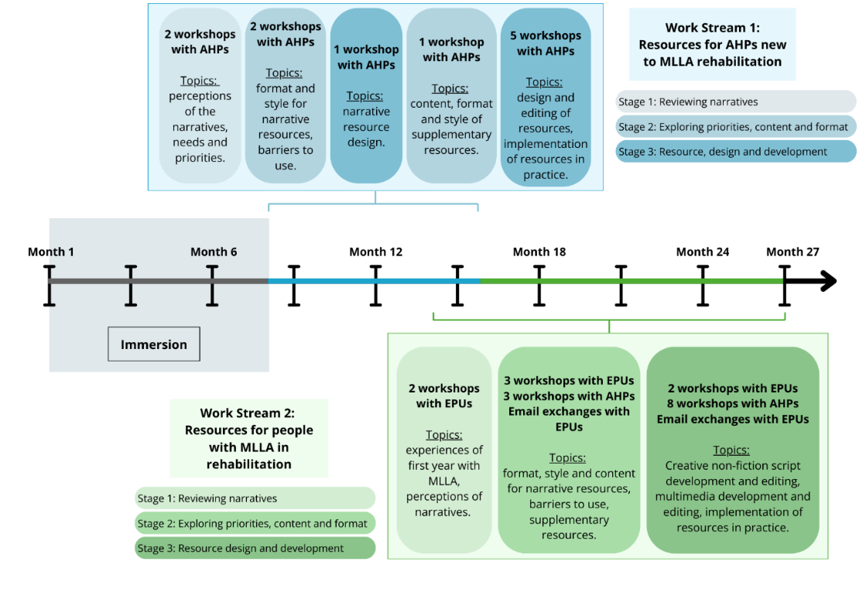
Figure 1. Overview of the two co-design workstreams and stages.
Five EPUs participated in co-design workstream 2, three of whom were male, and EPU ages ranged from 40-78 years old (M=59.4). Two of the users were unilateral transtibial amputees, whilst two were unilateral transfemoral amputees, and one was a bilateral transtibial amputee. Twenty-four AHPs participated across both co-design workstreams. Some AHPs participated in both, whereas others only participated in one due to rotation out of the setting. Other demographics are presented in Tables 1 and 2.
Table 1. Established prosthetic user (EPU) participant demographics.
EPUs | Sex | Level of MLLA* | MLLA Aetiology | Age | Ethnicity
EPU 1 | F | Unilateral TF | Trauma | 49 | White British
EPU 2 | F | Unilateral TT | Elective | 40 | White Other
EPU 3 | M | Bilateral TT | Infection | 61 | White British
EPU 4 | M | Unilateral TF | Infection | 78 | White British
EPU 5 | M | Unilateral TT | Vascular | 69 | White British
*TT (transtibial), TF (transfemoral).
Table 2. Allied health professional (AHP) participant demographics per workstream.
AHPs | Sex |  | Role | Workstream 1 | Workstream 2
Junior AHPs (less than 2 years MLLA rehabilitation experience)
AHP1 | F |  | Physiotherapist | X
AHP5 | M |  | Physiotherapist | X
AHP8 | F |  | Student Physiotherapist | X
AHP9 | F |  | Student Physiotherapist | X
AHP10 | F |  | Physiotherapist | X
AHP15 | F |  | Student Physiotherapist | X
AHP16 | F |  | Student Physiotherapist | X
AHP17 | F |  | Physiotherapist | X
AHP19 | F |  | Occupational Therapist | X | X
AHP20 | F |  | Physiotherapist | X | X
AHP21 | M |  | Student Physiotherapist | X
AHP22 | M |  | Student Physiotherapist | X
AHP23 | F |  | Physiotherapist |  | X
AHP24 | F |  | Physiotherapist |  | X
AHP25 | F |  | Physiotherapist |  | X
AHP26 | F |  | Physiotherapist |  | X
Senior AHPs (more than 2 years MLLA rehabilitation experience)
AHP2 | F |  | Physiotherapist | X | X
AHP3 | F | Physiotherapist |  | X | X
AHP4 | F | Occupational Therapist |  | X | X
AHP6 | F | Rehabilitation Assistant |  | X | X
AHP7 | F | Physiotherapist |  | X | X
AHP11 | F | Clinical Team Lead |  | X | X
AHP12 | F | Occupational Therapist |  | X
AHP18 | F | Clinical Psychologist |  | X | X
*Age, NHS Band level and prior experience working in MLLA rehabilitation were omitted to protect the identities of AHPs.
Stage 1: Reviewing Narratives
Initially, AHP and EPU discussions concerned the authenticity of the narratives in the environment, and the potential benefit of sharing the information (see Figure 2). Reflecting on their own stories and experiences, EPUs and AHPs perceived the five narratives to be recognisable either within their own stories or others they had met/supported. Some narratives were considered more common that others (e.g., accelerated decline, projection), and some considered more desirable and positive journeys than others (e.g., adaptation). The discussion encouraged EPUs to share their own stories of rehabilitation and the first year following MLLA, which grew rapport within the group. Similarly, it prompted AHPs to discuss patients who had embodied a single narrative or multiple narratives during their rehabilitation. Different patient characteristics were debated and attributed to narratives drawing upon clinical experiences, and patients embodying some storylines (e.g., illusory cure, accelerated decline) were considered more challenging to support than others.
Both groups saw benefit in sharing the five narratives in rehabilitation. EPUs felt the storylines could be powerful for patients due to their lack of connection with more experienced amputees. This included the narratives deemed “harder to hear” because “sadness can teach us things” (e.g., accelerated decline). The possible benefits of exposure to the narratives included greater knowledge and awareness, reduced stigma, and the normalisation of emotions and experiences - “that it’s a natural thing [to go through]”. When sharing narratives, EPUs recommended the inclusion of practical hints and tips, to make the information of greater benefit and interest to patients. AHPs felt similarly, yet they also considered the narratives to be valuable learning tools for new AHPs who often joined the team with minimal MLLA training, and a lack patient examples to draw from: “it's only us farts who have been here a while who actually have the stories and experiences from patients” (AHP3).
Workstream 1: Co-design of resources for new MLLA rehabilitation AHPs
Stage 2: Exploring Priorities, Content, and Formats
AHPs decided resources for new MLLA rehabilitation AHPs was a core priority. AHPs prioritised two forms of knowledge for the resources alongside information on the narratives themselves: a) characteristics to help flag patients storying each narrative and b) guidance for supporting patients storying each narrative. While awareness of the narratives was deemed helpful, AHPs felt practical information which could be used to directly enhance patient care was most beneficial. Subsequently, senior AHPs shared their experiential knowledge on language and behavioural characteristics representative of each narrative, as well as their hints and tips to directly inform guidance for new AHPs. This guidance included listening to patients’ stories, different approaches to goal setting, greater functional practice, normalising “bad days” and the timing and content of difficult conversations. For junior (including new) AHPs, information on general MLLA rehabilitation processes were prioritised. Junior AHPs lack of foundational MLLA rehabilitation knowledge was thought likely to make understanding the narratives challenging.
AHPs decided that the narrative resources should be paper-based and located in their workstation to encourage use. With limited technological infrastructure, and at a time when most admin tasks were paper-based, digital innovations were considered less accessible. Instead, paper-based formats, congruent with existing norms in the setting were preferred. In a busy, demanding rehabilitation environment, time-burden was frequently discussed. With large patient caseloads, and often complex patients (e.g., bilateral amputees), AHPs wanted easy-to-use, resources. Therefore, the storage of resources in the workstation was proposed as the most convenient, easily observable and accessible location.
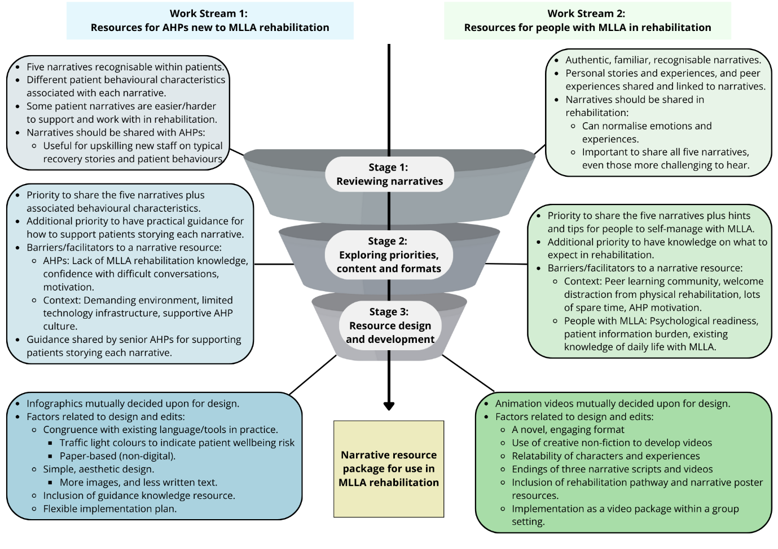
Figure 2. Overview of findings from each stage and each workstream of the co-design.
AHPs shared their supportive staff culture which supported observations made during immersion. Therefore, AHPs were conscious that resources should not replace existing mentorship and informal support processes. Instead, narrative resources should act as additional tools for new staff and offer a first point of reference for information during busy practice. Here, integrating resources into formal patient rehabilitation processes was considered an inhibitor to use – seen as “just another thing to do”. Rather, resources which could be discussed and junior AHPs could be directed too alongside mentorship were seen as helpful for developing clinical autonomy and professional learning and development.
Stage 3: Resource Design and Development
Infographics were chosen by AHPs as the preferred format. Printed infographics were perceived to offer a simple aesthetic solution, comprised of minimal words, pictures and symbols to illustrate key messages, including narrative plot lines, and easy to locate and store for reference. When designing and editing content, AHPs selected language congruent with their existing clinical backgrounds (e.g., physiotherapy) to facilitate new AHPs understanding. For instance, when describing the narratives and associated behavioural characteristics, AHPs suggested assigning specific colours (e.g., red, orange, green) to indicate perceived risk to patient wellbeing, consistent with “flagging in MSK (musculoskeletal) services”, and therapy education.
To accommodate for AHPs additional priorities (e.g., guidance for new AHPs supporting patients storying each narrative), additional paper-based infographic-style resources were designed. To facilitate use, these were designed with matching colour schemes to the associate infographics, and to be stored so that AHPs could see the narrative and the guidance on a double page spread. Other design preferences for the guidance included bullet points, and information presented temporally to show strategies AHPs could use at various stages of rehabilitation.
Five infographics (see Figure 3) and accompanying guidance sheets (one per narrative) were created from workstream 1. It was mutually agreed that these would be available for use on a flexible basis, within practice and mentorship, but with no formal implementation strategy.
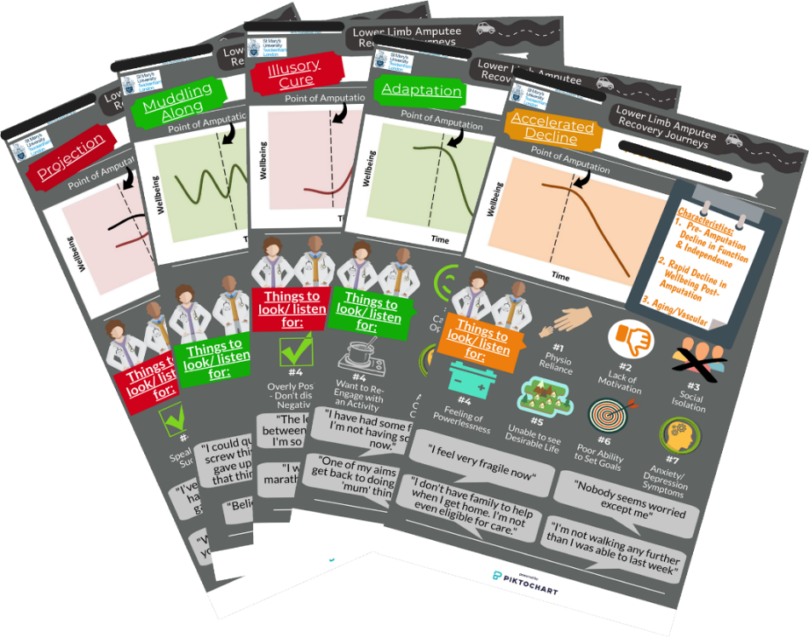
Figure 3: Five narrative infographics for AHPs new to MLLA rehabilitation.
*Parts of the image have been reacted for site confidentiality.
Workstream 2: Co-design of resources for people with MLLA in rehabilitation
Stage 2: Exploring Priorities, Content, and Formats
EPUs shared content which they would like to see in narrative resources. The narratives, people’s experiences, hints and tips were desired, but alike AHPs, realised additional information on rehabilitation processes was also a priority. EPUs suggested that without being aware of the rehabilitation pathway, understanding and resonating with narratives which cover rehabilitation could be challenging. Consequently, a resource outlining the MLLA rehabilitation process was prioritised to supplement the narrative resources.
Although positive about the sharing of the narratives, EPUs expressed some concern about people’s psychological readiness for plot lines with declines in wellbeing (e.g., accelerated decline). EPUs warned that early exposure, when someone might still be grieving and processing their MLLA, could be detrimental for their mental health. Conversely, shielding authentic narratives was considered unethical and could prevent opportunities for learning (e.g., “validating experiences”). After discussion, EPUs and AHPs both agreed that narrative resources should illustrate that ongoing support is available from the centre, and that these resources be introduced in the latter phase of a person’s rehabilitation, and on a case-by-case basis.
EPUs discussed several factors thought to impact peoples’ engagement with different narrative resource formats. EPUs explained that something novel, outside of the norm would be most engaging. The existing “large stack of paper” information was perceived as overwhelming and burdensome, and EPUs advised this be avoided as well as the creation of another AHP group education talk. Creative innovations, such as videos, were favoured given their uniqueness in the setting, but EPUs were apprehensive of the use of actors; actors were considered difficult to find and often unauthentic. Instead, animation was agreed upon. The implementation of resources into a new activity or event was also considered facilitative. EPUs suggested an opportunity to do “something different”, and/or have a distraction or rest from physically intensive therapy would likely be perceived positively by people in rehabilitation. EPUs recounted how people with MLLA often have a large amount of spare time in rehabilitation and rest periods during walking or exercise practise. They suggested visual information on the rehabilitation gym wall would also likely be absorbed and would comprise another suitable format for sharing information.
Beyond the format, points pertaining to content and delivery were also raised. EPUs shared how the peer community in rehabilitation could be a primary avenue for learning (e.g., copying others, exchanging experiences) and while inpatients nurture relationships on the wards, outpatients have less opportunity for peer support. It was suggested that if the resources were presented to people in group settings, amid opportunities for discussion and peer learning, people may be incentivised to attend. Finally, EPUs shared their hints and tips for navigating everyday life, and exchanged ideas and recommendations within the co-design, exemplifying the power of peer learning. Challenges and hints and tips they felt integral to weave into narrative resources included showering, getting dressed, cooking, managing family relationships and managing public perceptions.
Stage 3: Resource Design and Development
Five animation videos (one per narrative) were chosen by EPUs, and agreed by AHPs, as the favoured resource format. To develop the five videos from the narrative data, the creative analytical practice of creative non-fiction ⁴⁶ was used to maximise authenticity and evocation. Creative non-fiction uses “fictional strategies to represent the research findings in a storied manner” (p.135) ⁴⁷, and generates materials that are factual in content, grounded in lived experiences, yet fictional in form ⁴⁸. Here, the use of creative non-fiction facilitated the integration of narrative plot lines together with EPUs hints and tips, and techniques of fiction (e.g., dialogue, flashbacks, and composite characters) to communicate the narratives in compelling ways ⁴⁷. Five composite creative non-fiction scripts were constructed. Composite scripts were chosen as the data was already composite (e.g., narrative) and because the use of five videos was thought to show distinctions between and within each narrative. Composite scripts allowed for rich integration of EPUs’ and AHPs’ expertise, and the first author’s observations, into the content ⁴⁹. Steps to develop the scripts, and subsequent animation videos are summarised in Figure 4.
When developing scripts and videos, consideration included the representativeness of the five characters (e.g., age, sex, ethnicity, employment status, MLLA type, peer support, inpatient/outpatient, hobbies), supporting characters (e.g., healthcare professionals, peers), scenes (e.g., rehabilitation centre, home environments), sounds, graphics, animations, and the integration of lived experiences (e.g., hints/tips). EPUs and AHPs were engaged throughout the whole process, including shaping all scripts, main characters and video passages before reviewing each video, and then the final five video package. Collaboration from a digital learning practitioner was sought for video development.
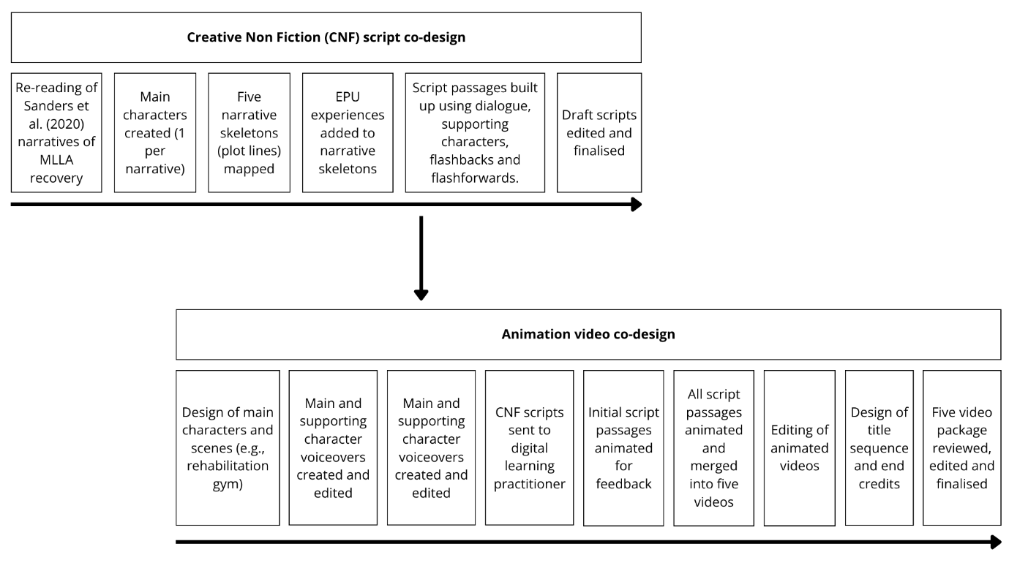
Figure 4. Development of creative nonfiction scripts and animation videos.
After watching a first draft of the videos, both groups felt some video content was too emotive and could cause severe discomfort for recipients. EPUs explained that the illusory cure main character “needed rescuing” and AHPs felt that people watching might “feel stuck”. To balance narrative authenticity and patient wellbeing, EPUs asked to adapt the endings of illusory cure, accelerated decline, and projection to include “more hope”. Scripts were revised and ‘hope’ was woven in, not by changing the endings, but giving a cross-roads type decision for the character where they were presented with a feasible “way out” (e.g., sourcing help). In this phase, EPUs and AHPs encountered some disagreement regarding the positivity of experiences portrayed. For instance, when discussing adaptation, EPUs felt the inclusion of negative encounters with the public were necessary to prepare people, whereas AHPs felt opposingly. However, in respect to their lived experiences, AHPs were led by EPUs decision making.
The five narrative animation videos were designed as a package, each featuring the main characters of each narrative video, as if all the characters were experiencing rehabilitation together in congruence with the community context. Screenshots from the final video package are shown in Figure 5. AHPs and EPUs agreed that videos should be shown collectively, rather than individually, to highlight the differences between the narratives. They also decided that the videos should be implemented by an AHP in a peer group setting to foster discussion, sharing of experiences and provide the opportunity for people to ask questions.
An illustrated mural and a narrative poster were chosen by EPUs and AHPs to address their additional priorities. The local geographic inspired mural was designed to show both new AHPs and people with MLLA the multiple phases of rehabilitation. The narrative poster was designed to show the narrative plot lines, reinforce the different journeys following MLLA, and act as a prompt to the videos and encourage discussion about life after rehabilitation.
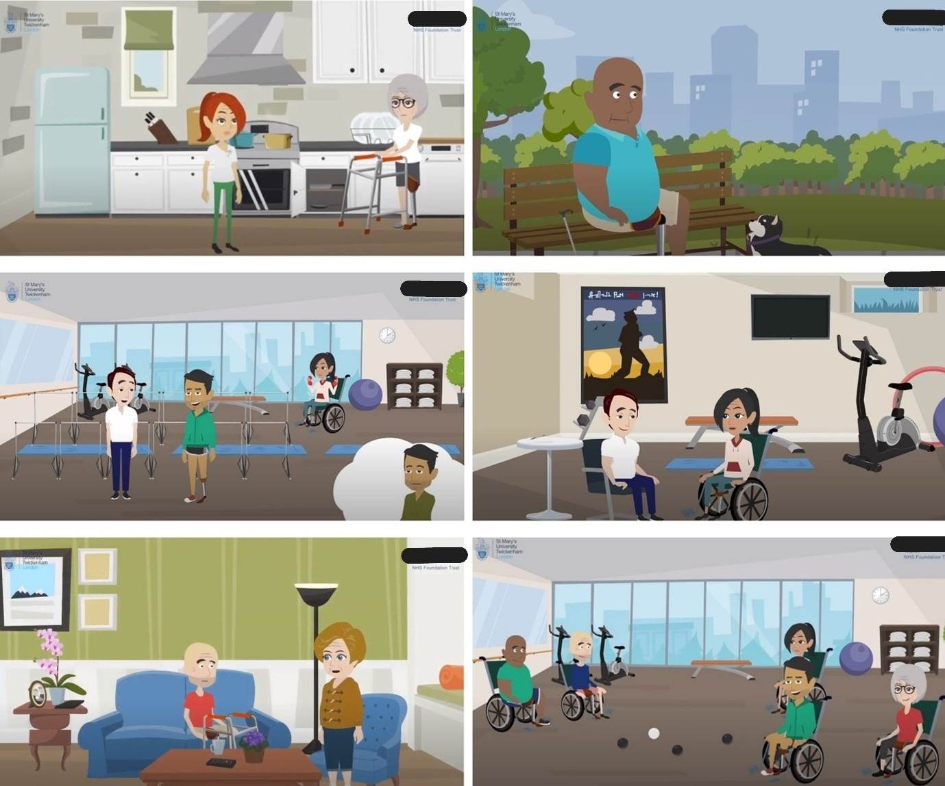
Figure 5. Still images from the five narrative animation videos for people with MLLA.
*Parts of the image have been reacted for site confidentiality.
Together, the five narrative videos, the mural, the poster, and the five infographics and guidance sheets for AHPs comprise the full narrative resource package for use in, and to broaden the narrative environment of MLLA rehabilitation.
Judging the rigour of the co-design processes
Following the co-design, EPUs shared reflections on the process. The following guiding questions were used to explore the quality of co-design: Did everyone feel their contributions were genuinely engaged with? Did contributions make a difference to decisions? How did researchers treat people with lived experience, and with what impact? Was an outcome created? ^{24,39}). Overall, reflections from both groups were positive. The AHP group had hoped the process would be faster but appreciated that the final outputs had made the wait worthwhile. They described enjoying the meetings and felt that their contributions had been listened to. EPUs found the process very rewarding and felt proud of how they were able to support others going through similar rehabilitation:
I would say it was very successful. Not only in what it was trying to do to, but in the way it was presented. It’s polished and professional, and it’s been done by people who have their hearts in the right place and are trying to help the patients. My involvement was terrific, so full marks for that. I have to say, I thoroughly enjoyed it. It was nice to feel free to make comments about what we’ve seen, and to have it taken on board. It felt very much as if we were helping the videos to evolve. What all of us have managed to produce is just spectacular compared to anything we could have expected at the very beginning. (EPU)
A full evaluation of the implementation and use of the resources in clinical practice is underway but early reflections from use of the animation videos were shared in email correspondence:
The comments we received were that everyone [patients] felt they could relate to a bit of each story, that it was reassuring, that taking small steps was a key message, and it was good to know they can always use us as a backup resource. (Clinical lead)
DISCUSSION
This original paper is the first to illustrate an immersive co-design process that was framed by knowledge translation, implementation science and narrative theory. In presenting this process, our aim is to guide future academic, clinical, and public collaborations by providing a transparent account of the three-stage process undertaken in both workstreams.
The research enhances understanding by highlighting how people living with long-term conditions, such as MLLA, advocate for the sharing of multiple narratives in rehabilitation. Alike other settings ⁵⁰, EPUs felt it important that multiple narratives be illustrated to normalise different emotions and experiences. Narratives were considered to aid understanding of the rehabilitation process, although the emotional readiness of individuals with MLLA was raised as a possible barrier to narrative engagement during workstream 2. As warnings in the literature articulate ²¹, sharing narratives with those who are not emotionally ready to hear them may be detrimental. From multiple sclerosis literature ⁵⁰, suggest stress and ‘brain fog’ should be considered before narrative exposure. In MLLA rehabilitation, the physical loss and associated grief may similarly impact a persons’ readiness to hear information. Feelings of loss and grief impact people differently, and therefore individuals’ unique emotional readiness should be considered before translating and exposing people to narratives in MLLA rehabilitation.
The fluid co-design process used illustrates a theoretically informed, three-stage approach to guide future practice. The process drew upon core co-design principles, while also accounting for practical considerations essential to the translation and implementation of innovations in healthcare. Here, as advocated ³³, phases within the Knowledge-to-Action framework’s action cycle were drawn upon interchangeably to account for multiple factors (e.g., knowledge, priorities, context and implementation) while exploring (stage 2) and designing (stage 3) the resources (see Figure 6). The process included elements from existing co-design methods, such as accelerated experience-based co-design, by placing the needs and priorities of service users and the public at the centre ³⁹ and including priority setting and content decision-making phases ²⁸, yet offers a process also underpinned by implementation science to maximise resource update in practice. Implementation factors found in this study (e.g., time, competing demands, emotional readiness, information burden) mirror existing research ⁵¹⁻⁵⁵, but extend these to the use of narratives in context of MLLA rehabilitation.
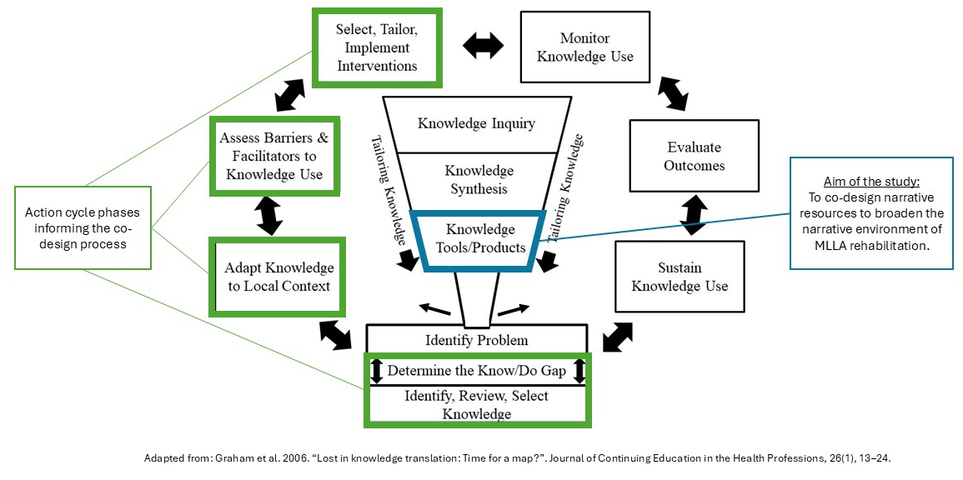
Figure 6: Adoption of the Knowledge-to-Action framework within the co-design process.
Unlike previous approaches ^{26,27,45}, a novel immersive period before the commencement of the co-design was undertaken. As advocated ²⁶, this longitudinal immersive component undertaken within the rehabilitation environment led to greater researcher contextual understanding (e.g., understanding day-to-day processes, patient routines, the physical environment, local jargon and language). It also enabled the researcher to understand how and why narrative resources might be beneficial (e.g., seeing peoples’ lack of awareness and knowledge of life after MLLA), and facilitated the envisaging of how resources might be implemented in practice. Rudstam and colleagues advocated the importance of researcher contextual understanding when doing knowledge translation with populations with a disability to enhance rigor ⁵⁶. While this could be extended to co-design processes for researchers with little knowledge of a context or population, we do acknowledge the cost implication of immersion and recognise this may not be an option in all situations or environments. However, it is likely that the ‘slow science’ time investment, and resultant relationships which were developed, contributed heavily to the success of the processes.
To create the five narrative video scripts, creative non-fiction was used as a method to translate research into a creative, user-friendly form. With growing popularity in health ⁵⁰, creative non-fiction provides a process to retain the factual grounding of research, while adding a fictional layer to bring the research to life. Although used to create theatre scripts and written pieces ⁵⁷, this study provides an exemplar for how this creative analytical practice can be used to design multimedia narrative resources.
During the co-design, the challenge of translating narratives with regressive plot lines (e.g., plots showing declines in wellbeing [projection and illusory cure]) was illustrated. Richardson and Motl touched upon the potential for this, through an acknowledgement that their regressive stories were not shared “for the intention to perpetuate a negative story, nor to upset anyone reading this, but to reflect the lived, embodied experiences” (p.10) ⁵⁰. During the co-design process, despite reflecting true lived experiences, the sharing of projection and illusory cure were met with concern surrounding lack of hope portrayed at the end of the stories. Without any hope for the characters in these two narratives, coupled with minimal knowledge of everyday life with MLLA, EPUs explained how recipients may experience greater harm than good, possibly rife with grief and fear. The translation of illusory cure and projection therefore fostered substantive ethical dilemma. EPUs discussed how the narratives were too sensitive to share, but by withholding them, they were in essence withholding and invalidating the lived experiences of others. As a co-design team, we resisted the notion to be completely swayed by master narratives that portray positivity and recovery (e.g., adaptation). Instead, modifications to the endings of projection and illusory cure videos were crafted with EPUs and AHPs. The input of EPUs and AHPs was crucial to the translation of these regressive narratives into resources, and thus, co-design offers a valuable method to develop narrative resources for rehabilitation settings.
Although the benefits of participatory research are multiple, and advocated by those in MLLA rehabilitation ²³, such processes are not without challenges. Challenges in the study included sharing regressive plot lines, time investment with AHPs (to avoid any disruption to patient care) and decision making between groups with differing priorities. For instance, EPUs prioritised normalising difficulties, whereas AHPs preferred a more positive lens with patient safety at heart. However, through sustained communication with both groups, and with flexibility, obstacles were collectively problem solved. To ensure that co-designed resources are useful, accessible and implementable in clinical practice, researchers need to attentively listen to the experiences of others, be efficient and adaptable with their communication, and commit time to understanding the priorities of the populations they are working together with.
CONCLUSION
This paper presents an illustration of two co-design workstreams used to develop narrative evidence-based resources, to broaden the narrative environment of MLLA rehabilitation in one UK setting. Rooted in rigorous qualitative research, five narrative trajectories following the first year of limb loss were translated into five infographics, five animation videos and several accompanying resources for rehabilitation. The implementation and evaluation of these narrative resources is now underway in one NHS amputation rehabilitation setting, and future research should seek to explore the transferability of these resources into other MLLA rehabilitation settings across the UK. From this co-design process, we are reminded of the power of stories and narratives. As Frank explains, “suffering does not magically disappear when a tale is told, but the more stories I heard, the less space my own suffering seemed to take up. I felt less alone” (xi) ⁵⁸. We hope this paper provides a useful contribution for researchers and healthcare professionals to illustrate how qualitative research can be transformed into evidence-based resources and be made accessible to populations it may benefit.

ACKNOWLEDGEMENTS
We are very grateful to all the allied health professionals, and established prosthetic users for their support, guidance and assistance with this research.
DECLARATION OF INTEREST STATEMENT
No potential conflict of interest was reported by the author(s).
DATA AVAILABILITY STATEMENT
The data that support the findings of this study are available on request from the corresponding author. The data are not publicly available due to privacy or ethical restrictions.
ETHICS STATEMENT
Ethical approval for the study was obtained from the Health Research Authority (HRA) Research Ethics Committee (REC) for England (reference 18/WM/0279) recognised by the UK Ethics Committee Authority. Informed consent to take part in the co‐design was sought before participation and participants were provided with the right to withdraw from the study at any point without giving a reason. Informed consent was retrieved from all participants in the study. Consent forms were given and completed face-to-face with participants signing and returning the forms directly to the first author. All consent forms are stored securely in a folder in a university password‐protected drive accessible only to the research team and will be destroyed after a period of 10 years from the study start date. All procedures were followed in accordance with the Declaration of Helsinki.
FUNDING
St George’s University Hospitals NHS Foundation Trust [N/A].
REFERENCES
1. Marshall, C., and G. Stansby. 2013. “Amputation and rehabilitation”. Surgery (Oxford), 31(5), 236–239. https://doi.org/10.1016/j.mpsur.2013.03.002
2. Gallagher, P., and M. MacLachlan. 2001. “Adjustment to an artificial limb: A qualitative perspective”. Journal of Health Psychology, 6(1), 85–100. https://doi.org/10.1177/135910530100600107
3. Grech, C., and R.F. Debono. 2014. “The lived experience of persons with an amputation.” Malta Journal of Health Sciences, 1(2), 54–59.
4. Horgan, O., and M. MacLachlan. 2004. “Psychosocial Adjustment to Lower-Limb Amputation: A Review.” Disability and Rehabilitation 26 (14–15): 837–50. https://doi.org/10.1080/09638280410001708869.
5. Murray, C. D., and M.J. Forshaw. 2013. “The experience of amputation and prosthesis use for adults: A metasynthesis”. Disability and Rehabilitation, 35(14), 1133–1142. https://doi.org/10.3109/09638288.2012.723790.
6. Senra, H., R.A. Oliveira, I. Leal, and C. Vieira. 2011. “Beyond the body image: A qualitative study on how adults experience lower limb amputation”. Clinical Rehabilitation, 26(2), 180–191. https://doi.org/10.1177/0269215511410731.
7. Columbo, J., L. Davies, R. Kang, J. Aaron Barnes, K. Leinweber, B D. Suckow, P. Goodney, and D H. Stone. 2018. “Patient Experience of Recovery After Major Leg Amputation for Arterial Disease.” Vascular and Endovascular Surgery 52 (4): 262–68. https://doi.org/10.1177/1538574418761984.
8. Murray, C. D. 2013. “‘Don’t You Talk to Your Prosthetist?’ Communicational Problems in the Prescription of Artificial Limbs.” Disability and Rehabilitation 35 (6): 513–21. https://doi.org/10.3109/09638288.2012.704125.
9. Norlyk, A., B. Martinsen, E. Hall, and A. Haahr. 2016. “Being In-Between: The Lived Experience of Becoming a Prosthesis User Following the Loss of a Leg.” SAGE Open 6 (3). https://doi.org/10.1177/2158244016671376.
10. Ostler, C., C. Ellis-Hill, and M. Donovan-Hall. 2014. “Expectations of Rehabilitation Following Lower Limb Amputation: A Qualitative Study.” Disability and Rehabilitation 36 (14): 1169–75. https://doi.org/10.3109/09638288.2013.833311.
11. Sinha, R., and W.J. Van Den Heuvel. “A systematic literature review of quality of life in lower limb amputees”. Disability and Rehabilitation. 2011;33(11):883-99. https://doi.org/10.3109/09638288.2010.514646
12. Smith, B., and A. Sparkes. 2009. “Narrative Inquiry in Sport and Exercise Psychology: What Can It Mean, and Why Might We Do It?” Psychology of Sport and Exercise 10 (1): 1–11. https://doi.org/10.1016/j.psychsport.2008.01.004.
13. Frank, A W. 2010. Letting Stories Breathe. Chicago, Illinois: University of Chicago Press.
14. Gubrium, J. F., and J A. Holstein. 2008. “Narrative Ethnography.” In Handbook of Emergent Methods, edited by S.N Hesse-Biber and P Leavy, 241–64. New York, NY: The Guilford Press.
15. Perrier, M., B. Smith, and A. Latimer-Cheung. 2013. “Narrative Environments and the Capacity of Disability Narratives to Motivate Leisure-Time Physical Activity among Individuals with Spinal Cord Injury.” Disability and Rehabilitation 35 (24): 2089–96. https://doi.org/10.3109/09638288.2013.821179.
16. Bamberg, M., and M. Andrews. 2004. Considering Counter Narratives: Narrating, Resisting, Making Sense. Amsterdam: John Benjamins.
17. Griffin, M., and C. Phoenix. 2016. “Becoming a Runner: Big, Middle and Small Stories about Physical Activity Participation in Later Life.” Sport, Education and Society 21 (1): 11–27. https://doi.org/10.1080/13573322.2015.1066770.
18. Sanders, P., R. Wadey, M. Day, and S. Winter. 2020. “Prosthetic Rehabilitation in Practice: An Exploration of Experiential Knowledge in the Multidisciplinary Team.” Qualitative Health Research. 31(2):309-322. https://doi.org/10.1177/1049732320933272
19. Sansam, K., R. O’Connor, V. Neumann, and B. Bhakta. 2014. “Clinicians’ Perspectives on Decision Making in Lower Limb Amputee Rehabilitation.” Journal of Rehabilitation Medicine 46 (5): 447–53. https://doi.org/10.2340/16501977-1791.
20. Sanders, P. 2019. A psychosocial exploration of prosthetic rehabilitation and the first year after major lower limb loss (unpublished doctoral dissertation). Liverpool Hope University.
21. Sanders, P., R. Wadey, M. Day, and S. Winter. 2020. “Narratives of Recovery Over the First Year After Major Lower Limb Loss.” Qualitative Health Research, 30(13):2049-2063. https://doi.org/10.1177/1049732320925794.
22. Robert G., J. Cornwell, L. Locock, A. Purushotham, G. Sturmey, and M. Gager. 2015. “Patients and staff as codesigners of healthcare services”. BMJ, 350. https://doi.org/10.1136/bmj.g7714
23. Van Twillert, S., J. Geertzen, T. Hemminga, K. Postema, and A. Lettinga. 2013. “Reconsidering Evidence-Based Practice in Prosthetic Rehabilitation: A Shared Enterprise.” Prosthetics and Orthotics International 37 (3): 203–11. https://doi.org/10.1177/0309364612459541.
24. Smith, B., O. Williams, L. Bone, and the Moving Social Work Co-Production Collective. 2022. “Co- production: A resource to guide co-producing research in the sport, exercise, and health sciences.” Qualitative Research in Sport, Exercise and Health. 8. https://10.1080/2159676X.2022.2052946.
25. Williams, O., G. Robert, G. Martin, E. Hanna, and J. O’Hara. 2020. “Is Co-production Just Really Good PPI? Making Sense of Patient and Public Involvement and Co-production Networks.” In Decentering Healthcare Networks, edited by M. Bevir and J. Waring, 213–237. London: Palgrave.
26. Archibald, M., R. Ambagtsheer, M.T. Lawless, M.O. Thompson, T. Shultz, M.J. Chehade, L. Whiteway, A. Sheppard, M.P. de Plaza, and A.L. Kitson. 2021. “Co-Designing evidence based videos in health care: A case exemplar of developing creative knowledge translation “evidence-experience” resources”. International Journal of Qualitative Methods, 20: 1-10. https://doi.org/10.1177/16094069211019623
27. Kulnik, S. T., H. Postges, R. Townsend, P. Micklethwaite and F. Jones. 2019. “A gift from experience: co-production and co-design in stroke and self management”. Design for Health, 3:98–118. https://doi.org/10.1080/24735132.2019.1577524
28. Jones, F., A. Domeny, J. Fish, F. Leggat, I. Patel, J. McRae, C. Rowe, and M.E. Busse. 2024. “Using co-design methods to develop new personalised support for people living with Long Covid: The 'LISTEN' intervention”. Health Expectations. 27(3):e14093. https://doi.org/10.1111/hex.14093
29. Smith, J., and D. Deemer. 2000. The problem of criteria in the age of relativism. In Handbook of Qualitative Research, edited by N. Denzin & Y. Lincoln, 877– 896. Sage.
30. Sparkes, A. C. and B. Smith. 2014. Qualitative Research Methods in Sport, Exercise and Health. London: Routledge.
31. Poucher, Z A., K A. Tamminen, J G. Caron, and S N. Sweet. 2020. “Thinking through and Designing Qualitative Research Studies: A Focused Mapping Review of 30 Years of Qualitative Research in Sport Psychology.” International Review of Sport and Exercise Psychology 13 (1): 163–86. https://doi.org/10.1080/1750984X.2019.1656276.
32. McKercher, K. A. 2020. Beyond sticky notes. Doing co-design for Real: Mindsets, Methods, and Movements. 1st ed. Australia: Beyond Sticky Notes.
33. Graham, I.D, J. Logan, M. Harrison, S. Straus, J. Tetroe, W. Caswell, and N. Robinson. 2006. “Lost in knowledge translation: Time for a map?”. Journal of Continuing Education in the Health Professions, 26(1), 13–24. https://doi.org/10.1002/chp.47
34. Nilsen, P. 2015. “Making sense of implementation theories, models and frameworks”. Implementation Science, 10:53. https://doi.org/10.1186/s13012-015-0242-0.
35. Damschroder, L., D. Aron, R. Keith, S. Kirsh, J. Alexander and J. Lowery. 2009. “Fostering implementation of health services research findings into practice: A consolidated framework for advancing implementation science”. Implementation Science, 4: 50. https://doi.org/10.1186/1748-5908-4-50.
36. Cane, J., D. O’Connor, and S. Michie (2012). “Validation of the theoretical domains framework for use in behaviour change and implementation research”. Implementation Science, 7: 37. https://doi.org/10.1186/1748-5908-7-37
37. Messiha, K., M.J.M. Chinapaw, H.C.F.F Ket, Q. An, V. Anand-Kumar, G.R. Longworth, S. Chastin, and T.M. Altenburg. 2023. “Systematic Review of Contemporary Theories Used for Co-creation, Co-design and Co-production in Public Health”. Journal of Public Health 45(3), 723–737. https://doi.org/10.1093/pubmed/fdad046
38. Smith, B., and A.C. Sparkes. 2007. “Narrative and its potential contribution to disability studies”. Disability and Society, 23(1), 17–28. https://doi.org/10.1080/09687590701725542
39. Donetto, S., P. Pierri, V. Tsianakas and G. Robert. 2015. “Experience-based co-design and healthcare improvement: realizing participatory design in the public sector”. The Design Journal, 18(2):227–248. https://doi.org/10.2752/175630615X14212498964312
40. Loeffer, E. 2021. Co-Production of Public Services and Outcomes. Palgrave Macmillan Cham.
41. Greenhalgh, T., C. Jackson, S. Shaw, and T. Janamian. 2016. “Achieving Research Impact Through Co-creation in Community-Based Health Services: Literature Review and Case Study”. Milbank Quarterly 94(2):392-429. https://doi.org/10.1111/1468-0009.12197
42. Rycroft-Malone, J, C.R. Burton, T. Bucknall, I.D. Graham, A.M. Hutchinson, and D. Stacey. 2016. “Collaboration and Co-Production of Knowledge in Healthcare: Opportunities and Challenges.” International Journal of Health Policy and Management 5 (4): 221–23. https://doi.org/10.15171/ijhpm.2016.08
43. Zych, M., W. Berta, and A. Gagliardi. 2020. “Conceptualising the Initiation of Researcher and Research User Partnerships: A Meta-Narrative Review.” Health Research Policy and Systems 18 (24). https://doi.org/10.1186/s12961-020-0536-9.
44. Tracy, S.J. and M.M. Hinrichs. 2017. “Big tent criteria for qualitative quality”. The International Encyclopedia of Communication Research Methods, 1-10. https://doi.org/10.1002/9781118901731.iecrm0016
45. Heaton-Shrestha C., A. Torrens-Burton, F. Leggat, I. Islam, M. Busse and F. Jones. 2022. “Co-designing personalised self-management support for people living with long Covid: the LISTEN protocol”. PLoS One 17 (10): e0274469. https://doi.org/10.1371/journal.pone.0274469
46. Cavallerio, F. 2022. Creative Nonfiction in Sport and Exercise Research. London, UK: Routledge.
47. Smith, B. 2013. “Sporting Spinal Cord Injuries, Social Relations, and Rehabilitation Narratives: An Ethnographic Creative Non-Fiction of Becoming Disabled through Sport.” Sociology of Sport Journal 30 (2): 132–52. https://doi.org/10.1123/ssj.30.2.132.
48. Smith, B., K. McGannon, and T. Williams. 2015. “Ethnographic Creative Nonfiction: Exploring the Whats, Whys and Hows.” In Ethnographies in Sport and Exercise Research, edited by L. Purdy and G. Molner, 59–73. Routledge.
49. Cavallerio, F., R. Wadey, and C. Wagstaff. 2016. “Understanding Overuse Injuries in Rhythmic Gymnastics: A 12-Month Ethnographic Study.” Psychology of Sport and Exercise 25: 100–109. https://doi.org/10.1016/j.psychsport.2016.05.002.
50. Richardson, E V., and R W. Motl. 2021. “‘Kicking and Screaming’ or ‘Gracefully Conceding’: Creative Nonfiction Stories of Aging With Multiple Sclerosis.” Qualitative Health Research, 31(10):1861-1874. https://doi.org/10.1177/10497323211009864.
51. Moore, J. L., J.A. Mbalilaki, and I.D. Graham. 2022. “Knowledge translation in physical medicine and rehabilitation: A citation analysis of the knowledge-to-action literature”. Archives of Physical Medicine and Rehabilitation, 103(7S):S256-S275. https://doi.org/10.1016/j.apmr.2020.12.031.
52. Roe, J., S. Brown, C. Yeo, S. Rennick-Egglestone, J. Repper, F. Ng, J. Llewelyn-Beardsley, A. Hui, P. Cuijpers, G. Thornicroft, Manley, K. Pollock, and M. Slade. 2020. “Opportunities, enablers, and barriers to the use of recorded recovery narratives in clinical settings”. Frontiers in Psychiatry, 11: 589731. https://doi.org/10.3389/fpsyt.2020.589731.
53. Slaughter, S. E., E. Bampton, D.F. Erin, C. Ickert, A.S. Wagg, C. Allyson Jones, C. Schalm, and C.A. Estabrooks. 2018. “Knowledge translation interventions to sustain direct care provider behaviour change in long-term care: A process evaluation”. Journal of Evaluation in Clinical Practice, 24(1): 159–165. https://doi.org/10.1111/jep.12784
54. Ng, F., A. Charles, K. Pollock, S. Rennick-Egglestone, P. Cuijpers, S. Gillard, L. Van Der Krieke, R. Bongaardt, S. Pomberth, J. Repper, J. Roe, J. Llewellyn-Beardsley, C. Yeo, A. Hui, L. Hare-Duke, D. Manley, and M. Slade. (2019). The mechanisms and processes of connection: Developing a causal chain model capturing impacts of receiving recorded mental health recovery narratives. BMC Psychiatry, 19: 413. https://doi.org/10.1186/s12888-019-2405-z
55. van Wyk, K., A. Backwell, and A. Townson. 2015. “A narrative literature review to direct spinal cord injury patient education programming”. Topics in Spinal Cord Injury Rehabilitation, 21(1), 49–60. https://doi.org/10.1310/sci2101-49.
56. Rudstam, H., W. Strobel Gower, and S. Van Looy. 2018. “A muddy river alive with shifting currents: Knowledge translation, disability, employment and organisational change”. Journal of Vocational Rehabilitation, 49(2): 173–185. https://doi.org/10.3233/JVR-180963.
57. Cavallerio, F., R. Wadey, and C. Wagstaff. 2021. “Impacting and Being Impacted by Overuse Injuries: An Ethnodrama of Parents’ Experiences.” Qualitative Research in Sport, Exercise and Health, 14(1), 19–36. https://doi.org/10.1080/2159676X.2021.1885480.
58. Frank, A W. 2013. The Wounded Storyteller. 2nd ed. University of Chicago Press.

