Supplement to
“Fatigue in children and young people up to 24 months
after infection with SARS-CoV-2”

Alvin Richards-Belle, Roz Shafran, Natalia K. Rojas, Terence Stephenson, Ewan Carr, Trudie Chalder, Emma Dalrymple, Kelsey McOwat, Ruth Simmons, CLoCk Consortium, Snehal M. Pinto Pereira

Supplementary Methods 2
Supplementary Tables 3
Supplementary Table 1. Comparison of functional forms of time using AIC. 3
Supplementary Table 2. Baseline characteristics of all CLoCk participants, those testing positive for SARS-CoV-2 at baseline, and the sub-cohort included in the present study. 4
Supplementary Table 3. Mean (SD) CFQ total and subscale scores. 5
Supplementary Table 4. Performance of severe single-item responses* in fatigue case ascertainment compared to CFQ. 6
Supplementary Table 5. Cross-sectional cross-tabulation of single-item assessments and CFQ case-ness* at each follow-up. 7
Supplementary Table 6. Predicted CFQ scores over time, stratified by sex. 8
Supplementary Table 7. Predicted CFQ scores over time, stratified by age group at baseline testing. 9
Supplementary Table 8. Predicted CFQ scores over time, stratified by ethnicity. 10
Supplementary Table 9. Predicted CFQ scores over time, stratified by quintile of the English Index of Multiple Deprivation. 11
Supplementary Table 10. Predicted CFQ scores over time, stratified by Education Health and Care Plan and/or learning difficulties at school (reported at baseline). 12
Supplementary Table 11. Predicted CFQ scores over time, stratified by feeling tired very often early in March 2020 (reported at baseline). 13
Supplementary Table 12. Predicted CFQ scores over time, stratified by tiredness/fatigue as main symptom at acute infection (reported at baseline). 14
Supplementary Table 13. Predicted CFQ scores over time, stratified by meeting Post-COVID condition definition at three months post-infection. 15
Supplementary Figures 16
Supplementary Figure 1. CFQ trajectory (bimodal scoring system) model diagnostics. 16
Supplementary Figure 2. CFQ trajectory (Likert-style scoring system) model diagnostics. 17
Supplementary Figure 3. Trajectory of CFQ total score over time – scored according to the Likert-style scale scoring system (95% CI indicated via shading around trajectory). 18
Supplementary Figure 4. Trajectory of CFQ total score, by ethnicity, IMD quintile, feeling of tiredness very often in early in March 2020, and tiredness/fatigue as main acute infection symptom (95% CI indicated via shading around trajectory). 19

Supplementary Methods

For each initial trajectory model (bimodal and Likert-style scoring), we examined underlying assumptions. Specifically, we: (i) visually assessed normality of residuals using a Quantile-Quantile plot, (ii) visually assessed homoscedasticity of residuals by plotting them against fitted values (i.e., fixed and predicted random effects) and (iii) visually assessed normality of random intercepts using Quantile-Quantile plots. For each model, plots can be seen in Supplementary Figures 1-2.

Supplementary Tables

Supplementary Table 1. Comparison of functional forms of time using AIC.

 | AIC | Difference
Linear (reference) | 17899.71 | -
Linear term and additional term:
Square (time²) | 17902.86 | +3.15
Square root (√time) | 17894.91 | –4.81
Cubic (time³) | 17909.12 | +9.41
Inverse (1/time) | 17896.94 | –2.77
AIC, akaike information criterion.

Supplementary Table 2. Baseline characteristics of all CLoCk participants, those testing positive for SARS-CoV-2 at baseline, and the sub-cohort included in the present study.
Characteristic | All CLoCk participants  N = 31,012 | Baseline test-positive CLoCk participants  N = 13,690 | Study cohort*  N = 943
Demographics
Sex at birth
Female | 19,051 (61.4%) | 8,385 (61.2%) | 645 (68.4%)
Male | 11,961 (38.6%) | 5,305 (38.8%) | 298 (31.6%)
Age at infection (years) | 14.4 (1.9) | 14.4 (1.9) | 14.6 (2.0)
English Index of Multiple Deprivation
quintile 1 - most deprived | 5,345 (17.2%) | 2,416 (17.6%) | 167 (17.7%)
quintile 2 | 5,548 (17.9%) | 2,477 (18.1%) | 187 (19.8%)
quintile 3 | 5,792 (18.7%) | 2,509 (18.3%) | 177 (18.8%)
quintile 4 | 6,656 (21.5%) | 2,917 (21.3%) | 188 (19.9%)
quintile 5 - least deprived | 7,671 (24.7%) | 3,371 (24.6%) | 224 (23.8%)
Ethnicity
Asian | 4,553 (14.7%) | 2,112 (15.4%) | 148 (15.7%)
Black | 933 (3.0%) | 390 (2.8%) | 34 (3.6%)
Mixed | 1,615 (5.2%) | 681 (5.0%) | 42 (4.5%)
Other | 524 (1.7%) | 264 (1.9%) | 16 (1.7%)
Prefer not to say | 189 (0.6%) | 88 (0.6%) | 5 (0.5%)
White | 23,198 (74.8%) | 10,155 (74.2%) | 698 (74.0%)
Region
East Midlands | 2,210 (7.1%) | 1,051 (7.7%) | 92 (9.8%)
East of England | 6,047 (19.5%) | 2,211 (16.2%) | 139 (14.7%)
London | 6,157 (19.9%) | 2,618 (19.1%) | 137 (14.5%)
North East | 1,198 (3.9%) | 596 (4.4%) | 31 (3.3%)
North West | 3,606 (11.6%) | 1,711 (12.5%) | 111 (11.8%)
South East | 4,917 (15.9%) | 2,167 (15.8%) | 169 (17.9%)
South West | 1,514 (4.9%) | 742 (5.4%) | 88 (9.3%)
West Midlands | 3,032 (9.8%) | 1,431 (10.5%) | 118 (12.5%)
Yorkshire and The Humber | 2,331 (7.5%) | 1,163 (8.5%) | 58 (6.2%)
Baseline characteristics (reported April-May 2021)
Education Health and Care Plan | 1,625 (5.2%) | 617 (4.5%) | 36 (3.8%)
Learning difficulties at school | 2,478 (8.0%) | 1,005 (7.3%) | 53 (5.6%)
Often felt tired in early March 2020 | 12,001 (38.7%) | 5,064 (37.0%) | 351 (37.2%)
Unusual fatigue/tiredness reported as main acute infection (in Jan-March 2021) symptom | 2,387 (7.7%) | 1,655 (12.1%) | 134 (14.2%)
Fatigue at 3m after infection (CFQ)
Case-ness¹ | 10,416 (33.6%) | 4,847 (35.4%) | 330 (35.0%)
Total score | 2.7 (3.1) | 2.9 (3.1) | 2.8 (3.1)
Physical subscale score | 1.8 (2.2) | 1.9 (2.3) | 1.9 (2.2)
Mental subscale score | 0.9 (1.2) | 0.9 (1.2) | 0.9 (1.2)
* baseline test positive CLoCk participants with data at 3-, 6,-,12- and 24-month after infection.
¹ Case-ness was defined as Chalder Fatigue Scale (CFQ) total score ≥4. Numbers and proportions are presented for categorical variables, means with standard deviations are presented for continuous variables.

Supplementary Table 3. Mean (SD) CFQ total and subscale scores.
Characteristic | CFQ case ever  N = 581 | CFQ case never  N = 362
3m
Total score | 4.25 (3.18) | 0.50 (0.87)
Physical fatigue subscale score | 2.89 (2.32) | 0.31 (0.66)
Mental fatigue subscale score | 1.36 (1.34) | 0.19 (0.51)
6m
Total score | 4.27 (3.18) | 0.46 (0.88)
Physical fatigue subscale score | 2.84 (2.33) | 0.30 (0.68)
Mental fatigue subscale score | 1.43 (1.38) | 0.15 (0.47)
12m
Total score | 5.00 (3.2) | 0.50 (0.9)
Physical fatigue subscale score | 3.33 (2.37) | 0.32 (0.67)
Mental fatigue subscale score | 1.66 (1.39) | 0.17 (0.46)
24m
Total score | 4.80 (3.2) | 0.50 (0.9)
Physical fatigue subscale score | 3.19 (2.38) | 0.35 (0.71)
Mental fatigue subscale score | 1.58 (1.42) | 0.20 (0.54)
CFQ, Chalder Fatigue Scale.

Supplementary Table 4. Performance of severe single-item responses* in fatigue case ascertainment compared to CFQ.
Time-point | N | Number of CFQ Fatigue cases | Total Severe single-item responses | Sensitivity | Specificity | Positive predictive value | Negative predictive value | Youden’s J
3m | 943 | 330 | 35 | 0.094 | 0.993 | 0.886 | 0.671 | 0.087
6m | 943 | 316 | 34 | 0.098 | 0.995 | 0.912 | 0.686 | 0.093
12m | 943 | 391 | 49 | 0.110 | 0.989 | 0.878 | 0.611 | 0.099
24m | 943 | 379 | 45 | 0.111 | 0.995 | 0.933 | 0.625 | 0.105
CFQ, Chalder Fatigue Scale.* ‘Severe’ responses to the single-item were treated as a binary variable.

Supplementary Table 5. Cross-sectional cross-tabulation of single-item assessments and CFQ case-ness* at each follow-up.
 |  | Single-item assessment
 | No fatigue | Mild fatigue | Severe fatigue
At 3m | n=563 | n=345 | n=35
CFQ case | 68 (12.1%) | 231 (67.0%) | 31 (88.6%)
Non-case | 495 (87.9%) | 114 (33.0%) | 4 (11.4%)
At 6m | n=556 | n=353 | n=34
CFQ case | 72 (12.9%) | 213 (60.3%) | 31 (91.2%)
Non-case | 484 (87.1%) | 140 (39.7%) | 3 (8.8%)
At 12m | n=496 | n=398 | n=49
CFQ case | 79 (15.9%) | 269 (67.6%) | 43 (87.8%)
Non-case | 417 (84.1%) | 129 (32.4%) | 6 (12.2%)
At 24m | n=531 | n=367 | n=45
CFQ case | 103 (19.4%) | 234 (63.8%) | 42 (93.3%)
Non-case | 428 (80.6%) | 133 (36.2%) | 3 (6.7%)
N=943. Case-ness was defined as Chalder Fatigue Scale (CFQ) total score ≥4.

Supplementary Table 6. Predicted CFQ scores over time, stratified by sex.
CFQ total score,  time-point | Female  N = 645 | Male  N = 298
3m | 3.16 (2.94, 3.39) | 2.16 (1.83, 2.49)
6m | 3.24 (3.03, 3.46) | 2.16 (1.84, 2.48)
12m | 3.40 (3.20, 3.61) | 2.16 (1.86, 2.47)
24m | 3.73 (3.49, 3.97) | 2.18 (1.82, 2.53)
Predicted CFQ total scores (95% confidence interval) derived from a linear mixed-effects model with CFQ total score as the outcome. Predictors included time, sex, and their interaction. A random intercept for participant was included. A likelihood ratio test comparing models with and without the interaction term yielded p=0.004.

Supplementary Table 7. Predicted CFQ scores over time, stratified by age group at baseline testing.
CFQ total score,  time-point | 11-13  N = 293 | 14-15  N = 261 | 16-17  N = 389
3m | 1.76 (1.43, 2.09) | 2.79 (2.44, 3.14) | 3.70 (3.42, 3.99)
6m | 1.81 (1.49, 2.12) | 2.90 (2.57, 3.23) | 3.73 (3.46, 4.00)
12m | 1.90 (1.60, 2.20) | 3.12 (2.80, 3.44) | 3.78 (3.52, 4.04)
24m | 2.09 (1.74, 2.44) | 3.56 (3.19, 3.93) | 3.88 (3.58, 4.19)
Predicted CFQ total scores (95% confidence interval) derived from a linear mixed-effects model with CFQ total score as the outcome. Predictors included time, age (continuous), and their interaction. A random intercept for participant was included. A likelihood ratio test comparing models with and without the interaction term yielded p=0.308.

Supplementary Table 8. Predicted CFQ scores over time, stratified by ethnicity.
CFQ total score,  time-point | Asian/Asian British  N = 148 | Black/African/  Caribbean/  British  N = 34 | Mixed/Other  N = 58 | White  N = 698
3m | 2.78 (2.30, 3.26) | 2.79 (1.78, 3.79) | 3.05 (2.29, 3.82) | 2.85 (2.63, 3.07)
6m | 2.89 (2.43, 3.35) | 2.80 (1.84, 3.76) | 3.09 (2.36, 3.82) | 2.90 (2.69, 3.11)
12m | 3.11 (2.67, 3.56) | 2.82 (1.89, 3.74) | 3.17 (2.46, 3.88) | 3.00 (2.79, 3.20)
24m | 3.55 (3.04, 4.06) | 2.86 (1.79, 3.93) | 3.33 (2.51, 4.15) | 3.19 (2.96, 3.43)
Predicted CFQ total scores (95% confidence interval) derived from a linear mixed-effects model with CFQ total score as the outcome. Predictors included time, ethnicity, and their interaction. A random intercept for participant was included. A likelihood ratio test comparing models with and without the interaction term yielded p=0.296. Interaction term P values for individual ethnicity levels and time were as follows: Asian/Asian British (0.082), Black/African/Caribbean/British (0.565), and Mixed/Other (0.847). Note that ‘White’ was taken as the reference level.

Supplementary Table 9. Predicted CFQ scores over time, stratified by quintile of the English Index of Multiple Deprivation.
CFQ total score,  time-point | Quintile 1 -  most deprived  N = 167 | Quintile 2  N = 187 | Quintile 3  N = 177 | Quintile 4  N = 188 | Quintile 5 -  least deprived  N = 224
3m | 3.16 (2.71, 3.60) | 2.63 (2.21, 3.05) | 3.28 (2.84, 3.71) | 2.94 (2.52, 3.37) | 2.37 (1.98, 2.75)
6m | 3.15 (2.72, 3.58) | 2.72 (2.31, 3.12) | 3.32 (2.90, 3.74) | 2.99 (2.59, 3.40) | 2.46 (2.09, 2.83)
12m | 3.14 (2.72, 3.55) | 2.89 (2.50, 3.28) | 3.40 (3.00, 3.81) | 3.10 (2.70, 3.49) | 2.65 (2.29, 3.00)
24m | 3.11 (2.63, 3.59) | 3.23 (2.78, 3.69) | 3.58 (3.11, 4.04) | 3.30 (2.84, 3.75) | 3.02 (2.60, 3.43)
Predicted CFQ total scores (95% confidence interval) derived from a linear mixed-effects model with CFQ total score as the outcome. Predictors included time, Index of Multiple Deprivation, and their interaction. A random intercept for participant was included. A likelihood ratio test comparing models with and without the interaction term yielded p=0.094. Interaction term P values for individual deprivation levels and time were as follows: Quintile 1 – most deprived (0.011), Quintile 2 (0.863), Quintile 3 (0.197), and Quintile 4 (0.261). Note that ‘Quintile 5 – least deprived’ was taken as the reference level.

Supplementary Table 10. Predicted CFQ scores over time, stratified by Education Health and Care Plan and/or learning difficulties at school (reported at baseline).
CFQ total score,  time-point | No  N = 871 | Yes  N = 72
3m | 2.76 (2.56, 2.96) | 3.88 (3.20, 4.56)
6m | 2.82 (2.63, 3.01) | 3.87 (3.22, 4.53)
12m | 2.94 (2.76, 3.13) | 3.86 (3.23, 4.49)
24m | 3.19 (2.98, 3.40) | 3.84 (3.10, 4.57)
Predicted CFQ total scores (95% confidence interval) derived from a linear mixed-effects model with CFQ total score as the outcome. Predictors included time, EHCP/learning difficulties, and their interaction. A random intercept for participant was included. A likelihood ratio test comparing models with and without the interaction term yielded p=0.150.

Supplementary Table 11. Predicted CFQ scores over time, stratified by feeling tired very often early in March 2020 (reported at baseline).
CFQ total score,  time-point | No  N = 592 | Yes  N = 351
3m | 1.96 (1.74, 2.18) | 4.34 (4.05, 4.63)
6m | 2.02 (1.81, 2.23) | 4.39 (4.11, 4.66)
12m | 2.14 (1.94, 2.34) | 4.48 (4.22, 4.74)
24m | 2.39 (2.15, 2.63) | 4.67 (4.36, 4.98)
Predicted CFQ total scores (95% confidence interval) derived from a linear mixed-effects model with CFQ total score as the outcome. Predictors included time, feeling tired very often early in March 2020, and their interaction. A random intercept for participant was included. A likelihood ratio test comparing models with and without the interaction term yielded p=0.577.

Supplementary Table 12. Predicted CFQ scores over time, stratified by tiredness/fatigue as main symptom at acute infection (reported at baseline).
CFQ total score,  time-point | No  N = 809 | Yes  N = 134
3m | 2.58 (2.38, 2.78) | 4.46 (3.96, 4.95)
6m | 2.66 (2.47, 2.86) | 4.34 (3.86, 4.82)
12m | 2.83 (2.64, 3.02) | 4.11 (3.65, 4.57)
24m | 3.17 (2.95, 3.39) | 3.64 (3.11, 4.17)
Predicted CFQ total scores (95% confidence interval) derived from a linear mixed-effects model with CFQ total score as the outcome. Predictors included time, tiredness/fatigue as main symptom at acute infection, and their interaction. A random intercept for participant was included. A likelihood ratio test comparing models with and without the interaction term yielded p<0.001.

Supplementary Table 13. Predicted CFQ scores over time, stratified by meeting Post-COVID condition definition at three months post-infection.
CFQ total score,  time-point | No  N = 710 | Yes  N = 233
3m | 1.94 (1.75, 2.14) | 5.59 (5.25, 5.93)
6m | 2.04 (1.86, 2.23) | 5.51 (5.19, 5.83)
12m | 2.24 (2.07, 2.42) | 5.35 (5.05, 5.66)
24m | 2.65 (2.44, 2.86) | 5.04 (4.67, 5.41)
Predicted CFQ total scores (95% confidence interval) derived from a linear mixed-effects model with CFQ total score as the outcome. Predictors included time, Post-COVID condition definition at three months, and their interaction. A random intercept for participant was included. A likelihood ratio test comparing models with and without the interaction term yielded p<0.001.

Supplementary Figures

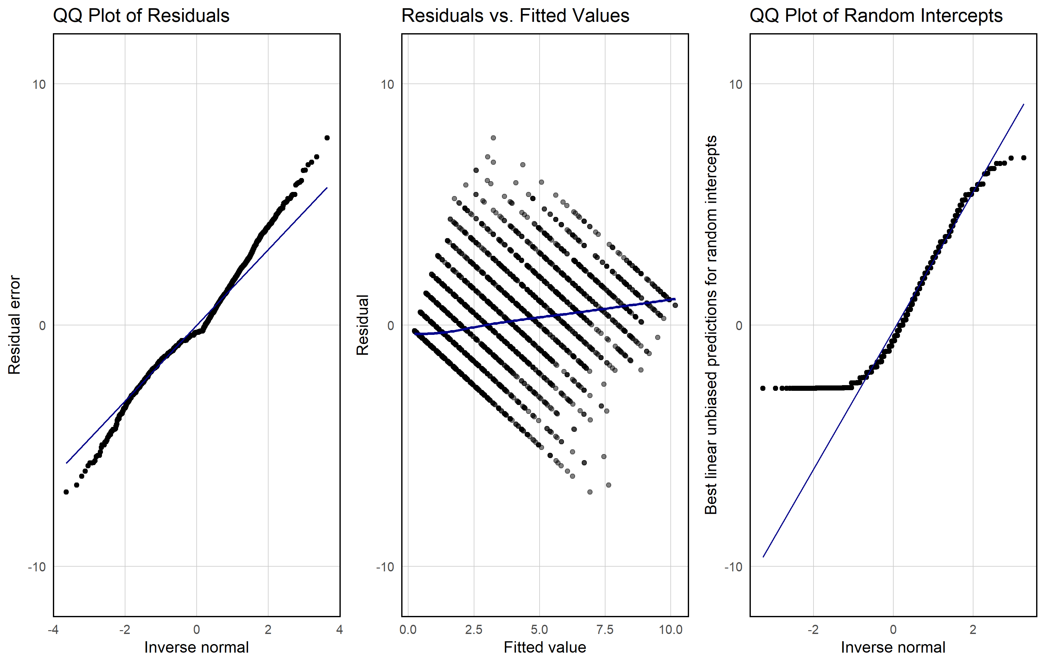

Supplementary Figure 1. CFQ trajectory (bimodal scoring system) model diagnostics.
The initial model included CFQ total score (bimodal scoring system) with a linear term for time since infection and a participant-level random intercept.

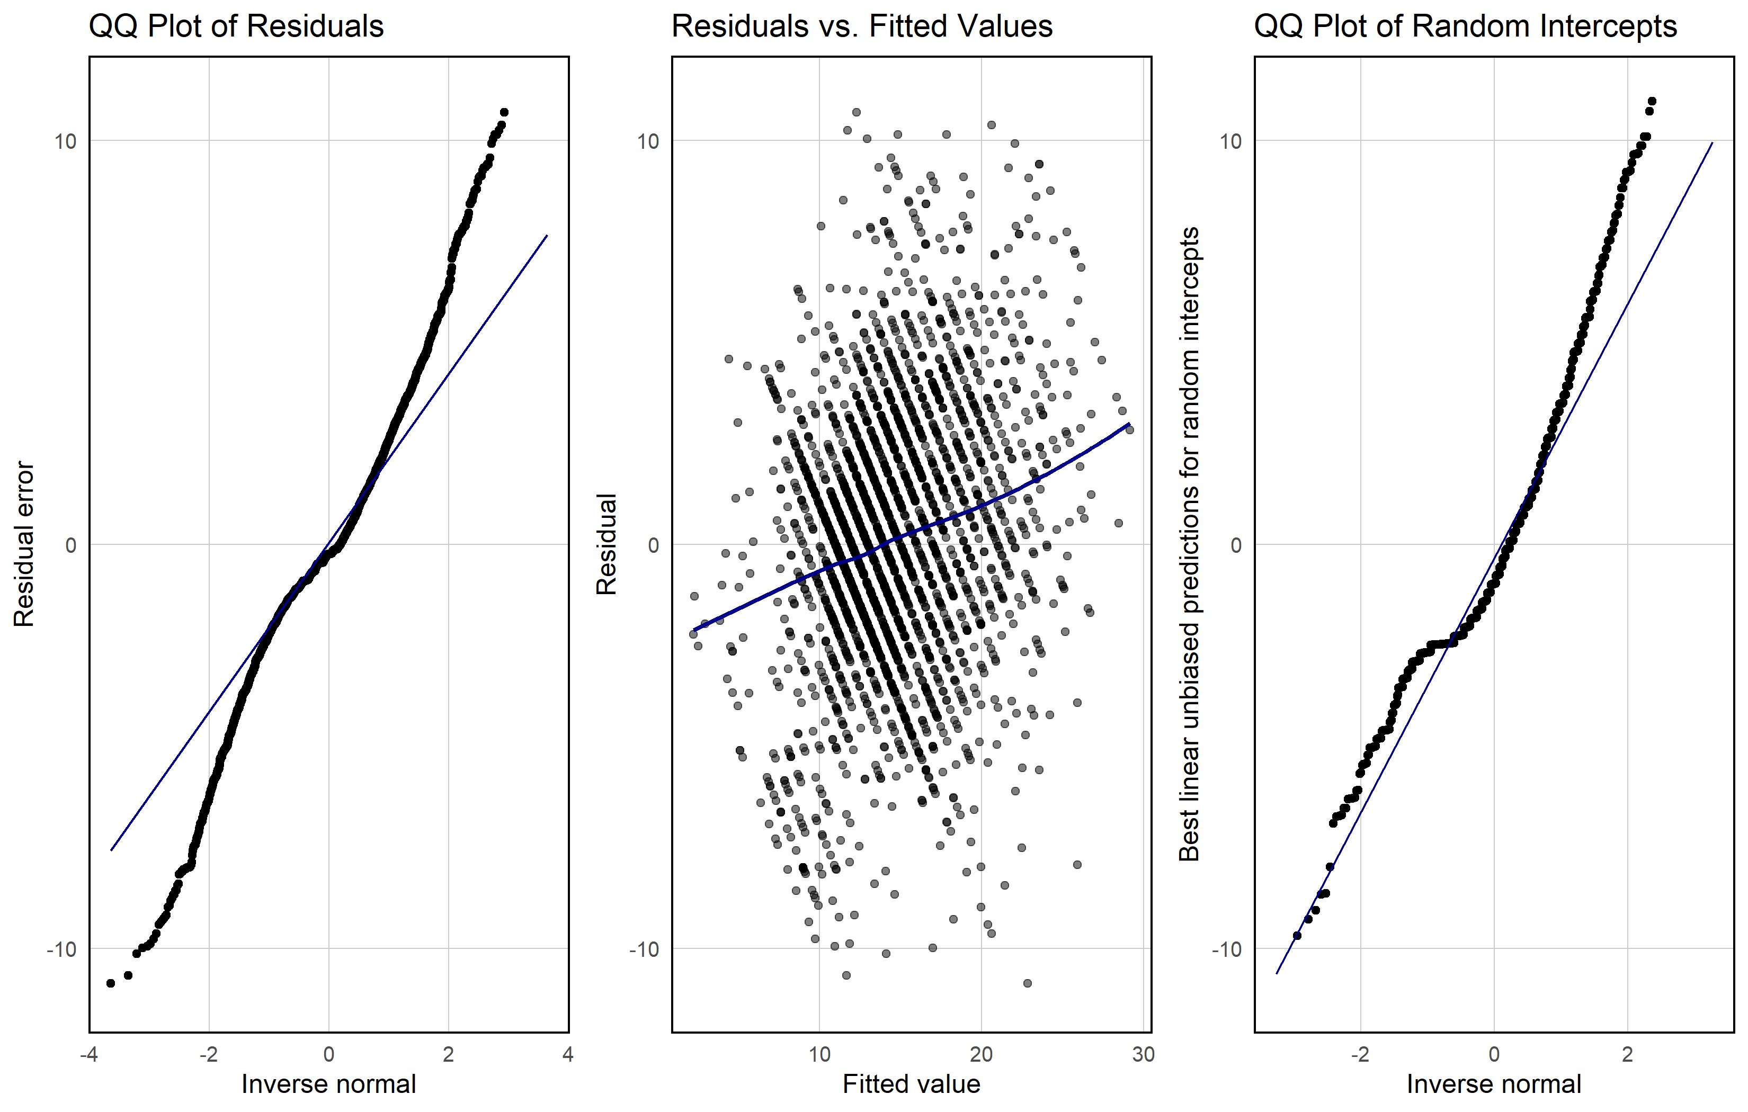

Supplementary Figure 2. CFQ trajectory (Likert-style scoring system) model diagnostics.
The initial model included CFQ total score (Likert-style scoring system) with a linear term for time since infection and a participant-level random intercept.
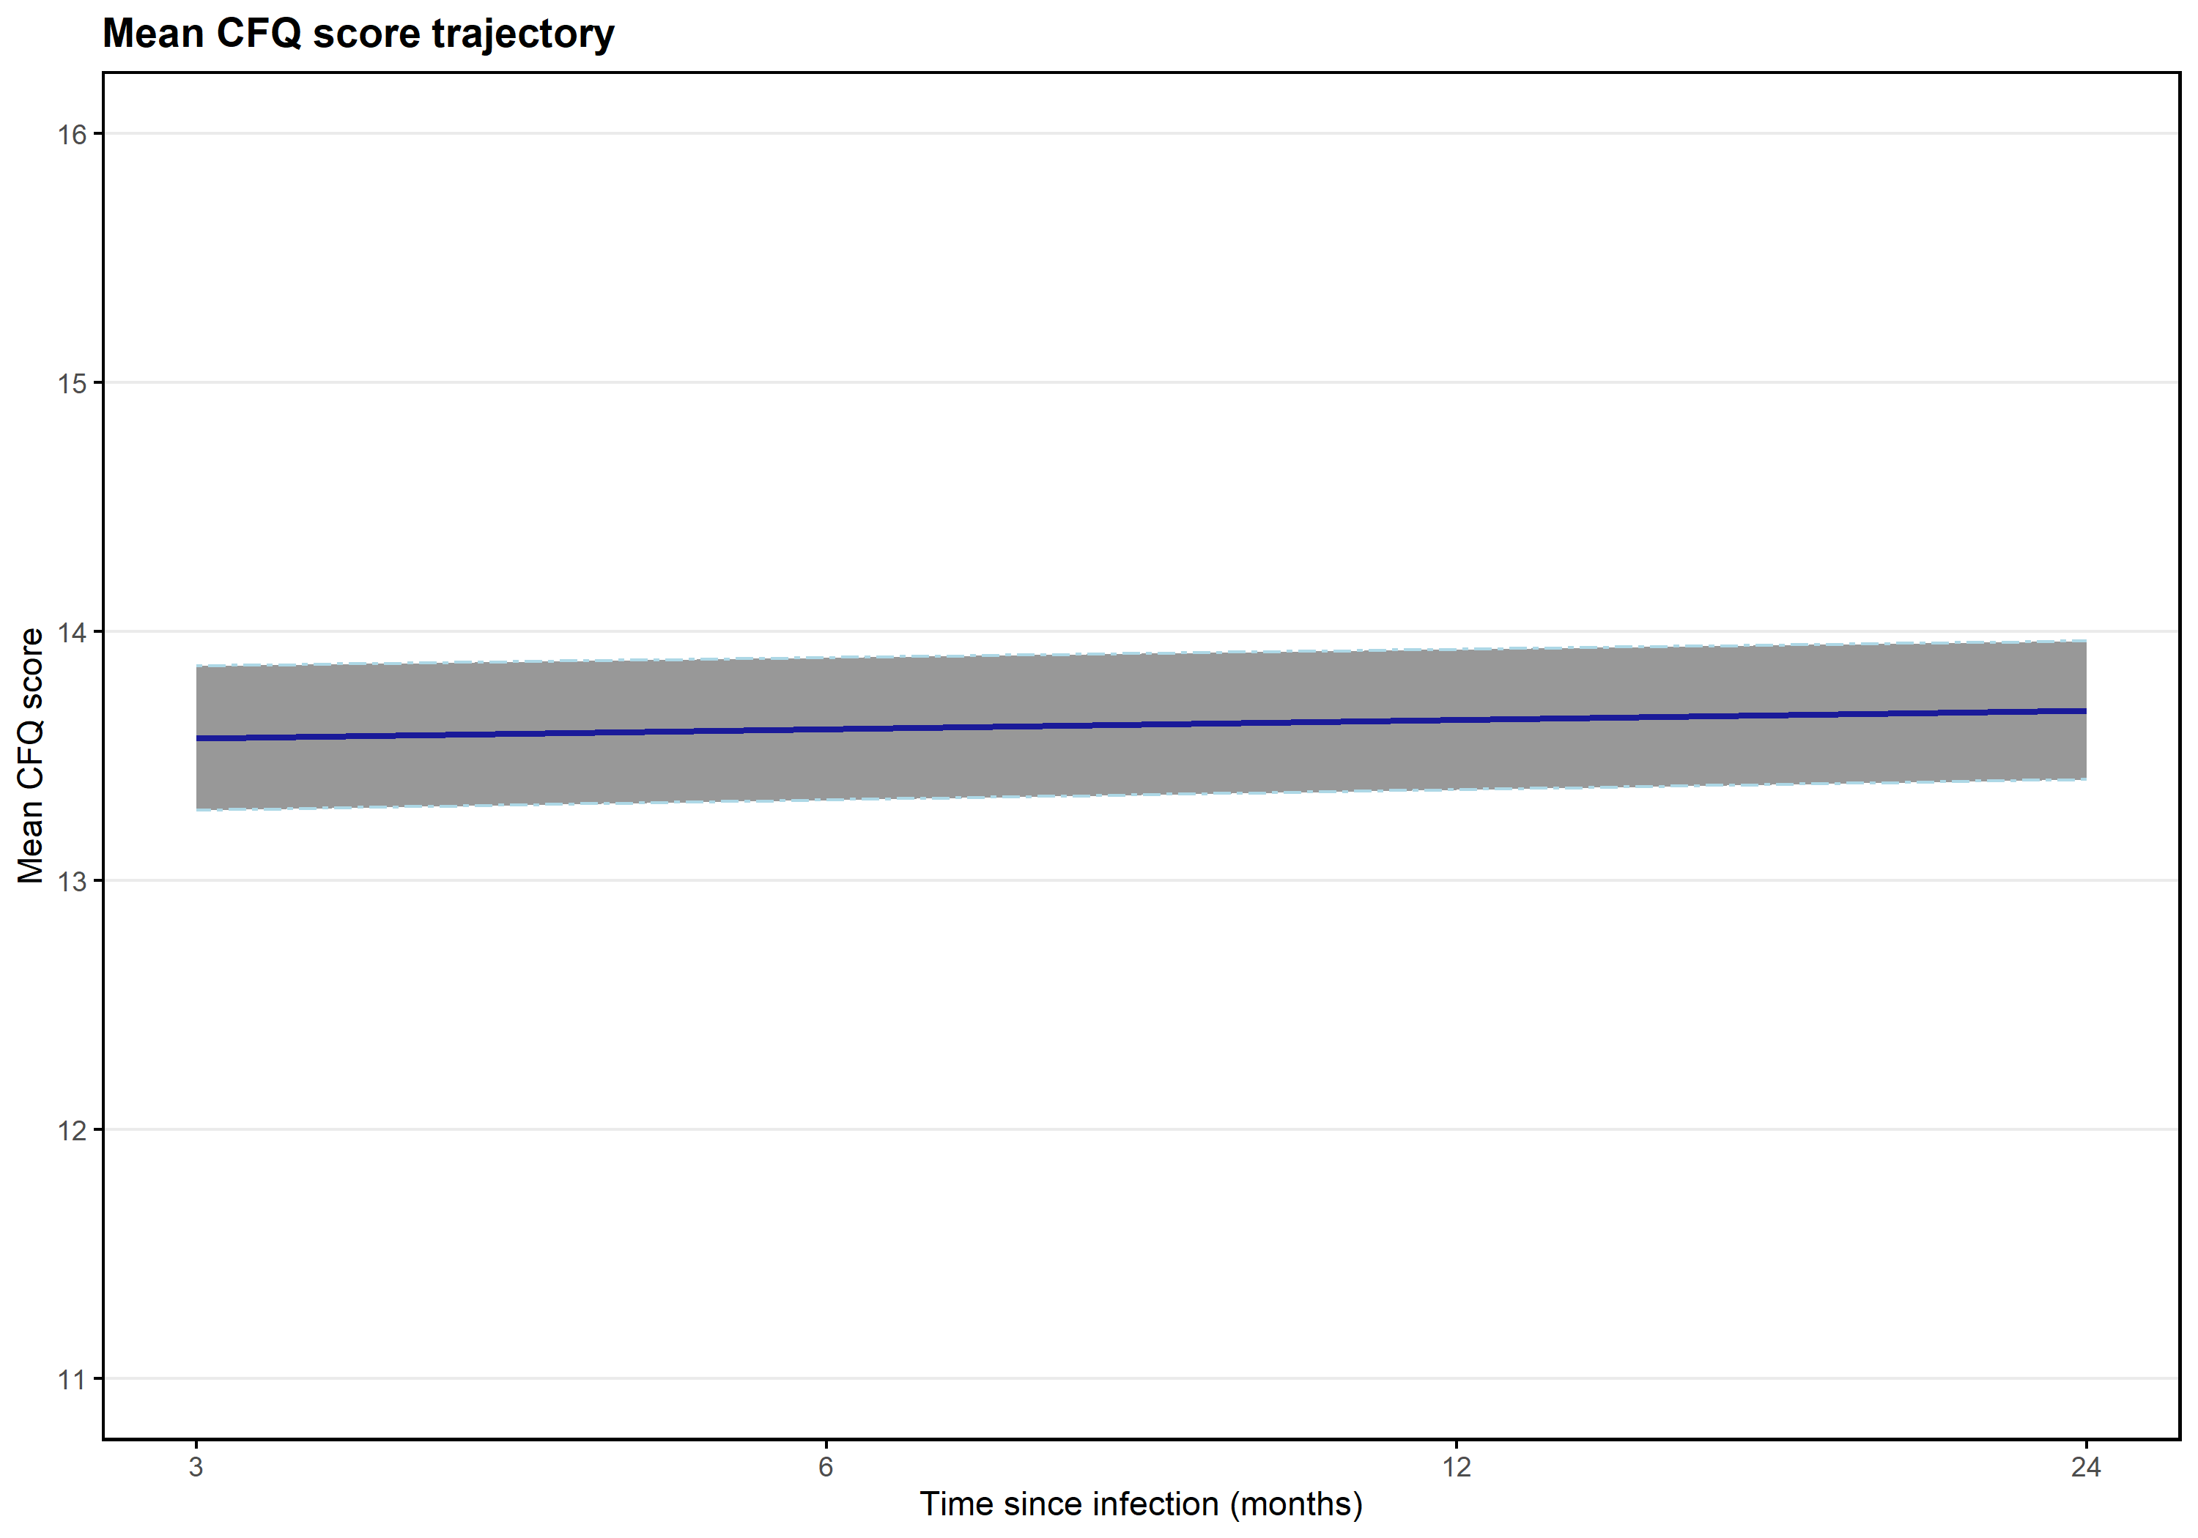

Supplementary Figure 3. Trajectory of CFQ total score over time – scored according to the Likert-style scale scoring system (95% CI indicated via shading around trajectory).
CFQ, Chalder Fatigue Scale.
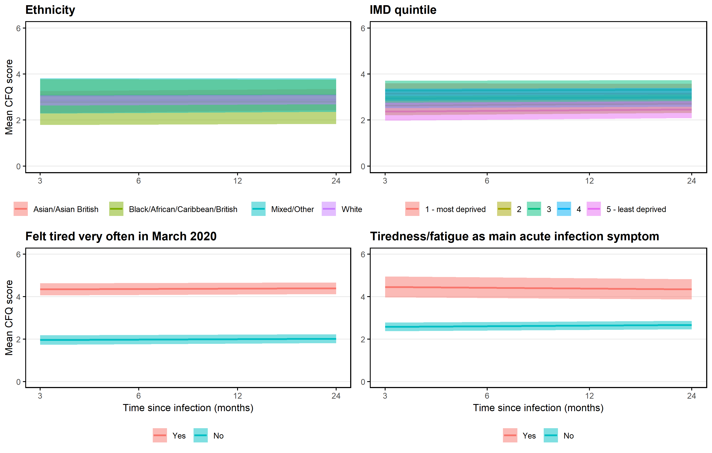

Supplementary Figure 4. Trajectory of CFQ total score, by ethnicity, IMD quintile, feeling of tiredness very often in early in March 2020, and tiredness/fatigue as main acute infection symptom (95% CI indicated via shading around trajectory).
CFQ, Chalder Fatigue Scale; IMD, index of multiple deprivation.

