Table of Contents
Appendix A. Supplementary data 3
Table A.1 Brief descriptions of the spatial variables. 3
Table A.2 GIS-derived land use potential predictors with pre-defined variable names, units, buffer sizes and direction of effect. 5
Table A.3 Selected variables in the annual LUR (CTM-incorporated) models. 7
Table A.4 Selected variables in the daily ST-LUR models. 7
Table A.5 Model performance of the annual LUR (CTM-incorporated) model and the differences with long-term ST-LUR models. 8
Figure A.1 Spatial distribution of monitoring sites by site type for NO₂, PM_{2.5}, PM₁₀ and O₃ in Great Britain across all study years 9
Figure A.2 Daily predicted vs daily measured concentrations of NO₂ 10
Figure A.3 Daily predicted vs daily measured concentrations of PM_{2.5} 11
Figure A.4 Daily predicted vs daily measured concentrations of PM₁₀ 12
Figure A.5 Daily predicted vs daily measured concentrations of O₃ 13
Appendix B. Annual air pollution surfaces 14
Figure B.1 Estimated annual average NO₂ concentrations mapped at 25 x 25m resolution in Great Britain for 2015 using the annual LUR (CTM-incorporated) model. 15
Figure B.2 Estimated annual average PM_{2.5} concentrations mapped at 25 x 25m resolution in Great Britain for 2015 using the annual LUR (CTM-incorporated) model. 16
Figure B.3 Estimated annual average PM₁₀ concentrations mapped at 25 x 25m resolution in Great Britain for 2015 using the annual LUR (CTM-incorporated) model. 17
Figure B.4 Estimated annual average O₃ concentrations mapped at 25 x 25m resolution in Great Britain for 2015 using the annual LUR (CTM-incorporated) model. 18
Figure B.5 Estimated annual average concentrations mapped at 25 x 25m resolution in London for 2015 for NO₂, O₃, PM_{2.5} and PM₁₀ using the annual LUR (CTM-incorporated) models. 19

Appendix A. Supplementary data
The following is the supplementary data to this article:

Table A.1 Brief descriptions of the spatial variables.
Data name | Yearª | Data source | Spatial coverage | Spatial resolution / geography | Temporal  resolution | Description
Land cover | 2014 | Fecht, Beale and Briggs (2014) | GB | 25 m | - | CORINE-enhanced LCM2007 (combining CORINE Land Cover 2012 and two urban classes from Land Cover Map 2007). The available 31 land classes were aggregated into 9 main groups: high density urban, low density urban, other built-up, ports, industrial, natural areas, green space, agriculture, and watercourses.
Road network | 2016 | Ordnance Survey Meridian 2 | GB | line | - | Information on road network including motorway, A-road, B-road, and minor road
Traffic | 2016 | Morley and Gulliver (2016) | UK | line | - | Improved annual average daily traffic (AADT) (counts) of all roads, including improved AADT on minor roads using a routing algorithm
Topography | 2016 | Ordnance Survey  Terrain 50 | GB | 50 m | - | Altitude
Building | 2019 | OS MasterMap Building Height Attribute | GB | polygon | - | Building footprint (area) and building height for all buildings.
Population and household | 2013 | Office for National Statistics (ONS) | UK | point | - | 2011 UK census. Containing population headcount and household count per postcode
ª Year/version of data when it was released

Table A.2 GIS-derived land use potential predictors with pre-defined variable names, units, buffer sizes and direction of effect.
Dataset | Predictor Variables | Variables Name | Unit | Buffer Size (m) | Direction of Effect
 |  |  |  |  | NO₂  PM_{2.5}  PM₁₀ | O₃
Land  cover | high density residential and commercial | HDURBAN | m² | 100  200  300  400  500  1,000  3,000  5,000 | + | -
Land  cover | low density residential and commercial | LDURBAN | m² | 100  200  300  400  500  1,000  3,000  5,000 | + | -
Land  cover | other built-up | OTHERBUILT | m² | 100  200  300  400  500  1,000  3,000  5,000 | + | -
Land  cover | ports | PORTS | m² | 100  200  300  400  500  1,000  3,000  5,000 | + | -
Land  cover | industrial | INDUSTRY | m² | 100  200  300  400  500  1,000  3,000  5,000 | + | -
Land  cover | natural, semi-natural or forested areas | NATURAL | m² | 100  200  300  400  500  1,000  3,000  5,000 | - | +
Land  cover | green space | GRESPACE | m² | 100  200  300  400  500  1,000  3,000  5,000 | - | +
Land  cover | agriculture | AGRICULTURE | m² | 100  200  300  400  500  1,000  3,000  5,000 | - | +
Land  cover | watercourses | WATER | m² | 100  200  300  400  500  1,000  3,000  5,000 | - | +
Population/  Household | number of inhabitants in a buffer | POP | N | 100  200  300  400  500  1,000  3,000  5,000 | + | -
Population/  Household | number of households in a buffer | HHOLD | N | 100  200  300  400  500  1,000  3,000  5,000 | + | -
Road  Network | road length of all roads | ROADLEN | m | 25  50  100  150  200  300  400  500  1,000 | + | -
Road  Network | road length of A-roads | ROADLENA | m | 25  50  100  150  200  300  400  500  1,000 | + | -
Road  Network | road length of B-roads | ROADLENB | m | 25  50  100  150  200  300  400  500  1,000 | + | -
Road  Network | road length of minor roads | ROADLENMIN | m | 25  50  100  150  200  300  400  500  1,000 | + | -
Road  Network | road length of motorway | ROADLENMOT | m | 25  50  100  150  200  300  400  500  1,000 | + | -
Road  Network | road length of major roads (motorway and A-roads) | ROADLENMAJ | m | 25  50  100  150  200  300  400  500  1,000 | + | -
Traffic | total traffic load on all roads (ALL MV) | TRAFLOAD | veh/day*m | 25  50  100  150  200  300  400  500  1,000 | + | -
Traffic | total traffic load on minor roads (ALLMV<10000) | TRAFLOADMIN | veh/day*m | 25  50  100  150  200  300  400  500  1,000 | + | -
Traffic | total traffic load on major traffic roads (ALLMV>=10000) | TRAFLOADMAJ | veh/day*m | 25  50  100  150  200  300  400  500  1,000 | + | -
Traffic | total heavy-duty traffic load on all roads (ALL C3) | HEAVYTRAFLOAD | veh/day*m | 25  50  100  150  200  300  400  500  1,000 | + | -
Traffic | total heavy-duty traffic load on minor traffic roads (C3<275) | HEAVYTRAFLOADMIN | veh/day*m | 25  50  100  150  200  300  400  500  1,000 | + | -
Traffic | total heavy-duty traffic load on major traffic roads (C3>=275) | HEAVYTRAFLOADMAJ | veh/day*m | 25  50  100  150  200  300  400  500  1,000 | + | -
Traffic | traffic intensity on nearest road | TRAFNEAR | veh/day | N/A | + | -
Traffic | traffic intensity on nearest major road | TRAFNEARMAJ | veh/day | N/A | + | -
Traffic | heavy-duty traffic intensity on nearest road | HEAVYTRAFNEAR | veh/day | N/A | + | -
Traffic | heavy duty traffic intensity on nearest major road | HEAVYTRAFNEARMAJ | veh/day | N/A | + | -
Traffic | inverse distance to nearest road | INVDIST | m⁻¹ | N/A | + | -
Traffic | inverse distance to nearest road squared | INVDISTSQ | m⁻² | N/A | + | -
Traffic | inverse distance to nearest major road | INVDISTMAJ | m⁻¹ | N/A | + | -
Traffic | inverse distance to nearest major road squared | INVDISTMAJSQ | m⁻² | N/A | + | -
Traffic | traffic intensity on nearest road x inverse distance to the nearest road | INTINVDIST | veh/day/m | N/A | + | -
Traffic | traffic intensity on nearest road x inverse distance to the nearest road squared | INTINVDISTSQ | veh/day/m² | N/A | + | -
Traffic | traffic intensity on nearest major road x inverse distance to the nearest major road | INTINVDISTMAJ | veh/day/m | N/A | + | -
Traffic | traffic intensity on nearest major road x inverse distance to the nearest major road squared | INTINVDISTMAJSQ | veh/day/m² | N/A | + | -
Traffic | heavy-duty traffic intensity on nearest road x inverse distance to the nearest road | HEAVYINTINVDIST | veh/day/m | N/A | + | -
Traffic | heavy-duty traffic intensity on nearest road x inverse distance to the nearest road squared | HEAVYINTINVDISTSQ | veh/day/m² | N/A | + | -
Traffic | heavy-duty traffic intensity on nearest major road x inverse distance to the nearest major road | HEAVYINTINVDISTMAJ | veh/day/m | N/A | + | -
Traffic | heavy-duty traffic intensity on nearest major road x inverse distance to the nearest major road squared | HEAVYINTINVDISTMAJSQ | veh/day/m² | N/A | + | -
Topography | altitude | ALTITUDE | m | N/A | + | -
Building | building volume within 50m of major road (sum of building area x height) in a circular buffer | BUILDINGVOL | m³ | 50  100 | + | -

Table A.3 Selected variables in the annual LUR (CTM-incorporated) models.
 | 1 | 2 | 3 | 4 | 5
NO₂ | MACCª | TRAFLOAD_50 | ROADLEN_1000 | BUILDINGVOL_50 | INVDISTSQ
PM_{2.5} | MACCª | TRAFLOAD_50 | NATURAL_500 | BUILDINGVOL_50
PM₁₀ | MACCª | TRAFLOAD_50 | NATURAL_1000 | BUILDINGVOL_50
O₃ | MACCª | TRAFLOAD_50 | GRESPACE_300 | ROADLENMAJ_1000
ª Annual average

Table A.4 Selected variables in the daily ST-LUR models.
 | Time-varying |  |  | Time-invariant
 | 1 | 2 |  | 1 | 2 | 3
NO₂ | Meteorologyª | MACC^{b} |  | TRAFLOAD_50 | ROADLEN_1000 | BUILDINGVOL_50
PM_{2.5} | Meteorologyª | MACC^{b} |  | TRAFLOAD_50 | NATURAL_1000 | BUILDINGVOL_50
PM₁₀ | Meteorologyª | MACC^{b} |  | TRAFLOAD_50 | NATURAL_1000 | BUILDINGVOL_100
O₃ | Meteorologyª | MACC^{b} |  | TRAFLOAD_50 | GRESPACE_300 | ROADLENMAJ_1000
ª Includes all four meteorology predictors: daily mean temperature, relative humidity, wind speed and wind direction.
^{b} Daily mean

For NO₂, the variable INVDISTSQ (inverse distance to nearest road squared) was not included in the final model because it did not improve the explained variance. Moreover, the buffer sizes of the selected variables for daily ST-LUR slightly differed from the annual LUR (CTM-incorporated) models. This is because the modified variables increased the explained variance in the daily measurements. For example, for PM_{2.5}, NATURAL_1000 (natural land in a 1000 m buffer) was included in the final model instead of NATURAL_500 (natural land in a 500 m buffer).

Table A.5 Model performance of the annual LUR (CTM-incorporated) model and the differences with long-term ST-LUR models. The differences for each indicator are recorded in the “diff.” columns.
Pollutant | Year | N | CV-R² | diff. | RMSE | diff. | RMSD | diff. | Bias | diff. | Slope | diff. | Intercept | diff.
NO₂ | 2011 | 79 | 0.75 | 0.05 | 7.33 | -0.94 | 0.50 | 0.08 | 5.48 | -0.33 | 0.90 | 0.07 | 2.05 | -3.19
 | 2012 | 73 | 0.75 | 0.09 | 7.40 | -1.52 | 0.46 | -0.04 | 5.47 | -0.79 | 0.95 | 0.13 | 0.74 | -4.80
 | 2013 | 74 | 0.78 | 0.06 | 6.91 | -1.11 | 0.45 | -0.07 | 4.90 | -0.47 | 0.96 | 0.07 | 0.59 | -3.42
 | 2014 | 74 | 0.77 | 0.06 | 7.17 | -0.88 | 0.41 | -0.04 | 4.99 | -0.60 | 0.93 | 0.04 | 1.11 | -2.44
 | 2015 | 76 | 0.75 | 0.03 | 6.84 | -0.55 | 0.44 | -0.04 | 5.08 | -0.08 | 0.94 | 0.05 | 1.04 | -2.53
PM_{2.5} | 2011 | 49 | 0.21 | -0.11 | 2.88 | -0.36 | 1.21 | 0.34 | 2.13 | -0.14 | 0.71 | 0.23 | 4.39 | -3.54
 | 2012 | 54 | 0.30 | -0.08 | 2.40 | -0.37 | 1.09 | 0.22 | 1.74 | -0.19 | 0.82 | 0.31 | 2.27 | -4.26
 | 2013 | 55 | 0.44 | -0.02 | 1.94 | -0.55 | 1.36 | 0.55 | 1.47 | -0.31 | 1.00 | 0.48 | 0.01 | -6.44
 | 2014 | 52 | 0.48 | 0.03 | 1.56 | -0.61 | 1.15 | 0.19 | 1.18 | -0.39 | 0.89 | 0.40 | 1.40 | -4.99
 | 2015 | 51 | 0.62 | 0.10 | 1.21 | -0.37 | 0.90 | 0.12 | 0.95 | -0.27 | 0.99 | 0.38 | 0.01 | -4.07
PM₁₀ | 2011 | 43 | 0.49 | -0.08 | 3.32 | 0.15 | 1.21 | 0.67 | 2.56 | 0.18 | 0.99 | 0.18 | 0.01 | -4.08
 | 2012 | 47 | 0.53 | -0.05 | 2.80 | 0.06 | 0.95 | 0.14 | 2.26 | -0.03 | 0.96 | 0.13 | 0.68 | -2.73
 | 2013 | 46 | 0.47 | -0.15 | 2.94 | 0.33 | 1.19 | 0.49 | 2.20 | 0.14 | 0.95 | 0.15 | 0.85 | -2.92
 | 2014 | 39 | 0.59 | -0.06 | 2.26 | 0.01 | 1.00 | 0.23 | 1.62 | -0.25 | 0.82 | 0.08 | 3.30 | -1.22
 | 2015 | 39 | 0.69 | 0.07 | 1.60 | -0.24 | 0.74 | 0.09 | 1.25 | -0.32 | 0.87 | 0.09 | 2.15 | -1.57
O₃ | 2011 | 55 | 0.74 | 0.08 | 4.84 | -0.79 | 0.44 | -0.03 | 3.86 | -0.43 | 0.96 | 0.07 | 1.89 | -3.54
 | 2012 | 57 | 0.80 | 0.05 | 4.43 | -0.74 | 0.35 | -0.01 | 3.56 | -0.39 | 0.91 | 0.08 | 4.40 | -3.29
 | 2013 | 55 | 0.91 | 0.03 | 3.13 | -0.68 | 0.26 | 0.00 | 2.50 | -0.55 | 1.00 | 0.10 | -0.03 | -5.03
 | 2014 | 56 | 0.87 | 0.08 | 3.78 | -1.06 | 0.29 | -0.05 | 2.72 | -0.84 | 1.00 | 0.07 | 0.38 | -3.56
 | 2015 | 55 | 0.86 | 0.08 | 3.74 | -1.15 | 0.34 | -0.07 | 2.99 | -0.75 | 1.01 | 0.13 | -0.13 | -6.46
CV-R²: cross-validated R² of the annual LUR (CTM-incorporated) model
diff.: model performance parameter for annual LUR (CTM-incorporated) minus model performance parameter for long-term ST-LUR

Figure A.1 Spatial distribution of monitoring sites by site type for NO₂, PM_{2.5}, PM₁₀ and O₃ in Great Britain across all study years. The four site types included in the NO₂, PM_{2.5} and O₃ models are background rural, background suburban, background urban and traffic urban. PM₁₀ models do not have background suburban site.

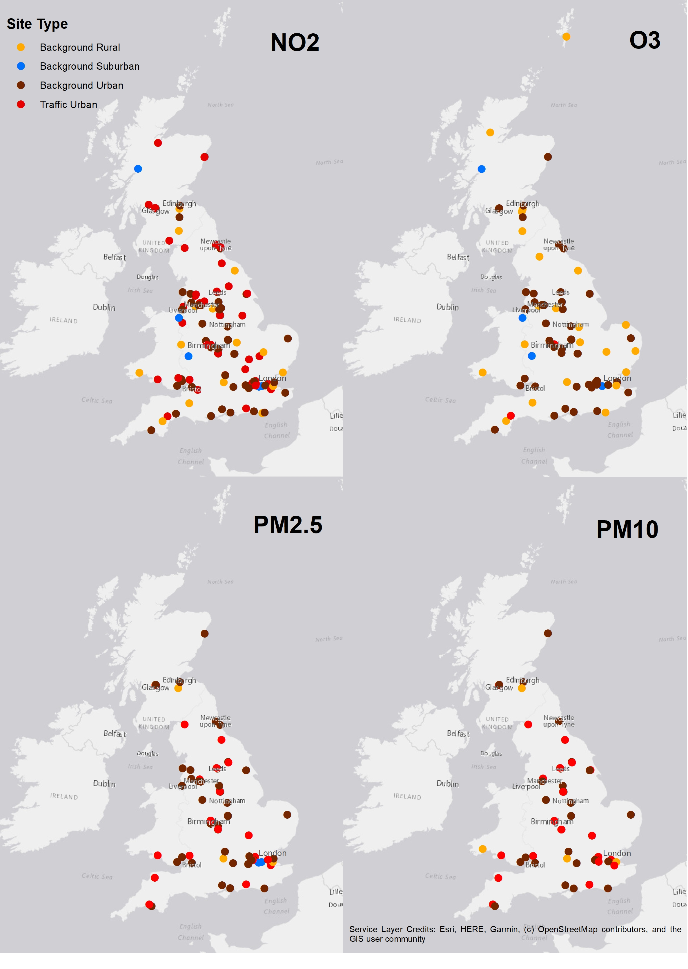

Figure A.2 Daily predicted vs daily measured concentrations of NO₂. Sites are stratified by site type: beige – Background Rural, blue – Background Suburban, yellow – Background Urban, red – Traffic Urban.

Figure A.3 Daily predicted vs daily measured concentrations of PM_{2.5}. Sites are stratified by site type: beige – Background Rural, blue – Background Suburban, yellow – Background Urban, red – Traffic Urban.

Figure A.4 Daily predicted vs daily measured concentrations of PM₁₀. Sites are stratified by site type: beige – Background Rural, yellow – Background Urban, red – Traffic Urban.

Figure A.5 Daily predicted vs daily measured concentrations of O₃. Sites are stratified by site type: beige – Background Rural, blue – Background Suburban, yellow – Background Urban, red – Traffic Urban.

Appendix B. Annual air pollution surfaces
Air pollution concentrations of points of interest (e.g. residential addresses) could be easily extracted from air pollution surfaces. The spatial resolution of the surfaces was set to 25 m. This was to 1) ensure the smallest buffer size (i.e. 25 m) of land use predictor variables was not aggregated during surface development, and 2) capture the concentration gradient of air pollution (especially NO₂) around sources. However, we acknowledged that surface development at such a fine scale was computationally intensive. Specifically, Great Britain comprised 375,152,482 grid cells with a resolution of 25 m. Values of the selected predictor variables needed to be extracted at all grid cells, which involved computing relevant GIS techniques for each variable. Creating one such variable at 25 m resolution took 4 – 96 hours in ArcGIS on a standard computer (8Gb Random-access memory (RAM) Intel Core i7).
Once the predictor variables were compiled as individual raster layers, the annual surfaces can be easily and quickly developed from the intercept and coefficient values of the LUR or CTM-incorporated LUR models using the ‘raster calculator’ function in ArcGIS.
The maps below (Figure B.1 – B.5) show the annual air pollution surfaces of 2015 using the above CTM-incorporated LUR models. The maps are shown for Great Britain and regional (London) scale. The spatial resolution of the surfaces is 25 m. The surfaces are stored in raster format that can be directly used on various platforms, including ArcGIS and R.

Figure B.1 Estimated annual average NO₂ concentrations mapped at 25 x 25m resolution in Great Britain for 2015 using the annual LUR (CTM-incorporated) model.
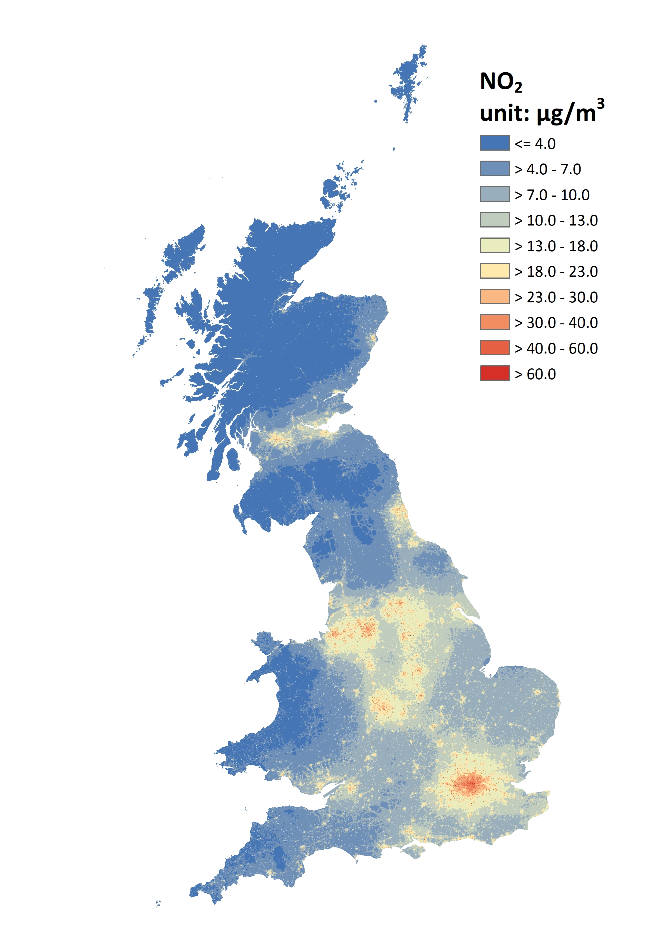

Figure B.2 Estimated annual average PM_{2.5} concentrations mapped at 25 x 25m resolution in Great Britain for 2015 using the annual LUR (CTM-incorporated) model.
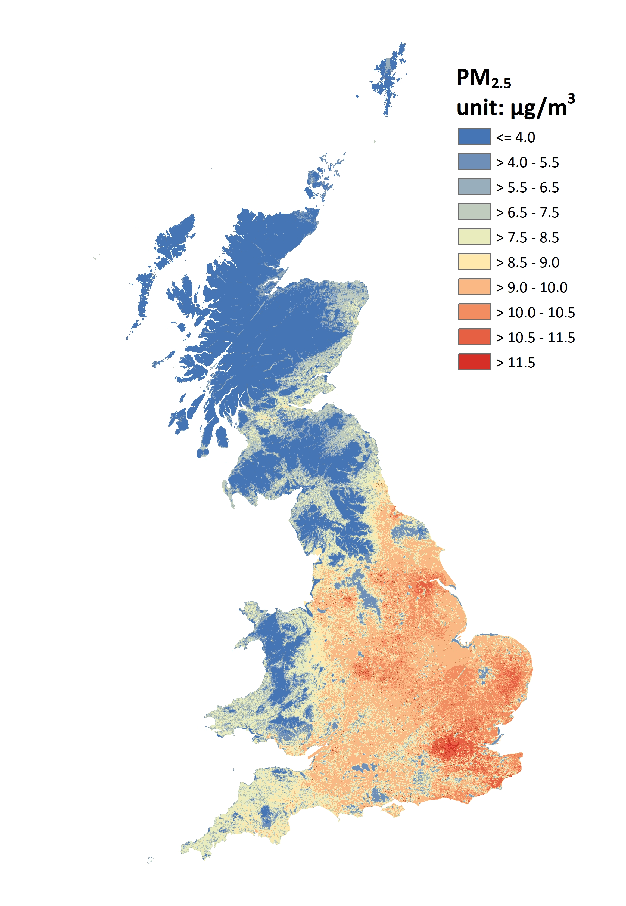

Figure B.3 Estimated annual average PM₁₀ concentrations mapped at 25 x 25m resolution in Great Britain for 2015 using the annual LUR (CTM-incorporated) model.
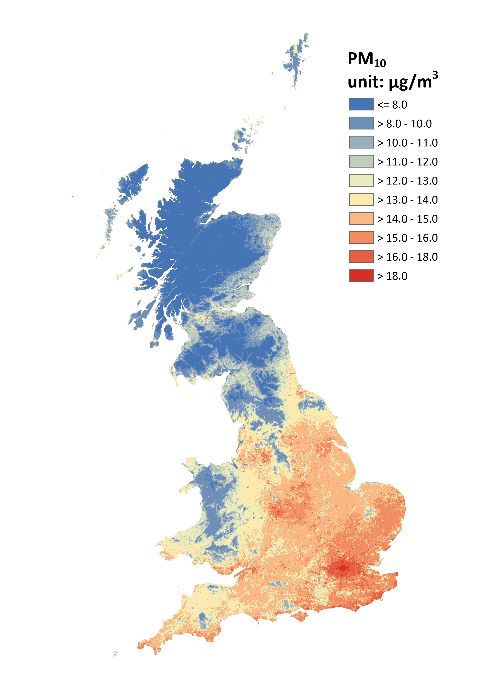

Figure B.4 Estimated annual average O₃ concentrations mapped at 25 x 25m resolution in Great Britain for 2015 using the annual LUR (CTM-incorporated) model.
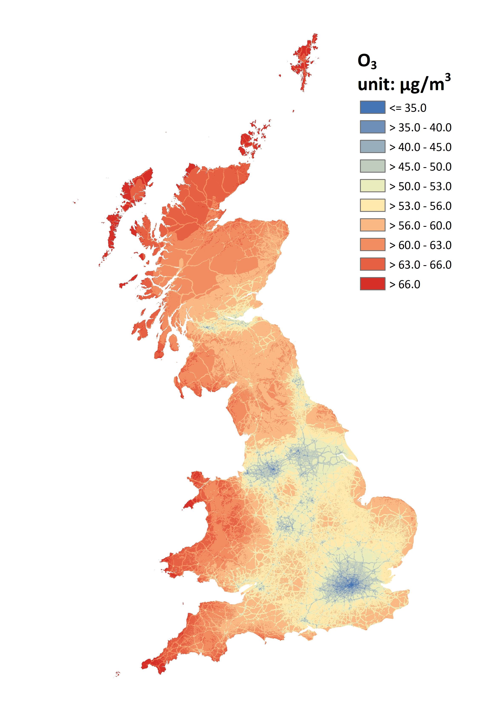

Figure B.5 Estimated annual average concentrations mapped at 25 x 25m resolution in London for 2015 for NO₂, O₃, PM_{2.5} and PM₁₀ using the annual LUR (CTM-incorporated) models.
