Online Supplement
Long-term exposure to aircraft noise and cardiovascular disease hospitalization and mortality near major airports in the UK, 2006-2015
Authors: Garyfallos Konstantinoudis*^{1,2}, Glory Atilola*^{2,3, 4}, Calvin Jephcote⁵, Kathryn Adams⁵, John Gulliver^{5,6}, Paul Elliott^{2,3,4}, Anna L Hansell^{2,3,5,7,8,9}**, Marta Blangiardo^{2,3,4*}**
*joint first authors
**joint senior authors
Affiliations:
¹ Grantham Institute for Climate Change and the Environment, Imperial College London
²UK Small Area Health Statistics Unit, Dept Epidemiology and Biostatistics, School of Public Health, Imperial College London, W2 1PG, UK
³ MRC Centre for Environment and Health, Dept Epidemiology and Biostatistics, School of Public Health, Imperial College London, W2 1PG, UK
⁴ NIHR Health Protection Research Unit in Environmental Exposures and Health, School of Public Health, Imperial College London, W2 1PG, UK
⁵Centre for Environmental Health and Sustainability, University of Leicester, Leicester, UK
⁶City St George’s, University of London, London, UK.
⁷National Institute of Health Research Health Protection Research Unit in Chemical Threats and Hazards, University of Leicester
⁸NIHR Leicester Biomedical Research Centre, Leicester General Hospital, Gwendolen Road, Leicester LE5 4PW
⁹Leicester British Heart Foundation Centre of Research Excellence, University of Leicester British Heart Foundation Cardiovascular Research Centre, Glenfield Hospital, Groby Road, Leicester LE3 9QP
Corresponding author: Marta Blangiardo m.blangiardo@imperial.ac.uk

Table of Contents
SUPPEMENTARY TEXT 14
S1. Confounders 14
S2. Spatial and other priors 17
S3. Temporal differences 18
SUPPLEMENTARY TABLES 21
Table S1. Descriptive summary of confounder data for COAs around each airport location 2006 to 2015. 21
Table S2. Total population years and mean and standard deviation of population by Census Output Areas near London Heathrow and near other airports (London Gatwick, Manchester and Birmingham) in the 2011 census and during 2006--2010, 2011-2015 and 2006-2015. 24
Table S3. Median relative hospitalisation risk and 95% credible intervals for the association between long-term exposure to annual average population weighted day-evening-night aircraft noise (Lden) and all cardiovascular disease, coronary heart disease and stroke near London Heathrow during 2006-2015. The unadjusted models account for temporal trends, age and sex, whereas the fully adjusted models additionally account for ethnicity, deprivation, road nose, rail noise, NO₂ exposure and spatial confounding. We bold results with credible intervals that exclude 1, suggesting strong evidence of an effect. 25
Table S4. Median and 95% Credible Intervals of relative hospitalisation or mortality risk per 5dB increase in Lden and Lnight in the unadjusted and fully adjusted linear models for all cardiovascular, coronary heart disease and stroke near London Heathrow for noise levels above 50dB for Lden and 45dB for Lnight (aircraft exposure data is not supplied by CAA below these levels). The unadjusted models account for temporal trends, age and sex, whereas the fully adjusted models additionally account for ethnicity, deprivation, road nose, rail noise, NO₂ exposure and spatial confounding. We bold results with credible intervals that exclude 1, suggesting strong evidence of an effect. 26
Table S5. Median relative hospitalisation risk and 95% credible intervals for the association between long-term exposure to annual average population weighted night time aircraft noise (Lnight) and all cardiovascular disease, coronary heart disease and stroke near London Heathrow during 2006-2015. The unadjusted models account for temporal trends, age and sex, whereas the fully adjusted models additionally account for ethnicity, deprivation, road nose, rail noise, NO₂ exposure and spatial confounding. We bold results with credible intervals that exclude 1, suggesting strong evidence of an effect. 27
Table S6. Median relative mortality risk and 95% credible intervals for the association between long-term exposure to annual average population weighted day/evening/night time aircraft noise (Lden) and all cardiovascular disease, coronary heart disease and stroke near London Heathrow during 2006-2015. The unadjusted models account for temporal trends, age and sex, whereas the fully adjusted models additionally account for ethnicity, deprivation, road nose, rail noise, NO2 exposure and spatial confounding. We bold results with credible intervals that exclude 1, suggesting strong evidence of an effect. 28
Table S7. Median relative mortality risk and 95% credible intervals for the association between long-term exposure to annual average population weighted night time aircraft noise (Lnight) and all cardiovascular disease, coronary heart disease and stroke near London Heathrow during 2006-2015. The unadjusted models account for temporal trends, age and sex, whereas the fully adjusted models additionally account for ethnicity, deprivation, road nose, rail noise, NO2 exposure and spatial confounding. We bold results with credible intervals that exclude 1, suggesting strong evidence of an effect. 29
Table S8. Median relative hospitalisation risk and 95% credible intervals for the association between long-term exposure to annual average population weighted day-evening-night aircraft noise (Lden) and all cardiovascular disease, coronary heart disease and stroke near other airports (London Gatwick, Birmingham and Manchester) during 2006-2015. The unadjusted models account for temporal trends, age and sex, whereas the fully adjusted models additionally account for ethnicity, deprivation, road nose, rail noise, NO₂ exposure and spatial confounding. We bold results with credible intervals that exclude 1, suggesting strong evidence of an effect. 30
Table S9. Median and 95% Credible Intervals of relative hospitalisation or mortality risk per 5dB increase in Lden and Lnight in the unadjusted and fully adjusted linear models for all cardiovascular, coronary heart disease and stroke near the other airports (London Gatwick. Birmingham and Manchester) in linear models for noise levels above 50dB for Lden and 45dB for Lnight (aircraft exposure data is not supplied by CAA below these levels). The unadjusted models account for temporal trends, age and sex, whereas the fully adjusted models additionally account for ethnicity, deprivation, road nose, rail noise, NO₂ exposure and spatial confounding. We bold results with credible intervals that exclude 1, suggesting strong evidence of an effect. 31
Table S10. Median relative hospitalisation risk and 95% credible intervals for the association between long-term exposure to annual average population weighted night time aircraft noise (Lnight) and all cardiovascular disease, coronary heart disease and stroke near other airports (London Gatwick, Birmingham and Manchester) during 2006-2015. The unadjusted models account for temporal trends, age and sex, whereas the fully adjusted models additionally account for ethnicity, deprivation, road nose, rail noise, NO₂ exposure and spatial confounding. We bold results with credible intervals that exclude 1, suggesting strong evidence of an effect. 32
Table S11. Median relative mortality risk and 95% credible intervals for the association between long-term exposure to annual average population weighted day/evening/night time aircraft noise (Lden) and all cardiovascular disease, coronary heart disease and stroke near other airports (London Gatwick, Birmingham and Manchester) during 2006-2015. The unadjusted models account for temporal trends, age and sex, whereas the fully adjusted models additionally account for ethnicity, deprivation, road nose, rail noise, NO₂ exposure and spatial confounding. We bold results with credible intervals that exclude 1, suggesting strong evidence of an effect. 33
Table S12. Median relative mortality risk and 95% credible intervals for the association between long-term exposure to annual average population weighted night time aircraft noise (Lnight) and all cardiovascular disease, coronary heart disease and stroke near other airports (London Gatwick, Birmingham and Manchester) during 2006-2015. The unadjusted models account for temporal trends, age and sex, whereas the fully adjusted models additionally account for ethnicity, deprivation, road nose, rail noise, NO₂ exposure and spatial confounding. We bold results with credible intervals that exclude 1, suggesting strong evidence of an effect. 34
Table S13. Deviance information criterion (DIC) and Wainabe-Akaike information criterion (WAIC) for models across the different health outcomes and exposures near London Heathrow during 2006-2015. The models are adjusted for temporal trends, age and sex, ethnicity, deprivation, road nose, rail noise and NO₂ exposure and they differ in the way spatial autocorrelation is modelled (no random effects capturing spatial autocorrelation, spatial autocorrelation is modelled with a Gaussian prior with no structure in the covariance matrix or iid and spatial autocorrelation is modelled with the BYM2 prior or BYM2). We bold the minimum DIC and WAIC values across the different groups. 35
Table S14. Deviance information criterion (DIC) and Wainabe-Akaike information criterion (WAIC) for models across the different health outcomes and exposures near other airports (London Gatwick, Birmingham and Manchester) during 2006-2015. The models are adjusted for temporal trends, age and sex, ethnicity, deprivation, road nose, rail noise and NO₂ exposure and they differ in the way spatial autocorrelation is modelled (no random effects capturing spatial autocorrelation, spatial autocorrelation is modelled with a Gaussian prior with no structure in the covariance matrix or iid and spatial autocorrelation is modelled with the BYM2 prior or BYM2). We bold the minimum DIC and WAIC values across the different groups. 36
Table S15. Median and 95% Credible Intervals of the mixing parameter of the BYM2 prior across the different health outcomes and airports. 37
Table S16. Correlation between Lden or Lnight and the spatial random effects of the fully adjusted models (temporal trends, age, sex, ethnicity, deprivation, road nose, rail noise and NO2 exposure) using the BYM2 prior. 38
Table S17. Population per noise category in 2009 and 2011. 39
SUPPLEMENTARY MATERIAL – FIGURES 41
Figure S1: Aircraft noise contours in 2006 and 2011 at London Heathrow airport, reported as ‘day-evening-night’ (Lden) and ‘night-time’ from 23:00 to 07:00 hours (Lnight). 42
Figure S2: Aircraft noise contours in 2006 and 2011 at London Gatwick airport, reported as ‘day- evening-night’ (Lden) and ‘night-time’ from 23:00 to 07:00 hours (Lnight). 43
Figure S3. Aircraft noise contours in 2006 and 2011 at Birmingham airport, reported as ‘day-evening-night’ (Lden) and ‘night-time’ from 23:00 to 07:00 hours (Lnight). 44
Figure S4: Aircraft noise contours in 2006 and 2011 at Manchester airport, reported as ‘day-evening-night’ (Lden) and ‘night-time’ from 23:00 to 07:00 hours (Lnight). 45
Figure S5. Exposure metrics for 24-hour weighted annual average day-evening-night time (Lden) and night time (Lnight) aircraft noise at Census Output Area (COA) level by airport. 46
Figure S6. COA-level measures around London Heathrow airport for: (A) Carstairs index of deprivation (quintile) in 2011 (lowest=least deprived), (B) Percentage of non-White ethnicity from 2011 Census, (C) Lden railway noise exposure, (D) Lnight railway noise exposure, (E) Lden road-transport noise exposure, (F) Lnight road-transport noise exposure, (G) All sources NO2 distribution (an indicator of air quality) in 2009. 47
Figure S7: The spatial distribution of the weighted day-evening-night (panel A) and the weighted nighttime aircraft noise (panel B) in dB near London Gatwick airport in 2006 and 2011. 48
Figure S8. COA-level measures around London Gatwick airport for: (A) Carstairs index of deprivation (quintile) in 2011 (lowest=least deprived), (B) Percentage of non-White ethnicity from 2011 Census, (C) Lden railway noise exposure, (D) Lnight railway noise exposure, (E) Lden road-transport noise exposure, (F) Lnight road-transport noise exposure, (G) All sources NO2 distribution (an indicator of air quality) in 2009. 49
Figure S9: The spatial distribution of the weighted day-evening-night (panel A) and the weighted nighttime aircraft noise (panel B) in dB near Birmingham airport in 2006 and 2011. 50
Figure S10. COA-level measures around Birmingham airport for: (A) Carstairs index of deprivation (quintile) in 2011 (lowest=least deprived), (B) Percentage of non-White ethnicity from 2011 Census, (C) Lden railway noise exposure, (D) Lnight railway noise exposure, (E) Lden road-transport noise exposure, (F) Lnight road-transport noise exposure, (G) All sources NO2 distribution (an indicator of air quality) in 2009. 51
Figure S11: The spatial distribution of the weighted day-evening-night (panel A) and the weighted nighttime aircraft noise (panel B) in dB near Manchester airport in 2006 and 2011. 52
Figure S12. COA-level measures around Manchester airport for: (A) Carstairs index of deprivation (quintile) in 2011 (lowest=least deprived), (B) Percentage of non-White ethnicity from 2011 Census, (C) Lden railway noise exposure, (D) Lnight railway noise exposure, (E) Lden road-transport noise exposure, (F) Lnight road-transport noise exposure, (G) All sources NO2 distribution (an indicator of air quality) in 2009. 53
Figure S13. Correlation coefficients between annual population-weighted average aircraft noise in 2006 and 2011, road noise, rail noise, NO₂, ethnicity and deprivation in London Heathrow. The values bellow the detection threshold were excluded for this calculation. 54
Figure S14. Correlation coefficients between annual population-weighted average aircraft noise in 2006 and 2011, road noise, rail noise, NO₂, ethnicity and deprivation in the other airports (London Gatwick, Birmingham and Manchester). The values bellow the detection threshold were excluded for this calculation. 55
Figure S15. Median relative hospitalisation or mortality risk and 95% credible intervals per 5dB increase in Lden and Lnight in the unadjusted and fully adjusted linear models for all cardiovascular, coronary heart disease and stroke near London Heathrow for noise levels above 50dB for Lden and 45dB for Lnight (aircraft exposure data is not supplied by CAA below these levels). The minimally adjusted model does not include additional covariates but accounts for temporal trends, age and sex through the expected counts (see (1)-(2) in the Methods section), whereas the fully adjusted model additionally accounts for ethnicity, deprivation, road nose, rail noise, NO₂ exposure and spatial confounding. This figure is a graphical representation of Table S5. 56
Figure S16. Median relative hospitalisation or mortality risk and 95% credible intervals per 5dB increase in Lden and Lnight in the unadjusted and fully adjusted linear models for all cardiovascular, coronary heart disease and stroke near the other airports (London Gatwick. Birmingham and Manchester) for noise levels above 50dB for Lden and 45dB for Lnight (aircraft exposure data is not supplied by CAA below these levels). The minimally adjusted model does not include additional covariates but accounts for temporal trends, age and sex through the expected counts (see (1)-(2) in the Methods section), whereas the fully adjusted model additionally accounts for ethnicity, deprivation, road nose, rail noise, NO₂ exposure and spatial confounding. This figure is a graphical representation of Table S8. 57
Figure S17. Comparing 2006-2010 and 2011-2015: Median relative hospitalisation risk and 95% credible intervals for the association between long-term exposure to annual average population day-evening-night time aircraft noise (Lden) (top panel), annual average population night time aircraft noise (Lnight) (bottom panel) and all cardiovascular disease, coronary heart disease and stroke near Heathrow . The effects shown are adjusted for temporal trends, age and sex, ethnicity, deprivation, road nose, rail noise, NO₂ exposure and spatial confounding. 58
Figure S18. Comparing 2006-2010 and 2011-2015: Median relative mortality risk and 95% credible intervals for the association between long-term exposure to annual average population day-evening-night time aircraft noise (Lden) (top panel), annual average population night time aircraft noise (Lnight) (bottom panel) and all cardiovascular disease, coronary heart disease and stroke near Heathrow. The effects shown are adjusted for temporal trends, age and sex, ethnicity, deprivation, road nose, rail noise, NO₂ exposure and spatial confounding. 59
Figure S19. Median relative hospitalisation risk and 95% credible intervals for all cardiovascular disease, coronary heart disease and stroke using the unadjusted and fully adjusted models in London Heathrow during 2006-2016 focusing on populations older than 55 years. Panel A. shows associations with long-term exposure to annual average population weighted day-evening-night aircraft noise. Panel B. shows associations with long-term exposure to annual average population weighted day night time aircraft noise. The minimally adjusted model does not include additional covariates but accounts for temporal trends, age and sex through the expected counts (see (1)-(2) in the Methods section), whereas the fully adjusted model additionally accounts for ethnicity, deprivation, road nose, rail noise, NO₂ exposure and spatial confounding. 60
Lden: Annual average population day-evening-night time noise, Lnight: Annual average population weighted night time noise, CVD: All cardiovascular disease, CHD: Coronary heart disease. 60
Figure S20. Median relative mortality risk and 95% credible intervals for all cardiovascular disease, coronary heart disease and stroke using the unadjusted and fully adjusted models in London Heathrow during 2006-2016 focusing on populations older than 55 years. Panel A. shows associations with long-term exposure to annual average population weighted day-evening-night aircraft noise. Panel B. shows associations with long-term exposure to annual average population weighted day night time aircraft noise. The minimally adjusted model does not include additional covariates but accounts for temporal trends, age and sex through the expected counts (see (1)-(2) in the Methods section), whereas the fully adjusted model additionally accounts for ethnicity, deprivation, road nose, rail noise, NO₂ exposure and spatial confounding. 61
Figure S21. Median relative hospitalisation risk and 95% credible intervals for all cardiovascular disease, coronary heart disease and stroke using the unadjusted and fully adjusted near the other airports (London Gatwick. Birmingham and Manchester) during 2006-2016 focusing on populations older than 55 years. Panel A. shows associations with long-term exposure to annual average population weighted day-evening-night aircraft noise. Panel B. shows associations with long-term exposure to annual average population weighted day night time aircraft noise. The minimally adjusted model does not include additional covariates but accounts for temporal trends, age and sex through the expected counts (see (1)-(2) in the Methods section), whereas the fully adjusted model additionally accounts for ethnicity, deprivation, road nose, rail noise, NO₂ exposure and spatial confounding. 62
Figure S22. Median relative mortality risk and 95% credible intervals for all cardiovascular disease, coronary heart disease and stroke using the unadjusted and fully adjusted near the other airports (London Gatwick. Birmingham and Manchester) during 2006-2016 focusing on populations older than 55 years. Panel A. shows associations with long-term exposure to annual average population weighted day-evening-night aircraft noise. Panel B. shows associations with long-term exposure to annual average population weighted day night time aircraft noise. The minimally adjusted model does not include additional covariates but accounts for temporal trends, age and sex through the expected counts (see (1)-(2) in the Methods section), whereas the fully adjusted model additionally accounts for ethnicity, deprivation, road nose, rail noise, NO₂ exposure and spatial confounding. 63
Figure S23. Median relative hospitalisation risk and 95% credible intervals for the association between long-term exposure to annual average population day-evening-night time aircraft noise (Lden) (top panel), annual average population night time aircraft noise (Lnight) (bottom panel) and all cardiovascular disease near London Heathrow during 2006-2015. The results show the minimally adjusted (MA) model (this does not include additional covariates but accounts for temporal trends, age and sex through the expected counts (see (1)-(2) in the Methods section)), models adjusted for one variable at a time and fully adjusted, with (FA+IID or FA+BYM2) and without (FA) random effects. 64
Figure S24. Median relative hospitalisation risk and 95% credible intervals for the association between long-term exposure to annual average population day-evening-night time aircraft noise (Lden) (top panel), annual average population night time aircraft noise (Lnight) (bottom panel) and coronary heart disease near London Heathrow during 2006-2015. The results show the minimally adjusted (MA) model (this does not include additional covariates but accounts for temporal trends, age and sex through the expected counts (see (1)-(2) in the Methods section)), models adjusted for one variable at a time and fully adjusted, with (FA+IID or FA+BYM2) and without (FA) random effects. 65
Figure S25. Median relative hospitalisation risk and 95% credible intervals for the association between long-term exposure to annual average population day-evening-night time aircraft noise (Lden) (top panel), annual average population night time aircraft noise (Lnight) (bottom panel) and stroke near London Heathrow during 2006-2015. The results show the minimally adjusted (MA) model (this does not include additional covariates but accounts for temporal trends, age and sex through the expected counts (see (1)-(2) in the Methods section)), models adjusted for one variable at a time and fully adjusted, with (FA+IID or FA+BYM2) and without (FA) random effects. 66
Figure S26. Median relative mortality risk and 95% credible intervals for the association between long-term exposure to annual average population day-evening-night time aircraft noise (Lden) (top panel), annual average population night time aircraft noise (Lnight) (bottom panel) and all cardiovascular disease near London Heathrow during 2006-2015. The results show the minimally adjusted (MA) model (this does not include additional covariates but accounts for temporal trends, age and sex through the expected counts (see (1)-(2) in the Methods section)), models adjusted for one variable at a time and fully adjusted, with (FA+IID or FA+BYM2) and without (FA) random effects. 67
Figure S27. Median relative mortality risk and 95% credible intervals for the association between long-term exposure to annual average population day-evening-night time aircraft noise (Lden) (top panel), annual average population night time aircraft noise (Lnight) (bottom panel) and coronary heart disease near London Heathrow during 2006-2015. The results show the minimally adjusted (MA) model (this does not include additional covariates but accounts for temporal trends, age and sex through the expected counts (see (1)-(2) in the Methods section)), models adjusted for one variable at a time and fully adjusted, with (FA+IID or FA+BYM2) and without (FA) random effects. 68
Figure S28. Median relative mortality risk and 95% credible intervals for the association between long-term exposure to annual average population day-evening-night time aircraft noise (Lden) (top panel), annual average population night time aircraft noise (Lnight) (bottom panel) and stroke near London Heathrow during 2006-2015. The results show the minimally adjusted (MA) model (this does not include additional covariates but accounts for temporal trends, age and sex through the expected counts (see (1)-(2) in the Methods section)), models adjusted for one variable at a time and fully adjusted, with (FA+IID or FA+BYM2) and without (FA) random effects. 69
Figure S29. Median relative hospitalisation risk and 95% credible intervals for the association between long-term exposure to annual average population day-evening-night time aircraft noise (Lden) (top panel), annual average population night time aircraft noise (Lnight) (bottom panel) and all cardiovascular disease near other airports during 2006-2015. The results show the minimally adjusted (MA) model (this does not include additional covariates but accounts for temporal trends, age and sex through the expected counts (see (1)-(2) in the Methods section)), models adjusted for one variable at a time and fully adjusted, with (FA+IID or FA+BYM2) and without (FA) random effects. 70
Figure S30. Median relative hospitalisation risk and 95% credible intervals for associations between long-term exposure to annual average population day-evening-night time aircraft noise (Lden) (top panel), annual average population night time aircraft noise (Lnight) (bottom panel) and coronary heart disease near other airports during 2006-2015. The results show the minimally adjusted (MA) model (this does not include additional covariates but accounts for temporal trends, age and sex through the expected counts (see (1)-(2) in the Methods section)), models adjusted for one variable at a time and fully adjusted, with (FA+IID or FA+BYM2) and without (FA) random effects. 71
Figure S31. Median relative hospitalisation risk and 95% credible intervals for the association between long-term exposure to annual average population day-evening-night time aircraft noise (Lden) (top panel), annual average population night time aircraft noise (Lnight) (bottom panel) and stroke near other airports during 2006-2015. The results show the minimally adjusted (MA) model (this does not include additional covariates but accounts for temporal trends, age and sex through the expected counts (see (1)-(2) in the Methods section)), models adjusted for one variable at a time and fully adjusted, with (FA+IID or FA+BYM2) and without (FA) random effects. 72
Figure S32. Median relative mortality risk and 95% credible intervals for associations between long-term exposure to annual average population day-evening-night time aircraft noise (Lden) (top panel), annual average population night time aircraft noise (Lnight) (bottom panel) and all cardiovascular disease near other airports during 2006-2015. The results show the minimally adjusted (MA) model (this does not include additional covariates but accounts for temporal trends, age and sex through the expected counts (see (1)-(2) in the Methods section)), models adjusted for one variable at a time and fully adjusted, with (FA+IID or FA+BYM2) and without (FA) random effects. 73
Figure S33. Median relative mortality risk and 95% credible intervals for the association between long-term exposure to annual average population day-evening-night time aircraft noise (Lden) (top panel), annual average population night time aircraft noise (Lnight) (bottom panel) and coronary heart disease near other airports during 2006-2015. The results show the minimally adjusted (MA) model (this does not include additional covariates but accounts for temporal trends, age and sex through the expected counts (see (1)-(2) in the Methods section)), models adjusted for one variable at a time and fully adjusted, with (FA+IID or FA+BYM2) and without (FA) random effects. 74
Figure S34. Median relative mortality risk and 95% credible intervals for the association between long-term exposure to annual average population day-evening-night time aircraft noise (Lden) (top panel), annual average population night time aircraft noise (Lnight) (bottom panel) and stroke near other airports during 2006-2015. The results show the minimally adjusted (MA) model (this does not include additional covariates but accounts for temporal trends, age and sex through the expected counts (see (1)-(2) in the Methods section)), models adjusted for one variable at a time and fully adjusted, with (FA+IID or FA+BYM2) and without (FA) random effects. 75
Figure S35. Comparing results using identical categories with previous Heathrow study: Median relative mortality risk and 95% credible intervals for the association between long-term exposure to annual average population day-evening-night time aircraft noise (Lden) (top panel), annual average population night time aircraft noise (Lnight) (bottom panel) and all cardiovascular disease, coronary heart disease and stroke near Heathrow. The minimally adjusted model does not include additional covariates but accounts for temporal trends, age and sex through the expected counts (see (1)-(2) in the Methods section), whereas the fully adjusted model additionally accounts for ethnicity, deprivation, road nose, rail noise, NO₂ exposure and spatial confounding. 76
Figure S36. Comparing results using identical categories with previous Heathrow study: Median relative mortality risk and 95% credible intervals for the association between long-term exposure to annual average population day-evening-night time aircraft noise (Lden) (top panel), annual average population night time aircraft noise (Lnight) (bottom panel) and all cardiovascular disease, coronary heart disease and stroke near Heathrow. The minimally adjusted model does not include additional covariates but accounts for temporal trends, age and sex through the expected counts (see (1)-(2) in the Methods section), whereas the fully adjusted model additionally accounts for ethnicity, deprivation, road nose, rail noise, NO₂ exposure and spatial confounding. 77

SUPPEMENTARY TEXT

S1. Confounders

Ethnicity: For the two major ethnic groups, we categorised areas by South Asian ethnicity (census term “Asian or Asian British,” for which we included only “Indian,” “Pakistani,” and “Bangladeshi”) and Black ethnicity (census term “Black or Black British,” which includes “Black Caribbean,” “Black African,” and “Other Black”).
We used the following cut points: the national average (%) for England and Wales at census output area level (5.3% for South Asian, 3.3% for Black ethnicity), double the national average (10.6%, 6.7%), and 50% South Asian or Black ethnicity—areas where these communities formed the majority ethnic group.
These values equate to the following four group classification systems:

Group | Type | South Asian | Black
1 | Min | < 5.3% | < 3.3%
2 | Mean | 5.3% – 10.5% | 3.3% – 6.6%
3 | Mean (x2) | 10.6% – 49.9% | 6.7% – 49.9%
4 | Major Group | 50% + | 50% +

The reference categories were established as less than the national average (%) for that ethnic group (<5.3% for South Asian and <3.3% for Black ethnicity).
Deprivation: The Carstairs index is an indicator of relative deprivation that is commonly used in spatial epidemiology to identify socio-economic confounding (Carstairs & Morris 1991). This deprivation index is constructed from four unweighted UK Census variables, which describe the level of: male unemployment, overcrowding, private vehicle ownership, and social composition in each community.
A revised form of the Carstairs index was constructed for Census Output Area (COA) and Lower Layer Super Output Areas (LSOA) in England and Wales, using the 2001 classification of low social classes devised by Paul Norman (2002):
https://census.ukdataservice.ac.uk/media/215841/Calculating_2001_deprivation.pdf

The revised low social class variable is an approximation of its counterpart from the 1991 Census, developed to account for ONS methodology and classification changes in later censuses.
Tables KS602EW, QS409EW, KS404EW, and QS607EW provided information on the four 2011 Census measures, across England and Wales:
Variable 1: Proportion of “Male Unemployment” (KS602EW)
Description | “Unemployed Males Age 16-74y” ÷ “Economically Active Males Age 16-74y”
Calculation | KS602EW0005 ÷  (KS602EW0002 + KS602EW0003 +KS602EW0004 + KS602EW0005 + KS602EW0006)
Variable 2: Proportion of “Overcrowded Households” (QS409EW)
Description | (“Over 1 and up to 1.5 persons per room” + “Over 1.5 persons per room”) ÷ “All Households”
Calculation | (QS409EW0004 + QS409EW0005) ÷ QS409EW0001

Variable 3: Proportion of “Households without Vehicle Ownership” (KS404EW)
Description | “No Cars or vans in household” ÷ “All households”
Calculation | KS404EW0002 ÷ KS404EW0001

Variable 4: Proportion of “Persons from a Low Social Class” (QS607EW)
Description | (L11.2 + L12.2 + L12.4 +L12.5 + L12.7 + L13.1 + L13.2 + L13.4 + L13.5) ÷ “All persons”
Calculation | (QS607EW0035 + QS607EW0038 + QS607EW0040 + QS607EW0041 + QS607EW0043 + QS607EW0045 + QS607EW0046 + QS607EW0048 + QS607EW0049) ÷ QS607EW0001

Each of these variables were z-scored (mean-centred and divided by their standard deviation), and all four z-scores were summed to return an index value measuring the relative level of deprivation in each community. A value of 0 identifies communities that follow the national average of England and Wales, with negative values identifying increased affluence, and positive values identifying increased levels of deprivation.
Carstair’s Index values for the 181,408 COA communities in England and Wales were then categorised in quintile groups, to control for any outliers within the data. This procedure was repeated for the 34,753 LSOA communities in England and Wales.
Road and railway noise: Annual average road-transport noise exposure metrics (Lden and Lnight) for 2013 were calculated at the population-weighted centroid of each postcode. A typical postcode unit in England and Wales consists of 43 residents (SD = 39) and 18 occupied households (SD = 15) in the 2021 UK Census. Road-transport noise exposures were modelled in accordance with the ‘Common framework for noise assessment methods’ (CNOSSOS-EU), developed by the European Commission (2002/49/EC). The CNOSSOS-EU model algorithms were implemented in PostgreSQL via the PostGIS v2.1 extension². Data inputs from 2013 include: (1) Annual Average Daily Traffic (AADT) counts and traffic speeds across the UK road network, (2) information relating to the surface roughness of land cover, (3) building heights, (4) wind profiles, and (5) average temperatures.
Railway noise: metrics (Lden and Lnight) were modelled on 10x10m raster surfaces across England and Wales by Extrium, on behalf of the Department for Environment, Food and Rural Affairs (Defra). The raster datasets represent the noise contributions from major rail corridors, defined as lines running 30,000 or more passenger vehicle trips in 2011.
The following procedure was used for calculating the population-weighted exposures from road and rail for the small-area level census units (COAs):
- Model the noise exposure metrics for each postcode point or overlay the postcode points on the raster surfaces to extract an exposure value measured in decibels (dB).
- Back-transform all postcode level noise exposures. Divide the decibels by 10 and then antilog-10.
- Multiply the inverse-noise values by the fraction of the population from a census unit residing at each postcode.
- For each census unit, sum the population-weighted inverse-noise values. Then convert the inverse-noise values into decibels using a log-10 transformation multiplied by 10.
Unlike the aircraft model outputs (with lowest 50dB Lden and 45dB Lnight), road traffic noise and railway noise are available down to a value of 0dB. However, we categorized them using the same categories as aircraft noise metrics i.e., ≤50, >50-|54, >54-|57, >57-|60, >60-|63, >63dB for Lden and ≤45, >45-|50, >50-|55, >55dB for Lnight.
Air pollution: Annual average nitrogen dioxide (NO₂) concentrations in µg/m³ from all sources of pollution were extracted from a 2009 Land Use Regression (LUR) surface of the UK³. The 50m x 50m raster surface is based on a multivariate regression equation (R² = 0.66) that sufficiently describes the relationship between national monitoring station data and location specific environmental variables (i.e., rural-urban land cover classifications and road network data within several proximity buffer zones). NO₂ exposure values were extracted for each of the population-weighted postcode centroids. The postcode level exposures were then multiplied by the fraction of the population from a census unit residing at each postcode, and for each COA, the population-weighted NO₂ values were summed.

S2. Spatial and other priors

We included random effects to account for spatial variability. Using the Besag-York-Mollie specification⁴, we included a weighted average of a spatially structured effect, accounting for local dependence, and an unstructured random effect, providing global smoothing⁵. In details, the random terms, $v_{i}$ and $u_{i}$ were modelled as described below:
$$b=\frac{1}{\sqrt{τ_{b}}}\left(\sqrt{1-ϕ} v+\sqrt{ϕ } u^{*}\right)$$
The precision parameter $τ_{b}>0$ controls the marginal variance contribution of the weighted sum of the spatially unstructured and spatially structured effects. The mixing parameter $0≤ϕ≤1$ measures the proportion of the marginal variance explained by the scaled version ($u^{*})$ of the spatially correlated effects $u_{i}$ ⁵.
To complete the model, we needed to assign prior distribution to all the parameters. We assigned a normal prior to all intercept terms and fixed effect parameters, $θ=\{α_{0s,} _{ }β^{ },γ^{ }\}\sim N(0,1000)$. Additionally, we assigned a small probability, equal to 0.01, that $\frac{1}{\sqrt{τ_{b}}}>1$, and a probability of 0.5 that $ϕ<0.5$ which does not favour the spatially structured or unstructured component⁶.

S3. Temporal differences
Tables S3.1-2 summarise the difference between 2011 and 2006 population-weighted noise exposures from aircraft, by the percentile of Census Output Areas (COAs) at each airport location. Temporally, there appears to be a small difference in exposures for the majority of COA communities that are exposed to modelled LDEN and LNIGHT from aircraft in 2006 and 2011.
For LDEN, differences of less than 1-decibel are recorded in approximately 80-90% of the COAs at Birmingham and Heathrow, and 70% of the COAs around Gatwick airport. Typically, this difference related to a reduction on the 2006 exposure level. Changes in exposure are more noticeable around Manchester airport, where >50% of COAs have seen at least a 1-decibel reduction in LDEN noise levels. The largest change is recorded by a single COA at Gatwick airport (“E00161017”), which reported a decrease in LDEN aircraft exposure from 85.04 dB in 2006, to 69.31 dB in 2011. The second largest reduction in LDEN COA community exposure at Gatwick, was recorded at -1.95dB.
There are fewer temporal differences for LNIGHT, with aircraft noise levels remaining relatively stable for those COA communities exposed in 2006 and 2011. The largest single reduction is recorded by the same COA community at Gatwick (“E00161017”). Overall, Manchester airport has experienced the biggest reduction in LNIGHT noise levels, with 55 out of the 470 COAs exposed in both years (12%), recording a reduction on 2006 levels by >3dB.
Table S3.3 provides annual counts of the COAs around each airport location that are exposed to LDEN or LNIGHT. Spatially, there has been a reduction in the extent of exposure for all four airports (i.e., a slight shrinkage of the noise contours). In 2011, there were
- 11-15% fewer COA communities recording a LDEN value of 50dB or above, than in 2006.
- 5-16% fewer COA communities recording a LNIGHT value of 50dB or above, than in 2006.

Table S3.1: The difference between 2011 and 2006 population-weighted LDEN noise exposures from aircraft, by the percentile of Census Output Areas (COAs) at each location.
Percentile of Census Output Areas (COAs) | 2011 vs 2006: Differences in LDEN aircraft noise exposure (dB)
Percentile of Census Output Areas (COAs) | Birmingham | Gatwick | Heathrow | Manchester | All Locations
0 | -1.44 | -15.73 | -3.70 | -3.19 | -15.73
10 | -1.08 | -1.29 | -1.06 | -2.26 | -1.29
20 | -0.96 | -1.15 | -0.80 | -1.87 | -1.02
30 | -0.82 | -0.94 | -0.62 | -1.57 | -0.84
40 | -0.65 | -0.71 | -0.40 | -1.29 | -0.70
50 | -0.46 | -0.56 | -0.20 | -1.04 | -0.54
60 | -0.27 | -0.27 | -0.01 | -0.78 | -0.34
70 | -0.10 | -0.06 | 0.00 | -0.47 | -0.20
80 | 0.00 | 0.00 | 0.00 | 0.00 | -0.05
90 | 0.01 | 0.00 | 0.09 | 0.00 | 0.13
100 | 0.48 | 0.61 | 1.18 | 1.15 | 1.18

Table S3.2: The difference between 2011 and 2006 population-weighted LNIGHT noise exposures from aircraft, by the percentile of Census Output Areas (COAs) at each location.
Percentile of Census Output Areas (COAs) | 2011 vs 2006: Differences in LNIGHT aircraft noise exposure (dB)
Percentile of Census Output Areas (COAs) | Birmingham | Gatwick | Heathrow | Manchester | All Locations
0 | -0.92 | -16.68 | -4.61 | -4.32 | -16.68
10 | -0.50 | -1.09 | -0.42 | -2.60 | -1.41
20 | -0.21 | -0.59 | -0.06 | -1.44 | -0.81
30 | 0.00 | -0.12 | 0.00 | -0.76 | -0.60
40 | 0.00 | 0.00 | 0.00 | -0.22 | -0.39
50 | 0.00 | 0.00 | 0.00 | 0.00 | -0.24
60 | 0.00 | 0.00 | 0.00 | 0.00 | -0.12
70 | 0.00 | 0.00 | 0.00 | 0.00 | -0.05
80 | 0.00 | 0.00 | 0.00 | 0.00 | 0.01
90 | 0.08 | 0.00 | 0.00 | 0.00 | 0.12
100 | 0.59 | 0.00 | 0.44 | 0.90 | 0.90

Table S3.3: Count of the Census Output Areas (COAs) around each airport location that are exposed to LDEN or LNIGHT, from 2006-2015.
Year | Count of Census Output Areas (COAs)
Year | Birmingham |  | Gatwick |  | Heathrow |  | Manchester
Year | LDEN | LNIGHT | LDEN | LNIGHT | LDEN | LNIGHT | LDEN | LNIGHT
2006 | 586 | 272 | 221 | 91 | 7,264 | 2,690 | 884 | 564
2011 | 522 | 259 | 194 | 82 | 6,225 | 2,549 | 747 | 476
2015 | - | - | - | - | 5,795 | 2,486 | 817 | 552

SUPPLEMENTARY TABLES

Table S1. Descriptive summary of confounder data for COAs around each airport location 2006 to 2015.
Variable | Heathrow  N (%) | London Gatwick  N (%) | Manchester  N (%) | Birmingham  N (%)
Lden
<=50 | 2805 (17.2) | 41 (9.0) | 165 (9.2) | 66 (5.6)
>50-54 | 7410 (45.5) | 299 (65.6) | 874 (48.7) | 723 (61.6)
>54-57 | 3161 (19.3) | 60 (13.2) | 391 (21.8) | 158 (13.5)
>54-60 | 1747 (10.7) | 30 (6.6) | 197 (11.0) | 125 (10.6)
>60-63 | 651 (4.0) | 15 (3.3) | 114 (6.3) | 68 (5.8)
>63 | 520 (3.2) | 11 (2.4) | 55 (3.1) | 34 (2.9)
Lnight
<=45 | 11055 (67.8) | 283 (62.1) | 756 (42.1) | 643 (54.8)
>45-50 | 3931 (24.1) | 135 (29.6) | 792 (44.1) | 384 (32.7)
>50-55 | 937 (5.8) | 29 (6.4) | 205 (11.4) | 118 (10.1)
>55 | 371 (2.3) | 9 (2.0) | 43 (2.4) | 29 (2.5)
Deprivation quintile
q1 (Affluent) | 1124 (13.8) | 101 (44.3) | 197 (21.9) | 46 (7.8)
q2 | 1167 (14.3) | 50 (21.9) | 148 (16.5) | 53 (9.0)
q3 | 1475 (18.1) | 35 (15.4) | 183 (20.4) | 96 (16.4)
q4 | 1750 (21.5) | 29 (12.7) | 163 (18.2) | 144 (24.5)
q5 (Deprived) | 2631 (32.3) | 13 (5.7) | 207 (23.1) | 248 (42.3)
South Asian (%)
<5.3 | 4917 (60.4) | 190 (83.3) | 709 (79.0) | 339 (57.8)
5.3-10.6 | 1533 (18.8) | 14 (6.1) | 95 (10.6) | 140 (23.9)
10.6-49.9 | 1379 (16.9) | 22 (9.7) | 89 (9.9) | 97 (16.5)
50+ | 318 (3.9) | 2 (0.9) | 5 (0.6) | 11 (1.9)
Black ethnicity (%)
<3.3 | 3101 (38.1) | 210 (92.1) | 850 (94.7) | 224 (38.2)
3.3-6.6 | 1238 (15.2) | 17 (7.5) | 40 (4.5) | 181 (30.8)
6.6-49.9 | 3601 (44.2) | 1 (0.4) | 8 (0.9) | 182 (31.0)
50+ | 207 (2.5) | 0(0) | 0(0) | -
Non-White (%)
<14 | 4027 (49.4) | 202 (88.6) | 823 (91.7) | 406 (69.2)
14-28 | 1672 (20.5) | 11 (4.8) | 53 (5.9) | 130 (22.2)
28-49.9 | 1594 (19.57) | 13 (5.70) | 17 (1.89) | 37 (6.30)
50+ | 854 (10.5) | 2 (0.9) | 5 (0.6) | 14 (2.4)
Road noise (Lden)
≤50 | 533 (6.5) | 64 (28.1) | 90 (10.0) | 120 (20.4)
>50-|54 | 2659 (32.6) | 55 (24.1) | 451 (50.2) | 274 (46.7)
>54-|57 | 1605 (19.7) | 37 (16.2) | 142 (15.8) | 110 (18.7)
>57-|60 | 1045 (12.8) | 20 (8.8) | 81 (9.0) | 27 (4.6)
>60-|63 | 797 (9.8) | 18 (7.9) | 51 (5.7) | 30 (5.1)
>63 | 1508 (18.5) | 34 (14.9) | 83 (9.2) | 26 (4.4)
Road noise (Lnight)
≤45 | 1470 (18.0) | 88 (38.6) | 277 (30.9) | 251 (42.8)
>45-|50 | 3238 (39.7) | 63 (27.6) | 400 (44.5) | 252 (42.9)
>50-|55 | 1603 (19.7) | 38 (16.7) | 122 (13.6) | 41 (7.0)
>55 | 1836 (22.5) | 39 (17.1) | 99 (11.0) | 43 (7.3)
Rail noise (Lden)
≤50 | 6454 (79.2) | 60 (26.3) | 714 (79.5) | 439 (74.8)
>50-|54 | 382 (4.7) | 2 (0.9) | 18 (2.0) | 20 (3.4)
>54-|57 | 177 (2.2) | 3 (1.3) | 7 (0.8) | 8 (1.4)
>57-|60 | 139 (1.7) | 2 (0.9) | 10 (1.1) | 7 (1.2)
>60-63 | 84 (1.0) | 2 (0.9) | 3 (0.3) | 9 (1.5)
>63 | 67 (0.8) | 2 (0.9) | 1 (0.1) | 2 (0.3)
NA | 844 (10.4) | 157 (68.9) | 145 (16.2) | 102 (17.4)
Rail noise (Lnight)
≤45 | 6725 (82.6) | 43 (18.9) | 718 (78.0) | 449 (76.5)
>45-|50 | 317 (3.9) | 1 (0.4) | 15 (1.7) | 17 (2.9)
>50-|55 | 178 (2.2) | 6 (2.6) | 11 (1.2) | 15 (2.6)
>55 | 73 (0.9) | 3 (1.3) | 1 (0.1) | 3 (0.5)
NA | 854 (10.5) | 175 (76.8) | 153 (17.0) | 103 (17.6)
NO₂ (Mean (SD)) | 46.7 (9.5) | 20.2 (4.7) | 31.4 (5.14) | 33.8 (4.0)
Total COAs | 8147 | 228 | 898 | 587

Table S2. Total population years and mean and standard deviation of population by Census Output Areas near London Heathrow and near other airports (London Gatwick, Manchester and Birmingham) in the 2011 census and during 2006--2010, 2011-2015 and 2006-2015.
 | N | Mean | SD
Heathrow
2011 (census) | 2,619,234 | 321 | 87
2006-2010 | 12,595,782 | 1,546 | 405
2011-2015 | 13,392,392 | 1,644 | 473
2006-2015 | 25,988,174 | 1,595 | 443
Other
2011 (census) | 519,703 | 303 | 65
2006-2010 | 2,558,894 | 1,494 | 292
2011-2015 | 2,624,966 | 1,532 | 331
2006-2015 | 5,183,860 | 1,513 | 312

Table S3. Median relative hospitalisation risk and 95% credible intervals for the association between long-term exposure to annual average population weighted day-evening-night aircraft noise (Lden) and all cardiovascular disease, coronary heart disease and stroke near London Heathrow during 2006-2015. The unadjusted models account for temporal trends, age and sex, whereas the fully adjusted models additionally account for ethnicity, deprivation, road nose, rail noise, NO₂ exposure and spatial confounding. We bold results with credible intervals that exclude 1, suggesting strong evidence of an effect.
All cardiovascular disease
 | Unadjusted |  |  | Adjusted
levels | median | 2.5% | 97.5% | median | 2.5% | 97.5%
50<= | 1 | - | - | 1 | - | -
>50-54 | 1.0233 | 1.0127 | 1.0339 | 1.0146 | 0.9983 | 1.0312
>54-57 | 1.0137 | 1.0012 | 1.0264 | 1.0108 | 0.9838 | 1.0384
>57-60 | 0.9434 | 0.9297 | 0.9573 | 1.0302 | 0.9942 | 1.0674
>60-63 | 0.9695 | 0.9504 | 0.9890 | 1.0402 | 0.9926 | 1.0900
>63 | 1.1212 | 1.0989 | 1.1439 | 1.0368 | 0.9800 | 1.0969
Coronary heart disease
50<= | 1 | - | - | 1 | - | -
>50-54 | 1.0086 | 0.9886 | 1.0290 | 1.0456 | 1.0153 | 1.0768
>54-57 | 0.9868 | 0.9634 | 1.0108 | 1.0496 | 1.0021 | 1.0994
>57-60 | 0.9383 | 0.9125 | 0.9648 | 1.0618 | 1.0011 | 1.1262
>60-63 | 1.0711 | 1.0329 | 1.1106 | 1.0750 | 0.9959 | 1.1603
>63 | 1.5145 | 1.4642 | 1.5666 | 1.0835 | 0.9914 | 1.1842
Stroke
50<= | 1 | - | - | 1 | - | -
>50-54 | 0.9877 | 0.9531 | 1.0235 | 0.9988 | 0.9557 | 1.0438
>54-57 | 0.9607 | 0.9202 | 1.0029 | 1.0050 | 0.9454 | 1.0683
>57-60 | 0.8420 | 0.7998 | 0.8865 | 0.9800 | 0.9104 | 1.0550
>60-63 | 0.8636 | 0.8048 | 0.9266 | 1.0136 | 0.9199 | 1.1168
>63 | 0.9499 | 0.8819 | 1.0231 | 0.9500 | 0.8498 | 1.0620

Table S4. Median and 95% Credible Intervals of relative hospitalisation or mortality risk per 5dB increase in Lden and Lnight in the unadjusted and fully adjusted linear models for all cardiovascular, coronary heart disease and stroke near London Heathrow for noise levels above 50dB for Lden and 45dB for Lnight (aircraft exposure data is not supplied by CAA below these levels). The unadjusted models account for temporal trends, age and sex, whereas the fully adjusted models additionally account for ethnicity, deprivation, road nose, rail noise, NO₂ exposure and spatial confounding. We bold results with credible intervals that exclude 1, suggesting strong evidence of an effect.
Hospital Admissions
 | All cardiovascular disease |  |  | Coronary heart disease |  |  | Stroke
 | median | 2.5% | 97.5% | median | 2.5% | 97.5% | median | 2.5% | 97.5%
Lden
Unadjusted | 1.00095 | 1.00008 | 1.00183 | 1.00433 | 1.00263 | 1.00605 | 0.99430 | 0.99131 | 0.99729
Adjusted | 1.00142 | 0.99983 | 1.00301 | 1.00443 | 1.00155 | 1.00731 | 0.99966 | 0.99552 | 1.00381
Lnight
Unadjusted | 0.99677 | 0.99596 | 0.99758 | 0.99761 | 0.99608 | 0.99915 | 0.99050 | 0.98763 | 0.99337
Adjusted | 0.99955 | 0.99703 | 1.00206 | 0.99926 | 0.99517 | 1.00336 | 0.99696 | 0.99224 | 1.0017
Mortality
Lden
Unadjusted | 1.00177 | 0.99953 | 1.00402 | 1.00044 | 0.99710 | 1.00380 | 0.99891 | 0.99378 | 1.00406
Adjusted | 1.00065 | 0.99728 | 1.00404 | 1.00021 | 0.99556 | 1.00487 | 1.00130 | 0.99471 | 1.00793
Lnight
Unadjusted | 1.00064 | 0.99862 | 1.00267 | 0.99931 | 0.99627 | 1.00236 | 0.99102 | 0.98627 | 0.99580
Adjusted | 1.00256 | 0.99860 | 1.00654 | 1.00470 | 0.99938 | 1.01005 | 0.99560 | 0.98902 | 1.00222
Lden: Annual average population day-evening-night time noise, Lnight: Annual average population weighted night time noise.

Table S5. Median relative hospitalisation risk and 95% credible intervals for the association between long-term exposure to annual average population weighted night time aircraft noise (Lnight) and all cardiovascular disease, coronary heart disease and stroke near London Heathrow during 2006-2015. The unadjusted models account for temporal trends, age and sex, whereas the fully adjusted models additionally account for ethnicity, deprivation, road nose, rail noise, NO₂ exposure and spatial confounding. We bold results with credible intervals that exclude 1, suggesting strong evidence of an effect.
All cardiovascular disease
 | Unadjusted |  |  | Adjusted
levels | median | 2.5% | 97.5% | median | 2.5% | 97.5%
45<= | 1 | - | - | 1 | - | -
>45-50 | 0.9628 | 0.9540 | 0.9716 | 0.9939 | 0.9702 | 1.0182
>50-55 | 0.9238 | 0.9093 | 0.9385 | 1.0099 | 0.9700 | 1.0514
>55 | 1.0874 | 1.0640 | 1.1114 | 0.9875 | 0.9332 | 1.0449
Coronary heart disease
45<= | 1 | - | - | 1 | - | -
>45-50 | 0.8757 | 0.8601 | 0.8916 | 0.9867 | 0.9479 | 1.0271
>50-55 | 0.9976 | 0.9694 | 1.0266 | 1.0142 | 0.9507 | 1.0819
>55 | 1.5001 | 1.4484 | 1.5536 | 1.0103 | 0.9249 | 1.1035
Stroke
45<= | 1 | - | - | 1 | - | -
>45-50 | 0.9366 | 0.9070 | 0.9672 | 0.9770 | 0.9301 | 1.0262
>50-55 | 0.8028 | 0.7577 | 0.8507 | 0.9439 | 0.8713 | 1.0226
>55 | 0.9674 | 0.8918 | 1.0495 | 0.9534 | 0.8483 | 1.0716

Table S6. Median relative mortality risk and 95% credible intervals for the association between long-term exposure to annual average population weighted day/evening/night time aircraft noise (Lden) and all cardiovascular disease, coronary heart disease and stroke near London Heathrow during 2006-2015. The unadjusted models account for temporal trends, age and sex, whereas the fully adjusted models additionally account for ethnicity, deprivation, road nose, rail noise, NO2 exposure and spatial confounding. We bold results with credible intervals that exclude 1, suggesting strong evidence of an effect.
All cardiovascular disease
 | Unadjusted |  |  | Adjusted
levels | median | 2.5% | 97.5% | median | 2.5% | 97.5%
50<= | 1 | - | - | 1 | - | -
>50-54 | 1.0192 | 0.9926 | 1.0464 | 1.0013 | 0.9663 | 1.0375
>54-57 | 1.0509 | 1.0186 | 1.0842 | 1.0332 | 0.9832 | 1.0858
>57-60 | 0.9686 | 0.9341 | 1.0043 | 0.9978 | 0.9401 | 1.0590
>60-63 | 0.9533 | 0.9073 | 1.0016 | 0.9960 | 0.9206 | 1.0776
>63 | 1.1236 | 1.0670 | 1.1832 | 1.0396 | 0.9483 | 1.1398
Coronary heart disease
50<= | 1 | - | - | 1 | - | -
>50-54 | 0.9940 | 0.9555 | 1.0340 | 0.9907 | 0.9432 | 1.0407
>54-57 | 1.0037 | 0.9575 | 1.0521 | 1.0241 | 0.9570 | 1.0958
>57-60 | 0.9585 | 0.9080 | 1.0119 | 1.0402 | 0.9594 | 1.1278
>60-63 | 0.9875 | 0.9182 | 1.0621 | 1.0500 | 0.9457 | 1.1658
>63 | 1.1779 | 1.0928 | 1.2696 | 1.0625 | 0.9428 | 1.1973
Stroke
50<= | 1 | - | - | 1 | - | -
>50-54 | 1.0305 | 0.9699 | 1.0949 | 1.0244 | 0.9523 | 1.1019
>54-57 | 0.9867 | 0.9173 | 1.0615 | 0.9983 | 0.9079 | 1.0976
>57-60 | 0.8725 | 0.8006 | 0.9508 | 0.9753 | 0.8734 | 1.0892
>60-63 | 0.9074 | 0.8082 | 1.0188 | 0.9316 | 0.8042 | 1.0791
>63 | 1.1453 | 1.0166 | 1.2903 | 0.9903 | 0.8386 | 1.1694

Table S7. Median relative mortality risk and 95% credible intervals for the association between long-term exposure to annual average population weighted night time aircraft noise (Lnight) and all cardiovascular disease, coronary heart disease and stroke near London Heathrow during 2006-2015. The unadjusted models account for temporal trends, age and sex, whereas the fully adjusted models additionally account for ethnicity, deprivation, road nose, rail noise, NO2 exposure and spatial confounding. We bold results with credible intervals that exclude 1, suggesting strong evidence of an effect.
All cardiovascular disease
 | Unadjusted |  |  | Adjusted
levels | median | 2.5% | 97.5% | median | 2.5% | 97.5%
45<= | 1 | - | - | 1 | - | -
>45-50 | 1.0221 | 0.9994 | 1.0454 | 1.0303 | 0.9890 | 1.0732
>50-55 | 0.9054 | 0.8705 | 0.9417 | 1.0020 | 0.9389 | 1.0694
>55 | 1.1211 | 1.0605 | 1.1853 | 1.0154 | 0.9216 | 1.1188
Coronary heart disease
45<= | 1 | - | - | 1 | - | -
>45-50 | 0.9847 | 0.9516 | 1.0190 | 1.0569 | 1.0006 | 1.1164
>50-55 | 0.9288 | 0.8761 | 0.9846 | 1.0080 | 0.9248 | 1.0985
>55 | 1.1700 | 1.0790 | 1.2688 | 1.0242 | 0.9045 | 1.1598
Stroke
45<= | 1 | - | - | 1 | - | -
>45-50 | 0.9069 | 0.8591 | 0.9572 | 0.9640 | 0.8961 | 1.0370
>50-55 | 0.8369 | 0.7626 | 0.9185 | 0.9261 | 0.8235 | 1.0415
>55 | 1.1511 | 1.0135 | 1.3073 | 0.9647 | 0.8075 | 1.1524

Table S8. Median relative hospitalisation risk and 95% credible intervals for the association between long-term exposure to annual average population weighted day-evening-night aircraft noise (Lden) and all cardiovascular disease, coronary heart disease and stroke near other airports (London Gatwick, Birmingham and Manchester) during 2006-2015. The unadjusted models account for temporal trends, age and sex, whereas the fully adjusted models additionally account for ethnicity, deprivation, road nose, rail noise, NO₂ exposure and spatial confounding. We bold results with credible intervals that exclude 1, suggesting strong evidence of an effect.
All cardiovascular disease
 | Unadjusted |  |  | Adjusted
levels | median | 2.5% | 97.5% | median | 2.5% | 97.5%
50<= | 1 | - | - | 1 | - | -
>50-54 | 1.0244 | 0.9974 | 1.0523 | 1.0264 | 0.9934 | 1.0606
>54-57 | 1.0772 | 1.0457 | 1.1096 | 1.0463 | 1.0038 | 1.0907
>57-60 | 1.0968 | 1.0612 | 1.1335 | 1.0644 | 1.0143 | 1.1170
>60-63 | 1.0503 | 1.0106 | 1.0916 | 1.0088 | 0.9529 | 1.0680
>63 | 1.0075 | 0.9604 | 1.0570 | 0.9970 | 0.9272 | 1.0720
Coronary heart disease
50<= | 1 | - | - | 1 | - | -
>50-54 | 0.9731 | 0.9249 | 1.0237 | 0.9610 | 0.9052 | 1.0203
>54-57 | 1.0367 | 0.9801 | 1.0966 | 0.9648 | 0.8961 | 1.0387
>57-60 | 1.0609 | 0.9967 | 1.1291 | 0.9868 | 0.9066 | 1.0741
>60-63 | 0.9895 | 0.9196 | 1.0648 | 0.9149 | 0.8277 | 1.0112
>63 | 0.9913 | 0.9069 | 1.0835 | 0.9839 | 0.8689 | 1.1141
Stroke
50<= | 1 | - | - | 1 | - | -
>50-54 | 1.0382 | 0.9485 | 1.1363 | 1.0643 | 0.9638 | 1.1754
>54-57 | 1.0045 | 0.9078 | 1.1115 | 1.0201 | 0.9075 | 1.1467
>57-60 | 1.1018 | 0.9855 | 1.2318 | 1.0993 | 0.9644 | 1.2530
>60-63 | 1.1071 | 0.9738 | 1.2587 | 1.1164 | 0.9594 | 1.2991
>63 | 1.0339 | 0.8796 | 1.2152 | 1.1106 | 0.9152 | 1.3476

Table S9. Median and 95% Credible Intervals of relative hospitalisation or mortality risk per 5dB increase in Lden and Lnight in the unadjusted and fully adjusted linear models for all cardiovascular, coronary heart disease and stroke near the other airports (London Gatwick. Birmingham and Manchester) in linear models for noise levels above 50dB for Lden and 45dB for Lnight (aircraft exposure data is not supplied by CAA below these levels). The unadjusted models account for temporal trends, age and sex, whereas the fully adjusted models additionally account for ethnicity, deprivation, road nose, rail noise, NO₂ exposure and spatial confounding. We bold results with credible intervals that exclude 1, suggesting strong evidence of an effect.
Hospital Admissions
 | All cardiovascular disease |  |  | Coronary heart disease |  |  | Stroke
 | median | 2.5% | 97.5% | median | 2.5% | 97.5% | median | 2.5% | 97.5%
Lden
Unadjusted | 1.00534 | 1.00299 | 1.00771 | 1.00187 | 0.99740 | 1.00635 | 1.00551 | 0.99757 | 1.01351
Adjusted | 1.00335 | 1.00035 | 1.00635 | 0.99724 | 0.99184 | 1.00267 | 1.00717 | 0.99825 | 1.01616
Lnight
Unadjusted | 1.00545 | 1.00400 | 1.00691 | 1.00608 | 1.00334 | 1.00882 | 1.00508 | 1.00013 | 1.01004
Adjusted | 1.00254 | 1.00022 | 1.00488 | 1.00119 | 0.99722 | 1.00519 | 1.00404 | 0.99797 | 1.01015
Mortality
Lden
Unadjusted | 1.00423 | 0.99873 | 1.00976 | 0.99864 | 0.99102 | 1.00631 | 1.00095 | 0.98806 | 1.01401
Adjusted | 1.00053 | 0.99385 | 1.00726 | 0.99732 | 0.98869 | 1.00603 | 1.00161 | 0.98693 | 1.01652
Lnight
Unadjusted | 1.00418 | 1.00092 | 1.00746 | 1.00352 | 0.99887 | 1.00820 | 0.99797 | 0.99024 | 1.00576
Adjusted | 1.00111 | 0.99623 | 1.00601 | 1.00077 | 0.99488 | 1.00670 | 0.99921 | 0.98928 | 1.00924
Lden: Annual average population day-evening-night time noise, Lnight: Annual average population weighted night time noise.

Table S10. Median relative hospitalisation risk and 95% credible intervals for the association between long-term exposure to annual average population weighted night time aircraft noise (Lnight) and all cardiovascular disease, coronary heart disease and stroke near other airports (London Gatwick, Birmingham and Manchester) during 2006-2015. The unadjusted models account for temporal trends, age and sex, whereas the fully adjusted models additionally account for ethnicity, deprivation, road nose, rail noise, NO₂ exposure and spatial confounding. We bold results with credible intervals that exclude 1, suggesting strong evidence of an effect.
All cardiovascular disease
 | Unadjusted |  |  | Adjusted
levels | median | 2.5% | 97.5% | median | 2.5% | 97.5%
45<= | 1 | - | - | 1 | - | -
>45-50 | 1.0561 | 1.0403 | 1.0720 | 1.0265 | 1.0004 | 1.0533
>50-55 | 1.0627 | 1.0377 | 1.0883 | 1.0429 | 1.0008 | 1.0868
>55 | 1.0073 | 0.9615 | 1.0554 | 0.9998 | 0.9304 | 1.0744
Coronary heart disease
45<= | 1 | - | - | 1 | - | -
>45-50 | 1.0676 | 1.0379 | 1.0982 | 1.0137 | 0.9701 | 1.0592
>50-55 | 1.0522 | 1.0057 | 1.1008 | 1.0005 | 0.9326 | 1.0735
>55 | 0.9977 | 0.9141 | 1.0890 | 0.9812 | 0.8671 | 1.1103
Stroke
45<= | 1 | - | - | 1 | - | -
>45-50 | 1.0279 | 0.9763 | 1.0822 | 1.0276 | 0.9628 | 1.0968
>50-55 | 1.1273 | 1.0418 | 1.2197 | 1.1399 | 1.0303 | 1.2612
>55 | 1.0293 | 0.8790 | 1.2052 | 1.0762 | 0.8893 | 1.3025

Table S11. Median relative mortality risk and 95% credible intervals for the association between long-term exposure to annual average population weighted day/evening/night time aircraft noise (Lden) and all cardiovascular disease, coronary heart disease and stroke near other airports (London Gatwick, Birmingham and Manchester) during 2006-2015. The unadjusted models account for temporal trends, age and sex, whereas the fully adjusted models additionally account for ethnicity, deprivation, road nose, rail noise, NO₂ exposure and spatial confounding. We bold results with credible intervals that exclude 1, suggesting strong evidence of an effect.
All cardiovascular disease
 | Unadjusted |  |  | Adjusted
levels | median | 2.5% | 97.5% | median | 2.5% | 97.5%
50<= | 1 | - | - | 1 | - | -
>50-54 | 1.0455 | 0.9815 | 1.1136 | 1.0086 | 0.9374 | 1.0851
>54-57 | 1.0644 | 0.9930 | 1.1409 | 1.0104 | 0.9240 | 1.1048
>57-60 | 1.0481 | 0.9704 | 1.1302 | 1.0295 | 0.9303 | 1.1392
>60-63 | 1.1022 | 1.0109 | 1.2019 | 1.0761 | 0.9575 | 1.2093
>63 | 0.8733 | 0.7792 | 0.9788 | 0.9229 | 0.7901 | 1.0781
Coronary heart disease
50<= | 1 | - | - | 1 | - | -
>50-54 | 0.9566 | 0.8765 | 1.0440 | 0.9755 | 0.8852 | 1.0749
>54-57 | 0.9809 | 0.8906 | 1.0803 | 0.9836 | 0.8763 | 1.1040
>57-60 | 1.0249 | 0.9213 | 1.1400 | 1.0664 | 0.9366 | 1.2143
>60-63 | 1.0336 | 0.9155 | 1.1668 | 1.0794 | 0.9292 | 1.2538
>63 | 0.7975 | 0.6784 | 0.9376 | 0.9131 | 0.7506 | 1.1107
Stroke
50<= | 1 | - | - | 1 | - | -
>50-54 | 1.1027 | 0.9481 | 1.2826 | 1.0539 | 0.8937 | 1.2428
>54-57 | 1.0598 | 0.8967 | 1.2525 | 1.0281 | 0.8486 | 1.2455
>57-60 | 0.8511 | 0.7013 | 1.0329 | 0.8247 | 0.6609 | 1.0291
>60-63 | 1.0301 | 0.8338 | 1.2727 | 0.9453 | 0.7375 | 1.2116
>63 | 0.9202 | 0.7024 | 1.2055 | 0.9507 | 0.6899 | 1.3102

Table S12. Median relative mortality risk and 95% credible intervals for the association between long-term exposure to annual average population weighted night time aircraft noise (Lnight) and all cardiovascular disease, coronary heart disease and stroke near other airports (London Gatwick, Birmingham and Manchester) during 2006-2015. The unadjusted models account for temporal trends, age and sex, whereas the fully adjusted models additionally account for ethnicity, deprivation, road nose, rail noise, NO₂ exposure and spatial confounding. We bold results with credible intervals that exclude 1, suggesting strong evidence of an effect.
All cardiovascular disease
 | Unadjusted |  |  | Adjusted
levels | median | 2.5% | 97.5% | median | 2.5% | 97.5%
45<= | 1 | - | - | 1 | - | -
>45-50 | 1.0521 | 1.0171 | 1.0884 | 1.0240 | 0.9721 | 1.0786
>50-55 | 1.0575 | 1.0030 | 1.1150 | 1.0478 | 0.9652 | 1.1374
>55 | 0.8989 | 0.8060 | 1.0025 | 1.0156 | 0.8726 | 1.1821
Coronary heart disease
45<= | 1 | - | - | 1 | - | -
>45-50 | 1.0398 | 0.9907 | 1.0914 | 1.0414 | 0.9759 | 1.1113
>50-55 | 1.0649 | 0.9876 | 1.1482 | 1.0824 | 0.9771 | 1.1990
>55 | 0.8765 | 0.7495 | 1.0251 | 0.9847 | 0.8134 | 1.1920
Stroke
45<= | 1 | - | - | 1 | - | -
>45-50 | 1.0091 | 0.9308 | 1.0941 | 1.0066 | 0.9081 | 1.1158
>50-55 | 0.9454 | 0.8297 | 1.0774 | 0.9529 | 0.8076 | 1.1243
>55 | 0.8863 | 0.6828 | 1.1504 | 0.9552 | 0.6991 | 1.3051

Table S13. Deviance information criterion (DIC) and Wainabe-Akaike information criterion (WAIC) for models across the different health outcomes and exposures near London Heathrow during 2006-2015. The models are adjusted for temporal trends, age and sex, ethnicity, deprivation, road nose, rail noise and NO₂ exposure and they differ in the way spatial autocorrelation is modelled (no random effects capturing spatial autocorrelation, spatial autocorrelation is modelled with a Gaussian prior with no structure in the covariance matrix or iid and spatial autocorrelation is modelled with the BYM2 prior or BYM2). We bold the minimum DIC and WAIC values across the different groups.
Hospital Admissions
 |  |  | DIC |  |  | WAIC
 | No Random Effects | IID | BYM2 | No Random Effects | IID | BYM2
CVD-Lden | 107,456 | 98,977 | 98,670 | 107,191 | 100,460 | 100,093
CVD-Lnight | 107,463 | 98,979 | 98,673 | 107,168 | 100,462 | 100,097
CHD-Lden | 77,919 | 72,932 | 72,675 | 81,071 | 73,576 | 73,287
CHD-Lnight | 77,982 | 72,936 | 72,682 | 77,607 | 73,582 | 73,297
Stroke-Lden | 48,234 | 47,744 | 47,658 | 48,242 | 47,884 | 47,789
Stroke-Lnight | 48,228 | 47,735 | 47,653 | 48,233 | 47,874 | 47,784
Mortality
CVD-Lden | 63,297 | 58,772 | 58,705 | 63,123 | 58,943 | 58,864
CVD-Lnight | 63,301 | 58,768 | 58,700 | 62,582 | 58,939 | 58,859
CHD-Lden | 44,191 | 43,620 | 43,501 | 44,162 | 43,659 | 43,543
CHD-Lnight | 44,185 | 43,613 | 43,494 | 44,152 | 43,658 | 43,536
Stroke-Lden | 28,636 | 27,337 | 27,337 | 28,616 | 27,255 | 27,254
Stroke-Lnight | 28,645 | 27,333 | 27,334 | 28,617 | 27,251 | 27,251
CVD: All cardiovascular disease, CHD: coronary heart disease, Lden: Annual average population day-evening-night time noise, Lnight: Annual average population weighted night time noise.

Table S14. Deviance information criterion (DIC) and Wainabe-Akaike information criterion (WAIC) for models across the different health outcomes and exposures near other airports (London Gatwick, Birmingham and Manchester) during 2006-2015. The models are adjusted for temporal trends, age and sex, ethnicity, deprivation, road nose, rail noise and NO₂ exposure and they differ in the way spatial autocorrelation is modelled (no random effects capturing spatial autocorrelation, spatial autocorrelation is modelled with a Gaussian prior with no structure in the covariance matrix or iid and spatial autocorrelation is modelled with the BYM2 prior or BYM2). We bold the minimum DIC and WAIC values across the different groups.
Hospital Admissions
 |  |  | DIC |  |  | WAIC
 | No Random Effects | IID | BYM2 | No Random Effects | IID | BYM2
CVD-Lden | 23,683 | 21,977 | 21,941 | 23,693 | 22,256 | 22,210
CVD-Lnight | 23,682 | 21,975 | 21,941 | 23,684 | 22,253 | 22,209
CHD-Lden | 17,963 | 17,049 | 17,013 | 17,982 | 17,205 | 17,162
CHD-Lnight | 17,956 | 17,045 | 17,010 | 17,970 | 17,201 | 17,159
Stroke-Lden | 11,838 | 11,593 | 11,589 | 11,849 | 11,606 | 11,601
Stroke-Lnight | 11,818 | 11,576 | 11,571 | 11,826 | 11,588 | 11,583
Mortality
CVD-Lden | 16,597 | 14,942 | 14,932 | 16,404 | 15,037 | 15,024
CVD-Lnight | 16,585 | 14,935 | 14,924 | 16,382 | 15,029 | 15,016
CHD-Lden | 12,246 | 11,936 | 11,889 | 12,251 | 11,944 | 11,894
CHD-Lnight | 12,235 | 11,930 | 11,884 | 12,240 | 11,939 | 11,890
Stroke-Lden | 7,976 | 7,551 | 7,552 | 7,958 | 7,534 | 7,535
Stroke-Lnight | 7,970 | 7,543 | 7,544 | 7,948 | 7,526 | 7,527
CVD: All cardiovascular disease, CHD: coronary heart disease, Lden: Annual average population day-evening-night time noise, Lnight: Annual average population weighted night time noise.

Table S15. Median and 95% Credible Intervals of the mixing parameter of the BYM2 prior across the different health outcomes and airports.
London Heathrow
 | Hospital Admissions |  |  | Mortality
 | median | 2.5% | 97.5% | median | 2.5% | 97.5%
CVD-Lden | 0.43 | 0.36 | 0.49 | 0.12 | 0.07 | 0.18
CVD-Lnight | 0.42 | 0.36 | 0.49 | 0.12 | 0.07 | 0.18
CHD-Lden | 0.37 | 0.30 | 0.45 | 0.28 | 0.18 | 0.40
CHD-Lnight | 0.36 | 0.28 | 0.44 | 0.28 | 0.18 | 0.40
Stroke-Lden | 0.22 | 0.13 | 0.33 | 0.01 | 0.00 | 0.06
Stroke-Lnight | 0.21 | 0.13 | 0.32 | 0.01 | 0.00 | 0.05
Other airports
CVD-Lden | 0.21 | 0.11 | 0.35 | 0.06 | 0.01 | 0.19
CVD-Lnight | 0.21 | 0.12 | 0.35 | 0.06 | 0.01 | 0.18
CHD-Lden | 0.20 | 0.10 | 0.34 | 0.22 | 0.09 | 0.42
CHD-Lnight | 0.20 | 0.10 | 0.34 | 0.21 | 0.08 | 0.42
Stroke-Lden | 0.05 | 0.01 | 0.19 | 0.01 | 0.00 | 0.06
Stroke-Lnight | 0.07 | 0.01 | 0.22 | 0.01 | 0.00 | 0.06
CVD: All cardiovascular disease, CHD: coronary heart disease, Lden: Annual average population day-evening-night time noise, Lnight: Annual average population weighted night time noise.

Table S16. Correlation between Lden or Lnight and the spatial random effects of the fully adjusted models (temporal trends, age, sex, ethnicity, deprivation, road nose, rail noise and NO2 exposure) using the BYM2 prior.
Outcome | Exposure | Diagnostic group | Heathrow | Other airports
Hospital admissions | Lden | All cardivascular disease | -0.021 | 0.050
 |  | Coronary heart disease | 0.089 | 0.038
 |  | Stroke | -0.121 | 0.003
 | Lnight | All cardivascular disease | -0.015 | 0.064
 |  | Coronary heart disease | 0.262 | 0.030
 |  | Stroke | -0.049 | 0.046
Mortality | Lden | All cardivascular disease | 0.043 | -0.047
 |  | Coronary heart disease | 0.048 | -0.111
 |  | Stroke | -0.004 | 0.010
 | Lnight | All cardivascular disease | 0.091 | -0.060
 |  | Coronary heart disease | 0.159 | -0.124
 |  | Stroke | 0.042 | -0.002
BYM2: Besag, York and Mollie 2 prior

Table S17. Population per noise category in 2006 and 2011.
 | 2006
Lden | Heathrow | Gatwick | Manchester | Birmingham
<=50 | 265,278 | 2,089 | 3,944 | 347
>50-54 | 1,248,861 | 49,430 | 134,683 | 113,663
>54-57 | 468,323 | 9,350 | 60,501 | 27,395
>57-60 | 267,830 | 5,106 | 28,979 | 19,620
>60-63 | 106,867 | 2,742 | 18,360 | 10,289
>63 | 98,435 | 1,886 | 12,682 | 5,478
Lnight
<=45 | 1,658,162 | 42,782 | 98,751 | 94,367
>45-50 | 578,100 | 21,324 | 118,668 | 60,671
>50-55 | 145,483 | 4,997 | 31,457 | 17,522
>55 | 73,849 | 1,500 | 10,273 | 4,232
 | 2011
Lden | Heathrow | Gatwick | Manchester | Birmingham
<=50 | 631,492 | 2,211 | 3,977 | 342
>50-54 | 1,054,396 | 51,381 | 137,171 | 116,274
>54-57 | 483,087 | 9,985 | 61,408 | 28,161
>57-60 | 258,497 | 5,382 | 29,747 | 20,468
>60-63 | 99,499 | 2,737 | 19,149 | 10,875
>63 | 92,263 | 1,892 | 12,902 | 5,641
Lnight
<=45 | 1,812,592 | 44,571 | 99,932 | 96,578
>45-50 | 594,464 | 22,429 | 121,542 | 62,154
>50-55 | 146,176 | 5,014 | 32,405 | 18,623
>55 | 66,002 | 1,574 | 10,475 | 4,406

SUPPLEMENTARY MATERIAL – FIGURES

Figure S1: Aircraft noise contours in 2006 and 2011 at London Heathrow airport, reported as ‘day-evening-night’ (Lden) and ‘night-time’ from 23:00 to 07:00 hours (Lnight).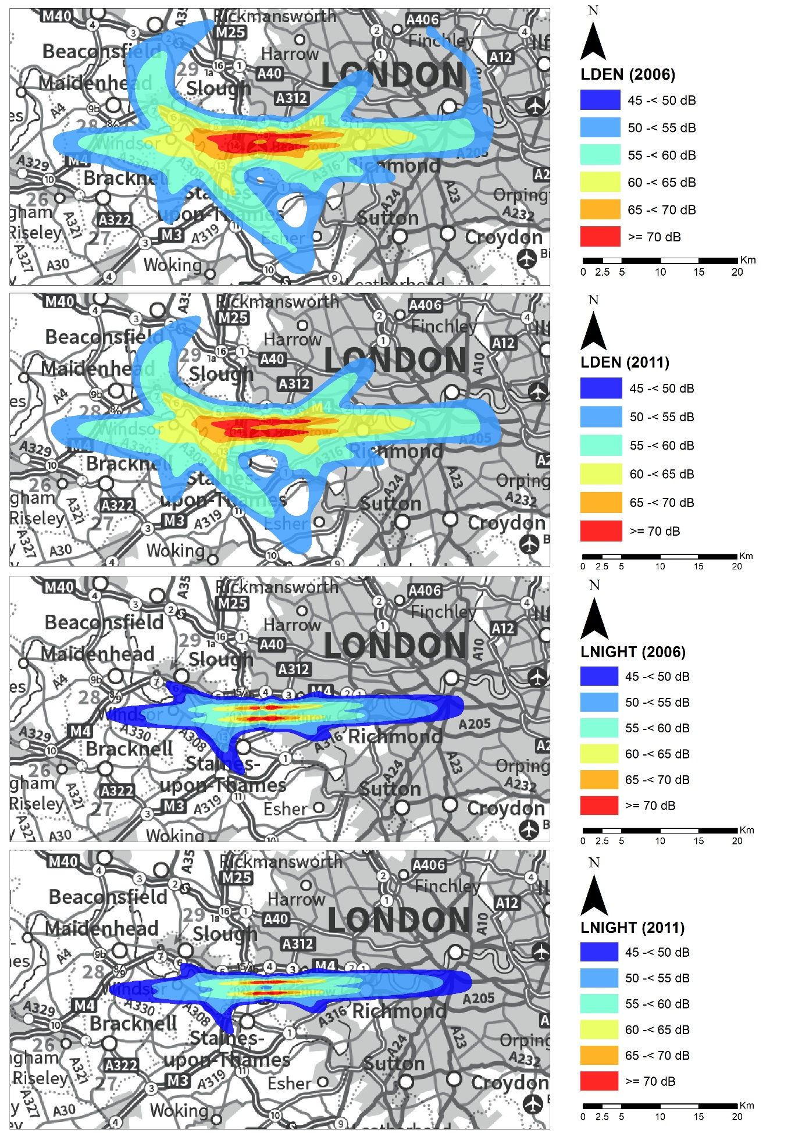

Figure S2: Aircraft noise contours in 2006 and 2011 at London Gatwick airport, reported as ‘day-evening-night’ (Lden) and ‘night-time’ from 23:00 to 07:00 hours (Lnight).
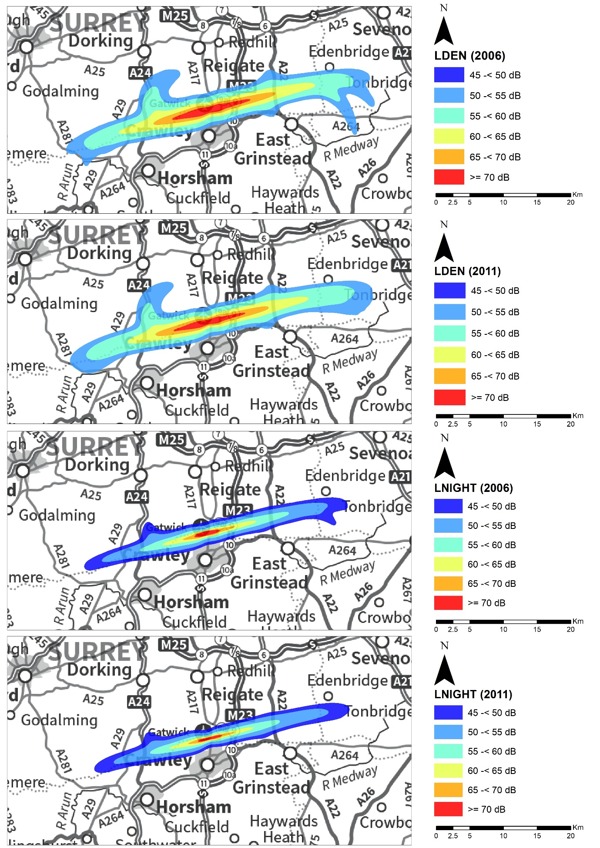

Figure S3. Aircraft noise contours in 2006 and 2011 at Birmingham airport, reported as ‘day-evening-night’ (Lden) and ‘night-time’ from 23:00 to 07:00 hours (Lnight).
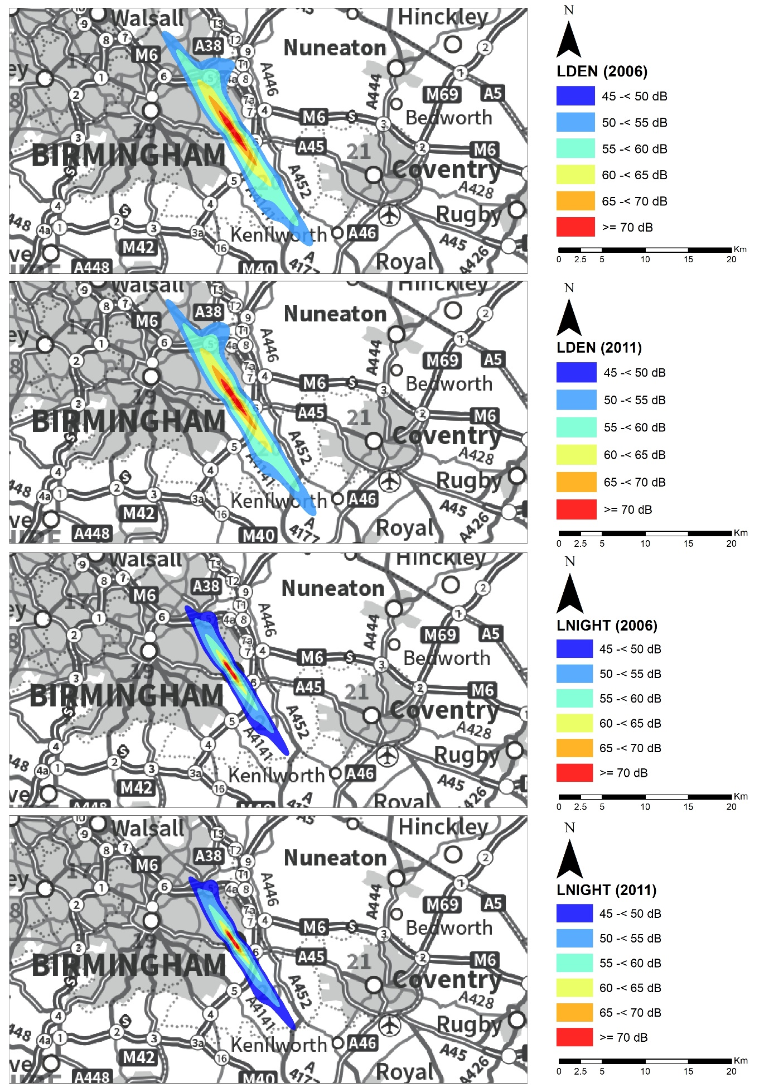

Figure S4: Aircraft noise contours in 2006 and 2011 at Manchester airport, reported as ‘day-evening-night’ (Lden) and ‘night-time’ from 23:00 to 07:00 hours (Lnight).
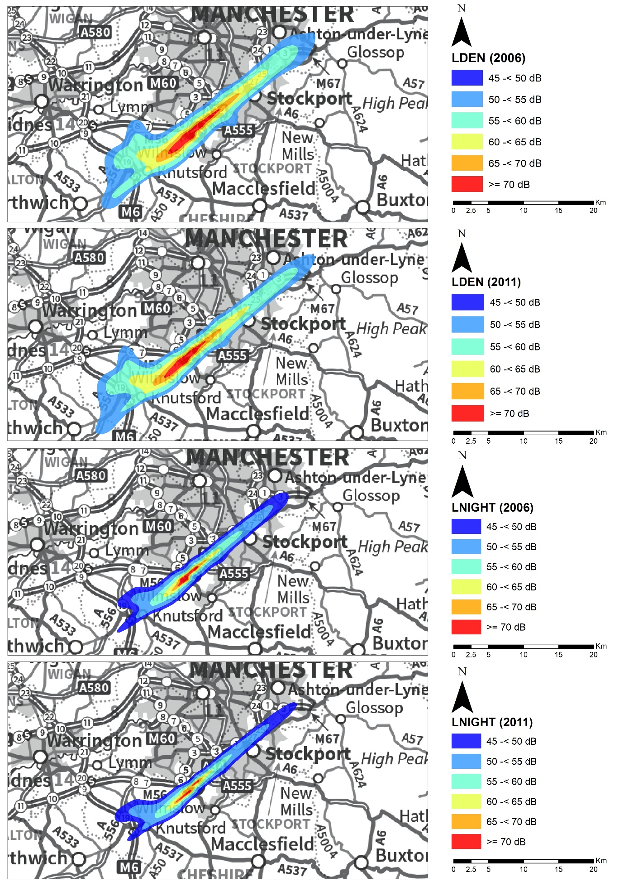

Figure S5. Exposure metrics for 24-hour weighted annual average day-evening-night time (Lden) and night time (Lnight) aircraft noise at Census Output Area (COA) level by airport.
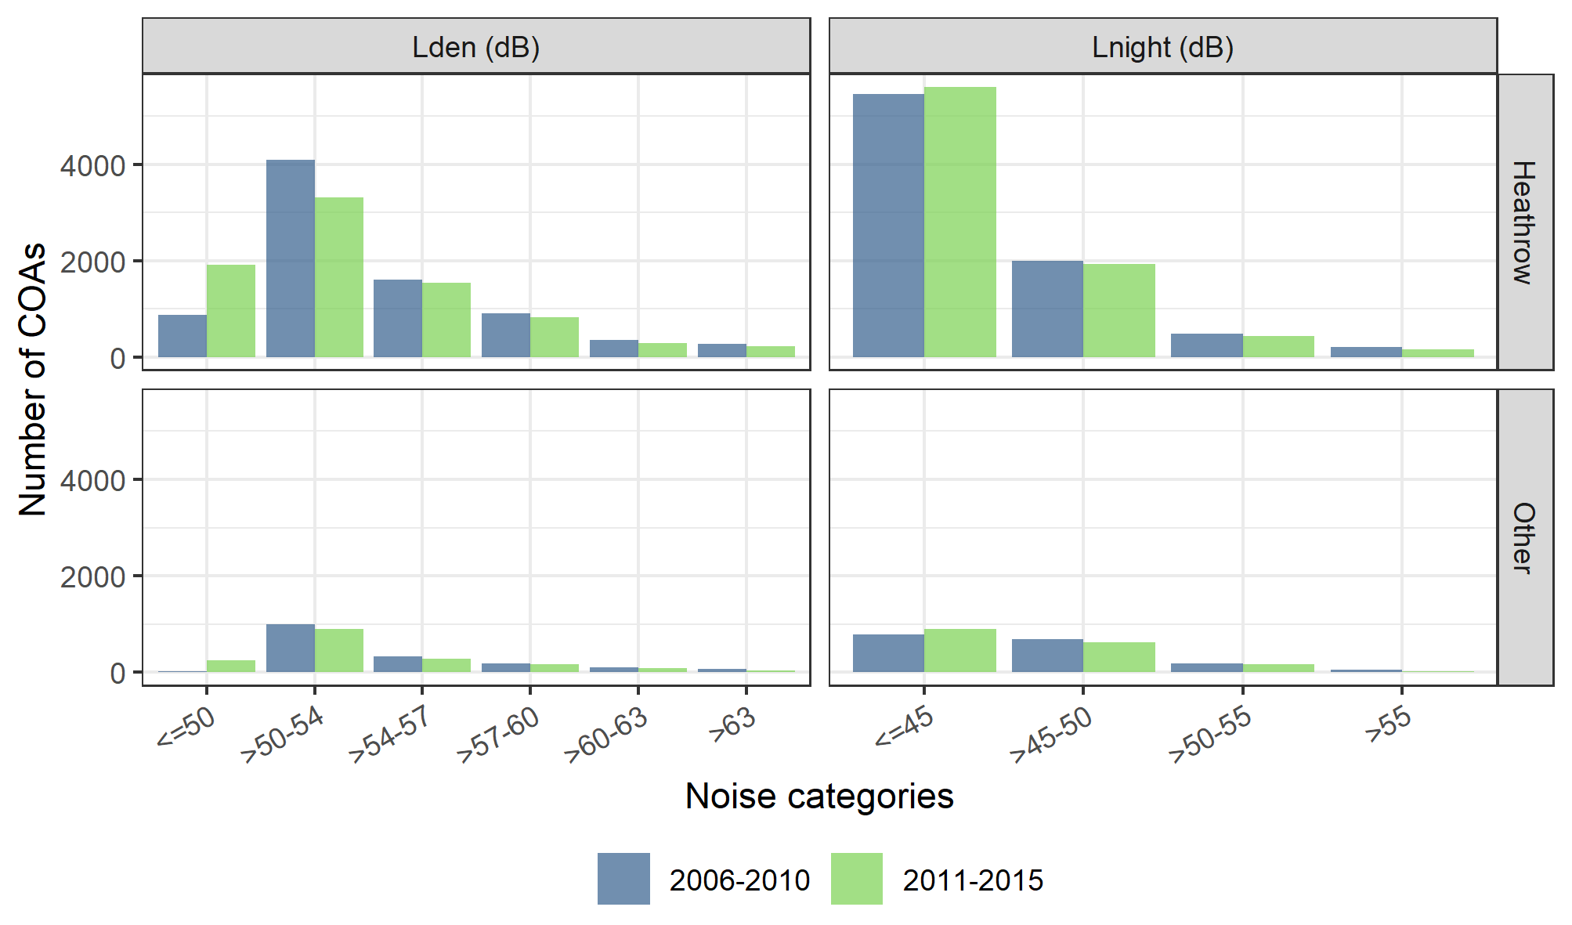

Figure S6. COA-level measures around London Heathrow airport for: (A) Carstairs index of deprivation (quintile) in 2011 (lowest=least deprived), (B) Percentage of non-White ethnicity from 2011 Census, (C) Lden railway noise exposure, (D) Lnight railway noise exposure, (E) Lden road-transport noise exposure, (F) Lnight road-transport noise exposure, (G) All sources NO2 distribution (an indicator of air quality) in 2009.
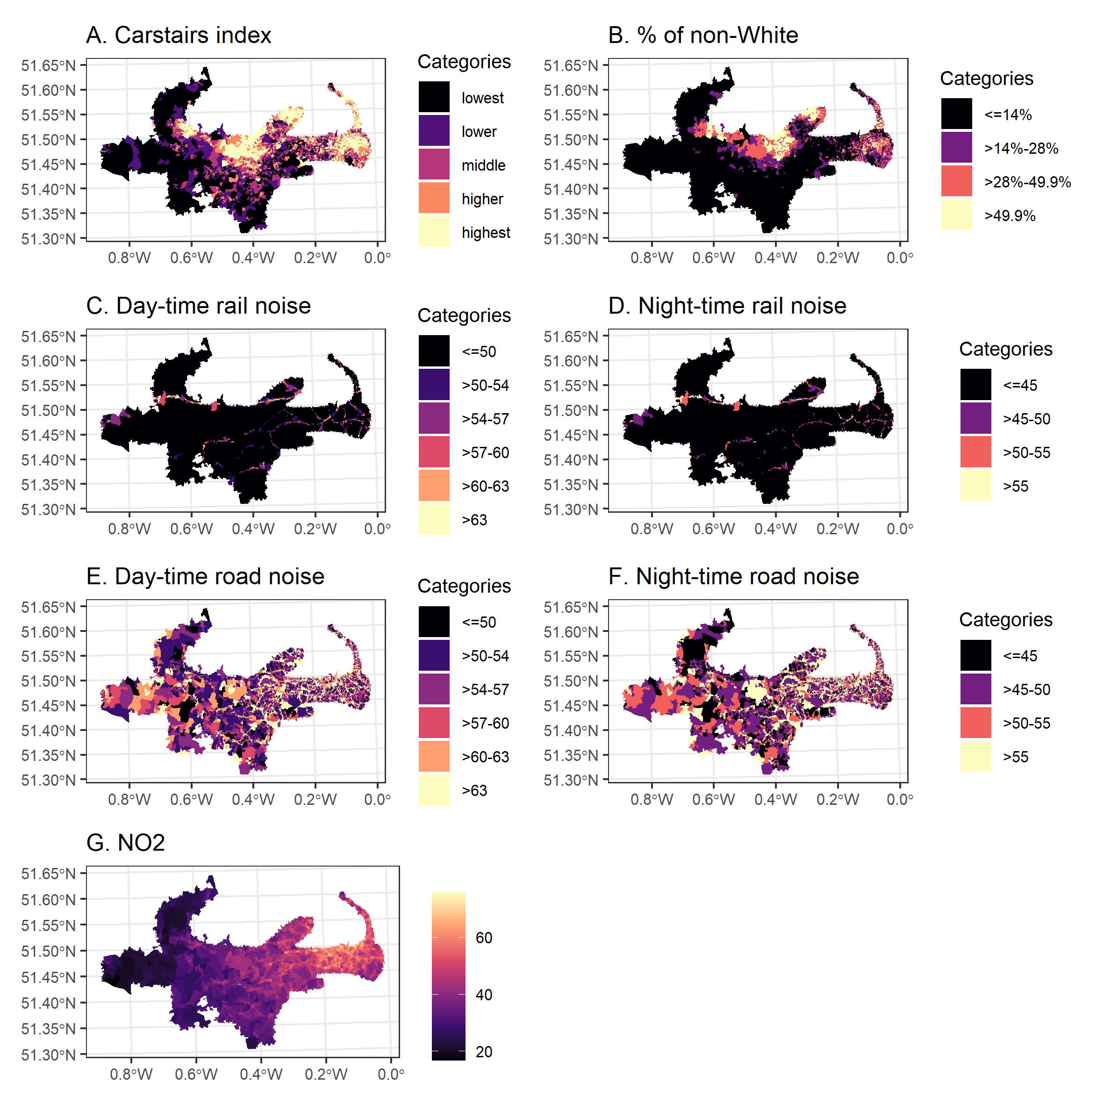
COA: census output areas, Lden: Annual average population day-evening-night time noise, Lnight: Annual average population weighted night time noise.

Figure S7: The spatial distribution of the weighted day-evening-night (panel A) and the weighted nighttime aircraft noise (panel B) in dB near London Gatwick airport in 2006 and 2011.
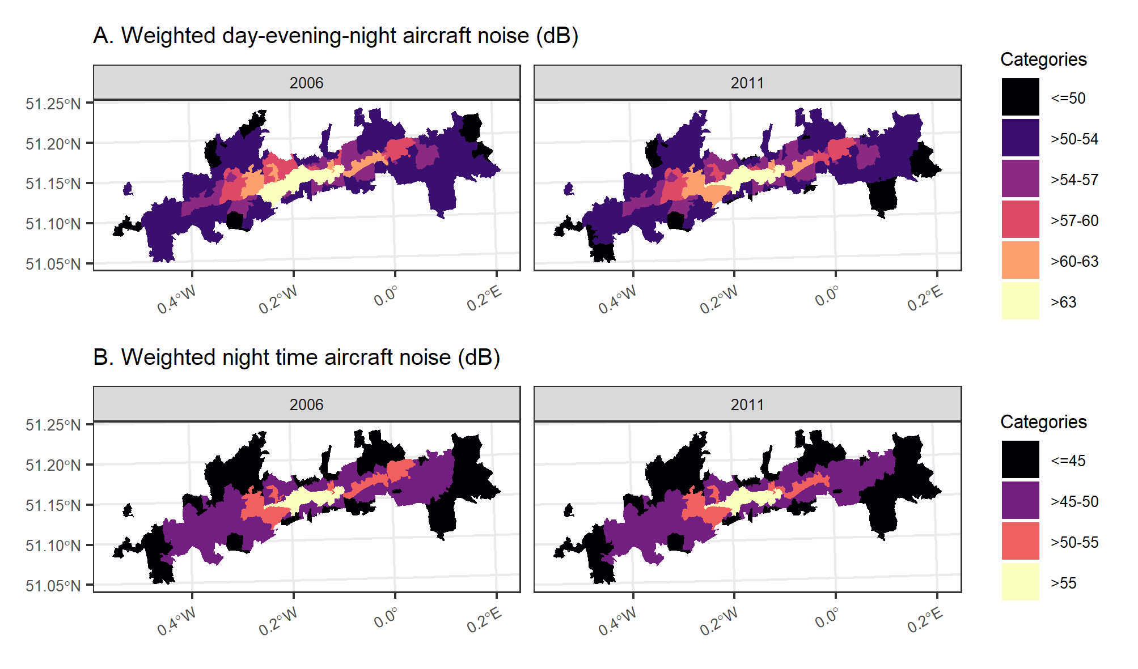

Figure S8. COA-level measures around London Gatwick airport for: (A) Carstairs index of deprivation (quintile) in 2011 (lowest=least deprived), (B) Percentage of non-White ethnicity from 2011 Census, (C) Lden railway noise exposure, (D) Lnight railway noise exposure, (E) Lden road-transport noise exposure, (F) Lnight road-transport noise exposure, (G) All sources NO2 distribution (an indicator of air quality) in 2009.
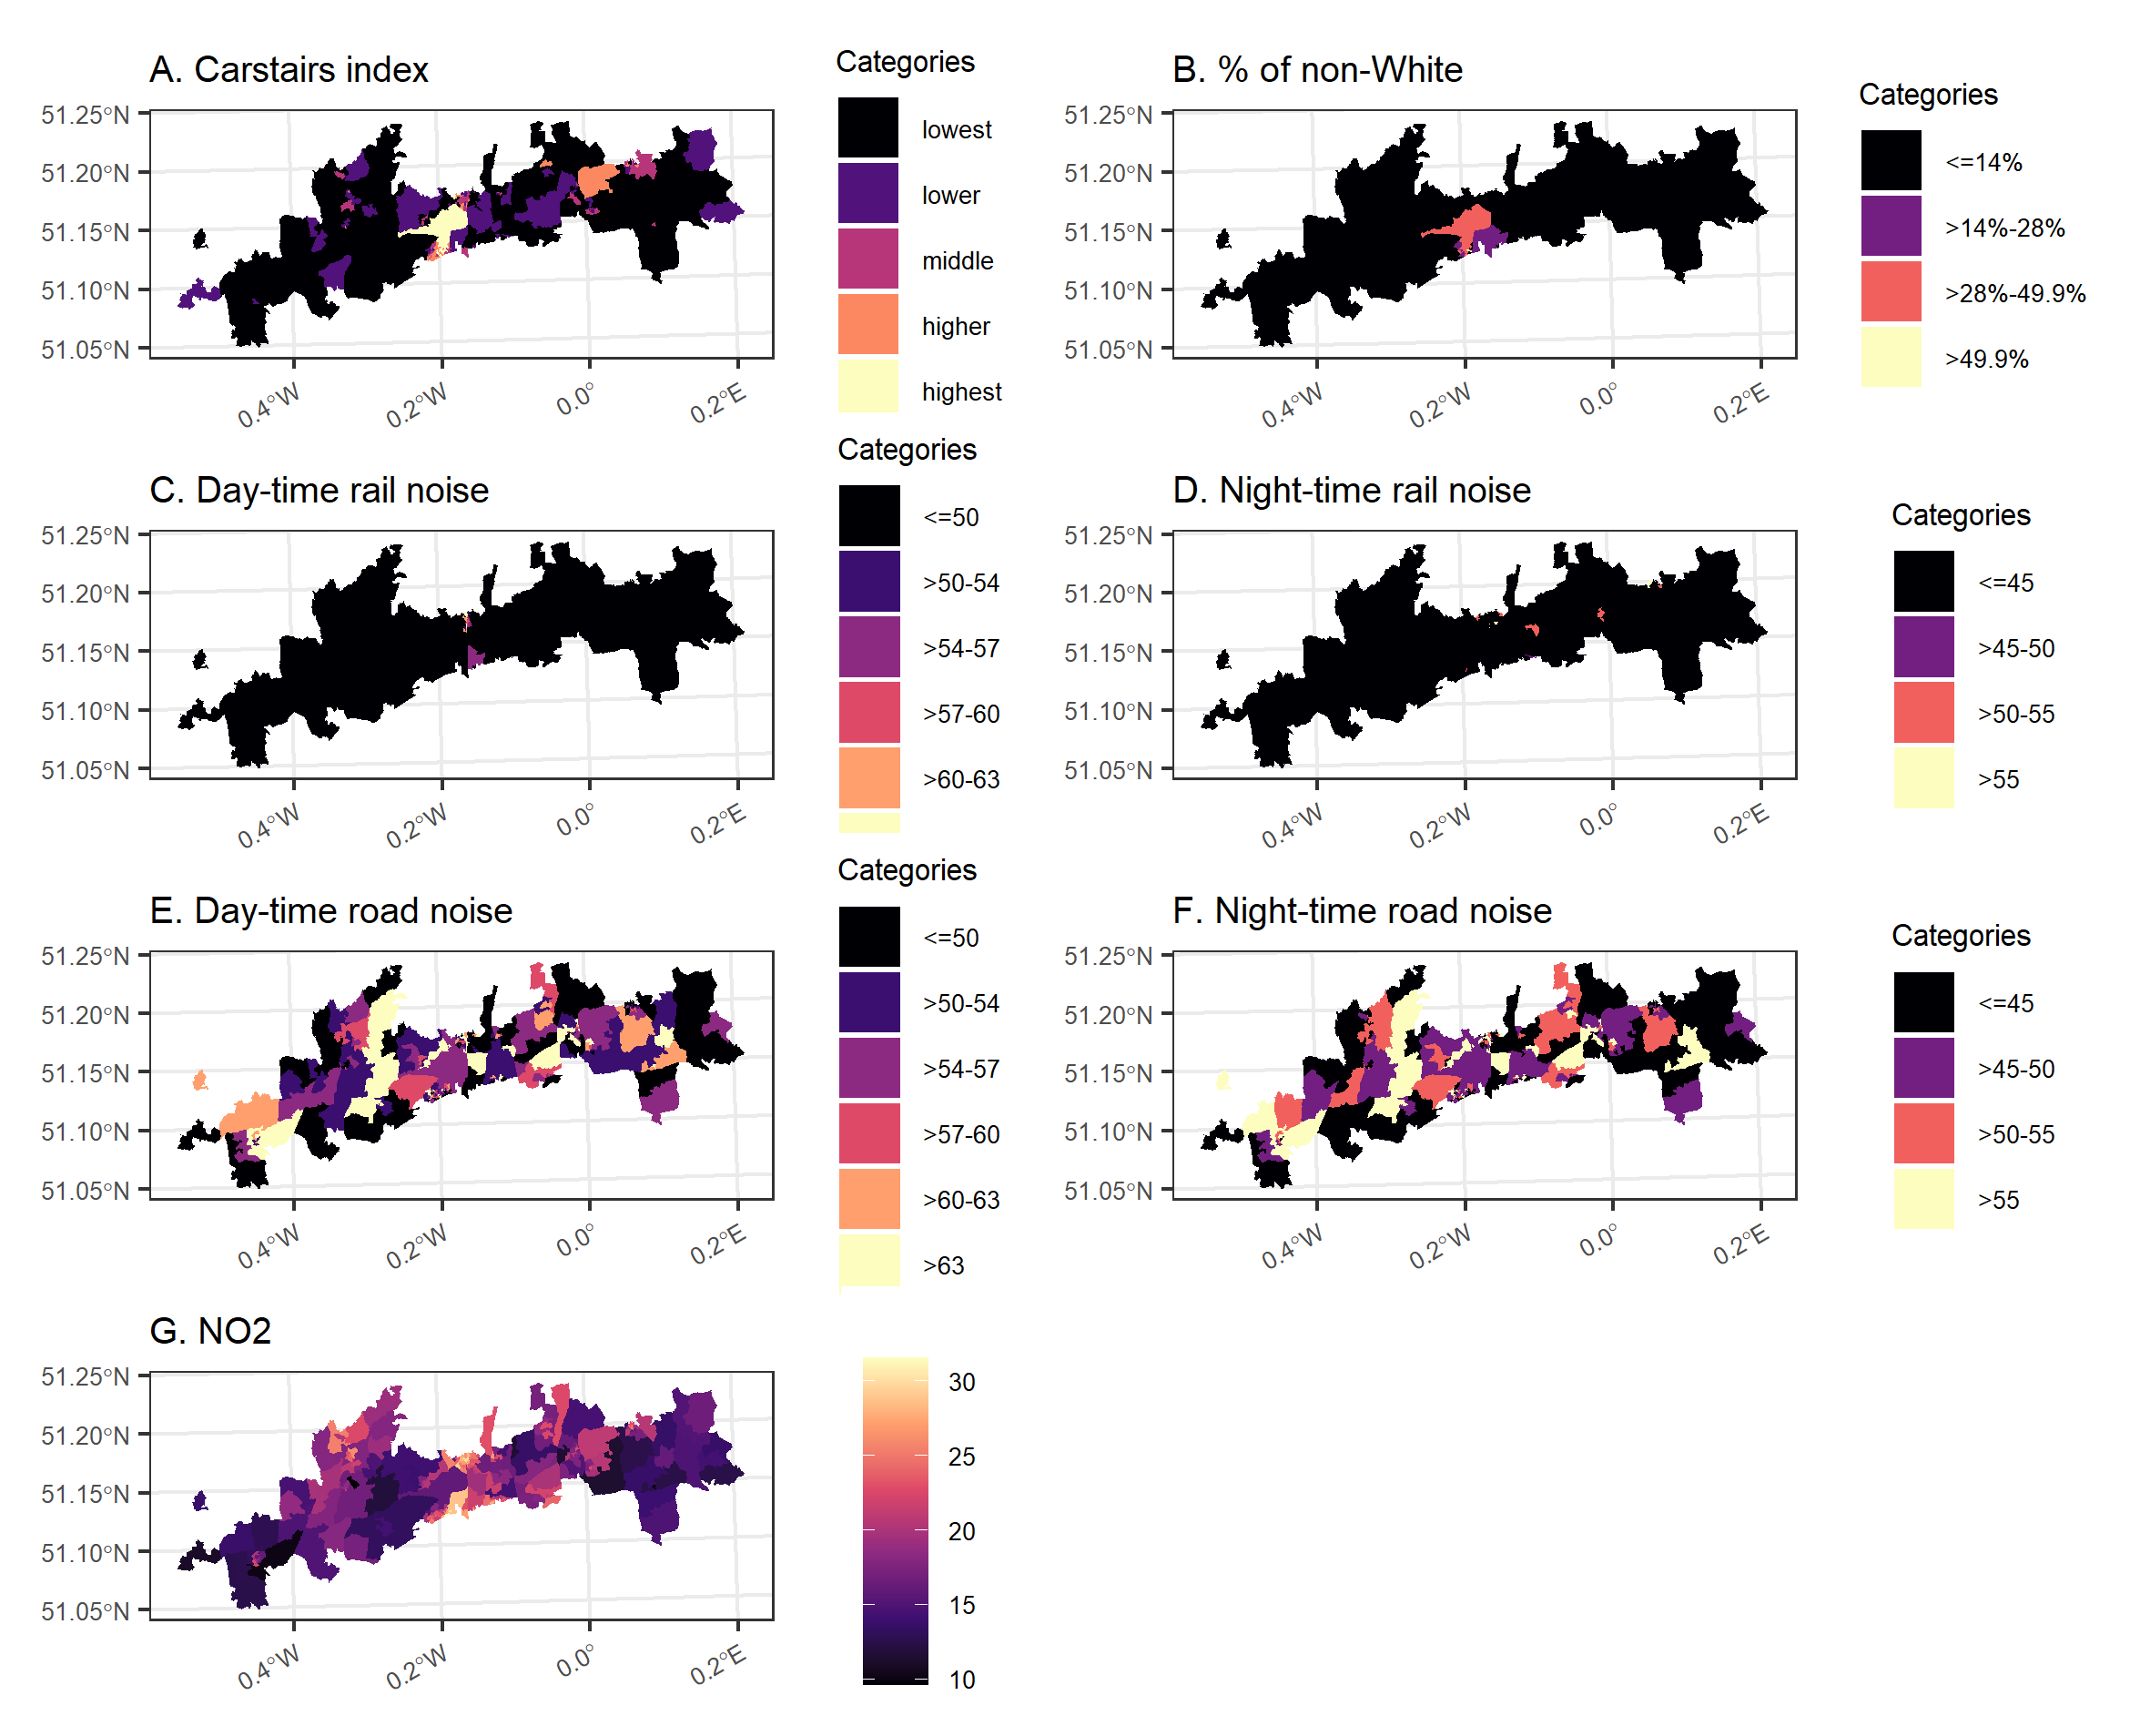
COA: census output areas, Lden: Annual average population day-evening-night time noise, Lnight: Annual average population weighted night time noise.

Figure S9: The spatial distribution of the weighted day-evening-night (panel A) and the weighted nighttime aircraft noise (panel B) in dB near Birmingham airport in 2006 and 2011.
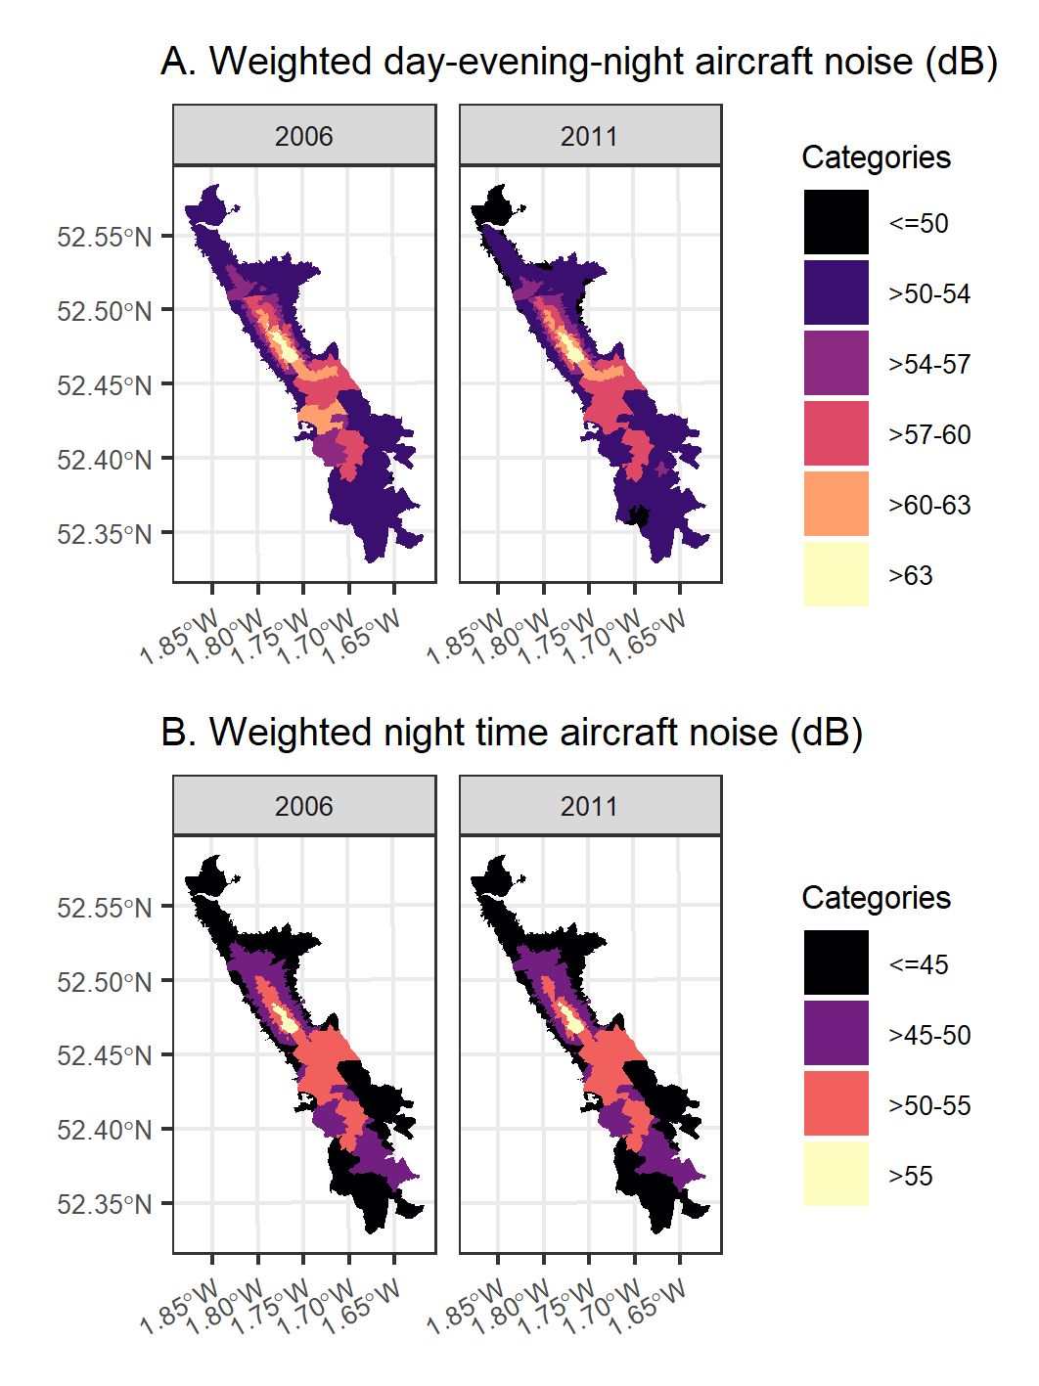

Figure S10. COA-level measures around Birmingham airport for: (A) Carstairs index of deprivation (quintile) in 2011 (lowest=least deprived), (B) Percentage of non-White ethnicity from 2011 Census, (C) Lden railway noise exposure, (D) Lnight railway noise exposure, (E) Lden road-transport noise exposure, (F) Lnight road-transport noise exposure, (G) All sources NO2 distribution (an indicator of air quality) in 2009.
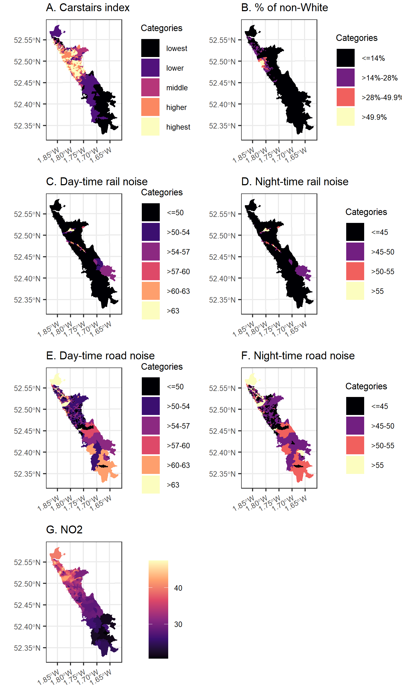
COA: census output areas, Lden: Annual average population day-evening-night time noise, Lnight: Annual average population weighted night time noise.

Figure S11: The spatial distribution of the weighted day-evening-night (panel A) and the weighted nighttime aircraft noise (panel B) in dB near Manchester airport in 2006 and 2011.
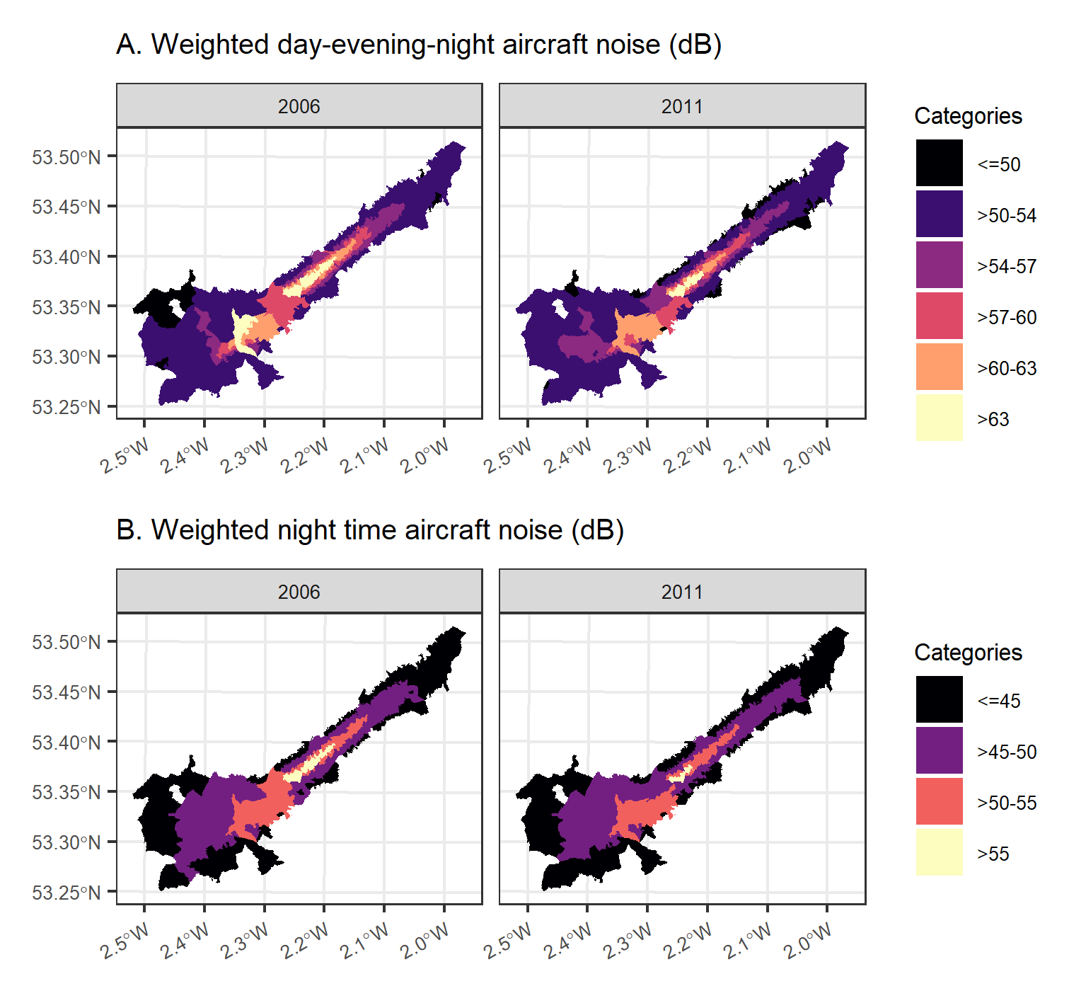

Figure S12. COA-level measures around Manchester airport for: (A) Carstairs index of deprivation (quintile) in 2011 (lowest=least deprived), (B) Percentage of non-White ethnicity from 2011 Census, (C) Lden railway noise exposure, (D) Lnight railway noise exposure, (E) Lden road-transport noise exposure, (F) Lnight road-transport noise exposure, (G) All sources NO2 distribution (an indicator of air quality) in 2009.
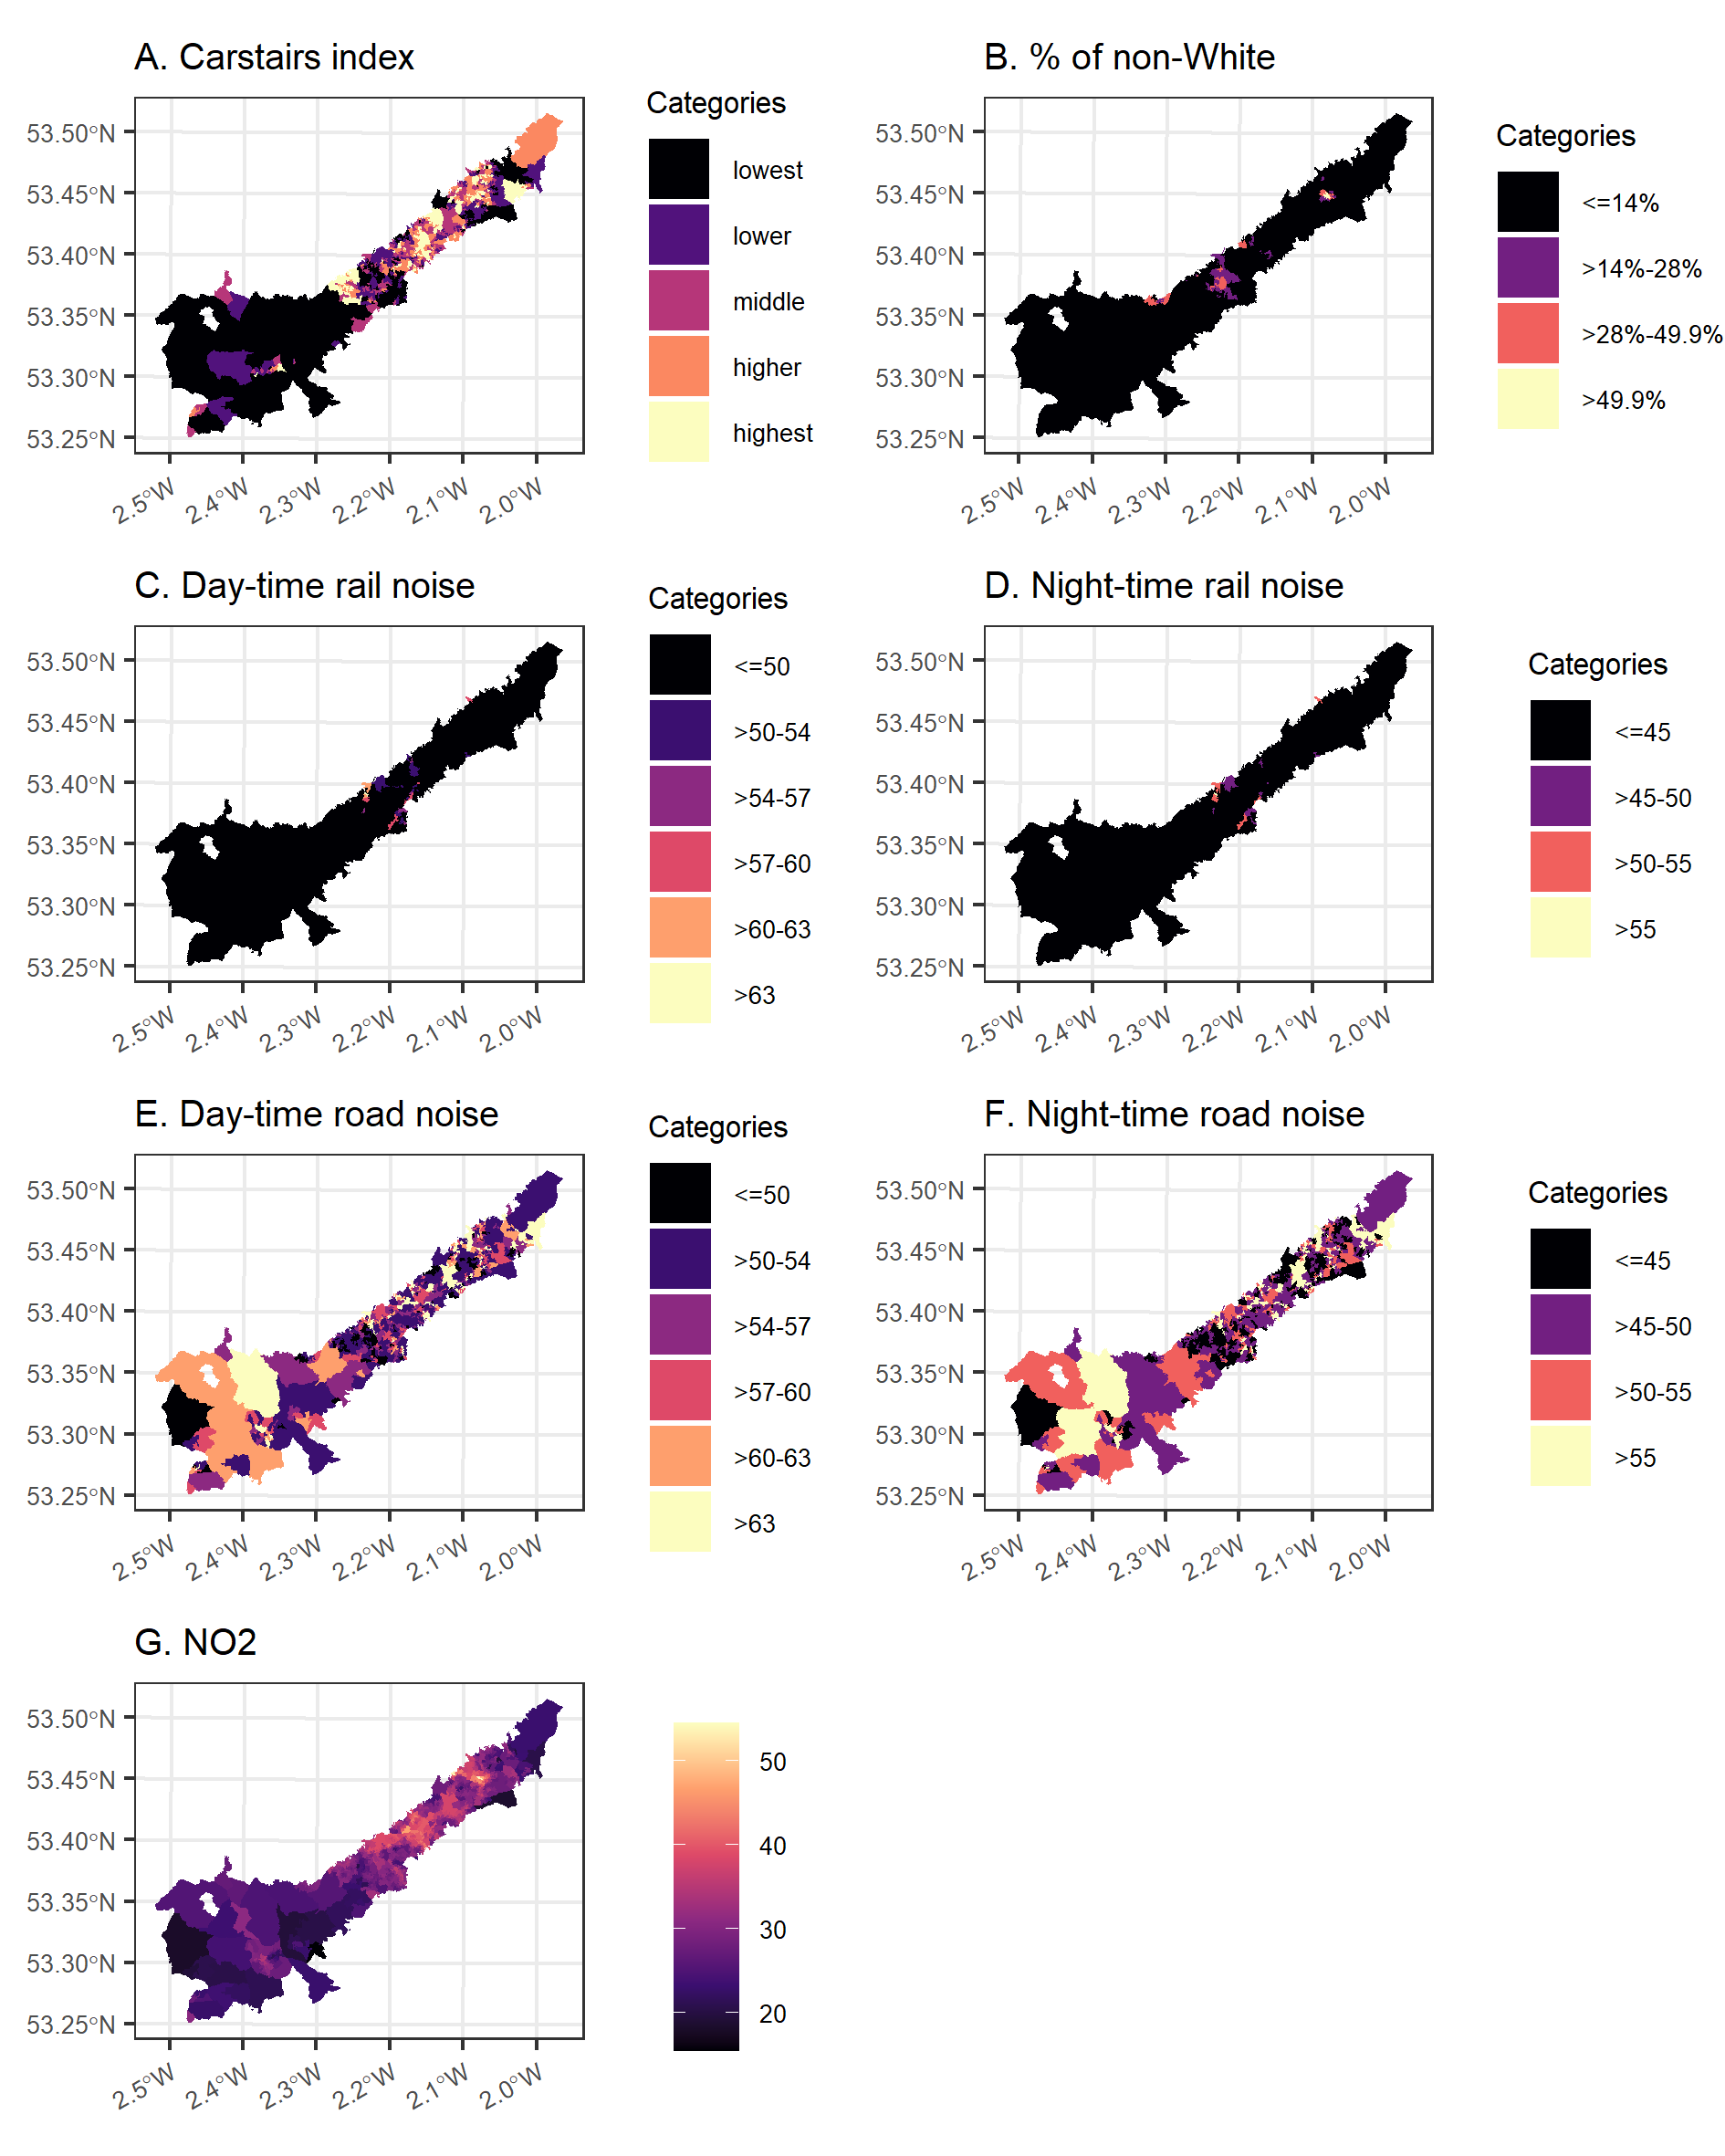
COA: census output areas, Lden: Annual average population day-evening-night time noise, Lnight: Annual average population weighted night time noise.

Figure S13. Correlation coefficients between annual population-weighted average aircraft noise in 2006 and 2011, road noise, rail noise, NO₂, ethnicity and deprivation in London Heathrow. The values bellow the detection threshold were excluded for this calculation.
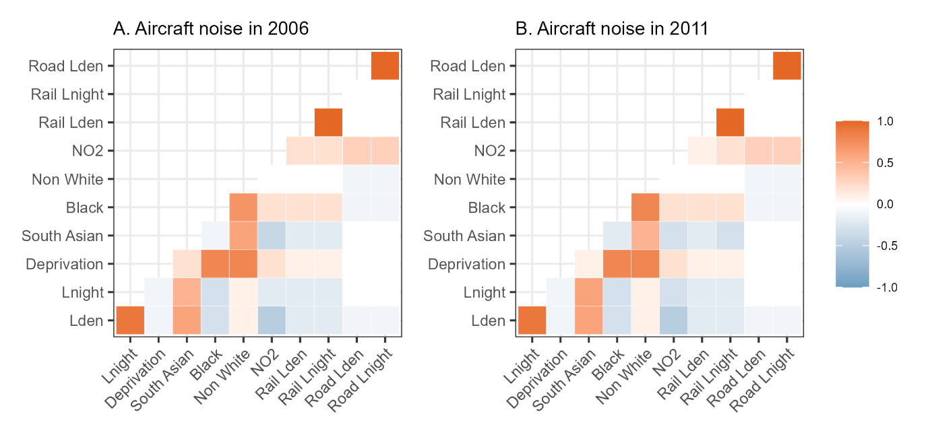
Lden: Annual average population day-evening-night time noise, Lnight: Annual average population weighted night time noise.

Figure S14. Correlation coefficients between annual population-weighted average aircraft noise in 2006 and 2011, road noise, rail noise, NO₂, ethnicity and deprivation in the other airports (London Gatwick, Birmingham and Manchester). The values bellow the detection threshold were excluded for this calculation.
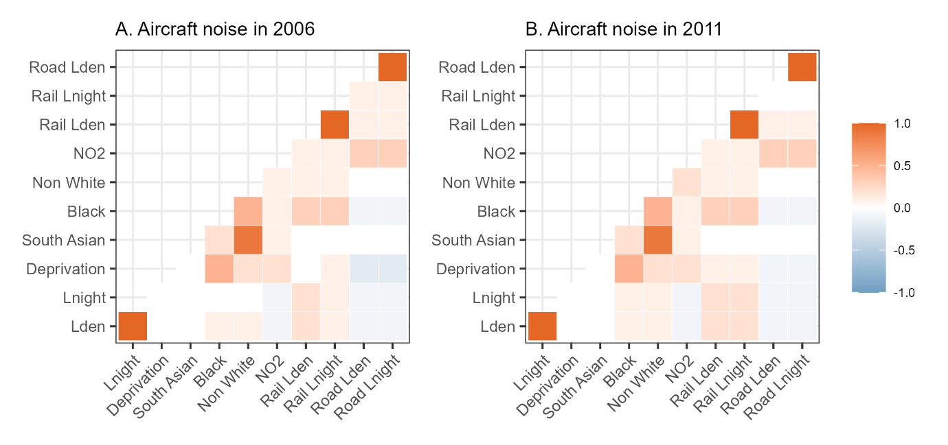
Lden: Annual average population day-evening-night time noise, Lnight: Annual average population weighted night time noise.

Figure S15. Median relative hospitalisation or mortality risk and 95% credible intervals per 5dB increase in Lden and Lnight in the unadjusted and fully adjusted linear models for all cardiovascular, coronary heart disease and stroke near London Heathrow for noise levels above 50dB for Lden and 45dB for Lnight (aircraft exposure data is not supplied by CAA below these levels). The minimally adjusted model does not include additional covariates but accounts for temporal trends, age and sex through the expected counts (see (1)-(2) in the Methods section), whereas the fully adjusted model additionally accounts for ethnicity, deprivation, road nose, rail noise, NO₂ exposure and spatial confounding. This figure is a graphical representation of Table S5.
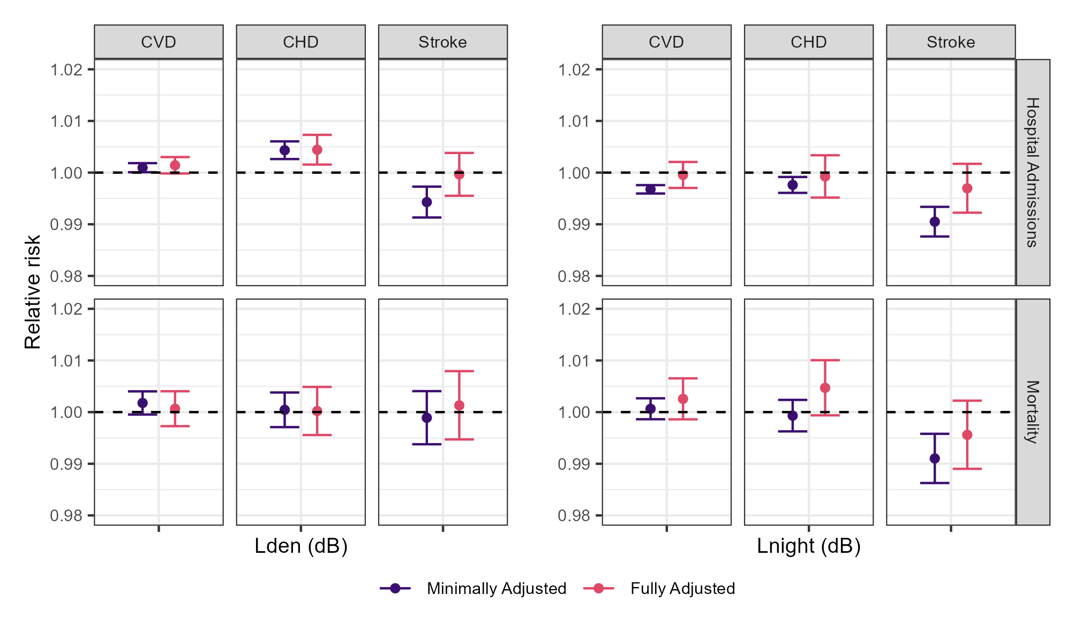
Lden: Annual average population day-evening-night time noise, Lnight: Annual average population weighted night time noise, CVD: All cardiovascular disease, CHD: Coronary heart disease

Figure S16. Median relative hospitalisation or mortality risk and 95% credible intervals per 5dB increase in Lden and Lnight in the unadjusted and fully adjusted linear models for all cardiovascular, coronary heart disease and stroke near the other airports (London Gatwick. Birmingham and Manchester) for noise levels above 50dB for Lden and 45dB for Lnight (aircraft exposure data is not supplied by CAA below these levels). The minimally adjusted model does not include additional covariates but accounts for temporal trends, age and sex through the expected counts (see (1)-(2) in the Methods section), whereas the fully adjusted model additionally accounts for ethnicity, deprivation, road nose, rail noise, NO₂ exposure and spatial confounding. This figure is a graphical representation of Table S8.
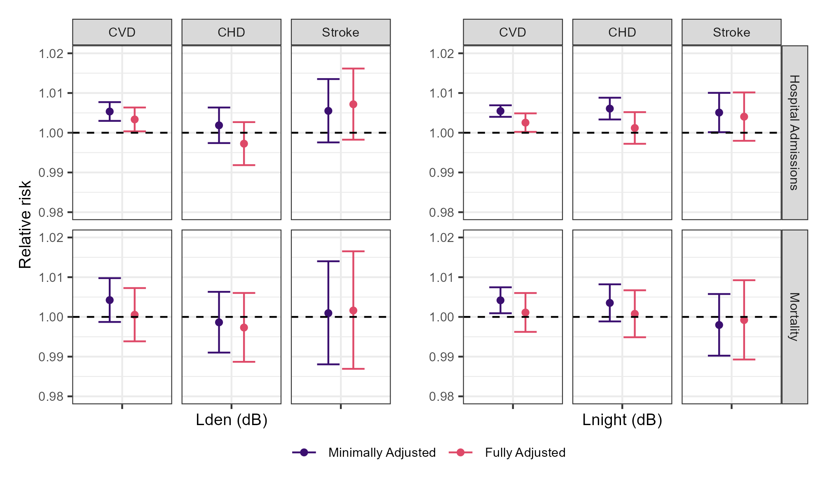
Lden: Annual average population day-evening-night time noise, Lnight: Annual average population weighted night time noise, CVD: All cardiovascular disease, CHD: Coronary heart disease.

Figure S17. Comparing 2006-2010 and 2011-2015: Median relative hospitalisation risk and 95% credible intervals for the association between long-term exposure to annual average population day-evening-night time aircraft noise (Lden) (top panel), annual average population night time aircraft noise (Lnight) (bottom panel) and all cardiovascular disease, coronary heart disease and stroke near Heathrow . The effects shown are adjusted for temporal trends, age and sex, ethnicity, deprivation, road nose, rail noise, NO₂ exposure and spatial confounding.
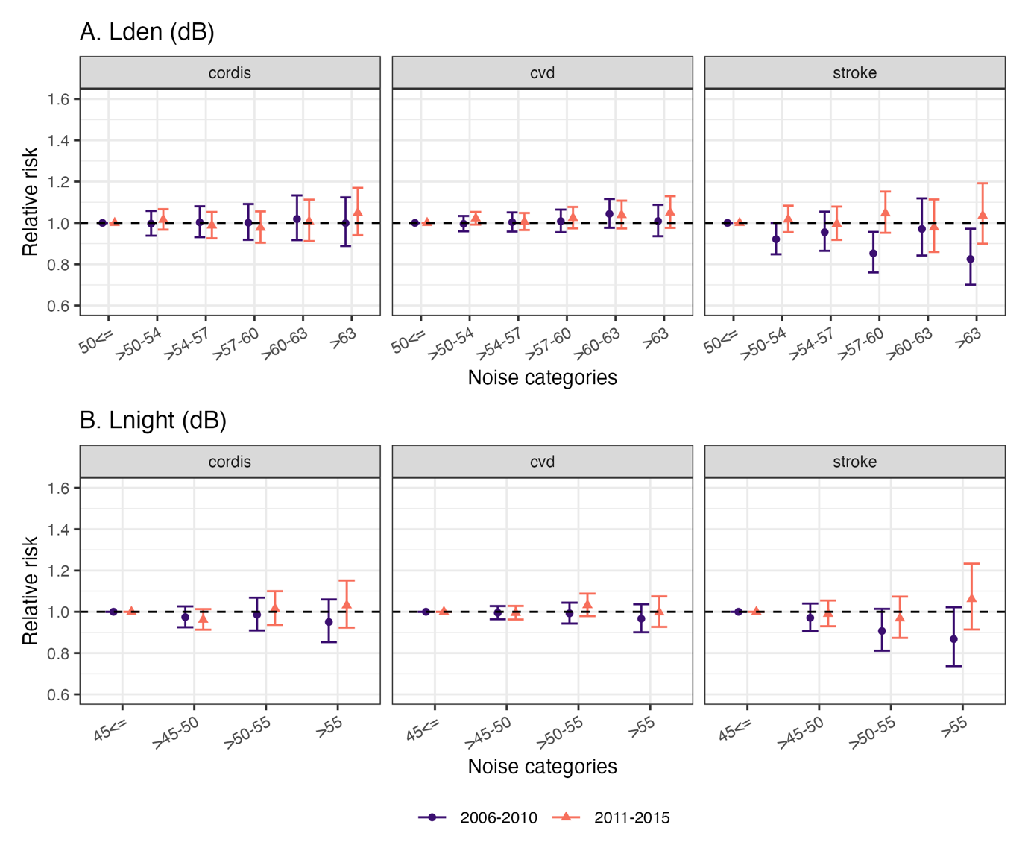
Lden: Annual average population day-evening-night time noise, Lnight: Annual average population weighted night time noise, CVD: All cardiovascular disease, CHD: Coronary heart disease.

Figure S18. Comparing 2006-2010 and 2011-2015: Median relative mortality risk and 95% credible intervals for the association between long-term exposure to annual average population day-evening-night time aircraft noise (Lden) (top panel), annual average population night time aircraft noise (Lnight) (bottom panel) and all cardiovascular disease, coronary heart disease and stroke near Heathrow. The effects shown are adjusted for temporal trends, age and sex, ethnicity, deprivation, road nose, rail noise, NO₂ exposure and spatial confounding.
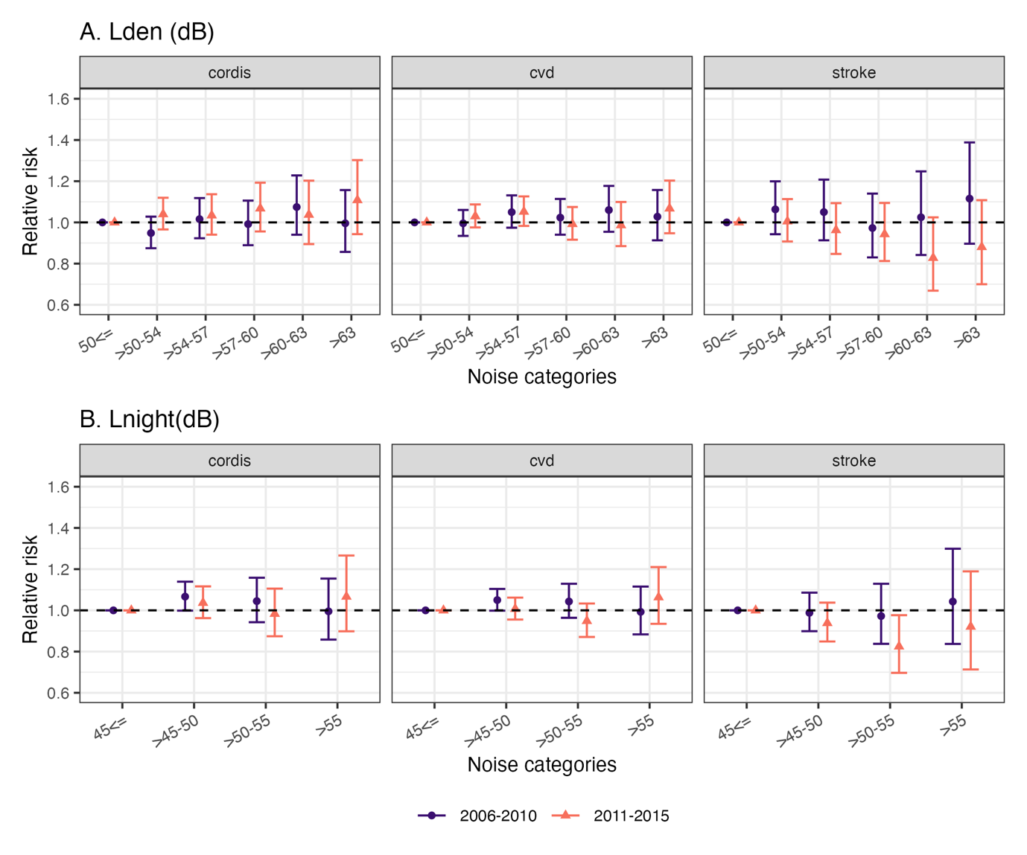
Lden: Annual average population day-evening-night time noise, Lnight: Annual average population weighted night time noise, CVD: All cardiovascular disease, CHD: Coronary heart disease.

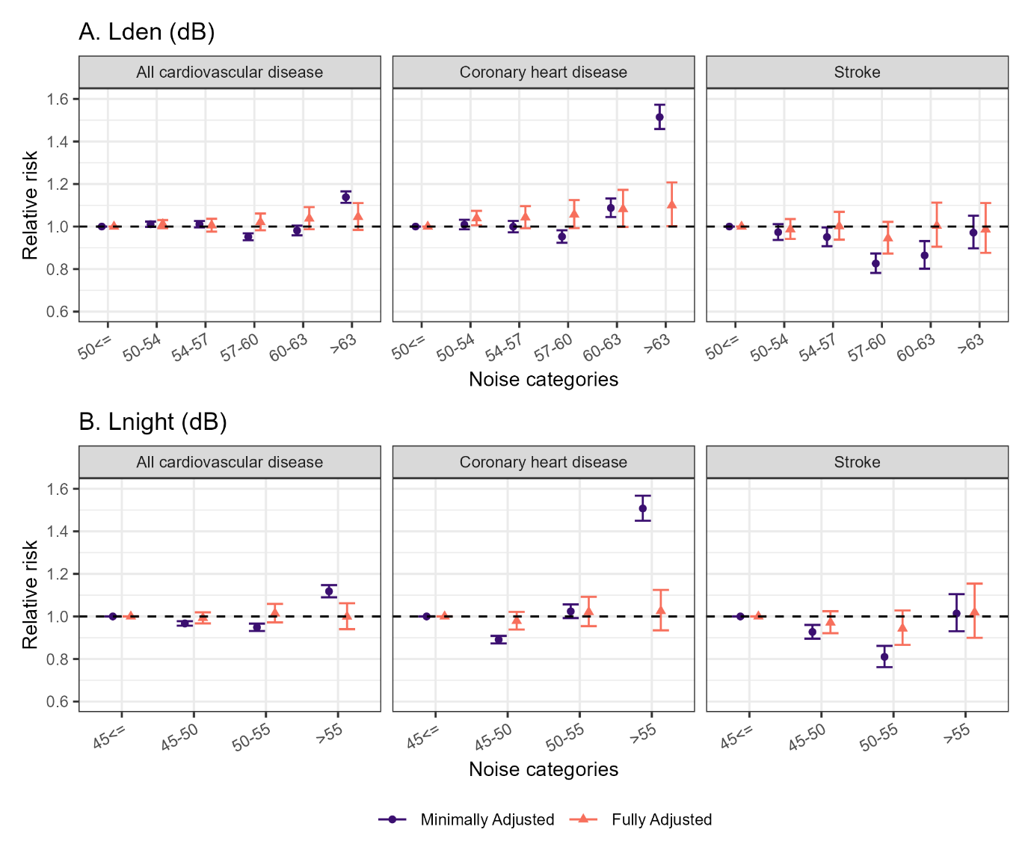
Figure S19. Median relative hospitalisation risk and 95% credible intervals for all cardiovascular disease, coronary heart disease and stroke using the unadjusted and fully adjusted models in London Heathrow during 2006-2016 focusing on populations older than 55 years. Panel A. shows associations with long-term exposure to annual average population weighted day-evening-night aircraft noise. Panel B. shows associations with long-term exposure to annual average population weighted day night time aircraft noise. The minimally adjusted model does not include additional covariates but accounts for temporal trends, age and sex through the expected counts (see (1)-(2) in the Methods section), whereas the fully adjusted model additionally accounts for ethnicity, deprivation, road nose, rail noise, NO₂ exposure and spatial confounding.

Lden: Annual average population day-evening-night time noise, Lnight: Annual average population weighted night time noise, CVD: All cardiovascular disease, CHD: Coronary heart disease.

Figure S20. Median relative mortality risk and 95% credible intervals for all cardiovascular disease, coronary heart disease and stroke using the unadjusted and fully adjusted models in London Heathrow during 2006-2016 focusing on populations older than 55 years. Panel A. shows associations with long-term exposure to annual average population weighted day-evening-night aircraft noise. Panel B. shows associations with long-term exposure to annual average population weighted day night time aircraft noise. The minimally adjusted model does not include additional covariates but accounts for temporal trends, age and sex through the expected counts (see (1)-(2) in the Methods section), whereas the fully adjusted model additionally accounts for ethnicity, deprivation, road nose, rail noise, NO₂ exposure and spatial confounding.
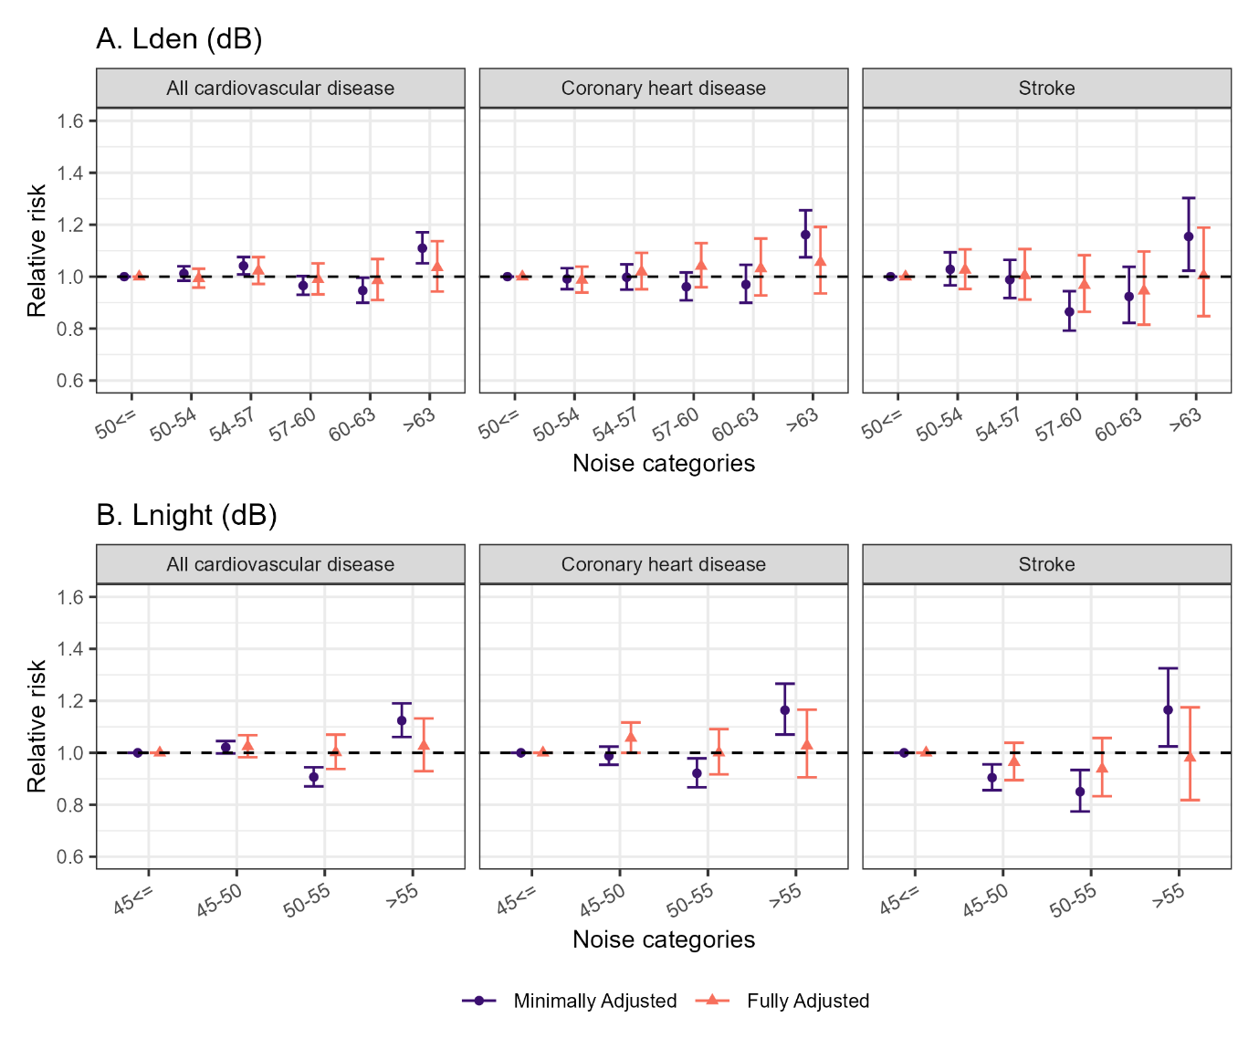
Lden: Annual average population day-evening-night time noise, Lnight: Annual average population weighted night time noise, CVD: All cardiovascular disease, CHD: Coronary heart disease.

Figure S21. Median relative hospitalisation risk and 95% credible intervals for all cardiovascular disease, coronary heart disease and stroke using the unadjusted and fully adjusted near the other airports (London Gatwick. Birmingham and Manchester) during 2006-2016 focusing on populations older than 55 years. Panel A. shows associations with long-term exposure to annual average population weighted day-evening-night aircraft noise. Panel B. shows associations with long-term exposure to annual average population weighted day night time aircraft noise. The minimally adjusted model does not include additional covariates but accounts for temporal trends, age and sex through the expected counts (see (1)-(2) in the Methods section), whereas the fully adjusted model additionally accounts for ethnicity, deprivation, road nose, rail noise, NO₂ exposure and spatial confounding.
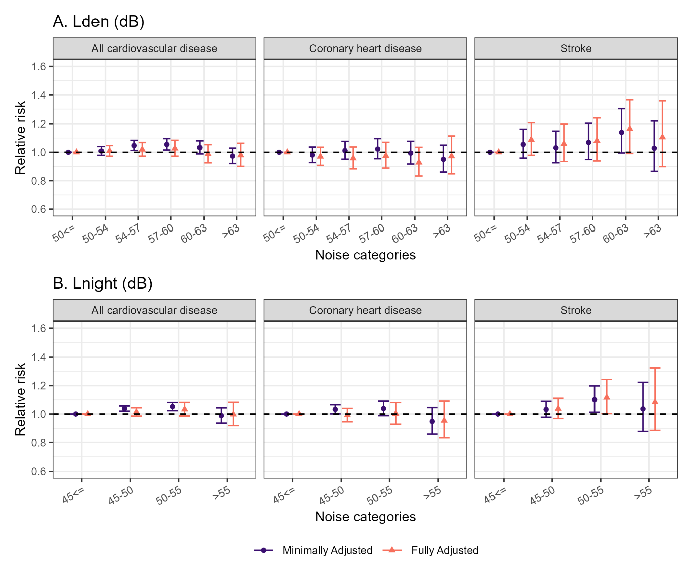
Lden: Annual average population day-evening-night time noise, Lnight: Annual average population weighted night time noise, CVD: All cardiovascular disease, CHD: Coronary heart disease.

Figure S22. Median relative mortality risk and 95% credible intervals for all cardiovascular disease, coronary heart disease and stroke using the unadjusted and fully adjusted near the other airports (London Gatwick. Birmingham and Manchester) during 2006-2016 focusing on populations older than 55 years. Panel A. shows associations with long-term exposure to annual average population weighted day-evening-night aircraft noise. Panel B. shows associations with long-term exposure to annual average population weighted day night time aircraft noise. The minimally adjusted model does not include additional covariates but accounts for temporal trends, age and sex through the expected counts (see (1)-(2) in the Methods section), whereas the fully adjusted model additionally accounts for ethnicity, deprivation, road nose, rail noise, NO₂ exposure and spatial confounding.
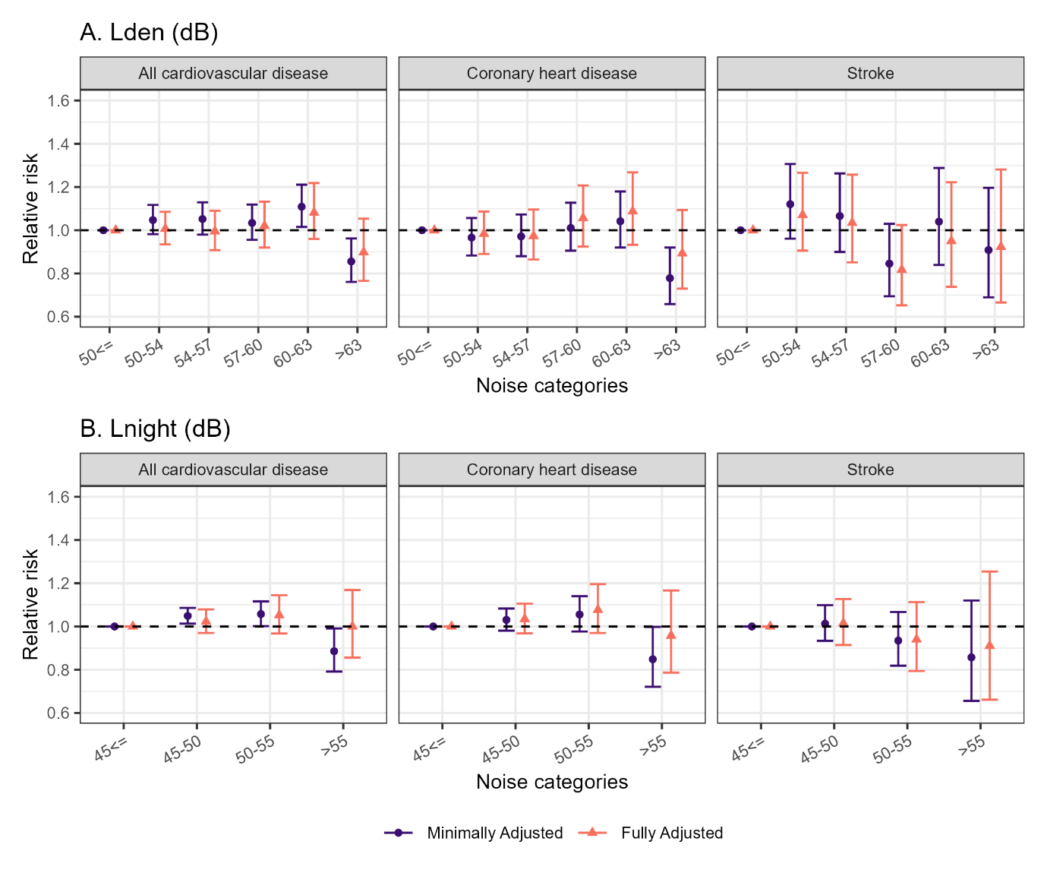
Lden: Annual average population day-evening-night time noise, Lnight: Annual average population weighted night time noise, CVD: All cardiovascular disease, CHD: Coronary heart disease.

Figure S23. Median relative hospitalisation risk and 95% credible intervals for the association between long-term exposure to annual average population day-evening-night time aircraft noise (Lden) (top panel), annual average population night time aircraft noise (Lnight) (bottom panel) and all cardiovascular disease near London Heathrow during 2006-2015. The results show the minimally adjusted (MA) model (this does not include additional covariates but accounts for temporal trends, age and sex through the expected counts (see (1)-(2) in the Methods section)), models adjusted for one variable at a time and fully adjusted, with (FA+IID or FA+BYM2) and without (FA) random effects.
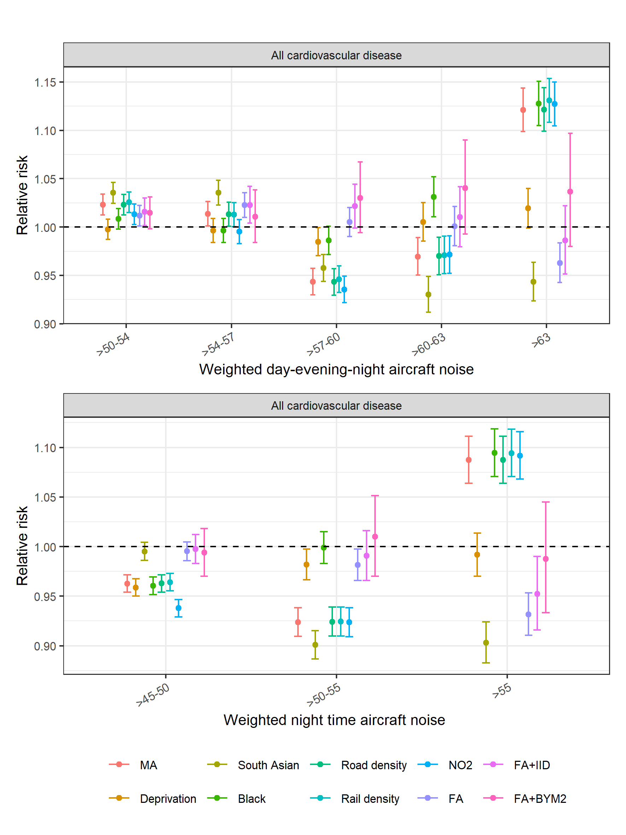

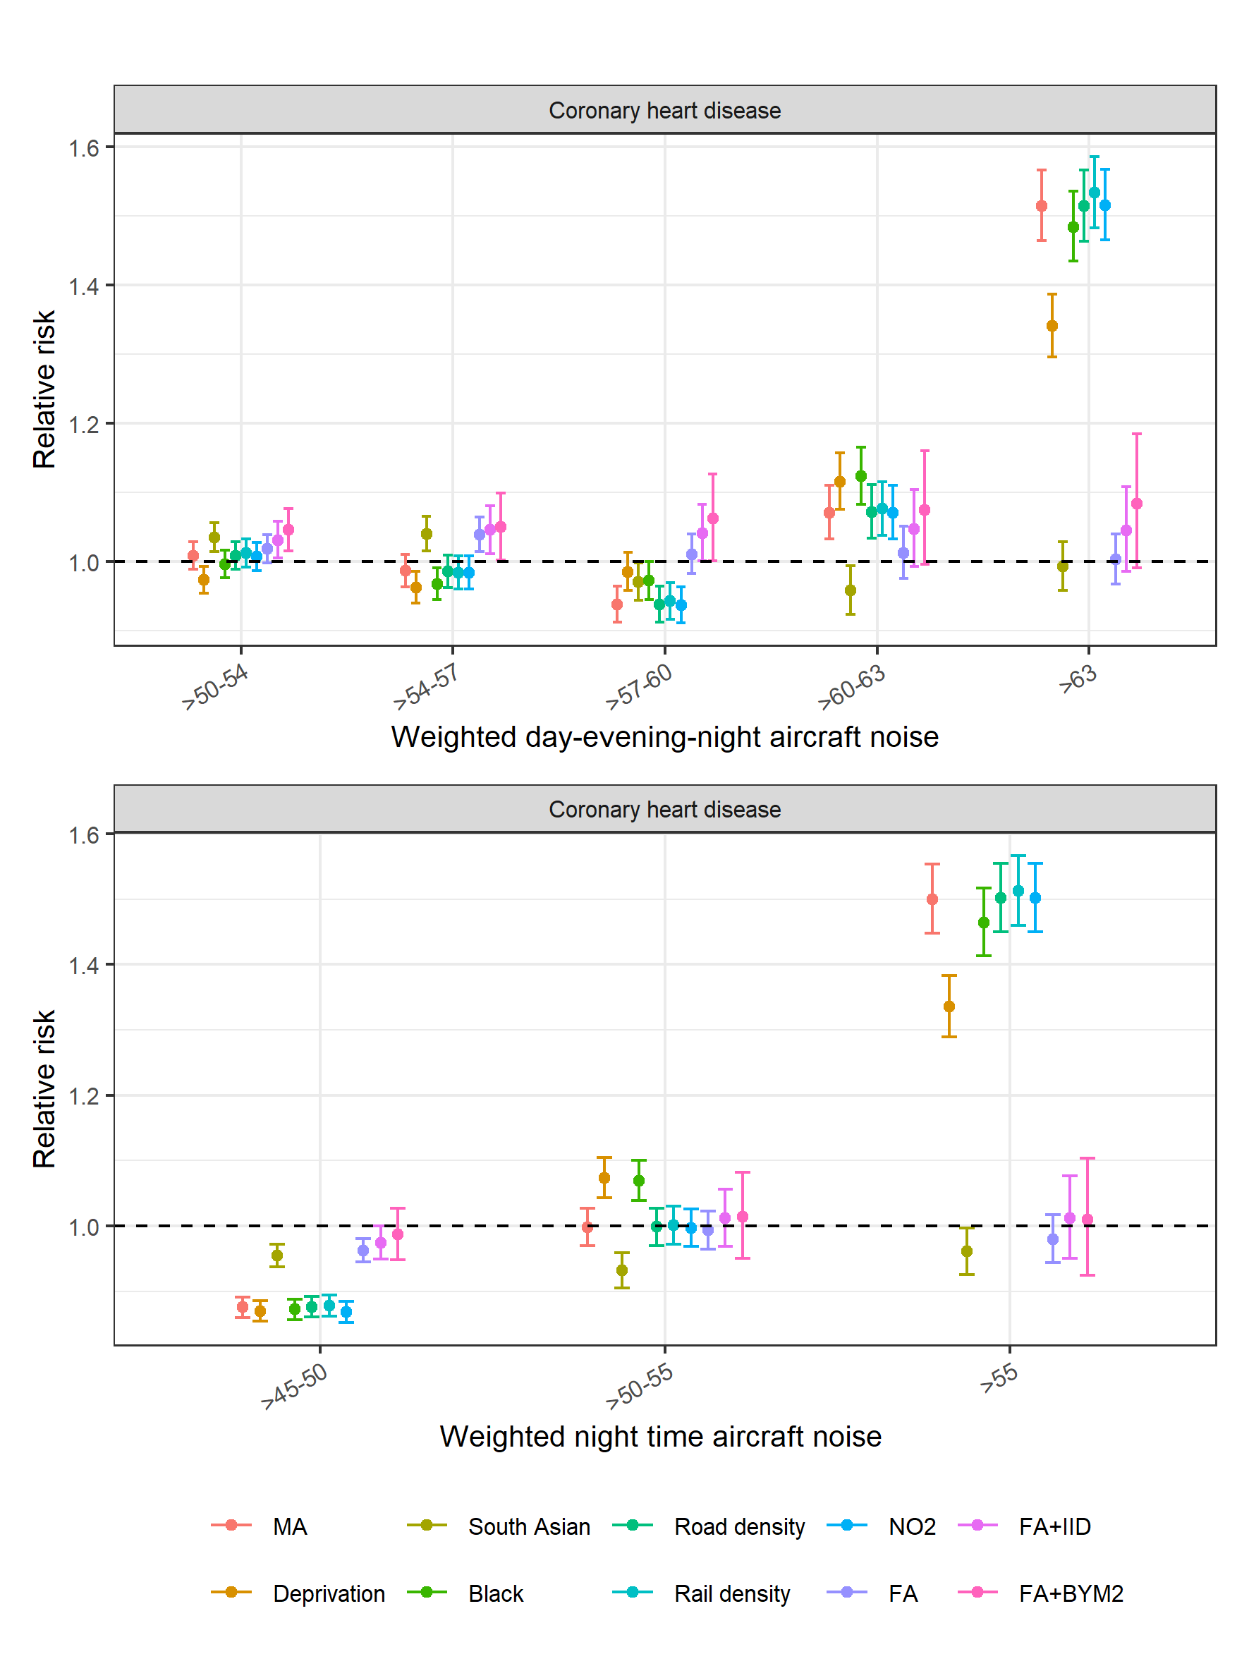
Figure S24. Median relative hospitalisation risk and 95% credible intervals for the association between long-term exposure to annual average population day-evening-night time aircraft noise (Lden) (top panel), annual average population night time aircraft noise (Lnight) (bottom panel) and coronary heart disease near London Heathrow during 2006-2015. The results show the minimally adjusted (MA) model (this does not include additional covariates but accounts for temporal trends, age and sex through the expected counts (see (1)-(2) in the Methods section)), models adjusted for one variable at a time and fully adjusted, with (FA+IID or FA+BYM2) and without (FA) random effects.

Figure S25. Median relative hospitalisation risk and 95% credible intervals for the association between long-term exposure to annual average population day-evening-night time aircraft noise (Lden) (top panel), annual average population night time aircraft noise (Lnight) (bottom panel) and stroke near London Heathrow during 2006-2015. The results show the minimally adjusted (MA) model (this does not include additional covariates but accounts for temporal trends, age and sex through the expected counts (see (1)-(2) in the Methods section)), models adjusted for one variable at a time and fully adjusted, with (FA+IID or FA+BYM2) and without (FA) random effects.
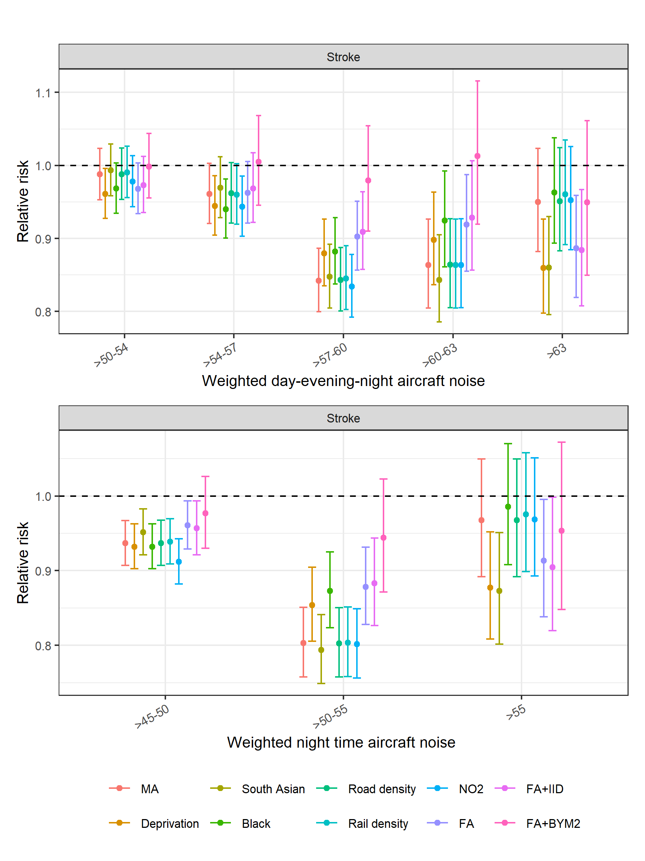

Figure S26. Median relative mortality risk and 95% credible intervals for the association between long-term exposure to annual average population day-evening-night time aircraft noise (Lden) (top panel), annual average population night time aircraft noise (Lnight) (bottom panel) and all cardiovascular disease near London Heathrow during 2006-2015. The results show the minimally adjusted (MA) model (this does not include additional covariates but accounts for temporal trends, age and sex through the expected counts (see (1)-(2) in the Methods section)), models adjusted for one variable at a time and fully adjusted, with (FA+IID or FA+BYM2) and without (FA) random effects.
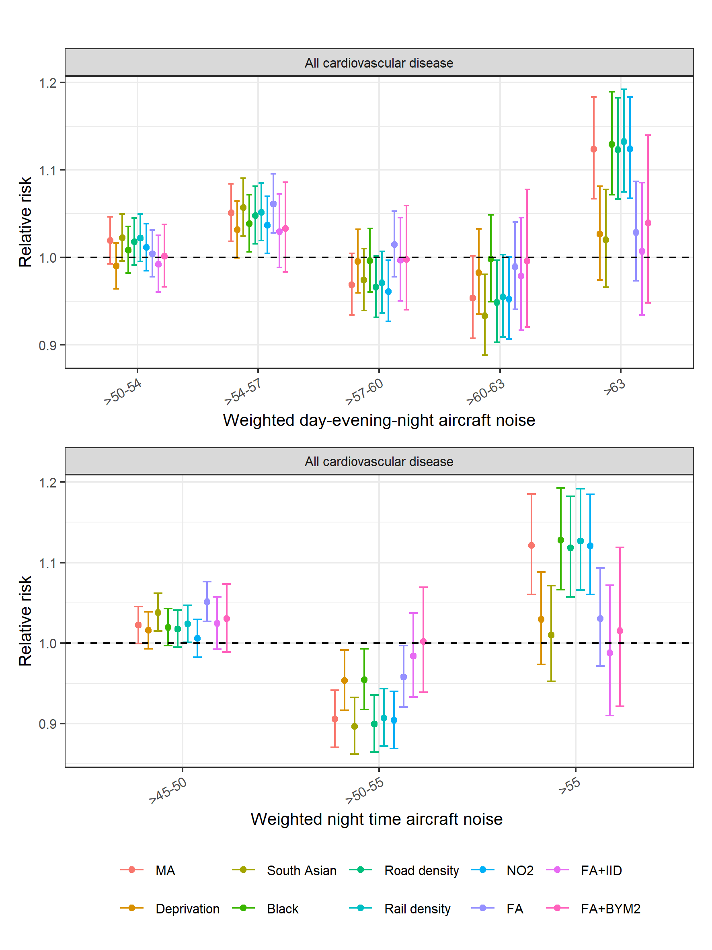

Figure S27. Median relative mortality risk and 95% credible intervals for the association between long-term exposure to annual average population day-evening-night time aircraft noise (Lden) (top panel), annual average population night time aircraft noise (Lnight) (bottom panel) and coronary heart disease near London Heathrow during 2006-2015. The results show the minimally adjusted (MA) model (this does not include additional covariates but accounts for temporal trends, age and sex through the expected counts (see (1)-(2) in the Methods section)), models adjusted for one variable at a time and fully adjusted, with (FA+IID or FA+BYM2) and without (FA) random effects.
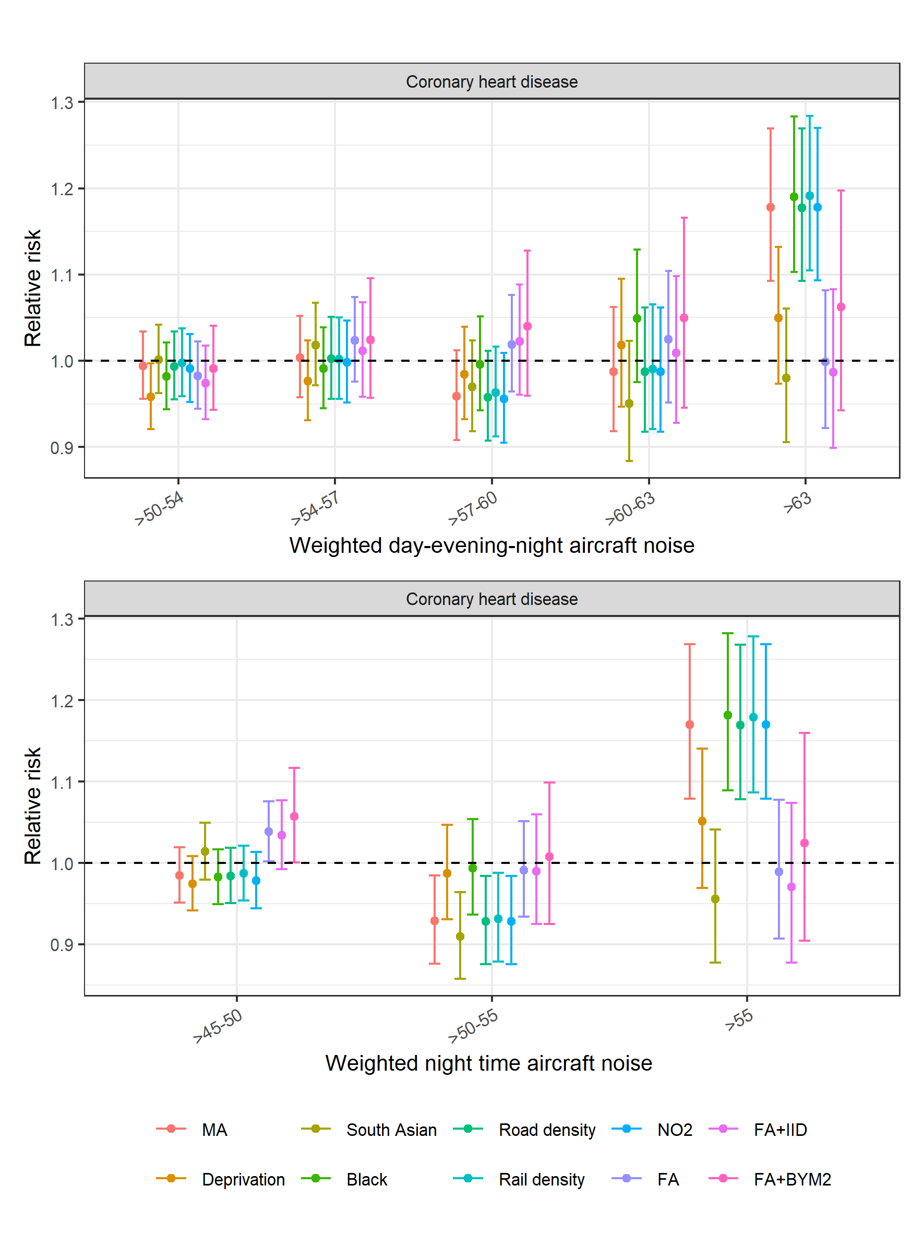

Figure S28. Median relative mortality risk and 95% credible intervals for the association between long-term exposure to annual average population day-evening-night time aircraft noise (Lden) (top panel), annual average population night time aircraft noise (Lnight) (bottom panel) and stroke near London Heathrow during 2006-2015. The results show the minimally adjusted (MA) model (this does not include additional covariates but accounts for temporal trends, age and sex through the expected counts (see (1)-(2) in the Methods section)), models adjusted for one variable at a time and fully adjusted, with (FA+IID or FA+BYM2) and without (FA) random effects.
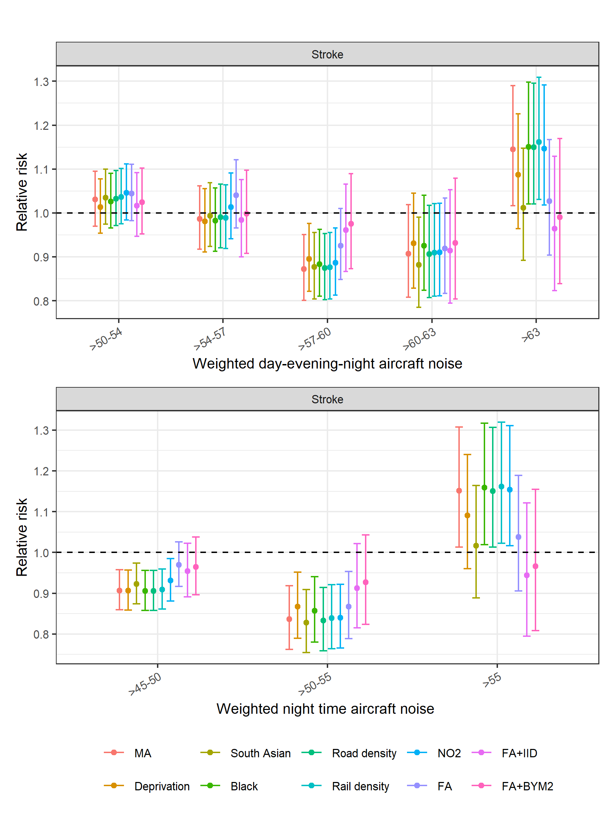

Figure S29. Median relative hospitalisation risk and 95% credible intervals for the association between long-term exposure to annual average population day-evening-night time aircraft noise (Lden) (top panel), annual average population night time aircraft noise (Lnight) (bottom panel) and all cardiovascular disease near other airports during 2006-2015. The results show the minimally adjusted (MA) model (this does not include additional covariates but accounts for temporal trends, age and sex through the expected counts (see (1)-(2) in the Methods section)), models adjusted for one variable at a time and fully adjusted, with (FA+IID or FA+BYM2) and without (FA) random effects.
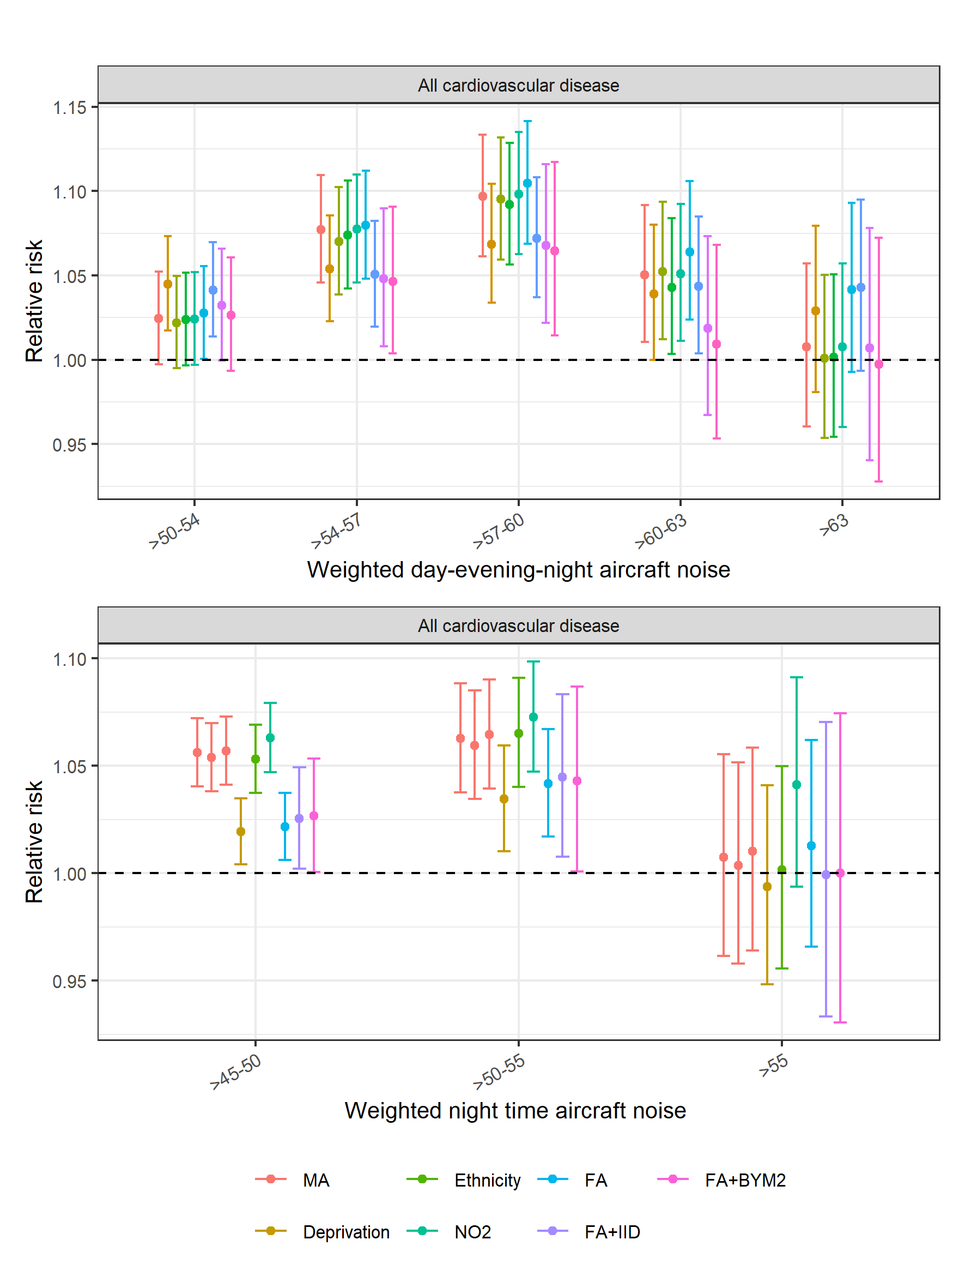

Figure S30. Median relative hospitalisation risk and 95% credible intervals for associations between long-term exposure to annual average population day-evening-night time aircraft noise (Lden) (top panel), annual average population night time aircraft noise (Lnight) (bottom panel) and coronary heart disease near other airports during 2006-2015. The results show the minimally adjusted (MA) model (this does not include additional covariates but accounts for temporal trends, age and sex through the expected counts (see (1)-(2) in the Methods section)), models adjusted for one variable at a time and fully adjusted, with (FA+IID or FA+BYM2) and without (FA) random effects.
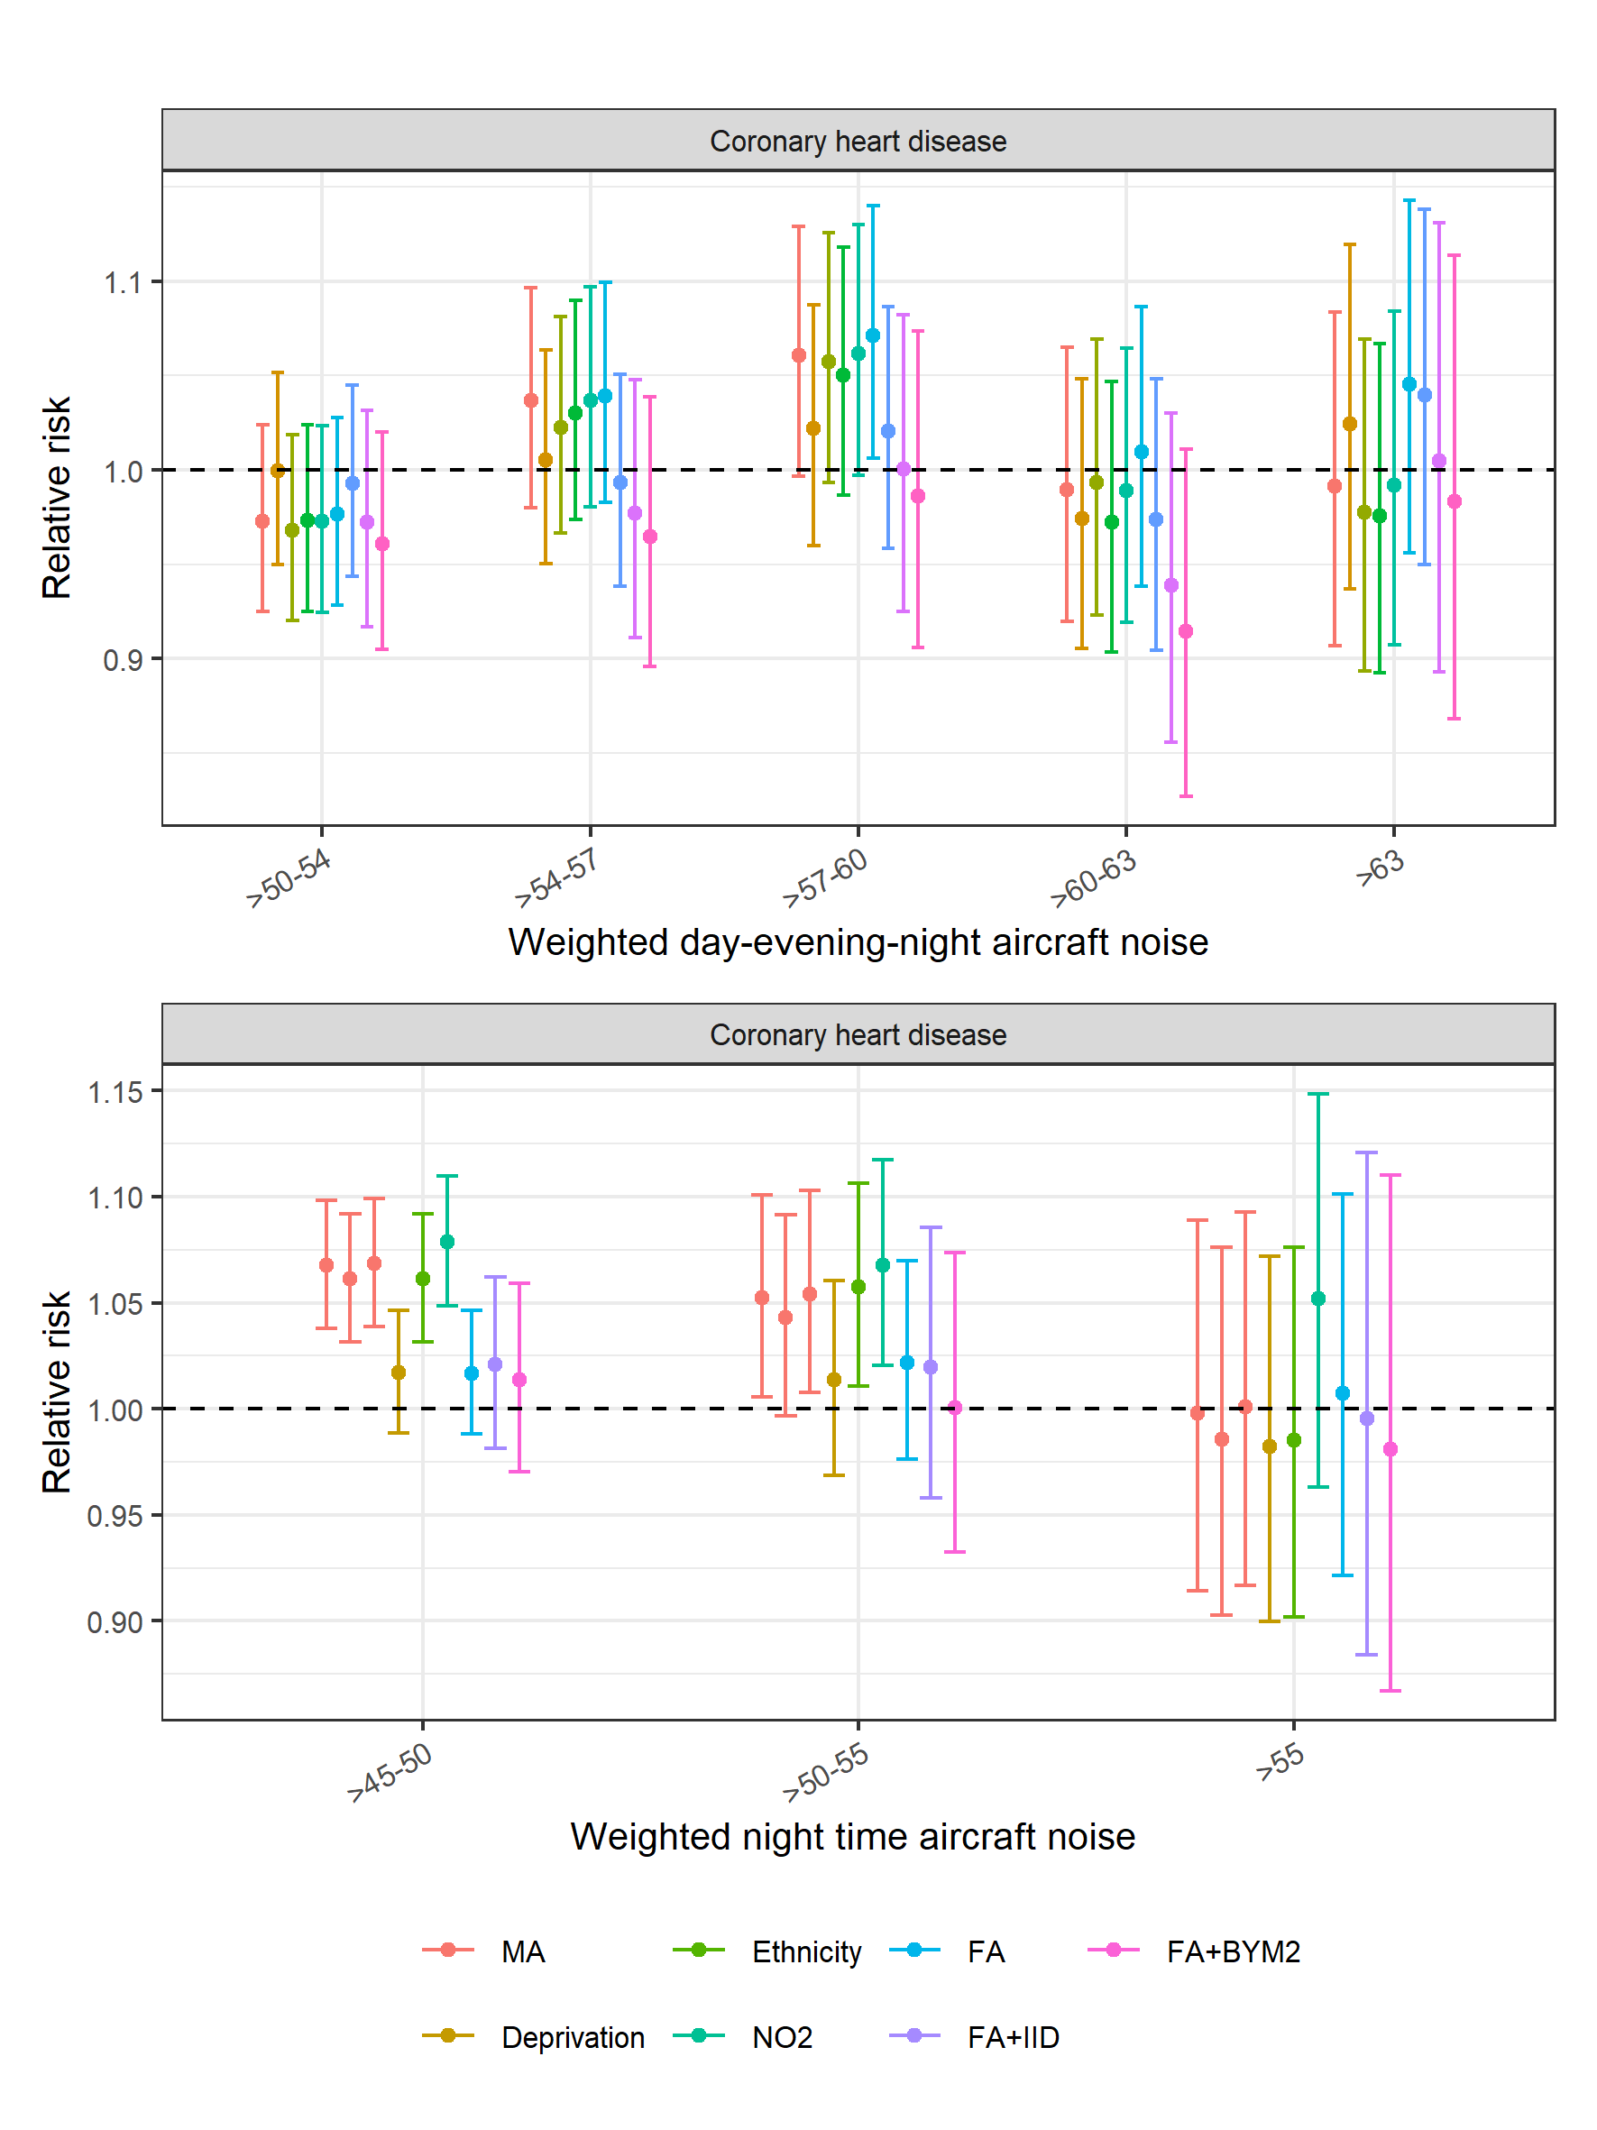

Figure S31. Median relative hospitalisation risk and 95% credible intervals for the association between long-term exposure to annual average population day-evening-night time aircraft noise (Lden) (top panel), annual average population night time aircraft noise (Lnight) (bottom panel) and stroke near other airports during 2006-2015. The results show the minimally adjusted (MA) model (this does not include additional covariates but accounts for temporal trends, age and sex through the expected counts (see (1)-(2) in the Methods section)), models adjusted for one variable at a time and fully adjusted, with (FA+IID or FA+BYM2) and without (FA) random effects.
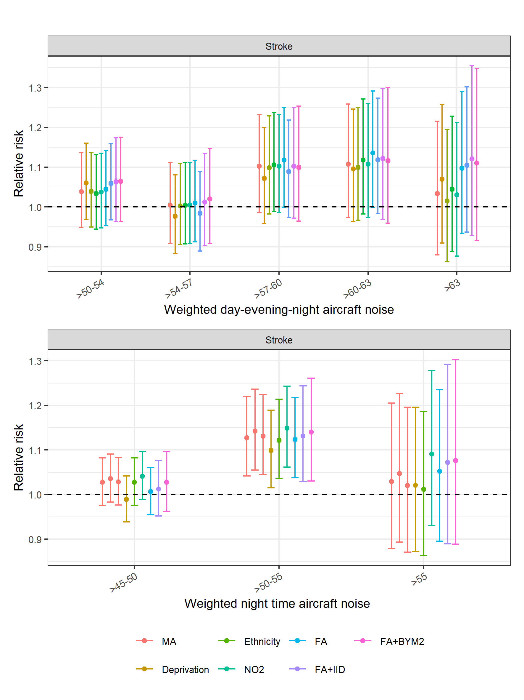

Figure S32. Median relative mortality risk and 95% credible intervals for associations between long-term exposure to annual average population day-evening-night time aircraft noise (Lden) (top panel), annual average population night time aircraft noise (Lnight) (bottom panel) and all cardiovascular disease near other airports during 2006-2015. The results show the minimally adjusted (MA) model (this does not include additional covariates but accounts for temporal trends, age and sex through the expected counts (see (1)-(2) in the Methods section)), models adjusted for one variable at a time and fully adjusted, with (FA+IID or FA+BYM2) and without (FA) random effects.
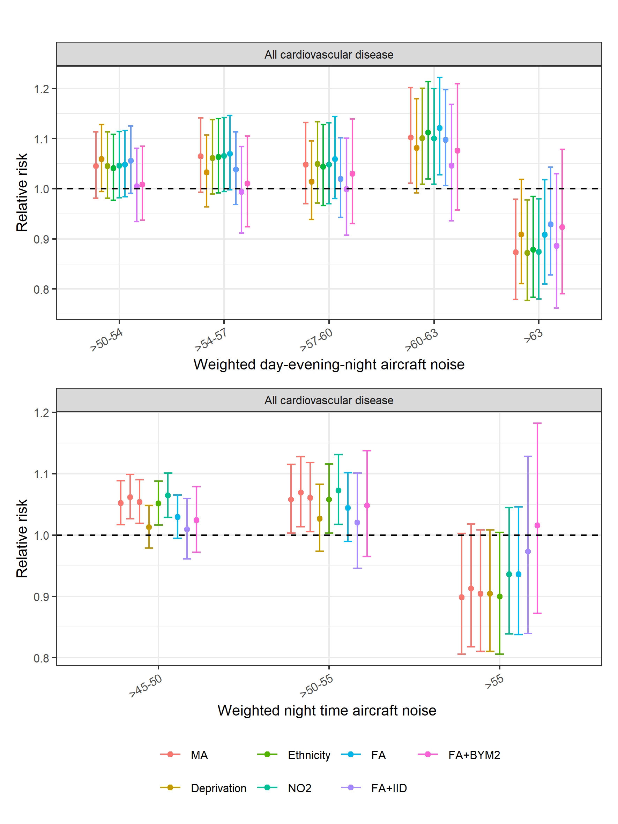

Figure S33. Median relative mortality risk and 95% credible intervals for the association between long-term exposure to annual average population day-evening-night time aircraft noise (Lden) (top panel), annual average population night time aircraft noise (Lnight) (bottom panel) and coronary heart disease near other airports during 2006-2015. The results show the minimally adjusted (MA) model (this does not include additional covariates but accounts for temporal trends, age and sex through the expected counts (see (1)-(2) in the Methods section)), models adjusted for one variable at a time and fully adjusted, with (FA+IID or FA+BYM2) and without (FA) random effects. 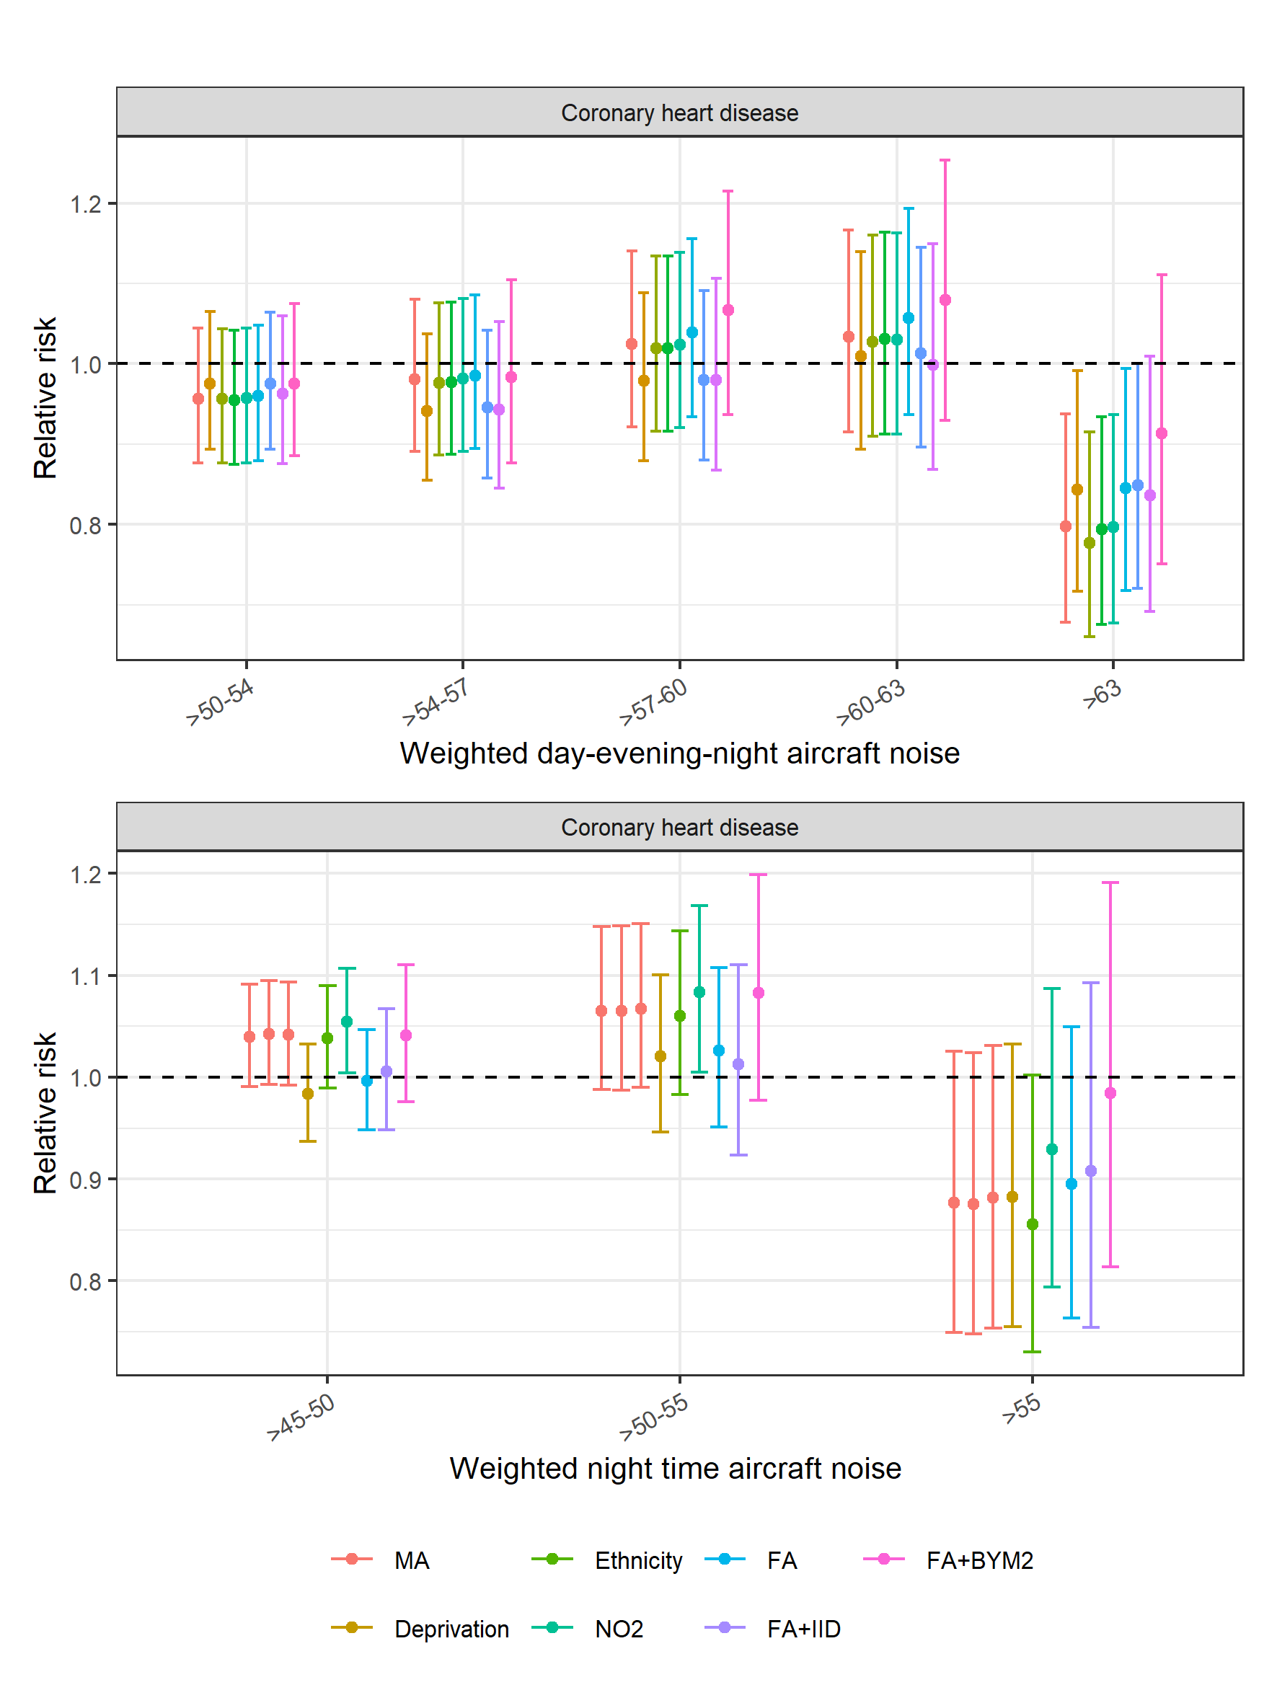

Figure S34. Median relative mortality risk and 95% credible intervals for the association between long-term exposure to annual average population day-evening-night time aircraft noise (Lden) (top panel), annual average population night time aircraft noise (Lnight) (bottom panel) and stroke near other airports during 2006-2015. The results show the minimally adjusted (MA) model (this does not include additional covariates but accounts for temporal trends, age and sex through the expected counts (see (1)-(2) in the Methods section)), models adjusted for one variable at a time and fully adjusted, with (FA+IID or FA+BYM2) and without (FA) random effects.
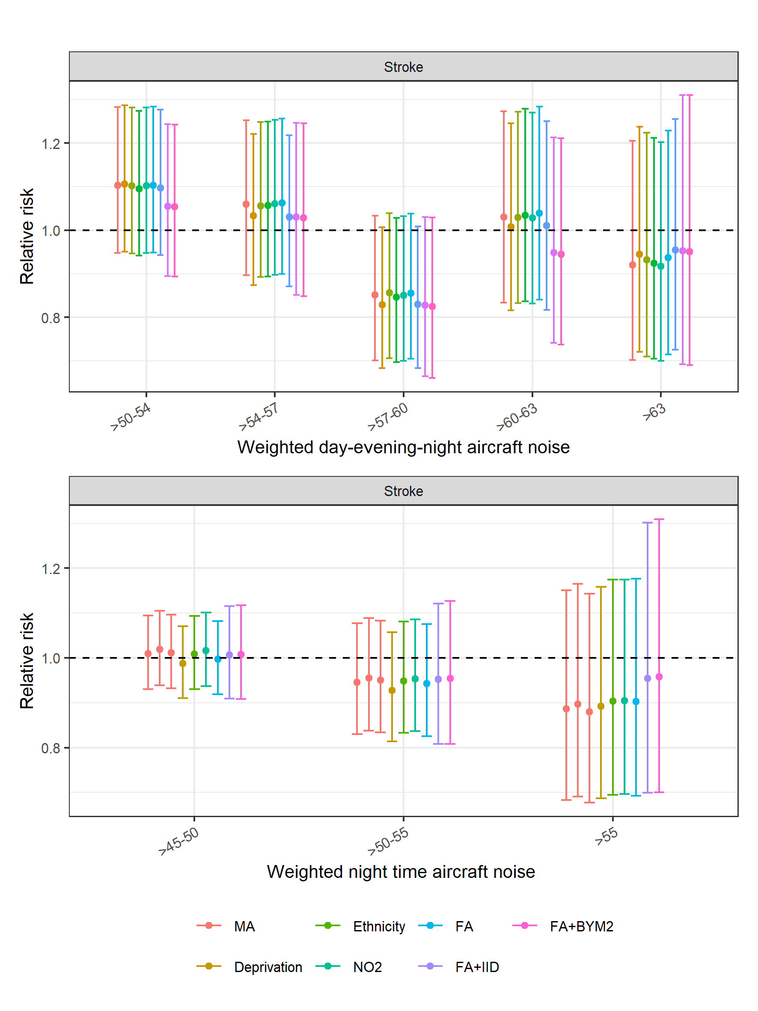

Figure S35. Comparing results using identical categories with previous Heathrow study: Median relative mortality risk and 95% credible intervals for the association between long-term exposure to annual average population day-evening-night time aircraft noise (Lden) (top panel), annual average population night time aircraft noise (Lnight) (bottom panel) and all cardiovascular disease, coronary heart disease and stroke near Heathrow. The minimally adjusted model does not include additional covariates but accounts for temporal trends, age and sex through the expected counts (see (1)-(2) in the Methods section), whereas the fully adjusted model additionally accounts for ethnicity, deprivation, road nose, rail noise, NO₂ exposure and spatial confounding.
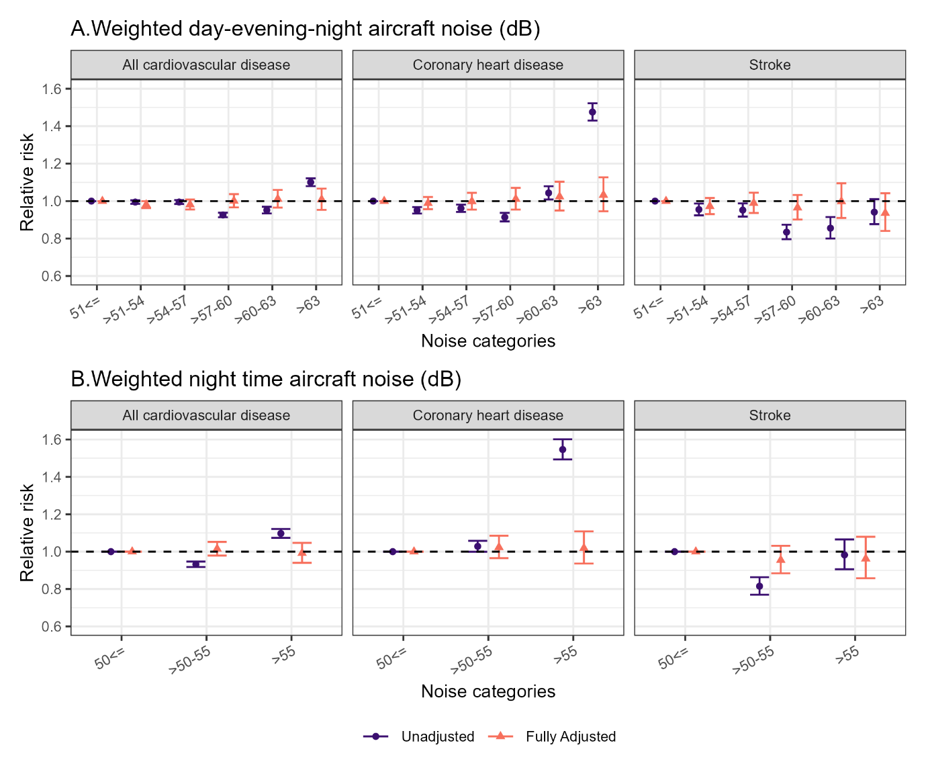

Figure S36. Comparing results using identical categories with previous Heathrow study: Median relative mortality risk and 95% credible intervals for the association between long-term exposure to annual average population day-evening-night time aircraft noise (Lden) (top panel), annual average population night time aircraft noise (Lnight) (bottom panel) and all cardiovascular disease, coronary heart disease and stroke near Heathrow. The minimally adjusted model does not include additional covariates but accounts for temporal trends, age and sex through the expected counts (see (1)-(2) in the Methods section), whereas the fully adjusted model additionally accounts for ethnicity, deprivation, road nose, rail noise, NO₂ exposure and spatial confounding.
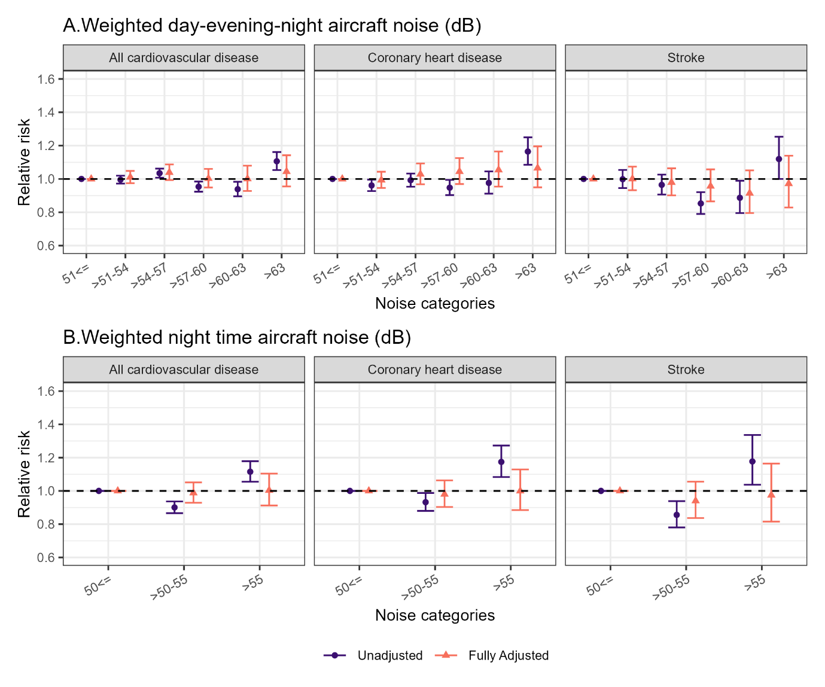

Supplement references
1. Morris R, Carstairs V. Which deprivation? A comparison of selected deprivation indexes. J Public Health Med 1991; 13(4): 318-26.
2. Morley D, De Hoogh K, Fecht D, et al. International scale implementation of the CNOSSOS-EU road traffic noise prediction model for epidemiological studies. Environmental pollution 2015; 206: 332-41.
3. Gulliver J, de Hoogh K, Hansell A, Vienneau D. Development and back-extrapolation of NO2 land use regression models for historic exposure assessment in Great Britain. Environ Sci Technol 2013; 47(14): 7804-11.
4. Besag J, York J, Mollié A. Bayesian image restoration, with two applications in spatial statistics. Annals of the institute of statistical mathematics 1991; 43: 1-20.
5. Riebler A, Sørbye SH, Simpson D, Rue H. An intuitive Bayesian spatial model for disease mapping that accounts for scaling. Statistical methods in medical research 2016; 25(4): 1145-65.
6. Simpson D, Rue H, Riebler A, Martins TG, Sørbye SH. Penalising model component complexity: A principled, practical approach to constructing priors. 2017.

