Supplementary Material. Measurement error in air pollution epidemiology: The performance of surrogate methods for individualised exposure assessment and the exposure error determinants.
Table of Contents
Section A. Personal and surrogate exposure assessment methodology 2
Monthly variability of infiltration efficiencies and total personal exposure 2
Prediction of annual personal exposures to pollution from outdoor sources 2
LTDS data and LHEM adjustment factor calculation 3
Comparison of predicted annual personal exposure from outdoor sources with surrogate measures 5
Total personal exposure and surrogate measures 5
Section B. Correlation coefficients and scatter plots between assigned personal exposure from outdoor sources and surrogate exposure in each personal monitoring campaign. 6
Section C. Error determinants analysis effect estimates 39

Section A. Personal and surrogate exposure assessment methodology

Monthly variability of infiltration efficiencies and total personal exposure

Figure A1. Seasonal variation in daily mean household infiltration factors and concentrations of personal exposure to air pollution from outdoor sources in COPE participants during the measurement period.
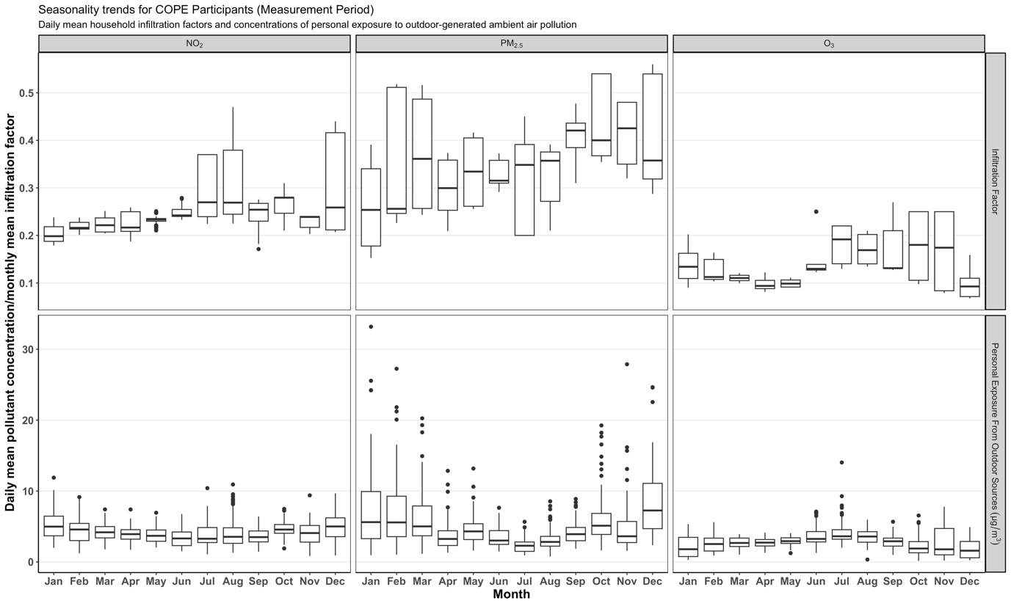

Prediction of annual personal exposures to pollution from outdoor sources
For the prediction of annual personal exposure from outdoor sources, we estimated annual levels for a full year from the measurement start date of each participant. The annual extrapolation was based on ambient air pollution data, infiltration efficiencies and mobility behaviour, and required two main assumptions: (1) that the infiltration efficiencies estimated for the personal exposure campaigns remain similar across the year and (2) that the mobility behaviour of the participants during the measurement period was the typical time-activity across the year. Hourly ambient air pollution concentrations were collected from reference monitors of the London Air Quality Network (www.londonair.org.uk) which were matched to the participants’ residential addresses. The matching process assigned a monitor of the dense London network that is close to each participant’s residence and has similar pollution levels and is fully described in Zhang et al. 2025. Participant-specific infiltration efficiencies were defined as the equilibrium fraction of air that infiltrates indoors and remains suspended, according to our previous publication (Zhang et al. 2025). We used the COPE dataset which provided data across the whole year to check the assumption of little variation of infiltration efficiencies. Monthly infiltration efficiencies are provided in Figure A1 above.
For people’s mobility, we did not use the same behaviour pattern as those observed during the measurement period, as this would result in no variation in time-activity patterns between measurement and extrapolation period. Instead, we utilised a random forest behaviour prediction model to predict whether a person was likely to be ‘at home’ or ‘not at home’ using the day of the week and hour of the day as inputs. More specifically, we used the measurement period dataset and divided it into training and test sets with a ratio of 7:3. To account for the imbalanced distribution of our measurement period mobility data (e.g. >90% ‘at home’ for COPE), we applied a Synthetic Minority Over-sampling Technique (SMOTE) and adjusted the predicted annual mobility output to match the overall time spent indoors and outdoors during the measurement period. SMOTE was only applied to COPE and PASTA participants, as DEMIST and BLW participants had more balanced distributions. For BLW, we took into account the school term and non-term dates and adjusted the time-activity of the schoolchildren based on previously published child time use surveys. We combined hourly matched monitor measurements, estimated monthly infiltration efficiencies and hourly mobility predictions and aggregated at annual level to estimate predicted annual personal exposure to pollution from outdoor sources. Personal measurements were not available throughout the year, so we could not validate our predictions, but a comparison of our annual predictions with the measurement period personal exposures (including COPE which had an average follow-up of 144 days per participant) was made (see Table 1 in main text).

LTDS data and LHEM adjustment factor calculation
In the present analysis, we estimated the participants’ exposure to outdoor air pollution by accounting for typical time-activity patterns by age group and area of residence. We used the London Hybrid Exposure Model (LHEM) and incorporated data from the London Travel Demand Survey (LTDS; https://tfl.gov.uk/corporate/privacy-and-cookies/travel-surveys), which includes 69,673 individuals across the years 2005-2010, ascertaining details of each person’s daily trips, travel mode, trip purpose and demographic data. These individuals are a representative sample of London inhabitants but do not overlap with the individuals in the exposure measurement campaigns of this study, i.e. COPE, BLW, PASTA and DEMIST. We estimated the ratio between the static PM_{2.5} and NO₂ modelled concentrations from CMAQ-urban (2011) at the residential address of LTDS participants and their LHEM personal exposure accounting for time-activity and microenvironments:

${Ratio}_{i}=\frac{LHEM Adjusted Concentrations_{i}}{Residential Pollutant Concentrations_{i}}$, Individuals i = 1 …, 69,673.

These ratios were averaged spatially and by age group to produce postcode sector- (i.e. 220 postcodes per postcode sector on average) and age-specific adjustment factors (AFs):

$AF_{jk}=\overline{Ratio_{i}}$, for each postcode sector j = 1, …, 1,445, Age group k = 1, …, 4
The mean numbers of LTDS participants residing in represented postcode sectors (1,054 postcode sectors in total) were 14.0, 32.9, 11.7 and 11.0 for age groups 5-18, 19-49, 50-64 and 65+, respectively. We hypothesised that individuals of the same age group, living in the same postcode sector, exhibit similar time-activity patterns based on data from UK surveys (https://www.ons.gov.uk/peoplepopulationandcommunity/personalandhouseholdfinances/incomeandwealth/bulletins/timeuseintheuk/march2023). Thus, we used the LTDS AFs to estimate the exposure of each individual in the measurement campaigns adjusting for their hypothesised time-activity patterns. These AFs were applied to the nearest monitor measurements and the STEAM modelled PM_{2.5} and NO₂ concentrations described in the main text. The total number and mean age of LTDS participants per age group included in AF calculation, as well as the mean number of individuals per represented postcode sector and mean calculated AFs per age group are provided in Tables A1-A3.
Table A1. Total number and mean age of LTDS participants (by age group) included in the calculation of LHEM adjustment factors.

 | LTDS age group
 | 5-18 | 19-49 | 50-64 | 65+
LHEM participants (n) | 13,332 | 34,128 | 11,564 | 10,649
Mean age (years) | 11.4 | 34.2 | 56.7 | 74.7

Table A2. Mean number of LTDS individuals per London postcode sector (n = 1,054 postcode sectors within which at least one LTDS participant resided) by age group.

LTDS age group | Mean number of participants per London postcode sector
5-18 | 14.0
19-49 | 32.9
50-64 | 11.7
65+ | 11.0

Table A3. Mean LHEM adjustment factors per LTDS age group, per pollutant.

 | LTDS age group
 | 5-18 | 19-49 | 50-64 | 65+
NO₂ | 0.356 | 0.390 | 0.386 | 0.358
PM₁₀ | 0.312 | 0.373 | 0.339 | 0.305
PM_{2.5} | 0.609 | 0.644 | 0.627 | 0.607

Comparison of predicted annual personal exposure from outdoor sources with surrogate measures
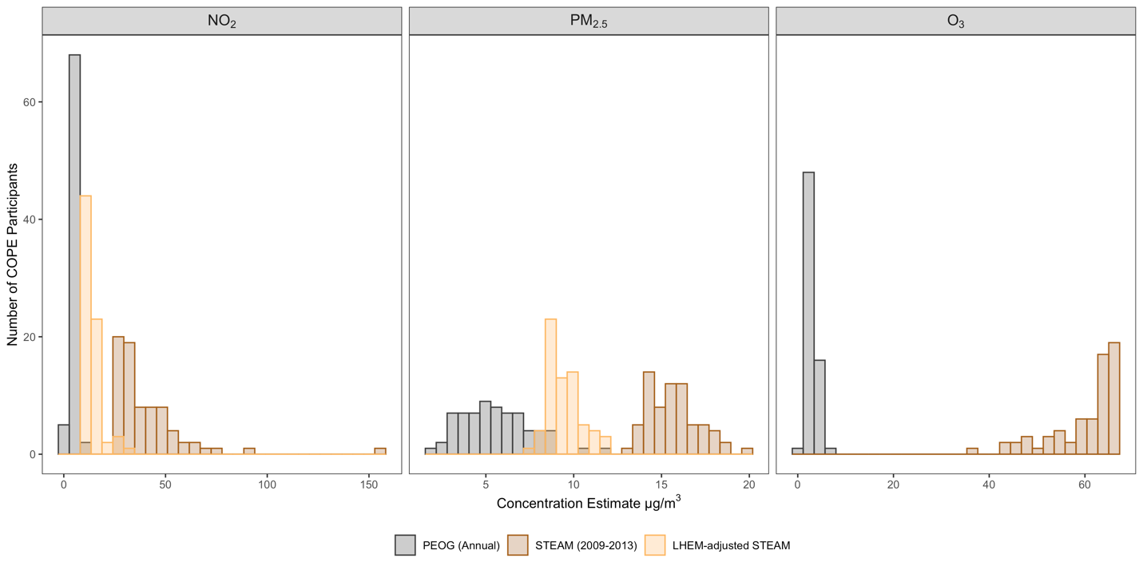
Figure A2. Frequency distributions of predicted annual personal exposure from outdoor sources and STEAM modelled ambient concentrations and the corresponding LHEM-adjusted exposure estimates for COPE participants for NO₂, PM_{2.5} and O₃.

Total personal exposure and surrogate measures

Table A4. Spearman correlation coefficients between measured total personal exposure during the measurement period and assigned surrogate concentration estimates in four exposure measurement campaigns (COPE, BLW, PASTA and DEMIST).

Surrogate exposure | NO₂ | PM_{2.5} |  | O₃ | BC
Surrogate exposure | COPE | COPE | BLW | COPE | PASTA | DEMIST
Nearest monitor (annual) | 0.06 | 0.10 | 0.29 | -0.07 | 0.02 | -0.21
STEAM (2009-13) for NO2, PM2.5 and O3 / ELASPE (2010) for BC | 0.18 | 0.03 | 0.00 | -0.09 | -0.24 | -0.19
Temporally aligned STEAM / ELAPSE (2015-19) | 0.19 | 0.04 | -0.13 | 0.09 | -0.12 | 0.02
LHEM-adjusted STEAM (2009-13) | 0.14 | -0.11 | -0.29 | - | - | -

Section B. Correlation coefficients and scatter plots between assigned personal exposure from outdoor sources and surrogate exposure in each personal monitoring campaign.

Table B1. Spearman correlations between estimated (measurement period) or predicted (annually) personal exposures to NO₂ from outdoor sources assigned to COPE participants (n = 75) during the measurement period, during the measurement period only at times the subject is indoors and annually (for all times and only when subject is indoors).

 | Personal from outdoors (annually predicted) | Personal from outdoors (measurement period) | Personal from outdoors when subject indoors (measurement period) | Personal from outdoors when subject indoors (annually predicted)
Personal from outdoors (annually predicted) | 1
Personal from outdoors (measurement period) | 0.89 | 1
Personal from outdoors when subject indoors (measurement period) | 0.85 | 0.92 | 1
Personal from outdoors when subject indoors (annually predicted) | 0.92 | 0.79 | 0.89 | 1

Figure B1. Scatterplots and Pearson correlation coefficients for estimated (measurement period) or predicted (annually) personal exposures of NO₂ (μg/m³) from outdoor sources assigned to COPE participants (n = 75) during the measurement period, during the measurement period only at times the subject is indoors and annually (for all times and only when subject is indoors).

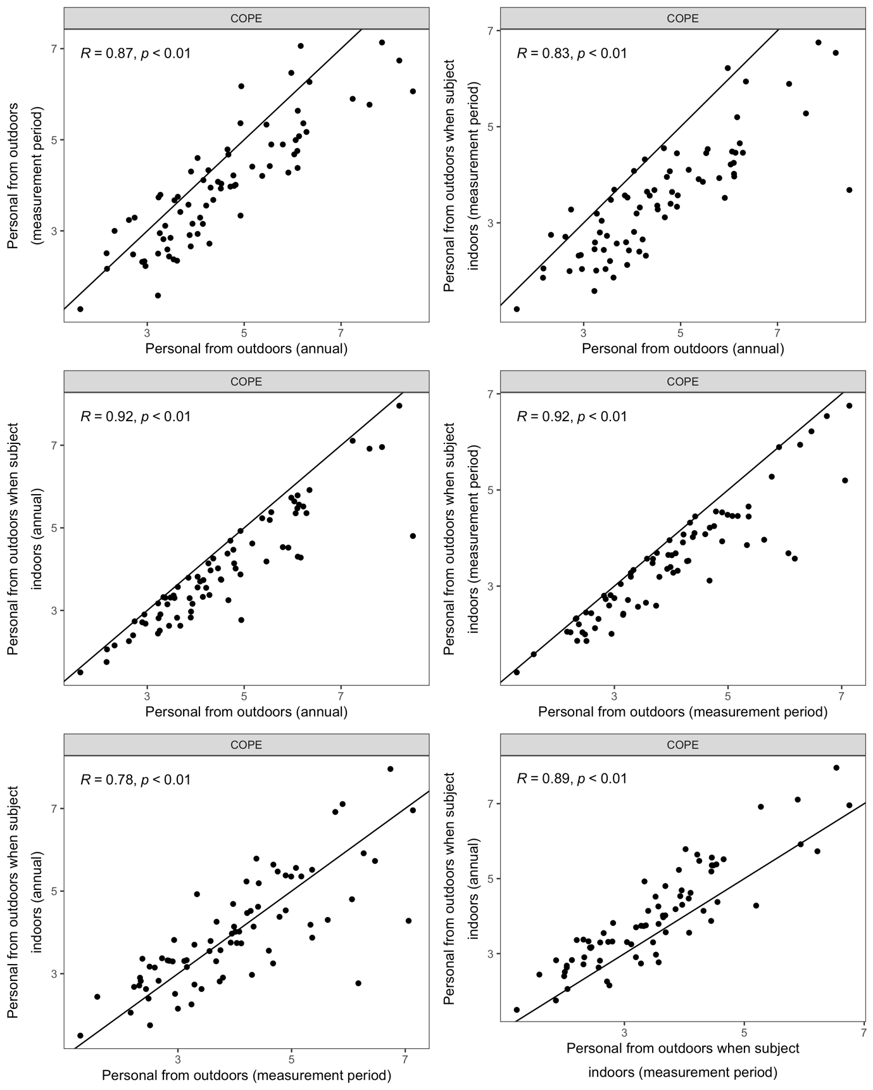

Table B2. Spearman correlations between estimated (measurement period) or predicted (annually) personal exposures to NO₂ from outdoor sources and selected surrogate measures assigned to COPE participants (n = 72 – 75).

 | Personal from outdoors (annually predicted) |  | Personal from outdoors (measurement period) |  | Personal from outdoors when subject indoors (measurement period) |  | Personal from outdoors when subject indoors (annually predicted)
Annual
Nearest monitor for the year after the 1st day of field work | 0.11 |  | 0.10 |  | 0.11 |  | 0.10
Postcode level STEAM estimate | 0.20 |  | 0.23 |  | 0.38 |  | 0.35
Nearest monitor as above adjusted by LHEM | 0.10 |  | 0.05 |  | 0.03 |  | 0.05
STEAM as above adjusted by LHEM | 0.20 |  | 0.21 |  | 0.31 |  | 0.28
STEAM as above scaled by nearest monitor changes between 2009-13 and 2015-19 | 0.21 |  | 0.25 |  | 0.38 |  | 0.35
Measurement Period
Nearest monitor | 0.12 |  | 0.28 |  | 0.27 |  | 0.11
Nearest monitor as above adjusted by LHEM | 0.08 |  | 0.20 |  | 0.17 |  | 0.03

Figure B2. Scatterplots and Pearson correlation coefficients for annually predicted personal exposures of NO₂ (μg/m³) from outdoor sources and selected surrogate measures assigned to COPE participants (n = 72 – 75).

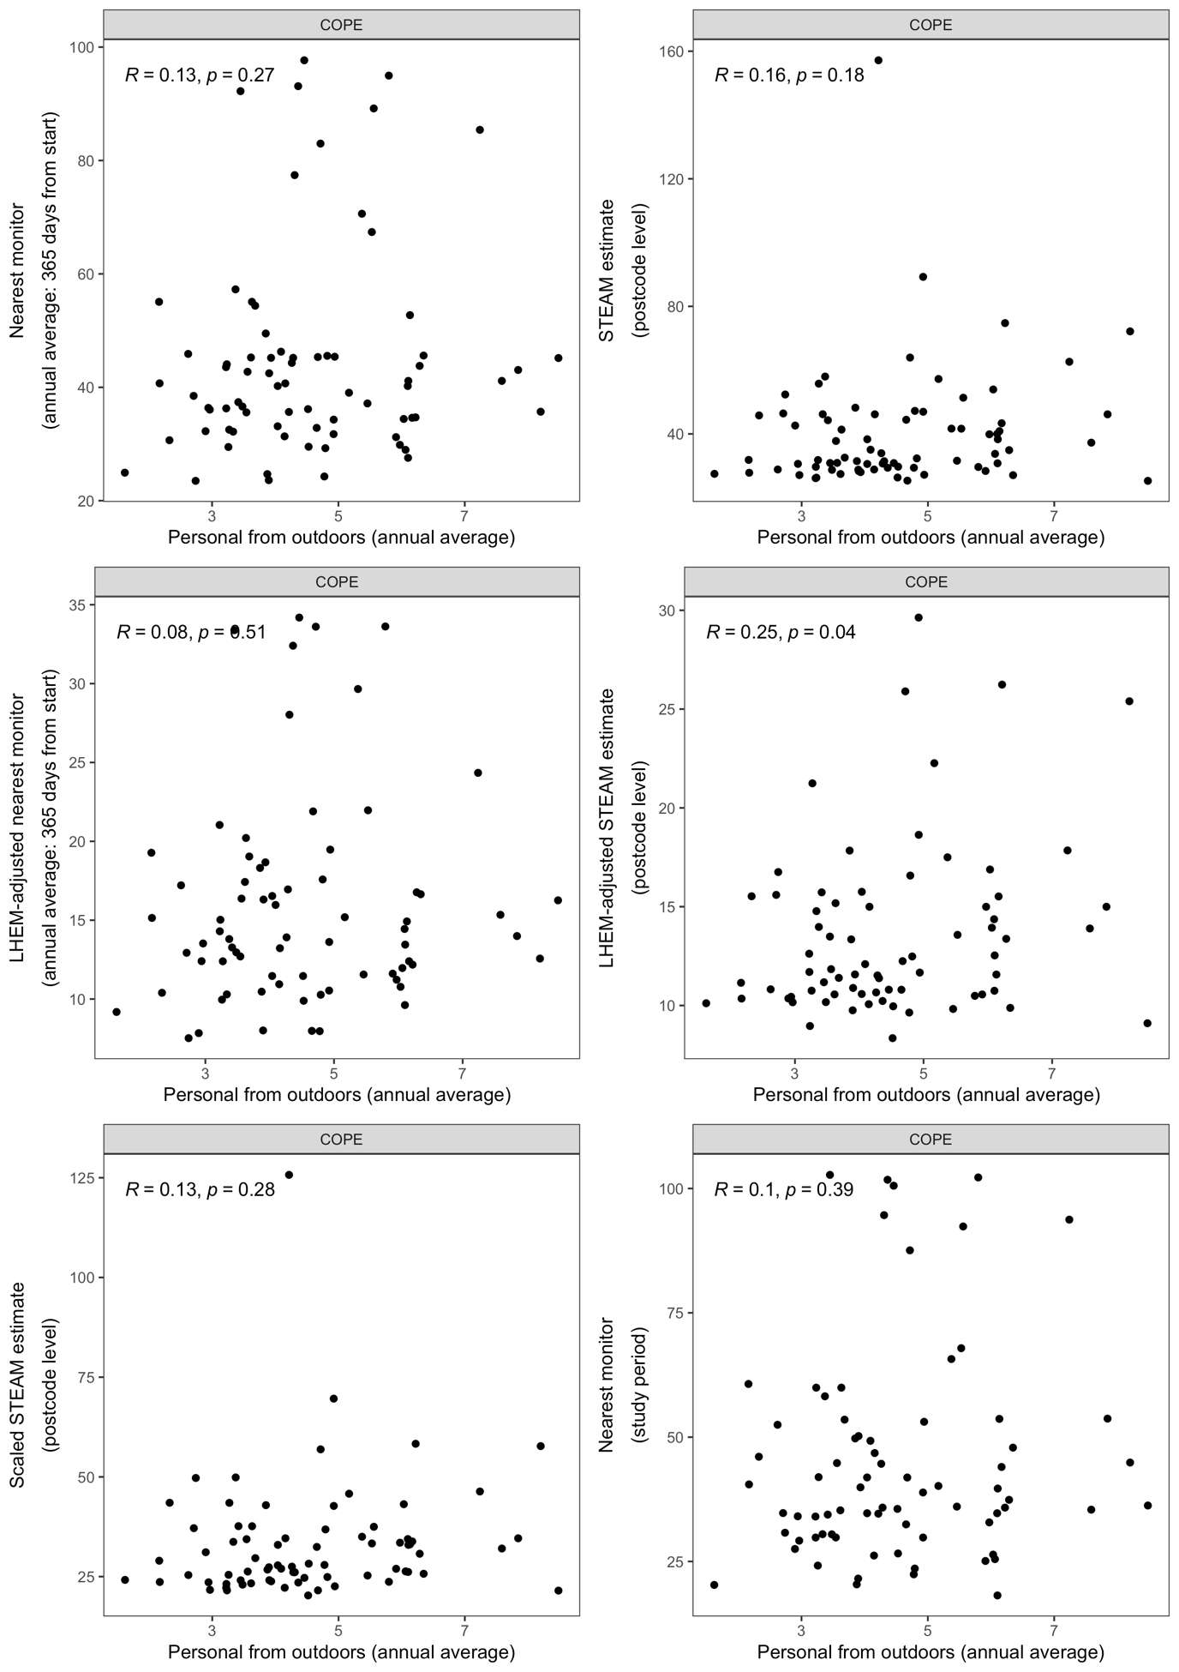
Figure B3. Scatterplots and Pearson correlation coefficients for estimated personal exposures of NO₂ (μg/m³) from outdoor sources for the measurement period and selected surrogate measures assigned to COPE participants (n = 72 – 75).

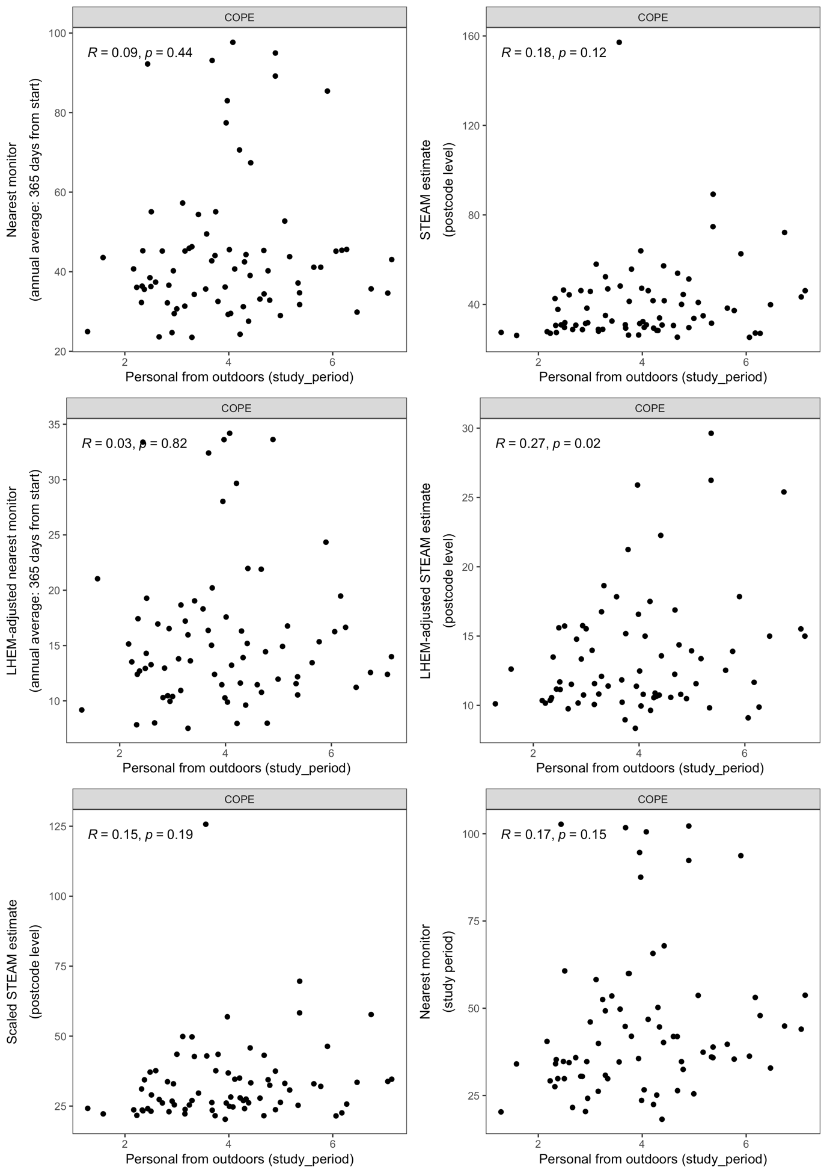
Figure B4. Scatterplots and Pearson correlation coefficients for estimated personal exposures of NO₂ (μg/m³) from outdoor sources for the measurement period (when the subject was indoors) and selected surrogate measures assigned to COPE participants (n = 72 – 75).

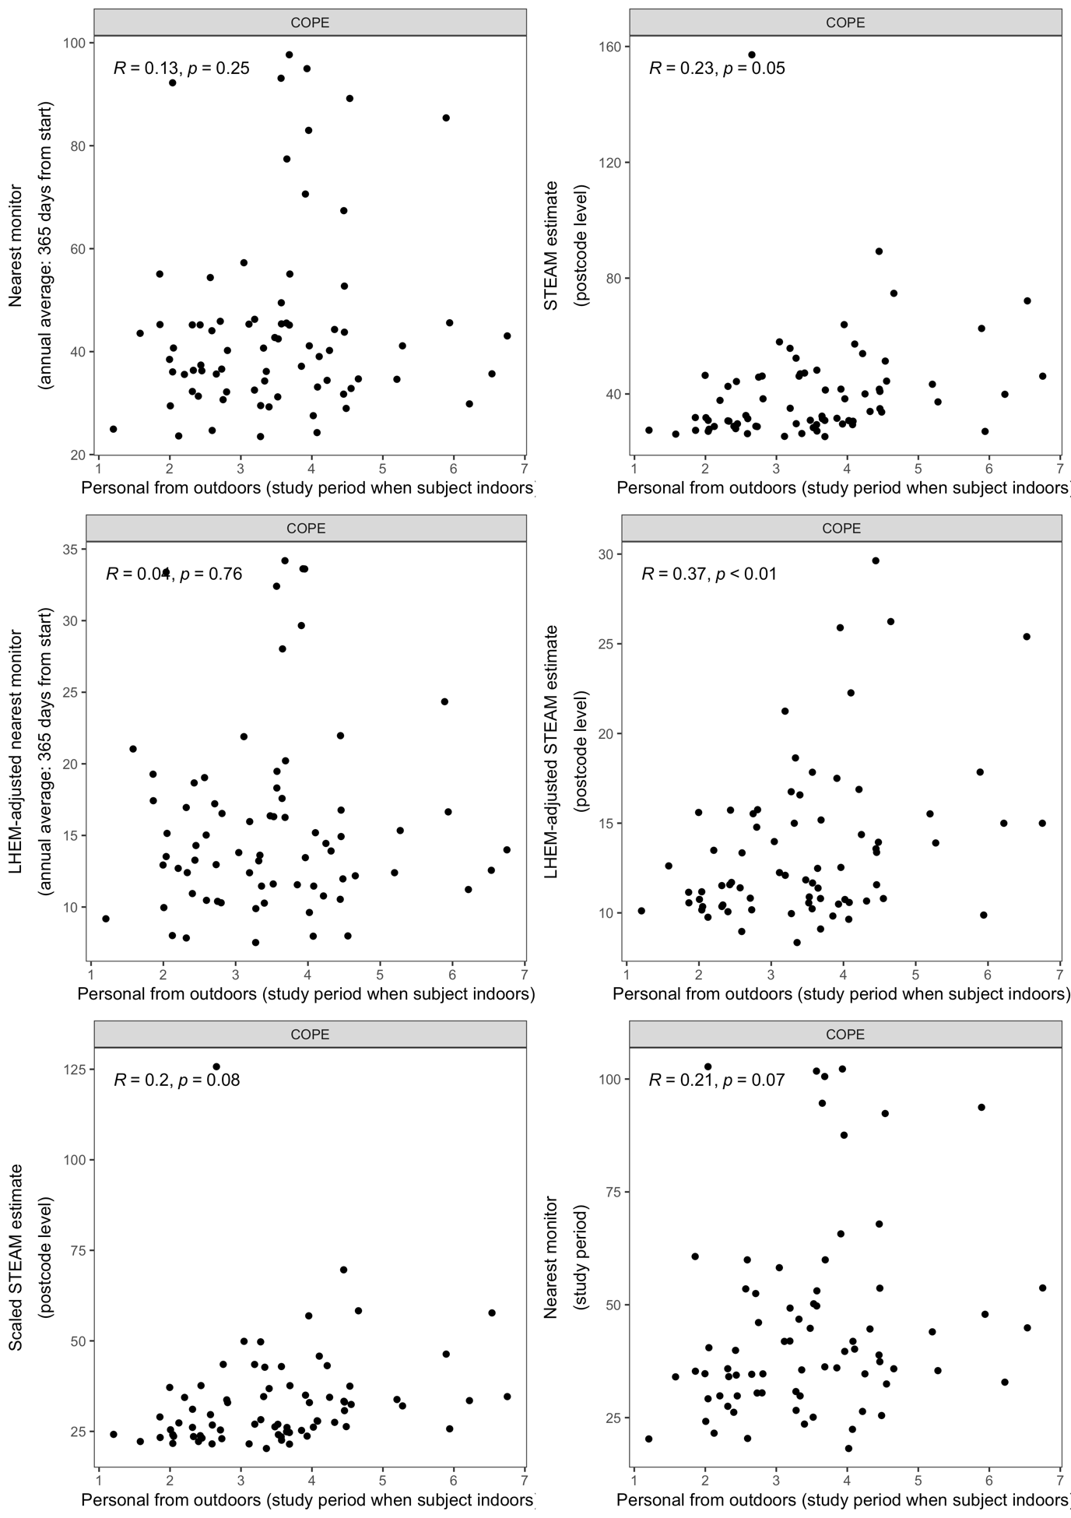
Figure B5. Scatterplots and Pearson correlation coefficients for annually predicted personal exposures of NO₂ (μg/m³) from outdoor sources (when the subject was indoors) and selected surrogate measures assigned to COPE participants (n = 72 – 75).

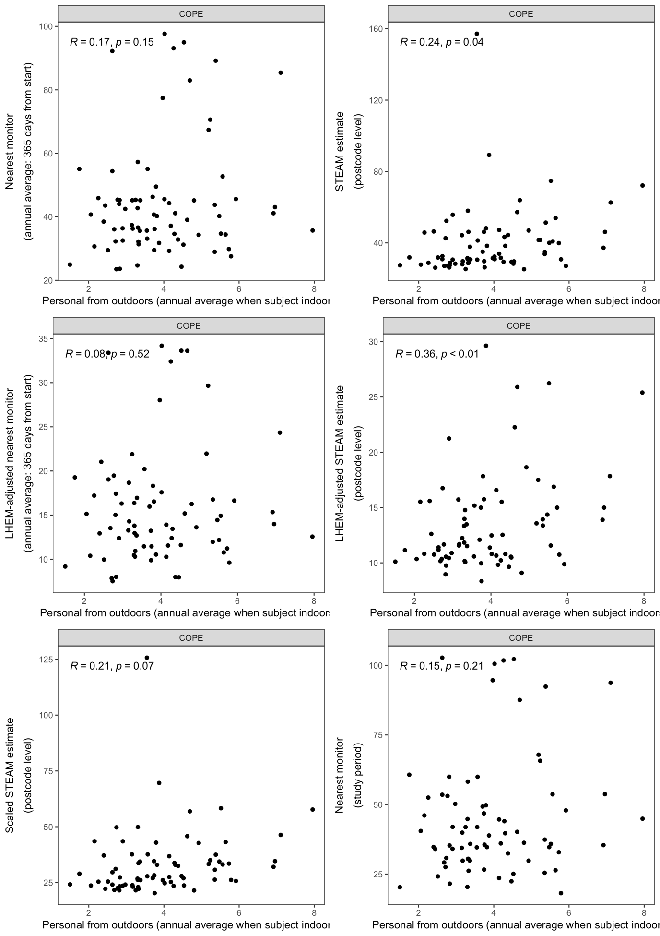
Table B3. Spearman correlations between selected surrogate measures of NO₂ assigned to COPE participants (n = 72 – 75).

 | Nearest monitor |  | Postcode level STEAM estimate |  | Nearest monitor as above adjusted by LHEM |  | STEAM as above adjusted by LHEM |  |  | STEAM scaled |  |  | Nearest monitor |  | Nearest monitor adjusted by LHEM
Annual
Nearest monitor | 1
Postcode level STEAM estimate | -0.07 |  | 1
Nearest monitor as above adjusted by LHEM | 0.93 |  | -0.17 |  | 1
STEAM as above adjusted by LHEM | 0.02 |  | 0.83 |  | 0.09 |  | 1
STEAM scaled | -0.13 |  | 0.94 |  | -0.21 |  | 0.81 |  | 1
Measurement Period
Nearest monitor | 0.87 |  | 0.12 |  | 0.77 |  | 0.15 |  | 0.08 |  |  | 1
Nearest monitor adjusted by LHEM | 0.86 |  | -0.01 |  | 0.88 |  | 0.20 |  | -0.02 |  |  | 0.94 |  | 1

Table B4. Spearman correlations between estimated (measurement period) or predicted (annually) personal exposures to PM_{2.5} from outdoor sources during the measurement period, during the measurement period only at times the subject is indoors and annually (for all times and only when subject is indoors). Assigned to COPE (n = 69) and BLW (n = 162) participants.

 | Personal from outdoors (annually predicted) | Personal from outdoors (measurement period) |  | Personal from outdoors when subject indoors (measurement period) |  | Personal from outdoors when subject indoors (annually predicted)
Personal from outdoors (annually predicted) | 1
Personal from outdoors (measurement period) | 0.87 / 0.35 | 1
Personal from outdoors when subject indoors (measurement period) | 0.75 / 0.37 | 0.89 / 0.84 |  | 1
Personal from outdoors when subject indoors (annually predicted) | 0.83 / 0.85 | 0.76 / 0.19 |  | 0.89 / 0.39 |  | 1

Figure B6. Scatterplots and Pearson correlation coefficients for estimated (measurement period) or predicted (annually) personal exposures of PM_{2.5} (μg/m³) from outdoor sources during the measurement period, during the measurement period only at times the subject is indoors and annually (for all times and only when subject is indoors). Assigned to COPE (n = 69) and BLW (n= 162) participants.

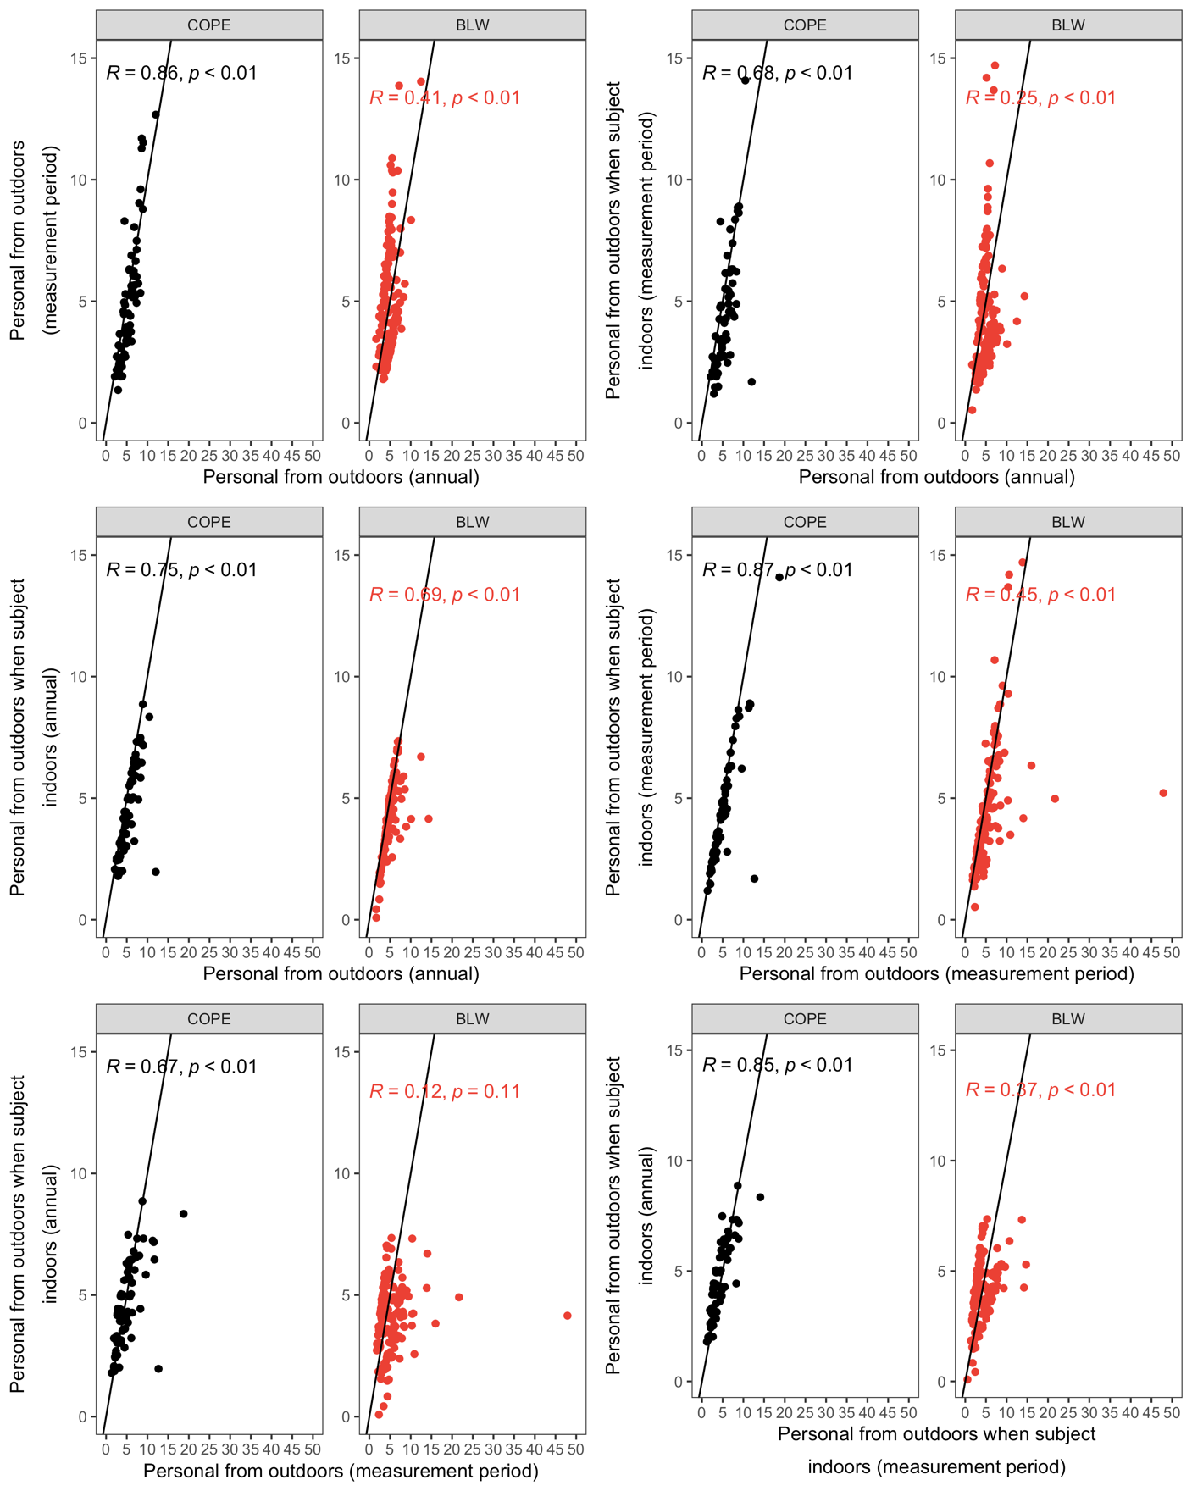

Table B5. Spearman correlations between estimated (measurement period) or predicted (annually) personal exposures to PM_{2.5} from outdoor sources and selected surrogate measures. Assigned to COPE (n = 67 – 69) and BLW (n = 161 – 162) participants.

 | Personal from outdoors (annually predicted) |  | Personal from outdoors (measurement period) |  | Personal from outdoors when subject indoors (measurement period) |  | Personal from outdoors when subject indoors (annually predicted)
Annual
Nearest monitor for the year after the 1st day of field work | 0.05 / -0.07 |  | 0.05 / 0.40 |  | -0.01 / 0.45 |  | -0.02 / -0.09
Postcode level STEAM estimate | 0.09 / -0.11 |  | 0.01 / 0.00 |  | 0.00 / -0.07 |  | 0.02 / -0.09
Nearest monitor as above adjusted by LHEM | 0.02 / -0.08 |  | 0.00 / 0.37 |  | -0.04 / 0.45 |  | -0.04 / -0.11
STEAM as above adjusted by LHEM | 0.04 / -0.02 |  | -0.06 / -0.24 |  | -0.06 / -0.25 |  | -0.02 / -0.08
STEAM as above scaled by nearest monitor changes between 2009-13 and 2015-19 | 0.00 / -0.07 |  | 0.02 / -0.16 |  | 0.05 / -0.23 |  | -0.02 / -0.08
Measurement Period
Nearest monitor | 0.11 / -0.28 |  | 0.36 / 0.68 |  | 0.30 / 0.59 |  | 0.06 / -0.28
Nearest monitor as above adjusted by LHEM | 0.10 / -0.28 |  | 0.36 / 0.66 |  | 0.30 / 0.57 |  | 0.05 / -0.29

Figure B7. Scatterplots and Pearson correlation coefficients for annually predicted personal exposures of PM_{2.5} (μg/m³) from outdoor sources and selected surrogate measures. Assigned to COPE (n = 67 – 69) and BLW (n = 161 – 162) participants.

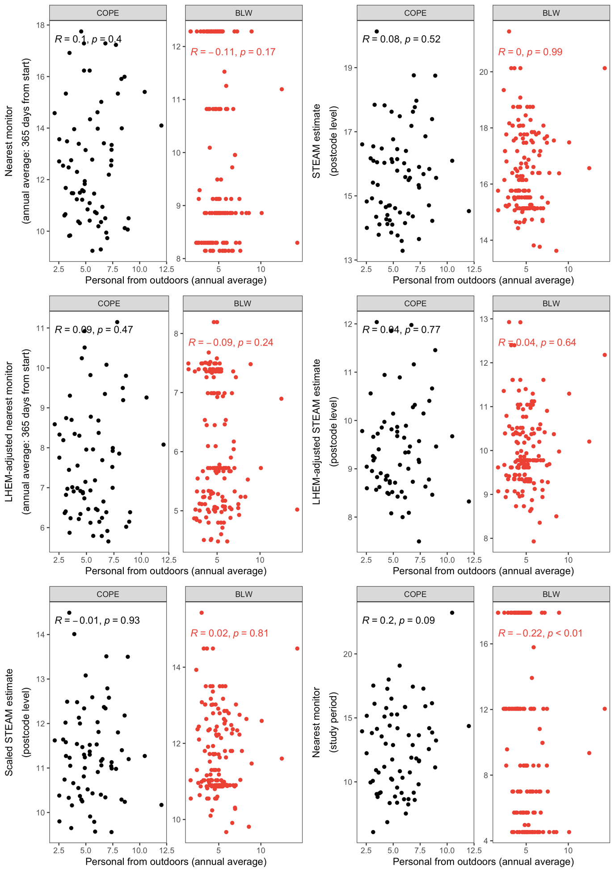
Figure B8. Scatterplots and Pearson correlation coefficients for estimated personal exposures of PM_{2.5} (μg/m³) from outdoor sources for the measurement period and selected surrogate measures. Assigned to COPE (n = 67 – 69) and BLW (n = 161 – 162) participants.

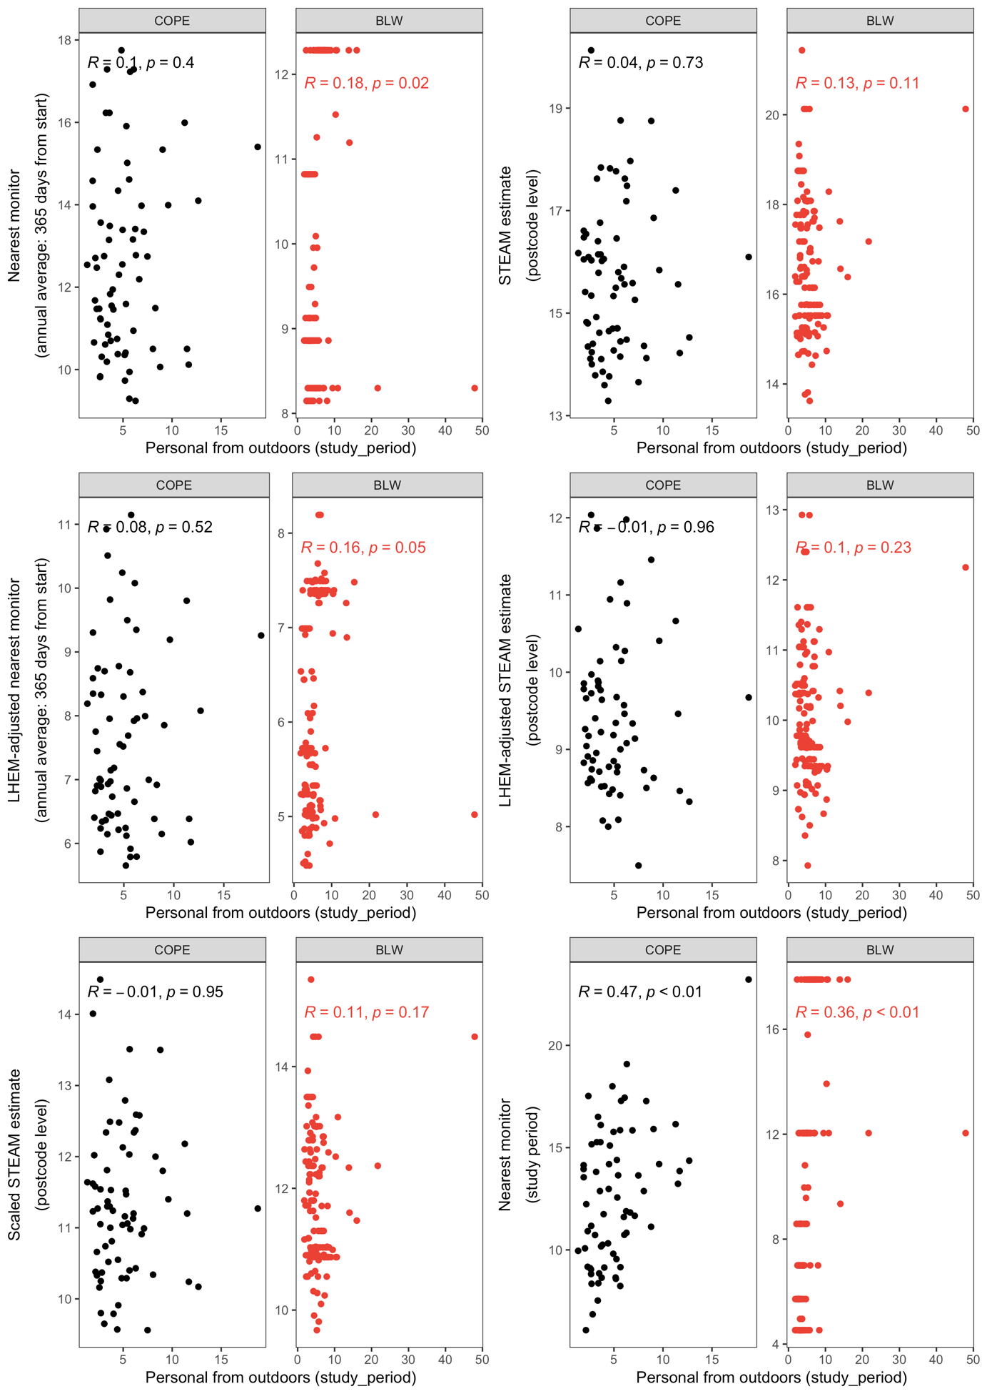
Figure B9. Scatterplots and Pearson correlation coefficients for estimated personal exposures of PM_{2.5} (μg/m³) from outdoor sources for the measurement period (when the subject was indoors) and selected surrogate measures. Assigned to COPE (n = 67 – 69) and BLW (n = 161 – 162) participants.

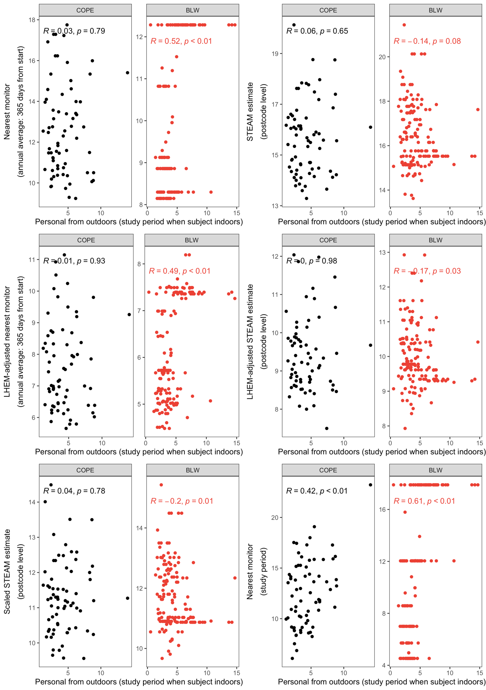
Figure B10. Scatterplots and Pearson correlation coefficients for predicted personal exposures of PM_{2.5} (μg/m³) from outdoor sources (annual average when the subject was indoors) and selected surrogate measures. Assigned to COPE (n = 67 – 69) and BLW (n = 161 – 162) participants.

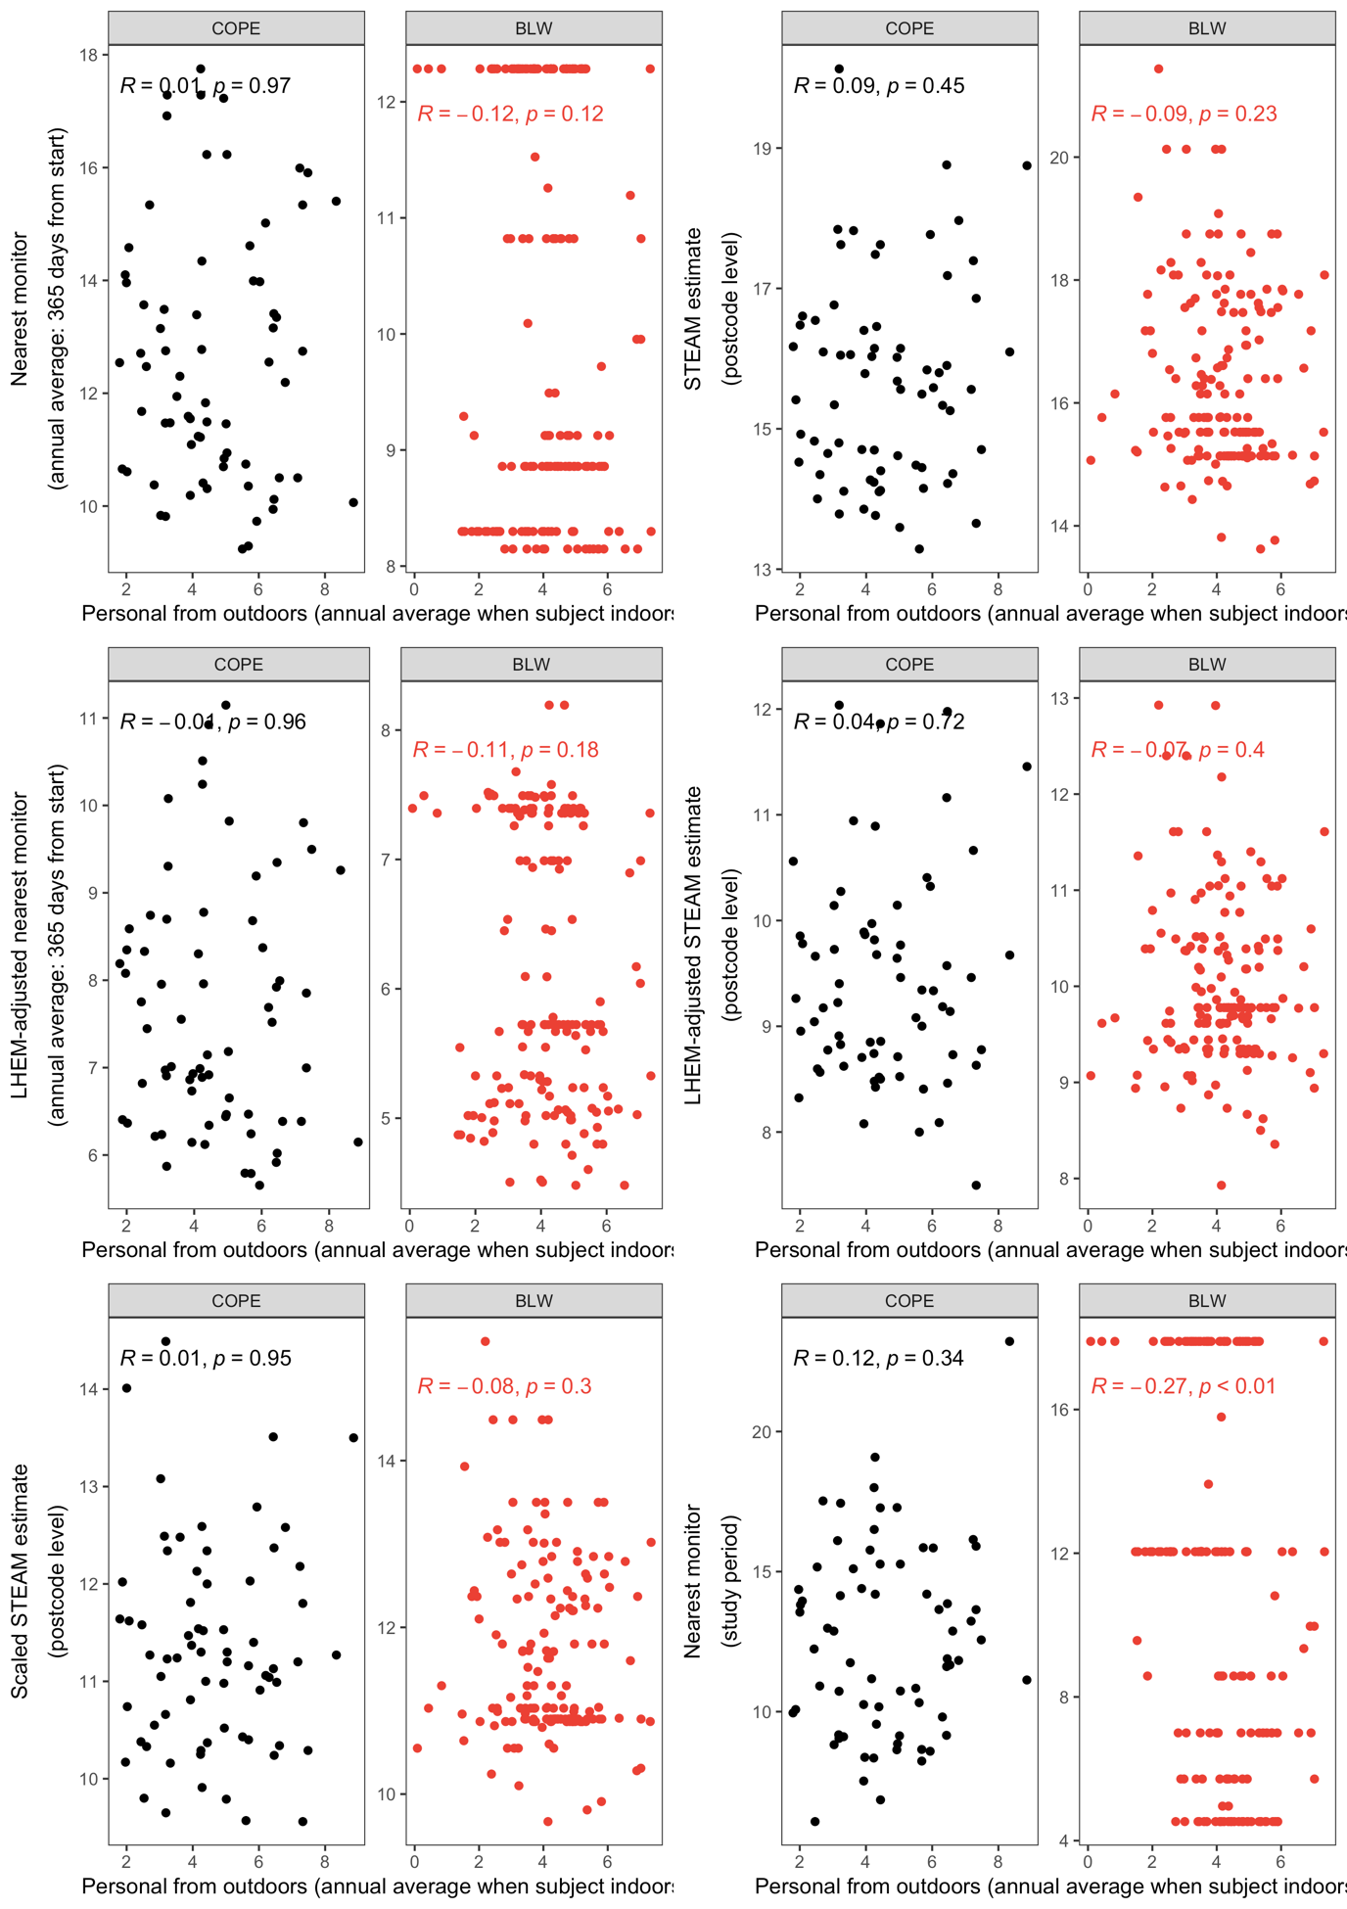
Table B6. Spearman correlations between selected surrogate measures of PM_{2.5}. Assigned to COPE (n = 67 – 69) and BLW (n = 161 – 162) participants.

 | Nearest monitor |  | Postcode level STEAM estimate |  | Nearest monitor as above adjusted by LHEM |  | STEAM as above adjusted by LHEM |  |  | STEAM scaled |  |  | Nearest monitor |  | Nearest monitor adjusted by LHEM
Annual
Nearest monitor | 1
Postcode level STEAM estimate | 0.13 / -0.41 |  | 1
Nearest monitor as above adjusted by LHEM | 0.96 / 0.92 |  | 0.10 / -0.49 |  | 1
STEAM as above adjusted by LHEM | -0.03 / -0.54 |  | 0.83 / 0.76 |  | 0.08 / -0.45 |  | 1
STEAM scaled | 0.05 / -0.59 |  | 0.84 / 0.92 |  | 0.03 / -0.63 |  | 0.72 / 0.83 |  | 1
Measurement Period
Nearest monitor | 0.74 / 0.58 |  | 0.13 / 0.11 |  | 0.68 / 0.52 |  | -0.04 / -0.28 |  | 0.14 / -0.14 |  |  | 1
Nearest monitor adjusted by LHEM | 0.71 / 0.56 |  | 0.11 / 0.08 |  | 0.70 / 0.56 |  | 0.04 / -0.25 |  | 0.15 / -0.14 |  |  | 0.98 / 0.98 |  | 1

Table B7. Spearman correlations between estimated (measurement period) or predicted (annually) personal exposures to ozone from outdoor sources during the measurement period, during the measurement period only at times the subject is indoors and annually (for all times and only when subject is indoors). Assigned to COPE (n = 66) participants.

 | Personal from outdoors (annually predicted) | Personal from outdoors (measurement period) | Personal from outdoors when subject indoors (measurement period) | Personal from outdoors when subject indoors (annually predicted)
Personal from outdoors (annually predicted) | 1
Personal from outdoors (measurement period) | 0.85 | 1
Personal from outdoors when subject indoors (measurement period) | 0.79 | 0.96 | 1
Personal from outdoors when subject indoors (annually predicted) | 0.94 | 0.90 | 0.90 | 1

Figure B11. Scatterplots and Pearson correlation coefficients for estimated (measurement period) or predicted (annually) personal exposures of ozone (μg/m³) from outdoor sources during the measurement period, during the measurement period only at times the subject is indoors and annually (for all times and only when subject is indoors). Assigned to COPE (n = 66) participants.

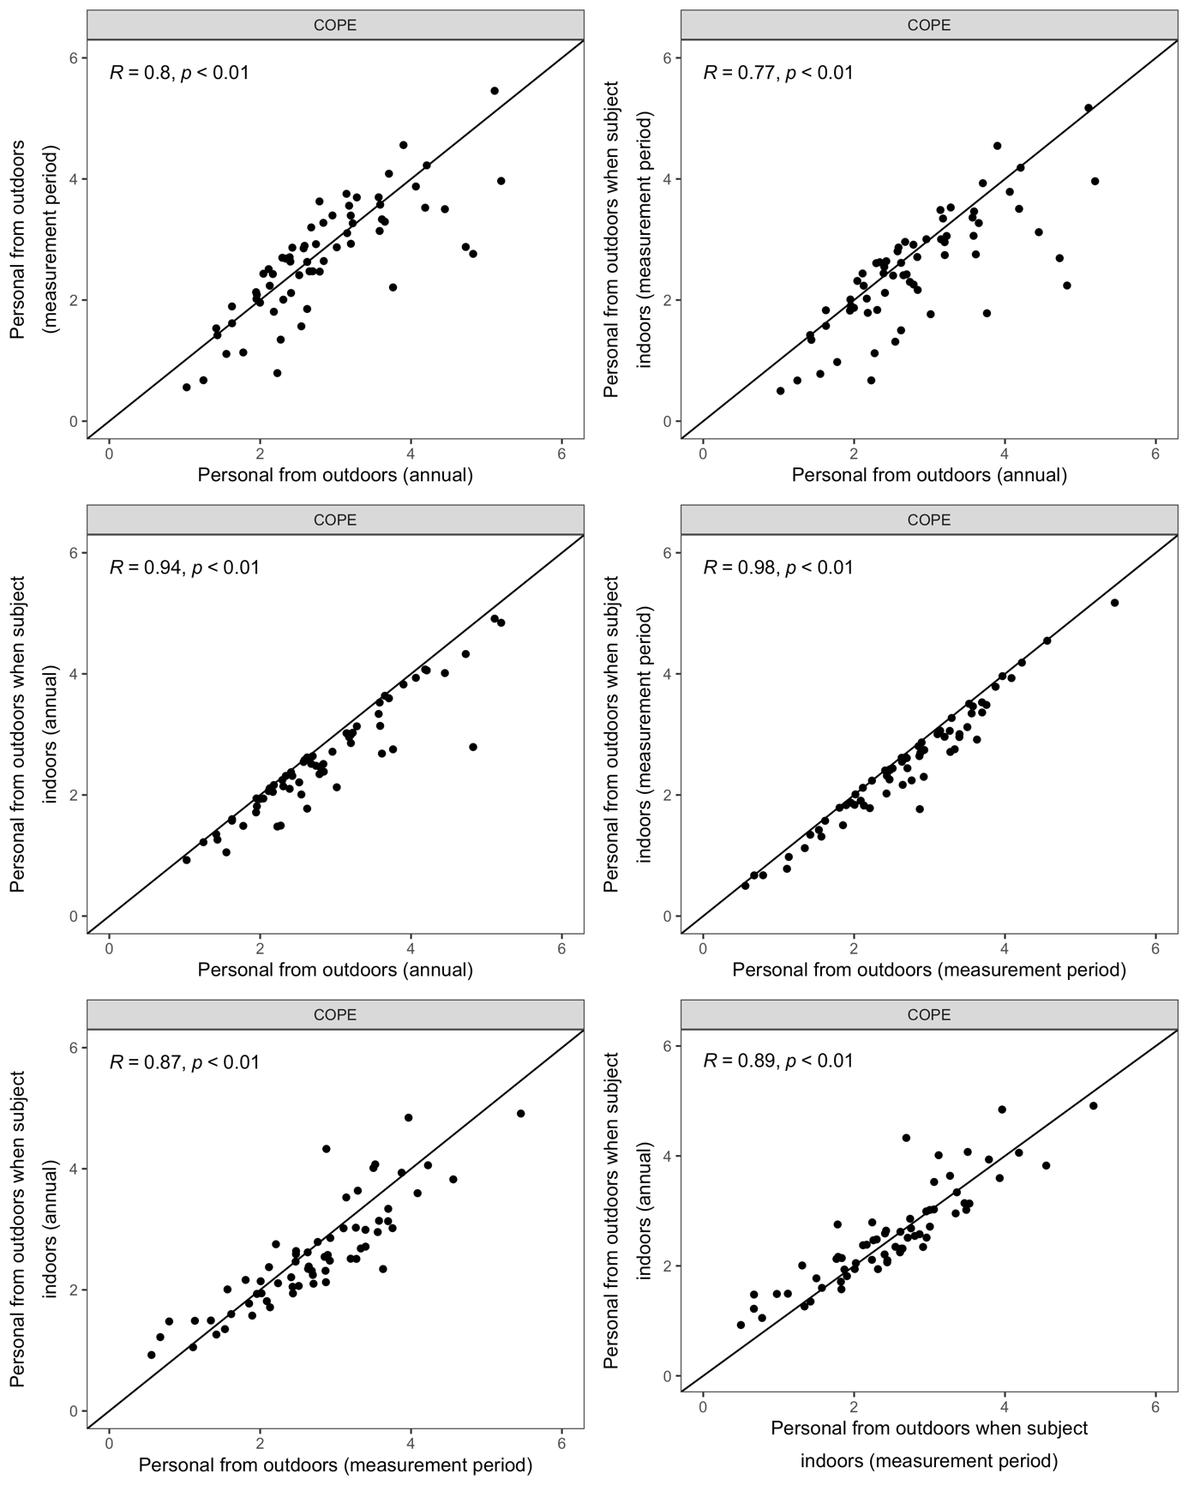

Table B8. Spearman correlations between estimated (measurement period) or predicted (annually) personal exposures to ozone from outdoor sources and selected surrogate measures. Assigned to COPE (n = 66) participants.

 | Personal from outdoors (annually predicted) | Personal from outdoors (measurement period) | Personal from outdoors when subject indoors (measurement period) | Personal from outdoors when subject indoors (annually predicted)
Annual
Nearest monitor for the year after the 1st day of field work | 0.02 | -0.07 | -0.07 | 0.02
Postcode level STEAM estimate | -0.15 | -0.13 | -0.14 | -0.20
STEAM as above scaled by nearest monitor changes between 2009-13 and 2015-19 | 0.05 | 0.09 | 0.07 | 0.03
Measurement Period
Nearest monitor | 0.05 | 0.28 | 0.31 | 0.19

Figure B12. Scatterplots and Pearson correlation coefficients for annually predicted personal exposures of ozone (μg/m³) from outdoor sources and selected surrogate measures. Assigned to COPE (n = 66) participants.

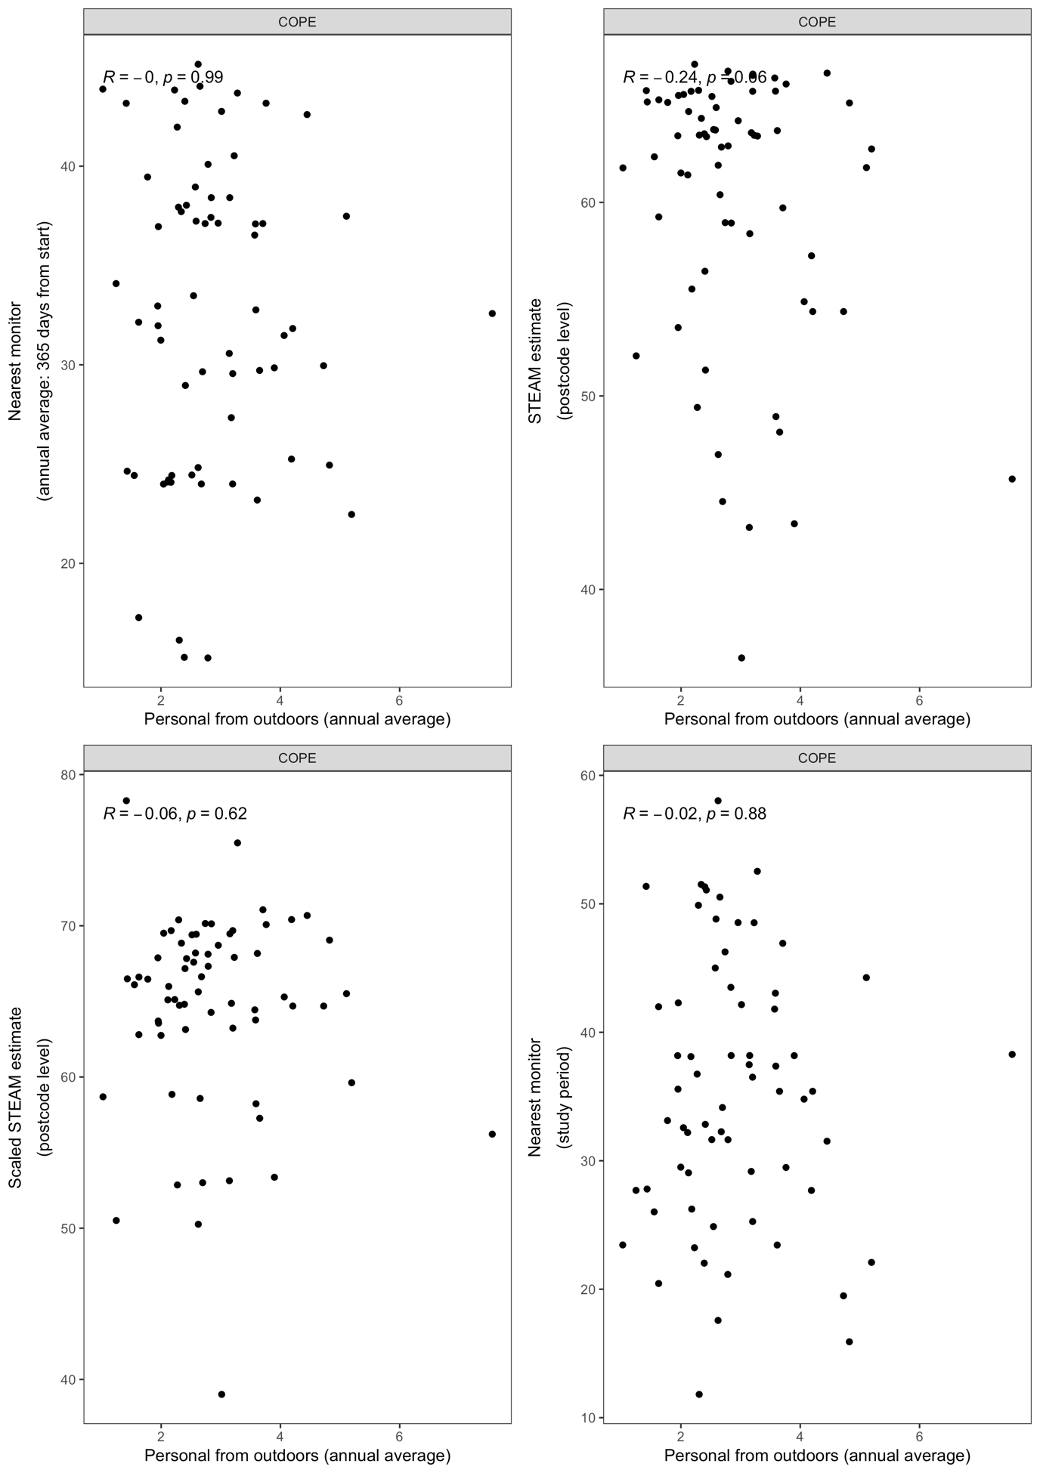
Figure B13. Scatterplots and Pearson correlation coefficients for estimated personal exposures of ozone (μg/m³) from outdoor sources for the measurement period and selected surrogate measures. Assigned to COPE (n = 66) participants.

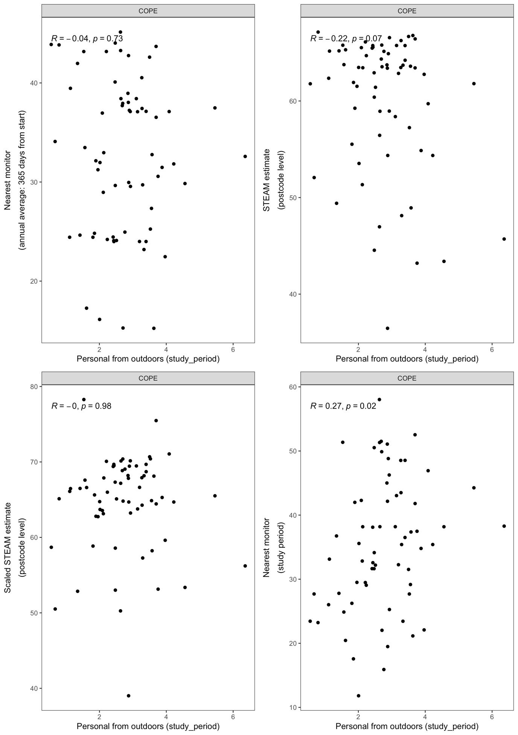
Figure B14. Scatterplots and Pearson correlation coefficients for estimated personal exposures of ozone (μg/m³) from outdoor sources for the measurement period (when the subject was indoors) and selected surrogate measures. Assigned to COPE (n = 66) participants.

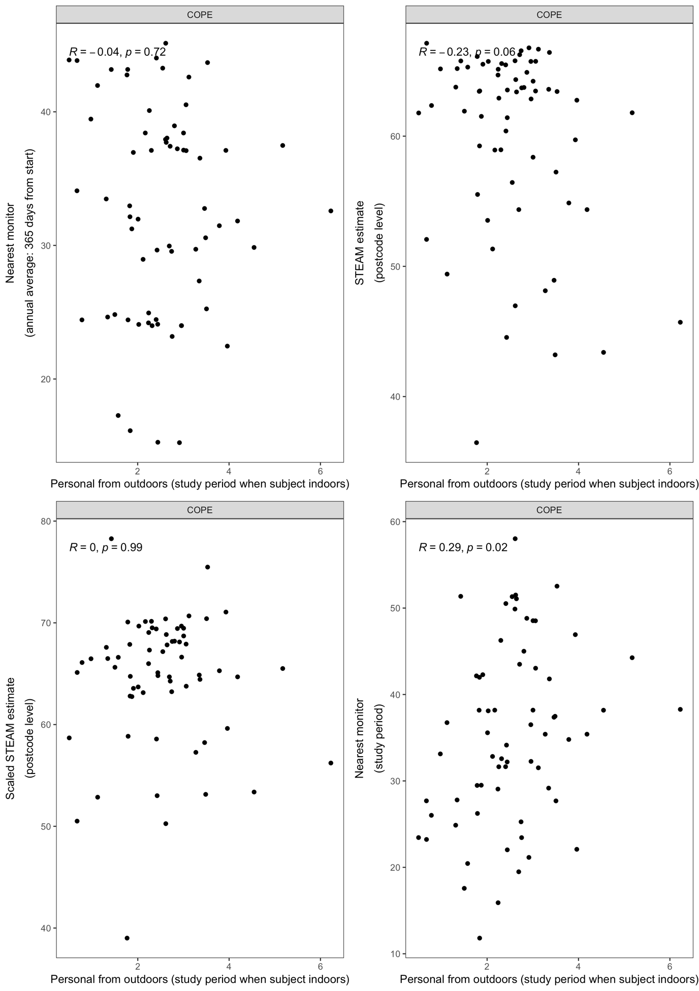
Figure B15. Scatterplots and Pearson correlation coefficients for predicted personal exposures of ozone (μg/m³) from outdoor sources (annual average when the subject was indoors) and selected surrogate measures. Assigned to COPE (n = 66) participants.

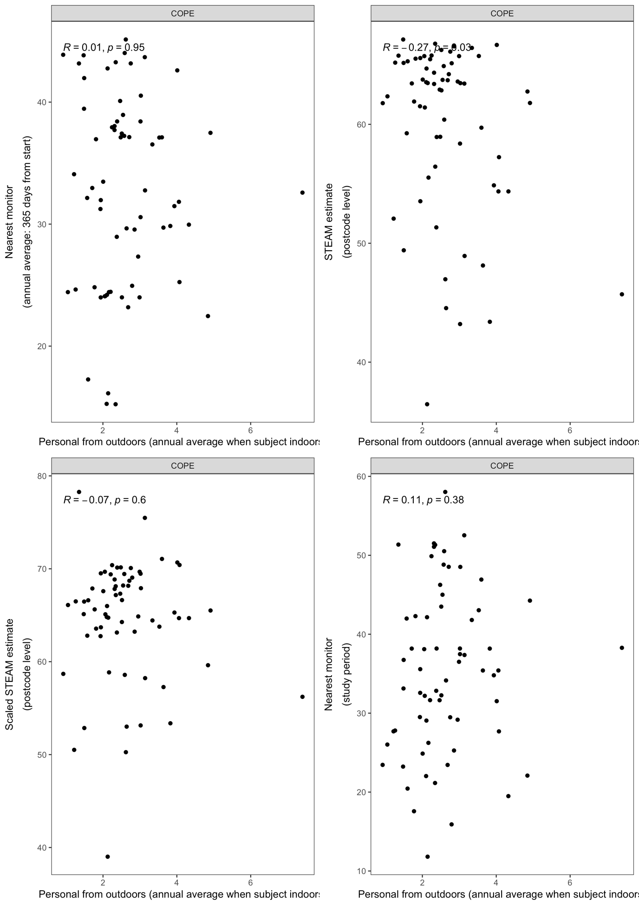

Table B9. Spearman correlations between selected surrogate measures of ozone. Assigned to COPE (n = 66) participants.

 | Nearest monitor for the year after the 1st day of field work | Postcode level STEAM estimate | STEAM as above scaled by nearest monitor changes between 2009-13 and 2015-19 | Nearest monitor
Annual
Nearest monitor for the year after the 1st day of field work | 1
Postcode level STEAM estimate | -0.06 | 1
STEAM as above scaled by nearest monitor changes between 2009-13 and 2015-19 | 0.05 | 0.54 | 1
Measurement Period
Nearest monitor | 0.62 | -0.12 | 0.14 | 1

Table B10. Spearman correlations between estimated (measurement period) or predicted (annually) personal exposures to black carbon from outdoor sources during the measurement period, during the measurement period only at times the subject is indoors and annually (for all times and only when subject is indoors). Assigned to PASTA (n=38) and DEMIST (n=66) participants.

 | Personal from outdoors (annually predicted) |  | Personal from outdoors (measurement period) |  | Personal from outdoors when subject indoors (measurement period) |  | Personal from outdoors when subject indoors (annually predicted)
 | PASTA | DEMIST | PASTA | DEMIST | PASTA | DEMIST | PASTA | DEMIST
Personal from outdoors (annually predicted) | 1
Personal from outdoors (measurement period) | 0.55 / 0.34 |  | 1
Personal from outdoors when subject indoors (measurement period) | 0.13 / -0.05 |  | 0.58 / 0.33 |  | 1
Personal from outdoors when subject indoors (annually predicted) | 0.29 / 0.35 |  | 0.20 / 0.05 |  | 0.34 / 0.15 |  | 1

Figure B16. Scatterplots and Pearson correlation coefficients for estimated (measurement period) or predicted (annually) personal exposures of black carbon (μg/m³) from outdoor sources during the measurement period, during the measurement period only at times the subject is indoors and annually (for all times and only when subject is indoors). Assigned to PASTA (n=38) and DEMIST (n=66) participants.

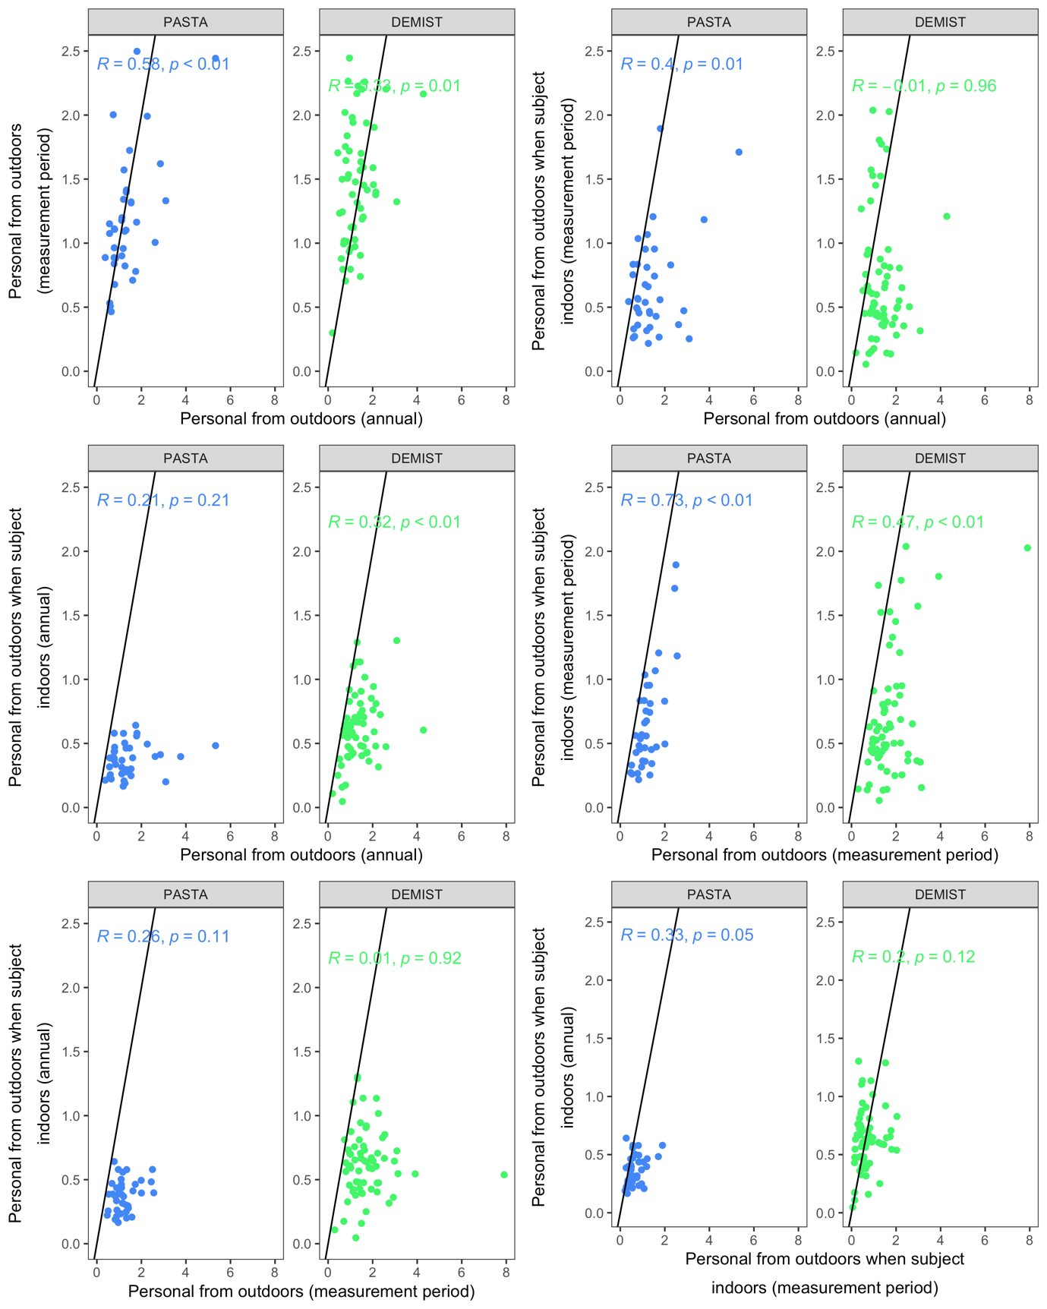

Table B11. Spearman correlations between estimated (measurement period) or predicted (annually) personal exposures to black carbon from outdoor sources and selected surrogate measures. Assigned to PASTA (n=38) and DEMIST (n=66) participants.

 | Personal from outdoors (annually predicted) |  | Personal from outdoors (measurement period) |  | Personal from outdoors when subject indoors (measurement period) |  | Personal from outdoors when subject indoors (annually predicted)
Annual
Nearest monitor for the year after the 1st day of field work | 0.17 / 0.17 |  | 0.09 / -0.28 |  | 0.11 / -0.09 |  | 0.08 / 0.24
ELAPSE estimate | 0.00 / -0.14 |  | -0.01 / -0.20 |  | 0.14 / 0.08 |  | 0.47 / 0.42
ELAPSE as above scaled by nearest monitor changes between 2009-13 and 2015-19 | -0.03 / -0.19 |  | 0.07 / 0.04 |  | 0.07 / -0.02 |  | 0.33 / 0.08
Measurement Period
Nearest monitor | -0.09 / -0.09 |  | -0.06 / -0.16 |  | -0.13 / 0.24 |  | -0.02 / -0.05

Figure B17. Scatterplots and Pearson correlation coefficients for annually predicted personal exposures to black carbon (μg/m³) from outdoor sources and selected surrogate measures. Assigned to PASTA (n=38) and DEMIST (n=66) participants.

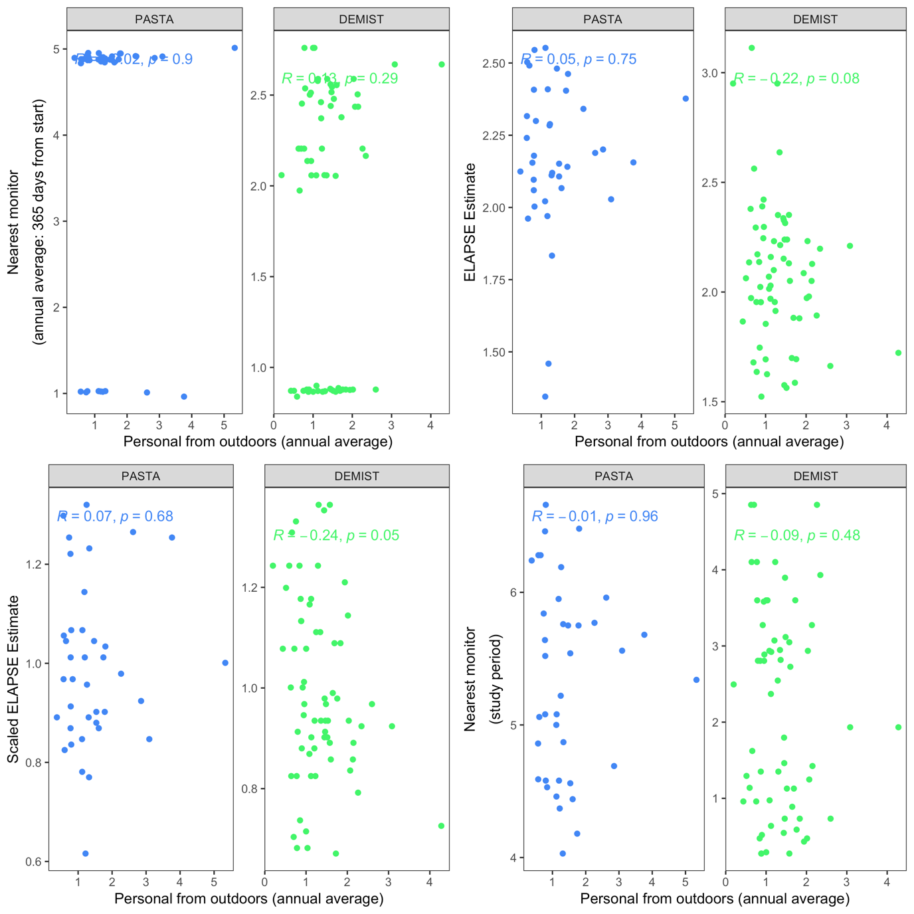

Figure B18. Scatterplots and Pearson correlation coefficients for estimated personal exposures to black carbon (μg/m³) from outdoor sources for the measurement period and selected surrogate measures. Assigned to PASTA (n=38) and DEMIST (n=66) participants.

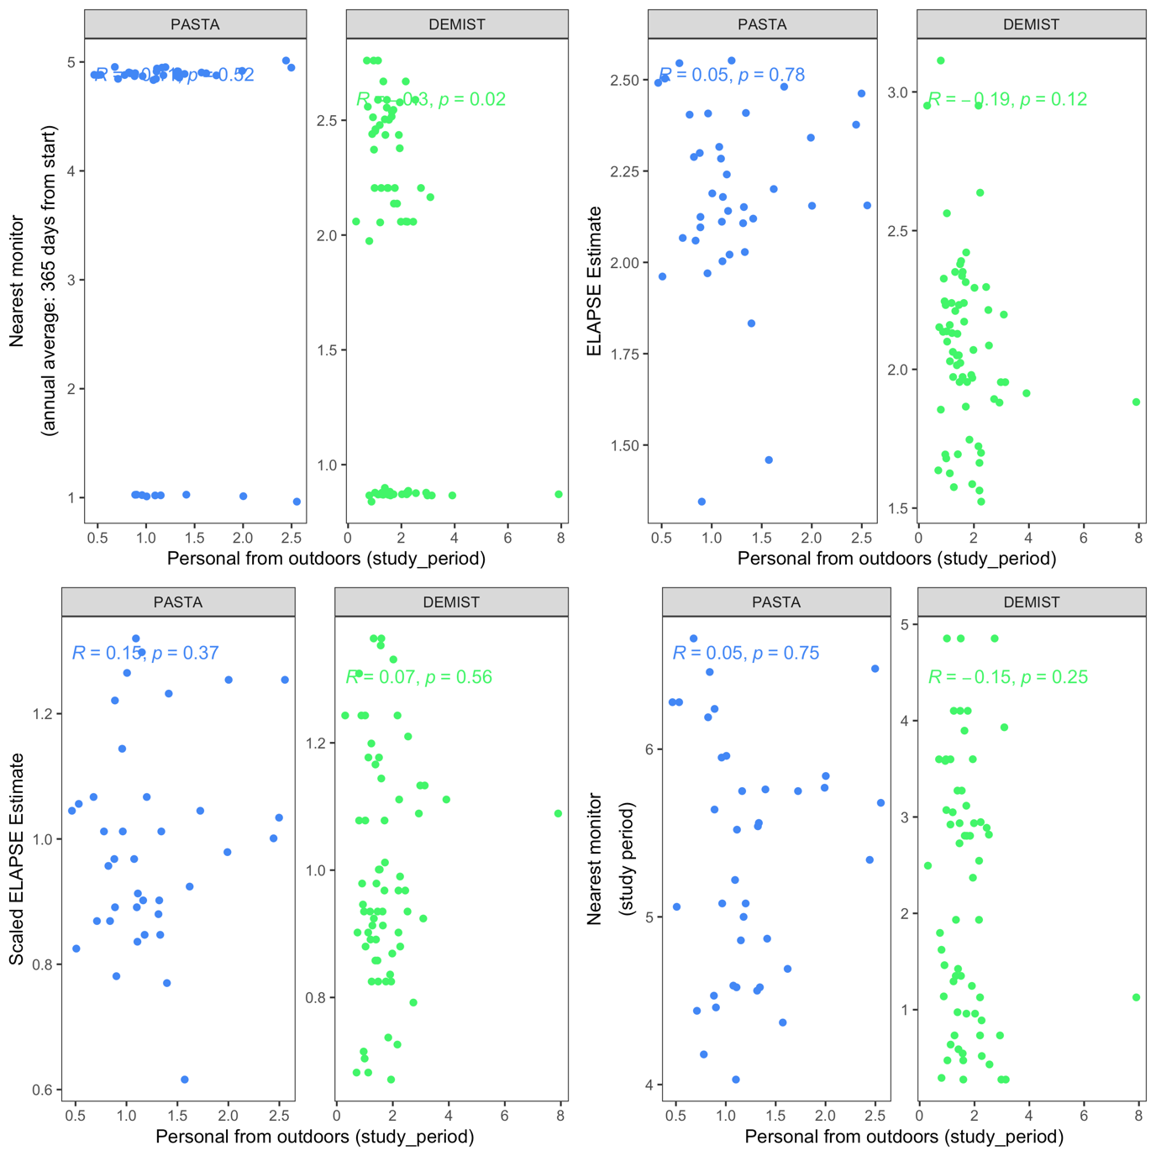

Figure B19. Scatterplots and Pearson correlation coefficients for estimated personal exposures to black carbon (μg/m³) from outdoor sources for the measurement period (when the subject was indoors) and selected surrogate measures. Assigned to PASTA (n=38) and DEMIST (n=66) participants.

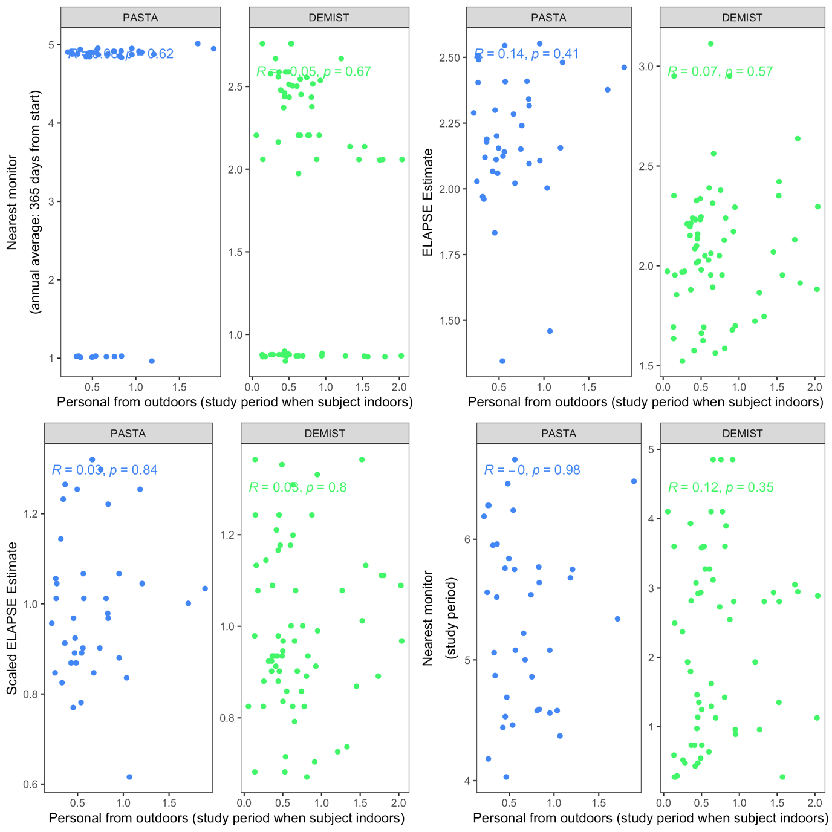

Figure B20. Scatterplots and Pearson correlation coefficients for annually predicted personal exposures to black carbon (μg/m³) from outdoor sources (when the subject was indoors) and selected surrogate measures. Assigned to PASTA (n=38) and DEMIST (n=66) participants.

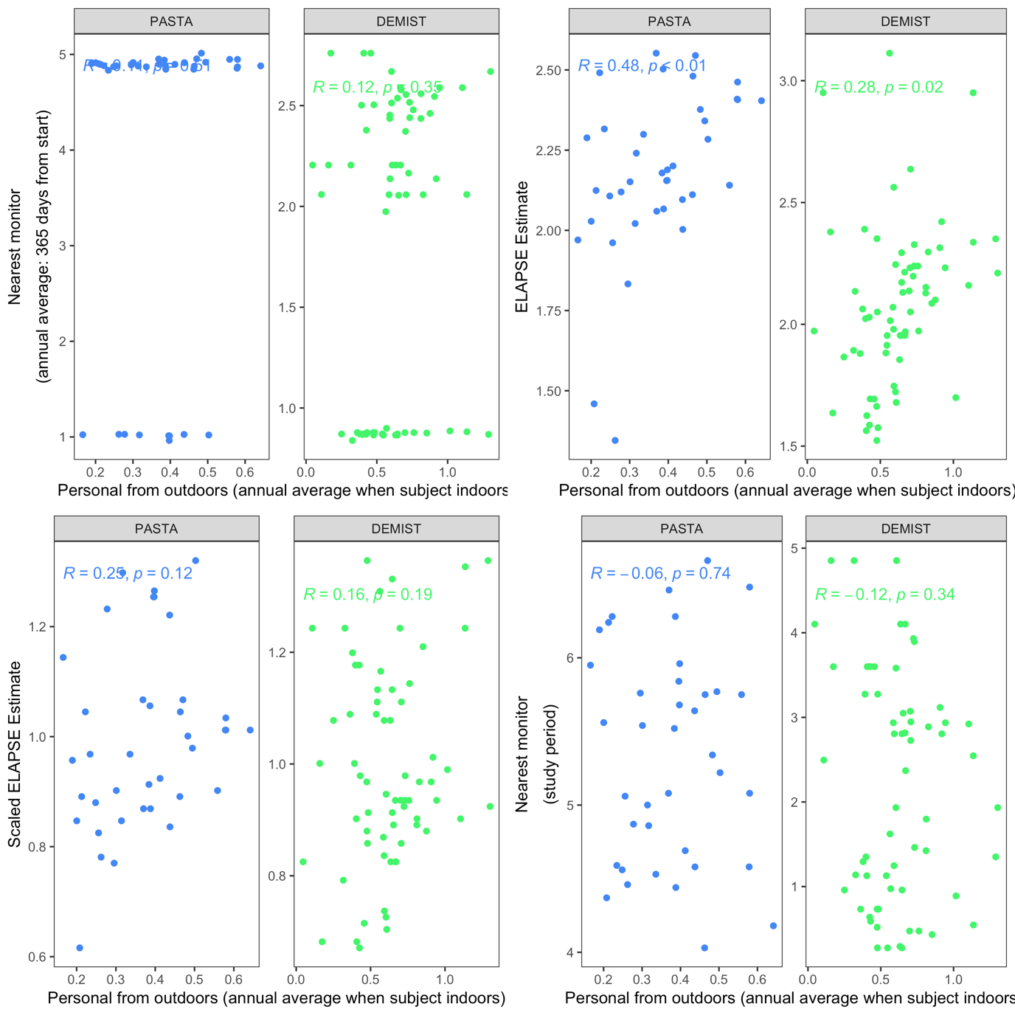
Table B12. Spearman correlations between selected surrogate measures of black carbon. Assigned to PASTA (n=38) and DEMIST (n=66) participants.

 | Nearest monitor | LSOA level STEAM estimate | ELAPSE scaled | Nearest monitor
Annual
Nearest monitor | 1
LSOA level ELPASE estimate | 0.21 / 0.13 | 1
ELAPSE scaled | -0.40 / -0.67 | 0.60 / 0.50 | 1
Measurement Period
Nearest monitor | 0.25 / 0.70 | 0.28 / 0.14 | 0.34 / -0.62 | 1

Table B13. Pearson correlation coefficients between the exposure measurement errors for different pollutants. The errors were defined as the difference between predicted annual personal exposures to pollution from outdoor sources and selected surrogate measures. Data from the COPE study (n=69).

 | Pearson correlation coefficient for the errors between pollutants
Surrogate exposure | PM_{2.5} and NO₂ | PM_{2.5} and O₃ | NO₂ and O₃
Nearest monitor | 0.013 | -0.030 | -0.041
Modelled: STEAM | 0.103 | -0.130 | -0.797
Temporally aligned STEAM | 0.083 | -0.014 | -0.669
LHEM-adjusted STEAM | 0.051 | - | -

Section C. Error determinants analysis effect estimates

Tables C1-C4 show the regression coefficients from the error determinants analysis when nearest monitor and STEAM/ELAPSE surrogated were used to estimate standardised exposure measurement error. In COPE participants, living in a residence that was classified as “other” was associated with an increase in the NO₂ measurement error (regression coefficient [95% confidence interval]: 1.05 [0.22, 1.89]) compared to living in a flat/apartment (Table D1) when the nearest monitor was considered as surrogate. The direction of the association was similar for the STEAM model estimates, although not statistically significant. Having very severe COPD (compared to moderate), cooking using electricity (compared to gas), spending more time outdoors and having lower deprivation scores were associated with a reduction in measurement error (coefficients ranging from -0.52 to -0.15), however these associations did not reach the nominal level of statistical significance. For PM_{2.5} exposure error (Table D2), an IQR increase in IMD score (equal to 18.6 units) was associated with an increase in the measurement error after exposure standardisation when the nearest monitor was the surrogate measure (0.73 [0.22, 1.23]), whilst a smaller, not statistically significant association was observed with the modelled surrogate. No other variables were associated with the exposure error. For ozone, living in a detached/semi-detached or other type of home (compared to living in a flat/apartment) was associated with an increase in measurement error for nearest monitor and modelled concentrations, respectively. The associations were significant only for the modelled surrogate, i.e. 1.27 [0.24, 2.31] for those living in detached/semi-detached house and 1.55 [0.45, 2.64] for those living in other forms of housing. Patients with very severe COPD had lower exposure errors compared to those with moderate COPD but the result was not statistically significant. For black carbon, spending one more hour in the day on average outdoors was associated with a decrease in measurement error when the nearest monitor surrogate was considered (0.16 [0.01, 0.32]).

Table C1. Regression coefficients for potential determinants of measurement error between measured standardised personal exposure to outdoor sources for COPE participants to NO₂ (n = 70) and the nearest monitor or modelled standardised surrogate of exposure.
Surrogate exposure | Determinant | Estimate [95% CI] | p-value
Nearest monitor | Age | 0.27 [-0.16, 0.71] | 0.21
 | Gender: Male | 0.18 [-0.51, 0.86] | 0.60
 | IMD score | -0.43 [-0.97, 0.11] | 0.12
 | COPD sev: Mild | -0.39 [-1.40, 0.61] | 0.44
 | COPD sev: Severe | -0.39 [-1.17, 0.39] | 0.33
 | COPD sev: Very Severe | -0.98 [-1.99, 0.03] | 0.06
 | Res. Type: Semi/Detached | 0.31 [-0.47, 1.10] | 0.43
 | Res. Type: Other | 1.05 [0.22, 1.89]* | 0.01
 | Cooking fuel: Electric | 0.21 [-0.50, 0.92] | 0.55
 | Cooking fuel: Other | 0.25 [-0.64, 1.14] | 0.58
 | Time spent out of home | -0.23 [-0.49, 0.04] | 0.09
STEAM | Age | 0.27 [-0.09, 0.63] | 0.14
 | Gender: Male | 0.10 [-0.46, 0.67] | 0.71
 | IMD score | -0.01 [-0.46, 0.43] | 0.96
 | COPD sev: Mild | 0.41 [-0.42, 1.24] | 0.32
 | COPD sev: Severe | 0.04 [-0.60, 0.69] | 0.90
 | COPD sev: Very Severe | -0.52 [-1.35, 0.32] | 0.22
 | Res. Type: Semi/Detached | 0.15 [-0.49, 0.80] | 0.64
 | Res. Type: Other | 0.46 [-0.22, 1.15] | 0.18
 | Cooking fuel: Electric | -0.15 [-0.74, 0.43] | 0.60
 | Cooking fuel: Other | -0.50 [-1.23, 0.24] | 0.18
 | Time spent out of home | -0.17 [-0.39, 0.05] | 0.13
Table C2. Regression coefficients for potential determinants of measurement error between measured standardised personal exposure to outdoor sources for COPE participants to PM_{2.5} (n = 65) and the nearest monitor or modelled standardised surrogate of exposure.

Surrogate exposure | Determinant | Estimate [95% CI] | p-value
Nearest monitor | Age | -0.27 [-0.74, 0.20] | 0.26
 | Gender: Male | -0.49 [-1.20, 0.22] | 0.17
 | IMD score | 0.73 [0.22, 1.23]** | 0.01
 | COPD sev: Mild | -0.34 [-1.36, 0.67] | 0.50
 | COPD sev: Severe | -0.61 [-1.43, 0.2] | 0.14
 | COPD sev: Very Severe | 0.33 [-0.69, 1.34] | 0.52
 | Res. Type: Semi/Detached | 0.48 [-0.33, 1.28] | 0.24
 | Res. Type: Other | -0.32 [-1.23, 0.59] | 0.48
 | Cooking fuel: Electric | -0.16 [-0.89, 0.57] | 0.66
 | Cooking fuel: Other | 0.07 [-0.88, 1.03] | 0.88
 | Time spent out of home | -0.14 [-0.44, 0.15] | 0.34
STEAM | Age | 0.18 [-0.33, 0.69] | 0.48
 | Gender: Male | -0.65 [-1.42, 0.11] | 0.09
 | IMD score | 0.15 [-0.4, 0.69] | 0.59
 | COPD sev: Mild | -0.70 [-1.80, 0.40] | 0.21
 | COPD sev: Severe | -0.54 [-1.42, 0.34] | 0.23
 | COPD sev: Very Severe | 0.35 [-0.75, 1.45] | 0.53
 | Res. Type: Semi/Detached | -0.15 [-1.02, 0.72] | 0.73
 | Res. Type: Other | -0.62 [-1.60, 0.37] | 0.22
 | Cooking fuel: Electric | -0.15 [-0.94, 0.64] | 0.71
 | Cooking fuel: Other | -0.08 [-1.12, 0.95] | 0.87
 | Time spent out of home | -0.06 [-0.39, 0.26] | 0.69

Table C3. Regression coefficients for potential determinants of measurement error between measured standardised personal exposure to outdoor sources for COPE participants to O₃ (n = 60) and the nearest monitor or modelled standardised surrogate of exposure.

Surrogate exposure | Determinant | Estimate [95% CI] | p-value
Nearest monitor | Age | -0.04 [-0.59, 0.50] | 0.87
 | Gender: Male | -0.31 [-1.18, 0.56] | 0.48
 | IMD score | 0.33 [-0.31, 0.98] | 0.30
 | COPD sev: Mild | 0.76 [-0.51, 2.02] | 0.24
 | COPD sev: Severe | -0.10 [-1.04, 0.85] | 0.84
 | COPD sev: Very Severe | -0.83 [-2.09, 0.43] | 0.19
 | Res. Type: Semi/Detached | 0.44 [-0.57, 1.46] | 0.39
 | Res. Type: Other | 0.97 [-0.11, 2.04] | 0.08
 | Cooking fuel: Electric | -0.20 [-1.06, 0.67] | 0.65
 | Cooking fuel: Other | -0.33 [-1.52, 0.86] | 0.58
 | Time spent out of home | -0.10 [-0.42, 0.23] | 0.55
STEAM | Age | -0.10 [-0.65, 0.46] | 0.73
 | Gender: Male | 0.26 [-0.63, 1.15] | 0.56
 | IMD score | -0.28 [-0.93, 0.38] | 0.40
 | COPD sev: Mild | -0.16 [-1.45, 1.14] | 0.81
 | COPD sev: Severe | -0.20 [-1.17, 0.76] | 0.67
 | COPD sev: Very Severe | -0.79 [-2.08, 0.49] | 0.22
 | Res. Type: Semi/Detached | 1.27 [0.24, 2.31]* | 0.02
 | Res. Type: Other | 1.55 [0.45, 2.64]** | 0.01
 | Cooking fuel: Electric | 0.23 [-0.66, 1.11] | 0.61
 | Cooking fuel: Other | 0.23 [-0.98, 1.44] | 0.70
 | Time spent out of home | -0.08 [-0.41, 0.25] | 0.62

Table C4. Regression coefficients for potential determinants of measurement error between measured standardised personal exposure to outdoor sources for PASTA participants to BC (n = 38) and the nearest monitor or modelled standardised surrogate of exposure.

Surrogate exposure | Determinant | Estimate [95% CI] | p-value
Nearest monitor | Age | 0.22 [-0.27, 0.71] | 0.37
 | Gender: Male | 0.00 [-1.03, 1.04] | 0.99
 | BMI | 0.01 [-0.17, 0.20] | 0.89
 | IMD score | 0.38 [-0.35, 1.11] | 0.29
 | Physical activity | 0.64 [-0.04, 1.31] | 0.06
 | Smoker: Former smoker | 0.13 [-1.04, 1.3] | 0.82
 | Residence Type: Semi/Detached | 0.10 [-1.00, 1.21] | 0.85
 | Residence Type: Other | 0.16 [-0.90, 1.22] | 0.76
 | Air pollution worry: Worried | -0.21 [-1.13, 0.71] | 0.64
 | Time spent out of home | -0.16 [-0.32, -0.01]* | 0.04
STEAM | Age | -0.01 [-0.59, 0.56] | 0.96
 | Gender: Male | 0.33 [-0.89, 1.55] | 0.59
 | BMI | 0.02 [-0.20, 0.24] | 0.85
 | IMD score | 0.08 [-0.78, 0.93] | 0.86
 | Physical activity | 0.29 [-0.51, 1.08] | 0.47
 | Smoker: Former smoker | 0.05 [-1.32, 1.43] | 0.94
 | Residence Type: Semi/Detached | -0.71 [-2.00, 0.59] | 0.27
 | Residence Type: Other | -0.21 [-1.46, 1.04] | 0.73
 | Air pollution worry: Worried | -0.33 [-1.41, 0.75] | 0.53
 | Time spent out of home | -0.16 [-0.34, 0.02] | 0.08

Zhang, H., Evangelopoulos, D., Wood, D., Chatzidiakou, L., Varaden, D., Quint, J., de Nazelle, A., Walton, H., Katsouyanni, K. and Barratt, B., 2025. Estimating exposure to pollutants generated from indoor and outdoor sources within vulnerable populations using personal air quality monitors: A London case study. Environment International, 198, p.109431
Chawla, N.V., Bowyer, K.W., Hall, L.O. and Kegelmeyer, W.P., 2002. SMOTE: synthetic minority over-sampling technique. Journal of artificial intelligence research, 16, pp.321-357
Diffey, B.L., 2011. An overview analysis of the time people spend outdoors. British Journal of Dermatology, 164(4), pp.848-854 and Olds, T., Maher, C. and Dumuid, D., 2019. Life on holidays: differences in activity composition between school and holiday periods in Australian children. BMC public health, 19, pp.1-8

