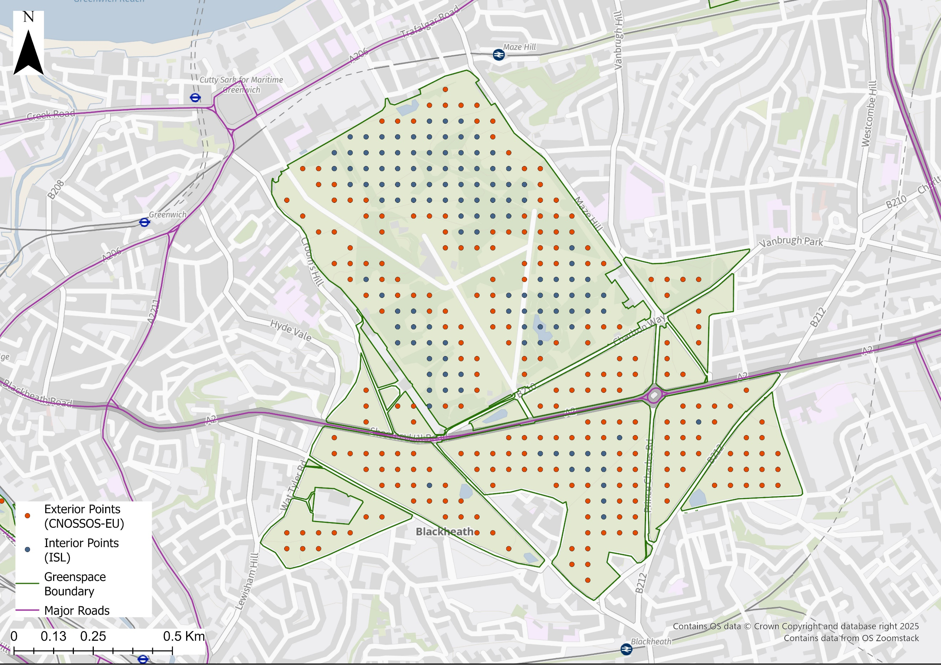
Supplementary Figure S1 – The distribution of ‘exterior’ and ‘interior’ receptor points within a greenspace area. Greenspace noise levels at exterior receptor points were modelled using the CNOSSOS-EU framework and noise levels at interior points were modelled using the ‘inverse square law’ (ISL) of sound attenuation.

Supplementary Table S1 – Sensitivity analysis of the percentage of greenspace areas with average noise levels exceeding the chosen thresholds under the CNOSSOS-EU noise model and combined with the Inverse Square Law of sound attenuation (ISL).
 |  | Percentage of greenspace areas above chosen threshold (L_{day})
 |  | CNOSSOS-EU | ISL
Greater London |  | 27.6 | 27.7
Central London |  | 34.7 | 35.8
LAD | Westminster | 61.1 | 61.1
Greenspace | St James’ Park | 13.5 | 13.5
Outer London |  | 25.9 | 25.5
LAD | Richmond | 27.5 | 27.5
Greenspace | Richmond Park | 2.7 | 2.7

Supplementary Table S2 – Sensitivity analysis of the differences in L_{day} noise levels (12-hour daytime period of 07:00-19:00), at the receptor point location, considering distance from the greenspace boundary, under the CNOSSOS-EU noise model and combined with the Inverse Square Law of sound attenuation (ISL).
Comparison | Distance (m) | Points (m) | CNOSSOS-EU |  | Absolute Difference:  CNOSSOS-EU - ISL |  | Absolute Percentage Error
Comparison | Distance (m) | Points (m) | Median (dB) | Mean (dB) | Median (dB) | Mean (dB) | Median (%) | Mean  (%)
ISL Error | <100 | 43,834 | 41.9 | 44.7 | ± 0.0 | ± 0.4 | ± 0.0 | ± 1.0
ISL Error | 100-199 | 14,027 | 39.4 | 42.8 | ± 2.1 | ± 2.5 | ± 4.9 | ± 6.1
ISL Error | 200-299 | 5,809 | 39.1 | 42.6 | ± 2.4 | ± 3.2 | ± 5.6 | ± 7.9
ISL Error | 300-399 | 3,492 | 40.2 | 43.5 | ± 2.7 | ± 3.6 | ± 6.3 | ± 8.8
ISL Error | 400-499 | 2,503 | 39.8 | 43.6 | ± 3.0 | ± 4.2 | ± 6.7 | ± 10.5
CNOSSOS Error | 500-599 | 1,966 | 38.0 * | 43.4 | ± 3.6 | ± 5.0 | ± 8.5 | ± 12.7
CNOSSOS Error | 600-699 | 1,372 | 38.0 * | 43.5 | ± 4.2 | ± 5.8 | ± 10.3 | ± 14.6
CNOSSOS Error | 700-799 | 893 | 38.0 * | 42.6 | ± 5.9 | ± 6.6 | ± 14.7 | ± 16.7
CNOSSOS Error | 800-899 | 601 | 38.0 * | 42.3 | ± 6.1 | ± 7.1 | ± 15.7 | ± 18.1
CNOSSOS Error | 900-999 | 402 | 38.0 * | 41.9 | ± 8.9 | ± 8.4 | ± 23.1 | ± 21.5
CNOSSOS Error | >1000 | 312 | 38.0 * | 42.3 | ± 10.5 | ± 10.3 | ± 26.0 | ± 26.6
* Lower limit of detection for L_{day} in the Morley et al. (2015) implementation of CNOSSOS-EU. Distances beyond 500m represent the threshold where L_{day} values fall below the 38 dB noise floor with distance from a greenspace boundary.

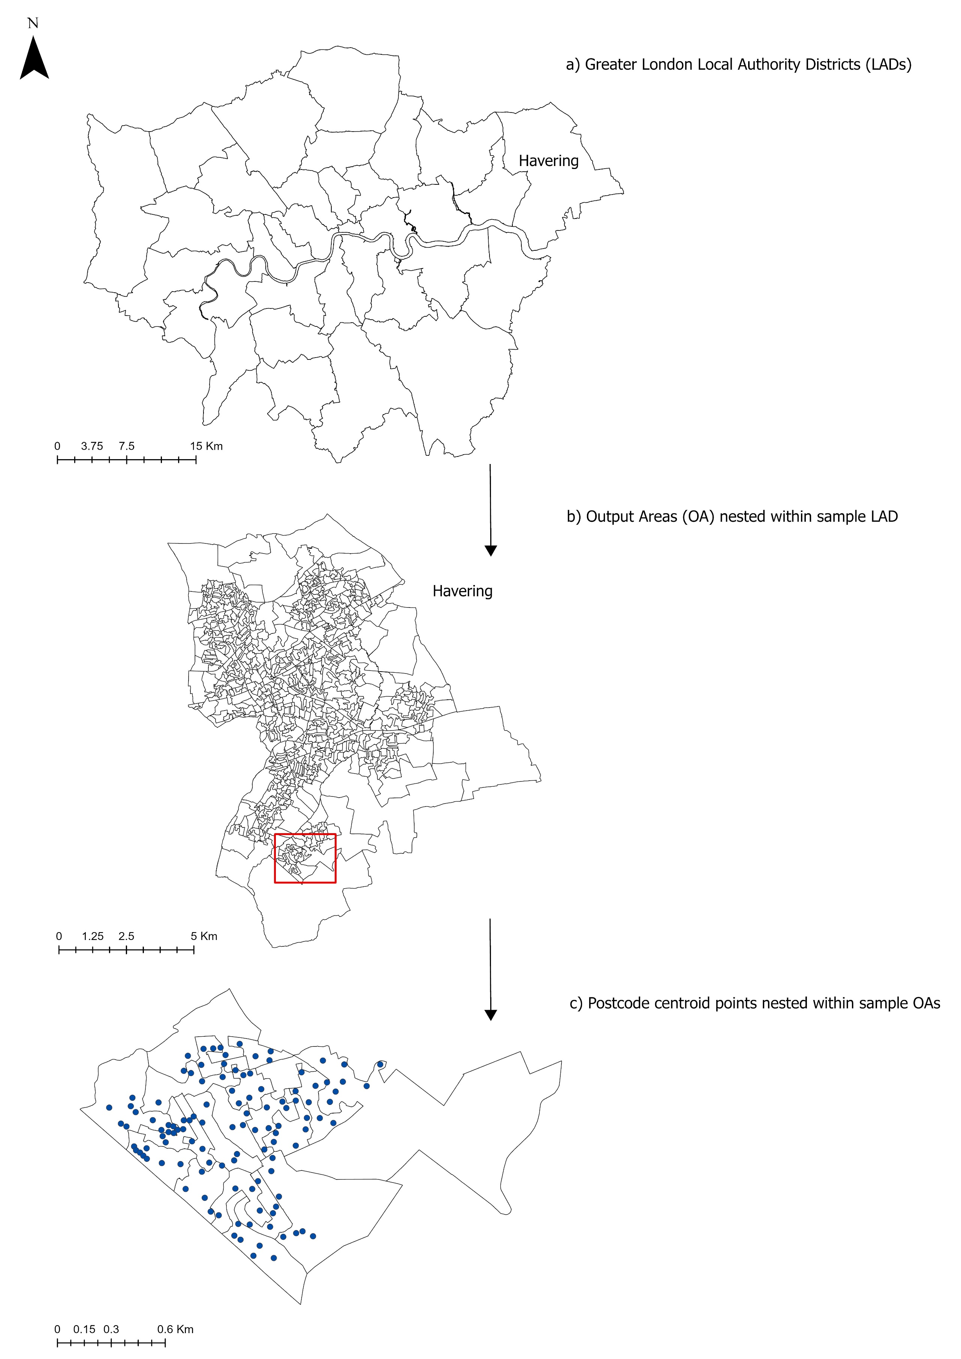
Supplementary Figure S2 – The different geographic coverages referred to in this study, where each geographic area is nested within the next: a) Greater London local authority districts (LAD), b) Output Areas, c) Postcode points. The sample area is Havering.
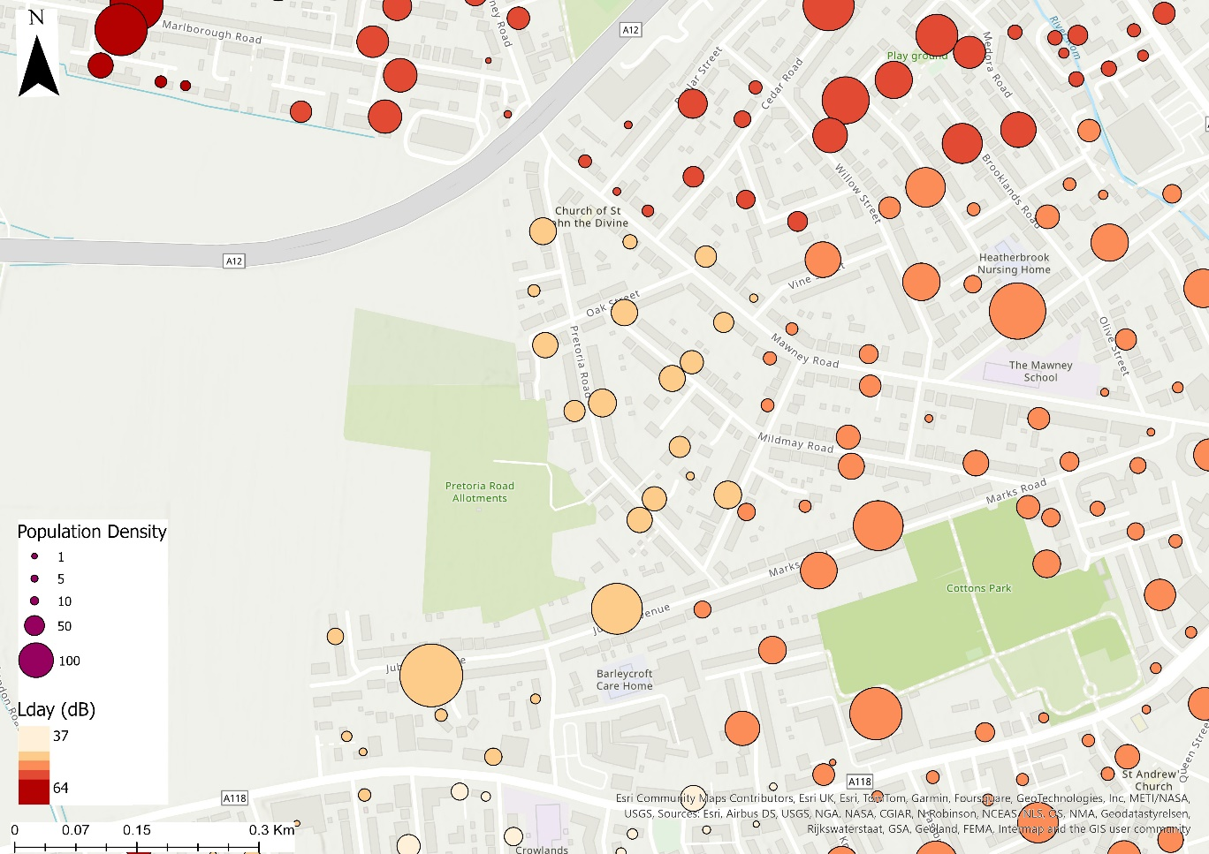
Supplementary Figure S3 – The influence of population density on population postcode exposures to road traffic noise levels (L_{day}).

Supplementary Table S3 - Summary statistics of the annual average noise levels in greenspaces across Greater London, categorised by greenspace type. Table includes the percentage of greenspaces with annual average noise levels that exceed the chosen noise thresholds for L_{day} and L_{eve}.
 | L_{day} (dB) |  |  |  |  |  |  |  |  |  | L_{eve} (dB)
 |  | N | Min | Max |  | Median |  | Mean |  | Above  ≥ 51.2 dB (%) | Min | Max |  | Median |  | Mean |  | Above  ≥ 47.9  dB (%)
Allotments |  | 412 | 37.7 |  | 71.5 |  | 42.5 |  | 44.8 | 15.3 | 37.6 |  | 67.9 |  | 40.5 |  | 43.0 | 15.3
Bowling Green |  | 18 | 38.0 |  | 67.5 |  | 43.3 |  | 45.7 | 27.8 | 38.0 |  | 64.0 |  | 41.1 |  | 43.7 | 27.8
Cemetery |  | 145 | 38.0 |  | 65.9 |  | 46.0 |  | 47.5 | 27.6 | 37.0 |  | 62.4 |  | 43.2 |  | 45.0 | 26.9
Golf Course |  | 114 | 35.1 |  | 68.4 |  | 44.8 |  | 47.3 | 37.7 | 35.0 |  | 64.9 |  | 42.1 |  | 44.9 | 36.8
Other Sports Facility |  | 387 | 36.9 |  | 70.6 |  | 44.6 |  | 47.1 | 27.6 | 35.7 |  | 67.1 |  | 42.1 |  | 44.9 | 27.6
Play Space |  | 58 | 38.0 |  | 68.5 |  | 44.4 |  | 45.9 | 13.8 | 38.0 |  | 65.0 |  | 41.9 |  | 43.8 | 13.8
Playing Field |  | 610 | 36.5 |  | 70.3 |  | 44.2 |  | 46.2 | 20.8 | 36.3 |  | 66.8 |  | 41.8 |  | 44.0 | 21.0
Public Park or Garden |  | 718 | 36.1 |  | 74.4 |  | 48.8 |  | 50.2 | 40.9 | 35.8 |  | 70.8 |  | 45.6 |  | 47.4 | 40.9
Religious Grounds |  | 36 | 38.0 |  | 62.3 |  | 45.7 |  | 47.0 | 22.2 | 38.0 |  | 58.8 |  | 43.0 |  | 44.7 | 22.2
Tennis Court |  | 34 | 38.0 |  | 68.6 |  | 42.5 |  | 44.6 | 17.6 | 38.0 |  | 65.1 |  | 40.5 |  | 42.7 | 17.6
* The chosen L_{day} (51.2 dB) and L_{eve} (47.9 dB) noise thresholds were derived from the 53 L_{den} noise guideline (World Health Organisation, 2018), using empirical conversions published by Brink et al. (2018). L_{day} represents the 12-hour daytime period of 07:00-19:00. L_{eve} represents the 4-hour evening period of 19:00-23:00.

Supplementary Table S4 - The percentage of greenspaces with annual average noise levels that exceed the chosen noise thresholds values for L_{day} and L_{eve} for either across the entire space (100%) or any part (>1%) of that space, categorised by local authority district.
 |  | L_{day} (dB) |  |  | L_{eve} (dB)
 | N | 100% Area exceed  ≥ 51.2 dB (%) | >1% Area exceeds  ≥ 51.2 dB (%) |  | 100% Area exceed  ≥ 47.9 dB (%) | >1% Area exceeds  ≥ 47.9 dB (%)
Barking and Dagenham | 40 | 17.5 |  | 57.5 | 17.5 | 57.5
Barnet | 165 | 12.7 |  | 43.6 | 13.9 | 46.7
Bexley | 104 | 12.5 |  | 34.6 | 12.5 | 36.5
Brent | 58 | 5.2 |  | 43.1 | 5.2 | 43.1
Bromley | 213 | 6.1 |  | 27.7 | 8.9 | 32.9
Camden | 25 | 36.0 |  | 56.0 | 40.0 | 60.0
Croydon | 116 | 6.9 |  | 39.7 | 7.8 | 45.7
Ealing | 132 | 10.6 |  | 41.7 | 11.4 | 43.2
Enfield | 121 | 11.6 |  | 48.8 | 11.6 | 48.8
Greenwich | 101 | 13.9 |  | 48.5 | 13.9 | 52.5
Hackney | 24 | 8.3 |  | 62.5 | 8.3 | 66.7
Hammersmith and Fulham | 31 | 25.8 |  | 54.8 | 25.8 | 58.1
Haringey | 66 | 7.6 |  | 45.5 | 7.6 | 48.5
Harrow | 92 | 10.9 |  | 33.7 | 10.9 | 35.9
Havering | 112 | 6.3 |  | 41.1 | 6.3 | 43.8
Hillingdon | 147 | 9.5 |  | 37.4 | 10.2 | 38.1
Hounslow | 114 | 14.0 |  | 40.4 | 17.5 | 43.9
Islington | 18 | 22.2 |  | 50.0 | 22.2 | 50.0
Kensington and Chelsea | 10 | 20.0 |  | 70.0 | 20.0 | 70.0
Kingston upon Thames | 65 | 3.1 |  | 36.9 | 6.2 | 38.5
Lambeth | 32 | 15.6 |  | 56.3 | 18.8 | 56.3
Lewisham | 72 | 9.7 |  | 38.9 | 9.7 | 40.3
Merton | 91 | 5.5 |  | 35.2 | 7.7 | 36.3
Newham | 56 | 28.6 |  | 57.1 | 30.4 | 64.3
Redbridge | 89 | 16.9 |  | 49.4 | 20.2 | 51.7
Richmond upon Thames | 109 | 11.0 |  | 45.0 | 11.0 | 45.9
Southwark | 66 | 18.2 |  | 47.0 | 18.2 | 48.5
Sutton | 83 | 4.8 |  | 32.5 | 6.0 | 34.9
Tower Hamlets | 35 | 25.7 |  | 57.1 | 25.7 | 57.1
Waltham Forest | 78 | 14.1 |  | 34.6 | 15.4 | 42.3
Wandsworth | 49 | 8.2 |  | 61.2 | 8.2 | 63.3
Westminster | 18 | 44.4 |  | 72.2 | 44.4 | 72.2
* The chosen L_{day} (51.2 dB) and L_{eve} (47.9 dB) noise thresholds were derived from the 53 L_{den} noise guideline (World Health Organisation, 2018), using empirical conversions published by Brink et al. (2018). L_{day} represents the 12-hour daytime period of 07:00-19:00. L_{eve} represents the 4-hour evening period of 19:00-23:00.

Supplementary Table S5 - The percentage of greenspaces with annual average noise levels that exceed the chosen noise thresholds for L_{day} and L_{eve} for either across the entire space (100%) or any part (>1%) of that space, categorised by greenspace type.
 |  | L_{day} (dB) |  | L_{eve} (dB)
 | N | 100% Area exceed  ≥ 51.2 dB (%) | >1% Area exceeds  ≥ 51.2 dB (%) | 100% Area exceed  ≥ 47.9 dB (%) | >1% Area exceeds  ≥ 47.9 dB (%)
Allotments | 412 | 9.0 | 20.6 | 10.2 | 23.3
Bowling Green | 18 | 27.8 | 27.8 | 27.8 | 27.8
Cemetery | 145 | 4.8 | 51.0 | 6.2 | 55.2
Golf Course | 114 | 5.3 | 59.6 | 6.1 | 64.9
Other Sports Facility | 387 | 10.3 | 40.1 | 11.9 | 42.6
Play Space | 58 | 13.8 | 13.8 | 15.5 | 15.5
Playing Field | 610 | 7.5 | 34.4 | 7.9 | 36.9
Public Park or Garden | 718 | 17.8 | 58.8 | 18.9 | 61.0
Religious Grounds | 36 | 13.9 | 27.8 | 16.7 | 27.8
Tennis Court | 34 | 17.6 | 17.6 | 17.6 | 20.6
* The chosen L_{day} (51.2 dB) and L_{eve} (47.9 dB) noise thresholds were derived from the 53 L_{den} noise guideline (World Health Organisation, 2018), using empirical conversions published by Brink et al. (2018). L_{day} represents the 12-hour daytime period of 07:00-19:00. L_{eve} represents the 4-hour evening period of 19:00-23:00.

Supplementary Table S6 – Summary statistics of the spatially averaged noise levels in greenspaces nearest to residential postcodes, categorised by local authority district. Table includes the percentage of residential locations with spatially averaged noise levels that exceed the chosen noise thresholds for L_{day} and L_{eve.}
 | L_{day} (dB) |  |  |  | L_{eve} (dB)
 |  | Min | Max | Median |  | Mean | ≥ 51.2 dB (%) | Min | Max | Median |  | Mean | ≥ 47.9 dB (%)
Barking and Dagenham |  | 38.2 | 68.4 | 47.1 |  | 58.6 | 30.7 | 38.0 | 64.8 | 44.1 |  | 55.1 | 28.5
Barnet |  | 36.8 | 71.1 | 46.7 |  | 58.4 | 34.2 | 36.5 | 67.6 | 43.7 |  | 54.9 | 33.8
Bexley |  | 37.3 | 65.9 | 43.0 |  | 54.4 | 26.3 | 36.9 | 62.4 | 40.7 |  | 51.0 | 28.2
Brent |  | 37.0 | 63.6 | 46.1 |  | 52.5 | 26.4 | 36.5 | 60.0 | 43.2 |  | 49.1 | 27.5
Bromley |  | 36.6 | 66.1 | 43.4 |  | 52.5 | 20.7 | 35.7 | 62.6 | 41.1 |  | 49.1 | 21.9
Camden |  | 38.3 | 74.4 | 48.8 |  | 60.8 | 35.4 | 38.2 | 70.9 | 45.7 |  | 57.3 | 37.6
City of London |  | 39.9 | 65.6 | 57.4 |  | 57.3 | 26.2 | 39.0 | 62.1 | 53.9 |  | 53.8 | 50.6
Croydon |  | 37.4 | 64.3 | 43.1 |  | 52.4 | 14.9 | 35.7 | 60.8 | 40.9 |  | 49.0 | 15.8
Ealing |  | 37.6 | 66.7 | 46.6 |  | 54.7 | 28.1 | 37.5 | 63.2 | 43.7 |  | 51.3 | 29.5
Enfield |  | 36.1 | 71.4 | 44.0 |  | 56.7 | 32.4 | 35.8 | 67.9 | 41.3 |  | 53.2 | 30.0
Greenwich |  | 38.0 | 68.4 | 48.4 |  | 58.1 | 37.0 | 37.1 | 64.9 | 45.3 |  | 54.6 | 36.4
Hackney |  | 38.8 | 61.9 | 48.8 |  | 53.4 | 34.4 | 38.2 | 58.4 | 45.7 |  | 50.0 | 33.6
Hammersmith and Fulham |  | 39.1 | 70.7 | 53.5 |  | 59.8 | 53.6 | 38.0 | 67.2 | 50.0 |  | 56.3 | 57.1
Haringey |  | 38.1 | 65.3 | 46.0 |  | 54.6 | 17.9 | 38.0 | 61.8 | 43.2 |  | 51.2 | 17.5
Harrow |  | 35.1 | 65.8 | 41.3 |  | 53.4 | 17.9 | 35.0 | 62.3 | 39.8 |  | 50.0 | 19.0
Havering |  | 37.5 | 61.1 | 44.0 |  | 51.7 | 27.2 | 37.0 | 57.6 | 41.6 |  | 48.4 | 25.4
Hillingdon |  | 35.5 | 69.0 | 45.0 |  | 55.3 | 27.5 | 35.4 | 65.5 | 42.4 |  | 51.9 | 28.8
Hounslow |  | 37.2 | 70.6 | 45.6 |  | 57.6 | 30.9 | 37.0 | 67.1 | 42.9 |  | 54.2 | 32.1
Islington |  | 38.7 | 62.6 | 49.8 |  | 54.6 | 41.7 | 38.3 | 59.1 | 46.6 |  | 51.2 | 42.0
Kensington and Chelsea |  | 39.3 | 70.7 | 50.8 |  | 55.2 | 27.0 | 38.0 | 67.2 | 47.6 |  | 51.8 | 32.6
Kingston upon Thames |  | 37.9 | 64.9 | 47.6 |  | 51.5 | 23.3 | 37.6 | 61.4 | 44.3 |  | 48.1 | 24.2
Lambeth |  | 38.0 | 66.9 | 53.3 |  | 58.5 | 57.0 | 37.4 | 63.4 | 49.8 |  | 55.0 | 58.5
Lewisham |  | 36.8 | 68.5 | 45.2 |  | 53.2 | 19.8 | 36.5 | 65.0 | 42.4 |  | 49.8 | 22.8
Merton |  | 37.9 | 67.6 | 45.5 |  | 53.5 | 27.2 | 37.4 | 64.1 | 42.8 |  | 50.1 | 29.4
Newham |  | 38.0 | 70.3 | 49.5 |  | 60.0 | 45.3 | 37.0 | 66.8 | 46.4 |  | 56.5 | 47.4
Redbridge |  | 36.9 | 70.3 | 47.7 |  | 59.2 | 27.7 | 36.0 | 66.8 | 44.7 |  | 55.7 | 29.8
Richmond upon Thames |  | 37.8 | 70.7 | 47.2 |  | 54.2 | 28.8 | 37.8 | 67.2 | 44.3 |  | 50.8 | 28.1
Southwark |  | 37.9 | 66.9 | 48.3 |  | 53.5 | 30.5 | 37.8 | 63.4 | 45.2 |  | 50.1 | 32.0
Sutton |  | 36.5 | 61.6 | 44.9 |  | 50.8 | 22.4 | 36.2 | 58.1 | 42.2 |  | 47.5 | 23.2
Tower Hamlets |  | 38.0 | 67.9 | 50.4 |  | 58.8 | 42.5 | 38.0 | 64.4 | 47.1 |  | 55.3 | 41.4
Waltham Forest |  | 38.2 | 67.1 | 45.3 |  | 54.2 | 21.8 | 37.7 | 63.6 | 42.4 |  | 50.8 | 20.7
Wandsworth |  | 38.3 | 61.4 | 54.1 |  | 56.2 | 56.3 | 38.1 | 58.0 | 50.7 |  | 52.8 | 57.3
Westminster |  | 39.8 | 74.4 | 55.5 |  | 66.0 | 49.5 | 38.6 | 70.9 | 52.0 |  | 62.5 | 61.2
* The chosen L_{day} (51.2 dB) and L_{eve} (47.9 dB) noise thresholds were derived from the 53 L_{den} noise guideline (World Health Organisation, 2018), using empirical conversions published by Brink et al. (2018). L_{day} represents the 12-hour daytime period of 07:00-19:00. L_{eve} represents the 4-hour evening period of 19:00-23:00.

Supplementary Table S7 - Summary statistics of the spatially averaged noise levels in greenspaces nearest to residential postcodes, categorised by Index of Multiple Deprivation quintile. IMD quintile 1 represents the 20% most deprived areas, while quintile 5 represents areas that are the 20% least deprived nationally. Table includes the percentage of residential locations with spatially averaged noise levels that exceed the chosen noise thresholds for L_{day} and L_{eve}.
 |  |  |  |  |  | L_{day} (dB) |  |  |  |  |  | L_{eve} (dB)
IMD Quintile |  | Min | Max |  | Median |  | Mean |  | ≥51.2dB (%) |  | Min |  | Max |  | Median |  | Mean | ≥47.9dB (%)
1 |  | 36.8 | 71.4 |  | 47.7 |  | 57.8 |  | 33.1 |  | 36.5 |  | 67.9 |  | 44.7 |  | 54.3 | 32.9
2 |  | 35.5 | 74.4 |  | 47.6 |  | 57.2 |  | 34.7 |  | 35.4 |  | 70.9 |  | 44.5 |  | 53.7 | 34.6
3 |  | 35.1 | 74.4 |  | 47.2 |  | 58.8 |  | 35.0 |  | 35.0 |  | 70.9 |  | 44.2 |  | 55.4 | 34.9
4 |  | 35.1 | 74.4 |  | 47.1 |  | 56.8 |  | 33.9 |  | 35.0 |  | 70.9 |  | 44.1 |  | 53.4 | 33.8
5 |  | 35.1 | 74.4 |  | 45.3 |  | 58.4 |  | 28.2 |  | 35.0 |  | 70.9 |  | 42.3 |  | 54.9 | 28.2
* The chosen L_{day} (51.2 dB) and L_{eve} (47.9 dB) noise thresholds were derived from the 53 L_{den} noise guideline (World Health Organisation, 2018), using empirical conversions published by Brink et al. (2018). L_{day} represents the 12-hour daytime period of 07:00-19:00. L_{eve} represents the 4-hour evening period of 19:00-23:00.

Supplementary Table S8 – ANOVA with post-hoc analysis describing difference in greenspace noise nearest to residential postcode between pairwise IMD Quintile groups. IMD quintile 1 represents the 20% most deprived areas, while quintile 5 represents areas that are the 20% least deprived nationally.
 |  |  |  |  | 2-Way ANOVA: P-Value ≤ 0.05  (Linear | Non-Linear*) |  |  | ANOVA Post-Hoc:
Proximity | Deprivation | Noise Metric |  | Pairwise Comparison | Means Difference (dB) | Lower 95% CI  (dB) | Upper 95% CI (dB) | P-Value ≤ 0.05  (Linear | Non-Linear*)
Nearest GS | IMD Quintile | L_{day} |  | 1-2 | 0.6 | 0.1 | 1.2
 |  |  |  | 1-3 | -1.1 | -1.1 | -0.6
 |  |  |  | 1-4 | 1.0 | 0.5 | 2.0
 |  |  |  | 1-5 | -0.6 | -0.9 | -0.2
 |  |  |  | 2-3 | -1.7 | -1.4 | -1.0
 |  |  |  | 2-4 | 0.4 | -0.1 | 1.0
 |  |  |  | 2-5 | -1.2 | -1.2 | -0.6
 |  |  |  | 3-4 | 2.0 | 2.9 | 5.4
 |  |  |  | 3-5 | 0.4 | 0.1 | 0.9
 |  |  |  | 4-5 | -1.6 | -1.5 | -0.9
 |  | L_{eve} |  | 1-2 | 0.6 | 0.1 | 0.5
 |  |  |  | 1-3 | -1.1 | -0.5 | -0.3
 |  |  |  | 1-4 | 1.0 | 0.2 | 0.8
 |  |  |  | 1-5 | -0.6 | -0.4 | -0.1
 |  |  |  | 2-3 | -1.7 | -0.7 | -0.5
 |  |  |  | 2-4 | 0.4 | -0.0 | 0.4
 |  |  |  | 2-5 | -1.2 | -0.6 | -0.3
 |  |  |  | 3-4 | 2.0 | 1.1 | 1.7
 |  |  |  | 3-5 | 0.4 | -0.0 | 0.4
 |  |  |  | 4-5 | -1.6 | -0.7 | -0.4
* The non-parametric test equivalent to the ANOVA was conducted using the ‘Kruskal Wallis’ Test. The non-parametric test equivalent to the Tukey Test was conducted using the ‘Dunn’s Test’. Index of Multiple Deprivation (IMD) pairwise classifies areas into five quintiles based on relative disadvantage. CI references to confidence interval. L_{day} represents the 12-hour daytime period of 07:00-19:00. L_{eve} represents the 4-hour evening period of 19:00-23:00.

Supplementary Table S9 - Summary statistics of the spatially averaged noise levels in greenspaces within 300m of residential postcodes, categorised by local authority district. Table includes the percentage of residential locations with spatially averaged noise levels that exceed the chosen noise thresholds for L_{day} and L_{eve}.
 | L_{day} (dB) |  |  |  |  | L_{eve} (dB)
 | Min | Max | Median | Mean | ≥51.2dB (%) |  | Min | Max | Median | Mean | ≥47.9dB (%)
Barking and Dagenham | 38.0 | 73.0 | 46.9 | 62.1 | 29.1 |  | 38.0 | 69.4 | 44.0 | 58.6 | 29.1
Barnet | 38.0 | 72.8 | 47.6 | 60.4 | 32.9 |  | 38.0 | 69.3 | 44.7 | 56.9 | 32.8
Bexley | 38.0 | 71.7 | 45.0 | 59.9 | 27.3 |  | 38.0 | 68.2 | 42.5 | 56.4 | 27.0
Brent | 38.0 | 69.5 | 45.9 | 55.4 | 27.3 |  | 38.0 | 66.0 | 43.0 | 52.0 | 27.1
Bromley | 38.0 | 66.3 | 44.1 | 54.4 | 22.5 |  | 38.0 | 62.7 | 41.7 | 51.0 | 22.4
Camden | 38.0 | 64.6 | 53.1 | 56.1 | 49.1 |  | 38.0 | 61.1 | 49.8 | 52.6 | 48.5
City of London | - | - | - | - | - |  | - | - | - | - | -
Croydon | 38.0 | 66.1 | 46.0 | 55.2 | 25.9 |  | 38.0 | 62.6 | 43.3 | 51.8 | 25.7
Ealing | 38.0 | 74.5 | 46.6 | 58.7 | 31.6 |  | 38.0 | 71.0 | 43.7 | 55.2 | 31.3
Enfield | 38.0 | 73.1 | 46.6 | 59.1 | 27.9 |  | 38.0 | 69.6 | 43.6 | 55.6 | 27.9
Greenwich | 38.0 | 72.8 | 50.2 | 59.6 | 36.3 |  | 38.0 | 69.3 | 47.0 | 56.1 | 36.0
Hackney | 38.8 | 64.2 | 48.2 | 56.2 | 31.4 |  | 38.4 | 60.7 | 45.1 | 52.7 | 31.4
Hammersmith and Fulham | 38.1 | 69.5 | 53.4 | 59.8 | 52.3 |  | 38.1 | 66.0 | 50.1 | 56.3 | 51.8
Haringey | 38.0 | 67.6 | 47.6 | 57.2 | 36.1 |  | 38.0 | 64.1 | 44.5 | 53.7 | 35.9
Harrow | 38.0 | 68.4 | 43.2 | 54.2 | 18.8 |  | 38.0 | 64.9 | 41.1 | 50.8 | 18.8
Havering | 38.0 | 70.5 | 45.3 | 58.5 | 29.9 |  | 38.0 | 67.0 | 42.7 | 55.0 | 29.9
Hillingdon | 38.0 | 77.8 | 45.9 | 60.0 | 31.3 |  | 38.0 | 74.3 | 43.2 | 56.5 | 31.3
Hounslow | 38.0 | 74.6 | 46.9 | 60.9 | 36.3 |  | 38.0 | 71.1 | 44.0 | 57.4 | 36.3
Islington | 39.2 | 62.6 | 50.0 | 53.0 | 33.5 |  | 38.6 | 59.1 | 46.8 | 49.6 | 33.5
Kensington and Chelsea | 39.6 | 68.6 | 42.2 | 56.8 | 25.1 |  | 38.7 | 65.1 | 40.3 | 53.4 | 25.1
Kingston upon Thames | 38.0 | 64.9 | 45.9 | 53.6 | 27.2 |  | 38.0 | 61.4 | 43.0 | 50.2 | 26.9
Lambeth | 38.5 | 66.3 | 46.1 | 56.9 | 31.6 |  | 38.2 | 62.8 | 43.3 | 53.4 | 31.6
Lewisham | 38.0 | 68.2 | 46.6 | 54.2 | 26.7 |  | 38.0 | 64.7 | 43.7 | 50.8 | 26.6
Merton | 38.0 | 66.9 | 47.1 | 56.6 | 39.0 |  | 38.0 | 63.4 | 44.2 | 53.1 | 39.0
Newham | 38.4 | 73.5 | 55.5 | 61.9 | 57.3 |  | 38.2 | 70.0 | 52.1 | 58.4 | 57.3
Redbridge | 38.0 | 74.2 | 47.2 | 60.9 | 39.8 |  | 38.0 | 70.7 | 44.3 | 57.4 | 39.8
Richmond upon Thames | 38.0 | 68.2 | 48.7 | 56.5 | 40.6 |  | 38.0 | 64.7 | 45.5 | 53.1 | 40.4
Southwark | 38.0 | 67.1 | 46.8 | 53.4 | 34.0 |  | 38.0 | 63.6 | 43.8 | 50.0 | 33.9
Sutton | 38.0 | 66.6 | 46.2 | 54.5 | 27.5 |  | 38.0 | 63.0 | 43.3 | 51.1 | 27.3
Tower Hamlets | 38.7 | 69.3 | 49.0 | 58.1 | 40.5 |  | 38.3 | 65.8 | 45.9 | 54.6 | 40.1
Waltham Forest | 38.0 | 70.3 | 46.7 | 56.4 | 32.8 |  | 38.0 | 66.7 | 43.9 | 53.0 | 32.8
Wandsworth | 38.4 | 66.0 | 51.6 | 57.4 | 53.9 |  | 38.2 | 62.5 | 48.3 | 53.9 | 53.4
Westminster | 39.3 | 74.7 | 57.2 | 64.7 | 50.6 |  | 38.6 | 71.2 | 53.7 | 61.2 | 50.6
* The chosen L_{day} (51.2 dB) and L_{eve} (47.9 dB) noise thresholds were derived from the 53 L_{den} noise guideline (World Health Organisation, 2018), using empirical conversions published by Brink et al. (2018). L_{day} represents the 12-hour daytime period of 07:00-19:00. L_{eve} represents the 4-hour evening period of 19:00-23:00.

Supplementary Table S10 - Summary statistics of the spatially averaged noise levels in greenspaces within 2km of residential postcodes, categorised by local authority district. Table includes the percentage of residential locations with spatially averaged noise levels that exceed the chosen noise thresholds for L_{day} and L_{eve}.
 | L_{day} (dB) |  |  |  |  | L_{eve} (dB)
 | Min | Max | Median | Mean | ≥51.2dB (%) |  | Min | Max | Median | Mean | ≥47.9dB (%)
Barking and Dagenham | 45.1 | 69.3 | 60.1 | 61.8 | 70.7 |  | 42.5 | 65.8 | 56.6 | 58.3 | 70.7
Barnet | 48.5 | 62.8 | 57.3 | 57.9 | 98.6 |  | 45.5 | 59.3 | 53.8 | 54.4 | 98.6
Bexley | 46.0 | 70.1 | 58.5 | 63.7 | 83.8 |  | 43.2 | 66.6 | 55.0 | 60.2 | 83.8
Brent | 45.2 | 60.8 | 52.4 | 54.0 | 69.1 |  | 42.5 | 57.3 | 49.1 | 50.6 | 69.2
Bromley | 38.8 | 66.0 | 49.7 | 55.6 | 39.9 |  | 38.4 | 62.5 | 46.5 | 52.1 | 39.9
Camden | 46.2 | 65.7 | 55.1 | 56.8 | 95.3 |  | 43.4 | 62.2 | 51.7 | 53.4 | 95.3
City of London | 51.3 | 61.5 | 58.9 | 58.5 | 100.0 |  | 48.0 | 58.1 | 55.4 | 55.0 | 100.0
Croydon | 42.3 | 62.6 | 55.3 | 56.3 | 82.3 |  | 40.5 | 59.1 | 51.8 | 52.8 | 82.4
Ealing | 47.8 | 69.7 | 58.9 | 61.2 | 89.6 |  | 44.8 | 66.2 | 55.5 | 57.7 | 89.9
Enfield | 41.3 | 61.5 | 54.1 | 56.1 | 70.3 |  | 39.8 | 58.0 | 50.7 | 52.7 | 70.4
Greenwich | 43.4 | 62.7 | 59.2 | 59.2 | 92.8 |  | 41.2 | 59.2 | 55.8 | 55.8 | 92.8
Hackney | 47.0 | 61.8 | 55.4 | 57.0 | 88.1 |  | 44.1 | 58.3 | 52.0 | 53.6 | 88.1
Hammersmith and Fulham | 48.0 | 64.6 | 57.4 | 57.3 | 95.0 |  | 45.0 | 61.1 | 54.0 | 53.9 | 95.7
Haringey | 48.6 | 62.2 | 55.5 | 57.1 | 91.1 |  | 45.5 | 58.7 | 52.1 | 53.7 | 91.2
Harrow | 42.9 | 60.5 | 52.5 | 54.6 | 66.2 |  | 40.9 | 57.0 | 49.2 | 51.2 | 66.8
Havering | 39.2 | 69.8 | 58.2 | 61.3 | 79.5 |  | 38.6 | 66.3 | 54.7 | 57.8 | 79.5
Hillingdon | 40.1 | 77.6 | 54.1 | 64.0 | 68.2 |  | 39.1 | 74.1 | 50.7 | 60.5 | 68.3
Hounslow | 42.3 | 70.2 | 56.0 | 61.9 | 78.9 |  | 40.4 | 66.7 | 52.6 | 58.4 | 79.1
Islington | 49.3 | 62.1 | 56.4 | 57.7 | 88.6 |  | 46.1 | 58.6 | 53.0 | 54.3 | 88.6
Kensington and Chelsea | 46.6 | 67.3 | 64.5 | 64.0 | 94.0 |  | 43.8 | 63.8 | 61.0 | 60.5 | 94.5
Kingston upon Thames | 43.0 | 57.3 | 51.8 | 52.3 | 51.6 |  | 40.9 | 53.9 | 48.5 | 49.0 | 51.8
Lambeth | 44.2 | 64.0 | 55.3 | 57.5 | 84.8 |  | 41.8 | 60.5 | 51.9 | 54.1 | 84.9
Lewisham | 41.1 | 58.6 | 53.2 | 53.1 | 68.5 |  | 39.6 | 55.2 | 49.9 | 49.8 | 68.7
Merton | 50.3 | 62.4 | 57.6 | 58.1 | 96.3 |  | 47.1 | 58.9 | 54.1 | 54.6 | 96.4
Newham | 50.4 | 68.2 | 61.3 | 62.6 | 99.6 |  | 47.2 | 64.7 | 57.8 | 59.1 | 99.6
Redbridge | 40.1 | 64.7 | 59.8 | 60.2 | 88.0 |  | 39.1 | 61.2 | 56.4 | 56.7 | 88.0
Richmond upon Thames | 44.9 | 62.8 | 57.4 | 58.2 | 95.4 |  | 42.3 | 59.3 | 53.9 | 54.7 | 95.4
Southwark | 46.2 | 59.6 | 53.2 | 53.8 | 67.6 |  | 43.3 | 56.2 | 49.8 | 50.4 | 67.5
Sutton | 44.8 | 59.2 | 53.5 | 55.0 | 80.2 |  | 42.3 | 55.8 | 50.1 | 51.6 | 81.0
Tower Hamlets | 50.3 | 61.0 | 54.4 | 55.4 | 96.0 |  | 47.1 | 57.5 | 51.0 | 52.0 | 96.2
Waltham Forest | 48.5 | 64.7 | 59.7 | 60.1 | 95.9 |  | 45.4 | 61.2 | 56.2 | 56.6 | 95.9
Wandsworth | 49.6 | 63.9 | 56.3 | 58.3 | 93.6 |  | 46.4 | 60.4 | 52.9 | 54.8 | 93.7
Westminster | 47.2 | 67.1 | 59.8 | 61.5 | 99.0 |  | 44.3 | 63.6 | 56.3 | 58.0 | 99.0
* The chosen L_{day} (51.2 dB) and L_{eve} (47.9 dB) noise thresholds were derived from the 53 L_{den} noise guideline (World Health Organisation, 2018), using empirical conversions published by Brink et al. (2018). L_{day} represents the 12-hour daytime period of 07:00-19:00. L_{eve} represents the 4-hour evening period of 19:00-23:00.

Supplementary Table S11 - Summary statistics of the spatially averaged noise levels in greenspaces within 5km of residential postcodes, categorised by local authority district. Table includes the percentage of residential locations with spatially averaged noise levels that exceed the chosen noise thresholds for L_{day} and L_{eve}.
 | L_{day} (dB) |  |  |  |  | L_{eve} (dB)
 | Min | Max | Median | Mean | ≥51.2dB (%) |  | Min | Max | Median | Mean | ≥47.9dB (%)
Barking and Dagenham | 56.0 | 62.4 | 58.6 | 59.8 | 100.0 |  | 52.6 | 58.9 | 55.1 | 56.3 | 100.0
Barnet | 53.5 | 58.9 | 56.0 | 56.5 | 100.0 |  | 50.2 | 55.4 | 52.6 | 53.1 | 100.0
Bexley | 50.7 | 66.3 | 62.9 | 63.3 | 99.6 |  | 47.4 | 62.8 | 59.4 | 59.8 | 99.6
Brent | 51.9 | 61.0 | 56.6 | 56.8 | 100.0 |  | 48.6 | 57.5 | 53.1 | 53.4 | 100.0
Bromley | 42.9 | 61.5 | 54.9 | 56.0 | 87.3 |  | 40.9 | 58.0 | 51.5 | 52.5 | 87.5
Camden | 54.6 | 62.3 | 59.6 | 59.8 | 100.0 |  | 51.2 | 58.8 | 56.1 | 56.4 | 100.0
City of London | 54.0 | 60.8 | 56.7 | 57.9 | 100.0 |  | 50.6 | 57.4 | 53.3 | 54.5 | 100.0
Croydon | 43.9 | 58.9 | 56.2 | 56.2 | 98.0 |  | 41.6 | 55.4 | 52.8 | 52.7 | 98.0
Ealing | 56.8 | 62.8 | 58.9 | 60.1 | 100.0 |  | 53.3 | 59.3 | 55.4 | 56.6 | 100.0
Enfield | 47.3 | 57.8 | 55.2 | 55.3 | 94.9 |  | 44.4 | 54.4 | 51.8 | 51.9 | 94.9
Greenwich | 54.6 | 66.0 | 61.3 | 61.7 | 100.0 |  | 51.2 | 62.5 | 57.8 | 58.3 | 100.0
Hackney | 55.1 | 60.8 | 57.2 | 57.4 | 100.0 |  | 51.7 | 57.3 | 53.7 | 53.9 | 100.0
Hammersmith and Fulham | 57.5 | 62.1 | 60.6 | 60.7 | 100.0 |  | 54.0 | 58.6 | 57.1 | 57.2 | 100.0
Haringey | 55.3 | 58.6 | 57.3 | 57.4 | 100.0 |  | 51.9 | 55.2 | 53.9 | 53.9 | 100.0
Harrow | 52.5 | 59.2 | 55.7 | 56.3 | 100.0 |  | 49.2 | 55.7 | 52.3 | 52.8 | 100.0
Havering | 44.9 | 65.5 | 61.9 | 61.6 | 95.5 |  | 42.3 | 62.0 | 58.4 | 58.1 | 95.5
Hillingdon | 48.3 | 73.0 | 62.3 | 65.5 | 97.6 |  | 45.2 | 69.5 | 58.8 | 62.0 | 97.6
Hounslow | 55.5 | 66.9 | 60.9 | 61.0 | 100.0 |  | 52.1 | 63.4 | 57.4 | 57.5 | 100.0
Islington | 54.8 | 60.3 | 56.5 | 56.8 | 100.0 |  | 51.4 | 56.8 | 53.0 | 53.4 | 100.0
Kensington and Chelsea | 60.5 | 61.9 | 61.1 | 61.2 | 100.0 |  | 57.0 | 58.4 | 57.6 | 57.7 | 100.0
Kingston upon Thames | 48.2 | 56.6 | 53.9 | 53.8 | 91.4 |  | 45.2 | 53.2 | 50.5 | 50.5 | 91.6
Lambeth | 55.6 | 62.0 | 57.6 | 58.2 | 100.0 |  | 52.2 | 58.5 | 54.2 | 54.7 | 100.0
Lewisham | 50.6 | 58.0 | 54.1 | 54.3 | 99.4 |  | 47.3 | 54.5 | 50.7 | 50.9 | 99.4
Merton | 52.8 | 58.8 | 56.6 | 56.7 | 100.0 |  | 49.4 | 55.3 | 53.2 | 53.3 | 100.0
Newham | 59.7 | 63.0 | 62.0 | 62.0 | 100.0 |  | 56.2 | 59.5 | 58.5 | 58.5 | 100.0
Redbridge | 55.7 | 62.3 | 60.7 | 60.4 | 100.0 |  | 52.2 | 58.8 | 57.2 | 56.9 | 100.0
Richmond upon Thames | 54.1 | 62.2 | 55.8 | 56.8 | 100.0 |  | 50.7 | 58.7 | 52.3 | 53.4 | 100.0
Southwark | 52.2 | 60.3 | 54.4 | 55.0 | 100.0 |  | 48.9 | 56.8 | 51.0 | 51.6 | 100.0
Sutton | 52.8 | 58.2 | 56.0 | 55.8 | 100.0 |  | 49.4 | 54.7 | 52.6 | 52.4 | 100.0
Tower Hamlets | 53.6 | 60.8 | 56.5 | 56.5 | 100.0 |  | 50.2 | 57.3 | 53.0 | 53.1 | 100.0
Waltham Forest | 57.8 | 61.7 | 60.9 | 60.7 | 100.0 |  | 54.3 | 58.2 | 57.4 | 57.2 | 100.0
Wandsworth | 53.1 | 61.9 | 57.6 | 58.1 | 100.0 |  | 49.8 | 58.4 | 54.1 | 54.6 | 100.0
Westminster | 59.6 | 62.2 | 61.5 | 61.3 | 100.0 |  | 56.1 | 58.7 | 58.0 | 57.8 | 100.0
* The chosen L_{day} (51.2 dB) and L_{eve} (47.9 dB) noise thresholds were derived from the 53 L_{den} noise guideline (World Health Organisation, 2018), using empirical conversions published by Brink et al. (2018). L_{day} represents the 12-hour daytime period of 07:00-19:00. L_{eve} represents the 4-hour evening period of 19:00-23:00.

Supplementary Table S12 - Summary statistics of the spatially averaged noise levels in greenspaces within 300m, 2km, and 5km of residential postcodes, categorised by Index of Multiple Deprivation quintile. IMD quintile 1 represents the 20% most deprived areas, while quintile 5 represents areas that the 20% least deprived nationally. Table includes the percentage of residential locations with spatially averaged noise levels that exceed the chosen noise thresholds for L_{day} and L_{eve}.
 |  |  |  | L_{day} (dB) |  |  |  |  |  |  | L_{eve} (dB)
 | IMD Quintile | Min | Max |  | Median | Mean |  | ≥51.2dB (%) |  | Min |  | Max | Median |  | Mean |  | ≥47.9dB (%)
300m | 1 | 38.0 | 77.8 |  | 47.8 | 59.2 |  | 34.0 |  | 38.0 |  | 74.3 | 44.8 |  | 55.7 |  | 33.9
 | 2 | 38.0 | 77.8 |  | 47.7 | 58.4 |  | 34.5 |  | 38.0 |  | 74.3 | 44.6 |  | 55.0 |  | 34.4
 | 3 | 38.0 | 74.7 |  | 46.8 | 58.5 |  | 32.4 |  | 38.0 |  | 71.2 | 44.0 |  | 55.0 |  | 32.3
 | 4 | 38.0 | 74.5 |  | 48.3 | 59.0 |  | 37.0 |  | 38.0 |  | 71.0 | 45.2 |  | 55.5 |  | 36.9
 | 5 | 38.0 | 74.7 |  | 47.1 | 57.5 |  | 31.8 |  | 38.0 |  | 71.2 | 44.2 |  | 54.1 |  | 31.6
2km | 1 | 41.1 | 76.5 |  | 55.4 | 58.7 |  | 80.7 |  | 39.6 |  | 73.0 | 52.0 |  | 55.3 |  | 80.8
 | 2 | 41.2 | 77.6 |  | 55.8 | 59.7 |  | 84.8 |  | 39.7 |  | 74.1 | 52.4 |  | 56.2 |  | 84.9
 | 3 | 40.1 | 75.8 |  | 56.2 | 59.1 |  | 85.4 |  | 39.1 |  | 72.3 | 52.7 |  | 55.6 |  | 85.5
 | 4 | 39.2 | 70.1 |  | 56.8 | 59.7 |  | 82.7 |  | 38.6 |  | 66.6 | 53.3 |  | 56.2 |  | 82.8
 | 5 | 38.8 | 69.4 |  | 55.3 | 58.6 |  | 77.7 |  | 38.4 |  | .65.9 | 51.8 |  | 55.2 |  | 77.9
5km | 1 | 43.9 | 71.0 |  | 57.6 | 59.2 |  | 99.4 |  | 41.6 |  | 67.5 | 54.1 |  | 55.7 |  | 99.4
 | 2 | 47.6 | 73.0 |  | 57.7 | 60.2 |  | 99.5 |  | 44.7 |  | 69.5 | 54.3 |  | 56.7 |  | 99.5
 | 3 | 44.9 | 70.9 |  | 57.7 | 59.6 |  | 99.1 |  | 42.3 |  | 67.4 | 54.2 |  | 56.1 |  | 99.1
 | 4 | 42.9 | 70.5 |  | 57.1 | 59.1 |  | 98.1 |  | 40.9 |  | 67.0 | 53.7 |  | 55.6 |  | 98.1
 | 5 | 44.2 | 65.9 |  | 56.1 | 58.2 |  | 96.7 |  | 41.8 |  | 62.4 | 52.7 |  | 54.8 |  | 96.7
* The chosen L_{day} (51.2 dB) and L_{eve} (47.9 dB) noise thresholds were derived from the 53 L_{den} noise guideline (World Health Organisation, 2018), using empirical conversions published by Brink et al. (2018). L_{day} represents the 12-hour daytime period of 07:00-19:00. L_{eve} represents the 4-hour evening period of 19:00-23:00.

Supplementary Table S13 – ANOVA with post-hoc analysis describing difference in greenspace noise levels within a 300m radius of residential address between pairwise IMD Quintile groups. IMD quintile 1 represents the 20% most deprived areas, while quintile 5 represents areas that are the 20% least deprived nationally.
 |  |  |  |  | 2-Way ANOVA: P-Value ≤ 0.05  (Linear | Non-Linear*) |  |  | ANOVA Post-Hoc:
Proximity | Deprivation | Noise Metric |  | Pairwise Comparison | Means Difference (dB) | Lower 95% CI (dB) | Upper 95% CI (dB) | P-Value ≤ 0.05  (Linear | Non-Linear*)
300m | IMD Quintile | L_{day} |  | 1-2 | 0.8 | 0.3 | 1.6
 |  |  |  | 1-3 | 0.7 | 0.4 | 1.9
 |  |  |  | 1-4 | 0.3 | -0.2 | 0.8
 |  |  |  | 1-5 | 1.7 | 0.8 | 3.2
 |  |  |  | 2-3 | 0-.1 | -0.3 | 0.7
 |  |  |  | 2-4 | -0.5 | -0.8 | -0.0
 |  |  |  | 2-5 | 0.9 | -0.2 | 1.3
 |  |  |  | 3-4 | -0.5 | -0.9 | -0.1
 |  |  |  | 3-5 | 1.0 | -0.4 | 1.1
 |  |  |  | 4-5 | 2.3 | 0.4 | 2.3
 |  | L_{eve} |  | 1-2 | 0.8 | 0.1 | 0.6
 |  |  |  | 1-3 | 0.7 | 0.2 | 0.7
 |  |  |  | 1-4 | 1.7 | 0.4 | 0.1
 |  |  |  | 1-5 | 0.3 | -0.1 | 0.4
 |  |  |  | 2-3 | -0.5 | -0.4 | -0.0
 |  |  |  | 2-4 | -0.1 | -0.1 | 0.3
 |  |  |  | 2-5 | 0.9 | -0.1 | 0.5
 |  |  |  | 3-4 | -0.5 | -0.4 | -0.1
 |  |  |  | 3-5 | 1.0 | -0.2 | 0.5
 |  |  |  | 4-5 | 1.5 | 0.2 | 0.9
* The non-parametric test equivalent to the ANOVA was conducted using the ‘Kruskal Wallis’ Test. The non-parametric test equivalent to the Tukey Test was conducted using the ‘Dunn’s Test’. Index of Multiple Deprivation (IMD) pairwise classifies areas into five quintiles based on relative disadvantage. CI references to confidence interval. L_{day} represents the 12-hour daytime period of 07:00-19:00. L_{eve} represents the 4-hour evening period of 19:00-23:00.

Supplementary Table S14 – ANOVA with post-hoc analysis describing difference in greenspace noise levels within a 2km radius of residential address between pairwise IMD Quintile groups. IMD quintile 1 represents the 20% most deprived areas, while quintile 5 represents areas that are the 20% least deprived nationally.
 |  |  |  |  | 2-Way ANOVA: P-Value ≤ 0.05  (Linear | Non-Linear*) |  |  | ANOVA Post-Hoc:
Proximity | Deprivation | Noise Metric |  | Pairwise Comparison | Means Difference (dB) | Lower 95% CI (dB) | Upper 95% CI (dB) | P-Value ≤ 0.05  (Linear | Non-Linear*)
2km | IMD Quintile | L_{day} |  | 1-2 | -1.0 | -0.9 | -0.5
 |  |  |  | 1-3 | -0.4 | -0.6 | -0.1
 |  |  |  | 1-4 | 0.1 | -0.2 | 0.4
 |  |  |  | 1-5 | -0.9 | -1.1 | -0.7
 |  |  |  | 2-3 | 0.0 | -0.4 | -0.1
 |  |  |  | 2-4 | 0.6 | 0.3 | 0.8
 |  |  |  | 2-5 | 1.1 | 0.9 | 1.6
 |  |  |  | 3-4 | -0.6 | -0.8 | -0.5
 |  |  |  | 3-5 | 0.5 | 0.3 | 0.9
 |  |  |  | 4-5 | 1.0 | 1.3 | 2.1
 |  | L_{eve} |  | 1-2 | -1.0 | -0.4 | -0.3
 |  |  |  | 1-3 | -0.4 | -0.3 | -0.1
 |  |  |  | 1-4 | 0.1 | =0.1 | 0.2
 |  |  |  | 1-5 | -0.9 | -0.5 | -0.3
 |  |  |  | 2-3 | 0.0 | -0.2 | -0.0
 |  |  |  | 2-4 | 0.6 | 0.1 | 0.3
 |  |  |  | 2-5 | 1.1 | 0.4 | 0.7
 |  |  |  | 3-4 | -0.6 | -0.4 | -0.2
 |  |  |  | 3-5 | 0.5 | 0.1 | 0.4
 |  |  |  | 4-5 | 1.0 | 0.5 | 0.8
* The non-parametric test equivalent to the ANOVA was conducted using the ‘Kruskal Wallis’ Test. The non-parametric test equivalent to the Tukey Test was conducted using the ‘Dunn’s Test’. Index of Multiple Deprivation (IMD) pairwise classifies areas into five quintiles based on relative disadvantage. L_{day} represents the 12-hour daytime period of 07:00-19:00. L_{eve} represents the 4-hour evening period of 19:00-23:00.

Supplementary Table S15 - ANOVA with post-hoc analysis describing difference in greenspace noise levels within a 5km radius of residential address between pairwise IMD Quintile groups. IMD quintile 1 represents the 20% most deprived areas, while quintile 5 represents areas that are the 20% least deprived nationally.
 |  |  |  |  | 2-Way ANOVA: P-Value ≤ 0.05  (Linear | Non-Linear*) |  |  | ANOVA Post-Hoc:
Proximity | Deprivation | Noise Metric |  | Pairwise Comparison | Means Difference (dB) | Lower 95% CI (dB) | Upper 95% CI (dB) | P-Value ≤ 0.05  (Linear | Non-Linear*)
5km | IMD Quintile | L_{day} |  | 1-2 | -1.0 | -0.8 | -0.6
 |  |  |  | 1-3 | -0.3 | -0.4 | -0.2 | |
 |  |  |  | 1-4 | 1.0 | 1.0 | 1.5
 |  |  |  | 1-5 | 0.1 | 0.1 | 0.3
 |  |  |  | 2-3 | 1.1 | 1.2 | 1.5
 |  |  |  | 2-4 | 0.6 | 0.5 | 0.8
 |  |  |  | 2-5 | 1.9 | 3.0 | 3.6
 |  |  |  | 3-4 | 0.5 | 0.4 | 0.7
 |  |  |  | 3-5 | 1.3 | 1.6 | 2.1
 |  |  |  | 4-5 | 0.8 | 0.8 | 1.2
 |  | L_{eve} |  | 1-2 | -1.0 | -0.4 | -0.3
 |  |  |  | 1-3 | -0.3 | -0.2 | -0.1 | |
 |  |  |  | 1-4 | 1.0 | 0.4 | 0.6
 |  |  |  | 1-5 | 0.1 | 0.0 | 0.1
 |  |  |  | 2-3 | 1.1 | 0.5 | 0.6
 |  |  |  | 2-4 | 0.6 | 0.2 | 0.3
 |  |  |  | 2-5 | 1.9 | 1.1 | 1.3
 |  |  |  | 3-4 | 0.5 | 0.2 | 0.3
 |  |  |  | 3-5 | 1.3 | 0.6 | 0.8
 |  |  |  | 4-5 | 0.8 | 0.3 | 0.5
* The non-parametric test equivalent to the ANOVA was conducted using the ‘Kruskal Wallis’ Test. The non-parametric test equivalent to the Tukey Test was conducted using the ‘Dunn’s Test’. Index of Multiple Deprivation (IMD) pairwise classifies areas into five quintiles based on relative disadvantage. CI references to confidence interval. L_{day} represents the 12-hour daytime period of 07:00-19:00. L_{eve} represents the 4-hour evening period of 19:00-23:00.

