Supplemental Figure 1:
A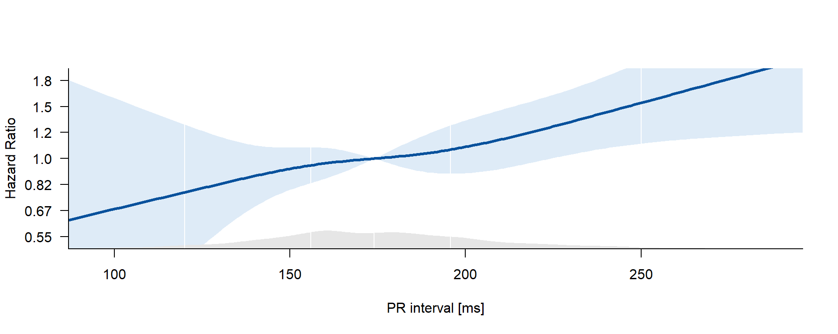
B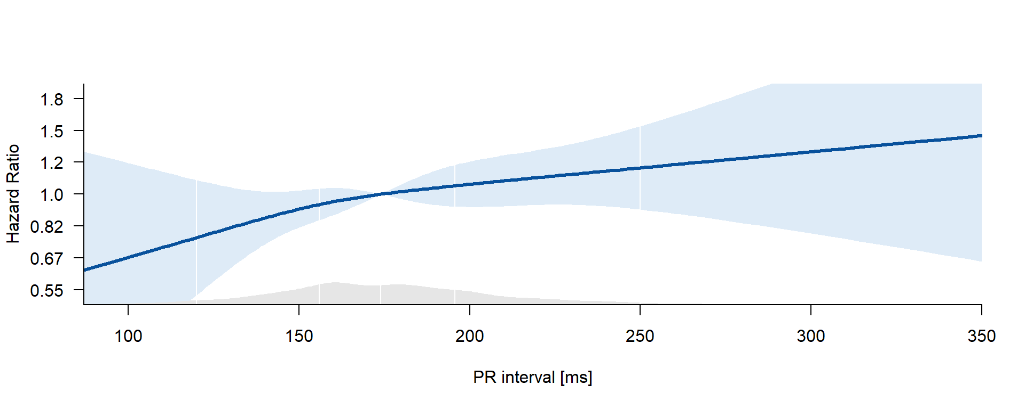
PR interval and Outcome. First primary outcome (A), a composite of cardiovascular death, stroke, or unplanned hospitalization for heart failure or acute coronary syndrome, and recurrent AF (B) is associacted with PR interval shown as Hazard Ratio (HR) from Cox regression in this study population. .
Supplemental Figure 2:
A 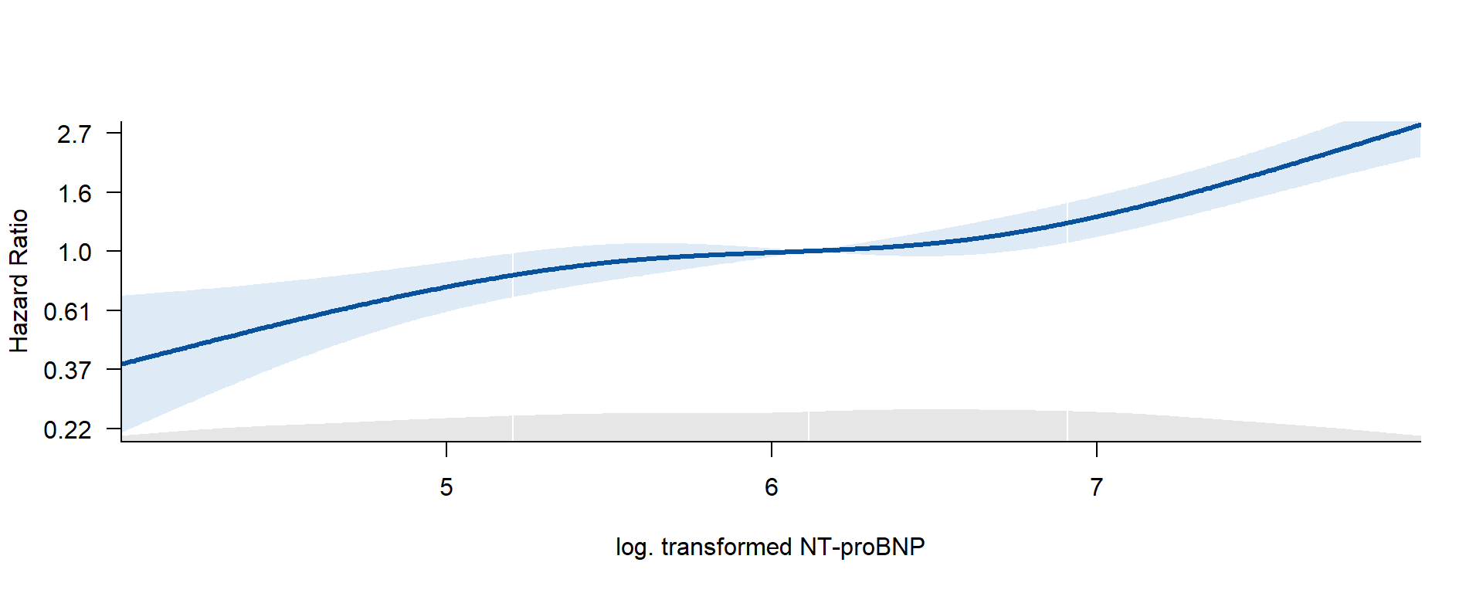B 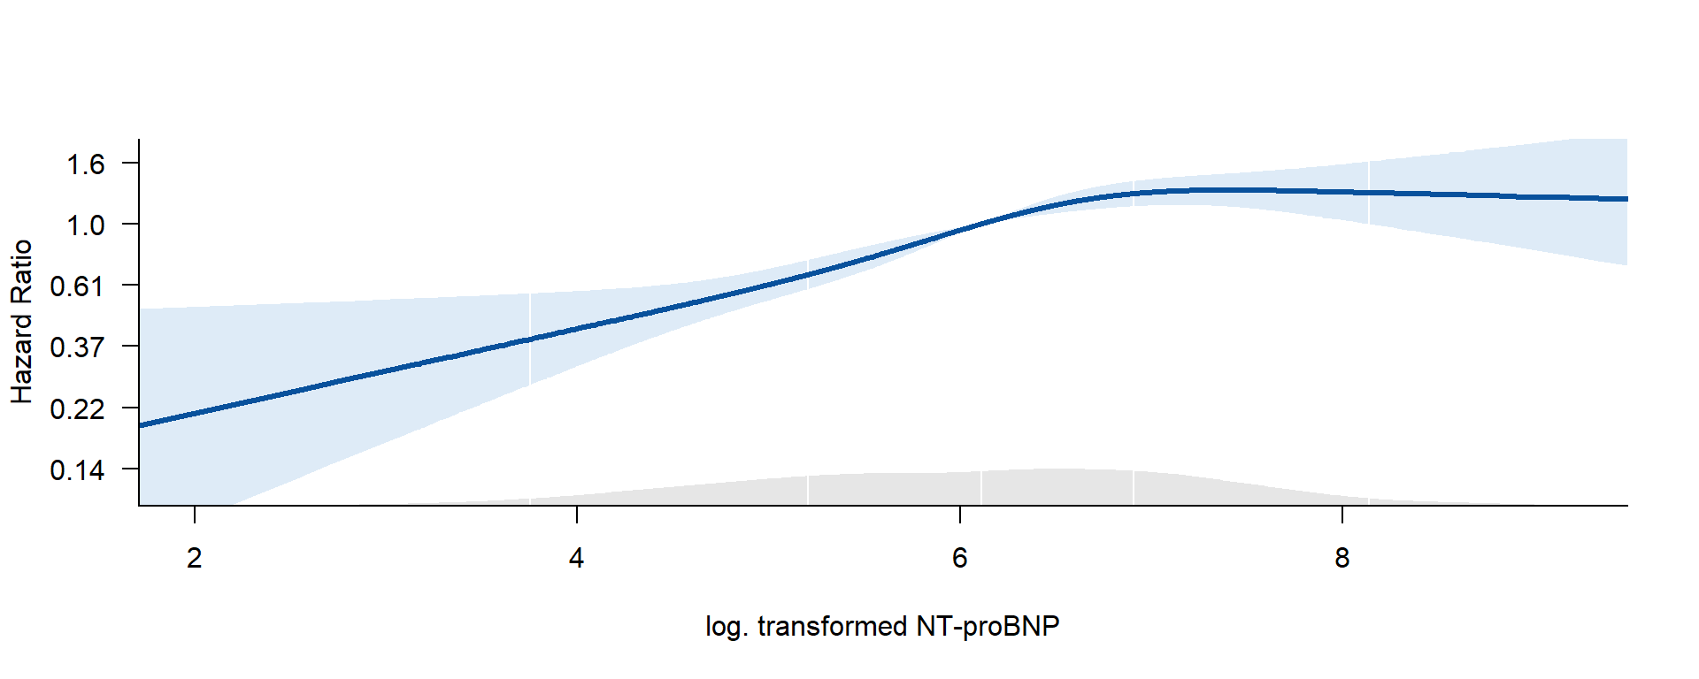
NT-proBNP and Outcome. First primary outcome (A), a composite of cardiovascular death, stroke, or unplanned hospitalization for heart failure or acute coronary syndrome, and recurrent AF (B) is associacted with NT-proBNP shown as Hazard Ratio (HR) from Cox regression in this study population. .
Supplemental Figure 3:
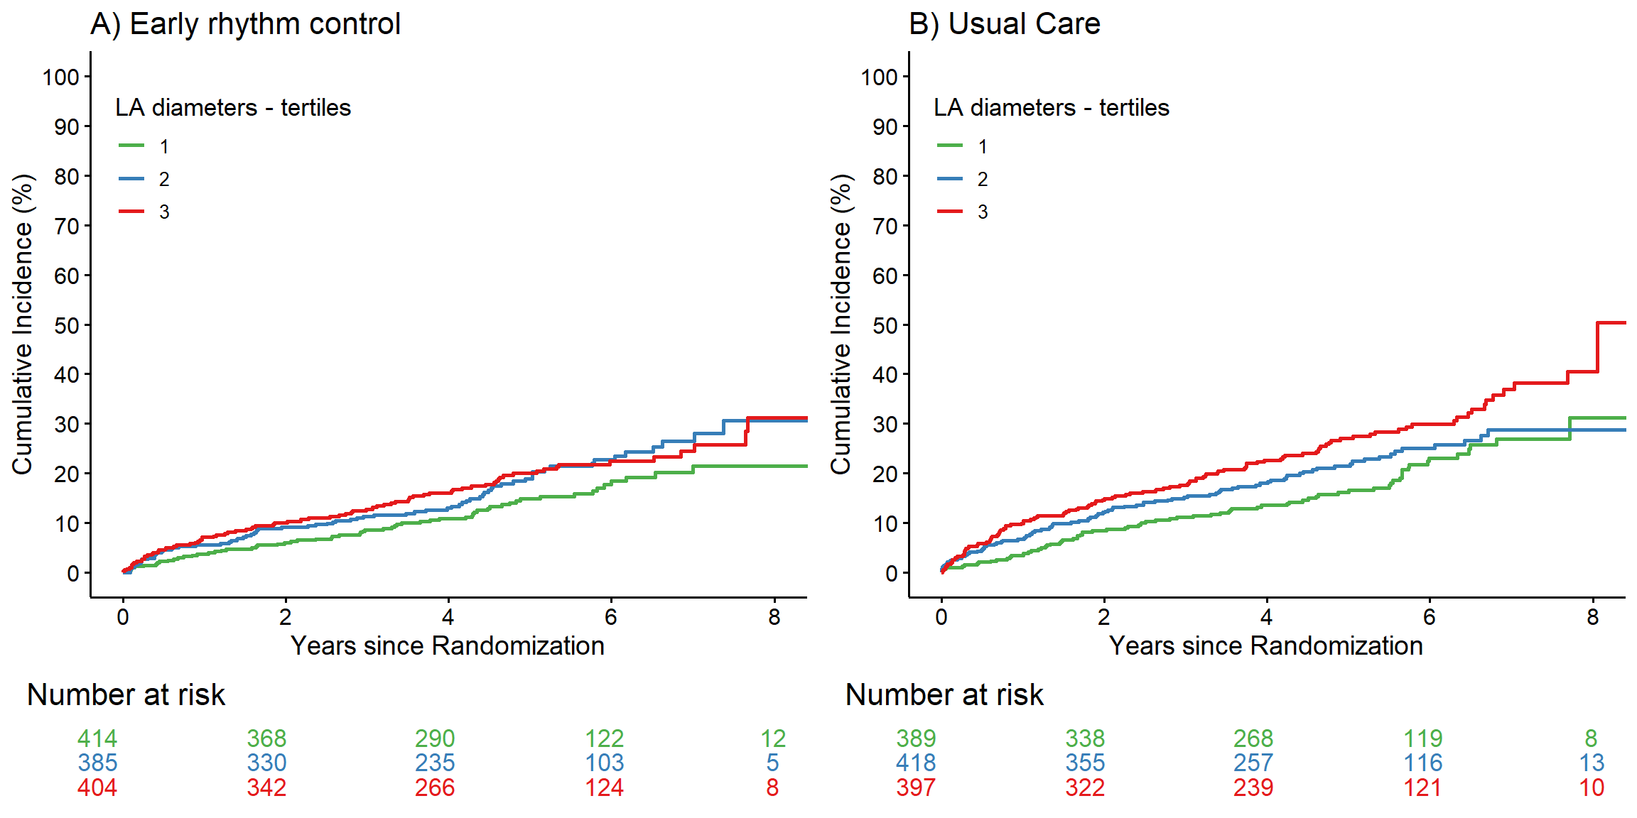
S-Figure 3: Aalen-Johnsen Cumulative Curves for first primary outcome, a composite of cardiovascular death, stroke, or unplanned hospitalization for heart failure or acute coronary syndrome, dependent on LA size in tertiles stratified by treatment group (A, Early rhythm control and B, Usual care).
Classification of atrial cardiomyopathy by LA-diameter, NT-proBNP and PR-interval:
none: all parameter in lower tertile
mild: all combination in lower and middle tertile
intermediate: one or two parameter in the upper tertile
severe: all parameter in upper tertile

Supplemental Figure 4:
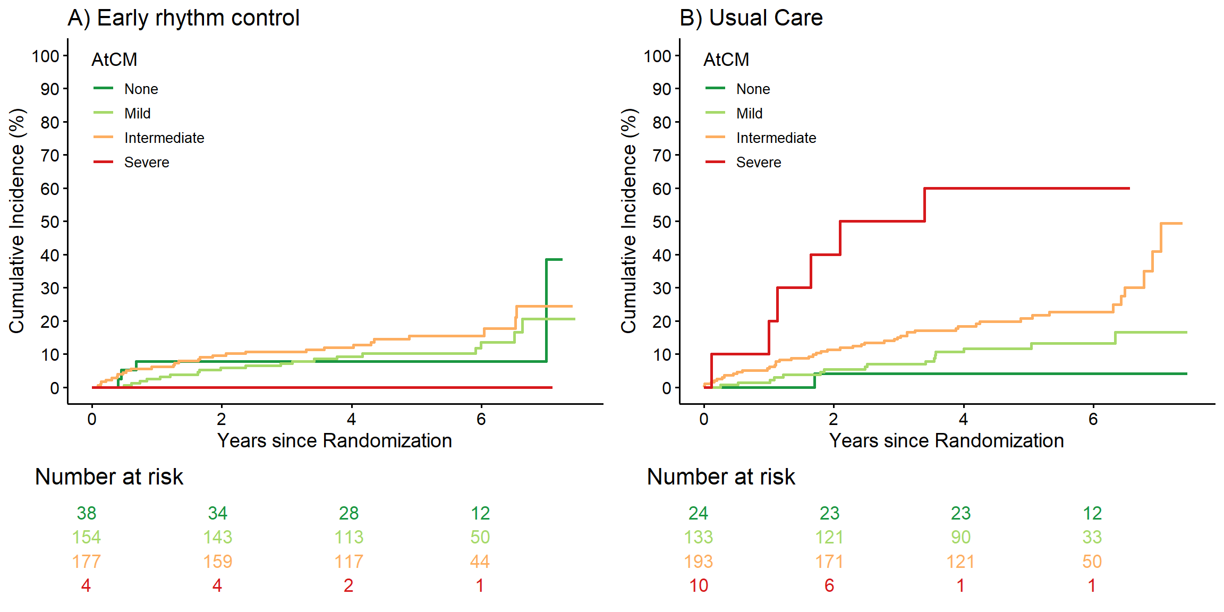
S-Figure 4: (A) Aalen-Johnsen Cumulative Curves for first primary outcome, a composite of cardiovascular death, stroke, or unplanned hospitalization for heart failure or acute coronary syndrome, dependent on severity of atrial cardiomyopathyAtrial cardiomyopathy stratified to treatment group (A, Early rhythm control and B, Usual care).
Classification of atrial cardiomyopathy by LA-diameter, NT-proBNP and PR-interval:
none: all parameter in lower tertile
mild: all combination in lower and middle tertile
intermediate: one or two parameter in the upper tertile
severe: all parameter in upper tertile
Supplemental Figure 5:
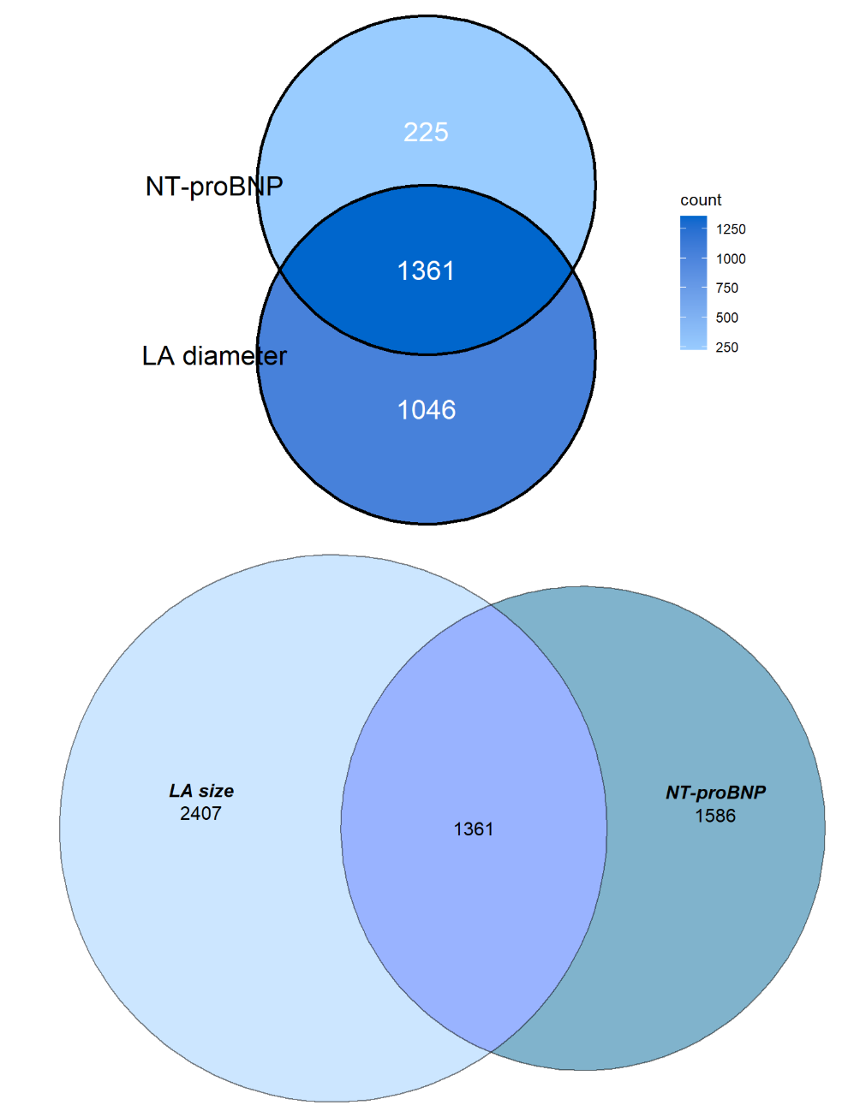

1361 patients have values for the two parameters (LA size by gender, NT-proBNP).
Classification of atrial cardiomyopathy by LA-diameter, NT-proBNP (and without PR-interval):
none: lower tertile of LA size and NT-proBNP
mild: all combination of LA size and NT-proBNP in lower and middle tertile
intermediate: LA size or NT-proBNP in the upper tertile
severe: upper Tertile of LA size and NT-proBNP

Supplemental Figure 6:

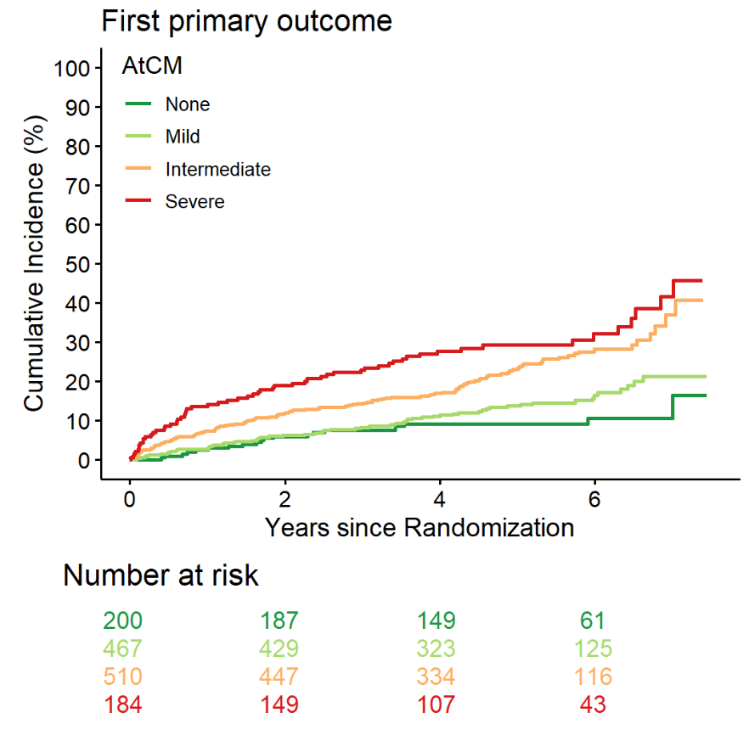

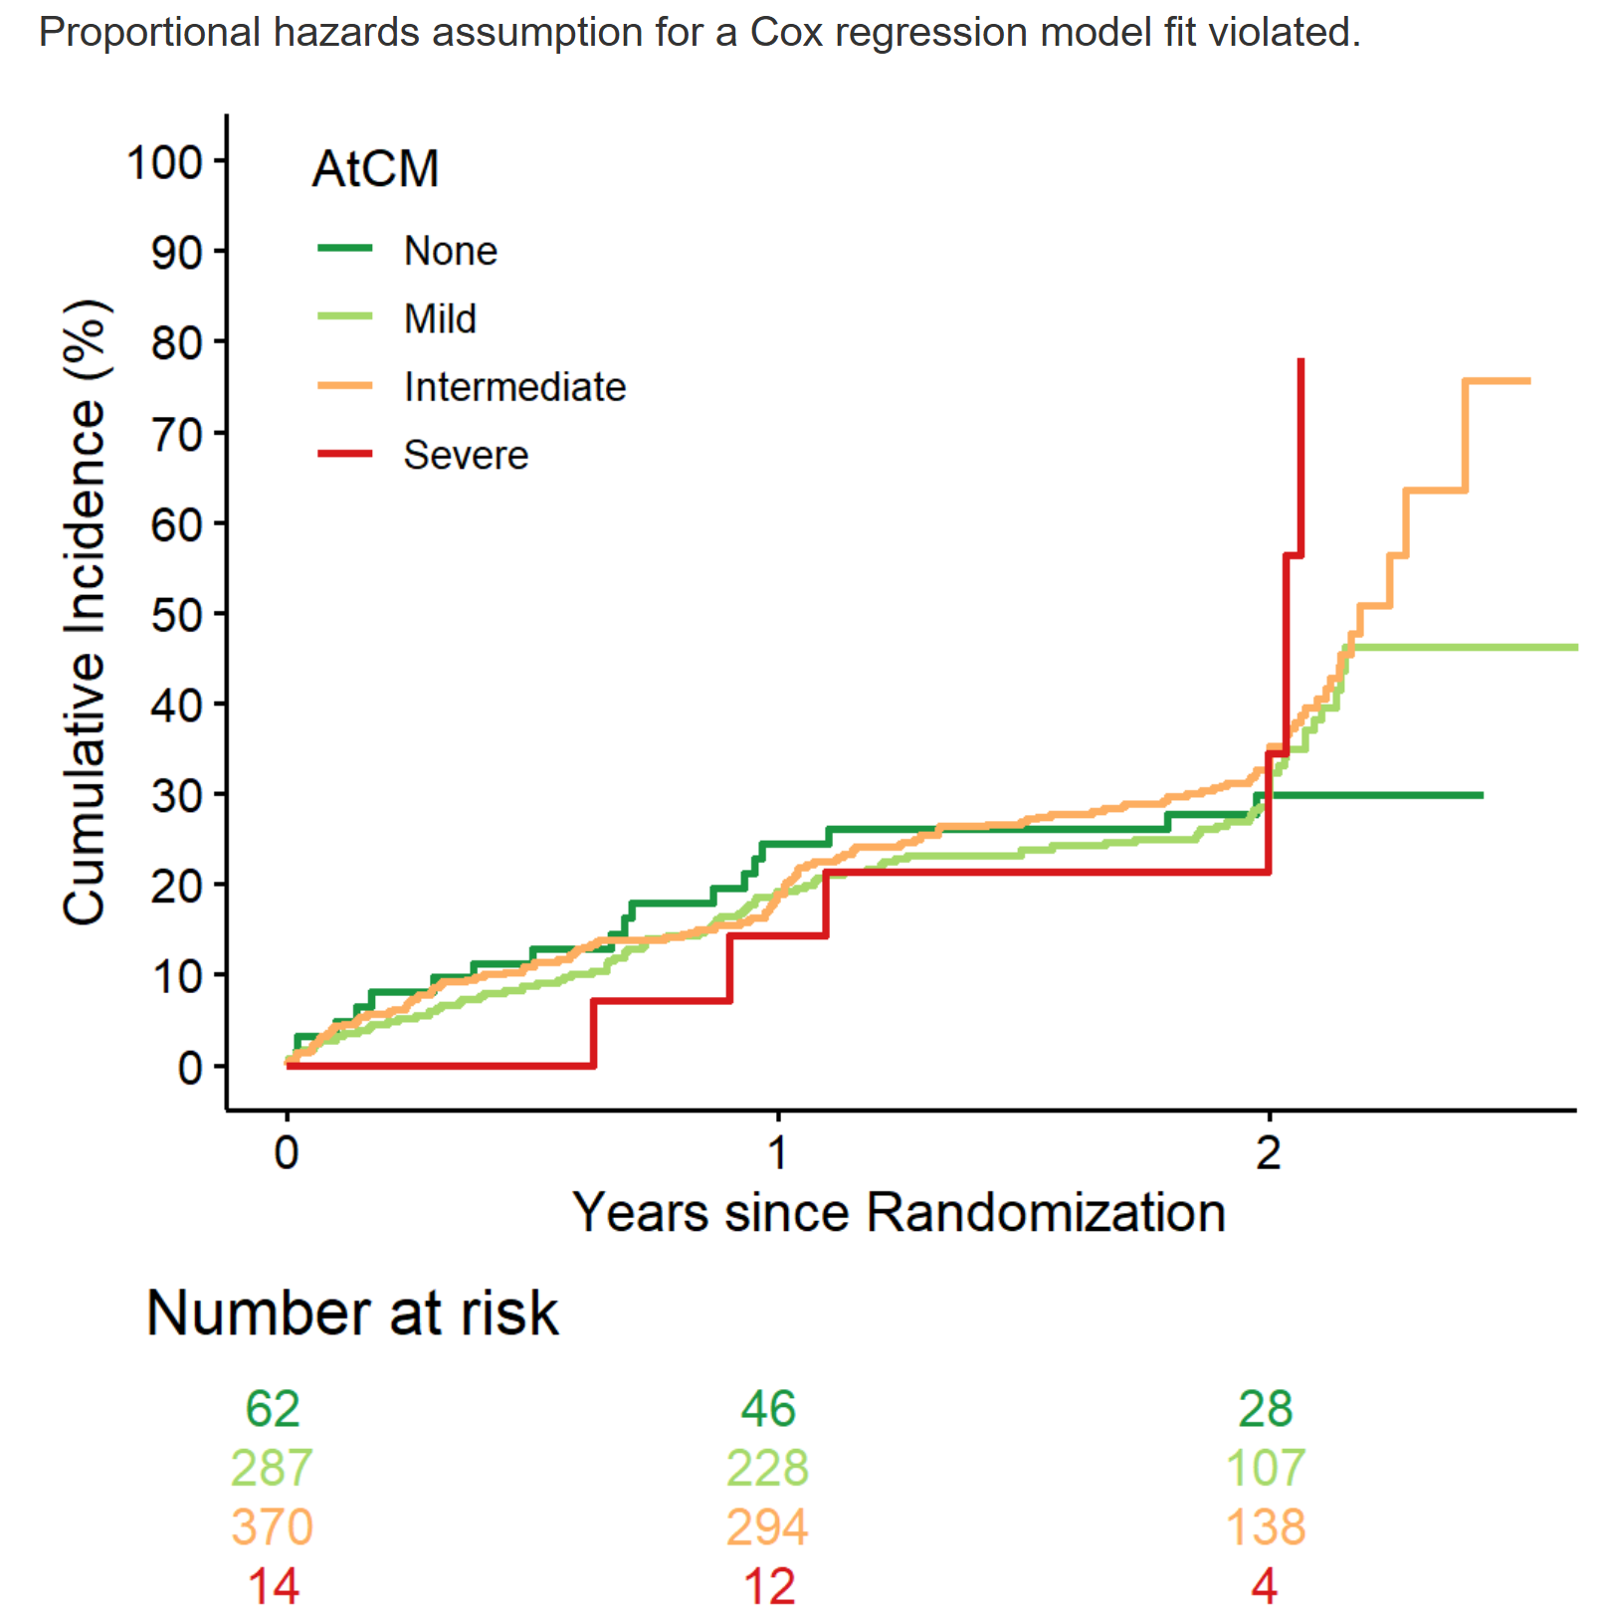
S-Figure 4: (A) Aalen-Johnsen Cumulative Curves for first primary outcome dependent on severity of atrial cardiomyopathy defined by LA-diameter and NT-proBNP.
Classification of atrial cardiomyopathy by LA-diameter, NT-proBNP (and without PR-interval):
none: lower tertile of LA size and NT-proBNP
mild: all combination of LA size and NT-proBNP in lower and middle tertile
intermediate: LA size or NT-proBNP in the upper tertile
severe: upper Tertile of LA size and NT-proBNP

S-Table 1. Baseline characteristics of patients stratified by atrial cardiomyopathy severity³.
Characteristic | Overall  N = 733¹ | Atrial cardiomyopathy (LA-diameter, NT-proBNP, PR-Interval)³ |  |  |  | p-value²
Characteristic | Overall  N = 733¹ | None  N = 62 (8.5%)¹ | Mild  N = 287 (39%)¹ | Intermediate  N = 370 (50%)¹ | Severe  N = 14 (1.9%)¹ | p-value²
Age |  |  |  |  |  | 0.006
Mean (SD) | 70 (8) | 68 (8) | 70 (9) | 71 (8) | 75 (6)
Median (Q1, Q3) | 71 (66, 76) | 69 (66, 75) | 70 (65, 76) | 71 (66, 76) | 78 (69, 79)
Min, Max | 39, 94 | 49, 83 | 39, 94 | 46, 91 | 63, 83
Gender |  |  |  |  |  | 0.13
Female | 377/733 (51%) | 34/62 (55%) | 159/287 (55%) | 175/370 (47%) | 9/14 (64%)
Male | 356/733 (49%) | 28/62 (45%) | 128/287 (45%) | 195/370 (53%) | 5/14 (36%)
Body Mass Index [kg/m²] |  |  |  |  |  | 0.012
Mean (SD) | 29.1 (5.2) | 27.3 (4.4) | 28.9 (5.5) | 29.5 (5.1) | 28.9 (4.0)
Median (Q1, Q3) | 28.7 (25.5, 31.6) | 26.3 (24.5, 30.5) | 28.1 (25.4, 31.3) | 29.2 (26.1, 32.4) | 27.7 (25.8, 32.8)
Min, Max | 15.9, 53.1 | 19.1, 43.4 | 18.5, 52.6 | 15.9, 53.1 | 22.9, 35.2
Diabetes mellitus | 177/733 (24%) | 11/62 (18%) | 64/287 (22%) | 101/370 (27%) | 1/14 (7.1%) | 0.10
CAD | 113/733 (15%) | 7/62 (11%) | 41/287 (14%) | 61/370 (16%) | 4/14 (29%) | 0.37
LVEF < 50% | 47/731 (6.4%) | 1/62 (1.6%) | 15/286 (5.2%) | 30/369 (8.1%) | 1/14 (7.1%) | 0.24
NYHA classification |  |  |  |  |  | <0.001
0 | 548/733 (75%) | 56/62 (90%) | 221/287 (77%) | 266/370 (72%) | 5/14 (36%)
I | 73/733 (10.0%) | 3/62 (4.8%) | 31/287 (11%) | 39/370 (11%) | 0/14 (0%)
II | 91/733 (12%) | 3/62 (4.8%) | 30/287 (10%) | 52/370 (14%) | 6/14 (43%)
III | 21/733 (2.9%) | 0/62 (0%) | 5/287 (1.7%) | 13/370 (3.5%) | 3/14 (21%)
Type of atrial fibrillation |  |  |  |  |  | <0.001
First episode | 277/733 (38%) | 28/62 (45%) | 105/287 (37%) | 140/370 (38%) | 4/14 (29%)
Paroxysmal | 369/733 (50%) | 31/62 (50%) | 161/287 (56%) | 172/370 (46%) | 5/14 (36%)
Persistent | 87/733 (12%) | 3/62 (4.8%) | 21/287 (7.3%) | 58/370 (16%) | 5/14 (36%)
Median days since AF diagnosis (IQR) |  |  |  |  |  | 0.97
Mean (SD) | 79 (92) | 78 (97) | 81 (95) | 78 (89) | 70 (97)
Median (Q1, Q3) | 46 (10, 113) | 43 (12, 91) | 47 (11, 121) | 46 (9, 112) | 22 (6, 143)
Min, Max | 0, 618 | 0, 403 | 0, 618 | 0, 415 | 1, 299
Absence of atrial fibrillation symptoms | 215/685 (31%) | 18/59 (31%) | 93/265 (35%) | 99/348 (28%) | 5/13 (38%) | 0.24
Planned therapy for rhythm control at baseline |  |  |  |  |  | 0.013
AAD | 361/733 (49.25%) | 34/62 (54.84%) | 152/287 (52.96%) | 170/370 (45.95%) | 5/14 (35.71%)
Ablation | 13/733 (1.77%) | 4/62 (6.45%) | 1/287 (0.35%) | 8/370 (2.16%) | 0/14 (0.00%)
None | 359/733 (48.98%) | 24/62 (38.71%) | 134/287 (46.69%) | 192/370 (51.89%) | 9/14 (64.29%)
AAD= antiarrhythmic drug; CAD = coronary artery disease; LVEF=left ventricular ejection fraction.
¹ Mean (SD) or Frequency with no./total no. (%)
² p-values resulting from mixed linear regression models for metric variables and mixed (multinomial or ordinal) logistic regression models for categorical variables. For categorical variables with more than two categories (not ordinal) Pearson’s Chi-squared Test or Fisher’s Exact Test was used.
³ Classification of atrial cardiomyopathy by LA-diameter, NT-proBNP and PR-interval:
none: all parameter in lower tertile
mild: all combination in lower and middle tertile
intermediate: one or two parameter in the upper tertile
severe: all parameter in upper tertile

Supplemental Table 2. Safety outcomes stratified tertiles of left atrial size.

 | Early rhythm control |  |  | Usual care
 | T1 | T2 | T3 | T1 | T2 | T3 | p-value interaction
n | 414 | 385 | 404 | 389 | 418 | 397
Primary composite safety outcome | 63 (15.2) | 59 (15.3) | 80 (19.8) | 58 (14.9) | 65 (15.6) | 79 (19.9) | 0.911
Stroke | 13 ( 3.1) | 9 ( 2.3) | 13 ( 3.2) | 19 ( 4.9) | 21 ( 5.0) | 20 ( 5.0) | 0.978
Death | 37 ( 8.9) | 37 ( 9.6) | 47 (11.6) | 41 (10.5) | 47 (11.2) | 59 (14.9) | 0.78
Serious adverse event of special interest related to rhythm control therapy | 16 ( 3.9) | 17 ( 4.4) | 27 ( 6.7) | 6 ( 1.5) | 4 ( 1.0) | 6 ( 1.5) | 0.378

Supplemental Table 3. Distribution of atrial cardiomyopathy (LA size & NTproBNP)

atrCM | Early rhythm control | Usual care | Total
None | 38 (10%) | 24 (6.7%) | 62 (8.5%)
Mild | 154 (41%) | 133 (37%) | 287 (39%)
Intermediate | 177 (47%) | 193 (54%) | 370 (50%)
Severe | 4 (1.1%) | 10 (2.8%) | 14 (1.9%)
Total | 373 (100%) | 360 (100%) | 733 (100%)

Classification of atrial cardiomyopathy by LA-diameter, NT-proBNP (and without PR-interval):
none: lower tertile of LA size and NT-proBNP
mild: all combination of LA size and NT-proBNP in lower and middle tertile
intermediate: LA size or NT-proBNP in the upper tertile
severe: upper Tertile of LA size and NT-proBNP

S-Table 4 Baseline characteristics per atrial cardiomyopathy(LA size & NTproBNP)

Characteristic | Overall (N=1361) | None (N=200, 15%) | Mild (N=467, 34%) | Intermediate (N=510, 37%) | Severe (N=184, 14%) | p-value
Age - Mean (SD) | 70 (8) | 69 (8) | 70 (8) | 71 (8) | 71 (8) | <0.001
Age - Median (Q1, Q3) | 71 (66,76) | 69 (65,75) | 71 (66,76) | 72 (67,76) | 72 (67,77)
Age - Min, Max | 39, 94 | 48, 91 | 39, 94 | 42, 91 | 48, 88
Gender - Female | 616/1361 (45%) | 91/200 (46%) | 222/467 (48%) | 219/510 (43%) | 84/184 (46%) | 0.63
Gender - Male | 745/1361 (55%) | 109/200 (55%) | 245/467 (52%) | 291/510 (57%) | 100/184 (54%)
BMI - Mean (SD) | 29.4 (5.4) | 28.2 (4.8) | 29.2 (5.2) | 29.6 (5.4) | 30.4 (6.3) | <0.001
BMI - Median (Q1, Q3) | 28.7 (25.5,32.4) | 27.5 (25.0,30.9) | 28.7 (25.6,31.7) | 29.2 (25.6,33.0) | 29.4 (25.9,33.6)
BMI - Min, Max | 15.9, 58.2 | 15.9, 51.3 | 16.8, 52.6 | 16.6, 53.1 | 19.0, 58.2
Diabetes mellitus | 339/1361 (25%) | 39/200 (20%) | 121/467 (26%) | 133/510 (26%) | 46/184 (25%) | 0.23
CAD | 222/1361 (16%) | 23/200 (12%) | 73/467 (16%) | 89/510 (17%) | 37/184 (20%) | 0.12
LVEF < 50% | 171/1352 (13%) | 3/198 (1.5%) | 35/466 (7.5%) | 80/505 (16%) | 53/183 (29%) | <0.001
NYHA 0 | 922/1361 (68%) | 176/200 (88%) | 336/467 (72%) | 326/510 (64%) | 84/184 (46%) | <0.001
NYHA I | 156/1361 (11%) | 14/200 (7%) | 47/467 (10%) | 67/510 (13%) | 28/184 (15%)
NYHA II | 238/1361 (17%) | 8/200 (4%) | 71/467 (15%) | 99/510 (19%) | 60/184 (33%)
NYHA III | 45/1361 (3.3%) | 2/200 (1%) | 13/467 (2.8%) | 18/510 (3.5%) | 12/184 (6.5%)
AF Type - First episode | 475/1361 (35%) | 81/200 (41%) | 171/467 (37%) | 176/510 (35%) | 47/184 (26%) | <0.001
AF Type - Paroxysmal | 490/1361 (36%) | 109/200 (55%) | 208/467 (45%) | 143/510 (28%) | 30/184 (16%)
AF Type - Persistent | 396/1361 (29%) | 10/200 (5%) | 88/467 (19%) | 191/510 (37%) | 107/184 (58%)
Median days since AF diagnosis - Mean (SD) | 86 (185) | 79 (102) | 81 (164) | 93 (239) | 89 (121) | 0.50
Median days since AF diagnosis - Median (Q1,Q3) | 44 (9,113) | 38 (9,104) | 39 (8,106) | 50 (10,118) | 46 (13,121)
Median days since AF diagnosis - Min,Max | 0,4586 | 0,426 | 0,2739 | 0,4586 | 0,1148
Absence of AF symptoms | 429/1277 (34%) | 58/189 (31%) | 156/434 (36%) | 161/478 (34%) | 54/176 (31%) | 0.49
Planned therapy - AAD | 647/1361 (47.5%) | 112/200 (56%) | 233/467 (49.9%) | 215/510 (42.2%) | 87/184 (47.3%) | <0.001
Planned therapy - Ablation | 45/1361 (3.3%) | 6/200 (3%) | 5/467 (1.1%) | 21/510 (4.1%) | 13/184 (7.1%)
Planned therapy - None | 669/1361 (49.2%) | 82/200 (41%) | 229/467 (49%) | 274/510 (53.7%) | 84/184 (45.7%)
1 Mean (SD) or Frequency with no./total no. (%)
2 p-values resulting from mixed linear regression models for metric variables and mixed (multinomial or ordinal) logistic regression models for categorical variables. For categorical variables with more than two categories (not ordinal) Pearson’s Chi-squared Test or Fisher’s Exact Test was used.
Classification of atrial cardiomyopathy by LA-diameter, NT-proBNP (and without PR-interval):
none: lower tertile of LA size and NT-proBNP
mild: all combination of LA size and NT-proBNP in lower and middle tertile
intermediate: LA size or NT-proBNP in the upper tertile
severe: upper Tertile of LA size and NT-proBNP

S-Table 5. Primary outcome for severy of atrial cardiomyopathy based on LA-size and NT-proBNP
Hazard Ratios per atrial Cardiomyopathy
Atrial cardiomyopathy | HR per SD | 95%-CI | p value
None | Ref
Mild | 1.59 | [0.62 , 4.08] | 0.339
Intermediate | 2.8 | [1.12 , 6.99] | 0.027
Severe | 7.97 | [2.32 , 27.37] | 0.001
Note:
Anova test p-value: 0.0005
Classification of atrial cardiomyopathy by LA-diameter, NT-proBNP (and without PR-interval):
none: lower tertile of LA size and NT-proBNP
mild: all combination of LA size and NT-proBNP in lower and middle tertile
intermediate: LA size or NT-proBNP in the upper tertile
severe: upper Tertile of LA size and NT-proBNP

S-Table 6. AF recurrence for severity of atrial cardiomyopathy based on LA-size and NT-proBNP

Atrial cardiomyopathy | HR per SD | 95%-CI | p value
None | Ref
Mild | 1.49 | [1.12 , 1.99] | 0.006
Intermediate | 1.96 | [1.48 , 2.59] | <0.001
Severe | 2.75 | [2.01 , 3.78] | <0.001
Note: Anova test p-value: 0.0005
Cox Regression for Recurrent AF ~ AtrCM + frailty term
Atrial cardiomyopathy | HR per SD | 95%-CI | p value
None/Mild | Ref
Intermediate/Severe | 2.14 | [1.7 , 2.7] | <0.001
Note: Anova test p-value: 0
Classification of atrial cardiomyopathy by LA-diameter, NT-proBNP (and without PR-interval):
none: lower tertile of LA size and NT-proBNP
mild: all combination of LA size and NT-proBNP in lower and middle tertile
intermediate: LA size or NT-proBNP in the upper tertile
severe: upper Tertile of LA size and NT-proBNP

