Exploring geographical differences in IgE response through network and manifold analyses

Alex Cucco MSc^{1,2}, Neil Pearce PhD³, Angela Simpson MD PhD⁴, Lucy Pembrey PhD³, Harriet Mpairwe PhD⁵, Camila A Figueiredo PhD⁶, Philip J. Cooper PhD^{7,8,9}, Jeroen Douwes PhD¹⁰,Collin Brooks PhD¹⁰, Ian M Adcock PhD¹, Nazanin Zounemat Kermani PhD¹, Graham DM Roberts MD PhD¹¹, Clare S Murray MD⁴, Adnan Custovic MD PhD FMedSci^{1*}‡, Sara Fontanella PhD¹‡, the WASP Study group, and the U-BIOPRED study team, Consortium

¹National Heart and Lung Institute, Imperial College London, London,
²Department of Socio-Economic, Managerial, and Statistical Studies, University “G. d’Annunzio” of Chieti-Pescara, Pescara, Italy

³Department of Medical Statistics, London School of Hygiene & Tropical Medicine, London, UK.

⁴Faculty of Biology, Medicine and Health, University of Manchester, Manchester, UK.
⁵ MRC/UVRI and LSHTM Uganda Research Unit, Entebbe, Uganda
⁶ Federal University of Bahia, Salvador, Brazil
⁷ Fundacion Ecuatoriana Para Investigacion en Salud, Quito, Ecuador
⁸School of Medicine, Universidad Internacional del Ecuador, Quito, Ecuador
⁹Institute of Infection and Immunity, St George’s University of London, London, UK
¹⁰ Centre for Public Health research, Massey University, Wellington, New Zealand

¹¹Human Development and Health, Faculty of Medicine, University of Southampton, Southampton, U.K

Online Supplementary Materials

METHODS
Study populations
WASP
Study design: Detailed study methods have been published elsewhere (1). The study was conducted in five centres: Bristol, UK (Avon Longitudinal Study of Parents and Children, ALSPAC)(2-4); Wellington, New Zealand; Salvador, Brazil; Quininde, Ecuador; and Entebbe, Uganda. Recruitment methods differed by centre: in four centres (Brazil(5) Ecuador, New Zealand (6) and the United Kingdom (2-4)), participants were recruited from ongoing cohort studies, and in three of these (Brazil, Ecuador, New Zealand) additional recruitment was through the community (usually from surveys in schools). Participants in Bristol, UK, were recruited from the ALSPAC birth cohort. For ALSPAC, pregnant women resident in Avon, UK with expected dates of delivery between 1st April 1991 and 31st December 1992 were invited to take part in the study. Of the 14,901 children alive at 1 year of age who were still in follow-up at age 22 years, those with and without a history of asthma based on longitudinal questionnaire data on symptoms and reported diagnosis of asthma were identified. Participants were then screened to identify those with current asthma (cases) or to confirm no history of asthma (controls) for inclusion in the WASP study. Study data were collected and managed using REDCap electronic data capture tools hosted at the University of Bristol. REDCap (Research Electronic Data Capture)(7) is a secure, web-based software platform designed to support data capture for research studies. Please note that the study website contains details of all the data that is available through a fully searchable data dictionary and variable search tool; http://www.bristol.ac.uk/alspac/researchers/our-data/. Consent for biological samples has been collected in accordance with the Human Tissue Act (2004). In Uganda, participants were recruited from a larger case-control study of asthmatics and non-asthmatics identified through a cross-sectional survey in schools(8).
Screening and recruitment: Subjects with chronic disease (except asthma) or who were pregnant were excluded from the study. Current asthma was defined as wheeze or whistling in the chest and/or use of asthma medication in the past 12 months, using the ISAAC questionnaire(9). Non-asthmatics had no history of asthma, using the same questionnaire. The study clinic appointment was postponed if participants had an acute exacerbation of asthma or a symptomatic respiratory infection in the last 4 weeks. All participants were asked to stop taking anti-histamines (5 days prior), steroid nasal sprays (7 days prior) and non-steroidal anti-inflammatories (NSAIDs) for 6 hours prior to visit. Asthmatics were asked to stop their asthma medication if safe to do so: no cromoglycate, nedocromil, short acting beta-agonists, ipratroprium bromide for 6 hours prior to visit, no long acting beta-agonists for 12 hours prior to visit, and no theophyllines for 24 hours prior to visit.
Manchester Asthma and Allergy Study
Study design: The Manchester Asthma and Allergy Study (MAAS) is an unselected birth cohort; participants were recruited prenatally and followed prospectively. The study was approved by the Research Ethics Committee; parents gave written informed consent.
Screening & Recruitment: All pregnant women were screened for eligibility at antenatal visits (8th-10th week of pregnancy) between 1995 and 1997. Of the 1499 couples who met the inclusion criteria (<10 weeks of pregnancy, maternal age >18 years), 288 declined to take part and 27 were lost to follow-up between recruitment and birth of a child. A total of 1184 participants had some evaluable data (10).
Follow-up: Children have been followed prospectively and attended review clinics at ages 1, 3, 5, 8, 11, 16 and 20 years(10). In this analysis, we used data collected at the follow-up at age 11 years. We carried out home visits for study participants who could not attend clinic appointments. Validated questionnaires were interviewer-administered to collect information on parentally reported symptoms, physician-diagnosed diseases, and treatments received. Blood samples were collected from participants who gave assent.
Asthma severity definition in MAAS and WASP
Symptoms of severe asthma are defined as those with current wheeze who, according to the written questionnaire, in the past 12 months, have had >4 attacks of wheeze, or >1 night per week sleep disturbance from wheeze, or wheeze affecting speech. Non wheezers and wheezers with none of the other characteristics were considered as non-severe.
Unbiased Biomarkers for the Prediction of Respiratory Disease Outcomes (U-BIOPRED)
U-BIOPRED project is a European Union consortium of academic institutions, pharmaceutical companies and patient organizations.
Clinical assessment: Baseline data included demographics plus detailed asthma and atopic disease histories. Asthma control was assessed using the Asthma Control Test (ACT) (for adults, children ≥12 years) or Childhood Asthma Control Test (cACT) (children <12 years). Non-scheduled healthcare utilisation was assessed using exacerbations. QoL was assessed using the Asthma Quality of life Questionnaire (adult), Paediatric Asthma Quality of Life Questionnaire (PAQLQ) (school-aged children) and the Paediatric Asthma Caregiver’s Quality of Life Questionnaire (PACQLQ). Spirometry and fraction of exhaled nitric oxide level (FeNO) were performed.
Mild/moderate school-aged asthma cohorts had controlled, or partly-controlled asthma treated with low-dose inhaled corticosteroids (ICS).
Measurement of component-specific IgE antibodies
For analyses across all studies in the WASP consortium (UK, New Zealand, Brazil, Ecuador and Uganda), we used the updated version of the CRD microarray which contains c-sIgE to galactose-alpha-1,3-galactose (alpha-gal). In MAAS, we used both the original and updated test, while the original array was used in U-BIOPRED.

STATISTICAL ANALYSIS
Hierarchical clustering
The principal aim of this analysis was to ascertain the generalisability of the sensitisation and C-sIgEs clusters(11, 12) to diverse populations The rationale behind fixing the number of sensitisation clusters at four was to facilitate a direct comparison of the sensitisation profiles across varied demographic and environmental contexts.
Fundamental Network Concepts
1. Graph Structure:
A graph is defined by two main components: a set of vertices, also known as nodes, and a collection of edges. The vertices are the individual points within the graph, while the edges are the pairs of vertices that connect these points, represented visually as lines between nodes. When two vertices are connected by an edge, they are referred to as adjacent or neighbours, and the edge is said to be incident to those vertices.
2. Network Types:
Networks can be classified as either directed or undirected. In undirected networks, the relationship between neighbouring nodes is mutual, meaning the nodes can be considered interchangeably. In contrast, directed networks assign an orientation to the connections, where the order of the node pairs matters, and directed edges are typically illustrated as arrows. When edges in a network have varying weights, indicating different levels of connection, the network is described as weighted.
Common Network Measures
- Strength: This measure indicates the number of direct connections a node has with other nodes in the network.
- Closeness: Closeness reflects how efficiently a node can access all other nodes in the network, based on the average shortest path distance from that node to all others.
- Betweenness: Betweenness quantifies the extent to which a node acts as an intermediary on the shortest paths between other nodes, highlighting nodes that serve as crucial links within the network.
Additional Network Characteristics
- Size of the Graph: Refers to the total number of edges within the graph.
- Density: This is the ratio between the number of actual edges and the number of potential edges that could exist in the network.
- Centrality Measures: These are used to identify the most significant nodes within a network:
- Node Strength: Calculated as the sum of the absolute values of all connections a node has with other nodes, reflecting the total weight of edges linked to that node.
- Closeness: Measures the average distance from one node to all others, with higher centrality indicating closer proximity to other nodes in the network.
- Betweenness: A measure of how frequently a node lies on the shortest path between other nodes, indicating its role as a bridge within the network.
Principal Component Analysis for Network Data and Projection of networks into a low-dimensional Euclidean space(13)
In this section we briefly summarise the rational of the technique utilised to embed the sets of networks into a lower dimensional Euclidean space. To this end it is crucial to understand the geometry of the space in which a specific data point lies. In particular, it is common to think of a data point as point in an Euclidean space, although, this is an oversimplification of the reality and a data point can rely on different types of spaces with different curvatures and shapes. More precisely the data may rely on, or be close to a manifold. A classic example of data relying on a manifold is the Swiss-roll case (Figure S1).
Figure S1: Swiss roll
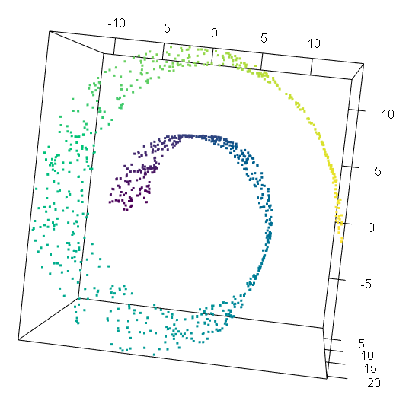
In this case, although the data are embedded in a 3-D Euclidean space, it is straight forward to recognise that the observations rely on a 2-D dimensional manifold (a plane) which has just been ‘rolled-up’. The application of standard techniques such as PCA are well known to perform poorly on this type of data due to the underlying use of the Euclidean metric, which in this case is not able to capture the local and global geometry of the space. However, other techniques, able to recognise and reconstruct the geometry of the manifold can identify the intrinsic geometry of the real space in which the data relies on. The Swiss-roll is probably the most famous example to support the idea that understanding the geometry of the space in which the data relies on is crucial.
This concept is even more relevant when dealing with complex objects such as networks or shapes. In our work we aimed to obtain a Euclidean representation of a set of networks, this means that starting from a specific object (a sets of adjacency matrices representing a set of graphs), we aim to obtain a sets of Euclidean coordinates for each of these adjacency matrices. Figure S2 summarise the key idea of this process. Given a set of graphs, we would like to represent them as points in a Euclidean space, such that the similarities between the networks are preserved.
To obtain the Euclidean coordinates, we rely on the properties of the Laplacian matrix, in particular the semi-positive definite nature of the Laplacian following (13). In fact, given a set of $k$graphs $G_{1},G_{2},…,G_{k}$ it is straight forward to identify the non-Euclidean nature of this type of data. Moreover, due to the semi-positive definite nature of each associated Laplacian $L_{1},L_{2},…,L_{k}$ it is easy to realise that each Laplaccian is a point relying on a specific manifold: a convex subset of a hyper cone. Recognising the geometry of this peculiar space is crucial to propose tailored metrics able to capture the similarities between different objects. We applied the Euclidean power metric following (13).

GLOSSARY OF ANALYTICAL TERMS
 | Term | Description | Interpretation
Network Analysis | Graph | A graph is a mathematical and visual structure used to represent a set of objects (nodes) and the connections (edges) between them. In this context, a graph is used to model relationships between elements such as allergens or individuals.  Nodes (also called vertices)  These represent the individual entities in the system, such as specific c-sIgEs.  Edges (also called links or connections)  These are the lines connecting pairs of nodes, indicating a relationship or interaction between them.  Two nodes are said to be adjacent or neighbours if they are directly connected by an edge. An edge is incident to the nodes it joins. | Visual and structural representation of data relationships.
Network Analysis | Undirected Network | A type of network where the relationships between nodes are mutual. In other words, if node A is connected to node B, then node B is equally connected to node A. The edges do not have a direction, and this is typically used when the interaction is bidirectional or symmetric. | Represents mutual relationships where directionality is irrelevant.
Network Analysis | Directed Network | In a directed network, the relationships between nodes have a specific direction. That means the connection flows from one node to another in a defined order. These are usually visualised as arrows pointing from a source node to a target node and are used when the relationship is not necessarily reciprocal. | Captures directional or one-way interactions between nodes.
Network Analysis | Weighted Network | A network in which each edge is assigned a numerical value (weight) to reflect the strength, frequency, or significance of the connection. For instance, a higher weight may indicate that two allergens co-occur more frequently across participants. | Adds quantitative value to edges to reflect strength or intensity of connections.
Network Analysis | Size | The total number of edges (connections) in the network. It gives a basic indication of how many relationships exist within the network. | Indicates overall volume of relationships.
Network Analysis | Density | A measure of how interconnected the network is. It is calculated as the ratio of the number of actual edges to the maximum number of possible edges. A denser network suggests more frequent or widespread relationships among nodes. | Reflects how closely nodes are linked overall.
Network Analysis | Centrality Measures | These are used to identify the most relevant or influential nodes within a network, based on their position and connectivity. | Highlights key or central nodes in the network.
Network Analysis | Degree | The number of direct connections a node has. It indicates how many other nodes a given node is immediately linked to. | Measures direct connectivity of a node.
Network Analysis | Strength | In weighted networks, strength refers to the sum of the weights of all connections attached to a node. It reflects the overall intensity or importance of that node’s interactions. | Captures intensity of a node‚ its interactions.
Network Analysis | Closeness | This quantifies how close a node is to all other nodes in the network. A node with high closeness can be reached quickly from any other node and may be central in terms of information flow. | Indicates ease of reaching other nodes from a given node.
Network Analysis | Betweenness | A measure of how often a node appears on the shortest paths between other nodes. High betweenness suggests a node acts as a bridge or connector within the network, potentially influencing communication or interaction between different parts of the graph. | Shows a node‚ its role in connecting different parts of the network.
Network Analysis | Shortest Path | The shortest path between two nodes in a network is the route that connects them with the fewest steps or lowest total weight (in a weighted network). It represents the most efficient way to travel from one node to another.  Shortest paths are used in network analysis to understand how easily information or influence can flow between nodes. They are also fundamental for calculating centrality measures such as closeness and betweenness. | Defines the most efficient route between nodes.
Clustering | Clustering | A set of unsupervised learning techniques used to group data points or individuals based on similarity across selected features. Clustering does not rely on pre-labelled data and is often used to discover natural groupings or patterns in a dataset. | Groups similar data points together without the need for predefined categories.
Clustering | Hierarchical Clustering | A clustering method that builds a hierarchy of clusters through either a bottom-up (agglomerative) or top-down (divisive) approach. In agglomerative clustering, each point starts in its own cluster, and the closest pairs are merged step-by-step. The result is a tree-like structure called a dendrogram. | Reveals nested group structures by successively merging or splitting clusters.
Clustering | Dendrogram | A tree diagram used to visualize the results of hierarchical clustering. It shows how clusters are formed by joining smaller clusters based on their similarity, and at what level this joining occurs. The height of each merge reflects the distance or dissimilarity between clusters. | Visual tool that illustrates how clusters merge and at what similarity level.
Clustering | Similarity Matrix | A square matrix that quantifies the similarity (or dissimilarity) between all pairs of data points. It serves as the input for many clustering algorithms, especially hierarchical and spectral clustering. | Provides a numerical foundation for determining how alike each pair of data points is.
Clustering | Jaccard Distance | A measure of dissimilarity between two sets, defined as 1 minus the size of the intersection divided by the size of the union. Often used when data is binary (e.g., presence/absence of sensitisation). | Quantifies how different two binary profiles are—lower values mean more similar.
Clustering | Elbow Method | A heuristic used to determine the optimal number of clusters in a dataset when using clustering algorithms. It involves plotting the total cluster sum of squares against the number of clusters and identifying the point where adding more clusters yields diminishing improvements. This point, which forms an “elbow” shape in the graph, suggests a suitable number of clusters. | Helps identify the ideal number of clusters by finding the point where adding more clusters stops significantly reducing variation within them.
Graph Embedding | Euclidean Space | A standard geometric space characterized by flatness and straight-line distances. It is the space in which we usually visualize data—points are positioned using coordinates, and distance is measured using the Euclidean metric (straight-line distance). | The familiar "flat" space used in most visualisations; assumes simple, linear relationships between data points.
Graph Embedding | Manifold | A manifold is a curved, lower-dimensional surface embedded in a higher-dimensional space. Although the overall space may be complex (non-Euclidean), the manifold is locally similar to a flat (Euclidean) space. | A hidden shape or surface where the data truly resides—understanding it helps reveal the true relationships between data points.
Graph Embedding | Euclidean Space Projection | The process of transforming graphs (or networks) into vector representations in a lower-dimensional Euclidean space, while preserving important structural features such as similarity between graphs. | Represents entire graphs as points in a geometric space so they can be compared, visualized, or clustered more easily.
Graph Embedding | Adjacency Matrix | A matrix used to represent a graph, where each element indicates whether a pair of nodes is connected and possibly how strongly. Each graph in the study is initially represented this way. | A mathematical format for encoding network structure—used as the starting point for embedding
Graph Embedding | Laplacian Matrix | A matrix derived from the adjacency matrix that captures the structure of a graph. It plays a central role in spectral methods and is semi-positive definite, meaning all its eigenvalues are non-negative. | An object that encodes the geometry of a network and helps transform it into a form suitable for embedding.
Graph Embedding | Graph Laplacian Manifold | The collection of all graph Laplacians (from different graphs) lies on a structured geometric space—a manifold shaped like a convex subset of a hyper cone. | The true space where the graphs "live"; understanding this space helps compare and analyse graphs meaningfully.
Graph Embedding | Principal Component Analysis (PCA) | A linear technique used to reduce the dimensionality of high-dimensional data by projecting it onto a set of orthogonal axes (principal components) that explain the most variance. In the context of this work, PCA is applied after the graph embedding step, which transforms networks into vector representations in a high-dimensional Euclidean space. | Once each graph has been embedded, PCA is used to simplify and visualise the embedded graphs in 2D or 3D, making patterns and groupings easier to interpret.
Graph Embedding | Spectral Clustering | A technique that uses the eigenvectors of a similarity matrix (a network) to reduce the dimensionality of data and then performs clustering. | It helps in identifying distinct groups within the data based on structural patterns.
Graph Embedding | Spectral Clustering Eigenvectors | Mathematical components used in spectral clustering that represent the structure of data. | The choice of eigenvectors helps to enhance the accuracy of identifying meaningful clusters.

Figure S2: Graphical representation of the methodology employed
- Panel a represents the general idea of graph embedding: from graph space to Euclidean space.
- Panel b summarises the entire workflow: starting from a sample of graphs observed in different countries, the Euclidean representation of graphs is used to obtain clusters and the associated mean representation, which are then re-transformed into mean graphs to characterise the retrieved clusters.
a)
b)
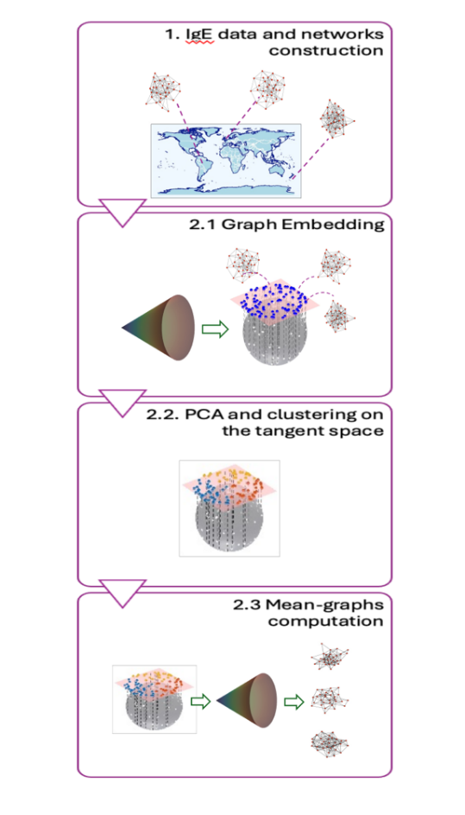
Spectral clustering
Spectral clustering is a technique that partitions data into clusters using the spectral properties of a network. Performing spectral clustering translates into the eigen decomposition of a specific matrix representation of the graph. More precisely, given an adjacency matrix A, spectral clustering is usually performed on the associated graph Laplacian $L$ defined as $L=D-A$ where $D$ is the diagonal matrix storing the degree of each node. As it is possible to use other definitions of the Laplacian matrix (e.g. normalised Laplacian), different spectral clustering techniques may be applied. For an introduction to the topic the reader is referred to (14). The selection of the spectral clustering algorithm needs to be justified by the case study and supported by the analysis of the involved network and nodes-degree distributions. In this work, we opt for the decomposition of the normalised version of the Laplacian defined as $L=I-D^{-1}A$. The top eigenvectors of the Laplacian matrix are then selected and clustering algorithm, such as k-means, is applied to assign data points to clusters based on their transformed representations. This method is effective for revealing complex structures and patterns in data that may be challenging for traditional clustering approaches. To select the number of top eigenvectors the elbow rule was used.

RESULTS
Characteristics of the study populations
Table S1. WASP population description before filtering, country breakdown
Column 1 depicts the numbers of subjects for whom IgEs levels were measured, column 2 the number of subjects for which at least 1 c-sIgE level was greater than 0.3 and the last column depicts the number of asthma cases with at least one IgE positive response.
Country | Available IgEs | At least 1 positive c-sIgE | Asthma cases with at least 1 positive c-sIgE | Sex  (male) | Age Range
Brazil | 190 | 188 | 167 | 41.62% | 12-24
Bristol | 128 | 127 | 109 | 36.22% | 24-27
Ecuador | 159 | 129 | 91 | 68.75% | 10-17
New Zealand | 216 | 214 | 160 | 55.19% | 8-20
Uganda | 131 | 123 | 108 | 35.25% | 12-18

Table S2. MAAS: Characteristics of children with c-sIgE data at age 11 years
Total sample size | 461
 | n (%)
Sex (male) | 255 (55.3)
Maternal asthma | 78 (16.9)
Paternal asthma | 71 (15.4)
Maternal atopy | 256 (55.5)
Paternal atopy | 277 (60.1)
Maternal smoking | 59 (12.8)
Current wheeze | 91 (19.7)
 | Median [IQR]
Height | 148.40 [142.90- 153.30]
Weight | 40.60 [35.50- 45.75]
BMI | 18.31 [16.89-20.38]

Clustering structures across diverse geographical areas
Table S3: c-sIgEs selected for each individual country and study population
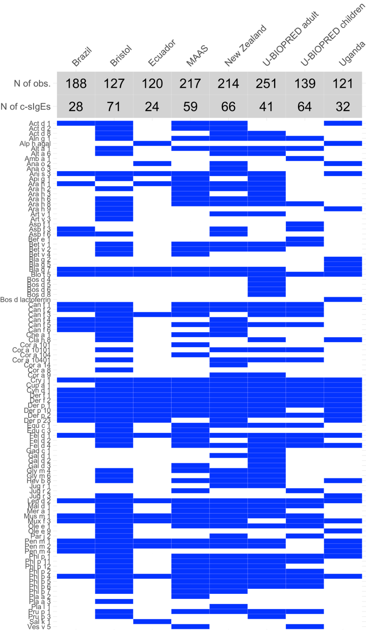

Clustering structures across diverse geographical areas: Component clusters
Figure S3: Hierarchical clustering reveals co-occurrence patterns in c-sIgE reflective of the underlying similarities between allergenic protein structural homogeneity and sources
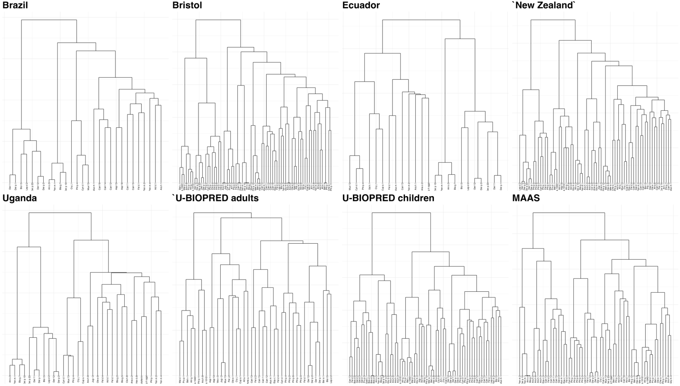
Comparative analysis across countries using a common c-sIgE set
Figure S4: Representation of shared 18 IgEs

Table S4: Proportion of positive reactions to the 18 c-sIgEs across different countries. The redder the cell, the higher the value.
 | Brazil | Bristol | Ecuador | New Zealand | Uganda | U-BIOPRED adults | U-BIOPRED children | MAAS
Ani s 3 | 14.0% | 2.4% | 8.8% | 5.2% | 18.4% | 1.2% | 5.0% | 3.2%
Blo t 5 | 79.6% | 10.2% | 39.5% | 16.5% | 47.4% | 2.8% | 2.9% | 4.1%
Cry j 1 | 3.8% | 5.5% | 16.7% | 11.3% | 12.3% | 7.9% | 2.1% | 5.5%
Cup a 1 | 1.6% | 4.7% | 7.9% | 15.1% | 12.3% | 11.5% | 4.3% | 11.9%
Cyn d 1 | 6.5% | 57.5% | 45.6% | 46.2% | 30.7% | 18.2% | 28.6% | 53.0%
Der f 1 | 60.8% | 56.7% | 30.7% | 72.6% | 49.1% | 22.9% | 46.4% | 42.0%
Der f 2 | 67.7% | 56.7% | 36.0% | 73.1% | 53.5% | 34.8% | 44.3% | 45.2%
Der p 1 | 58.1% | 62.2% | 32.5% | 75.9% | 51.8% | 29.3% | 50.0% | 44.3%
Der p 10 | 16.7% | 2.4% | 10.5% | 7.6% | 20.2% | 1.6% | 6.4% | 3.2%
Der p 2 | 67.7% | 57.5% | 34.2% | 74.5% | 52.6% | 39.1% | 47.1% | 43.4%
Fel d 1 | 23.1% | 48.0% | 5.3% | 44.3% | 3.5% | 40.7% | 49.3% | 36.5%
Fel d 4 | 1.1% | 15.8% | 1.8% | 10.9% | 2.6% | 14.6% | 19.3% | 9.1%
Lep d 2 | 64.5% | 25.2% | 23.7% | 41.5% | 39.5% | 10.3% | 10.7% | 16.0%
MUX f 3 | 7.0% | 13.4% | 34.2% | 8.5% | 26.3% | 2.8% | 1.4% | 12.3%
Pen m 1 | 15.1% | 3.2% | 9.7% | 6.1% | 21.1% | 1.6% | 7.9% | 3.2%
Pen m 2 | 9.1% | 11.0% | 5.3% | 8.5% | 25.4% | 2.0% | 2.9% | 2.3%
Phl p 1 | 1.1% | 74.8% | 1.8% | 73.6% | 3.5% | 42.7% | 52.1% | 69.4%
Phl p 4 | 9.7% | 55.9% | 47.4% | 37.7% | 34.2% | 10.7% | 10.0% | 49.3%

Dimensionality reduction – selection of dimension
Based on the evaluation of the eigenvalues, we selected three dimensions for dimensionality reduction. While a slight ambiguity could arise between choosing three or four dimensions, the partition retrieved using either would remain the same (Figure S5). To ensure clarity and readability in graphical representation, we opted for three dimensions, as adding an extra dimension would not provide additional interpretative value but would complicate visualization.
Figure S5 Eigenvalue distribution and hierarchical clustering dendrograms.
The first panel (a) shows the eigenvalues from the dimensionality reduction analysis. The second panels (b)display the dendrograms obtained using hierarchical clustering, illustrating the partitioning structure based on the selected dimensions.
a)
b)

Figure S6: Selection of eigenvectors for spectral clustering. The plot displays the eigenvalue distribution, highlighting the choice of three eigenvectors. Although a slight ambiguity exists for mean 3 between selecting three or four eigenvectors, the decision to use three aligns with the selections for the other means, ensuring consistency across analyses.

References

1. Pembrey L, Barreto ML, Douwes J, Cooper P, Henderson J, Mpairwe H, et al. Understanding asthma phenotypes: the World Asthma Phenotypes (WASP) international collaboration. ERJ open research. 2018;4(3).
2. Boyd A, Golding J, Macleod J, Lawlor DA, Fraser A, Henderson J, et al. Cohort profile: the ‘children of the 90s’—the index offspring of the Avon Longitudinal Study of Parents and Children. International journal of epidemiology. 2013;42(1):111-27.
3. Fraser A, Macdonald-Wallis C, Tilling K, Boyd A, Golding J, Davey Smith G, et al. Cohort profile: the Avon Longitudinal Study of Parents and Children: ALSPAC mothers cohort. International journal of epidemiology. 2013;42(1):97-110.
4. Northstone K, Lewcock M, Groom A, Boyd A, Macleod J, Timpson N, Wells N. The Avon Longitudinal Study of Parents and Children (ALSPAC): an update on the enrolled sample of index children in 2019. Wellcome open research. 2019;4.
5. Barreto ML, Cunha SS, Alcântara-Neves N, Carvalho LP, Cruz ÁA, Stein RT, et al. Risk factors and immunological pathways for asthma and other allergic diseases in children: background and methodology of a longitudinal study in a large urban center in Northeastern Brazil (Salvador-SCAALA study). BMC pulmonary medicine. 2006;6:1-10.
6. Epton MJ, Town GI, Ingham T, Wickens K, Fishwick D, Crane J, et al. The New Zealand Asthma and Allergy Cohort Study (NZA 2 CS): Assembly, Demographics and Investigations. BMC Public Health. 2007;7:1-9.
7. Harris PA, Taylor R, Thielke R, Payne J, Gonzalez N, Conde JG. Research electronic data capture (REDCap)—a metadata-driven methodology and workflow process for providing translational research informatics support. Journal of biomedical informatics. 2009;42(2):377-81.
8. Mpairwe H, Namutebi M, Nkurunungi G, Tumwesige P, Nambuya I, Mukasa M, et al. Risk factors for asthma among schoolchildren who participated in a case-control study in urban Uganda. Elife. 2019;8:e49496.
9. Asher M, Anderson H, Stewart A, Crane J, Ait-Khaled N, Anabwani G, et al. Worldwide variations in the prevalence of asthma symptoms: the International Study of Asthma and Allergies in Childhood (ISAAC). The European respiratory journal. 1998;12(2):315-35.
10. Custovic A, Simpson BM, Murray CS, Lowe L, Woodcock A, Asthma NACM, Allergy Study G. The National Asthma Campaign Manchester Asthma and Allergy Study. Pediatr Allergy Immunol. 2002;13(s15):32-7.
11. Fontanella S, Frainay C, Murray CS, Simpson A, Custovic A. Machine learning to identify pairwise interactions between specific IgE antibodies and their association with asthma: A cross-sectional analysis within a population-based birth cohort. PLOS Medicine. 2018;15(11):e1002691.
12. Roberts G, Fontanella S, Selby A, Howard R, Filippi S, Hedlin G, et al. Connectivity patterns between multiple allergen specific IgE antibodies and their association with severe asthma. J Allergy Clin Immunol. 2020;146(4):821-30.
13. Severn KE, Dryden IL, Preston SP. Manifold valued data analysis of samples of networks, with applications in corpus linguistics. The Annals of Applied Statistics. 2022;16(1):368-90, 23.
14. Von Luxburg U. A tutorial on spectral clustering. Stat Comput. 2007;17(4):395-416.

U-BIOPRED consortium study team members, contributors, partner organisations, members of the ethics board, members of the safety monitoring board
U-BIOPRED consortium study team members
Name | Affiliation
Adcock I M | National Heart and Lung Institute, Imperial College, London, UK;
Ahmed H | European Institute for Systems Biology and Medicine, CNRS-ENS-UCBL-INSERM, Lyon, France;
Auffray C | European Institute for Systems Biology and Medicine, CNRS-ENS-UCBL-INSERM, Lyon, France;
Bakke P | Department of Clinical Science, University of Bergen, Bergen, Norway;
Bansal A T | Acclarogen Ltd, St. John’s Innovation Centre, Cambridge, UK;
Baribaud F | Janssen R&D, USA;
Bates S | Respiratory Therapeutic Unit, GSK, London, UK;
Bel E H | Academic Medical Centre, University of Amsterdam, Amsterdam, The Netherlands;
Bigler J | Previously Amgen Inc
Bisgaard H | COPSAC, Copenhagen Prospective Studies on Asthma in Childhood, Herlev and Gentofte Hospital,  University of Copenhagen, Copenhagen, Denmark
Boedigheimer M J | Amgen Inc.; Thousand Oaks, USA
Bønnelykke K | COPSAC, Copenhagen Prospective Studies on Asthma in Childhood, Herlev and Gentofte  Hospital, University of Copenhagen, Copenhagen, Denmark;
Brandsma J | University of Southampton, Southampton, UK
Brinkman P | Academic Medical Centre, University of Amsterdam, Amsterdam, The Netherlands;
Bucchioni E | Chiesi Pharmaceuticals SPA, Parma, Italy
Burg D | Centre for Proteomic Research, Institute for Life Sciences, University of Southampton, Southampton, UK
Bush A | National Heart and Lung Institute, Imperial College, London, UK; Royal Brompton and Harefield NHS trust, UK
Caruso M | Dept. Clinical and Experimental Medicine, University of Catania, Catania, Italy;
Chaiboonchoe A | European Institute for Systems Biology and Medicine, CNRS-ENS-UCBL-INSERM, Lyon, France;
Chanez P | Assistance publique des Hôpitaux de Marseille - Clinique des bronches, allergies et sommeil, Aix Marseille Université, Marseille, France
Chung F K | National Heart and Lung Institute, Imperial College, London, UK;
Compton C H | Respiratory Therapeutic Unit, GSK, London, UK
Corfield J | Areteva R&D, Nottingham, UK;
D’Amico A | University of Rome ‘Tor Vergata’, Rome Italy;
Dahlén B | Karolinska University Hospital & Centre for Allergy Research, Karolinska Institutet, Stockholm, Sweden
Dahlén S E | Centre for Allergy Research, Karolinska Institutet, Stockholm, Sweden
De Meulder B | European Institute for Systems Biology and Medicine, CNRS-ENS-UCBL-INSERM, Lyon, France;
Djukanovic R | NIHR Southampton Respiratory Biomedical Research Unit and Clinical and Experimental Sciences, Southampton, UK;
Erpenbeck V J | Translational Medicine, Respiratory Profiling, Novartis Institutes for Biomedical Research, Basel, Switzerland;
Erzen D | Boehringer Ingelheim Pharma GmbH & Co. KG; Biberach, Germany
Fichtner K | Boehringer Ingelheim Pharma GmbH & Co. KG; Biberach, Germany
Fitch N | BioSci Consulting, Maasmechelen, Belgium;
Fleming L J | National Heart and Lung Institute, Imperial College, London, UK; Royal Brompton and Harefield NHS trust, UK
Formaggio E | Previously CROMSOURCE, Verona Italy
Fowler S J | Division of infection, immunity and respiratory medicine, School of biological sciences, University of Manchester, Manchester University NHS Foundation Trust, Manchester Academic Health Science Centre, Manchester, United Kingdom
Frey U | University Children’s Hospital, Basel, Switzerland;
Gahlemann M | Boehringer Ingelheim (Schweiz) GmbH,Basel, Switzerland;
Geiser T | Department of Respiratory Medicine, University Hospital Bern, Switzerland;
Goss V | NIHR Respiratory Biomedical Research Unit, University Hospital Southampton NHS Foundation Trust, Integrative Physiology and Critical Illness Group, Clinical and Experimental Sciences, Sir Henry Wellcome Laboratories, Faculty of Medicine, University of Southampton, Southampton, UK;
Guo Y | Data Science Institute, Imperial College, London, UK;
Hashimoto S | Academic Medical Centre, University of Amsterdam, Amsterdam, The Netherlands;
Haughney J | International Primary Care Respiratory Group, Aberdeen, Scotland;
Hedlin G | Dept. Women’s and Children’s Health & Centre for Allergy Research, Karolinska Institutet, Stockholm, Sweden;
Hekking P W | Academic Medical Centre, University of Amsterdam, Amsterdam, The Netherlands;
Higenbottam T | Allergy Therapeutics, West Sussex, UK;
Hohlfeld J M | Fraunhofer Institute for Toxicology and Experimental Medicine, Hannover, Germany
Holweg C | Respiratory and Allergy Diseases, Genentech, San Francisco, USA
Horváth I | Semmelweis University, Budapest, Hungary
Howarth P | NIHR Southampton Respiratory Biomedical Research Unit, Clinical and Experimental Sciences and Human Development and Health, Southampton, UK
James A J | Centre for Allergy Research, Karolinska Institutet, Stockholm, Sweden;
Knowles RG | Knowles Consulting Ltd, Stevenage. UK;
Knox A J | Respiratory Research Unit, University of Nottingham, Nottingham, UK;
Krug N | Fraunhofer Institute for Toxicology and Experimental Medicine, Hannover, Germany;
Lefaudeux D | European Institute for Systems Biology and Medicine, CNRS-ENS-UCBL-INSERM, Lyon, France;
Loza M J | Janssen R&D, USA;
Lutter R | Academic Medical Centre, University of Amsterdam, Amsterdam, The Netherlands;
Manta A | Roche Diagnostics GmbH, Mannheim, Germany
Masefield S | European Lung Foundation, Sheffield, UK;
Matthews J G | Respiratory and Allergy Diseases, Genentech, San Francisco, USA;
Mazein A | European Institute for Systems Biology and Medicine, CNRS-ENS-UCBL-INSERM, Lyon, France
Meiser A | Data Science Institute, Imperial College, London, UK
Middelveld R J M | Centre for Allergy Research, Karolinska Institutet, Stockholm, Sweden
Miralpeix M | Almirall, Barcelona, Spain;
Montuschi P | Università Cattolica del Sacro Cuore, Milan, Italy;
Mores N | Università Cattolica del Sacro Cuore, Milan, Italy;
Murray C S | Division of infection, immunity and respiratory medicine, School of biological sciences, University of Manchester, Manchester University NHS Foundation Trust, and Manchester Academic Health Science Centre, Manchester, United Kingdom
Musial J | Dept. of Medicine, Jagiellonian University Medical College, Krakow, Poland
Myles D | Respiratory Therapeutic Unit, GSK, London, UK;
Pahus L | Assistance publique des Hôpitaux de Marseille, Clinique des bronches, allergies et sommeil  Espace Éthique Méditerranéen, Aix-Marseille Université, Marseille, France;
Pandis I | Data Science Institute, Imperial College, London, UK
Pavlidis S | National Heart and Lung Institute, Imperial College, London, UK
Postle A | University of Southampton, UK
Powel P | European Lung Foundation, Sheffield, UK;
Praticò G | CROMSOURCE, Verona, Italy
Puig Valls M | CROMSOURCE, Barcelona, Spain
Rao N | Janssen R&D, USA;
Riley J | Respiratory Therapeutic Unit, GSK, London, UK;
Roberts A | Asthma UK, London, UK;
Roberts G | NIHR Southampton Respiratory Biomedical Research Unit, Clinical and Experimental Sciences and Human Development and Health, Southampton, UK;
Rowe A | Janssen R&D, UK;
Sandström T | Dept of Public Health and Clinical Medicine, Umeå University, Umeå, Sweden;
Schofield JPR | Centre for Proteomic Research, Institute for Life Sciences, University of Southampton, Southampton, UK
Seibold W | Boehringer Ingelheim Pharma GmbH, Biberach, Germany
Selby A | NIHR Southampton Respiratory Biomedical Research Unit, Clinical and Experimental Sciences and Human Development and Health, Southampton, UK;
Shaw D E | Respiratory Research Unit, University of Nottingham, UK;
Sigmund R | Boehringer Ingelheim Pharma GmbH & Co. KG; Biberach, Germany
Singer F | Pediatric Respiratory Medicine, Department of Pediatrics, Inselspital, Bern University Hospital, University of Bern, Bern, Switzerland.
Skipp P J | Centre for Proteomic Research, Institute for Life Sciences, University of Southampton, Southampton, UK
Sousa A R | Respiratory Therapeutic Unit, GSK, London, UK;
Sterk P J | Academic Medical Centre, University of Amsterdam, Amsterdam, The Netherlands;
Sun K | Data Science Institute, Imperial College, London, UK
Thornton B | MSD, USA
van Aalderen W M | Academic Medical Centre, University of Amsterdam, Amsterdam, The Netherlands;
van Geest M | AstraZeneca, Mölndal, Sweden;
Vestbo J | Centre for Respiratory Medicine and Allergy, Institute of Inflammation and Repair, University of Manchester and University Hospital of South Manchester, Manchester Academic Health Sciences Centre, Manchester, United Kingdom
Vissing N H | COPSAC, Copenhagen Prospective Studies on Asthma in Childhood, Herlev and Gentofte Hospital,  University of Copenhagen, Copenhagen, Denmark;
Wagener A H | Academic Medical Center Amsterdam, Amsterdam, The Netherlands
Wagers S S | BioSci Consulting, Maasmechelen, Belgium
Weiszhart Z | Semmelweis University, Budapest, Hungary;
Wheelock C E | Centre for Allergy Research, Karolinska Institutet, Stockholm, Sweden;
Wilson S J | Histochemistry Research Unit, Faculty of Medicine, University of Southampton, Southampton, UK;

The WASP Study group
United Kingdom, London:
Neil Pearce
Lucy Pembrey
Steven Robertson
Karin van Veldhoven
Charlotte E Rutter
Sinead Langan
Sarah Thorne
Donna Davoren
United Kingdom, Bristol:
John Henderson
Susan Ring
Elizabeth Brierley
Sophie Fitzgibbon
Simon Scoltock
Amanda Hill
Brazil, Leading Group:
Alvaro Cruz
Camila Figueiredo
Mauricio Barreto
Brazil, ProAR collaborators/associates:
Cinthia Vila Nova Santana
Gabriela Pimentel
Gilvaneide Lima
Valmar Bião Lima
Jamille Fernandes
Brazil, Lab students/associates:
Tamires Cana Brasil Carneiro
Candace Andrade
Gerson Queiroz
Anaque Pires
Milca Silva
Jéssica Cerqueira
Ecuador:
Philip Cooper
Martha Chico
Cristina Ardura-Garcia
Araceli Falcones
Aida Y Oviedo
Andrea Zambrano
New Zealand:
Jeroen Douwes
Collin Brooks
Hajar Ali
Jeroen Burmanje
Uganda:
Harriet Mpairwe
Irene Nambuya
Pius Tumwesige
Milly Namutebi
Marble Nnaluwooza
Mike Mukasa

STELAR/UNICORN consortium
Stephen Turner, Royal Aberdeen Children's Hospital NHS Grampian Aberdeen, AB25 2ZG, UK
John W. Holloway, Faculty of Medicine, University of Southampton, Southampton, UK
John A Curtin, Division of Infection, Immunity and Respiratory Medicine, School of Biological Sciences, Faculty of Biology, Medicine and Health, University of Manchester, UK
Syed Hasan Arshad, Faculty of Medicine, University of Southampton, Southampton, UK
Raquel Granell, Bristol Medical School, University of Bristol, UK
Professor Andrew Bush, National Heart and Lung Institute, Imperial College London, UK
Sejal Saglani, National Heart and Lung Institute, Imperial College London, UK
Ashley Woodcock, Division of Infection, Immunity and Respiratory Medicine, School of Biological Sciences, Faculty of Biology, Medicine and Health, University of Manchester, UK

