Supplemental Material

Cardiac resynchronization therapy for enabling guideline-directed pharmacological therapy optimization in heart failure.

Abbreviations:
ACEi, angiotensin-converting enzyme inhibitor; AF, atrial fibrillation; ARB, angiotensin receptor blocker; ARNi, angiotensin receptor–neprilysin inhibitor; AV, atrioventricular; BP, blood pressure; CABG, coronary artery bypass grafting; CI, confidence interval; COPD, chronic obstructive pulmonary disease; CRT, cardiac resynchronization therapy; CRT-D, cardiac resynchronization therapy defibrillator; CRT-P cardiac resynchronization therapy pacemaker; EF, ejection fraction; eGFR, estimated glomerular filtration rate; ESC, European Society of Cardiology; GDMT, guideline-directed medical therapy; HF, heart failure; HFH, heart failure hospitalization; HFrEF, heart failure with reduced ejection fraction; ICD, implantable cardiac defibrillator; IQR, interquartile range; ITT, intention-to-treat; LBBB, left bundle branch block; LVEF, left ventricular ejection fraction; LISA, Longitudinal integrated database for health insurance and labour market studies; mo., months; MRA, mineralocorticoid receptor antagonist; NYHA, New York Heart Association; NPDR, National Prescribed Drug Registry; NPR, National Patient Register; NT-proBNP, N-terminal pro-B-type natriuretic peptide; OMT, optimal medical therapy; OR, odds ratio; PC, primary care; PCI, percutaneous coronary intervention; PINs, Patient Individual Numbers; PM, pacemaker; PP, per-protocol; pts, patients; RTP, Register of the Total Population; RV, right ventricular; SBP, systolic blood pressure; SCB, Statistiska centralbyrån; SGLT2i, sodium-glucose co-transporter 2 inhibitors; SR, sinus rhythm, TD, target dose.

Supplemental Tables.
Table S1. Data sources for each variable and % of missing values.
Variable | Data source | Missing (%)
Demographics
Calender year | SwedeHF | 0
Sex | SwedeHF | 0
Age (years) | SwedeHF | 0
Clinical variables, ECG, echo and laboratory findings
Duration of HF (months) | NPR | 0
Previous HF hospitalization < 1 year | NPR | 0
Systolic blood pressure (mmHg) | SwedeHF | 3
Mean arterial pressure (mmHg) | SwedeHF | 2
Heart rate (beats/min) | SwedeHF | 3
NYHA class | SwedeHF | 18
ECG rhythm | SwedeHF | 2
QRS width | SwedeHF | 10
Left Bundle Branch Block (LBBB) | SwedeHF | 15
LVEF | SwedeHF | 0
eGFR (mL/min/1.73 m²) | SwedeHF | 2
NT-proBNP (pg/mL) | SwedeHF | 32
Follow-up referral HF nurse clinic | SwedeHF | 4
Follow-up referral speciality | SwedeHF | 2
Comorbidities
Diabetes | NPR: ICD-10 E10-4 * | 0
Atrial fibrillation/flutter | NPR: ICD-10 I48 * | 0
Ischemic heart disease | NPR: ICD-9/10 410-4, I20-5, Z951, Z955 Procedure FNA, FNB, FNC, FND, FNE, FNF, FNH, FNG * | 0
Hypertension | NPR: ICD-10 I10-5 * | 0
Peripheral artery disease | NPR: ICD-10 I70-3 * | 0
PCI | NPR: Procedure FNG * | 0
CABG | NPR: ICD-9/10 Z951, Z955 Procedure FNA, FNB, FNC, FND, FNE, FNF, FNH * | 0
Stroke | NPR: ICD-9/10 430-4, 438, I60-4, I690-4 * | 0
Valvular disease | NPR: ICD-10 I05-8, I34-9, Q22, Q230-3, Q230-3, Q235-9, Z952-4 * | 0
Malignant cancer within 3 years | NPR: ICD-10 C * | 0
COPD | NPR: ICD-10 J40-4 * | 0
Liver disease | NPR: ICD-10 B18, I85, I864, I982, K70, K710, K711, K713-7, K72-4, K760, K762-9 * | 0
Dementia | NPR: ICD-10 F00-4, R54 * | 0
Severe bleeding | NPR: ICD-10 S064, S065, S066, I850, I983, K226, K250, K252, K254, K256, K260, K262, K264, K266, K270, K272, K274, K276, K280, K284, K286, K290, K625, K661, K920, K921, K922, H431, N02, R04, R58, T810, D629 Procedure DR029 * | 0
Muscoloskeletal/connective tissue diseases within 3 years | NPR: ICD-10 M * | 0
Charlson Comorbidity Index | NPR † | 0
Treatment
Beta-blocker | NPDR: ATC C07 ‡,§
ACEi/ARB/ARNi | NPDR: ATC C09A, C09B, C09C, C09D ‡,§
MRA | NPDR: ATC C03DA ‡,§
Loop diuretic | NPDR: ATC C03C ‡,§
SGLT2i | NPDR: ATC A10BK, A10BD16, A10BD15, A10BD20, A10BD23, A10BD27, A10BD25, A10BD21, A10BD29, A10BD24 ‡ | 0
Calcium channel blockers | NPDR: ATC C08 ‡ | 0
Antiplatelet | NPDR: ATC B01AC ‡ | 0
Anticoagulant | NPDR: ATC B01AA, B01AB, B01AE, B01AF, B01AX05 ‡ | 0
Insulin | NPDR: ATC A10A ‡ | 0
Oral glucose lowering | NPDR: ATC A10B ‡ | 0
Lipid lowering | NPDR: ATC C10 ‡ | 0
Digoxin | NPDR: ATC C01AA05 ‡ | 0
Nitrate | NPDR: ATC C01DA ‡ | 0
Antiarrhythmic | NPDR: ATC C01BD01, C01BD07, C01BC04, C01BC03, C07AA07, C01BA03 ‡ | 0
CRT-P | ICD & PM Registry | 0
CRT-D | ICD & PM Registry | 0
Previous ICD | ICD & PM Registry | 0
Previous PM | ICD & PM Registry | 0
Socioeconomics
Family situation | LISA|| | 0
Children | RTP || | 0
Education | LISA || | 2
Income | LISA || | 0
* Derived from diagnoses/operations in all positions, in-patient and out-patient speciality care within 5 years prior to index (ICD-10)/1987 (ICD-9) unless stated otherwise.
† Derived from diagnoses in all positions, in-patient and out-patient speciality care within 10 years prior to index using ICD-9/10 according to Ludvigsson, 2021.¹
‡ At baseline medications derived from dispensed prescriptions within 4 months prior up until day before the date of inclusion (for GDMT and loop diuretics); other medications derived from dispensed prescriptions 4 months prior to date of inclusion (non-GDMT); at follow-up medications (GDMT and loop diuretics) derived from dispensed prescriptions 18 months +/- 2 months after the date of inclusion.
§ The dose taken by the patient was evaluated using the strength of the tablet prescribed multiplied by the number of pills the patients was prescribed to take each day. The latter is written in free text and an algorithm was derived to extract the dose prescribed. If there was no text or it was not possible to interpret the number of tablets/day was assumed to be the mean number of pills taken per day for the posts with non-missing values with the same ATC code. The % target dose was then calculated according to the defined target dose for each substance (see Supplemental Table 3). For the pills with a combination of substances the target dose was calculated for the MRA, Beta-blocker, ACEi/ARB part of the pill.
Limitations for dose calculation: The text extraction is sometimes a matter of interpretation. Further, in approximately 15.9% of the cases there is no text or no text indicating the number of pills that should be taken. For pills with combination substances the strength was not available. For many combination pills there was only one available dose on the market but for those where there was no information the target dose was set to 50%. The % of combination pills was however low (0.7%) except for ARNi (5.8%). For ARNi, packages containing packages containing 28 or 56 pills were assumed to be of the strength 49/51 together with packages containing 168 pills where the patient was prescribed > 2 pills/day. If the patient was prescribed > 4 pills / day the strength was assumed to be 24/26 mg. The rest was assumed to be strength 97 mg/103 mg. The last prescription prior to baseline and closest to 1 year was selected, however, the last prescription can be old and the doctor can verbally have instructed the patient to take a different dose/stop medication.
|| From the year prior to index date
Table S2: Recommendations for CRT implantation across different ESC HF guidelines (from 2008 to 2021).
2008²
CRT is recommended to reduce morbidity and mortality in patients with NYHA Class III/IV, EF ≤35% despite optimal medical therapy and QRS ≥120 ms | Class I Level A
2012³
Recommendations for the use of CRT where the evidence is strong - patients in sinus rhythm with NYHA functional class III and ambulatory class IV heart failure and a persistently reduced ejection fraction, despite optimal pharmacological therapy
LBBB QRS morphology  CRT-P/CRT-D is recommended in patients in sinus rhythm with a QRS duration of ≥120 ms, LBBB QRS morphology, and an EF ≤35%, who are expected to survive with good functional status for >1 year, to reduce the risk of HF hospitalization and the risk of premature death. | Class I Level A
Non-LBBB QRS morphology  CRT-P/CRT-D should be considered in patients in sinus rhythm with a QRS duration of ≥150 ms, irrespective of QRS morphology, and an EF ≤35%, who are expected to survive with good functional status for >1 year, to reduce the risk of HF hospitalization and the risk of premature death. | Class IIa Level A
Recommendations for the use of CRT where the evidence is strong - patients in sinus rhythm with NYHA functional class II heart failure and a persistently reduced ejection fraction, despite optimal pharmacological therapy
LBBB QRS morphology
CRT, preferably CRT-D is recommended in patients in sinus rhythm with a QRS duration of ≥130 ms, LBBB QRS morphology, and an EF ≤30%, who are expected to survive for >1 year with good functional status, to reduce the risk of HF hospitalization and the risk of premature death. | Class I Level A
Non-LBBB QRS morphology  CRT, preferably CRT-D should be considered in patients in sinus rhythm with a QRS duration of ≥150 ms, irrespective of QRS morphology, and an EF ≤30%, who are expected to survive for >1 year with good functional status, to reduce the risk of HF hospitalization and the risk of premature death. | Class IIa Level A
Recommendations for the use of CRT where the evidence is uncertain—patients with symptomatic HF (NYHA functional class II–IV) and a persistently reduced EF despite optimal pharmacological therapy and in AF or with a conventional pacing indication
Patients in permanent AF  CRT-P/CRT-D may be considered in patients in NYHA functional class III or ambulatory class IV with a QRS duration ≥120 ms and an EF ≤35%, who are expected to survive with good functional status for >1 year, to reduce the risk of HF worsening if:  • The patient requires pacing because of an intrinsically slow ventricular rate  • The patient is pacemaker dependent as a result of AV nodal ablation  • The patient’s ventricular rate is ≤60 b.p.m. at rest and ≤90 b.p.m. on exercise. | Class IIb Level C  Class IIa Level C  Class IIb Level C
Patients with an indication for conventional pacing and no other indication for CRT  In patients who are expected to survive with good functional status for >1 year:  • CRT should be considered in those in NYHA functional class III or IV with an EF ≤35%, irrespective of QRS duration, to reduce the risk of worsening of HF  • CRT may be considered in those in NYHA functional class II with an EF ≤35%, irrespective of QRS duration, to reduce the risk of worsening of HF | Class IIa Level C  Class IIb Level C
2016⁴
CRT is recommended for symptomatic patients with HF in sinus rhythm with a QRS duration ≥150 msec and LBBB QRS morphology and with EF ≤35% despite OMT in order to improve symptoms and reduce morbidity and mortality. | Class I Level A
CRT should be considered for symptomatic patients with HF in sinus rhythm with a QRS duration ≥150 msec and non-LBBB QRS morphology and with EF ≤35% despite OMT in order to improve symptoms and reduce morbidity and mortality. | Class IIa Level B
CRT is recommended for symptomatic patients with HF in sinus rhythm with a QRS duration of 130–149 msec and LBBB QRS morphology and with EF ≤35% despite OMT in order to improve symptoms and reduce morbidity and mortality. | Class I Level B
CRT may be considered for symptomatic patients with HF in sinus rhythm with a QRS duration of 130–149 msec and non-LBBB QRS morphology and with EF ≤35% despite OMT in order to improve symptoms and reduce morbidity and mortality. | Class IIb Level B
CRT rather than RV pacing is recommended for patients with HFrEF regardless of NYHA class who have an indication for ventricular pacing and high degree AV block in order to reduce morbidity. This includes patients with AF. | Class I Level A
CRT should be considered for patients with EF ≤35% in NYHA Class III–IV despite OMT in order to improve symptoms and reduce morbidity and mortality, if they are in AF and have a QRS duration ≥130 msec provided a strategy to ensure bi-ventricular capture is in place or the patient is expected to return to sinus rhythm. | Class IIa Level B
Patients with HFrEF who have received a conventional pacemaker or an ICD and subsequently develop worsening HF despite OMT and who have a high proportion of RV pacing may be considered for upgrade to CRT. This does not apply to patients with stable HF. | Class IIb Level B
CRT is contra-indicated in patients with a QRS duration < 130 msec. | Class III Level A
2021⁵
CRT is recommended for symptomatic patients with HF in SR with a QRS duration ≥150 ms and LBBB QRS morphology and with EF ≤35%  despite OMT in order to improve symptoms and reduce morbidity and mortality. | Class I Level A
CRT rather than RV pacing is recommended for patients with HFrEF regardless of NYHA class or QRS width who have an indication for ventricular pacing for high degree AV block in order to reduce morbidity. This includes patients with AF. | Class I Level A
CRT should be considered for symptomatic patients with HF in SR with a QRS duration ≥150 ms and non-LBBB QRS morphology and with EF ≤35% despite OMT in order to improve symptoms and reduce morbidity and mortality. | Class IIa Level B
CRT should be considered for symptomatic patients with HF in SR with a QRS duration of 130-149 ms and LBBB QRS morphology and with EF ≤35% despite OMT in order to improve symptoms and reduce morbidity and mortality. | Class IIa Level B
Patients with an EF ≤35% who have received a conventional pacemaker or an ICD and subsequently develop worsening HF despite OMT and who have a significant proportion of RV pacing should be considered for ‘upgrade’ to CRT. | Class IIa Level B
CRT may be considered for symptomatic patients with HF in SR with a QRS duration of 130-149 ms and non-LBBB QRS morphology and with EF ≤35% despite OMT in order to improve symptoms and reduce morbidity and mortality. | Class IIb Level B
CRT is not recommended in patients with a QRS duration <130 ms who do not have an indication for pacing due to high degree AV block. | Class III Level A

Table S3. Evidence-based doses of disease-modifying drugs in key randomized trials in patients with heart failure with reduced ejection fraction (from 2021 ESC guidelines for the management of acute and chronic HF⁵).
ACEi
Captopril, 50 mg t.i.d.
Enalapril, 10-20 mg b.i.d.
Lisinopril, 20-35 mg o.d.
Ramipril, 5 mg b.i.d.
Trandolapril, 4 mg o.d.

ARB
Candesartan 32 mg o.d.
Losartan 150 mg o.d.
Valsartan 160 mg b.i.d.

ARNi
Sacubitril/valsartan, 97/103 mg b.i.d.

Beta-blockers
Bisoprolol, 10 mg o.d.
Carvedilol, 25 mg b.i.d.*
Metoprolol succinate (CR/XL), 200 mg o.d.
Nebivolol, 10 mg o.d.

MRA
Eplerenone, 50 mg o.d.
Spironolactone, 50 mg o.d.

* Maximum dose: 25 mg orally twice a day in patients weighing 85 kg or less and 50 mg orally twice a day in patients weighing 85 kg or greater.

Table S4. Baseline characteristics of the study population stratified by CRT groups (No CRT vs CRT) in patients with SBP<110 mmHg (intention-to-treat analysis).
Variable | No CRT | CRT | p-value
N (%) | 816 (66) | 416 (34)
Demographics
Calender year |  |  | 0.088
2009-2013 | 231 (28) | 141 (34)
2014-2018 | 330 (40) | 164 (39)
2019-2022 | 255 (31) | 111 (27)
Sex |  |  | 0.333
Female | 190 (23) | 86 (21)
Male | 626 (77) | 330 (79)
Age (years) | 74 [67-81] | 71 [64-78] | <0.001
Age (years) |  |  | <0.001
<70 | 270 (33) | 170 (41)
70-80 | 341 (42) | 188 (45)
>80 | 205 (25) | 58 (14)
Clinical variables and laboratory findings
Duration of HF (months) |  |  | 0.646
3-9 | 155 (19) | 70 (17)
10-18 | 81 (10) | 43 (10)
>=19 | 580 (71) | 303 (73)
Previous heart failure hospitalization < 1 year a | 444 (54) | 190 (46) | 0.004
Mean arterial pressure (mmHg) |  |  | 0.437
<=90 | 807 (99) | 414 (100)
>90 | <10 | <10
Heart rate (beats/min) |  |  | 0.444
<=60 | 161 (20) | 86 (22)
>60 | 646 (80) | 304 (78)
NYHA class |  |  | 0.052
I-II | 350 (51) | 154 (44)
III-IV | 340 (49) | 195 (56)
eGFR (mL/min/1.73 m²) |  |  | 0.524
>=60 | 437 (54) | 215 (52)
<60 | 366 (46) | 196 (48)
NT-proBNP (pg/mL) |  |  | 0.995
≤1080 | 157 (28) | 79 (28)
1081-3110 | 174 (31) | 87 (30)
>3110 | 238 (42) | 121 (42)
Follow-up referral HF nurse clinic | 604 (77) | 322 (80) | 0.274
Follow-up referral speciality |  |  | <0.001
Primary care/Other | 138 (17) | 21 (5)
Hospital | 661 (83) | 390 (95)
Comorbidities
Diabetes | 222 (27) | 113 (27) | 1.000
Atrial fibrillation/flutter | 423 (52) | 238 (57) | 0.084
Ischemic heart disease | 485 (59) | 259 (62) | 0.370
Hypertension | 424 (52) | 189 (45) | 0.035
Peripheral artery disease | 75 (9) | 34 (8) | 0.625
PCI | 200 (25) | 112 (27) | 0.394
CABG | 281 (34) | 154 (37) | 0.404
Stroke | 106 (13) | 57 (14) | 0.795
Valvular disease | 185 (23) | 100 (24) | 0.641
Malignant cancer within 3 years | 99 (12) | 41 (10) | 0.273
COPD | 101 (12) | 48 (12) | 0.738
Liver disease | 17 (2) | 13 (3) | 0.354
Dementia | <10 | <10 | 0.276
Severe bleeding | 150 (18) | 56 (13) | 0.035
Muscoloskeletal/connective tissue diseases within 3 years | 260 (32) | 119 (29) | 0.269
Charlson Comorbidity Index |  |  | 0.447
1 | 204 (25) | 111 (27)
2-3 | 336 (41) | 183 (44)
4-7 | 254 (31) | 111 (27)
>=8 | 22 (3) | 11 (3)
Treatments
SGLT2i | 53 (6) | 28 (7) | 0.971
Calcium channel blockers | 44 (5) | <10 | 0.003
Antiplatelet | 327 (40) | 145 (35) | 0.086
Anticoagulant | 432 (53) | 215 (52) | 0.720
Insulin | 81 (10) | 51 (12) | 0.248
Oral glucose lowering | 159 (19) | 84 (20) | 0.826
Lipid lowering | 439 (54) | 248 (60) | 0.060
Digoxin | 105 (13) | 62 (15) | 0.368
Nitrate | 177 (22) | 81 (19) | 0.406
Antiarrhythmic | 59 (7) | 43 (10) | 0.078
CRT type
CRT-P | - | 146 (35)
CRT-D | - | 270 (65)
Previous ICD | 80 (10) | 64 (15) | 0.005
Previous PM | 113 (14) | 114 (27) | <0.001
Socioeconomics
Family situation |  |  | 0.930
Cohabitating | 483 (59) | 245 (59)
Living alone | 331 (41) | 171 (41)
Children | 675 (83) | 344 (83) | 1.000
Education |  |  | 0.067
Compulsory school | 297 (37) | 128 (31)
Secondary school | 357 (45) | 190 (47)
University | 140 (18) | 89 (22)
Income |  |  | 0.047
1st tertile within year | 269 (33) | 117 (28)
2nd tertile within year | 267 (33) | 128 (31)
3rd tertile within year | 278 (34) | 171 (41)
Data presented as n percentage or median (IQR).

Table S5. Baseline and follow-up use and achieved % of target doses of medications stratified by CRT in the subgroup of patients with SBP<110 mmHg (intention-to-treat analysis).
 | Baseline |  |  | Follow-up
Variable | No CRT | CRT | p-value | No CRT | CRT | p-value
 | N=816 | N=416 |  | N=816 | N=416
Beta-blocker (% of target dose) |  |  | 0.377 |  |  | 0.109
Not treated | 124 (15) | 64 (15) |  | 131 (16) | 58 (14)
<25 | 68 (8) | 34 (8) |  | 53 (6) | 22 (5)
25-49 | 192 (24) | 111 (27) |  | 149 (18) | 61 (15)
50-74 | 203 (25) | 83 (20) |  | 179 (22) | 91 (22)
75-99 | 51 (6) | 22 (5) |  | 58 (7) | 26 (6)
100 | 178 (22) | 102 (25) |  | 246 (30) | 158 (38)
Median [q1-q3] | 50 [25-75] | 41 [25-75] | 0.991 | 50 [25-100] | 50 [25-100] | 0.010
ACEi/ARB/ARNi (% of target dose) |  |  | 0.002 |  |  | 0.718
Not treated | 82 (10) | 47 (11) |  | 122 (15) | 66 (16)
<25 | 113 (14) | 28 (7) |  | 84 (10) | 32 (8)
25-49 | 168 (21) | 72 (17) |  | 145 (18) | 73 (18)
50-74 | 222 (27) | 126 (30) |  | 190 (23) | 93 (22)
75-99 | 30 (4) | 18 (4) |  | 25 (3) | 14 (3)
100 | 201 (25) | 125 (30) |  | 250 (31) | 138 (33)
Median [q1-q3] | 50 [25-76] | 50 [25-100] | 0.005 | 50 [19-100] | 50 [25-100] | 0.388
MRA (% of target dose) |  |  | 0.287 |  |  | 0.685
Not treated | 370 (45) | 168 (40) |  | 360 (44) | 183 (44)
<50 | 65 (8) | 31 (7) |  | 71 (9) | 32 (8)
50-99 | 322 (39) | 179 (43) |  | 296 (36) | 162 (39)
100 | 59 (7) | 38 (9) |  | 89 (11) | 39 (9)
Median [q1-q3] | 25 [0-50] | 50 [0-50] | 0.057 | 25 [0-50] | 25 [0-50] | 0.939
Loop diuretic (furosemide equivalent dose, mg) |  |  | 0.681 |  |  | 0.717
Not treated | 248 (30) | 130 (31) |  | 331 (41) | 181 (44)
<=40 | 322 (39) | 170 (41) |  | 247 (30) | 117 (28)
41-80 | 175 (21) | 77 (19) |  | 166 (20) | 79 (19)
>80 | 71 (9) | 39 (9) |  | 72 (9) | 39 (9)
Median [q1-q3] | 40 [0-80] | 40 [0-65] | 0.466 | 40 [0-80] | 40 [0-80] | 0.406

Table S6. Logistic regression models for the association between CRT compared with No CRT and 1) optimization of GDMTs and 2) decrease in loop diuretic doses in the subgroup of patients with SBP<110mmHg (intention-to-treat analysis).
Medication | No CRT (N=816), N(%) | CRT (N=416), N(%) | Crude OR (95%CI),p-value | Adjusted OR (95%CI),p-value
Beta-blocker | 280 (34.3) | 175 (42.1) | 1.39 (1.09-1.77), 0.008 | 1.43 (1.05-1.95), 0.025
ACEi/ARB/ARNi | 289 (35.4) | 146 (35.1) | 0.99 (0.77-1.26), 0.911 | 1.08 (0.79-1.46), 0.636
MRA | 191 (23.4) | 101 (24.3) | 1.05 (0.80-1.38), 0.734 | 1.18 (0.85-1.65), 0.331
Loop diuretic | 251 (30.8) | 130 (31.2) | 1.02 (0.79-1.32), 0.860 | 1.21 (0.86-1.69), 0.276

Table S7. Logistic regression models for the association between CRT compared with No CRT and 1) optimization of GDMTs and 2) decrease in loop diuretic doses in the subgroup of patients with a class of recommendation I for CRT, based on 2021 HF guidelines criteria (intention-to-treat analysis).
Medication | No CRT (  N=908), N(%) | CRT (N=89), N(%) | Crude OR (95%CI),p-value | Adjusted OR (95%CI),p-value
Beta-blocker | 374 (41.2) | 50 (56.2) | 1.83 (1.18-2.84), 0.007 | 1.78 (1.02-3.11), 0.042
ACEi/ARB/ARNi | 353 (38.9) | 30 (33.7) | 0.80 (0.51-1.27), 0.339 | 0.62 (0.35-1.10), 0.102
MRA | 219 (24.1) | 15 (16.9) | 0.64 (0.36-1.13), 0.125 | 0.73 (0.37-1.43), 0.359
Loop diuretic | 247 (27.2) | 24 (27.0) | 0.99 (0.61-1.61), 0.962 | 1.26 (0.65-2.45), 0.495

Table S8. Changes in systolic blood pressure and eGFR from baseline to 1.5-year follow-up stratified by changes in medications and CRT groups (intention-to-treat analysis).
 |  | No CRT |  | CRT
Medication |  | No optimization | Optimization | No optimization | Optimization
Beta-blocker | Systolic blood pressure (mmHg) | 234, -2.0 [-15.0-6.8] | 135, -5.0 [-12.5-6.0] | 79, 0.0 [-10.0-9.5] | 80, 1.5 [-5.0-9.2]
 | eGFR (mL/min/1.73m²) | 237, -3.5 [-11.5-3.7] | 134, -3.9 [-11.8-1.7] | 87, -0.3 [-13.2-6.2] | 75, -3.3 [-11.2-1.7]
ACEi/ARB/ARNi | Systolic blood pressure (mmHg) | 200, -1.0 [-11.2-7.0] | 169, -5.0 [-15.0-5.0] | 90, 0.0 [-10.0-5.0] | 69, 1.0 [-5.0-10.0]
 | eGFR (mL/min/1.73m²) | 200, -3.8 [-13.0-4.0] | 171, -3.6 [-11.4-1.6] | 93, -2.9 [-12.8-4.4] | 69, -2.2 [-11.2-1.8]
MRA | Systolic blood pressure (mmHg) | 264, -3.0 [-14.0-7.2] | 105, -5.0 [-15.0-5.0] | 114, 2.0 [-5.0-10.0] | 45, 0.0 [-10.0-5.0]
 | eGFR (mL/min/1.73m²) | 271, -3.1 [-10.7-4.0] | 100, -5.6 [-14.2-0.5] | 116, -2.7 [-12.4-2.8] | 46, -2.8 [-10.9-2.4]
 |  | No CRT |  | CRT
Medication |  | No decrease | Decrease | No decrease | Decrease
Loop diuretic | Systolic blood pressure (mmHg) | 280, -3.0 [-13.2-5.0] | 89, -5.0 [-15.0-10.0] | 112, 0.0 [-5.2-8.2] | 47, 1.0 [-10.0-10.0]
 | eGFR (mL/min/1.73m²) | 280, -4.1 [-13.0-2.5] | 91, -1.6 [-8.9-4.4] | 114, -2.8 [-12.4-2.8] | 48, -1.3 [-11.8-2.2]
Data presented as N, median [q1-q3] difference value (difference defined as value at 1.5-year follow-up - value at baseline).

Table S9. Logistic regression models for the association between CRT compared with No CRT and 1) optimization of GDMTs and 2) decrease in loop diuretic doses in the subgroup of patients with SBP<110mmHg (per-protocol analysis)
Medication | No CRT  (N=522), N(%) | CRT  (N=369), N(%) | Crude OR (95%CI),p-value | Adjusted OR (95%CI),p-value
Beta-blocker | 159 (30.5) | 155 (42.0) | 1.65 (1.25-2.18), <0.001 | 2.00 (1.37-2.93), <0.001
ACEi/ARB/ARNi | 163 (31.2) | 128 (34.7) | 1.17 (0.88-1.55), 0.278 | 1.41 (0.98-2.04), 0.064
MRA | 107 (20.5) | 90 (24.4) | 1.25 (0.91-1.72), 0.168 | 1.51 (1.01-2.26), 0.044
Loop diuretic | 155 (29.7) | 109 (29.5) | 0.99 (0.74-1.33), 0.960 | 1.09 (0.73-1.63), 0.679

Table S10. Logistic regression models for the association between CRT compared with No CRT and 1) optimization of GDMTs and 2) decrease in loop diuretic doses in the subgroup of patients with Class I indication to CRT (per-protocol analysis)
Medication | No CRT  (N=524), N(%) | CRT  (N=84), N(%) | Crude OR (95%CI),p-value | Adjusted OR (95%CI),p-value
Beta-blocker | 191 (36.5) | 47 (56.0) | 2.21 (1.39-3.53), 0.001 | 2.91 (1.50-5.61), 0.002
ACEi/ARB/ARNi | 181 (34.5) | 29 (34.5) | 1.00 (0.62-1.62), 0.997 | 0.81 (0.42-1.57), 0.537
MRA | 107 (20.4) | 13 (15.5) | 0.71 (0.38-1.34), 0.292 | 0.86 (0.39-1.92), 0.718
Loop diuretic | 133 (25.4) | 21 (25.0) | 0.98 (0.58-1.67), 0.940 | 1.31 (0.59-2.88), 0.507

Table S11. Changes in systolic blood pressure and eGFR from baseline to 1.5-year follow-up stratified by changes in medications and CRT groups (per-protocol analysis).
 |  | No CRT |  | CRT
Medication |  | No optimization | Optimization | No optimization | Optimization
Beta-blocker | Systolic blood pressure (mmHg) | 153, -5.0 [-14.0-5.0] | 75, -5.0 [-10.5-5.0] | 68, 0.0 [-10.0-5.5] | 71, 1.0 [-5.0-10.0]
 | eGFR (mL/min/1.73m²) | 158, -4.4 [-13.1-3.6] | 73, -4.1 [-14.1-1.7] | 76, -0.4 [-13.5-6.4] | 68, -4.6 [-12.1-1.0]
ACEi/ARB/ARNi | Systolic blood pressure (mmHg) | 130, -4.5 [-12.8-5.0] | 98, -5.0 [-13.5-5.0] | 81, 0.0 [-10.0-5.0] | 58, 1.5 [-5.0-10.0]
 | eGFR (mL/min/1.73m²) | 133, -4.7 [-14.2-3.7] | 98, -4.1 [-12.0-1.7] | 85, -3.0 [-13.5-3.6] | 59, -3.1 [-12.4-1.4]
MRA | Systolic blood pressure (mmHg) | 168, -5.0 [-14.0-5.0] | 60, -5.0 [-11.5-3.5] | 100, 1.5 [-5.0-10.0] | 39, -2.0 [-10.5-5.0]
 | eGFR (mL/min/1.73m²) | 174, -3.6 [-11.3-3.6] | 57, -5.6 [-16.7-0.4] | 103, -2.9 [-12.9-2.6] | 41, -4.8 [-13.4-2.4]
 |  | No CRT |  | CRT
Medication |  | No decrease | Decrease | No decrease | Decrease
Loop diuretic | Systolic blood pressure (mmHg) | 182, -3.0 [-12.0-5.0] | 46, -5.5 [-15.0-5.0] | 100, 0.0 [-8.5-7.2] | 39, 2.0 [-10.0-10.0]
 | eGFR (mL/min/1.73m²) | 184, -4.8 [-14.1-2.6] | 47, -1.9 [-8.9-5.0] | 105, -3.3 [-13.5-2.6] | 39, -2.9 [-12.0-2.5]

Data presented as N, median [q1-q3] difference value (difference defined as value at 1.5-year follow-up - value at baseline).

Supplemental Figures
Figure S1. Patients’ flowchart and inclusion/exclusion criteria.
- General inclusion (green arrows)/exclusion (red arrows) criteria.
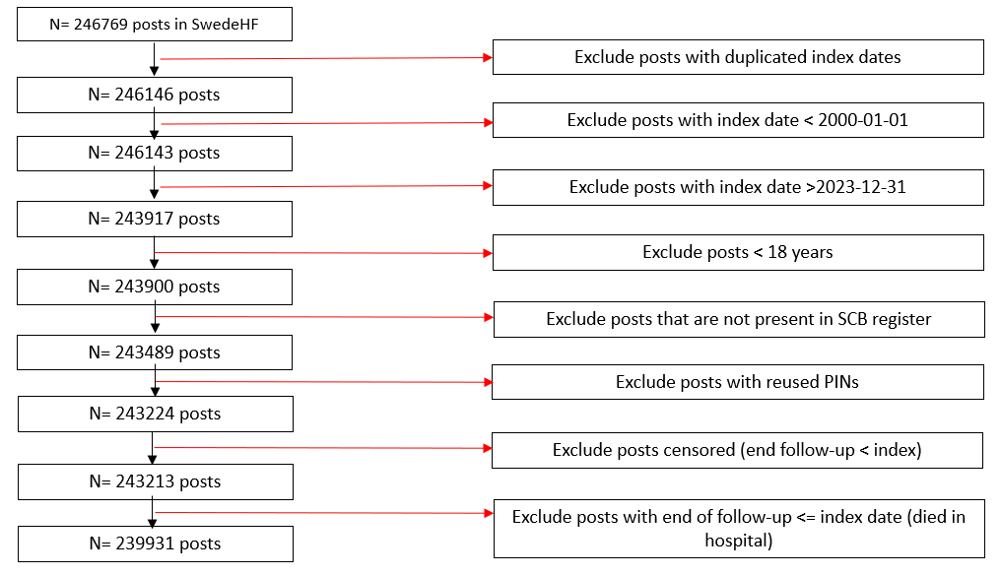
- Project specific inclusion (green arrows) /exclusion (red arrows) criteria.
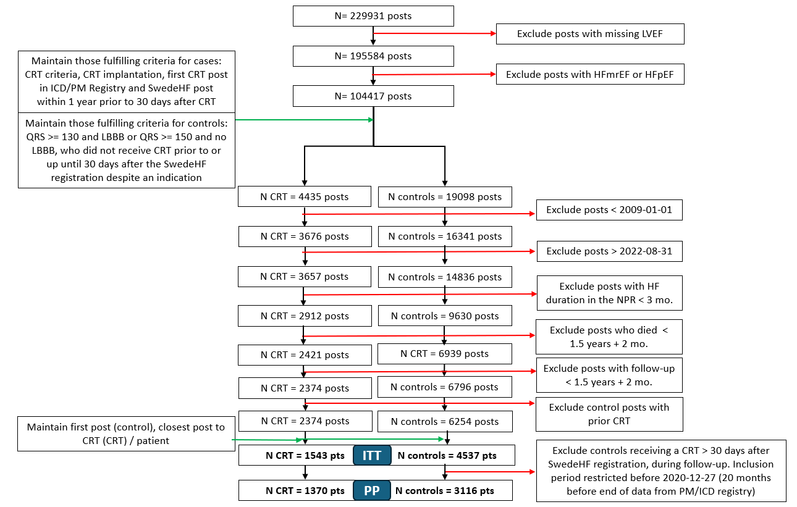

Figure S2. Proportion of patients with decrease, stable or increase use of GDMTs and loop diuretics stratified by CRT (CRT vs No CRT) in the subgroup of patients with SBP < 110 mmHg at baseline (intention-to-treat analysis).
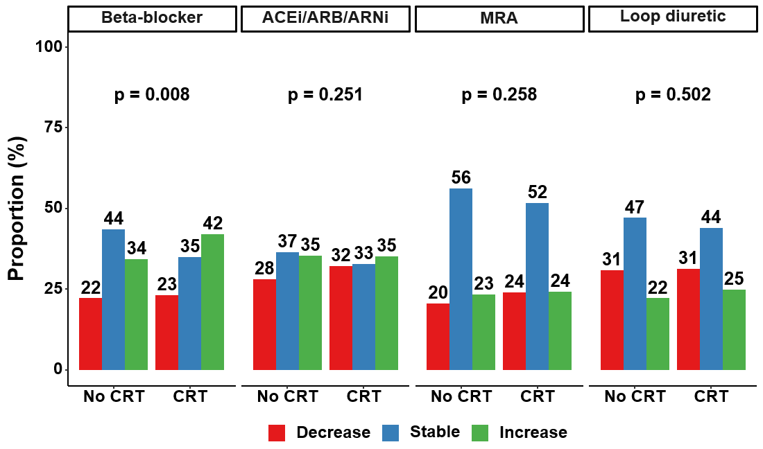

Figure S3. Proportion of patients with decrease, stable or increase use of GDMTs and loop diuretics stratified by CRT (CRT vs No CRT) in the subgroup of patients with SBP < 110 mmHg at baseline (per-protocol analysis).
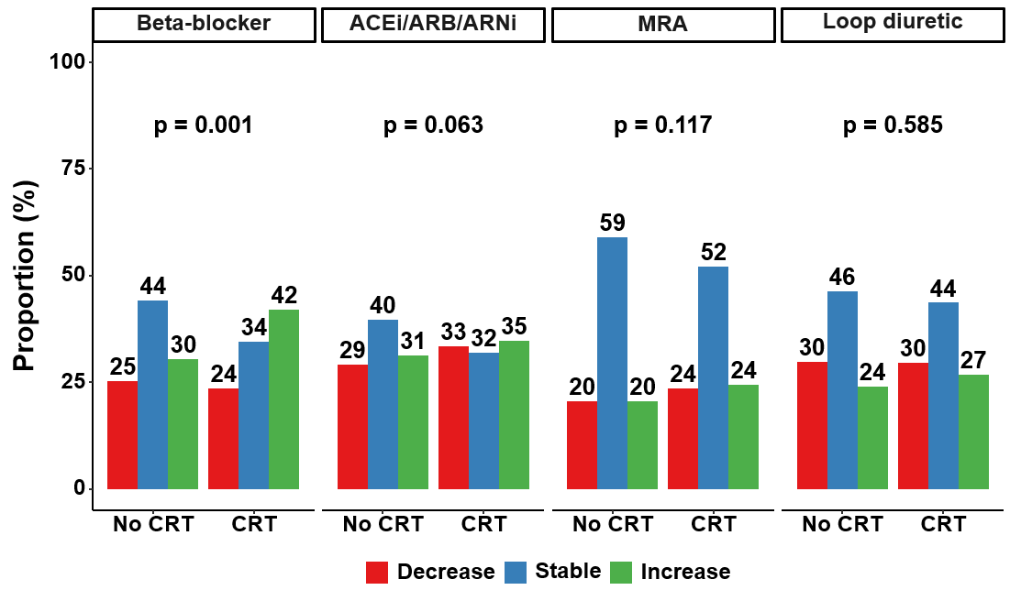

References:
1. Ludvigsson JF, Appelros P, Askling J, Byberg L, Carrero JJ, Ekstrom AM, et al. Adaptation of the Charlson Comorbidity Index for Register-Based Research in Sweden. Clin Epidemiol 2021;13:21-41. doi: https://doi.org/10.2147/CLEP.S282475
2. Dickstein K, Cohen-Solal A, Filippatos G, McMurray JJ, Ponikowski P, Poole-Wilson PA, et al. ESC Guidelines for the diagnosis and treatment of acute and chronic heart failure 2008: the Task Force for the Diagnosis and Treatment of Acute and Chronic Heart Failure 2008 of the European Society of Cardiology. Developed in collaboration with the Heart Failure Association of the ESC (HFA) and endorsed by the European Society of Intensive Care Medicine (ESICM). Eur Heart J 2008;29:2388-2442. doi: https://doi.org/10.1093/eurheartj/ehn309
3. McMurray JJ, Adamopoulos S, Anker SD, Auricchio A, Bohm M, Dickstein K, et al. ESC guidelines for the diagnosis and treatment of acute and chronic heart failure 2012: The Task Force for the Diagnosis and Treatment of Acute and Chronic Heart Failure 2012 of the European Society of Cardiology. Developed in collaboration with the Heart Failure Association (HFA) of the ESC. Eur J Heart Fail 2012;14:803-869. doi: https://doi.org/10.1093/eurjhf/hfs105
4. Ponikowski P, Voors AA, Anker SD, Bueno H, Cleland JG, Coats AJ, et al. 2016 ESC Guidelines for the diagnosis and treatment of acute and chronic heart failure: The Task Force for the diagnosis and treatment of acute and chronic heart failure of the European Society of Cardiology (ESC). Developed with the special contribution of the Heart Failure Association (HFA) of the ESC. Eur J Heart Fail 2016;18:891-975. doi: https://doi.org/10.1002/ejhf.592
5. Authors/Task Force M, McDonagh TA, Metra M, Adamo M, Gardner RS, Baumbach A, et al. 2021 ESC Guidelines for the diagnosis and treatment of acute and chronic heart failure: Developed by the Task Force for the diagnosis and treatment of acute and chronic heart failure of the European Society of Cardiology (ESC). With the special contribution of the Heart Failure Association (HFA) of the ESC. Eur J Heart Fail 2022;24:4-131. doi: https://doi.org/10.1002/ejhf.2333

