Supplementary Figure S1.

Fig S1. Time from clinical diagnosis of cryptococcosis to immunophenotyping blood tests.

Supplementary Figure S2.
B
A
Fig S2. A. Concentration of IL-17 in supernatants of whole blood from eleven patients with cryptococcal infection and contemporaneously processed controls following stimulation with PHA, including three additional patients not included in main paper due to subsequent identification of underlying immune compromise increasing susceptibility to opportunistic infection or incomplete diagnostic workup as follows. One individual with eczema, scoliosis, suspected delayed retention of primary teeth, and recurrent abscesses requiring frequent prolonged courses of antibiotics, but no history of chronic mucocutaneous candidiasis, whose genetic testing revealed STAT3 Hyper IgE syndrome; one individual who was later proven to have HTLV-driven lymphoma; and one elderly individual (age >80 years) with cryptococcal meningitis who underwent cytokine testing but had insufficient further diagnostic work-up. B. Concentration of IFN-γ, TNF-α, IL-6 and IL-1β in supernatants of whole blood from ten patients with cryptococcal infection (n=9 for IL-1β) and contemporaneously processed controls following stimulation with PHA, again including three additional patients not included in main paper. Key: ***: p<0.00; ns = not significant using Mann-Whitney two-tailed test; green data points: three additional patients with Hyper IgE syndrome, advanced age and HTLV-driven lymphoma.

Supplementary Figure S3.
C
B
Healthy control unstimulated:  A  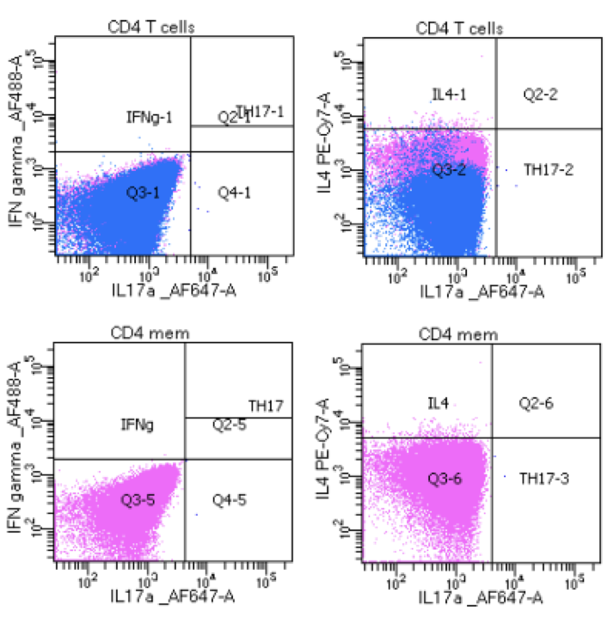 | Healthy control stimulated:  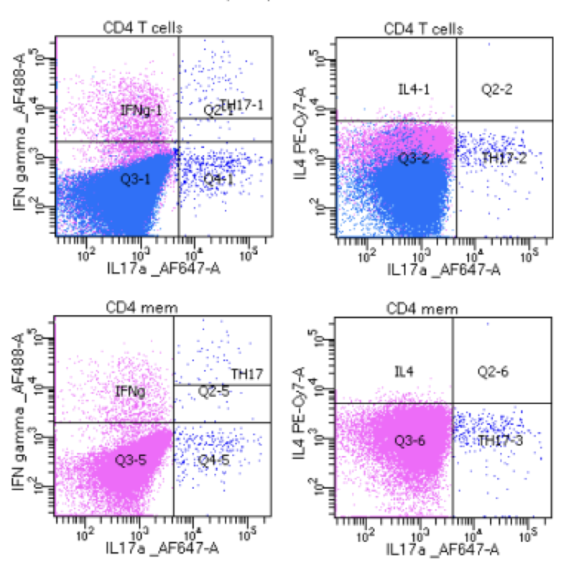
Patient unstimulated:  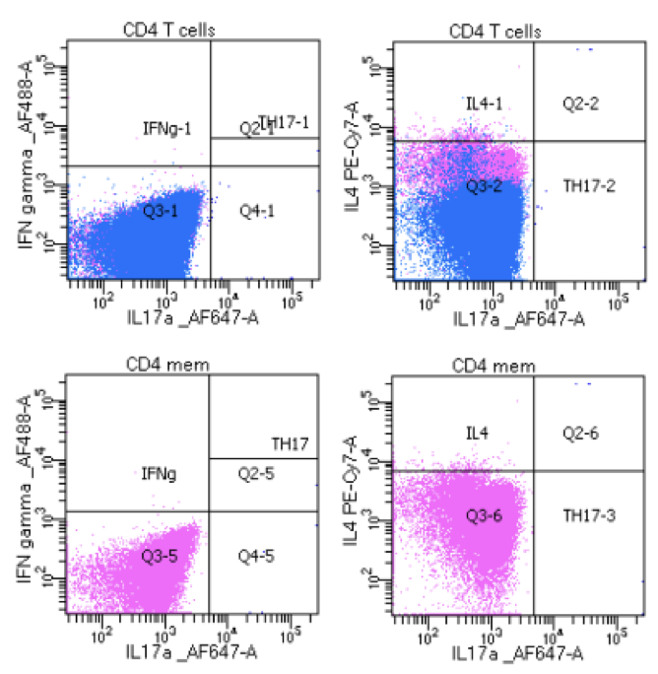 | Patient stimulated:  D  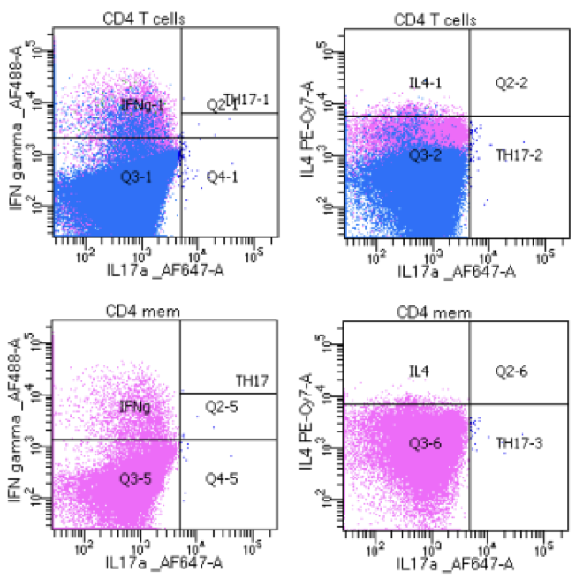

Gating strategy (shown on healthy control):
E
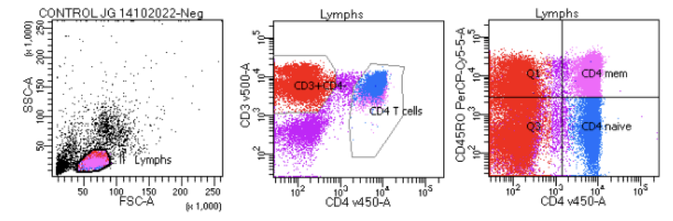

Fig S3. Representative FACS plots from a healthy control compared to a patient with low percentage of CD4⁺ CD45RO⁺ T-cells expressing IL-17. Flow cytometric plots demonstrating percentage of IL17⁺ CD4⁺ T cells, including CD45RO⁺ (Memory) T-cell subset, before and after stimulation with SEB, in healthy control (A, B) and representative patient (C, D). Red boxes highlight IL-17⁺ CD4⁺ T cells, with CD45RO⁺ memory T cells in pink; CD45RO⁻ naïve T cells in blue. IFN-γ expression is used as a positive control marker of successful stimulation with SEB. E. Gating strategy for IL-17⁺CD4⁺ memory T cells (pink), with aid of density plot (III-left) for CD4⁺ T cell population differentiation, shown on healthy control unstimulated sample.

