SUPPLEMENTARY FILE

**Supplementary Table S1.** Summary of national data sources, period of available mortality data, time unit, availability of sex and age-specific data, and data quality of civil registration and vital statistics systems per country.

|  |  |  |  |  |  |  |  |  |  |  |
| --- | --- | --- | --- | --- | --- | --- | --- | --- | --- | --- |
| **Country** | **Partners** | **Access Date** | **Source** | **Public data (Y/N)** | **Link (if available)** | **Notes** | **Time Unit** | **Weekly sex specific data available** | **Weekly age specific data available** | **% Completeness of vital registration systems\*** |
| Australia | Deakin University | July 31st, 2023 | Australian Bureau of Statistics | YES | [Australia](https://www.abs.gov.au/statistics/health/causes-death) |  | ISO | YES | YES | 100 |
| Austria | Department for Epidemiology, Center for Public Health, Medical University of Vienna | July 25th, 2023 | Cause of death statistics, Statistics Austria | NO |  |  | ISO | YES | YES | 100 |
| Belgium | Statistics Belgium, Sciensano | June 20th, 2023 | National register | YES | [Belgium](https://statbel.fgov.be/en/open-data/number-deaths-day-sex-district-age) |  | ISO | YES | YES | 99.8 |
| Brazil | Brazilian Ministry of Health | April 11th, 2023 | Mortality Information System | YES | [Brazil](https://opendatasus.saude.gov.br/dataset/sim) |  | Epi | YES | YES | 99.3 |
| Cyprus | University of Nicosia & Health Monitoring Unit, Cyprus Ministry of Health | June 2023 | Eurostat | YES | [Cyprus](https://ec.europa.eu/eurostat/databrowser/view/DEMO_R_MWK_05__custom_6174513/default/table?lang=en) |  | ISO | YES | YES | 90.7 |
| Denmark | Statistics Denmark | April 10th, 2023 | Central Persons Register | YES | [[Denmark](https://statbank.dk/statbank5a/default.asp?w=1536)](https://www.statistikbanken.dk/dodc1) |  | Epi | YES | YES | 100 |
| England and Wales | St George's, University of London | July 10th, 2023 | Office for National Statistics | YES | [England and Wales](https://www.ons.gov.uk/peoplepopulationandcommunity/birthsdeathsandmarriages/deaths/datasets/weeklyprovisionalfiguresondeathsregisteredinenglandandwales/2021) |  | National | YES | YES | 100 |
| Estonia | National Institute for Health Development | July 4th, 2023 | Estonian Causes of Death Register | YES | [Estonia](https://statistika.tai.ee/pxweb/en/Andmebaas/Andmebaas__01Rahvastik__04Surmad/?tablelist=true) |  | ISO | YES | YES | 100 |
| France | EHESP | July, 2023 | INED, INSEE, CépiDC-Inserm | YES | [France-INSEE](https://www.insee.fr/fr/information/4190491)  [France-INED](https://dc-covid.site.ined.fr/fr/donnees/france/)  [France-CépiDC](https://opendata-cepidc.inserm.fr/) |  | ISO | YES | YES | 100 |
| Georgia | National Center for Disease Control and Public Health | July 19th, 2023 | Vital Registration System | NO |  |  | ISO | YES | YES | 94.3 |
| Greece | Hellenic Statistical Authority | July 13th, 2023 | Statistics on Population and Social Conditions | YES | [Greece](https://www.statistics.gr/en/statistics/-/publication/SPO09/-) |  | ISO | YES | YES | 100 |
| Israel | Central Bureau of Statistics | June 13th,  2023 | Code list from death certificates | NO |  |  | Epi | YES | YES | 100 |
| Italy | ISTAT national census Italy | November 17th, 2023 | ISTAT national census Italy | YES |  |  | Epi | YES | YES | 100 |
| Mauritius | Statistics Mauritius | November 1st, 2023 | Statistics Mauritius - Government agency | NO |  |  | National | YES | YES | 99.8 |
| Northern Ireland | St George's, University of London | July 10th, 2023 | Northern Ireland Statistics and Research Agency | NO |  |  | National | NO | YES | 100 |
| Norway | University of Oslo | September 1st, 2023 | Statistics Norway | YES | [Norway](https://www.ssb.no/en/statbank/table/12954) |  | ISO | YES | YES | 100 |
| Peru | Universidad del Pacífico | May 3rd,  2023 | Ministerio de Salud | YES |  | The National Computer System of Deaths (in Spanish "SINADEF")  contains the data of the deceased, it includes fetal deaths, general deaths, diagnoses or disease history of causes of death | ISO | YES | YES | 64.4 |
| Poland | Nicolaus Copernicus University in Toruń | August 24th, 2023 | Statistics Poland | YES | [[Poland](https://stat.gov.pl/en/topics/population/population/weekly-deaths-which-include-age-sex-as-well-as-73-subregion-in-2023,12,24.html)](https://stat.gov.pl/en/topics/population/population/weekly-deaths-which-include-age-sex-as-well-as-73-subregion-in-2023,12,24.html) |  | ISO | YES | YES | 100 |
| Slovenia | National Institute of Public Health | November 14th, 2023 | Mortality statistics database | NO |  |  | ISO | YES | YES | 94.8 |
| Spain | University of Oviedo | July 31st, 2023 | Spanish National Statistical Institute (INE) | YES | [[Spain](https://www.ine.es/jaxiT3/Tabla.htm?t=7947&L=0)](https://www.ine.es/jaxiT3/Tabla.htm?t=7947&L=0) |  | ISO | YES | YES | 100 |
| Sweden | Karolinska Institutet | November 20th, 2023 | National Board of Health and Welfare | YES | [Sweden](https://www.socialstyrelsen.se/en/statistics-and-data/statistics/) |  | ISO | YES | YES | 100 |
| USA | East Tennessee State University | July 17th, 2024 | National Center for Health Statistics (NCHS) | YES | [USA-by age](https://data.cdc.gov/NCHS/Provisional-COVID-19-Death-Counts-by-Sex-Age-and-W/vsak-wrfu)  [USA-COVID deaths](https://data.cdc.gov/NCHS/Weekly-Provisional-Counts-of-Deaths-by-State-and-S/muzy-jte6/about_data)  [USA-weekly deaths](https://data.cdc.gov/NCHS/Weekly-Counts-of-Death-by-Jurisdiction-and-Select-/u6jv-9ijr/about_data)  [USA-weekly COVID deaths](https://data.cdc.gov/NCHS/Provisional-COVID-19-Death-Counts-by-Week-Ending-D/r8kw-7aab/about_data) |  | Epi | YES | YES | 100 |

Abbreviations: ISO: International Organization for Standardization; Epi: epidemiological

* Source: Supplementary Appendix 1 from Abbafati C, Abbas KM, Abbasi-Kangevari M, et al. Global burden of 369 diseases and injuries in 204 countries and territories, 1990–2019: a systematic analysis for the Global Burden of Disease Study 2019. *Lancet*. 2020;396(10258):1204-1222. doi:10.1016/S0140-6736(20)30925-9

**Supplementary Table S2.** Description and publicly available sources for the database of pandemic related variables (reported weekly).

|  |  |  |  |  |  |
| --- | --- | --- | --- | --- | --- |
| **Variable Label** | **Description** | **Time span** | **Range of Values** | **Data Source** | **Weblink** |
| Weekly incidence of COVID-19 | Number of COVID-19 new cases per week per 100,000 population | 2021-2022 | 0.23 - 32351.22 | IHME (2022); WHO COVID-19 Dashboard | [weekly COVID-19 incidence](https://ourworldindata.org/grapher/daily-new-estimated-covid-19-infections-ihme-model) |
| Stringency index | Mean stringency index per week | 2021-2022 | 0 – 100  (full range: 0 – 100, with higher values indicating more stringent control measures) | Blavatnik School of Government, University of Oxford | [stringency_index](https://www.bsg.ox.ac.uk/research/covid-19-government-response-tracker) |
| Government policy measures (School Closing,  Workplace Closing,  Cancel Public Events,  Restrictions on Gatherings,  Close Public Transport,  Stay at Home Requirements,  Restrictions on Internal Movement,  International Travel Controls) | Categorical ordinal variables, with higher levels indicating increased stringency | 2021-2022 | See Supplementary Table S3 | Blavatnik School of Government, University of Oxford | [government policy measures](https://www.bsg.ox.ac.uk/research/covid-19-government-response-tracker) |
| Total vaccinations per 100 population | Weekly cumulative number of total vaccinations administered per 100 population (includes first doses and boosters) | 2021-2022 | 0.00 – 254.4 | Our World in Data | [vaccinations](https://github.com/owid/covid-19-data/tree/master/public/data/vaccinations)  &  [vaccination meta-data](https://github.com/owid/covid-19-data/blob/master/public/data/vaccinations/README.md) |

**Supplementary Table S3.** Overview of Government Policy Measures on COVID-19: Classification by Type, Description, and Ordinal Categories

|  |  |  |  |  |
| --- | --- | --- | --- | --- |
| **ID** | **Name** | **Description** | **Type** | **Categories** |
| C1 | School Closing | Record closings of schools and universities | Ordinal | 0 - no measures  1 - recommend closing or all schools open with alterations resulting in significant differences compared to non-Covid-19 operations  2 - require closing (only some levels or categories, eg just high school, or just public schools)  3 - require closing all levels |
| C2 | Workplace Closing | Record closings of workplaces | Ordinal | 0 - no measures 1 - recommend closing (or recommend work from home) or all businesses open with alterations resulting in significant differences compared to non-Covid-19 operation 2 - require closing (or work from home) for some sectors or categories of workers 3 - require closing (or work from home) for all-but-essential workplaces (eg grocery stores, doctors) |
| C3 | Cancel Public Events | Record cancelling public events | Ordinal | 0- No measures  1 - Recommend cancelling  2 - Require cancelling |
| C4 | Restrictions on Gatherings | Record the cut-off size for limits on gatherings | Ordinal | 0 - no restrictions  1 - restrictions on very large gatherings (the limit is above 1000 people)  2 - restrictions on gatherings between 101-1000 people  3 - restrictions on gatherings between 11-100 people  4 - restrictions on gatherings of 10 people or less |
| C5 | Close Public Transport | Record closing of public transport | Ordinal | 0 - No measures  1 - Recommend closing (or significantly reduce volume/route/means of transport available)  2 - Require closing (or prohibit most citizens from using it) |
| C6 | Stay at Home Requirements | Record orders to “shelter-in- place” and otherwise confine to the home | Ordinal | 0 - no measures  1 - recommend not leaving house  2 - require not leaving house with exceptions for daily exercise, grocery shopping, and 'essential' trips  3 - require not leaving house with minimal exceptions (eg allowed to leave once a week, or only one person can leave at a time, etc) |
| C7 | Restrictions on Internal Movement | Record restrictions on internal movement between cities/regions | Ordinal | 0 - No measures  1 - Recommend not to travel between regions/cities  2 – internal movement restrictions in place |
| C8 | International Travel Controls | Record restrictions on international travel  Note: this records policy for foreign travellers, not citizens | Ordinal | 0 - no restrictions  1 - screening arrivals  2 - quarantine arrivals from some or all regions  3 - ban arrivals from some regions 4 - ban on all regions or total border closure |

**Supplementary Table S4.** Description of aggregate age groups created for the age-standardization according to age-specific all-cause mortality data availability.

|  |  |  |  |  |
| --- | --- | --- | --- | --- |
| Country | Age groups_Category 1 | Age groups_Category 2 | Age groups_Category 3 | Age groups_Category 4 |
|  | **<15, 15-44, 45-65, 65+** | **<20, 20-49, 50-69, 70+** | **<45, 45-64, 65+** | **<15, 15-64, 65+** |
| Australia | **x** |  |  |  |
| Austria | **x** |  |  |  |
| Belgium |  |  | **x** |  |
| Brazil | **x** |  |  |  |
| Cyprus | **x** |  |  |  |
| Denmark |  |  |  | **x** |
| England and Wales | **x** |  |  |  |
| Estonia | **x** |  |  |  |
| France |  |  | **x** |  |
| Georgia | **x** |  |  |  |
| Greece |  |  |  | **x** |
| Israel | **x** |  |  |  |
| Italy | **x** |  |  |  |
| Mauritius |  | **x** |  |  |
| N. Ireland | **x** |  |  |  |
| Norway | **x** |  |  |  |
| Peru | **x** |  |  |  |
| Poland | **x** |  |  |  |
| Slovenia | **x** |  |  |  |
| Spain | **x** |  |  |  |
| Sweden |  | **x** |  |  |
| USA |  |  |  | **x** |

Crude mortality rates (CMRs) were calculated for total population and sex-specific groups using equation (1)

$CMR_{y,w}=\frac{D_{y,w}}{P_{y} /N}$ (1)where $D_{y,w}$ denotes the number of deaths in all age-groups in year $y$ and week $w$, $P_{y}$ denotes the mid-year population for year $y$, and $N$ denotes the number of weeks in the year.

Age-specific mortality rates (ASpMRs) were calculated using equation (2)

$ASpMR_{y,w,i}=\frac{D_{y,w,i}}{P_{y,i} /N}$ (2)

where $D_{y,w,i}$ denotes the number of deaths in the age-group $i$ in year $y$ and week $w$, $P_{y,i}$ denotes the mid-year population of age group $i$ in year $y$, and $N$ denotes the number of weeks in the year.

Weekly age (directly) standardized mortality rates (ASMRs) were calculated as a weighted average of the ASMRs using equation (3) as previously described [Demetriou et al. 2020], where, index $i$ denotes the aggregate age groups (see Supplementary Table S4) and the standard population weights $p_{i}^{s}$ correspond to the proportion of population in the $i^{th }$ age interval in the WHO World Standard Population 2000-2025 [Ahmad et al. 2000].

$ASMR = \sum_{i=1}^{n}{\left(p_{i}^{s}ASpDR_{y,w,i}\right)}$ (3)

**Equation used for age-standardization for the aggregate age groups category 1 (<15, 15-44, 45-65, 65+)**;

ASMR1_totalpop=((ASpMR0-14*0.2615)+(ASpMR15-44*0.4597)+(ASpMR45-64*0.1968)+(ASpMR65+*0.08235))

(same equation applies for male and female population)

**Equation used for age-standardization for the aggregate age groups category 2 (<20, 20-49, 50-69, 70+)**;

ASMR2_totalpop=((ASpMR0-19*0.3462)+(ASpMR20-49*0.4354)+(ASpMR50-69*0.166)+(ASpMR70+*0.5275))

(same equation applies for male and female population)

**Equation used for age-standardization for the aggregate age groups category 3 (<45, 45-64, 65+);**

ASMR3_totalpop=((ASpMR0-44*0.7212)+(ASpMR45-64*0.1968)+(ASpMR65+*0.08235))

(same equation applies for male and female population)

**Equation used for age-standardization for the aggregate age groups category 4 (<15, 15-64, 65+);**

ASMR4_totalpop=((ASpMR0-14*0.2615)+(ASpMR15-64*0.6565)+(ASpMR65+*0.08235))

(same equation applies for male and female population)

References:

Demetriou CA, Achilleos S, Quattrocchi A, et al. Impact of the COVID-19 pandemic on total, sexand age-specific all-causemortality in 20 countries worldwide during 2020: results from the C-MOR project. *International Journal of Epidemiology.* 2022; 00(00):1-13.

Ahmad OB, Boschi-Pinto C, Lopez AD, Murray CJ, Lozano R, Inoue M. Age standardization of rates: a new WHO standard. GPE Discussion Paper Series: No31. *Geneva World Heal Organ*. 2000;(31). http://www.who.int/healthinfo/paper31.pdf

**Supplementary Table S5.** Truncated weeks excluded per country.

|  |  |
| --- | --- |
| **Country** | **Truncated weeks** |
| **Australia** | 53 |
| **Austria** | 53 |
| **Belgium** | 53 |
| **Brazil** | 53 |
| **Cyprus** | 53 |
| **Denmark** | 53 |
| **England and Wales** | 1, 52 |
| **Estonia** | 53 |
| **France** | 53 |
| **Georgia** | 53 |
| **Greece** | 53 |
| **Israel** | 53 |
| **Italy** | 53 |
| **Mauritius** | 1, 53 |
| **N. Ireland** | 51, 52 |
| **Norway** | 53 |
| **Peru** | 53 |
| **Poland** | 53 |
| **Slovenia** | 52, 53 |
| **Spain** | 53 |
| **Sweden** | 53 |
| **USA** | 53 |

**Supplementary methods for the investigation of the relationship of total vaccinations and governmental control measures with excess mortality**

To understand the relationship between the weekly number of vaccine doses (primary and booster) of various vaccine types administered per 100,000 population and the excess mortality observed in different countries for the years 2021 and 2022, multilevel regression analysis was performed, while accounting for weekly incidence of COVID-19 per 100,000 population (3-week lag), weekly average stringency index of government control measures (3-week lag) and weekly non-COVID-19 mortality rate. Stringency index was chosen as a summary estimate of the governmental response due to the high collinearity between individual governmental policy measures and vaccine doses administered. The effect of each governmental policy measure (3-week lag) on excess mortality during 2021 and 2022, was examined in independent models, while accounting for total vaccinations and non-COVID-19 mortality. The incorporation of the 3-week lag meant that weekly stringency of control measures (week n) was modelled against the excess mortality z-score of the week three weeks after (week n+3). For these analyses, multilevel models were used (separately for 2021 and for 2022), with country as a random effect, the pandemic-related variables as fixed effects, and with the method of restricted (residual) maximum likelihood. The rationale for a multilevel model, with Country as a random variable, was theoretical to enable investigation of how changes in the weekly variables within a country influence the outcome, independent of cross-country variation. Over and above signifying calendar years, the separate models across years were used to account for the prevalence of different virus variants, since Delta became the dominant variant in >130 countries worldwide during June–November 2021, while in 2022 the most prevalent variant across countries was Omicron (https://gisaid.org/hcov19-variants/). In all models above, weeks with z-scores larger than 15 (1% of datapoints) or smaller than -5 (0.1% of data points) were excluded as outliers based on the bag plots presented in Supplementary Figure S1.

**Supplementary Figure S1 – Bag plot for the detection of outliers in the multi-level models for excess mortality.** Bag plot of the observations in 2021 and 2022, regarding excess mortality z-score and total vaccinations per 100 (3-week lag). In the bag plot, half of the data is in the dark blue polygon (interior polygon) and the outer polygon is used to identify outliers.

**Supplementary Results:**

**Weekly comparisons-total population and by sex in 2020-2022**

Supplementary Figure S2 shows the weekly ASMR z-score over time for the total population from week 1 2020 to week 52 2022. Sex-specific weekly ASMR z-scores from 2020 over 2022 are shown for each country in Supplementary Figure S3 for males and females, respectively. For the total population, some countries observed smaller peaks in 2022 than in previous years, for example Peru, Brazil, and the USA. On the other hand, Mauritius observed a substantial excess mortality peak only at the end of 2022. Austria, Belgium, France, Italy, Slovenia, Sweden and Spain observed peaks mostly before 2021. Poland observed peaks from the end of 2020 until the end of 2021.

The countries that showed a substantial increase (>4 z-scores) in the ASMR over time from week 1 2022 to week 52 2022 for the total population, as well as for the male and female population are presented in Supplementary Table S5. In 2022, all countries showed a substantial increase in the ASMR for the total population ranging from 1 to 10 weeks. For the total population, in some countries the substantial increase was observed at the beginning of 2022, like in Australia, Brazil, Cyprus, Georgia, Israel, Peru, and the USA, while in some other countries, such as Estonia, Italy, Norway, Spain, and England and Wales, the substantial increase was observed in the middle through the end of 2022. Austria and Slovenia showed a substantial increase at the end of 2022, while Poland showed a substantial increase at the very beginning and very end of 2022. Northern Ireland did not display substantial excess mortality for any week during 2022. For the male population, the excess mortality duration among the countries varied between 1 and 12 weeks for 2022. Cyprus, and Slovenia did not display substantial excess mortality in males for any week during 2022. For the female population, the excess mortality duration in the countries varied between 1 and 8 weeks for 2022. Slovenia did not display substantial excess mortality in females for any week during 2022.

**Weekly comparisons by age group for total population in 2020-2022**

Supplementary Figures S4 and S5 show the weekly mortality rate z-score over time from 2020 to 2022 for ages <65, 65+, <70, 70+ years for the total population. The countries that experienced a substantial increase in the weekly mortality rate over 2022 for the younger age group investigated include Austria, Brazil, Estonia, Georgia, Greece, Peru, Poland, and the USA (age group <65), and Cyprus, Georgia, Mauritius, Poland, and Sweden (age group <70). All participating countries showed a substantial increase in the weekly mortality rate for the older age group 70+, while N. Ireland and Slovenia, did not show any substantial increase in the weekly mortality rate for the older age group 65+.



**Supplementary Figure S2.** Weekly z-score of age-standardised all-cause mortality rate for total population for the whole years, 2020, 2021, and 2022.



**Supplementary Figure S3.** Weekly z-score of age-standardised all-cause mortality rate by sex for 2020, 2021, and 2022.

**Supplementary Table S6. Number of weeks with substantial excess (z-score > 4)** **ASMR for each country during 2022 for the total, male and female population.**

|  |  |  |  |
| --- | --- | --- | --- |
| **Number of weeks with substantial excess ASMR (z-score>4) during 2022** | | | |
|  | **Total population** | **Males** | **Females** |
| **Australia** | 8 | 10 | 11 |
| **Austria** | 2 | 2 | 1 |
| **Belgium** | 1 | 1 | 1 |
| **Brazil** | 8 | 9 | 8 |
| **Cyprus** | 2 | 0 | 2 |
| **Denmark** | 3 | 1 | 1 |
| **England and Wales** | 2 | 1 | 2 |
| **Estonia** | 7 | 4 | 2 |
| **France** | 2 | 4 | 1 |
| **Georgia** | 10 | 7 | 7 |
| **Greece** | 4 | 4 | 3 |
| **Israel** | 5 | 6 | 4 |
| **Italy** | 3 | 3 | 2 |
| **Mauritius** | 5 | 5 | 5 |
| **Norway** | 8 | 10 | 4 |
| **Peru** | 8 | 7 | 8 |
| **Poland** | 4 | 4 | 3 |
| **Slovenia** | 1 | 0 | 0 |
| **Spain** | 8 | 12 | 7 |
| **Sweden** | 3 | 5 | 3 |
| **USA** | 7 | 8 | 6 |



**Supplementary Figure S4.** Weekly z-score of all-cause mortality rate for age groups <65 and 65+ between 2020 and 2022.



**Supplementary Figure S5.** Weekly z-score of all-cause mortality rate for age groups <70 and 70+ between 2020 and 2022.

**Supplementary Table S7.** Cumulative observed and expected ASMRs per 100,000 population for 2022; total population.

|  |  |  |  |  |  |  |  |  |
| --- | --- | --- | --- | --- | --- | --- | --- | --- |
| Country | Observed mortality rate / 100,000 population | Expected mortality rate / 100,000 population | Lower limit of 95% CI of Expected mortality rate | Upper limit of 95% CI of Expected mortality rate | Difference (Observed-Expected mortality rate) | Difference using the Lower limit of 95% CI of Expected mortality rate | Difference using the Upper limit of 95% CI of Expected mortality rate | P-score (the ratio of the excess to the expected, expressed as a percentage) |
| Australia | 413.5 | 353.5 | 348.2 | 358.7 | 60.1↑ | 65.3 | 54.8 | 17.0 |
| Austria | 494.3 | 443.1 | 434.4 | 451.8 | 51.2↑ | 59.9 | 42.5 | 11.6 |
| Belgium | 482.6 | 444.8 | 437.1 | 452.6 | 37.7↑ | 45.5 | 30.0 | 8.5 |
| Brazil | 599.4 | 561.7 | 555.0 | 568.3 | 37.8↑ | 44.4 | 31.1 | 6.7 |
| Cyprus | 448.3 | 375.9 | 362.8 | 389.2 | 72.4↑ | 85.5 | 59.2 | 19.3 |
| Denmark | 598.0 | 553.7 | 545.9 | 561.6 | 44.3↑ | 52.1 | 36.5 | 8.0 |
| England and Wales | 494.1 | 434.9 | 426.4 | 443.4 | 59.2↑ | 67.7 | 50.6 | 13.6 |
| Estonia | 639.3 | 529.2 | 517.4 | 541.0 | 110.1↑ | 121.9 | 98.3 | 20.8 |
| France | 442.9 | 411.2 | 405.5 | 416.9 | 31.7↑ | 37.3 | 26.0 | 7.7 |
| Georgia | 846.1 | 730.0 | 714.1 | 746.0 | 116.2↑ | 132.1 | 100.2 | 15.9 |
| Greece | 603.0 | 539.6 | 530.0 | 549.2 | 63.4↑ | 73.0 | 53.8 | 11.8 |
| Israel | 442.8 | 374.0 | 366.4 | 381.7 | 68.8↑ | 76.4 | 61.1 | 18.4 |
| Italy | 457.8 | 409.3 | 401.9 | 416.7 | 48.5↑ | 55.9 | 41.1 | 11.8 |
| Mauritius | 773.8 | 706.3 | 689.3 | 723.5 | 67.5↑ | 84.5 | 50.3 | 9.6 |
| Northern Ireland | 493.0 | 455.0 | 441.5 | 468.6 | 38.0↑ | 51.5 | 24.4 | 8.4 |
| Norway | 426.8 | 367.6 | 362.2 | 373.0 | 59.3↑ | 64.7 | 53.8 | 16.1 |
| Peru | 422.7 | 414.1 | 407.0 | 421.2 | 8.6↑ | 15.7 | 1.5 | 2.1 |
| Poland | 610.8 | 560.6 | 552.5 | 568.7 | 50.2↑ | 58.3 | 42.1 | 9.0 |
| Slovenia | 484.6 | 440.5 | 431.0 | 450.1 | 44.2↑ | 53.7 | 34.6 | 10.0 |
| Spain | 458.4 | 395.3 | 389.3 | 401.3 | 63.1↑ | 69.1 | 57.1 | 16.0 |
| Sweden | 366.3 | 326.0 | 321.0 | 331.1 | 40.3↑ | 45.3 | 35.3 | 12.4 |
| USA | 614.5 | 541.5 | 535.0 | 548.1 | 73.0↑ | 79.5 | 66.5 | 13.5 |

*For all countries, the sum of observed and expected deaths is up to week 52, with the exception of England & Wales (starting from week 2 up to week 51), Mauritius (starting from week 2 up to week 52), Northern Ireland (up to week 50), and Slovenia (up to 51). ↑ Indicates statistically significant excess all-cause mortality using the sum of deaths for 2022. Due to the variability in the provided age groupings by countries, age-standardised mortality values are not entirely comparable between countries and direct comparisons between countries should be avoided.

**Table S8.** Difference between cumulative observed and expected ASMRs per 100,000 population for 2021 and 2020 separately; total population.

|  |  |  |  |  |  |  |  |  |
| --- | --- | --- | --- | --- | --- | --- | --- | --- |
| Country | Difference (Observed-Expected mortality rate) in 2021 | Difference using the Lower limit of 95% CI of Expected mortality rate in 2021 | Difference using the Upper limit of 95% CI of Expected mortality rate in 2021 | P-score (the ratio of the excess to the expected, expressed as a percentage) in 2021 | Difference (Observed-Expected mortality rate) in 2020 | Difference using the Lower limit of 95% CI of Expected mortality rate in 2020 | Difference using the Upper limit of 95% CI of Expected mortality rate in 2020 | P-score (the ratio of the excess to the expected, expressed as a percentage) in 2020 |
| Australia | 14.5↑ | 19.7 | 9.2 | 4.0 | 2.6 | 7.9 | -2.7 | 0.7 |
| Austria | 42.0↑ | 50.6 | 33.3 | 9.4 | 47.0↑ | 55.6 | 38.3 | 10.4 |
| Belgium | 16.9↑ | 24.6 | 9.1 | 3.7 | 68.3↑ | 76.1 | 60.5 | 14.8 |
| Brazil | 183.6↑ | 190.3 | 177.0 | 32.2 | 88.0↑ | 94.7 | 81.4 | 15.2 |
| Cyprus | 53.2↑ | 66.3 | 40.0 | 14.0 | 24.0↑ | 37.1 | 10.7 | 6.2 |
| Denmark | 13.4↑ | 21.2 | 5.5 | 2.4 | 1.4↑ | 9.2 | -6.4 | 0.3 |
| England and Wales | 59.0↑ | 67.5 | 50.5 | 13.4 | 72.1↑ | 80.6 | 63.5 | 16.0 |
| Estonia | 127.0↑ | 138.8 | 115.2 | 23.5 | 33.7↑ | 45.6 | 21.8 | 6.1 |
| France | 27.6↑ | 33.4 | 21.7 | 6.3 | 34.5↑ | 40.3 | 28.7 | 7.8 |
| Georgia | 256.8↑ | 272.7 | 240.6 | 34.2 | 94.2↑ | 110.3 | 77.9 | 12.2 |
| Greece | 88.7↑ | 98.3 | 79.2 | 16.4 | 30.0↑ | 39.5 | 20.5 | 5.6 |
| Israel | 54.8↑ | 62.5 | 47.1 | 8.0 | 33.9↑ | 41.6 | 26.1 | 8.6 |
| Italy | 30.8↑ | 38.2 | 23.4 | 13.2 | 50.9↑ | 58.4 | 43.4 | 11.9 |
| Mauritius | -53.9↓ | -37.1 | -70.8 | -7.7 | -30.8↓ | -14.2 | -47.6 | -4.4 |
| Northern Ireland | 51.9↑ | 65.4 | 38.3 | 11.3 | 45.4↑ | 58.9 | 31.8 | 9.7 |
| Norway | 16.0↑ | 21.4 | 10.5 | 4.2 | 7.8↑ | 13.3 | 2.3 | 2.0 |
| Peru | 337.2↑ | 343.9 | 330.4 | 83.9 | 318.4↑ | 324.7 | 311.9 | 83.4 |
| Poland | 140.0↑ | 148.1 | 131.9 | 24.6 | 89.9↑ | 97.9 | 81.8 | 15.6 |
| Slovenia | 52.8↑ | 62.3 | 43.2 | 11.8 | 67.2↑ | 76.8 | 57.6 | 14.7 |
| Spain | 33.7↑ | 39.8 | 27.7 | 8.4 | 78.5↑ | 84.6 | 72.4 | 19.1 |
| Sweden | 22.0↑ | 27.1 | 16.8 | 6.5 | 43.4↑ | 48.5 | 38.2 | 12.3 |
| USA | 112.4↑ | 118.9 | 105.9 | 20.6 | 100.5↑ | 107.0 | 94.0 | 18.2 |

**Supplementary Table S9.** Cumulative observed and expected ASMRs per 100,000 population for the years 2020, 2021 and 2022 together; total population.

|  |  |  |  |  |  |  |  |  |
| --- | --- | --- | --- | --- | --- | --- | --- | --- |
| Country | Observed mortality rate / 100,000 population | Expected mortality rate / 100,000 population | Lower limit of 95% CI of Expected mortality rate | Upper limit of 95% CI of Expected mortality rate | Difference (Observed-Expected mortality rate) | Difference using the Lower limit of 95% CI of Expected mortality rate | Difference using the Upper limit of 95% CI of Expected mortality rate | P-score (the ratio of the excess to the expected, expressed as a percentage) |
| Australia | 387.0 | 361.3 | 358.3 | 364.4 | 25.7↑ | 28.8 | 22.7 | 7.1 |
| Austria | 494.5 | 447.8 | 442.8 | 452.8 | 46.7↑ | 51.7 | 41.7 | 10.4 |
| Belgium | 493.6 | 452.7 | 448.2 | 457.2 | 41.0↑ | 45.5 | 36.5 | 9.1 |
| Brazil | 673.0 | 569.9 | 566.1 | 573.7 | 103.1↑ | 107.0 | 99.3 | 18.1 |
| Cyprus | 431.2 | 381.3 | 373.7 | 389.0 | 49.9↑ | 57.5 | 42.2 | 13.1 |
| Denmark | 580.1 | 560.4 | 555.8 | 564.9 | 19.7↑ | 24.2 | 15.2 | 3.5 |
| England and Wales | 505.4 | 442.0 | 437.1 | 446.9 | 63.4↑ | 68.4 | 58.5 | 14.4 |
| Estonia | 632.0 | 541.7 | 534.9 | 548.6 | 90.3↑ | 97.1 | 83.5 | 16.7 |
| France | 460.7 | 429.4 | 426.1 | 432.8 | 31.3↑ | 34.6 | 27.9 | 7.3 |
| Georgia | 905.8 | 750.1 | 740.9 | 759.4 | 155.7↑ | 164.9 | 146.4 | 20.8 |
| Greece | 600.3 | 539.6 | 534.1 | 545.1 | 60.7↑ | 66.2 | 55.2 | 11.3 |
| Israel | 435.9 | 383.4 | 379.0 | 387.9 | 52.5↑ | 56.9 | 48.0 | 13.7 |
| Italy | 464.7 | 420.4 | 416.2 | 424.8 | 44.2↑ | 48.5 | 39.9 | 10.5 |
| Mauritius | 694.8 | 700.5 | 690.8 | 710.3 | -5.7 | 4.0 | -15.5 | -0.8 |
| Northern Ireland | 506.0 | 460.9 | 453.1 | 468.7 | 45.1↑ | 52.9 | 37.3 | 9.8 |
| Norway | 405.2 | 377.5 | 374.3 | 380.7 | 27.7↑ | 30.8 | 24.5 | 7.3 |
| Peru | 620.5 | 399.1 | 395.2 | 403.0 | 221.4↑ | 225.3 | 217.5 | 55.5 |
| Poland | 661.9 | 568.6 | 563.9 | 573.2 | 93.4↑ | 98.0 | 88.7 | 16.4 |
| Slovenia | 502.9 | 448.2 | 442.7 | 453.7 | 54.7↑ | 60.2 | 49.2 | 12.2 |
| Spain | 461.2 | 402.7 | 399.2 | 406.2 | 58.5↑ | 61.9 | 55.0 | 14.5 |
| Sweden | 374.2 | 339.0 | 336.1 | 342.0 | 35.2↑ | 38.2 | 32.3 | 10.4 |
| USA | 641.5 | 546.2 | 542.5 | 550.0 | 95.3↑ | 99.1 | 91.6 | 17.5 |

*For all countries, the sum of observed and expected deaths is up to week 52, with the exception of England & Wales (starting from week 2 up to week 51), Mauritius (starting from week 2 up to week 52), Northern Ireland (up to week 50), and Slovenia (up to 51). ↑ Indicates statistically significant excess all-cause mortality using the sum of deaths for 2020, 2021 and 2022. ↓Indicates a statistically significant reduction all-cause mortality using the sum of deaths for 2020, 2021 and 2022. Due to the variability in the provided age groupings by countries, age-standardised mortality values are not entirely comparable between countries and direct comparisons between countries should be avoided.

**Supplementary Table S10.** Cumulative observed and expected mortality rate for 2022 by sex.

|  |  |  |  |  |  |  |  |  |  |  |  |  |  |  |  |  |
| --- | --- | --- | --- | --- | --- | --- | --- | --- | --- | --- | --- | --- | --- | --- | --- | --- |
|  | Males | | | | | | | | Females | | | | | | | |
| Country | **Observed mortality rate / 100,000 population** | **Expected mortality rate / 100,000 population** | **Lower limit of 95% CI of Expected mortality rate** | **Upper limit of 95% CI of Expected mortality rate** | **Difference (Observed-Expected mortality rate)** | **Difference using the Lower limit of 95% CI of Expected mortality rate** | **Difference using the Upper limit of 95% CI of Expected mortality rate** | **P-score (the ratio of the excess to the expected, expressed as a percentage)** | **Observed mortality rate / 100,000 population** | **Expected mortality rate / 100,000 population** | **Lower limit of 95% CI of Expected mortality rate** | **Upper limit of 95% CI of Expected mortality rate** | **Difference (Observed-Expected mortality rate)** | **Difference using the Lower limit of 95% CI of Expected mortality rate** | **Difference using the Upper limit of 95% CI of Expected mortality rate** | **P-score (the ratio of the excess to the expected, expressed as a percentage)** |
| Australia | 464.0 | 400.7 | 395.1 | 406.3 | 63.4↑ | 68.9 | 57.7 | 15.8 | 366.2 | 309.1 | 304.2 | 314.1 | 57.0↑ | 61.9 | 52.1 | 18.4 |
| Austria | 560.8 | 496.1 | 486.2 | 506.1 | 64.7↑ | 74.6 | 54.7 | 13.0 | 434.8 | 395.3 | 386.6 | 404.1 | 39.5↑ | 48.1 | 30.7 | 10.0 |
| Belgium | 530.2 | 488.7 | 480.3 | 497.2 | 41.4↑ | 49.9 | 32.9 | 8.5 | 438.2 | 404.2 | 396.0 | 412.4 | 34.0↑ | 42.2 | 25.8 | 8.4 |
| Brazil | 723.9 | 681.3 | 674.0 | 688.6 | 42.6↑ | 49.9 | 35.3 | 6.3 | 490.5 | 456.9 | 451.0 | 463.0 | 33.6↑ | 39.6 | 27.6 | 7.3 |
| Cyprus | 504.2 | 434.8 | 416.6 | 453.2 | 69.4↑ | 87.6 | 51.0 | 16.0 | 397.2 | 321.8 | 306.1 | 337.7 | 75.4↑ | 91.1 | 59.5 | 23.4 |
| Denmark | 560.3 | 522.0 | 513.8 | 530.3 | 38.3↑ | 46.6 | 30.0 | 7.3 | 440.7 | 408.6 | 401.9 | 415.3 | 32.1↑ | 38.8 | 25.4 | 7.9 |
| England and Wales | 548.7 | 484.0 | 475.2 | 493.0 | 64.6↑ | 73.5 | 55.7 | 13.4 | 443.9 | 389.8 | 381.4 | 398.2 | 54.2↑ | 62.5 | 45.7 | 13.9 |
| Estonia | 818.6 | 668.7 | 650.0 | 687.6 | 149.9↑ | 168.6 | 131.0 | 22.4 | 501.5 | 423.0 | 411.5 | 434.6 | 78.5↑ | 90.0 | 67.0 | 18.6 |
| France | 512.8 | 470.5 | 464.4 | 476.6 | 42.3↑ | 48.3 | 36.2 | 9.0 | 381.0 | 358.5 | 353.1 | 364.0 | 22.4↑ | 27.8 | 17.0 | 6.3 |
| Georgia | 1160.8 | 1000.3 | 978.3 | 1022.4 | 160.6↑ | 182.6 | 138.4 | 16.1 | 624.6 | 537.4 | 522.6 | 552.4 | 87.2↑ | 102.0 | 72.2 | 16.2 |
| Greece | 568.0 | 505.7 | 496.8 | 514.6 | 62.3↑ | 71.2 | 53.3 | 12.3 | 527.7 | 472.8 | 462.8 | 482.8 | 54.9↑ | 64.9 | 44.9 | 11.6 |
| Israel | 503.0 | 415.5 | 406.2 | 424.9 | 87.5↑ | 96.8 | 78.2 | 21.1 | 389.1 | 335.6 | 327.5 | 343.9 | 53.5↑ | 61.7 | 45.3 | 15.9 |
| Italy | 503.4 | 450.0 | 442.6 | 457.4 | 53.5↑ | 60.8 | 46.1 | 11.9 | 417.3 | 372.9 | 365.4 | 380.5 | 44.3↑ | 51.8 | 36.8 | 11.9 |
| Mauritius | 942.5 | 831.3 | 805.8 | 857.1 | 111.2↑ | 136.7 | 85.4 | 13.4 | 621.1 | 586.0 | 567.3 | 605.0 | 35.0↑ | 53.8 | 16.1 | 6.0 |
| Norway | 457.4 | 387.2 | 380.2 | 394.4 | 70.1↑ | 77.2 | 63.0 | 18.1 | 396.6 | 346.9 | 340.2 | 353.7 | 49.7↑ | 56.4 | 43.0 | 14.3 |
| Peru | 421.9 | 411.7 | 404.1 | 419.4 | 10.2↑ | 17.8 | 2.5 | 2.5 | 425.9 | 418.3 | 410.8 | 425.8 | 7.6↑ | 15.1 | 0.1 | 1.8 |
| Poland | 761.3 | 696.2 | 686.7 | 705.7 | 65.2↑ | 74.7 | 55.6 | 9.4 | 482.3 | 442.0 | 434.7 | 449.4 | 40.2↑ | 47.6 | 32.9 | 9.1 |
| Slovenia | 551.0 | 492.4 | 477.5 | 507.4 | 58.7↑ | 73.6 | 43.7 | 11.9 | 421.7 | 387.5 | 376.8 | 398.3 | 34.2↑ | 44.9 | 23.4 | 8.8 |
| Spain | 526.7 | 456.1 | 449.9 | 462.3 | 70.6↑ | 76.8 | 64.4 | 15.5 | 397.1 | 341.9 | 335.7 | 348.1 | 55.2↑ | 61.3 | 48.9 | 16.1 |
| Sweden | 396.4 | 347.3 | 342.0 | 352.6 | 49.2↑ | 54.5 | 43.9 | 14.2 | 337.4 | 305.1 | 300.0 | 310.2 | 32.3↑ | 37.4 | 27.2 | 10.6 |
| USA | 708.2 | 621.3 | 614.3 | 628.3 | 86.9↑ | 93.9 | 79.9 | 14.0 | 525.1 | 465.6 | 459.6 | 471.7 | 59.5↑ | 65.5 | 53.4 | 12.8 |

*For all countries, the sum of observed and expected deaths is up to week 52, with the exception of England & Wales (starting from week 2 up to week 51), Mauritius (starting from week 2 up to week 52), and Slovenia (up to 51). ↑ Indicates statistically significant excess all-cause mortality using the sum of deaths for 2022. ↓ Indicates a statistically significant reduction all-cause mortality using the sum of deaths for 2022. Due to the variability in the provided age groupings by countries, age-standardised mortality values are not entirely comparable between countries and direct comparisons between countries should be avoided.

**Supplementary Table S11.** Male to female cumulative excess ratio for 2020, 2021 and 2022, respectively.

|  |  |  |  |  |  |  |  |  |  |
| --- | --- | --- | --- | --- | --- | --- | --- | --- | --- |
|  | **2020** | | | **2021** | | | **2022** | | |
| **Country** | **Male Excess Mortality**  **(per 100,000 population)** | **Female Excess Mortality (per 100,000 population)** | **Ratio Males: Females** | **Male Excess Mortality (per 100,000 population)** | **Female Excess Mortality (per 100,000 population)** | **Ratio Males: Females** | **Male Excess Mortality (per 100,000 population)** | **Female Excess Mortality (per 100,000 population)** | **Ratio Males: Females** |
| **Australia** | 3.4 | 2.1 | 1.6 | 13.4 | 15.5 | 0.9 | 63.4 | 57.0 | 1.1 |
| **Austria** | 59.0 | 36.7 | 1.6 | 58.1 | 27.7 | 2.1 | 64.7 | 39.5 | 1.6 |
| **Belgium** | 76.1 | 61.3 | 1.2 | 33.5 | 2.5 | 13.4 | 41.4 | 34.0 | 1.2 |
| **Brazil** | 122.0 | 60.1 | 2.0 | 227.7 | 146.0 | 1.6 | 42.6 | 33.6 | 1.3 |
| **Cyprus** | 25.4 | 22.3 | 1.1 | 58.6 | 49.0 | 1.2 | 69.4 | 75.4 | 0.9 |
| **Denmark** | 2.8 | -5.9 | -0.5 | 9.0 | 16.4 | 0.5 | 38.3 | 32.1 | 1.2 |
| **England and Wales** | 109.6 | 62.0 | 1.8 | 98.0 | 49.5 | 2.0 | 64.6 | 54.2 | 1.2 |
| **Estonia** | 43.4 | 24.0 | 1.8 | 170.8 | 92.3 | 1.9 | 149.9 | 78.5 | 1.9 |
| **France** | 46.1 | 24.8 | 1.9 | 42.2 | 15.3 | 2.8 | 42.3 | 22.4 | 1.9 |
| **Georgia** | 138.9 | 67.4 | 2.1 | 321.4 | 217.7 | 1.5 | 160.6 | 87.2 | 1.8 |
| **Greece** | 28.0 | 26.8 | 1.0 | 85.5 | 70.0 | 1.2 | 62.3 | 54.9 | 1.1 |
| **Israel** | 46.3 | 23.7 | 2.0 | 70.7 | 41.0 | 1.7 | 87.5 | 53.5 | 1.6 |
| **Italy** | 62.8 | 41.3 | 1.5 | 40.3 | 22.9 | 1.8 | 53.5 | 44.3 | 1.2 |
| **Mauritius** | -10.6 | -48.7 | 0.2 | -33.4 | -70.7 | 0.5 | 111.2 | 35.0 | 3.2 |
| **Norway** | 11.8 | 4.5 | 2.6 | 16.6 | 15.8 | 1.1 | 70.1 | 49.7 | 1.4 |
| **Peru** | 353.7 | 293.4 | 1.2 | 348.7 | 332.6 | 1.0 | 10.2 | 7.6 | 1.3 |
| **Poland** | 128.1 | 61.6 | 2.1 | 181.4 | 108.2 | 1.7 | 65.2 | 40.2 | 1.6 |
| **Slovenia** | 77.6 | 63.4 | 1.2 | 84.4 | 32.7 | 2.6 | 58.7 | 34.2 | 1.7 |
| **Spain** | 89.6 | 69.0 | 1.3 | 44.7 | 24.6 | 1.8 | 70.6 | 55.2 | 1.3 |
| **Sweden** | 56.0 | 31.9 | 1.8 | 32.8 | 12.1 | 2.7 | 49.2 | 32.3 | 1.5 |
| **USA** | 121.4 | 80.4 | 1.5 | 141.4 | 84.7 | 1.7 | 86.9 | 59.5 | 1.5 |

**Discussion on sex-specific mortality patterns:**

Both male and female populations demonstrated excess cumulative mortality rates. In 2022, Cyprus showed higher excess mortality for females compared to males, whereas in 2021, this was observed in Australia, Denmark, and Mauritius. These sex-specific patterns might be due to country-specific factors such as differences in healthcare access, societal or occupational roles, or behavioral responses to health advisories (Galasso et al. 2020 & Brown et al. 2022).

**References:**

Galasso V, Pons V, Profeta P, Becher M, Brouard S, Foucault M. Gender differences in COVID-19 attitudes and behavior: Panel evidence from eight countries. PNAS. 2020;117(44):27285–27291.

Brown TH, Kamis C, Homan P. Empirical evidence on structural racism as a driver of racial inequities in COVID-19 mortality. Front Public Health. 2022;1–10.

**Supplementary Table S12.** Cumulative observed and expected mortality rate for 2022 by age group.

|  |  |  |  |  |  |  |  |  |  |  |  |  |  |  |  |  |  |
| --- | --- | --- | --- | --- | --- | --- | --- | --- | --- | --- | --- | --- | --- | --- | --- | --- | --- |
| Country | Observed mortality rate / 100,000 population* | Expected mortality rate / 100,000 population* | Lower limit of 95% CI of Expected mortality rate | Upper limit of 95% CI of Expected mortality rate | Difference (Observed-Expected mortality rate) | Difference using the Lower limit of 95% CI of Expected mortality rate | Difference using the Upper limit of 95% CI of Expected mortality rate | P-score (the ratio of the excess to the expected, expressed as a percentage) | Observed mortality rate / 100,000 population* | | Expected mortality rate / 100,000 population* | Lower limit of 95% CI of Expected mortality rate | Upper limit of 95% CI of Expected mortality rate | Difference (Observed-Expected mortality rate) | Difference using the Lower limit of 95% CI of Expected mortality rate | Difference using the Upper limit of 95% CI of Expected mortality rate | P-score (the ratio of the excess to the expected, expressed as a percentage) |
|  | **<65** | | | | | | | |  | **65+** | | | | | | | |
| Australia | 141.6 | 131.1 | 127.9 | 134.3 | 10.5↑ | 13.7 | 7.3 | 8.0 | 3717.3 | | 3080.7 | 3048.5 | 3113.0 | 636.5↑ | 668.7 | 604.2 | 20.7 |
| Austria | 181.7 | 164.1 | 160.5 | 167.7 | 17.7↑ | 21.2 | 14.0 | 10.8 | 4596.6 | | 4114.2 | 4024.9 | 4204.1 | 482.4↑ | 571.7 | 392.5 | 11.7 |
| Belgium | 172.1 | 157.7 | 154.2 | 161.3 | 14.3↑ | 17.8 | 10.8 | 9.1 | 4419.5 | | 4012.3 | 3932.0 | 4093.0 | 407.2↑ | 487.5 | 326.5 | 10.2 |
| Brazil | 274.0 | 267.3 | 262.7 | 271.9 | 6.7↑ | 11.3 | 2.1 | 2.5 | 4476.4 | | 4097.9 | 4063.3 | 4132.6 | 378.5↑ | 413.1 | 343.7 | 9.2 |
| Cyprus | 133.7 | 126.2 | 117.5 | 135.1 | 7.5 | 16.2 | -1.4 | 6.0 | 4213.7 | | 3419.5 | 3294.8 | 3545.7 | 794.2↑ | 918.9 | 668.0 | 23.2 |
| Denmark | 163.1 | 158.4 | 154.3 | 162.5 | 4.6↑ | 8.7 | 0.5 | 2.9 | 4345.0 | | 4031.2 | 3976.9 | 4085.8 | 313.8↑ | 368.1 | 259.2 | 7.8 |
| England and Wales | 185.0 | 168.1 | 164.4 | 171.8 | 17.0↑ | 20.7 | 13.2 | 10.1 | 4406.4 | | 3838.5 | 3753.1 | 3924.6 | 567.9↑ | 653.3 | 481.8 | 14.8 |
| Estonia | 303.1 | 235.1 | 224.8 | 245.6 | 68.0↑ | 78.3 | 57.5 | 28.9 | 5254.0 | | 4577.8 | 4470.0 | 4686.5 | 676.2↑ | 784.0 | 567.5 | 14.8 |
| France | 184.0 | 166.9 | 163.3 | 170.6 | 17.0↑ | 20.6 | 13.4 | 10.2 | 3942.7 | | 3528.6 | 3469.6 | 3587.9 | 414.1↑ | 473.0 | 354.8 | 11.7 |
| Georgia | 375.3 | 335.8 | 327.8 | 343.9 | 39.5↑ | 47.5 | 31.4 | 11.8 | 6906.9 | | 5862.5 | 5710.8 | 6015.5 | 1044.4↑ | 1196.1 | 891.5 | 17.8 |
| Greece | 210.1 | 191.3 | 187.4 | 195.2 | 18.8↑ | 22.7 | 14.9 | 9.8 | 5243.2 | | 4577.5 | 4479.0 | 4676.7 | 665.7↑ | 764.2 | 566.5 | 14.5 |
| Israel | 109.1 | 100.0 | 97.1 | 102.9 | 9.1↑ | 12.0 | 6.3 | 9.2 | 4153.3 | | 3413.6 | 3339.5 | 3488.1 | 739.7↑ | 813.7 | 665.1 | 21.7 |
| Italy | 158.6 | 147.0 | 143.6 | 150.4 | 11.6↑ | 15.0 | 8.2 | 7.9 | 4575.0 | | 4039.6 | 3960.5 | 4119.2 | 535.4↑ | 614.5 | 455.8 | 13.3 |
| Northern Ireland | 187.8 | 182.3 | 174.1 | 190.7 | 5.5 | 13.8 | -2.9 | 3.0 | 4351.7 | | 3919.1 | 3794.8 | 4044.7 | 432.6↑ | 556.9 | 307.0 | 11.0 |
| Norway | 128.9 | 116.1 | 112.6 | 119.6 | 12.8↑ | 16.3 | 9.3 | 11.0 | 4078.3 | | 3465.2 | 3411.4 | 3519.4 | 613.1↑ | 666.9 | 558.9 | 17.7 |
| Peru | 162.6 | 165.5 | 161.6 | 169.3 | -2.8 | 1.0 | -6.7 | -1.7 | 3488.0 | | 3159.1 | 3105.0 | 3213.5 | 328.9↑ | 383.0 | 274.5 | 10.4 |
| Poland | 302.3 | 292.3 | 287.5 | 297.1 | 10.1↑ | 14.8 | 5.3 | 3.4 | 4892.9 | | 4346.5 | 4270.5 | 4422.8 | 546.4↑ | 622.4 | 470.1 | 12.6 |
| Slovenia | 191.5 | 176.6 | 169.7 | 183.5 | 15.0↑ | 21.8 | 8.0 | 8.5 | 4394.7 | | 3989.4 | 3896.0 | 4083.5 | 405.3↑ | 498.7 | 311.2 | 10.2 |
| Spain | 167.2 | 149.8 | 146.4 | 153.3 | 17.3↑ | 20.7 | 13.9 | 11.5 | 4315.0 | | 3698.8 | 3633.3 | 3764.6 | 616.2↑ | 681.7 | 550.4 | 16.7 |
| USA | 304.5 | 264.4 | 259.9 | 269.0 | 40.1↑ | 44.6 | 35.5 | 15.2 | 4307.4 | | 3834.2 | 3804.7 | 3863.9 | 473.2↑ | 502.8 | 443.5 | 12.3 |
|  | | | | | | | | | | | | | | | | | |
| <70 | | | | | | | | | **70+** | | | | | | | | |
| Cyprus | 185.3 | 170.0 | 160.0 | 180.2 | 15.3↑ | 25.3 | 5.1 | 9.0 | 5598.3 | | 4605.1 | 4430.4 | 4782.1 | 993.2↑ | 1167.9 | 816.2 | 21.6 |
| Georgia | 500.8 | 448.8 | 439.1 | 458.5 | 52.0↑ | 61.7 | 42.2 | 11.6 | 9202.8 | | 8039.3 | 7827.0 | 8253.4 | 1163.5↑ | 1375.8 | 949.4 | 14.5 |
| Italy | 220.4 | 198.5 | 194.5 | 202.4 | 21.9↑ | 25.8 | 18.0 | 11.0 | 5763.1 | | 5010.1 | 4908.6 | 5112.3 | 753.0↑ | 854.5 | 650.9 | 15.0 |
| Mauritius | 549.9 | 531.9 | 516.9 | 546.9 | 18.0↑ | 33.0 | 3.0 | 3.4 | 7157.7 | | 6299.0 | 6079.9 | 6520.6 | 858.7↑ | 1077.8 | 637.1 | 13.6 |
| Norway | 181.9 | 159.2 | 155.1 | 163.3 | 22.7↑ | 26.8 | 18.6 | 14.3 | 5320.7 | | 4394.4 | 4321.0 | 4468.1 | 926.4↑ | 999.7 | 852.7 | 21.1 |
| Poland | 432.4 | 425.3 | 419.6 | 431.1 | 7.1↑ | 12.9 | 1.3 | 1.7 | 6438.7 | | 5734.5 | 5628.7 | 5841.1 | 704.1↑ | 810.0 | 597.6 | 12.3 |
| Sweden | 154.4 | 139.7 | 136.5 | 143.1 | 14.6↑ | 17.9 | 11.3 | 10.5 | 4927.8 | | 4345.6 | 4280.3 | 4411.3 | 582.2↑ | 647.5 | 516.5 | 13.4 |

*For all countries, the sum of observed and expected deaths is up to week 52, with the exception of England & Wales (starting from week 2 up to week 51), Mauritius (starting from week 2 up to week 52), and Slovenia (up to 51). ↑ Indicates statistically significant excess all-cause mortality using the sum of deaths for 2022. ↓ Indicates a statistically significant reduction all-cause mortality using the sum of deaths for 2022. Due to the variability in the provided age groupings by countries, age-standardised mortality values are not entirely comparable between countries and direct comparisons between countries should be avoided.

**Discussion on age-group-specific mortality patterns:**

Age-specific differences in cumulative mortality rates were notable across most countries, with older age groups (65+ and 70+) experiencing higher excess mortality. This finding is consistent with the increased susceptibility of older individuals to severe outcomes from COVID-19 and other comorbid conditions exacerbated during the pandemic (Yanez et al. 2020 & Guan et al. 2020).

**References:**

Yanez ND, Weiss NS, Romand JA, Treggiari MM. COVID-19 mortality risk for older men and women. BMC Public Health. BioMed Central Ltd; 2020 Dec 1;20(1).

Guan WJ, Liang WH, Zhao Y, et al. Comorbidity and its impact on 1590 patients with COVID-19 in China: a nationwide analysis. European Respiratory Journal. Georg Thieme Verlag; 2020 Oct 1;55(5):1–14.

**Supplementary Table S13. COVID-19 deaths and other causes of deaths per country for 2020-2022.**

|  |  |  |  |  |  |  |  |  |  |
| --- | --- | --- | --- | --- | --- | --- | --- | --- | --- |
| Country | Observed Mortality 2022 | Observed Mortality 2021 | Observed Mortality 2020 | Total COVID-19 deaths per hundred thousand (2022) | Other causes of death per hundred thousand (2022) | Total COVID-19 deaths per hundred thousand (2021) | Other causes of death per hundred thousand (2021) | Total COVID-19 deaths per hundred thousand (2020) | Other causes of death per hundred thousand (2020) |
| Australia | 413.5 | 375.7 | 371.9 | 37.6 | 375.9 | 4.8 | 370.8 | 3.4 | 368.5 |
| Austria | 494.3 | 489.7 | 499.5 | 70.5 | 423.8 | 86.3 | 403.4 | 74.7 | 424.7 |
| Belgium | 482.6 | 469.4 | 528.9 | 42.5 | 440.1 | 72.7 | 396.7 | 172.7 | 356.3 |
| Brazil | 599.4 | 753.4 | 666.2 | 32.2 | 567.2 | 197.2 | 556.2 | 100.7 | 565.5 |
| Cyprus | 448.3 | 434.5 | 410.8 | 76.7 | 371.7 | 69.3 | 365.2 | 14.9 | 395.9 |
| Denmark | 598.0 | 573.6 | 568.5 | 63.7 | 534.3 | 32.4 | 541.2 | 24.0 | 544.5 |
| Engl&Wales | 494.1 | 500.9 | 521.4 | 55.4 | 438.7 | 123.8 | 377.1 | 141.4 | 380.0 |
| Estonia | 639.3 | 668.6 | 588.3 | 68.7 | 570.6 | 131.9 | 536.6 | 16.5 | 571.7 |
| France | 442.9 | 463.0 | 476.2 | 72.7 | 370.2 | 104.5 | 358.5 | 124.7 | 351.5 |
| Georgia | 846.1 | 1006.5 | 864.7 | 50.0 | 796.1 | 297.7 | 708.8 | 70.3 | 794.4 |
| Greece | 603.0 | 628.3 | 569.6 | 135.2 | 467.8 | 153.2 | 475.1 | 47.6 | 522.0 |
| Israel | 457.8 | 444.9 | 426.8 | 42.4 | 415.4 | 52.2 | 392.7 | 36.1 | 390.7 |
| Italy | 442.8 | 438.1 | 479.8 | 79.0 | 363.8 | 103.6 | 334.4 | 129.7 | 350.1 |
| Mauritius | 773.8 | 646.6 | 663.9 | 60.4 | 713.3 | 4.7 | 641.9 | 0.8 | 663.1 |
| N.Ireland | 493.0 | 512.8 | 512.3 | 53.6 | 439.4 | 114.7 | 398.1 | 96.6 | 415.7 |
| Norway | 426.8 | 393.3 | 395.4 | 64.2 | 362.6 | 0.6 | 392.8 | 8.4 | 387.0 |
| Peru | 422.7 | 738.8 | 700.0 | 2.4 | 420.3 | 24.7 | 714.2 | 26.3 | 673.7 |
| Poland | 610.8 | 708.5 | 666.5 | 47.3 | 563.6 | 235.1 | 473.4 | 111.8 | 554.7 |
| Slovenia | 484.6 | 500.8 | 523.3 | 118.9 | 365.8 | 140.7 | 360.0 | 164.8 | 358.5 |
| Spain | 458.4 | 436.3 | 488.8 | 55.3 | 403.1 | 81.8 | 354.5 | 127.4 | 361.3 |
| Sweden | 366.3 | 360.7 | 395.6 | 34.2 | 332.1 | 48.6 | 312.1 | 93.6 | 302.0 |
| USA | 614.5 | 658.6 | 651.5 | 72.5 | 542.0 | 135.8 | 522.7 | 117.0 | 534.5 |

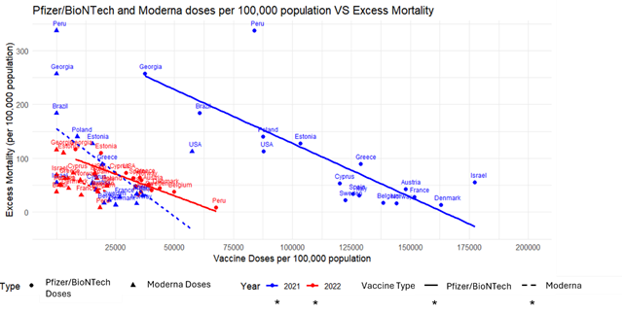

**Supplementary Figure S6. Relationship Between Pfizer/BioNTech and Moderna Vaccine Doses and Excess Mortality in 2021 and 2022.**

Asterisk (*) indicates the trend line that is statistically significant.

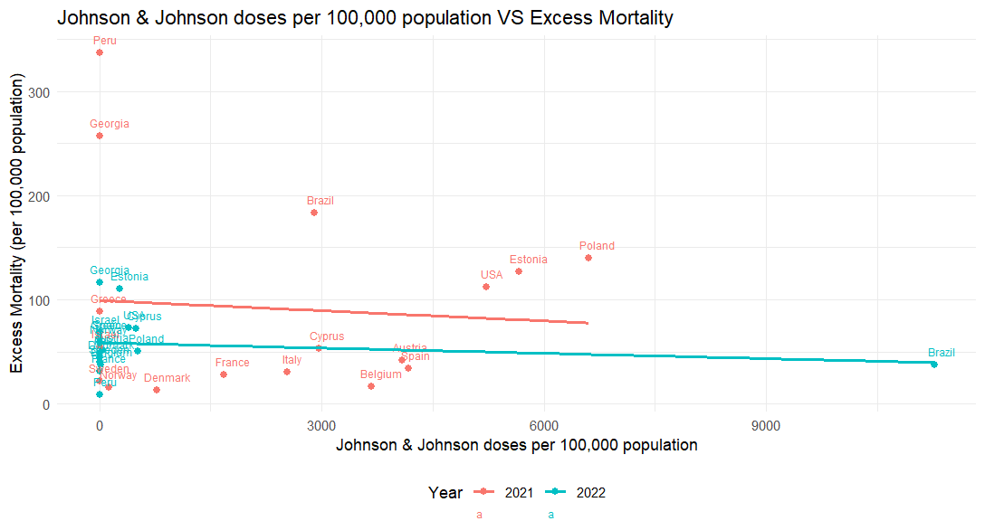

**Supplementary Figure S7. Relationship Between Johnson and Johnson Vaccine Doses and Excess Mortality in 2021 and 2022.**

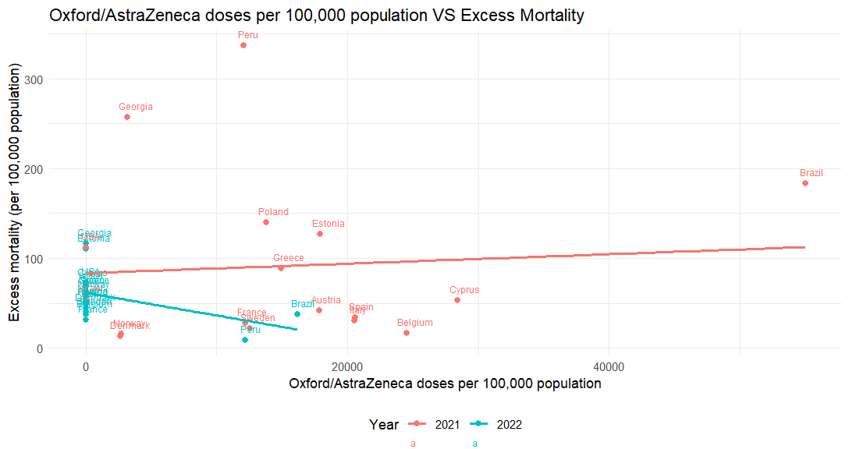

**Supplementary Figure S8. Relationship Between Oxford/AstraZeneca Vaccine Doses and Excess Mortality in 2021 and 2022.**

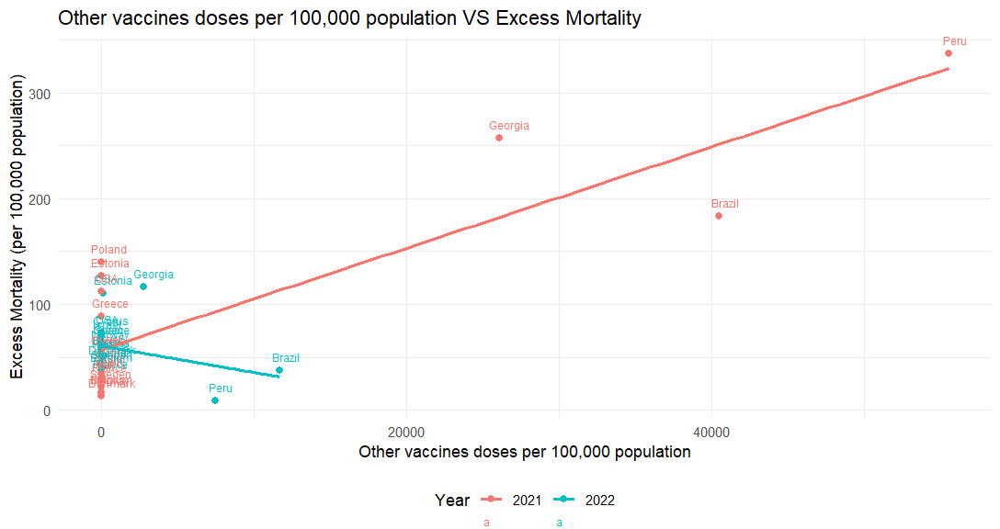

*

**Supplementary Figure S9. Relationship Between Other Vaccines Doses and Excess Mortality in 2021 and 2022.** Other Vaccines include Sputnik V, Sinovac, Sinopharm/Beijing, CanSino, Novavax, Covaxin, Medicago, Sanofi/GSK, SKYCovione, and Valneva.

Asterisk (*) indicates the trend line that is statistically significant.

**Supplementary Figure S10.** **Relationship Between Oxford/AstraZeneca Vaccine Doses and Excess Mortality in 2021 and 2022, after removing Brazil.**

**Supplementary Table S14. Regression analysis of the relationship between vaccine doses and excess mortality for different vaccine types in 2021 and 2022.**

|  |  |  |  |  |  |  |
| --- | --- | --- | --- | --- | --- | --- |
| Year | Vaccine Type | Term of the regression model | Estimated coefficient | Standard error | T-statistic | p-value |
| 2021 | Pfizer/BioNTech | Doses | -0.00200 | 0.000393 | -5.08 | 0.000136 |
| 2022 | Pfizer/BioNTech | Doses | -0.00162 | 0.000273 | -5.94 | 0.0000273 |
| 2021 | Moderna | Doses | -0.00326 | 0.00128 | -2.54 | 0.0228 |
| 2022 | Moderna | Doses | -0.00152 | 0.000804 | -1.89 | 0.0778 |
| 2021 | Johnson&Jonhson | Doses | -0.003259 | 0.010617 | -0.307 | 0.7631 |
| 2022 | Johnson&Jonhson | Doses | -0.001684 | 0.002497 | -0.674 | 0.51 |
| 2021 | Oxford/Astrazeneca | Doses | 0.0005275 | 0.001791 | 0.294 | 0.7724 |
| 2022 | Oxford/Astrazeneca | Doses | -0.002521 | 0.001289 | -1.957 | 0.0693 |
| 2021 | Other Vaccines | Doses | 0.004789 | 0.0007169 | 6.680 | 0.00000736 |
| 2022 | Other Vaccines | Doses | -0.002509 | 0.002009 | -1.249 | 0.231 |

**Description:** At the ecological level, Pfizer/BioNTech (2021: β=-0.00200, p<0.001 & 2022: β=-0.00162, p<0.001) and Moderna (2021: β=-0.00326, p=0.023 & 2022: β=-0.00152, p=0.0778) vaccines showed negative relationships with cumulative excess mortality in both 2021 and 2022, suggesting that as more vaccine doses were administered, excess mortality decreased. Johnson & Johnson and Oxford/AstraZeneca vaccines did not show robust relationships with cumulative excess mortality. The "Other Vaccines" category showed an unexpected positive relationship with excess mortality in 2021 (β=0.004789, p<0.001), but not in 2022. The "Other Vaccines" category included Sputnik V, Sinovac, Sinopharm/Beijing, CanSino, Novavax, Covaxin, Medicago, Sanofi/GSK, SKYCovione, and Valneva.

**Discussion:** Interestingly, Johnson and Johnson, Oxford/AstraZeneca, and the other vaccines either showed no significant effect or, in the case of other vaccines for 2021, an unexpected positive relationship with excess mortality. The non-significant results observed may be attributed to differential effectiveness of each vaccine at the individual level. However, the ecological nature of this investigation also presents as a potential explanation the fact that high administration of these vaccines (rather than Pfizer/BioNTech and Moderna) may be a reflection of country-level factors such as weaker healthcare system access and quality, and reduced overall effectiveness of the pandemic response all of which could have been associated with excess mortality.

For example, Peru, Brazil, and Georgia saw increased usage of other vaccines (Mathieu et al. 2023) likely due to the relatively lower economic statuses and political instability of these countries in 2022. However, the political and economic challenges in Peru and Brazil, and the significant poverty and unemployment in Georgia had a profound negative effect on healthcare systems during the pandemic, which could have masked any benefits from these vaccines (World Bank Group, 2024). Notably, after removing Brazil in a sensitivity analysis, the observed upward trend in the association between Oxford/AstraZeneca vaccines and excess mortality during 2021 was no longer positive but negative (Supplementary Figure S10). These results highlight the main caveats of ecological investigations, and the caution that should be exercised when interpreting their results. However, they also stress the fact that global vaccination efforts were not equitable, since low- and middle-income countries lacked timely access to what were considered the most effective vaccines.

**References:**

Mathieu E, Ritchie H, Rodés-Guirao L, et al. Coronavirus Pandemic (COVID-19) [Internet]. Our World in Data 2020 [cited 2023 May 22]. Available from: <https://ourworldindata.org/coronavirus>

World Bank Group. Countries and Economies [Internet]. World Bank Group 2024 [cited 2024 Jul 14]. Available from: https://data.worldbank.org/country

**Supplementary Figures S11-S18, show the percentage of weeks in each year (2020-2022), for which a specific stringency level of each policy was applied in each country.**

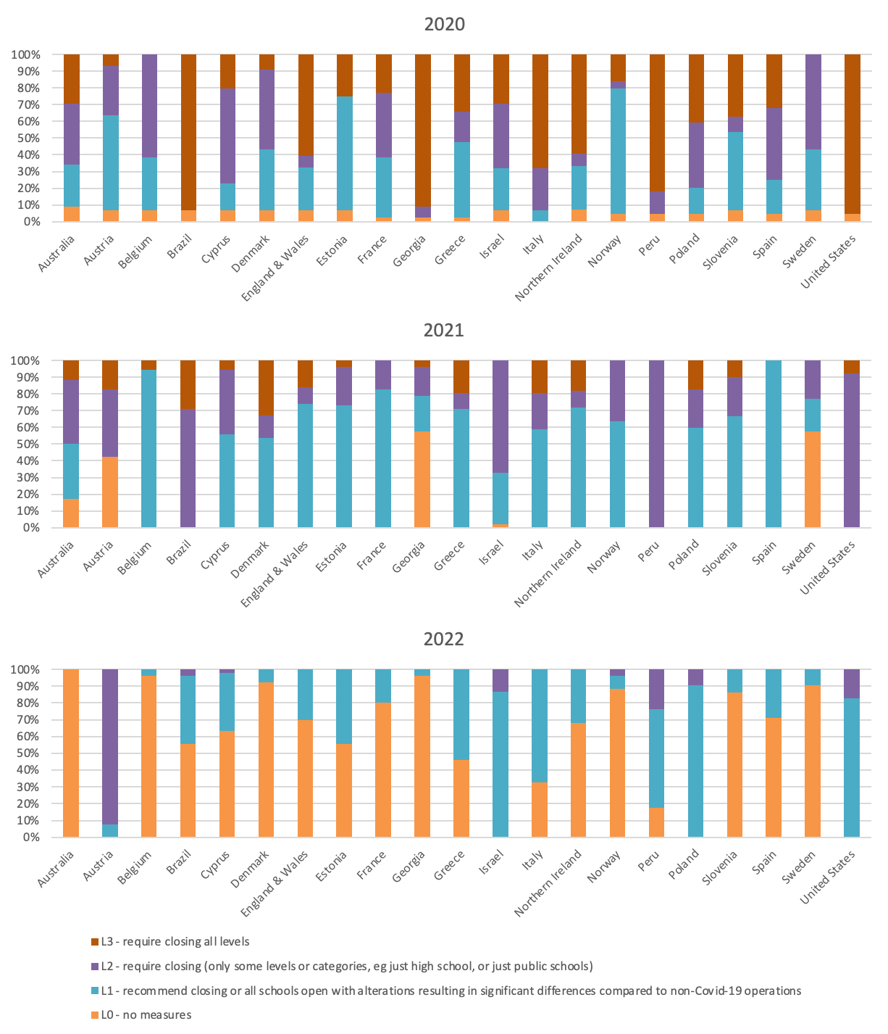

**Figure S11. Stringency Levels of School Closure (C1) Policy in 21 Countries, 2020-2022**

**Figure S12. Stringency Levels of Workplace Closure (C2) Policy in 21 Countries, 2020-2022**

**Figure S13. Stringency Levels of Public Events Cancellation (C3) Policy in 21 Countries, 2020-2022**

**Figure S14. Stringency Levels of Restrictions on Gatherings (C4) Policy in 21 Countries, 2020-2022**

**Figure S15. Stringency Levels of Public Transport Closure (C5) Policy in 21 Countries, 2020-2022**

**Figure S16. Stringency Levels of Stay at Home Requirements (C6) Policy in 21 Countries, 2020-2022**

**Figure S17. Stringency Levels of Restrictions on Internal Movement (C7) Policy in 21 Countries, 2020-2022**

**Figure S18. Stringency Levels of International Travel Controls (C8) Policy in 21 Countries, 2020-2022**

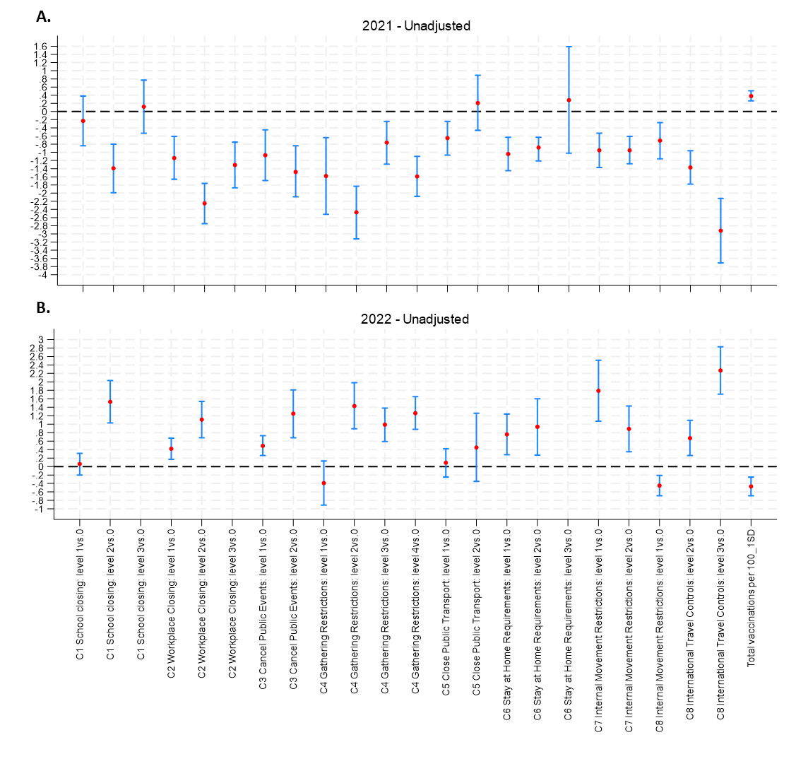

**Supplementary Figure S19.** Unadjusted multi-level model results on the relationship between governmental control policies (3 week lag) and excess mortality in (A) 2021 & (B) 2022

Multilevel models included Country as a random effect and categorical governmental control measures as fixed effects, adjusting for total vaccinations and non-COVID-19 mortality. A separate model was built for each governmental control measure. Red circles represent the regression coefficient for each control measure level, and blue whiskers represent the 95% Confidence Intervals. Lack of regression coefficients for particular control measure levels indicates that that level was not implemented in the respective year analysed.”

**Strengths and Limitations of the study**

The international collaboration within the COVID-19 Mortality (C-MOR) Consortium ensures a comprehensive and geographically diverse dataset, enabling insights into global trends in mortality during the ongoing pandemic. By utilizing standardized methods such as age-standardized mortality rates (ASMR) and statistical models that account for seasonal variations and historical trends, the study facilitates meaningful comparisons across different demographic groups and regions. Moreover, the availability of data over several consecutive years allows for the assessment of temporal trends, including comparisons with pre-pandemic mortality rates, thereby offering valuable insights into the pandemic's long-term impact on mortality. This study is among a limited number of research efforts that have aimed to analyze total, sex-specific, and age-specific excess mortality across multiple countries throughout the entirety of 2022, utilizing national mortality data sources. Lastly, the study's approach of using excess all-cause mortality provides a more robust measure by reflecting broader pandemic impacts on mortality, rather than focusing on COVID-19 specific mortality which is more subject to reporting biases and under- or over-reporting (Ioannidis 2020 & Badker et al. 2021).

However, several limitations should be considered when interpreting the findings of this study. Variability in the reporting and categorization of mortality data across participating countries, including the use of inconsistent age groupings, as well as differences in the definition of a COVID-19 death as utilised by involved countries, may introduce challenges in data harmonization and comparability (Mostert.et al. 2020). Age-grouping inconsistency means that age-standardized results are not fully comparable across countries, making direct comparisons unreliable. Therefore, the extent of excess mortality in 2022 should not be used to gauge the comparative impact among countries. Additionally, while efforts were made to mitigate reporting delays by compiling data several months after the study period, residual delays of months or even years could still influence the accuracy and timeliness of mortality estimates, particularly for recent periods like 2022. The possibility of data quality variations between countries, particularly in developing countries where data collection and reporting systems may be less robust, is another limitation of this investigation. Similarly, registration data quality displayed temporal variability during the pandemic, even within countries, based on the strain faced by healthcare and other systems. Furthermore, the number of vaccines administered per population unit may not accurately reflect the number of individuals vaccinated due to multiple doses per person. Another limitation of this investigation is the lack of harmonised information for all participating countries on the demographic characteristics of those vaccinated, including vaccination coverage among vulnerable groups, and the lack of data showing the prevalence of different virus variants in each country during the course of the pandemic. Availability of such data could have improved our understanding of excess mortality determinants. Lastly, since population-level correlations may be proxies for other factors directly affecting excess deaths or death reporting, the relationships observed between excess mortality and its determinants may not represent individual experience due to possible ecological fallacy. The potential for ecological fallacy is recognised by the authors thus all results have been interpreted with caution.

**References:**

Badker R, Miller K, Pardee C, et al. Challenges in reported COVID-19 data: Best practices and recommendations for future epidemics. BMJ Glob Health BMJ Publishing Group; 2021.

Ioannidis JPA. Global perspective of COVID-19 epidemiology for a full-cycle pandemic. Eur J Clin Invest Blackwell Publishing Ltd; 2020.

Mostert S, Hoogland M, Huibers M, Kaspers G. Excess mortality across countries in the Western World since the COVID-19 pandemic: ‘Our World in Data’ estimates of January 2020 to December 2022. BMJ Public Health. 2024 May;2(1):e000282.