# **Introduction of biopharmaceuticals in Europe: A cross-sectional study of early diffusion patterns and data availability**

Ivar Veszelei1, Brian Godman2,3,4, Katri Aaltonen5*,6, Gisbert W. Selke*7, Kristina Garuolienė8, Agnese Cangini*9, Amanj Kurdi2,3, António Teixeira Rodrigues10,11, Caridad Pontes12,13, Carla Torre14,15, Carlotta Lunghi16,17, Edel Burton18,19,20, Elita Poplavska21, Freyja Jónsdóttir22,23, Guenka Petrova24, Irene Langer*7, Irina Iaru25, Irina Odnoletkova26, Juraj Slabý*27, Katarina Gvozdanović28, Leena Saastamoinen*29, Ott Laius*30, Ria Benkö31,32, Silvija Žiogaitė8, Stuart McTaggart33, Tanja Mueller2, Thais de Pando12,*34, TomášTesař*35, Zornitsa Mitkova24, Björn Wettermark1,8.

1. Department of Pharmacy, Faculty of Pharmacy, Uppsala University, Uppsala, Sweden
2. Strathclyde Institute of Pharmacy and Biomedical Sciences, University of Strathclyde, Glasgow, UK
3. Department of Public Health Pharmacy and Management, School of Pharmacy, Sefako Makgatho Health Sciences University, Pretoria 0208, South Africa
4. Antibiotic Policy Group, Institute for Infection and Immunity, City St. George’s, University of London, London SW17 0RE, United Kingdom
5. INVEST Research Flagship Centre, University of Turku, Turku, Finland
6. The Social Insurance Institution of Finland (Kela), Helsinki, Finland
7. AOK Research Institute (WIdO), Berlin, Germany
8. Pharmacy and Pharmacology Center, Faculty of Medicine, Vilnius University, Vilnius, Lithuania
9. Italian Medicines Agency (AIFA), Rome, Italy
10. Centre for Health Evaluation & Research/Infosaúde, National Association of Pharmacies, 1300-125 Lisbon, Portugal.
11. Life and Health Sciences Research Institute (ICVS), School of Medicine, University of Minho, Campus de Gualtar, 4710-057 Braga, Portugal.
12. Servei de Farmacología Clínica. Hospital de la Santa Creu i Sant Pau, Barcelona, Spain
13. Departament de Farmacologia, de Terapèutica i de Toxicologia. Universitat Autònoma de Barcelona, Barcelona, Spain
14. Faculdade de Farmácia da Universidade de Lisboa, Portugal
15. Laboratory of Systems Integration Pharmacology, Clinical and Regulatory Science, Research Institute for Medicines of the University of Lisbon (iMed.ULisboa), Lisboa, Portugal.
16. Department of Medical and Surgical Sciences, University of Bologna, Bologna, Italy
17. Department of Life Sciences, Health and Health Professions, Link Campus University, Rome, Italy.
18. Pharmaceutical Care Research Group, School of Pharmacy, University College Cork, Cork, Ireland
19. School of Public Health, University College Cork, Cork, Ireland
20. Pharmacy Department, Bon Secours Hospital, Cork, Ireland
21. Department of Applied Pharmacy, Faculty of Pharmacy & Institute of Public Health, Riga Stradins university, Riga, Lativa
22. Faculty of Pharmaceutical Sciences, University of Iceland, Reykjavik, Iceland
23. Pharmacy Services, Landspitali University Hospital, Hringbraut, 101 Reykjavík; Iceland
24. Department of organization and economy of pharmacy. Faculty of Pharmacy, Medical University of Sofia, Bulgaria
25. Pharmacology, Physiology, and Pathophysiology Department, Faculty of Pharmacy, luliu Hatieganu University of Medicine and Pharmacy, 400 012 Cluj-Napoca, Romania
26. Belgian Health Care Knowledge Centre, Brussels, Belgium
27. State Institute for Drug Control, Prague, Czech Republic
28. Department of Pharmacoepidemiology, Andrija Stampar, Teaching Institute of Public Health, Zagreb, Croatia
29. Research and Information section, Finnish Medicines Agency Fimea, Helsinki, Finland
30. Estonian State Agency of Medicines, Tartu, Estonia
31. University of Szeged, Faculty of Pharmacy, Institute of Clinical Pharmacy, Szeged, Hungary
32. University of Szeged, Albert Szent-györgyi Health Centre, Institute of Clinical Pharmacy, Szeged, Hungary
33. Public Health Scotland, Edinburgh, UK
34. Área del Medicament, Servei Català de la Salut, Barcelona, Spain
35. Department of Organisation and Management in Pharmacy, Faculty of Pharmacy, Comenius University in Bratislava, Slovakia

* Affiliations relate to organizations whose activities include payer decision-making (including reimbursement) and/or health technology assessment.

*ORCID*

Ivar Veszelei 0009-0009-4889-0616  
Brian Godman 0000-0001-6539-6972  
Katri Aaltonen [0000-0002-1737-264X](https://orcid.org/0000-0002-1737-264X)  
Gisbert W. Selke [0000-0002-9614-9875](https://orcid.org/0000-0002-9614-9875)   
Kristina Garuolienė [0000-0001-7910-0108](https://orcid.org/0000-0002-7943-3030)   
Agnese Cangini 0000-0002-1640-3993

Amanj Kurdi 0000-0001-5036-1988

António Teixeira Rodrigues 0000-0002-8161-9264  
Caridad Pontes 0000-0002-3274-6048

Carla Torre 0000-0002-5542-9993

Carlotta Lunghi 0000-0001-7636-6285  
Edel Burton 0000-0002-5847-0174

Elita Poplavska 0000-0002-9649-2120

Freyja Jónsdóttir 0000-0002-9232-6723

Guenka Petrova 0000-0001-8116-5138

Irene Langer 0000-0002-2951-3921  
Irina Iaru 0000-0002-8011-3261

Irina Odnoletkova 0000-0001-5224-1250

Katarina Gvozdanović 0000-0002-7943-3030  
Leena Saastamoinen 0000-0002-0887-0137

Ott Laius 0000-0003-3828-1373  
Ria Benko 0000-0002-8009-8962

Silvija Žiogaitė 0009-0004-2769-0598  
Stuart McTaggart 0000-0001-6060-9019

Tanja Mueller 0000-0002-0418-4789

Thais de Pando 0009-0002-9238-5560

Tomáš Tesař 0000-0002-0023-4574

Zornitsa Mitkova 0000-0003-0782-200X

Björn Wettermark [0000-0003-0531-2516](https://orcid.org/0000-0003-0531-2516)

Correspondence: Björn Wettermark

Department of Pharmacy

Faculty of Pharmacy

Uppsala University

Box 580, 751 23 Uppsala, Sweden

Email: [bjorn.wettermark@uu.se](mailto:bjorn.wettermark@uu.se)

### Disclosure

A.C., G.S., I.L., K.A., O.T., T-D.P., and T.T. are affiliated with organizations involved in payer decision-making and the reimbursement of medicines, although they may not be directly engaged in such activities. J.S. and L.S. are affiliated with organizations involved in health technology assessment in advisory or expert roles. All other authors declare no conflicts of interest related to payer or HTA agencies.

### Funding

The study was financed by local funds from Uppsala University.

# Supplementary material

## A) ­– Biologicals, ATC, DDD and initial indications

|  |  |  |  |  |
| --- | --- | --- | --- | --- |
| Product | ATC code | Substance | Units (u), Milligram (mg), Microgram (mcg) per DDD | Initital indication |
| Suliqua | A10AE54 | Insulin glargine, lixisenatide | 40 u | Type 2 diabetes mellitus |
| Repatha | C10AX13 | Evolocumab | 10 mg | Hypercholesterolemia and mixed dyslipidaemia, |
| Praluent | C10AX14 | Alirocumab | 5.4 mg | Hypercholesterolemia and mixed dyslipidaemia, |
| Dupixent | D11AH05 | Dupilumab | 21.4 mg | Atopic dermatitis |
| Rekovelle | G03GA10 | Follitropin Delta | 12 mcg | Controlled ovarian stimulation for undergoing assisted reproductive technologies |
| Cosentyx | L04AC10 | Secukinumab | 10 mg | Moderate to severe plaque psoriasis |
| Kyntheum | L04AC12 | Brodalumab | 15 mg | Moderate to severe plaque psoriasis |
| Taltz | L04AC13 | Ixekizumab | 2.9 mg | Moderate to severe plaque psoriasis |
| Kevzara | L04AC14 | Sarilumab | 14.3 mg | Moderately to severely active rheumatoid arthritis |
| Tremfya | L04AC16 | Guselkumab | 1.79 mg | Moderate to severe plaque psoriasis |
| Ilumetri | L04AC17 | Tildrakizumab | 1.11 mg | Moderate to severe plaque psoriasis |
| Skyrizi | L04AC18 | Risankizumab | 1.67 mg | Moderate to severe plaque psoriasis |
| Aimovig | N02CD01 | Erenumab | 2.5 mg | Prophylaxis of migraine |
| Emgality | N02CD02 | Galcanezumab | 4 mg | Prophylaxis of migraine |
| Ajovy | N02CD03 | Fremanezumab | 7.5 mg | Prophylaxis of migraine |
| Nucala | R03DX09 | Mepolizumab | 3.6 mg | Add-on treatment for severe eosinophilic asthma |
| Fasenra | R03DX10 | Benralizumab | 0.54 mg | Add-on treatment for severe eosinophilic asthma |
| Sources: DDDs from WHO Collaborating Centre for Drug Statistics Methodology. ATC classification index with DDDs 2024. Initial approved indications from the European Medicines Agency - Download Medicine Data - EPAR 2023. | | | | |

## B) ­– Data collection template

|  |  |  |  |  |  |  |  |  |
| --- | --- | --- | --- | --- | --- | --- | --- | --- |
| **Medicine name** | **ATC code** | **Substance** | **Time period** | **Prescription** | **Time period** | **Hospital care** | **Time period** | **Wholesaler** |
| **Suliqua** | **A10AE54** | **Insulin glargine, lixisenatide** | **2015-2022** | **0** | **2015-2022** | **0** | **2015-2022** | **0** |
| Suliqua | A10AE54 | Insulin glargine, lixisenatide | 2015 | X | 2015 | 0 | 2015 | X |
| Suliqua | A10AE54 | Insulin glargine, lixisenatide | 2016 | X | 2016 | X | 2016 | X |
| Suliqua | A10AE54 | Insulin glargine, lixisenatide | 2017 | X | 2017 | X | 2017 | X |
| Suliqua | A10AE54 | Insulin glargine, lixisenatide | 2018 | X | 2018 | X | 2018 | X |
| Suliqua | A10AE54 | Insulin glargine, lixisenatide | 2019 | X | 2019 | X | 2019 | X |
| Suliqua | A10AE54 | Insulin glargine, lixisenatide | 2020 | X | 2020 | X | 2020 | X |
| Suliqua | A10AE54 | Insulin glargine, lixisenatide | 2021 | X | 2021 | X | 2021 | X |
| Suliqua | A10AE54 | Insulin glargine, lixisenatide | 2022 | X | 2022 | X | 2022 | X |
|  |  |  |  |  |  |  |  |  |
| **Repatha** | **C10AX13** | **Evolocumab** | **2015-2022** | **0** | **2015-2022** | **0** | **2015-2022** | **0** |
| Repatha | C10AX13 | Evolocumab | 2015 | X | 2015 | X | 2015 | X |
| Repatha | C10AX13 | Evolocumab | 2016 | X | 2016 | X | 2016 | X |
| Repatha | C10AX13 | Evolocumab | 2017 | X | 2017 | X | 2017 | X |
| Repatha | C10AX13 | Evolocumab | 2018 | X | 2018 | X | 2018 | X |
| Repatha | C10AX13 | Evolocumab | 2019 | X | 2019 | X | 2019 | X |
| Repatha | C10AX13 | Evolocumab | 2020 | X | 2020 | X | 2020 | X |
| Repatha | C10AX13 | Evolocumab | 2021 | X | 2021 | X | 2021 | X |
| Repatha | C10AX13 | Evolocumab | 2022 | X | 2022 | X | 2022 | X |
|  |  |  |  |  |  |  |  |  |
| **Praluent** | **C10AX14** | **Alirocumab** | **2015-2022** | **0** | **2015-2022** | **0** | **2015-2022** | **0** |
| Praluent | C10AX14 | Alirocumab | 2015 | X | 2015 | X | 2015 | X |
| Praluent | C10AX14 | Alirocumab | 2016 | X | 2016 | X | 2016 | X |
| Praluent | C10AX14 | Alirocumab | 2017 | X | 2017 | X | 2017 | X |
| Praluent | C10AX14 | Alirocumab | 2018 | X | 2018 | X | 2018 | X |
| Praluent | C10AX14 | Alirocumab | 2019 | X | 2019 | X | 2019 | X |
| Praluent | C10AX14 | Alirocumab | 2020 | X | 2020 | X | 2020 | X |
| Praluent | C10AX14 | Alirocumab | 2021 | X | 2021 | X | 2021 | X |
| Praluent | C10AX14 | Alirocumab | 2022 | X | 2022 | X | 2022 | X |
|  |  |  |  |  |  |  |  |  |
| **Dupixent** | **D11AH05** | **Dupilumab** | **2015-2022** | **0** | **2015-2022** | **0** | **2015-2022** | **0** |
| Dupixent | D11AH05 | Dupilumab | 2015 | X | 2015 | X | 2015 | X |
| Dupixent | D11AH05 | Dupilumab | 2016 | X | 2016 | X | 2016 | X |
| Dupixent | D11AH05 | Dupilumab | 2017 | X | 2017 | X | 2017 | X |
| Dupixent | D11AH05 | Dupilumab | 2018 | X | 2018 | X | 2018 | X |
| Dupixent | D11AH05 | Dupilumab | 2019 | X | 2019 | X | 2019 | X |
| Dupixent | D11AH05 | Dupilumab | 2020 | X | 2020 | X | 2020 | X |
| Dupixent | D11AH05 | Dupilumab | 2021 | X | 2021 | X | 2021 | X |
| Dupixent | D11AH05 | Dupilumab | 2022 | X | 2022 | X | 2022 | X |
|  |  |  |  |  |  |  |  |  |
| **Rekovelle** | **G03GA10** | **Follitropin delta** | **2015-2022** | **0** | **2015-2022** | **0** | **2015-2022** | **0** |
| Rekovelle | G03GA10 | Follitropin delta | 2015 | X | 2015 | X | 2015 | X |
| Rekovelle | G03GA10 | Follitropin delta | 2016 | X | 2016 | X | 2016 | X |
| Rekovelle | G03GA10 | Follitropin delta | 2017 | X | 2017 | X | 2017 | X |
| Rekovelle | G03GA10 | Follitropin delta | 2018 | X | 2018 | X | 2018 | X |
| Rekovelle | G03GA10 | Follitropin delta | 2019 | X | 2019 | X | 2019 | X |
| Rekovelle | G03GA10 | Follitropin delta | 2020 | X | 2020 | X | 2020 | X |
| Rekovelle | G03GA10 | Follitropin delta | 2021 | X | 2021 | X | 2021 | X |
| Rekovelle | G03GA10 | Follitropin delta | 2022 | X | 2022 | X | 2022 | X |
|  |  |  |  |  |  |  |  |  |
| **Cosentyx** | **L04AC10** | **Secukinumab** | **2015-2022** | **0** | **2015-2022** | **0** | **2015-2022** | **0** |
| Cosentyx | L04AC10 | Secukinumab | 2015 | X | 2015 | X | 2015 | X |
| Cosentyx | L04AC10 | Secukinumab | 2016 | X | 2016 | X | 2016 | X |
| Cosentyx | L04AC10 | Secukinumab | 2017 | X | 2017 | X | 2017 | X |
| Cosentyx | L04AC10 | Secukinumab | 2018 | X | 2018 | X | 2018 | X |
| Cosentyx | L04AC10 | Secukinumab | 2019 | X | 2019 | X | 2019 | X |
| Cosentyx | L04AC10 | Secukinumab | 2020 | X | 2020 | X | 2020 | X |
| Cosentyx | L04AC10 | Secukinumab | 2021 | X | 2021 | X | 2021 | X |
| Cosentyx | L04AC10 | Secukinumab | 2022 | X | 2022 | X | 2022 | X |
|  |  |  |  |  |  |  |  |  |
| **Kyntheum** | **L04AC12** | **Brodalumab** | **2015-2022** | **0** | **2015-2022** | **0** | **2015-2022** | **0** |
| Kyntheum | L04AC12 | Brodalumab | 2015 | X | 2015 | X | 2015 | X |
| Kyntheum | L04AC12 | Brodalumab | 2016 | X | 2016 | X | 2016 | X |
| Kyntheum | L04AC12 | Brodalumab | 2017 | X | 2017 | X | 2017 | X |
| Kyntheum | L04AC12 | Brodalumab | 2018 | X | 2018 | X | 2018 | X |
| Kyntheum | L04AC12 | Brodalumab | 2019 | X | 2019 | X | 2019 | X |
| Kyntheum | L04AC12 | Brodalumab | 2020 | X | 2020 | X | 2020 | X |
| Kyntheum | L04AC12 | Brodalumab | 2021 | X | 2021 | X | 2021 | X |
| Kyntheum | L04AC12 | Brodalumab | 2022 | X | 2022 | X | 2022 | X |
|  |  |  |  |  |  |  |  |  |
| **Taltz** | **L04AC13** | **Ixekizumab** | 2015-2022 | 0 | 2015-2022 | 0 | 2015-2022 | 0 |
| Taltz | L04AC13 | Ixekizumab | 2015 | X | 2015 | X | 2015 | X |
| Taltz | L04AC13 | Ixekizumab | 2016 | X | 2016 | X | 2016 | X |
| Taltz | L04AC13 | Ixekizumab | 2017 | X | 2017 | X | 2017 | X |
| Taltz | L04AC13 | Ixekizumab | 2018 | X | 2018 | X | 2018 | X |
| Taltz | L04AC13 | Ixekizumab | 2019 | X | 2019 | X | 2019 | X |
| Taltz | L04AC13 | Ixekizumab | 2020 | X | 2020 | X | 2020 | X |
| Taltz | L04AC13 | Ixekizumab | 2021 | X | 2021 | X | 2021 | X |
| Taltz | L04AC13 | Ixekizumab | 2022 | X | 2022 | X | 2022 | X |
|  |  |  |  |  |  |  |  |  |
| **Kevzara** | **L04AC14** | **Sarilumab** | 2015-2022 | 0 | 2015-2022 | 0 | 2015-2022 | 0 |
| Kevzara | L04AC14 | Sarilumab | 2015 | X | 2015 | X | 2015 | X |
| Kevzara | L04AC14 | Sarilumab | 2016 | X | 2016 | X | 2016 | X |
| Kevzara | L04AC14 | Sarilumab | 2017 | X | 2017 | X | 2017 | X |
| Kevzara | L04AC14 | Sarilumab | 2018 | X | 2018 | X | 2018 | X |
| Kevzara | L04AC14 | Sarilumab | 2019 | X | 2019 | X | 2019 | X |
| Kevzara | L04AC14 | Sarilumab | 2020 | X | 2020 | X | 2020 | X |
| Kevzara | L04AC14 | Sarilumab | 2021 | X | 2021 | X | 2021 | X |
| Kevzara | L04AC14 | Sarilumab | 2022 | X | 2022 | X | 2022 | X |
|  |  |  |  |  |  |  |  |  |
| **Tremfya** | **L04AC16** | **Guselkumab** | 2015-2022 | 0 | 2015-2022 | 0 | 2015-2022 | 0 |
| Tremfya | L04AC16 | Guselkumab | 2015 | X | 2015 | X | 2015 | X |
| Tremfya | L04AC16 | Guselkumab | 2016 | X | 2016 | X | 2016 | X |
| Tremfya | L04AC16 | Guselkumab | 2017 | X | 2017 | X | 2017 | X |
| Tremfya | L04AC16 | Guselkumab | 2018 | X | 2018 | X | 2018 | X |
| Tremfya | L04AC16 | Guselkumab | 2019 | X | 2019 | X | 2019 | X |
| Tremfya | L04AC16 | Guselkumab | 2020 | X | 2020 | X | 2020 | X |
| Tremfya | L04AC16 | Guselkumab | 2021 | X | 2021 | X | 2021 | X |
| Tremfya | L04AC16 | Guselkumab | 2022 | X | 2022 | X | 2022 | X |
|  |  |  |  |  |  |  |  |  |
| **Ilumetri** | **L04AC17** | **Tildrakizumab** | 2015-2022 | 0 | 2015-2022 | 0 | 2015-2022 | 0 |
| Ilumetri | L04AC17 | Tildrakizumab | 2015 | X | 2015 | X | 2015 | X |
| Ilumetri | L04AC17 | Tildrakizumab | 2016 | X | 2016 | X | 2016 | X |
| Ilumetri | L04AC17 | Tildrakizumab | 2017 | X | 2017 | X | 2017 | X |
| Ilumetri | L04AC17 | Tildrakizumab | 2018 | X | 2018 | X | 2018 | X |
| Ilumetri | L04AC17 | Tildrakizumab | 2019 | X | 2019 | X | 2019 | X |
| Ilumetri | L04AC17 | Tildrakizumab | 2020 | X | 2020 | X | 2020 | X |
| Ilumetri | L04AC17 | Tildrakizumab | 2021 | X | 2021 | X | 2021 | X |
| Ilumetri | L04AC17 | Tildrakizumab | 2022 | X | 2022 | X | 2022 | X |
|  |  |  |  |  |  |  |  |  |
| **Skyrizi** | **L04AC18** | **Risankizumab** | 2015-2022 | 0 | 2015-2022 | 0 | 2015-2022 | 0 |
| Skyrizi | L04AC18 | Risankizumab | 2015 | X | 2015 | X | 2015 | X |
| Skyrizi | L04AC18 | Risankizumab | 2016 | X | 2016 | X | 2016 | X |
| Skyrizi | L04AC18 | Risankizumab | 2017 | X | 2017 | X | 2017 | X |
| Skyrizi | L04AC18 | Risankizumab | 2018 | X | 2018 | X | 2018 | X |
| Skyrizi | L04AC18 | Risankizumab | 2019 | X | 2019 | X | 2019 | X |
| Skyrizi | L04AC18 | Risankizumab | 2020 | X | 2020 | X | 2020 | X |
| Skyrizi | L04AC18 | Risankizumab | 2021 | X | 2021 | X | 2021 | X |
| Skyrizi | L04AC18 | Risankizumab | 2022 | X | 2022 | X | 2022 | X |
|  |  |  |  |  |  |  |  |  |
| **Aimovig** | **N02CD01** | **Erenumab** | 2015-2022 | 0 | 2015-2022 | 0 | 2015-2022 | 0 |
| Aimovig | N02CD01 | Erenumab | 2015 | X | 2015 | X | 2015 | X |
| Aimovig | N02CD01 | Erenumab | 2016 | X | 2016 | X | 2016 | X |
| Aimovig | N02CD01 | Erenumab | 2017 | X | 2017 | X | 2017 | X |
| Aimovig | N02CD01 | Erenumab | 2018 | X | 2018 | X | 2018 | X |
| Aimovig | N02CD01 | Erenumab | 2019 | X | 2019 | X | 2019 | X |
| Aimovig | N02CD01 | Erenumab | 2020 | X | 2020 | X | 2020 | X |
| Aimovig | N02CD01 | Erenumab | 2021 | X | 2021 | X | 2021 | X |
| Aimovig | N02CD01 | Erenumab | 2022 | X | 2022 | X | 2022 | X |
|  |  |  |  |  |  |  |  |  |
| **Emgality** | **N02CD02** | **Galcanezumab** | 2015-2022 | 0 | 2015-2022 | 0 | 2015-2022 | 0 |
| Emgality | N02CD02 | Galcanezumab | 2015 | X | 2015 | X | 2015 | X |
| Emgality | N02CD02 | Galcanezumab | 2016 | X | 2016 | X | 2016 | X |
| Emgality | N02CD02 | Galcanezumab | 2017 | X | 2017 | X | 2017 | X |
| Emgality | N02CD02 | Galcanezumab | 2018 | X | 2018 | X | 2018 | X |
| Emgality | N02CD02 | Galcanezumab | 2019 | X | 2019 | X | 2019 | X |
| Emgality | N02CD02 | Galcanezumab | 2020 | X | 2020 | X | 2020 | X |
| Emgality | N02CD02 | Galcanezumab | 2021 | X | 2021 | X | 2021 | X |
| Emgality | N02CD02 | Galcanezumab | 2022 | X | 2022 | X | 2022 | X |
|  |  |  |  |  |  |  |  |  |
| **Ajovy** | **N02CD03** | **Fremanezumab** | 2015-2022 | 0 | 2015-2022 | 0 | 2015-2022 | 0 |
| Ajovy | N02CD03 | Fremanezumab | 2015 | X | 2015 | X | 2015 | X |
| Ajovy | N02CD03 | Fremanezumab | 2016 | X | 2016 | X | 2016 | X |
| Ajovy | N02CD03 | Fremanezumab | 2017 | X | 2017 | X | 2017 | X |
| Ajovy | N02CD03 | Fremanezumab | 2018 | X | 2018 | X | 2018 | X |
| Ajovy | N02CD03 | Fremanezumab | 2019 | X | 2019 | X | 2019 | X |
| Ajovy | N02CD03 | Fremanezumab | 2020 | X | 2020 | X | 2020 | X |
| Ajovy | N02CD03 | Fremanezumab | 2021 | X | 2021 | X | 2021 | X |
| Ajovy | N02CD03 | Fremanezumab | 2022 | X | 2022 | X | 2022 | X |
|  |  |  |  |  |  |  |  |  |
| **Nucala** | **R03DX09** | **Mepolizumab** | 2015-2022 | 0 | 2015-2022 | 0 | 2015-2022 | 0 |
| Nucala | R03DX09 | Mepolizumab | 2015 | X | 2015 | X | 2015 | X |
| Nucala | R03DX09 | Mepolizumab | 2016 | X | 2016 | X | 2016 | X |
| Nucala | R03DX09 | Mepolizumab | 2017 | X | 2017 | X | 2017 | X |
| Nucala | R03DX09 | Mepolizumab | 2018 | X | 2018 | X | 2018 | X |
| Nucala | R03DX09 | Mepolizumab | 2019 | X | 2019 | X | 2019 | X |
| Nucala | R03DX09 | Mepolizumab | 2020 | X | 2020 | X | 2020 | X |
| Nucala | R03DX09 | Mepolizumab | 2021 | X | 2021 | X | 2021 | X |
| Nucala | R03DX09 | Mepolizumab | 2022 | X | 2022 | X | 2022 | X |
|  |  |  |  |  |  |  |  |  |
| **Fasenra** | **R03DX10** | **Benralizumab** | 2015-2022 | 0 | 2015-2022 | 0 | 2015-2022 | 0 |
| Fasenra | R03DX10 | Benralizumab | 2015 | X | 2015 | X | 2015 | X |
| Fasenra | R03DX10 | Benralizumab | 2016 | X | 2016 | X | 2016 | X |
| Fasenra | R03DX10 | Benralizumab | 2017 | X | 2017 | X | 2017 | X |
| Fasenra | R03DX10 | Benralizumab | 2018 | X | 2018 | X | 2018 | X |
| Fasenra | R03DX10 | Benralizumab | 2019 | X | 2019 | X | 2019 | X |
| Fasenra | R03DX10 | Benralizumab | 2020 | X | 2020 | X | 2020 | X |
| Fasenra | R03DX10 | Benralizumab | 2021 | X | 2021 | X | 2021 | X |
| Fasenra | R03DX10 | Benralizumab | 2022 | X | 2022 | X | 2022 | X |

## C) – Country information

|  |  |  |  |  |
| --- | --- | --- | --- | --- |
| ***‍Code*** | ***Country*** | ***Source of data***  *(From Pharmacy, Hospital, Reimbursement, Insurance, Sales, Wholesalers or Report study)* | ***Covering what type of diffusion***  *(Out-of-hospital, Hospital or Wholesalers)* | ***Source***  *(Full name* & *Abbreviation)* |
| AT | Austria | *Insurance & reimbursement* | Out-of-hospital | Dachverband der Österreichischen Sozialversicherungsträger |
| ‍*BE* | *Belgium* | Pharmacy & Hospital | Out-of-hospital & Hospital | National Institute for Health and Disability Insurance (NIHDI) |
| ‍*BG* | *Bulgaria* | Reimbursement | Wholesalers | National health insurance fund (NHIF) |
| ‍*CAT* | *Catalonia (Spain)* | Reimbursement | Out-of-hospital & Hospital | Sistema d'Informació Sanitària del Sistema Català de Salut (SISCAT) & Servei Català de la Salut (CATSALUT) |
| ‍*CZ* | *Czech Republic* | Insurance & Wholesaler | Out-of-hospital & Wholesalers | State Institute for Drug Control (SUKL) |
| ‍*DE* | *Germany* | Insurance | Out-of-hospital | Federal Ministry of Health & GKV-Arzneimittel-Schnellinformation (GAmSi) |
| ‍*DK* | *Denmark* | Sales | All three | Medstat |
| ‍*EE* | *Estonia* | Wholesalers | Out-of-hospital & Hospital | Estonian State Agency of Medicine (RAVIMIAMET) |
| ‍*FI* | *Finland* | Wholesaler | All three | Finnish Medicines Agency (Fimea) |
| ‍*FR* | *France* | Pharmacy | Out-of-hospital | L’Assurance Maladie (ASSURANCE) |
| ‍*HR* | *Croatia* | Sales | Out-of-hospital & Hospital | Agency for Medicinal Products and Medical Devices (HALMED) |
| ‍*HU* | *Hungary* | Reimbursement | Out-of-hospital | National Health Insurance Fund Administration (NHIFA) |
| ‍*IE* | *Republic of Ireland* | Pharmacy | Out-of-hospital | Health Service Executive top 100 list from high tech drug scheme by the Primary Care Reimbursement Service (PCRS) |
| IS | Iceland | Pharmacy, Hospital & wholesalers | All three | National Prescription registry, Icelandic Medicine Agency, Landspitali University Hospital |
| ‍*IT* | *Italy* | Pharmacy & Hospital | Out-of-hospital & Hospital | Italian Medicines Agency (AIFA) |
| ‍*LT* | *Lithuania* | Wholesaler | Out-of-hospital & Hospital | Lithuanian Medicines Agency (VVKT) |
| LV | Latvia | Wholesalers | Wholesalers | State Agency of Medicines Republic of Latvia |
| ‍*NL* | *Netherlands* | Pharmacy | Out-of-hospital | Gipdatabank |
| ‍*NO* | *Norway* | Pharmacy & Wholesaler | Reseptregisteret - Out-of-hospital & FHI - Wholesalers | Reseptregisteret & Norwegian Drug Wholesales Statistics (FHI) |
| ‍*PT* | *Portugal* | Report study/Extrapolation | Hospital | HMR information system |
| ‍*RO* | *Romania* | Report study/Extrapolation | Out-of-hospital & Hospital | CEGEDIM Romania, from pharma & hospital report, a panel-based survey of drug consumption in retail pharmacies and hospitals (sell-out), extrapolated at national level. |
| ‍*SCO* | *Scotland (United Kingdom)* | Reimbursement & Hospital | PCA - Out-of-hospital HMUD - Hospital | Prescription Cost Analysis (PCA) & Hospital Medicines Utilization Database (HMUD) From Public Health Scotland (PHS) |
| ‍*SE* | *Sweden* | Sales | All three | Swedish eHealth Agency |
| ‍*SI* | *Slovenia* | Reimbursement | Out-of-hospital & Hospital | Zavod za Zdravstveno Zavarovanje Slovenije (ZZZS) |
| ‍*SK* | *Slovakia* | Sales | All three | State Institute for Drug Control (SIDC) & Consumption of Medicinal Products in Slovakia (MCR, s.r.o.) |

## D) ­– Accumulated diffusion of medicines

Supplementary figure 1. Accumulated Defined Daily Doses per 1,000 inhabitants over the first four years following market authorization for the fixed combination of insulin glargine and lixisenatide (A10AE54) across the study population. 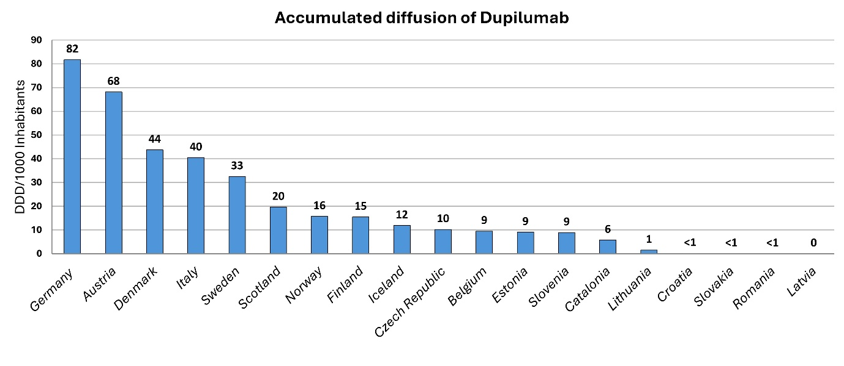Supplementary figure 2. Accumulated Defined Daily Doses per 1,000 inhabitants over the first four years following market authorization for the PCSK-9 inhibitors, evolocumab (C10AX13) and alirocumab (C10AX14) across the study population.

Supplementary figure 3. Accumulated Defined Daily Doses per 1,000 inhabitants over the first four years following market authorization for dupilumab (D11AH05) across the study population.

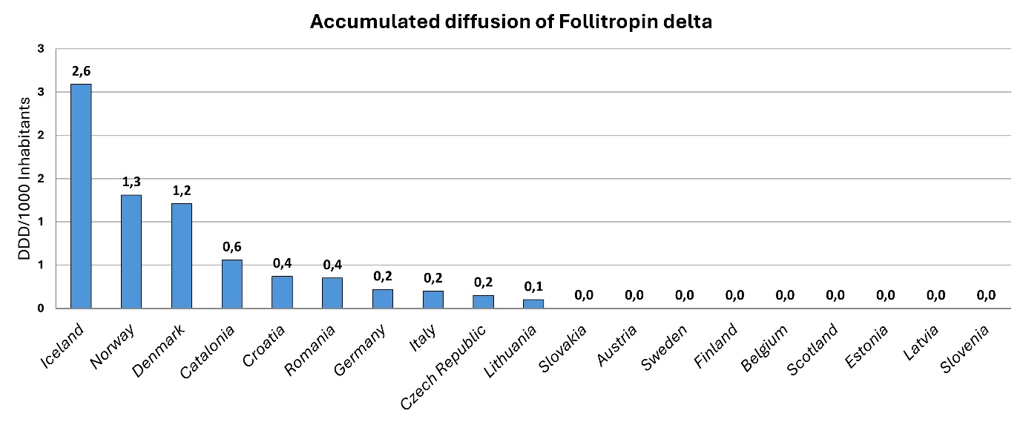Supplementary figure 4. Accumulated Defined Daily Doses per 1,000 inhabitants over the first four years following market authorization for follitropin delta (G03GA10) across the study population.

Supplementary figure 5. Accumulated Defined Daily Doses per 1,000 inhabitants over the first four years following market authorization for all the immunosuppressive antibodies, within the L04AC group consisting of secukinumab (L04AC10), brodalumab (L04AC12), ixekizumab (L04AC13), sarilumab (L04AC14), guselkumab (L04AC16), tildrakizumab (L04AC17), and risankizumab (L04AC18) across the study population.

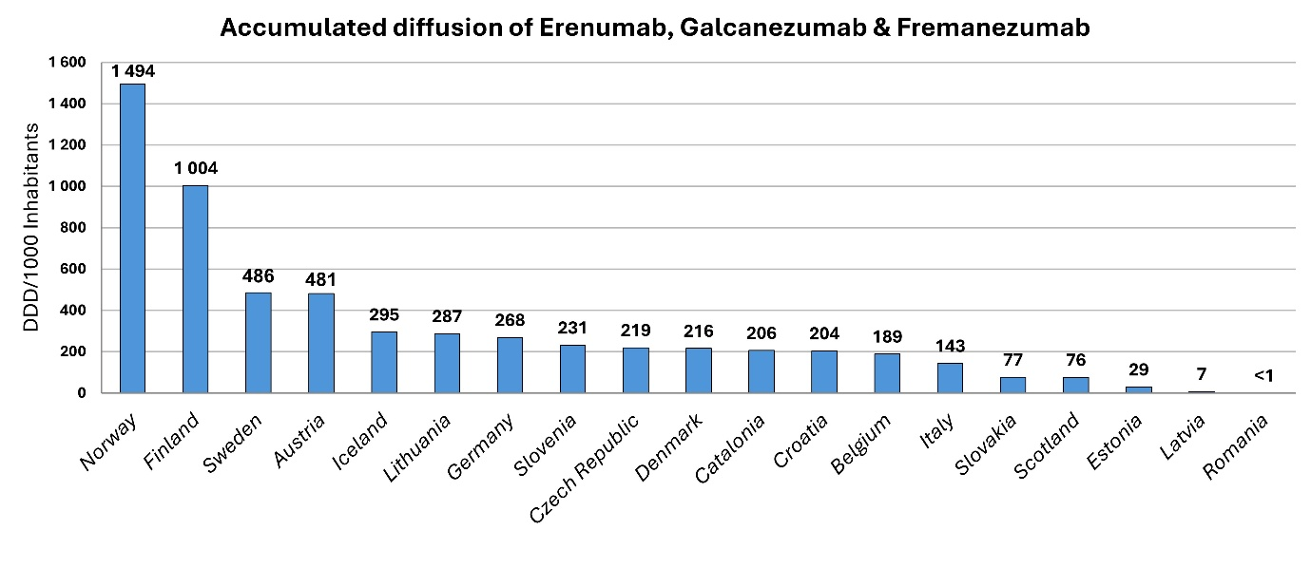Supplementary figure 6. Accumulated Defined Daily Doses per 1,000 inhabitants over the first four years following market authorization for tildrakizumab (L04AC17) across the study population.

Supplementary figure 7. Accumulated Defined Daily Doses per 1,000 inhabitants over the first four years following market authorization for the CGRP receptor antagonists, within the N02CD group consisting of erenumab (N02CD01), galcanezumab (N02CD02) and fremanezumab (N02CD03) across the study population.

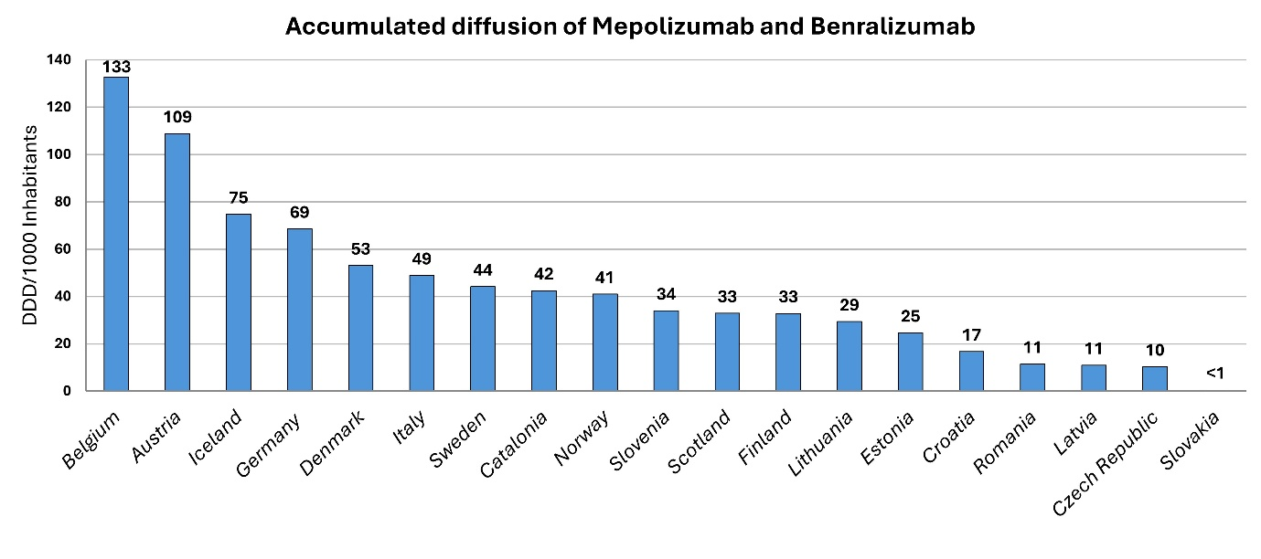Supplementary figure 8. Accumulated Defined Daily Doses per 1,000 inhabitants over the first four years following market authorization for both the IL-5 targeting therapies, within the R03DX group consisting ofmepolizumab (R03DX09) and benralizumab (R03DX10) across the study population.