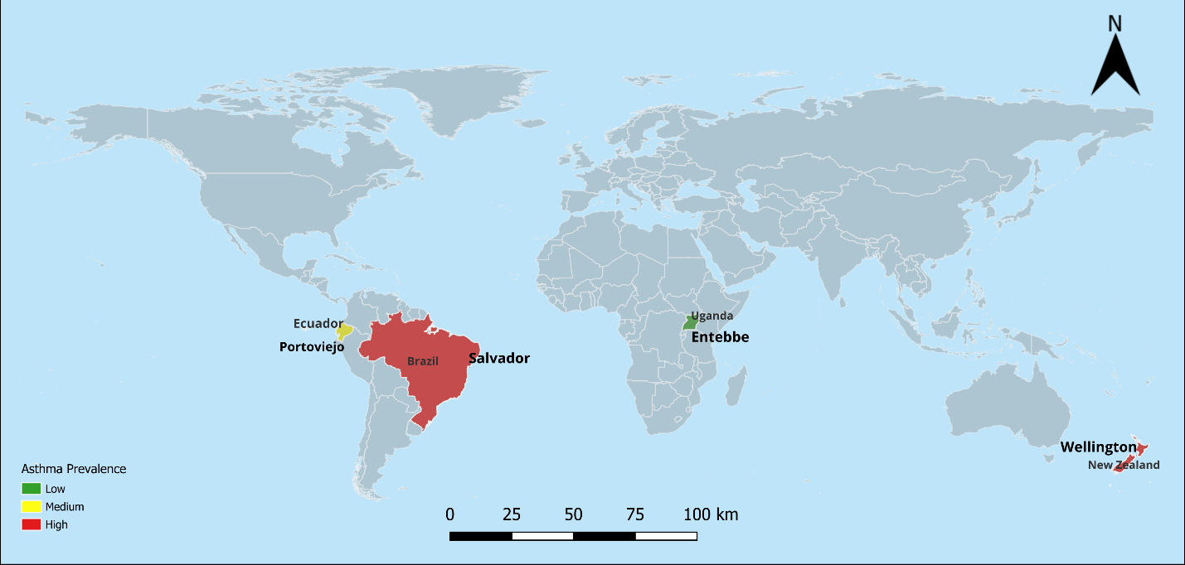

Figure S1: Map showing the location of CAMERA study centres by asthma prevalence

\*Brazil, Ecuador, and Uganda are LMICs whereas New Zealand is a HIC