S1 Figure – Forest plots of risk difference in symptom prevalence between cases and control participants in controlled studies: analyses including symptoms reported in 3 or more studies. Individual symptoms listed in alphabetical order.

Reported symptom: Altered/loss of smell or taste
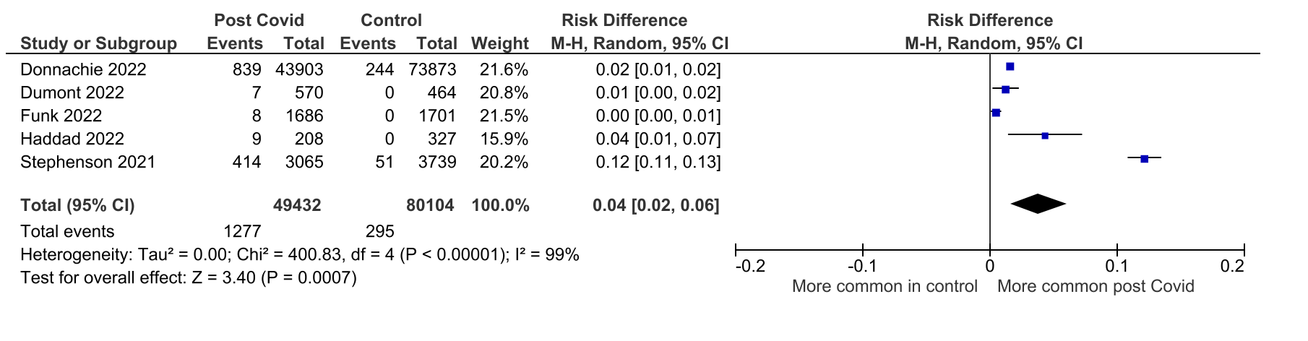
Reported symptom: Anxiety
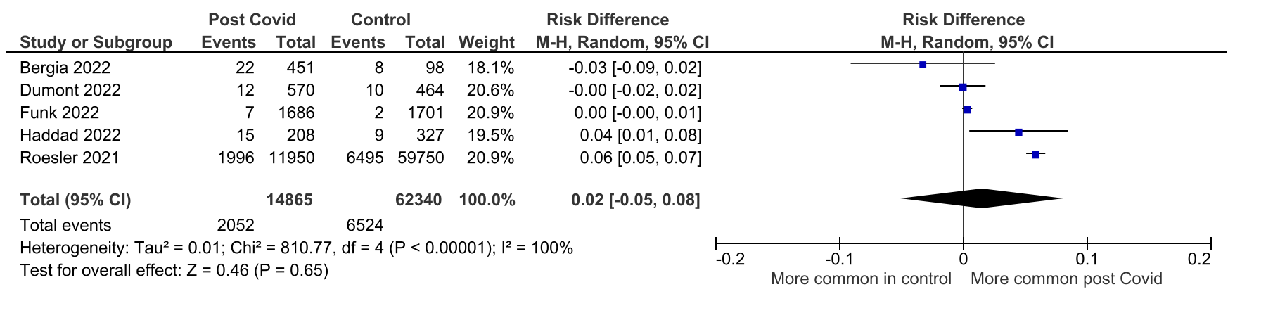

Reported symptom: Cardiovascular symptoms / palpitations
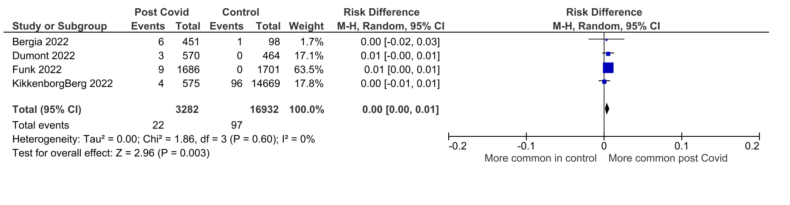

Reported symptom: Chest pain or tightness
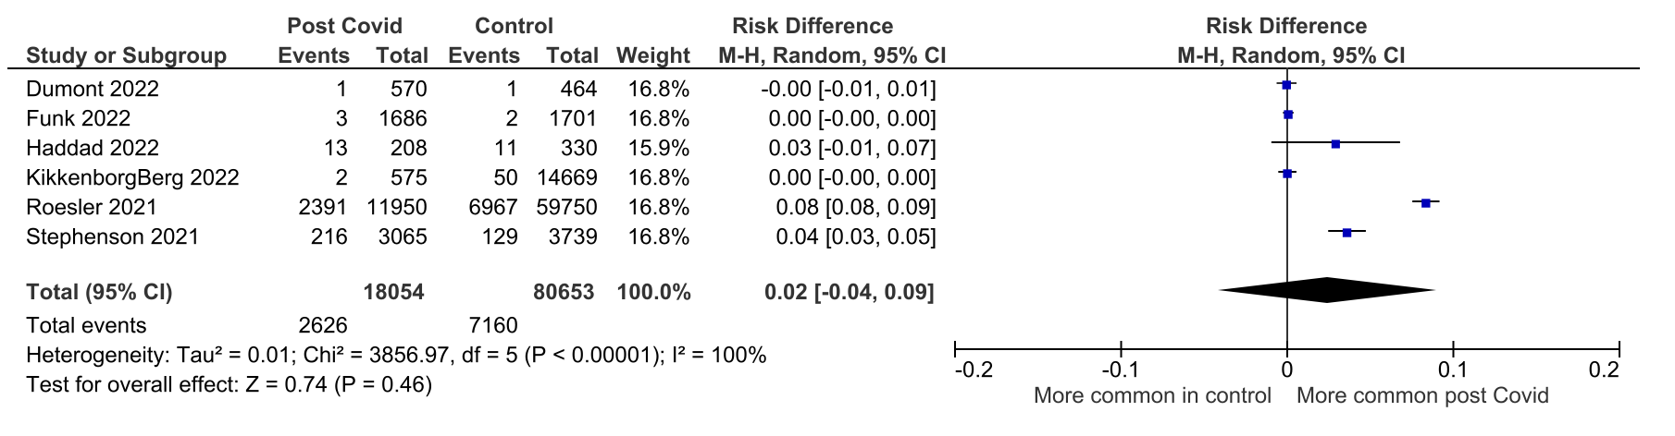

Reported symptom: Cognitive difficulties or brain fog
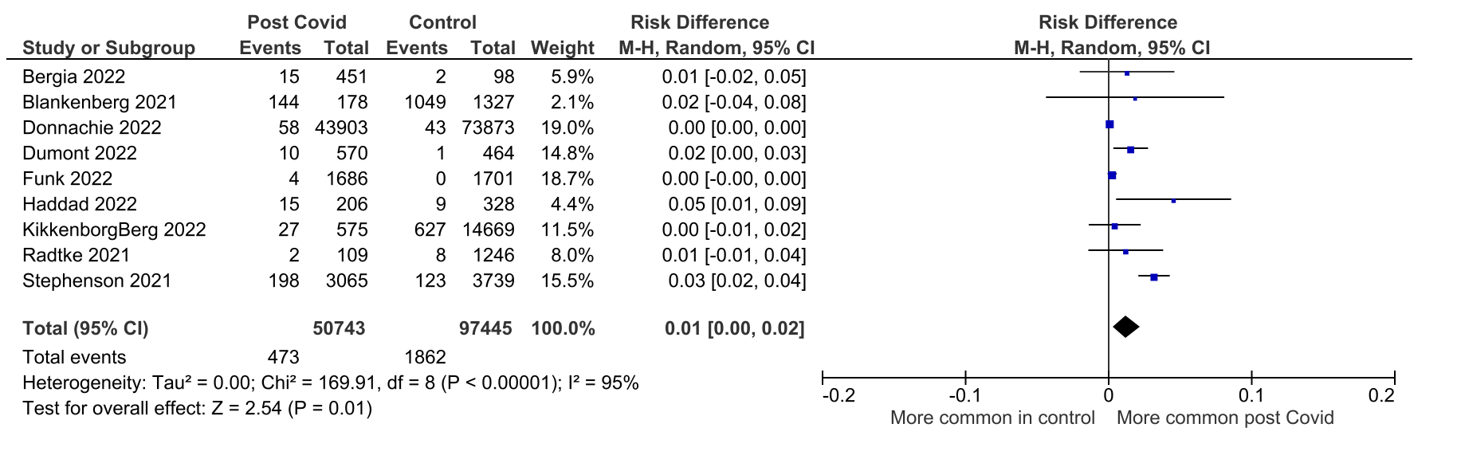

Reported symptom: Cough
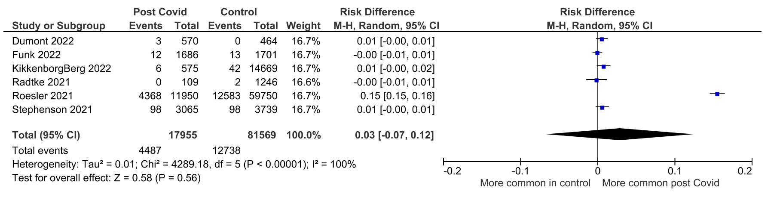

Reported symptom: Depression/ low mood
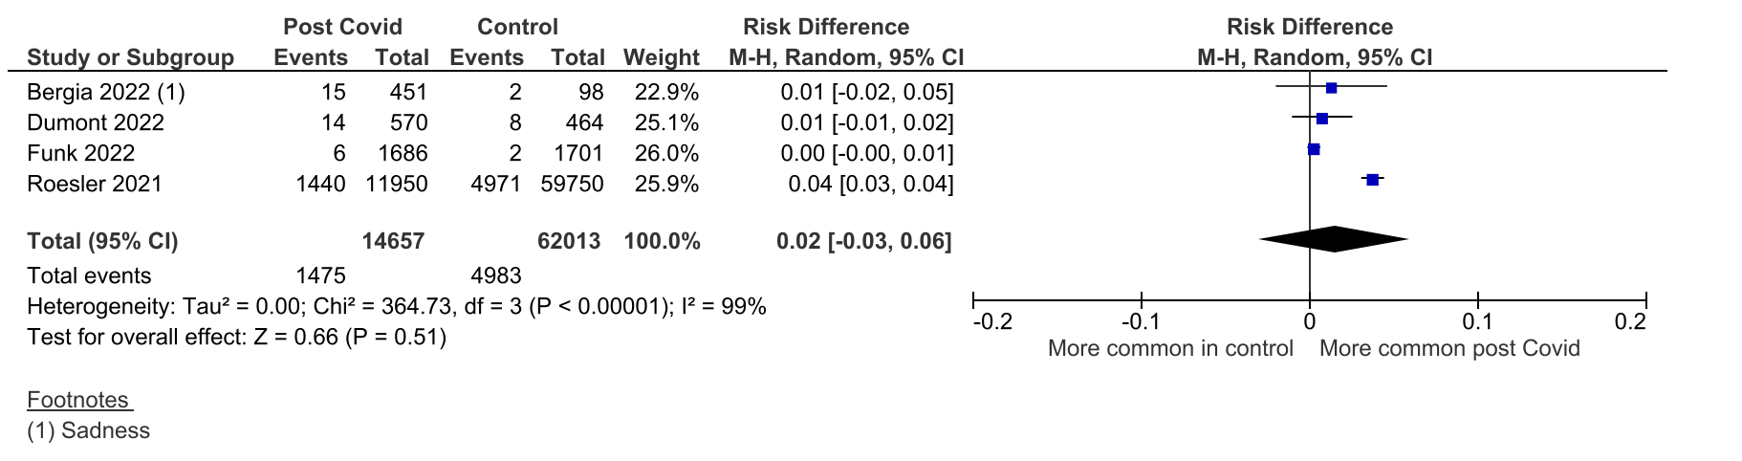

Reported symptom: Dermatological symptoms
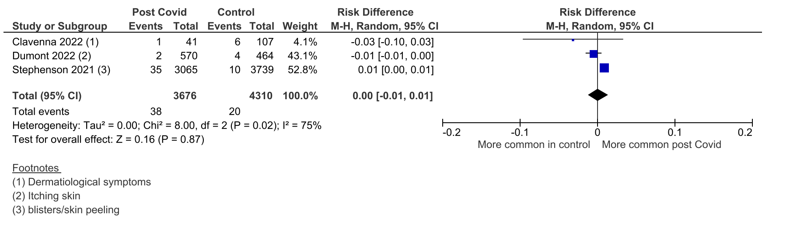

Reported symptom: Dizziness
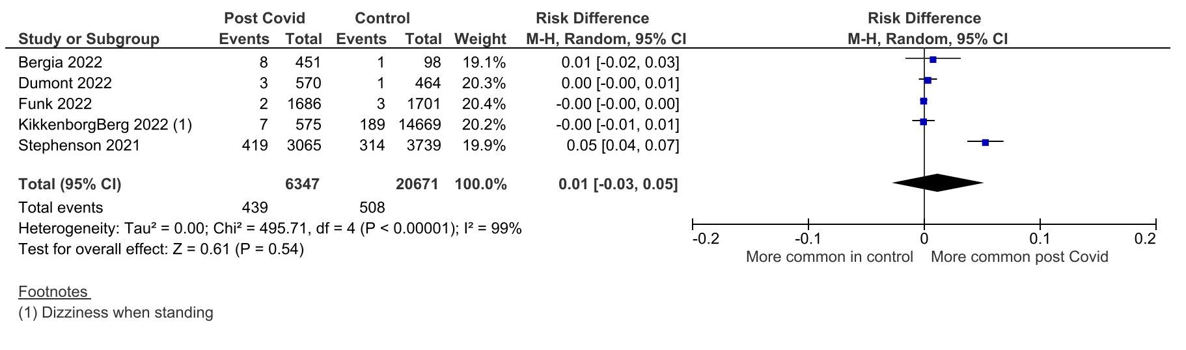

Reported symptom: Dyspnoea or wheezing
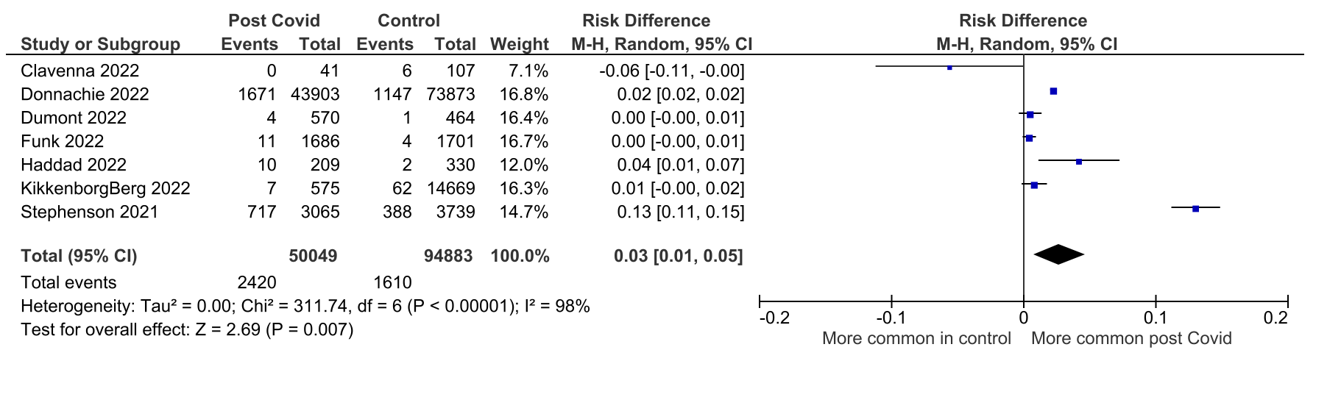

Reported symptom: Fatigue/ weakness
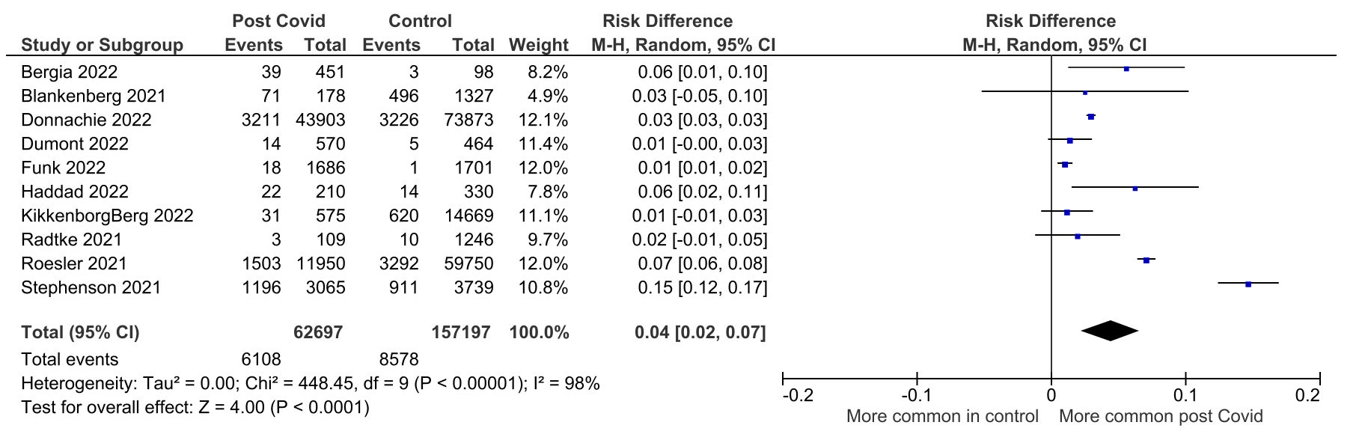

Reported symptom: Fever
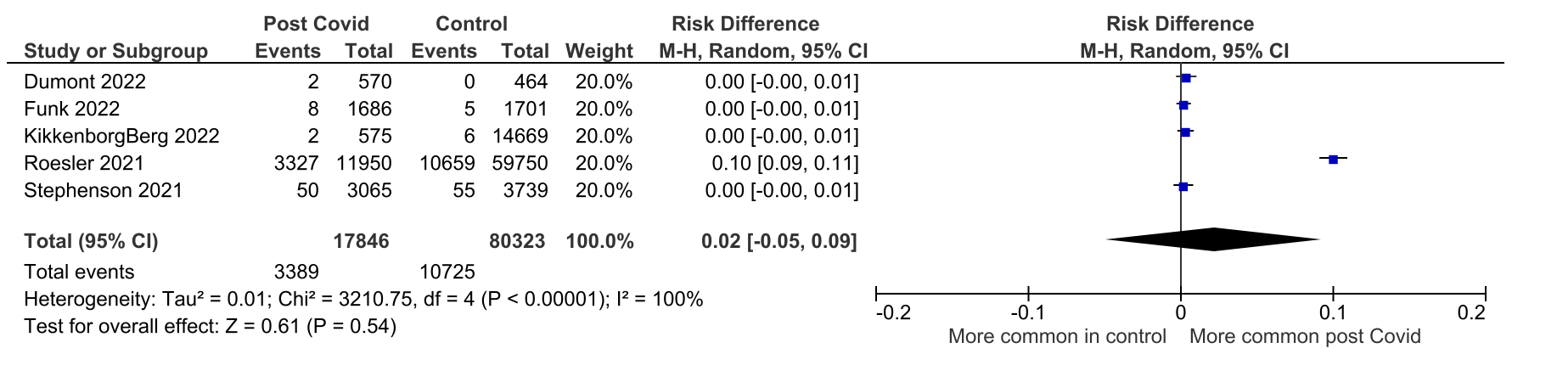

Reported symptom: Headache
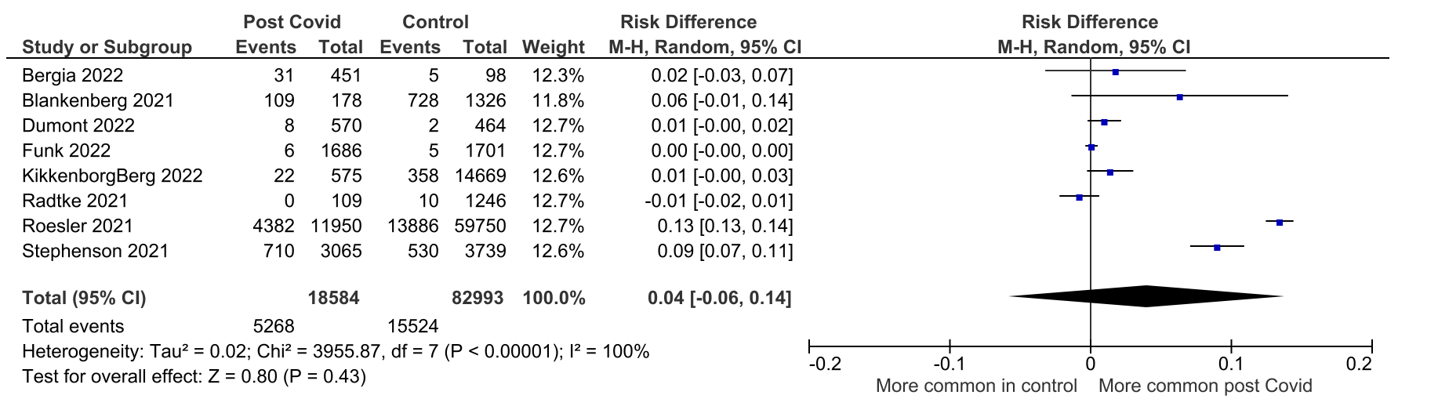

Reported symptom: Insomnia / sleep difficulty
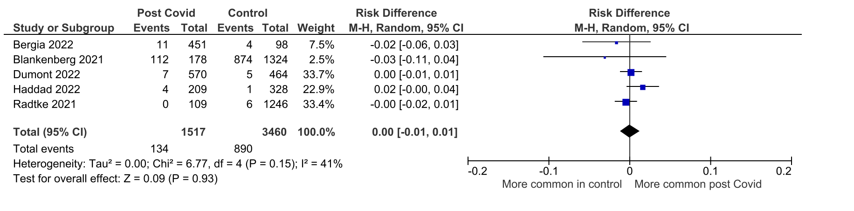

Reported symptom: Loss of appetite
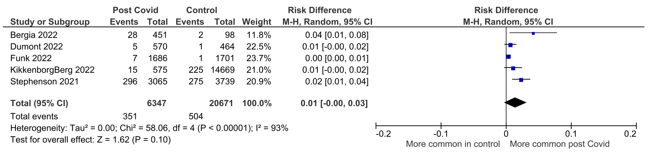

Reported symptom: Myalgia
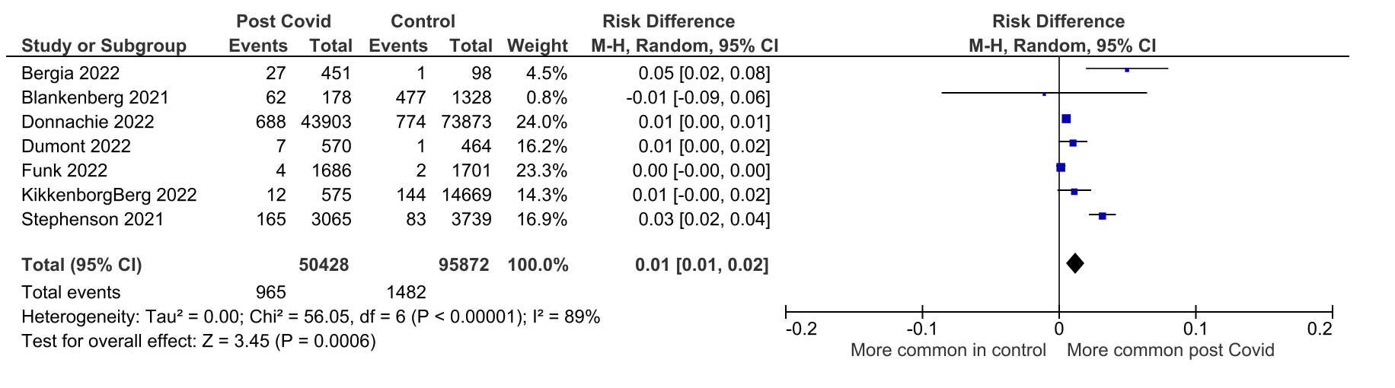

Reported symptom: Nasal congestion or rhinorrhoea
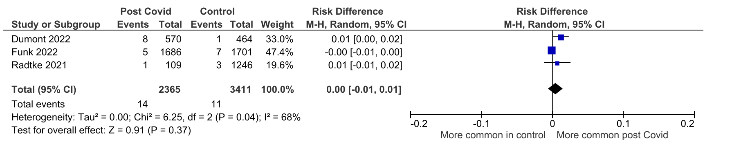

Reported symptom: Ophthalmologic / otolaryngologic symptoms
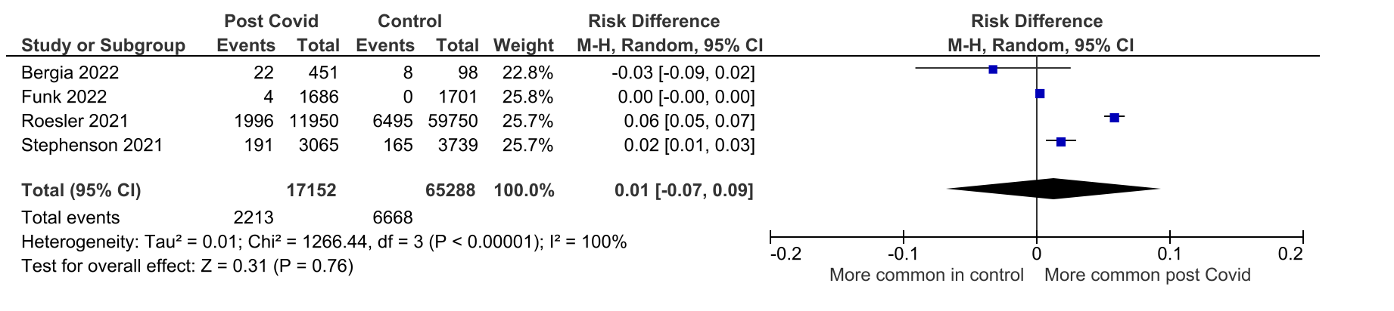

Reported symptom: Rash
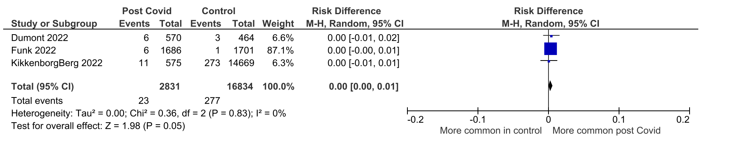

Reported symptom: Sore throat
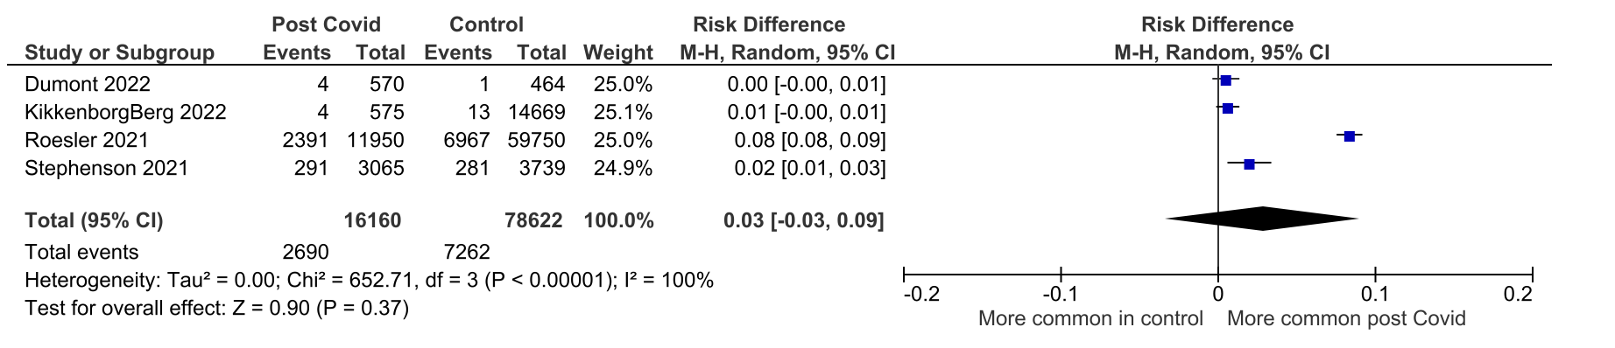

Reported symptom: Stomach ache / gastrointestinal symptoms
