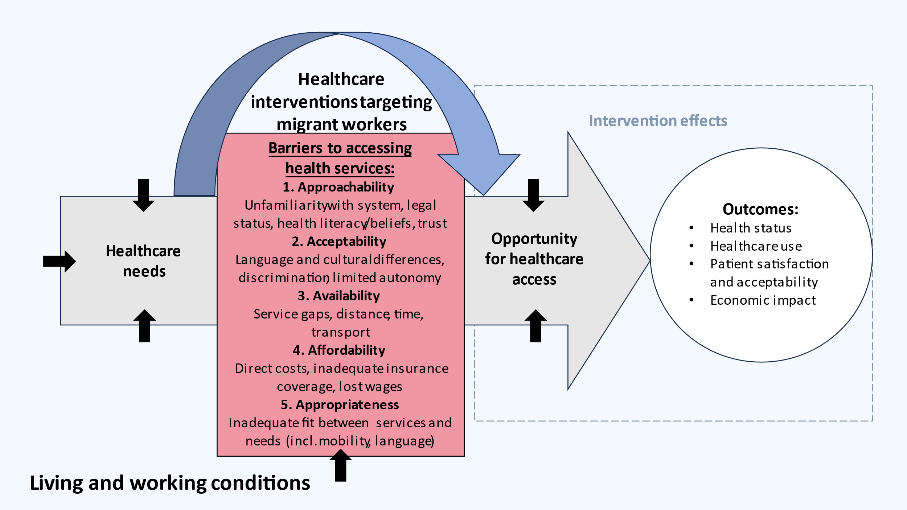

**Supplement 1:** Conceptual framework for the present review of healthcare services for low-wage migrant workers