Supplementary appendix

Systematic screening for atrial fibrillation with non-invasive devices: a systematic review and meta-analysis
Ali Wahab*, Ramesh Nadarajah*, Harriet Larvin, Maryum Farooq, Keerthenan Raveendra, Mohammad Haris, Umbreen Nadeem, Tobin Joseph, Asad Bhatty, Chris Wilkinson, Kamlesh Khunti, Rajesh Vedanathan, A John Camm, Emma Svennberg, Gregory YH Lip, Ben Freedman, Jianhua Wu, Chris P Gale

Contents
Section 1- OVID EMBASE Search Strategy 2
Section 2- Medline Search Strategy 5
Section 3: Cochrane Library Search Strategy 8
Section 4 – Web of Science Search Strategy 10
Section 5: Definitions 13
Figure 1: Forest plot of incidence rate of new atrial fibrillation diagnosis in prospective cohort studies or reports of the intervention arm alone from a randomised clinical trial of AF. 15
Figure 2: Forest plot of incidence rate of new atrial fibrillation diagnosis in prospective cohort studies or reports of the intervention arm alone from a randomised clinical trial of AF, stratified by monitoring type. 16
Figure 3: Forest plot of incidence rate of new atrial fibrillation diagnosis in prospective cohort studies or reports of the intervention arm alone from a randomised clinical trial of AF, stratified by monitoring type limited to studies published after 2010. 17
Figure 4: Funnel plot for results of yield from prospective cohort studies 18
Figure 5- Funnel plot of for results of clinical outcomes from randomised clinical trials 19
Figure 6- Risk of Bias for prospective cohort studies. 20
Figure 7- Risk of Bias for RCT’s 21
Figure 8: Forrest plot after exclusion of high ROB prospective studies 22
Table 1- Baseline characteristics of RCT 23
Table 2- Baseline characteristics of prospective cohort studies. 24
Table 3: Characteristics of recruitment and protocol adherence (RCT’s) 27
Table 4: Characteristics of recruitment and protocol adherence (observational studies) 28
Table 5: Baseline characteristics of all studies 30
Table 6- Cochran's Q, degrees of freedom and I^2 measures of statistical heterogeneity within subgroup analyses 32

Section 1- OVID EMBASE Search Strategy

# | Searches | Results
1 | exp atrial fibrillation/ | 143475
2 | ((atrial or atria or atrium or auricular) adj3 fibrillat*).ti,ab. | 179794
3 | AF.ti,ab. | 108556
4 | or/1-3 [atrial fibrillation] | 253401
5 | (diagnos* adj3 (performance* or accurac* or utilit* or value* or efficien* or effectiveness)).ti,ab. | 274888
6 | Mass screening/ | 69216
7 | ((targeted or opportunistic) adj2 (detect* or screen*)).ti,ab. | 11528
8 | point of care.ti,ab. | 47683
9 | electronic health record/ | 48166
10 | electronic medical record system/ | 3010
11 | ("electronic patient record*" or "electronic medical record*" or "electronic health record*" or "computeri?ed patient record*" or "computeri#ed medical record*" or "computeried health record*" or EHR or EPR).ti,ab. | 150768
12 | ((portable or ambulatory or monitor* or lead* or handheld or hand held or daily or longterm or short-term or strap* or device*) adj3 (ECG* or EKG* or electrocardio*)).ti,ab. | 46623
13 | ((ECG* or EKG* or electrocardio*) adj2 (assess* or check* or monitor* or detect* or screen* or diagnos* or measure*)).ti,ab. | 31033
14 | (iECG* or Holter*).ti,ab. | 22593
15 | ((ambulatory or event) adj monitor*).ti,ab. | 5982
16 | *electrocardiography/ or ambulatory electrocardiography/ | 63751
17 | (ILR* or loop record*).ti,ab. | 3974
18 | ((heart or cardiac) adj monitor*).ti,ab. | 5727
19 | (pulse adj2 (assess* or check* or monitor* or detect* or screen* or diagnos* or measure* or palpation*)).ti,ab. | 11856
20 | (pulse oximetr* adj device*).ti,ab. | 59
21 | Pulse rate/ | 62560
22 | ((blood pressure or BP) adj2 (assess* or check* or monitor* or detect* or screen* or diagnos* or measure*)).ti,ab. | 78454
23 | Blood Pressure Monitor/ or Blood Pressure Monitoring/ | 67407
24 | (AliveCor or MyDiagnostic*).ti,ab. | 335
25 | (Microlife or WatchBP or "watch BP").ti,ab. | 349
26 | (Heartscan or Zenicor or AliveECG or Kardia*).ti,ab. | 399
27 | (photoplethysmograph* or PPG).ti,ab. | 10867
28 | (wearable adj2 (technology or device* or sensor* or ECG or EKG or electrocardio*)).ti,ab. | 17365
29 | (smartwatch* or smart watch* or Applewatch* or Apple watch* or wrist watch* or wristwatch* or fitness band* or fitness tracker* or smartphone* or smart phone* or mobile phone*).ti,ab. | 51311
30 | (wearable adj2 (technology or device* or sensor* or ECG or EKG or electrocardio*)).ti,ab. | 17365
31 | or/6-30 [ point of care tests used to detect AF or screening or diagnosis effectiveness terms] | 674245
32 | randomized controlled trial/ | 837901
33 | random*.ti,ab. | 2113492
34 | factorial*.ti,ab. | 50583
35 | (crossover* or cross over*).ti,ab. | 133109
36 | ((doubl* or singl*) adj blind*).ti,ab. | 291615
37 | (assign* or allocat* or volunteer* or placebo*).ti,ab. | 1346023
38 | crossover procedure/ | 79391
39 | single blind procedure/ | 55767
40 | double blind procedure/ | 224517
41 | or/32-40 [RCTs] | 3123585
42 | Prospective studies/ | 828016
43 | (prospective and (study or studies or review or analys* or cohort* or data)).ti,ab. | 1122625
44 | or/42-43 [prospective studies] | 1387690
45 | 41 or 44 [RCTS or prospective studies] | 4208177
46 | 4 and 31 and 45 | 5934
47 | letter/ or letter.pt. | 1342536
48 | note.pt. | 996750
49 | editorial.pt. | 816503
50 | case study/ or case report/ | 3216548
51 | (letter or comment*).ti. | 257479
52 | or/47-51 [excluded publication types] | 6106486
53 | randomized controlled trial/ or random*.ti,ab. | 2235916
54 | 52 not 53 | 6043916
55 | animals/ not humans/ | 1522658
56 | nonhuman/ | 7813476
57 | exp Animal Experiment/ | 3229408
58 | exp Experimental Animal/ | 896635
59 | animal model/ | 1819455
60 | exp Rodent/ | 4637763
61 | (rat or rats or mouse or mice).ti. | 1856463
62 | or/55-61 [animal studies] | 10670021
63 | 46 not 52 | 5800
64 | 63 not 62 [final results excluding animals or certain excluded publication types] | 5630
65 | limit 64 to dc=19900101-20250201 | 6130

Section 2- Medline Search Strategy
# | Searches | Results
1 | exp atrial fibrillation/ | 75324
2 | ((atrial or atria or atrium or auricular) adj3 fibrillat*).ti,ab. | 97808
3 | AF.ti,ab. | 56915
4 | or/1-3 [atrial fibrillation] | 129523
5 | (diagnos* adj3 (performance* or accurac* or utilit* or value* or efficien* or effectiveness)).ti,ab. | 187741
6 | Mass screening/ | 118553
7 | ((targeted or opportunistic) adj2 (detect* or screen*)).ti,ab. | 7881
8 | point of care.ti,ab. | 35535
9 | electronic health record/ | 28942
10 | Medical Records Systems, Computerized/ | 19168
11 | ("electronic patient record*" or "electronic medical record*" or "electronic health record*" or "computeri?ed patient record*" or "computeri#ed medical record*" or "computeried health record*" or EHR or EPR).ti,ab. | 91961
12 | ((portable or ambulatory or monitor* or lead* or handheld or hand held or daily or longterm or short-term or strap* or device*) adj3 (ECG* or EKG* or electrocardio*)).ti,ab. | 27302
13 | ((ECG* or EKG* or electrocardio*) adj2 (assess* or check* or monitor* or detect* or screen* or diagnos* or measure*)).ti,ab. | 18665
14 | (iECG* or Holter*).ti,ab. | 12233
15 | ((ambulatory or event) adj monitor*).ti,ab. | 3946
16 | *electrocardiography/ or electrocardiography, ambulatory/ | 81059
17 | (ILR* or loop record*).ti,ab. | 1894
18 | ((heart or cardiac) adj monitor*).ti,ab. | 3062
19 | (pulse adj2 (assess* or check* or monitor* or detect* or screen* or diagnos* or measure* or palpation*)).ti,ab. | 8479
20 | (pulse oximetr* adj device*).ti,ab. | 43
21 | Pulse/ | 17106
22 | ((blood pressure or BP) adj2 (assess* or check* or monitor* or detect* or screen* or diagnos* or measure*)).ti,ab. | 48360
23 | Blood Pressure Monitors/ or Blood Pressure Monitoring, Ambulatory/ | 14278
24 | (AliveCor or MyDiagnostic*).ti,ab. | 144
25 | (Microlife or WatchBP or "watch BP").ti,ab. | 144
26 | (Heartscan or Zenicor or AliveECG or Kardia*).ti,ab. | 584
27 | (photoplethysmograph* or PPG).ti,ab. | 7611
28 | (wearable adj2 (technology or device* or sensor* or ECG or EKG or electrocardio*)).ti,ab. | 15817
29 | (smartwatch* or smart watch* or Applewatch* or Apple watch* or wrist watch* or wristwatch* or fitness band* or fitness tracker* or smartphone* or smart phone* or mobile phone*).ti,ab. | 40493
30 | (wearable adj2 (technology or device* or sensor* or ECG or EKG or electrocardio*)).ti,ab. | 15817
31 | or/6-30 [ point of care tests used to detect AF or screening or diagnosis effectiveness terms] | 514373
32 | randomized controlled trial.pt. | 618008
33 | controlled clinical trial.pt. | 95579
34 | randomi#ed.ab. | 779935
35 | placebo.ab. | 250234
36 | randomly.ab. | 438150
37 | clinical trials as topic.sh. | 202832
38 | trial.ti. | 314193
39 | or/32-38 [RCTs] | 1663529
40 | Prospective studies/ | 692996
41 | (prospective and (study or studies or review or analys* or cohort* or data)).ti,ab. | 721716
42 | or/40-41 [prospective studies] | 989150
43 | 39 or 42 [RCTS or prospective studies] | 2446705
44 | 4 and 31 and 43 | 2752
45 | letter/ | 1263286
46 | editorial/ | 699240
47 | news/ | 225965
48 | exp historical article/ | 412158
49 | Anecdotes as Topic/ | 4747
50 | comment/ | 1038684
51 | case reports/ | 2418771
52 | (letter or comment*).ti. | 201988
53 | or/45-52 | 5117405
54 | randomized controlled trial/ or random*.ti,ab. | 1665931
55 | 53 not 54 | 5083060
56 | animals/ not humans/ | 5206979
57 | exp Animals, Laboratory/ | 966821
58 | exp Animal Experimentation/ | 10524
59 | exp Models, Animal/ | 656115
60 | exp Rodentia/ | 3626353
61 | (rat or rats or mouse or mice).ti. | 1473909
62 | or/55-61 | 11231350
63 | 44 not 62 [search results without animal studies or letters or commentaries etc.] | 2715
64 | limit 63 to dt=19900101-20250201 | 2759

Section 3: Cochrane Library Search Strategy
# | Searches | Results
1 | MeSH descriptor: [Atrial Fibrillation] explode all trees and with qualifier(s): [diagnosis - DI] | 7381
2 | (atria* or atrium or auricular) NEAR/3 (performance or accurac* or utilit* or value* or efficien* or effectiveness):ti,ab | 250
3 | AF:ti,ab | 9787
4 | MeSH descriptor: [Mass Screening] explode all trees | 6006
5 | (diagnos*) NEXT (performance* or accurac* or utilit* or value* or efficiency* or effectiveness*):ti,ab | 6094
6 | (targeted or opportunistic) NEAR/3 (detect* or screen*):ti,ab | 280
7 | point-of-care:ti,ab | 2837
8 | MeSH descriptor: [Electronic Health Records] explode all trees | 900
9 | MeSH descriptor: [Medical Records Systems, Computerized] explode all trees | 1215
10 | electronic patient record or electronic medical record or electronic health record or computeri*ed patient record* or computeri*ed health record* or EHR or EPR):ab,ti | 6601
11 | (portable or ambulatory or monitor* or lead* or handheld* or "hand held" or daily or "long term" or "short term" or strap or device) NEAR (ECG* or EKG or electrocardio*):ti,ab | 9678
12 | (ECG* or EKG or electrocardio*) NEAR (assess* or check or monitor* or detect* or screen* or diagnos* or measure*):ti,ab | 10600
13 | iECG or holter:ti,ab | 3187
14 | (ambulatory or event) NEXT (monitor*):ti,ab | 1227
15 | MeSH descriptor: [Electrocardiography] explode all trees | 10602
16 | MeSH descriptor: [Electrocardiography, Ambulatory] explode all trees | 1395
17 | ILR*:ti,ab | 442
18 | "loop record":ti,ab | 0
19 | (heart or cardiac) NEXT (monitor*):ti,ab | 908
20 | (pulse) NEXT (assess* or check or monitor or detect* or screen* or diagnos* or measure* or palpation*):ti,ab | 251
21 | (pulse oximetr* NEXT device):ti,ab | 69
22 | MeSH descriptor: [Pulse] explode all trees | 1576
23 | MeSH descriptor: [Blood Pressure Monitors] explode all trees | 185
24 | MeSH descriptor: [Blood Pressure Monitoring, Ambulatory] explode all trees | 1974
25 | ("blood pressure") NEXT (assess* or check or monitor or detect* or screen* or diagnos* or measure*):ti,ab | 5134
26 | aliveCOR:ti,ab | 72
27 | mydiagnostic*:ti,ab | 4
28 | microlife or WatchBP or "watch BP":ti,ab | 72
29 | heartscan or zenicor or aliveECG or kardia:ti,ab | 74
30 | photoplethysmograph or PPG:ti,ab | 1128
31 | (wearable) NEAR (technology or device* or sensor* or ECG or EKG or electrocardio*):ti,ab | 1726
32 | #1 or #2 or #3 | 10309
33 | #4 or #5 or #6 #7 or #8 or #9 or #10 or #11 or #12 or #13 or #14 or #15 or #16 or #17 or #18 or #19 or #20 or #21 or #22 or #23 or #24 or #25 or #26 or #27 or #28 or #29 or #30 or #31 | 54984
34 | #32 and #33 with Publication Year from 2023 to 2025, with Cochrane Library publication date Between May 2023 and Feb 2025, in Trials with 'Heart' in Cochrane Groups | 0

Section 4 – Web of Science Search Strategy
# | Searches | Results
1 | TS="atrial fibrillation" | 140720
2 | TS=((atrial OR atria OR atrium OR auricular) NEAR/3 fibrillat*) | 142166
3 | TS=‘AF’ | 86957
4 | #1 OR #2 OR #3 "[atrial fibrillation]" | 142166
5 | TS="Mass screening" | 7365
6 | TS=((targeted OR opportunistic) NEAR/2 (detect* OR screen*)) | 82869
7 | TS="point of care" | 49542
8 | TS= "electronic health record" | 21990
9 | TS=((diagnos* NEAR/3 (performance* OR accurac* OR utilit* OR value* OR efficien* OR effectiveness))) | 249198
10 | TS=("electronic patient record*" OR "electronic medical record*" OR "electronic health record*" OR "computeri*ed patient record*" OR "computeri*ed medical record*" OR "computeri*ed health record*" OR EHR OR EPR) | 160887
11 | TS=((portable OR ambulatory OR monitor* OR lead* OR handheld OR "hand held" OR daily OR longterm OR short-term OR strap* OR device*) NEAR/3 (ECG* OR EKG* OR electrocardio*)) | 32821
12 | TS= ((ECG* OR EKG* OR electrocardio*) NEAR/2 (assess* OR check* OR monitor* OR detect* OR screen* OR diagnos* OR measure*)) | 2740
13 | TS=(((ambulatory OR event) NEAR/0 monitor*)) | 6744
14 | TS=(electrocardiography OR "ambulatory electrocardiography") | 26421
15 | TS=((ILR* OR "loop record*")) | 3673
16 | TS=(((heart OR cardiac) NEAR/0 monitor*)) | 5759
17 | TS=((pulse NEAR/2 (assess* OR check* OR monitor* OR detect* OR screen* OR diagnos* OR measure* OR palpation*))) | 45368
18 | TS=(("pulse oximetr*" NEAR/0 device*)) | 57
19 | TS=((("blood pressure" OR BP) NEAR/2 (assess* OR check* OR monitor* OR detect* OR screen* OR diagnos* OR measure*))) | 61904
20 | TS=("Blood Pressure Monitor" OR "Blood Pressure Monitoring") | 13255
21 | TS=((AliveCor OR MyDiagnostic*)) | 175
22 | TS=((Microlife OR WatchBP OR "watch BP")) | 177
23 | ALL=((Heartscan OR Zenicor OR AliveECG OR Kardia*)) | 1290
24 | ALL=((photoplethysmograph* OR PPG)) | 24278
25 | TS=((wearable NEAR/2 (technology OR device* OR sensor* OR ECG OR EKG OR electrocardio*))) | 57910
26 | TS=((smartwatch* OR "smart watch*" OR Applewatch* OR "Apple watch*" OR "wrist watch*" OR wristwatch* OR "fitness band*" OR "fitness tracker*" OR smartphone* OR "smart phone*" OR "mobile phone*")) | 143050
27 | TS=((wearable NEAR/2 (technology OR device* OR sensor* OR ECG OR EKG OR electrocardio*))) | 57910
28 | TS=("randomized controlled trial") | 229082
29 | TS=("randomized controlled trial") | 22082
30 | TS=(random*) | 270794
31 | TS=(factorial*) | 229082
32 | TS=((crossover* OR "cross over*")) | 178623
33 | TS=(((doubl* OR singl*) NEAR/0 blind*)) | 393681
34 | TS=((assign* OR allocat* OR volunteer* OR placebo*)) | 1829023
35 | TS=("crossover procedure") | 73
36 | TS=("single blind procedure") | 21
37 | TS=("double blind procedure") | 228
38 | #32 OR #33 OR #34 OR #35 OR #36 OR #37 [RCTs] | 325
39 | ALL=("Prospective studies") | 53077
40 | ALL=((prospective AND (study OR studies OR review OR analys* OR cohort* OR data))) | 829470
42 | TS=#38 OR #39 "[prospective studies]" | 882547
42 | TS=##38 OR #42 [RCTS OR "prospective studies]" | 882,872
43 | TS=#4 AND #31 AND #42 | 9284
44 | TS="case study" OR "case report" | 609,503
45 | TS=Editorial | 160,170
46 | TS=note | 965,452
47 | TS=letter OR letter | 4624
48 | TS=letter OR comment* | 770,093
49 | ALL=#44 OR #45OR #46 OR #47 OR #48 "[excluded publication types]" | 3764
51 | ALL=”Experiment" | 80
52 | ALL="Experimental Animal" | 3746
53 | TS="animal model" | 126,008
54 | TS=#51 OR #52 OR #53 "[animal studies]" | 189,786
55 | TS=#49 NOT #52 | 60,432
55 | TS=#55NOT #64[final results excluding animals"OR"certain excluded publication types]" | 46,244
56 | TS=#55 Timespan-1990-01-01 to 2025-02-01 | 15,567

Section 5: Definitions

Photoplethysmography (PPG): non-invasive method for measuring blood volume changes in microvascular bed of skin based on optical properties such as absorption, scattering and transmission properties of human body composition under a specific light wavelength. ¹
PPG based AF technology utilising PPG signal for opportunistic AF detection has been developed by multiple smartwatch manufacturers including Apple², Samsung ³and Fitbit⁴.

Types of Rhythm Monitoring | Description
Continuous ECG | ECG monitoring using a device worn throughout the study period, e.g. a patch
Intermittent ECG | Assessment with PPG when individual interacts with device at pre-determined time points in the study protocol e.g. four times per day with a handheld device
Continuous PPG | Continuous PPG assessment of underlying heart rhythm using a wearable device, e.g. watch
Intermittent PPG | Assessment with PPG when individual interacts with device at pre-determined time points in the study protocol e.g. four times per day

Systematic AF screening: systematic screening programmes for AF differ from routine practice by offering tests for AF to a wider range of people than those who present in routine consultations with symptoms, risk factors or other indications for AF testing. A systematic approach would define which test should be used in conjunction with which screening strategy to increase the diagnosis of AF in the community among patients with asymptomatic AF and those who are symptomatic but remain undiagnosed.
Study designs:
We included randomised clinical trials of systematic AF screening that reported results of comparing an intervention arm (systematic AF screening) and control arm (usual care).

We included prospective studies where systematic AF screening had been conducted for individuals without a known AF diagnosis. These studies were not reported with a comparison arm of usual care. These studies were grouped under a title of prospective cohort studies.

PICO:
Randomised clinical trials with an intervention and control arm
Patient, problem, or population | People aged ≥18 years
Intervention | Systematic screening for atrial fibrillation with a non-invasive device
Comparison, control, or comparator | People undergoing usual care
Outcome | - Detection of previously undiagnosed atrial fibrillation  - Clinical outcomes including death, stroke, systemic embolization, cardiovascular hospitalisation, and bleeding

Prospective cohort studies
Patient, problem, or population | People aged ≥18 years without known diagnosis of atrial fibrillation
Exposure | Systematic screening for atrial fibrillation with a non-invasive device
Comparison, control, or comparator | -
Outcome | - Detection of previously undiagnosed atrial fibrillation

Risk of Bias assessment
Cochrane Reviews provides framework for assessment of risk of bias in studies. When randomized controlled trials (RCT’s) are included, risk of bias is estimated using the revised version of Cochrane tool, RoB2. Prospective cohort studies were assessed through Cochrane’s ROBINS
RoB2 assessment is composed of the following domains:
- Bias arising from the randomization process;
- Bias due to deviations from intended interventions;
- Bias due to missing outcome data;
- Bias in measurement of the outcome; and
- Bias in selection of the reported result.
Cochrane’s ROBIN assessment is composed of following domains:
- Bias arising from confounding
- Bias due to selection of participants
- Bias in classification of interventions
- Bias due to deviations from intended interventions
- Bias due to missing outcome data;
- Bias in measurement of the outcome
- Bias in selection of the reported result

Each domain contains ‘signalling questions’, answers to which through aid of an algorithm, allow users to formulate judgement with respects to degree of bias for that particular domain. Potential answers to these signalling questions are as follows:
- Yes;
- Probably yes;
- Probably no;
- No;
- No information.
Once these questions have been answered, the subsequent steps involve concluding risk to bias judgement for that domain based on three levels:
- Low risk of bias;
- Some concerns; or
- High risk of bias.

RCT’s were overall scored low vs moderate vs high risk of bias as following:

Low risk: If all domains scored ‘low risk’ of bias
Moderate risk: If < 3 domains scored ‘some concerns’
High risk: If 1 or more domain scored ‘high risk’ of bias.

Prospective cohort studies were scored low/ moderate /high risk of bias as following:

Low Risk: If all domains scored ‘low risk’ of bias
Moderate Risk: If ≤ 4 domains scored ‘some concerns’
High Risk: If 1 or more domain scored ‘high risk’ of bias.

The scoring categories were agreed by co-authors prior to undertaking risk of bias assessment for each study.

Figure 1: Forest plot of incidence rate of new atrial fibrillation diagnosis in prospective cohort studies or reports of the intervention arm alone from a randomised clinical trial of AF.

Figure 2: Forest plot of incidence rate of new atrial fibrillation diagnosis in prospective cohort studies or reports of the intervention arm alone from a randomised clinical trial of AF, stratified by monitoring type.

Figure 3: Forest plot of incidence rate of new atrial fibrillation diagnosis in prospective cohort studies or reports of the intervention arm alone from a randomised clinical trial of AF, stratified by monitoring type limited to studies published after 2010.

Figure 4: Funnel plot for results of yield from prospective cohort studies

Figure 5- Funnel plot of for results of clinical outcomes from randomised clinical trials

Figure 6- Risk of Bias for prospective cohort studies.

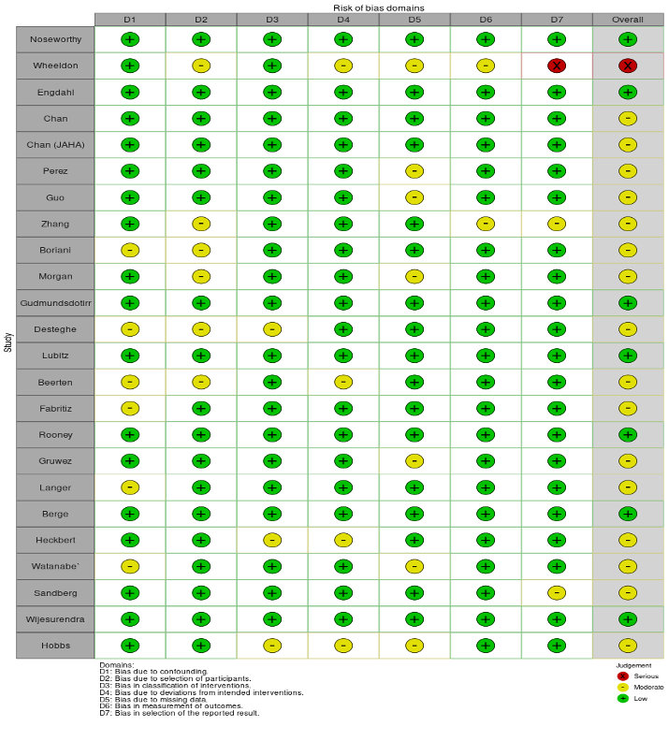

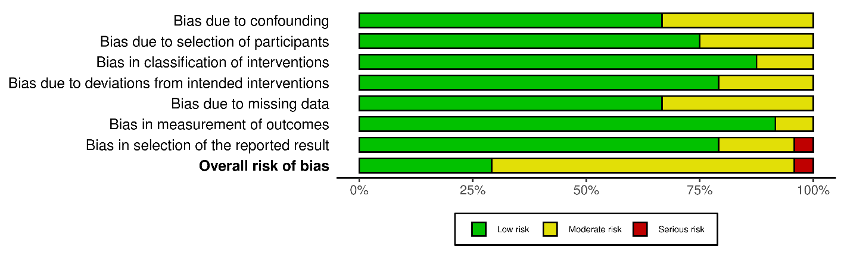

Figure 7- Risk of Bias for RCT’s

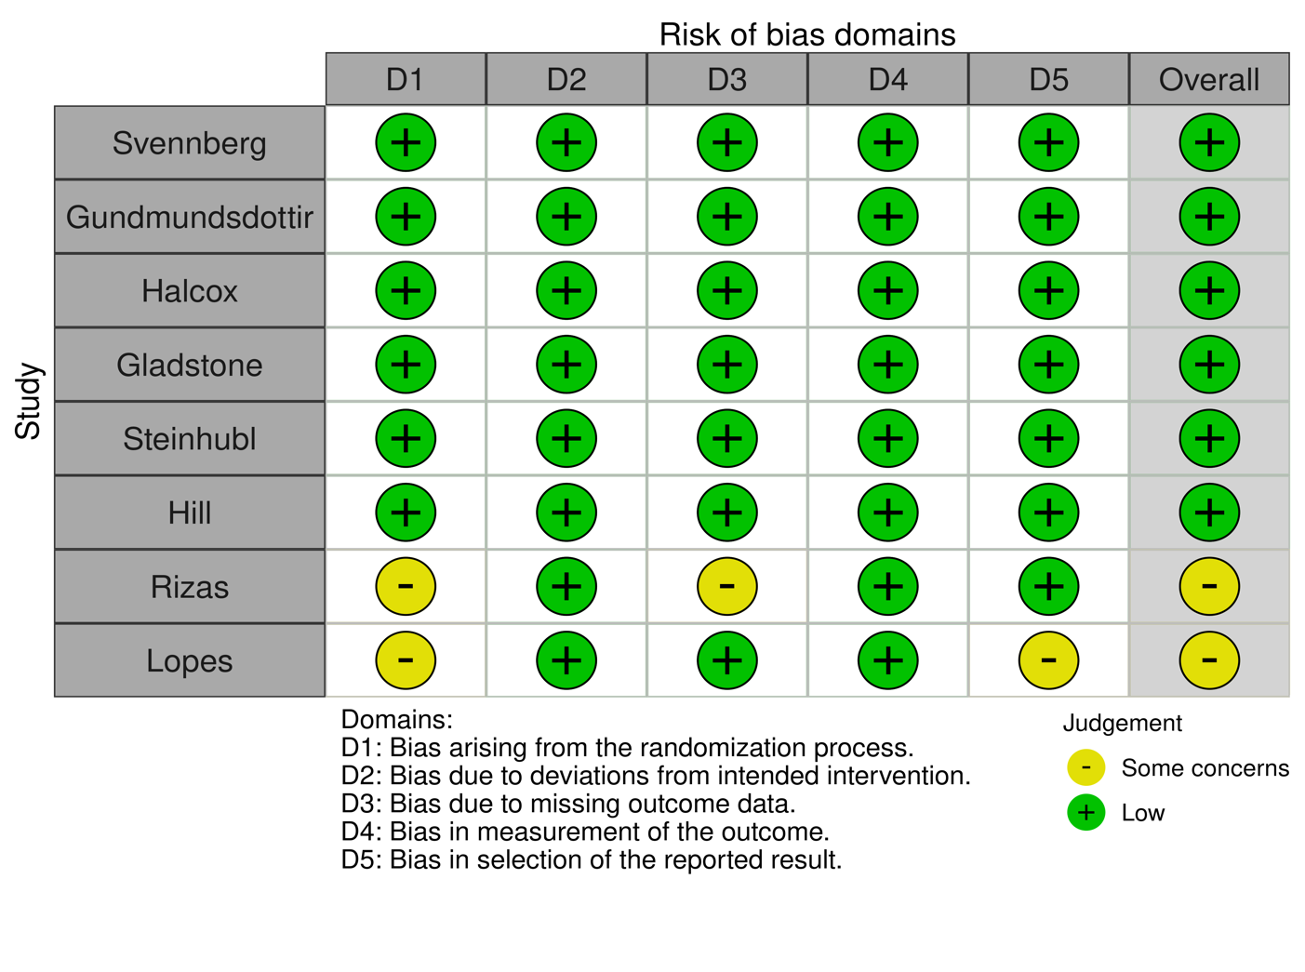
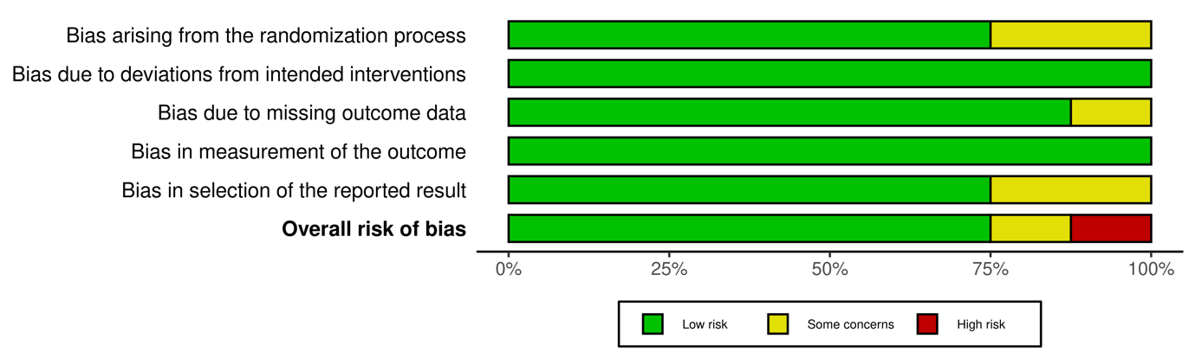

Figure 8: Forrest plot after exclusion of high ROB prospective studies

Abbreviations: PPG- Photoplethysmography, ROB- Risk of Bias

Table 1- Baseline characteristics of RCT

Study (year) | Number | Location | Eligibility | Eligibility criteria | Exclusion criteria | Method of invitation | Method of consent | Method of device delivery | Protocol | Device
Svennberg et al  2021 | 28768 | Sweden | Age | 75-76 | No exclusion stated | Up to 3 written letters | Written | Attend screening centre | Single Lead ECG intermittently for 14 days | Zenicor
Gudmundsdottir et al  2019  (Sweden) | 28712 | Sweden | Age + Biomarker | 75-76+NT-proBNP≥125ng/L | No exclusion stated | Up to 2 written letters | Written | Attend screening centre | Single Lead ECG intermittently for 14 days | Zenicor
Halcox et al (2017) | 5846 | USA | >=65 + CHADSVASC>=2 | Age + 1 risk factor | <65, previous diagnosis of AF | Written letter | Written | Attend screening centre | twice-weekly single lead ECG for 12 months | AliveCor
Gladstone et al (2021) | 856 | Canada and Germany | Age >=75 with hypertension | Age + AF risk score (CHADVAS ≥2) | Previous diagnosis of AF/ Pacemaker insitu/ ILR | During outpatient appointment (Canada), written letters (Germany) | Written | Delivery | 2-week continuous ECG patch worn twice three weeks apart | ZioXT patch
Steinhubl et al (2018) | 2820 | USA | Male age > 55 years, or females age > 65 years + 1 comorbidity | Age + 1 risk factor | Previous diagnosis of AF/ Pacemaker insitu/ ILR/ already on NOAC | Email or written letter | Digital | Delivery | 4-week continuous ECG patch | ZioXT patch
Hill et al (2020) | 23745 | UK | >=30 | Risk Score | Previous diagnosis of AF | Up to 2 written letters and option of phone for non-responders | Written | Attend screening centre | twice-daily single-lead ECG for 2 weeks | AliveCor
Rizas et al (2022) | 2780 | Germany | 50-90, CHADSVASc ≥1 in men, CHADSVASc ≥2 in women, | Age + RF | Previous diagnosis of AF/ on NOAC | written letter | Digital | Delivery | PPG on smartphone app twice daily for 14 days then twice weekly until 6 months, if abnormal findings then 14-day ECG recorder | Smartphone Application
Singer et al (2024) | 11957 | USA | >=70 | Age | Previous diagnosis of AF/ on NOAC/pacemaker in situ | written letter | Written | Delivery | 14 days continuous ECG patch | ZioXT patch

Abbreviations: ILR- implantable loop recorder, NOAC- Novel Oral anticoagulation, PPG- Photoplethysmography
NT pro-BNP- Natriuretic pro Brain Natriuretic Peptide

Table 2- Baseline characteristics of prospective cohort studies.
Study (year) | N | Eligibility | Eligibility criteria | Exclusion criteria | Method of invitation | Method of consent | Method of device delivery | Protocol | Device
Noseworthy et al  2021  (USA) | 1003 | >=18 | Risk score | Patient on NOAC/oral anticoagulation | Email/written letter | Digital | Delivery | 30-day continuous ECG patch | MoMe 3-lead monitor
Hobbs et al  2005  (UK) | 2358 | >65 + Risk factor | Age + Risk factor | Palliative/ change in registered general practice | Up to two written letters | Written | Attended screening clinic | 12- Lead ECG screening clinic | 12 lead ECG
Morgan  2002  (UK) | 1099 | >=65 | Age | No exclusion criteria stated | Up to 2 written letters and option of phone for non-responders | Written | Attended screening clinic | Pulse palpation followed by ECG | 12 lead ECG
Wheeldon et al  1998  (UK) | 1207 | ≥65 years | Age | No exclusion criteria stated | Up to 2 written letters and option of phone or visit for non-responders | Written | Attend screening centre | 12- Lead ECG screening clinic | 12- Lead ECG
Engdahl et al  2013  (Sweden) | 848 | 75-76 | Age + Risk factor | <75 years | Up to two written letters | Written | Attend screening centre | Twice-daily single-lead ECG for 2 weeks | Zenicor II handheld device
Chan et al  2017  (Hong Kong) | 5969 | Age ≥ 65  OR  diabetes mellitus /hypertension | Age or Risk factor | Patients with pacemaker in situ | In person in outpatient clinic | Written | In person in outpatient clinic | Single lead ECG | AliveCor Heart monitor
Chan et al  2017  (Hong Kong) | 1013 | Age ≥65  OR  diabetes mellitus /hypertension | Age  OR  Risk factor | Patients with pacemaker or ICD in situ | In person in outpatient clinic | Written | In person in outpatient clinic | Single lead ECG | AliveCor KardiaMobile Heart Monitor
Perez et al  2019  (USA) | 419297 | Age ≥ 22  With  Apple iPhone+ watch + ECG patch notification | Age | Previous diagnosis of AF | Available App | Digital | Consumer-owned device | PPG on smartphone followed by ECG confirmation | Apple watch photoplethysmography sensor
Guo et al  2019  (China) | 187912 | Age ≥ 18  With  Huawei (android 5.0) + watch | Age | <18 and inability to use smartphone | Available app | Digital | Consumer-owned device | PPG on smartphone followed by ECG confirmation | Wristwatch (Huawei watch GT/Honor watch) /Wristband (Honor band 4)
Lubitz et al  2022  (USA) | 455699 | Age ≥ 22 | Age | Previous diagnosis of AF, on NOAC,  PPM/ICD in situ | Email,  FitBit app notifications,  Social media,  Other marketing channels | Digital | Consumer-owned device | PPG data Fitbit followed by ECG confirmation | Fitbit device paired with FitBit account on android/IOS smartphone
Boriani et al  2021  (Italy) | 2814 | Age ≥ 18 | Age | Previous diagnosis of AF,  PPM/ICD in situ | Not stated | Written | Delivery | Single lead ECG followed by 12 lead ECG | MyDiagnostick bar device
Beerten et al  2021  (Belgium) | 92 | Age ≥ 65,  AF risk score (CHARGE AF of at least 10%) | Risk score | Previous diagnosis of AF,  PPM/ICD in situ | Not stated | Written | Consumer-owned device | Twice daily use of Fibricheck app for 14 days | Fibricheck app
Fabritz et al  2023  (Belgium/Germany/Poland) | 882 | Age ≥ 65 | Age | Previous diagnosis of AF,  On oral anticoagulants | Newspaper and TV advertisements targeting older adults,  Senior citizen interest groups,  Personal contacts in the sites,  GP in the community,  Leaflets and a website | Digital | Delivery | PPG wristband,  Followed by 14-day ECG recorder in the event of irregular pulse | Corsano Preventicus app
Rooney et al  2019  (USA) | 2616 | Age 45-64 at inception of cohort | Age | ILR/PPM/ICD in situ,  On oral anticoagulants | In prospective cohort study | Not applicable | In prospective cohort study | Continuous ECG for 14 days | ZioXT patch
Gruwez et al  2023  (Belgium) | 60629 | Age ≥ 65 | Age | No clear exclusion criteria | Article in newspaper | Digital | Consumer-owned device | PPG via smartphone app,  Followed by questionnaire,  Confirmation via 12 lead ECG | Fibricheck app
Langer et al  2021  (Canada) | 938 | Age ≥ 65 with ≥ 1 high-risk factor  OR  Age ≥ 75 with ≥ 2 moderate risk factors | Age  And  Risk factor | Previous diagnosis of AF on 12 lead ECG/Holter,  PPM/ICD in situ | In person in outpatient clinic | Written | In person in outpatient clinic | Continuous ECG for 7 days | CardioState  Icentia, Canada
Heckbert et al  2018  (USA) | 804 | Age 45- 84 at inception of cohort  Without clinically recognized cardiovascular disease | Age | Allergy to tapes and adhesives, | In prospective cohort study | Not applicable | In prospective cohort study | ≥ 12 days continuous monitoring with one device  VS.  ≥ 2 days continous monitoring with two devices | ZioXT patch
Berge et al  2017  (Norway) | 1510 | Age ≥ 65,  CHA2DS2-VASc score  ≥ 2 (men)  ≥ 3 (women) | Age + RF | Known AF | In prospective cohort study | Not applicable | In prospective cohort study | Twice daily single- lead ECG for 2 weeks | Zenicor II handheld device
Watanbe et al  2022  (Japan) | 1141 | Age ≥ 65,  With  Moderate-to-high risk of stroke  CHA2DS2-VASc score  ≥ 2  Or  CHADS2 > 1 | Age + RF | Previously documented AF,  Use of anti-arrhythmic drugs,  Inability to use monitoring devices properly | In person in outpatient clinic | Written | In person in outpatient clinic | Patient undergoing BP monitoring,  Followed by  Twice daily single-lead ECG via handheld device for 14 days | HEM-9200T blood pressure cuff, then  MyBeat Omron handheld device
Zhang et al  2022  (China) | 3244 | Age ≥ 65 | Age | Previous diagnosis of AF | Public health press conference and media release in Shanghai  Official notices of the neighbourhood committee,  Posters in 5 community health centers | Written | Attend screening center | Screening every year with single-lead ECG | AliveCor KardiaMobile handheld device
Zhang et al  2022  (China) | 2944 | Age ≥ 65 | Age | Previous diagnosis of AF | Public health press conference and media release in Shanghai  Official notices of the neighbourhood committee,  Posters in 5 community health centers | Written | Attend screening center | Screening every quarter-year with single-lead ECG | AliveCor KardiaMobile handheld device
Sandberg et al  2023  (Norway) | 1848 | Age ≥ 65  with  > 1 risk factor for stroke according to CHA2DS2-VASc risk score | Age + RF | Self-reported prior diagnosis of AF,  No access to a smart phone | Hospitals Facebook pages,  Study sponsor’s (pharmaceutical companies) Facebook pages,  Mention in regional newspapers and on radio | Digital | Delivery | Up to 14 days continuous ECG patch | ECG 247 Smart Heart sensor
Wijesurendra et al  2023  (UK) | 2127 | Age ≥ 65  With  CHA2DS2-VASc score  ≥ 3 (men)  ≥ 4 (women)  With  No previous history of AF  And  No latex allergy | Age + RF | Previous diagnosis of AF | Written letter | Written | Delivery | 14 days continuous ECG patch | ZioXT patch

Abbreviations: N- number of participants, PPM- Permanent Pacemaker

Table 3: Characteristics of recruitment and protocol adherence (RCT’s)
Study (Country) | Number invited overall | Number consented overall (%) | Number invited intervention | Number invited control | Number consented intervention | Number consented control | PPG conducted | PPG irregular notification | ECG rhythm monitoring conducted | AF in control arm (%)
Svennberg 2021 (Sweden) | 28768 | N/A | 14387 | 14381 | 14387 | 14381 | No | N/A | 7173 | 3
Gudmundsdottir et al  2019  (Sweden) | 28712 | N/A | 13870 | 14356 | 3766 | 2549 | No | N/A | 3766 | 0.04
Halcox et al  2017  (UK) | 5846 | 17.1 | 502 | 502 | 502 | 502 | No | N/A | 500 | 3.8
Gladstone et al  2021  (Canada/Germany) | 856 | 100 | 434 | 422 | 434 | 422 | No | N/A | 386 | 5.3
Steinhubl et al 2018  (USA) | 2820 | 94.2 | 1366 | 1293 | 1366 | 1293 | No | N/A | 906 | 3.9
Hill et al  2020  (UK) | 23745 | 3.3 | 11849 | 11896 | 11849 | 11896 | No | N/A | 255 | 5.1
Rizas et al  2022  (Germany) | 5551 | 100 | 2860 | 2691 | 2860 | 2691 | No | N/A | 2142 | 4
Singer et al  2024  (USA) | 11957 | 11905 | 11957 | 5953 | 5952 | 5332 | No | N/A | 5684 | 3.3

Abbreviations PPG- Photoplethysmography

Table 4: Characteristics of recruitment and protocol adherence (observational studies)

Study (Country) | Number invited overall | Number consented overall (%) | Number consented intervention  n | PPG conducted | PPG irregular notification | ECG rhythm monitoring conducted | AF in intervention arm (%)
Noseworthy  2021  (USA) | 15165 | 8.0 | 1225 | No | N/A | 1003 | 7.6
Hobbs  2005  (UK) | 14802 | 29.9 | 4433 | No | N/A | 2357 | 5.7
Morgan  2002  (UK) | 3001 | 49.9 | 1499 | No | N/A | 1099 | 4.5
Wheeldon et al  1998  (UK | 1422 | 100 | 1422 | No | N/A | 1207 | 5.3
Engdahl et al  2013  (Sweden) | 1330 | 63.7 | 848 | No | N/A | 403 | 7.2
Chan et al  2017  (Hong Kong)  BMJ Open | 6075 | 98.2 | 5969 | No | N/A | 5969 | 1.2
Chan et al  2017  (Hong Kong) | 1097 | 93.5 | 1026 | No | N/A | 1013 | 2.7
Perez et al  2019  (USA) | 419297 | 100 | 419297 | 2161 | 2161 | 450 | 3.6
Guo et al  2019  (China) | 187912 | 100 | 246541 | 265139 | 424 | 187912 | 0.1
Lubitz et al  2022  (USA) | 455699 | 100 | 455699 | 4728 | N/A | 2513 | 15.3
Boriani et al  2021  (Italy) | 2814 | 100 | 2814 | No | N/A | 1848 | 2
Beerten et al  2021  (Belgium) | 92 | 100 | 92 | No | N/A | 92 | 5.7
Fabritz et al  2023  (Belgium/Germany/Poland) | 1037 | 90.1 | 935 | N/A | 53 | 882 | 3.1
Rooney et al  2019  (USA) | 15792 | 25.4 | 4003 | No | N/A | 2616 | 2.2
Gruwez et al  2023  (Belgium) | 62807 | 100 | 62807 | 513821 | N/A | 60629 | N/A
Langer et al  2021  (Canada) | 942 | 100 | 942 | No | N/A | 942 | 2.7
Heckbert et al  2018  (USA) | 1500 | 92 | 1385 | No | N/A | 1385 | N/A
Berge et al  2017  (Norway) | 3706 | 43.2 | 1601 | No | N/A | 1510 | 0.9
Watanbe et al  2022  (Japan) | 1148 | 99 | 1141 | N/A | 481 | 480 | 0.09
Zhang et al  2022  (China) | 8420 | 100 | 8240 | No | N/A | 576 | N/A
Zhang et al  2022  (China) | 8420 | 50 | 4120 | No | N/A | N/A | N/A
Sandberg  2023  (Norway) | N/A | N/A | 2212 | No | N/A | 1849 | 41
Wijesurendra  2023  (UK) | 22188 | 22.7 | 5040 | No | N/A | N/A | 4.8
Singer et Al  2024  (USA) | 11957 | 49.8 | 5952 | No | No | 5684 | 5.0

Abbreviations PPG- Photoplethysmograhy

Table 5: Baseline characteristics of all studies

Study (Country) | N | Age (mean, SD) | Female % | Hypertension % | Diabetes mellitus % | Heart failure % | Stroke/TIA % | CHA2DS2-VASC score (mean, SD)
Svennberg et al  2021  (Sweden) | 28768 | 75.5 (-) | 53.9 | 31.6 | 11.6 | 4.8 | 8.8 | 3.3; (-)
Halcox et al  2017  (UK) | 5846 | 72.6 (5.4) | 53.4 | 53.9 | 26 | 1 | 7 | 3; 1
Gladstone et al  2021  (Canada/Germany) | 856 | 79.8 (3.8) | 56.9 | N/A | 23.9 | 4.1 | 9.7 | 4; (-)
Steinbuhl et al  2018  (USA) | 2820 | 73.5 (7.4) | 36.3 | 72.6 | 35.5 | 4.5 | 13.1 | 3; (-)
Hill et al  2020  (UK) | 23745 | 78.4 (8.9) | 45.3 | 69.4 | 23.7 | 7.8 | 8.1 | N/A; (-)
Rizas et al  2022  (Germany) | 2780 | N/A (5.5) | 31 | 65 | 13 | 4 | 6 | 3; (-)
Noseworthy et al  2021  (USA) | 1003 | 75.2 (7.6) | 38.2 | 82.4 | 30.6 | 17.5 | 13.3 | 3.6; (-)
Hobbs  2005  (UK) | 2358 | 75.2 (7.1) | N/A | N/A | N/A | N/A | N/A | N/A; (-)
Morgan  2002  (UK) | 1099 | 75.3 (-) | 58 | N/A | N/A | N/A | N/A | N/A; (-)
Gudmundsdottir et al  2019  (Sweden) | 6315 | 75.5 (-) | 54 | 51.7 | 11.4 | 2.4 | 8.1 | 3.4; 1
Wheeldon et al  1998  (UK | 1207 | (N/A) | (N/A) | 17.9 | N/A | 32.1 | 7.1 | N/A; (-)
Engdahl et al  2013  (Sweden) | 848 | 75.5 (-) | 57 | 53 | 11 | 4 | 10 | 1.9; (-)
Chan et al  2017  (Hong Kong) | 5969 | 67.2 (11) | 53.7 | 82.9 | 45.9 | 0.9 | 4.5 | 2.8; 1.3
Chan et al  2017  (Hong Kong) | 1013 | 68.4 (12.2) | 53.2 | 90.4 | 36.6 | 4.4 | 10.5 | 3.0; 1.5
Perez et al  2019  (USA) | 419297 | 41 (13) | 42 | 21 | 4.9 | 0.6 | 1 | 1; (-)
Guo et al  2019  (China) | 187912 | 34.7 (11.5) | 13 | N/A | N/A | N/A | N/A | 1; (-)
Lubitz et al  2022  (USA) | 455699 | (N/A) | 48.2 | 42.1 | 8.3 | 0.7 | 0.5 | 1.5; 1.1
Boriani et al  2021  (Italy) | 2814 | (N/A) | 57.9 | 75 | 19.6 | 26.8 | 8.9 | 3.3;1
Beerten et al  2021  (Belgium) | 92 | 78 (8.1) | 39 | 84 | 36.3 | 6.8 | 11.3 | N/A; (-)
Fabritz et al  2023  (Belgium/Germany/Poland) | 882 | 71 (5) | 65.7 | 47 | 11 | N/A | N/A | 2.6; 1.4
Rooney et al  2019  (USA) | 2616 | 79.2 (4.6) | 57.9 | N/A | 32 | 8.2 | 4.1 | 3.8; 1.1
Gruwez et al  2023  (Belgium) | 60629 | 49 (15) | 43 | 20 | 4 | 3 | 3 | 1; (-)
Langer et al  2021  (Canada) | 938 | 78.7 (6.1) | 42.1 | 64.1 | 30.5 | 10.4 | 69.2 | N/A; (-)
Heckbert et al  2018  (USA) | 804 | 75(8) | 49.1 | 54.3 | 14.8 | 3.8 | N/A | N/A; (-)
Berge et al  2017  (Norway) | 1510 | 65 (-) | 43.6 | 86.4 | 21.3 | 2.4 | 7.4 | 2.7; 0.8
Watanbe et al  2022  (Japan) | 1141 | (N/A) | 49.5 | 92.5 | 29.1 | 5.4 | 2.2 | 4; (-)
Zhang et al  2022  (China) | 3244 | 71.3 (6.1) | 49.6 | 68.7 | 25.5 | 0.6 | 22.6 | N/A; (-)
Zhang et al  2022  (China) | 2944 | 71.6 (6.3) | (N/A) | N/A | N/A | N/A | N/A | N/A; (-)
Sandberg  2023  (Norway) | 1848 | 70.1 (4.2) | 73 | 47 | 8 | 2 | 3 | 2.6; 0.8

Abbreviations: SD- Standard Deviation

Table 6- Cochran's Q, degrees of freedom and I^2 measures of statistical heterogeneity within subgroup analyses

Eligibility criteria | Cohort studies | Randomised controlled trials
Age + RF | Q = 204.36, df = 8, p = 0; I^2 = 96.6% | Q = 5.80, df = 3, p = 0.012; I^2 = 45.6%
Age | Q = 5229.8, df = 10, p = 0; I^2 = 99.8% | Q = 8.62, df = 1, p = 0.13; I^2 = 56.2%
Monitoring type
Intermittent ECG | Q = 44.27, df = 2, p = 0; I^2 = 97.7% | Q = 8.62, df = 2, p = 0.01; I^2 = 83.4%
Continuous ECG | Q = 39.87, df = 5, p = 0; I^2 = 85.9% | Q = 16.55, df = 2, p = 0; I^2 = 89.0%
Single time point | Q = 170.58, df = 5, p = 0; I^2 = 96.7% | -
Intermittent PPG | Q = 1051.77, df = 2, p = 0; I^2 = 99.7% | -
Continuous PPG | Q = 474.46, df = 2, p = 0; I^2 = 99.8%) | -
Age criteria
75 years and older | Q = 7.47, df = 1, p = 0.01; I^2 = 86.6% | Q = 12.52, df = 2, p = 0.07; I^2 = 85.7%
65 - 74 years | Q = 855.02, df = 11, p = 0; I^2 = 97.8% | Q = 3.4, df = 1, p = 0.07; I^2 = 70.6%
45 - 64 years | Q = 7.64, df = 1, p = 0.01; I^2 = 86.9% | -
18 - 44 years | Q = 1369.48, df = 4, p = 0; I^2 = 99.9% | -

Abbreviations : RF- Risk Factor, Q- Cochrane Q, 1^2- Heterogeneity statistic

