**Supplementary Figures.**

**Supplementary Figure 1.** Calibration plot for the prediction of SGA <5th centile according to maternal characteristics.

**Supplementary Figure 2.** Calibration plot for the prediction of SGA <5th centile according to EFW centile

**Supplementary Figure 3.** Calibration plot for the prediction of SGA <5th centile according to AC centile

**Supplementary Figure 4.** Calibration plot for the prediction of SGA <5th centile according to Umbilical Artery PI

**Supplementary Figure 5.** Calibration plot for the prediction of SGA <5th centile according to the Middle Cerebral Artery PI

**Supplementary Figure 6.** Calibration plot for the prediction of SGA <5th centile according to the Cerebroplacental ratio

**Supplementary Figure 7.** Calibration plot for the prediction of SGA <5th centile according to the Uterine Artery PI

**Supplementary Figure 8.** Calibration plot for the prediction of SGA <5th centile according to the EFW Centile and Umbilical Artery PI

**Supplementary Figure 9.** Calibration plot for the prediction of SGA <5th centile according to the EFW Centile and CPR

**Supplementary Figure 10.** Calibration plot for the prediction of SGA<5th centile according to EFW centile, Umbilical Artery PI and MCA PI.

**Supplementary Figure 11.** Calibration plot for the prediction of SGA<5th centile according to EFW centile, Umbilical Artery PI and Uterine Artery PI.

**Supplementary Figure 12.** Calibration plot for the prediction of SGA<5th centile according to EFW centile, Uterine Artery PI and CPR.

**Supplementary Figure 13.** Calibration plot for the prediction of SGA<5th centile according to EFW centile, MCA PI and Uterine Artery PI.

**Supplementary Figure 14.** Calibration plot for the prediction of FGR according to maternal characteristics.

**Supplementary Figure 15.** Calibration plot for the prediction FGR according to EFW centile

**Supplementary Figure 16.** Calibration plot for the prediction of FGR according to AC centile

**Supplementary Figure 17**. Calibration plot for the prediction of FGR according to Umbilical Artery PI

**Supplementary Figure 18.** Calibration plot for the prediction of FGR according to the Middle Cerebral Artery PI

**Supplementary Figure 19.** Calibration plot for the prediction of FGR according to the Cerebroplacental ratio

**Supplementary Figure 20.** Calibration plot for the prediction of FGR according to the Uterine Artery PI

**Supplementary Figure 21.** Calibration plot for the prediction of FGR according to the EFW Centile and Umbilical Artery PI.

**Supplementary Figure 22.** Calibration plot for the prediction of FGR according to the EFW Centile and CPR

**Supplementary Figure 23.** Calibration plot for the prediction of FGR according to the EFW Centile, Umbilical Artery PI and MCA PI.

**Supplementary Figure 24.** Calibration plot for the prediction of FGR according to the EFW Centile, Umbilical Artery PI and Uterine Artery PI.

**Supplementary Figure 25.** Calibration plot for the prediction of FGR according to the EFW Centile, CPR and UtA PI

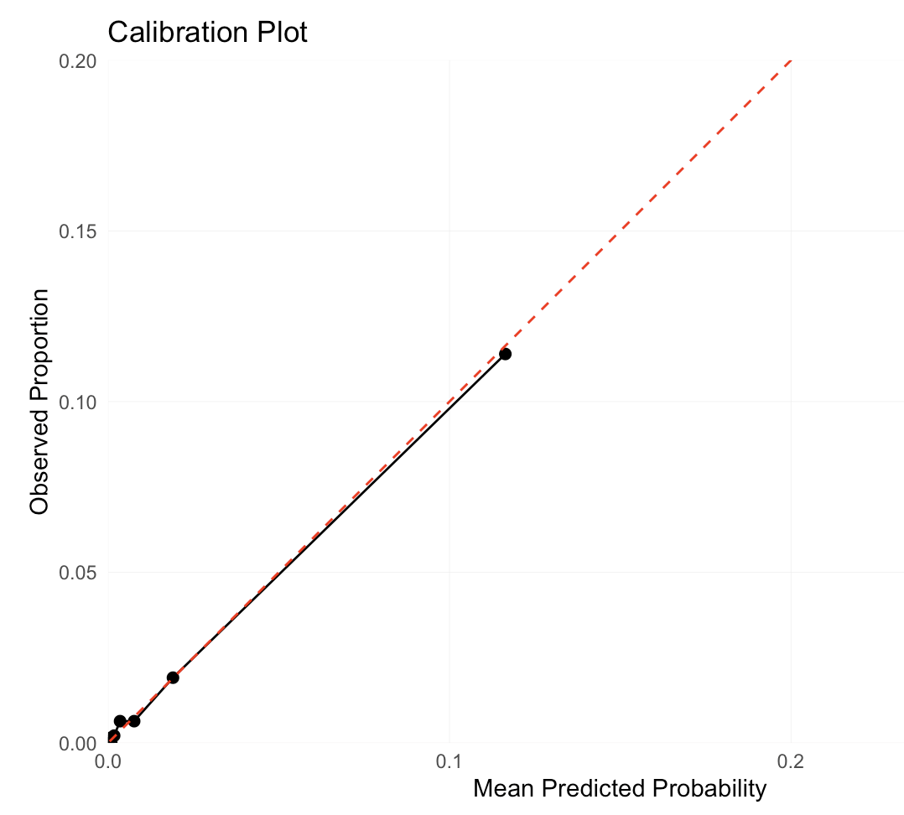

**Supplementary Figure 26.** Calibration plot for the prediction of FGR according to the EFW Centile, MCA PI and Uterine Artery PI.

