Supplementary Tables and Figures

Contents

Table S1: HbA1c variability score (HVS) by selected characteristics, in type 1 and type 2 diabetes 2

Table S2: Adjusted relative risks for a HbA1c variability score (HVS) of 50 or more vs. HVS<50 by selected characteristics 3

Table S3: Number of deaths during 2015-17 by selected baseline characteristics 4

Table S4: Sensitivity analyses with different adjusted models for all-cause mortality during 2015-17 by average HbA1c and HbA1c variability score (HVS), in type 1 and type 2 diabetes 6

Table S5: Adjusted hazard ratios for all-cause mortality during 2015-17 cross-classified by average HbA1c and HbA1c variability score (HVS), in type 1 and type 2 diabetes 7

Table S6: Adjusted hazard ratios for all-cause mortality during 2015-17 by a HbA1c variability score calculated by only counting negative (HVS-) or positive (HVS+) fluctuations, in type 1 and type 2 diabetes 8

Table S7: Adjusted hazard ratios for all-cause mortality during 2015-17 by first recorded HbA1c in 2015 and related fluctuation, in type 1 and type 2 diabetes 9

Table S8: Sensitivity analyses using only follow-up to the end of 2015 for all-cause mortality by average HbA1c and HbA1c variability score (HVS), in type 1 and type 2 diabetes 10

Table S9: Sensitivity analyses requiring HbA1c measurements to be between 90 and 730 days apart during 2011-14 in models for all-cause mortality during 2015-17 by average HbA1c and HbA1c variability score (HVS), in type 1 and type 2 diabetes 11

Table S10: Sensitivity analyses using coefficient of variation instead of HbA1c variability score (HVS) in main analysis for all-cause mortality during 2015-17, in type 1 and type 2 diabetes 12

Table S11: Sensitivity analyses excluding to different sub-groups for all-cause mortality during 2015-17 by average HbA1c and HbA1c variability score (HVS), in type 1 diabetes 13

Table S12: Sensitivity analyses excluding to different sub-groups for all-cause mortality during 2015-17 by average HbA1c and HbA1c variability score (HVS), in type 2 diabetes 14

Figure S1: Flow chart of participants with type 1 and type 2 diabetes included in the study 15

Figure S2: Distribution of HbA1c variability score vs. average HbA1c level, by diabetes type 16

Figure S3: Distribution of HbA1c variability score (HVS) and average HbA1c, in type 1 and type 2 diabetes stratified by anti-diabetes medication 17

Figure S4: Adjusted hazard ratios for all-cause mortality by average HbA1c and HbA1c variability score (HVS), in type 1 and type 2 diabetes stratified by age 18

Figure S5: Adjusted hazard ratios for all-cause mortality by average HbA1c and HbA1c variability score (HVS), in type 1 and type 2 diabetes stratified by diabetes medication 19

## Table S1: HbA1c variability score (HVS) by selected characteristics, in type 1 and type 2 diabetes

|  | Type 1 Diabetes | | | | Type 2 Diabetes | | | |
| --- | --- | --- | --- | --- | --- | --- | --- | --- |
|  | 0-<20 | 20-<50 | 50-<80 | 80-100 | 0- <20 | 20-<50 | 50-<80 | 80-100 |
|  |  |  |  |  |  |  |  |  |
| Sex |  |  |  |  |  |  |  |  |
| - Females (%) | 27.1 | 39.6 | 28.2 | 5.2 | 29.5 | 35.1 | 28.4 | 6.9 |
| - Males (%) | 27.9 | 40.0 | 26.7 | 5.4 | 24.7 | 34.8 | 31.9 | 8.6 |
|  |  |  |  |  |  |  |  |  |
| Age |  |  |  |  |  |  |  |  |
| - Years in 2015 (mean) | 54.1 | 53.3 | 51.7 | 50.8 | 70.9 | 67.9 | 65.3 | 63.0 |
|  |  |  |  |  |  |  |  |  |
| Ethnicity |  |  |  |  |  |  |  |  |
| - South Asian (%) | 19.6 | 40.8 | 30.9 | 8.8 | 22.4 | 35.3 | 33.2 | 9.0 |
| - Black (%) | 14.6 | 33.2 | 41.1 | 11.1 | 20.9 | 31.6 | 35.5 | 12.0 |
| - Mixed (%) | 19.0 | 40.4 | 32.0 | 8.6 | 22.8 | 34.6 | 33.2 | 9.5 |
| - White (%) | 28.4 | 40.0 | 26.6 | 5.0 | 28.1 | 35.2 | 29.4 | 7.3 |
|  |  |  |  |  |  |  |  |  |
| Index of Multiple Deprivation |  |  |  |  |  |  |  |  |
| - Least deprived fifth (%) | 31.4 | 40.0 | 24.4 | 4.2 | 30.1 | 35.5 | 27.9 | 6.5 |
| - Most deprived fifth (%) | 20.8 | 39.4 | 32.9 | 7.0 | 23.7 | 34.4 | 32.8 | 9.1 |
|  |  |  |  |  |  |  |  |  |
| BMI |  |  |  |  |  |  |  |  |
| - Kg/m2 (mean) | 27.2 | 27.4 | 27.4 | 27.2 | 29.9 | 30.9 | 31.6 | 32.0 |
|  |  |  |  |  |  |  |  |  |
| Smoking |  |  |  |  |  |  |  |  |
| - Never (%) | 29.3 | 40.6 | 25.3 | 4.8 | 27.2 | 35.1 | 30.0 | 7.7 |
| - Ex (%) | 27.6 | 40.1 | 27.3 | 5.0 | 27.4 | 35.2 | 30.0 | 7.5 |
| - Current (%) | 23.4 | 37.5 | 32.0 | 7.1 | 23.7 | 33.7 | 33.0 | 9.7 |
|  |  |  |  |  |  |  |  |  |
| Time since diagnosis |  |  |  |  |  |  |  |  |
| - Mean (years) | 29.1 | 28.0 | 25.4 | 23.2 | 10.1 | 11.1 | 11.2 | 10.7 |
|  |  |  |  |  |  |  |  |  |
| Average HbA1c |  |  |  |  |  |  |  |  |
| - 2011 to 2014 (mean) | 66.2 | 68.6 | 70.6 | 72.6 | 50.6 | 57.3 | 63.0 | 67.3 |
|  |  |  |  |  |  |  |  |  |
| HbA1c Measurements |  |  |  |  |  |  |  |  |
| - 2011 to 2014 (mean) | 6.7 | 6.7 | 6.2 | 5.6 | 6.5 | 6.9 | 6.8 | 6.1 |
|  |  |  |  |  |  |  |  |  |
| Follow-up Time 2015-17 |  |  |  |  |  |  |  |  |
| - Mean (days) | 1078 | 1070 | 1059 | 1040 | 1050 | 1043 | 1036 | 1033 |
|  |  |  |  |  |  |  |  |  |
| Number of  co-morbidities† |  |  |  |  |  |  |  |  |
| - 0 (%) | 28.1 | 38.9 | 27.7 | 5.3 | 22.4 | 34.4 | 33.4 | 9.8 |
| - 1 to 2 (%) | 28.2 | 40.6 | 26.1 | 5.1 | 28.3 | 35.0 | 29.3 | 7.4 |
| - 2 or more (%) | 20.7 | 41.6 | 31.1 | 6.7 | 27.1 | 35.3 | 30.5 | 7.1 |

† - Count of the following: atrial fibrillation, cancer, coronary heart disease, chronic kidney disease, chronic obstructive pulmonary disease, dementia, epilepsy, heart failure, hypertension, peripheral vascular disease, serious mental Illness e.g. psychosis, schizophrenia & bipolar affective disorder, stroke/TIA.

## Table S2: Adjusted relative risks for a HbA1c variability score (HVS) of 50 or more vs. HVS<50 by selected characteristics

| Covariate | Type 1 Diabetes (n=20,347) | | Type 2 Diabetes (n=409,821) | |
| --- | --- | --- | --- | --- |
|  | RR | 95% CI | RR | 95% CI |
| Sex |  |  |  |  |
| - Male vs. Female | 0.98 | 0.94 – 1.02 | 1.12 | 1.11 – 1.13 |
|  |  |  |  |  |
| Age |  |  |  |  |
| - Decrease of 10 years | 1.07 | 1.05 – 1.09 | 1.10 | 1.09 – 1.10 |
|  |  |  |  |  |
| Ethnicity |  |  |  |  |
| - South Asian vs. White | 1.18 | 1.05 – 1.33 | 0.94 | 0.92 – 0.95 |
| - Black vs. White | 1.53 | 1.36 – 1.72 | 1.03 | 1.01 – 1.05 |
| - Mixed vs. White | 1.22 | 1.10 – 1.35 | 0.97 | 0.95 – 0.99 |
|  |  |  |  |  |
| Years since diagnosed |  |  |  |  |
| - 0-5 vs. 5-10 | 1.58 | 1.48 – 1.69 | 1.07 | 1.06 – 1.08 |
| - 15+ vs. 5-10 | 0.89 | 0.85 – 0.93 | 1.04 | 1.03 – 1.05 |
|  |  |  |  |  |
| BMI (kg/m2) |  |  |  |  |
| - 25-30 vs. 18-25 | 0.95 | 0.90 – 0.99 | 1.04 | 1.03 – 1.05 |
| - 30-40 vs. 18-25 | 1.01 | 0.96 – 1.07 | 1.13 | 1.12 – 1.14 |
| - 40+ vs. 18-25 | 1.22 | 1.08 – 1.39 | 1.22 | 1.20 – 1.24 |
|  |  |  |  |  |
| Smoking |  |  |  |  |
| - Current vs. Never | 1.20 | 1.13 – 1.26 | 1.02 | 1.00 – 1.03 |
| - Ex vs. Never | 1.10 | 1.04 – 1.15 | 1.05 | 1.04 – 1.06 |
|  |  |  |  |  |
| IMD Quintile |  |  |  |  |
| - 2 vs. 1 (least) | 1.03 | 0.96 – 1.10 | 1.02 | 1.01 – 1.03 |
| - 3 vs. 1 (least) | 1.09 | 1.02 – 1.16 | 1.04 | 1.03 – 1.06 |
| - 4 vs. 1 (least) | 1.14 | 1.06 – 1.21 | 1.05 | 1.04 – 1.06 |
| - 5 vs. 1 (least) | 1.28 | 1.20 – 1.36 | 1.07 | 1.05 – 1.08 |
|  |  |  |  |  |
| Co-morbidities (yes vs. no) |  |  |  |  |
| - Atrial Fibrillation | 1.27 | 1.12 – 1.45 | 1.11 | 1.10 – 1.13 |
| - Cancer | 1.07 | 0.96 – 1.20 | 1.10 | 1.08 – 1.11 |
| - Coronary Heart Disease | 1.23 | 1.15 – 1.32 | 1.03 | 1.02 – 1.04 |
| - Chronic Kidney Disease | 1.25 | 1.18 – 1.33 | 1.11 | 1.10 – 1.12 |
| - COPD | 1.17 | 1.03 – 1.34 | 1.13 | 1.11 – 1.14 |
| - Dementia | 1.58 | 1.30 – 1.91 | 1.30 | 1.27 – 1.33 |
| - Epilepsy | 1.08 | 0.96 – 1.22 | 1.09 | 1.06 – 1.12 |
| - Heart Failure | 1.47 | 1.31 – 1.66 | 1.20 | 1.18 – 1.22 |
| - Hypertension | 1.02 | 0.98 – 1.06 | 1.01 | 1.01 – 1.02 |
| - Peripheral artery disease | 1.13 | 1.03 – 1.24 | 1.07 | 1.05 – 1.08 |
| - Serious Mental Illness | 1.33 | 1.15 – 1.55 | 1.11 | 1.08 – 1.14 |
| - Stroke | 1.24 | 1.13 – 1.36 | 1.11 | 1.10 – 1.13 |
|  |  |  |  |  |
| Average Level (mmol/mol) |  |  |  |  |
| - Increase of 11 | 1.10 | 1.09 – 1.12 | 1.26 | 1.26 – 1.27 |

Note: Relative Risk (RR) for a Hba1c variability score (HVS) of 50 or more vs. HVS<50 from a modified Poisson regression model, using generalized estimating equations (GEE) to account for the clustering by practice. Model adjusts for age, sex, and average HbA1c level.

## Table S3: Number of deaths during 2015-17 by selected baseline characteristics

|  | People with Type 1 diabetes | | | People with Type 2 diabetes | | |
| --- | --- | --- | --- | --- | --- | --- |
|  | N | Died in 2015-17 | % | N | Died in 2015-17 | % |
|  |  |  |  |  |  |  |
| All | 20,347 | 1,043 | 5.1 | 409,821 | 40,723 | 9.9 |
|  |  |  |  |  |  |  |
| Sex |  |  |  |  |  |  |
| - Females | 8,662 | 411 | 4.7 | 181,072 | 17,184 | 9.5 |
| - Males | 11,685 | 632 | 5.4 | 228,749 | 23,539 | 10.3 |
|  |  |  |  |  |  |  |
| Age in 2015 |  |  |  |  |  |  |
| - 31 to 40 | 3,920 | 35 | 0.9 | 7,343 | 43 | 0.6 |
| - 41 to 50 | 5,503 | 116 | 2.1 | 32,715 | 404 | 1.2 |
| - 51 to 60 | 5,300 | 191 | 3.6 | 76,329 | 1,932 | 2.5 |
| - 61 to 70 | 3,327 | 213 | 6.4 | 113,602 | 6,156 | 5.4 |
| - 71 to 80 | 1,737 | 285 | 16.4 | 116,155 | 14,311 | 12.3 |
| - 81 to 90 | 560 | 203 | 36.3 | 63,767 | 17,877 | 28.0 |
|  |  |  |  |  |  |  |
| Ethnicity |  |  |  |  |  |  |
| - South Asian | 444 | 20 | 4.5 | 41,016 | 1,705 | 4.2 |
| - Black | 316 | 7 | 2.2 | 16,545 | 935 | 5.7 |
| - Mixed | 584 | 20 | 3.4 | 23,066 | 1,137 | 4.9 |
| - White | 16,881 | 807 | 4.8 | 292,706 | 30,055 | 10.3 |
| - Missing | 2,122 | 189 | 8.9 | 36,488 | 6,891 | 18.9 |
|  |  |  |  |  |  |  |
| Index of Multiple Deprivation |  |  |  |  |  |  |
| - 1 (least deprived) | 4,532 | 181 | 4.0 | 69,700 | 6,795 | 9.8 |
| - 2 | 4,420 | 213 | 4.8 | 77,171 | 7,628 | 9.9 |
| - 3 | 4,107 | 196 | 4.8 | 79,403 | 7,948 | 10.0 |
| - 4 | 3,770 | 212 | 5.6 | 89,214 | 8,614 | 9.7 |
| - 5 (most deprived) | 3,498 | 241 | 6.9 | 94,047 | 9,711 | 10.3 |
| - Missing | 20 | 0 | 0.0 | 286 | 27 | 9.4 |
|  |  |  |  |  |  |  |
| Body Mass Index (kg/m2) |  |  |  |  |  |  |
| - <25 | 7,122 | 416 | 5.9 | 62,649 | 10,169 | 16.3 |
| - 25 to <30 | 7,966 | 333 | 4.2 | 139,323 | 13,532 | 9.7 |
| - 30 to <40 | 4,794 | 236 | 4.9 | 172,448 | 13,656 | 7.9 |
| - ≥40 | 429 | 39 | 9.4 | 34,806 | 2,800 | 8.1 |
| - Not recorded | 36 | 19 | 20.2 | 595 | 566 | 33.9 |
|  |  |  |  |  |  |  |
| Smoking |  |  |  |  |  |  |
| - Never | 8,377 | 283 | 3.4 | 151,001 | 10,898 | 7.2 |
| - Ex | 8,366 | 534 | 6.4 | 206,939 | 24,301 | 11.7 |
| - Current | 3,602 | 226 | 6.3 | 51,860 | 5,520 | 10.6 |
| - Not recorded | 2 | 0 | 0.0 | 21 | 4 | 19.1 |
|  |  |  |  |  |  |  |
| Number of  co-morbidities† |  |  |  |  |  |  |
| - 0 | 10,404 | 138 | 1.3 | 84,481 | 2,188 | 2.6 |
| - 1 to 2 | 8,372 | 504 | 6.0 | 247,386 | 18,304 | 7.4 |
| - 2 or more | 1,571 | 401 | 25.5 | 77,954 | 20,231 | 26.0 |
|  |  |  |  |  |  |  |
| Anti-diabetic medications prescribed in 2014‡ |  |  |  |  |  |  |
| - None | _ | _ | _ | 68,418 | 8,060 | 11.8 |
| - Biguanides only | _ | _ | _ | 123,903 | 3,891 | 19.3 |
| - Biguanides & other | _ | _ | _ | 130,054 | 9,305 | 7.5 |
| - Other | _ | _ | _ | 20,126 | 9,585 | 7.4 |
| - Insulin | 20,347 | 1,043 | 5.1 | 67,320 | 9,882 | 14.7 |
|  |  |  |  |  |  |  |
| Time Since Diagnosis (years) |  |  |  |  |  |  |
| - 0 to 5 | 1,139 | 36 | 3.2 | 112,972 | 7,160 | 6.3 |
| - 5 to 15 | 4,179 | 158 | 3.8 | 221,716 | 21,389 | 9.7 |
| - More than 15 | 15,029 | 849 | 5.7 | 75,133 | 12,174 | 16.2 |
|  |  |  |  |  |  |  |
| Average HbA1c (mmol/mol) |  |  |  |  |  |  |
| - <42 | 283 | 18 | 6.4 | 27,505 | 3,660 | 13.3 |
| - 42 to <53 | 2,084 | 93 | 4.5 | 147,898 | 14,721 | 10.0 |
| - 53 to <64 | 5,990 | 248 | 4.1 | 126,200 | 11,550 | 9.2 |
| - 64 to <75 | 6,195 | 328 | 5.3 | 60,587 | 5.962 | 9.8 |
| - 75 to <86 | 3,380 | 199 | 5.9 | 27,760 | 2,732 | 9.8 |
| - ≥86 | 2,415 | 157 | 6.5 | 19,871 | 2,098 | 10.6 |
|  |  |  |  |  |  |  |
| HbA1c Variability Score (%) |  |  |  |  |  |  |
| - 0 to <20 | 5,606 | 182 | 3.3 | 109,939 | 9,741 | 8.9 |
| - 20 to <50 | 8,105 | 405 | 5.0 | 143,201 | 14,044 | 9.8 |
| - 50 to <80 | 5,558 | 355 | 6.4 | 124,498 | 13,310 | 10.7 |
| - 80 to 100 | 1,078 | 101 | 9.4 | 32,183 | 3,628 | 11.3 |

† - Count of the following (% in each group): atrial fibrillation (T1=2.1%, T2=8.2%), cancer (T1=3.5%, T2=8.3%), coronary heart disease (T1=8.6%, T2=19.0%), chronic kidney disease (T1=11.5%, T2=20.2%), chronic obstructive pulmonary disease (T1=2.1%, T2=6.6%), dementia (T1=0.6%, T2=2.2%), epilepsy (T1=2.6%, T2=1.6%), heart failure (T1=1.8%, 4.8%), hypertension (T1=37.7%, T2=66.4%), peripheral vascular disease (T1=4.6%, T2=4.8%), serious mental Illness e.g. psychosis, schizophrenia & bipolar affective disorder (T1=1.1%, T2=2.1%) , stroke/TIA (T1=4.0%, T2=7.9%).  
‡ - “Biguanides & other” excludes insulin, “Other” excludes biguanides & insulin, “Insulin” include both insulin only or in combination.

## Table S4: Sensitivity analyses with different adjusted models for all-cause mortality during 2015-17 by average HbA1c and HbA1c variability score (HVS), in type 1 and type 2 diabetes

|  | Type 1 Diabetes (n=20,347) | | | Type 2 Diabetes (n=409,821) | | |
| --- | --- | --- | --- | --- | --- | --- |
|  | Adjusted for age, sex and ethnicity only | Main analysis (as per Figure 2) | Adjusted for individual co-morbidities* | Adjusted for age, sex and ethnicity only | Main analysis (as per Figure 2) | Adjusted for individual co-morbidities* |
|  | HR (95% CI) | HR (95% CI) | HR (95% CI) | HR (95% CI) | HR (95% CI) | HR (95% CI) |
| **Average HbA1c** |  |  |  |  |  |  |
| - <42 | 1.72 (1.05-2.83) | 1.61 (0.97-2.65) | 1.46 (0.87-2.44) | 1.39 (1.34-1.44) | 1.31 (1.26-1.36) | 1.29 (1.25-1.34) |
| 42 to <53 | 1 (Reference) | 1 (Reference) | 1 (Reference) | 1 (Reference) | 1 (Reference) | 1 (Reference) |
| 53 to <64 | 0.95 (0.75-1.21) | 0.96 (0.75-1.23) | 0.93 (0.73-1.19) | 0.94 (0.92-0.97) | 0.95 (0.92-0.97) | 0.94 (0.92-0.97) |
| 64 to <75 | 1.27 (1.01-1.60) | 1.24 (0.98-1.57) | 1.20 (0.95-1.53) | 1.13 (1.10-1.17) | 1.08 (1.05-1.12) | 1.06 (1.03-1.10) |
| 75 to <86 | 1.65 (1.29-2.12) | 1.49 (1.15-1.93) | 1.49 (1.16-1.93) | 1.34 (1.29-1.40) | 1.24 (1.19-1.30) | 1.20 (1.15-1.26) |
| ≥86 | 2.48 (1.89-3.24) | 2.07 (1.57-2.73) | 2.00 (1.51-2.63) | 1.98 (1.89-2.08) | 1.76 (1.67-1.85) | 1.69 (1.60-1.78) |
| Attributable Fraction to average (%)† | 19.2% | 16.9% | 14.8% | 5.8% | 4.4% | 3.6% |
|  |  |  |  |  |  |  |
| **HbA1c Variability Score (HVS)** |  |  |  |  |  |  |
| 0 to <20 | 1 (Reference) | 1 (Reference) | 1 (Reference) | 1 (Reference) | 1 (Reference) | 1 (Reference) |
| 20 to <50 | 1.57 (1.32-1.87) | 1.38 (1.16-1.65) | 1.36 (1.14-1.62) | 1.37 (1.34-1.41) | 1.30 (1.27-1.33) | 1.26 (1.23-1.29) |
| 50 to <80 | 2.15 (1.79-2.57) | 1.76 (1.46-2.12) | 1.69 (1.40-2.04) | 1.77 (1.72-1.82) | 1.60 (1.56-1.65) | 1.52 (1.47-1.56) |
| 80 to 100 | 3.60 (2.81-4.62) | 2.78 (2.15-3.60) | 2.67 (2.05-3.48) | 2.14 (2.05-2.23) | 1.91 (1.83-1.99) | 1.77 (1.70-1.85) |
| Attributable Fraction to variability (%)† | 32.8% | 26.2% | 25.0% | 26.8% | 23.2% | 20.9% |

HR = Hazard ratio. Main analysis adjusts for age, sex, ethnicity, deprivation (IMD), time since diagnosis, co-morbidity count, smoking, BMI and HbA1c mean/variability.   
* - Alternative analysis adjust for 12 individual comorbidities (atrial fibrillation, cancer, chronic obstructive pulmonary disease, coronary heart disease, chronic kidney disease, dementia, epilepsy, heart failure, hypertension, peripheral vascular disease, serious mental Illness and stroke)  
† Attributable fractions estimates assume a casual association under which all patients are moved to reference category.

## Table S5: Adjusted hazard ratios for all-cause mortality during 2015-17 cross-classified by average HbA1c and HbA1c variability score (HVS), in type 1 and type 2 diabetes

|  |  | HbA1c Variability Score (HVS) | | | |
| --- | --- | --- | --- | --- | --- |
|  |  | 0 to <20 | 20 to <50 | 50 to <80 | 80 to 100 |
| **Type 1** |  |  |  |  |  |
| **Average HbA1c** |  |  |  |  |  |
| - <42 | N (%)  **HR**  (95%CI) | 99 (0.5%)  **1.13**  (0.36-3.56) | 108 (0.5%)  **2.46**  (0.94-6.41) | 60 (0.3%) **4.45**  (2.04-9.70) | 16 (0.1%) **4.41**  (1.30-14.93) |
| 42 to <53 | N (%)  **HR**  (95%CI) | 659 (3.2%)  **1.00** Reference | 850 (4.2%) **1.21**  (0.68-2.14) | 496 (2.4%) **2.35**  (1.31-4.21) | 79 (0.4%) **3.92**  (1.57-9.84) |
| 53 to <64 | N (%)  **HR**  (95%CI) | 1,877 (9.2%)  **0.97**  (0.57-1.67) | 2,388 (11.7%)  **1.42**  (0.86-2.35) | 1,475 (7.2%) **1.80**  (1.07-3.01) | 250 (1.2%) **3.21**  (1.67-6.18) |
| 64 to <75 | N (%)  **HR**  (95%CI) | 1,760 (8.6%) **1.52**  (0.90-2.57) | 2,452 (12.1%)  **1.84**  (1.12-3.01) | 1,671 (8.2%)  **2.16**  (1.30-3.60) | 312 (1.5%)  **3.52**  (1.94-6.38) |
| 75 to <86 | N (%)  **HR**  (95%CI) | 775 (3.8%)  **1.52**  (0.83-2.78) | 1,389 (6.8%)  **2.21**  (1.32-3.69) | 997 (4.9%)  **2.68**  (1.58-4.56) | 219 (1.1%)  **5.15**  (2.79-9.53) |
| ≥86 | N (%)  **HR**  (95%CI) | 436 (2.1%) **2.02**  (1.01-4.05) | 918 (4.5%)  **3.39**  (1.99-5.79) | 859 (4.2%) **3.99**  (2.33-6.84) | 202 (1.0%) **4.47**  (2.25-8.89) |
| Type 2 |  |  |  |  |  |
| Average HbA1c |  |  |  |  |  |
| - <42 | N (%)  **HR**  (95%CI) | 14,187 (3.5%)  **1.23**  (1.16-1.30) | 8,970 (2.2%)  **1.73**  (1.62-1.84) | 3,823 (0.9%)  **2.31**  (2.12-2.51) | 525 (0.1%)  **3.29**  (2.71-3.99) |
| 42 to <53 | N (%)  **HR**  (95%CI) | 63,527 (15.5%)  **1.00** (Reference) | 52,930 (12.9%) **1.27**  (1.23-1.32) | 27,315 (6.7%)  **1.64**  (1.57-1.71) | 4,126 (1.0%) **2.25**  (2.06-2.46) |
| 53 to <64 | N (%)  **HR**  (95%CI) | 24,704 (6.0%)  **0.98**  (0.93-1.03) | 48,687 (11.9%)  **1.21**  (1.17-1.26) | 42,973 (10.5%)  **1.55**  (1.49-1.61) | 9,836 (2.4%)  **1.79**  (1.67-1.92) |
| 64 to <75 | N (%)  **HR**  (95%CI) | 4,412 (1.1%)  **1.20**  (1.08-1.33) | 19,186 (4.7%) **1.47**  (1.39-1.55) | 27,863 (6.8%) **1.71**  (1.63-1.79) | 9,126 (2.2%) **2.03**  (1.89-2.17) |
| 75 to <86 | N (%)  **HR**  (95%CI) | 1,545 (0.4%) **1.44**  (1.21-1.72) | 7,645 (1.9%)  **1.87**  (1.73-2.02) | 13,378 (3.3%)  **1.89**  (1.78-2.02) | 5,192 (1.3%)  **2.21**  (2.02-2.41) |
| ≥86 | N (%)  **HR**  (95%CI) | 1,564 (0.4%)  **2.28**  (1.89-2.75) | 5,783 (1.4%)  **2.44**  (2.23-2.68) | 9,146 (2.2%)  **2.76**  (2.58-2.97) | 3,378 (0.8%)  **3.14**  (2.82-3.49) |

HRs adjusted for age, sex, ethnicity, deprivation (IMD), time since diagnosis, co-morbidity count, smoking, BMI and HbA1c mean/variability

## Table S6: Adjusted hazard ratios for all-cause mortality during 2015-17 by a HbA1c variability score calculated by only counting negative (HVS-) or positive (HVS+) fluctuations, in type 1 and type 2 diabetes

|  | Type 1 Diabetes  (n=20,347) | Type 2 Diabetes  (n=409,821) |
| --- | --- | --- |
|  | HR (95% CI) | HR (95% CI) |
|  |  |  |
| Model with NEGATIVE HVS only |  |  |
| 0 to <20 | 1 | 1 |
| 20 to <50 | 1.25 (1.09-1.42) | 1.31 (1.28-1.33) |
| 50 to 100 | 2.12 (1.69-2.66) | 1.69 (1.62-1.75) |
|  |  |  |
| Model with POSITIVE HVS only |  |  |
| 0 to <20 | 1 | 1 |
| 20 to <50 | 1.40 (1.22-1.59) | 1.24 (1.22-1.27) |
| 50 to 100 | 2.02 (1.60-2.54) | 1.45 (1.40-1.51) |
|  |  |  |

HRs adjusted for age, sex, ethnicity, deprivation (IMD), time since diagnosis, co-morbidity count, smoking, BMI and average HbA1c level.

## Table S7: Adjusted hazard ratios for all-cause mortality during 2015-17 by first recorded HbA1c in 2015 and related fluctuation, in type 1 and type 2 diabetes

|  | Type 1 Diabetes  (n=13,835) | | Type 2 Diabetes  (n=305,262) | |
| --- | --- | --- | --- | --- |
|  | N (%) | HR (95% CI) | N (%) | HR (95% CI) |
|  |  |  |  |  |
| **First HbA1c in 2015** |  |  |  |  |
| - <42 | 226 (1.6) | 0.88 (0.48-1.61) | 23,886 (7.8) | 1.41 (1.35-1.47) |
| 42 to <53 | 1,626 (11.8) | 1 (Ref) | 104,829 (34.3) | 1 (Ref) |
| 53 to <64 | 3,914 (28.3) | 0.77 (0.58-1.01) | 85,113 (27.9) | 0.97 (0.94-1.01) |
| 64 to <75 | 3,973 (28.7) | 0.98 (0.75-1.29) | 43,999 (14.4) | 1.07 (1.02-1.11) |
| 75 to <86 | 2,266 (16.4) | 1.27 (0.95-1.70) | 22,923 (7.5) | 1.14 (1.08-1.21) |
| ≥86 | 1,830 (13.2) | 1.53 (1.12-2.09) | 24,512 (8.0) | 1.45 (1.37-1.53) |
| Attributable Fraction (%)† |  | -1.4% |  | 5.8% |
|  |  |  |  |  |
| **First Fluctuation in 2015** |  |  |  |  |
| < -20% | 425 (2.2) | 2.14 (1.46-3.12) | 14,527 (4.8) | 2.00 (1.90-2.10) |
| -20% to -10% | 1,407 (10.2) | 1.57 (1.24-2.00) | 27,158 (8.9) | 1.44 (1.38-1.50) |
| Within +/- 10% | 8,856 (64.0) | 1 (Ref) | 180,980 (59.3) | 1 (Ref) |
| +10% to +20% | 2,103 (15.2) | 1.12 (0.89-1.41) | 46,359 (15.2) | 1.04 (1.00-1.08) |
| > + 20% | 1,044 (7.6) | 1.50 (1.15-1.95) | 36,238 (11.9) | 1.27 (1.22-1.33) |
| Attributable Fraction (%)† |  | 9.5% |  | 8.2% |

Note: Analysis restricted to people with a HbA1c measurement in 2015 within 365 days of their last measurement in 2014. Follow-up time begins from the day after 2015 measurement. Number of deaths to the end of the 2017: Type 1 n=642 (4.6%), Type 2 n=25,218 (8.3%).

HRs adjusted for age, sex, ethnicity, deprivation (IMD), time since diagnosis, co-morbidity count, smoking, BMI and first HbA1c / fluctuation.

† - Attributable fractions estimates assume a casual association under which all patients are moved to reference category.

## Table S8: Sensitivity analyses using only follow-up to the end of 2015 for all-cause mortality by average HbA1c and HbA1c variability score (HVS), in type 1 and type 2 diabetes

|  | Type 1 Diabetes (n=20,347) | | Type 2 Diabetes (n=409,821) | |
| --- | --- | --- | --- | --- |
|  | Follow-up to the end of 2015 only | Main analysis (as per Figure 2) | Follow-up to the end of 2015 only | Main analysis (as per Figure 2) |
|  | HR (95% CI) | HR (95% CI) | HR (95% CI) | HR (95% CI) |
|  |  |  |  |  |
| **Average HbA1c** |  |  |  |  |
| - <42 | 1.37 (0.56-3.35) | 1.61 (0.97-2.65) | 1.36 (1.27-1.44) | 1.31 (1.26-1.36) |
| 42 to <53 | 1 (Reference) | 1 (Reference) | 1 (Reference) | 1 (Reference) |
| 53 to <64 | 0.93 (0.61-1.39) | 0.96 (0.75-1.22) | 0.94 (0.90-0.99) | 0.95 (0.92-0.97) |
| 64 to <75 | 1.04 (0.70-1.56) | 1.24 (0.98-1.57) | 1.06 (1.00-1.13) | 1.08 (1.05-1.12) |
| 75 to <86 | 1.30 (0.84-2.00) | 1.49 (1.15-1.93) | 1.19 (1.10-1.28) | 1.24 (1.19-1.30) |
| ≥86 | 2.17 (1.39-3.40) | 2.07 (1.57-2.73) | 1.65 (1.51-1.80) | 1.76 (1.67-1.85) |
| Attributable Fraction to average (%)† | 9.4% | 16.9% | 3.7% | 4.4% |
|  |  |  |  |  |
| **HbA1c Variability Score (HVS)** |  |  |  |  |
| 0 to <20 | 1 (Reference) | 1 (Reference) | 1 (Reference) | 1 (Reference) |
| 20 to <50 | 1.27 (0.92-1.74) | 1.38 (1.15-1.65) | 1.45 (1.38-1.52) | 1.30 (1.27-1.33) |
| 50 to <80 | 1.86 (1.35-2.56) | 1.76 (1.46-2.12) | 1.87 (1.78-1.97) | 1.60 (1.56-1.65) |
| 80 to 100 | 2.91 (1.90-4.45) | 2.78 (2.15-3.60) | 2.14 (1.99-2.31) | 1.91 (1.83-1.99) |
| Attributable Fraction to variability (%)† | 24.4% | 26.1% | 29.1% | 23.2% |

HR = Hazard ratio. Adjusts for age, sex, ethnicity, deprivation (IMD), time since diagnosis, co-morbidity count, smoking, BMI and HbA1c mean/variability. Total number of deaths: 2015 only T1=339 (1.7%), T2=12,891 (3.2%); 2015-17 T1=1,043 (5.1%), T2=40,723 (9.9%),   
† Attributable fractions estimates assume a casual association under which all patients are moved to reference category.

## Table S9: Sensitivity analyses requiring HbA1c measurements to be between 90 and 730 days apart during 2011-14 in models for all-cause mortality during 2015-17 by average HbA1c and HbA1c variability score (HVS), in type 1 and type 2 diabetes

|  | Type 1 Diabetes (n=20,347) | | | Type 2 Diabetes (n=409,821) | | |
| --- | --- | --- | --- | --- | --- | --- |
|  | Main analysis  (as per Figure 2) | Restricted to HbA1c measures 90-730 days apart only (n=19,338) | | Main analysis (as per Figure 2) | Restricted to HbA1c measures 90-730 days apart only (n=389,519) | |
|  | HR (95% CI) | % | HR (95% CI) | HR (95% CI) | % | HR (95% CI) |
|  |  |  |  |  |  |  |
| **Average HbA1c** |  |  |  |  |  |  |
| - <42 | 1.61 (0.97-2.65) | 1.4% | 1.34 (0.79-2.28) | 1.31 (1.26-1.36) | 6.8% | 1.32 (1.27-1.37) |
| 42 to <53 | 1 (Reference) | 10.3% | 1 (Reference) | 1 (Reference) | 36.1% | 1 (Reference) |
| 53 to <64 | 0.96 (0.75-1.22) | 29.7% | 0.92 (0.72-1.18) | 0.95 (0.92-0.97) | 31.1% | 0.94 (0.92-0.96) |
| 64 to <75 | 1.24 (0.98-1.57) | 30.4% | 1.23 (0.97-1.56) | 1.08 (1.05-1.12) | 14.6% | 1.07 (1.04-1.11) |
| 75 to <86 | 1.49 (1.15-1.93) | 16.5% | 1.51 (1.16-1.96) | 1.24 (1.19-1.30) | 6.7% | 1.23 (1.18-1.29) |
| ≥86 | 2.07 (1.57-2.73) | 11.7% | 2.14 (1.62-2.82) | 1.76 (1.67-1.85) | 4.8% | 1.72 (1.64-1.82) |
| Attributable Fraction to average (%)† | 16.9% |  | 15.2% | 4.4% |  | 3.9% |
|  |  |  |  |  |  |  |
| **HbA1c Variability Score (HVS)** |  |  |  |  |  |  |
| 0 to <20 | 1 (Reference) | 26.8% | 1 (Reference) | 1 (Reference) | 26.0% | 1 (Reference) |
| 20 to <50 | 1.38 (1.15-1.65) | 37.7% | 1.23 (1.03-1.48) | 1.30 (1.27-1.33) | 33.1% | 1.30 (1.26-1.33) |
| 50 to <80 | 1.76 (1.46-2.12) | 29.0% | 1.66 (1.38-1.99) | 1.60 (1.56-1.65) | 31.3% | 1.59 (1.55-1.64) |
| 80 to 100 | 2.78 (2.15-3.60) | 6.5% | 2.28 (1.78-2.94) | 1.91 (1.83-1.99) | 9.7% | 1.89 (1.81-1.96) |
| Attributable Fraction to variability (%)† | 26.1% |  | 22.3% | 23.2% |  | 23.8% |

HR = Hazard ratio. Adjusts for age, sex, ethnicity, deprivation (IMD), time since diagnosis, co-morbidity count, smoking, BMI and HbA1c mean/variability. Total number of deaths during 2015-17 in restricted dataset: Type 1 n=990 (5.1%), Type 2 n=38,806 (10.0%).  
† Attributable fractions estimates assume a casual association under which all patients are moved to reference category.

## Table S10: Sensitivity analyses using coefficient of variation instead of HbA1c variability score (HVS) in main analysis for all-cause mortality during 2015-17, in type 1 and type 2 diabetes

|  | Type 1 Diabetes (n=20,347) | | Type 2 Diabetes (n=409,821) | |
| --- | --- | --- | --- | --- |
|  | Main analysis (as per Figure 2) | Uses coefficient of variation instead of HVS | Main analysis (as per Figure 2) | Uses coefficient of variation instead of HVS |
|  | HR (95% CI) | HR (95% CI) | HR (95% CI) | HR (95% CI) |
|  |  |  |  |  |
| **Average HbA1c** |  |  |  |  |
| - <42 | 1.61 (0.97-2.65) | 1.56 (0.94-2.58) | 1.31 (1.26-1.36) | 1.34 (1.29-1.39) |
| 42 to <53 | 1 (Reference) | 1 (Reference) | 1 (Reference) | 1 (Reference) |
| 53 to <64 | 0.96 (0.75-1.22) | 0.95 (0.74-1.21) | 0.95 (0.92-0.97) | 0.91 (0.89-0.93) |
| 64 to <75 | 1.24 (0.98-1.57) | 1.24 (0.98-1.58) | 1.08 (1.05-1.12) | 1.00 (0.97-1.04) |
| 75 to <86 | 1.49 (1.15-1.93) | 1.45 (1.12-1.88) | 1.24 (1.19-1.30) | 1.14 (1.09-1.19) |
| ≥86 | 2.07 (1.57-2.73) | 2.03 (1.54-2.68) | 1.76 (1.67-1.85) | 1.62 (1.54-1.71) |
| Attributable Fraction to average (%)‡ | 16.9% | 16.0% | 4.4% | 1.3% |
|  |  |  |  |  |
| **HbA1c Variability Score (HVS)** |  |  |  |  |
| 0 to <20 | 1 (Reference) | _ | 1 (Reference) | _ |
| 20 to <50 | 1.38 (1.15-1.65) | _ | 1.30 (1.27-1.33) | _ |
| 50 to <80 | 1.76 (1.46-2.12) | _ | 1.60 (1.56-1.65) | _ |
| 80 to 100 | 2.78 (2.15-3.60) | _ | 1.91 (1.83-1.99) | _ |
| Coefficient of HbA1c Variation† |  |  |  |  |
| 0 to <6.32 | _ | 1 (Reference) | _ | 1 (Reference) |
| 6.32 to <12.12 | _ | 1.33 (1.13-1.58) | _ | 1.30 (1.27-1.34) |
| 12.12 to <26.20 | _ | 2.08 (1.73-2.50) | _ | 1.75 (1.70-1.80) |
| ≥26.20 | _ | 3.08 (2.16-4.39) | _ | 2.12 (2.03-2.21) |
| Attributable Fraction to variability (%)‡ | 26.1% | 24.0% | 23.2% | 25.3% |

HR = Hazard ratio. All analyses adjust for age, sex, ethnicity, deprivation (IMD), time since diagnosis, co-morbidity count, smoking, BMI and HbA1c mean/variability.

† - Category cut-points chose to match overall distribution of HVS. Numbers in each group (%), Type 1: CV=0-6.32 n=6,263 (30.7%), 6.32-12.12 n=9,379 (46.1%), 12.12-26.20 n=4,066 (20.0%), ≥26.20 n=649 (3.2%); Type 2: CV=0-6.32 n=109,540 (26.7%), 6.32-12.12 n=141,685 (34.6%), 12.12-26.20 n=126,106 (30.8%), ≥26.20 n=32,490 (7.9%) . ,   
‡ - Attributable fractions estimates assume a casual association under which all patients are moved to reference category.

## Table S11: Sensitivity analyses excluding to different sub-groups for all-cause mortality during 2015-17 by average HbA1c and HbA1c variability score (HVS), in type 1 diabetes

|  | Type 1 Diabetes (n=20,347) | | | | | |
| --- | --- | --- | --- | --- | --- | --- |
|  | Adjusted as per main analysis*, excluding deaths occurring during the first 6 months (n=20,182) | | Adjusted as per main analysis*, excluding those with a history of hypoglycaemia (n=14,309) | | Adjusted as per main analysis*, excluding those with any co-morbidity (n=10,404) | |
|  | % | HR (95% CI) | % | HR (95% CI) | % | HR (95% CI) |
|  |  |  |  |  |  |  |
| **Average HbA1c** |  |  |  |  |  |  |
| - <42 | 1.4 | 1.77 (1.02-3.03) | 1.3 | 2.23 (1.19-4.17) | 1.6 | _ |
| 42 to <53 | 10.2 | 1 (Reference) | 9.9 | 1 (Reference) | 10.6 | 1 (Reference) |
| 53 to <64 | 29.5 | 0.96 (0.73-1.25) | 29.2 | 1.12 (0.81-1.55) | 29.5 | 1.09 (0.54-2.19) |
| 64 to <75 | 30.5 | 1.31 (1.01-1.69) | 30.4 | 1.32 (0.96-1.81) | 29.5 | 1.03 (0.51-2.10) |
| 75 to <86 | 16.6 | 1.57 (1.19-2.08) | 16.8 | 1.65 (1.17-2.31) | 16.2 | 1.37 (0.66-2.86) |
| ≥86 | 11.8 | 2.06 (1.52-2.79) | 12.3 | 2.37 (1.64-3.40) | 12.7 | 2.63 (1.29-5.37) |
| Attributable Fraction to average (%)† |  | 18.6% |  | 24.9% |  | 15.5% |
|  |  |  |  |  |  |  |
| **HbA1c Variability Score (HVS)** |  |  |  |  |  |  |
| 0 to <20 | 27.7 | 1 (Reference) | 27.3 | 1 (Reference) | 28.0 | 1 (Reference) |
| 20 to <50 | 39.9 | 1.37 (1.14-1.66) | 39.8 | 1.43 (1.14-1.81) | 38.9 | 1.43 (1.03-1.98) |
| 50 to <80 | 27.2 | 1.71 (1.41-2.09) | 27.4 | 1.79 (1.40-2.29) | 27.7 | 1.93 (1.39-2.68) |
| 80 to 100 | 5.2 | 2.61 (1.85-3.47) | 5.5 | 2.84 (2.02-4.00) | 5.3 | 2.13 (1.28-3.52) |
| Attributable Fraction to variability (%)† |  | 25.4% |  | 27.7% |  | 21.4% |

HR = Hazard ratio. Number of deaths in each analysis: Deaths 6 months to 3 years only n=878 (4.4%), No hypoglycaemia n=615 (4.3%), No co-morbidities n=138 (1.3%). There were no deaths in the <42 average level group without co-morbidity so HR could be estimated.  
* - Adjusts for age, sex, ethnicity, deprivation (IMD), time since diagnosis, co-morbidity count, smoking, BMI and HbA1c mean/variability.  
† - Attributable fractions estimates assume a casual association under which all patients are moved to reference category.

## Table S12: Sensitivity analyses excluding to different sub-groups for all-cause mortality during 2015-17 by average HbA1c and HbA1c variability score (HVS), in type 2 diabetes

|  | Type 2 Diabetes (n=409,821) | | | | | |
| --- | --- | --- | --- | --- | --- | --- |
|  | Adjusted as per main analysis*, excluding deaths occurring during the first 6 months (n=403,329) | | Adjusted as per main analysis*, excluding those with a history of hypoglycaemia (n=393,683) | | Adjusted as per main analysis*, excluding those with any co-morbidity (n=88,481) | |
|  | % | HR (95% CI) | % | HR (95% CI) | % | HR (95% CI) |
|  |  |  |  |  |  |  |
| **Average HbA1c** |  |  |  |  |  |  |
| - <42 | 5.1 | 1.29 (1.24-1.35) | 6.9 | 1.31 (1.26-1.36) | 5.1 | 1.64 (1.38-1.96) |
| 42 to <53 | 30.6 | 1 (Reference) | 36.7 | 1 (Reference) | 30.6 | 1 (Reference) |
| 53 to <64 | 31.3 | 0.95 (0.93-0.98) | 30.7 | 0.94 (0.92-0.97) | 31.3 | 1.01 (0.90-1.13) |
| 64 to <75 | 17.2 | 1.10 (1.06-1.14) | 14.4 | 1.08 (1.04-1.12) | 17.3 | 1.17 (1.02-1.35) |
| 75 to <86 | 8.6 | 1.25 (1.19-1.31) | 6.6 | 1.22 (1.16-1.28) | 8.6 | 1.29 (1.08-1.55) |
| ≥86 | 7.0 | 1.79 (1.70-1.89) | 4.7 | 1.75 (1.66-1.85) | 7.0 | 2.19 (1.84-2.61) |
| Attributable Fraction to average (%)† |  | 4.7% |  | 4.0% |  | 10.7% |
|  |  |  |  |  |  |  |
| **HbA1c Variability Score (HVS)** |  |  |  |  |  |  |
| 0 to <20 | 22.5 | 1 (Reference) | 27.2 | 1 (Reference) | 22.5 | 1 (Reference) |
| 20 to <50 | 34.3 | 1.26 (1.23-1.30) | 34.9 | 1.29 (1.26-1.33) | 34.3 | 1.26 (1.12-1.42) |
| 50 to <80 | 33.4 | 1.53 (1.48-1.57) | 30.1 | 1.59 (1.54-1.64) | 33.4 | 1.57 (1.38-1.78) |
| 80 to 100 | 9.8 | 1.85 (1.77-1.93) | 7.8 | 1.90 (1.81-1.98) | 9.8 | 2.04 (1.72-2.43) |
| Attributable Fraction to variability (%)† |  | 21.3% |  | 22.7% |  | 24.2% |

HR = Hazard ratio. Number of deaths in each analysis: Deaths 6 months to 3 years only n=34,231 (8.5%), No hypoglycaemia n=37,649 (9.6%), No co-morbidities n=2,188 (2.6%).  
* - Adjusts for age, sex, ethnicity, deprivation (IMD), time since diagnosis, co-morbidity count, smoking, BMI and HbA1c mean/variability.  
† - Attributable fractions estimates assume a casual association under which all patients are moved to reference category.

## Figure S1: Flow chart of participants with type 1 and type 2 diabetes included in the study

**N=568,645 (6.5%)**   
diagnosed with diabetes prior to 2015*

**N=** **8,722,348 (100%)**Patients aged 18-90 active on CPRD on 1st January 2015 and registered for >1 year

**N=409,821**4+ HbA1c measures in 2011-14

**N=527,151 (6.0%)**with Type 2 diabetes

**N=20,347**4+ HbA1c measures in 2011-14

**N=40,723 (9.9%)**with linked death in 2015-17

**N=1,043 (5.1%)**with linked death in 2015-17

**N=33,851 (0.4%)**with Type 1 diabetes

**N=523,127**aged 31-90 only

**N=26,535**aged 31-90 only

N=4,024 (0.8%)excluded aged 18-30

N=7,316 (21.6%) excluded aged 18-30

N=113,306 (21.7%) excluded <4 HbA1c’s

N=6,188 (23.3%) excluded <4 HbA1c’s

CPRD = Clinical Practice Research Datalink. *Read code lists for diabetes are available in the repository <https://doi.org/10.24376/rd.sgul.21565557.v1>

## Figure S2: Distribution of HbA1c variability score vs. average HbA1c level, by diabetes type

## Figure S3: Distribution of HbA1c variability score (HVS) and average HbA1c, in type 1 and type 2 diabetes stratified by anti-diabetes medication

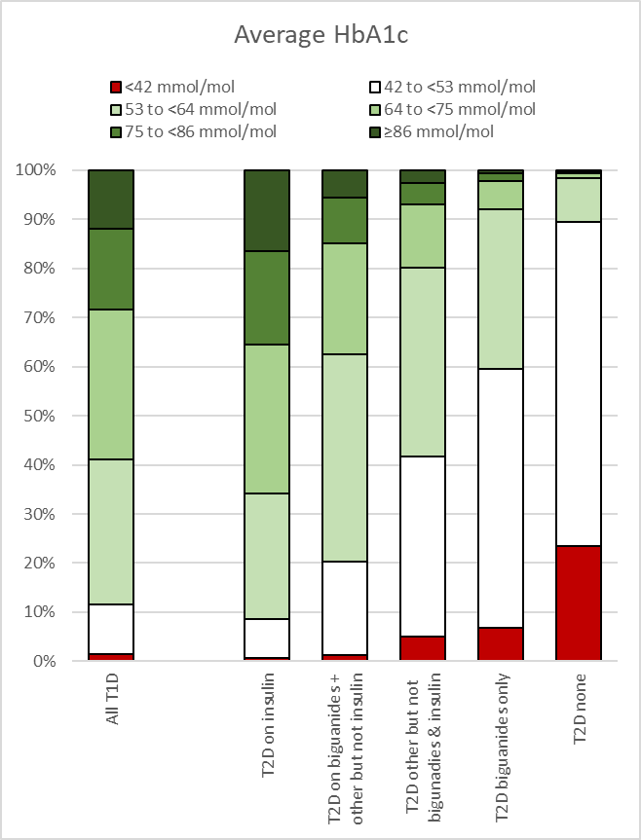 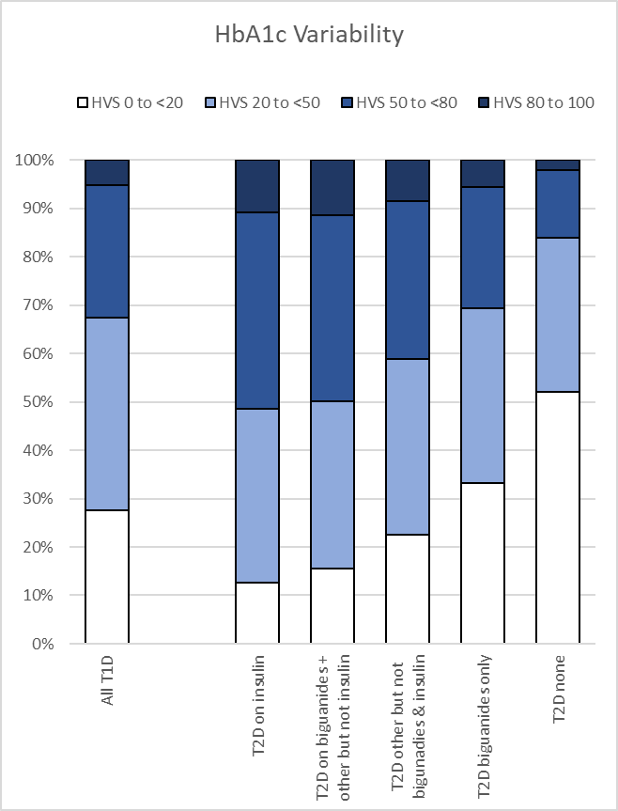

## Figure S4: Adjusted hazard ratios for all-cause mortality by average HbA1c and HbA1c variability score (HVS), in type 1 and type 2 diabetes stratified by age

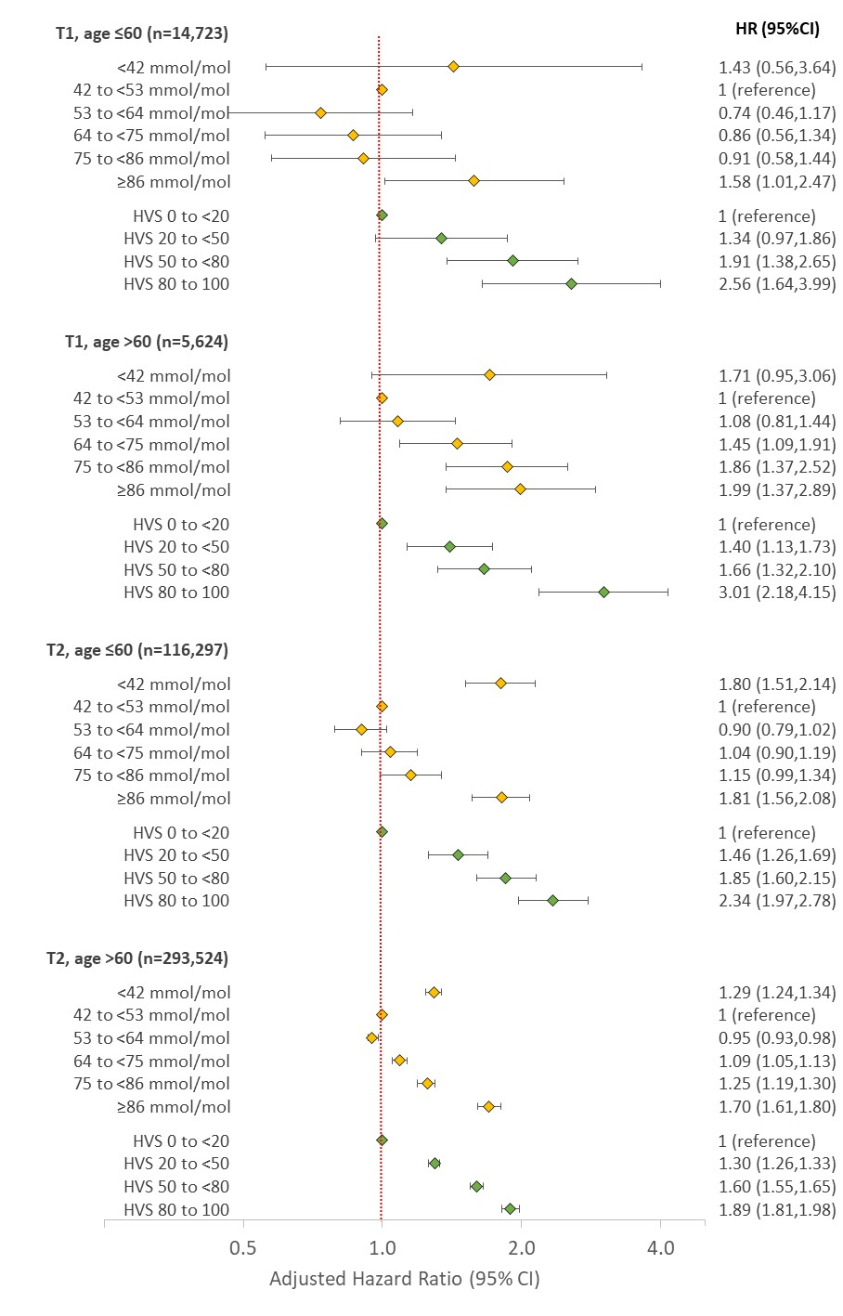  
Hazard Ratios (HR) adjusted for age, sex, ethnicity, deprivation (IMD), time since diagnosis, co-morbidity count, smoking, BMI and HbA1c mean/variability. All tests for HVS trend were p<0.001. Tests for interaction between HVS trend and age (≤60 or >60) were p=0.02 (Type 1) and p<0.001 (Type 2).

## Figure S5: Adjusted hazard ratios for all-cause mortality by average HbA1c and HbA1c variability score (HVS), in type 1 and type 2 diabetes stratified by diabetes medication

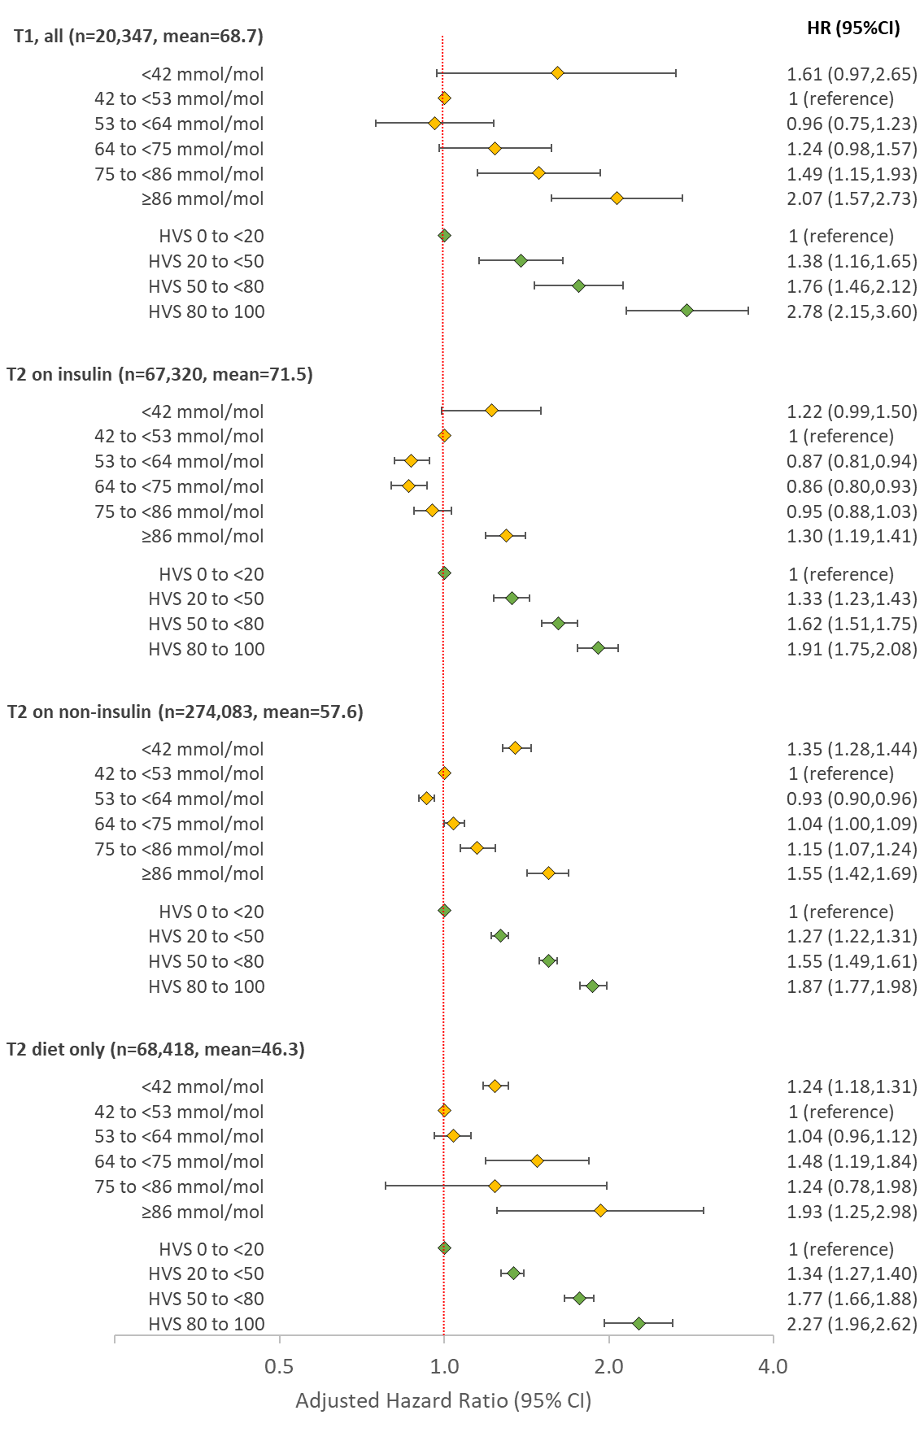

Hazard Ratios (HR) adjusted for age, sex, ethnicity, deprivation (IMD), time since diagnosis, co-morbidity count, smoking, BMI and HbA1c mean/variability. All tests for HVS trend were p<0.001. Test for interaction between HVS trend and medication type in Type 2 (insulin, non-insulin, diet) was p<0.001.