Transient Conduction Disturbance During Pulsed-Field Ablation for Atrial Fibrillation in a Patient with Pre-existing Conduction disease

SUMMARY
Pulsed-field ablation (PFA) is a novel, non-thermal technique for atrial fibrillation (AF) ablation, known for its tissue specificity and reduced risk of collateral damage. However, its impact on cardiac conduction pathways in patients with preexisting conduction abnormalities is not well understood. We present the first documented case of transient conduction block observed PFA for AF. A late 60s gentleman with paroxysmal AF and a dual chamber pacemaker for sinus node disease underwent successful PFA using a 31 mm pentaspline Farapulse catheter. During pulmonary vein isolations, transient prolongation of atrioventricular (AV) conduction time and a temporary shift from right bundle branch block (RBBB) to left bundle branch block (LBBB) lasting up to 4 beats were observed. This novel observation underscores the need for careful monitoring of conduction during PFA, particularly in patients with underlying conduction disorders, and highlights the importance of further research into PFA's mechanism of action and its long-term impact.

BACKGROUND
Pulsed-field ablation (PFA) represents an innovative non-thermal approach for treating atrial fibrillation, utilizing high-amplitude electrical pulses of microsecond duration to ablate myocardium through sarcolemmal membrane electroporation without generating significant tissue heating [1]. Notably, PFA exhibits tissue specificity, with myocardium being highly susceptible to irreversible injury, while structures such as the esophagus, phrenic nerves, pulmonary veins, and coronary arteries show relative resistance [2]. This specificity may yield a broader therapeutic window and enhanced safety during atrial fibrillation ablation. Conduction disturbances as a complication of AF ablation have not been well studied in humans. A study by Koruth et al. (2023) highlighted the potential selective sparing of Purkinje fibers observed 4 weeks after pulsed-field myocardial ablation in swine ventricles, suggesting lower susceptibility compared to cardiomyocytes, though transient effects were not explored [3]. The interplay between tissue-specific effects of PFA and inadvertent stimulation of cardiac ganglionated plexi highlights the complexity of autonomic modulation during ablation procedures. Here, we report a first case of transient conduction disturbance observed during PFA in pulmonary veins, potentially shedding light on its mechanism of action and safety profile in clinical practice, especially in patients with underlying conduction tissue disease.

CASE PRESENTATION
A late 60s gentleman with symptomatic paroxysmal AF and multiple comorbidities, including ischemic heart disease, chronic obstructive pulmonary disease, hypertension, hypothyroidism, and hiatus hernia underwent pulsed field AF ablation. He also has a dual chamber permanent pacemaker in-situ for post conversion pause implanted 2 years ago. His regular medications included Beclomethasone/formotero/glycopyrronium 87/5/9 mcg dry powder inhaler, allopurinol 300 mg once a day, atorvastatin 80 mg once a night, bisoprolol 2.5 mg once a day, clopidogrel 75 mg once a day, Edoxaban 60 mg once a day, folic acid 5 mg once a day, furosemide 40 mg once a day, and lansoprazole 30 mg once a day.

INVESTIGATIONS
His echocardiogram showed normal biventricular size with preserved systolic function. Left atrium was dilated (LAVI 46 ml/m2). There was no significant valvular abnormalities. 12-lead Electrocardiogram at baseline showed atrial paced rhythm with incomplete right bundle branch morphology (QRS duration of 66 ms), normal cardiac axis and PR interval. (Figure 1). Blood test showed haemoglobin of 93 g/dL (normal range: 13.8-17.2 g/dL), eGFR: 56 (>90), CRP: 3.4 mg/L (<10), Creatinine: 115 μmol/L (normal range:53-97) and NT-pro BNP: 1019 pg/mL (<100). Other blood tests are normal.

TREATMENT
The patient underwent PFA for paroxysmal atrial fibrillation under general anaesthesia. Right femoral venous access under ultrasound guidance, utilizing a 7 and 9 French sheaths. A decapolar catheter was advanced and positioned within the coronary sinus (CS) under fluoroscopic guidance. A SLO sheath was used with a BRK-1 needle, and under SoundStar intra-cardiac echocardiogram (ICE) guidance, a single transseptal puncture was successfully performed without complications. Using the HD Grid catheter and Ensite mapping system, a local activation time (LAT) and voltage map were created, revealing normal bipolar voltage in the left atrium. A total of 2 right-sided veins and 2 left-sided veins were identified. Farapulse Inc., Faradrive (Boston Scientific, Marlborough, MA) sheath was used to introduce the 31 mm pentaspline PFA catheter (Farawave). Pulsed field ablation (PFA) was applied in basket and flower configurations with 8 applications per vein initially, followed by additional four applications where signal remained on the septal side of the right inferior pulmonary vein (RIPV). The patient’s cardiac conduction was monitored before, during, and after the procedure through surface 12-lead electrocardiograms (ECGs) and intracardiac electrogram via coronary sinus catheter. After a total of 36 PFA applications, all veins became electrically quiet, indicating successful AF ablation. The procedure concluded with the removal of sheaths and closure of the groin access site with a z-stitch.

OUTCOME AND FOLLOW-UP
Immediately following application of pulses (2.0 kV) to all pulmonary veins, except for left inferior PV isolation in basket and flower configurations, transient prolongation of conduction time from coronary sinus (CS) atrial pacing to the ventricles (Stim A-V interval) occurred increasing from 144 ms to 318 ms, along with the appearance of a left bundle branch block (LBBB) pattern (wide QRS duration of 138 ms) (figure 2). The A-V conduction time progressively shortened, and the QRS duration narrowed back to baseline within these 4 beats. Cardiac axis remained unchanged, and post-ablation 12-lead ECG mirrored pre-ablation ECG (RBBB morphology). At five-month follow-up, the patient was asymptomatic and remained free from recurrence of atrial fibrillation. A 24-hour Holter monitor three months post ablation showed sinus rhythm throughout with one episode of transient LBBB morphology for 33 beats at 60 beats per minute.

DISCUSSION
Pulsed-field ablation (PFA) is a novel non-thermal ablation modality for atrial arrhythmia treatment. It uses high-intensity electric fields to create precise lesions through a process known as electroporation. This method has shown promising results in the treatment of atrial fibrillation (AF), offering advantages over traditional thermal ablation techniques like radiofrequency (RF) and cryoablation. Studies have highlighted the safety and effectiveness of PFA in reducing AF burden and maintaining sinus rhythm [4-6]. PFA utilizes ultra-short pulses of electric fields to selectively destroy myocardial tissue, offering potential safety advantages compared to traditional ablation methods [7]. Furthermore, PFA has been shown to be effective in reducing AF burden and has been associated with a low rate of complications [6].

Transient or permanent conduction tissue disturbances can occur following cardiac ablation procedures due to various factors such as the approach used, the presence of preexisting structural and electrophysiological substrates, and the impact of QRS morphology. Ablation procedures for atrial flutter and supraventricular tachycardia carry a 1.4% risk of AV block leading to pacemaker implantation [8], likely due to direct AV node injury effect from RF thermal injury and PFA's irreversible electroporation. For an instance, Andrikopoulos et al. (2023) recently reported occurrences of transient atrioventricular block and infranodal conduction disturbances, following pulsed-field cavotricuspid isthmus ablation [9]. Another example is transient LBBB and poor AV nodal conduction has been reported during radiofrequency (RF) ablation procedures due to direct mechanical injury by transaortic approach, particularly in cases involving accessory pathways at the left ventricle [10].

To our knowledge, this is the first case report of unusual transient conduction disturbance noticed during PFA for AF. The precise mechanisms behind the transient prolongation of A-V conduction time and the occurrence of left bundle branch block during AF ablation have not been previously reported or thoroughly studied. It's unlikely that the direct damage to the atrioventricular (AV) node or fascicular branch or Purkinje fibres would occur due to their anatomical distance from the pulmonary veins. Verma et al. (2022) has emphasized the tissue-specific effects of PFA, with myocardium exhibiting heightened vulnerability to ablation while adjacent structures demonstrate relative resistance [11]. This tissue specificity may contribute to the development of transient conduction disturbances observed in clinical practice. Intraprocedural vagal responses such as sinus bradycardia, asystole, and atrioventricular block were observed during pulmonary vein isolation (PVI) with the Farapulse PFA system while targeting atrial fibrillation substrates. The frequency of these responses varied significantly among the four pulmonary veins (3-45%), predominantly with left superior pulmonary vein (LSPV), persisting through subsequent applications in 83% of cases [12,13]. However, it causes only transitory modulation of the ganglionated plexi (GP), which completely recovers by the end of the procedure.

This case report speculates that the transient conduction delay likely happened within the His-Purkinje system, specifically at the infranodal level, potentially induced by ganglionated plexi (GP) stimulation during the pulsed field procedure. LBBB is uncommonly seen with vagal response. To note, the selective absence of such conduction disturbances during LIPV isolation is not clearly understood. Since a His catheter was not placed during routine AF ablation, the precise level of conduction block whether intranodal or infra-Hisian cannot be definitively determined. Further investigation is warranted to better comprehend the molecular mechanism of such unusual conduction blocks and long-term effects of PFA on cardiac electrophysiology.

LEARNING POINTS
- Pulsed-field ablation (PFA) in pulmonary veins can induce transient conduction disturbances in the infra-Hisian region, demonstrating prolongation of atrioventricular (AV) conduction time and shifts in bundle branch block patterns, particularly in patients with pre-existing conduction abnormalities.
- The hypothetical mechanism of such transient conduction delay, may be induced by direct electrical impacts on cardiac ganglionated plexuses during the pulsed-field ablation process, warranting further exploration of these mechanisms.
- The long-term effects of PFA on cardiac conduction systems are not fully understood, emphasising the need for ongoing research to ensure patient safety and optimise patient outcomes.

REFERENCES
1. Bradley CJ, Haines DE. Pulsed field ablation for pulmonary vein isolation in the treatment of atrial fibrillation. Journal of Cardiovascular Electrophysiology. 2020 Aug;31(8):2136-47.
2. Verma A, Boersma L, Haines DE, Natale A, Marchlinski FE, Sanders P, Calkins H, Packer DL, Hummel J, Onal B, Rosen S. First-in-human experience and acute procedural outcomes using a novel pulsed field ablation system: the PULSED AF pilot trial. Circulation: Arrhythmia and Electrophysiology. 2022 Jan;15(1):e010168.
3. Koruth JS, Kawamura I, Reddy VY. Selective sparing of Purkinje fibres with pulsed-field myocardial ablation. Europace. 2023 Feb 1;25(2):330.
4. Clarke, J., Piccini, J., & Friedman, D. (2021). The role of posterior wall isolation in catheter ablation of persistent atrial fibrillation. Journal of Cardiovascular Electrophysiology, 32(9), 2567-2576.
5. Turagam, M., Neužil, P., Schmidt, B., Reichlin, T., Neven, K., Metzner, A., … & Reddy, V. (2023). Safety and effectiveness of pulsed field ablation to treat atrial fibrillation: one-year outcomes from the manifest-pf registry. Circulation, 148(1), 35-46.
6. Shaheen, N., Shaheen, A., Ramadan, A., & Nashwan, A. (2023). Efficacy and safety of novel pulsed field ablation (pfa) technique for atrial fibrillation: a systematic review and meta‐analysis. Health Science Reports, 6(1).
7. Qamar, U. (2024). Efficacy and safety of pulsed field ablation for atrial fibrillation: a systematic review and meta‐analysis. Pacing and Clinical Electrophysiology, 47(3), 474-480.
8. Spector, P., Reynolds, M.R., Calkins, H., Sondhi, M., Xu, Y., Martin, A., Williams, C.J. and Sledge, I., 2009. Meta-analysis of ablation of atrial flutter and supraventricular tachycardia. The American journal of cardiology, 104(5), pp.671-677.
9. Andrikopoulos G, Tampakis K, Sykiotis A, Pastromas S. Transient conduction disturbances acutely after pulsed-field cavotricuspid isthmus ablation: a case report. European Heart Journal-Case Reports. 2023 Aug;7(8):ytad370.
10. Chiang, K., Wang, C., Huang, J., & Hsieh, Y. (2020). Transient left bundle branch block and poor atrioventricular conduction during ablation of accessory pathway at the left ventricle. Journal of Arrhythmia, 36(6), 1092-1095.
11. Verma, A.; Asivatham, S.J.; Deneke, T.; Castellvi, Q.; Neal, R.E., 2nd. Primer on Pulsed Electrical Field Ablation: Understanding the Benefits and Limitations. Circ. Arrhythm. Electrophysiol. 2021, 14, e10086.
12. Del Monte, A., Della Rocca, D.G., Pannone, L., Vetta, G., Fernández, M.C., Marcon, L., Doundoulakis, I., Mouram, S., Audiat, C., Zeriouh, S. and Monaco, C., 2024. Pulsed field ablation of the right superior pulmonary vein prevents vagal responses via anterior right ganglionated plexus modulation. Heart Rhythm.
13. Musikantow DR, Neuzil P, Petru J, Koruth JS, Kralovec S, Miller MA, Funasako M, Chovanec M, Turagam MK, Whang W, Sediva L. Pulsed field ablation to treat atrial fibrillation: autonomic nervous system effects. Clinical Electrophysiology. 2023 Apr 1;9(4):481-93.

FIGURES
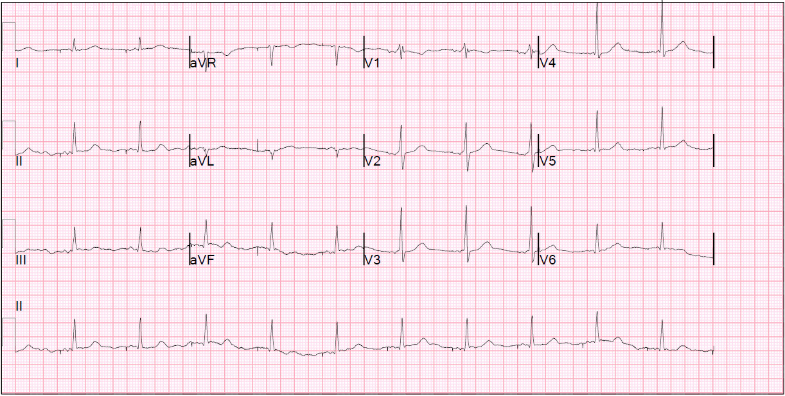
Figure 1. 12-lead Electrogram showed atrial paced rhythm with right bundle branch block morphology.
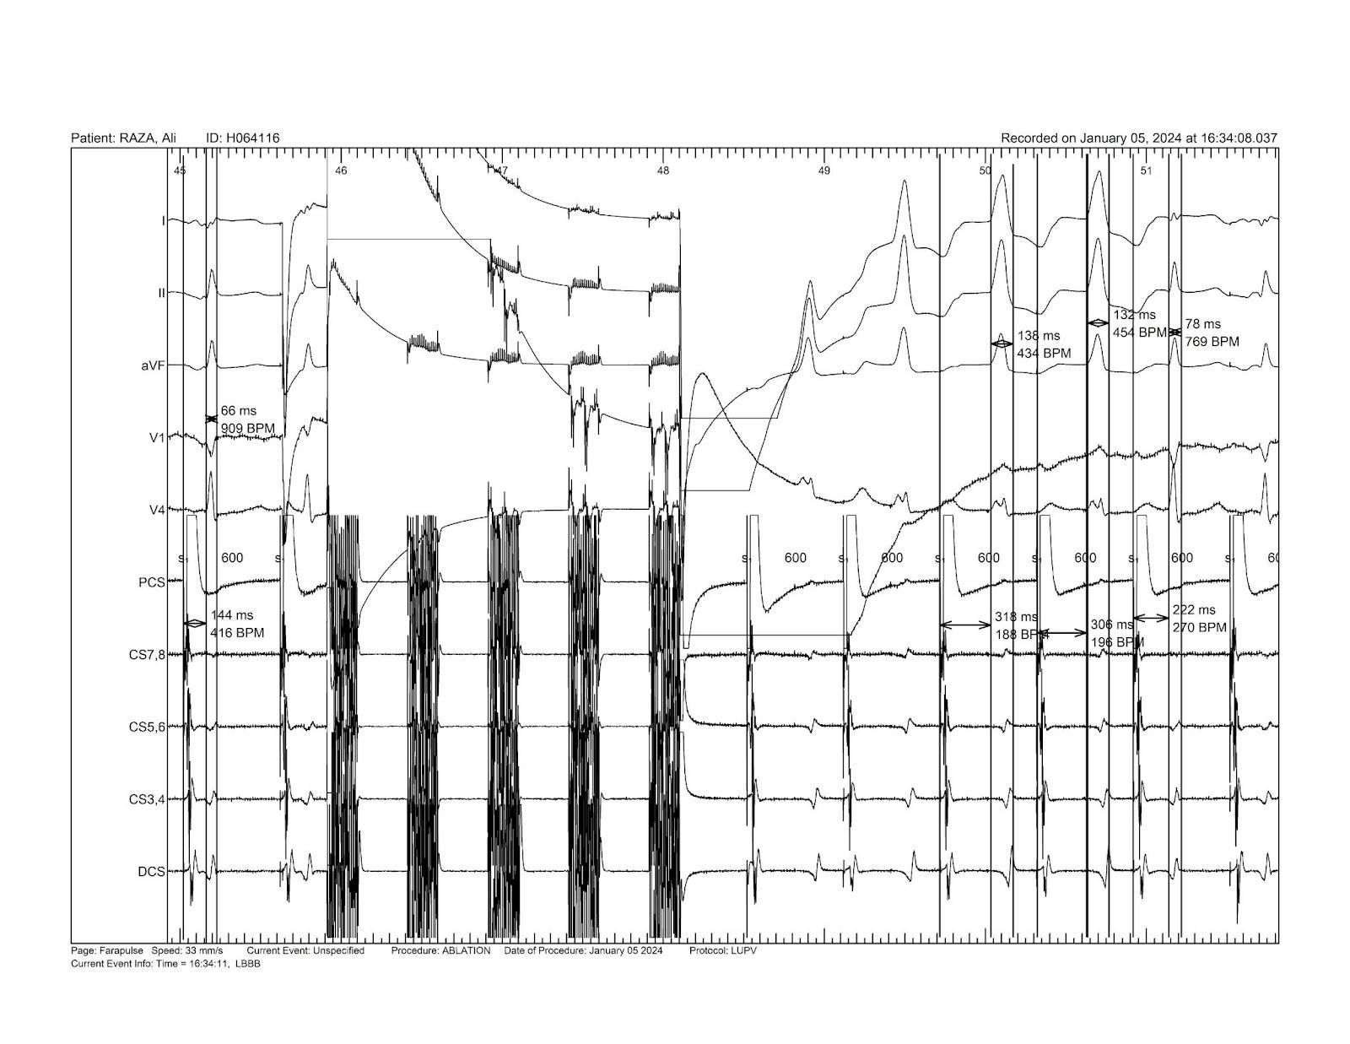
Figure 2. Intracardiac EGM during PFA showed transient prolonged stim to ventricular conduction time (from 126 ms to 208 ms) with LBBB morphology ventricular rhythm (QRS duration 132-138 ms) for 4 beats followed by return of baseline narrow QRS rhythm (72 ms).

INTELLECTUAL PROPERTY RIGHTS ASSIGNMENT OR LICENCE STATEMENT
I, [May Honey Ohn], the Author has the right to grant and does grant on behalf of all authors, an exclusive licence and/or a non-exclusive licence for contributions from authors who are: i) UK Crown employees; ii) where BMJ has agreed a CC-BY licence shall apply, and/or iii) in accordance with the relevant stated licence terms for US Federal Government Employees acting in the course of the their employment, on a worldwide basis to the BMJ Publishing Group Ltd (“BMJ”) and its licensees, to permit this Work (as defined in the below licence), if accepted, to be published in BMJ Case Reports and any other BMJ products and to exploit all rights, as set out in our licence author licence.

Date: 17.10.2024

Submitting author’s last name and date of submission, e.g. Ohn_October_2024.doc

