Factors influencing UK arthroplasty surgeons’ decision making between total and medial unicompartmental knee surgery: A vignette-based behavioural experiment

SUPPLEMENTARY MATERIALS (SM)

SM1: The 32 clinical vignettes

Vignette 1: Patient A (aged 47, BMI 26) presents with generalised knee pain. Their ASA Physical Classification Score is 1 (healthy). On examination, ACL is normal.

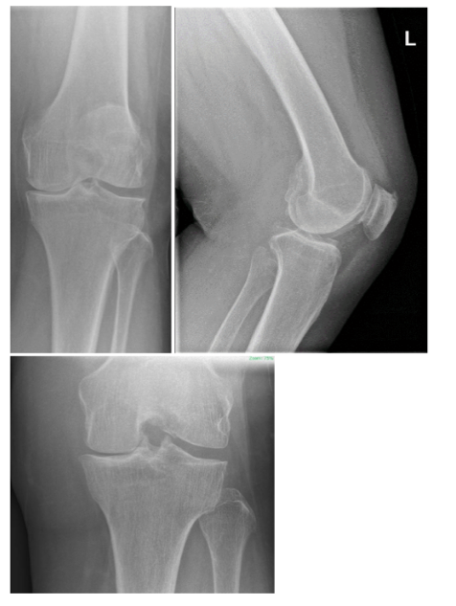

Vignette 2: Patient B (aged 60, BMI 29) presents with generalised knee pain. Their ASA Physical Classification Score is 2 (mild systemic disease). On examination, ACL is normal.
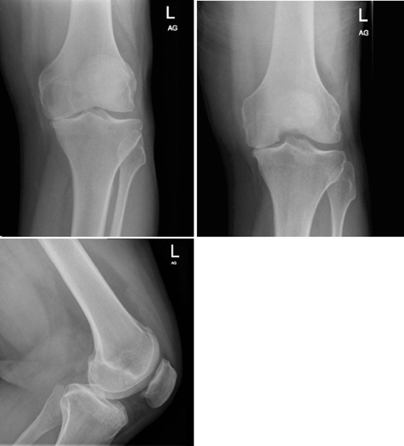

Vignette 3: Patient C (aged 44, BMI 30) presents with generalised knee pain. Their ASA Physical Classification Score is 1 (healthy). On examination, ACL is normal.
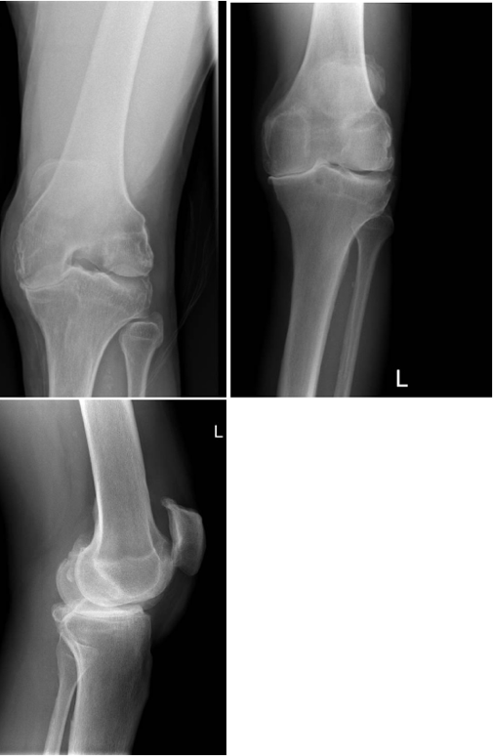

Vignette 4: Patient D (aged 56, BMI 31) presents with generalised knee pain. Their ASA Physical Classification Score is 2 (mild systemic disease). On examination, ACL is normal.

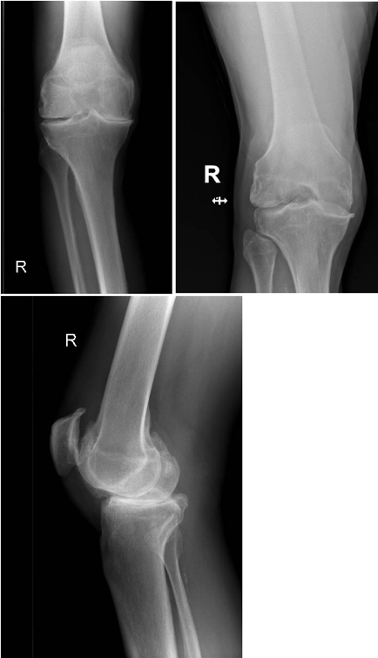

Vignette 5: Patient E (aged 40, BMI 21) presents with medial knee pain. Their ASA Physical Classification Score is 1 (healthy). On examination, ACL is normal.

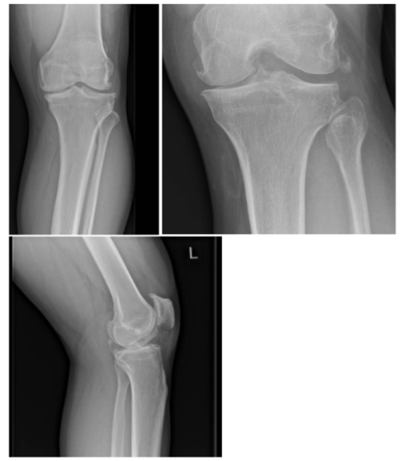

Vignette 6: Patient F (aged 63, BMI 24) presents with medial knee pain. Their ASA Physical Classification Score is 2 (mild systemic disease). On examination, ACL is normal.
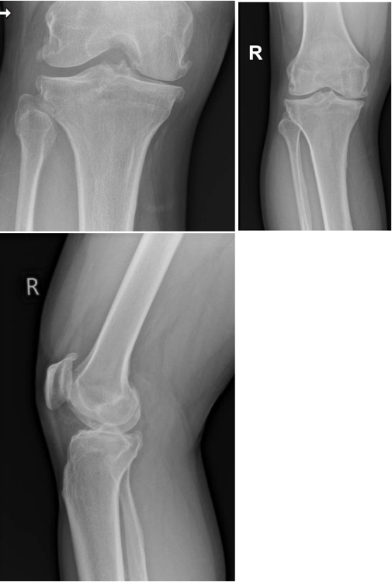

Vignette 7: Patient G (aged 48, BMI 33) presents with medial knee pain. Their ASA Physical Classification Score is 2 (mild systemic disease). On examination, ACL is normal.

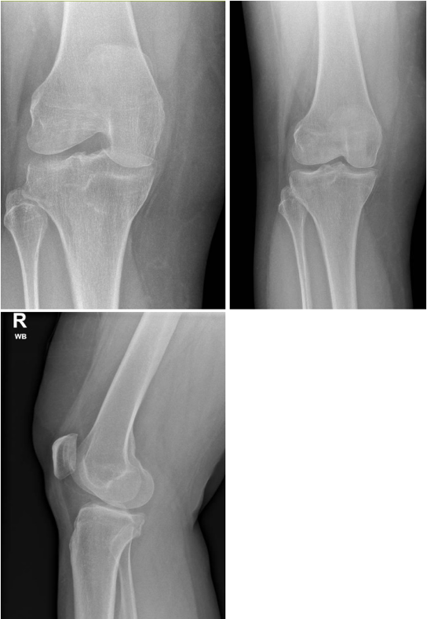

Vignette 8: Patient H (aged 80, BMI 31) presents with medial knee pain. Their ASA Physical Classification Score is 2 (mild systemic disease). On examination, ACL is normal.
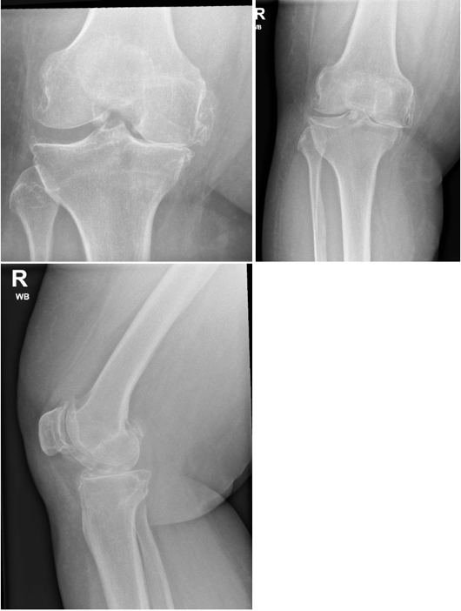

Vignette 9: Patient I (aged 49, BMI 22) presents with generalised knee pain. Their ASA Physical Classification Score is 3 (severe systemic disease). On examination, ACL is normal.
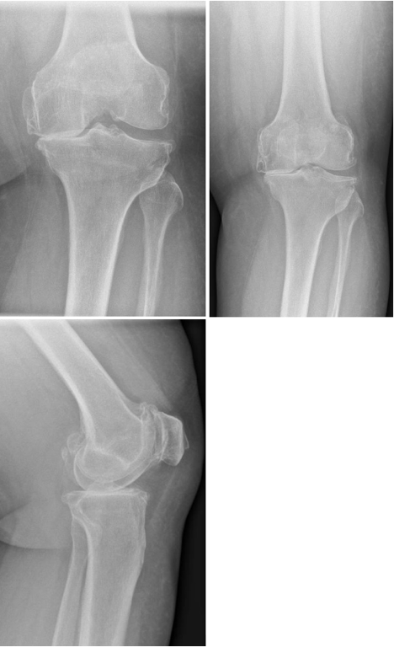

Vignette 10: Patient J (aged 77, BMI 27) presents with generalised knee pain. Their ASA Physical Classification Score is 3 (severe systemic disease). On examination, ACL is normal.

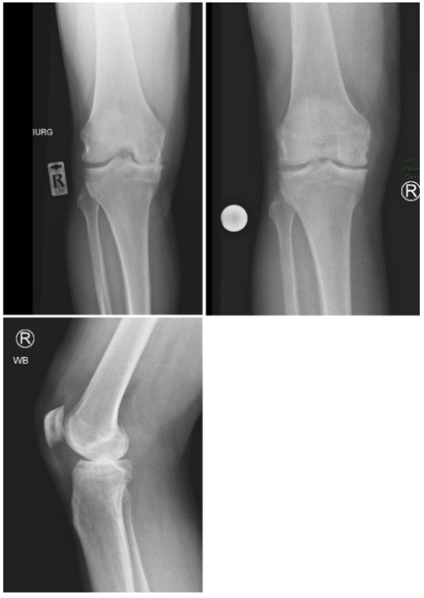

Vignette 11: Patient K (aged 45, BMI 32) presents with generalised knee pain. Their ASA Physical Classification Score is 3 (severe systemic disease). On examination, ACL is normal.
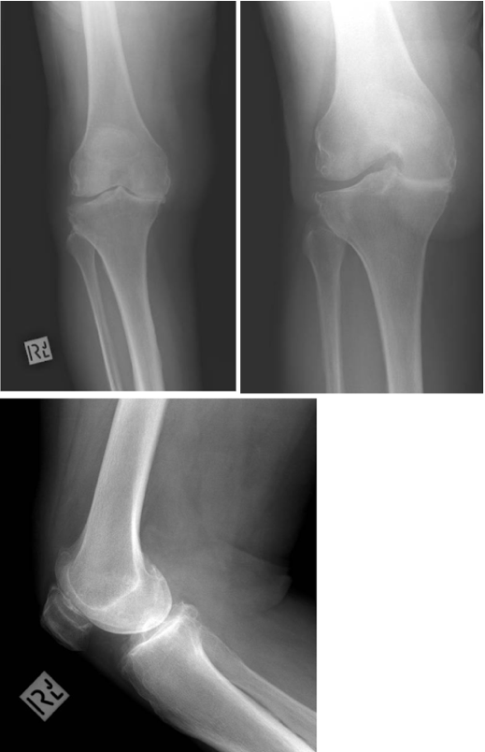

Vignette 12: Patient L (aged 54, BMI 33) presents with generalised knee pain. Their ASA Physical Classification Score is 3 (severe systemic disease). On examination, ACL is normal.

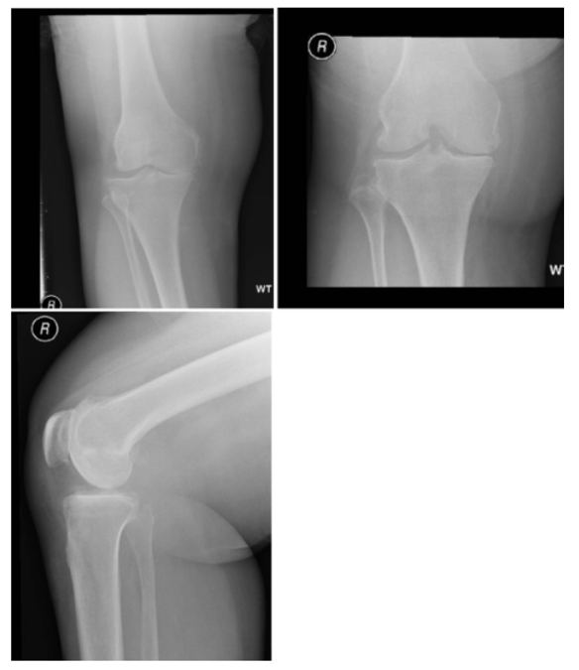

Vignette 13: Patient M (aged 46, BMI 23) presents with medial knee pain. Their ASA Physical Classification Score is 3 (severe systemic disease). On examination, ACL is normal.

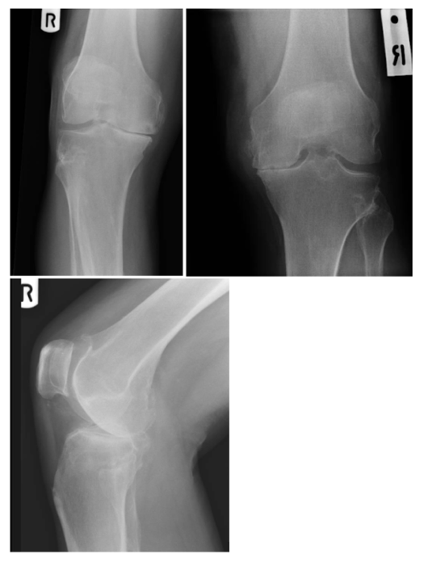

Vignette 14: Patient N (aged 71, BMI 26) presents with medial knee pain. Their ASA Physical Classification Score is 3 (severe systemic disease). On examination, ACL is normal.
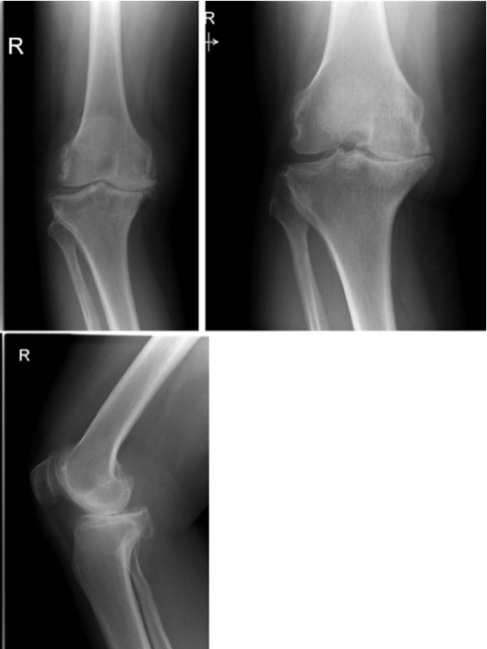

Vignette 15: Patient O (aged 40, BMI 35) presents with medial knee pain. Their ASA Physical Classification Score is 3 (severe systemic disease). On examination, ACL is normal.
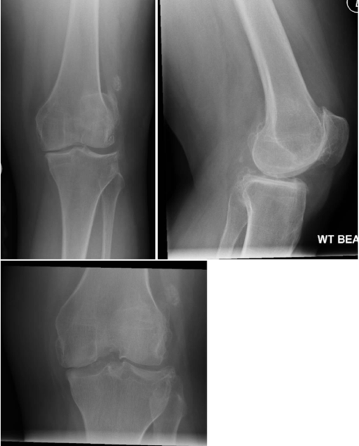

Vignette 16: Patient P (aged 65, BMI 34) presents with medial knee pain. Their ASA Physical Classification Score is 3 (severe systemic disease). On examination, ACL is normal.
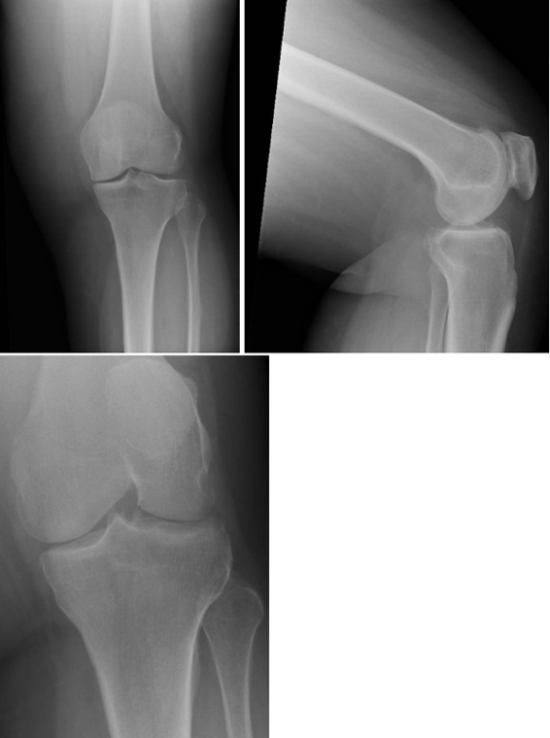

Vignette 17: Patient Q (aged 45, BMI 19) presents with generalised knee pain. Their ASA Physical Classification Score is 1 (healthy). On examination, ACL is abnormal.
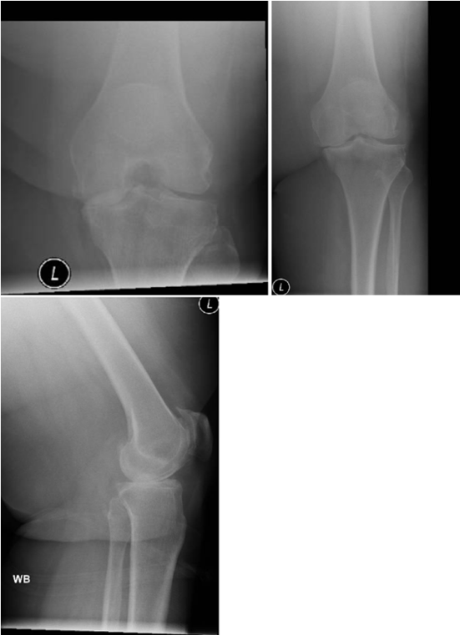

Vignette 18: Patient R (aged 50, BMI 20) presents with generalised knee pain. Their ASA Physical Classification Score is 1 (healthy). On examination, ACL is abnormal.

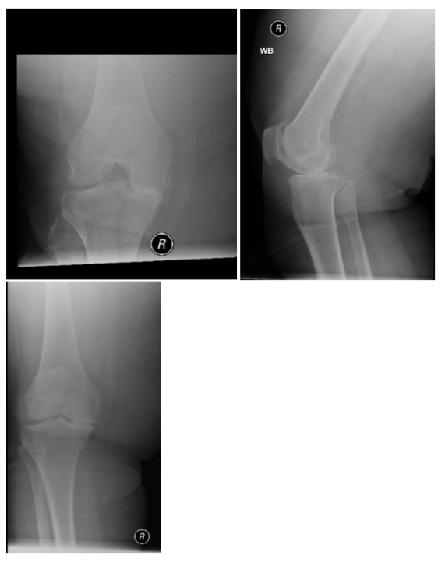

Vignette 19: Patient S (aged 45, BMI 32) presents with generalised knee pain. Their ASA Physical Classification Score is 1 (healthy). On examination, ACL is abnormal.

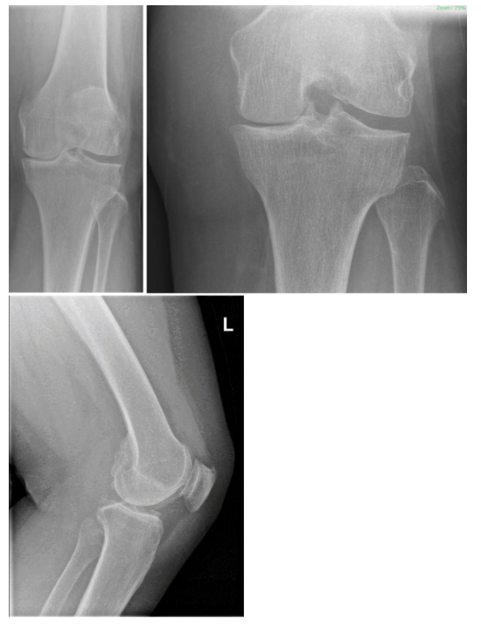

Vignette 20: Patient T (aged 75, BMI 33) presents with generalised knee pain. Their ASA Physical Classification Score is 2 (mild systemic disease). On examination, ACL is abnormal.

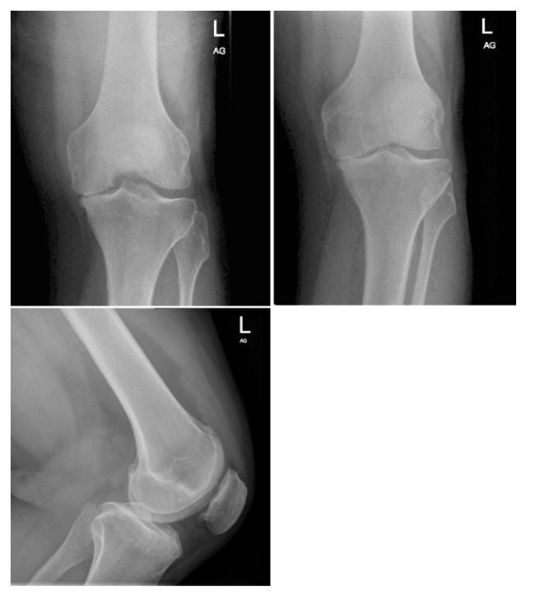

Vignette 21: Patient U (aged 49, BMI 23) presents with medial knee pain. Their ASA Physical Classification Score is 2 (mild systemic disease). On examination, ACL is abnormal.

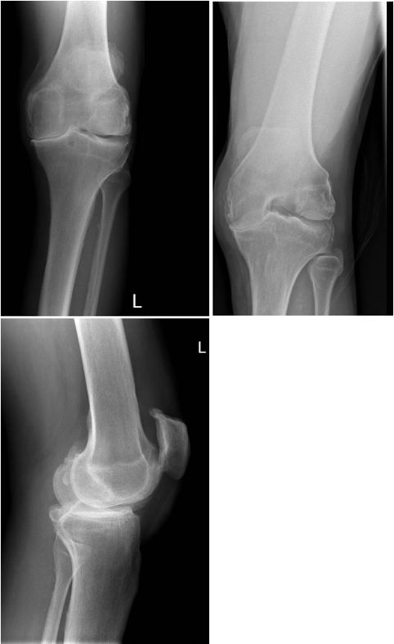

Vignette 22: Patient V (aged 68, BMI 29) presents with medial knee pain. Their ASA Physical Classification Score is 1 (healthy). On examination, ACL is abnormal.

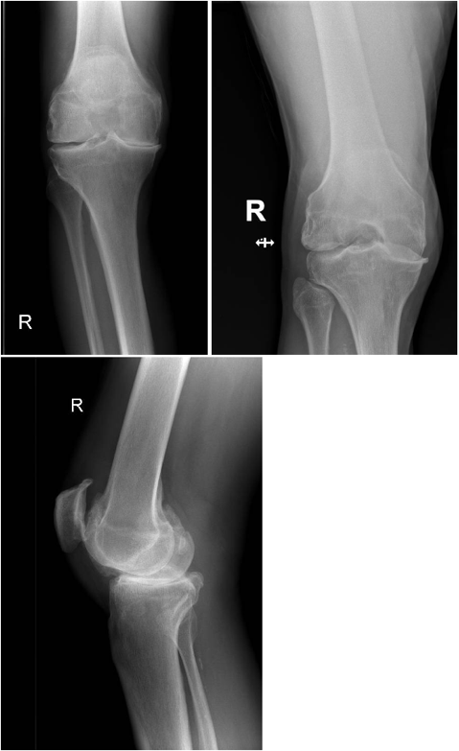
Vignette 23: Patient W (aged 47, BMI 35) presents with medial knee pain. Their ASA Physical Classification Score is 2 (mild systemic disease). On examination, ACL is abnormal.

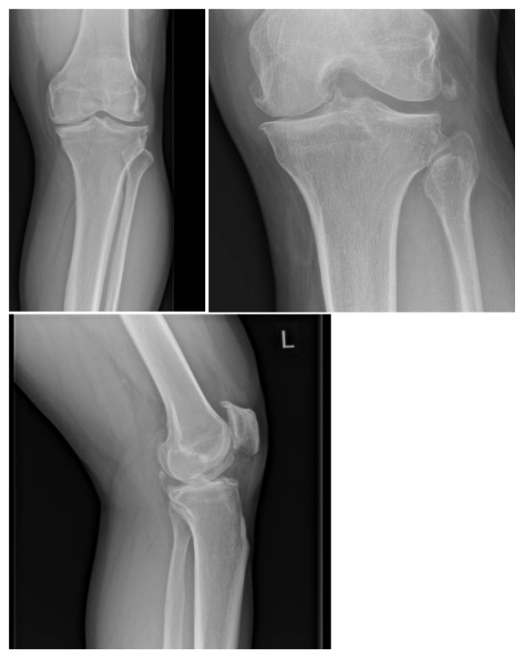

Vignette 24: Patient X (aged 66, BMI 30) presents with medial knee pain. Their ASA Physical Classification Score is 1 (healthy). On examination, ACL is abnormal.

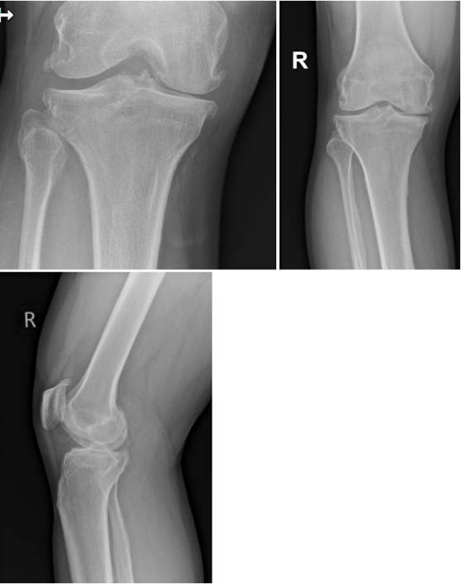

Vignette 25: Patient Y (aged 48, BMI 19) presents with generalised knee pain. Their ASA Physical Classification Score is 3 (severe systemic disease). On examination, ACL is abnormal.
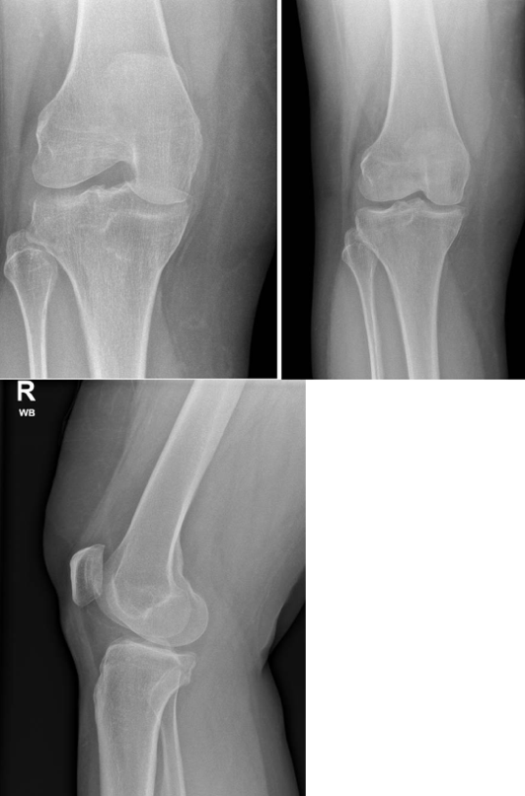

Vignette 26: Patient Z (aged 59, BMI 26) presents with generalised knee pain. Their ASA Physical Classification Score is 3 (severe systemic disease). On examination, ACL is abnormal.
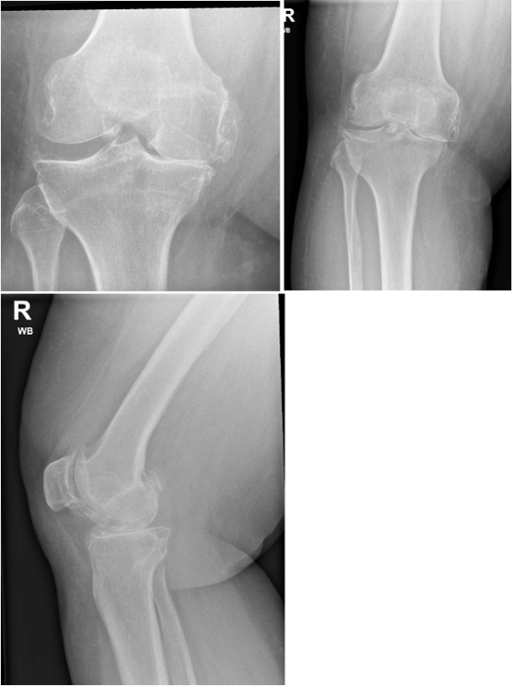

Vignette 27: Patient DW (aged 46, BMI 36) presents with generalised knee pain. Their ASA Physical Classification Score is 3 (severe systemic disease). On examination, ACL is abnormal.

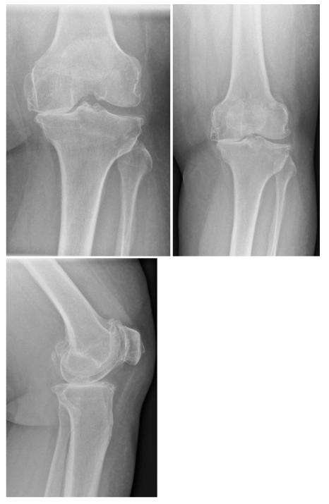

Vignette 28: Patient PL (aged 74, BMI 32) presents with generalised knee pain. Their ASA Physical Classification Score is 3 (severe systemic disease). On examination, ACL is abnormal.
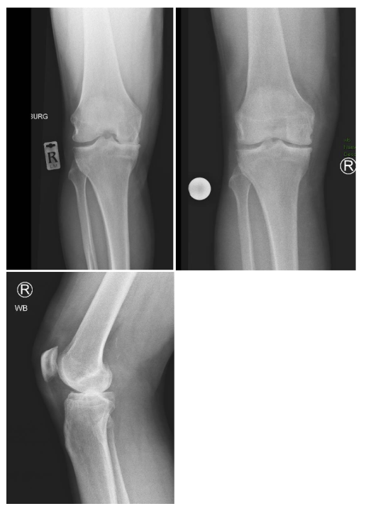

Vignette 29: Patient JS (aged 40, BMI 27) presents with medial knee pain. Their ASA Physical Classification Score is 3 (severe systemic disease). On examination, ACL is abnormal.
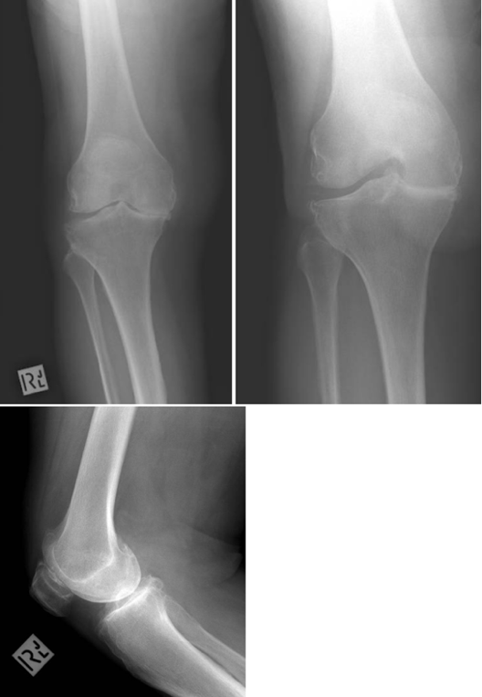

Vignette 30: Patient KS (aged 79, BMI 21) presents with medial knee pain. Their ASA Physical Classification Score is 3 (severe systemic disease). On examination, ACL is abnormal.

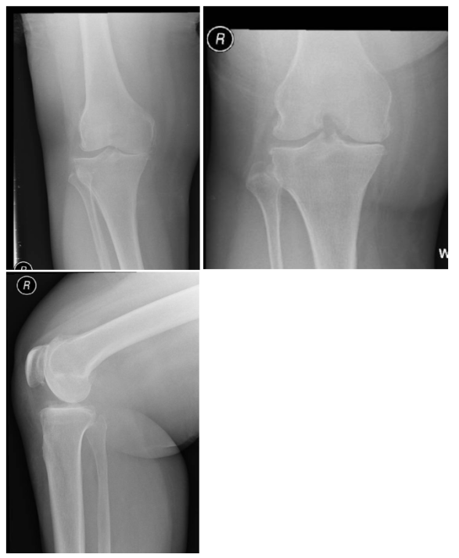

Vignette 31: Patient HW (aged 43, BMI 31) presents with medial knee pain. Their ASA Physical Classification Score is 3 (severe systemic disease). On examination, ACL is abnormal.
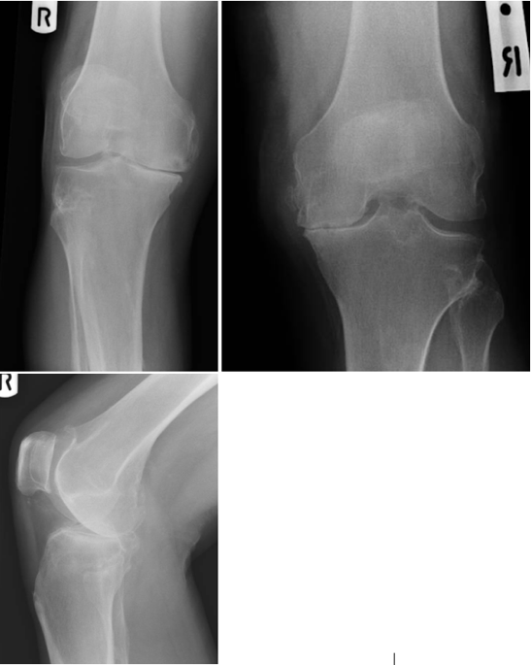

Vignette 32: Patient SM (aged 53, BMI 34) presents with medial knee pain. Their ASA Physical Classification Score is 3 (severe systemic disease). On examination, ACL is abnormal.
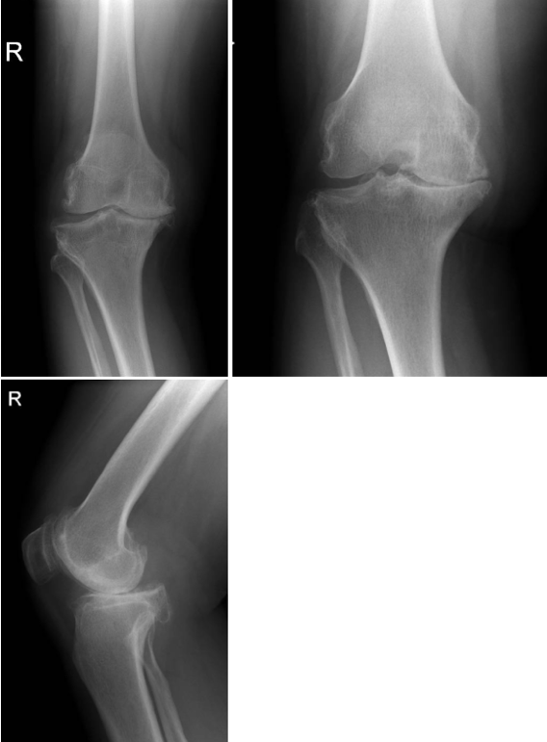

SM2: Actively Open-minded Thinking (AOT) scale (Baron, 2019)

- Allowing oneself to be convinced by a solid opposing argument is a sign of good character.
- People should take into consideration evidence that goes against conclusions they favour.
- Being undecided or unsure is the result of muddled thinking (R).
- People should revise their conclusions in response to relevant new information.
- Changing your mind is a sign of weakness (R).
- People should search actively for reasons why they might be wrong.
- It is OK to ignore evidence against your established beliefs (R).
- It is important to be loyal to your beliefs even when evidence is brought to bear against them (R).
- When we are faced with a new question, the first answer that occurs to us is usually best (R).
- Good thinking leads to uncertainty when there are good arguments on both sides.
- When faced with a new question, we should consider more than one possible answer before reaching a conclusion.

For each statement, surgeons indicated their agreement on a 5-point scale, ranging from “Completely disagree” to “Completely agree” with midpoint “Neutral”. (R) = reverse score.

