Appendix
Table A0. Subcomponents of the LTC index

The LTC index combines information on three indicators:
- Long-term care beds in institutions and hospitals, per 1,000 population aged 65 and over. This information was compiled with data from the OECD’s report “Health at a Glance” available at https://www.oecd-ilibrary.org/social-issues-migration-health/health-at-a-glance_19991312].
- Long-term care workers as a share of the population aged 65 and over. Data came from the same report mentioned above.
- Percentage of population aged 65 years and over receiving long-term care. We compiled data from OECD Health Statistics available at [http://dx.doi.org/10.1787/health-data-en].
Country | Beds | Year | LTC workers | year | Expenditure | Year | LTC Index
Austria | 0.13 | 2017 | -0.15 | 2016 | 0.17 | 2018 | 0.14
Germany | 0.34 | 2017 | 0.12 | 2016 | 0.65 | 2018 | 1.10
Belgium | 1.10 | 2019 | 0.04 | 2016 | 1.86 | 2018 | 2.99
Luxembourg | 1.79 | 2017 | 0.87 | 2016 | -0.16 | 2018 | 2.50
France | 0.29 | 2017 | -0.62 | 2016 | 0.40 | 2018 | 0.06
Sweden | 1.21 | 2017 | 2.09 | 2016 | 2.06 | 2018 | 5.36
Denmark | -0.51 | 2019 | 0.93 | 2016 | 1.19 | 2018 | 1.61
Netherlands | 1.46 | 2017 | 0.90 | 2016 | 1.87 | 2018 | 4.24
Spain | -0.54 | 2011 | -0.12 | 2011 | -0.34 | 2013 | -1.01
Italy | -1.47 | 2017 | -0.75 | 2016 | -0.37 | 2018 | -2.58
Greece | -2.23 | 2017 | -1.16 | 2016 | -1.00 | 2018 | -4.39
Czech Republic | -0.04 | 2017 | -0.64 | 2016 | -0.01 | 2018 | -0.69
Poland | -1.84 | 2017 | -1.12 | 2016 | -0.76 | 2018 | -3.72
Slovenia | 0.33 | 2017 | -0.64 | 2016 | -0.29 | 2018 | -0.60
Estonia | 0.10 | 2017 | 0.17 | 2016 | -0.79 | 2018 | -0.52
Portugal | -1.41 | 2017 | -1.04 | 2016 | -0.90 | 2018 | -3.36
United Kingdom | 0.20 | 2011 | -0.11 | 2011 | 0.25 | 2013 | -1.20
Finland | 0.57 | 2017 | 0.80 | 2016 | 0.37 | 2018 | 3.10
Hungary | 0.23 | 2017 | -0.66 | 2016 | -0.93 | 2018 | -1.19
Ireland | 0.04 | 2017 | -0.18 | 2016 | 0.33 | 2018 | -1.35
Latvia | -1.59 | 2017 | -0.91 | 2019 | -0.89 | 2018 | -3.84
Lithuania | -0.41 | 2017 | -0.96 | 2019 | -0.60 | 2018 | -1.97
Slovak Republic | 0.39 | 2017 | -0.85 | 2016 | -1.17 | 2018 | -1.04
Norway | -0.08 | 2017 | 2.17 | 2016 | 2.09 | 2018 | 6.25
Bulgaria | 0.23 | 2017 | -0.66 | 2016 | -1.00 | 2020 | -2.12
Croatia | 0.23 | 2017 | -0.66 | 2016 | -0.97 | 2018 | -1.41
Iceland | 0.54 | 2017 | 1.84 | 2019 | 0.78 | 2018 | 2.09
Romania | 0.23 | 2017 | -0.66 | 2016 | -0.85 | 2018 | -0.22

Table A1. List of Macro-Indicators and country values

 | Youth Unemployment | Care paid leave | Confidence in health system | Duty to care | Old age care regime
Austria | -0.79 | 1 | 85.47 | 40.74 | Moderate DF/SF
Germany | -1.07 | 1 | 38.79 | 45.22 | Moderate DF/SF
Belgium | -0.15 | 1 | 94.95 | 80.27 | Moderate DF/SF
Luxembourg | -0.02 | 1 | 82.06 | 84.37 | Moderate DF/SF
France | 0.53 | 1 | 81.34 | 73.11 | Moderate DF/SF
Sweden | 0.01 | 1 | 76.47 | 30.66 | Strong DF/SF
Denmark | -0.54 | 1 | 80.59 | 24.83 | Strong DF/SF
Netherlands | -1.06 | 1 | 72.63 | 19.14 | Strong DF/SF
Spain | 2.75 | 1 | 78.90 | 53.02 | Moderate DF/SF
Italy | 2.03 | 0 | 58.56 | 75.63 | FbD
Greece | 2.79 | 0 | 51.23 | 74.23 | FbD
Czech Republic | -0.80 | 1 | 42.35 | 69.86 | FbD
Poland | -0.46 | 1 | 49.60 | 73.69 | FbD
Slovenia | -0.70 | 1 | 68.75 | 57.83 | Moderate DF/SF
Estonia | -0.45 | 1 | 54.69 | 53.19 | FbD
Portugal | 0.60 | 0 | 52.66 | 79.04 | FbD
Finland | -0.07 | 1 | 80.52 | 21.11 | Strong DF/SF
Hungary | -0.45 | 0 | 40.46 | 59.96 | FbD
Ireland | -0.20 | 1 | 40.15 | 51.10 | Moderate DF/SF
Latvia | -0.30 | 0 | 50.24 | 56.67 | FbD
Slovak Republic | 0.29 | 0 | 56.85 | 72.79 | FbD
Norway | -0.74 | 1 | 63.63 | 31.49 | Strong DF/SF
Bulgaria | -0.15 | 0 | 40.46 | 59.96 | FbD
Croatia | 0.78 | 0 | 40.46 | 59.96 | FbD
Iceland | -1.02 | 1 | 94.88 | 29.02 | Strong DF/SF
Romania | 0.02 | 0 | 40.46 | 59.96 | FbD
United Kingdom | 0.34 | 0 | 85.34 | 40.43 | Moderate DF/SF
Sources: LTC Index: OECD; Youth unemployment: Eurostat; Care Paid Leave: Colombi et al. (2011); Confidence and Duty: European Values Study; Care Regime: Van Damme and Spijker, 2023.
Table A2. P-values for the gap between carers and non-carers in being NEET, having low education and reporting fair/bad self-perceived health

 |  | % of young NEET |  | Sig. Difference | % of primary and lower secondary education among young adults |  | Sig. Difference | Prevalence of fair/bad self-perceived health |  | Sig. Difference
Year | C. | Non-carers | Carers | P-value | Non-carers | Carers | P-value | Non-carers | Carers | P-value
2019 | AT | 14.74 | 14.42 | 0.067 | 11.85 | 7.31 | 0.000 | 8.35 | 9.19 | 0.341
 | BE | 7.66 | 11.31 | 0.035 | 20.07 | 23.52 | 0.000 | 5.46 | 18.59 | 0.000
 | BG | 24.35 | 30.46 | 0.029 | 20.74 | 21.74 | 0.000 | 3.00 | 2.12 | 0.000
 | CZ | 15.58 | 17.87 | 0.816 | 18.14 | 10.01 | 0.000 | 6.16 | 3.44 | 0.000
2020 | DE | 10.14 | 9.25 | 0.000 | 21.31 | 20.27 | 0.000 | 12.50 | 13.22 | 0.000
2019 | DK | 9.01 | 18.21 | 0.003 | 14.71 | 31.26 | 0.490 | 15.26 | 24.53 | 0.005
 | EE | 14.00 | 12.58 | 0.075 | 23.54 | 38.78 | 0.019 | 15.73 | 12.46 | 0.000
 | EL | 23.50 | 32.40 | 0.000 | 6.66 | 3.99 | 0.000 | 2.61 | 9.38 | 0.000
2011 | ES | 18.42 | 20.18 | 0.000 | 29.48 | 30.03 | 0.000 | 7.80 | 7.96 | 0.291
 | FI | 11.82 | 13.82 | 0.521 | 25.10 | 28.93 | 0.051 | 17.66 | 18.82 | 0.000
 | FR | 12.04 | 15.73 | 0.147 | 25.12 | 33.33 | 0.000 | 10.64 | 12.68 | 0.004
 | HR | 24.45 | 25.18 | 0.675 | 11.78 | 14.54 | 0.000 | 4.80 | 4.64 | 0.000
 | HU | 17.58 | 32.70 | 0.134 | 19.36 | 26.18 | 0.000 | 12.18 | 25.33 | 0.014
 | IE | 31.84 | 35.91 | 0.019 | 5.28 | 4.97 | 0.251 | 5.37 | 29.18 | 0.670
 | IS | 6.15 | 9.02 | 0.028 | 24.17 | 35.49 | 0.739 | 15.20 | 19.79 | 0.149
 | IT | 24.33 | 25.43 | 0.005 | 23.72 | 17.13 | 0.000 | 5.77 | 6.10 | 0.000
 | LT | 14.06 | 21.99 | 0.019 | 11.01 | 7.68 | 0.000 | 12.59 | 13.61 | 0.000
 | LU | 10.06 | 5.59 | 0.002 | 15.06 | 12.33 | 0.000 | 15.83 | 14.79 | 0.001
 | LV | 15.70 | 14.33 | 0.084 | 21.34 | 20.74 | 0.000 | 15.75 | 17.01 | 0.000
2019 | NL | 6.76 | 5.63 | 0.000 | 18.70 | 21.96 | 0.000 | 12.67 | 22.87 | 0.198
 | NO | 7.28 | 10.05 | 0.000 | 35.35 | 36.12 | 0.766 | 13.42 | 20.20 | 0.032
 | PL | 15.20 | 21.07 | 0.000 | 15.01 | 19.55 | 0.000 | 7.07 | 14.17 | 0.000
 | PT | 12.49 | 21.10 | 0.000 | 20.18 | 19.64 | 0.000 | 14.29 | 22.42 | 0.125
 | RO | 19.61 | 21.06 | 0.003 | 21.82 | 22.57 | 0.001 | 2.09 | 1.37 | 0.009
 | SE | 11.87 | 18.15 | 0.000 | 23.57 | 33.30 | 0.000 | 18.70 | 28.31 | 0.000
 | SI | 7.62 | 9.73 | 0.068 | 14.39 | 13.89 | 0.000 | 9.35 | 9.41 | 0.000
 | SK | 17.62 | 11.01 | 0.005 | 14.02 | 6.57 | 0.000 | 5.39 | 8.50 | 0.043
2013 | UK | 14.88 | 26.40 | 0.000 | 14.09 | 19.68 | 0.235 | 8.54 | 17.24 | 0.000
Wave 3 EHIS, except UK (wave 2) and Spain (ENSE)

Table A3. Multilevel Logistic Regression of being in NEET status
 |  |  | Model 2 |  |  | Model 3
 |  |  | OR | SE | P-value | OR | SE | p-value
Intensity of care (No care) |  | Less than 10 hours | 1.07 | 0.06 | 0.278 | 1.27 | 0.32 | 0.348
 |  | 10-20 hours | 1.25 | 0.16 | 0.080 | 0.50 | 0.29 | 0.237
 |  | More than 20 hours | 1.34 | 0.17 | 0.019 | 1.25 | 0.59 | 0.630
Sex (Men) |  | Women | 1.63 | 0.05 | 0.000 | 1.64 | 0.05 | 0.000
Age (18-19) |  | 20-24 | 0.25 | 0.01 | 0.000 | 0.25 | 0.01 | 0.000
 |  | 25-29 | 0.56 | 0.02 | 0.000 | 0.56 | 0.02 | 0.000
Education (Primary) |  | Lower secondary | 0.44 | 0.04 | 0.000 | 0.43 | 0.04 | 0.000
 |  | Upper secondary | 0.23 | 0.02 | 0.000 | 0.23 | 0.02 | 0.000
 |  | Tertiary | 0.15 | 0.01 | 0.000 | 0.15 | 0.01 | 0.000
Household type (One-person) |  | Lone parent | 2.27 | 0.18 | 0.000 | 2.28 | 0.18 | 0.000
 |  | Couple without children | 1.29 | 0.10 | 0.001 | 1.30 | 0.10 | 0.001
 |  | Couple with children | 2.44 | 0.18 | 0.000 | 2.43 | 0.18 | 0.000
 |  | Other types of HH | 1.97 | 0.15 | 0.000 | 1.97 | 0.15 | 0.000
Number of persons living in the household |  |  | 1.08 | 0.02 | 0.000 | 1.08 | 0.02 | 0.000
Birth Place (Native-born) |  | Born in EU | 1.12 | 0.10 | 0.188 | 1.12 | 0.10 | 0.208
 |  | Born outside EU | 1.20 | 0.07 | 0.003 | 1.20 | 0.07 | 0.002
 |  | No info | 0.72 | 0.25 | 0.338 | 0.66 | 0.19 | 0.142
Care Regime (Strong DF/SF) |  | Moderate DF/SF | 1.49 | 0.31 | 0.053 | 1.50 | 0.31 | 0.047
 |  | FbD | 2.09 | 0.40 | 0.000 | 2.05 | 0.39 | 0.000
Youth unemployment |  |  | 1.18 | 0.08 | 0.016 | 1.22 | 0.06 | 0.000
Care Intensity *Care Regime | Less than 10*Moderate |  |  |  |  | 0.86 | 0.27 | 0.631
 | Less than 10*FdB |  |  |  |  | 0.76 | 0.23 | 0.376
 | 10-20*Moderate |  |  |  |  | 2.76 | 1.76 | 0.113
 | 10-20*FdB |  |  |  |  | 2.43 | 1.53 | 0.158
 | More than 20*Moderate |  |  |  |  | 0.84 | 0.45 | 0.744
 | More than 20*FdB |  |  |  |  | 1.13 | 0.60 | 0.821
Constant |  |  | 0.45 | 0.10 | 0.000 | 0.47 | 0.10 | 0.000
Variance between countries |  |  | 0.11 | 0.03 |  | 0.11 | 0.03
Intraclass correlation coeff. |  |  | 0.03 | 0.01
N Respondents |  |  | 37,146
N Countries |  |  | 28
Sources: Wave 3 EHIS, except UK (wave 2) and Spain (ENSE)
Table A4. Multilevel Logistic Regression of reporting fair/poor self-perceived health
 |  |  | Model 2 |  |  | Model 3
 |  |  | OR | SE | P-value | OR | SE | p-value
Intensity of care (No care) |  | Less than 10 hours | 1.24 | 0.08 | 0.001 | 1.52 | 0.38 | 0.093
 |  | 10-20 hours | 1.45 | 0.21 | 0.009 | 2.44 | 0.92 | 0.018
 |  | More than 20 hours | 1.62 | 0.23 | 0.001 | 1.37 | 0.58 | 0.460
Sex (Men) |  | Women | 1.29 | 0.05 | 0.000 | 1.29 | 0.05 | 0.000
Age (18-19) |  | 20-24 | 0.47 | 0.03 | 0.000 | 0.47 | 0.03 | 0.000
 |  | 25-29 | 0.75 | 0.03 | 0.000 | 0.75 | 0.03 | 0.000
Education (Primary) |  | Lower secondary | 0.78 | 0.08 | 0.018 | 0.78 | 0.08 | 0.017
 |  | Upper secondary | 0.46 | 0.05 | 0.000 | 0.46 | 0.05 | 0.000
 |  | Tertiary | 0.27 | 0.03 | 0.000 | 0.27 | 0.03 | 0.000
Household type (One-person) |  | Lone parent | 1.16 | 0.09 | 0.060 | 1.17 | 0.09 | 0.056
 |  | Couple without children | 0.95 | 0.07 | 0.469 | 0.95 | 0.07 | 0.494
 |  | Couple with children | 0.98 | 0.08 | 0.812 | 0.98 | 0.08 | 0.814
 |  | Other types of HH | 1.09 | 0.09 | 0.293 | 1.09 | 0.09 | 0.290
Number of persons living in the household |  |  | 0.95 | 0.02 | 0.010 | 0.95 | 0.02 | 0.007
Birth Place (Native-born) |  | Born in EU | 0.86 | 0.09 | 0.168 | 0.86 | 0.09 | 0.155
 |  | Born outside EU | 0.82 | 0.06 | 0.014 | 0.83 | 0.07 | 0.016
 |  | No info | 0.76 | 0.27 | 0.446 | 0.81 | 0.21 | 0.431
Household income (Below 1st quintile) |  | 1st-2nd quintile | 0.87 | 0.05 | 0.014 | 0.87 | 0.05 | 0.012
 |  | 2nd-3rd quintile | 0.75 | 0.04 | 0.000 | 0.75 | 0.04 | 0.000
 |  | 3rd-4th quintile | 0.73 | 0.04 | 0.000 | 0.73 | 0.04 | 0.000
 |  | 4th-5th quintile | 0.57 | 0.04 | 0.000 | 0.57 | 0.04 | 0.000
 |  | Unknown | 0.70 | 0.06 | 0.000 | 0.71 | 0.06 | 0.000
Care Regime (Strong DF/SF) |  | Moderate DF/SF | 0.53 | 0.12 | 0.007 | 0.54 | 0.12 | 0.006
 |  | FbD | 0.44 | 0.10 | 0.000 | 0.45 | 0.09 | 0.000
Youth unemployment |  |  | 0.83 | 0.07 | 0.028 | 0.89 | 0.05 | 0.041
Care Intensity *Care Regime | Less than 10*Moderate |  |  |  |  | 0.76 | 0.25 | 0.392
 | Less than 10*FdB |  |  |  |  | 0.77 | 0.24 | 0.419
 | 10-20*Moderate |  |  |  |  | 0.58 | 0.27 | 0.248
 | 10-20*FdB |  |  |  |  | 0.40 | 0.20 | 0.068
 | More than 20*Moderate |  |  |  |  | 1.15 | 0.59 | 0.783
 | More than 20*FdB |  |  |  |  | 1.37 | 0.71 | 0.546
Constant |  |  | 0.37 | 0.10 | 0.000 | 0.40 | 0.09 | 0.000
Variance between countries |  |  | 0.15 | 0.04 |  | 0.14 | 0.03
Intraclass correlation coeff. |  |  | 0.04 | 0.01
N Respondents |  |  | 35,397
N Countries |  |  | 28
Sources: Wave 3 EHIS, except UK (wave 2) and Spain (ENSE)

Table A5. Multilevel Logistic Regression of reporting worse mental health scores
 |  |  | Model 2 |  |  | Model 3
 |  |  | OR | SE | P-value | OR | SE | p-value
Intensity of care (No care) |  | Less than 10 hours | 1.52 | 0.12 | 0.000 | 1.65 | 0.53 | 0.116
 |  | 10-20 hours | 1.77 | 0.32 | 0.002 | 2.11 | 0.95 | 0.098
 |  | More than 20 hours | 1.97 | 0.34 | 0.000 | 2.48 | 1.16 | 0.051
Sex (Men) |  | Women | 1.84 | 0.09 | 0.000 | 1.84 | 0.09 | 0.000
Age (18-19) |  | 20-24 | 0.86 | 0.07 | 0.046 | 0.86 | 0.07 | 0.059
 |  | 25-29 | 0.95 | 0.05 | 0.327 | 0.95 | 0.05 | 0.332
Education (Primary) |  | Lower secondary | 0.77 | 0.12 | 0.085 | 0.78 | 0.12 | 0.097
 |  | Upper secondary | 0.47 | 0.07 | 0.000 | 0.47 | 0.07 | 0.000
 |  | Tertiary | 0.31 | 0.05 | 0.000 | 0.32 | 0.05 | 0.000
Household type (One-person) |  | Lone parent | 1.07 | 0.11 | 0.532 | 1.07 | 0.11 | 0.502
 |  | Couple without children | 0.73 | 0.07 | 0.001 | 0.73 | 0.07 | 0.001
 |  | Couple with children | 0.85 | 0.09 | 0.126 | 0.85 | 0.09 | 0.133
 |  | Other types of HH | 1.10 | 0.11 | 0.333 | 1.09 | 0.11 | 0.393
Number of persons living in the household |  |  | 0.91 | 0.02 | 0.000 | 0.91 | 0.02 | 0.000
Birth Place (Native-born) |  | Born in EU | 1.04 | 0.13 | 0.730 | 1.03 | 0.13 | 0.785
 |  | Born outside EU | 1.08 | 0.10 | 0.429 | 1.08 | 0.10 | 0.417
 |  | No info | 0.65 | 0.33 | 0.389 | 0.66 | 0.23 | 0.233
Household income (Below 1st quintile) |  | 1st-2nd quintile | 0.92 | 0.06 | 0.222 | 0.92 | 0.06 | 0.215
 |  | 2nd-3rd quintile | 0.79 | 0.06 | 0.002 | 0.79 | 0.06 | 0.001
 |  | 3rd-4th quintile | 0.67 | 0.05 | 0.000 | 0.67 | 0.05 | 0.000
 |  | 4th-5th quintile | 0.58 | 0.05 | 0.000 | 0.58 | 0.05 | 0.000
 |  | Unknown | 0.68 | 0.08 | 0.002 | 0.68 | 0.08 | 0.002
Care Regime (Strong DF/SF) |  | Moderate DF/SF | 0.53 | 0.18 | 0.059 | 0.53 | 0.16 | 0.034
 |  | FbD | 0.17 | 0.05 | 0.000 | 0.16 | 0.05 | 0.000
Youth unemployment |  |  | 0.70 | 0.08 | 0.003 | 0.78 | 0.06 | 0.001
Care Intensity *Care Regime | Less than 10*Moderate |  |  |  |  | 0.75 | 0.32 | 0.489
 | Less than 10*FdB |  |  |  |  | 1.15 | 0.49 | 0.745
 | 10-20*Moderate |  |  |  |  | 0.72 | 0.42 | 0.569
 | 10-20*FdB |  |  |  |  | 0.63 | 0.43 | 0.500
 | More than 20*Moderate |  |  |  |  | 0.54 | 0.31 | 0.287
 | More than 20*FdB |  |  |  |  | 1.08 | 0.68 | 0.909
Constant |  |  | 0.21 | 0.07 | 0.000 | 0.23 | 0.07 | 0.000
Variance between countries |  |  | 0.30 | 0.09 |  | 0.25 | 0.06
Intraclass correlation coeff. |  |  | 0.08 | 0.02
N Respondents |  |  | 34,997
N Countries |  |  | 28
Sources: Wave 3 EHIS, except UK (wave 2) and Spain (ENSE)

A6. Average marginal effects of caring and intensity on the probability of being in NEET status (reference category: non-carers)
With Education Without Education
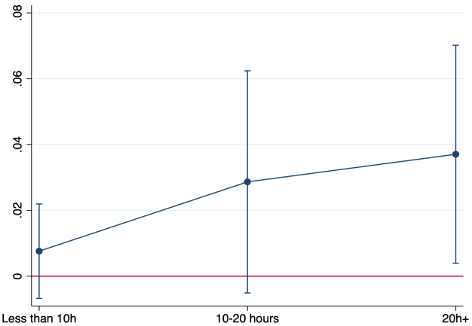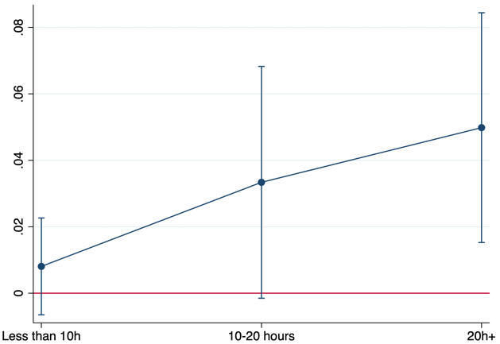
Notes: AMEs calculated on the basis of Model 3 (see table 5 for completed regression results for models including education. Regression coefficients for model without education are available upon request)

A7. Average marginal effects of caring and intensity on the probability of reporting fair/bad self-perceived health
With Education Without Education
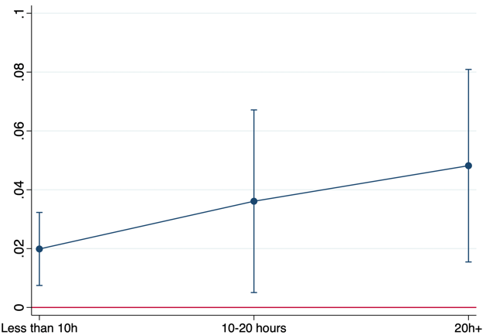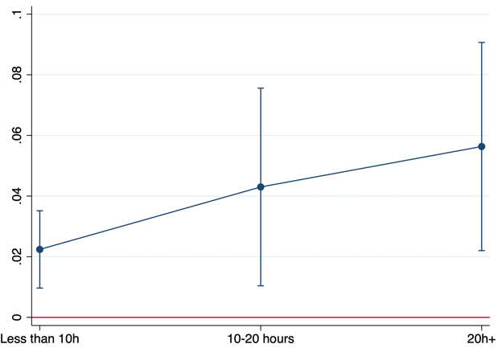
Notes: AMEs calculated on the basis of Model 3 (see table 5 for completed regression results for models including education. Regression coefficients for model without education are available upon request)

A8. Average marginal effects of caring and intensity on the probability of reporting worse mental health
With Education Without Education
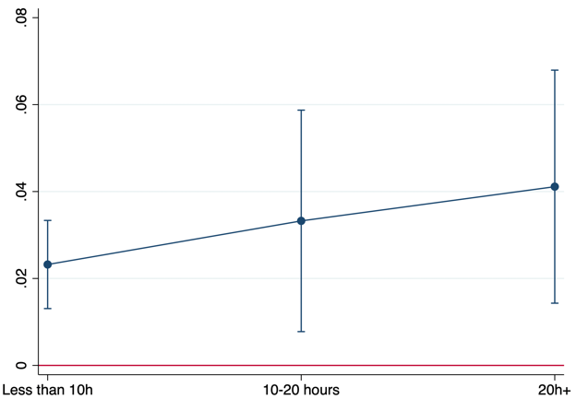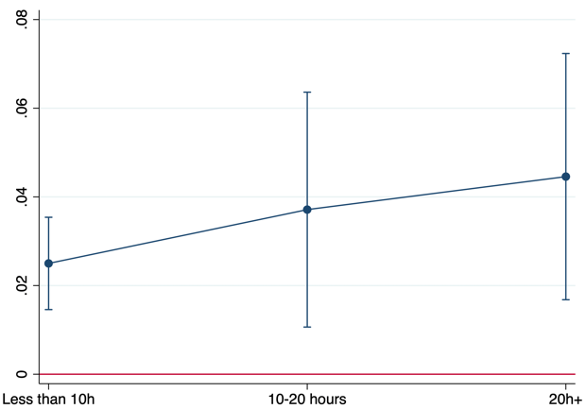
Notes: AMEs calculated on the basis of Model 3 (see table 5 for completed regression results for models including education. Regression coefficients for model without education are available upon request)

Table A9. Multilevel Logistic Regression for our main three outcomes. No controls for Education

 |  | NEET |  |  | Fair/bad self-perceived health |  |  | Worse scores of mental health
 |  | OR | SE | P-value | OR | SE | p-value | OR | SE | p-value
Intensity of care (No care) | Less than 10 hours | 1.07 | 0.12 | 0.558 | 1.29 | 0.19 | 0.086 | 1.62 | 0.30 | 0.009
 | 10-20 hours | 1.18 | 0.21 | 0.366 | 1.45 | 0.30 | 0.072 | 1.57 | 0.44 | 0.105
 | More than 20 hours | 1.31 | 0.23 | 0.126 | 1.74 | 0.35 | 0.007 | 2.08 | 0.53 | 0.004
Sex (Men) | Women | 1.50 | 0.05 | 0.000 | 1.20 | 0.04 | 0.000 | 1.74 | 0.09 | 0.000
Age (18-19) | 20-24 | 0.35 | 0.02 | 0.000 | 0.69 | 0.04 | 0.000 | 1.23 | 0.09 | 0.004
 | 25-29 | 0.58 | 0.02 | 0.000 | 0.81 | 0.03 | 0.000 | 1.02 | 0.06 | 0.710
Education (Primary) | Lower secondary
 | Upper secondary
 | Tertiary
Household type (One-person) | Lone parent | 2.48 | 0.19 | 0.000 | 1.28 | 0.10 | 0.002 | 1.17 | 0.12 | 0.130
 | Couple without children | 1.29 | 0.10 | 0.001 | 0.93 | 0.07 | 0.329 | 0.71 | 0.07 | 0.000
 | Couple with children | 2.46 | 0.18 | 0.000 | 1.03 | 0.08 | 0.750 | 0.89 | 0.09 | 0.278
 | Other types of HH | 1.97 | 0.15 | 0.000 | 1.11 | 0.09 | 0.162 | 1.14 | 0.11 | 0.208
Number of persons living in the household |  | 1.11 | 0.02 | 0.000 | 0.97 | 0.02 | 0.144 | 0.92 | 0.02 | 0.003
Birth Place (Native-born) | Born in EU | 1.17 | 0.10 | 0.073 | 0.88 | 0.09 | 0.202 | 1.00 | 0.12 | 0.969
 | Born outside EU | 1.35 | 0.08 | 0.000 | 0.89 | 0.07 | 0.114 | 1.16 | 0.10 | 0.106
 | No info | 0.76 | 0.21 | 0.316 | 1.21 | 0.35 | 0.523 | 0.82 | 0.30 | 0.601
Household income (Below 1st quintile) | 1st-2nd quintile | 0.58 | 0.02 | 0.000 | 0.84 | 0.05 | 0.001 | 0.89 | 0.06 | 0.092
 | 2nd-3rd quintile | 0.38 | 0.02 | 0.000 | 0.68 | 0.04 | 0.000 | 0.74 | 0.05 | 0.000
 | 3rd-4th quintile | 0.25 | 0.01 | 0.000 | 0.63 | 0.04 | 0.000 | 0.60 | 0.05 | 0.000
 | 4th-5th quintile | 0.15 | 0.01 | 0.000 | 0.46 | 0.03 | 0.000 | 0.49 | 0.04 | 0.000
 | Unknown | 0.54 | 0.03 | 0.000 | 0.65 | 0.06 | 0.000 | 0.65 | 0.08 | 0.000
LTC index |  | 0.92 | 0.02 | 0.000 | 1.06 | 0.03 | 0.082 | 1.24 | 0.05 | 0.000
Youth unemployment |  | 1.20 | 0.06 | 0.000 | 0.91 | 0.06 | 0.168 | 0.85 | 0.08 | 0.068
LTC index * Caregiving intensity | Less than 10 hours | 1.02 | 0.04 | 0.583 | 1.02 | 0.05 | 0.636 | 0.99 | 0.06 | 0.928
 | 10-20 hours | 0.95 | 0.05 | 0.384 | 1.11 | 0.07 | 0.105 | 1.08 | 0.09 | 0.372
 | More than 20 hours | 0.96 | 0.05 | 0.478 | 0.95 | 0.06 | 0.449 | 0.97 | 0.08 | 0.684
Constant |  | 0.19 | 0.03 | 0.000 | 0.11 | 0.02 | 0.000 | 0.03 | 0.01 | 0.000
Variance between countries |  | 0.12 | 0.03 |  | 0.22 | 0.05 | 0.33 | 0.08
N Respondents |  | 37,146 |  |  | 35,397 |  |  | 34,997
N Countries |  | 28
Sources: Wave 3 EHIS, except UK (wave 2) and Spain (ENSE)

Table A10. Percentage of missing information in Self-perceived health and Mental health in EHIS original sample

 |  | Self-perceived health |  |  | Mental health
Country | Year | Good/very good | Fair/poor | Missing | Best scores | Worse Scores | Missing
AT | 2019 | 91.57 | 8.43 | 0 | 96.0 | 4.0 | 0
BE |  | 64.22 | 6.42 | 29.36 | 62.94 | 6.17 | 30.89
BG |  | 90.2 | 2.94 | 6.85 | 91.89 | 0.67 | 7.44
CZ |  | 92.19 | 5.93 | 1.87 | 96.72 | 1.41 | 1.87
DE | 2020 | 87.37 | 12.63 | 0 | 89.23 | 9.57 | 1.2
DK | 2019 | 82.98 | 16.76 | 0.26 | 76.57 | 15.93 | 7.5
EE |  | 84.17 | 15.5 | 0.33 | 89.25 | 9.84 | 0.9
EL |  | 96.2 | 3.11 | 0.68 | 98.54 | 0.38 | 1.08
ES | 2011-12 | 88.32 | 11.68 | 0 | 97.22 | 2.43 | 0.35
FI | 2019 | 75.42 | 17.78 | 6.8 | 77.39 | 12.22 | 10.38
FR |  | 88.98 | 11.02 | 0 | 89.02 | 10.98 | 0
HR |  | 88.47 | 4.78 | 6.75 | 91.03 | 2.12 | 6.85
HU |  | 86.26 | 13.31 | 0.43 | 92.49 | 4.82 | 2.69
IE |  | 93.16 | 6.84 | 0 | 92.18 | 6.16 | 1.66
IS |  | 83.52 | 16.38 | 0.1 | 85.39 | 12.1 | 2.51
IT |  | 91.16 | 5.79 | 3.04 | 93.7 | 1.96 | 4.34
LT |  | 86.79 | 12.67 | 0.55 | 91.98 | 4.93 | 3.09
LU |  | 82.89 | 15.75 | 1.36 | 81.73 | 12.39 | 5.88
LV | 2019 | 80.4 | 15.88 | 3.72 | 96.38 | 3.39 | 0.23
NL |  | 86.68 | 13.32 | 0 | 89.46 | 10.05 | 0.49
NO |  | 85.84 | 14.16 | 0 | 89.8 | 9.07 | 1.13
PL |  | 64.39 | 7.51 | 28.11 | 70.61 | 0.98 | 28.41
PT |  | 85.07 | 14.85 | 0.08 | 90.92 | 4.17 | 4.92
RO |  | 97.92 | 2.05 | 0.04 | 97.71 | 0.47 | 1.82
SE |  | 79.76 | 19.28 | 0.95 | 79.86 | 15.91 | 4.23
SI |  | 90.34 | 9.36 | 0.3 | 89.35 | 7.95 | 2.7
SK |  | 94.37 | 5.63 | 0 | 99.1 | 0.9 | 0
UK | 2013 | 62.04 | 9.43 | 28.52 | 66.55 | 4.42 | 29.04
Total |  | 85.59 | 9.95 | 7.46 | 85.69 | 5.86 | 8.45
Source: European Health Interview Survey wave 3, UK: wave 2, ES: Encuesta Nacional de Salud 11-12

