Association between timing of motherhood and prospective cardiovascular biomarker risk factors: A twin study

Contents
Text S1: Non-response weights 5
Table S1: Standardised regression coefficients (95% CI) from minimally adjusted weighted unstratified analysis of between- and within-family effects in DZ and MZ twins. 6
Table S2: Minimally adjusted standardised regression coefficients (95% CI) for unweighted individual-level, DZ and MZ co-twin design models (Models 1-3). 8
Table S3: Adjusted standardised within-family regression coefficients (95% CI) from unweighted DZ and MZ co-twin design models adjusted for age at measurement, cohort, age at menarche, and birth order (Models 4&6) and additionally for education (Models 5&7). 11
Table S4: Minimally adjusted standardised regression coefficients (95% CI) for individual-level, DZ and MZ co-twin design models (Models 1-3). Sensitivity analyses for weighted blood pressure and LDL outcomes. 14
Table S5: Adjusted standardised within-family regression coefficients (95% CI) from unweighted DZ and MZ co-twin design models adjusted for age at measurement, cohort, age at menarche, and birth order (Models 4&6) and additionally for education (Models 5&7). Sensitivity analyses for blood pressure and LDL outcomes. 16
Table S6: Minimally adjusted standardised regression coefficients (95% CI) for individual-level, DZ and MZ co-twin design weighted models (Models 1-3). Sensitivity analyses with a binary exposure (age at first birth ≥ 20 =reference). 18
Table S7: Adjusted standardised within-family regression coefficients (95% CI) from DZ and MZ co-twin design weighted models adjusted for age at measurement, cohort, age at menarche, and birth order (Models 4&6) and additionally for education (Models 5&7). Sensitivity analyses with a binary exposure (age at first birth ≥ 20 =reference). 19
Table S8: Minimally adjusted standardised regression coefficients (95% CI) from crude individual-level, DZ and MZ co-twin design models (Models 1-3). 20
Figure S1: Histogram of non-response weights 22
Figure S2: Standardised regression coefficients and 95% CIs of associations of age at first birth with BMI (Models 1-5). 25
Figure S3: Standardised regression coefficients and 95% CIs of associations of age at first birth with android/gynoid fat ratio (Models 1-5). 28
Figure S4: Standardised regression coefficients and 95% CIs of associations of age at first birth with systolic blood pressure (Models 1-5). 31
Figure S5: Standardised regression coefficients and 95% CIs of associations of age at first birth with diastolic blood pressure (Models 1-5). 34
Figure S6: Standardised regression coefficients and 95% CIs of associations of age at first birth with triglycerides (Models 1-5). 37
Figure S7: Standardised regression coefficients and 95% CIs of associations of age at first birth with HDL (Models 1-5). 40
Figure S8: Standardised regression coefficients and 95% CIs of associations of age at first birth with LDL (Models 1-5). 43

Text S1: Non-response weights
Non-response weights were created to account for potential non-response bias in the analytic (complete case) sample. First, using the sample of women of the target population who had data on at least one outcome (N=2,204), individual weights were created one by one to predict non-response for the independent variable and covariates, starting with the variable with the least missingness. For each variable, this was done by (i) predicting probability of non-response from an intercept only GEE model (prob1), (ii) predicting non-response from a GEE model including all study variables with complete cases (prob2), (iii) calculating a non-response weight by dividing prob1 by prob2. After that, missing cases on this respective variable would be excluded and the same process repeated for the next variable with the least missingness, this time including the latter variable with complete data in the prediction model (prob2). For example, the only variables with complete data to predict non-response for early menarche were cohort and zygosity. For the prediction of missingness in education, the sample used had complete data on all other covariates which were included in the prediction of non-response (cohort, zygosity, early menarche, birth order, age at first birth). Goodness of fit was assessed by the QIC statistic. In a final step, all weights were then multiplied to compute the non-response weight for the analysis. Figure S1 shows a histogram of the weights in the analytic sample.

Table S1: Standardised regression coefficients (95% CI) from minimally adjusted weighted unstratified analysis of between- and within-family effects in DZ and MZ twins.
 | Model 1 (individual-level) | Model 6 (DZ & MZ)
 |  | Between-family | Within-family
BMI (N=1,100)
< 20 | 0.21 (-0.01; 0.43) | 0.45 (0.13; 0.77)* | -0.16 (-0.53; 0.22)*
20-24 | 0.14 (0.00; 0.27) | 0.21 (0.02; 0.39) | -0.03 (-0.23; 0.18)
25-29 | ref | ref | ref
30-34 | 0.00 (-0.18; 0.18) | -0.02 (-0.26; 0.22) | 0.06 (-0.18; 0.31)
>35 | 0.12 (-0.21; 0.44) | -0.05 (-0.48; 0.38) | 0.32 (-0.10; 0.73)
Android/gynoid fat ratio (N=1,103)
< 20 | 0.38 (0.15; 0.61) | 0.48 (0.16; 0.79) | 0.23 (-0.16; 0.63)
20-24 | 0.20 (0.05; 0.34) | 0.16 (-0.03; 0.36) | 0.20 (-0.02; 0.42)
25-29 | ref | ref | ref
30-34 | 0.11 (-0.09; 0.30) | 0.00 (-0.25; 0.25) | 0.26 (-0.03; 0.54)
>35 | -0.09 (-0.42; 0.24) | -0.32 (-0.76; 0.12) | 0.18 (-0.31; 0.67)
Systolic blood pressure (N=1,095)
< 20 | 0.08 (-0.15; 0.31) | 0.15 (-0.18; 0.47) | -0.03 (-0.37; 0.30)
20-24 | 0.09 (-0.05; 0.23) | 0.19 (0.00; 0.38) | -0.06 (-0.28; 0.16)
25-29 | ref | ref | ref
30-34 | 0.13 (-0.07; 0.32) | 0.20 (-0.08; 0.48) | 0.07 (-0.19; 0.32)
>35 | -0.02 (-0.33; 0.29) | -0.07 (-0.47; 0.32) | 0.04 (-0.39; 0.47)
Diastolic blood pressure (N=1,096)
< 20 | 0.00 (-0.23; 0.24) | 0.15 (-0.21; 0.50) | -0.20 (-0.58; 0.18)
20-24 | 0.08 (-0.06; 0.22) | 0.15 (-0.04; 0.34) | -0.05 (-0.26; 0.17)
25-29 | ref | ref | ref
30-34 | 0.02 (-0.18; 0.21) | 0.05 (-0.21; 0.31) | -0.02 (-0.30; 0.26)
>35 | 0.00 (-0.33; 0.33) | 0.12 (-0.31; 0.55) | -0.15 (-0.61; 0.32)
Triglyceridesª (N=972)
< 20 | 0.22 (-0.02; 0.45) | 0.32 (0.01; 0.63) | 0.05 (-0.33; 0.43)
20-24 | 0.14 (-0.01; 0.30) | 0.20 (-0.01; 0.41) | 0.05 (-0.19; 0.28)
25-29 | ref | ref | ref
30-34 | 0.05 (-0.14; 0.24) | 0.06 (-0.21; 0.33) | 0.06 (-0.20; 0.32)
>35 | -0.02 (-0.37; 0.34) | -0.06 (-0.51; 0.39) | 0.04 (-0.43; 0.51)
HDL (N=1,029)
< 20 | -0.13 (-0.39; 0.14) | -0.26 (-0.60; 0.08) | 0.07 (-0.34; 0.49)
20-24 | -0.04 (-0.19; 0.11) | -0.07 (-0.26; 0.13) | 0.02 (-0.22; 0.26)
25-29 | ref | ref | ref
30-34 | 0.10 (-0.09; 0.29) | 0.10 (-0.18; 0.39) | 0.06 (-0.20; 0.32)
>35 | 0.43 (0.12; 0.74) | 0.71 (0.30; 1.12)* | 0.12 (-0.31; 0.55)*
LDL (N=1,029)
< 20 | 0.05 (-0.21; 0.31) | -0.10 (-0.47; 0.27) | 0.26 (-0.17; 0.68)
20-24 | 0.13 (-0.02; 0.28) | 0.11 (-0.09; 0.30) | 0.18 (-0.06; 0.42)
25-29 | ref
30-34 | 0.08 (-0.10; 0.27) | 0.02 (-0.25; 0.28) | 0.17 (-0.09; 0.42)
>35 | -0.12 (-0.38; 0.15) | -0.13 (-0.52; 0.25) | -0.10 (-0.48; 0.29)
Note: ª Distribution skewed; log transformed. Distributions have been winsorised at 0.5% and 99.5%. * = significant different within- and between-level effects. Models are adjusted for age at measurement and cohort. Abbreviations: BMI = body mass index; CI = confidence interval; DZ = dizygotic; HDL = high-density lipoprotein; LDL = low-density lipoprotein; MZ = monozygotic.

Table S2: Minimally adjusted standardised regression coefficients (95% CI) for unweighted individual-level, DZ and MZ co-twin design models (Models 1-3).
 | Model 1 (individual-level) | Model 2 (DZ) |  | Model 3 (MZ)
 |  | Between-family | Within-family | Between-family | Within-family
BMI (N=1,100; N_{DZ}=548; N_{MZ}=552)
< 20 | 0.21 (-0.01; 0.42) | 0.43 (-0.05; 0.90) | -0.29 (-0.83; 0.26) | 0.41 (-0.01; 0.83) | 0.03 (-0.47; 0.54)
20-24 | 0.13 (-0.01; 0.27) | 0.13 (-0.14; 0.40) | 0.05 (-0.26; 0.35) | 0.25 (-0.02; 0.51) | -0.10 (-0.39; 0.18)
25-29 | ref | ref | ref | ref | ref
30-34 | -0.01 (-0.19; 0.17) | -0.14 (-0.49; 0.22) | 0.06 (-0.29; 0.41) | 0.05 (-0.29; 0.38) | 0.06 (-0.29; 0.41)
>35 | 0.09 (-0.23; 0.41) | -0.31 (-0.93; 0.31) | 0.07 (-0.59; 0.72) | 0.16 (-0.41; 0.72) | 0.59 (0.13; 1.05)
Android/gynoid fat ratio (N=1,003; N_{DZ}=493; N_{MZ}=510)
< 20 | 0.37 (0.14; 0.61) | 0.42 (-0.03; 0.88) | -0.18 (-0.74; 0.37) | 0.43 (-0.01; 0.87) | 0.68 (0.12; 1.25)
20-24 | 0.18 (0.03; 0.32) | -0.01 (-0.27; 0.26) | 0.11 (-0.2; 0.41) | 0.25 (-0.02; 0.52) | 0.31 (0.01; 0.62)
25-29 | ref | ref | ref | ref | ref
30-34 | 0.08 (-0.12; 0.27) | -0.31 (-0.64; 0.03)* | 0.20 (-0.19; 0.59)* | 0.23 (-0.13; 0.60) | 0.17 (-0.22; 0.55)
>35 | -0.10 (-0.43; 0.23) | -0.49 (-1.00; 0.02) | -0.08 (-0.65; 0.50) | -0.17 (-0.85; 0.52) | 0.50 (-0.30; 1.29)
Systolic blood pressure (N=1,095; N_{DZ}=546; N_{MZ}=549)
< 20 | 0.08 (-0.14; 0.30) | 0.08 (-0.36; 0.53) | -0.11 (-0.50; 0.29) | 0.14 (-0.30; 0.58) | 0.12 (-0.41; 0.65)
20-24 | 0.09 (-0.05; 0.22) | 0.03 (-0.22; 0.29) | -0.24 (-0.54; 0.06) | 0.29 (0.02; 0.56) | 0.19 (-0.08; 0.46)
25-29 | ref | ref | ref | ref | ref
30-34 | 0.08 (-0.10; 0.26) | 0.06 (-0.30; 0.42) | -0.02 (-0.37; 0.33) | 0.16 (-0.18; 0.51) | 0.12 (-0.24; 0.48)
>35 | -0.02 (-0.31; 0.28) | -0.03 (-0.56; 0.50) | -0.14 (-0.71; 0.43) | -0.14 (-0.64; 0.36) | 0.29 (-0.26; 0.85)
Diastolic blood pressure (N=1,096; N_{DZ}=547; N_{MZ}=549)
< 20 | 0.02 (-0.21; 0.24) | 0.00 (-0.44; 0.45) | -0.26 (-0.71; 0.20) | 0.13 (-0.34; 0.61) | 0.10 (-0.42; 0.63)
20-24 | 0.08 (-0.06; 0.22) | -0.04 (-0.29; 0.21) | -0.19 (-0.5; 0.11) | 0.28 (0.01; 0.54) | 0.19 (-0.09; 0.47)
25-29 | ref | ref | ref | ref | ref
30-34 | 0.00 (-0.19; 0.19) | -0.21 (-0.56; 0.15) | -0.15 (-0.51; 0.22) | 0.13 (-0.21; 0.48) | 0.17 (-0.23; 0.58)
>35 | 0.02 (-0.29; 0.34) | 0.28 (-0.30; 0.86) | -0.23 (-0.88; 0.42) | -0.06 (-0.61; 0.50) | 0.06 (-0.55; 0.66)
Triglyceridesª (N=972; N_{DZ}=482; N_{MZ}=490)
< 20 | 0.23 (-0.01; 0.47) | 0.34 (-0.11; 0.80) | 0.01 (-0.55; 0.57) | 0.34 (-0.10; 0.78) | 0.12 (-0.42; 0.66)
20-24 | 0.11 (-0.04; 0.26) | 0.09 (-0.20; 0.37) | -0.06 (-0.39; 0.28) | 0.25 (-0.03; 0.52) | 0.05 (-0.28; 0.38)
25-29 | ref | ref | ref | ref | ref
30-34 | 0.03 (-0.16; 0.21) | -0.01 (-0.40; 0.39) | -0.05 (-0.44; 0.34) | 0.10 (-0.24; 0.43) | 0.10 (-0.25; 0.45)
>35 | -0.03 (-0.37; 0.32) | 0.13 (-0.62; 0.87) | 0.21 (-0.51; 0.92) | -0.26 (-0.78; 0.26) | -0.20 (-0.72; 0.32)
HDL (N=1,029; N_{DZ}=510; N_{MZ}=519)
< 20 | -0.16 (-0.41; 0.09) | -0.20 (-0.62; 0.22) | 0.19 (-0.36; 0.75) | -0.40 (-0.86; 0.06) | 0.03 (-0.51; 0.57)
20-24 | -0.06 (-0.20; 0.08) | 0.04 (-0.19; 0.27) | 0.04 (-0.29; 0.37) | -0.24 (-0.52; 0.04) | 0.08 (-0.23; 0.39)
25-29 | ref | ref | ref | ref | ref
30-34 | 0.13 (-0.05; 0.31) | 0.35 (-0.04; 0.74) | 0.31 (-0.04; 0.67) | -0.11 (-0.47; 0.25) | -0.07 (-0.43; 0.29)
>35 | 0.46 (0.15; 0.77) | 0.70 (0.16; 1.25) | 0.35 (-0.14; 0.84) | 0.73 (0.12; 1.34) | 0.03 (-0.65; 0.70)
LDL (N=1,029; N_{DZ}=510; N_{MZ}=519)
< 20 | 0.04 (-0.20; 0.29) | -0.34 (-0.77; 0.1) | 0.14 (-0.42; 0.69) | 0.11 (-0.43; 0.65) | 0.28 (-0.32; 0.87)
20-24 | 0.14 (-0.01; 0.28) | 0.02 (-0.24; 0.28) | 0.14 (-0.2; 0.48) | 0.18 (-0.11; 0.46) | 0.23 (-0.09; 0.54)
25-29 | ref | ref | ref | ref | ref
30-34 | 0.11 (-0.06; 0.28) | -0.24 (-0.58; 0.11)* | 0.26 (-0.08; 0.60)* | 0.29 (-0.04; 0.62)* | 0.06 (-0.26; 0.39)*
>35 | -0.15 (-0.41; 0.12) | -0.2 (-0.77; 0.36) | -0.1 (-0.66; 0.46) | -0.21 (-0.75; 0.33) | -0.06 (-0.61; 0.50)
Note: ª Distribution skewed; log transformed. Distributions have been winsorised at 0.5% and 99.5%. Models are adjusted for age at measurement and cohort. * = significant different within- and between-level effects. Abbreviations: BMI = body mass index; CI = confidence interval; DZ = dizygotic; HDL = high-density lipoprotein; LDL = low-density lipoprotein; MZ = monozygotic.

Table S3: Adjusted standardised within-family regression coefficients (95% CI) from unweighted DZ and MZ co-twin design models adjusted for age at measurement, cohort, age at menarche, and birth order (Models 4&6) and additionally for education (Models 5&7).
 | Model 4 (DZ) | Model 5 (DZ) | Model 6 (MZ) | Model 7 (MZ)
BMI (N_{DZ}=548; N_{MZ}=552)
< 20 | -0.30 (-0.85; 0.24) | -0.27 (-0.81; 0.27) | -0.01 (-0.52; 0.49) | -0.04 (-0.54; 0.46)
20-24 | 0.06 (-0.24; 0.35) | 0.06 (-0.24; 0.35) | -0.12 (-0.40; 0.17) | -0.11 (-0.39; 0.17)
25-29 | ref | ref | ref | ref
30-34 | 0.06 (-0.29; 0.40) | 0.08 (-0.27; 0.43) | 0.06 (-0.29; 0.40) | 0.05 (-0.29; 0.40)
>35 | 0.11 (-0.52; 0.75) | 0.12 (-0.5; 0.75) | 0.58 (0.13; 1.02) | 0.57 (0.14; 1.01)
Android/gynoid fat ratio (N_{DZ}=493; N_{MZ}=510)
< 20 | -0.19 (-0.74; 0.37) | -0.17 (-0.72; 0.38) | 0.62 (0.06; 1.18) | 0.61 (0.04; 1.17)
20-24 | 0.11 (-0.20; 0.42) | 0.11 (-0.19; 0.42) | 0.29 (-0.01; 0.60) | 0.29 (-0.01; 0.60)
25-29 | ref | ref | ref | ref
30-34 | 0.19 (-0.20; 0.58)* | 0.20 (-0.20; 0.59) | 0.16 (-0.22; 0.55) | 0.16 (-0.23; 0.54)
>35 | -0.06 (-0.63; 0.52) | -0.05 (-0.62; 0.52) | 0.48 (-0.31; 1.27) | 0.48 (-0.31; 1.27)
Systolic blood pressure (N_{DZ}=546; N_{MZ}=549)
< 20 | -0.06 (-0.46; 0.34) | -0.02 (-0.42; 0.38) | 0.13 (-0.39; 0.65) | 0.12 (-0.40; 0.64)
20-24 | -0.25 (-0.55; 0.05) | -0.25 (-0.55; 0.05) | 0.20 (-0.07; 0.46) | 0.20 (-0.07; 0.46)
25-29 | ref | ref | ref | ref
30-34 | -0.05 (-0.41; 0.30) | -0.03 (-0.38; 0.33) | 0.11 (-0.25; 0.47) | 0.11 (-0.25; 0.47)
>35 | -0.10 (-0.65; 0.45) | -0.09 (-0.65; 0.47) | 0.27 (-0.29; 0.83) | 0.27 (-0.29; 0.83)
Diastolic blood pressure (N_{DZ}=547; N_{MZ}=549)
< 20 | -0.22 (-0.69; 0.24) | -0.20 (-0.67; 0.27) | 0.09 (-0.43; 0.61) | 0.09 (-0.43; 0.60)
20-24 | -0.20 (-0.50; 0.10) | -0.20 (-0.50; 0.10) | 0.19 (-0.09; 0.47) | 0.19 (-0.09; 0.47)
25-29 | ref | ref | ref | ref
30-34 | -0.18 (-0.55; 0.20) | -0.16 (-0.53; 0.21) | 0.16 (-0.24; 0.56) | 0.16 (-0.24; 0.56)
>35 | -0.19 (-0.81; 0.44) | -0.18 (-0.81; 0.45) | 0.03 (-0.58; 0.63) | 0.03 (-0.58; 0.63)
Triglyceridesª (N_{DZ}=482; N_{MZ}=490)
< 20 | -0.04 (-0.59; 0.52) | -0.04 (-0.60; 0.51) | 0.08 (-0.45; 0.61) | 0.07 (-0.46; 0.60)
20-24 | -0.03 (-0.36; 0.30) | -0.03 (-0.36; 0.30) | 0.03 (-0.29; 0.36) | 0.03 (-0.30; 0.36)
25-29 | ref | ref | ref | ref
30-34 | -0.04 (-0.42; 0.34) | -0.05 (-0.42; 0.33) | 0.09 (-0.26; 0.44) | 0.09 (-0.27; 0.44)
>35 | 0.24 (-0.47; 0.95) | 0.24 (-0.47; 0.95) | -0.23 (-0.73; 0.28) | -0.22 (-0.73; 0.28)
HDL (N_{DZ}=510; N_{MZ}=519)
< 20 | 0.19 (-0.36; 0.75) | 0.15 (-0.40; 0.70) | 0.05 (-0.50; 0.59) | 0.08 (-0.46; 0.61)
20-24 | 0.04 (-0.29; 0.37) | 0.04 (-0.28; 0.36) | 0.09 (-0.22; 0.40) | 0.09 (-0.22; 0.40)
25-29 | ref | ref | ref | ref
30-34 | 0.32 (-0.03; 0.67) | 0.29 (-0.06; 0.64) | -0.08 (-0.44; 0.28) | -0.07 (-0.44; 0.29)
>35 | 0.33 (-0.16; 0.82) | 0.31 (-0.16; 0.78) | 0.01 (-0.66; 0.69) | 0.01 (-0.65; 0.68)
LDL (N_{DZ}=510; N_{MZ}=519)
< 20 | 0.12 (-0.44; 0.68) | 0.08 (-0.48; 0.64) | 0.26 (-0.33; 0.86) | 0.26 (-0.33; 0.86)
20-24 | 0.15 (-0.18; 0.49) | 0.15 (-0.18; 0.49) | 0.22 (-0.09; 0.53) | 0.22 (-0.09; 0.53)
25-29 | ref | ref | ref | ref
30-34 | 0.26 (-0.08; 0.60) | 0.24 (-0.10; 0.57) | 0.07 (-0.26; 0.40) | 0.07 (-0.26; 0.40)
>35 | -0.07 (-0.62; 0.49) | -0.08 (-0.64; 0.48) | -0.05 (-0.60; 0.51) | -0.05 (-0.61; 0.51)
Note: ª Distribution skewed; log transformed. Distributions have been winsorised at 0.5% and 99.5%. * = significant different within- and between-level effects. Abbreviations: BMI = body mass index; CI = confidence interval; DZ = dizygotic; HDL = high-density lipoprotein; LDL = low-density lipoprotein; MZ = monozygotic.

Table S4: Minimally adjusted standardised regression coefficients (95% CI) for individual-level, DZ and MZ co-twin design models (Models 1-3). Sensitivity analyses for weighted blood pressure and LDL outcomes.
 | Model 1 (individual-level) | Model 2 (DZ) |  | Model 3 (MZ)
 |  | Between-family | Within-family | Between-family | Within-family
Systolic blood pressure (N=1,087; N_{DZ}=540; N_{MZ}=547)
< 20 | 0.17 (-0.08; 0.41) | 0.26 (-0.24; 0.77) | -0.10 (-0.55; 0.34) | 0.19 (-0.26; 0.65) | 0.24 (-0.33; 0.81)
20-24 | 0.12 (-0.02; 0.27) | 0.02 (-0.26; 0.29) | -0.28 (-0.59; 0.04) | 0.4 (0.1; 0.69) | 0.26 (-0.04; 0.56)
25-29 | ref | ref | ref | ref | ref
30-34 | 0.10 (-0.09; 0.28) | 0.02 (-0.35; 0.39) | -0.04 (-0.43; 0.36) | 0.11 (-0.25; 0.48) | 0.30 (-0.05; 0.66)
>35 | 0.04 (-0.25; 0.33) | 0.11 (-0.43; 0.64) | -0.17 (-0.73; 0.4) | -0.01 (-0.51; 0.5) | 0.22 (-0.34; 0.78)
Diastolic blood pressure (N=1,087; N_{DZ}=540; N_{MZ}=547)
< 20 | 0.07 (-0.17; 0.31) | -0.02 (-0.5; 0.45) | -0.11 (-0.56; 0.33) | 0.23 (-0.24; 0.7) | 0.07 (-0.48; 0.63)
20-24 | 0.06 (-0.08; 0.20) | -0.09 (-0.36; 0.18) | -0.16 (-0.45; 0.13) | 0.31 (0.03; 0.59) | 0.06 (-0.27; 0.39)
25-29 | ref | ref | ref | ref | ref
30-34 | 0.05 (-0.14; 0.25) | -0.25 (-0.61; 0.12) | -0.02 (-0.39; 0.36) | 0.2 (-0.19; 0.58) | 0.26 (-0.13; 0.64)
>35 | 0.19 (-0.11; 0.5) | 0.29 (-0.31; 0.89) | 0.04 (-0.63; 0.7) | 0.26 (-0.29; 0.81) | 0.16 (-0.42; 0.74)
LDL (N=972; N_{DZ}=482; N_{MZ}=490)
< 20 | 0.09 (-0.14; 0.33) | -0.28 (-0.7; 0.15) | 0.35 (-0.21; 0.9) | 0.32 (-0.2; 0.84) | 0.01 (-0.62; 0.64)
20-24 | -0.03 (-0.18; 0.13) | -0.09 (-0.37; 0.2) | -0.14 (-0.46; 0.19) | 0.07 (-0.22; 0.35) | 0.03 (-0.31; 0.38)
25-29 | ref | ref | ref | ref | ref
30-34 | 0.03 (-0.16; 0.22) | 0.01 (-0.38; 0.41) | 0.14 (-0.23; 0.51) | 0.06 (-0.31; 0.42) | -0.10 (-0.47; 0.27)
>35 | -0.36 (-0.64; -0.08) | -0.11 (-0.73; 0.5) | -0.47 (-1.07; 0.12) | -0.30 (-0.87; 0.26) | -0.64 (-1.22; -0.06)
Note: Distributions have been winsorised at 0.5% and 99.5%. Models are adjusted for age at measurement and cohort. Abbreviations: CI = confidence interval; DZ = dizygotic; LDL = low-density lipoprotein; MZ = monozygotic.

Table S5: Adjusted standardised within-family regression coefficients (95% CI) from unweighted DZ and MZ co-twin design models adjusted for age at measurement, cohort, age at menarche, and birth order (Models 4&6) and additionally for education (Models 5&7). Sensitivity analyses for blood pressure and LDL outcomes.
 | Model 4 (DZ) | Model 5 (DZ) | Model 6 (MZ) | Model 7 (MZ)
Systolic blood pressure (N_{DZ}=540; N_{MZ}=547)
< 20 | -0.05 (-0.50; 0.40) | -0.03 (-0.47; 0.42) | 0.22 (-0.34; 0.79) | 0.23 (-0.34; 0.79)
20-24 | -0.28 (-0.59; 0.03) | -0.28 (-0.59; 0.03) | 0.26 (-0.04; 0.55) | 0.25 (-0.04; 0.55)
25-29 | Ref | ref | ref | ref
30-34 | -0.07 (-0.46; 0.33) | -0.04 (-0.43; 0.35) | 0.29 (-0.07; 0.65) | 0.29 (-0.07; 0.65)
>35 | -0.15 (-0.71; 0.41) | -0.15 (-0.71; 0.42) | 0.20 (-0.36; 0.77) | 0.20 (-0.36; 0.77)
Diastolic blood pressure (N_{DZ}=540; N_{MZ}=547)
< 20 | -0.08 (-0.54; 0.38) | -0.06 (-0.52; 0.39) | 0.03 (-0.53; 0.60) | 0.05 (-0.51; 0.62)
20-24 | -0.16 (-0.45; 0.13) | -0.16 (-0.45; 0.13) | 0.05 (-0.28; 0.38) | 0.04 (-0.29; 0.37)
25-29 | Ref | ref | ref | ref
30-34 | -0.04 (-0.41; 0.34) | -0.02 (-0.40; 0.35) | 0.25 (-0.13; 0.64) | 0.25 (-0.13; 0.64)
>35 | 0.07 (-0.58; 0.72) | 0.07 (-0.58; 0.73) | 0.15 (-0.43; 0.74) | 0.15 (-0.44; 0.74)
LDL (N_{DZ}=482; N_{MZ}=490)
< 20 | 0.32 (-0.24; 0.88) | 0.29 (-0.27; 0.84) | 0.01 (-0.62; 0.64) | 0.02 (-0.61; 0.65)
20-24 | -0.12 (-0.45; 0.20) | -0.12 (-0.45; 0.21) | 0.03 (-0.32; 0.38) | 0.03 (-0.31; 0.38)
25-29 | ref | ref | ref | ref
30-34 | 0.15 (-0.22; 0.53) | 0.12 (-0.26; 0.49) | -0.10 (-0.46; 0.27) | -0.09 (-0.45; 0.27)
>35 | -0.46 (-1.06; 0.14) | -0.46 (-1.05; 0.13) | -0.63 (-1.21; -0.05) | -0.63 (-1.22; -0.05)
Note: Distributions have been winsorised at 0.5% and 99.5%. Abbreviations: CI = confidence interval; DZ = dizygotic; LDL = low-density lipoprotein; MZ = monozygotic.

Table S6: Minimally adjusted standardised regression coefficients (95% CI) for individual-level, DZ and MZ co-twin design weighted models (Models 1-3). Sensitivity analyses with a binary exposure (age at first birth ≥ 20 =reference).
 | Model 1 (individual-level) | Model 2 (DZ) |  | Model 3 (MZ)
 |  | Between-family | Within-family | Between-family | Within-family
BMI | 0.16 (-0.05; 0.36) | 0.48 (0.02; 0.95)* | -0.37 (-0.90; 0.16)* | 0.33 (-0.07; 0.73) | 0.07 (-0.41; 0.55)
Android/gynoid fat ratio | 0.29 (0.08; 0.51) | 0.53 (0.11; 0.95)* | -0.26 (-0.78; 0.27)* | 0.35 (-0.08; 0.79) | 0.42 (-0.12; 0.96)
Systolic blood pressure | 0.03 (-0.19; 0.25) | 0.09 (-0.35; 0.53) | 0.04 (-0.31; 0.39) | 0.04 (-0.39; 0.48) | -0.06 (-0.58; 0.45)
Diastolic blood pressure | -0.03 (-0.25; 0.20) | 0.15 (-0.32; 0.63) | -0.23 (-0.72; 0.25) | 0.04 (-0.43; 0.51) | -0.08 (-0.59; 0.43)
Triglyceridesª | 0.15 (-0.08; 0.38) | 0.28 (-0.16; 0.71) | 0.02 (-0.49; 0.54) | 0.25 (-0.16; 0.66) | 0.02 (-0.47; 0.51)
HDL | -0.14 (-0.40; 0.11) | -0.26 (-0.69; 0.18) | 0.06 (-0.48; 0.61) | -0.33 (-0.80; 0.14) | 0.12 (-0.40; 0.63)
LDL | -0.01 (-0.26; 0.24) | -0.38 (-0.80; 0.05) | 0.10 (-0.42; 0.63) | 0.10 (-0.44; 0.63) | 0.16 (-0.40; 0.72)
Note: ª Distribution skewed; log transformed. Distributions have been winsorised at 0.5% and 99.5%. Models are adjusted for age at measurement and cohort. * = significant different within- and between-level effects. Abbreviations: BMI = body mass index; CI = confidence interval; DZ = dizygotic; HDL = high-density lipoprotein; LDL = low-density lipoprotein; MZ = monozygotic.

Table S7: Adjusted standardised within-family regression coefficients (95% CI) from DZ and MZ co-twin design weighted models adjusted for age at measurement, cohort, age at menarche, and birth order (Models 4&6) and additionally for education (Models 5&7). Sensitivity analyses with a binary exposure (age at first birth ≥ 20 =reference).
 | Model 4 (DZ) | Model 5 (DZ) | Model 6 (MZ) | Model 7 (MZ)
BMI | -0.40 (-0.92; 0.14)* | -0.37 (-0.90; 0.17) | 0.03 (-0.45; 0.51) | 0.00 (-0.47; 0.48)
Android/gynoid fat ratio | -0.25 (-0.78; 0.27)* | -0.24 (-0.76; 0.29)* | 0.37 (-0.16; 0.90) | 0.35 (-0.18; 0.88)
Systolic blood pressure | 0.09 (-0.27; 0.44) | 0.12 (-0.24; 0.47) | -0.06 (-0.57; 0.45) | -0.07 (-0.57; 0.43)
Diastolic blood pressure | -0.20 (-0.69; 0.29) | -0.18 (-0.68; 0.31) | -0.10 (-0.60; 0.41) | -0.10 (-0.60; 0.40)
Triglyceridesª | -0.06 (-0.57; 0.45) | -0.07 (-0.57; 0.44) | -0.01 (-0.49; 0.47) | -0.02 (-0.50; 0.46)
HDL | 0.07 (-0.47; 0.61) | 0.03 (-0.51; 0.57) | 0.13 (-0.39; 0.64) | 0.15 (-0.36; 0.67)
LDL | 0.09 (-0.44; 0.61) | 0.07 (-0.46; 0.59) | 0.14 (-0.42; 0.70) | 0.14 (-0.42; 0.70)
Note: ª Distribution skewed; log transformed. Distributions have been winsorised at 0.5% and 99.5%. * = significant different within- and between-level effects. Abbreviations: BMI = body mass index; CI = confidence interval; DZ = dizygotic; HDL = high-density lipoprotein; LDL = low-density lipoprotein; MZ = monozygotic.

Table S8: Minimally adjusted standardised regression coefficients (95% CI) from crude individual-level, DZ and MZ co-twin design models (Models 1-3).
 | Model 1 (individual-level) | Model 2 (DZ) |  | Model 3 (MZ)
 |  | Between-family | Within-family | Between-family | Within-family
BMI (N=1,572; N_{DZ}=834; N_{MZ}=738)
< 20 | 0.22 (0.01; 0.44) | 0.63 (0.21; 1.04)* | -0.22 (-0.67; 0.24)* | 0.16 (-0.23; 0.55) | 0.15 (-0.31; 0.61)
20-24 | 0.16 (0.05; 0.28) | 0.25 (0.04; 0.46) | -0.05 (-0.29; 0.19) | 0.13 (-0.09; 0.35) | 0.20 (-0.06; 0.45)
25-29 | ref | ref | ref | ref | ref
30-34 | -0.01 (-0.15; 0.14) | -0.11 (-0.39; 0.17) | -0.09 (-0.38; 0.21) | -0.04 (-0.35; 0.26) | 0.33 (0.04; 0.62)
>35 | 0.06 (-0.19; 0.32) | -0.27 (-0.73; 0.19) | 0.08 (-0.38; 0.55) | 0.12 (-0.39; 0.62) | 0.52 (-0.02; 1.07)
Android/gynoid fat ratio (N=1,190; N_{DZ}=606; N_{MZ}=584)
< 20 | 0.28 (0.05; 0.52) | 0.52 (0.12; 0.92)* | -0.45 (-0.93; 0.02)* | 0.49 (0.09; 0.89) | 0.49 (-0.06; 1.04)
20-24 | 0.13 (0.00; 0.26) | 0.12 (-0.13; 0.36) | -0.06 (-0.32; 0.21) | 0.13 (-0.11; 0.38) | 0.28 (-0.02; 0.58)
25-29 | ref | ref | ref | ref | ref
30-34 | 0.06 (-0.12; 0.23) | -0.01 (-0.31; 0.30) | 0.00 (-0.38; 0.38) | 0.12 (-0.24; 0.47) | 0.18 (-0.18; 0.54)
>35 | 0.04 (-0.28; 0.37) | 0.09 (-0.43; 0.60) | 0.11 (-0.43; 0.65) | -0.11 (-0.75; 0.53) | 0.23 (-0.51; 0.97)
Systolic blood pressure (N=1,557; N_{DZ}=825; N_{MZ}=732)
< 20 | -0.01 (-0.18; 0.17) | 0.16 (-0.17; 0.48) | -0.23 (-0.60; 0.14) | -0.14 (-0.49; 0.21) | 0.17 (-0.31; 0.64)
20-24 | -0.01 (-0.12; 0.10) | -0.02 (-0.22; 0.18) | -0.16 (-0.40; 0.08) | 0.11 (-0.12; 0.33) | -0.02 (-0.28; 0.23)
25-29 | ref | ref | ref | ref | ref
30-34 | 0.02 (-0.13; 0.17) | -0.09 (-0.37; 0.18) | -0.05 (-0.34; 0.25) | 0.08 (-0.22; 0.38) | 0.11 (-0.23; 0.44)
>35 | -0.05 (-0.30; 0.19) | 0.07 (-0.36; 0.50) | 0.08 (-0.38; 0.53) | -0.38 (-0.79; 0.03) | -0.01 (-0.49; 0.47)
Diastolic blood pressure (N=1,558; N_{DZ}=826; N_{MZ}=732)
< 20 | -0.06 (-0.25; 0.13) | 0.16 (-0.18; 0.49)* | -0.45 (-0.84; -0.06)* | -0.06 (-0.48; 0.36) | -0.02 (-0.50; 0.47)
20-24 | -0.06 (-0.17; 0.06) | -0.13 (-0.33; 0.08) | -0.35 (-0.59; -0.11) | 0.12 (-0.11; 0.34) | 0.04 (-0.22; 0.29)
25-29 | ref | ref | ref | ref | ref
30-34 | -0.01 (-0.18; 0.15) | -0.26 (-0.55; 0.03) | -0.25 (-0.56; 0.06) | 0.06 (-0.26; 0.38) | 0.46 (0.11; 0.81)
>35 | -0.09 (-0.33; 0.15) | -0.09 (-0.53; 0.36) | 0.01 (-0.46; 0.48) | -0.04 (-0.53; 0.46) | -0.22 (-0.76; 0.31)
Triglyceridesª (N=1,109; N_{DZ}=570; N_{MZ}=539)
< 20 | 0.27 (0.03; 0.50) | 0.45 (0.00; 0.90) | -0.10 (-0.59; 0.40) | 0.47 (0.03; 0.90) | 0.00 (-0.55; 0.55)
20-24 | 0.20 (0.06; 0.34) | 0.28 (0.02; 0.53) | -0.13 (-0.44; 0.18) | 0.28 (0.02; 0.55) | 0.15 (-0.16; 0.46)
25-29 | ref | ref | ref | ref | ref
30-34 | 0.03 (-0.14; 0.19) | 0.00 (-0.33; 0.34) | -0.06 (-0.41; 0.29) | 0.00 (-0.31; 0.31) | 0.19 (-0.15; 0.52)
>35 | -0.06 (-0.35; 0.23) | -0.02 (-0.63; 0.60) | 0.02 (-0.57; 0.60) | -0.06 (-0.54; 0.43) | -0.05 (-0.57; 0.47)
HDL (N=1,246; N_{DZ}=633; N_{MZ}=613)
< 20 | -0.11 (-0.33; 0.11) | -0.36 (-0.76; 0.05) | 0.20 (-0.28; 0.68) | -0.32 (-0.69; 0.04)* | 0.29 (-0.18; 0.75)*
20-24 | -0.08 (-0.20; 0.05) | -0.14 (-0.37; 0.09) | -0.05 (-0.34; 0.25) | -0.11 (-0.35; 0.13) | 0.18 (-0.10; 0.47)
25-29 | ref | ref | ref | ref | ref
30-34 | -0.02 (-0.19; 0.15) | 0.04 (-0.32; 0.41) | 0.03 (-0.29; 0.34) | -0.07 (-0.39; 0.26) | -0.28 (-0.60; 0.04)
>35 | 0.25 (-0.02; 0.52) | 0.59 (0.11; 1.06)* | -0.37 (-0.79; 0.05)* | 0.72 (0.19; 1.26)* | -0.08 (-0.70; 0.55)*
LDL (N=1,244; N_{DZ}=632; N_{MZ}=612)
< 20 | -0.16 (-0.39; 0.08) | -0.16 (-0.56; 0.24) | -0.46 (-0.92; 0.00) | 0.22 (-0.26; 0.71) | -0.49 (-1.02; 0.05)
20-24 | 0.09 (-0.04; 0.22) | 0.04 (-0.20; 0.28) | 0.12 (-0.16; 0.40) | 0.29 (0.04; 0.55)* | -0.22 (-0.49; 0.05)*
25-29 | ref | ref | ref | ref | ref
30-34 | -0.07 (-0.22; 0.09) | -0.15 (-0.49; 0.18) | -0.15 (-0.45; 0.16) | 0.21 (-0.08; 0.51) | -0.18 (-0.50; 0.15)
>35 | -0.04 (-0.30; 0.23) | 0.38 (-0.20; 0.96) | -0.01 (-0.57; 0.56) | -0.10 (-0.58; 0.38) | -0.45 (-0.92; 0.02)
Note: ª Distribution skewed; log transformed. Distributions have been winsorised at 0.5% and 99.5%. Models are adjusted for age at measurement and cohort. * = significant different within- and between-level effects. Abbreviations: BMI = body mass index; CI = confidence interval; DZ = dizygotic; HDL = high-density lipoprotein; LDL = low-density lipoprotein; MZ = monozygotic.

Figure S1: Histogram of non-response weights
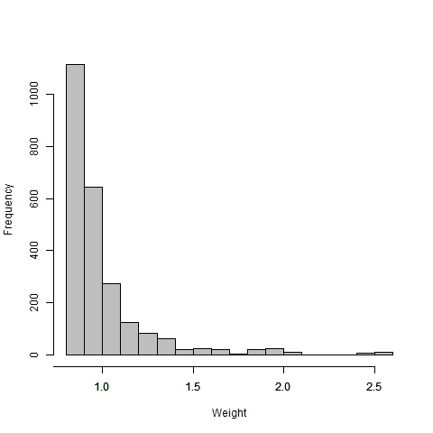

Figure S2: Standardised regression coefficients and 95% CIs of associations of age at first birth with BMI (Models 1-5).
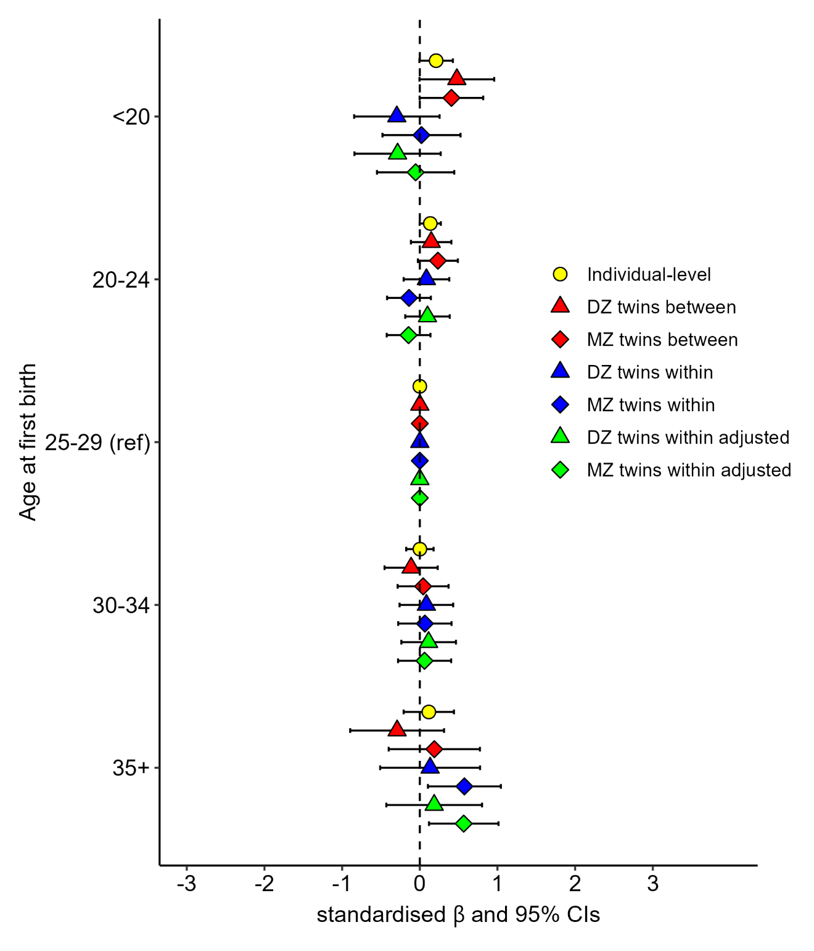
Note. N= 1,100 (DZ=548; MZ=552). Abbreviations: BMI = body mass index; CI = confidence interval; DZ = dizygotic; MZ = monozygotic; ref = reference category.

Figure S3: Standardised regression coefficients and 95% CIs of associations of age at first birth with android/gynoid fat ratio (Models 1-5).
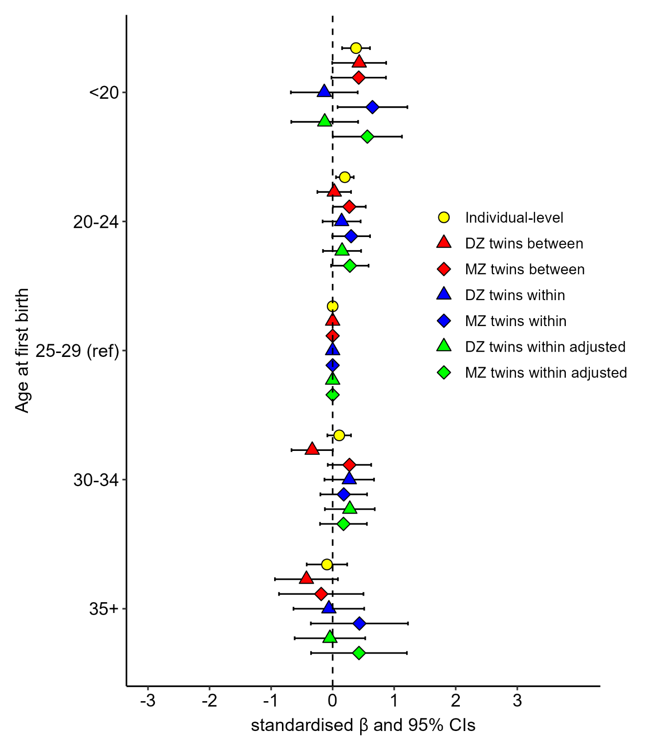
Note. N= 1,003 (DZ=493; MZ=510). Abbreviations: CI = confidence interval; DZ = dizygotic; MZ = monozygotic, ref = reference category.

Figure S4: Standardised regression coefficients and 95% CIs of associations of age at first birth with systolic blood pressure (Models 1-5).
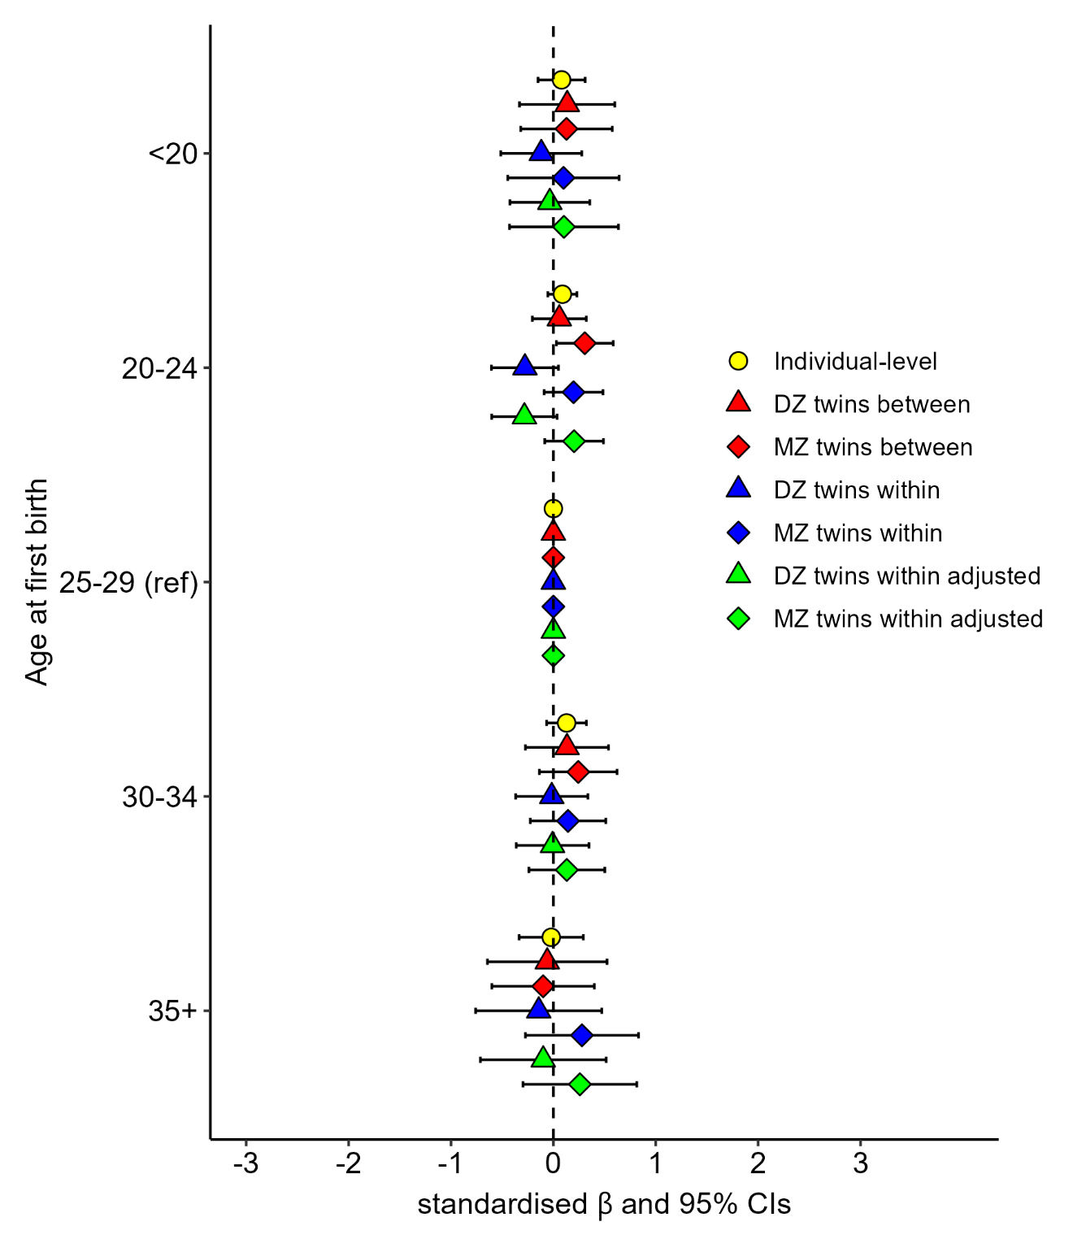
Note. N= 1,095 (DZ=546; MZ=549). Abbreviations: CI = confidence interval; DZ = dizygotic; MZ = monozygotic; ref = reference category.

Figure S5: Standardised regression coefficients and 95% CIs of associations of age at first birth with diastolic blood pressure (Models 1-5).
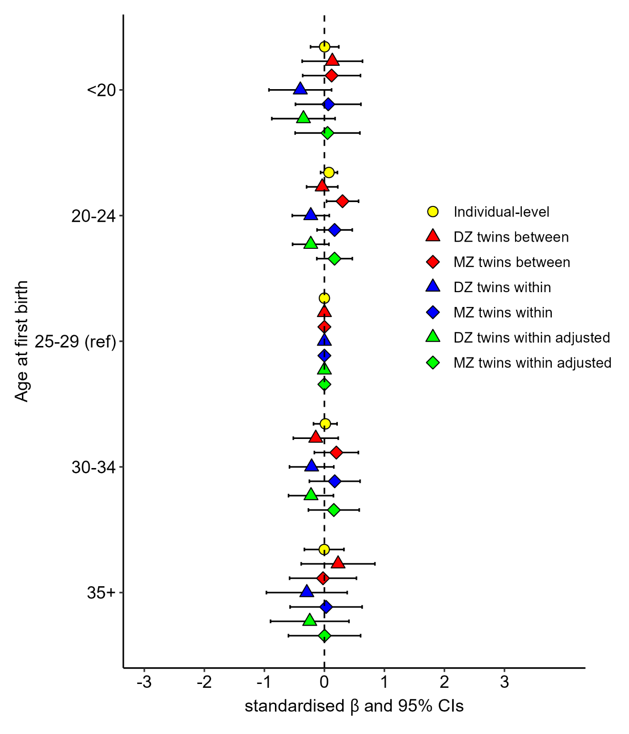
Note. N= 1,096 (DZ=547; MZ=549). Abbreviations: CI = confidence interval; DZ = dizygotic; MZ = monozygotic; ref = reference category.

Figure S6: Standardised regression coefficients and 95% CIs of associations of age at first birth with triglycerides (Models 1-5).
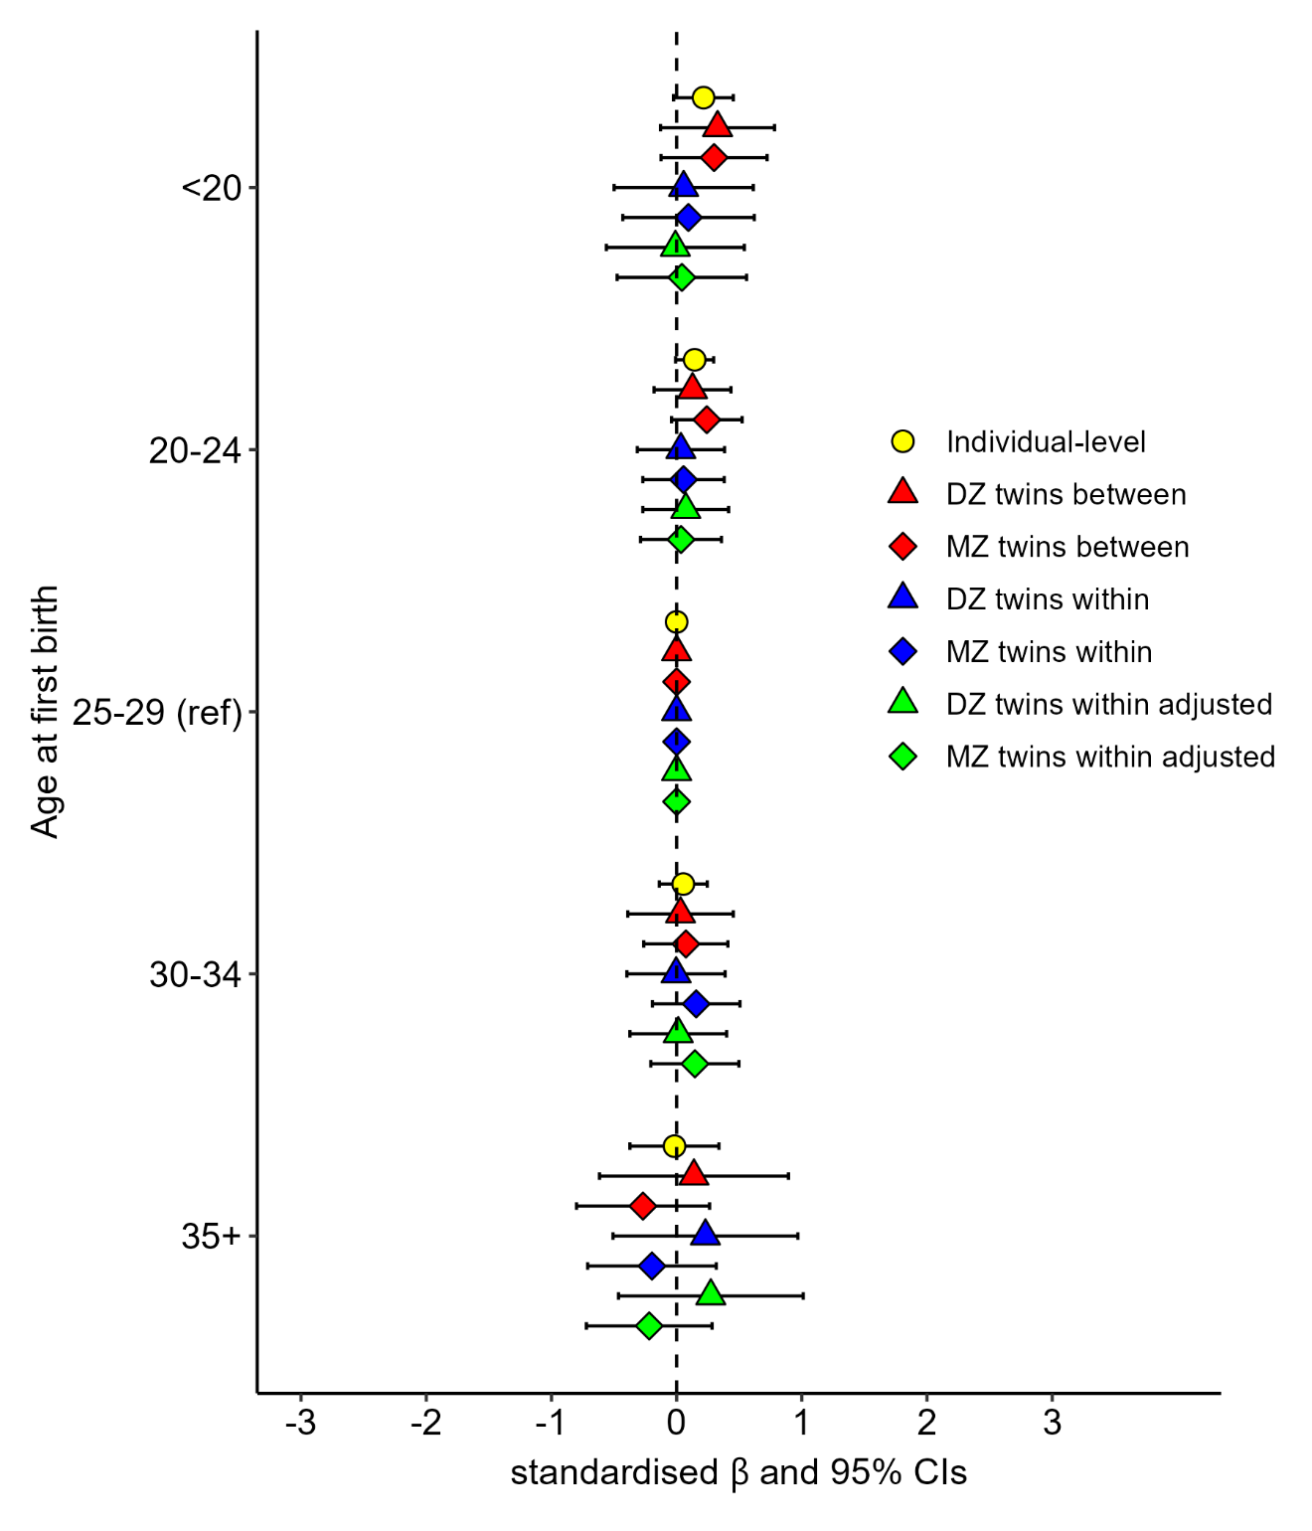
Note. N= 972 (DZ=482; MZ=490). Abbreviations: CI = confidence interval; DZ = dizygotic; MZ = monozygotic; ref = reference category.

Figure S7: Standardised regression coefficients and 95% CIs of associations of age at first birth with HDL (Models 1-5).
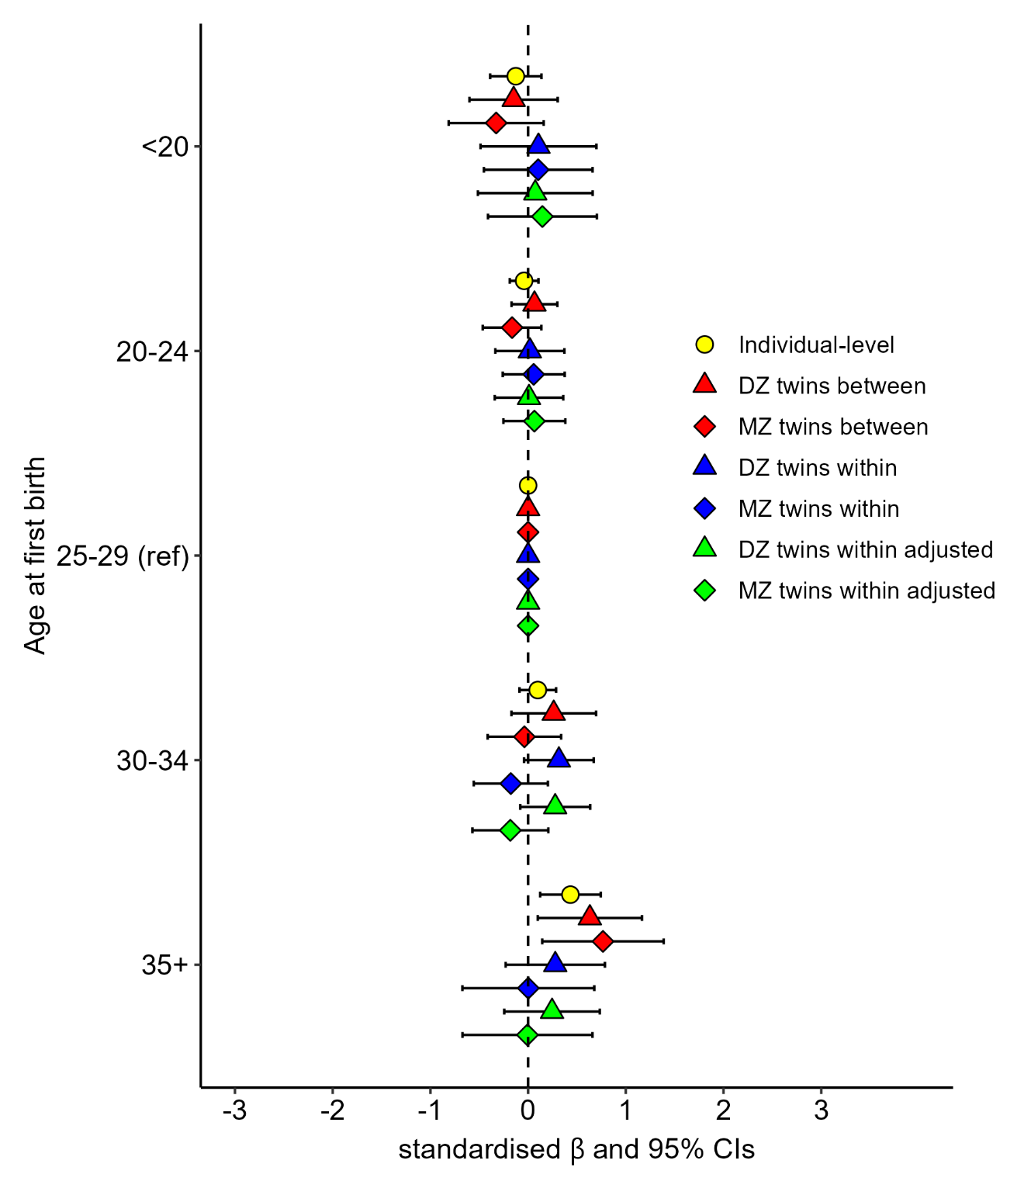
Note. N= 1,029 (DZ=510; MZ=519). Abbreviations: CI = confidence interval; DZ = dizygotic; HDL = high-density lipoprotein; MZ = monozygotic; ref = reference category.

Figure S8: Standardised regression coefficients and 95% CIs of associations of age at first birth with LDL (Models 1-5).
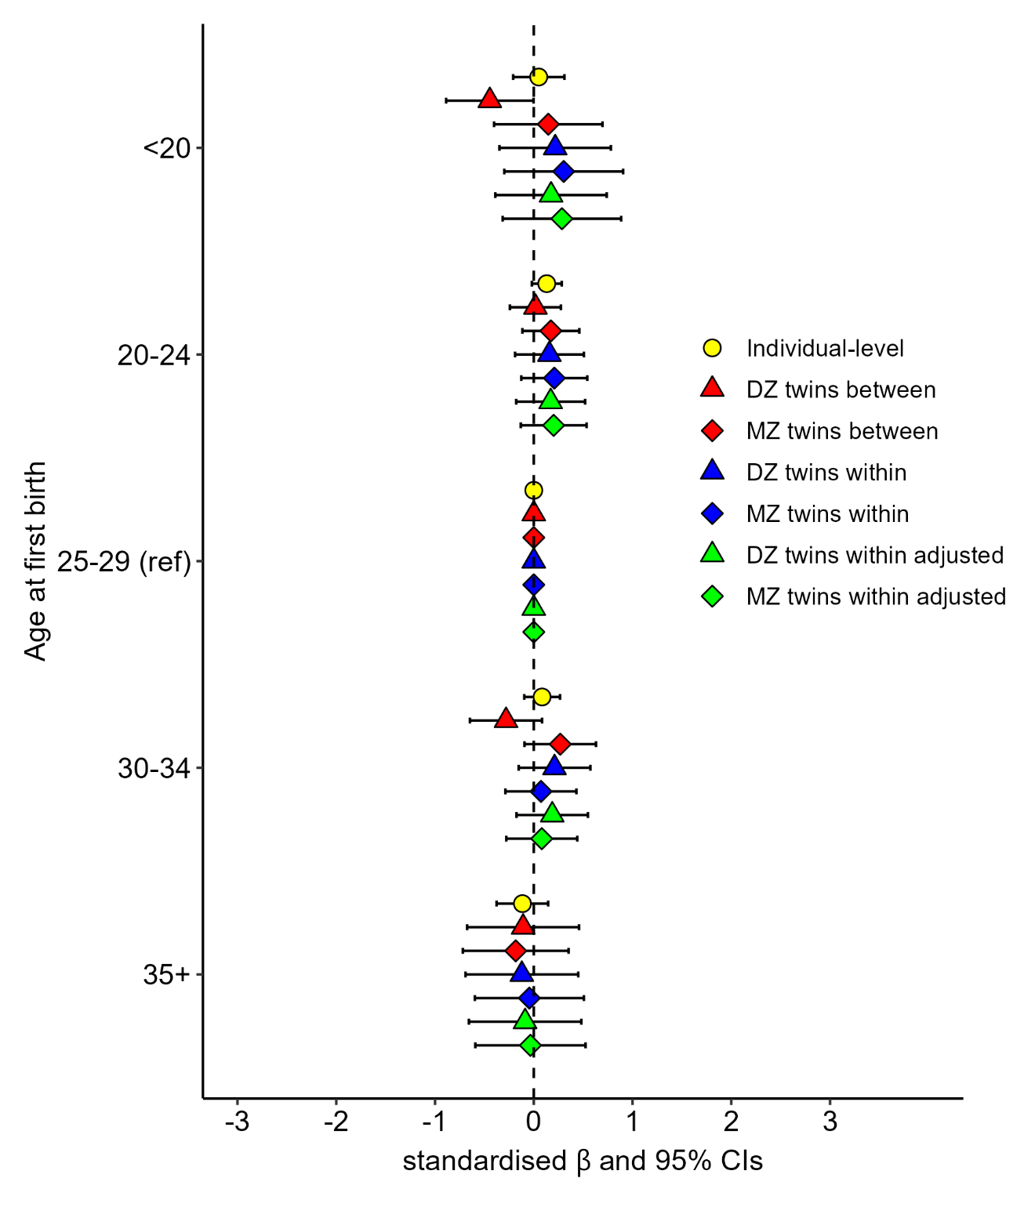
Note. N= 1,029 (DZ=510; MZ=519). Abbreviations: CI = confidence interval; DZ = dizygotic; LDL = low-density lipoprotein; MZ = monozygotic; ref = reference category.

The 5-level cohort variable used in the main analyses led to complete separation issues. The 5 levels were therefore collapse into 3 (<1945, 1945-1954, 1955-1974).

