Contents
Contents 1
Model Specifications 7
Covariate Definitions for Maternal Diseases. 8
Covariates for Propensity Scores 8
Covariates for Propensity to dispensation of J01CA Penicillins with extended spectrum 8
Covariates for Propensity to dispensation of J01CE Beta-lactamase sensitive penicillins 9
Covariates for Propensity to dispensation of J01CF Beta-lactamase resistant penicillins 10
Covariates for Propensity to dispensation of J01DB First-generation cephalosporins 10
Covariates for Propensity to dispensation of J01EA Trimethroprim and derivatives 11
Covariates for Propensity to dispensation of J01FA Macrolides 11
Covariates for Propensity to dispensation of J01XE Nitrofuran derivatives 12
Covariates for Propensity to dispensation of A10AB Insulins and analogues for injection, fast-acting 13
Covariates for Propensity to dispensation of A10AC Insulins and analogues for injection, intermediate-acting 13
Covariates for Propensity to dispensation of A10AE Insulins and analogues for injection, long-acting 14
Covariates for Propensity to dispensation of C05AA Corticosteroids 14
Covariates for Propensity to dispensation of C07AG Alpha and Beta blocking agents 15
Covariates for Propensity to dispensation of H02AB Glucocorticoids 15
Covariates for Propensity to dispensation of M01AE Propionic acid derivatives 16
Covariates for Propensity to dispensation of G03DA Pregen (4) derivaties 17
Covariates for Propensity to dispensation of G03GA Gonadotrophins 17
Covariates for Propensity to dispensation of H03AA Thyroid Hormones 18
Covariates for Adjusted GLMs 19
Covariates for GLMs with dispensation of J01CA Penicillins with extended spectrum 19
Covariates for GLMs with dispensation of J01CE Beta-lactamase sensitive penicillins 19
Covariates for GLMs with dispensation of J01CF Beta-lactamase resistant penicillins 19
Covariates for GLMs with dispensation of J01DB First-generation cephalosporins 19
Covariates for GLMs with dispensation of J01EA Trimethroprim and derivatives 19
Covariates for GLMs with dispensation of J01FA Macrolides 19
Covariates for GLMS with dispensation of J01XE Nitrofuran derivatives 19
Covariates for GLMs with dispensation of C05AA Corticosteroids 19
Covariates for GLMs with dispensation of C07AG Alpha and Beta blocking agents 19
Covariates for GLMS with dispensation of M01AE Propionic acid derivatives 20
Covariates for GLMs with dispensation of H03AA Thyroid Hormones 20
WHO-ATC Codes for Inclusion 20
Table S1a. WHO-ATC Codes for Inclusion: Antibiotics 20
Table S1b. WHO-ATC Codes for Inclusion: Antidiabetics 21
Table S1c. WHO-ATC Codes for Inclusion: Cardiovascular Medications 22
Table S1d. WHO-ATC Codes for Inclusion: Immunosuppressive agents 25
Table S1e. WHO-ATC Codes for Inclusion: Sex Hormones 26
Table S1f. WHO-ATC Codes for Inclusion: Thyroid Therapy. 27
International Classification of Childhood Cancer 3rd Edition Subgroups 28
Table S2. ICCC3 subgroups 28
Criteria for True Positives, False Positives, True Negatives and False Negatives 30
Full Model Results 31
J01CA Penicillins with extended spectrum – 011 Lymphoid leukaemias 31
J01CA Penicillins with extended spectrum – 012 Acute myeloid leukaemias 32
J01CA Penicillins with extended spectrum - 014 Myelodysplastic syndrome and other myeloproliferative diseases 32
J01CA Penicillins with extended spectrum – 022 Non-Hodgkin lymphomas (except Burkitt lymphoma) 33
J01CA Penicillins with extended spectrum – 023 Burkitt lymphoma 33
J01CA Penicillins with extended spectrum – 024 Miscellaneous lymphoreticular neoplasms 34
J01CA Penicillins with extended spectrum – 031 Ependymomas and chorid plexus tumour 35
J01CA Penicillins with extended spectrum – 032 Astrocytomas 36
J01CA Penicillins with extended spectrum – 033 Intracranial and intraspinal embryonal tumours 37
J01CA Penicillins with extended spectrum – 035 Other specified intracranial and intraspinal neoplasms 38
J01CA Penicillins with extended spectrum – 036 Unspecified intracranial and intraspinal neoplasms 39
J01CA Penicillins with extended spectrum – 041 Neuroblastoma and ganglioneuroblastoma 39
J01CA Penicillins with extended spectrum – 050 Retinoblastoma 40
J01CA Penicillins with extended spectrum – 061 Nephroblastoma and other nonepithelial renal tumours 40
J01CA Penicillins with extended spectrum – 071 Heptaoblastoma 41
J01CA Penicillins with extended spectrum – 091 Rhabdomyosarcomas 41
J01CA Penicillins with extended spectrum – 094 Other specified soft tissue sarcomas 41
J01CA Penicillins with extended spectrum – 102 Malignant extracranial and extragonadal germ cell tumours 42
J01CA Penicillins with extended spectrum - 103 Malignant gonadal germ cell tumours 42
J01CA Penicillins with extended spectrum – 999 Not classified by ICCC or in situ 42
J01CE Beta-lactamase sensitive penicillins – 011 Lymphoid leukaemias 43
J01CE Beta-lactamase sensitive penicillins – 012 Acute myeloid leukaemias 43
J01CE Beta-lactamase sensitive penicillins – 024 Miscellaneous lymphoreticular neoplasms 44
J01CE Beta-lactamase sensitive penicillins – 032 Astrocytomas 44
J01CE Beta-lactamase sensitive penicillins – 033 Intracranial and intraspinal embryonal tumours 44
J01CE Beta-lactamase sensitive penicillins – 035 Other specified intracranial and intraspinal neoplasms 45
J01CE Beta-lactamase sensitive penicillins – 041 Neuroblastoma and ganglioneuroblastoma 45
J01CE Beta-lactamase sensitive penicillins – 050 Retinoblastoma 45
J01CE Beta-lactamase sensitive penicillins – 061 Nephroblastoma and other nonepithelial renal tumours 46
J01CE Beta-lactamase sensitive penicillins – 091 Rhabdomyosarcomas 46
J01CF Beta-lactamase resistant penicillins – 011 Lymphoid leukaemias 46
J01DB First-generation cephalosporins – 011 Lymphoid leukaemias 47
J01DB First-generation cephalosporins – 012 Acute myeloid leukaemias 47
J01DB First-generation cephalosporins - 022 Non-Hodgkin lymphomas (except Burkitt lymphoma) 48
J01DB First-generation cephalosporins – 023 Burkitt lymphoma 48
J01DB First-generation cephalosporins – 031 Ependymomas and chorid plexus tumour 48
J01DB First-generation cephalosporins – 032 Astrocytomas 49
J01DB First-generation cephalosporins – 033 Intracranial and intraspinal embryonal tumours 50
J01DB First-generation cephalosporins – 035 Other specified intracranial and intraspinal neoplasms 51
J01DB First-generation cephalosporins – 041 Neuroblastoma and ganglioneuroblastoma 52
J01DB First-generation cephalosporins – 050 Retinoblastoma 52
J01DB First-generation cephalosporins – 061 Nephroblastoma and other nonepithelial renal tumours 53
J01EA Trimethroprim and derivatives – 011 Lymphoid leukaemias 53
J01FA Macrolides – 011 Lymphoid leukaemias Lymphoid leukaemias 54
J01FA Macrolides – 032 Astrocytomas 54
J01FA Macrolides – 033 Intracranial and intraspinal embryonal tumours 55
J01FA Macrolides – 061 Nephroblastoma and other nonepithelial renal tumours 55
J01XE Nitrofuran derivatives – 011 Lymphoid leukaemias 56
J01XE Nitrofuran derivatives – 041 Neuroblastoma and ganglioneuroblastoma 56
A10AB Insulins and analogues for injection, fast-acting – 011 Lymphoid leukaemias 57
A10AC Insulins and analogues for injection, intermediate-acting – 011 Lymphoid leukaemias 57
A10AE Insulins and analogues for injection, long-acting – 011 Lymphoid leukaemias 58
C05AA Corticosteroids – 011 Lymphoid leukaemias 58
C07AG Alpha and Beta blocking agents – 011 Lymphoid leukaemias 58
H02AB Glucocorticoids – 011 Lymphoid leukaemias 59
M01AE Propionic acid derivatives – 011 Lymphoid leukaemias 59
M01AE Propionic acid derivatives – 041 Neuroblastoma and ganglioneuroblastoma 60
G03DA Pregen (4) derivaties – 011 Lymphoid leukaemias 60
G03DA Pregen (4) derivaties – 061 Nephroblastoma and other nonepithelial renal tumours 61
G03GA Gonadotrophins – 011 Lymphoid leukaemias 61
G03GA Gonadotrophins – 036 Unspecified intracranial and intraspinal neoplasms 61
G03GA Gonadotrophins – 041 Neuroblastoma and ganglioneuroblastoma 62
G03GA Gonadotrophins – 061 Nephroblastoma and other nonepithelial renal tumours 62
H03AA Thyroid Hormones – 011 Lymphoid leukaemias 63
H03AA Thyroid Hormones – 012 Acute myeloid leukaemias 63
H03AA Thyroid Hormones – 024 Miscellaneous lymphoreticular neoplasms 63
H03AA Thyroid Hormones – 032 Astrocytomas 64
H03AA Thyroid Hormones – 041 Neuroblastoma and ganglioneuroblastoma 64
H03AA Thyroid Hormones – 050 Retinoblastoma 64
H03AA Thyroid Hormones – 061 Nephroblastoma and other nonepithelial renal tumours 65
Directed Graph 66
Propensity Score Density and Balance Plots 67
J01CA Penicillins with extended spectrum 67
J02CE Beta-lactamase sensitive penicillins 69
J01CF Beta-lactamase resistant penicillins 71
J01DB First-generation cephalosporins 73
J01EA Trimethroprim and derivatives 75
J01FA Macrolides 77
J01XE Nitrofuran derivatives 79
A10AB Insulins and analogues for injection, fast-acting 81
A10AC Insulins and analogues for injection, intermediate-acting 83
A10AE Insulins and analogues for injection, long-acting 85
C05AA Corticosteroids 87
C07AG Alpha and Beta blocking agents 89
H02AB Glucocorticoids 91
M01AE Propionic acid derivatives 93
G03DA Pregen (4) derivaties 95
G03GA Gonadotrophins 97
H03AA Thyroid Hormones 99

Model Specifications
All IC models were run with 100,000 iterations with seed set to 552.
For the BHM models the R package “rjags” was used to run three Monte-Carlo Markov Chains (MCMC) with random number generator “Mersenne-Twister” and seeds set to 1, 2 and 3. Analysis was restricted to medications and cancers with at least one pair with an observed frequency > 4. Initial values were provided as -1.5, -1, and 0. Convergence to the target distribution was assessed through visual inspection of chains and the Ruben-Gelman statistic. An effective sample size of 10,000 was exceeded for all parameters and hyper-parameters. As analysis was conducted on 4th level ATC codes, hierarchical grouping was based on the 3rd level ATC medication groups.
For the unadjusted 0-4 years analysis, medications hierarchical grouping was based on the 3rd level ATC code and included: Group 1: J01CA, J01CE, J01CF; Group 2: J01DB; Group 3: J01EA; Group 4: J01FA; Group 5: J01XE; Group 6: A10AB, A10AC, A10AE; Group 7: C05AA; Group 8: C07AG; Group 9: H02AB; Group 10: M01AE; Group 11: G03DA; Group 12: G03GA; Group 13: H03AA. Cancer hierarchical grouping was based on the ICCC3 classification and included: Group 1: 011, 012, 014; Group 2: 022, 024; Group 3: 031, 032, 033, 035, 036; Group 4: 041; Group 5: 050; Group 6: 061; Group 7: 071; Group 8: 091, 094; Group 9: 102, 103; Group 10: 999. For each chain, a total of 1,001,000 iterations were run with a burn-in of 1,000 discarded. Chains were thinned by 8, giving an overall sample size of 375,000.
For the unadjusted 5-9 years analysis, medications hierarchical grouping was based on the 3rd level ATC code and included: Group 1: J01CA, J01CE; Group 2: J01DB; Group 3: J01FA. Cancer hierarchical grouping was based on the ICCC3 classification and included: Group 1: 011; Group 2: 031, 032, 033, 035. For each chain, a total of 51,000 iterations were run with a burn-in of 1,000 discarded, giving an overall sample size of 150,000. No thinning was required.
For the unadjusted 0-9 years analysis, medications hierarchical grouping was based on the 3rd level ATC code and included: Group 1: J01CA, J01CE; Group 2: J01DB; Group 3: J01FA; Group 4: J01XE; Group 5: A10AB, A10AC; Group 6: C07AG; Group 7: M01XE; Group 8: G03DA; Group 9: G03GA; Group 10: H03AA. Cancer hierarchical grouping was based on the ICCC3 classification and included: Group 1: 011, 012; Group 2: 022, 023, 024; Group 3: 031, 032, 033, 035; Group 4: 041; Group 5: 050; Group 6: 061; Group 7: 091. For each chain, a total of 51,000 iterations were run with a burn-in of 1,000 discarded, giving an overall sample size of 150,000. No thinning was required.
For the adjusted 0-4 years analysis, medications hierarchical grouping was based on the 3rd level ATC code and included: Group 1: J01CA, J01CE, J01CF; Group 2: J01DB; Group 3: J01EA; Group 4: J01FA; Group 5: J01XE; Group 6: A10AB, A10AC, A10AE; Group 7: C05AA; Group 8: C07AG; Group 9: H02AB; Group 10: M01AE; Group 11: G03DA; Group 10: G03GA; Group 11: H03AA. Cancer hierarchical grouping was based on the ICCC3 classification and included: Group 1: 011, 012, 013, 014, 015; Group 2: 021, 022, 023, 024; Group 3: 031, 032, 033, 034, 035, 036; Group 4: 041; Group 5: 050; Group 6: 061, 063; Group 7: 071, 072; Group 8: 091, 092, 094, 095; Group 9: 101, 102, 105; Group 10: 999. For each chain, a total of 810,000 iterations were run with a burn-in of 10,000 discarded. Chains were thinned by 16 giving an overall sample size of 150,000.
For the adjusted 5-9 years analysis, medications hierarchical grouping was based on the 3rd level ATC code and included: Group 1: J01CA, J01CE; Group 2: J01DB; Group 3: J01FA. Cancer hierarchical grouping was based on the ICCC3 classification and included: Group 1: 011; Group 2: 031, 032, 033, 035. For each chain, a total of 1,010,000 iterations were run with a burn-in of 10,000 discarded, giving an overall sample size of 3,000,000. No thinning was required.
For the adjusted 0-9 years analysis, medications hierarchical grouping was based on the 3rd level ATC code and included: Group 1: J01CA, J01CE; Group 2: J01DB; Group 3: J01FA; Group 4: J01XE; Group 5: A10AB, A10AC; Group 6: C07AG; Group 7: M01XE; Group 8: G03DA; Group 9: G03GA; Group 10: H03AA. Cancer hierarchical grouping was based on the ICCC3 classification and included: Group 1: 011, 012; Group 2: 022, 023, 024; Group 3: 031, 032, 033, 035; Group 4: 041; Group 5: 050; Group 6: 061; Group 7: 091. For each chain, a total of 810,000 iterations were run with a burn-in of 10,000 discarded. Chains were thinned by 10 giving an overall sample size of 240,000.

Covariate Definitions for Maternal Diseases and Parity.
Chronic hypertension was defined as International Classification of Disease 10th Revision (ICD-10) codes O10, O11, I10-15 or I27.0, or Finnish reimbursement code 205. Chronic diabetes was defined as ICD-10 codes E10, O24.0, E11, O24.1, E13, or E14, or Finnish reimbursement codes 103, 171, 215, 285, or 346. Preeclampsia was defined as ICD-10 codes O11 or O14. Gestational hypertension was defined as ICD-10 code O13, and no chronic hypertension or preeclampsia. Gestational diabetes was defined as ICD-10 codes O24.4, O24.9, or a pathological oral glucose tolerance test.
In the Swedish Medical Birth Registry, parity is defined as the number of times a woman has given birth to a child, live or stillborn with a gestational duration ≥154 days (22 weeks). In the Finnish Medical Birth Registry, parity is defined as the number of previous live births or stillbirths with a gestational duration ≥154 days (22 weeks) or having a birth weight of at least 500g. In the Norway Medical Birth Registry, parity is defined as the number of previous live births and stillbirths, including abortions, from 12 weeks onwards.

Covariates for Propensity Scores

Covariates for Propensity to dispensation of J01CA Penicillins with extended spectrum
Source country; centred calendar year of birth; maternal age; chronic diabetes; chronic hypertension; ART; child sex; maternal cancer prior to pregnancy; parity; smoking in early pregnancy; any medication dispensed in the 3 months prior to pregnancy; number of different medications dispensed in the 3 months prior to pregnancy; dispensed in the 3-months prior to pregnancy: J01XX; J01EA; A07A; A07AA; R03DA; J01E; N07BB; J01CR; N07B; N05AF; R03AK; R03D; R03DC; J01MB; A10BB; R03BB; R01AD; C07B; C07BB; J01X; N06C; N06CA; N05AA; R01A; J01EE; G04BD; J01M; R03A; J01MA; N05BE; G04B; N06AA; A08; J01XE; R03AC; A02BA; R03BA; R03B; M03BC; R03; G04; A02; N07C; N07CA; N02AX; N06AX; H04; N01; L03AB; N05; A01AB; N05CD; N06; R01; A02B; N05AN; N05BA; A02BC; R01B; R01BA; D02AE; N05AH; N06A; L03A; N05B; N03AX; L01; D02; N05A; N06AB; J02; R06AE; N02A; A01A; J02AC; J02A; D02A; D04; N07; R06A; L04AD; N02B; C09B; A11; N02BE; G01; C09BA; N02AJ; R06AX; N03; A06; N03A; L03; A03; N02; N05C; N03AG; A02BD; M03; N05CF; M03B; N03AE; A06AC; P01; G01AA; M02; S01ED; A01; D02AX; N03AF; J01DC; D10B; D10BA; R03BC; R06; M03BX; A03C; A03CA; N02CC; M02AM02AA; N02C; J01FA; S03; S01G; S01GX; P01A; P01AB; A06A; D01AE; C08D; S01CA; S01C; S01X; S01XA; N06BA; S01E; J01F; G01A; N06B; J05; S01BA; R05D; R05DA; D06BB; C09D; R05; D01B; D01BA; C09DA; C03C; C03CA; S01B; R05FB; R03CC; M01AH; A10AC; D01AC; D01A; S01BC; N05AB; C08DA; R03C; D07CA; M01AX; C09; R05DB; C09A; C09AA; J05A; C09C; C09CA; D01; J05AB; N05BB; D06; D07BA; D07AD; M01AC; R05F; A03F; A03FA; J01A; J01AA; P01BA; D07AB; C07AB; D10AF; M03BA; P01B; S01AX; G02BA; J01D; A12; R05FA; J02AB; J01DB; M01AE; S03C; S03CA; H04A; H04AA; D07AC; D07; D07C; D07A; N05AX; M01; M01A; D06B; R01AC; M01AB; S01; D10; G01AF; D07BC; D07CC; H03BB; A10AB; D07B; A10A; M01AG; C08; C07; A10; C07A; A10AE; D07XC; C03; A10BA; A10B; D08; H02; H02AB; H02A; C08C; C08CA; G02A; M01C; G02AB; N04B; D10A; H02AA; G03DC; N04BC; J07; C10AA; D07AA; C03E; D07X; B01AA; H03B; R05C; C03A; G03DB; D10AX; A12AX; C10A; D07BB; C10; G03HB; G03H; C07AA; J01CE; V01; G03AA; C05BA; B02; A12A; A05; A06AD; C03AA; D11; S02; C05B; M01CB; J01FF; S01A; C03EA; N04; D05A; D06BX; J01CF; A10AD; S02C; S02CA; C07AG; B03AC; L04AX; D05AX; C03D; D05; D06A; D06AX; S01AD; L04; L04A; C05AE; L02BG; C03DA; L02B; G03A; B02A; B02AA; C05; D11A; G02C; G02CB; C05A; S01AA; C05AA; N06AG; A05A; A05AA; G03F; G02; C01; C10AC; G03AB; D07XB; G02B; C01C; C01CA; G03FB; D11AX; A07; G02BB; B01; G03; A07E; H03; A07EC; L04AB; H03A; H03AA; B01AB; G03D; G03AC; G03GB; G03C; G03CA; B03; H03BA; B03A; A07EA; B01A; B03AA; G03G; H01; B03BA; C02A; G03GA; L02; C02AB; C02; H01CA; G03DA; H01C; B03B; H01CC; L02A; L02AE; B03BB; B01AC; Interaction between source country and birth year; interaction between source country and maternal age; interaction between birth year and maternal age; interaction between source country, birth year and maternal age.

Covariates for Propensity to dispensation of J01CE Beta-lactamase sensitive penicillins
Source country; centred calendar year of birth; maternal age; chronic diabetes; chronic hypertension; ART; child sex; maternal cancer prior to pregnancy; parity; smoking in early pregnancy; any medication dispensed in the 3 months prior to pregnancy; number of different medications dispensed in the 3 months prior to pregnancy; dispensed in the 3-months prior to pregnancy: B03AC; A08; C05BA; C05B; S03; C03C; C03CA; J01CF; A11; C03AA; N01; C03A; B03A; N07; B03AA; C05AE; D04; S02; L04AB; N06BA; N06B; B03; B03BA; B01AC; D08; C03D; G02BA; C03DA; J01XE; G03AC; G03AB; C02; M01AB; B03B; C03; J01X; N05; G03A; V01; C05; B03BB; H04; C05A; C05AA; G03AA; J01FF; H02AB; H02A; N02; J07; H02; B01; A10BB; S01; G02B; G02BB; A03; A10AE; B01A; D11; C10AC; L04; L04A; R05; C09C; C09CA; G04; B02; C01; C01C; C01CA; J01XX; P01; D05; J01EA; H03A; H03AA; B01AB; H03; C08DA; D06; A10BA; A10B; J01A; J01AA; C10A; C10; H03BA; A10; M01AC; R01; A10A; R06; C02A; J01CA; M01A; M01; C10AA; N06; L04AX; N03; A10AB; J01E; C09; G03DC; G01; R03; G03GB; C09D; C09DA; A02; N05AH; C08C; C08CA; C08; L04AD; B02A; B02AA; A12; G03; J01CR; C08D; M01AH; M01AE; A07EA; N03AX; G02; C09BA; N06AX; C09A; C09AA; H03B; J01F; D01; H03BB; N02BE; J05; N05CD; N02B; N05BA; J01MA; J01M; C07AB; G03DA; D10; D07; C09B; B01AA; N05CF; N05B; J01FA; J01EE; N05C; G03C; G03CA; A06; C07A; L03; N05A; N02AJ; A01; C07; P01A; P01AB; C07AA; N07BB; A07; G03G; N05AX; N02A; D02; N03AG; R03AK; J02; G03D; A10AD; H01; C07AG; R03D; N07B; M02; H01CC; R03DC; M03BC; C03EA; N06AG; N06A; C03E; G03GA; L03AB; N03A; N06AB; N03AE; A07E; L03A; G01AA; A07EC; N02AX; N06AA; A02BC; L02; R03A; A02B; G03FB; R03AC; M03; G03HB; G03H; A10AC; H01C; G03F; N06C; N06CA; A06AD; N05AB; A12AX; J01DB; D05A; D07AD; D05AX; J01D; A12A; D02A; L02BG; D07CC; R03BA; M03B; R01AD; R01A; A02BD; G01A; A06A; R03B; L02B; H01CA; J02AC; A06AC; L02AE; L02A; J02A; N02CC; D07AC; N02C; D07BA; R06AE; J05AB; J05A; D06BB; A02BA; M03BX; N05BB; R06A; D07A; M01AX; R06AX; D07B; M01AG; D07AB; N04; S01X; S01XA; M02A; M02AA; D06B; D07BC; D07C; S01CA; S01C; G04BD; G04B; D07BB; S01GX; S01G; S01A; D01B; D01BA; A03F; A03FA; G03DB; D01A; J01DC; R01AC; P01B; D01AC; G01AF; N03AF; P01BA; D07XC; D07AA; D07X; D06BX; D01AE; R01B; R01BA; D10AX; A01A; R05FB; A01AB; R05F; R05FA; G02C; G02CB; D10A; R03BC; D07CA; D06A; D06AX; R05DA; R05D; D10AF; Interaction between source country and birth year; interaction between source country and maternal age; interaction between birth year and maternal age; interaction between source country, birth year and maternal age.

Covariates for Propensity to dispensation of J01CF Beta-lactamase resistant penicillins
Source country; centred calendar year of birth; maternal age; chronic diabetes; chronic hypertension; ART; child sex; maternal cancer prior to pregnancy; parity; smoking in early pregnancy; any medication dispensed in the 3 months prior to pregnancy; number of different medications dispensed in the 3 months prior to pregnancy; dispensed in the 3-months prior to pregnancy: D08; L04AB; B03AA; B03A; J01FF; J01XE; J01X; B03BA; B03; A08; B03B; S03; A10AE; C07AG; A10AB; A10A; L04; L04A; C03; B01; B01AB; B03BB; A11; C10AA; G03AC; D06; C10; B01A; B01AC; C10A; H02AB; H02A; J01CE; H02; G03A; G03AB; A10; M01AB; G03AA; C08; G02B; A03; L04AX; B02; C01C; C01CA; G02BB; J01MA; B02A; B02AA; J01M; C05A; C01; C05; H03A; H03AA; H03; G03DA; C05AA; G03GB; N05; S01; G03; G02; J01EA; G03DC; J01E; A10AC; H01CC; N02; C07A; A07; J01EE; C07; J01A; J01AA; C07AA; J01F; G03G; G03D; D10; A10B; D01; A07E; A10BA; M01A; M01; R05; G03GA; A07EC; L02; H01; L02AE; L02A; J01CA; N03; C09; P01; M01AH; G01; H01C; J05; G03CA; G03C; D07; C07AB; M01AE; R06; A02; J01FA; H01CA; R01; R03; N06; M01AC; J01D; J02; J01DB; J01CR; Interaction between source country and birth year; interaction between source country and maternal age; interaction between birth year and maternal age; interaction between source country, birth year and maternal age.

Covariates for Propensity to dispensation of J01DB First-generation cephalosporins
Source country; centred calendar year of birth; maternal age; chronic diabetes; chronic hypertension; ART; child sex; maternal cancer prior to pregnancy; parity; smoking in early pregnancy; any medication dispensed in the 3 months prior to pregnancy; number of different medications dispensed in the 3 months prior to pregnancy; dispensed in the 3-months prior to pregnancy: R03BB; R03DA; M03BA; N05AA; N05AF; J01DC; R03D; R03DC; N05CD; H04A; H04AA; N06AA; D07XB; R03BC; R03AK; N02AX; D07BA; D06A; D06AX; R03CC; R03C; N05BB; S03C; S03CA; A06AD; G04BD; G04B; N03AE; N07BB; A07A; A07AA; R01B; R01BA; D11AX; R03A; A01A; N05BE; D07B; S02C; S02CA; N07B; R05DB; R03B; N05BA; N05B; R03AC; R01AD; J01MB; R01A; R03BA; N06C; N06CA; N03AX; D07BC; A01AB; D07CC; N05C; R05D; N05AX; R05DA; N05A; D07AA; R06AE; D07BB; G01AF; N05AH; J02AC; R01AC; J02A; N05CF; D07C; A02BA; R06A; S01E; N06BA; N02A; N06B; R06AX; D07AB; R05C; A03F; A03FA; N03A; D01AE; D01A; A02BC; A02B; R05FB; D07CA; D01AC; M03BC; C07B; C07BB; S01AX; M02A; M02AA; D07A; A03C; A03CA; N06AX; R05F; D07AC; P01A; P01AB; N06A; N05AN; N02AJ; R05FA; N07C; N07CA; N05AB; N06AB; D06BB; G01A; N03AG; M03B; N03AF; J01EE; M03BX; D10AF; S01CA; M03; S01C; D07X; S01GX; S01G; D06B; S01AD; N02B; D11A; N02BE; J01CR; N02C; N02CC; J05AB; G01AA; C08DA; A06A; J05A; S01ED; S01A; S01BA; A02BD; G02A; G02AB; C08D; J01M; J02; J01MA; R03; D07XC; A05A; A05AA; M01AG; D07AD; J01FA; S01B; S01X; S01XA; A06AC; D10A; D06BX; C03E; D01B; D01BA; D02AE; N04BC; M02; A12A; J01F; J02AB; A12AX; D10AX; N04B; S01AA; G03DB; C09B; C03EA; A01; H02AA; L03AB; M01AX; D10B; D10BA; P01B; L03A; R01; N06AG; A02; B01AA; P01BA; N03; A06; N06; D02A; J01A; J01AA; M01AH; C09BA; G04; N04; G02C; G02CB; H04; A05; M01C; D05A; D05AX; D02; D07; M01CB; M01AE; L04AD; C08; A10AC; J01E; D02AX; N05; C08C; C08CA; C09DA; C07AB; P01; L02BG; C09; C09A; C09AA; R06; L02B; G01; C07; C09C; C09CA; J01CA; B02A; B02AA; C09D; C07A; J01FF; J05; C03; A12; J01XX; C03AA; C07AA; C03C; C03CA; D01; M01; M01A; A10AE; A10A; S01BC; A10AB; G03HB; G03H; H02; S02; H02A; H02AB; N02; C07AG; L03; J01EA; A10; M01AC; B02; A10AD; R05; C10A; G03F; C10; C10AA; G03FB; A07EC; A03; A07E; J01C; C03A; A10B; A07; A10BA; C10AC; N07; D06; C01; L04AX; C01C; C01CA; H03BB; A10BB; H01CA; L04; L04A; D10; L02A; L02AE; A07EA; G03C; G03CA; H01C; S01; B01AB; B01A; G03D; H03B; D05; M01AB; H03; C05AA; H03A; H03AA; L02; C05A; C03DA; D11; J01X; C05; C03D; G03DC; G03GA; H01CC; J01CE; H01; J01XE; G03G; G03; L04AB; G02; B01; G03DA; B01AC; G03GB; S03; G02BA; B03BA; B03A; B03AA; J01CF; B03B; B03; B03BB; G02B; G03AC; G02BB; A11; G03A; G03AA; G03AB; Interaction between source country and birth year; interaction between source country and maternal age; interaction between birth year and maternal age; interaction between source country, birth year and maternal age.

Covariates for Propensity to dispensation of J01EA Trimethroprim and derivatives
Source country; centred calendar year of birth; maternal age; chronic diabetes; chronic hypertension; ART; child sex; maternal cancer prior to pregnancy; parity; smoking in early pregnancy; any medication dispensed in the 3 months prior to pregnancy; number of different medications dispensed in the 3 months prior to pregnancy; dispensed in the 3-months prior to pregnancy: J01XX; D08; N01; A08; A11; D11; J01X; J01XE; A03; S03; J01M; J07; J01MA; J01EE; N05; G03AA; D06; G01; G03AB; N02; G03A; C10AA; J01FF; D10; J01CA; P01; G02BB; G02B; C09C; C09CA; M01AB; R05; G03DC; G03AC; S01; C10A; C10; R06; D01; N06; N07; J01C; J01F; M01AC; A02; G02; J05; J01FA; C09A; C09AA; C09; G03GB; A12; A10AE; L04; L04A; J02; A06; J01CF; N03; C03; A10AB; R01; J01CE; C05AA; G03; A10B; C05; N05CF; A10BA; G03HB; G03H; C05A; A10; A10A; R03; N05C; M01A; M01; M02; L04AX; B03; D07; B01; H02AB; H02A; H02; C01; N03AX; A10AC; M01AH; J01A; J01AA; N05AH; C07AA; N05A; C07A; M01AE; C07; C07AB; H03A; H03AA; H03; B02; N05BA; N05B; G03G; G01AA; N06AX; J02A; J02AC; B03BA; M03BC; A07; G03CA; G03C; N03A; L02; N06A; G03D; H01; G01A; J01DB; J01D; N02A; N06AB; N02AJ; N02B; M03; G03GA; G03DA; S01GX; S01G; N02BE; J01CR; A07E; N02CC; N02C; A07EC; R03AK; B03B; M03B; R01AD; R06AX; R01A; R03A; P01A; P01AB; A02B; R03AC; A02BC; R05F; G03DB; R06A; M03BX; D07A; R03B; R06AE; R03BA; H01C; H01CA; L02AE; L02A; H01CC; Interaction between source country and birth year; interaction between source country and maternal age; interaction between birth year and maternal age; interaction between source country, birth year and maternal age.

Covariates for Propensity to dispensation of J01FA Macrolides
Source country; centred calendar year of birth; maternal age; chronic diabetes; chronic hypertension; ART; child sex; maternal cancer prior to pregnancy; parity; smoking in early pregnancy; any medication dispensed in the 3 months prior to pregnancy; number of different medications dispensed in the 3 months prior to pregnancy; dispensed in the 3-months prior to pregnancy: R03DA; R03BB; R03D; R03DC; R03BC; R01B; R01BA; R03AK; D10AF; D06BX; N05AF; D10A; A01AB; D07XB; A01A; A03C; A03CA; R05FB; D10AX; A10AD; S01AD; J01DC; R05F; R05FA; R03CC; R03A; N05CD; G01AF; R03C; A02BA; N06AA; R03B; R03AC; R03BA; R05D; R05DA; R01AD; R01A; R01AC; S02C; S02CA; D07BA; R03; J02AB; N07BB; A01; S01A; R06AX; C03E; N07B; N05AB; R06A; N05C; S01E; N06AG; N06C; N06CA; D06A; D06AX; A02B; N05BA; J01CR; A02BC; N05B; R06AE; R01; J01EE; N05CF; D06B; N03AE; D07X; N02AX; D07CA; C03EA; A03F; A03FA; J02A; M02A; M02AA; J02AC; R05; N05BB; G01A; J01A; J01AA; M03BC; S01GX; S01G; S01X; S01XA; D07XC; J05AB; N06AX; J05A; N06A; A02; D07AB; J01D; D10; N06AB; J02; D07B; P01A; P01AB; M02; J01DB; M03B; D01AC; C03C; C03CA; L03A; D07BC; M03; M03BX; N05A; D01A; N05; S01CA; A12AX; S01C; M01AX; R06; M01AG; N06; N02A; N03AX; A12A; S02; C03; N02BE; N02B; N03A; D07C; C09C; C09CA; A06AC; A03; G04BD; D06BB; N02C; G04B; N02CC; N07; D01B; D01BA; D07A; G01; N02AJ; P01; D07AD; N05AH; S01BA; J05; A06A; D01AE; N03AF; A06; J01MA; J01FF; J01M; D06; G01AA; C01C; C01CA; N03; D07AC; N03AG; D07BB; D02A; M01AC; D02; N02; C01; D07; J01E; D05A; S01B; A12; D07CC; H02; H02AB; H02A; C09; D07AA; D01; M01AH; D08; N01; A02BD; C07AA; G03DB; M01AE; D05AX; S01; P01B; C09DA; A10AC; P01BA; C07A; C07; C07AB; D11; A08; G04; G02C; G02CB; D05; M01A; M01; B02; L03; C08C; C08CA; C09D; C08; B02A; B02AA; J01CA; L02B; B01AA; C07AG; G03DC; L02BG; C09A; C09AA; J01EA; G03HB; G03H; A07; C10A; C10; A07EA; C03A; S03; A10A; A10AB; N05AX; J01C; C10AA; A07EC; A07E; L04AX; A10; J01XX; M01AB; G03FB; A10BA; A11; G03F; A10B; L04; L04A; A10AE; J07; H03A; H03AA; H03; G03D; J01CE; G03CA; G03C; H01CA; B01AB; L02AE; L02A; L02; G03; B01; G02; G03AB; C05A; C05AA; C05; G03AA; H01C; B01A; G03GA; G03G; H01; G03A; H03BB; G03GB; G03DA; J01X; H03B; J01CF; H01CC; L04AB; G02B; J01XE; G02BB; G03AC; B03; B03B; B03BB; B03BA; B03AA; B03A; Interaction between source country and birth year; interaction between source country and maternal age; interaction between birth year and maternal age; interaction between source country, birth year and maternal age.

Covariates for Propensity to dispensation of J01XE Nitrofuran derivatives
Source country; centred calendar year of birth; maternal age; chronic diabetes; chronic hypertension; ART; child sex; maternal cancer prior to pregnancy; parity; smoking in early pregnancy; any medication dispensed in the 3 months prior to pregnancy; number of different medications dispensed in the 3 months prior to pregnancy; dispensed in the 3-months prior to pregnancy: J01XX; J01EA; B03AC; C05BA; C05B; B03AA; B03A; J01E; N01; B03BA; C03C; C03CA; B03B; B03; B03BB; J01MA; J01M; C10AC; C03A; L04AD; B01AC; J01CF; A08; J01FF; G04; C03D; G02BA; G02BB; G03AC; G02B; A10AB; G03A; C03DA; A10A; G03AA; C10; J01EE; C10A; A10AE; S03; C03; J01CA; B01A; C03AA; C10AA; G03AB; B01; C01C; C01CA; J07; B01AB; A03; C01; A11; L04AB; G03GB; C05; H02AB; J01C; H02A; A10; H02; M01AB; G02; C05AA; C05A; A07EA; G03DA; L04; L04A; C09C; C09CA; C09A; C09AA; J01CE; C08C; C08CA; B01AA; H01CC; A10AC; B02; G03; L04AX; D08; C08; C09; H03A; H03AA; H03; G03G; A10B; A10BA; B02A; B02AA; J01A; J01AA; G03D; H01; C07AA; N07; G01; H03B; R05; G03GA; C07A; H01C; C07; C07AB; D06; J01F; P01; L02; G03DC; N05; M01A; H03BB; M01; G03CA; C07AG; G03C; N02; L02A; L02AE; D10; S01; J01FA; D01; M01AC; H01CA; R06; A07; M01AE; A07E; M01AX; N03; A02; J05; D07; M01AH; G03HB; G03H; A07EC; R01; A01; D05; J02; A06; A12; N06; R03; G01AF; J01D; J01DB; M02; R05FB; G01A; A02BA; J01DC; J01CR; D01A; D01AC; N03AF; R05F; G01AA; R01B; R01BA; M01AG; J02AC; J02A; P01A; P01AB; G02C; G02CB; R05FA; R05DA; R05D; N03A; N05B; N05BA; R03B; D07AB; N05A; N06AB; R03BA; M03; N06A; D07A; J05AB; J05A; R06AE; D07AC; R01AD; A02B; R03AC; R01A; R06A; G03DB; R03A; R06AX; M03BX; M03B; A02BC; N02CC; N02C; Interaction between source country and birth year; interaction between source country and maternal age; interaction between birth year and maternal age; interaction between source country, birth year and maternal age.

Covariates for Propensity to dispensation of A10AB Insulins and analogues for injection, fast-acting
Source country; centred calendar year of birth; maternal age; chronic diabetes; chronic hypertension; ART; child sex; maternal cancer prior to pregnancy; parity; smoking in early pregnancy; gestational diabetes; any medication dispensed in the 3 months prior to pregnancy; number of different medications dispensed in the 3 months prior to pregnancy; dispensed in the 3-months prior to pregnancy: A10AE; A10AC; A10AD; A10BB; C10AA; C09A; C09AA; C10A; C10; A10B; A10BA; C09; C09BA; C09B; H02AA; C02AB; C09DA; C09D; C07AG; C09C; C09CA; C02A; S01ED; C08C; C08CA; C03C; C03CA; C08; C02; C03AA; C03A; S01E; C03; N05AX; C07AB; N06AA; C03E; C07; C07A; H03A; H03AA; H03; C03EA; N05AB; N05A; N05AH; N03AE; P01BA; B01AC; P01B; N02AX; B03BB; B03B; A08; B03BA; N05BA; N03AX; B03; A12A; B03AA; N06AX; N05B; A12AX; N03A; N02A; B03A; N05CD; N06A; R03D; N03; L04AX; N05C; N06AB; N05CF; G04; N03AF; S01CA; N06; S01C; N02AJ; R03DC; B02A; B02AA; A02BC; N05; N07; A12; A02B; B01A; R03AK; B02; D07BB; A02; B01; D07BC; D06BB; J02AC; J02A; N02BE; J01FF; N02B; L04; L04A; J01XE; G01AF; D01AC; N03AG; A03F; A03FA; M03BX; M03; M03B; J01X; J01MA; J02; H03B; J01M; R06AE; R03A; J05A; D01B; D01BA; J01CF; M01AH; R03AC; R05D; D07B; J05AB; M01AC; M03BC; R05DA; A02BA; S01X; S01XA; A06; G03DB; H02; H02A; J05; D06B; H02AB; D01A; J01DB; R03; C01; D01; H01CC; N02; J01D; S03; R06A; M01AE; J01CR; G02C; G02CB; M02A; M02AA; M01; M01A; A03; A06A; R03BA; G03GB; J01CA; G03CA; G03C; R03B; M01AB; A11; A07EA; R01AD; G03G; J01C; M02; G03D; M01AX; R01A; J01; R06AX; N02C; N02CC; D07CA; G03GA; D06; C01C; C01CA; L02AE; L02A; D07; G03DA; G03DC; J01F; R06; D07C; J01A; J01AA; A07E; L04AB; J01CE; D07AC; R05; A07EC; A07; J01EA; A06AC; C05AA; G01A; G01; L02; D07A; H01; J01XX; J01FA; C05A; J01E; B01AB; S01; H01C; R01; C07AA; C05; M01AG; D07AA; J07; G03; D07CC; S01GX; S01G; P01; R05FB; J01EE; D07AB; H01CA; P01A; P01AB; R05F; G02; R01B; R01BA; D10A; D10; R05FA; G03AC; G01AA; J01DC; G03A; G03AA; D10AX; G03HB; G03H; G03AB; G02B; G02BB; Interaction between source country and birth year; interaction between source country and maternal age; interaction between birth year and maternal age; interaction between source country, birth year and maternal age.

Covariates for Propensity to dispensation of A10AC Insulins and analogues for injection, intermediate-acting
Source country; centred calendar year of birth; maternal age; chronic diabetes; chronic hypertension; ART; child sex; maternal cancer prior to pregnancy; parity; smoking in early pregnancy; gestational diabetes; any medication dispensed in the 3 months prior to pregnancy; number of different medications dispensed in the 3 months prior to pregnancy; dispensed in the 3-months prior to pregnancy: A10BB; A10AD; H04A; H04AA; H04; A10AB; A10B; A10BA; C09A; C09AA; C10AA; C09BA; C09B; C09; C09DA; C10A; C10; C09D; C03AA; N05AA; C03A; C07AG; C09C; C09CA; C08C; C08CA; N05AF; C08; N05AX; A10AE; C03; N05AB; N05AH; C03C; C03CA; N05A; C03EA; C03E; N06AA; C07AB; N03AE; C07; C07A; N03AX; N05CD; N02AX; N05C; N05CF; A03F; A03FA; N06AX; N05BA; N05B; A08; N06A; N06AB; N02BE; N02B; D07AD; N03A; R03AK; A02BC; A02B; N06C; N06CA; N02A; B01AA; D01B; D01BA; N06; R03D; R03A; M02A; M02AA; A02BA; R03AC; H03A; H03AA; H03; R03DC; R05D; N05; N03; A02; R05DA; N02AJ; N03AF; A12AX; M03BX; M03B; M03BC; N07; M03; A12A; G01AF; D07BC; M02; B01AB; P01BA; R03BA; R03B; P01B; R03; R06AE; M01AH; G03FB; D07AC; G03DB; A06; N03AG; S01CA; S01C; G03F; A06A; B02A; B02AA; D07A; R06A; D07B; J01DB; B01A; J01D; M01AE; A03; J01FF; A12; R01AD; M01AX; N02; D07BA; R01A; G02C; G02CB; B02; P01A; P01AB; H02AB; J02AC; H02A; H02; N02CC; N02C; J02A; D07AB; G01A; R06AX; M01; M01A; J01CR; D01AC; D07; A06AC; B03BA; B01; H03B; G03CA; J02; G03C; B03AA; S01X; S01XA; L04AX; D07C; M01AG; C05AA; B03A; R06; D01; D01A; D07CC; G03DC; C05A; L04; L04A; D06BB; J01F; C05; D07X; J01A; J01AA; D07AA; M01AC; J01FA; B03B; P01; R01; B03; H01CC; G01; L02AE; L02A; J01CA; G03GA; C07AA; M01AB; J01; J01MA; B03BB; R05FB; G03G; J01M; J05AB; R05; J05A; G01AA; J01DC; J01C; S03; C01; L02; D06B; R01B; R01BA; G03D; R05F; A07; A07EC; H01C; H01; G03GB; A07E; J01CE; J05; C01C; C01CA; S01GX; S01G; R05FA; H01CA; J01EE; A11; S01; D06; G03; J01CF; J01X; J01XE; J01E; G03DA; G02; J01EA; D10A; D10; G03HB; G03H; G02B; G03AB; G03AC; G03A; G03AA; G02BB; Interaction between source country and birth year; interaction between source country and maternal age; interaction between birth year and maternal age; interaction between source country, birth year and maternal age.

Covariates for Propensity to dispensation of A10AE Insulins and analogues for injection, long-acting
Source country; centred calendar year of birth; maternal age; chronic diabetes; chronic hypertension; ART; child sex; maternal cancer prior to pregnancy; parity; smoking in early pregnancy; gestational diabetes; any medication dispensed in the 3 months prior to pregnancy; number of different medications dispensed in the 3 months prior to pregnancy; dispensed in the 3-months prior to pregnancy: A10AB; H04; H04A; H04AA; C10AA; C09A; C09AA; C10A; C10; C09BA; A10AD; C09B; C09; A10AC; A10B; A10BA; C09DA; C03C; C03CA; C08C; C08CA; C09D; C09C; C09CA; C08; C07AG; H03A; H03AA; H03; C03; B01AC; C07AB; L04AX; B03BB; C07A; B03B; C07; B01A; N05AH; J05A; L04; L04A; A12AX; N02AJ; N06AX; N02A; J05AB; A12A; B03; B03BA; N02BE; N02AX; N02B; N05A; B01; J05; A12; C01; J02A; J02AC; J01CR; J01CF; J02; D06B; M03BC; B01AB; N06A; J01XE; N03AX; B02A; B02AA; N03; M01AC; N06AB; N05BA; J01MA; J01X; N06; B02; J01M; N05B; M01AH; N03A; N05C; J01EA; J01FF; N05CF; J01CA; A02BC; J01C; A07E; J01DB; C07AA; M03; A07; R06AE; M03B; A07EC; B03AA; J01D; M01AE; D06; H02; H01CC; N05; N02; H02AB; H02A; J01E; B03A; R01AD; J01CE; D01; J01; R03AC; R01A; A02B; R06A; M01A; M01; M03BX; R03A; A02; R03AK; S01; D10; R06AX; M01AB; J01A; J01AA; J01F; G03AC; R03; G03GB; J01FA; G03G; G03DB; H01C; R01; G03GA; G03A; G03AA; G03; R06; S01GX; S01G; N02CC; G03DA; G03D; N02C; G03CA; G03C; H01; R03BA; P01A; P01AB; P01; R03B; G02BB; G02B; G01; L02; G02; D07; H01CA; D07AC; D07A; L02AE; L02A; R05; Interaction between source country and birth year; interaction between source country and maternal age; interaction between birth year and maternal age; interaction between source country, birth year and maternal age.

Covariates for Propensity to dispensation of C05AA Corticosteroids
Source country; centred calendar year of birth; maternal age; chronic diabetes; chronic hypertension; ART; child sex; maternal cancer prior to pregnancy; parity; smoking in early pregnancy; any medication dispensed in the 3 months prior to pregnancy; number of different medications dispensed in the 3 months prior to pregnancy; dispensed in the 3-months prior to pregnancy: C05AE; N01; A07EA; A06; D11; A06AC; C03C; C03CA; A06A; S03; A08; C03; B03A; B03BA; B03AA; L04AB; L04; L04A; L04AX; A11; A07E; A12AX; A07EC; A07; C01C; C01CA; B03BB; A12A; D06; A12; B03B; B03; N07; A02; C01; B01AC; D05; N05; G01; S01; J01XX; A03; J01CF; N02; M01AB; C08; J01XE; G03GB; J02; J01FF; J01EE; M01AC; J07; J01X; D01; C08C; C08CA; D07XC; R05; D07X; H02AB; H02A; H02; N05CF; J01E; A02BC; D06BB; R06; M02; J01EA; P01; D07; H03A; H03AA; G03DC; H03; G02BB; J05; A02B; D10; N05C; G02; G02B; G03F; L02; M01AH; G03DA; M01A; M01; G03G; B02A; B02AA; D06B; D07CA; G03CA; G03C; B02; C07AA; C09C; C09CA; H01; N02BE; R01; N02B; N06; G03GA; D07BB; J01CE; D01AC; A10BA; M01AE; H01CA; J01M; N02C; J01MA; G03D; N02AX; A10B; N02CC; N06AX; J02AC; G03; G01A; B01A; N03AF; M02A; M02AA; J02A; N03AX; L02AE; L02A; C09; B01; R03DC; R03; N03; G01AF; G01AA; D01A; C10AA; N02AJ; J01C; N02A; H01C; R03D; N05B; G03AC; M03; G03AA; N05BA; G03A; M01AX; M03BC; J01F; C07A; C07; C10A; G02C; G02CB; C10; J01CA; D07C; J01; R06AX; S01GX; S01G; C07AB; G03AB; N05AH; H01CC; J01FA; J05AB; M03BX; M03B; C09A; C09AA; J05A; J01A; J01AA; J01CR; N05A; R01B; R01BA; A02BA; R06A; D07AC; N06A; S01X; S01XA; P01A; P01AB; A10; D07A; R05FA; N03A; R06AE; D07B; R01AD; R01A; D10AX; N06AB; R03AK; D10A; D07AB; G03DB; R03AC; R03A; B01AB; R03B; C07AG; R03BA; G03HB; G03H; J01DB; J01D; M01AG; R05F; A10AE; A10A; A10AB; A10AC; R05FB; Interaction between source country and birth year; interaction between source country and maternal age; interaction between birth year and maternal age; interaction between source country, birth year and maternal age.

Covariates for Propensity to dispensation of C07AG Alpha and Beta blocking agents
Source country; centred calendar year of birth; maternal age; chronic diabetes; chronic hypertension; ART; child sex; maternal cancer prior to pregnancy; parity; smoking in early pregnancy; any medication dispensed in the 3 months prior to pregnancy; number of different medications dispensed in the 3 months prior to pregnancy; dispensed in the 3-months prior to pregnancy: C09BA; C09B; C09A; C09AA; C08C; C08CA; C07B; C07BB; C09DA; C02AB; C09D; C08; C09; C02; C03A; C03AA; C02A; C09C; C09CA; C03EA; C03E; C03; C07AB; L04AD; C08D; A10BB; C03D; C03DA; A10AC; A10AD; C03C; C03CA; C10AA; C10A; C10; A10A; A10AB; H04; A10; A10AE; B01AC; G03FB; L04; L04A; G03F; L04AX; L04AB; C07AA; D01AE; A10B; A08; A10BA; N06C; N06CA; R05FB; R05F; R05FA; A02BA; B01; B01A; L02A; L02AE; A01A; G03CA; G03C; D01A; J01DC; A01; R05D; R05DA; N06AA; L02; G01AF; G03DC; G03DA; A11; R01B; R01BA; D01AC; R05; B03BA; G03D; H02AB; B02; H02A; H02; N03AF; B02A; B02AA; M01AX; B03B; H01CA; B03A; B03AA; B01AB; B03BB; H03A; H03AA; H03; B03; G03GB; D01; G03G; G03GA; J01XX; G01A; G02C; G02CB; H01C; H01; D07C; J01X; D07AC; S03; M01AG; J01EE; C01; J01FF; N05BA; G03DB; G03; J01XE; M02A; M02AA; M02; N05B; S01CA; S01C; J01F; A12; N05; J01FA; M01AB; J01A; J01AA; G03AC; D07A; D07; C05; R06AX; C05AA; R06; J01M; R01; A02; R03BA; C05A; J01MA; N03; R03B; N02AX; J02; R03AC; J02A; J01D; R03; J02AC; S01; G01; J01; M03BX; G02; M01AC; J01CF; J01DB; J01E; N02; P01; M01; M01A; R06A; H01CC; D07AB; R03A; A07; M03; G01AA; A02B; N03A; J05; N02C; J01CE; A07EC; J01CA; A07E; J01C; C01C; C01CA; D10A; M03B; N02CC; J01EA; S01GX; S01G; D10AX; A03; M01AE; G03A; J05AB; J05A; N06; R06AE; D06; R01A; R01AD; P01A; P01AB; D10; M01AH; N05C; A02BC; N06A; D07B; N06AB; G03AB; G03AA; G02B; G03HB; G03H; G02BB; J01CR; M03BC; N05CF; N05A; R03AK; N06AX; N02A; Interaction between source country and birth year; interaction between source country and maternal age; interaction between birth year and maternal age; interaction between source country, birth year and maternal age.

Covariates for Propensity to dispensation of H02AB Glucocorticoids
Source country; centred calendar year of birth; maternal age; chronic diabetes; chronic hypertension; ART; child sex; maternal cancer prior to pregnancy; parity; smoking in early pregnancy; any medication dispensed in the 3 months prior to pregnancy; number of different medications dispensed in the 3 months prior to pregnancy; dispensed in the 3-months prior to pregnancy: H02AA; L04AD; L04AB; L04; L04A; P01BA; P01B; L04AX; R03DA; L01; M01CB; M01C; A12AX; A07EA; A12A; R03BB; A07EC; A07E; A12; A07; R03D; R03DC; B01AB; R03AK; B01AC; A05A; A05AA; C02A; B01A; B01; A05; C01C; C01CA; A07A; A07AA; C02; S01BC; C01; G03F; B03AC; G03FB; S01B; C08C; C08CA; R03A; C10AC; S01BA; R03AC; C08; C03C; C03CA; R03BA; R03B; R03; G03C; G03CA; R03BC; N05BB; P01; B03BB; C09DA; B03B; C09A; C09AA; C09D; C03; A01AB; B03; B01AA; A01A; N02AX; B03A; B03BA; A02BC; B03AA; C09; H01CC; A02B; N06AA; L02B; L02; D02; R01AC; D02A; C09C; C09CA; L02AE; L02A; L02BG; M01AH; D07BA; C03EA; N02A; C10A; C10; N02BE; N06C; N06CA; N02B; N02AJ; N05B; A02; A01; C03E; N03AX; S01X; S01XA; N05BA; G03DA; H01C; R06AX; R06AE; H01; R06A; A02BA; D07AB; C07AB; H03A; H03AA; R01A; R01AD; C03A; H03; C07AG; S01GX; S01G; G03GA; N05CD; D07B; A10BA; N05C; N05AH; D07BB; N05CF; A10B; H01CA; D11; J01MA; J01M; R06; D07AC; D07A; D07AD; G03D; C07A; C07; M01AX; N05A; G03G; A06AC; G02C; G02CB; J01A; J01AA; N02; N06AX; N05; R01; A06A; C10AA; D07AA; A06; J05A; J05AB; D07BC; S01; D07CA; H03BB; J01FF; J01DC; D07; M01AE; N07; P01A; P01AB; M01AC; D07C; A03F; A03FA; J01F; J01CR; J01FA; R01B; R01BA; N03AE; D07CC; N03A; N06A; M01; G03; D01B; D01BA; A03; J05; M01A; H03B; N02C; N02CC; A10; C07AA; J01XX; J01CF; N06AB; M02A; M02AA; N06; M03BX; B02A; B02AA; M03; J07; M03B; C05; R05DA; R05D; J02A; S01C; J02AC; D01AC; M01AB; D07X; M03BC; N03; C05A; J01D; D07XC; M02; S01CA; C05AA; J01EE; J01DB; B02; J01X; A08; A11; J02; J01; D06B; J01XE; D01A; G01AF; D06BB; R05; R05FA; R05F; G02; G01A; R05FB; D06; A10A; J01C; J01CA; G01AA; J01CE; A10AB; G03GB; G03DB; S03; J01E; A10AE; G01; D01; N03AF; J01EA; G03DC; D05; D10; A10AC; G03AA; G03A; G02B; G03AB; G03AC; D10AX; D10A; G02BB; M01AG; G03HB; G03H; Interaction between source country and birth year; interaction between source country and maternal age; interaction between birth year and maternal age; interaction between source country, birth year and maternal age.

Covariates for Propensity to dispensation of M01AE Propionic acid derivatives
Source country; centred calendar year of birth; maternal age; chronic diabetes; chronic hypertension; ART; child sex; maternal cancer prior to pregnancy; parity; smoking in early pregnancy; any medication dispensed in the 3 months prior to pregnancy; number of different medications dispensed in the 3 months prior to pregnancy; dispensed in the 3-months prior to pregnancy: L04AB; N05CD; M01CB; L03A; M01C; N03AE; N02AX; L03AB; N02CC; N02C; A12AX; N06AA; N03AX; N05BE; P01BA; P01B; N05AA; A12A; N02A; N02AJ; N05C; N05CF; N07B; N07BB; N05BA; N05AF; N05B; N06C; N06CA; N02BE; N02B; M03BA; C03E; A12; L03; N06B; A03F; A03FA; C03EA; N06BA; N03A; A10BB; A06AD; N06AX; N05AH; M03BC; M03BX; M03B; M03; A02BC; N05A; N02; A02B; C03C; C03CA; R03DC; C09DA; R03D; L04; L04A; C09D; A02BA; D02AE; C03; M02A; M02AA; C07AB; N03; N05; N05AX; C09C; C09CA; N06A; R03AK; N05AB; A02; S01X; S01XA; J05A; M02; M01AH; J05AB; C10AA; S01E; A06A; N06AB; R06AE; C07AA; C07A; C07; D06BB; D02A; N04B; D07AA; L04AD; G04BD; G04B; D07AD; N06; R03A; R03AC; R06A; A06AC; D02; C10A; C10; D06B; R01AD; J02A; J02AC; C09; N03AG; A03; S01GX; S01G; R01A; N04; D07AB; N05BB; D01AE; A06; A07EC; D07BA; S01B; R06AX; M01AG; A07E; S01BA; P01A; P01AB; D07A; D07XC; N07; D01B; D01BA; A02BD; A01AB; A01A; A07; J02; D07AC; D01AC; M01AC; J01CR; D07X; D06BX; D01A; B02A; B02AA; L02B; N03AF; H02; G02BA; R03; J05; H02AB; H02A; P01; R03BA; D07B; R03B; L02BG; M01AX; J01DB; J01D; D07BC; R01B; R01BA; B02; G01AA; D07CA; G04; C03AA; R06; R01; C08C; C08CA; J01MA; J01DC; C08; C03A; J01M; A10B; A10BA; D07C; B01AA; C09A; C09AA; D05A; D06A; D06AX; A01; S01CA; S01C; D05AX; D07; D07CC; G01A; R01AC; G03DB; S01A; A10AE; D10AX; M01AB; J01FF; J01A; J01AA; D01; D10A; J01F; J01FA; L04AX; A10; D07BB; D05; D10AF; R05FB; J01; J01EE; R05DA; H03BB; R05D; J01CA; C07AG; R03BC; J01C; J01CE; A10A; R05F; S01; H01CA; R05FA; A08; S02; J01E; D06; L02AE; L02A; C05AA; G01AF; G02C; G02CB; G01; C05; C05A; A10AB; J01EA; A10AC; G03HB; G03H; H01C; C01C; C01CA; H03B; C01; S03; H03; H03A; H03AA; R05; B03AA; B01AB; L02; B03BA; B03A; D11; G03C; G03CA; H01CC; D10; G03GA; B01A; H01; B03; A11; G03D; G03G; G03FB; G03DC; G02; G03; A07EA; G03F; B01; B03B; J01XE; J01X; J01XX; B03BB; G02B; G03DA; J01CF; G03AA; G03AB; G03A; G03GB; B01AC; G02BB; G03AC; Interaction between source country and birth year; interaction between source country and maternal age; interaction between birth year and maternal age; interaction between source country, birth year and maternal age.

Covariates for Propensity to dispensation of G03DA Pregen (4) derivaties
Source country; centred calendar year of birth; maternal age; chronic diabetes; chronic hypertension; ART; child sex; maternal cancer prior to pregnancy; parity; smoking in early pregnancy; any medication dispensed in the 3 months prior to pregnancy; number of different medications dispensed in the 3 months prior to pregnancy; dispensed in the 3-months prior to pregnancy: L02; G03CA; G03C; L02AE; L02A; H01; H01CA; B01AC; G03GA; H01C; G03G; G03FB; G03F; H01CC; B01; G03DC; B03BB; B01A; B03B; B01AB; B03; A10BA; G02C; G02CB; A10B; G03GB; C10AC; H03A; H03AA; B03BA; H03; H02AB; H02A; H02; C02; C03DA; C03D; A10; N05BB; C07AG; L04AB; G03DB; D10AF; J01XX; R03BC; R05; R05FB; S03; R01B; R01BA; C01C; C01CA; N05CD; G02; C01; R05FA; R05F; R01AC; A11; C03; M01AG; L04AD; D07CA; C03E; C03EA; C03C; C03CA; R05DA; B03AA; A08; A03; R05D; B03A; G01AF; J07; A02BA; S01A; J01X; D10A; M01AX; L04; L04A; D07X; C10A; C10; C05A; C05; C05AA; D01AC; D10; J01XE; S01; N01; C07A; C07; D01A; J01CF; C03A; G01; G01A; D07XC; R06; M01AB; D07; N05; D05; A01; A12; A01A; S01BA; N02; D01; A01AB; S01B; D06A; D06AX; A06; M02; R01; A10AC; M02A; M02AA; S02; A07; D06; A10AB; D07C; G04; A10A; D10AX; J01DC; G01AA; B02; C07AB; C10AA; A06A; A07EA; J01A; J01AA; C07AA; J01FA; D07BA; B02A; B02AA; J01F; J02; A03F; A03FA; J05; G03AA; A07E; M01A; M01; M01AC; R03; A07EC; J01M; A06AC; J01MA; J01CE; D05A; L04AX; J01EE; A10AE; A02; J02A; J02AC; C08; C08C; C08CA; J01; J01FF; J01C; R06AE; D07AC; P01; S01GX; S01G; J01CA; J01E; D07BC; D07B; M01AE; N02C; D07CC; J01EA; N02CC; D07A; D07AA; N06AA; N07; R06A; N05B; R03B; S01CA; D07AB; S01C; R03BA; N05BA; G03A; N03; M01AH; D06B; R06AX; J01D; D06BB; A02B; R01A; R03AC; J01DB; N05C; N02AX; R01AD; D07BB; G03AB; N03AF; M03BX; M03; P01A; P01AB; R03A; N03AG; M03B; N06; A02BC; J05AB; J05A; C09; C09C; C09CA; J01CR; C09A; C09AA; N05CF; S01X; S01XA; R03D; N03A; N06A; N06AB; M03BC; R03AK; N05A; G03HB; G03H; N02A; G02B; G02BB; N06AX; G03AC; N02B; N02BE; Interaction between source country and birth year; interaction between source country and maternal age; interaction between birth year and maternal age; interaction between source country, birth year and maternal age.

Covariates for Propensity to dispensation of G03GA Gonadotrophins
Source country; centred calendar year of birth; maternal age; chronic diabetes; chronic hypertension; ART; child sex; maternal cancer prior to pregnancy; parity; smoking in early pregnancy; any medication dispensed in the 3 months prior to pregnancy; number of different medications dispensed in the 3 months prior to pregnancy; dispensed in the 3-months prior to pregnancy: H01CA; L02; H01; L02AE; L02A; L02BG; H01C; L02B; H01CC; G03DA; G03F; G03D; G03FB; B03BB; A10BA; A10B; G03DC; B03B; B01; G03CA; G03C; G03GB; G03DB; B03; B01AC; G02C; G02CB; A10; B01AB; B01A; H03A; H03AA; H03; A12AX; A12A; S01E; B03BA; A12; H02AB; H02A; H02; C03D; L04AB; C01; L03A; C01C; C01CA; A06; S01X; S01XA; A06AC; N05CF; A06A; C07AG; C03E; C03AA; N05C; D07CA; N02BE; N02B; C03A; N02C; N02CC; D10AX; C03EA; G01AA; L04; L04A; G02; N05CD; L04AD; D10A; A07E; A07EC; C03; A11; A02BD; J01XX; N02; A07; R03DC; R03D; J02AC; P01BA; J02A; A02BC; C07; C07A; C07AB; R03AK; P01B; S01A; A02B; D07C; J02; L03; S03; N05; C10A; C10; M02A; M02AA; A03F; A03FA; A02; D07BC; R03BC; G04; C07AA; R06AE; D07XC; C10AA; R06; D07AC; A07EA; R01A; R01AD; S01GX; S01G; D07; N02AJ; R03; S01; N06AA; A08; J05; R01AC; L04AX; G01A; R06A; R05; C08; M01AX; M02; J05A; D06BX; R01; J05AB; D07X; R03BA; M01AG; R03B; D07A; R06AX; C05AA; M01AE; D10; D01AC; D01A; C05A; R03A; N02A; A02BA; M01; M01A; C05; M01AH; M01AB; N01; D07CC; D07AD; B03AA; M01AC; A03; B03A; G01; R05DA; A10A; A10AC; R05D; A10AB; M03BC; D07AA; M03; D07AB; N03AG; N02AX; M03B; M03BX; H03B; R03AC; C08C; C08CA; D01AE; J07; D01; N05BA; J01MA; N05B; J01M; J01FA; R05FA; S01CA; S01C; A10AE; J01F; N06C; N06CA; D06; R01B; R01BA; D10AF; R05F; N06AX; C03C; C03CA; D11; D06B; S01B; J01CR; R05FB; J01A; J01AA; N06A; B02A; B02AA; D01B; D01BA; J01; N06AB; J01CF; P01; D07B; J01X; J01CA; N06; D07BB; N05AH; H03BB; J01C; B02; J01EA; P01A; P01AB; N03A; N05A; J01D; J01DB; D05; J01E; N03AX; G01AF; D06BB; N03; J01EE; J01CE; J01XE; J01FF; C09C; C09CA; J01DC; N03AF; N07; A01; C09; G03AB; G03AA; C09A; C09AA; G03HB; G03H; G03A; Interaction between source country and birth year; interaction between source country and maternal age; interaction between birth year and maternal age; interaction between source country, birth year and maternal age.

Covariates for Propensity to dispensation of H03AA Thyroid Hormones
Source country; centred calendar year of birth; maternal age; chronic diabetes; chronic hypertension; ART; child sex; maternal cancer prior to pregnancy; parity; smoking in early pregnancy; any medication dispensed in the 3 months prior to pregnancy; number of different medications dispensed in the 3 months prior to pregnancy; dispensed in the 3-months prior to pregnancy: H02AA; H03BB; H03B; H03BA; A10AE; A10AB; A10A; A11; B03BA; B01AC; A12A; N05AN; H04; H04A; H04AA; A12; A10; B03B; A12AX; G03F; C03C; C03CA; G03FB; B03BB; B03; C10AA; B03AA; B01A; B03A; B01AB; C03DA; C10A; C10; C03D; H01CC; A10AC; B03AC; C03; N04BC; A10B; A10BA; B01; P01BA; C09B; P01B; C05B; H01C; C09A; C09AA; N04B; C09C; C09CA; C09BA; C09; C03E; N04; N05AH; D02AX; G03DA; C03EA; C09DA; C05BA; C03A; H01CA; L02BG; C09D; L02B; A10AD; H01; C05AE; G03GA; G03CA; G03C; C03AA; H02A; H02AB; H02; L02AE; L02A; G03G; L04AB; C08C; C08CA; N05A; C08; L02; G03GB; G03D; C07AA; C07AB; N03AX; S01X; S01XA; C07; C07A; A10BB; N07C; N07CA; C08D; N06AX; C01; C02; C01C; C01CA; L04AD; N05AX; C05; C08DA; A08; N06C; N06CA; C05A; N02BE; N02B; C05AA; D11A; N05CF; L04; L04A; B02A; B02AA; N05C; A02BC; C07AG; G03; J01XE; J01CF; N02AJ; B02; D02A; N06A; A02B; N05CD; J01X; G02C; G02CB; D02; A06AC; N06AB; N03A; N03; L04AX; N06; D06BX; A02; N05AB; R03DC; N03AE; A07; A07E; R03D; S01E; N05; N02A; A07EA; R03AK; N06AA; A06A; A07EC; D11; C10AC; M01AH; A06; B01AA; D05A; N05BA; D05AX; L03A; N05AF; R01AD; R01A; D01B; D01BA; R06AE; D05; N05B; R06; N07; J01CR; M03BC; J01CE; N02; L03; G03DB; J01XX; R06A; J01A; J01AA; M01AB; N03AF; J01FF; J05A; S03; N03AG; M01AE; J05AB; D07AB; R06AX; M01; M01A; D07AA; R03A; J01C; N02CC; S01; J05; N02C; R03; J01MA; R01AC; D07AD; S01CA; R03AC; D07A; R01; G01AA; S01C; J01M; M03B; M03; J01; G04; D01; A03F; A03FA; D07XC; J01CA; M03BX; G03AC; D07; D07AC; A01AB; P01; R03BA; N01; R03B; A03; G02; D07BA; J02; J01EA; G03DC; D07X; S01GX; D10AX; S01G; A01A; J02AC; J02A; D10; N02AX; J07; P01A; P01AB; J01E; J01F; G02BA; J01DB; J01FA; A02BA; A01; J01D; D07BB; G03A; M02; D01AE; D06; D06B; D07B; A02BD; D10A; R03BC; J01EE; G03AB; M01AC; G03AA; D01A; G02B; M02A; M02AA; G01A; G02BB; S02; G01; D01AC; D07CA; M01AX; R05; D07BC; D07C; S01A; S01B; D07CC; J01DC; M01AG; G03HB; G03H; D06BB; R05DA; R05D; R01B; R01BA; G01AF; R05FB; R05F; R05FA; Interaction between source country and birth year; interaction between source country and maternal age; interaction between birth year and maternal age; interaction between source country, birth year and maternal age.

Covariates for Adjusted GLMs

Covariates for GLMs with dispensation of J01CA Penicillins with extended spectrum
J01CA; propensity to J01CA.

Covariates for GLMs with dispensation of J01CE Beta-lactamase sensitive penicillins
J01CE; propensity to J01CE.

Covariates for GLMs with dispensation of J01CF Beta-lactamase resistant penicillins
J01CF; propensity to J01CF.

Covariates for GLMs with dispensation of J01DB First-generation cephalosporins
J01DB; propensity to J01DB.

Covariates for GLMs with dispensation of J01EA Trimethroprim and derivatives
J01EA; propensity to J01EA.

Covariates for GLMs with dispensation of J01FA Macrolides
J01FA; propensity to J01FA.

Covariates for GLMS with dispensation of J01XE Nitrofuran derivatives
J01XE; propensity to J01XE.

Covariates for GLMs with dispensation of C05AA Corticosteroids
C05AA; propensity to C05AA.

Covariates for GLMs with dispensation of C07AG Alpha and Beta blocking agents
C07AG; propensity to C07AG; source country.

Covariates for GLMS with dispensation of M01AE Propionic acid derivatives
M01AE; propensity to M01AE.

Covariates for GLMs with dispensation of H03AA Thyroid Hormones
H03AA; propensity to H03AA.

WHO-ATC Codes for Inclusion

Table S1a. WHO-ATC Codes for Inclusion: Antibiotics
ATC Code | ATC text | Total number of pregnancies with medication dispensed (within Analysis Dataset) | Unadjusted Signal Detection:  0-4 Years | Adjusted Signal Detection:  0-4 Years | Unadjusted Signal Detection: 5-9 Years | Adjusted Signal Detection:  5-9 Years | Unadjusted Signal Detection:  0-9 Years | Adjusted Signal Detection:  0-9 Years
J01AA | Tetracyclines | 11,257
J01CA | Penicillins with extended spectrum | 258,418 | Included | Included | Included | Included | Included | Included
J01CE | Beta-lactamase sensitive penicillins | 121,532 | Included | Included | Included | Included | Included | Included
J01CF | Beta-lactamase resistant penicillins | 8,112 | Included | Included
J01CR | Combinations of penicillins, incl. beta-lactamase inhibitors | 7,777
J01DB | First-generation cephalosporins | 109,932 | Included | Included | Included | Included | Included | Included
J01DC | Second-generation cephalosporins | 3,599
J01DD | Third-generation cephalosporins | 1,421
J01DH | Carbapenems | 6
J01EA | Trimethroprim and derivatives | 8,984 | Included | Included
J01EE | Combinations of sulphonamides and trimethroprim, incl. derivatives | 1,652
J01FA | Macrolides | 40,336 | Included | Included | Included | Included | Included | Included
J01FF | Linconsamides | 5,668
J01GB | Other aminoclycosides | 22
J01MA | Fluroquinolones | 3,915
J01MB | Other quninolones | 45
J01XB | Polymyxins | 6
J01XC | Steriod antibacterials | 50
J01XE | Nitrofuran derivatives | 41,372 | Included | Included |  |  | Included | Included
J01XX | Other antibacterials | 1,835
Medications were only included in unadjusted analysis where at least 1 medication-cancer pair had >4 observations. Medications were only included in adjusted analysis where at least 1 medication-cancer pair had >4 observations following trimming.

The following medications were dispensed in <5 total pregnancies within the analysis dataset: J01BA Amphenicols; J01CG Beta-lactamase inhibitors; J01DE Fourth-generation cephalosporins; J01DF Monobactams; J01DI Other cephalosporins and penems; J01EB Short-acting sulfonamides; J01EC Intermediate-acting sulfonamides; J01ED Long-acting sulfonamides; J01FG Streptogramins; J01GA Streptomycins; J01RA Combinations of antibacterials; J01XA Glycopeptide antibacterials; J01XD Imadazole derivatives

Table S1b. WHO-ATC Codes for Inclusion: Antidiabetics
ATC Code | ATC text | Total number of pregnancies with medication dispensed (within Analysis Dataset) | Unadjusted Signal Detection:  0-4 Years | Adjusted Signal Detection:  0-4 Years | Unadjusted Signal Detection: 5-9 Years | Adjusted Signal Detection:  5-9 Years | Unadjusted Signal Detection:  0-9 Years | Adjusted Signal Detection:  0-9 Years
A10AB | Insulins and analogues for injection, fast-acting | 18,340 | Included |  |  |  | Included
A10AC | Insulins and analogues for injection, intermediate-acting | 14,525 | Included |  |  |  | Included
A10AD | Insulins and analogues for injection, intermediate- or long-acting combined with fast-acting | 927
A10AE | Insulins and analogues for injection, long-acting | 5,772 | Included
A10BA | Biguanides | 7,098
A10BB | Sulfonylureas | 107
A10BD | Combinations of oral blood glucose lowering drugs | 25
A10BG | Thiazolidinediones | 20
A10BH | Dipeptidyl peptidase 4 (DPP-4) inhibitors | 31
A10BJ | Glucagon-like peptide-1 (GLP-1) analogues | 23
A10BX | Other blood glucose lowering drugs, excl. insulins | 1,475
Medications were only included in unadjusted analysis where at least 1 medication-cancer pair had >4 observations. Medications were only included in adjusted analysis where at least 1 medication-cancer pair had >4 observations following trimming.

The following medications were dispensed in <5 total pregnancies within the analysis dataset: A10AF Insulins and analogues for inhalation; A10BC Sulfonamides (heterocyclic); A10BF Alpha glucosidase inhibitors; A10BK Sodium-glucose co-transporter 2 (SGLT2) inhibitors; A10XA Aldose reductase inhibitors; A10XX Other drugs used in diabetes.

Table S1c. WHO-ATC Codes for Inclusion: Cardiovascular Medications
ATC Code | ATC text | Total number of pregnancies with medication dispensed (within Analysis Dataset) | Unadjusted Signal Detection:  0-4 Years | Adjusted Signal Detection:  0-4 Years | Unadjusted Signal Detection: 5-9 Years | Adjusted Signal Detection:  5-9 Years | Unadjusted Signal Detection:  0-9 Years | Adjusted Signal Detection:  0-9 Years
C01AA | Digitalis glycosides | 145
C01BA | Antiarrhythmics, class Ia | 6
C01BC | Antiarrhythmics, class Ic | 87
C01BD | Antiarrhythmics, class III | 6
C01CA | Adrenergic and doperminergic agents | 3,235
C01DA | Organic nitrates | 1,362
C01EB | Other cardiac preparations | 5
C02AB | Methyldopa | 464
C02AC | Imidazoline receptor agonists | 40
C02CA | Alpha-adrenoreceptor antagonists | 27
C02DB | Hydrazinophthalazine derivatives | 150
C03AA | Thiazides, plain | 265
C03AB | Thiazides and potassium in combination | 44
C03CA | Sulfonamides, plain | 660
C03DA | Aldosterone antagonists | 162
C03DB | Other potassium-sparing agents | 12
C03EA | Low-ceiling diuretics and potassium-sparing agents | 297
C03EB | High-ceiling diuretics and potassium-sparing agents | 21
C05AA | Corticosteroids | 17,046 | Included | Included
C05AE | Muscle relaxants | 195
C05AX | Other agents for treatment of haemorrhoids and anal fissures for topical use | 302
C05BA | Heparins or heparinoids for topical use | 1,922
C07AA | Beta blocking agents, non-selective | 4,828
C07AB | Beta blocking agents, selective | 6,148
C07AG | Alpha and beta blocking agents | 14,110 | Included | Included |  |  | Included
C07BB | Beta blocking agents, selective, and thiazides | 52
C07FB | Beta blocking agents and calcium channel blockers | 34
C08CA | Dihydropyridine derivatives | 7,021
C08DA | Phenylalkylamine derivatives | 165
C08DB | Benzothiazepine derivatives | 36
C09AA | ACE inhibitors, plain | 695
C09BA | ACE inhibitors and diuretics | 106
C09CA | Angiotensin II receptor blockers (ARBs), plain | 717
C09DA | Angiotensin II receptor blockers (ARBs) and diuretics | 192
C09DB | Angiotensin II receptor blockers (ARBs) and calcium channel blockers | 12
C10AA | HMG CoA reductase inhibitors | 533
C10AB | Fibrates | 15
C10AC | Bile acid sequestrants | 394
C10AX | Other lipid modifying agents | 28
Medications were only included in unadjusted analysis where at least 1 medication-cancer pair had >4 observations. Medications were only included in adjusted analysis where at least 1 medication-cancer pair had >4 observations following trimming.

The following medications were dispensed in <5 total pregnancies within the analysis dataset: C01AB Scilla glycosides; C01AC Strophanthus glycosides; C01AX Other cardiac glycosides; C01BB Antiarrhythmics, class Ib; C01BG Other antiarrhythmics, class I and III; C01CE Phosphodiesterase inhibitors; C01CX Other cardiac stiumulants; C01DB Quinolone vasodilators; C01DX Other vasodilators used in cardiac diseases; C01EA Prostaglandins; C01EX Other cardiac combination products; C02AA Rauwolfia alkaloids; C02BA Sulfonium derivatives; C02BB Secondary and tertiary amines; C02BC Bisquarternary ammonium compounds; C02CC Guanidine derivatives; C02DA Thiazide derivatives; C02DC Pyrimidine derivatives; C02DD Nitroferricyanide derivatives; C02DG Guanidine derivatives; C02KA Alkaloids, excl. rauwolfia; C02KB Tyrosine hydroxylase inhibitors; C02KC MAO inhibitors; C02KD Seratonin antagonists; C02KN Other antihypertensives; C02KX Antihypertensives for pulmonary arterial hypertension; C02LA Rauwolfia alkaloids and diuretics in combination; C02LB Methyldopa and diuretics in combination; C02LC Imidazoline receptor agonists in combination with diuretics; C02LE Alpha-adrenoreceptor antagonists and diuretics; C02LF Guanidine derivatives and diuretics; C02LG Hydrazinophthalazine derivatives and diuretics; C02LK Alkaloids, excl. rauwolfia, in combination with diuretics; C02LL MAO inhibitors and diuretics; C02LN Serotonin antagonists and diuretics; C02LX Other antihypertensives and diuretics; C03AH Thiazides, combinations with psycholeptics and/or analgesics; C03AX Thiazides, combinations with other drugs; C03BA Sulfonamides, plain; C03BB Sulfonamides and potassium in combination; C03BC Mercurial diuretics; C03BD Xanthine derivatives; C03BK Sulfonamides, combinations with other drugs; C03BX Other low-ceiling diuretics; C03CB Sulfonamides and potassium in combination; C03CC Aryloxyacetic acid derivatives; C03CD Pyrazolone derivatives; C03CX Other high-ceiling diuretics; C03XA Vasopressin antagonists; C04AA 2-amino-1-phenylethanol derivatives; C04AB Imidazoline derivatives; C04AC Nicotinic acid and derivatives; C04AD Purine derivatives; C04AE Ergot alkaloids; C04AF Enzymes; C04AX Other peripheral vasodilators; C05AB Antibiotics; C05AD Local anaesthetics; C05BB Sclerosing agents for local injection; C05BX Other sclerosing agents; C05CA Bioflavonoids; C05CX Other capillary stabalizing agents; C05XX Other vasoprotectives; C07BA Beta blocking agents, non-selective, and thiazides; C07BG Alpha and beta blocking agents and thiazides; C07CA Beta blocking agents, non-selective, and other diuretics; C07CB Beta blocking agents, selective, and other diuretics; C07CG Alpha and beta blocking agents and other diuretics; C07DA Beta blocking agents, non-selective, thiazides and other diuretics; C07DB Beta blocking agents, selective, thiazides and other diuretics; C07EA Beta blocking agents, non-selective, and vasodilators; C07EB Beta blocking agents, selective, and vasodilators; C07FX Beta blocking agents, other combinations; C08CX Other selective calcium channel blockers with mainly vascular effects; C08EA Phenylalkylamine derivatives; C08EX Other non-selective calcium channel blockers; C08GA Calcium channel blockers and diuretics; C09BB ACE inhibitors and calcium channel blockers; C09BX ACE inhibitors, other combinations; C09DX Angiotension II receptor blockers (ARBs), other combinations); C09XA Renin-inhibitors; C10AD Nicotinic acid and derivatives; C10BA Combinations of various lipid modifying agents; C10BX Lipid modifying agents in combination with other drugs.

Table S1d. WHO-ATC Codes for Inclusion: Immunosuppressive agents
ATC Code | ATC text | Total number of pregnancies with medication dispensed (within Analysis Dataset) | Unadjusted Signal Detection:  0-4 Years | Adjusted Signal Detection:  0-4 Years | Unadjusted Signal Detection: 5-9 Years | Adjusted Signal Detection:  5-9 Years | Unadjusted Signal Detection:  0-9 Years | Adjusted Signal Detection:  0-9 Years
A07EA | Corticosteriods acting locally | 2,022
A07EB | Antiallergic agents, excl. corticosteroids | 15
A07EC | Aminosalicylic acid and similar agents | 9,888
H02AA | Mineralocortiods | 188
H02AB | Glucocorticoids | 18,962 | Included
L04AA | Selective immunosuppressants | 39
L04AB | Tumour necrosis factor alpha (TNF-α) inhibitors | 660
L04AD | Calcineurin inhibitors | 367
L04AX | Other immunosuppressants | 2,210
M01AB | Acetic acid derivatives | 13,393
M01AC | Oxicams | 1,674
M01AE | Propionic acid derivatives | 31,211 | Included | Included |  |  | Included | Included
M01AG | Fenamates | 1,430
M01AH | Coxibs | 1,754
M01AX | Other anti-inflammatory and antirheumatic agents, non-steriods | 771
M01CB | Gold preparations | 50
Medications were only included in unadjusted analysis where at least 1 medication-cancer pair had >4 observations. Medications were only included in adjusted analysis where at least 1 medication-cancer pair had >4 observations following trimming.

The following medications were dispensed in <5 total pregnancies within the analysis dataset: L04AC Interleukin inhibitors; L04AE Sphingosine-1-phosphate (S1P) receptor modulators; L04AF Janus-associated kinase (JAK) inhibitors; L04AG Monoclonal antibodies; L04AH Mammalian target of rapamycin (mTOR) kinase inhibitors; L04AJ Complement inhibitors; L04AK Dihydroorotate dehydrogenase (DHODH) inhibitors; M01AA Butylpyrazolidines; M01BA Antiinflammatory/antirheumatic agents in combination with corticosteroids; M01BX Other antiinflammatory/antirheumatic agents in combination with other drugs; M01CA Quinolines; M01CC Penicillamine and similar agents; M01CX Other specific antirheumatic agents.

Table S1e. WHO-ATC Codes for Inclusion: Sex Hormones
ATC Code | ATC text | Total number of pregnancies with medication dispensed (within Analysis Dataset) | Unadjusted Signal Detection:  0-4 Years | Adjusted Signal Detection:  0-4 Years | Unadjusted Signal Detection: 5-9 Years | Adjusted Signal Detection:  5-9 Years | Unadjusted Signal Detection:  0-9 Years | Adjusted Signal Detection:  0-9 Years
G02BA (G02BA03 only) | Intrauterine contraceptives (plastic IUD with progestogen only) | 391
G02BB (G02BB01 only) | Intravaginal contraceptives (vaginal ring with progestogen and estrogen only) | 723
G03AA | Progestogens and estrogens, fixed combinations | 5,539
G03AB | Progestogens and estrogens, sequential preparations | 920
G03AC | Progestogens | 3,806
G03AD | Emergency contraceptives | 13
G03CA | Natural and semisynthetic estrogens, plain | 12,692
G03CC | Estrogens, combinations with other drugs | 7
G03DA | Pregnen (4) derivatives | 43,083 | Included |  |  |  | Included
G03DB | Pregnadien derivatives | 4,175
G03DC | Estren derivatives | 874
G03FA | Progestogens and estrogens, fixed combinations | 15
G03FB | Progestogens and estrogens, sequential preparations | 96
G03GA | Gonadotropins | 42,893 | Included |  |  |  | Included
G03GB | Ovulation stimulants, synthetic | 8,599
G03HB | Antiandrogens and estrogens | 740
Medications were only included in unadjusted analysis where at least 1 medication-cancer pair had >4 observations. Medications were only included in adjusted analysis where at least 1 medication-cancer pair had >4 observations following trimming.

The following medications were dispensed in <5 total pregnancies within the analysis dataset: G03BA 3-oxoandrosten (4) derivatives; G03BB 5-androstanon (3) derivatives; G03CB Synthetic estrogens, plain; G03CX Other estrogens; G03EA Androgens and estrogens; G03EB Androgen, progestogen and estrogen in combination; G03EK Androgens and female sex hormones in combination with other drugs; G03HA Antiandrogens, plain; G03XA Antigonadotropins and similar agents; G03XB Progesterone receptor modulators; G03XC Selective estrogen receptor modulators; G03XX Other sex hormone modulators of the genital system.

Table S1f. WHO-ATC Codes for Inclusion: Thyroid Therapy.
ATC Code | ATC text | Total number of pregnancies with medication dispensed (within Analysis Dataset) | Unadjusted Signal Detection:  0-4 Years | Adjusted Signal Detection:  0-4 Years | Unadjusted Signal Detection: 5-9 Years | Adjusted Signal Detection:  5-9 Years | Unadjusted Signal Detection:  0-9 Years | Adjusted Signal Detection:  0-9 Years
H03AA | Thyroid hormones | 67,068 | Included | Included |  |  | Included
H03BA | Thiouracils | 569
H03BB | Sulfur-containing imidazole derivatives | 790
Medications were only included in unadjusted analysis where at least 1 medication-cancer pair had >4 observations. Medications were only included in adjusted analysis where at least 1 medication-cancer pair had >4 observations following trimming.

The following medications were dispensed in <5 total pregnancies within the analysis dataset: H03BC Perchlorates; H03BX Other antithyroid preparations; H03CA Iodine therapy

International Classification of Childhood Cancer 3rd Edition Subgroups

Table S2. ICCC3 subgroups
ICCC3 Code | ICCC3 Text | Total number of children diagnosed between 0-4 years | Total number of children diagnosed between 5-9 years | Total number of children diagnosed between 0-9 years
011 | Lymphoid leukaemias | 715 | 161 | 500
012 | Acute myeloid leukaemias | 119 | 17 | 77
013 | Chronic myeloproliferative disease | 5 | 7 | 9
014 | Myelodysplastic syndrome and other myeloproliferative diseases | 21 | <5 | 9
015 | Unspecified and other specified leukaemias | 27 | 5 | 21
021 | Hodgkin lymphomas | 5 | 11 | 12
022 | Non-Hodgkin lymphomas (except Burkitt lymphoma) | 58 | 20 | 60
023 | Burkitt lymphoma | 20 | 22 | 28
024 | Miscellaneous lymphoreticular neoplasms | 65 | 11 | 36
025 | Unspecified lymphomas | <5 | <5 | <5
031 | Ependymomas and chorid plexus tumour | 75 | 17 | 44
032 | Astrocytomas | 186 | 93 | 193
033 | Intracranial and intraspinal embryonal tumours | 99 | 40 | 82
034 | Other gliomas | 13 | 15 | 21
035 | Other specified intracranial and intraspinal neoplasms | 65 | 47 | 80
036 | Unspecified intracranial and intraspinal neoplasms | 68 | 15 | 38
041 | Neuroblastoma and ganglioneuroblastoma | 244 | 12 | 135
042 | Other peripheral nervous cell tumours | <5 | <5 | <5
050 | Retinoblastoma | 119 | <5 | 65
061 | Nephroblastoma and other nonepithelial renal tumours | 196 | 18 | 104
062 | Renal carcinomas | <5 | <5 | <5
063 | Unspecified malignant renal tumours | <5 | <5 | <5
071 | Heptaoblastoma | 36 | 6 | 23
072 | Hepatic carcinomas | <5 | <5 | <5
073 | Unspecified malignant hepatic tumours | <5 | <5 | <5
081 | Osteosarcomas | <5 | 13 | 14
082 | Chondrosarcomas | <5 | <5 | <5
083 | Ewing tumour and related sarcomas of bone | <5 | 11 | 12
084 | Other specified malignant bone tumours | <5 | <5 | <5
085 | Unspecified malignant bone tumours | <5 | <5 | <5
091 | Rhabdomyosarcomas | 71 | 18 | 52
092 | Fibrosarcomas, peripheral nerve sheath tumours, and other fibrous neoplasms | 17 | <5 | 14
093 | Kaposi sarcoma | <5 | <5 | <5
094 | Other specified soft tissue sarcomas | 25 | 12 | 24
095 | Unspecified soft tissue sarcomas | <5 | <5 | <5
101 | Intracranial intraspinal germ cell tumours | 6 | 6 | 8
102 | Malignant extracranial and extragonadal germ cell tumours | 35 | <5 | 17
103 | Malignant gonadal germ cell tumours | 25 | 5 | 20
104 | Gonadal carcinomas | <5 | <5 | <5
105 | Other and unspecified malignant gonadal tumours | <5 | <5 | <5
111 | Adrenocortical carcinomas | 5 | <5 | <5
112 | Thyroid carcinomas | <5 | <5 | <5
113 | Nasopharyngeal carcinomas | <5 | <5 | <5
114 | Malignant melanomas | <5 | 15 | 16
115 | Skin carcinomas | <5 | <5 | <5
116 | Other and unspecified carcinomas | <5 | 9 | 10
121 | Other specified malignant tumours | 10 | <5 | 5
122 | Other unspecified malignant tumours | 9 | <5 | 5
999 | Not classified by ICCC or in situ | 64 | 5 | 11

Criteria for True Positives, False Positives, True Negatives and False Negatives
Table S3. Criteria for True Positive, True Negative, False Positive, and False Negative signals.
 | Evidence of increased adjusted odds ratio (lower 95% confidence interval >1) | No evidence of increased adjusted odds ratio (lower 95% confidence interval <1)
Signal detected by signal detection method | True Positive | False Positive
No signal detected by signal detection method | False Negative | True Negative

Full Model Results
Signals from OR, IC, SPRT, and BHM models, and statistical significant increases in risk from the adjusted odd ratio models are highlighted in red. For the OR models signals are defined as the 95% lower confidence interval exceeding 1. IC model results have been transformed to the same scale as the OR for ease of interpretation, with signals are defined as the transformed 95% lower credible interval exceeding 1. For the SPRT models signals are defined as a statistic exceeding 2.95. For the BHM models signals are defined as the 95% lower credible interval exceeding 1. Results are not shown for medication-cancer pairs with < 5 observations. Results are not shown for adjusted analysis for medication-cancer pairs with < 5 observations following trimming.

J01CA Penicillins with extended spectrum – 011 Lymphoid leukaemias
Table S4a. 0-4 years analysis for J01CA-011
Analysis | Observed Frequency | Expected Frequency | OR | Transformed IC | SPRT with hypothesised OR of 2 | SPRT with hypothesised OR of 4 | BHM | Adjusted odds ratio
Unadjusted | 79 | 90 | 0.86 (0.68 – 1.1) | 0.87 (0.70 – 1.1) | -36 | -161 | 0.91 (0.73 – 1.1)
Adjusted | 74 | 79 | 0.88 (0.64 – 1.2) | 0.94 (0.78 – 1.1) | -28 | -135 | 0.95 (0.77 – 1.1) | 0.87 (0.68 – 1.1)
Table S4b. 0-9 years analysis for J01CA-011
Analysis | Observed Frequency | Expected Frequency | OR | Transformed IC | SPRT with hypothesised OR of 2 | SPRT with hypothesised OR of 4 | BHM | Adjusted odds ratio
Unadjusted | 55 | 67 | 0.80 (0.60 – 1.1) | 0.81 (0.63 – 1.0) | -29 | -126 | 0.84 (0.65 – 1.1)
Adjusted | 54 | 60 | 0.83 (0.58 – 1.2) | 0.91 (0.73 – 1.1) | -22 | -104 | 0.91 (0.70 – 1.1) | 0.83 (0.62 – 1.1)
Table S4c. 5-9 years analysis for J01CA-011
Analysis | Observed Frequency | Expected Frequency | OR | Transformed IC | SPRT with hypothesised OR of 2 | SPRT with hypothesised OR of 4 | BHM | Adjusted odds ratio
Unadjusted | 24 | 22 | 1.1 (0.73 – 1.7) | 1.1 (0.73 – 1.5) | -5.0 | -32 | 1.1 (0.72 – 1.6)
Adjusted | 24 | 22 | 1.2 (0.67 – 2.2) | 1.1 (0.80 – 1.4) | -5.2 | -32 | 1.1 (0.72 – 1.6) | 1.2 (0.78 – 1.9)

J01CA Penicillins with extended spectrum – 012 Acute myeloid leukaemias
Table S5a. 0-4 years analysis for J01CA-012
Analysis | Observed Frequency | Expected Frequency | OR | Transformed IC | SPRT with hypothesised OR of 2 | SPRT with hypothesised OR of 4 | BHM | Adjusted odds ratio
Unadjusted | 11 | 15 | 0.71 (0.38 – 1.3) | 0.72 (0.38 – 1.2) | -7.4 | -30 | 0.90 (0.54 – 1.3)
Adjusted | 9 | 12 | 0.63 (0.27 – 1.5) | 0.77 (0.41 – 1.2) | -5.4 | -23 | 0.92 (0.61 – 1.3) | 0.63 (0.32 – 1.3)
Table S5b. 0-9 years analysis for J01CA-012
Analysis | Observed Frequency | Expected Frequency | OR | Transformed IC | SPRT with hypothesised OR of 2 | SPRT with hypothesised OR of 4 | BHM | Adjusted odds ratio
Unadjusted | 10 | 10 | 0.96 (0.49 – 1.9) | 0.94 (0.48 – 1.6) | -3.4 | -17 | 0.92 (0.59 – 1.4)
Adjusted | 9 | 9.5 | 0.91 (0.37 – 2.2) | 0.95 (0.52 – 1.4) | -3.2 | -16 | 0.92 (0.57 – 1.4) | 0.90 (0.44 – 1.8)

J01CA Penicillins with extended spectrum - 014 Myelodysplastic syndrome and other myeloproliferative diseases
Table S6a. 0-4 years analysis for J01CA-014
Analysis | Observed Frequency | Expected Frequency | OR | Transformed IC | SPRT with hypothesised OR of 2 | SPRT with hypothesised OR of 4 | BHM | Adjusted odds ratio
Unadjusted | 6 | 2.7 | 2.8 (1.1 – 7.1) | 2.2 (0.95 – 3.9) | 1.5 | 0.36 | 1.2 (0.77 – 2.8)
Adjusted | 6 | 3.9 | 3.4 (0.63 – 18) | 1.6 (0.89 – 1.9) | 0.28 | -3.3 | 1.0 (0.70 – 1.7) | 2.9 (1.1 – 7.7)

J01CA Penicillins with extended spectrum – 022 Non-Hodgkin lymphomas (except Burkitt lymphoma)
Table S7a. 0-4 years analysis for J01CA-022
Analysis | Observed Frequency | Expected Frequency | OR | Transformed IC | SPRT with hypothesised OR of 2 | SPRT with hypothesised OR of 4 | BHM | Adjusted odds ratio
Unadjusted | 7 | 7.3 | 0.95 (0.43 – 2.1) | 0.92 (0.40 – 1.7) | -2.5 | -12 | 0.91 (0.50 – 1.5)
Adjusted | 7 | 7.1 | 0.96 (0.34 – 2.7) | 0.98 (0.49 – 1.5) | -2.3 | -12 | 0.94 (0.54 – 1.5) | 1.0 (0.45 – 2.2)
Table S7b. 0-9 years analysis for J01CA-022
Analysis | Observed Frequency | Expected Frequency | OR | Transformed IC | SPRT with hypothesised OR of 2 | SPRT with hypothesised OR of 4 | BHM | Adjusted odds ratio
Unadjusted | 8 | 8.1 | 0.99 (0.47 – 2.1) | 0.96 (0.45 – 1.7) | -2.5 | -13 | 1.1 (0.59 – 1.7)
Adjusted | 8 | 7.8 | 1.1 (0.39 – 2.8) | 1.0 (0.55 – 1.5) | -2.3 | -12 | 1.0 (0.58 – 1.6) | 1.1 (0.52 – 2.3)

J01CA Penicillins with extended spectrum – 023 Burkitt lymphoma
Table S8b. 0-9 years analysis for J01CA-023
Analysis | Observed Frequency | Expected Frequency | OR | Transformed IC | SPRT with hypothesised OR of 2 | SPRT with hypothesised OR of 4 | BHM | Adjusted odds ratio
Unadjusted | 5 | 3.8 | 1.4 (0.53 – 3.7) | 1.3 (0.47 – 2.5) | -0.3 | -4.4 | 1.1 (0.61 – 2.0)
Adjusted | 5 | 4.4 | 1.3 (0.35 – 5.1) | 1.2 (0.51 – 1.7) | -0.9 | -6.2 | 1.0 (0.56 – 1.8) | 1.4 (0.5 – 3.7)

J01CA Penicillins with extended spectrum – 024 Miscellaneous lymphoreticular neoplasms
Table S9a. 0-4 years analysis for J01CA-024
Analysis | Observed Frequency | Expected Frequency | OR | Transformed IC | SPRT with hypothesised OR of 2 | SPRT with hypothesised OR of 4 | BHM | Adjusted odds ratio
Unadjusted | 8 | 8.2 | 0.97 (0.46 – 2.0) | 0.95 (0.44 – 1.7) | -2.7 | -14 | 0.92 (0.52 – 1.5)
Adjusted | 8 | 8.5 | 0.88 (0.34 – 2.3) | 0.94 (0.49 – 1.4) | -3.0 | -14 | 0.93 (0.54 – 1.5) | 0.92 (0.43 – 1.9)
Table S9b. 0-9 years analysis for J01CA-024
Analysis | Observed Frequency | Expected Frequency | OR | Transformed IC | SPRT with hypothesised OR of 2 | SPRT with hypothesised OR of 4 | BHM | Adjusted odds ratio
Unadjusted | 5 | 4.8 | 1.0 (0.40 – 2.7) | 0.98 (0.36 – 2.0) | -1.4 | -7.6 | 1.1 (0.56 – 1.8)
Adjusted | 5 | 4.9 | 1.0 (0.30 – 3.6) | 1.0 (0.43 – 1.6) | -1.5 | -7.8 | 1.0 (0.54 – 1.7) | 1.1 (0.41 – 2.8)

J01CA Penicillins with extended spectrum – 031 Ependymomas and chorid plexus tumour
Table S10a. 0-4 years analysis for J01CA-031
Analysis | Observed Frequency | Expected Frequency | OR | Transformed IC | SPRT with hypothesised OR of 2 | SPRT with hypothesised OR of 4 | BHM | Adjusted odds ratio
Unadjusted | 13 | 9.5 | 1.5 (0.80 – 2.6) | 1.3 (0.77 – 2.1) | -0.49 | -10 | 1.1 (0.80 – 1.6)
Adjusted | 12 | 10 | 1.4 (0.59 – 3.4) | 1.2 (0.74 – 1.6) | -1.9 | -14 | 1.0 (0.74 – 1.5) | 1.4 (0.77 – 2.7)
Table S10b. 0-9 years analysis for J01CA-031
Analysis | Observed Frequency | Expected Frequency | OR | Transformed IC | SPRT with hypothesised OR of 2 | SPRT with hypothesised OR of 4 | BHM | Adjusted odds ratio
Unadjusted | 10 | 5.9 | 1.9 (0.94 – 3.8) | 1.7 (0.87 – 2.7) | 1.0 | -3.9 | 1.3 (0.86 – 2.0)
Adjusted | 9 | 7.0 | 1.8 (0.61 – 5.5) | 1.3 (0.78 – 1.7) | -0.72 | -8.4 | 1.1 (0.73 – 1.6) | 1.8 (0.86 – 3.8)
Table S10c. 5-9 years analysis for J01CA-031
Analysis | Observed Frequency | Expected Frequency | OR | Transformed IC | SPRT with hypothesised OR of 2 | SPRT with hypothesised OR of 4 | BHM | Adjusted odds ratio
Unadjusted | 6 | 2.3 | 3.5 (1.3 – 9.5) | 2.6 (1.1 – 4.3) | 1.9 | 1.5 | 1.4 (0.81 – 2.8)
Adjusted | 5 | 3.2 | 3.4 (0.54 – 22) | 1.6 (0.82 – 2.0) | 0.23 | -2.8 | 1.1 (0.68 – 2.0) | 3.0 (1.0 – 8.7)

J01CA Penicillins with extended spectrum – 032 Astrocytomas
Table S11a. 0-4 years analysis for J01CA-032
Analysis | Observed Frequency | Expected Frequency | OR | Transformed IC | SPRT with hypothesised OR of 2 | SPRT with hypothesised OR of 4 | BHM | Adjusted odds ratio
Unadjusted | 22 | 23 | 0.93 (0.60 – 1.4) | 0.93 (0.60 – 1.3) | -8.2 | -40 | 1.0 (0.73 – 1.3)
Adjusted | 20 | 21 | 0.89 (0.49 – 1.6) | 0.94 (0.65 – 1.2) | -7.4 | -36 | 0.99 (0.72 – 1.3) | 0.88 (0.55 – 1.4)
Table S11b. 0-9 years analysis for J01CA-032
Analysis | Observed Frequency | Expected Frequency | OR | Transformed IC | SPRT with hypothesised OR of 2 | SPRT with hypothesised OR of 4 | BHM | Adjusted odds ratio
Unadjusted | 26 | 26 | 1.0 (0.66 – 1.5) | 0.99 (0.67 – 1.4) | -7.9 | -42 | 1.1 (0.77 – 1.4)
Adjusted | 26 | 26 | 0.99 (0.57 – 1.7) | 1.0 (0.73 – 1.3) | -8.1 | -42 | 1.0 (0.74 – 1.4) | 1.0 (0.66 – 1.5)
Table S11c. 5-9 years analysis for J01CA-032
Analysis | Observed Frequency | Expected Frequency | OR | Transformed IC | SPRT with hypothesised OR of 2 | SPRT with hypothesised OR of 4 | BHM | Adjusted odds ratio
Unadjusted | 14 | 13 | 1.1 (0.64 – 2.0) | 1.1 (0.64 – 1.7) | -2.8 | -18 | 1.2 (0.74 – 1.7)
Adjusted | 14 | 13 | 1.1 (0.52 – 2.4) | 1.1 (0.68 – 1.4) | -3.6 | -20 | 1.1 (0.70 – 1.6) | 1.1 (0.64 – 2.0)

J01CA Penicillins with extended spectrum – 033 Intracranial and intraspinal embryonal tumours
Table S12a. 0-4 years analysis for J01CA-033
Analysis | Observed Frequency | Expected Frequency | OR | Transformed IC | SPRT with hypothesised OR of 2 | SPRT with hypothesised OR of 4 | BHM | Adjusted odds ratio
Unadjusted | 17 | 13 | 1.4 (0.85 – 2.4) | 1.3 (0.83 – 2.0) | -0.72 | -14 | 1.1 (0.83 – 1.6)
Adjusted | 15 | 13 | 1.3 (0.60 – 2.8) | 1.1 (0.75 – 1.5) | -2.9 | -19 | 1.0 (0.75 – 1.4) | 1.3 (0.73 – 2.2)
Table S12b. 0-9 years analysis for J01CA-033
Analysis | Observed Frequency | Expected Frequency | OR | Transformed IC | SPRT with hypothesised OR of 2 | SPRT with hypothesised OR of 4 | BHM | Adjusted odds ratio
Unadjusted | 15 | 11 | 1.4 (0.82 – 2.5) | 1.3 (0.80 – 2.0) | -0.63 | -12 | 1.2 (0.85 – 1.8)
Adjusted | 13 | 12 | 1.2 (0.54 – 2.7) | 1.1 (0.70 – 1.5) | -2.9 | -18 | 1.0 (0.72 – 1.5) | 1.2 (0.65 – 2.2)
Table S12c. 5-9 years analysis for J01CA-033
Analysis | Observed Frequency | Expected Frequency | OR | Transformed IC | SPRT with hypothesised OR of 2 | SPRT with hypothesised OR of 4 | BHM | Adjusted odds ratio
Unadjusted | 6 | 5.4 | 1.1 (0.48 – 2.7) | 1.1 (0.44 – 2.0) | -1.2 | -7.8 | 1.2 (0.67 – 1.8)
Adjusted | 6 | 5.7 | 1.1 (0.35 – 3.6) | 1.1 (0.51 – 1.6) | -1.5 | -8.7 | 1.1 (0.64 – 1.7) | 1.1 (0.47 – 2.7)

J01CA Penicillins with extended spectrum – 035 Other specified intracranial and intraspinal neoplasms
Table S13a. 0-4 years analysis for J01CA-035
Analysis | Observed Frequency | Expected Frequency | OR | Transformed IC | SPRT with hypothesised OR of 2 | SPRT with hypothesised OR of 4 | BHM | Adjusted odds ratio
Unadjusted | 6 | 8.2 | 0.70 (0.30 – 1.6) | 0.70 (0.28 – 1.4) | -4.0 | -16 | 1.0 (0.64 – 1.4)
Adjusted | 4
Table S13b. 0-9 years analysis for J01CA-035
Analysis | Observed Frequency | Expected Frequency | OR | Transformed IC | SPRT with hypothesised OR of 2 | SPRT with hypothesised OR of 4 | BHM | Adjusted odds ratio
Unadjusted | 12 | 11 | 1.1 (0.62 – 2.1) | 1.1 (0.60 – 1.7) | -2.4 | -16 | 1.1 (0.77 – 1.6)
Adjusted | 11 | 10 | 1.1 (0.47 – 2.6) | 1.1 (0.64 – 1.5) | -2.8 | -16 | 1.0 (0.70 – 1.5) | 1.1 (0.60 – 2.2)
Table S12c. 5-9 years analysis for J01CA-035
Analysis | Observed Frequency | Expected Frequency | OR | Transformed IC | SPRT with hypothesised OR of 2 | SPRT with hypothesised OR of 4 | BHM | Adjusted odds ratio
Unadjusted | 8 | 6.3 | 1.3 (0.62 – 2.8) | 1.2 (0.58 – 2.1) | -0.78 | -7.9 | 1.2 (0.72 – 1.9)
Adjusted | 8 | 6.7 | 1.5 (0.49 – 4.4) | 1.2 (0.67 – 1.7) | -1.2 | -9.1 | 1.1 (0.68 – 1.7) | 1.5 (0.70 – 3.2)

J01CA Penicillins with extended spectrum – 036 Unspecified intracranial and intraspinal neoplasms
Table S14a. 0-4 years analysis for J01CA-036
Analysis | Observed Frequency | Expected Frequency | OR | Transformed IC | SPRT with hypothesised OR of 2 | SPRT with hypothesised OR of 4 | BHM | Adjusted odds ratio
Unadjusted | 11 | 8.6 | 1.3 (0.70 – 2.5) | 1.3 (0.67 – 2.0) | -0.96 | -11 | 1.1 (0.78 – 1.6)
Adjusted | 10 | 8.4 | 1.5 (0.56 – 3.9) | 1.2 (0.72 – 1.6) | -1.4 | -11 | 1.0 (0.74 – 1.5) | 1.5 (0.77 – 3.0)

J01CA Penicillins with extended spectrum – 041 Neuroblastoma and ganglioneuroblastoma
Table S15a. 0-4 years analysis for J01CA-041
Analysis | Observed Frequency | Expected Frequency | OR | Transformed IC | SPRT with hypothesised OR of 2 | SPRT with hypothesised OR of 4 | BHM | Adjusted odds ratio
Unadjusted | 43 | 31 | 1.5 (1.1 – 2.1) | 1.4 (1.0 – 1.8) | -1.0 | -33 | 1.3 (0.97 – 1.8)
Adjusted | 38 | 32 | 1.5 (0.91 – 2.5) | 1.2 (0.96 – 1.4) | -5.3 | -42 | 1.2 (0.84 – 1.6) | 1.5 (1.0 – 2.1)
Table S15b. 0-9 years analysis for J01CA-041
Analysis | Observed Frequency | Expected Frequency | OR | IC | SPRT hOR2 | SPRT hOR4 | BHM | GLM
Unadjusted | 24 | 18 | 1.4 (0.90 – 2.2) | 1.3 (0.88 – 1.8) | -1.5 | -21 | 1.3 (0.84 – 1.8)
Adjusted | 20 | 18 | 1.3 (0.66 – 2.5) | 1.1 (0.76 – 1.4) | -4.0 | -26 | 1.1 (0.67 – 1.6) | 1.3 (0.78 – 2.0)

J01CA Penicillins with extended spectrum – 050 Retinoblastoma
Table S16a. 0-4 years analysis for J01CA-050
Analysis | Observed Frequency | Expected Frequency | OR | Transformed IC | SPRT with hypothesised OR of 2 | SPRT with hypothesised OR of 4 | BHM | Adjusted odds ratio
Unadjusted | 14 | 15 | 0.92 (0.53 – 1.6) | 0.92 (0.53 – 1.4) | -5.3 | -26 | 0.93 (0.55 – 1.4)
Adjusted | 14 | 14 | 0.99 (0.47 – 2.1) | 0.99 (0.64 – 1.4) | -4.4 | -23 | 0.97 (0.57 – 1.5) | 0.99 (0.56 – 1.7)
Table S16b. 0-9 years analysis for J01CA-050
Analysis | Observed Frequency | Expected Frequency | OR | Transformed IC | SPRT with hypothesised OR of 2 | SPRT with hypothesised OR of 4 | BHM | Adjusted odds ratio
Unadjusted | 8 | 8.7 | 0.90 (0.43 – 1.9) | 0.88 (0.41 – 1.6) | -3.2 | -15 | 0.98 (0.47 – 1.7)
Adjusted | 8 | 8.2 | 0.95 (0.36 – 2.5) | 0.97 (0.52 – 1.4) | -2.7 | -14 | 0.94 (0.45 – 1.7) | 0.94 (0.45 – 2.0)

J01CA Penicillins with extended spectrum – 061 Nephroblastoma and other nonepithelial renal tumours
Table S17a. 0-4 years analysis for J01CA-061
Analysis | Observed Frequency | Expected Frequency | OR | Transformed IC | SPRT with hypothesised OR of 2 | SPRT with hypothesised OR of 4 | BHM | Adjusted odds ratio
Unadjusted | 16 | 25 | 0.62 (0.37 – 1.0) | 0.64 (0.38 – 0.98) | -14 | -52 | 0.68 (0.40 – 1.1)
Adjusted | 14 | 19 | 0.59 (0.31 – 1.1) | 0.74 (0.45 – 1.1) | -9.2 | -37 | 0.81 (0.48 – 1.2) | 0.59 (0.34 – 1.0)
Table S17b. 0-9 years analysis for J01CA-061
Analysis | Observed Frequency | Expected Frequency | OR | Transformed IC | SPRT with hypothesised OR of 2 | SPRT with hypothesised OR of 4 | BHM | Adjusted odds ratio
Unadjusted | 8 | 14 | 0.54 (0.26 – 1.1) | 0.55 (0.26 – 1.0) | -8.4 | -31 | 0.63 (0.30 – 1.1)
Adjusted | 8 | 11 | 0.58 (0.24 – 1.4) | 0.73 (0.37 – 1.1) | -5.3 | -22 | 0.77 (0.37 – 1.3) | 0.57 (0.28 – 1.2)

J01CA Penicillins with extended spectrum – 071 Heptaoblastoma
Table S18a. 0-4 years analysis for J01CA-071
Analysis | Observed Frequency | Expected Frequency | OR | Transformed IC | SPRT with hypothesised OR of 2 | SPRT with hypothesised OR of 4 | BHM | Adjusted odds ratio
Unadjusted | 8 | 4.5 | 2.0 (0.90 – 4.3) | 1.7 (0.82 – 2.9) | 1.0 | -2.5 | 1.6 (0.78 – 2.9)
Adjusted | 8 | 6.0 | 2.0 (0.61 – 6.8) | 1.4 (0.78 – 1.8) | -0.4 | -6.8 | 1.2 (0.58 – 2.2) | 2.0 (0.87 – 4.4)

J01CA Penicillins with extended spectrum – 091 Rhabdomyosarcomas
Table S19a. 0-4 years analysis for J01CA-091
Analysis | Observed Frequency | Expected Frequency | OR | Transformed IC | SPRT with hypothesised OR of 2 | SPRT with hypothesised OR of 4 | BHM | Adjusted odds ratio
Unadjusted | 13 | 9.0 | 1.6 (0.85 – 2.8) | 1.4 (0.81 – 2.2) | 0 | -8.9 | 1.4 (0.84 – 2.1)
Adjusted | 13 | 11 | 1.6 (0.70 – 3.9) | 1.2 (0.81 – 1.6) | -1.5 | -14 | 1.1 (0.70 – 1.7) | 1.7 (0.90 – 3.1)
Table S19b. 0-9 years analysis for J01CA-091
Analysis | Observed Frequency | Expected Frequency | OR | Transformed IC | SPRT with hypothesised OR of 2 | SPRT with hypothesised OR of 4 | BHM | Adjusted odds ratio
Unadjusted | 6 | 7.0 | 0.84 (0.36 – 2.0) | 0.82 (0.33 – 1.6) | -2.8 | -13 | 0.79 (0.32 – 1.6)
Adjusted | 6 | 6.6 | 0.83 (0.28 – 2.5) | 0.90 (0.42 – 1.4) | -2.5 | -12 | 0.83 (0.34 – 1.7) | 0.82 (0.35 – 1.9)

J01CA Penicillins with extended spectrum – 094 Other specified soft tissue sarcomas
Table S20a. 0-4 years analysis for J01CA-094
Analysis | Observed Frequency | Expected Frequency | OR | Transformed IC | SPRT with hypothesised OR of 2 | SPRT with hypothesised OR of 4 | BHM | Adjusted odds ratio
Unadjusted | 5 | 3.2 | 1.7 (0.65 – 4.6) | 1.5 (0.56 – 2.9) | 0.31 | -2.5 | 1.4 (0.73 – 2.4)
Adjusted | 5 | 4.0 | 1.6 (0.39 – 6.8) | 1.3 (0.58 – 1.8) | -0.56 | -5.2 | 1.1 (0.60 – 1.9) | 1.6 (0.60 – 4.5)

J01CA Penicillins with extended spectrum – 102 Malignant extracranial and extragonadal germ cell tumours
Table S21a. 0-4 years analysis for J01CA-102
Analysis | Observed Frequency | Expected Frequency | OR | IC | SPRT hOR2 | SPRT hOR4 | BHM | GLM
Unadjusted | 5 | 4.4 | 1.2 (0.45 – 3.0) | 1.1 (0.39 – 2.2) | -0.95 | -6.3 | 1.2 (0.58 – 2.2)
Adjusted | 5 | 4.3 | 1.4 (0.46 – 5.6) | 1.2 (0.53 – 1.7) | -0.80 | -5.9 | 1.2 (0.59 – 2.0) | 1.4 (0.54 – 3.7)

J01CA Penicillins with extended spectrum - 103 Malignant gonadal germ cell tumours
Table S22a. 0-4 years analysis for J01CA-103
Analysis | Observed Frequency | Expected Frequency | OR | Transformed IC | SPRT with hypothesised OR of 2 | SPRT with hypothesised OR of 4 | BHM | Adjusted odds ratio
Unadjusted | 5 | 3.2 | 1.7 (0.65 – 4.6) | 1.5 (0.57 – 2.9) | 0.31 | -2.5 | 1.4 (0.66 – 2.7)
Adjusted | 5 | 3.9 | 1.8 (0.42 – 8.1) | 1.3 (0.62 – 1.8) | -0.40 | -4.7 | 1.2 (0.60 – 2.1) | 1.9 (0.69 – 5.0)

J01CA Penicillins with extended spectrum – 999 Not classified by ICCC or in situ
Table S23a. 0-4 years analysis for J01CA-999
Analysis | Observed Frequency | Expected Frequency | OR | Transformed IC | SPRT with hypothesised OR of 2 | SPRT with hypothesised OR of 4 | BHM | Adjusted odds ratio
Unadjusted | 7 | 8.1 | 0.85 (0.39 – 1.9) | 0.84 (0.36 – 1.6) | -3.2 | -15 | 0.85 (0.37 – 1.6)
Adjusted | 5 | 5.8 | 0.76 (0.24 – 2.4) | 0.86 (0.35 – 1.4) | -2.3 | -10 | 0.80 (0.33 – 1.6) | 0.78 (0.31 – 2.0)

J01CE Beta-lactamase sensitive penicillins – 011 Lymphoid leukaemias
Table S24a. 0-4 years analysis for J01CE-011
Analysis | Observed Frequency | Expected Frequency | OR | Transformed IC | SPRT with hypothesised OR of 2 | SPRT with hypothesised OR of 4 | BHM | Adjusted odds ratio
Unadjusted | 42 | 42 | 1.0 (0.73 – 1.4) | 0.99 (0.73 – 1.3) | -13 | -68 | 1.0 (0.76 – 1.3)
Adjusted | 35 | 35 | 0.99 (0.62 – 1.6) | 1.0 (0.76 – 1.2) | -11 | -57 | 0.98 (0.75 – 1.3) | 0.99 (0.70 – 1.4)
Table S24b. 0-9 years analysis for J01CE-011
Analysis | Observed Frequency | Expected Frequency | OR | Transformed IC | SPRT with hypothesised OR of 2 | SPRT with hypothesised OR of 4 | BHM | Adjusted odds ratio
Unadjusted | 17 | 15 | 1.1 (0.70 – 1.8) | 1.1 (0.67 – 1.7) | -3.2 | -22 | 0.98 (0.68 – 1.5)
Adjusted | 15 | 15 | 1.0 (0.50 – 2.1) | 1.0 (0.67 – 1.4) | -4.4 | -24 | 0.95 (0.64 – 1.4) | 1.0 (0.61 – 1.7)
Table S24c. 5-9 years analysis for J01CE-011
Analysis | Observed Frequency | Expected Frequency | OR | Transformed IC | SPRT with hypothesised OR of 2 | SPRT with hypothesised OR of 4 | BHM | Adjusted odds ratio
Unadjusted | 5 | 4.8 | 1.0 (0.43 – 2.5) | 0.97 (0.34 – 2.1) | -1.4 | -7.6 | 1.0 (0.46 – 1.9)
Adjusted | 5 | 4.7 | 1.1 (0.31 – 4.1) | 1.1 (0.47 – 1.6) | -1.3 | -7.3 | 1.0 (0.47 – 1.9) | 1.1 (0.46 – 2.8)

J01CE Beta-lactamase sensitive penicillins – 012 Acute myeloid leukaemias
Table S25a. 0-4 years analysis for J01CE-012
Analysis | Observed Frequency | Expected Frequency | OR | Transformed IC | SPRT with hypothesised OR of 2 | SPRT with hypothesised OR of 4 | BHM | Adjusted odds ratio
Unadjusted | 8 | 7.0 | 1.2 (0.56 – 2.4) | 1.1 (0.50 – 2.0) | -1.5 | -10 | 1.1 (0.67 – 1.8)
Adjusted | 7 | 6.8 | 1.1 (0.37 – 3.1) | 1.0 (0.53 – 1.5) | -1.9 | -11 | 0.98 (0.66 – 1.4) | 1.1 (0.49 – 2.3)

J01CE Beta-lactamase sensitive penicillins – 024 Miscellaneous lymphoreticular neoplasms
Table S26a. 0-4 years analysis for J01CE-024
Analysis | Observed Frequency | Expected Frequency | OR | Transformed IC | SPRT with hypothesised OR of 2 | SPRT with hypothesised OR of 4 | BHM | Adjusted odds ratio
Unadjusted | 5 | 3.8 | 1.3 (0.53 – 3.3) | 1.2 (0.44 – 2.6) | -0.37 | -4.6 | 0.98 (0.52 – 1.9)
Adjusted | 5 | 4.3 | 1.4 (0.36 – 5.4) | 1.2 (0.53 – 1.7) | -0.83 | -5.9 | 0.97 (0.53 – 1.7) | 1.4 (0.56 – 3.6)

J01CE Beta-lactamase sensitive penicillins – 032 Astrocytomas
Table S27a. 0-4 years analysis for J01CE-032
Analysis | Observed Frequency | Expected Frequency | OR | Transformed IC | SPRT with hypothesised OR of 2 | SPRT with hypothesised OR of 4 | BHM | Adjusted odds ratio
Unadjusted | 11 | 11 | 1.0 (0.55 – 1.8) | 0.98 (0.51 – 1.6) | -3.3 | -18 | 1.0 (0.72 – 1.4)
Adjusted | 11 | 10 | 1.2 (0.51 – 3.0) | 1.1 (0.67 – 1.5) | -2.3 | -15 | 1.0 (0.73 – 1.4) | 1.2 (0.66 – 2.3)
Table S27b. 0-9 years analysis for J01CE-032
Analysis | Observed Frequency | Expected Frequency | OR | Transformed IC | SPRT with hypothesised OR of 2 | SPRT with hypothesised OR of 4 | BHM | Adjusted odds ratio
Unadjusted | 6 | 5.8 | 1.0 (0.46 – 2.3) | 0.98 (0.39 – 2.0) | -1.6 | -9.1 | 1.1 (0.71 – 1.7)
Adjusted | 5 | 5.5 | 0.84 (0.25 – 2.8) | 0.91 (0.38 – 1.5) | -2.0 | -9.5 | 1.0 (0.64 – 1.5) | 0.80 (0.33 – 2.0)

J01CE Beta-lactamase sensitive penicillins – 033 Intracranial and intraspinal embryonal tumours
Table S28a. 0-4 years analysis for J01CE-033
Analysis | Observed Frequency | Expected Frequency | OR | Transformed IC | SPRT with hypothesised OR of 2 | SPRT with hypothesised OR of 4 | BHM | Adjusted odds ratio
Unadjusted | 5 | 5.8 | 0.85 (0.35 – 2.1) | 0.81 (0.28 – 1.7) | -2.4 | -11 | 1.0 (0.67 – 1.5)
Adjusted | 5 | 5.6 | 0.82 (0.27 – 2.7) | 0.89 (0.37 – 1.5) | -2.1 | -9.8 | 1.0 (0.67 – 1.4) | 0.83 (0.33 – 2.1)

J01CE Beta-lactamase sensitive penicillins – 035 Other specified intracranial and intraspinal neoplasms
Table S29a. 0-4 years analysis for J01CE-035
Analysis | Observed Frequency | Expected Frequency | OR | Transformed IC | SPRT with hypothesised OR of 2 | SPRT with hypothesised OR of 4 | BHM | Adjusted odds ratio
Unadjusted | 6 | 3.8 | 1.6 (0.70 – 3.8) | 1.5 (0.60 – 2.9) | 0.33 | -3.2 | 1.1 (0.76 – 1.7)
Adjusted | 5 | 3.9 | 1.8 (0.41 – 7.6) | 1.3 (0.59 – 1.8) | -0.45 | -4.8 | 1.0 (0.70 – 1.5) | 1.8 (0.69 – 4.5)

J01CE Beta-lactamase sensitive penicillins – 041 Neuroblastoma and ganglioneuroblastoma
Table S30a. 0-4 years analysis for J01CE-041
Analysis | Observed Frequency | Expected Frequency | OR | Transformed IC | SPRT with hypothesised OR of 2 | SPRT with hypothesised OR of 4 | BHM | Adjusted odds ratio
Unadjusted | 13 | 14 | 0.90 (0.51 – 1.6) | 0.88 (0.49 – 1.4) | -5.4 | -25 | 0.97 (0.54 – 1.5)
Adjusted | 11 | 12 | 0.91 (0.40 – 2.1) | 0.95 (0.56 – 1.4) | -3.9 | -19 | 1.0 (0.57 – 1.6) | 0.91 (0.49 – 1.7)

J01CE Beta-lactamase sensitive penicillins – 050 Retinoblastoma
Table S31a. 0-4 years analysis for J01CE-050
Analysis | Observed Frequency | Expected Frequency | OR | Transformed IC | SPRT with hypothesised OR of 2 | SPRT with hypothesised OR of 4 | BHM | Adjusted odds ratio
Unadjusted | 8 | 7.0 | 1.2 (0.56 – 2.4) | 1.1 (0.51 – 2.0) | -1.5 | -10 | 1.0 (0.54 – 1.8)
Adjusted | 6 | 6 | 1.0 (0.33 – 3.1) | 1.0 (0.47 – 1.5) | -1.8 | -9.6 | 0.96 (0.46 – 1.7) | 1.0 (0.43 – 2.3)

J01CE Beta-lactamase sensitive penicillins – 061 Nephroblastoma and other nonepithelial renal tumours
Table S32a. 0-4 years analysis for J01CE-061
Analysis | Observed Frequency | Expected Frequency | OR | Transformed IC | SPRT with hypothesised OR of 2 | SPRT with hypothesised OR of 4 | BHM | Adjusted odds ratio
Unadjusted | 17 | 12 | 1.5 (0.92 – 2.5) | 1.4 (0.87 – 2.2) | 0.23 | -11 | 1.3 (0.75 – 2.1)
Adjusted | 14 | 12 | 1.5 (0.65 – 3.4) | 1.2 (0.79 – 1.6) | -2.0 | -16 | 1.0 (0.63 – 1.7) | 1.5 (0.84 – 2.6)
Table S32b. 0-9 years analysis for J01CE-061
Analysis | Observed Frequency | Expected Frequency | OR | Transformed IC | SPRT with hypothesised OR of 2 | SPRT with hypothesised OR of 4 | BHM | Adjusted odds ratio
Unadjusted | 5 | 3.1 | 1.6 (0.67 – 4.0) | 1.5 (0.53 – 3.2) | 0.35 | -2.4 | 1.1 (0.44 – 2.8)
Adjusted | 4

J01CE Beta-lactamase sensitive penicillins – 091 Rhabdomyosarcomas
Table S33a. 0-4 years analysis for J01CE-091
Analysis | Observed Frequency | Expected Frequency | OR | Transformed IC | SPRT with hypothesised OR of 2 | SPRT with hypothesised OR of 4 | BHM | Adjusted odds ratio
Unadjusted | 5 | 4.2 | 1.2 (0.49 – 3.0) | 1.1 (0.40 – 2.4) | -0.72 | -5.6 | 1.3 (0.66 – 2.1)
Adjusted | 5 | 4.6 | 1.2 (0.32 – 4.2) | 1.1 (0.47 – 1.7) | -1.2 | -7.0 | 1.1 (0.58 – 1.8) | 1.2 (0.46 – 2.9)

J01CF Beta-lactamase resistant penicillins – 011 Lymphoid leukaemias
Table S34a. 0-4 years analysis for J01CF-011
Analysis | Observed Frequency | Expected Frequency | OR | Transformed IC | SPRT with hypothesised OR of 2 | SPRT with hypothesised OR of 4 | BHM | Adjusted odds ratio
Unadjusted | 6 | 2.8 | 2.1 (0.96 – 4.8) | 2.0 (0.78 – 4.1) | 1.3 | -0.12 | 1.2 (0.76 – 2.7)
Adjusted | 6 | 4.1 | 2.8 (0.59 – 14) | 1.5 (0.82 – 1.9) | 0.10 | -3.9 | 1.0 (0.70 – 1.6) | 2.8 (1.3 – 6.4)

J01DB First-generation cephalosporins – 011 Lymphoid leukaemias
Table S35a. 0-4 years analysis for J01DB-011
Analysis | Observed Frequency | Expected Frequency | OR | Transformed IC | SPRT with hypothesised OR of 2 | SPRT with hypothesised OR of 4 | BHM | Adjusted odds ratio
Unadjusted | 48 | 40 | 1.2 (0.91 – 1.6) | 1.2 (0.89 – 1.5) | -6.8 | -54 | 1.2 (0.87 – 1.5)
Adjusted | 44 | 41 | 1.2 (0.76 – 1.8) | 1.1 (0.87 – 1.3) | -10 | -61 | 1.1 (0.78 – 1.4) | 1.2 (0.87 – 1.6)
Table S35b. 0-9 years analysis for J01DB-011
Analysis | Observed Frequency | Expected Frequency | OR | Transformed IC | SPRT with hypothesised OR of 2 | SPRT with hypothesised OR of 4 | BHM | Adjusted odds ratio
Unadjusted | 49 | 45 | 1.1 (0.81 – 1.5) | 1.1 (0.81 – 1.4) | -11 | -68 | 1.0 (0.78 – 1.4)
Adjusted | 47 | 42 | 1.3 (0.83 – 2.0) | 1.1 (0.91 – 1.3) | -9.2 | -60 | 1.1 (0.82 – 1.4) | 1.3 (0.95 – 1.8)
Table S35c. 5-9 years analysis for J01DB-011
Analysis | Observed Frequency | Expected Frequency | OR | Transformed IC | SPRT with hypothesised OR of 2 | SPRT with hypothesised OR of 4 | BHM | Adjusted odds ratio
Unadjusted | 15 | 15 | 1.0 (0.61 – 1.8) | 1.0 (0.59 – 1.6) | -4.2 | -23 | 1.0 (0.58 – 1.6)
Adjusted | 14 | 13 | 1.2 (0.55 – 2.6) | 1.1 (0.71 – 1.5) | -3.2 | -19 | 1.1 (0.60 – 1.7) | 1.2 (0.68 – 2.1)

J01DB First-generation cephalosporins – 012 Acute myeloid leukaemias
Table S36a. 0-4 years analysis for J01DB-012
Analysis | Observed Frequency | Expected Frequency | OR | Transformed IC | SPRT with hypothesised OR of 2 | SPRT with hypothesised OR of 4 | BHM | Adjusted odds ratio
Unadjusted | 6 | 6.7 | 0.90 (0.39 – 2.0) | 0.85 (0.34 – 1.7) | -2.5 | -12 | 1.0 (0.48 – 1.7)
Adjusted | 5 | 5.2 | 0.91 (0.27 – 3.1) | 0.95 (0.40 – 1.5) | -1.8 | -8.8 | 0.97 (0.45 – 1.7) | 0.89 (0.36 – 2.2)

J01DB First-generation cephalosporins - 022 Non-Hodgkin lymphomas (except Burkitt lymphoma)
Table S37a. 0-4 years analysis for J01DB-022
Analysis | Observed Frequency | Expected Frequency | OR | Transformed IC | SPRT with hypothesised OR of 2 | SPRT with hypothesised OR of 4 | BHM | Adjusted odds ratio
Unadjusted | 5 | 3.2 | 1.6 (0.64 – 4.0) | 1.5 (0.52 – 3.0) | 0.22 | -2.8 | 1.2 (0.44 – 2.7)
Adjusted | 5 | 4.3 | 1.4 (0.36 – 5.3) | 1.2 (0.52 – 1.7) | -0.86 | -6.0 | 0.98 (0.41 – 2.0) | 1.4 (0.54 – 3.6)
Table S37b. 0-9 years analysis for J01DB-022
Analysis | Observed Frequency | Expected Frequency | OR | Transformed IC | SPRT with hypothesised OR of 2 | SPRT with hypothesised OR of 4 | BHM | Adjusted odds ratio
Unadjusted | 6 | 5.4 | 1.1 (0.48 – 2.6) | 1.1 (0.42 – 2.1) | -1.3 | -8.0 | 1.0 (0.41 – 2.0)
Adjusted | 6 | 5.0 | 1.5 (0.42 – 5.4) | 1.2 (0.60 – 1.7) | -0.83 | -6.6 | 1.1 (0.47 – 2.1) | 1.5 (0.65 – 3.6)

J01DB First-generation cephalosporins – 023 Burkitt lymphoma
Table S38b. 0-9 years analysis for J01DB-023
Analysis | Observed Frequency | Expected Frequency | OR | Transformed IC | SPRT with hypothesised OR of 2 | SPRT with hypothesised OR of 4 | BHM | Adjusted odds ratio
Unadjusted | 5 | 2.5 | 2.2 (0.83 – 5.7) | 1.9 (0.70 – 3.7) | 0.93 | -0.67 | 1.5 (0.53 – 3.6)
Adjusted | 4

J01DB First-generation cephalosporins – 031 Ependymomas and chorid plexus tumour
Table S39a. 0-4 years analysis for J01DB-031
Analysis | Observed Frequency | Expected Frequency | OR | Transformed IC | SPRT with hypothesised OR of 2 | SPRT with hypothesised OR of 4 | BHM | Adjusted odds ratio
Unadjusted | 5 | 4.2 | 1.2 (0.49 – 3.0) | 1.1 (0.40 – 2.3) | -0.74 | -5.7 | 1.2 (0.67 – 2.0)
Adjusted | 4

J01DB First-generation cephalosporins – 032 Astrocytomas
Table S40a. 0-4 years analysis for J01DB-032
Analysis | Observed Frequency | Expected Frequency | OR | Transformed IC | SPRT with hypothesised OR of 2 | SPRT with hypothesised OR of 4 | BHM | Adjusted odds ratio
Unadjusted | 15 | 10 | 1.5 (0.87 – 2.5) | 1.4 (0.82 – 2.2) | 0 | -11 | 1.3 (0.86 – 2.0)
Adjusted | 11 | 10 | 1.2 (0.49 – 2.8) | 1.1 (0.65 – 1.5) | -2.6 | -15 | 1.1 (0.68 – 1.7) | 1.2 (0.63 – 2.2)
Table S40b. 0-9 years analysis for J01DB-032
Analysis | Observed Frequency | Expected Frequency | OR | Transformed IC | SPRT with hypothesised OR of 2 | SPRT with hypothesised OR of 4 | BHM | Adjusted odds ratio
Unadjusted | 13 | 18 | 0.73 (0.41 – 1.3) | 0.73 (0.41 – 1.2) | -8.5 | -34 | 0.87 (0.50 – 1.3)
Adjusted | 12 | 13 | 0.91 (0.42 – 2.0) | 0.95 (0.58 – 1.3) | -4.3 | -21 | 1.1 (0.64 – 1.6) | 0.91 (0.50 – 1.6)
Table S40c. 5-9 years analysis for J01DB-032
Analysis | Observed Frequency | Expected Frequency | OR | Transformed IC | SPRT with hypothesised OR of 2 | SPRT with hypothesised OR of 4 | BHM | Adjusted odds ratio
Unadjusted | 5 | 8.4 | 0.57 (0.23 – 1.4) | 0.56 (0.20 – 1.2) | -5.0 | -18 | 0.86 (0.35 – 1.5)
Adjusted | 5 | 5.8 | 0.77 (0.24 – 2.5) | 0.86 (0.35 – 1.4) | -2.3 | -10 | 1.0 (0.50 – 1.8) | 0.75 (0.30 – 1.9)

J01DB First-generation cephalosporins – 033 Intracranial and intraspinal embryonal tumours
Table S41a. 0-4 years analysis for J01DB-033
Analysis | Observed Frequency | Expected Frequency | OR | Transformed IC | SPRT with hypothesised OR of 2 | SPRT with hypothesised OR of 4 | BHM | Adjusted odds ratio
Unadjusted | 8 | 5.5 | 1.5 (0.72 – 3.1) | 1.4 (0.64 – 2.5) | 0 | -5.5 | 1.3 (0.77 – 2.1)
Adjusted | 6 | 5.3 | 1.3 (0.39 – 4.4) | 1.1 (0.55 – 1.7) | -1.2 | -7.6 | 1.1 (0.65 – 1.8) | 1.3 (0.54 – 3.0)
Table S41b. 0-9 years analysis for J01DB-033
Analysis | Observed Frequency | Expected Frequency | OR | Transformed IC | SPRT with hypothesised OR of 2 | SPRT with hypothesised OR of 4 | BHM | Adjusted odds ratio
Unadjusted | 10 | 7.4 | 1.4 (0.72 – 2.7) | 1.3 (0.67 – 2.2) | -0.5 | -8.4 | 1.2 (0.70 – 2.0)
Adjusted | 10 | 8.0 | 1.7 (0.61 – 4.7) | 1.3 (0.77 – 1.7) | -1.0 | -10 | 1.2 (0.71 – 1.8) | 1.7 (0.84 – 3.3)
Table S41c. 5-9 years analysis for J01DB-033
Analysis | Observed Frequency | Expected Frequency | OR | Transformed IC | SPRT with hypothesised OR of 2 | SPRT with hypothesised OR of 4 | BHM | Adjusted odds ratio
Unadjusted | 6 | 3.6 | 1.8 (0.74 – 4.2) | 1.6 (0.64 – 3.0) | 0.54 | -2.5 | 1.3 (0.65 – 2.6)
Adjusted | 6 | 4.5 | 2.1 (0.51 – 8.4) | 1.4 (0.71 – 1.8) | -0.30 | -5.0 | 1.2 (0.62 – 2.1) | 2.1 (0.85 – 5.0)

J01DB First-generation cephalosporins – 035 Other specified intracranial and intraspinal neoplasms
Table S42a. 0-4 years analysis for J01DB-035
Analysis | Observed Frequency | Expected Frequency | OR | Transformed IC | SPRT with hypothesised OR of 2 | SPRT with hypothesised OR of 4 | BHM | Adjusted odds ratio
Unadjusted | 6 | 3.6 | 1.7 (0.74 – 4.0) | 1.6 (0.63 – 3.1) | 0.52 | -2.6 | 1.3 (0.77 – 2.3)
Adjusted | 6 | 4.5 | 2.0 (0.50 – 7.9) | 1.3 (0.70 – 1.8) | -0.35 | -5.2 | 1.2 (0.68 – 1.9) | 2.0 (0.82 – 4.7)
Table S42b. 0-9 years analysis for J01DB-035
Analysis | Observed Frequency | Expected Frequency | OR | Transformed IC | SPRT with hypothesised OR of 2 | SPRT with hypothesised OR of 4 | BHM | Adjusted odds ratio
Unadjusted | 13 | 7.2 | 1.9 (1.1 – 3.5) | 1.8 (1.0 – 2.8) | 1.8 | -3.7 | 1.4 (0.83 – 2.4)
Adjusted | 12 | 8.5 | 2.4 (0.84 – 6.7) | 1.4 (0.94 – 1.8) | -0.23 | -9.0 | 1.2 (0.77 – 1.9) | 2.4 (1.3 – 4.4)
Table S42c. 5-9 years analysis for J01DB-035
Analysis | Observed Frequency | Expected Frequency | OR | Transformed IC | SPRT with hypothesised OR of 2 | SPRT with hypothesised OR of 4 | BHM | Adjusted odds ratio
Unadjusted | 7 | 4.3 | 1.8 (0.79 – 3.9) | 1.6 (0.70 – 2.9) | 0.60 | -3.1 | 1.3 (0.68 – 2.5)
Adjusted | 6 | 4.5 | 2.0 (0.49 – 7.8) | 1.3 (0.69 – 1.8) | -0.37 | -5.3 | 1.2 (0.62 – 2.1) | 2.0 (0.82 – 4.7)

J01DB First-generation cephalosporins – 041 Neuroblastoma and ganglioneuroblastoma
Table S43a. 0-4 years analysis for J01DB-041
Analysis | Observed Frequency | Expected Frequency | OR | Transformed IC | SPRT with hypothesised OR of 2 | SPRT with hypothesised OR of 4 | BHM | Adjusted odds ratio
Unadjusted | 15 | 14 | 1.1 (0.66 – 1.9) | 1.1 (0.62 – 1.7) | -3.3 | -20 | 1.1 (0.62 – 1.7)
Adjusted | 13 | 13 | 1.0 (0.48 – 2.3) | 1.0 (0.64 – 1.4) | -3.7 | -20 | 1.0 (0.54 – 1.6) | 1.0 (0.60 – 1.9)
Table S43b. 0-9 years analysis for J01DB-041
Analysis | Observed Frequency | Expected Frequency | OR | Transformed IC | SPRT with hypothesised OR of 2 | SPRT with hypothesised OR of 4 | BHM | Adjusted odds ratio
Unadjusted | 10 | 12 | 0.80 (0.42 – 1.5) | 0.80 (0.40 – 1.4) | -5.3 | -23 | 0.79 (0.39 – 1.4)
Adjusted | 9 | 9.2 | 0.95 (0.38 – 2.4) | 0.97 (0.54 – 1.4) | -3.0 | -15 | 0.94 (0.45 – 1.7) | 0.96 (0.48 – 1.9)

J01DB First-generation cephalosporins – 050 Retinoblastoma
Table S44a. 0-4 years analysis for J01DB-050
Analysis | Observed Frequency | Expected Frequency | OR | Transformed IC | SPRT with hypothesised OR of 2 | SPRT with hypothesised OR of 4 | BHM | Adjusted odds ratio
Unadjusted | 13 | 6.7 | 2.1 (1.2 – 3.7) | 1.9 (1.1 – 3.0) | 2.3 | -2.0 | 1.9 (1.0 – 3.1)
Adjusted | 11 | 8.9 | 1.6 (0.62 – 4.2) | 1.2 (0.78 – 1.6) | -1.3 | -12 | 1.2 (0.62 – 2.1) | 1.7 (0.87 – 3.2)
Table S44b. 0-9 years analysis for J01DB-050
Analysis | Observed Frequency | Expected Frequency | OR | Transformed IC | SPRT with hypothesised OR of 2 | SPRT with hypothesised OR of 4 | BHM | Adjusted odds ratio
Unadjusted | 7 | 5.9 | 1.2 (0.55 – 2.7) | 1.1 (0.50 – 2.1) | -1.0 | -7.9 | 1.1 (0.47 – 2.2)
Adjusted | 5 | 5.0 | 1.0 (0.29 – 3.5) | 1.0 (0.43 – 1.6) | -1.5 | -8.1 | 0.94 (0.33 – 2.0) | 0.99 (0.39 – 2.5)

J01DB First-generation cephalosporins – 061 Nephroblastoma and other nonepithelial renal tumours
Table S45a. 0-4 years analysis for J01DB-061
Analysis | Observed Frequency | Expected Frequency | OR | Transformed IC | SPRT with hypothesised OR of 2 | SPRT with hypothesised OR of 4 | BHM | Adjusted odds ratio
Unadjusted | 13 | 11 | 1.2 (0.68 – 2.1) | 1.2 (0.64 – 1.9) | -2.0 | -15 | 1.2 (0.63 – 1.9)
Adjusted | 10 | 9.8 | 1.0 (0.43 – 2.5) | 1.0 (0.59 – 1.4) | -2.9 | -16 | 0.98 (0.49 – 1.7) | 1.0 (0.54 – 2.0)
Table S45c. 0-9 years analysis for J01DB-061
Analysis | Observed Frequency | Expected Frequency | OR | Transformed IC | SPRT with hypothesised OR of 2 | SPRT with hypothesised OR of 4 | BHM | Adjusted odds ratio
Unadjusted | 10 | 9.4 | 1.1 (0.56 – 2.1) | 1.0 (0.53 – 1.8) | -2.5 | -14 | 1.0 (0.51 – 1.8)
Adjusted | 8 | 8.0 | 1.0 (0.37 – 2.7) | 1.0 (0.53 – 1.5) | -2.5 | -13 | 0.96 (0.43 – 1.8) | 1.0 (0.48 – 2.1)

J01EA Trimethroprim and derivatives – 011 Lymphoid leukaemias
Table S46a. 0-4 years analysis for J01EA-011
Analysis | Observed Frequency | Expected Frequency | OR | Transformed IC | SPRT with hypothesised OR of 2 | SPRT with hypothesised OR of 4 | BHM | Adjusted odds ratio
Unadjusted | 5 | 3.0 | 1.7 (0.70 – 4.1) | 1.6 (0.55 – 3.5) | 0.51 | -2.0 | 1.5 (0.59 – 3.3)
Adjusted | 4

J01FA Macrolides – 011 Lymphoid leukaemias Lymphoid leukaemias
Table S47a. 0-4 years analysis for J01FA-011
Analysis | Observed Frequency | Expected Frequency | OR | Transformed IC | SPRT with hypothesised OR of 2 | SPRT with hypothesised OR of 4 | BHM | Adjusted odds ratio
Unadjusted | 16 | 14 | 1.1 (0.68 – 1.8) | 1.1 (0.64 – 1.7) | -3.2 | -21 | 1.1 (0.68 – 1.7)
Adjusted | 15 | 14 | 1.2 (0.56 – 2.5) | 1.1 (0.72 – 1.4) | -3.4 | -21 | 1.0 (0.62 – 1.6) | 1.2 (0.72 – 2.0)
Table S47b. 0-9 years analysis for J01FA-011
Analysis | Observed Frequency | Expected Frequency | OR | Transformed IC | SPRT with hypothesised OR of 2 | SPRT with hypothesised OR of 4 | BHM | Adjusted odds ratio
Unadjusted | 17 | 15 | 1.2 (0.72 – 1.9) | 1.1 (0.68 – 1.8) | -2.9 | -20 | 1.1 (0.65 – 1.7)
Adjusted | 16 | 14 | 1.3 (0.63 – 2.8) | 1.1 (0.77 – 1.5) | -2.9 | -20 | 1.1 (0.63 – 1.7) | 1.3 (0.81 – 2.2)
Table S47c. 5-9 years analysis for J01FA-011
Analysis | Observed Frequency | Expected Frequency | OR | Transformed IC | SPRT with hypothesised OR of 2 | SPRT with hypothesised OR of 4 | BHM | Adjusted odds ratio
Unadjusted | 5 | 4.7 | 1.1 (0.44 – 2.6) | 0.99 (0.35 – 2.1) | -1.3 | -7.3 | 0.99 (0.35 – 2.2)
Adjusted | 5 | 4.5 | 1.2 (0.33 – 4.5) | 1.1 (0.48 – 1.7) | -1.1 | -6.7 | 1.0 (0.36 – 2.3) | 1.2 (0.51 – 3.0)

J01FA Macrolides – 032 Astrocytomas
Table S48b. 0-9 years analysis for J01FA-032
Analysis | Observed Frequency | Expected Frequency | OR | Transformed IC | SPRT with hypothesised OR of 2 | SPRT with hypothesised OR of 4 | BHM | Adjusted odds ratio
Unadjusted | 6 | 5.7 | 1.1 (0.47 – 2.4) | 1.0 (0.39 – 2.0) | -1.5 | -8.7 | 1.1 (0.47 – 2.0)
Adjusted | 4

J01FA Macrolides – 033 Intracranial and intraspinal embryonal tumours
Table S49a. 0-4 years analysis for J01FA-033
Analysis | Observed Frequency | Expected Frequency | OR | Transformed IC | SPRT with hypothesised OR of 2 | SPRT with hypothesised OR of 4 | BHM | Adjusted odds ratio
Unadjusted | 7 | 2.0 | 3.7 (1.7 – 8.0) | 3.4 (1.4 – 6.3) | 2.9 | 3.8 | 2.3 (0.90 – 5.4)
Adjusted | 7 | 4.3 | 4.3 (0.78 – 24) | 1.7 (1.0 – 2.0) | 0.54 | -3.2 | 1.2 (0.62 – 2.4) | 4.3 (1.9 – 9.4)
Table S49b. 0-9 years analysis for J01FA-033
Analysis | Observed Frequency | Expected Frequency | OR | Transformed IC | SPRT with hypothesised OR of 2 | SPRT with hypothesised OR of 4 | BHM | Adjusted odds ratio
Unadjusted | 7 | 2.4 | 3.1 (1.4 – 6.7) | 2.8 (1.2 – 5.2) | 2.4 | 2.5 | 1.9 (0.84 – 4.5)
Adjusted | 7 | 4.5 | 3.5 (0.74 – 17) | 1.6 (0.95 – 1.9) | 0.38 | -3.7 | 1.2 (0.58 – 2.4) | 3.5 (1.6 – 7.7)

J01FA Macrolides – 061 Nephroblastoma and other nonepithelial renal tumours
Table S50a. 0-4 years analysis for J01FA-061
Analysis | Observed Frequency | Expected Frequency | OR | Transformed IC | SPRT with hypothesised OR of 2 | SPRT with hypothesised OR of 4 | BHM | Adjusted odds ratio
Unadjusted | 5 | 3.9 | 1.3 (0.53 – 3.1) | 1.2 (0.42 – 2.6) | -0.46 | -4.8 | 1.2 (0.42 – 2.6)
Adjusted | 5 | 4.1 | 1.6 (0.38 – 6.4) | 1.2 (0.56 – 1.8) | -0.64 | -5.4 | 1.1 (0.39 – 2.5) | 1.5 (0.63 – 3.8)

J01XE Nitrofuran derivatives – 011 Lymphoid leukaemias
Table S51a. 0-4 years analysis for J01XE-011
Analysis | Observed Frequency | Expected Frequency | OR | Transformed IC | SPRT with hypothesised OR of 2 | SPRT with hypothesised OR of 4 | BHM | Adjusted odds ratio
Unadjusted | 17 | 14 | 1.2 (0.73 – 1.9) | 1.2 (0.69 – 1.8) | -2.6 | -20 | 1.1 (0.65 – 1.8)
Adjusted | 14 | 12 | 1.3 (0.58 – 2.8) | 1.1 (0.74 – 1.5) | -2.7 | -18 | 1.0 (0.58 – 1.7) | 1.3 (0.76 – 2.2)
Table S51b. 0-9 years analysis for J01XE-011
Analysis | Observed Frequency | Expected Frequency | OR | Transformed IC | SPRT with hypothesised OR of 2 | SPRT with hypothesised OR of 4 | BHM | Adjusted odds ratio
Unadjusted | 7 | 2.6 | 2.8 (1.3 – 5.8) | 2.6 (1.1 – 5.0) | 2.3 | 2.0 | 2.4 (1.0 – 4.8)
Adjusted | 5 | 3.8 | 1.9 (0.43 – 8.2) | 1.3 (0.62 – 1.8) | -0.37 | -4.6 | 1.2 (0.4 – 2.5) | 1.8 (0.75 – 4.5)

J01XE Nitrofuran derivatives – 041 Neuroblastoma and ganglioneuroblastoma
Table S52a. 0-4 years analysis for J01XE-041
Analysis | Observed Frequency | Expected Frequency | OR | Transformed IC | SPRT with hypothesised OR of 2 | SPRT with hypothesised OR of 4 | BHM | Adjusted odds ratio
Unadjusted | 5 | 4.9 | 1.0 (0.42 – 2.5) | 0.95 (0.3 3– 2.1) | -1.5 | -7.8 | 0.95 (0.33 – 2.1)
Adjusted | 4

A10AB Insulins and analogues for injection, fast-acting – 011 Lymphoid leukaemias
Table S53a. 0-4 years analysis for A10AB-011
Analysis | Observed Frequency | Expected Frequency | OR | Transformed IC | SPRT with hypothesised OR of 2 | SPRT with hypothesised OR of 4 | BHM | Adjusted odds ratio
Unadjusted | 15 | 6.5 | 2.3 (1.4 – 3.9) | 2.3 (1.3 - 3.6) | 3.9 | 1.3 | 2.0 (1.2 – 3.2)
Adjusted | 0
Table S53b. 0-9 years analysis for A10AB-011
Analysis | Observed Frequency | Expected Frequency | OR | Transformed IC | SPRT with hypothesised OR of 2 | SPRT with hypothesised OR of 4 | BHM | Adjusted odds ratio
Unadjusted | 9 | 4.3 | 2.1 (1.1 – 4.1) | 2.0 (0.95 – 3.6) | 1.9 | -0.48 | 1.9 (1.1 – 3.2)
Adjusted | 1

A10AC Insulins and analogues for injection, intermediate-acting – 011 Lymphoid leukaemias
Table S54a. 0-4 years analysis for A10AC-011
Analysis | Observed Frequency | Expected Frequency | OR | Transformed IC | SPRT with hypothesised OR of 2 | SPRT with hypothesised OR of 4 | BHM | Adjusted odds ratio
Unadjusted | 6 | 5.2 | 1.2 (0.52 – 2.6) | 1.1 (0.43 – 2.2) | -1.0 | -7.2 | 1.4 (0.65 – 2.4)
Adjusted | 0
Table S54b. 0-9 years analysis for A10AC-011
Analysis | Observed Frequency | Expected Frequency | OR | Transformed IC | SPRT with hypothesised OR of 2 | SPRT with hypothesised OR of 4 | BHM | Adjusted odds ratio
Unadjusted | 8 | 4.1 | 2.0 (0.99 – 4.0) | 1.9 (0.86 – 3.5) | 1.5 | -1.1 | 1.9 (1.0 – 3.2)
Adjusted | 1

A10AE Insulins and analogues for injection, long-acting – 011 Lymphoid leukaemias
Table S55a. 0-4 years analysis for A10AE-011
Analysis | Observed Frequency | Expected Frequency | OR | Transformed IC | SPRT with hypothesised OR of 2 | SPRT with hypothesised OR of 4 | BHM | Adjusted odds ratio
Unadjusted | 7 | 2.0 | 3.5 (1.6 – 7.3) | 3.2 (1.4 – 6.3) | 2.8 | 3.6 | 2.2 (1.2 – 4.5)
Adjusted | 0

C05AA Corticosteroids – 011 Lymphoid leukaemias
Table S56a. 0-4 years analysis for C05AA-011
Analysis | Observed Frequency | Expected Frequency | OR | Transformed IC | SPRT with hypothesised OR of 2 | SPRT with hypothesised OR of 4 | BHM | Adjusted odds ratio
Unadjusted | 9 | 5.9 | 1.5 (0.80 – 3.0) | 1.5 (0.70 – 2.7) | 0.37 | -5.1 | 1.5 (0.74 – 2.6)
Adjusted | 8 | 6.6 | 1.5 (0.51 – 4.6) | 1.2 (0.68 – 1.7) | -1.1 | -8.7 | 1.2 (0.58 – 2.1) | 1.5 (0.76 – 3.1)

C07AG Alpha and Beta blocking agents – 011 Lymphoid leukaemias
Table S57a. 0-4 years analysis for C07AG-011
Analysis | Observed Frequency | Expected Frequency | OR | Transformed IC | SPRT with hypothesised OR of 2 | SPRT with hypothesised OR of 4 | BHM | Adjusted odds ratio
Unadjusted | 6 | 5.0 | 1.2 (0.54 – 2.7) | 1.1 (0.45 – 2.3) | -0.80 | -6.6 | 1.0 (0.40 – 2.2)
Adjusted | 5 | 4.0 | 1.6 (0.39 – 7.0) | 1.3 (0.58 – 1.8) | -0.58 | -5.2 | 1.1 (0.37 – 2.3) | 1.6 (0.68 – 4.0)
Table S57b. 0-9 years analysis for C07AG-011
Analysis | Observed Frequency | Expected Frequency | OR | Transformed IC | SPRT with hypothesised OR of 2 | SPRT with hypothesised OR of 4 | BHM | Adjusted odds ratio
Unadjusted | 5 | 4.3 | 1.2 (0.49 – 2.8) | 1.1 (0.38 – 2.4) | -0.80 | -5.9 | 1.0 (0.35 – 2.2)
Adjusted | 4

H02AB Glucocorticoids – 011 Lymphoid leukaemias
Table S58a. 0-4 years analysis for H02AB-011
Analysis | Observed Frequency | Expected Frequency | OR | Transformed IC | SPRT with hypothesised OR of 2 | SPRT with hypothesised OR of 4 | BHM | Adjusted odds ratio
Unadjusted | 5 | 6.7 | 0.74 (0.31 – 1.8) | 0.70 (0.25 – 1.5) | -3.2 | -13.2 | 0.70 (0.26 – 1.5)
Adjusted | 4

M01AE Propionic acid derivatives – 011 Lymphoid leukaemias
Table S59a. 0-4 years analysis for M01AE-011
Analysis | Observed Frequency | Expected Frequency | OR | Transformed IC | SPRT with hypothesised OR of 2 | SPRT with hypothesised OR of 4 | BHM | Adjusted odds ratio
Unadjusted | 13 | 11 | 1.2 (0.67 – 2.0) | 1.1 (0.62 – 1.9) | -2.2 | -16 | 1.1 (0.58 – 1.8)
Adjusted | 11 | 10 | 1.2 (0.49 – 2.8) | 1.1 (0.66 – 1.5) | -2.6 | -15 | 0.98 (0.50 – 1.7) | 1.2 (0.64 – 2.1)
Table S59b. 0-9 years analysis for M01AE-011
Analysis | Observed Frequency | Expected Frequency | OR | Transformed IC | SPRT with hypothesised OR of 2 | SPRT with hypothesised OR of 4 | BHM | Adjusted odds ratio
Unadjusted | 6 | 8.6 | 0.69 (0.31 – 1.6) | 0.66 (0.26 – 1.4) | -4.4 | -18 | 0.61 (0.24 – 1.3)
Adjusted | 5 | 5.9 | 0.73 (0.23 – 2.3) | 0.84 (0.34 – 1.4) | -2.5 | -11 | 0.74 (0.26 – 1.6) | 0.73 (0.30 – 1.8)

M01AE Propionic acid derivatives – 041 Neuroblastoma and ganglioneuroblastoma
Table S60a. 0-4 years analysis for M01AE-041
Analysis | Observed Frequency | Expected Frequency | OR | Transformed IC | SPRT with hypothesised OR of 2 | SPRT with hypothesised OR of 4 | BHM | Adjusted odds ratio
Unadjusted | 8 | 3.8 | 2.1 (1.1 – 4.3) | 2.0 (0.92 – 3.7) | 1.7 | -0.37 | 2.0 (0.90 – 3.8)
Adjusted | 6 | 4.5 | 2.0 (0.49 – 7.9) | 1.3 (0.70 – 1.8) | -0.38 | -5.3 | 1.2 (0.49 – 2.6) | 2.0 (0.87 – 4.5)
Table S60b. 0-9 years analysis for M01AE-041
Analysis | Observed Frequency | Expected Frequency | OR | Transformed IC | SPRT with hypothesised OR of 2 | SPRT with hypothesised OR of 4 | BHM | Adjusted odds ratio
Unadjusted | 7 | 2.3 | 3.1 (1.5 – 6.7) | 2.9 (1.2 – 5.5) | 2.5 | 2.7 | 2.9 (1.2 – 5.6)
Adjusted | 6 | 3.8 | 3.4 (0.65 – 18) | 1.6 (0.89 – 2.0) | 0.31 | -3.2 | 1.5 (0.57 – 3.0) | 3.5 (1.5 – 8.0)

G03DA Pregen (4) derivaties – 011 Lymphoid leukaemias
Table S61a. 0-4 years analysis for G03DA-011
Analysis | Observed Frequency | Expected Frequency | OR | Transformed IC | SPRT with hypothesised OR of 2 | SPRT with hypothesised OR of 4 | BHM | Adjusted odds ratio
Unadjusted | 16 | 15 | 1.1 (0.66 – 1.8) | 1.1 (0.62 – 1.7) | -3.7 | -22 | 1.1 (0.66 – 1.7)
Adjusted | 3
Table S61b. 0-9 years analysis for G03DA-011
Analysis | Observed Frequency | Expected Frequency | OR | Transformed IC | SPRT with hypothesised OR of 2 | SPRT with hypothesised OR of 4 | BHM | Adjusted odds ratio
Unadjusted | 9 | 9 | 1.0 (0.52 – 1.9) | 0.97 (0.46 – 1.7) | -2.7 | -15 | 0.94 (0.46 – 1.7)
Adjusted | 1

G03DA Pregen (4) derivaties – 061 Nephroblastoma and other nonepithelial renal tumours
Table S62a. 0-4 years analysis for G03DA-061
Analysis | Observed Frequency | Expected Frequency | OR | Transformed IC | SPRT with hypothesised OR of 2 | SPRT with hypothesised OR of 4 | BHM | Adjusted odds ratio
Unadjusted | 5 | 4.0 | 1.2 (0.51 – 3.0) | 1.2 (0.41 – 2.5) | -0.56 | -5.2 | 1.2 (0.40 – 2.5)
Adjusted | 0

G03GA Gonadotrophins – 011 Lymphoid leukaemias
Table S63a. 0-4 years analysis for G03GA-011
Analysis | Observed Frequency | Expected Frequency | OR | Transformed IC | SPRT with hypothesised OR of 2 | SPRT with hypothesised OR of 4 | BHM | Adjusted odds ratio
Unadjusted | 18 | 15 | 1.2 (0.76 – 1.9) | 1.2 (0.72 – 1.8) | -2.5 | -20 | 1.2 (0.74 – 1.8)
Adjusted | 3
Table S63b. 0-9 years analysis for G03GA-011
Analysis | Observed Frequency | Expected Frequency | OR | Transformed IC | SPRT with hypothesised OR of 2 | SPRT with hypothesised OR of 4 | BHM | Adjusted odds ratio
Unadjusted | 10 | 8.7 | 1.2 (0.62 – 2.2) | 1.1 (0.56 – 1.9) | -1.8 | -12 | 1.2 (0.62 – 2.0)
Adjusted | 2

G03GA Gonadotrophins – 036 Unspecified intracranial and intraspinal neoplasms
Table S64a. 0-4 years analysis for G03GA-036
Analysis | Observed Frequency | Expected Frequency | OR | Transformed IC | SPRT with hypothesised OR of 2 | SPRT with hypothesised OR of 4 | BHM | Adjusted odds ratio
Unadjusted | 5 | 1.4 | 3.7 (1.5 – 9.2) | 3.3 (1.2 – 6.9) | 2.0 | 2.7 | 2.3 (0.63 – 6.1)
Adjusted | 3

G03GA Gonadotrophins – 041 Neuroblastoma and ganglioneuroblastoma
Table S65a. 0-4 years analysis for G03GA-041
Analysis | Observed Frequency | Expected Frequency | OR | Transformed IC | SPRT with hypothesised OR of 2 | SPRT with hypothesised OR of 4 | BHM | Adjusted odds ratio
Unadjusted | 8 | 5.1 | 1.6 (0.78 – 3.2) | 1.5 (0.69 – 2.8) | 0.44 | -4.2 | 1.5 (0.68 – 2.8)
Adjusted | 2
Table S65b. 0-9 years analysis for G03GA-041
Analysis | Observed Frequency | Expected Frequency | OR | Transformed IC | SPRT with hypothesised OR of 2 | SPRT with hypothesised OR of 4 | BHM | Adjusted odds ratio
Unadjusted | 5 | 2.4 | 2.2 (0.89 – 5.3) | 2.0 (0.70 – 4.3) | 1.1 | -0.13 | 2.0 (0.69 – 4.3)
Adjusted | 2

G03GA Gonadotrophins – 061 Nephroblastoma and other nonepithelial renal tumours
Table S66a. 0-4 years analysis for G03GA-061
Analysis | Observed Frequency | Expected Frequency | OR | Transformed IC | SPRT with hypothesised OR of 2 | SPRT with hypothesised OR of 4 | BHM | Adjusted odds ratio
Unadjusted | 5 | 4.1 | 1.2 (0.50 – 3.0) | 1.1 (0.40 – 2.5) | -0.64 | -5.4 | 1.1 (0.40 – 2.5)
Adjusted | 0

H03AA Thyroid Hormones – 011 Lymphoid leukaemias
Table S67a. 0-4 years analysis for H03AA-011
Analysis | Observed Frequency | Expected Frequency | OR | Transformed IC | SPRT with hypothesised OR of 2 | SPRT with hypothesised OR of 4 | BHM | Adjusted odds ratio
Unadjusted | 19 | 24 | 0.79 (0.50 – 1.3) | 0.79 (0.48 – 1.2) | -11 | -45 | 0.83 (0.53 – 1.2)
Adjusted | 9 | 9.5 | 0.91 (0.37 – 2.2) | 0.95 (0.52 – 1.4) | -3.2 | -16 | 0.90 (0.46 – 1.6) | 0.90 (0.47 – 1.8)
Table S67b. 0-9 years analysis for H03AA-011
Analysis | Observed Frequency | Expected Frequency | OR | Transformed IC | SPRT with hypothesised OR of 2 | SPRT with hypothesised OR of 4 | BHM | Adjusted odds ratio
Unadjusted | 6 | 7.7 | 0.77 (0.35 – 1.7) | 0.74 (0.29 – 1.5) | -3.6 | -15 | 0.86 (0.34 – 1.7)
Adjusted | 3

H03AA Thyroid Hormones – 012 Acute myeloid leukaemias
Table S68a. 0-4 years analysis for H03AA-012
Analysis | Observed Frequency | Expected Frequency | OR | Transformed IC | SPRT with hypothesised OR of 2 | SPRT with hypothesised OR of 4 | BHM | Adjusted odds ratio
Unadjusted | 5 | 4.0 | 1.3 (0.52 – 3.1) | 1.2 (0.42 – 2.5) | -0.49 | -4.9 | 1.0 (0.49 – 2.1)
Adjusted | 1

H03AA Thyroid Hormones – 024 Miscellaneous lymphoreticular neoplasms
Table S69a. 0-4 years analysis for H03AA-024
Analysis | Observed Frequency | Expected Frequency | OR | Transformed IC | SPRT with hypothesised OR of 2 | SPRT with hypothesised OR of 4 | BHM | Adjusted odds ratio
Unadjusted | 6 | 2.2 | 3.0 (1.3 – 6.8) | 2.6 (1.1 – 5.1) | 2.0 | 1.8 | 2.5 (1.1 – 4.8)
Adjusted | 1

H03AA Thyroid Hormones – 032 Astrocytomas
Table S70a. 0-4 years analysis for H03AA-032
Analysis | Observed Frequency | Expected Frequency | OR | Transformed IC | SPRT with hypothesised OR of 2 | SPRT with hypothesised OR of 4 | BHM | Adjusted odds ratio
Unadjusted | 7 | 6.2 | 1.1 (0.53 – 2.4) | 1.1 (0.47 – 2.1) | -1.3 | -8.9 | 1.0 (0.55 – 1.8)
Adjusted | 4

H03AA Thyroid Hormones – 041 Neuroblastoma and ganglioneuroblastoma
Table S71a. 0-4 years analysis for H03AA-041
Analysis | Observed Frequency | Expected Frequency | OR | Transformed IC | SPRT with hypothesised OR of 2 | SPRT with hypothesised OR of 4 | BHM | Adjusted odds ratio
Unadjusted | 10 | 8.1 | 1.2 (0.66 – 2.3) | 1.2 (0.60 – 2.1) | -1.2 | -11 | 1.2 (0.59 – 2.1)
Adjusted | 5 | 4.0 | 1.6 (0.39 – 6.6) | 1.3 (0.57 – 1.8) | -0.58 | -5.2 | 1.2 (0.40 – 2.5) | 1.6 (0.66 – 3.9)
Table S71b. 0-9 years analysis for H03AA-041
Analysis | Observed Frequency | Expected Frequency | OR | Transformed IC | SPRT with hypothesised OR of 2 | SPRT with hypothesised OR of 4 | BHM | Adjusted odds ratio
Unadjusted | 5 | 2.1 | 2.5 (1.0 – 6.0) | 2.2 (0.79 – 4.8) | 1.4 | 0.67 | 2.2 (0.76 – 4.9)
Adjusted | 2

H03AA Thyroid Hormones – 050 Retinoblastoma
Table S72a. 0-4 years analysis for H03AA-050
Analysis | Observed Frequency | Expected Frequency | OR | Transformed IC | SPRT with hypothesised OR of 2 | SPRT with hypothesised OR of 4 | BHM | Adjusted odds ratio
Unadjusted | 5 | 4.0 | 1.3 (0.52 – 3.1) | 1.2 (0.42 – 2.5) | -0.49 | -4.9 | 1.2 (0.41 – 2.6)
Adjusted | 1

H03AA Thyroid Hormones – 061 Nephroblastoma and other nonepithelial renal tumours
Table S73a. 0-4 years analysis for H03AA-061
Analysis | Observed Frequency | Expected Frequency | OR | Transformed IC | SPRT with hypothesised OR of 2 | SPRT with hypothesised OR of 4 | BHM | Adjusted odds ratio
Unadjusted | 8 | 6.5 | 1.2 (0.61 – 2.5) | 1.2 (0.54 – 2.2) | -0.98 | -8.5 | 1.2 (0.53 – 2.2)
Adjusted | 4

Directed Graph
Figure S1. Directed Graph for Propensity Score Adjustment Covariates
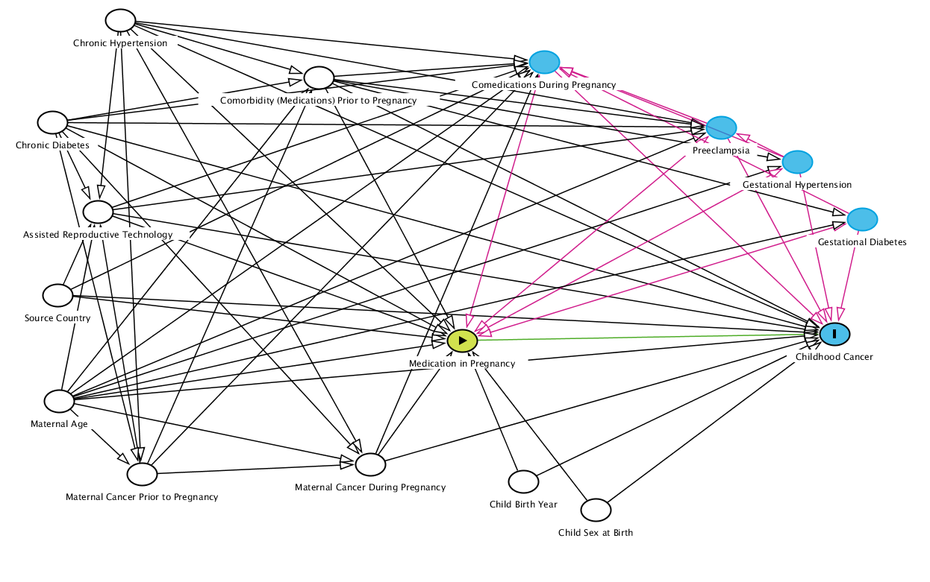

Propensity Score Density and Balance Plots

J01CA Penicillins with extended spectrum
Figure S2a. J01CA Propensity Score Density Plot | Figure S2b. J01CA Propensity Score Density Plot Trimmed Population
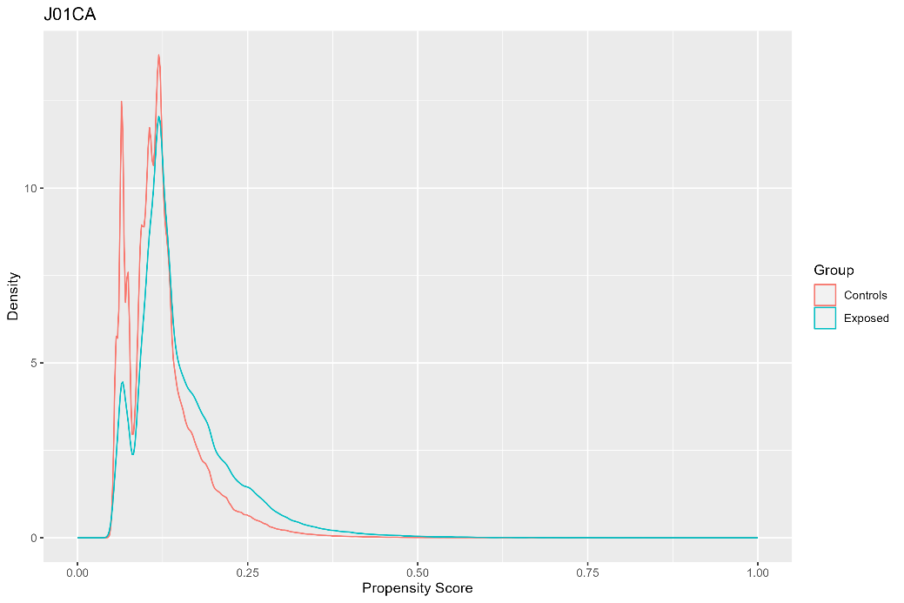 | 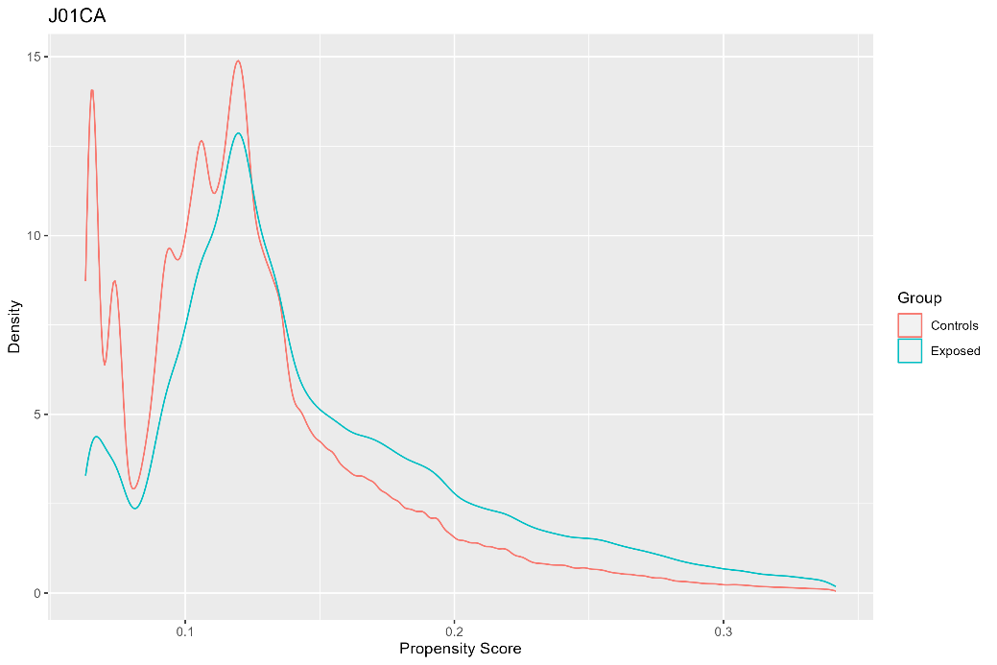
Notes: Population before trimming. Exposed = dispensed J01CA during pregnancy (N = 258,418; maximum propensity = 0.88; minimum propensity 0.05). Controls = not dispensed J01CA during pregnancy (N = 1,765,090; maximum propensity = 0.84; minimum propensity <0.01). | Notes: Population after trimming. Exposed = dispensed J01CA during pregnancy (N = 232,154; 90%; 26,264 trimmed). Controls = not dispensed J01CA during pregnancy (N = 1,626,525; 92%; 138,565 trimmed).

Figure S2c. Absolute Standardised Differences for J01CA
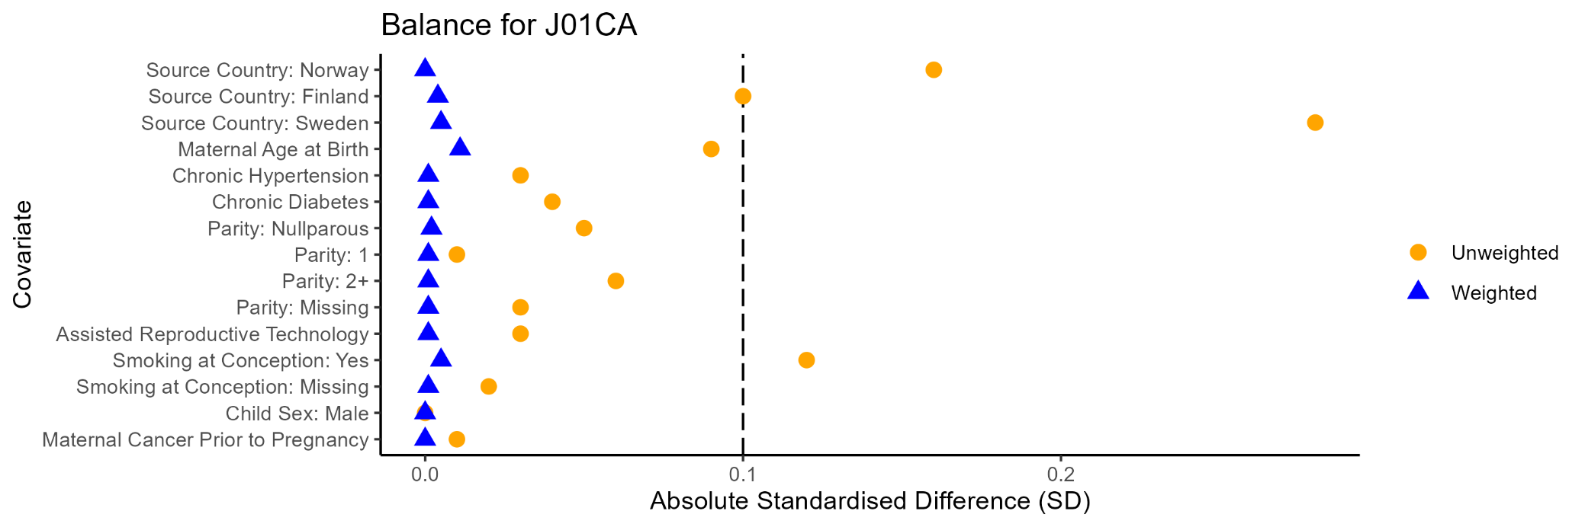

J02CE Beta-lactamase sensitive penicillins
Figure S3a. J02CE Propensity Score Density Plot | Figure S3b. J01CE Propensity Score Density Plot Trimmed Population
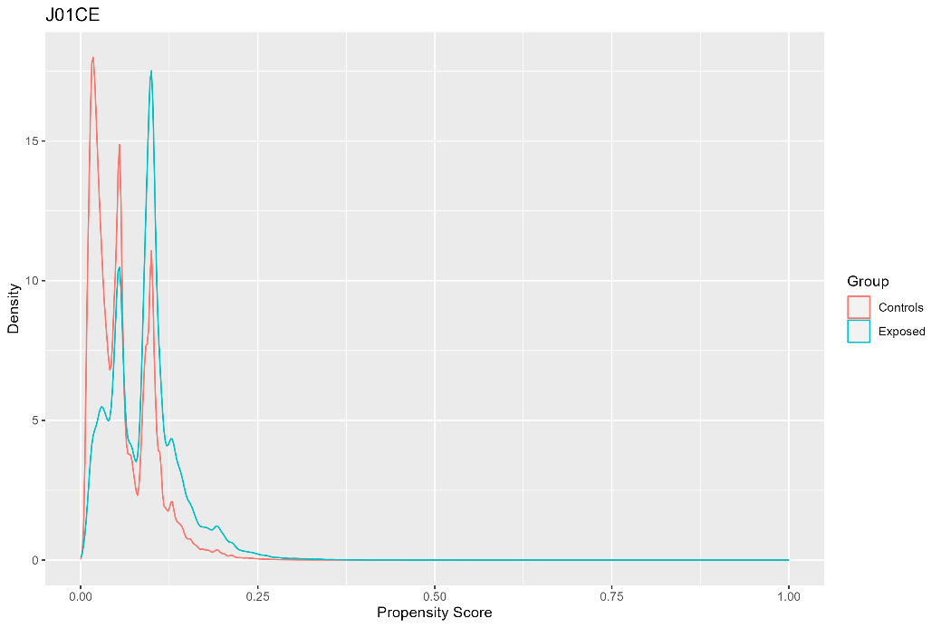 | 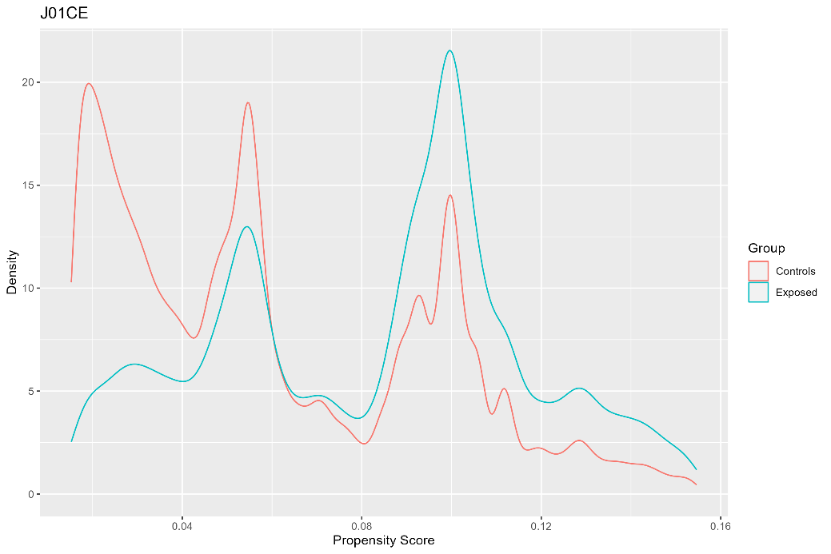
Notes: Population before trimming. Exposed = dispensed J01CE during pregnancy (N = 121,532; maximum propensity = 0.63; minimum propensity <0.01). Controls = not dispensed J01CE during pregnancy (N = 1,901,976; maximum propensity = 0.61; minimum propensity <0.01). | Notes: Population after trimming. Exposed = dispensed J01CE during pregnancy (N = 107,715; 89%; 13,817 trimmed). Controls = not dispensed J01CE during pregnancy (N = 1,638,329; 86%; 263,607 trimmed).

Figure S3c. Absolute Standardised Differences for J01CE
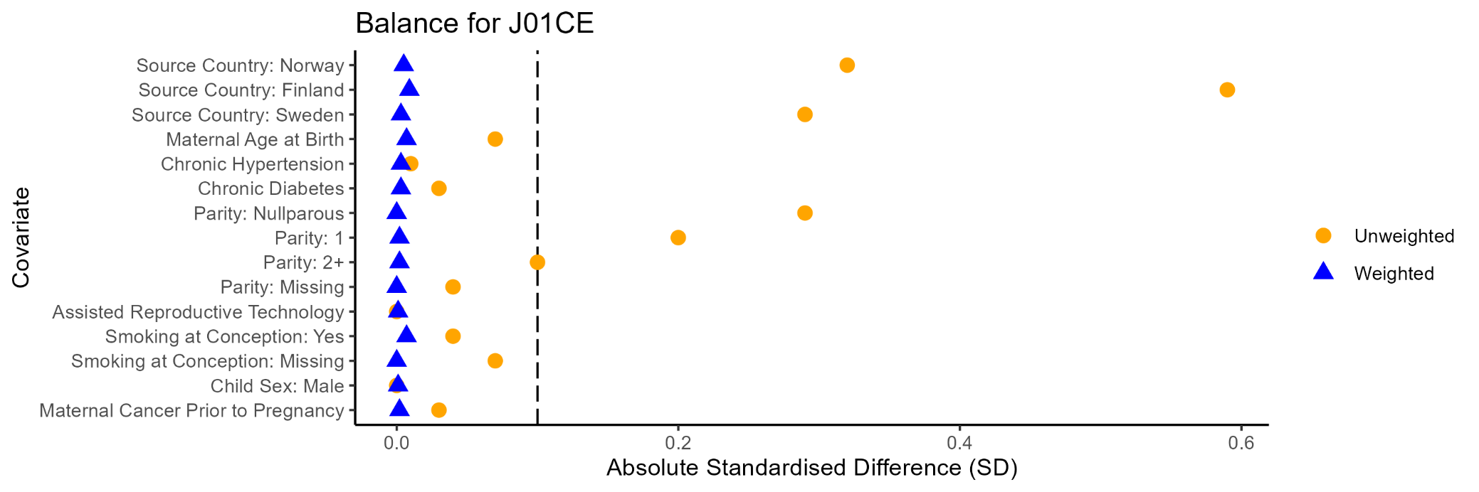

J01CF Beta-lactamase resistant penicillins
Figure S4a. J01CF Propensity Score Density Plot | Figure S4b. J01CF Propensity Score Density Plot Trimmed Population
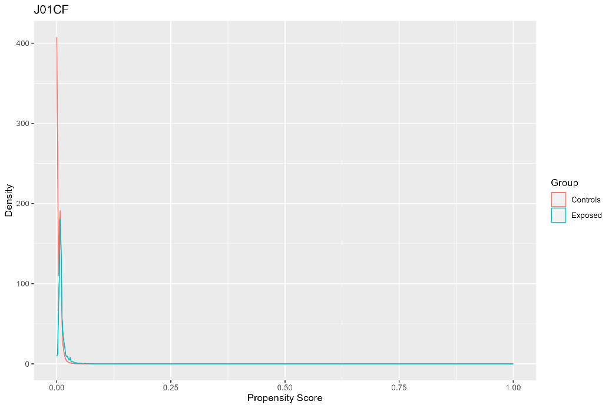 | 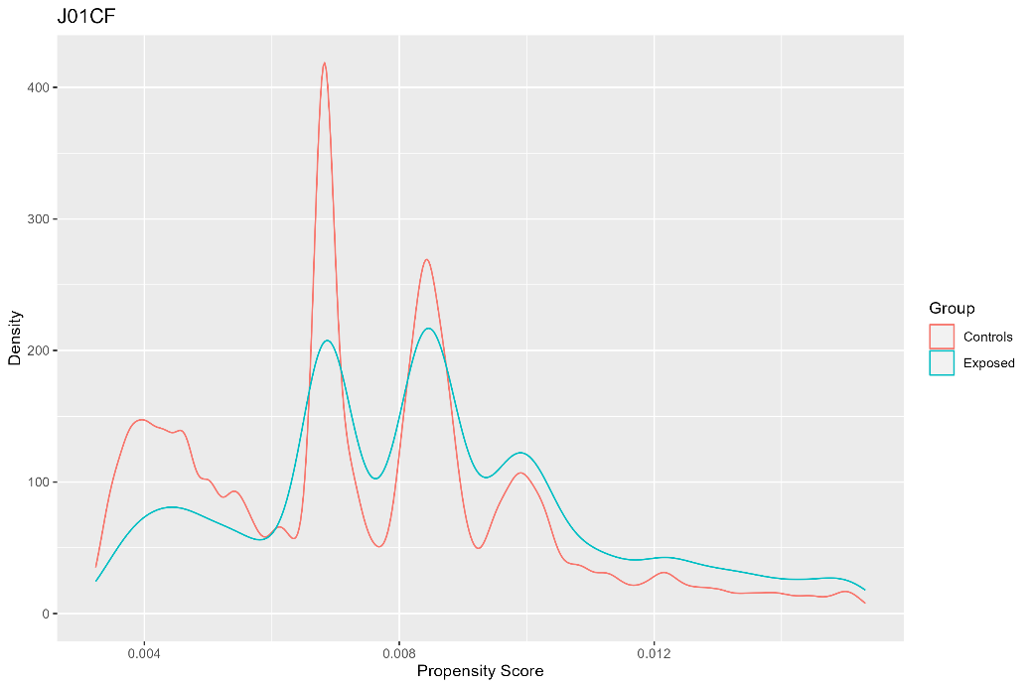
Notes: Population before trimming. Exposed = dispensed J01CF during pregnancy (N = 8,112; maximum propensity = 0.64; minimum propensity < 0.01). Controls = not dispensed J01CF during pregnancy (N = 2,015,396; maximum propensity = 0.46; minimum propensity <0.01). | Notes: Population after trimming. Exposed = dispensed J01CF during pregnancy (N = 6,707; 83%; 1,405 trimmed). Controls = not dispensed J01CF during pregnancy (N = 899,869; 45%; 1,115,527 trimmed).

Figure S4c. Absolute Standardised Differences for J01CF
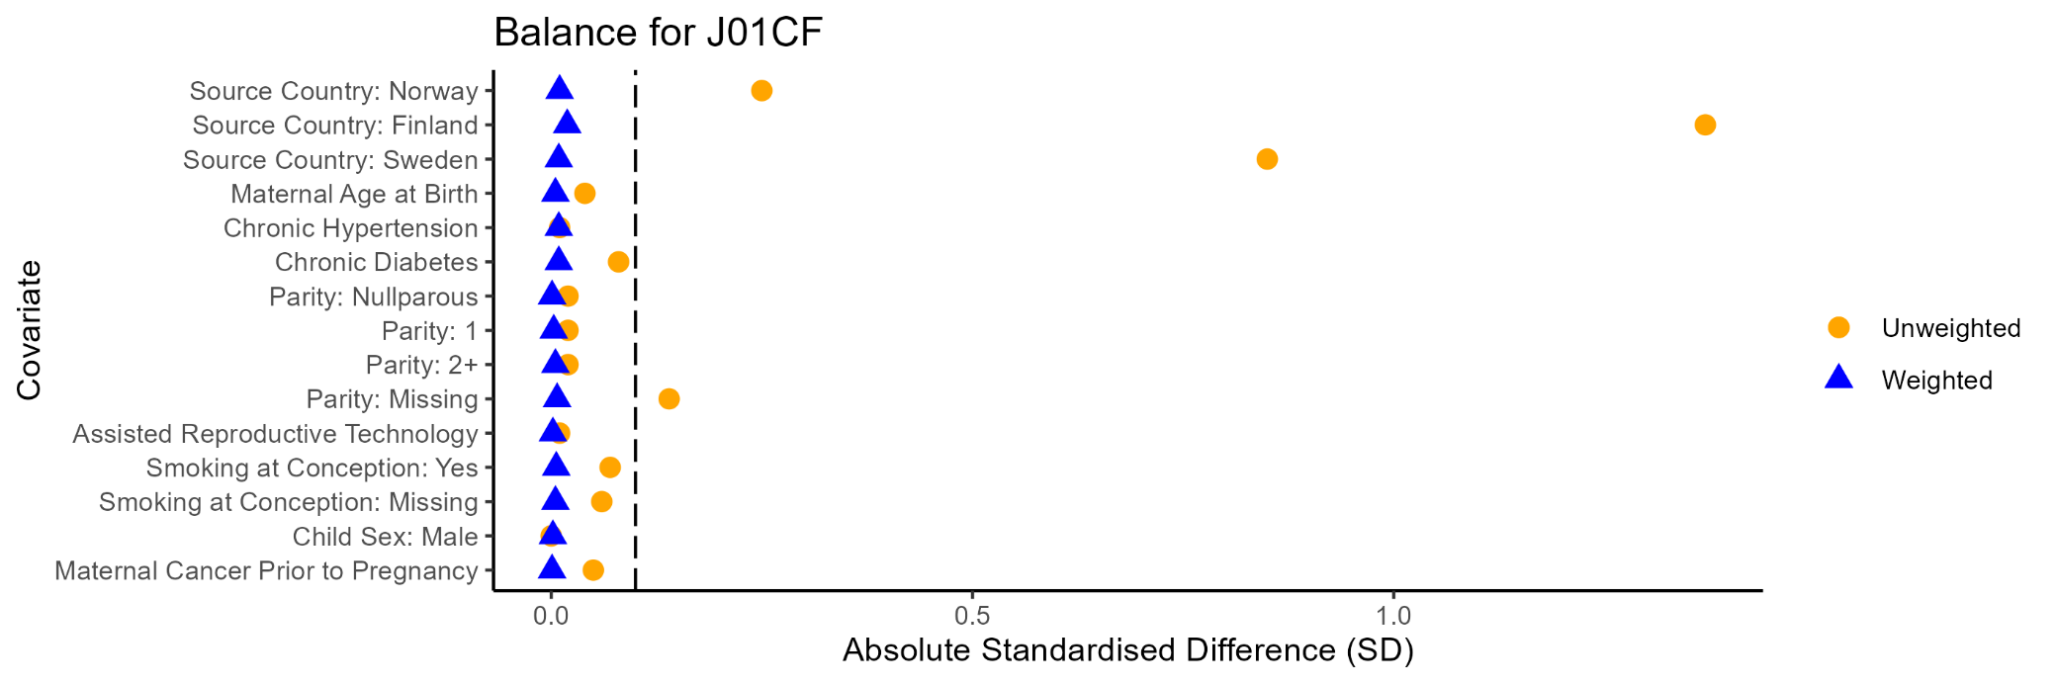

J01DB First-generation cephalosporins
Figure S5a. J01DB Propensity Score Density Plot | Figure S5b. J01DB Propensity Score Density Plot Trimmed Population
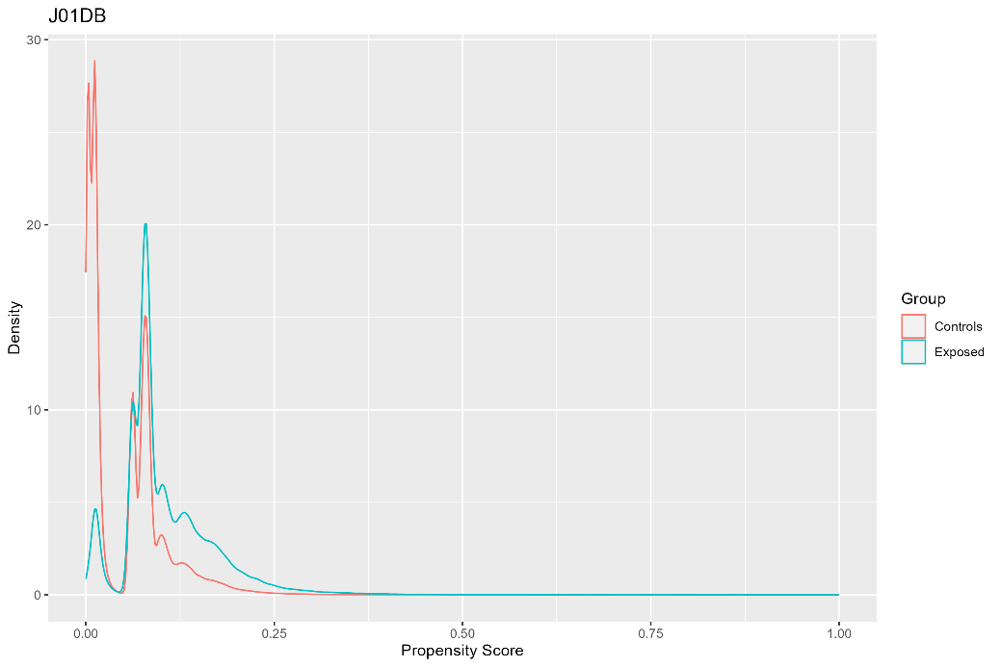 | 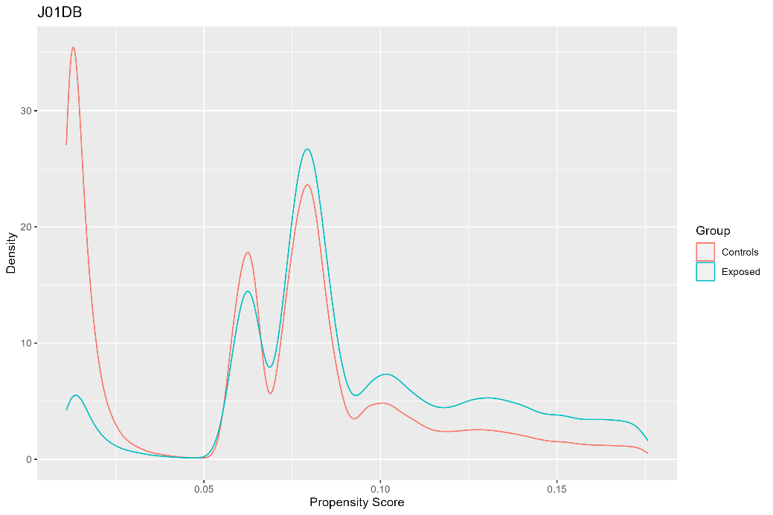
Notes: Population before trimming. Exposed = dispensed J01DB during pregnancy (N = 109,932; maximum propensity = 0.87; minimum propensity < 0.01). Controls = not dispensed J01DB during pregnancy (N = 1,913,576; maximum propensity = 0.78; minimum propensity <0.01). | Notes: Population after trimming. Exposed = dispensed J01DB during pregnancy (N = 93,995; 86%; 15,937 trimmed). Controls = not dispensed J01DB during pregnancy (N = 1,303,829; 68%; 609,747 trimmed).

Figure S5c. Absolute Standardised Differences for J01DB
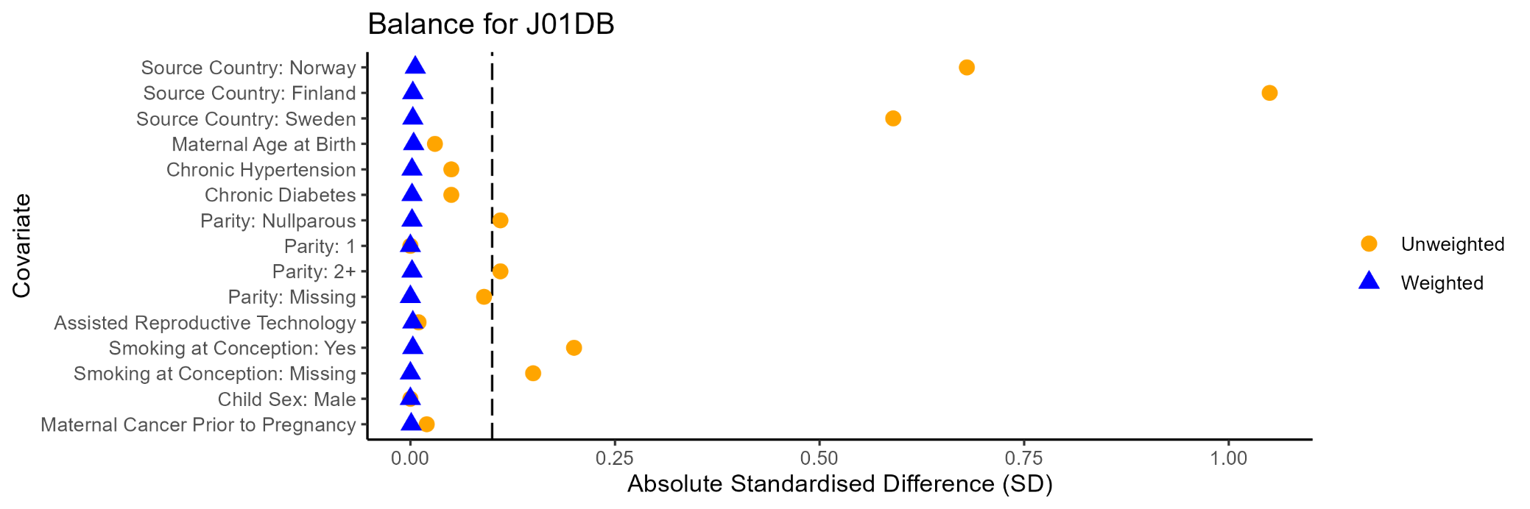

J01EA Trimethroprim and derivatives
Figure S6a. J01EA Propensity Score Density Plot | Figure S6b. J01EA Propensity Score Density Plot Trimmed Population
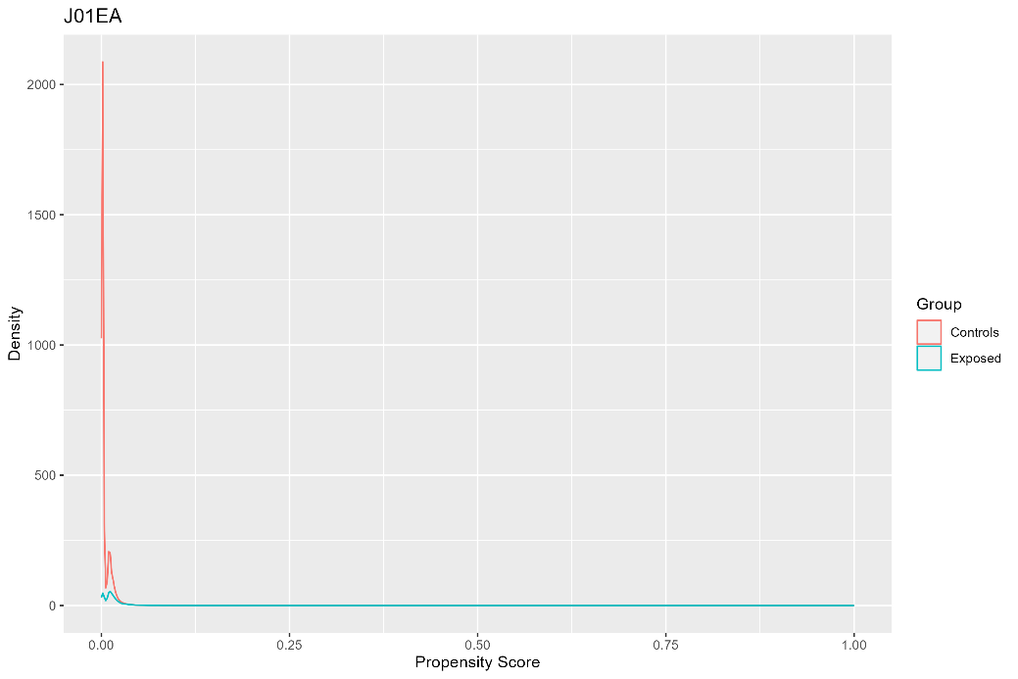 | 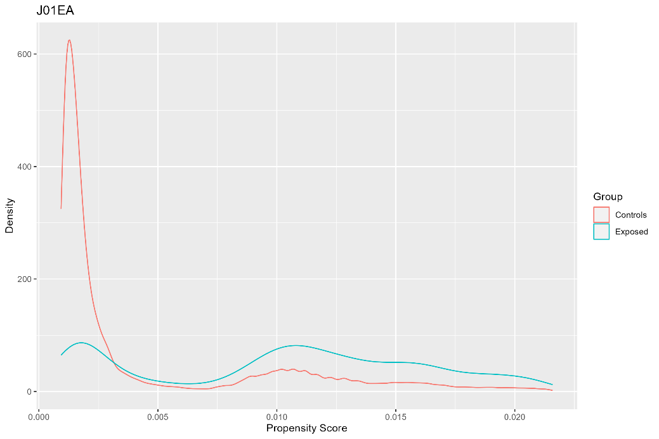
Notes: Population before trimming. Exposed = dispensed J01EA during pregnancy (N = 8,984; maximum propensity = 0.43; minimum propensity <0.01). Controls = not dispensed J01EA during pregnancy (N = 2,014,524; maximum propensity = 0.67; minimum propensity <0.01). | Notes: Population after trimming. Exposed = dispensed J01EA during pregnancy (N = 7,154; 80%; 1,830 trimmed). Controls = not dispensed J01EA during pregnancy (N = 1,548,026; 77%; 466,498 trimmed).

Figure S6c. Absolute Standardised Differences for J01EA
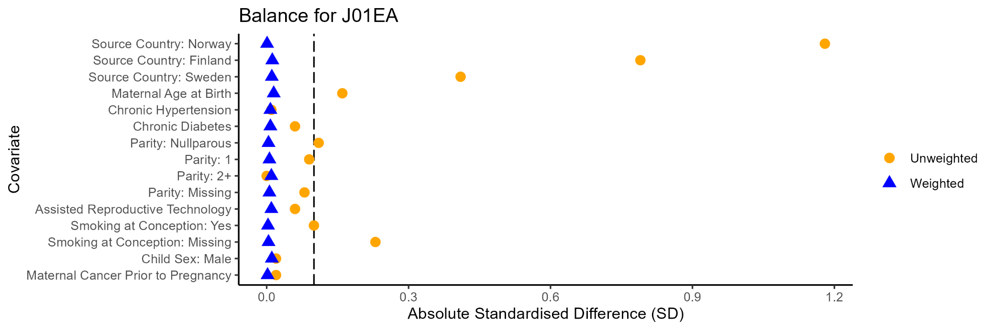

J01FA Macrolides
Figure S7a. J01FA Propensity Score Density Plot | Figure S7b. J01FA Propensity Score Density Plot Trimmed Population
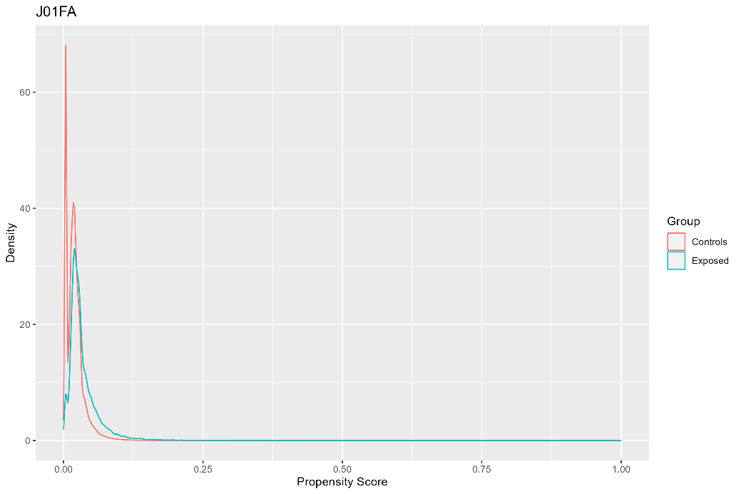 | 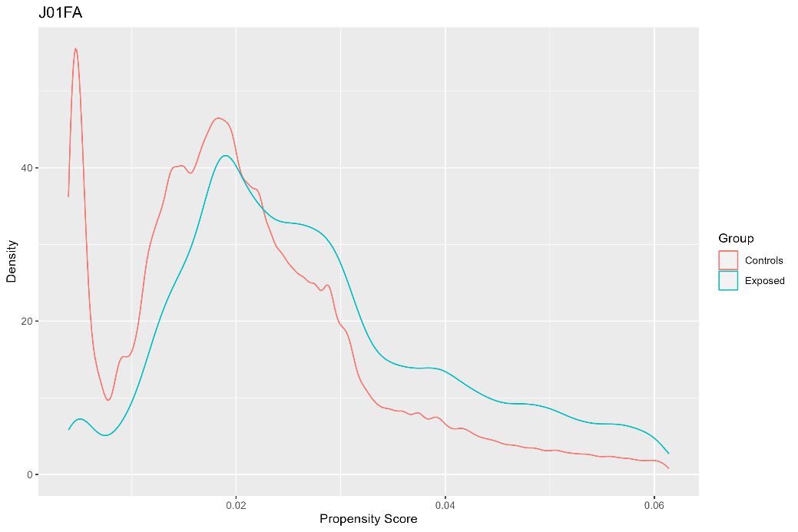
Notes: Population before trimming. Exposed = dispensed J01FA during pregnancy (N = 40,336; maximum propensity = 0.84; minimum propensity <0.01). Controls = not dispensed J01FA during pregnancy (N = 1,983,172; maximum propensity = 0.81; minimum propensity <0.01). | Notes: Population after trimming. Exposed = dispensed J01FA during pregnancy (N = 34,705; 86%; 5,631 trimmed). Controls = not dispensed J01FA during pregnancy (N = 1,614,731; 81%; 368,441 trimmed).

Figure S7c. Absolute Standardised Differences for J01FA
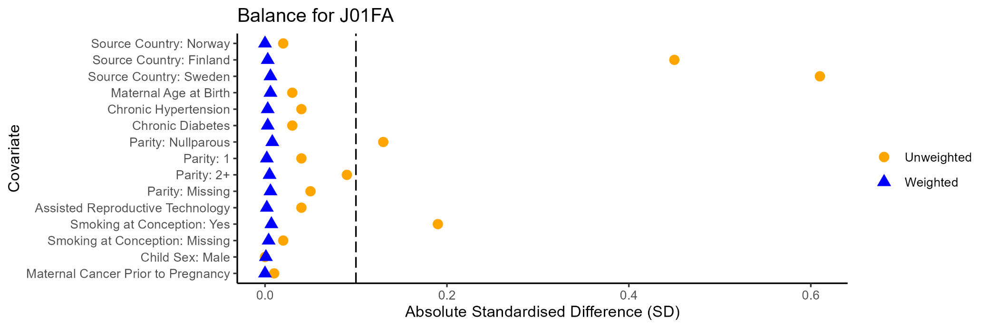

J01XE Nitrofuran derivatives
Figure S8a. J01XE Propensity Score Density Plot | Figure S8b. J01XE Propensity Score Density Plot Trimmed Population
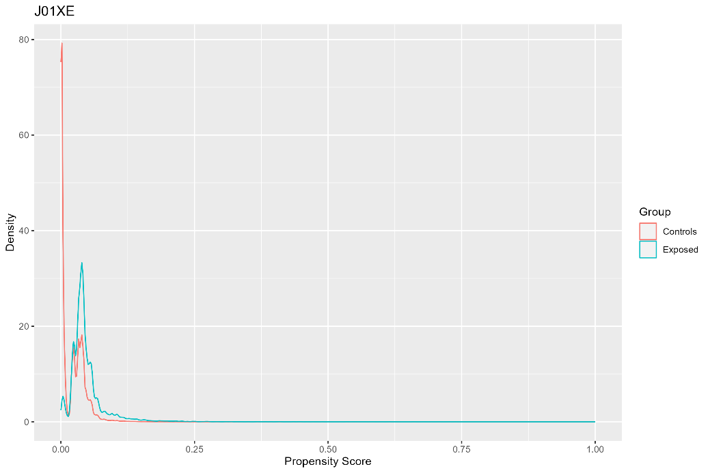 | 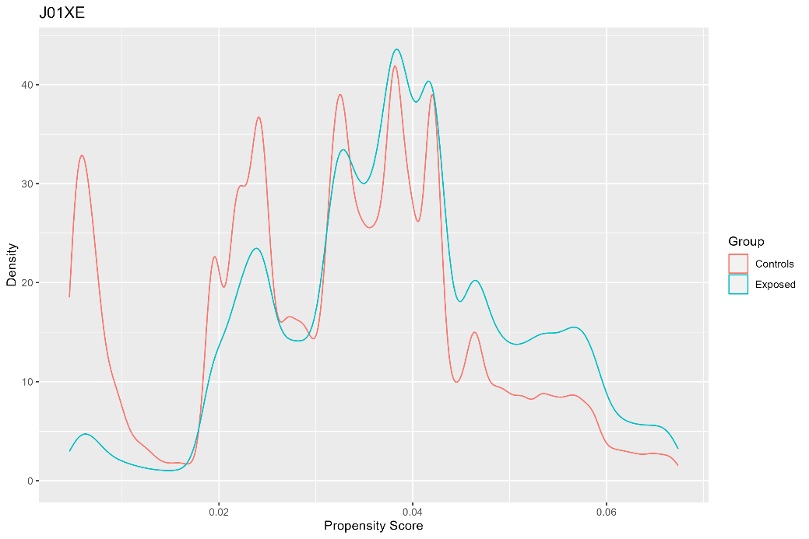
Notes: Population before trimming. Exposed = dispensed J01XE during pregnancy (N = 41,372; maximum propensity = 0.74; minimum propensity <0.01). Controls = not dispensed J01XE during pregnancy (N = 1,982,136; maximum propensity = 0.90; minimum propensity <0.01). | Notes: Population after trimming. Exposed = dispensed J01XE during pregnancy (N = 34,721; 84%; 6,651 trimmed). Controls = not dispensed J01XE during pregnancy (N = 1,052,471; 53%; 929,665 trimmed).

Figure S8c. Absolute Standardised Differences for J01XE
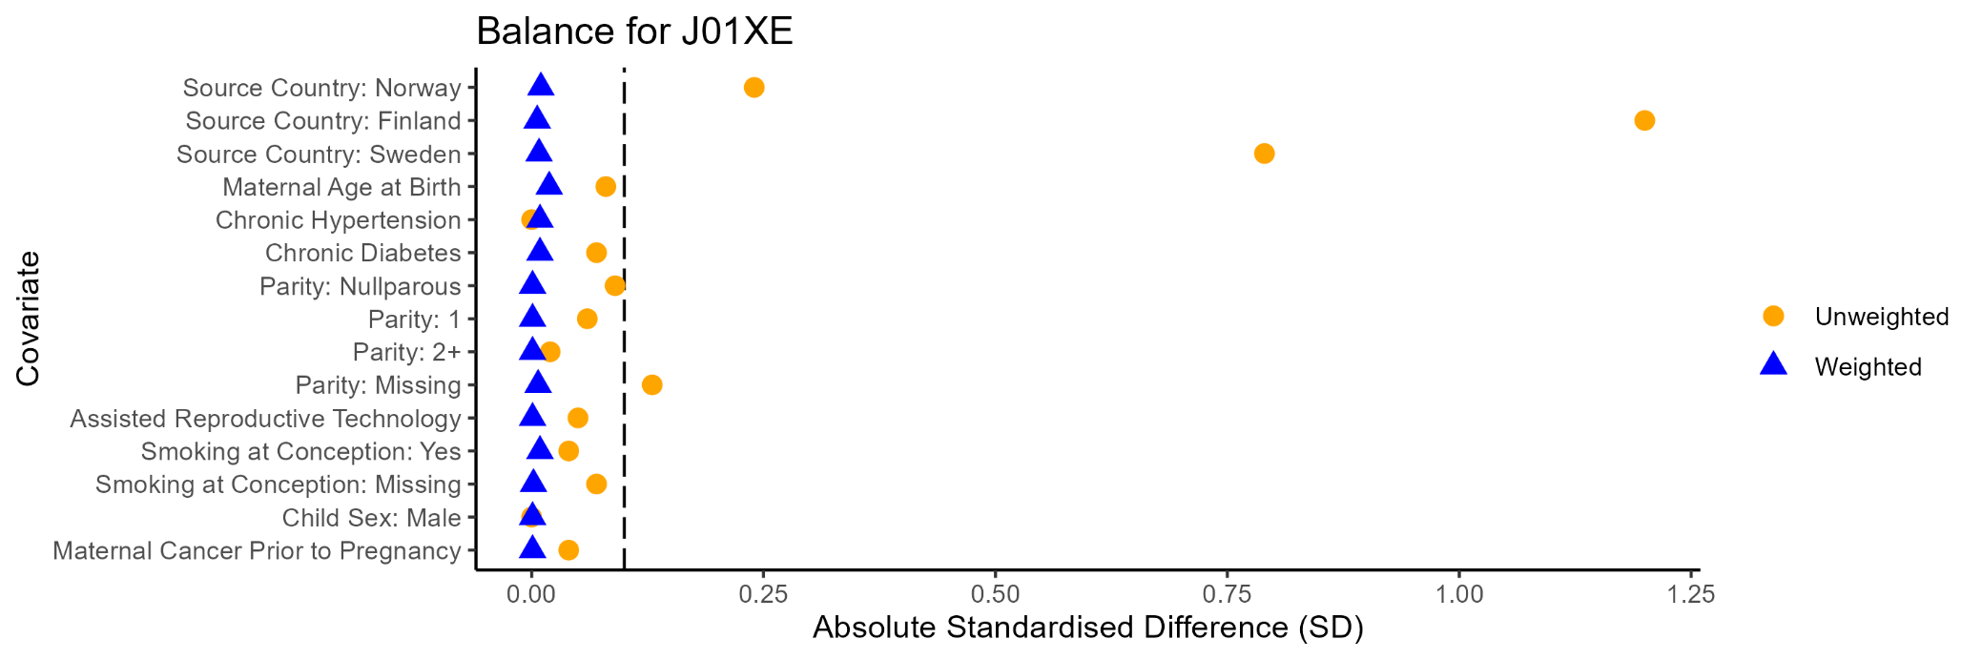

A10AB Insulins and analogues for injection, fast-acting
Figure S9a. A10AB Propensity Score Density Plot | Figure S9b. A10AB Propensity Score Density Plot Trimmed Population
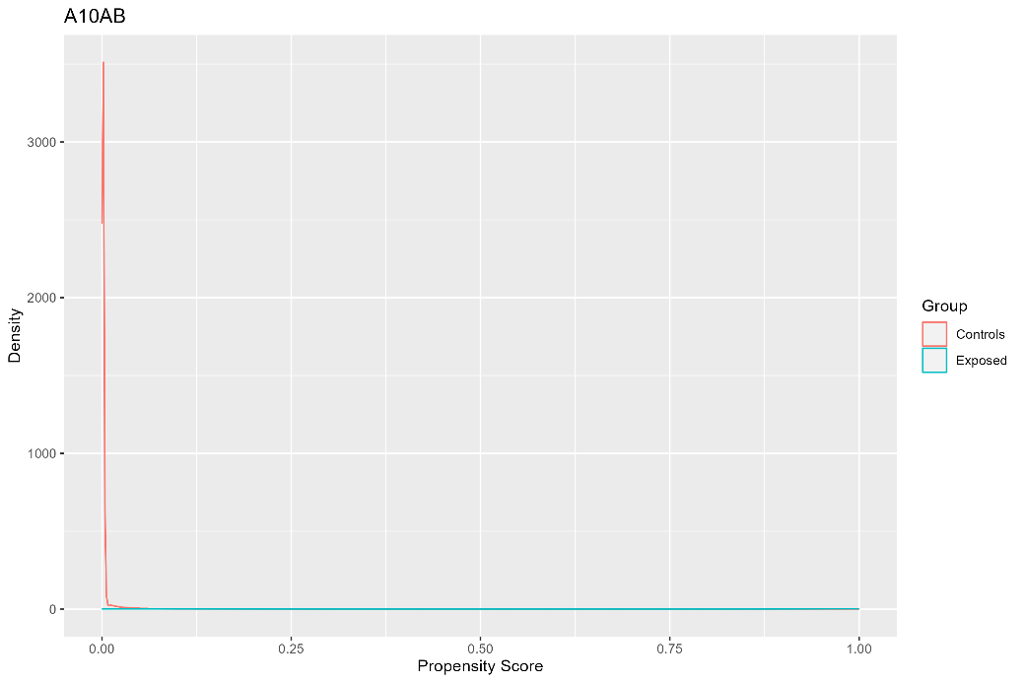 | 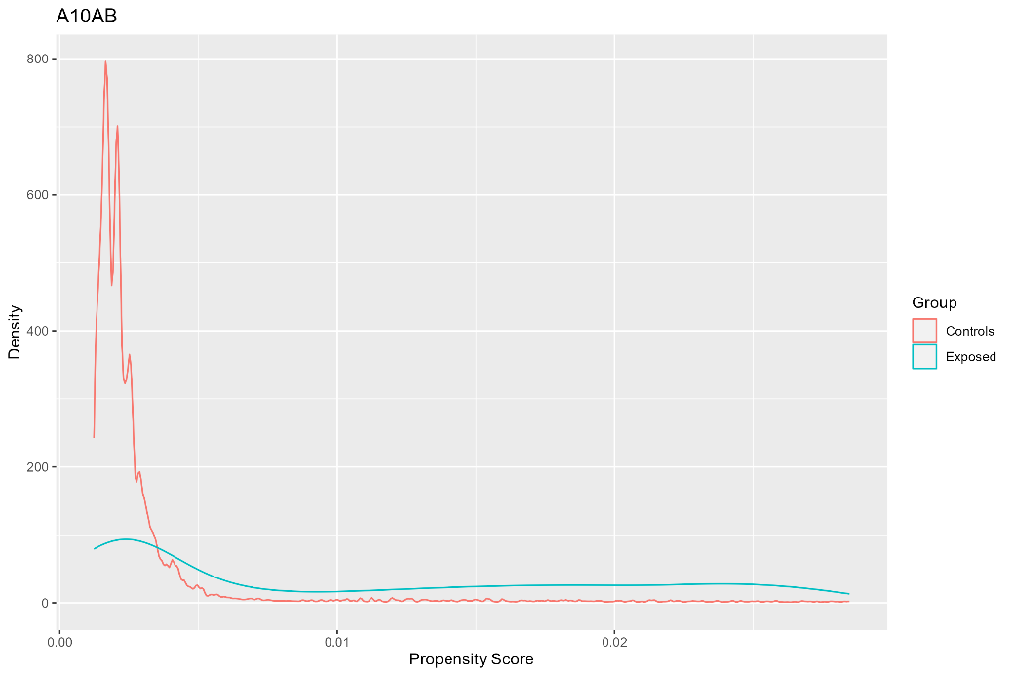
Notes: Population before trimming. Exposed = dispensed A10AB during pregnancy (N = 18,340; maximum propensity = 1; minimum propensity < 0.01). Controls = not dispensed A10AB during pregnancy (N = 2,005,168; maximum propensity = 1; minimum propensity < 0.01). | Notes: Population after trimming. Exposed = dispensed A10AB during pregnancy (N = 2,172; 12%; 16,168 trimmed). Controls = not dispensed A10AB during pregnancy (N = 901,019; 46%; 1,084,149 trimmed).

Figure S9c. Absolute Standardised Differences for A10AB
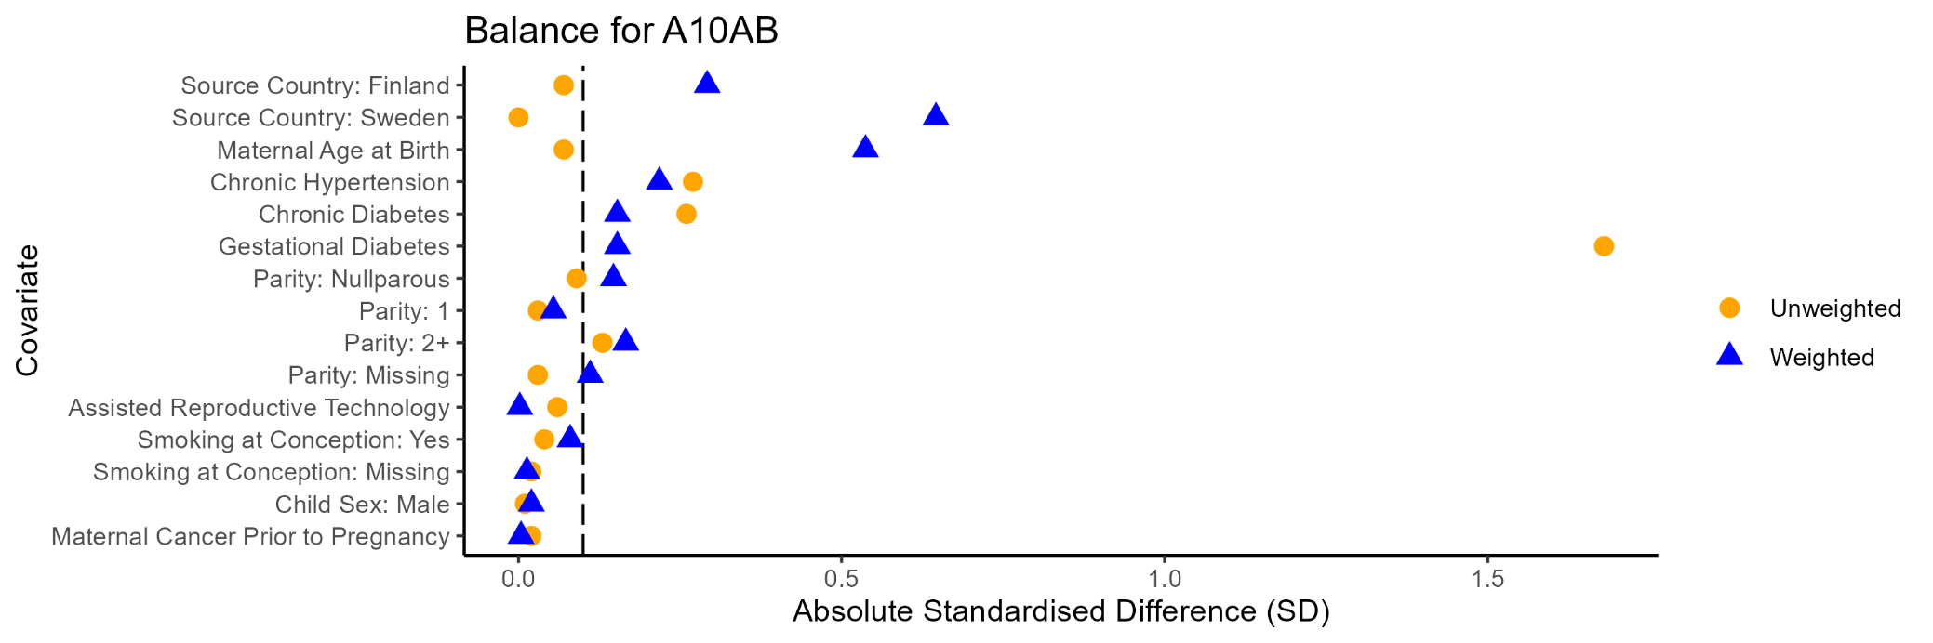

A10AC Insulins and analogues for injection, intermediate-acting
Figure S10a. A10AC Propensity Score Density Plot | Figure S10b. A10AC Propensity Score Density Plot Trimmed Population
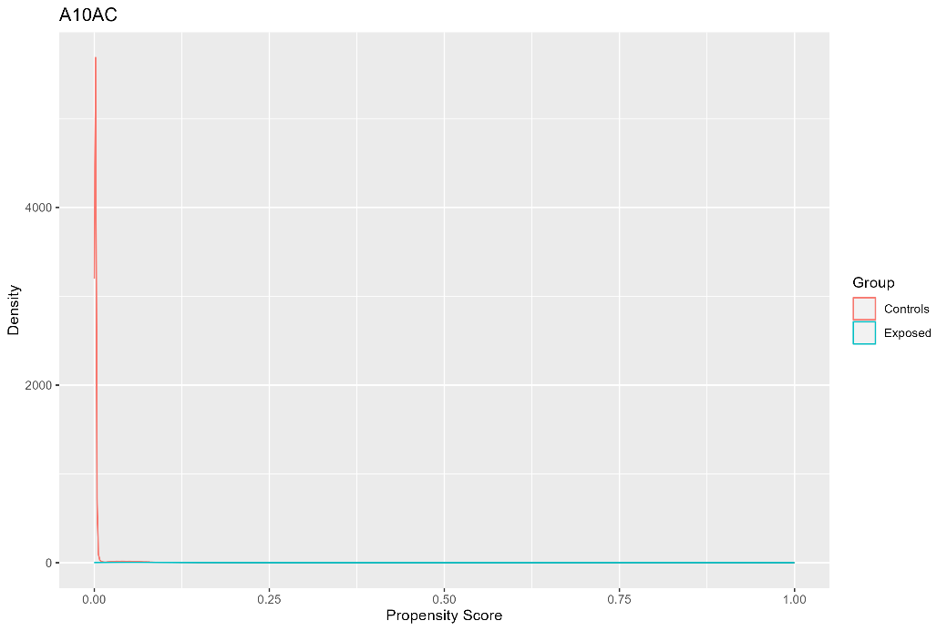 | 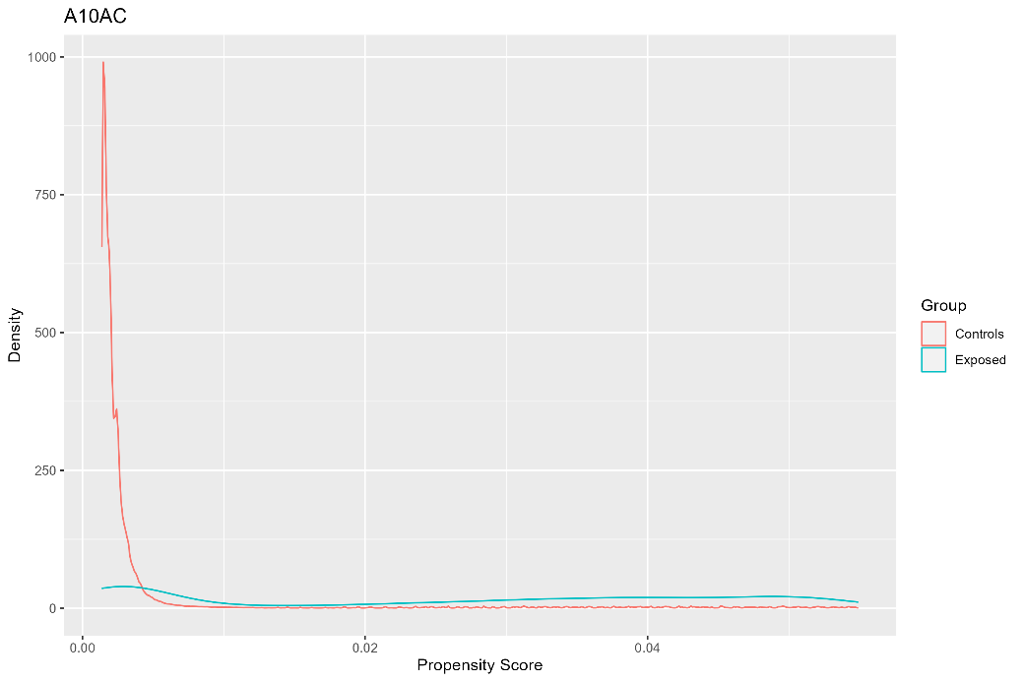
Notes: Population before trimming. Exposed = dispensed A10AC during pregnancy (N = 14,525; maximum propensity = 1; minimum propensity < 0.01). Controls = not dispensed A10AC during pregnancy (N = 2,008,983; maximum propensity = 1; minimum propensity < 0.01). | Notes: Population after trimming. Exposed = dispensed A10AC during pregnancy (N = 4,108; 28%; 10,471 trimmed). Controls = not dispensed A10AC during pregnancy (N = 827,183; 41%; 1,181,800 trimmed).

Figure S10c. Absolute Standardised Differences for A10AC
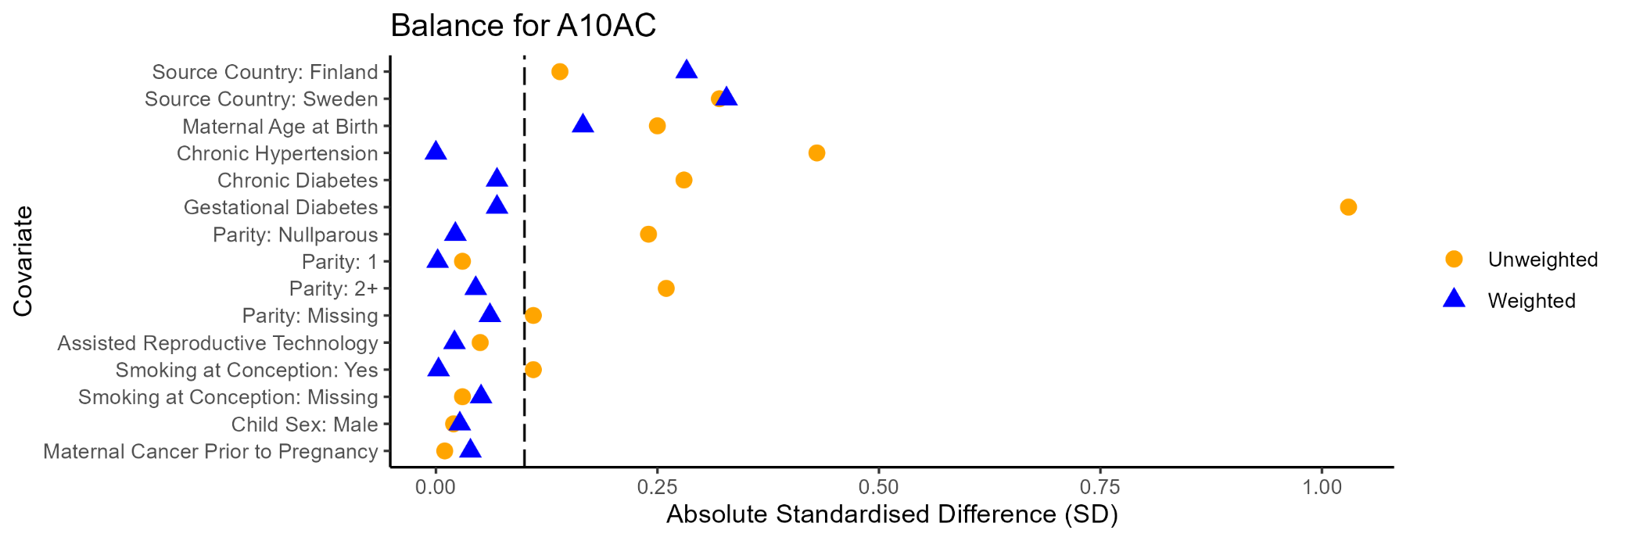

A10AE Insulins and analogues for injection, long-acting
Figure S11a. A10AE Propensity Score Density Plot | Figure S11b. A10AE Propensity Score Density Plot Trimmed Population
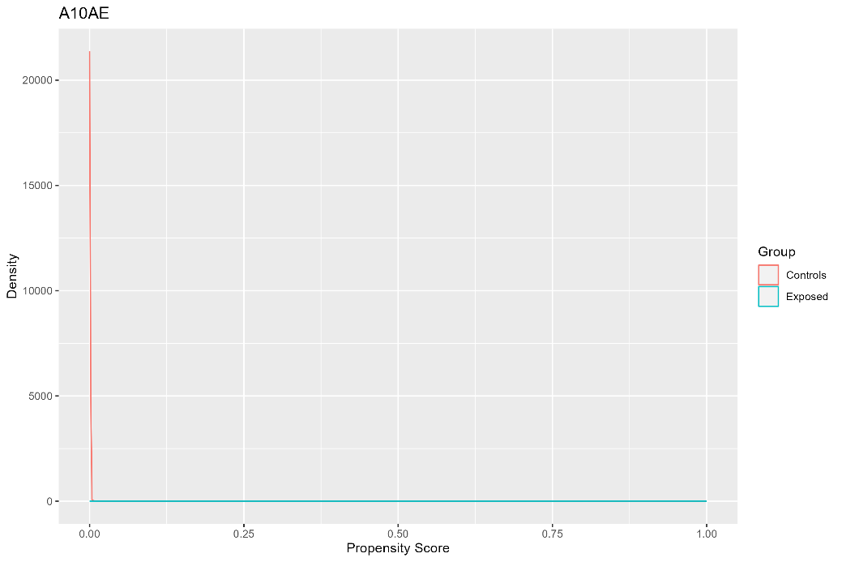 | 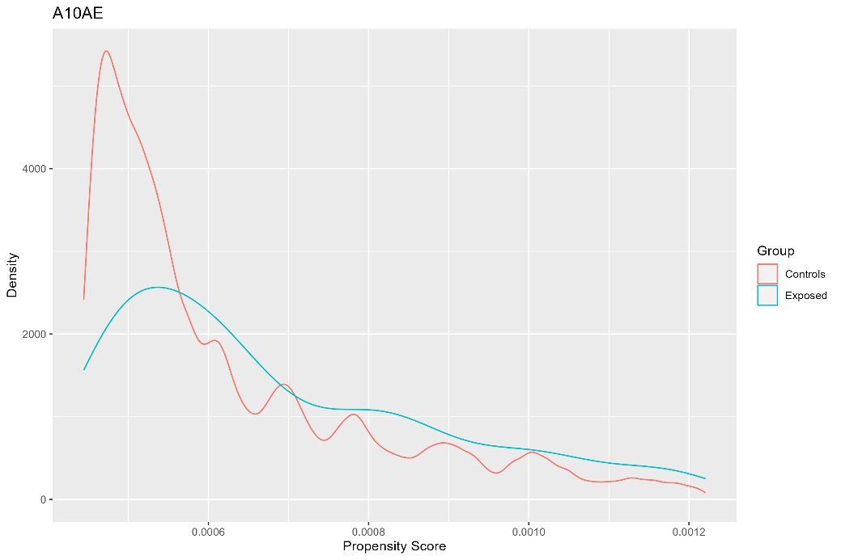
Notes: Population before trimming. Exposed = dispensed A10AE during pregnancy (N = 5,772; maximum propensity = 1; minimum propensity <0.01). Controls = not dispensed A10AE during pregnancy (N = 2,017,736; maximum propensity = 1; minimum propensity <0.01). | Notes: Population after trimming. Exposed = dispensed A10AE during pregnancy (N = 279; 4.8%; 5,493 trimmed). Controls = not dispensed A10AE during pregnancy (N = 515,093; 26%; 1,502,643 trimmed).

Figure S11c. Absolute Standardised Differences for A10AE
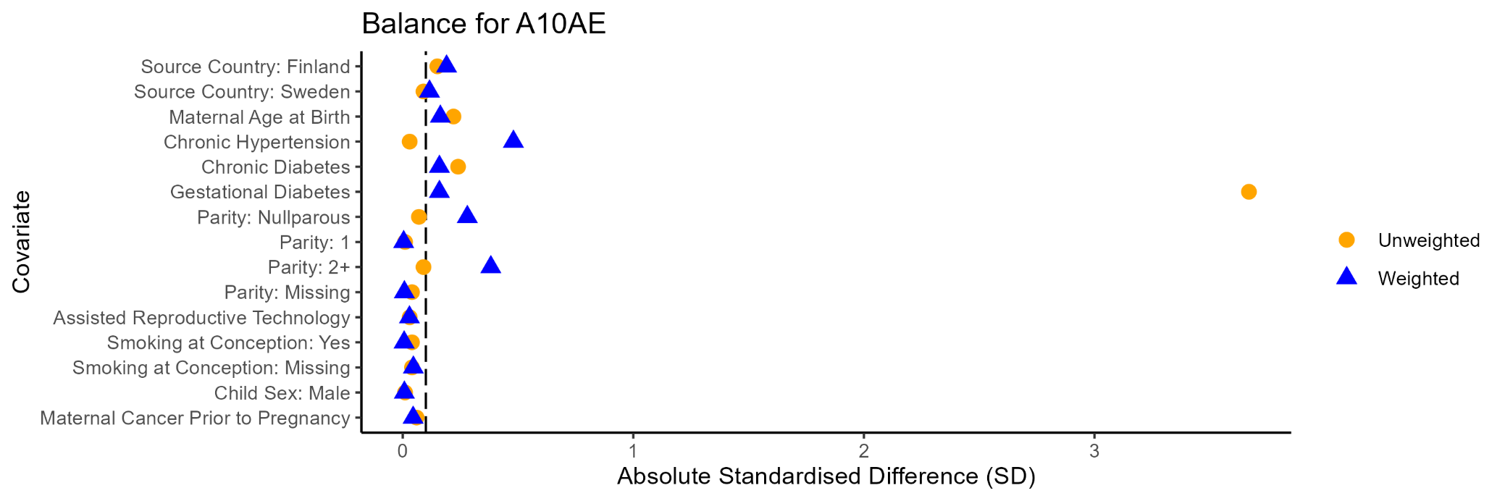

C05AA Corticosteroids
Figure S12a. C05AA Propensity Score Density Plot | Figure S12b. C05AA Propensity Score Density Plot Trimmed Population
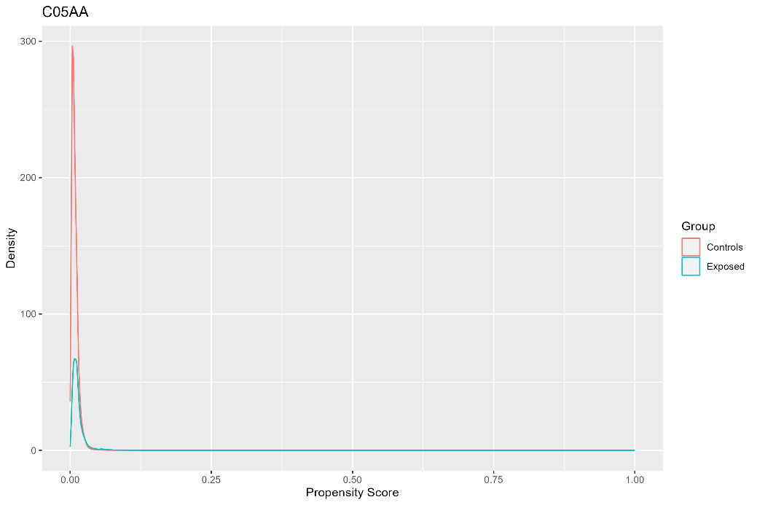 | 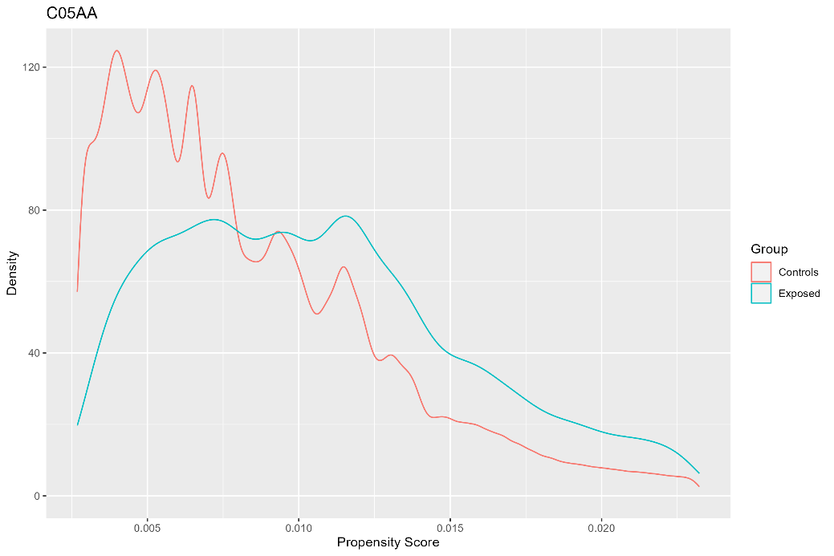
Notes: Population before trimming. Exposed = dispensed C05AA during pregnancy (N = 17,046; maximum propensity = 0.79; minimum propensity <0.01). Controls = not dispensed C05AA during pregnancy (N =2,006,262; maximum propensity = 0.62; minimum propensity <0.01 ). | Notes: Population after trimming. Exposed = dispensed C05AA during pregnancy (N = 14,743; 86%; 2,303 trimmed). Controls = not dispensed C05AA during pregnancy (N = 1,758,152; 88%; 248,310 trimmed).

Figure S12c. Absolute Standardised Differences for C05AA
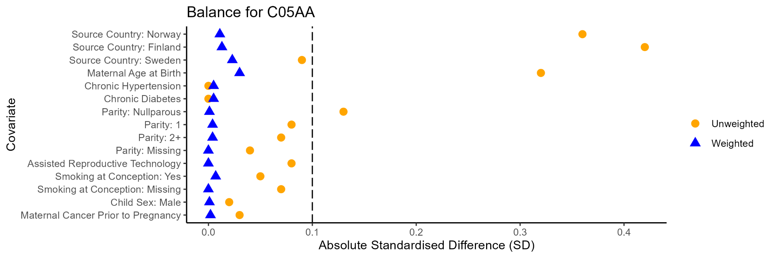

C07AG Alpha and Beta blocking agents
Figure S13a. C07AG Propensity Score Density Plot | Figure S13b. C07AG Propensity Score Density Plot Trimmed Population
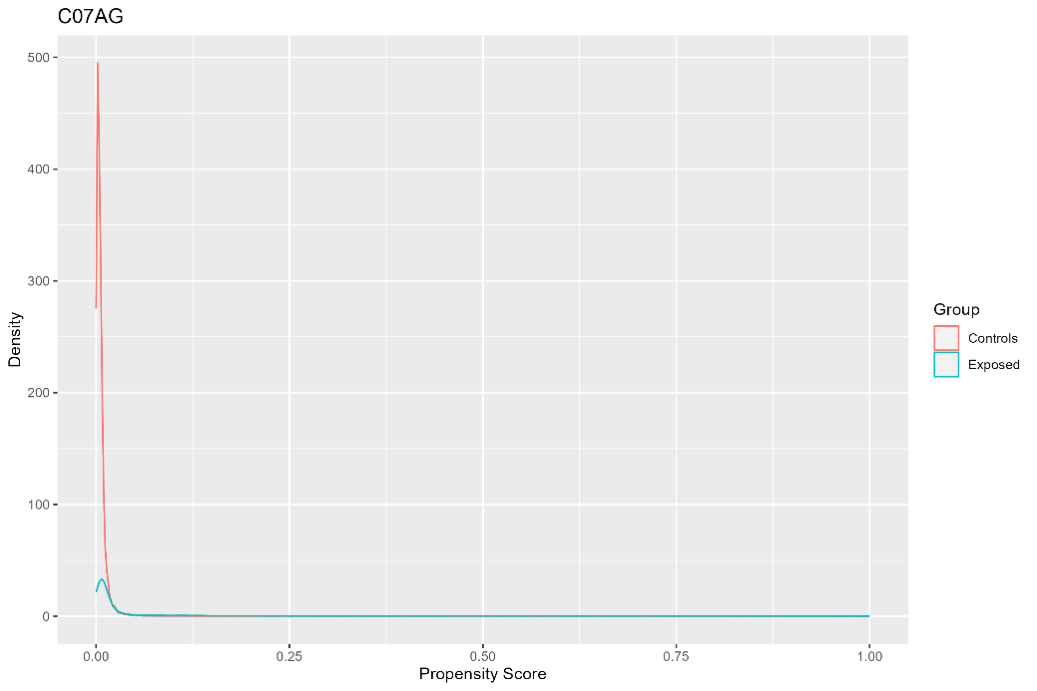 | 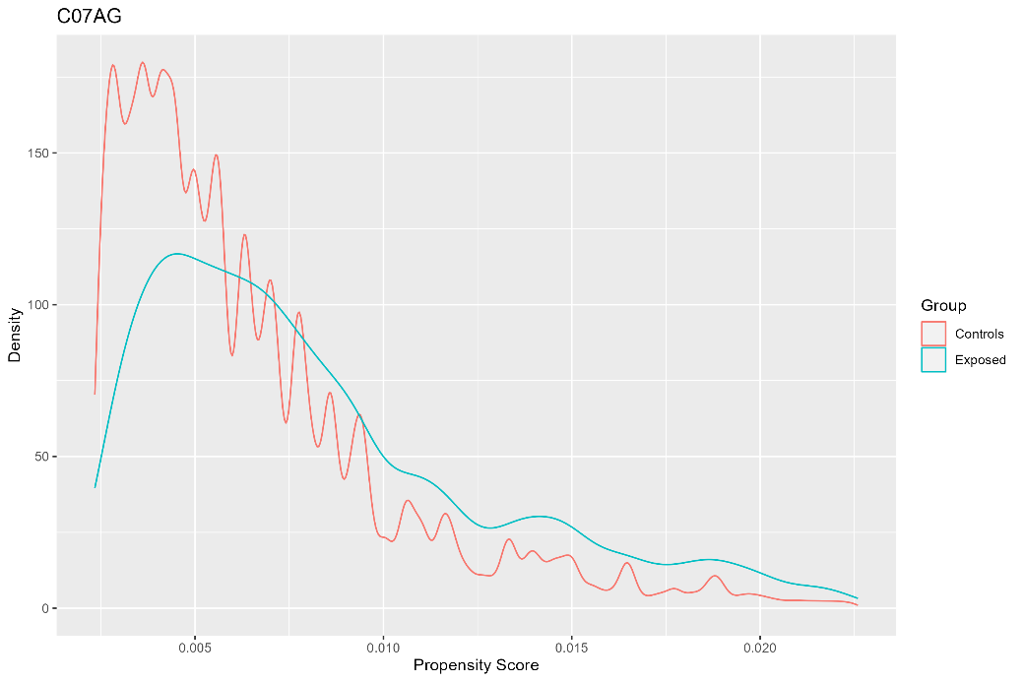
Notes: Population before trimming. Exposed = dispensed C07AG during pregnancy (N = 14,110; maximum propensity = 1; minimum propensity <0.01). Controls = not dispensed C07AG during pregnancy (N = 2,009,398; maximum propensity = 1; minimum propensity < 0.01). | Notes: Population after trimming. Exposed = dispensed C07AG during pregnancy (N = 8,928; 63%; 5,182 trimmed). Controls = not dispensed C07AG during pregnancy (N = 1,297,825; 65%; 711,573 trimmed).

Figure S13c. Absolute Standardised Differences for C07AG
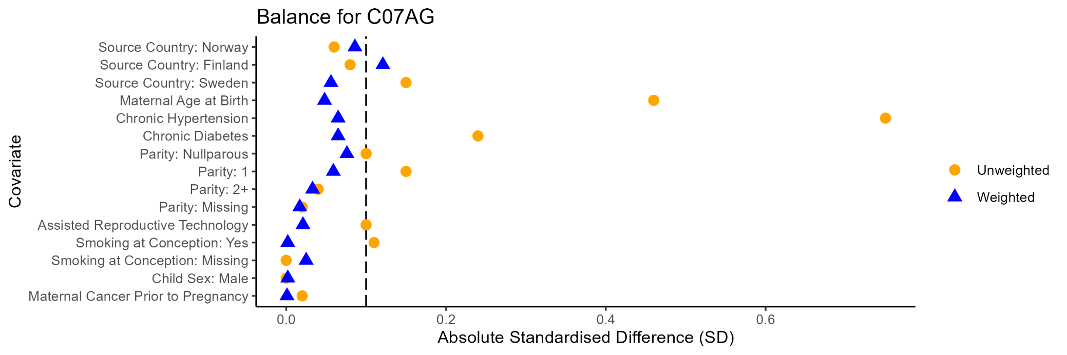

H02AB Glucocorticoids
Figure S14a. H02AB Propensity Score Density Plot | Figure S14b. H02AB Propensity Score Density Plot Trimmed Population
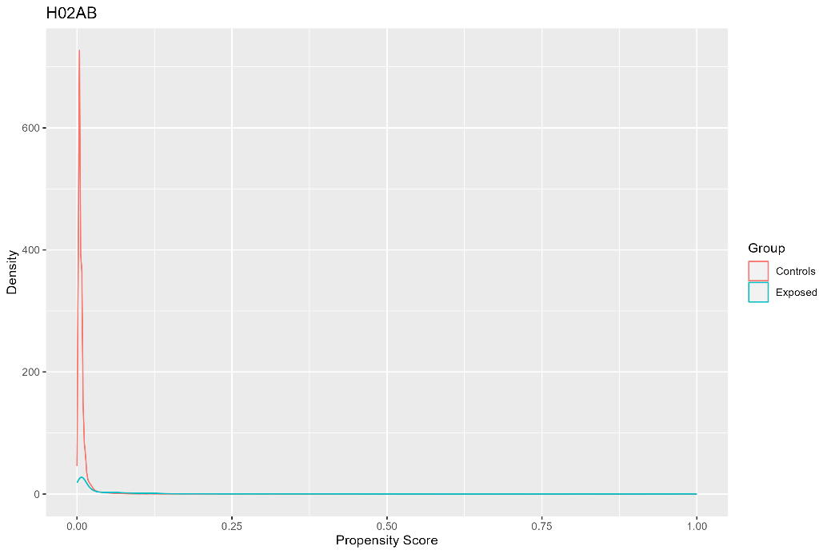 | 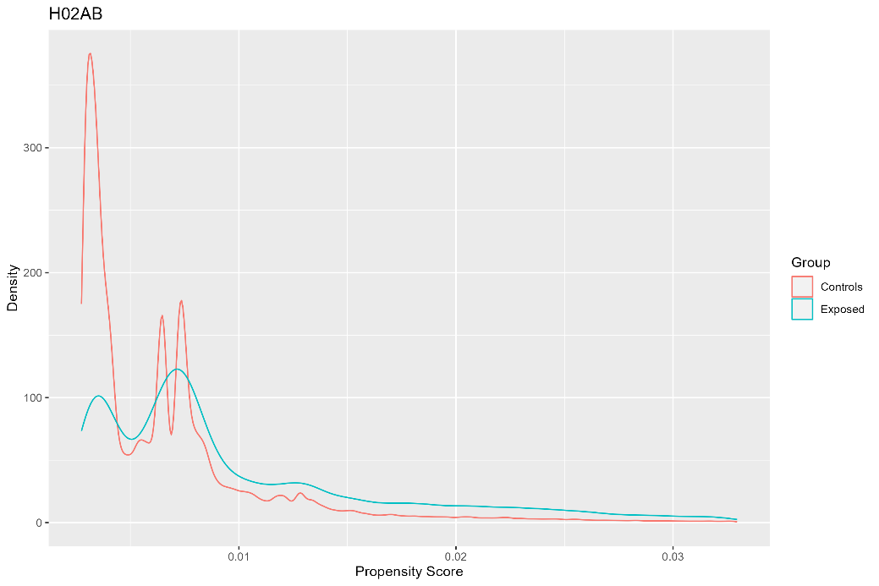
Notes: Population before trimming. Exposed = dispensed H02AB during pregnancy (N = 18,962; maximum propensity = 1; minimum propensity <0.01). Controls = not dispensed H02AB during pregnancy (N = 2,004,546; maximum propensity = 1; minimum propensity <0.01). | Notes: Population after trimming. Exposed = dispensed H02AB during pregnancy (N = 11,377; 60%; 7,585 trimmed). Controls = not dispensed H02AB during pregnancy (N = 1,778,725; 89%; 225,821 trimmed).

Figure S14c. Absolute Standardised Differences for H02AB
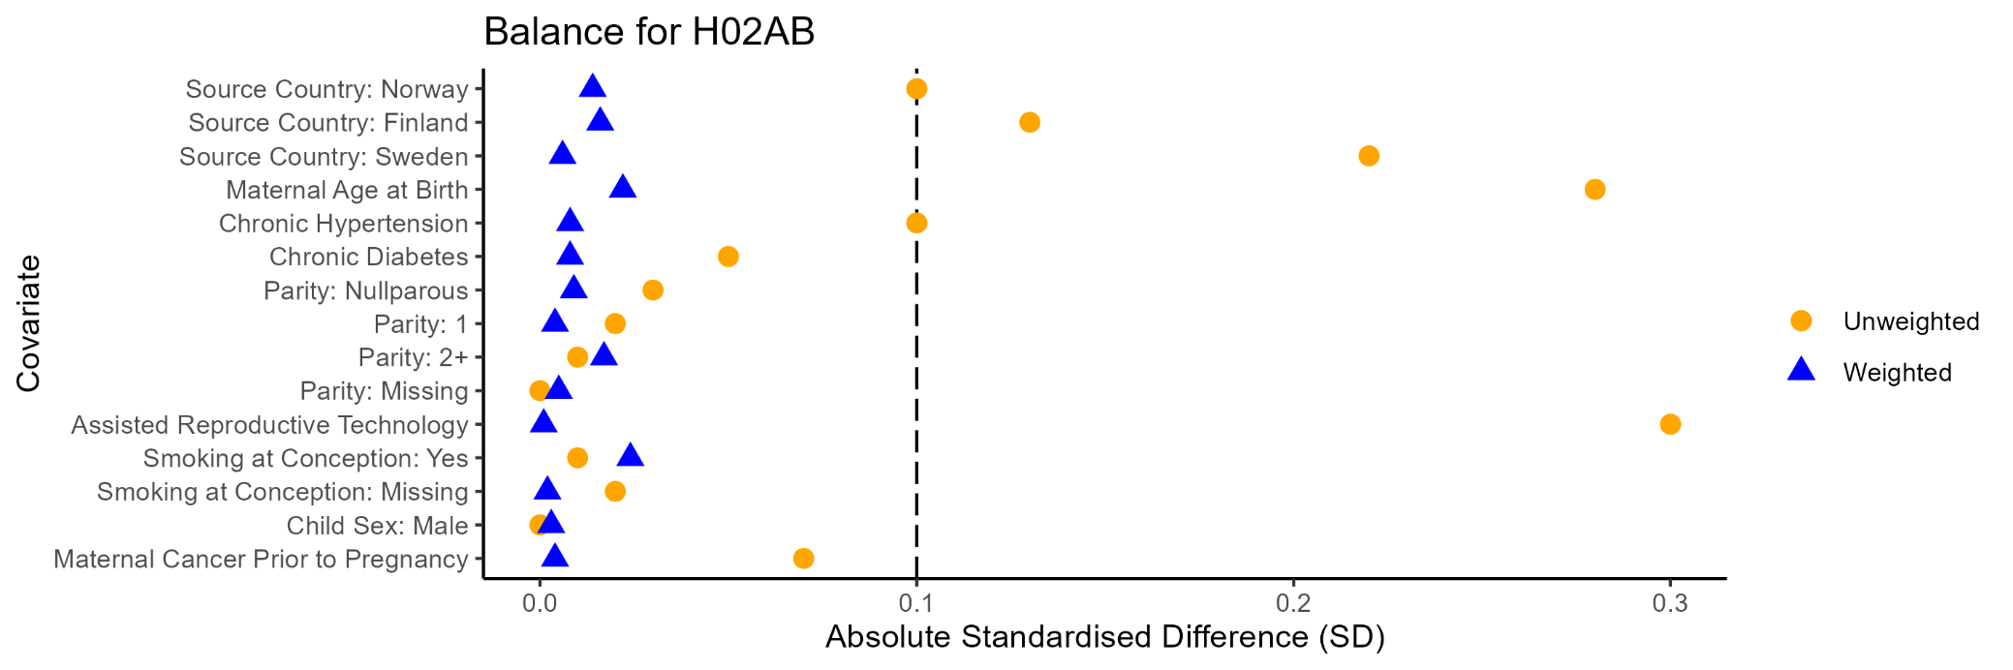

M01AE Propionic acid derivatives
Figure S15a. M01AE Propensity Score Density Plot | Figure S15b. x Propensity Score Density Plot Trimmed Population
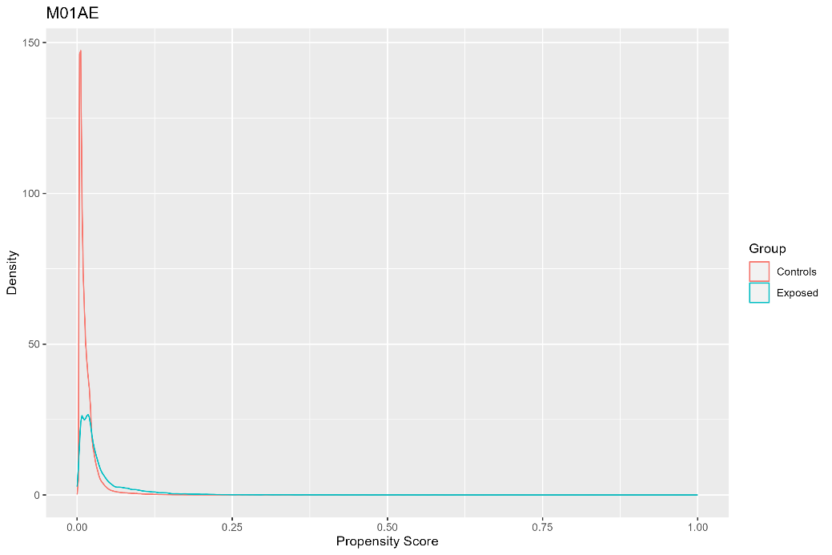 | 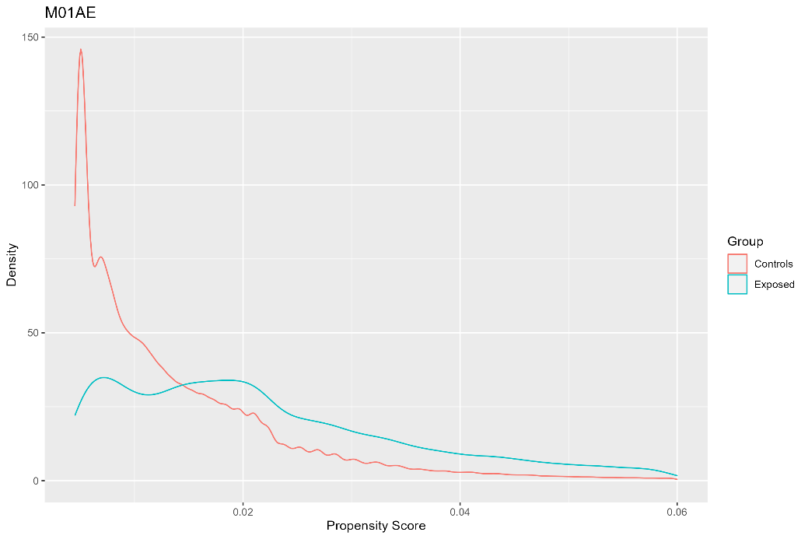
Notes: Population before trimming. Exposed = dispensed M01AE during pregnancy (N = 31,211; maximum propensity = 1; minimum propensity <0.01). Controls = not dispensed M01AE during pregnancy (N = 1,992,297; maximum propensity = 0.85; minimum propensity <0.01). | Notes: Population after trimming. Exposed = dispensed M01AE during pregnancy (N = 25,130; 81%; 6,081 trimmed). Controls = not dispensed M01AE during pregnancy (N = 1,724,383; 87%; 267,914 trimmed).

Figure S15c. Absolute Standardised Differences for M01AE
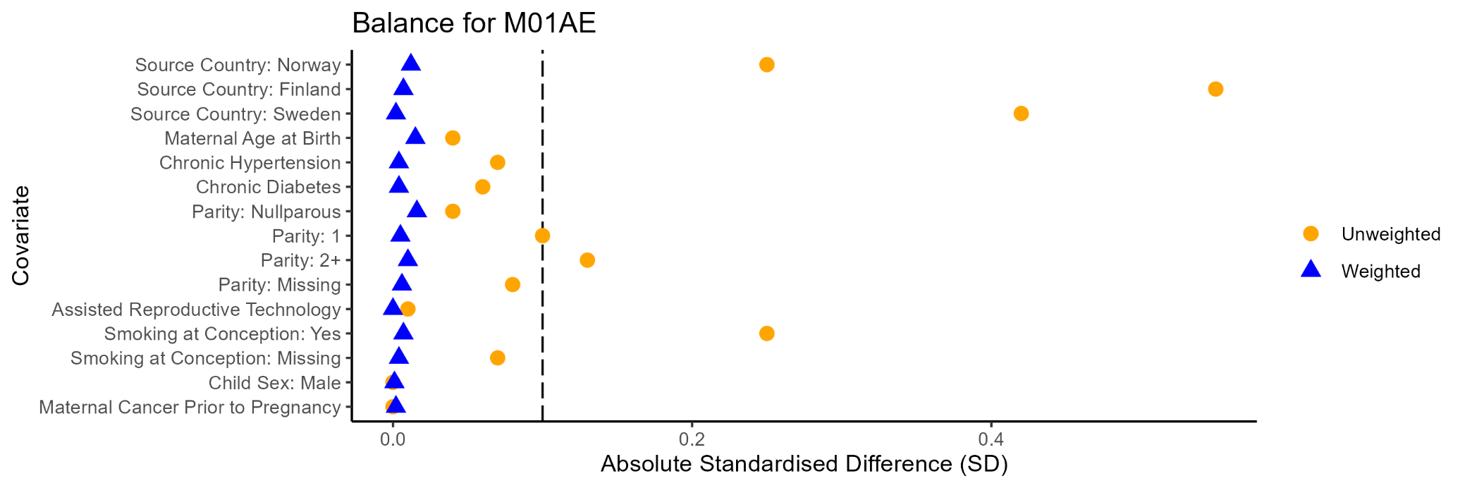

G03DA Pregen (4) derivaties
Figure S16a. G03DA Propensity Score Density Plot | Figure S16b. G03DA Propensity Score Density Plot Trimmed Population
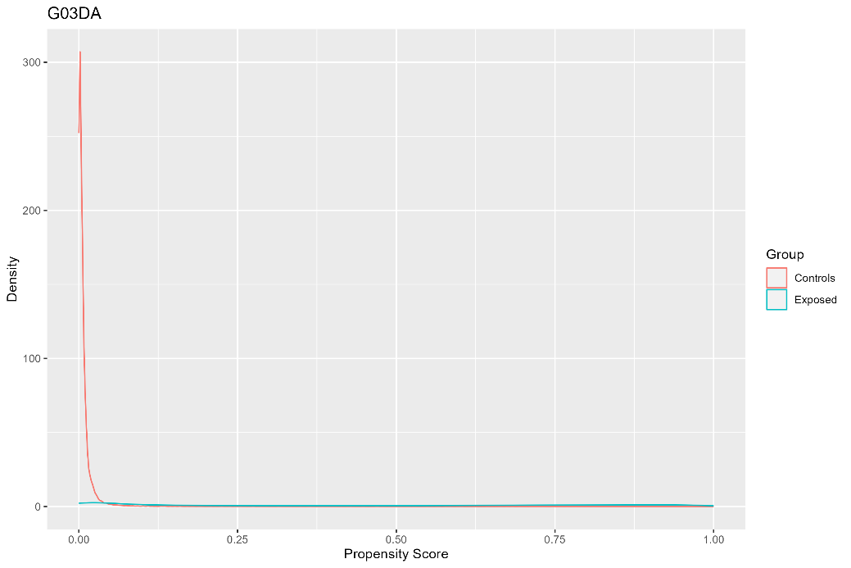 | 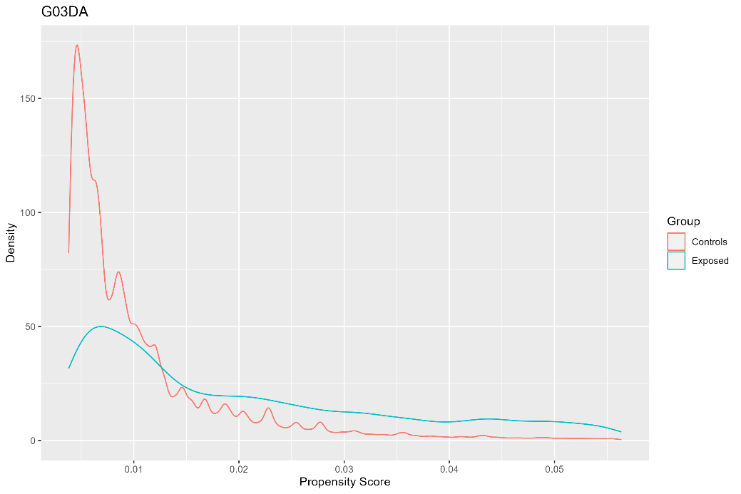
Notes: Population before trimming. Exposed = dispensed G03DA during pregnancy (N = 43,083; maximum propensity = 1; minimum propensity <0.01). Controls = not dispensed G03DA during pregnancy (N = 1,980,425; maximum propensity = 1; minimum popensity <0.01). | Notes: Population after trimming. Exposed = dispensed G03DA during pregnancy (N = 9,109; 21%; 33,974 trimmed). Controls = not dispensed G03DA during pregnancy (N = 973,696; 49%; 1,006,729 trimmed).

Figure S16c. Absolute Standardised Differences for G03DA
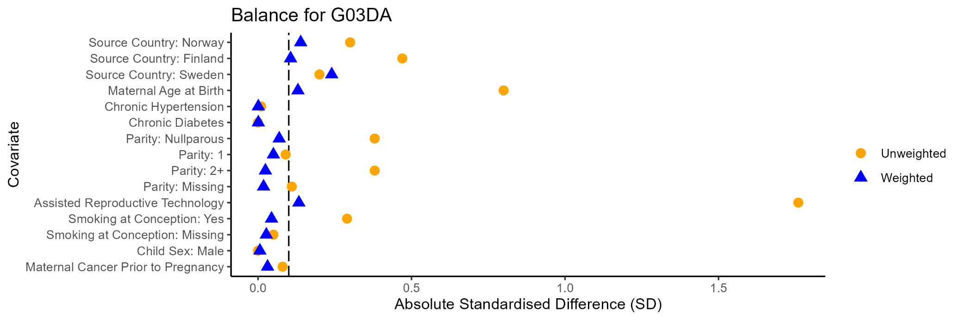

G03GA Gonadotrophins
Figure S17a. G03GA Propensity Score Density Plot | Figure S17b. G03GA Propensity Score Density Plot Trimmed Population
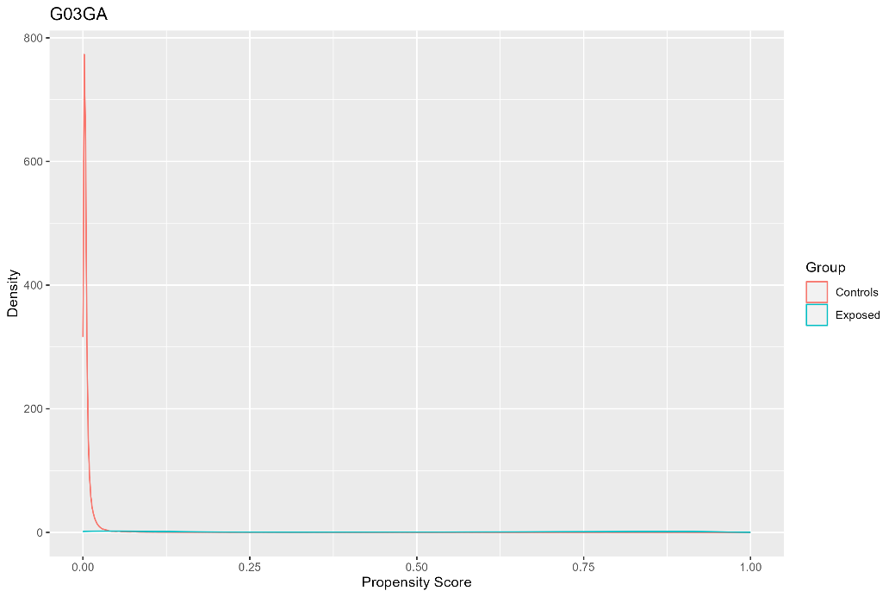 | 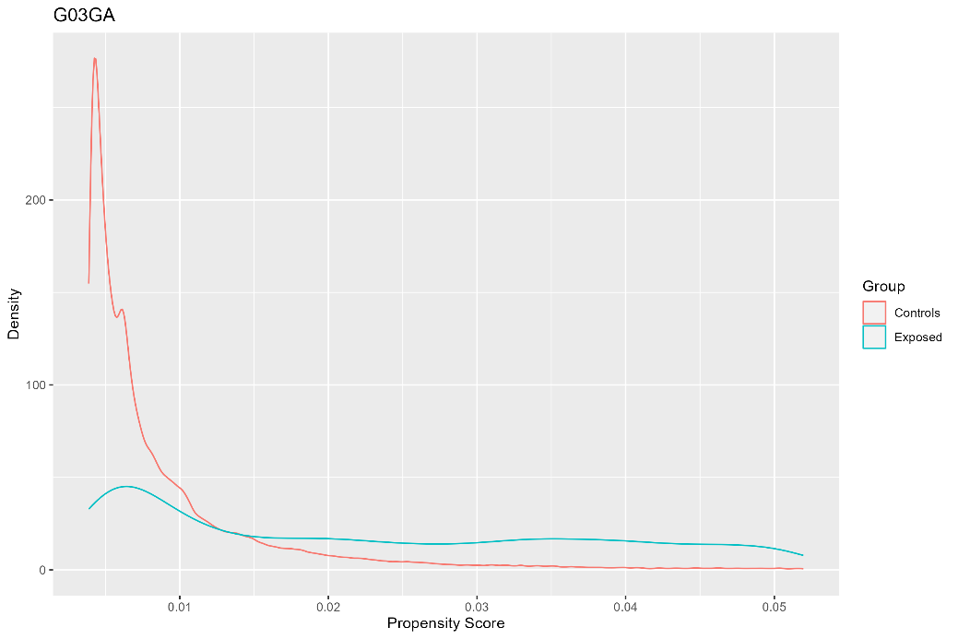
Notes: Population before trimming. Exposed = dispensed G03GA during pregnancy (N = 42,893; maximum propensity = 1; minimum propensity <0.01). Controls = not dispensed G03GA during pregnancy (N = 1,980,615; maximum propensity = 0.99; minimum propensity <0.01). | Notes: Population after trimming. Exposed = dispensed G03GA during pregnancy (N = 5,821; 14%; 37,072 trimmed). Controls = not dispensed G03GA during pregnancy (N = 787,206; 40%; 1,193,409 trimmed).

Figure S17c. Absolute Standardised Differences for G03GA
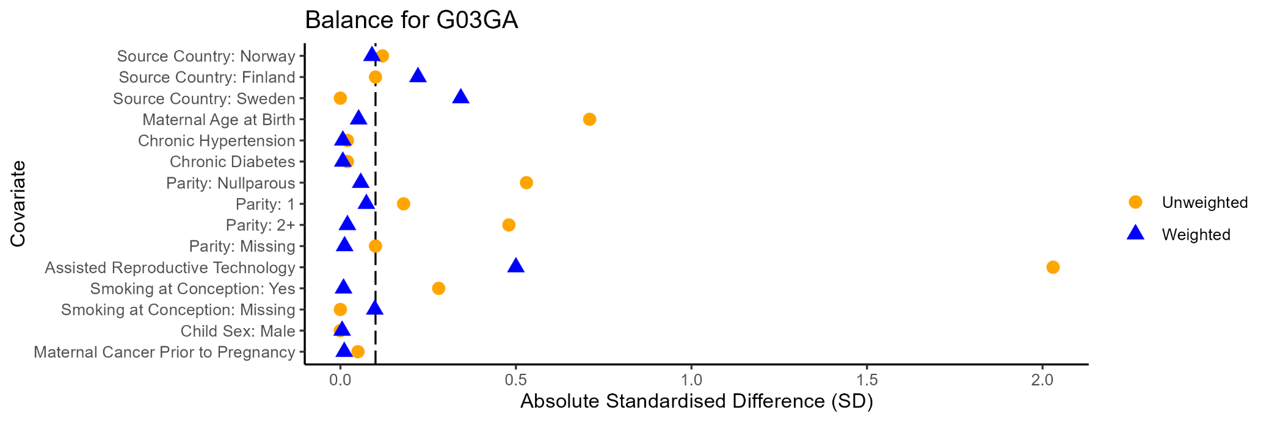

H03AA Thyroid Hormones
Figure S18a. H03AA Propensity Score Density Plot | Figure S18b. H03AA Propensity Score Density Plot Trimmed Population
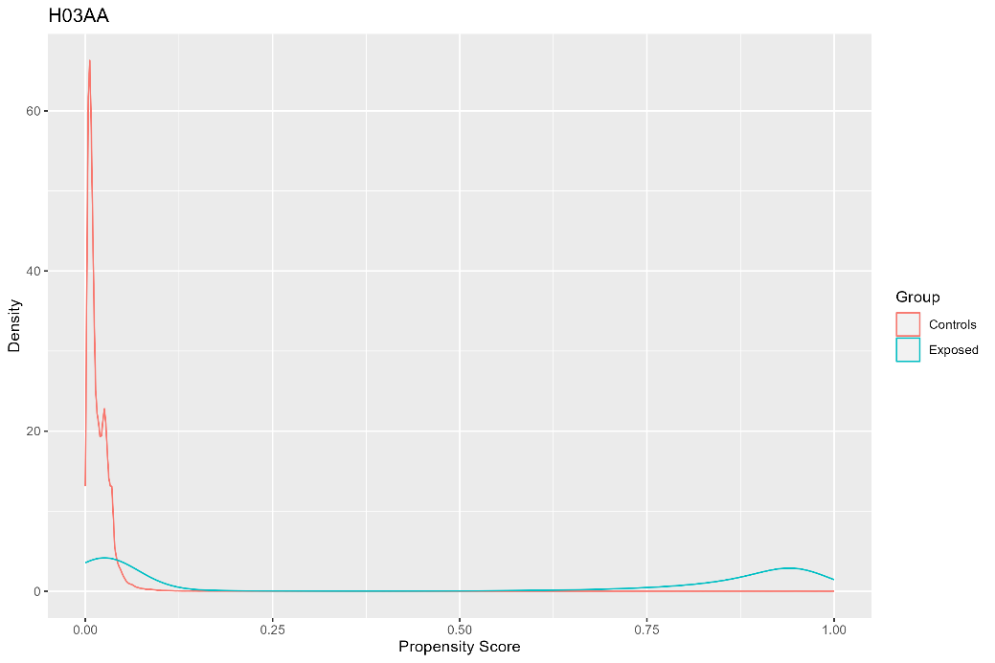 | 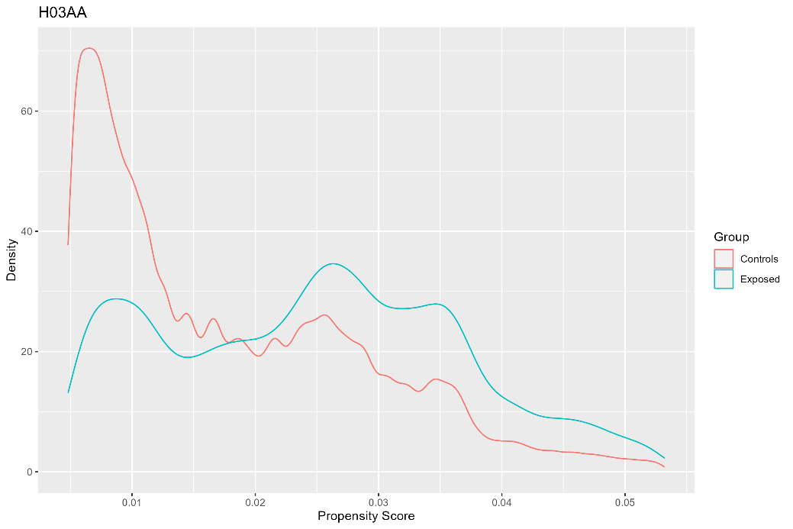
Notes: Population before trimming. Exposed = dispensed H03AA during pregnancy (N = 67,068; maximum propensity = 1; minimum propensity <0.01). Controls = not dispensed H03AA during pregnancy (N = 1,956,440; maximum propensity = 1; minimum propensity <0.01 ). | Notes: Population after trimming. Exposed = dispensed H03AA during pregnancy (N = 28,017; 42%; 39,051 trimmed). Controls = not dispensed H03AA during pregnancy (N = 1,537,647; 79%; 418,793 trimmed).

Figure S18c. Absolute Standardised Differences for H03AA
