**Supplementary material**

Figure S1 Histograms showing distribution of uterine artery pulsatility index (PI) before and after log transformation.

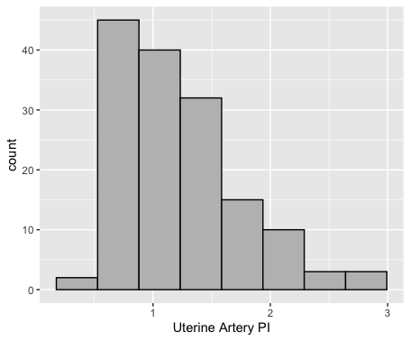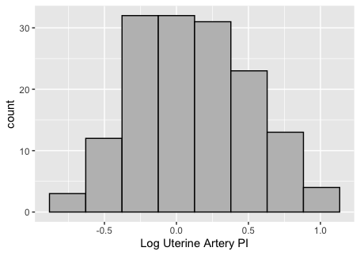

**Figure S2** Relationship between ophthalmic artery Doppler indices (peak systolic velocity ratio (PSV ratio) in (a–f) and pulsatility index (PI) in (g–l)) and selected maternal hemodynamic indices. MAP, mean arterial pressure; HR, heart rate; SVR, systemic vascular resistance; CO, cardiac output; SV, stroke volume; PKR, potential energy/kinetic energy ratio.

|  |  |
| --- | --- |
| a) | b) |
| C) | d) |
| e) | f) |
| g) | h) |
| i) | j) |
| k) | l) |

**Figure S3** Relationship between ophthalmic artery Doppler measurements in left and right eyes: (a) pulsatility index (PI); and (b) peak systolic velocity ratio (PSV ratio).

|  |  |
| --- | --- |
| a) | b) |