Table of contents

Appendix 1 – Availability of caring and outcome measurements across UKHLS waves
Appendix 2 - Description of study covariates
Appendix 3 - Checking the quality of the propensity score matching
Appendix 4 - Description of the analysis approach
Appendix 5 – Sample selection process
Appendix 6 – Predicted mean life satisfaction scores each year
Appendix 7 – Predicted mean self-esteem scores each year
Appendix 8 – Predicted mean probabilities of good/very good health each year
Appendix 9 -- Predicted mean life satisfaction per year - Sensitivity analysis: PSM with weights
Appendix 10 -- Predicted mean self-esteem scores per year - Sensitivity analysis: PSM with weights
Appendix 11 – Predicted mean probabilities of good self-rated health per year - PSM with weights
Appendix 12 -- Fitted Lines for Carers and Non-Carers Trajectories
Appendix 13 – Investigating continuity in young caring across youth and adult questionnaires
Appendix 14 – Comparing included and excluded samples20.
Appendix 15 – Sensitivity analyses applying survey weights

Appendix 1 -- Availability of caring and outcome measurements across UKHLS waves

Wave | 1 | 2 | 3 | 4 | 5 | 6 | 7 | 8 | 9 | 10 | 11 | 12 | 13
Caring (16+yrs) | x | x | x | x | x | x | x | x | x | x | x | x | X
Caring (10-15 yrs) |  |  | x |  | x |  | x |  | x |  | x |  | x
Life satisfaction (10-25 yrs) | x | x | x | x | x | x | x | x | x | x | x | x | X
Self-esteem (10-21 yrs) |  | x |  | x |  | x |  | x |  | x |  | x
Self-rated health (16+ yrs) | x | x | x | x | x | x | x | x | x | x | x | x | x
Self-rated health (10-15 yrs) |  | x |  | x |  | x |  | x |  | x |  | x

Appendix 2 -- Description of study covariates

Age was banded into two groups indicating the policy definitions of young carers (<18 years) and young adult carers (18-25 years). Sex was self-reported in binary form (male/female). Ethnicity was categorised as: White, Black, Indian, Pakistani/Bangladeshi, or Other. Household income was reported as monthly net income, equilvalised using the OECD equivalence scale and split into quintiles. The number of natural, step- or adopted siblings in the household was categorised as 0, 1, 2, 3 or more. Parental occupational class was measured using the National Statistics Socio-Economic Classification. Categories were: Managerial/Professional, Intermediate, Routine and Not working. The highest class from either parent was used. The highest parental educational qualification obtained was categorised as Degree, Other Higher Qualification, Advanced (A) Level, General Certificate of Secondary Education (GCSE/CSE)-level, Other, or No qualifications. Household parental composition was categorised as two- or single-parent household. Urbanicity was either urban or rural and based on whether the participants’ home was located in a settlement with a population of 10,000 or more (“Urban”) or not (“Rural”) by the Office of National Statistics (ONS) Rural and Urban Classification of Output Areas 2001. The total number of waves the young person participated in was categorised as 2 to 13. All covariates were taken from baseline – the participants’ first observed wave.

Appendix 3 – Checking the quality of the propensity score matching (PSM)

The adequacy of the propensity score matching was checked using two methods. First, by checking the density plots of the propensity score for carers and non-carers before and after matching. Second, by checking the distributions of all covariates before and after matching. Three, by viewing the standardised differences to test the balance of covariates after PSM. All sets of outputs are shown below and show that the PSM has performed well, reducing much of the differences between carers and non-carers.

Density plots
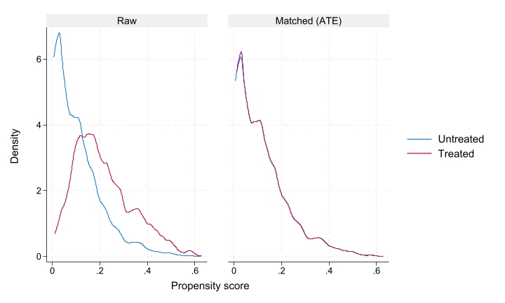
Figure - Density plot for life satisfaction sample for the raw and matched untreated (non-carers) and treated (young carers)
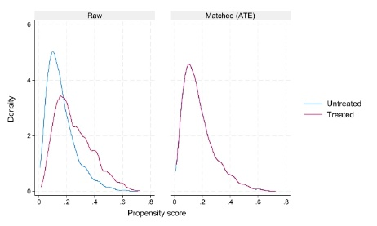
Figure - Density plot for self-esteem sample for the raw and matched untreated (non-carers) and treated (young carers)
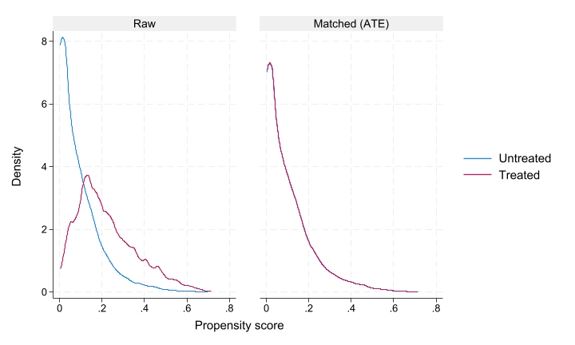
Figure - Density plot for self-rated health sample for the raw and matched untreated (non-carers) and treated (young carers)

Observing changes in covariates after matching

Table - Comparing the balance of covariates in the life satisfaction sample pre- and post-PSM
 | Pre PSMª |  |  | Post PSM^{b}
 | Total | Non carers | Carers | Total ^{c} |  | Non carers |  | Carers
n | 19,022 | 16,622 | 2,400 | 4,424 |  | 2,024  45.8 |  | 2,400  54.3
% |  | 87.4 | 12.6
 | % | % | % | % | n | % | n | % | n
Gender
Male | 47.4 | 46.9 | 51.0 | 51.1 | 2261 | 51.3 | 1038 | 51.0 | 1223
Female | 52.6 | 53.1 | 49.0 | 48.9 | 2163 | 48.7 | 986 | 49.0 | 1177
Age group
10-17 | 67.0 | 63.6 | 90.5 | 92.3 | 4081 | 94.3 | 1908 | 90.5 | 2173
18-25 | 33.0 | 36.4 | 9.5 | 7.8 | 343 | 5.7 | 116 | 9.5 | 227
Caring hours (per week)
1-9 hrs | 70.4 |  | 70.4 | 70.4 | 1,444 |  |  | 70.4 | 1,444
10+ hrs | 29.6 |  | 29.6 | 29.6 | 608 |  |  | 29.6 | 608
Care recipient
Parent | 69.9 |  | 69.9 | 69.9 | 1,327 |  |  | 69.9 | 1,327
Other | 30.1 |  | 30.1 | 30.1 | 572 |  |  | 30.1 | 572
Ethnicity
White | 74.9 | 76 | 67.0 | 71.3 | 3156 | 76.4 | 1547 | 67.0 | 1609
Black | 7.5 | 7.5 | 8.0 | 7.2 | 318 | 6.3 | 127 | 8.0 | 191
Indian | 4.1 | 34 | 5.2 | 4.7 | 207 | 4.1 | 82 | 5.2 | 125
Pakistani/Bangladeshi | 8.5 | 7.5 | 15.5 | 12.7 | 563 | 9.4 | 191 | 15.5 | 372
Other | 5.0 | 5.1 | 4.3 | 4.1 | 180 | 3.8 | 77 | 4.3 | 103
Urbanicity
Urban | 79.6 | 79.2 | 82.3 | 81.1 | 3575 | 79.1 | 1601 | 82.3 | 1974
Rural | 20.4 | 20.8 | 17.8 | 18.9 | 849 | 20.9 | 423 | 17.8 | 426
Parental composition
Two parent household | 70.9 | 71.6 | 65.6 | 69.9 | 3090 | 74.9 | 1515 | 65.6 | 1575
Single parent household | 29.2 | 28.4 | 34.4 | 30.2 | 1334 | 25.2 | 509 | 34.4 | 825
Number siblings in the hhold
None | 28.7 | 30.7 | 14.9 | 13.5 | 595 | 11.8 | 238 | 14.9 | 357
1 | 36.7 | 36.3 | 39.2 | 42.9 | 1897 | 47.3 | 957 | 39.2 | 940
2 | 21.0 | 20.6 | 24.4 | 25.0 | 1105 | 25.6 | 519 | 24.4 | 586
3 or more | 14.0 | 12.4 | 21.5 | 18.7 | 827 | 15.3 | 310 | 21.5 | 517
Hhold income
Highest quintile | 15.2 | 16.3 | 7.8 | 10.0 | 444 | 12.7 | 256 | 7.8 | 188
Second quintile | 19.8 | 20.7 | 13.5 | 16.3 | 723 | 19.7 | 398 | 13.5 | 325
Third quintile | 20.7 | 21 | 18.5 | 19.5 | 861 | 20.6 | 417 | 18.5 | 444
Fourth quintile | 21.6 | 20.6 | 28.7 | 27.0 | 1196 | 25.1 | 507 | 28.7 | 689
Lowest quintile | 22.7 | 21.4 | 31.4 | 27.1 | 1200 | 22.0 | 446 | 31.4 | 754
Parental occupational class
Managerial/professional | 40.9 | 43.1 | 26.4 | 33.3 | 1472 | 41.4 | 735 | 26.4 | 634
Intermediate | 19.8 | 20.3 | 16.8 | 16.8 | 745 | 16.9 | 341 | 16.8 | 404
Routine | 23.9 | 23.7 | 25.1 | 23.5 | 1040 | 21.6 | 438 | 25.1 | 603
Not in paid work | 15.4 | 13.0 | 31.6 | 26.4 | 1167 | 20.2 | 368 | 31.6 | 759
Parental education
Degree | 31.9 | 33.3 | 22.5 | 27.7 | 1226 | 33.9 | 686 | 22.5 | 540
Other Higher | 15.0 | 15.0 | 14.6 | 14.4 | 680 | 16.3 | 330 | 14.6 | 350
A-Level etc | 22.1 | 22.4 | 20.0 | 19.8 | 876 | 19.5 | 395 | 20.0 | 481
GSCE etc | 19.5 | 19.0 | 23.1 | 21.6 | 956 | 19.8 | 401 | 23.1 | 555
Other qualification | 5.5 | 5.1 | 8.6 | 7.0 | 308 | 5.0 | 101 | 8.6 | 207
No qualification | 6.0 | 5.3 | 11.1 | 8.5 | 378 | 5.5 | 108 | 11.1 | 267
Abbreviations: PSM = propensity score matching
ªUnweighted distributions, sample after applying inclusion/exclusion criteria, before PSM
^{b}Unweighted distributions, sample after PSM
^{c}Total analysis sample for carers vs non-carers and care intensity analysis

Table - Comparing the balance of covariates in the self-esteem sample pre- and post-PSM
 | Pre PSMª |  |  | Post PSM^{b}
 | Total | Non carers | Carers | Total^{c} |  | Non carers |  | Carers
n | 8,052 | 6,638 | 1,414 | 2,453 |  | 1,309 |  | 1,414
% |  | 82.4 | 17.6 |  |  | 42.3 |  | 57.6
 | % | % | % | % | n | % | n | % | n
Gender
Male | 48.6 | 48.2 | 50.8 | 50.5 | 1,238 | 50.1 | 520 | 50.8 | 718
Female | 51.4 | 51.8 | 49.2 | 49.5 | 1,215 | 50.0 | 519 | 49.2 | 696
Age group
10-17 | 99.2 | 99.1 | 99.8 | 99.8 | 2,448 | 99.8 | 1,037 | 99.8 | 1,411
18-21 | 0.8 | 0.9 | 0.2 | 0.2 | 5 | 0.2 | 2 | 0.2 | 3
Caring hours (per week)
1-9 hrs | 77.5 |  | 77.5 | 77.5 | 916 |  |  | 77.5 | 916
10+ hrs | 22.5 |  | 22.5 | 22.5 | 266 |  |  | 22.5 | 266
Care recipient
Parent | 72.9 |  | 72.9 | 72.9 | 771 |  |  | 72.9 | 771
Other | 27.1 |  | 27.1 | 27.1 | 286 |  |  | 27.1 | 286
Ethnicity
White | 76.2 | 77.7 | 69.2 | 73.2 | 1,795 | 78.5 | 816 | 69.2 | 979
Black | 6.8 | 6.6 | 7.9 | 7.1 | 175 | 6.1 | 63 | 7.9 | 112
Indian | 4.0 | 3.8 | 5.0 | 4.4 | 109 | 3.7 | 38 | 5.0 | 71
Pakistani/Bangladeshi | 8.2 | 7.1 | 13.6 | 11.5 | 282 | 8.7 | 90 | 13.6 | 192
Other | 4.8 | 4.9 | 4.2 | 3.8 | 92 | 3.1 | 32 | 4.2 | 60
Urbanicity
Urban | 76.8 | 76.2 | 79.7 | 79.0 | 1,938 | 78.1 | 811 | 79.7 | 1,127
Rural | 23.2 | 23.8 | 20.3 | 21.0 | 515 | 21.9 | 228 | 20.3 | 287
Parental composition
Two parent household | 74.6 | 76.1 | 68.0 | 72.0 | 1,765 | 77.4 | 804 | 68.0 | 961
Single parent household | 25.4 | 24.0 | 32.0 | 28.1 | 688 | 22.6 | 235 | 32.0 | 453
Number siblings in the hhold
None | 13.6 | 13.8 | 12.8 | 13.1 | 320 | 13.4 | 139 | 12.8 | 181
1 | 44.1 | 45.0 | 39.6 | 42.0 | 1,031 | 45.3 | 471 | 39.6 | 560
2 | 26.2 | 26.2 | 26.5 | 26.6 | 652 | 26.7 | 277 | 26.5 | 375
3 or more | 16.1 | 15.0 | 21.1 | 18.3 | 450 | 14.6 | 152 | 21.1 | 298
Hhold income
Highest quintile | 16.3 | 17.8 | 9.5 | 11.7 | 288 | 14.8 | 154 | 9.5 | 134
Second quintile | 19.5 | 20.6 | 14.1 | 17.1 | 419 | 21.1 | 219 | 14.1 | 200
Third quintile | 21.0 | 21.6 | 18.5 | 18.8 | 462 | 19.4 | 201 | 18.5 | 261
Fourth quintile | 22.4 | 21.2 | 28.1 | 26.3 | 644 | 23.8 | 247 | 28.1 | 397
Lowest quintile | 20.9 | 19.0 | 29.8 | 26.1 | 640 | 21.0 | 218 | 29.8 | 422
Parental occupational class
Managerial/professional | 44.2 | 47.7 | 27.8 | 34.7 | 852 | 44.2 | 459 | 27.8 | 393
Intermediate | 19.4 | 19.6 | 18.4 | 15.6 | 431 | 16.5 | 171 | 18.4 | 260
Routine | 20.6 | 19.5 | 25.7 | 23.5 | 577 | 20.5 | 213 | 25.7 | 364
Not in paid work | 15.8 | 13.2 | 28.1 | 24.2 | 593 | 18.9 | 196 | 28.1 | 397
Parental education
Degree | 35.7 | 38.0 | 25.0 | 29.4 | 722 | 35.4 | 368 | 25.0 | 354
Other Higher | 15.6 | 15.7 | 15.4 | 15.1 | 370 | 14.6 | 152 | 15.4 | 218
A-Level etc | 19.7 | 19.8 | 19.2 | 19.1 | 468 | 18.9 | 196 | 19.2 | 272
GSCE etc | 19.3 | 18.4 | 23.6 | 22.7 | 556 | 21.5 | 223 | 23.6 | 333
Other qualification | 4.6 | 4.0 | 7.5 | 6.1 | 150 | 4.2 | 44 | 7.5 | 106
No qualification | 5.1 | 4.2 | 9.3 | 7.6 | 187 | 5.4 | 56 | 9.3 | 131
Abbreviations: PSM = propensity score matching
ªUnweighted distributions, sample after applying inclusion/exclusion criteria, before PSM
^{b}Unweighted distributions, sample after PSM
^{c}Total analysis sample for carers vs non-carers and care intensity analysis

Table - Comparing the balance of covariates in the self-rated health sample pre- and post-PSM
 | Pre PSMª |  |  | Post PSM^{b}
 | Total | Non carers | Carers | Total^{c} |  | Non carers |  | Carers
n | 19,711 | 17,497 | 2,214 | 3,731 |  | 1,517 |  | 2,214
% |  | 88.8 | 11.2 |  |  | 40.6 |  | 59.3
 | % | % | % | % | n | % | n | % | n
Gender
Male | 48.2 | 47.9 | 50.1 | 49.8 | 1,859 | 49.5 | 751 | 50.1 | 1,108
Female | 51.8 | 52.1 | 49.9 | 50.2 | 1,872 | 50.5 | 766 | 50.0 | 1,106
Age group
10-17 | 61.3 | 58.3 | 85.1 | 87.5 | 3,265 | 91.0 | 1,380 | 85.1 | 1,885
18-21 | 38.7 | 41.7 | 14.9 | 12.5 | 466 | 9.0 | 137 | 14.9 | 329
Caring hours (per week)
1-9 hrs | 68.6 |  | 68.6 | 68.6 | 1,299 |  |  | 68.6 | 1,299
10+ hrs | 31.4 |  | 31.4 | 31.4 | 595 |  |  | 31.4 | 595
Care recipient
Parent | 69.9 |  | 69.9 | 69.9 | 1,257 |  |  | 69.9 | 1,257
Other | 30.1 |  | 30.1 | 30.1 | 542 |  |  | 30.1 | 542
Ethnicity
White | 73.9 | 74.9 | 65.5 | 69.7 | 2,601 | 75.9 | 1152 | 65.5 | 1,449
Black | 7.9 | 7.9 | 8.3 | 7.5 | 279 | 6.3 | 96 | 8.3 | 183
Indian | 4.3 | 4.1 | 5.7 | 5.0 | 187 | 4 | 61 | 5.7 | 126
Pakistani/Bangladeshi | 8.8 | 7.8 | 16.2 | 13.5 | 502 | 9.5 | 144 | 16.2 | 358
Other | 5.2 | 5.2 | 4.4 | 4.3 | 162 | 4.2 | 64 | 4.4 | 98
Urbanicity
Urban | 80.0 | 79.6 | 82.7 | 81.1 | 3,024 | 78.7 | 1,194 | 82.7 | 1,830
Rural | 20.0 | 20.4 | 17.3 | 19.0 | 707 | 21.3 | 323 | 17.3 | 384
Parental composition
Two parent household | 70.3 | 70.9 | 65.5 | 68.3 | 2,549 | 72.5 | 1100 | 65.5 | 1,449
Single parent household | 29.7 | 29.1 | 34.6 | 31.7 | 1,182 | 27.5 | 417 | 34.6 | 765
Number siblings in the hhold
None | 30.6 | 32.5 | 15.6 | 15.3 | 570 | 14.8 | 224 | 15.6 | 346
1 | 35.9 | 35.6 | 38.9 | 41.6 | 1,552 | 45.5 | 690 | 38.9 | 862
2 | 20.4 | 19.8 | 24.9 | 25.4 | 947 | 26.1 | 396 | 24.9 | 551
3 or more | 13.1 | 12.1 | 20.6 | 17.7 | 662 | 13.7 | 207 | 20.6 | 455
Hhold income
Highest | 15.4 | 16.3 | 8.4 | 9.9 | 368 | 12.1 | 183 | 8.4 | 185
Second quintile | 20 | 20.9 | 13.4 | 16.4 | 612 | 20.8 | 315 | 13.4 | 297
Third quintile | 20.6 | 20.9 | 18.1 | 19.1 | 713 | 20.6 | 312 | 18.1 | 401
Fourth quintile | 21.1 | 20.1 | 28.4 | 27.0 | 1,008 | 25.0 | 379 | 28.4 | 629
Lowest | 22.9 | 21.8 | 31.7 | 27.6 | 1,030 | 21.6 | 328 | 31.7 | 702
Parental occupational class
Managerial/professional | 40.6 | 45.2 | 26.5 | 32.4 | 1,207 | 40.9 | 621 | 26.5 | 586
Intermediate | 19.7 | 20.2 | 16.3 | 16.6 | 618 | 17.0 | 258 | 16.3 | 360
Routine | 24.1 | 24.1 | 24 | 23.6 | 882 | 23.1 | 350 | 24.0 | 532
Not in paid work | 15.6 | 13.2 | 33.2 | 27.5 | 1,024 | 19.0 | 288 | 33.2 | 736
Parental education
Degree | 31.6 | 32.7 | 23.2 | 27.2 | 1,016 | 33.1 | 502 | 23.2 | 514
Other Higher | 14.9 | 15.0 | 14.3 | 14.8 | 552 | 15.6 | 237 | 14.2 | 315
A-Level etc | 22.0 | 22.3 | 19.7 | 20.1 | 749 | 20.7 | 314 | 19.7 | 435
GSCE etc | 19.6 | 19.1 | 23.0 | 21.7 | 811 | 19.9 | 301 | 23.0 | 510
Other qualification | 5.6 | 5.2 | 8.5 | 7.0 | 262 | 4.9 | 75 | 8.5 | 187
No qualification | 6.3 | 5.7 | 11.4 | 9.1 | 341 | 5.8 | 88 | 11.4 | 253
Abbreviations: PSM = propensity score matching
ªUnweighted distributions, sample after applying inclusion/exclusion criteria, before PSM
^{b}Unweighted distributions, sample after PSM
^{c}Total analysis sample for carers vs non-carers and care intensity analysis

Table – Standardised differences to test balance of covariates after PSM – life satisfaction sample
 | PSM without weights | PSM with weights
ethnicity | 0.02 | 0.001
urbanicity | 0.07 | 0.08
numbers of siblings | 0.02 | 0.02
parental composition | 0.1 | 0.1
household income | 0.1 | 0.1
occupational class | 0.2 | 0.2
parental qualifications | 0.2 | 0.2
number of waves observed | 0.02 | 0.01

Table – Standardised differences to test balance of covariates after PSM – self esteem sample
 | PSM without weights | PSM with weights
ethnicity | 0.06 | 0.03
urbanicity | 0.04 | 0.08
numbers of siblings | 0.004 | 0.05
parental composition | 0.1 | 0.1
household income | 0.1 | 0.2
occupational class | 0.2 | 0.3
parental qualifications | 0.1 | 0.2
number of waves observed | 0.02 | 0.01

Table – Standardised differences to test balance of covariates after PSM – self-rated health sample
 | PSM without weights | PSM with weights
ethnicity | 0.01 | 0.03
urbanicity | 0.1 | 0.05
numbers of siblings | 0.001 | 0.03
parental composition | 0.1 | 0.1
household income | 0.1 | 0.1
occupational class | 0.3 | 0.3
parental qualifications | 0.2 | 0.2
number of waves observed | 0.02 | 0.04

Appendix 4-- Description of the analysis approach
To investigate wellbeing before, during, and after the onset of young caring the analyses followed these steps:

- Piecewise linear regression: A piecewise linear regression model was constructed by dividing the time variable into three segments, representing time before, at transition and after the transition to becoming a young carer.
- Multilevel mixed-effects linear regression: A multilevel mixed-effects linear regression model was used to analyse wellbeing over time, allowing for random intercepts at both the household and individual levels. The young carer status variable was included in the model, along with interaction terms to assess its effects on different segments of the time scale.
- Graphing marginal effects: Separate regression were run for carers and non-carers. The marginal effects of time on wellbeing were plotted, illustrating changes in wellbeing before, during and after the onset of young caring for both groups.
- Testing significance: The final model includes interaction terms between young carer status and the time segments, allowing us to test the significance of differences in wellbeing trajectories between carers and non-carers.

Appendix 5 – Sample selection process

Figure – Sample selection process for life satisfaction analyses

Aged 10-25 and answered yes/no to carer Q
N=27,678 (4,484 carers, 23,194 non-carers)
Select carers who have ≥1 life satisfaction measure before & after young carer transition
N=19,122 (2,500 carers, 16,622 non-carers)
Exclude carers who have missing covariate data
N=19,022 (2,400 carers, 16,622 non-carers)

Apply propensity score matching (PSM), 1:2 matchingª

 | Carer  Analysis^{b} | Age  analysis | Ethnicity  analysis | Hhold income  analysis
Carers | 2,400 | 2,400 | 2,400 | 2,400
Non-carers | 3,657 | 4,179 | 3,684 | 3,675
Total | 6,057 | 6,579 | 6,084 | 6,075

Only select non-carers who have ≥1 life satisfaction measure before & after matched caring transition

Final analytic samples

 | Carer  Analysis^{b} | Age  analysis | Ethnicity  analysis | Hhold income  analysis
Carers | 2,400 | 2,400 | 2,400 | 2,400
Non-carers | 2,024 | 1,502 | 2,103 | 2,206
Total | 4,424 | 3,902 | 4,503 | 4,606

ªPSM run separately for each inequality analysis removing that particular variable from the PSM e.g. ethnicity omitted from PSM for ethnicity inequality analysis but included in all other PSMs
^{b}Caring hours (n=2052; 1-9 hrs per week = 1444; 10+ hrs per week = 608) and care recipient (n=1899; parent = 1327; other = 572) analyses run for carers only

Figure – Sample selection process for self-esteem analyses

Aged 10-21 and answered yes/no to carer Qª
N=21,842 (4,124 carers, 17,718 non-carers)
Select carers who have ≥1 self esteem measure before & after young carer transition
N=8,082 (1,444 carers, 6,638 non-carers)
Exclude carers who have missing covariate data
N=8,052 (1,414 carers, 6,638 non-carers)

Apply propensity score matching (PSM), 1:2 matching^{b}

 | Carer  Analysis^{b} | Age  analysis | Ethnicity  analysis | Hhold income  analysis
Carers | 2,070 | 2,315 | 2,038 | 2,147
Non-carers | 1,414 | 1,414 | 1,414 | 1,414
Total | 3,484 | 3,729 | 3,452 | 3,561

Only select non-carers who have ≥1 life satisfaction measure before & after matched caring transition

Final analytic samples

 | Carer  Analysis^{b} | Age  analysis | Ethnicity  analysis | Hhold income  analysis
Carers | 1,414 | 1,414 | 1,414 | 1,414
Non-carers | 1,039 | 906 | 1,094 | 1,137
Total | 2,453 | 2,320 | 2,508 | 2,551

ªSelf-esteem only asked of young people aged 10-21 years
^{b}PSM run separately for each inequality analysis removing that particular variable from the PSM e.g. ethnicity omitted from PSM for ethnicity inequality analysis but included in all other PSMs
^{b}Caring hours (n=1182; 1-9 hrs per week = 916; 10+ hrs per week = 266) and care recipient (n=1057; parent = 771; other = 286) analyses run for carers only

Figure – Sample selection process for self-rated health analyses

Aged 10-25 and answered yes/no to carer Q
N=27,678 (4,484 carers, 23,194 non-carers)
Select carers who have ≥1 self-rated measure before & after young carer transition
N=19,818 (2,321 carers, 17,497 non-carers)
Exclude carers who have missing covariate data
N=19,711 (2,214 carers, 17,497 non-carers)

Apply propensity score matching (PSM), 1:2 matchingª

 | Carer  Analysis^{b} | Age  analysis | Ethnicity  analysis | Hhold income  analysis
Carers | 2,214 | 2,214 | 2,214 | 2,214
Non-carers | 3,392 | 3,696 | 3,442 | 3,496
Total | 5,606 | 5,910 | 5,656 | 5,710

Only select non-carers who have ≥1 life satisfaction measure before & after matched caring transition

Final analytic samples

 | Carer  Analysis^{b} | Age  analysis | Ethnicity  analysis | Hhold income  analysis
Carers | 2,214 | 2,214 | 2,214 | 2,214
Non-carers | 1,517 | 1,262 | 1,632 | 1,621
Total | 3,731 | 3,476 | 3,846 | 3,835

ªPSM run separately for each inequality analysis removing that particular variable from the PSM e.g. ethnicity omitted from PSM for ethnicity inequality analysis but included in all other PSMs
^{b}Caring hours (n=1894; 1-9 hrs per week = 1299; 10+ hrs per week = 595) and care recipient (n=1799; parent = 1257; other = 542) analyses run for carers only

Appendix 6 - Predicted mean life satisfaction per year

Carers |  |  |  |  |  | Non-Carers
Year | Mean (AME) |  |  | 95%CI |  | Year | Mean (AME) |  |  | 95%CI
-10 |  | 6.80 | 6.13 |  | 7.24 | -10 |  | 6.57 | 5.88 |  | 6.72
-9 |  | 6.10 | 5.68 |  | 6.48 | -9 |  | 6.40 | 5.94 |  | 6.57
-8 |  | 6.13 | 5.76 |  | 6.42 | -8 |  | 6.22 | 5.9 |  | 6.41
-7 |  | 6.28 | 6.03 |  | 6.54 | -7 |  | 6.28 | 5.91 |  | 6.32
-6 |  | 5.88 | 5.67 |  | 6.11 | -6 |  | 6.06 | 5.83 |  | 6.18
-5 |  | 6.01 | 5.83 |  | 6.18 | -5 |  | 6.06 | 5.9 |  | 6.1
-4 |  | 5.80 | 5.68 |  | 5.94 | -4 |  | 5.98 | 5.84 |  | 6.07
-3 |  | 5.73 | 5.64 |  | 5.85 | -3 |  | 5.92 | 5.84 |  | 6.03
-2 |  | 5.70 | 5.63 |  | 5.79 | -2 |  | 5.86 | 5.78 |  | 5.94
-1 |  | 5.63 | 5.57 |  | 5.71 | -1 |  | 5.80 | 5.78 |  | 5.91
0 |  | 5.49 | 5.44 |  | 5.56 | 0 |  | 5.67 | 5.64 |  | 5.77
1 |  | 5.36 | 5.29 |  | 5.43 | 1 |  | 5.59 | 5.55 |  | 5.68
2 |  | 5.26 | 5.18 |  | 5.33 | 2 |  | 5.40 | 5.35 |  | 5.49
3 |  | 5.17 | 5.09 |  | 5.25 | 3 |  | 5.35 | 5.3 |  | 5.45
4 |  | 5.11 | 5.02 |  | 5.2 | 4 |  | 5.26 | 5.15 |  | 5.31
5 |  | 5.07 | 4.98 |  | 5.16 | 5 |  | 5.20 | 5.13 |  | 5.31
6 |  | 4.95 | 4.85 |  | 5.05 | 6 |  | 5.07 | 4.97 |  | 5.17
7 |  | 4.86 | 4.75 |  | 4.97 | 7 |  | 4.98 | 4.82 |  | 5.04
8 |  | 4.83 | 4.72 |  | 4.95 | 8 |  | 5.02 | 4.88 |  | 5.12
9 |  | 4.77 | 4.62 |  | 4.92 | 9 |  | 5.06 | 4.73 |  | 5.03
10 |  | 4.72 | 4.56 |  | 4.88 | 10 |  | 5.00 | 4.65 |  | 5.01
11 |  | 4.53 | 4.11 |  | 4.94 | 11 |  | 4.77 | 4.59 |  | 5.20
Abbreviations: AME = average marginal effect

Appendix 7 – Predicted mean self-esteem scores per year

Carers |  |  |  |  |  | Non-Carers
Year | Mean (AME) |  |  | 95%CI |  | Year |  | Mean (AME) |  | 95%CI
-7 |  | 26.0 | 24.2 |  | 27.7 | -7 | 26.6 |  | 24.9 |  | 28.4
-6 |  | 25.4 | 24.3 |  | 26.5 | -6 | 25.8 |  | 24.3 |  | 27.3
-5 |  | 25.7 | 24.7 |  | 26.7 | -5 | 25.3 |  | 24.4 |  | 26.2
-4 |  | 24.7 | 23.9 |  | 25.5 | -4 | 25.5 |  | 24.9 |  | 26.2
-3 |  | 24.9 | 24.5 |  | 25.4 | -3 | 24.8 |  | 24.3 |  | 25.3
-2 |  | 24.8 | 24.3 |  | 25.5 | -2 | 25.6 |  | 25.2 |  | 26.0
-1 |  | 24.6 | 24.3 |  | 24.8 | -1 | 24.8 |  | 24.6 |  | 25.1
0 |  | 24.0 | 24.5 |  | 24.5 | 0 | 25.0 |  | 24.4 |  | 25.4
1 |  | 24.3 | 24.0 |  | 24.5 | 1 | 24.7 |  | 23.8 |  | 25.0
2 |  | 23.6 | 22.9 |  | 24.3 | 2 | 24.2 |  | 23.6 |  | 24.6
3 |  | 23.8 | 23.6 |  | 24.1 | 3 | 24.0 |  | 23.5 |  | 24.3
4 |  | 23.9 | 23.2 |  | 24.7 | 4 | 24.0 |  | 23.5 |  | 24.5
5 |  | 23.8 | 23.4 |  | 24.1 | 5 | 24.0 |  | 23.6 |  | 24.5
6 |  | 23.6 | 22.7 |  | 24.5 | 6 | 23.4 |  | 22.7 |  | 24.1
7 |  | 22.9 | 22.5 |  | 23.4 | 7 | 23.1 |  | 22.5 |  | 23.8
8 |  | 23.1 | 21.6 |  | 24.5 | 8 | 24.0 |  | 22.8 |  | 25.2
9 |  | 22.1 | 21.4 |  | 22.9 | 9 | 23.2 |  | 22.1 |  | 24.4
Abbreviations: AME = Average Marginal Effect

Appendix 8 – Predicted mean probabilities of good self-rated health per year

Carers |  |  |  |  |  | Non-Carers
Year | Mean (APP) |  |  | 95%CI |  |  | Year | Mean (APP) |  |  | 95%CI
-9 |  | 0.91 | 0.84 |  | 0.99 |  | -9 |  | 0.87 | 0.78 |  | 0.97
-8 |  | 0.99 | 0.97 |  | 1.00 |  | -8 |  | 0.95 | 0.90 |  | 0.99
-7 |  | 0.90 | 0.85 |  | 0.95 |  | -7 |  | 0.95 | 0.92 |  | 0.99
-6 |  | 0.91 | 0.87 |  | 0.95 |  | -6 |  | 0.96 | 0.93 |  | 0.99
-5 |  | 0.94 | 0.91 |  | 0.96 |  | -5 |  | 0.95 | 0.92 |  | 0.97
-4 |  | 0.92 | 0.89 |  | 0.94 |  | -4 |  | 0.95 | 0.93 |  | 0.97
-3 |  | 0.91 | 0.89 |  | 0.93 |  | -3 |  | 0.93 | 0.91 |  | 0.95
-2 |  | 0.91 | 0.89 |  | 0.93 |  | -2 |  | 0.93 | 0.91 |  | 0.94
-1 |  | 0.91 | 0.90 |  | 0.92 |  | -1 |  | 0.93 | 0.91 |  | 0.94
0 |  | 0.87 | 0.86 |  | 0.89 |  | 0 |  | 0.93 | 0.91 |  | 0.94
1 |  | 0.89 | 0.87 |  | 0.90 |  | 1 |  | 0.90 | 0.89 |  | 0.92
2 |  | 0.88 | 0.86 |  | 0.90 |  | 2 |  | 0.92 | 0.91 |  | 0.94
3 |  | 0.88 | 0.86 |  | 0.89 |  | 3 |  | 0.92 | 0.90 |  | 0.94
4 |  | 0.86 | 0.84 |  | 0.88 |  | 4 |  | 0.91 | 0.89 |  | 0.93
5 |  | 0.87 | 0.85 |  | 0.89 |  | 5 |  | 0.90 | 0.87 |  | 0.93
6 |  | 0.83 | 0.81 |  | 0.86 |  | 6 |  | 0.89 | 0.86 |  | 0.92
7 |  | 0.82 | 0.79 |  | 0.85 |  | 7 |  | 0.88 | 0.84 |  | 0.91
8 |  | 0.83 | 0.79 |  | 0.86 |  | 8 |  | 0.86 | 0.82 |  | 0.90
9 |  | 0.78 | 0.80 |  | 0.82 |  | 9 |  | 0.88 | 0.84 |  | 0.93
10 |  | 0.79 | 0.74 |  | 0.84 |  | 10 |  | 0.85 | 0.78 |  | 0.92
Abbreviations: APP = average predicted probabilities

Appendix 9 -- Predicted mean life satisfaction per year
-- Sensitivity analysis: PSM with weights

Carers |  |  |  |  |  | Non-Carers
Year | Mean (AME) |  |  | 95%CI |  | Year | Mean (AME) |  |  | 95%CI
-10 |  | 6.83 | 6.39 |  | 7.27 | -10 |  | 6.47 | 5.97 |  | 6.98
-9 |  | 6.13 | 5.77 |  | 6.48 | -9 |  | 6.25 | 5.85 |  | 6.66
-8 |  | 6.15 | 5.83 |  | 6.46 | -8 |  | 6.56 | 6.24 |  | 6.88
-7 |  | 6.29 | 6.05 |  | 6.53 | -7 |  | 6.32 | 6.07 |  | 6.57
-6 |  | 5.97 | 5.76 |  | 6.19 | -6 |  | 6.25 | 6.06 |  | 6.44
-5 |  | 6.07 | 5.89 |  | 6.24 | -5 |  | 6.26 | 6.11 |  | 6.40
-4 |  | 5.87 | 5.74 |  | 6.00 | -4 |  | 6.01 | 5.90 |  | 6.13
-3 |  | 5.81 | 5.70 |  | 5.92 | -3 |  | 6.05 | 5.95 |  | 6.14
-2 |  | 5.73 | 5.65 |  | 5.81 | -2 |  | 5.93 | 5.86 |  | 6.01
-1 |  | 5.69 | 5.63 |  | 5.76 | -1 |  | 5.91 | 5.84 |  | 5.97
0 |  | 5.54 | 5.48 |  | 5.60 | 0 |  | 5.77 | 5.71 |  | 5.83
1 |  | 5.43 | 5.36 |  | 5.51 | 1 |  | 5.60 | 5.53 |  | 5.67
2 |  | 5.32 | 5.24 |  | 5.40 | 2 |  | 5.49 | 5.41 |  | 5.56
3 |  | 5.23 | 5.14 |  | 5.31 | 3 |  | 5.43 | 5.35 |  | 5.50
4 |  | 5.15 | 5.07 |  | 5.24 | 4 |  | 5.30 | 5.22 |  | 5.38
5 |  | 5.12 | 5.02 |  | 5.21 | 5 |  | 5.24 | 5.15 |  | 5.33
6 |  | 5.01 | 4.91 |  | 5.11 | 6 |  | 5.15 | 5.05 |  | 5.24
7 |  | 4.90 | 4.79 |  | 5.01 | 7 |  | 5.07 | 4.96 |  | 5.17
8 |  | 4.88 | 4.76 |  | 5.00 | 8 |  | 5.04 | 4.92 |  | 5.16
9 |  | 4.81 | 4.66 |  | 4.96 | 9 |  | 5.08 | 4.94 |  | 5.22
10 |  | 4.77 | 4.61 |  | 4.93 | 10 |  | 4.91 | 4.74 |  | 5.09
11 |  | 4.57 | 4.16 |  | 4.98 | 11 |  | 4.74 | 4.46 |  | 5.02
Abbreviations: AME = average marginal effect

Appendix 10 – Predicted mean self-esteem scores per year
-- Sensitivity analysis: PSM with weights

Carers |  |  |  |  |  | Non-Carers
Year | Mean (AME) |  |  | 95%CI |  | Year |  | Mean (AME) |  | 95%CI
-7 |  | 26.1 | 24.3 |  | 27.8 | -7 | 25.2 |  | 24.3 |  | 26.2
-6 |  | 25.3 | 24.2 |  | 26.4 | -6 | 25.3 |  | 24.5 |  | 26.1
-5 |  | 25.9 | 24.9 |  | 26.9 | -5 | 25.6 |  | 25.0 |  | 26.3
-4 |  | 24.8 | 24.1 |  | 25.6 | -4 | 25.4 |  | 24.9 |  | 25.8
-3 |  | 25.0 | 24.5 |  | 25.4 | -3 | 25.4 |  | 25.0 |  | 25.8
-2 |  | 24.9 | 24.2 |  | 25.5 | -2 | 25.2 |  | 24.9 |  | 25.6
-1 |  | 24.6 | 24.3 |  | 24.8 | -1 | 25.0 |  | 24.7 |  | 25.3
0 |  | 24.0 | 23.4 |  | 24.5 | 0 | 24.8 |  | 24.5 |  | 25.0
1 |  | 24.3 | 24.0 |  | 24.5 | 1 | 24.7 |  | 24.4 |  | 25.0
2 |  | 23.6 | 23.0 |  | 24.3 | 2 | 24.2 |  | 23.9 |  | 24.5
3 |  | 23.8 | 23.6 |  | 24.1 | 3 | 24.5 |  | 24.2 |  | 24.8
4 |  | 23.9 | 23.1 |  | 24.7 | 4 | 24.0 |  | 23.7 |  | 24.3
5 |  | 23.8 | 23.5 |  | 24.1 | 5 | 24.0 |  | 23.7 |  | 24.4
6 |  | 23.6 | 22.7 |  | 24.5 | 6 | 24.2 |  | 23.8 |  | 24.5
7 |  | 22.9 | 22.5 |  | 23.4 | 7 | 23.9 |  | 23.5 |  | 24.3
8 |  | 22.6 | 21.1 |  | 24.1 | 8 | 24.1 |  | 23.5 |  | 24.6
9 |  | 22.2 | 21.4 |  | 22.9 | 9 | 23.8 |  | 23.2 |  | 24.4
Abbreviations: AME = Average Marginal Effect

Appendix 11 – Predicted mean probabilities of good self-rated health per year
-- PSM with weights

Carers |  |  |  |  |  | Non-Carers
Year | Mean (APP) |  |  | 95%CI |  |  | Year | Mean (APP) |  |  | 95%CI
-9 |  | 0.92 | 0.85 |  | 0.99 |  | -9 |  | 0.85 | 0.59 |  | 1.11
-8 |  | 0.98 | 0.96 |  | 0.99 |  | -8 |  | 0.95 | 0.89 |  | 1.00
-7 |  | 0.90 | 0.85 |  | 0.96 |  | -7 |  | 0.95 | 0.91 |  | 0.99
-6 |  | 0.92 | 0.87 |  | 0.96 |  | -6 |  | 0.95 | 0.91 |  | 1.00
-5 |  | 0.93 | 0.90 |  | 0.96 |  | -5 |  | 0.96 | 0.93 |  | 0.98
-4 |  | 0.93 | 0.90 |  | 0.95 |  | -4 |  | 0.97 | 0.96 |  | 0.99
-3 |  | 0.92 | 0.90 |  | 0.94 |  | -3 |  | 0.94 | 0.92 |  | 0.96
-2 |  | 0.91 | 0.88 |  | 0.93 |  | -2 |  | 0.95 | 0.93 |  | 0.97
-1 |  | 0.92 | 0.90 |  | 0.93 |  | -1 |  | 0.94 | 0.93 |  | 0.96
0 |  | 0.88 | 0.86 |  | 0.90 |  | 0 |  | 0.92 | 0.90 |  | 0.94
1 |  | 0.90 | 0.89 |  | 0.92 |  | 1 |  | 0.92 | 0.90 |  | 0.94
2 |  | 0.89 | 0.87 |  | 0.91 |  | 2 |  | 0.92 | 0.90 |  | 0.94
3 |  | 0.89 | 0.87 |  | 0.91 |  | 3 |  | 0.90 | 0.87 |  | 0.92
4 |  | 0.87 | 0.85 |  | 0.89 |  | 4 |  | 0.89 | 0.87 |  | 0.92
5 |  | 0.88 | 0.86 |  | 0.91 |  | 5 |  | 0.89 | 0.86 |  | 0.92
6 |  | 0.85 | 0.82 |  | 0.87 |  | 6 |  | 0.89 | 0.86 |  | 0.92
7 |  | 0.83 | 0.80 |  | 0.86 |  | 7 |  | 0.89 | 0.86 |  | 0.92
8 |  | 0.85 | 0.82 |  | 0.88 |  | 8 |  | 0.89 | 0.85 |  | 0.93
9 |  | 0.80 | 0.75 |  | 0.84 |  | 9 |  | 0.84 | 0.78 |  | 0.89
10 |  | 0.81 | 0.76 |  | 0.86 |  | 10 |  | 0.88 | 0.81 |  | 0.94
Abbreviations: APP = average predicted probabilities

Appendix 12 – Fitted Lines for Carers and Non-Carers Trajectories

Figure – Life satisfaction trajectories before, during and after becoming a young carer

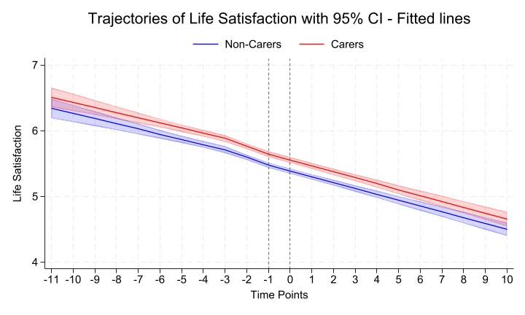

Figure – Self-esteem trajectories before, during and after becoming a young carer

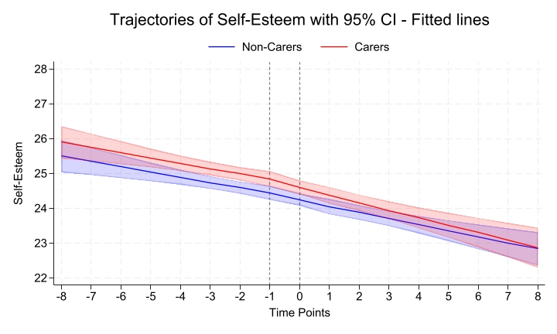

Figure – Self-rated health trajectories before, during and after becoming a young carer

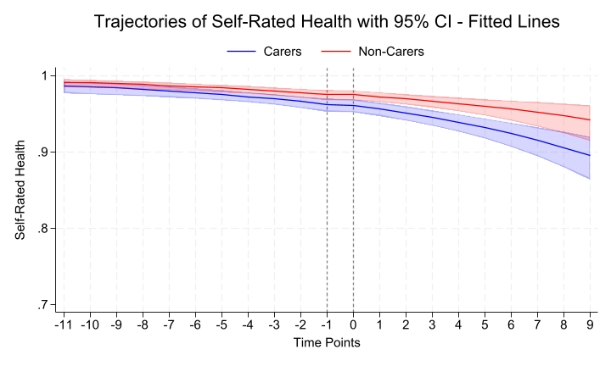

Appendix 13 - Investigating continuity in young caring across youth and adult questionnaires

Table – Count of waves in which young carers reported providing care in the life satisfaction sample
Number of waves | n | %
1 | 1572 | 65.5
2 | 477 | 19.9
3 | 164 | 6.8
4 | 84 | 3.5
5 | 53 | 2.2
6 | 24 | 1.0
7 | 11 | 0.5
8 | 9 | 0.4
9 | 4 | 0.2
10 | 2 | 0.1

Table – Reporting as a young carer on both the youth and adult questionnaires in the life satisfaction sample
 | n | %
report caring only youth or adult quest | 584 | 70.5
report caring on both youth and adult quest | 244 | 29.5

Appendix 14 – Comparing included and excluded samples

Table – Descriptive comparison of individuals excluded from the analysis and the analytic sample prior to PS for the life satisfaction sample

 | Pre PSM
 | Individuals Included in the PSM |  |  | Individuals Excluded from the PSM
 | total | Non carers | Carers | total | Non carers | Carers
n | 19,022 | 16,622 | 2,400 | 8,656 | 6,572 | 2,084
 | % | % | % | % | % | %
Gender
Male | 47.4 | 46.9 | 51.0 | 52.0 | 52.6 | 50.2
Female | 52.6 | 53.1 | 49.0 | 48.0 | 47.4 | 49.8
Age first observed
10 to 17 | 67.0 | 63.6 | 90.5 | 39.1 | 30.7 | 65.8
18 to 25 | 33.0 | 36.4 | 9.5 | 60.9 | 69.3 | 34.2
Ethnicity
White | 74.9 | 76.0 | 67.0 | 65.6 | 68.1 | 57.7
Black | 7.5 | 7.5 | 8.0 | 9.9 | 9.8 | 10.1
Indian | 4.1 | 3.4 | 5.2 | 5.2 | 5.4 | 4.7
Pakistani/Bangladeshi | 8.5 | 7.5 | 15.5 | 12.7 | 9.6 | 22.1
Other | 5.0 | 5.1 | 4.3 | 6.7 | 7.1 | 5.4
Urbanicity
Urban | 79.6 | 79.2 | 82.3 | 85.5 | 85.1 | 86.6
Rural | 20.4 | 20.8 | 17.8 | 14.5 | 14.9 | 13.4
Parental composition
Two parent household | 70.9 | 71.6 | 65.6 | 60.9 | 60.2 | 63.1
Single parent household | 29.2 | 28.4 | 34.4 | 39.1 | 39.8 | 36.9
Numb siblings in the Hh
None | 28.7 | 30.7 | 14.9 | 45.4 | 51.9 | 26.1
1 | 36.7 | 36.3 | 39.2 | 26.2 | 24.7 | 30.8
2 | 21.0 | 20.6 | 24.4 | 15.7 | 13.5 | 22.2
3 or more | 14.0 | 12.4 | 21.5 | 12.7 | 9.9 | 20.9
Household income
Highest | 15.2 | 16.3 | 7.8 | 12.1 | 13.9 | 6.4
Second quintile | 19.8 | 20.7 | 13.5 | 17.0 | 18.8 | 11.4
Third quintile | 20.7 | 21 | 18.5 | 19.1 | 18.7 | 20.1
Fourth quintile | 21.6 | 20.6 | 28.7 | 21.4 | 19.4 | 27.8
Lowest | 22.7 | 21.4 | 31.4 | 30.4 | 29.2 | 34.4
Parental occupational class
Managerial/professional | 40.9 | 43.1 | 26.4 | 32.8 | 35.7 | 23.8
Intermediate | 19.8 | 20.3 | 16.8 | 19.3 | 20.6 | 15.4
Routine | 23.9 | 23.7 | 25.1 | 26.9 | 28.2 | 23.0
Not in paid work | 15.4 | 13.0 | 31.6 | 21.0 | 15.5 | 37.8
Parental education
Degree | 31.9 | 33.3 | 22.5 | 27.4 | 29.3 | 21.3
Other Higher | 15.0 | 15.0 | 14.6 | 13.6 | 13.8 | 13.0
A-Level | 22.1 | 22.4 | 20 | 25.2 | 26.0 | 22.7
GSCE | 19.5 | 19.0 | 23.1 | 19.4 | 18.3 | 22.9
Other qualification | 5.5 | 5.1 | 8.6 | 6.1 | 5.6 | 7.6
No qualification | 6.0 | 5.3 | 11.1 | 8.3 | 7.0 | 12.5
Unweighted distributions: Sample after applying inclusion/exclusion criteria, before propensity score matching (PSM).
Individuals were excluded from the analysis due to one of the following reasons: (i) carers missing outcome measures both pre- and post-onset, (ii) incomplete data on other covariables, or (iii) non-carers with fewer than two outcome measures.

Table – Descriptive comparison of individuals excluded from the analysis and the analytic sample prior to PS for the self esteem sample

 | Pre PSM
 | Individuals Included in the PSM |  |  | Individuals Excluded from the PSM
 | total | Non carers | Carers | total | Non carers | Carers
n | 8,052 | 6,638 | 1,414 | 13,790 | 11,080 | 2,710
 | % | % | % | % | % | %
Gender
Male | 48.6 | 48.2 | 50.8 | 49.8 | 49.4 | 51.33
Female | 51.4 | 51.8 | 49.2 | 50.2 | 50.6 | 48.7
Age first observed
10 to 17 | 99.2 | 99.1 | 99.8 | 59.0 | 54.2 | 78.7
18 to 25 | 0.8 | 0.9 | 0.2 | 41.0 | 45.8 | 21.3
Ethnicity
White | 76.2 | 77.7 | 69.2 | 69.7 | 71.9 | 60.43
Black | 6.8 | 6.6 | 7.9 | 9.8 | 9.7 | 10.0
Indian | 4.0 | 3.8 | 5.0 | 4.1 | 3.9 | 4.7
Pakistani/Bangladeshi | 8.2 | 7.1 | 13.6 | 10.6 | 8.3 | 19.9
Other | 4.8 | 4.9 | 4.2 | 5.9 | 6.1 | 5.1
Urbanicity
Urban | 76.8 | 76.2 | 79.7 | 82.5 | 81.6 | 85.95
Rural | 23.2 | 23.8 | 20.3 | 17.5 | 18.4 | 14.1
Parental composition
Two parent household | 74.6 | 76.1 | 68.0 | 63.8 | 64.0 | 62.8
Single parent household | 25.4 | 24.0 | 32.0 | 36.2 | 36.0 | 37.3
Number of siblings in the Hh
None | 13.6 | 13.8 | 12.8 | 28.8 | 31.2 | 19.3
1 | 44.1 | 45.0 | 39.6 | 34.9 | 34.9 | 34.9
2 | 26.2 | 26.2 | 26.5 | 20.9 | 20.2 | 23.4
3 or more | 16.1 | 15.0 | 21.1 | 15.4 | 13.6 | 22.5
Household income
Highest | 16.3 | 17.8 | 9.5 | 11.4 | 12.7 | 6.14
Second quintile | 19.5 | 20.6 | 14.1 | 16.6 | 17.9 | 11.4
Third quintile | 21.0 | 21.6 | 18.5 | 19.5 | 19.6 | 19.2
Fourth quintile | 22.4 | 21.2 | 28.1 | 22.7 | 21.4 | 28.0
Lowest | 20.9 | 19.0 | 29.8 | 29.8 | 28.5 | 35.2
Parental occupational class
Managerial/professional | 44.2 | 47.7 | 27.8 | 34.3 | 36.7 | 24.6
Intermediate | 19.4 | 19.6 | 18.4 | 19.3 | 20.2 | 15.5
Routine | 20.6 | 19.5 | 25.7 | 26.0 | 26.7 | 23.5
Not in paid work | 15.8 | 13.2 | 28.1 | 20.4 | 16.4 | 36.5
Parental education
Degree | 35.7 | 38.0 | 25.0 | 25.0 | 26.1 | 20.68
Other Higher | 15.6 | 15.7 | 15.4 | 14.5 | 14.8 | 13.2
A-Level | 19.7 | 19.8 | 19.2 | 25.2 | 25.8 | 22.4
GSCE | 19.3 | 18.4 | 23.6 | 20.6 | 20.2 | 22.4
Other qualification | 4.6 | 4.0 | 7.5 | 6.8 | 6.4 | 8.8
No qualification | 5.1 | 4.2 | 9.3 | 7.9 | 6.8 | 12.5
Unweighted distributions: Sample after applying inclusion/exclusion criteria, before propensity score matching (PSM).
Individuals were excluded from the analysis due to one of the following reasons: (i) carers missing outcome measures both pre- and post-onset, (ii) incomplete data on other covariables, or (iii) non-carers with fewer than two outcome measures.

Table – Descriptive comparison of individuals excluded from the analysis and the analytic sample prior to PS for the self-rated health sample

 | Pre PSM
 | Individuals Included in the PSM |  |  | Individuals Excluded from the PSM
 | total | Non carers | Carers | total | Non carers | Carers
n | 19,711 | 17,497 | 2,214 | 13,790 | 11,080 | 2,710
 | % | % | % | % | % | %
Gender
Male | 48.2 | 47.9 | 50.1 | 50.6 | 50.4 | 51.2
Female | 51.8 | 52.1 | 49.9 | 49.4 | 49.6 | 48.9
Age
10 to 17 | 61.3 | 58.3 | 85.1 | 50.8 | 41.9 | 73.1
18 to 25 | 38.7 | 41.7 | 14.9 | 49.2 | 58.1 | 26.9
Ethnicity
White | 73.9 | 74.9 | 65.5 | 67.4 | 70.4 | 60.0
Black | 7.9 | 7.9 | 8.3 | 9.1 | 8.8 | 9.6
Indian | 4.3 | 4.1 | 5.7 | 4.8 | 5.1 | 4.2
Pakistani/Bangladeshi | 8.8 | 7.8 | 16.2 | 12.3 | 8.8 | 20.9
Other | 5.2 | 5.2 | 4.4 | 6.4 | 6.9 | 5.2
Urbanicity
Urban | 80.0 | 79.6 | 82.7 | 85.0 | 84.7 | 85.8
Rural | 20.0 | 20.4 | 17.3 | 15.0 | 15.3 | 14.2
Parental composition
Two parents household | 70.3 | 70.9 | 65.5 | 61.5 | 60.8 | 63.5
Single parent household | 29.7 | 29.1 | 34.6 | 38.5 | 39.3 | 36.5
Number of siblings in the Hh
None | 30.6 | 32.5 | 15.6 | 42.0 | 49.4 | 24.4
1 | 35.9 | 35.6 | 38.9 | 27.2 | 25.3 | 31.7
2 | 20.4 | 19.8 | 24.9 | 16.9 | 14.7 | 21.9
3 or more | 13.1 | 12.1 | 20.6 | 14.0 | 10.6 | 22.0
Household income
Highest | 15.4 | 16.3 | 8.4 | 11.5 | 13.7 | 6.0
Second quintile | 20 | 20.9 | 13.4 | 16.2 | 18.0 | 11.7
Third quintile | 20.6 | 20.9 | 18.1 | 19.2 | 18.7 | 20.4
Fourth quintile | 21.1 | 20.1 | 28.4 | 22.7 | 20.6 | 28.1
Lowest | 22.9 | 21.8 | 31.7 | 30.4 | 29.0 | 33.9
Parental occupational class
Managerial/professional | 40.6 | 45.2 | 26.5 | 32.8 | 36.5 | 24.0
Intermediate | 19.7 | 20.2 | 16.3 | 19.5 | 20.9 | 16.1
Routine | 24.1 | 24.1 | 24 | 26.5 | 27.4 | 24.4
Not in paid work | 15.6 | 13.2 | 33.2 | 21.1 | 15.3 | 35.5
Parental educational
Degree | 31.6 | 32.7 | 23.2 | 27.7 | 30.4 | 20.7
Other Higher | 14.9 | 15 | 14.3 | 13.7 | 13.8 | 13.4
A-Level | 22 | 22.3 | 19.7 | 25.6 | 26.7 | 22.9
GSCE | 19.6 | 19.1 | 23 | 19.3 | 17.7 | 23.1
Other qualification | 5.6 | 5.2 | 8.5 | 6.0 | 5.3 | 7.8
No qualification | 6.3 | 5.7 | 11.4 | 7.9 | 6.2 | 12.1
Unweighted distributions: Sample after applying inclusion/exclusion criteria, before propensity score matching (PSM).
Individuals were excluded from the analysis due to one of the following reasons: (i) carers missing outcome measures both pre- and post-onset, (ii) incomplete data on other covariables, or (iii) non-carers with fewer than two outcome measures.
Hh: Household

Appendix 15 – Sensitivity analysis applying survey weights

Shown below are the results of sensitivity analysis applying the baseline (wave at first observation) cross-sectional survey weights to the main analyses comparing the health and wellbeing trajectories of carers vs non-carers. The findings with the weights applied are the same as the unweighted analyses presented in the main manuscript.

Figure – Changes in life satisfaction before, during and after becoming a young carer including weights

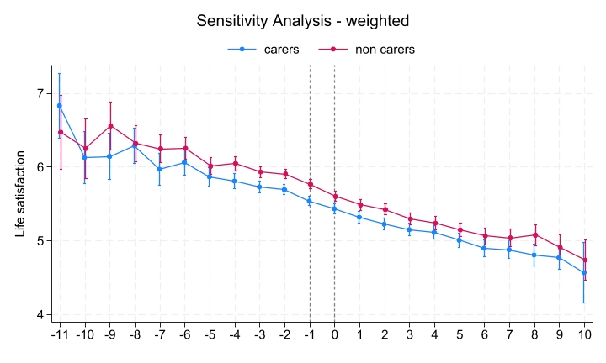

Figure – Changes in self esteem before, during and after becoming a young carer including weights

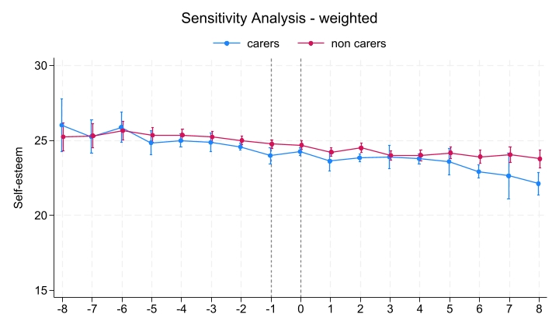
Figure – Changes in self-rated before, during and after becoming a young carer including weights

