SUPPLEMENTARY MATERIAL

Variants in LPA are associated with Familial Hypercholesterolaemia: whole genome sequencing analysis in the 100,000 Genomes Project.

Martin Bird¹, Antoine Rimbert², Alan Pittman³, Steve E Humphries⁴ and Marta Futema^{1,4}

Martin Bird¹, Antoine Rimbert², Alan M Pittman³, Steve E Humphries⁴ and Marta Futema^{1,4}
¹Experimental Cardiology, Cardiovascular and Genomics Research Institute, School of Health & Medical Sciences, City St George's, University of London, London, UK
²Nantes Université, CNRS, INSERM, l’institut du thorax, F-44000 Nantes, France
³Genomics, Cardiovascular and Genomics Research Institute, School of Health & Medical Sciences, City St George's, University of London, London, UK
⁴Institute of Cardiovascular Science, Faculty of Population Health, University College London, London, UK

SUPPLEMENTARY METHODS
Whole Genome Sequencing
All samples were sequenced with 150bp paired-end reads using Illumina HiSeq X and uniformly processed on the Illumina North Star Version 4 Whole Genome Sequencing Workflow (NSV4, version 2.6.53.23), which comprises the iSAAC Aligner (version 03.16.02.19) and Starling Small Variant Caller (version 2.4.7). Samples were aligned to the Homo Sapiens NCBI GRCh38 assembly with decoys. Single-sample gVCFs were aggregated using the Illumina software gVCF genotyper (version: 2019.02.26). Variant normalisation and decomposition was implemented by vt (version 0.57721).
Sample QC
Samples with contamination>0.03 (estimated using verifyBamID), excess of chimeric reads>5%, median fragment size<250bp, percentage of AT dropout>10%, percentage of mapped reads<60% were excluded from the analysis.
Variant QC for GWAS
Only variants with a minor allele frequency (MAF)>=0.1% were assessed. Variants are further filtered for a median coverage≥10, median GQ≥20, and a missingness of ≤5%. Furthermore, only variants for which at least 25% of the heterozygous sites are not showing significant allele imbalance (p=0.01, binomial test) were included in the analysis. Variants with evidence of differential missingness (p≤ 1e-05) between cases and controls and variants which fail HWE in unrelated controls (p ≤1e-05) were also excluded from the analysis.
Genetic ancestry definition
Data generated data by Genomics England, as described on their website: https://re-docs.genomicsengland.co.uk/ancestry_inference/ and https://re-docs.genomicsengland.co.uk/principal_components/ was used to infer genetic ancestry of all participants. Briefly, principal components (PCs) and SNP loadings were calculated for 1KGP3 by using GCTA v.1.93.1_beta on a 30K set of high-quality independent variants. Next, the 1KGP3 SNP loadings were used to calculate projected individual loadings for the participants.
To assign ancestry, a random forest classifier was used (rpackage: randomForest) on the 1KGP3 samples using 6 PCs from the 1KGP3 PCs and superpopulation labels (EUR, AFR, AMR, SAS, EAS). The trained model was used on the projected loadings of genomicsengland100kgp participants to calculate probabilities of assignment to each super-population. A probability cut-off threshold T≥ 0.8 was then used to assign each individual to a superpopulation ancestry. 95,829 of high confidence LD-pruned biallelic SNPs to be used on all downstream analyses. The SNPs were selected based on the following criteria:
- Include autosomal, bi-allelic SNPs only
- Keep variants which are common (MAF>1%) in both aggV2 and the 1KGP3
- Missingness < 1%
- Median GQ ≥ 30
- Median Depth ≥ 30
- AB Ratio ≥ 0.9
- Completeness ≥ 0.9
- Exclude variants in complex regions, as defined in the 'high LD exclusion regions' file
- Remove all SNPs where the ref/alt combination was AT or GC (A/T, T/A, G/C, C/G), to avoid ambiguous allele swaps
- LD prune using plink version v1.9 with an r² 0.1, 500kb window
- Remove all SNPs which are out of Hardy Weinberg Equilibrium (HWE) in any of the afr, eas, eur or sas super-populations, with a p-value cutoff of pHWE < 1e⁻⁵

SUPPLEMENTARY RESULTS

GWAS summary statistics data
The summary statistics data have been uploaded into the following repository:
https://doi.org/10.24376/rd.sgul.26152918.v2

TABLE S1.
Summary of Human Phenotype Ontology (HPO) terms assigned to FH cohort participants.
HPO Term | Count of participants
hypercholesterolemia | 513
hyperlipidemia | 368
hyperlipoproteinemia | 211
increased ldl cholesterol concentration | 211
myocardial infarction | 200
corneal arcus | 60
premature coronary artery atherosclerosis | 48
hypertriglyceridemia | 27
tendon xanthomatosis | 26
hypertension | 15
coronary artery atherosclerosis | 7
depressivity | 5
xanthelasma | 5

TABLE S2.
WGS variant quality control criteria.
Filter | Description
PASS | PASS value is given if all below listed filters passed
missingness | Missingness (fully missing genotypes with DP=0) ≤ 5%
depth | Median Depth ≥ 10
GQ | Median GQ ≥ 15
ABratio | Percentage of het calls not showing significant allele imbalance for reads supporting the ref and alt alleles ≥ 25%
completeGTRatio | Percentage of complete sites (sites with no missing data) ≥ 50%
phwe_eur | mid p-value for deviations from HWE in unrelated samples of inferred European ancestry ≥ 1e⁻⁵

TABLE S3.
Tier 1 and tier 2 FH genes’ coordinates on human genome GRCh38.

Gene name | Chromosome number | Start coordinate | End coordinate
LDLR | 19 | 11,089,262 | 11,133,820
APOB | 2 | 21,001,429 | 21,044,073
APOE | 19 | 44,905,791 | 44,909,393
PCSK9 | 1 | 55,039,347 | 55,064,852
ABCG5 | 2 | 43,806,211 | 43,839,231
ABCG8 | 2 | 43,838,971 | 43,882,988
CYP27A1 | 2 | 218,782,147 | 218,815,293
LIPA | 10 | 89,213,572 | 89,251,775
LPA | 6 | 160,531,482 | 160,664,275

TABLE S4.
Likely pathogenic (LP) and pathogenic (P) single nucleotide variants and small deletions and insertions found in FH Tier 1 genes.
Gene name | Variant position (chr:position:ref:alt) | cDNA change | Protein change | Number of carriers (number of probands) | Prediction (P/LP)
LDLR | 19:11089550:TG:T | c.6del | p.Trp4Glyfs*202 | 1 (1) | P
LDLR | 19:11100291:T:G | c.136T>G | p.Cys46Gly | 2 (1) | LP
LDLR | 19:11102717:T:G | c.244T>G | p.Cys82Gly | 1 (1) | LP
LDLR | 19:11102742:A:G | c.269A>G | p.Asp90Gly | 2 (1) | LP
LDLR | 19:11102774:G:A | c.301G>A | p.Glu101Lys | 2 (1) | LP
LDLR | 19:11102775:A:C | c.302A>C | p.Glu101Ala | 3 (1) | LP
LDLR | 19:11102787:G:A | c.313+1G>A |  | 2 (2) | LP
LDLR | 19:11102788:T:C | c.313+2T>C |  | 1 (1) | P
LDLR | 19:11105496:G:A | c.590G>A | p.Cys197Tyr | 2 (0) | LP
LDLR | 19:11105568:A:G | c.662A>G | p.Asp221Gly | 2 (1) | LP
LDLR | 19:11105585:GAC:G | c.680_681del | p.Asp227Glyfs*12 | 1 (1) | P
LDLR | 19:11105587:C:G | c.681C>G | p.Asp227Glu | 1 (1) | LP
LDLR | 19:11105588:G:T | c.682G>T | p.Glu228* | 4 (4) | P
LDLR | 19:11107425:G:A | c.851G>A | p.Cys284Tyr | 2 (1) | LP
LDLR | 19:11107432:C:A | c.858C>A | p.Ser286Arg | 1 (1) | LP
LDLR | 19:11107461:G:A | c.887G>A | p.Cys296Tyr | 1 (1) | LP
LDLR | 19:11107495:T:G | c.921T>G | p.Asp307Glu | 1 (1) | LP
LDLR | 19:11107504:CA:C | c.933del | p.Glu312Serfs*58 | 1 (1) | P
LDLR | 19:11110759:C:T | c.1048C>T | p.Arg350* | 3 (2) | P
LDLR | 19:11111538:A:C | c.1085A>C | p.Asp362Ala | 1 (1) | LP
LDLR | 19:11111568:A:AGGGT | c.1118_1121dup | p.Tyr375Trpfs*7 | 1 (1) | P
LDLR | 19:11111644:G:A | c.1186+5G>A | p.Gly369fs*26 | 1 (1) | P
LDLR | 19:11113293:T:A | c.1202T>A | p.Leu401His | 1 (1) | LP
LDLR | 19:11113313:G:A | c.1222G>A | p.Glu408Lys | 2 (2) | LP
LDLR | 19:11113385:C:G | c.1294C>G | p.Leu432Val | 1 (1) | LP
LDLR | 19:11113743:G:A | c.1567G>A | p.Val523Met | 1 (1) | LP
LDLR | 19:11113767:G:A | c.1586+5G>A |  | 1 (1) | LP
LDLR | 19:11116141:G:A | c.1634G>A | p.Gly545Glu | 2 (1) | LP
LDLR | 19:11116153:G:A | c.1646G>A | p.Gly549Asp | 1 (1) | P
LDLR | 19:11116898:T:C | c.1745T>C | p.Leu582Pro | 1 (1) | LP
LDLR | 19:11116928:G:A | c.1775G>A | p.Gly592Glu | 1 (1) | LP
LDLR | 19:11120106:G:T | c.1860G>T | p.Trp620Cys | 2 (2) | LP
LDLR | 19:11120197:G:T | c.1951G>T | p.Asp651Tyr | 1 (1) | LP
LDLR | 19:11120408:G:A | c.2026G>A | p.Gly676Ser | 1 (1) | LP
LDLR | 19:11120411:T:C | c.2029T>C | p.Cys677Arg | 1 (1) | LP
LDLR | 19:11120436:C:T | c.2054C>T | p.Pro685Leu | 5 (4) | LP
LDLR | 19:11120480:G:A | c.2098G>A | p.Asp700Asn | 1 (1) | LP
LDLR | 19:11120519:AC:A | c.2138del | p.Thr713Lysfs*17 | 1 (1) | P
LDLR | 19:11123200:G:T | c.2167G>T | p.Glu723* | 2 (1) | P
LDLR | 19:11123271:TC:T | c.2241del | p.Asp748ThrfsTer17 | 1 (1) | P
APOB | 2:21006288:C:T | c.10580G>A | p.Arg3527Gln | 6 (5) | P
APOB | 2:21006289:G:A | c.10579C>T | p.Arg3527Trp | 1 (1) | P
APOE | 19:44908791:GCTC:G | c.499_501delCTC | p.Leu167del | 14 (10) | LP
Total |  |  |  | 83 (65)

TABLE S5.
VUSs identified in FH Tier 1 genes.

Gene name | Variant position (chr:position:ref:alt) | cDNA change | Protein change | Number of carriers (number of probands) | Prediction (P/LP/VUS)
LDLR | 19:11089514:C:G | c.-35C>G | 5'UTR | 1 (1) | VUS
LDLR | 19:11090620:C:T | c.67+1005C>T | intronic | 1 (1) | VUS
LDLR | 19:11090668:G:A | c.67+1053G>A | intronic | 1 (1) | VUS
LDLR | 19:11110721:A:G | c.1010A>G | p.Glu337Gly | 1 (1) | VUS
LDLR | 19:11110768:G:A | c.1057G>A | p.Glu353Lys | 1 (1) | VUS
LDLR | 19:11116969:G:T | c.1816G>T | p.Ala606Ser | 2 (1) | VUS
LDLR | 19:11123329:A:G | c.2296A>G | p.Thr766Ala | 1 (1) | VUS
LDLR | 19:11129475:G:A | c.2390-38G>A | intronic | 1 (1) | VUS
APOB | 2:21003092:G:T | c.12330C>A | p.Asn4110Lys | 1 (1) | VUS
APOB | 2:21006297:T:G | c.10571A>C | p.Lys3524Thr | 1 (1) | VUS
APOB | 2:21019741:G:A | c.2981C>T | p.Pro994Leu | 8 (8) | VUS
APOB | 2:21019859:G:A | c.2863C>T | p.Pro955Ser | 2 (1) | VUS

TABLE S6.
Structural variants identified in the LDLR gene.

Gene name | Variant start position (chr:position:ref) | DNA change | Protein consequence | Length (bp) | Number of carriers (number of probands) | Prediction (P/LP)
LDLR | 19:11089513:T | c.-35_c.67+1036del | deletion of promoter and exon 1 | 1138 | 3 (1) | P
LDLR | 19:11106156:C | c.695-409_817+373del | deletion of exon 5 | 904 | 1 (1) | P
LDLR | 19:11118054:T | c.1845-2038_1988+1354del | deletion of exons 13 and 14 | 3822 | 4 (1) | P
LDLR | 19:11121708:T | c.2141-1466_2311+3835del | deletion of exon 15 | 5471 | 1 (1) | LP
Total |  |  |  |  | 9 (4)

TABLE S7.
SNVs and small indels identified in Tier 2 genes. The table includes the ABCG8 homozygote variant p.Trp361Ter which was classified as pathogenic.
Gene name | Variant position (chr:position:ref:alt) | cDNA change | Protein change | Genotype (het, hom) | Number of carriers (number of probands) | Prediction (P/LP/VUS)
ABCG5 | 2:43822886:G:C | c.1374C>G | p.Tyr458Ter | Het | 1 (1) | P*
 | 2:43822924:G:A | c.1336C>T | p.Arg446Ter | Het | 1 (1) | P*
 | 2:43824931:C:G | c.862G>C | p.Gly288Arg | Het | 1 (1) | VUS
 | 2:43832063:G:C | c.286C>G | p.Leu96Val | Het | 1 (1) | VUS
ABCG8 | 2:43865534:del | c.965-6382_965-6343del |  | Hom | 1 (1) | VUS
 | 2:43872094:G:A | c.1083G>A | p.Trp361Ter | Hom | Hom=1 (1), Het=4 (4) | P*
 | 2:43873795:T:A | c.1220T>A | p.Ile407Asn | Het | 1 (1) | VUS
 | 2:43874471:T:A | c.1476T>A | p.Tyr492Ter | Het | 1 (1) | P*
CYP27A1 | 2:218812741:T:G | c.836T>G | p.Phe279Cys | Het | 1 (1) | VUS
 | 2:218814188:G:A | c.1184+1G>A |  | Het | 1 (1) | LP*
LIPA | 10:89215004:C:T | c.1024G>A | p.Gly342Arg | Het | 1 (1) | LP*

*P or LP prediction is for variants in either homozygous or compound heterozygous state

TABLE S8.
LDL PRS deciles based on the control cohort of 100KGP (n=77,660). The cohort includes non-FH individuals who had FH-related HPO terms in their records (n=383).

Decile | Mean | SD | Min | Max | Range
1 | 0.110 | 0.114 | -0.748 | 0.243 | 0.991
2 | 0.307 | 0.0349 | 0.243 | 0.364 | 0.121
3 | 0.409 | 0.0252 | 0.364 | 0.451 | 0.0872
4 | 0.489 | 0.0213 | 0.451 | 0.525 | 0.0734
5 | 0.559 | 0.0200 | 0.525 | 0.594 | 0.0689
6 | 0.628 | 0.0201 | 0.594 | 0.664 | 0.0699
7 | 0.700 | 0.0213 | 0.664 | 0.737 | 0.0737
8 | 0.778 | 0.0247 | 0.737 | 0.823 | 0.0855
9 | 0.877 | 0.0332 | 0.823 | 0.939 | 0.116
10 | 1.07 | 0.109 | 0.939 | 1.71 | 0.769

TABLE S9.
Lp(a) PRS deciles based on the control cohort of 100KGP (n=77,660). The cohort includes non-FH individuals who had FH-related HPO terms in their records (n=383).
Decile | Lp(a) PRS (nmol/L) | IQR
Min | -130.335
1 | -8.000
2 | -0.645
Q1 | 1.935 | 56.454
3 | 4.900 | 56.454
4 | 10.535 | 56.454
5 (Median) | 17.585 | 56.454
6 | 26.400 | 56.454
7 | 43.215 | 56.454
Q3 | 58.265 | 56.454
8 | 79.505
9 | 121.690
10 (Max) | 416.455

Figure S1.
Cohort selection for GWAS analysis.

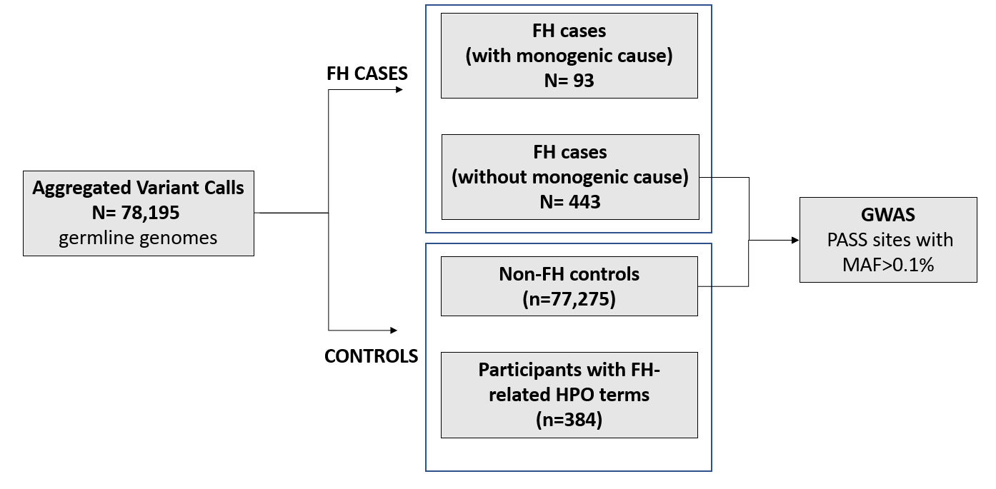

Figure S2.
Cohort selection for PRS analysis. A. LDL-C PRS, B. Lp(a) PRS.
A.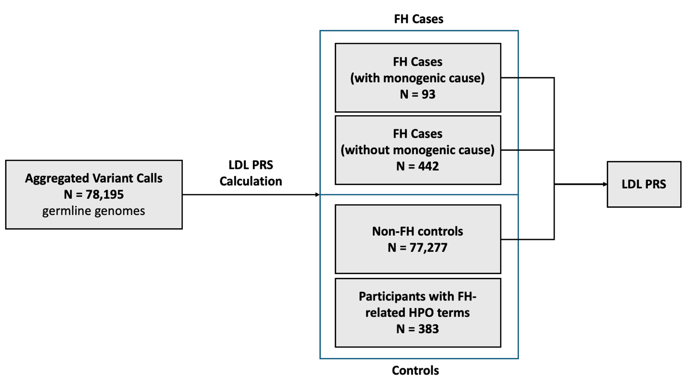
B.

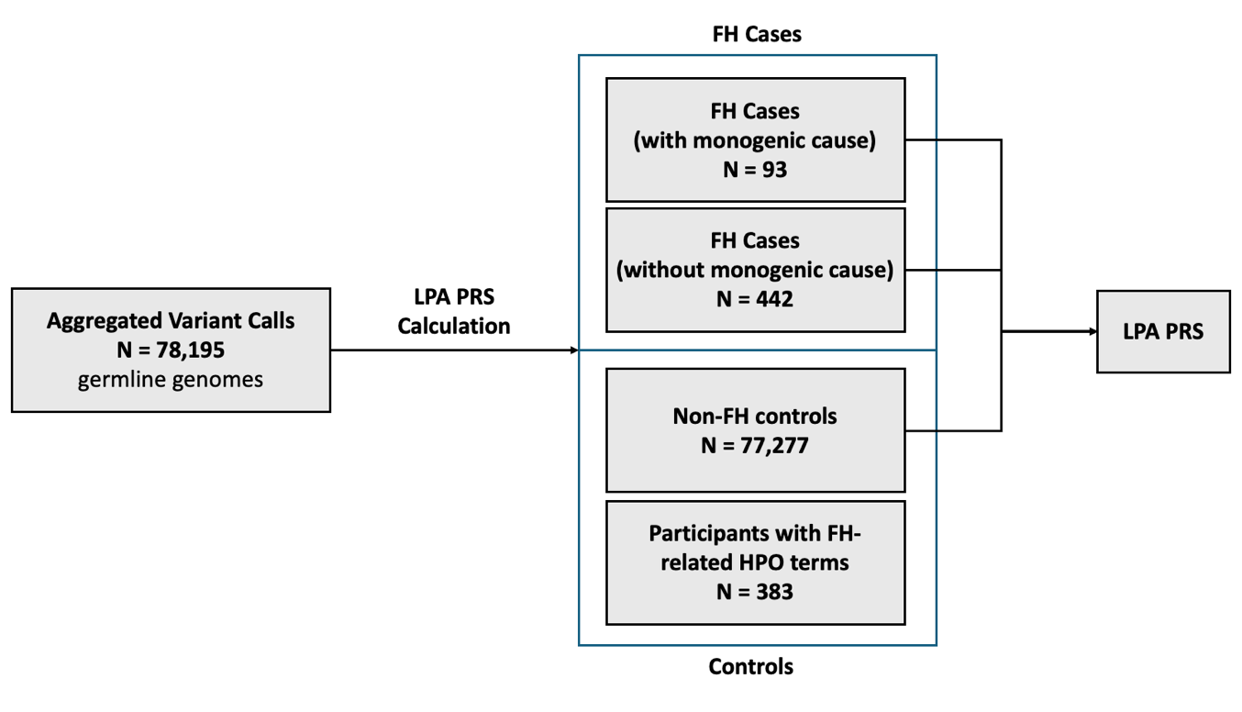
Figure S3.
Principal component analysis (PCA) for genetic ancestry. PCs with FH cases and 100KGP controls assignment, inferred super-population regions (using a threshold of T≥0.8) are overlayed.

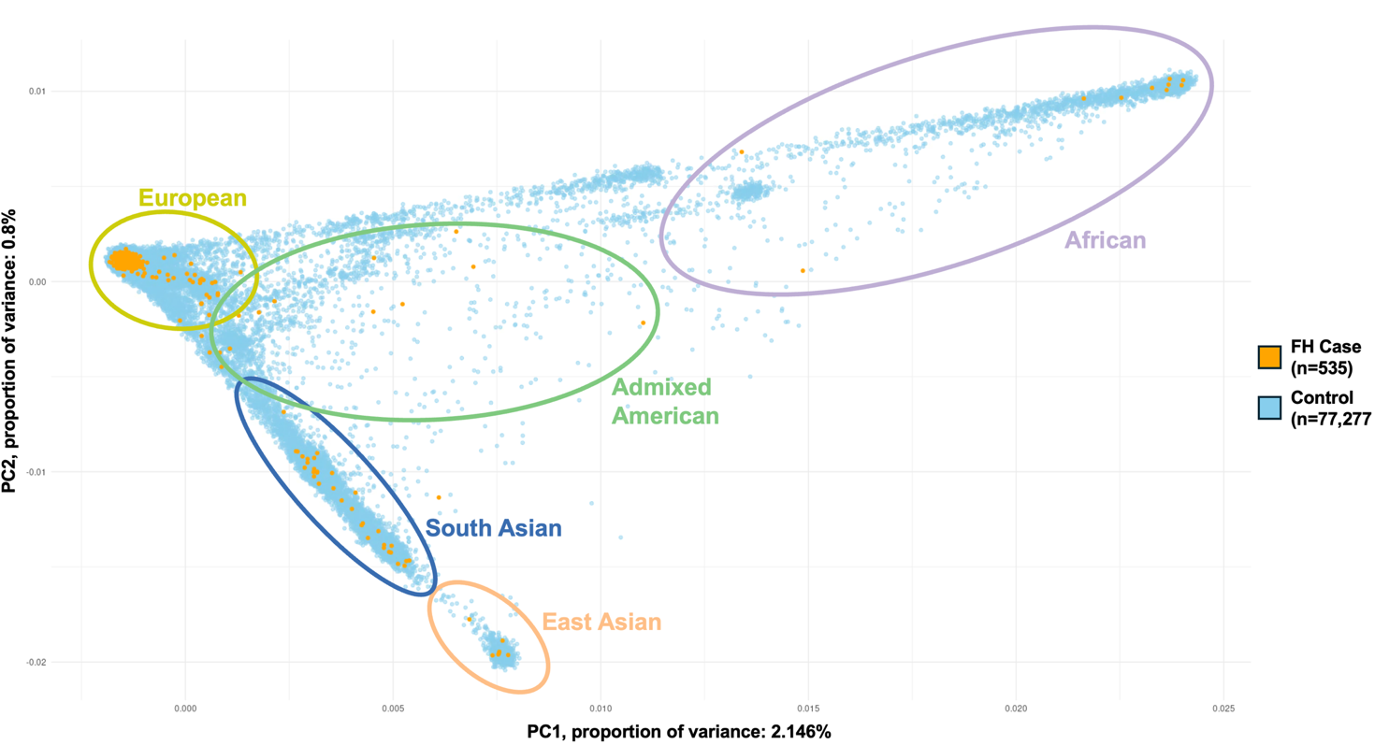
Figure S4.

Structural variants identified in the LDLR gene, in relation to the gene’s main functional domains.

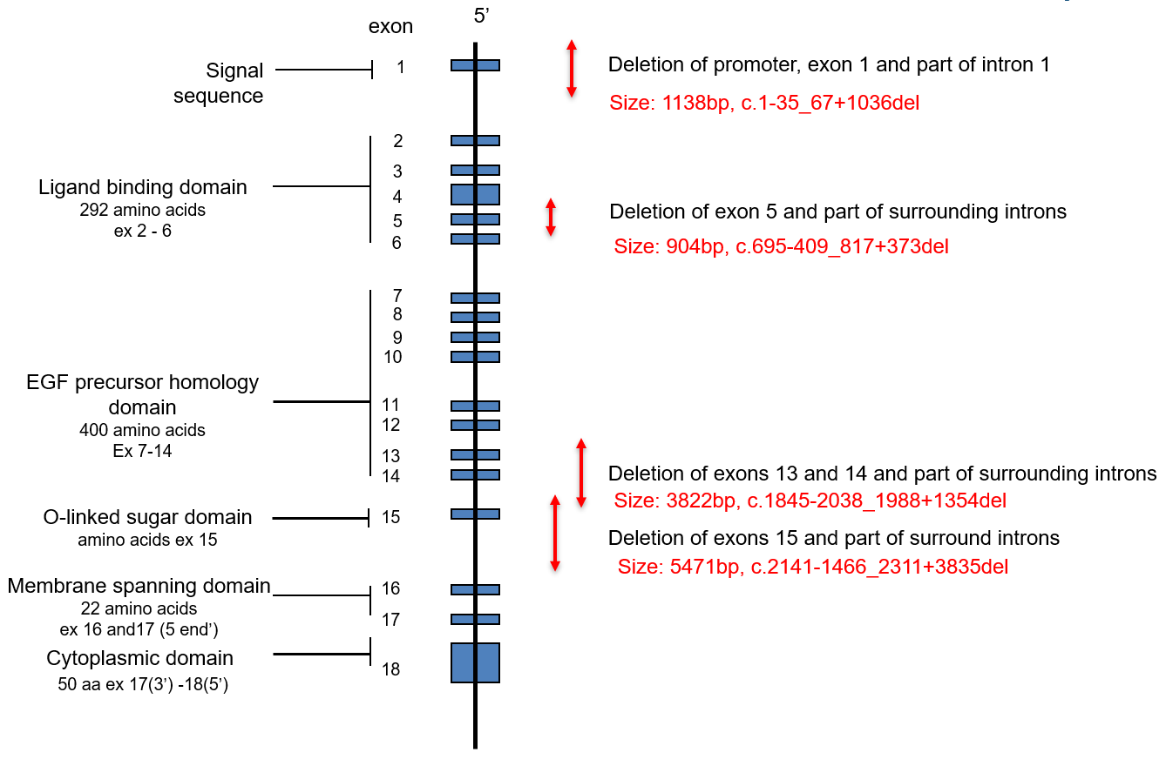

Figure S5.
Quantile-Quantile (QQ) plot for GWAS of FH-variant negative participants data. Lambda =1.14.
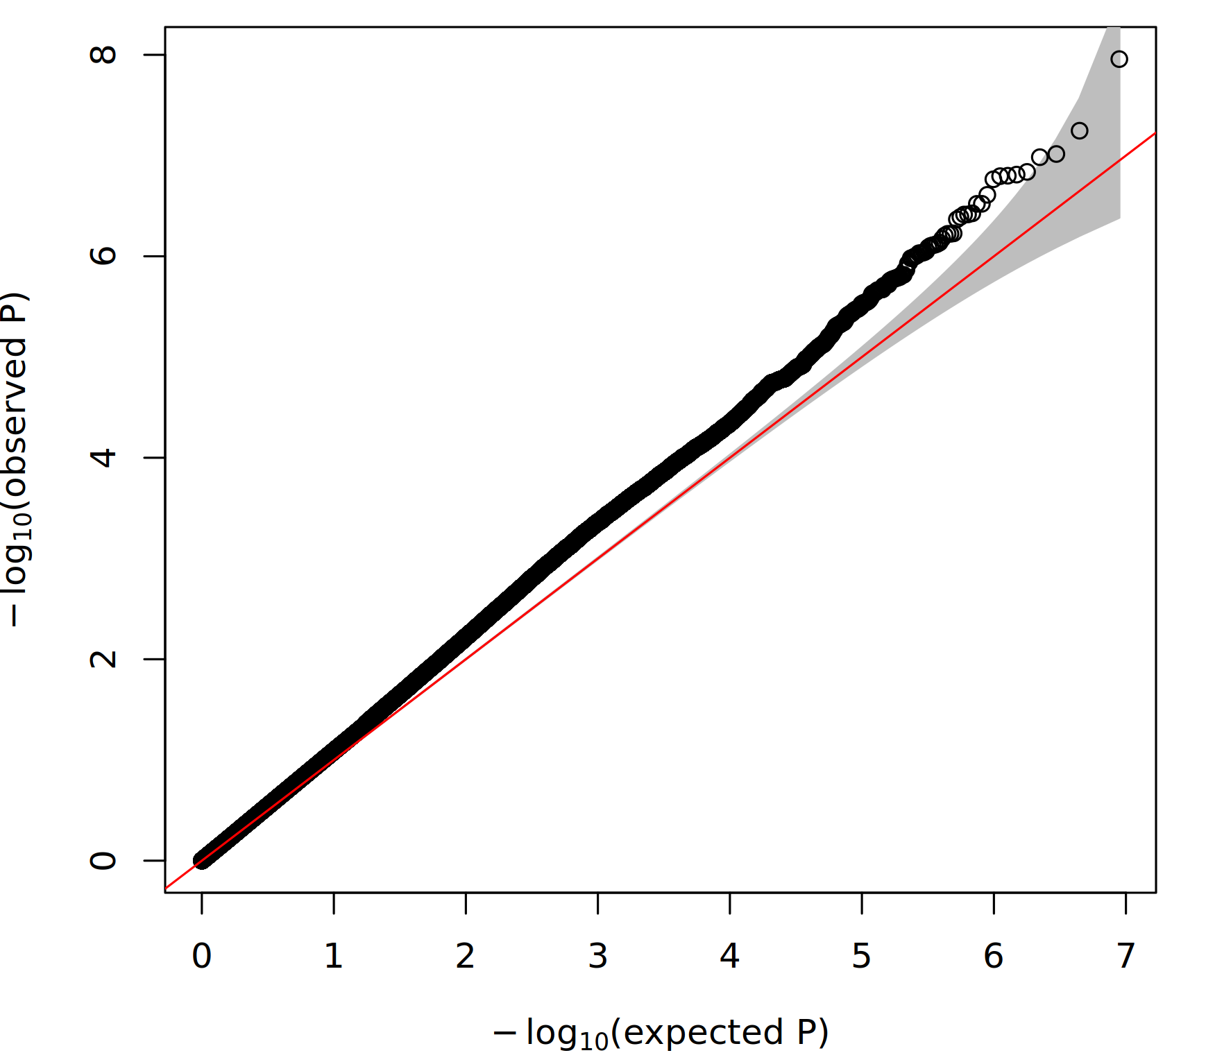

Figure S6.
Regional plot (generated by Locus Zoom: https://my.locuszoom.org/) of the LPA locus when running GWAS between FH variant positive cases (n=92) and non-FH controls (n=77,275). No significant associations in the LPA locus have been observed.
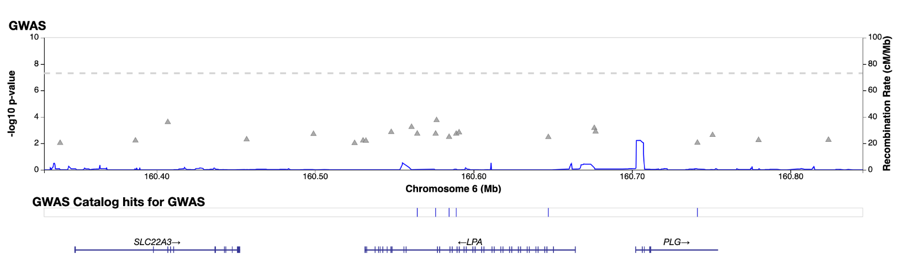

Figure S7.
Distribution of Lp(a) PRS across genetically inferred ancestries in the control population, genetic ancestry in AggV2 is inferred using super-populations from the 1000 Genomes study as described in Supplementary Methods.
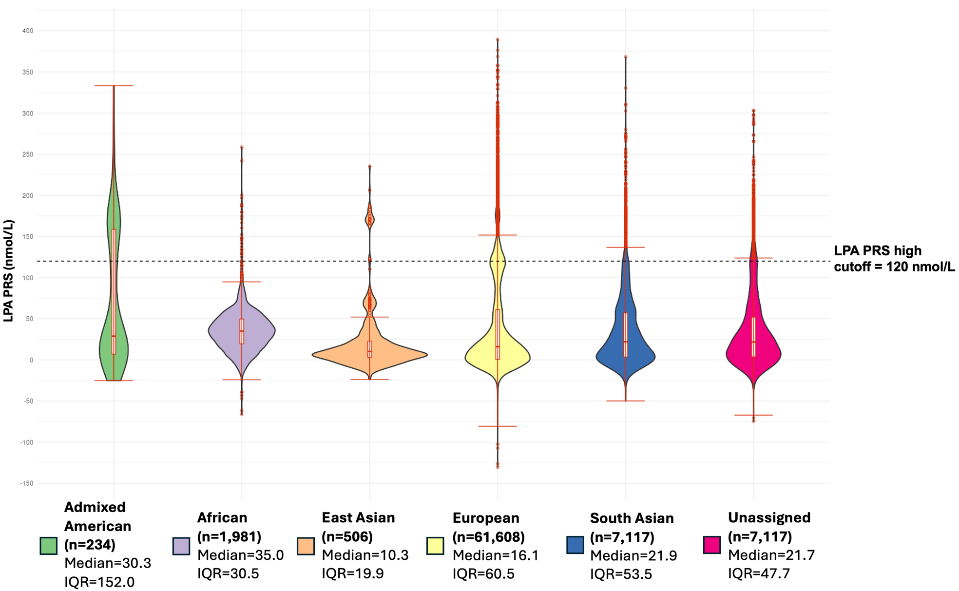
Figure S8.
Summary of monogenic and polygenic components of hypercholesterolaemia in FH participants.
