# Figure S1

Forest Plot to demonstrate the adjusted odds ratios for preterm and term stillbirth with interaction test p-values to demonstrate differences in associations between the two.

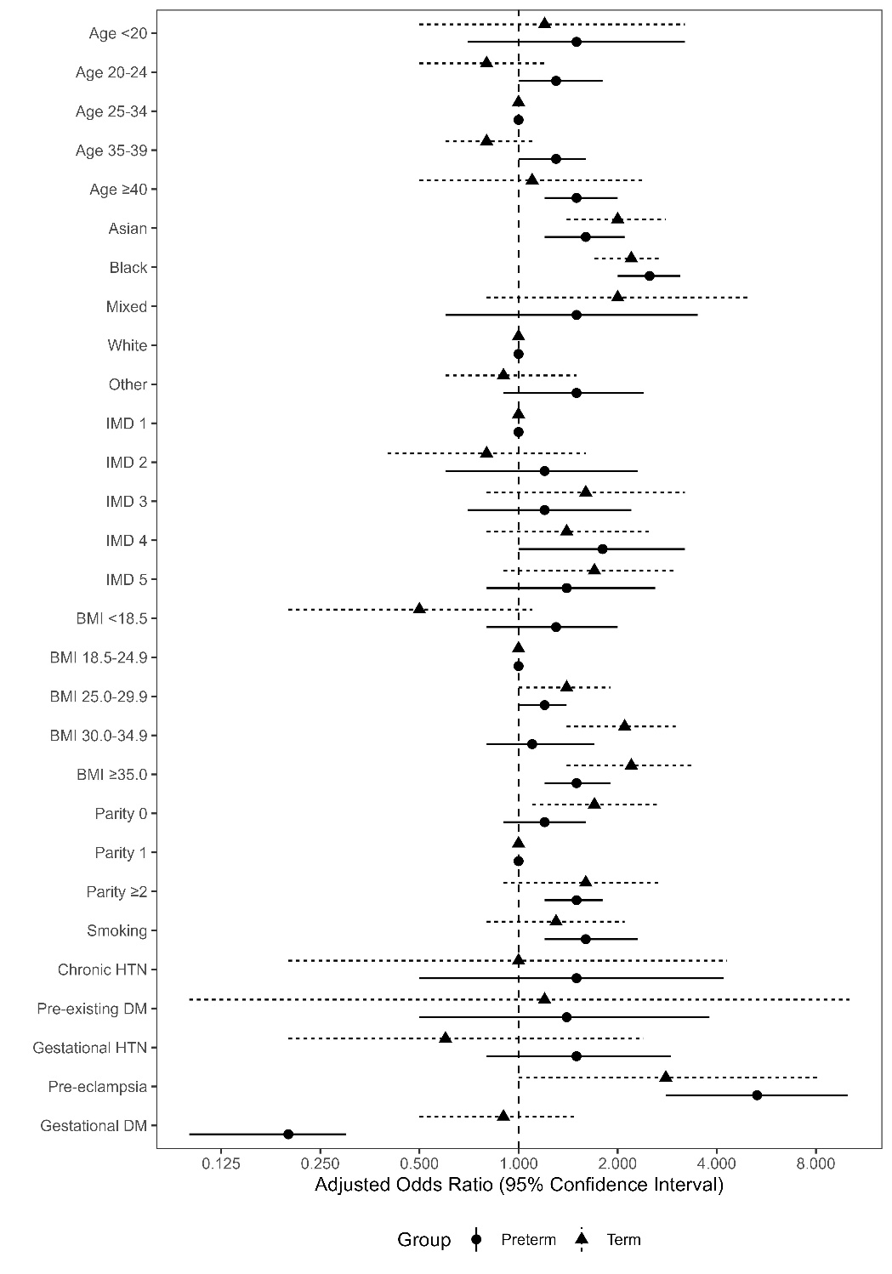

<0.01

<0.01

<0.01

<0.01

<0.01

<0.01

<0.01

<0.01

0.04

0.08

0.53

(SB rate = number of stillbirths per 1000 births, restricted to term births only at term; aOR = adjusted odds ratio (exposures adjusted for *a priori* selected confounders (**age**: ethnicity, IMD, parity; **ethnicity**: n/a, **IMD**: age, ethnicity, parity, pre-existing co-morbidities; **BMI:** age, ethnicity, IMD, parity, smoking, pre-existing co-morbidities; **parity:** age, ethnicity, IMD, BMI, pre-existing co-morbidities; **smoking:** age, ethnicity, IMD, parity, pre-existing co-morbidities; **cHTN / pre-existing DM:** all variables except cHTN / pre-existing DM respectively and pregnancy complications; **gHTN / PE / GDM:** all variables except gHTN/PE/GDM respectively; also described inSupplementary Table 1), as well as the implementation period and arm of main trial); IMD = index of multiple deprivation; BMI = body mass index; HTN = hypertension; cHTN = chronic hypertension; DM = diabetes mellitus; gHTN = gestational hypertension; GDM = gestational diabetes mellitus)