Western Blots

Figure 3f KCNN4

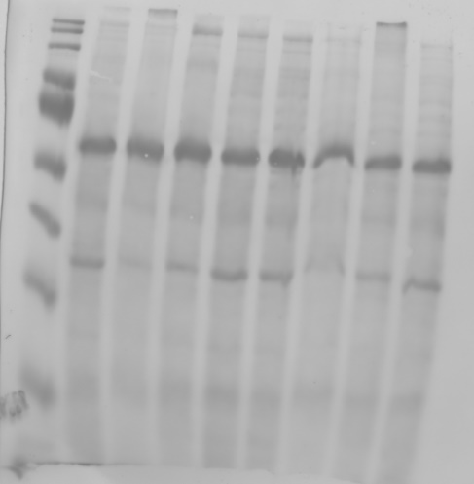
Figure 3f Ponceau Total Protein Stain

Figure 4i MLC
Figure 4i MLC exposure used in figure

Figure 4i p-MLC

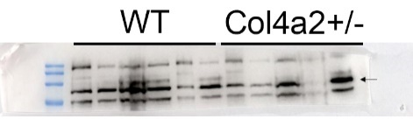
Figure 4i MYLK

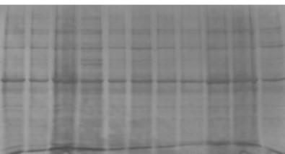
Figure 4i Ponceau Total Protein Stain
Supplemental Figure 2l eif2p

Supplemental Figure 2l eif2

Supplemental Figure 2l Total Protein Stain

Supplemental Figure 2m Grp94

Supplemental Figure 2m Ponceau Total Protein Stain

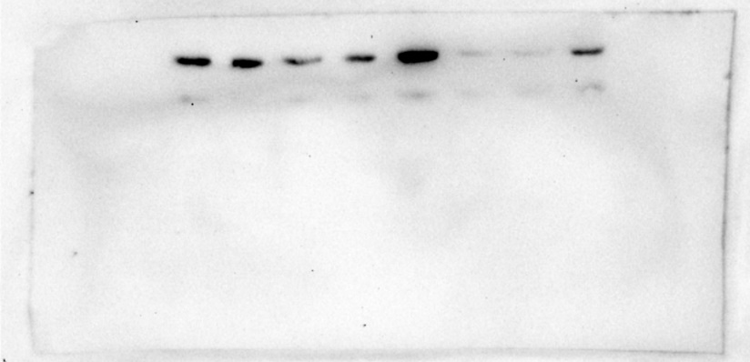
Supplemental Figure 2n eif2P

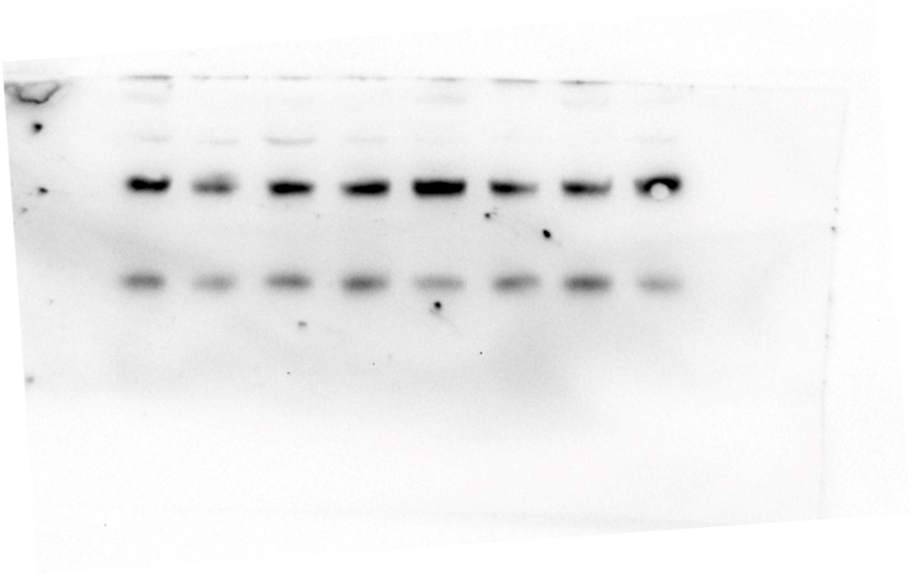
Supplemental Figure 2n eif2

Supplemental Figure 2n Bip
Supplemental Figure 2n VDAC

Supplemental Figure 2o Grp94
Supplemental Figure 2o VDAC (bottom band)

Supplemental Figure 6g eNOS. Lanes marked X were not part of the investigation.
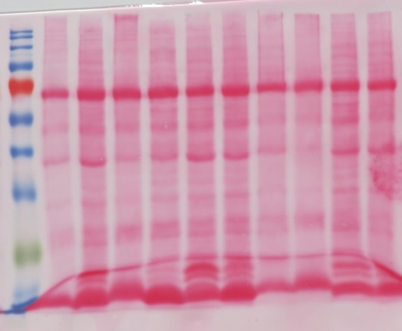
Supplemental Figure 6g Ponceau Total Protein Stain

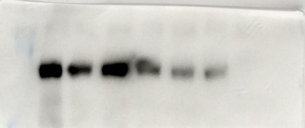
Supplemental Figure 7f COL4A2

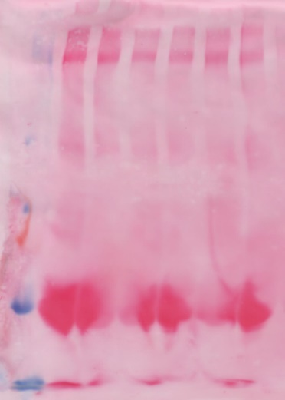
Supplemental Figure 7f Ponceau Total Protein Stain

Supplemental Figure 8e αSMA X lanes were not part of the investigation

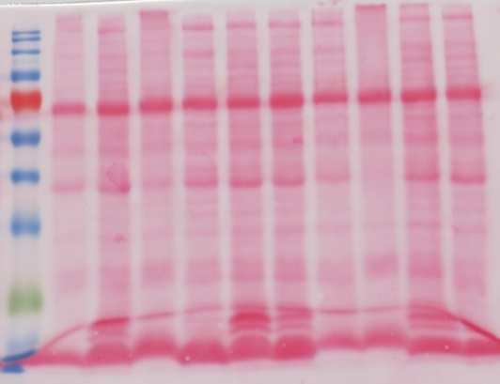
Supplemental Figure 8e Ponceau Total Protein Stain

Supplemental Figure 8f Vimentin. Lanes marked X were not part of the investigation.

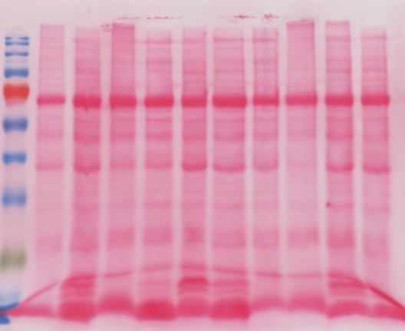
Supplemental Figure 8f Ponceau Total Protein Stain

