**Use MY Voice to EndTB: empowering community health workers to destigmatize TB care in South Africa**

**Focus group discussion (FGD) guide**

**Briefing for FGD.**

*[Introduce research team members]. Thank you for agreeing to take part. This focus group discussion (or group interview) is for a research study about understanding the experience of both those with TB and the carers or family members of those with TB to develop person-centered interventions to improve TB care. We greatly value your perspective. There are no right or wrong answers to the questions we will ask.*

*We would like to digitally record our conversation using this device. This will allow us to type our conversation, but any names or places that you mention will be taken out so that you will be anonymous. This way, if someone were to read this focus group discussion, they would not be able to know who you are because your name will be replaced with a code. If at any point during the focus group discussion you do not wish to answer a question that is ok.*

*Do you have any questions?*

**Obtain informed consent** (FGD moderators should carry consent forms)

**Topics**

Below is a list of topics to be discussed during the FGDs. The questions will remain flexible to the participants’ agendas but should focus on issues related to TB stigma. This FGD should take the form of a workshop building on the process called ‘human-centred design’ to develop counselling as an intervention that addresses the human needs, capabilities and behaviours identified by participants. We will focus on identifying how counselling can reduce stigma experienced by TB survivors and carers and how health workers can receive training to provide counselling and reduce stigma.

1. Discuss different levels at which stigma can be experienced (see figure)
2. Discuss themes including fear, disclosure concerns, and trust/mistrust that could be addressed by counselling a) to patients and b) training health workers

Please note that this interview guide will be refined based on feedback from stakeholder discussions. The following are examples of questions that could be used. Given this study’s methodology (semi-structured FGDs), additional questions may be added during FGDs following the topics listed above.

**Brief introductions** to get to know the group

- for HWs - gender, age, how they are involved in TB care

- for patients/survivors - gender, age, type of TB (pulmonary/extra-pulmonary, DS vs DR-TB), how long ago they had it

- for caregivers -- gender and age of the child who had TB (and the caregiver), type of TB (pulmonary/extra-pulmonary, DS vs DR-TB), how long ago they had it

*Facilitators them provide a brief reminder of the reasons for undertaking this FGD:*

*The purpose of this FGD to co-develop a counselling intervention focused on reducing TB stigma to improve TB care. We need your help as experts to figure out which components to include and how to deliver this intervention. We will use a process called human-centred design which helps to ensure that person-centred perspectives from people with experiences and insights that you have are incorporated directly into the design of interventions.*

Our prior focus groups highlighted how stigma can impact individuals and communities across multiple different levels. This picture shows how these levels overlap and we have colour coded quotes or findings from the focus groups to show stigma at each of these levels to help us brainstorm to develop stigma reduction strategies.

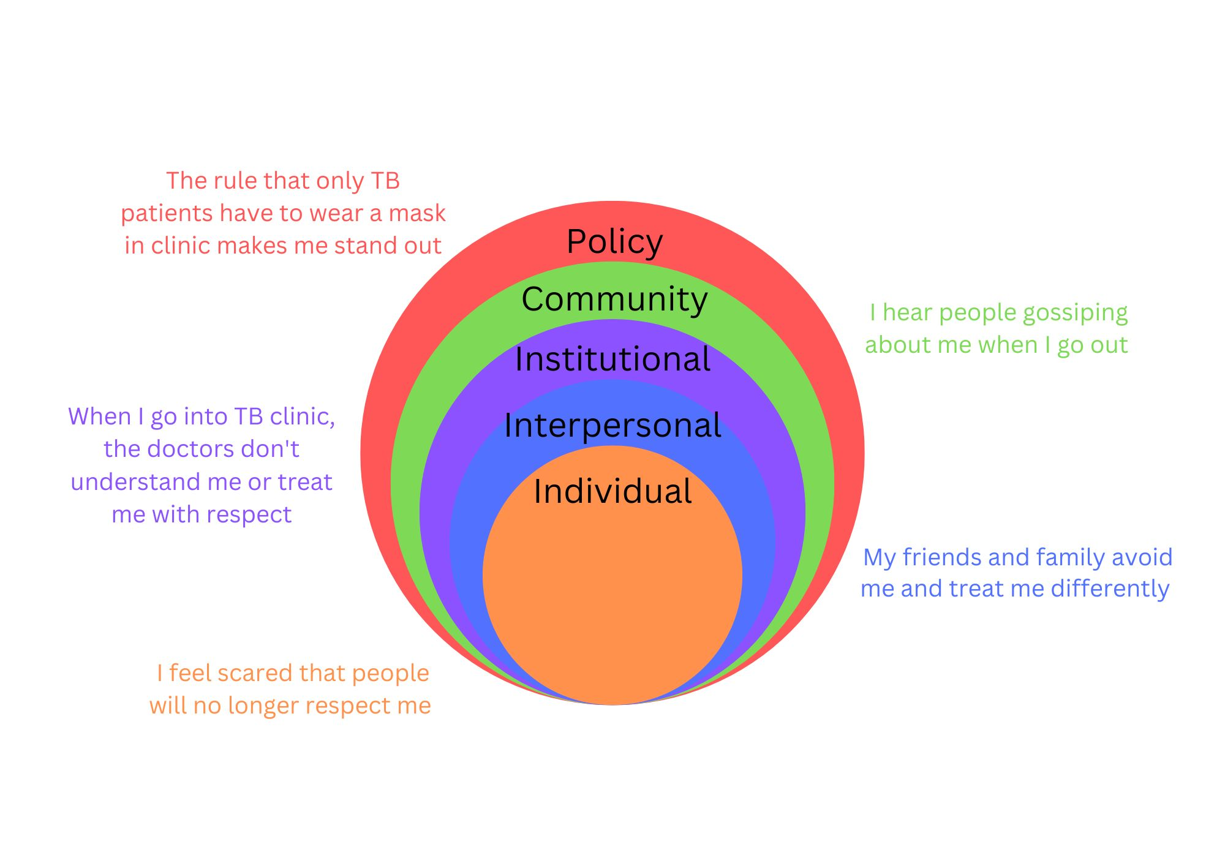

Three key themes that arose from our data were fear, disclosure concerns, and trust, all of which are stigma drivers.

**Fear- driver of internal stigma**

- How can counselling address negative self-perceptions that arise with TB diagnosis?

- What messages would people being diagnosed with TB benefit from hearing?

**Disclosure concerns - driver of anticipated and enacted stigma e.g. from family/friends to patients**

- How can counselling be delivered to caregivers to decrease stigma experienced by the person with TB?

- How can people with TB be empowered to discuss their diagnosis with loved ones?

**Trust - driver of anticipated and enacted stigma in healthcare facilities**

- What are the reasons people with TB have mistrust of healthcare settings and how can we address these?

- What messages would people with TB like health workers to know?

- What messages would health workers like people with TB to know?