**Supplements**

**Statistical analysis of country-specific macro health economic factors.**

Exponentiated country random effects extracted from the above models can be regarded as hazard ratios (HR). A country HR smaller than 1 indicates lower than expected risk of death (or other outcome) given the patients/disease/HCT characteristics in that country. On the other hand, a HR greater than 1 indicates higher than expected risk of death (or relapse or NRM). The HR of countries with few patients are drawn toward the overall mean (HR of 1) whereas HRs from countries with many patients are less drawn toward the mean. The economic analysis was performed on all country level data, except for Taiwan because of missing information on governmental health care expenditures. Transplant activity and post-transplant outcomes were correlated with mean GNI or HCE/GNI ratio of the years 2013 to 2017. The association of the macroeconomic factors with TR was estimated by single linear regression analysis, using Pearson correlation coefficient (r). The linear relationship, positive or negative, between the macroeconomic factors and TR was measured using the *t* statistic; a level of 5% was considered significant. All analysis were performed in Python (3.12.1) using the following packages: numpy (1.26.3). pandas (2.1.4), scipy (1.11.4), statsmodels (0.14.1).

**Table S1:** Number of auto-HCT by year and region.

|  |  |  |  |  |  |  |  |
| --- | --- | --- | --- | --- | --- | --- | --- |
|  | **Total** | **2013** | **2014** | **2015** | **2016** | **2017** | **Mean increase /year** |
|  | **N (%)** | **N (%)** | **N (%)** | **N (%)** | **N (%)** | **N (%)** |
| **Europe** | 37459 (100%) | 7018 (18.7%) | 7196 (19.2%) | 7645 (20.4%) | 7654 (20.4%) | 7946 (21.2%) | 231.4 |
| **USA** | 16217 (100%) | 2823 (17.4%) | 2970 (18.3%) | 3059 (18.9%) | 3586 (22.1%) | 3779 (23.3%) | 252.8 |
| **Australia and New Zealand** | 3164 (100%) | 597 (18.9%) | 571 (18.0%) | 619 (19.6%) | 708 (22.4%) | 669 (21.1%) | 28.1 |
| **Japan** | 3122 (100%) | 567 (18.2%) | 640 (20.5%) | 608 (19.5%) | 627 (20.1%) | 680 (21.8%) | 21.3 |
| **EM region** | 543 (100%) | 131 (24.1%) | 110 (20.3%) | 94 (17.3%) | 84 (15.5%) | 124 (22.8%) | -4.0 |
| **Taiwan** | 524 (100%) | 89 (17.0%) | 87 (16.6%) | 111 (21.2%) | 118 (22.5%) | 119 (22.7%) | 9.1 |
| **Latin America** | 339 (100%) | 36 (10.6%) | 56 (16.5%) | 58 (17.1%) | 80 (23.6%) | 109 (32.2%) | 17.0 |
| **Ottawa, Canada** | 188 (100%) | 29 (15.4%) | 33 (17.6%) | 40 (21.3%) | 51 (27.1%) | 35 (18.6%) | 3.0 |
| **Malaysia** | 169 (100%) | 27 (16.0%) | 36 (21.3%) | 38 (22.5%) | 31 (18.3%) | 37 (21.9%) | 1.5 |
| **China** | 72 (100%) | 13 (18.1%) | 6 (8.3%) | 6 (8.3%) | 15 (20.8%) | 32 (44.4%) | 4.7 |

**Table S2A**: Overall Survival and Progression Free Survival at different time points after HCT according to regions/countries

|  |  |  |  |  |  |
| --- | --- | --- | --- | --- | --- |
|  |  | **Overall Survival probability** | | | |
| Regions | Total n | **12 months**  **% (95% CI)** | **24 months**  **% (95% CI)** | **36 months**  **% (95% CI)** | **Log-rank p-value** |
| Total population | 61725 | 94.7 (94.5-94.9) | 88.4 (88.1-88.7) | 82.1 (81.7-82.4) |  |
| Europe | 37459 | 94.4 (94.2-94.7) | 87.8 (87.4-88.2) | 80.9 (80.4-81.4) | <0.001 |
| USA | 16217 | 95.6 (95.3-95.9) | 89.9 (89.4-90.4) | 84.3 (83.7-84.9) |
| Australia/New Zealand | 3164 | 93.9 (93.1-94.8) | 87.0 (85.7-88.2) | 81.7 (80.2-83.2) |
| Japan | 3122 | 95.0 (94.2-95.8) | 89.5 (88.3-90.6) | 83.0 (81.5-84.4) |
| East Mediterranean Region | 543 | 92.8 (90.5-95.2) | 84.7 (81.2-88.2) | 77.1 (72.7-81.4) |
| Taiwan | 524 | 93.0 (90.7-95.4) | 82.0 (77.7-86.2) | 74.5 (69.2-79.9) |
| Latin America | 339 | 95.7 (93.5-97.9) | 90.6 (87.5-93.8) | 83.7 (79.6-87.8) |
| Ottawa/Canada | 188 | 94.9 (91.6-98.1) | 89.5 (85.0-94.1) | 82.1 (76.3-88.0) |
| Malaysia | 169 | 87.6 (82.6-92.5) | 75.1 (68.6-81.7) | 68.6 (61.6-75.6) |
|  |  |  |  |  |  |
|  |  | **Progression-free survival probability** | | | |
| Total population | 58295 | 82.7 (82.4-83.1) | 64.6 (64.1-65.0) | 50.6 (50.2-51.1) |  |
| Europe | 35614 | 82.6 (82.1-83.0) | 62.3 (61.7-62.9) | 46.6 (45.9-47.2) | <0.001 |
| USA | 16201 | 83.5 (82.9-84.0) | 67.5 (66.8-68.2) | 55.0 (54.2-55.8) |
| Australia/New Zealand | 2082 | 82.3 (80.7-84.0) | 60.8 (58.6-63.0) | 48.2 (45.9-50.5) |
| Japan | 2758 | 81.6 (80.1-83.1) | 70.9 (69.1-72.7) | 62.5 (60.5-64.4) |
| East Mediterranean Region | 504 | 78.7 (74.9-82.5) | 59.5 (54.7-64.4) | 45.7 (40.5-50.9) |
| Taiwan | 518 | 82.0 (78.4-85.7) | 63.6 (58.3-68.9) | 52.4 (46.3-58.6) |
| Latin America | 290 | 82.5 (78.1-86.9) | 69.1 (63.7-74.5) | 56.8 (50.9-62.6) |
| Ottawa/Canada | 164 | 84.8 (79.3-90.3) | 71.3 (64.4-78.3) | 53.5 (45.8-61.1) |
| Malaysia | 164 | 73.2 (66.4-80.0) | 54.3 (46.6-61.9) | 43.3 (35.7-50.9) |

**Table S2B**: Relapse Incidence and Non-Relapse mortality at different time points after HCT according to regions/countries

|  |  |  |  |  |  |  |
| --- | --- | --- | --- | --- | --- | --- |
|  | **Cumulative relapse Incidence** | | | | |  |
| Regions | Total n | **3 months**  **% (95% CI)** | **6 months**  **% (95% CI)** | **12 months**  **% (95% CI)** | **36 months**  **% (95% CI)** | **Gray’s test p-value** |
| Total population | 58259 | 2.4 (2.3-2.5) | 6.8 (6.6-6.7) | 15.7 (15.4-16.1) | 46.0 (45.5-46.4) |  |
| Europe | 35614 | 2.3 (2.1-2.4) | 6.8 (6.5-7.1) | 15.9 (15.5-16.4) | 50.3 (49.7-51.0) | <0.001 |
| USA | 16201 | 2.2 (2.0-2.4) | 6.2 (5.8-6.6) | 14.9 (14.4-15.5) | 41.5 (40.8-42.3) |
| Australia/New Zealand | 2082 | 2.2 (1.6-2.8) | 7.3 (6.1-8.4) | 16.2 (14.6-17.8) | 48.6 (46.3-50.9) |
| Japan | 2758 | 4.6 (3.8-5.4) | 9.3 (8.2-10.4) | 17.1 (15.7-18.6) | 31.7 (29.8-33.5) |
| EMBMT | 504 | 5.6 (3.6-7.7) | 10.9 (8.1-13.7) | 20.5 (16.7-24.3) | 52.3 (47.1-57.5) |
| Taiwan | 518 | 3.2 (1.6-4.7) | 5.9 (3.8-8.0) | 15.3 (11.9-18.7) | 40.1 (34.1-46.0) |
| LABMT | 290 | 2.1 (0.4-3.7) | 9.3 (6.0-12.7) | 16.4 (12.1-20.7) | 40.3 (34.5-46.1) |
| Ottawa/Canada | 164 | 1.8 (0.0-3.9) | 4.9 (1.6-8.2) | 13.4 (8.2-18.6) | 42.8 (35.2-50.4) |
| Malaysia | 164 | 1.2 (0.0-2.9) | 9.1 (4.7-13.6) | 24.4 (17.8-31.0) | 51.8 (44.2-59.5) |
|  |  |  |  |  |  |  |
|  | **Cumulative non relapse mortality** | | | | |  |
| Total population | 58259 | 0.6 (0.6-0.7) | 1.0 (0.9-1.0) | 1.5 (1.4-1.6) | 3.4 (3.2-3.6) |  |
| Europe | 35614 | 0.7 (0.6-0.7) | 1.0 (0.9-1.1) | 1.5 (1.3-1.6) | 3.1 (2.8-3.3) | <0.001 |
| USA | 16201 | 0.6 (0.5-0.8) | 0.9 (0.8-1.1) | 1.6 (1.4-1.8) | 3.5 (3.2-3.8) |
| Australia/New Zealand | 2082 | 0.4 (0.2-0.7) | 1.0 (0.5-1.4) | 1.5 (1.0-2.0) | 3.2 (2.4-4.0) |
| Japan | 2758 | 0.4 (0.2-0.6) | 0.6 (0.3-0.8) | 1.3 (0.9-1.7) | 5.8 (4.9-6.8) |
| EMBMT | 504 | 0.6 (0.0-1.3) | 0.8 (0.0-1.6) | 0.8 (0.0-1.6) | 2.0 (0.6-3.3) |
| Taiwan | 518 | 1.0 (0.1-1.9) | 1.8 (0.6-3.0) | 2.6 (1.2-4.1) | 7.5 (4.3-10.7) |
| LABMT | 290 | 0.0 (0.0-0.0) | 0.0 (0.0-0.0) | 1.1 (0.0-2.3) | 2.9 (0.9-4.9) |
| Ottawa/Canada | 164 | 1.2 (0.0-2.9) | 1.2 (0.0-2.9) | 1.8 (0.0-3.9) | 3.7 (0.8-6.6) |
| Malaysia | 164 | 1.8 (0.0-3.9) | 1.8 (0.0-3.9) | 2.4 (0.1-4.8) | 4.9 (1.6-8.2) |

**Table S3**: Multivariable analysis in patients with complete data. As HCT-CI, ISS and the cytogenetic risk score had a high degree of missingness these variables are not included. The OS model included 53828 patients, the PFS, relapse and NRM models included 51857 patients.

|  |  |  |  |  |  |  |  |  |
| --- | --- | --- | --- | --- | --- | --- | --- | --- |
| **characteristics** | **OS: HR (95% CI)** | **p** | **PFS: HR (95% CI)** | **p** | **Relapse: HR (95% CI)** | **p** | **NRM: HR (95% CI)** | **p** |
| **Gender** |  |  |  |  |  |  |  |  |
| Male | 1.00 |  | 1.00 |  | 1.00 |  | 1.00 |  |
| Female | 0.93 (0.89-0.97) | 0.002 | 0.94 (0.91-0.96) | <0.0001 | 0.94 (0.91-0.97) | <0.0001 | 0.89 (0.80-0.99) | 0.03 |
| **MM classification** |  |  |  |  |  |  |  |  |
| IgG | 1.00 |  | 1.00 |  | 1.00 |  | 1.00 |  |
| IgA | 1.47 (1.39-1.56) | <0.0001 | 1.28 (1.23-1.33) | <0.0001 | 1.28 (1.23-1.32) | <0.0001 | 1.33 (1.16-1.53) | <0.0001 |
| Light chain | 1.14 (1.07-1.21) | <0.0001 | 1.08 (1.04-1.12) | <0.0001 | 1.08 (1.04-1.12) | <0.0001 | 1.15 (1.01-1.32) | 0.04 |
| **Interval diagnosis-HCT** (per 6 months more) | 1.00 (0.99-1.01) | 0.62 | 0.99 (0.99-1.00) | 0.05 | 0.99 (0.99-1.00) | 0.06 | 1.00 (0.98-1.02) | 0.79 |
| **Age at HCT** (per 10 year increase) | 1.11 (1.08-1.15) | <0.0001 | 1.03 (1.01-1.05) | 0.0003 | 0.95 (0.94-0.96) | 0.003 | 1.36 (1.26-1.46) | <0.0001 |
| **Year of HCT** (per year later) | 0.94 (0.92-0.95) | <0.0001 | 0.95 (0.94-0.96) | <0.0001 | 0.97 (0.96-0.99) | 0.001 | 0.97 (0.93-1.00) | 0.07 |
| **Karnofsky score at HCT** |  |  |  |  |  |  |  |  |
| 100 | 1.00 |  | 1.00 |  | 1.00 |  | 1.00 |  |
| ≤90 | 1.33 (1.26-1.40) | <0.0001 | 1.10 (1.07-1.14) | <0.0001 | 1.09 (1.051.12) | <0.0001 | 1.40 (1.22-1.60) | <0.0001 |
| **Disease stage at HCT** |  |  |  |  |  |  |  |  |
| CR | 1.00 |  | 1.00 |  | 1.00 |  | 1.00 |  |
| VGPR | 1.21 (1.12-1.30) | <0.0001 | 1.26 (1.21-1.32) | <0.0001 | 1.28 (1.23-1.34) | <0.0001 | 1.04 (0.89-1.22) | 0.61 |
| PR | 1.44 (1.33-1.55) | <0.0001 | 1.54 (1.48-1.61) | <0.0001 | 1.55 (1.48-1.62) | <0.0001 | 1.47 (1.26-1.72) | <0.0001 |
| SD/MR | 1.99 (1.78-2.22) | <0.0001 | 1.84 (1.72-1.98) | <0.0001 | 1.81 (1.68-1.95) | <0.0001 | 2.19 (1.73-2.77) | <0.0001 |
| Relapse/progression | 5.23 (4.61-5.92) | <0.0001 | 3.44 (3.12-3.80) | <0.0001 | 3.51 (3.18-3.89) | <0.0001 | 2.56 (1.73-3.80) | <0.0001 |
| **Conditioning** |  |  |  |  |  |  |  |  |
| Melphalan 200 | 1.00 |  | 1.00 |  | 1.00 |  | 1.00 |  |
| Melphalan 140 | 1.25 (1.16-1.33) | <0.0001 | 1.16 (1.11-1.21) | <0.0001 | 1.12 (1.07-1.17) | <0.0001 | 1.64 (1.43-1.88) | <0.0001 |
| **Maintenance** |  |  |  |  |  |  |  |  |
| Lenalidomide | 1.00 |  | 1.00 |  | 1.00 |  |  |  |
| Other | 1.32 (1.09-1.61) | 0.005 | 1.47 (1.32-1.64) | <0.0001 | 1.49 (1.34-1.66) | <0.0001 |  |  |
| None | 1.79 (1.40-2.28) | <0.0001 | 1.72 (1.48-1.99) | <0.0001 | 1.64 (1.41-1.91) | <0.0001 |  |  |

Abbreviations: HR >1 is associated with an increased risk for the endpoint. OS: overall survival, PFS: progression free survival, NRM: non-relapse mortality, HR: hazard ratio, CI: confidence interval, MM: multiple myeloma, CR: complete response, VGPR: very good partial response, PR: partial response, SD: stable disease, MR: minor response. * The association of lenalidomide was investigated in a separate landmark model including only patients without event at 3 months and with data on maintenance therapy available (n= 5697 for OS and 5404 for PFS and relapse) but including the variables listed in this table and a random country effect.

**Table S4:** Transplant rate in 2017 per region/country

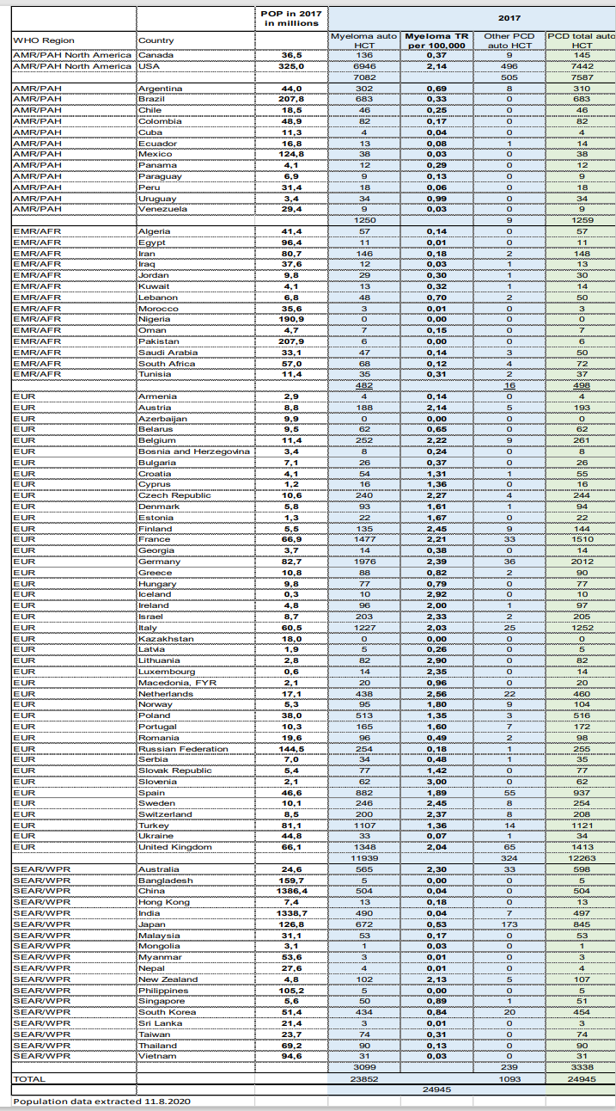

Abbreviations: AMR: American Region. EMR/AFR: Eastern Mediterranean Region/African Region.

Eur: Europe. SEAR/WPR: Southeast East Asia Region/West pacific region. POP: population.

HCT: hematopoietic cell transplantation. TR: transplant rate. PCD: plasma cell disorder

Legends to supplemental Figures

**Supplemental Figure 1:**

Outcome after auto-HCT by lenalidomide maintenance, other maintenance or no maintenance: a) probability of overall survival (OS), log-rank p<0.001, b) progression free survival (PFS) ), log-rank p<0.001, c) cumulative relapse incidence (RI) ), Gray’s test p<0.001 and d) cumulative incidence of non-relapse mortality (NRM), Gray’s test p<0.001. Estimates were obtained in the subset of patients who were alive without relapse at 3 months post-ASCT. Shaded areas show the 95% confidence intervals. Numbers below the graphs show the number of patients at risk.

**Supplemental Figure 2:**

The activity and outcome data are compared to the macroeconomic factors, Gross National Income (GNI) and Health Care Expenditure (HCE)per country.Each WBMT region is colorized and put in relation to the activity and outcome data of the study population.

2a: Activity defined by transplant rate per 10 million population (TR) according to ratio of health care expenditures (HCE) per capita, PPP in current international $ (HCE)

2b: Hazard rate of death according to HCE

2c: Hazard rate of death according to HCE/GNI

2d: Hazard rate of death and risk of relapse according to HCE/GNI

2e: Hazard rate of risk of relapse according to HCE/GNI

2f: Hazard rate of death from non-relapse causes according to HCE/GNI

Supplemental Fig 1

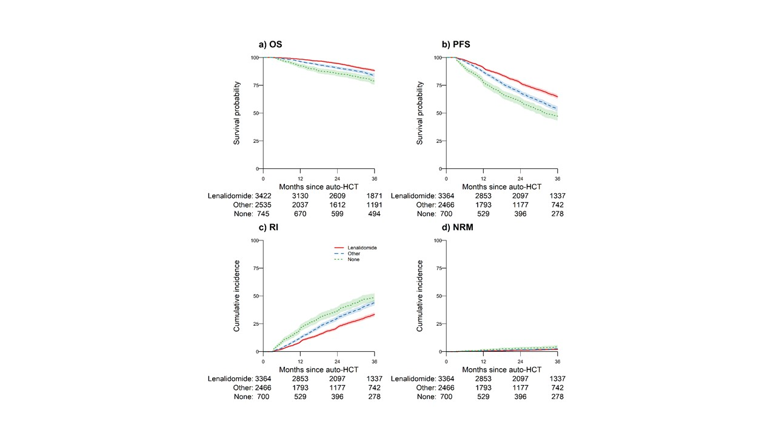

Supplemental Fig 2

