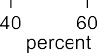
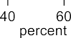
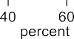
Anticipated Internal Enacted

Stigma delayed symptom recognition
Stigma delayed initial clinic visit Stigma delayed starting treatment
Stigma delayed seeking adherence support Stigma delayed completing treatment Stigma delayed seeking post-treatment care
Additional file 6: Figure S1: Impact of anticipated, internal and enacted stigma on care cascade engagement according to caregivers.

