Supporting Information for
Enhanced Efficacy of Glyco-Engineered Rice Cell-Produced Trastuzumab
Jun-Hye Shin^{1,2}, Sera Oh^{3,4}, Mi-Hwa Jang², Seok-Yong Lee^{3,4}, Chanhong Min⁵, Young-Jae Eu², Hilal Begum¹, Jong-Chan Kim¹, Gap Ryol Lee¹, Han-Bin Oh⁵, Matthew J. Paul ⁶, Julian K-C Ma⁶, Ho-Shin Gwak⁷, Hyewon Youn^{3,4}*, Seong-Ryong Kim^{1,2}*

¹Department of Life Science, Sogang University, Seoul, Republic of Korea
²PhytoMab Co. Ltd., South Korea
³Department of Nuclear Medicine, Cancer Imaging Center, Seoul National University Hospital, Seoul, South Korea
⁴Cancer Research Institute, Seoul National University College of Medicine, Seoul, South Korea
⁵Department of Chemistry, Sogang University, Seoul, South Korea
⁶Hotung Molecular Immunology Unit, Institute for Infection & Immunity, St George's University of London, Cranmer Terrace, London, SW17 0RE, United Kingdom
⁷National Cancer Center Korea, Goyang-si, Kyunggi-do, South Korea

Supporting information: Figure S1~S4; Table S1~S6

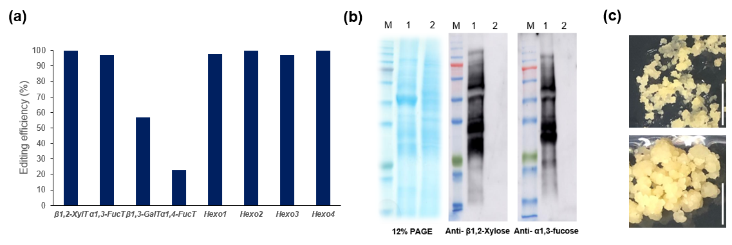

Figure S1. Investigation of genome editing of callus line #1-12-20-11. (a) Editing efficiency was analyzed using Synthego program. T-DNA region of pPM101 was integrated into rice genome via Agrobacterium-mediated transformation method. Among hygromycine resistant-calli, #1-12-20-11 line was finally selected via examining INDEL efficiency. The efficiency of genome-editing was analyzed by ICE tool (https://ice.synthego.com/#/). (b) Immunoblotting of #1-12-20-11 line using anti-β1,2-XylT and anti-α1,3-FucT. Total cellular proteins (10 μg) from the #1-12-20-11 line and WT callus separated in 12% SDS-PAGE gel were stained using Coomassie blue (left panel) or transferred to nitrocellulose membranes for immunoblotting using either anti-β1,2-xylose (middle panel) or anti-α1,3-fucose (right panel). M, size marker; Lane 1, Wild-type (Dongjin); Lane 2, # 1-12-20-11. (c) Images of #1-12-20-11 callus (top panel) and WT callus (bottom panel). Bar = 1 cm.

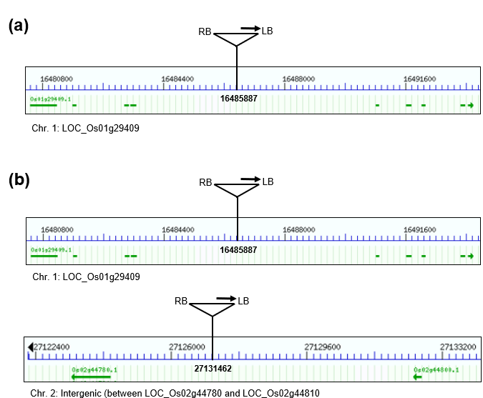

Figure S2. Summary of the T-DNA insertion into rice genome of PMC1 (a) and PMC2 (b). Inverse PCR (IPCR) was performed for identify the T-DNA location in the genome of each cell. (a) T-DNA was found to be integrated within LOC_Os01g29409. (b) T-DNAs in PMC2 genome were identified in LOC_Os01g29409 and the intergenic region between LOC_Os02g44780 and LOC_Os02g44810.

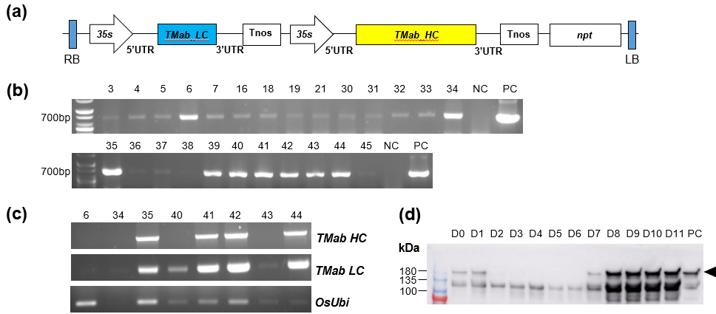

Figure S3. Construction of constitutive TMab expression vector and screening of O-TMab-expressed callus lines from Agrobacterium-mediated transgenic wild-type (non-glycoengineered) rice calli. (a) The diagram of T-DNA region of pSK446 expressing TMab. Codon-optimized TMab light chain (TMab_LC) and heavy chain (TMab_HC) genes were inserted into separate expression cassettes driven by the cauliflower mosaic virus (CaMV) 35S promoter, and then introduced into pEAQ-HT vector, resulting in the construction of the TMab LC and HC co-expression vector, pSK446. Both 5’ and 3’ UTR sequences are from RNA-2 in cowpea mosaic virus (CPMV) genome. Tnos, nopaline synthase gene terminator; npt, neomycin phosphotransferase gene; RB, right border; LB, left border. (b) gDNA PCR using the primer set for the TMab-LC gene. Approximately 700 base pair-sized bands were detected in G418-resistant callus lines. NC, non-transgenic WT callus; PC, pSK446 plasmid. (c) RT-PCR of the callus lines selected by gDNA PCR. After cDNA was synthesized from total RNA (0.5 µg) using oligo-dT primer, PCR was performed using TMab-HC, TMab-LC and OsUbi gene primer. (d) O-TMab expression pattern observed in lines #44. The suspension cell culture was established via the inoculation of #44 calli. After subculture, the O-TMab expression was examined in the cultured media from day 0 (D0) to Day 11 (D11) using immunoblotting. The harvested media (10 µl) was separated under non-reducing conditions in 6% SDS/PAGE. The O-TMab was detected using rabbit α-human IgG-HRP at a dilution factor 1:5,000. The arrowhead indicates a TMab. PC, TMab (5 ng were loaded).

Figure S4. In vitro ADCC assay of O-TMab and TMab. The HER2-positive BT-474 cells seeded in a 96-well plate (a density of 1.25×10⁴ cells) were incubated in a CO₂ incubator for 24 hours. ADCC buffer treated with TMab, or O-TMab at various concentrations and Jurkat cells were treated at a concentration of 3×10⁶ cells/mL and then incubated for 24 hours. The data in this study are depicted as mean values from three biological replicates, accompanied by standard errors of the mean (SEM) indicated as ±.

Table S1. Information of sgRNAs for CRISPR-cas9-based knock-out of 8 target genes involved in plant specific N-glycosylation in rice.

Gene name (Locus number) | Seq | Target region | Direction
β1,2-XylT (LOC_Os08g39380) | ACTCCTGTGAGGGGTACTTC | Exon 1 | +
α1,3-FucT (LOC_Os06g12390) | AGAGAGTATCCTCAGATCGA | Exon 2 | +
α1,4-FucT (LOC_Os12g07290) | GTACGGCGCCAACTCGACCG | Exon 1 | +
β1,3-GalT (LOC_Os06g12390) | TCATTCTTCGAATGGAATAT | Exon 1 | -
Hexo1 (LOC_Os05g02510) | GCTGCCGAGGAACTTCACCT | Exon 1 | -
Hexo2 (LOC_Os03g11980) | GACCGGGTAGAAATTCCTGG | Exon 1 | +
Hexo3 (LOC_Os01g66700) | CTTGAAGGATGCCTTCCAGA | Exon 2 | -
Hexo4 (LOC_Os05g34320) | AGGGGAGCGTCGTCGAGGTG | Exon 1 | +

Table S2. The relative amount of N-glycan in PMCs

Type of glycan (%) | WT (Cell) | WT (Media) | PMC1 (Cell) | PMC1 (Media) | PMC2 (Cell) | PMC2 (Media)
MM | 0 | 0 | 0 | 1 | 0 | 0
MMX | 18.0 | 2.7 | 0 | 0 | 0 | 0
MMXF | 55.8 | 81.6 | 0 | 0 | 0 | 0
GnM | 0 | 0 | 19.2 | 1.6 | 7.7 | 18.1
GnMX | 0.6 | 0 | 0 | 0 | 0 | 0
GnMXF | 7.5 | 11.4 | 0 | 0 | 0 | 0
GnGn | 0.0 | 0 | 80.8 | 97.4 | 92.3 | 81.9
GnGnXF | 3.3 | 1.3 | 0 | 0 | 0 | 0
AGnX | 0.1 | 0 | 0 | 0 | 0 | 0
AGnXF | 4.1 | 2.1 | 0 | 0 | 0 | 0
AGnGnXF | 2.4 | 0.8 | 0 | 0 | 0 | 0
AFGnGnXF | 3.8 | 0 | 0 | 0 | 0 | 0
AAGnGnXF | 1.6 | 0 | 0 | 0 | 0 | 0
AAFFGnGnXF | 1.9 | 0 | 0 | 0 | 0 | 0
Total | 100 | 100 | 100 | 100 | 100 | 100

Table S3. Analysis of full-length amino acid sequence of P-TMab by LC/MS

Protein | Chain | Enzyme | No. of identified residue/ No. of total residue | Coverage (%) | Total coverage (%)
TMab | Light | Trypsin | 211/214 | 98.6 | 100
 |  | Glu-C | 214/214 | 100.0
 | Heavy | Trypsin | 450/450 | 100.0 | 100
 |  | Glu-C | 450/450 | 100.0
P-TMab | Light | Trypsin | 211/214 | 98.6 | 100
 |  | Glu-C | 214/214 | 100.0
 | Heavy | Trypsin | 450/450 | 100.0 | 100
 |  | Glu-C | 450/450 | 100.0

Table S4. Analysis of full-length amino acid sequence of P-TMab by LC/MS/MS.

Protein | Chain | Enzyme | No. of identified residue/No. of total residue | Coverage (%) | Total coverage (%) |  | Sequence homology (%)
TMab | Light | Trypsin | 192/214 | 89.7 | 94.0 | 100
 |  | Glu-C | 164/214 | 76.6
 |  | Trypsin+Glu-C | 210/214 | 98.1
 | Heavy | Trypsin | 383/450 | 85.1
 |  | Glu-C | 252/450 | 56.0
 |  | Trypsin+Glu-C | 414/450 | 92.0
P-TMab | Light | Trypsin | 197/214 | 92.1 | 93.7 | 100
 |  | Glu-C | 157/214 | 73.4
 |  | Trypsin+Glu-C | 210/214 | 98.1
 | Heavy | Trypsin | 365/450 | 81.1
 |  | Glu-C | 275/450 | 61.1
 |  | Trypsin+Glu-C | 412/450 | 91.6

Table S5. The relative amount of N-glycan in P-TMab and TMab.

Type of glycan | TMab | P-TMab
G0-GN | 0.7 | 4.5
G0F-GN | 1.0 | 0.0
G0 | 5.4 | 95.5
G0F | 42.6 | 0.0
G1F-GN | 1.9 | 0.0
G1 | 3.4 | 0.0
G1F | 39.0 | 0.0
G2F | 5.9 | 0.0
Total (%) | 100.0 | 100.0

Table S6. List and sequences of Primers used in this study.

Primer name | Sequences (From 5' to 3') | Size | Application
β1,2-XylT-F | ACAACAGCAACAACCATCGG | 550 bp | Genome editing efficiency
β1,2-XylT-R | CATCACCTGGTCGAGCGG
α1,3-FucT-F | CCCTCAAGCTTTATGCTCAACT | 591 bp | Genome editing efficiency
α1,3-FucT-R | TGTGTGACTTCTCAACATGGAT
α1,4-FucT-F | CTCCCACCCTTTCCACTGTA | 691 bp | Genome editing efficiency
α1,4-FucT-R | ACGTGTACACCCCGTCGAG
β1,3-GalT-F | TGCAGTTCAGAATCCACAGAA | 469 bp | Genome editing efficiency
β1,3-GalT-R | AAGCACAATTGGAGGGTCTG
Hexo1-F | ATACCCGGGCACATTTACAG | 483 bp | Genome editing efficiency
Hexo1-R | CCACTCCAAGCTCCAGCTAC
Hexo2-F | CGACGAGTCCTACACGCTCT | 369 bp | Genome editing efficiency
Hexo2-R | GAGTAGGAGCCGGAGTTGG
Hexo3-F | CATTACGAAATGGCTTTTCCAT | 535 bp | Genome editing efficiency
Hexo3-R | TGCTATTCAACAGGCCAAGTTA
Hexo4-F | GGCGTTTCTCTTCATCTTCTTG | 451 bp | Genome editing efficiency
Hexo4-R | CAGCTCTATCAGCGTCACCA
TMab-LC-F_SalI | GCGTCGACATGGGCAAGCACCACGTGAC | 723 bp | Cloning and PCR
TMab-LC-R_SacI | GCGAGCTCTCATCAGCACTCGCCGCGGT
TMab-HC-F_SalI | GCGTCGACATGGGCAAGCACCACGTGAC | 1431 bp | Cloning
TMab-HC-R_SacI | GCGAGCTCTCATCACTTGCCTGGAGACA

