Appendix S3 Proposed work-up, staging, and scoring systems suggested in literature for suspected fetal lower urinary tract obstruction (LUTO)

Workup

- Detailed ultrasonography
- Fetal echocardiography, if yes then which trimester
- Fetal MRI, if yes then which trimester
- Genetic screening: first trimester screen, cell free DNA,
- Diagnostic genetic testing:
- Modality: CVS, amniocentesis, amnioinfusion then amniocentesis, cordocentesis, placental biopsy, bladder tap
- Assessment: FISH, karyotype, microarray, overgrowth syndromic panel, BWRS panel, exome sequencing.
- Assessment of fetal renal function via
- Ultrasound: appearance of renal cortex: cortical cysts, echogenicity, cortico-medullary differentiation, kidney size, urinary ascites, perinephric abscess
- Amniotic fluid volume or deepest vertical pocket
- No, one, two, three pre-intervention bladder taps: assess for bladder refill and/or biochemistry
- Urine or blood biochemistry: sodium, chloride, calcium, osmolarity, B2- macroglobulin, peptidome (12PUV)
- Bladder refill: ultrasound bladder volume via VOCAL or urine volume after one or two or three bladder taps. Definition of bladder refill: Ruano et al 2016 suggested <27% reduction after the 48 hr bladder tap, Nassr et al 2021 suggested 48 hr bladder tap volume>80% of the initial volume.

Staging and scoring systems:

- Staging system proposed by Ruano et al 2016.

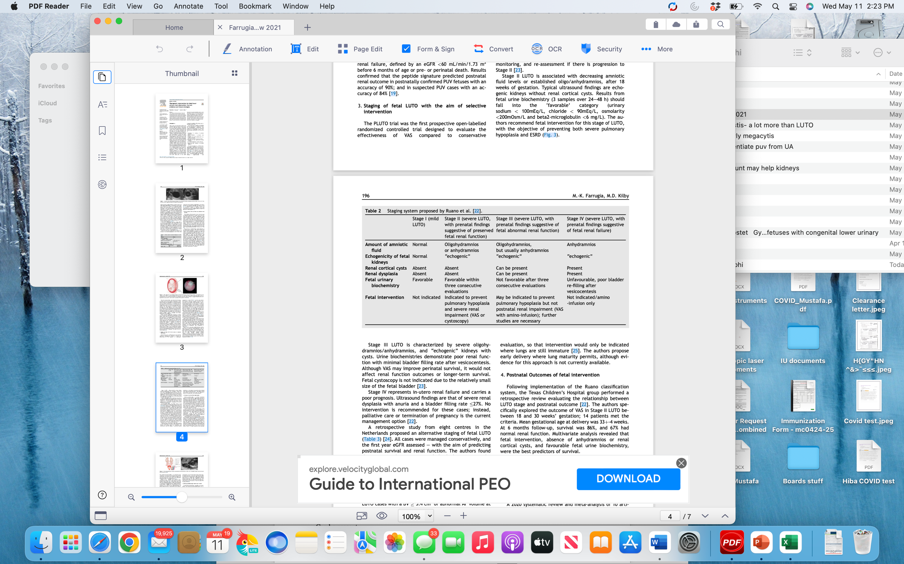

- Staging system suggested by Fontanella et al 2019

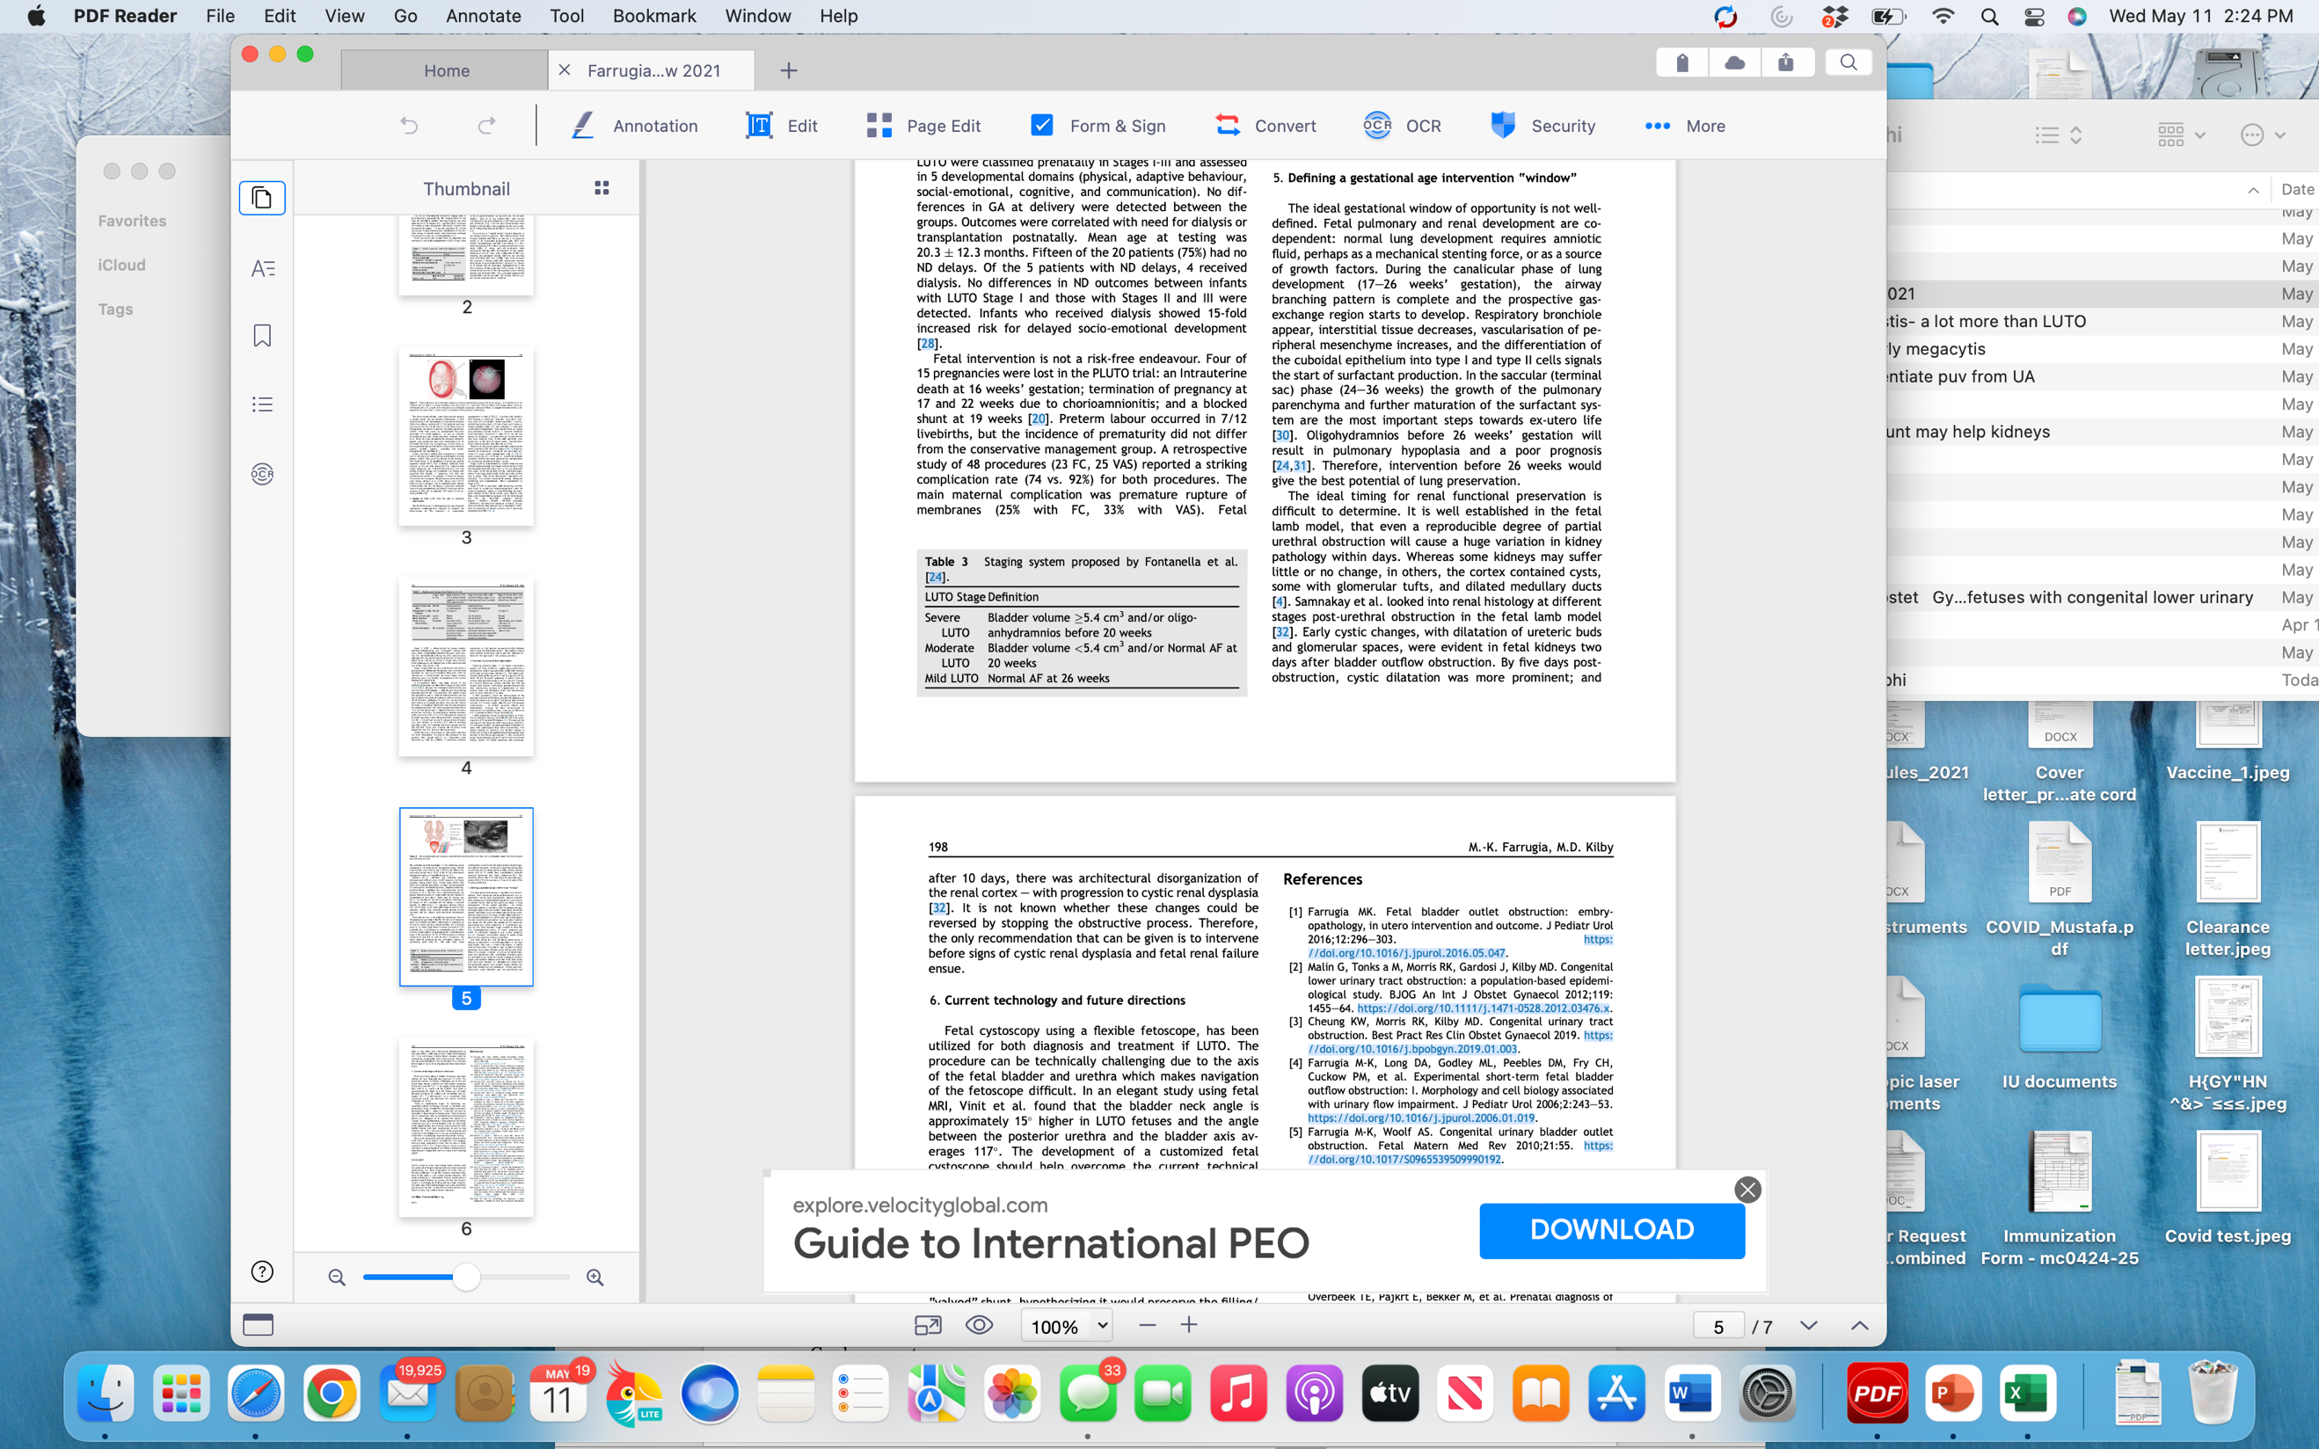

- Nassr et al 2021 proposed scoring system to choose candidates for intervention, in which those with score >3 are associated with 0% chances for survival at 6 months of life.

